Syllabus for English 122

Writing 122 Winter Quarter
CRN: 30384
Albany Campus
Room: Mackenzie Hall 118
Mon/Wed/Fri 10-10:50
Prof. Nannette Schultz
Office Hour: 2-3 M/W/F South Santiam Hall 215
(Also by appointment MWF)
schultn@linnbenton.edu

Textbooks: Required
Critical Thinking to Argument: A Portable Guide

The Little Seagull Handbook

Final Exam: Monday, March 16, 2020 at 8-9:50 AM

Course Description:
WR 122 English Composition: Argumentation
Emphasizes the logical means of supporting claims in argumentative essays, thesis statements and reasoning. Includes logic, style and research.
Credits 3
Prerequisite: Prerequisite: WR 121 English Composition or equivalent with a grade of C or better.
Notes
Lower DivisionTransfer (LDT) Course

Course Overview:
3 Out of class essays 40%
4 Current Event Assignments 20%
Smaller In-Class (Participation) & Homework Assignments 20%
Final Exam 15%
Reflection 5%

Course Outcomes

Upon successful completion of this course, students will be able to:
Analyze the rhetorical needs the needs of their audience in relationship to the assignment for college-level persuasive writing assignments. Apply appropriate levels of critical thinking strategies (knowledge, comprehension, application, analysis, synthesis, evaluation) in their written assignments, with an emphasis on analysis and evaluation/persuasion. Implement appropriate rhetorical elements and organization (introduction, thesis, development and support, counter-argument, conclusion, etc.) in their written assignments, with an emphasis on standard argument models, particularly the Toulmin model. Locate, evaluate, and integrate high-quality information and opinion appropriate for college-level analysis and argument assignments. Craft sentences and paragraphs that communicate their ideas clearly and effectively using words, sentence patterns, and writing conventions at a high college level to make their writing clear, credible, and persuasive.

Exceptions: I will make an exception in the case of unforeseen and unavoidable emergencies of a documentable nature. I understand that life happens!!! If you know of something, ahead of time, coming up that will prevent you from attending a class session or turning in an assignment, then please discuss this we me and we can make the necessary arrangements. I am very happy to work with you but I cannot do that without clear communication. Communication with instructors is key to college success!

Revision Policy:

I will allow revision of any major assignment that was turned in on-time for a higher grade! Theref0re, it is your best interest to turn all assignments on time.

- One Extra Current Event may be turned in for extra points or to replace a low score on a previous current event by the end of the course.

Smaller Homework Assignments:

These are support assignments and will not be accepted for credit one week after the initial due date as the relevance will be minimized…unless I make a specific arrangement individually or with the class.

Attendance will be noted every course session:

- In a writing course, everyone is a participant not an observer.
- Your presence is not only requested but it is required.
- Participation points cannot be earned without attendance.
- Participation points cannot be made up.
- You will have a harder time without the support of the team and the team will have a harder time without you!!!
- It is vital to attend every class session and keep on the assignments as the reading, writing, and new concepts will be extensive.

Classroom Etiquette:

Electronics should be turned off and put away unless they are being used as part of the learning environment.

If you are expecting an important call or text, please put your phone on vibrate, and take the call in the hallway. Our time is very short in the classroom, so the attention needs to be on what is going in the classroom not what is what is going in the outside world. They can wait! LBCC Policy is that electronics are not to be used in the classroom without the instructor's specific permission.

Group Work and Peer Review are expected in this course:

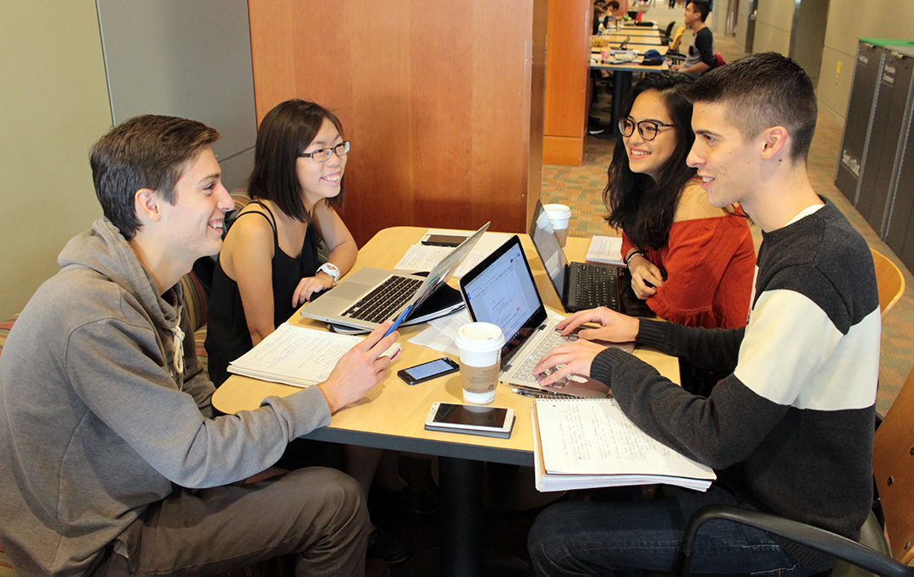

Small Group Work and Peer Review are required

- Come to class prepared and on time.
- Be willing to participate.
- Expect to share your writing.
- Be respectful of the ideas of others at all times!
- It is fine to disagree with ideas but not to disrespect the person.
- No “Ad Homonym” arguments—no name calling!
- Linn-Benton provides a safe and inclusive learning environment for all students. (See Student Rights and Responsibilities on the LBCC)
- Use the Golden Rule: Treat others the way you want to be treated!
- This will be an interactive classroom environment.
- Active Learning not passive learning will occur here.
- Overly disruptive behavior will not be tolerated.

Expectations:

This is a skill building course. The skills that will be build are: critical thinking, logic, learning to recognize and avoid rhetorical/logical fallacies the ability to make a sound argument starting with an opinion using factual evidence to support the position in a critical way. The ability to refute counterarguments logically and make concessions when needed are also essential skills of this course. These skills will be introduced and practiced orally in class but honed in at home through extensive reading and writing. In order to be proficient at argument and improve writing skills, close critical reading is essential. Expect as much reading in this course as writing. Therefore, this is NOT a course that can be learned at the last minute. These skills require diligent effort over the entire term and lifetime to master. It is imperative to attend all class sessions and to keep up with both reading and writing assignments. It cannot be crammed or caught-up at the last minute.

Campus Resources

CFAR (Center for Accessibility Resources) (located on main campus) www.linnbenton.edu/cfar
LBCC is committed to inclusiveness and equal access to higher education. If you have approved accommodations through the Center for Accessibility Resources (CFAR) and would like to use your accommodations in the class, please talk to your instructor as soon as possible to discuss your needs. If you believe you may need accommodations but are not yet registered with CFAR, please visit the CFAR Website for steps on how to apply for services. In order to receive these services, one needs to make an appointment to discuss what is needed. (541) 917-4328 Red Cedar Hall Room 105 (Coming soon to the Lebanon Center.)
It is the student’s responsibility to discuss with the instructor in private regarding any needed accommodations. (Office hour/email)

Writing Center available on main campus in Albany.

They have peer tutors available and writing resources as well as a safe space to work. Linn Benton also has an online writing lab/ OWL that is available to all students remotely. They can provide feedback on writing assignments prior to submission.

- The Purdue OWL Website is also extremely helpful!
- I have a Moodle shell set up for this course that can be accessed to check on grades, read announcements, and to review and print out course materials.

Academic Honesty AKA Plagiarism

Academic Integrity is expected of all Linn-Benton students. All work that is turned in by students should be the work of that student. In a writing class, sources are often incorporated into a student’s writing. All borrowed words AND ideas must give credit where credit is due. Paraphrasing and effectively integrating and citing sources was covered in 121. We can review that in this course. Anything that is deliberately turned in that is someone else’s work that is not credited to that other person is called PLAGIARISM. In the academic world and the workplace, the act of willful plagiarism is a major offense as it is stealing the work of others. Plagiarism or any form cheating in college is punishable by failing the assignment and/or the course. Multiple offenses can lead to permanent expulsion from the college.

My Definition of Plagiarism:
The willful and repeated (not accidental and not incidental) use of another person’s work. This class will briefly review formatting that was covered in 121. If you are still have difficulties with formatting then please consult Purdue OWL. The Writing Center, or come see me in office hours. Students that willfully commit plagiarism at LBCC can fail the assignment, the course, and in some cases can be fully expelled from LBCC. Simply, there is not excuse for plagiarism or may other type of cheating. In the end. cheaters only cheat themselves.

Most Important:
This is a very challenging course. It will train students to critically think and support their ideas and arguments in a logical way. This will be done both orally and in writing. First thoughts are rarely the best thoughts! Expect that ideas will be challenged so that the ability to support arguments will be most effective as well the ability to consider opposing viewpoints in an objective manner. Revision of major essay assignments is encouraged, so that, as more is learned more effective arguments can be made. The most successful students see their instructors in office hours especially in the most challenging classes.

This class is all about logically considering the ideas and opinions of others. Revision is expected in writing so that the best work is turned in.

“It is the mark of an educated man to entertain an idea without necessarily accepting it. __ Aristotle.

