ART 102

Understanding Art

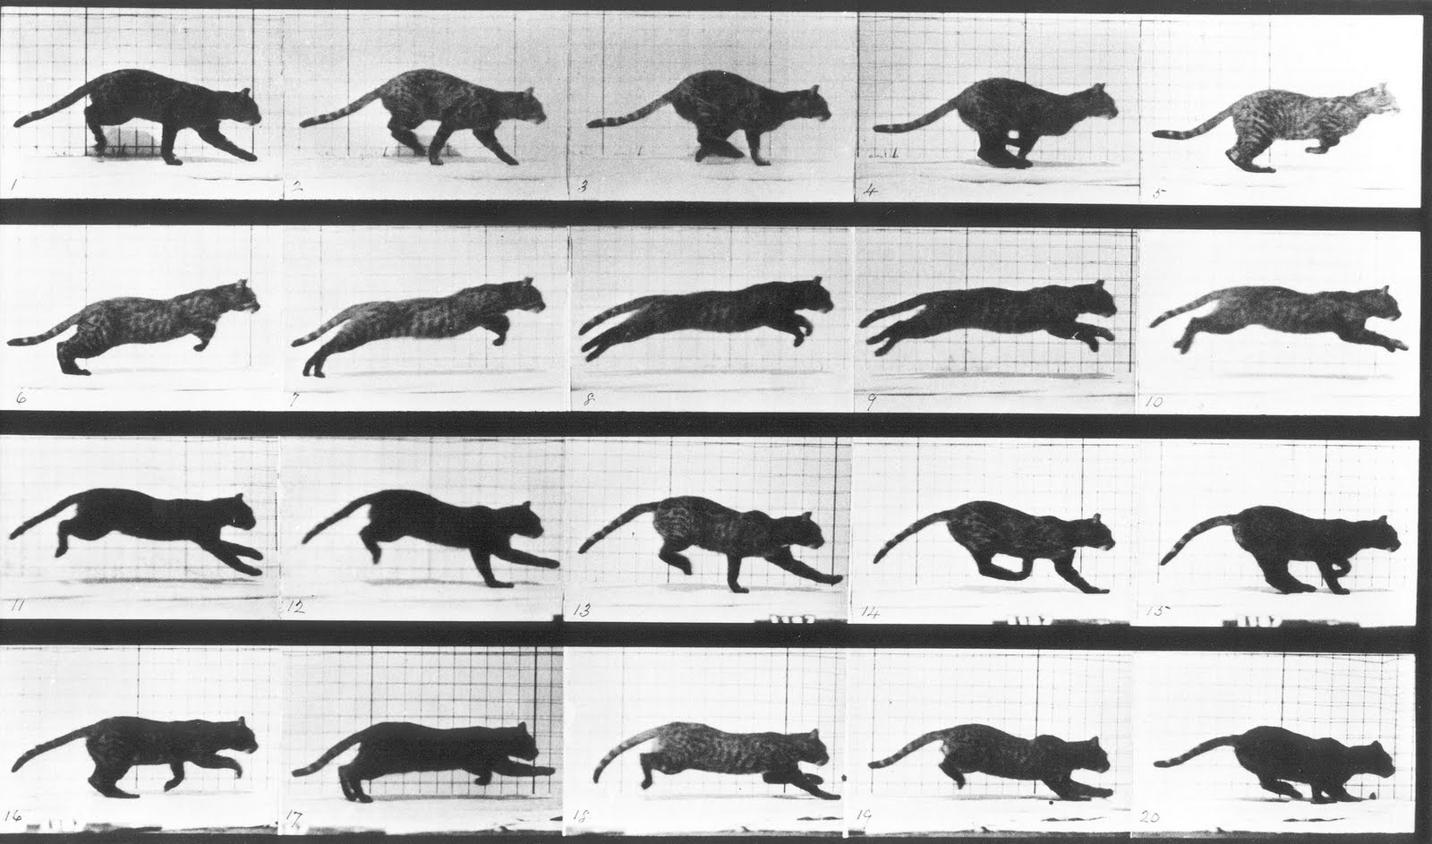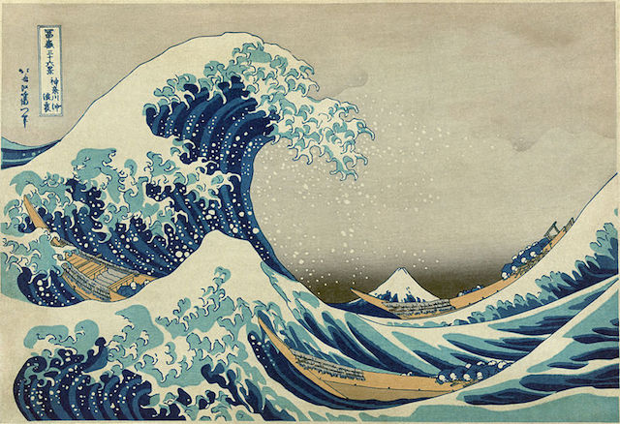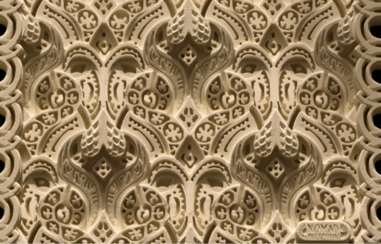
Spring 2017
Linn-Benton Community College

CRN: Benton Center
MW 2:30-3:50, BC 204
CRN: Albany Campus
MW 10-11:20, MKH 203

Professor: Isabelle Havet
Email:haveti@linnbenton.edu
Office: SSH 116C, Albany Campus
Office Hours: MW 11:30-1:00; TR 1:30-2
& by appointment
Art 102  Understanding Art |  | Winter 2017  Class Times:  CRN: Benton Center  MW 2:30-3:50, BC 204  CRN: Albany Campus  MW 10-11:20, MKH 203
Professor: Isabelle Havet
E-mail: haveti@linnbenton.edu
Phone: 541-917-4559
Office: SSH 116C, Albany Campus
Office Hours: MW 11:30-1:00;
TR 1:30-2 & by appt.

Course Description

Understanding Art explores the ways we make, perceive, and interpret art. After gaining a practical understanding of the major formal elements and principles of design, students survey the characteristics and developments of artistic media and movements within their cultural and historical contexts. Topics include, but are not limited to: drawing, painting, graphic arts, sculpture, design, architecture, digital arts, and new media. This course focuses on building foundational knowledge of art and art history, therefore no prior experience is required.

Learning Outcomes
Upon successful completion of this course, students will be able to:
- Demonstrate an understanding of a variety of media and techniques.
- Analyze in writing an artwork using the formal elements of art and principles of design.
- Understand artworks within their social, cultural and historical contexts.
Credits: 3 credits; 3 hours of class per week.

General Education Requirements
Cultural Literacy AAOT/AAS, Human Relations AAS, AS Liberal Arts Core 1, AAS Human Relations, AAOT Arts & Letters, AS Literature & the Arts, AGS Humanities/Arts.

Prerequisites: None. This is an introductory-level course.

Recommended (but not required): College-level reading and writing skills.

Required Textbook: No textbook required. Readings and videos be provided in Moodle.

Required Supplies: Notebook (will be collected)

Course Assignments
- Notebook
- Weekly Quizzes
- Class Activities & Technical Workshops
- Group Show & Tell Presentation
- Formal Analysis Paper
- Midterm & Final Exam

Description of Course Assignments

Readings and videos are assigned for each class session. Read all assigned readings and watch all assigned videos before each class session. See the Course Schedule for what to read for each class. You will frequently be asked to write reflections or discuss readings and videos in class, and thus are expected to keep on top of them. The quizzes, midterm, and final will revolve heavily around readings, videos, and lectures. I will check your Moodle progress frequently. If I see that you are falling behind, I will ask you why.
- Notebook
You are required to take notes in class from the lecture and during classroom assignments. Studies show that note-taking students perform better than non-note-taking students. In addition to regular note-taking of lectures and assigned readings /videos, you will be asked to write reflections. Bring your Notebook each class (including exam days). Your Notebook will be collected and graded, so must be separate from other classwork.
- Quizzes
Students take short quizzes in Moodle each week of instruction (Weeks 1-10). Quizzes are designed to help students keep pace with the material (readings, videos, lectures), and are a mix of multiple choice, true/false, word matching, and short answer questions.
- Class Activities & Workshops
  - Class Activities: Students will participate often in class activities. Activities may include: writing assignments, pop quizzes, and class presentations on selected course topics. Some activities will be graded and some will not.
  - Technical Workshops: Students will deepen their knowledge of the course material by experimenting with artistic media and techniques during hands-on workshops. Students will be assessed according to effort, rather than their artistic skill.
- Group Show & Tell Presentation
Small groups (3-4 students) will co-teach a 10-minute lesson on selected topics (See Course Schedule).
- Formal Analysis Paper
Students complete a short (2-3 page) formal analysis paper on a selected artwork.
- Midterms & Final Exam
2 short Midterm Exams (one on Formal Elements & Principles of Design; 1 on Visual Media) and 1 Final Exam will be administered in class. They may include a combination of multiple choice questions, short answers, and essays.

Failure to submit an assignment or participate in an activity in a timely manner will result in a 0 grade. Class activities cannot be made up later.

Assignment | Points
Attendance | 10
Notebook | 10
Weekly Quizzes (10) & Syllabus Quiz | 20
Class Activities & Workshops | 10
Group Show & Tell Presentation | 10
Formal Analysis Paper | 20
Midterm & Final Exam | 20
Total Points | 100

Grading Scale
A 90-100%
B 80-89%
C 70-79%
D 60-69&
F 59% or below
What do I need to do to be successful in this class?
- Attend class.
- Check your LBCC email. Check it frequently (preferably daily), or have your LBCC email forwarded to your prefered account.
- Communicate regularly. Come to office hours or see me before or after class. I check email most weekdays and occasionally on weekends.
- Keep up with the material. Do not let it snowball on you. You usually should be spending 30-60 minutes reviewing assigned materials and taking notes before each class period. The instructor reserves the right to administer pop quizzes to ascertain if students are keeping up.
- Take notes during class, and of assigned readings/videos each week. Note-taking is an important college skill developed through practice. There will be times that you will be very glad to have your notes in class. Your Notebook will be collected periodically and graded.
- When in class, focus on class. Class time is valuable. You should be focused on class while you are in the room; if you can’t focus, leave the room. If you have personal business to attend to (e.g. phones calls/texting, conversations, or other class work), take care of it outside of the classroom. If I see you engaging in any of the above behaviors, I will call you on it. I expect you to apply yourself to your education during class hours. You are the person who has the greatest impact on your learning and your grade.
- Actively participate. You will NOT be successful in this class if you show up and “tune out.” Students who do not participate on a regular basis (by actively listening and engaging in discussions and activities) are unlikely to earn a passing grade.
- Be positive and have fun! This course is about stretching our thinking and learning together. We will also be looking at cool art and stuff.
- Be a good class citizen. This means be open to: 1) working with others, 2) being respectful your peers and the instructor, and 3) trying new things. It’s always OK to be unsure about how to do something; it’s never OK to give up without trying.
- Be a good team member. You will spend time working with your “team.” Teams will have work assignments (some graded, some not). The best teams work through style differences. Approach collaborative activities with the attitude that you will contribute something to the group, rather than that you don’t know or can’t do something, and so shouldn’t try.
- Get ready to move. Be prepared to stand, move around, use your electronic device/the internet, and talk each day in class.
- Be accountable. Bottom line: you’ll get what you put into this class. You are the person who has the greatest impact on your learning, and ultimately, on your grade in this class.
Course Policies
Institutional Drop for Non-Attendance
Faculty at LBCC may administratively withdraw a student for nonattendance during the first week of the term. Students will be automatically dropped by the second Monday of the term if they are not attending regularly and fully participating in the course. Students who do not attend each class session, or who do not complete the Syllabus Quiz and Quiz 1 by Sunday, April 9 at 11:59PM, may be institutionally dropped from the course.
Moodle
This course uses the Moodle learning platform. Think of Moodle as the online class hub: you will use the Moodle course site to access announcements, the Syllabus and Class Schedule, assignments guidelines, lecture slides, videos, readings, forums, and more. I post lecture slides after the class session. While they are not a substitute for attending lectures, they are provided as a courtesy to help you study key artworks and concepts. If I notice that students are not attending class regularly, I will be forced to stop posting lectures.
You will turn in assignments in Moodle. Assignments must be uploaded by Sunday at 11:59 pm on the week they are due (See Course Schedule for specific due dates). It is the student’s responsibility to upload assignments to Moodle by deadline, and in an acceptable file format (doc, docx, or pdf). If you are having trouble uploading an assignment, contact the Help Desk or email the instructor right away (before the deadline!) It is the student’s responsibility to turn in work on time. Do not wait until the last minute to turn in assignments! “Last-minute problems” such as a faulty internet connection, computer problem, conflicting travel plans, personal schedule conflicts, or work in other classes, are not considered valid excuses for missing assignment deadlines.
Emailed assignments will NEVER be accepted. If it’s not submitted in Moodle, it’s not graded.
Attendance & Participation
The course spans only 10 weeks. It is vital to attend class regularly and arrive on time. Please do not come late to class. It is disruptive, and you risk missing important information and activities. The class has been structured in such a way that assignments are given nearly every class meeting. If you miss an in-class activity or assignment, you cannot make it up.
I enjoy teaching and I love the material we are covering. As such, class meetings are fairly informal discussions of fascinating works of art, artists, and time periods. I respect and welcome input from everyone in the class, as it adds to the quality of class. I come to class fully prepared; I show up early; I respect thoughtful input. In return, I expect you to show up fully prepared, on time, and respectful of me and your peers.
Grading System:
A (Excellent)= Always prepared, frequently participates, rarely absent
B (Good)= Usually prepared, participates only when called on, rarely absent
C (Average)= Usually prepared, rarely speaks, sometimes absent
D (Below average)= Often unprepared, several absences
F = Usually unprepared, frequent absences

Moodle Attendance
Students track their own attendance in Moodle using their personal electronic devices. I find that this method is much more efficient and less of a hassle for all. Students mark themselves as Present, Absent, or Late at the beginning of each class session. If you do not have a personal device to mark your attendance, just come see me after class and I will mark your attendance for you. Attendance works on the honor system. Falsifying your attendance record in any way constitutes acadmic dishonesty, a serious college offense (See Academic Honesty section below).
Present: Student arrives on time and stays the entire session.
Absent: Student does not attend class, or leaves early without prior approval.
Late: Student is 5 min late or more. 2 Late marks result in an unexcused absence.
Excused (marked only by instructor): Excused absences require documentation and are granted solely at the discretion of the instructor. If at all possible, arrange excused absences ahead of time.

Unexcused absences result in a lowering of the student’s final course grade by 5 points per absence. Please plan accordingly.

I understand that sometimes things happen. If you are late, will be late, or must miss class for a valid reason (emergency, military duty, death in the family), speak with me right away. I will excuse tardiness/absences if it is for a valid reason and is not a frequent occurrence.

Communication
- The best way to reach me is via email and during office hours. I try to respond to emails daily during weekdays. Feel free to email me if you have a question.
- When you email me:
  - Write your first & last name, course number & section days/time, and a short reason in the subject line (e.g.: Jane Smith, ART101 MW 10-11–Request for Appointment).
  - Double-check that your email is appropriate and written in a professional manner. I love teaching, and I enjoy interacting with students outside of class. However, it is disheartening to receive emails that are disrespectful, demanding, overly-personal, angy, or venting. This happens rarely, and is more often than not unintentional. However, this method of communication is helpful to neither instructor nor student and runs counter to LBCC core values, and thus is unacceptable.
- Check your LBCC email frequently (preferably daily), or forward it to your personal email. I frequently send out important information via Moodle, and you are responsible for reading that information on time.

Resources

Moodle Support
If you have questions about Moodle or need technical support, contact:
- Student Help Desk (located in the Library): Either visit, call at 541.917.4630, or email at student.helpdesk@linnbenton.edu
- LBCC Moodle User Support Forum: Look up or post questions: http://elearning.linnbenton.edu/mod/forum/view.php?id=2697
Accessibility
You should meet with your instructor during the first week of class if:
- you have a documented disability and need accommodations,
- your instructor needs to know medical information about you, or
- you need special arrangements in the event of an emergency.
If you have documented your disability, remember that you must make your request for accommodations through the Center for Accessibility Resources Online Services web page every term in order to receive accommodations. If you believe you may need accommodations, but are not yet registered with CFAR, please go to http://linnbenton.edu/cfar for steps on how to apply for services or call 541-917-4789.
Writing Center
https://www.linnbenton.edu/writing-center
There are 3 ways to use the Writing Center: Schedule a 30-minute appointment (recommended); Use Drop-In Services; Use OWL (the Online Writing Lab).
Important Academic Calendar Dates:
- Last day to add/drop: April 10, 2017
- Last day to withdraw: May 19, 2017
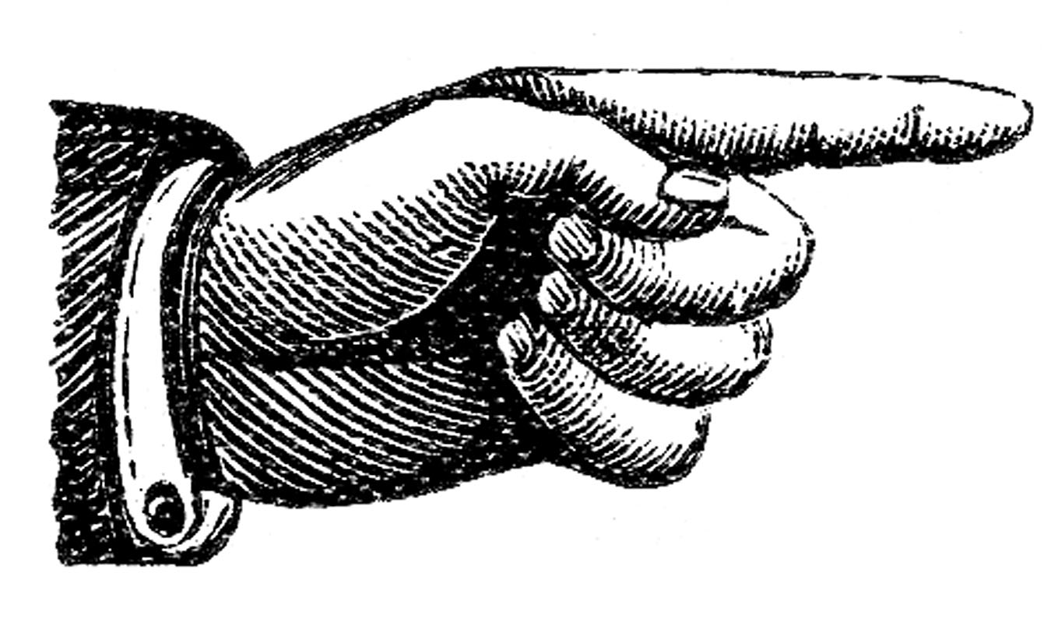

Extra Credit!

- Option 1: Use the Writing Center
You can receive up to three (3) extra credit points for using the Writing Center for a paper assignment. These services are highly recommended!
To receive credit: Attach proof of using the Writing Center at the end of your paper (a picture you take with your phone of the Writing Center dated stamp or other confirmation is fine).

- Option 2: Attend a campus/local lecture or exhibition: During the term, I will announce campus/local lectures and exhibitions that are of interest to the class. You can receive up to two (2) extra credit points added to your course grade for each event you attend by turning in a 1-page reflection paper on the event. In your reflection, you may discuss any aspect of the lecture or exhibition that struck you or that you feel ties into issues we’ve explored in the class, as long as you include some specific details showing you attended the event. Imagine that you’re a reporter or blogger writing a review of the event. Including pictures in your write-up is great. You are encouraged to request permission to do an extra credit write-up of an alternative local event/exhibition they wish to attend; instructor approval required.

- Option 3: Write a 1-page reflection in your Notebook. I will make periodic announcements of writing topics in class. Write these on a fresh notebook page and head the entry with “Extra Credit” so I know to give you credit for your work.

Incomplete Grade Policy
An incomplete grade may be assigned when a student has completed and passed a majority of the required work, but for reasons beyond the student’s control, cannot complete the entire course. Incompletes are given only in extraordinary and documented circumstances (i.e., a family emergency or serious medical excuse), and at the discretion of the instructor. If an Incomplete is granted, the instructor will determine the work that must be completed as well as a nonnegotiable completion deadline for submitting all missing work. If the incomplete work is not submitted on time or is deemed unsatisfactory, the incomplete will revert to an F-grade.

Academic Honesty
Academic honesty is an indispensable value as students acquire knowledge and develop college skills. Students are expected to practice academic honesty by not cheating, plagiarizing, or misrepresenting their coursework in any way. Plagiarism, collusion, and other forms of misrepresentation hurt the student and run counter to the goals of education. Students are ultimately responsible for understanding and avoiding academic dishonesty, whether such incidences are intentional or unintentional. Violations will result in failure of the assignment and possibly the course. Per LBCC policy, all incidents of academic dishonesty will be reported to the Associate Dean of Student Development and the Dean of Arts, Social Science & Humanities.

Stay Connected with LBCC Visual Arts!
You can follow LBCC’s Visual Arts department on Instagram and Facebook, to stay up to date on LBCC advising, scheduling, gallery opening events, and much more!
Instagram: @lbccart
Facebook: Linn-Benton Community College Visual Arts

