Course Information Sheet for CMA 112
Medical Law and Ethics
Instructor: Rick Durling Email: durlinr@linnbenton.edu Office: HOC 210
Instructor office hours and schedule

The official course text for this class is included below. You should copy it to your Google Drive and use it as a lecture resource. You may edit, change, delete, or add to it; as long as you save a copy of it and don’t try to edit the original
.
Description
This course presents much of its content online. The student will be responsible for content, assignments, and group projects completed online in Moodle. Please let your instructor know as soon as possible if this is a problem for you. We can work together to solve the problem; or accommodations may be made. This course is designed to help the medical professional become familiar with legal and ethical considerations specific to the healthcare field.

Outcomes
Upon successful completion of this course, the student will be able to apply legal and medical-ethical concepts while solving problems with patients, coworkers, superiors, subordinates, and society. The student will be able to identify the origin of their own ethics as well as the origin of the ethical positions taken by others in their discussion groups. The student will be able to apply an ethical framework to various situations encountered in the healthcare field.
Students in the Medical Assistant and Coding/Reimbursement Program students will learn and be evaluated on 64 areas of content and competency required by the AAMA and Advisory Board of the CRS program.
Assessment
- 9 individual Competency Assessments 10 points each - 90
- 9 group Activities 10 pts each - 90
- 9 Quizzes 10 points each - 90
- 1 Final Project - 30 points
- Total Points in this course: 300
- A = 270 pts, B = 240 pts, C = 210 pts, D = 180 pts, F = < 180 pts

HYBRID Course
This is a hybrid course. This means that students will have two primary, and one secondary method of attendance. Students may attend courses live and in person at the Healthcare Occupations Center campus; or students may attend virtually through ZOOM, these are the primary and recommended methods of attendance. From time to time, or more frequent if necessary, a student may have unavoidable commitments during regular course hours. This makes both the in-person and ZOOM options unavailable. When this becomes the case, a recorded version of classroom activities will become available, usually by the end of the day. However, collaboration and communication with team members, often on a daily basis, will still be the student’s responsibility should they choose this option for attendance. If you are unfamiliar with ZOOM, HERE is a series of training videos to help you access this important course content.
There is a link to the LIVE CLASSROOM which will take you directly to our scheduled class meetings as they are occurring live.

A quick instruction to use ZOOM to watch and participate in class LIVE: Simply click on the appropriate link in the “Course Communication” section for the proper day. The first time you do this you will need to let ZOOM set up the software for you. It is pretty quick. Next you will have a few configuration questions. Answer them and keep moving until you see this:
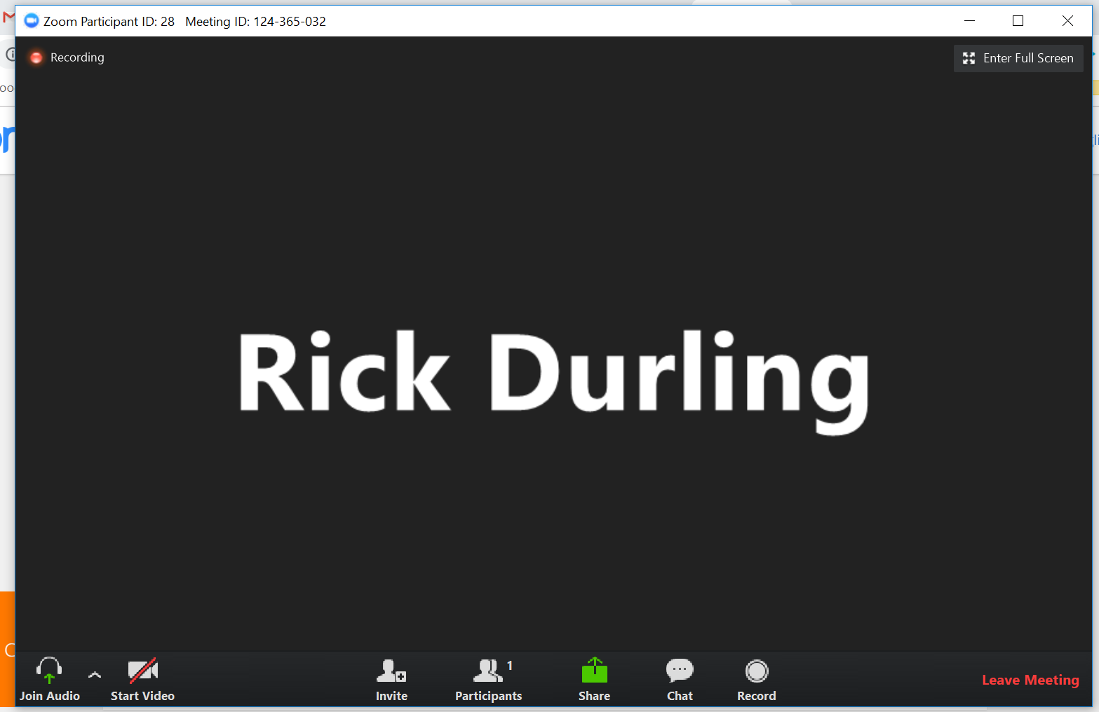
From here, the broadcast of the classroom will begin when it is time for class to start or within a few minutes.

Competency Assessments and Activities
There will be one competency assessment and one activity for each week (module). Each competency assessment and activity will be worth 10 points and will be due according to the student schedule of course responsibilities. CA’s are due by the scheduled Sunday due date at 8:00 AM and must be submitted through moodle. CA’s submitted by email will not be accepted or graded. Follow the specific CA instructions on your moodle page and take a look at the grading rubric before submitting your assignment.

Activities are a little different since they are all group activities. You will read through a scenario early in the week and discuss it online in the forum provided for your group.
Leaders:
Each week/module your group will select a different leader. The leader will collect input from all group members (who participate in the process). On Saturday morning by 0800 the group leader will complete a position/solution paper for the scenario. On this paper, include a header identifying you and your group as well as the names of all group members who participated with you in person or on your forum for this module. The leader will submit the paper to moodle on a google doc after posting a link to it in your forum.
The rest of the group:
Hopefully the group members will have a day or so to read the paper, both in progress, and when it is ready to submit, by reading it in the forum. All group members, except for the leader, will then perform an evaluation of the other three group papers which will be posted Saturday morning (shortly after 0800) by your instructor. Using the evaluation form provided on moodle, submit a document which ranks the other three papers from 1 for best to 3 for worst. This will be completed by Sunday morning at 0800. If you do not submit an evaluation form, or you do not participate in your group’s process, you will receive a 0 for this assignment.

Learning Activities
We will participate in discussion, lecture, review, group work and homework assignments. Group projects will be REQUIRED in this class and participation will be accomplished ONLINE as well as in class. Your ONLINE participation in the group forum is all what I will use to evaluate your contribution to the group. Anybody who does not participate or contribute online will receive a greatly reduced score or a 0. It is up to the members of each group to motivate each member to participate. Group conflict is inevitable and must be resolved by group members in a professional manner. Let your instructor know if you feel there is abusive or inappropriate behavior during group activities. The more participation you have, the better your group score will be. Diversity WILL be your greatest asset only if you learn to embrace it and continue to respect it by employing its benefits.

Course Academic Dishonesty Policy
Any student caught cheating, duplicating another student’s work, or other form of academic dishonesty, will be counseled by the instructor. The first offense will result in a “zero” grade for that assignment/assessment, a lowering of the final course grade by one full grade, and the student’s name and offense may be sent to the Dean of Students for LBCC depending upon student response. A second offense will result in an automatic “fail” for the course and the student will be referred to the Dean of Students for LBCC to determine further disciplinary action and to gain approval before returning to class.
LBCC Comprehensive Statement of Nondiscrimination
LBCC prohibits unlawful discrimination based on race, color, religion, ethnicity, use of native language, national origin, sex, sexual orientation, marital status, disability, veteran status, age, or any other status protected under applicable federal, state, or local laws.(for further information http://po.linnbenton.edu/BPsandARs/
For Students with Disabilities
"The Office of Disability Services (ODS) provides reasonable accommodations, academic adjustments and auxiliary aids to ensure that qualified students with disabilities have access to classes, programs and events at Linn-Benton Community College. Students are responsible for requesting accommodations in a timely manner. To receive appropriate and timely accommodations from LBCC, please give the Office of Disability Services as much advance notice of your disability and specific needs as possible, as certain accommodations such as sign language interpreting take days to weeks to have in place. Contact the Disability Coordinator at Linn-Benton Community College, RCH-105, 6500 Pacific Blvd. SW, Albany, Oregon 97321, Phone (541)-917-4690 or via Oregon Telecommunications Relay TTD at 1-800-735-2900 or 1-800-735-1232."

CMA 112 Medical Law and Ethics by Rick Durling
Course Text/Lecture Companion

This Text is designed to help the student achieve competency in the required areas assigned to this class by the American Association of Medical Assistants and the American Academy of Professional Coders. LBCC has partnerships with these two organizations to help deliver the best and most current education available for our allied health programs.

Each Module of this text is designed to help the student master a group of similar competencies, as well as to challenge their group skills. Success or failure in this course will largely depend on the student’s ability to communicate effectively within a group setting, and to develop relationships that will assist in their success. Specific week-by-week (module by module) content and competency correlations are shown on the the Schedule of Student Responsibility. HERE is a link to the AAMA’s competency map for this course as well as for all of our department courses.

Assessments for this course can be found on the Schedule of Student Responsibility and on the course Moodle Site.

Lecture outlines as well as more defined material and hyperlinks will comprise the content of each module in this text. Please email your instructor if you have any questions about the content or it’s accuracy.

Lastly, this text is a work in progress and will be in a nearly constant state of editing.

Module I Lecture
I. The Constitution
Who, What, Where, When, Why
Read It Please
HERE is another short presentation to help you with an overview...
II. Branches of Government
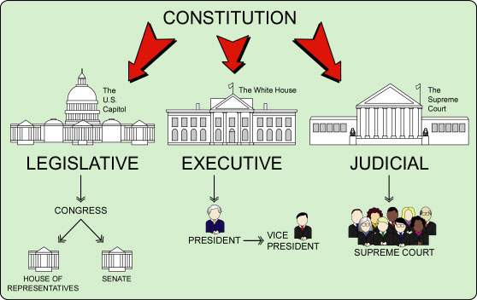
III. Organization of the Courts
- Federal System
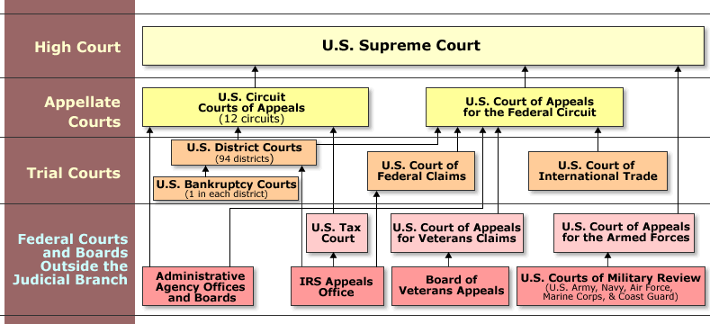

III. State System
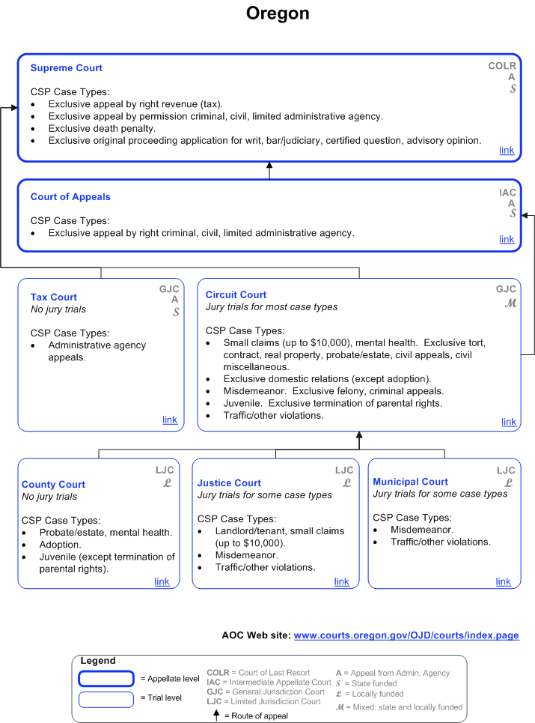

IV. Bill of Rights
Who, What, Where, When, Why
Another overview PRESENTATION
V. The Rest of the Amendments
Who, What, Where, When, Why
VI. Terminology to Remember
A. Subpoena duces tecum: is a court summons ordering the recipient to appear before the court and produce documents or other tangible evidence for use at a hearing or trial.
B. Respondeat Superior: is a legal doctrine which states that, in many circumstances, an employer is responsible for the actions of employees performed within the course of their employment. Literally - “Let the Master answer”....
C. Res ipsa loquitor - Latin for "the thing speaks for itself," a doctrine of law that one is presumed to be negligent if he/she/it had exclusive control of whatever caused the injury even though there is no specific evidence of an act of negligence, and without negligence the accident would not have happened.
D. Locum tenens - One filling an office for a time or temporarily taking the place of another —used especially of a doctor or clergyman.
E. Defendant - In a criminal case: the accused.
F. Plaintiff - In a criminal or civil case: the complainant or accuser (In a criminal case the plaintiff becomes the state or federal government.
G. Respondent - In a civil case, the accused or defendant.
H. Arbitration vs. Mediation: Arbitration and mediation are similar in that they are alternatives to traditional litigation, and sometimes they are used in conjunction with litigation (opposing parties may first try to negotiate, and if that fails, move forward to trial). Both arbitration and mediation employ a neutral third party to oversee the process, and they both can be binding. However, it is common to employ mediation as a non-binding process and arbitration as a binding process. In simpler terms, binding arbitration replaces the trial process with the arbitration process.
Arbitration is generally conducted with a panel of multiple arbitrators who take on a role like that of a judge, make decisions about evidence and give written opinions (which can be binding or non-binding). Although arbitration is sometimes conducted with one arbitrator, the most common procedure is for each side to select an arbitrator. Then, those two arbitrators select a third arbitrator, at which point the dispute is presented to the three chosen arbitrators. Decisions are made by majority vote.

Mediation, on the other hand, is generally conducted with a single mediator who does not judge the case but simply helps to facilitate discussion and eventual resolution of the dispute.
I. Statute of Limitations: A statute of limitations is the deadline for filing a lawsuit. Most lawsuits MUST be filed within a certain amount of time. In general, once the statute of limitations on a case “runs out,” the legal claim is not valid any longer. This can have implications for health care workers under certain health care laws and regulations. Physicians, coders, MA’s, nurses, etcetera, are all human and make mistakes as a matter of course. Mainly, statutes of limitations can provide “cover” for wrongful acts that go undiscovered for a time; but also, it may give us more time to “make it right” when we have made an error. You can judge for yourself whether either of these is actually a good thing or not. Malpractice carries a statute of limitations in Oregon of two years generally. For coders, medicare fraud carries a civil statute of limitations of 5 years, and a criminal limitation of 6 years.
J. PSDA (Patient Self-Determination Act): The 1990 Patient Self-Determination Act (PSDA) encourages everyone to decide now about the types and extent of medical care they want to accept or refuse if they become unable to make those decisions due to illness. The PSDA requires all health care agencies to recognize the living will and durable power of attorney for health care. The Act applies to hospitals, long-term care facilities, and home health agencies that get Medicare and Medicaid reimbursement. Under the PSDA, health care agencies must ask you whether you have an advance directive. They also must give you information about your rights under state law.
Everyone getting medical care in hospitals or extended care facilities (nursing homes), enrolling in HMOs, and entering into hospice or home care agreements must be given certain information in writing. This must include information on your state’s laws about your rights to make decisions about medical care, such as your right to accept or refuse medical or surgical treatment. You are also entitled to receive information about your right to create an advance directive. They may even offer simple advance directive forms for you to use. But it’s not a good idea to wait until you are in the hospital to fill out a form. Chances are you won’t be feeling well, and you might not be able to complete the form when you are admitted.

K. Risk Management
1. Financial:
2. Clinical:

Module II Lecture

- Types of Laws (Sources)
- Legislative (Statutory)
- Administrative (Agency) (Executive)
- Common (Case)
II. Standard of Care
- Professional
- Reasonable Person
III. Negligence
- Goes by Standard
- Failure to use “due” care
- Proximate Cause - (cause-in-fact)
IV. CDC
- Their Mission
- Our duty
V. Minors - Consent - Incompetence
- Emancipation and Required Consent
- Exceptions:
1. Military Service
2. Emancipation by Judge
3. Marriage
4. Pregnancy*
VI. Punishment
- The 3 R’s
- Retribution
- Reformation
- Restraint
B. Sentencing Phase / Guidelines
VII. Role Playing
- Defendant / Respondent
- Plaintiff
- Judge
- Jury
VIII. Compliance Stuff -> 1 2 3 (might be handy for activity this module)

Module III Lecture

I. Malpractice
- The General Process
- The trial if necessary
  - Establishing the Extent of the Doctor-Patient Relationship (duty)
  - Proving Negligent Care - res ipsa loquitor (breach of duty)
  - Proving an Injury Occurred as a Result of Negligence - (proximate cause)
  - Presenting Proof of Damages
- Avoiding Lawsuits
II. Good Samaritan Act
III. HIPAA
- What is it?
- Relationship to the ACA
- How to comply
IV. Scope of Practice
- Medical Assistant
  - no state scope of practice
  - not covered by board of nursing
  - not covered by board of medical examiners
  - Oregon Definition
  - most important - CPOE and Who can Use it
B. Certified Professional Coder
- normal limits and duties
- Access and authority in the medical record and CPOE
- fiduciary duty
V. Privacy
- Privacy vs. Confidentiality
- By Definition
- Privacy vs. Security
- How does it apply to MA’s or Coders?
VI. Confidentiality
- One Study
- Practical Measures
VII. Privilege under the Law
VIII. GINA
Module IV Lecture

- Forms of Business
- Corporation
- Limited Liability Company
- S-Corporation
- Partnership
- Sole Proprietorship
- Definition of Risk vs. Control
II. Discrimination
- Disparate Treatment
- Disparate Impact
III. Sexual Harassment
- Quid Pro Quo
In common law, quid pro quo indicates that an item or a service has been traded in return for something of value, usually when the propriety or equity of the transaction is in question. A contract must involve consideration: that is, the exchange of something of value for something else of value. For example, when buying an item of clothing or a gallon of milk, a predetermined amount of money is exchanged for the product the customer is purchasing; therefore, they have received something but have given up something of equal value in return. - Wikipedia
- Hostile Work Environment
IV. ADA
V. Civil Rights Act - Protected Groups
* Age
- Pregnancy
- National Origin
- Race
- Ethnic Background
- Religious Beliefs
- Sexual Orientation
- Gender: ERA
- Disability: ADA
VI. Polst Form, Advanced Directive, Living Will
VII. Oregon Law recent statutes, Uniform Anatomical Gift Act, Durable Power of Atty

Module V Lecture

I. ACA
II. ARRA
III. HITECH
- Meaningful Use
- Penalties
IIIa. MACRA
IV. ICD-10
*contracts - written, verbal, express, implied - covered in lecture earlier but not presented in class.
V. Medical Errors
VI. Reporting
- Mandatory Reporters, Sexual Assault
- CDC
- Local County Health Department
VII. Consent
- DPA
- Parental Consent in Oregon
- Mental Capacity Temporary and Permanent - NOT DISABILITY
- What consent (documents) are signed when you become a patient
- Consent to use your information to collect a bill
- Consent to use your information (with others) to treat
- What consents need to be obtained later
- Informed
- Express
- Implied

Module VI Lecture

- Deontological
  - Aristotle
  - Practical - Historical - deontological
II. Teleological
- Plato
- Practical - Historical - teleological
III. Socrates
- Both views
- Balance
IV. Balance on Four Legs - An “ethical” table as it were…...
V. Politics
“especially : competition between competing interest groups or individuals for power, resources, and leadership”
VI. Etiquette
“There are certain accepted behaviors in all social situations that you need to learn. “
VII. Religion
“a cause, principle, or system of beliefs held to with ardor and faith”
VIII. Morals
“of or relating to principles of right and wrong in behavior”

Module VI Lecture (part Deux)
I Wrap up of Deontological vs. Teleological
A. Deontological: Process, journey, evolution, character, duty, obligation, downplay result. A belief that some actions are wrong regardless of the outcome. Moral absolutism.
B. Teleological: outcome orientation, end justifies the means, where design and purpose are overshadowed by result and end. In religion intelligent design is a teleological demonstration of God.
II Morality
- The pursuit of right vs. wrong, good vs. evil, dark vs. light, black vs. white
- Often connected with courage, balance, fairness, wisdom
- Right vs. wrong could be influenced by culture, religion, even politics
III Etiquette
- Socially accepted procedure for interaction with society as it changes with time and community.
- Manners
- Politeness
- Courtesy
- Dress code
IV Religion
- How a higher power influences you in your interaction with the environment.
- How the lack of a higher power influences your interaction with the same.
- Judeo-Christian ethic….. long-entrenched dual religion attitude and thought process engrained in many or most western societies.
V Politics
A. Power, Position, Influence
B. Money, Control, Law/Government

Module VII Lecture

I.Patient Advocacy
- PPAI
- Gilkey Article
- Coach, Navigator, CMA,
- Peer Wellness Specialist, OHA Direction
II. Patient Bill of Rights
- Federal
- State
- Practice
III. Is Healthcare a right or a privilege? (just another look)
IV. Americans without Health Insurance on the RISE
VI. HC Coverage Distribution in US (by state) Overall Mix = 56% private 44% govt
VII. Discussion of Deon vs. Tele as it relates to the four chosen ingredients of ethics with P-E-R-M.

Module VIII Lecture
- Introduction and a Narrow View of Diversity
- Required Lecture: Jeanette Walls
III. Areas of Diversity to consider….
- gender (identification)
- race
- religion
- age
- economic status
- appearance
IV. Examples of Diversity
- cultural
- social
- Ethnic
V. Two helpful links: MORALS RELIGION
My $.02: Achieving diversity and inclusiveness in the workplace is a fundamental part of fulfilling the mission of any health care providing organization. Working to achieve diverse and inclusive environments has numerous demonstrated benefits, including: enhanced creativity, better and more productive communications, faster problem solving, and enhanced programs and services to our patients. Making the commitment is the first step. Educating ourselves about how deep the commitment must be over time is a big hurdle. Understanding that the work is not linear is also important. There is no beginning per se and no end. Achieving diversity and inclusiveness in your workplace is instead a process for creating change through education, collaboration and vigilance. Each new level of insight can result in growth and new experiences for individuals and the organization. The work itself can be uncomfortable, and the territory unfamiliar. The question is: Is your organization as a whole, and you in specific, willing to live with that discomfort for a time in order to achieve healthy, whole communities—with parity for all (Or at least to work towards it)?

Here are the links to complete your assignments:

Education Equity Quiz

Health Equity Quiz

A Lofty Existence
Module IX Lecture

I. Death and Dying in Oregon (optional watch)
II. Death with Dignity Act
- The Cons
- A guidebook for HC professionals
- Recent Usage Studies
- What does it look like?
- Is there Grief and who is grieving?
- How is the Grief process changed with PAS - for the patient? for those left behind?
- Hippocratic Oath
III. Bioethics
- DNA Editing in human embryos

five stages of grief - elisabeth kübler ross
1 - Denial Denial is a conscious or unconscious refusal to accept facts, information, reality, etc., relating to the situation concerned. It's a defence mechanism and perfectly natural. Some people can become locked in this stage when dealing with a traumatic change that can be ignored. Death of course is not particularly easy to avoid or evade indefinitely.
2 - Anger Anger can manifest in different ways. People dealing with emotional upset can be angry with themselves, and/or with others, especially those close to them. Knowing this helps keep detached and non-judgemental when experiencing the anger of someone who is very upset.
3 - Bargaining Traditionally the bargaining stage for people facing death can involve attempting to bargain with whatever God the person believes in. People facing less serious trauma can bargain or seek to negotiate a compromise. For example "Can we still be friends?.." when facing a break-up. Bargaining rarely provides a sustainable solution, especially if it's a matter of life or death.
4 - Depression Also referred to as preparatory grieving. In a way it's the dress rehearsal or the practice run for the 'aftermath' although this stage means different things depending on whom it involves. It's a sort of acceptance with emotional attachment. It's natural to feel sadness and regret, fear, uncertainty, etc. It shows that the person has at least begun to accept the reality.
5 - Acceptance Again this stage definitely varies according to the person's situation, although broadly it is an indication that there is some emotional detachment and objectivity. People dying can enter this stage a long time before the people they leave behind, who must necessarily pass through their own individual stages of dealing with the grief.

