**CRS 110 Medical Insurance Procedures(CRN 32569)**

**Course Information Sheet**

**Class Time: Tues/Thurs 1000 - 1150**

Instructor: Rick Durling, email: durlinr@linnbenton.edu

[Office Hours](https://docs.google.com/spreadsheets/d/1buaMdFl5HVV5NdcnlwI6htpCt7vJ6GmCXRwTo4R45Mk/edit?usp=sharing)  Class Location/Time: HOC 251

**MOODLE**

This course uses our learning management system, [Moodle](https://elearning.linnbenton.edu/course/view.php?id=3343#section-3).

1. View and read lecture background material before Tuesday’s class
2. Complete and submit competency assessment prior to due date
3. Complete small group project prior to due date (5 out of 10 weeks)
4. Complete and submit quiz prior to due date
5. Watch recorded class discussion for Tuesday - *only required if not in attendance live or virtually at the time of the class, optional otherwise*
6. Watch recorded class discussion for Thursday - *only required if not in attendance live or virtually at the time of the class, optional otherwise*

In addition, each module will have a “discussion outline”. These are optional viewing or printing to help manage any notes you may wish to take during class.

**Required Text and Workbook**: There is no textbook to purchase for this course. We will be utilizing open source materials as text for this course. Links will be specifically provided to reading material each module.

**Course Responsibilities**

[Schedule of Student Responsibilities](https://docs.google.com/spreadsheets/d/12g4DWHGFJO0SOZhLF9vlVerAqXCg5vZC6n33Z3B_njY/edit?usp=sharing)

**HYBRID Course**

This is a hybrid course. This means that students will have two primary, and one secondary method of attendance. Students may attend courses live and in person at the Healthcare Occupations Center campus; or students may attend virtually through ZOOM, these are the primary and recommended methods of attendance. From time to time, or more frequent if necessary, a student may have unavoidable commitments during regular course hours. This makes both the in-person and ZOOM options unavailable. When this becomes the case, a recorded version of classroom activities will become available, usually by the end of the day. However, collaboration and communication with team members, often on a daily basis, will still be the student’s responsibility should they choose this option for attendance. If you are unfamiliar with ZOOM, [HERE](https://support.zoom.us/hc/en-us/categories/200101697) is a series of training videos to help you access this important course content.

There is a link to the LIVE CLASSROOM which will take you directly to our scheduled class meetings as they are occurring live.

A quick instruction to use ZOOM to watch and participate in class LIVE: Simply click on the appropriate link in the “Course Communication” section for the proper day. The first time you do this you will need to let ZOOM set up the software for you. It is pretty quick. Next you will have a few configuration questions. Answer them and keep moving until you see this:

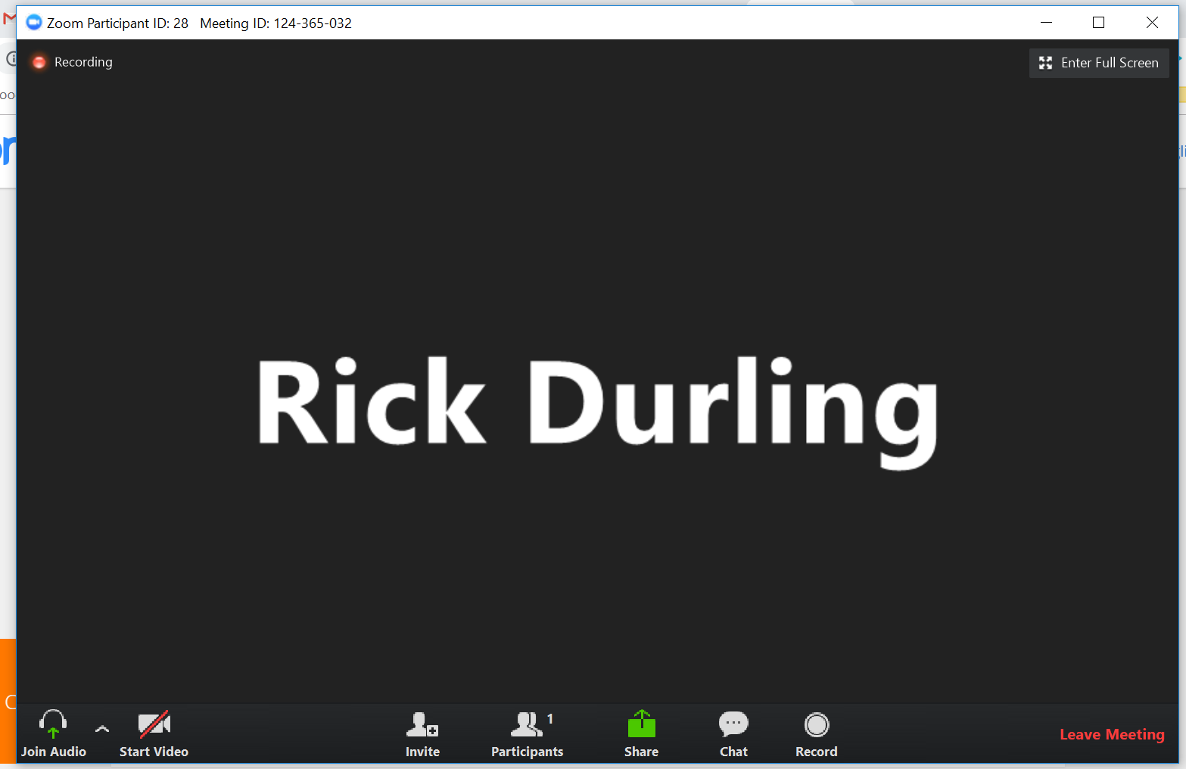

From here, the broadcast of the classroom will begin when it is time for class to start or within a few minutes.

**Attendance**

Attendance is mandatory. Absences will severely impact your ability to succeed in this difficult course. An absence is considered failure to attend class in person, or via ZOOM, or to view the recorded classroom activity within 24 hours of its posting.

[Office Hours](https://docs.google.com/spreadsheets/d/1G519fc4blqODJ1BFJWXdOSlsEUxv6SWQb0J5WqJ5Nq8/edit?usp=sharing)

I will be available to provide assistance with coursework or advising for your MA or CRS program progress during office hours. My office hours are posted on moodle and in the link above.

**Assessment**

*All Submissions for this course need a proper header. The header is specifically instructed in each assignment. But in general it looks like this:*

*Emily Student*

*November 6, 2019*

*CRS 110 CA1*

*(If a group submission the group members would be listed here)*

1. Competency Assessment: There are ten individual competencies scheduled for this course, one for each module (week). Individual competencies must be submitted on time to count for score. If not, they still need to be completed and submitted in order to pass the course. They are worth ten points each, or a total of 100 points. Most individual competencies are brief two-page research papers.
2. Group Projects: There are five group projects in this course. We will form groups of 3-5 students. You should have access to your group’s chat room on your moodle page. These chat rooms are private to each group and can only be accessed by group members. Each person is to submit their own copy of the completed group project, usually it will be some sort of written document or media content. Each group project is worth 10 points, or a total of 50 points.
3. Quizzes: There are nine quizzes for this course, one for each of the first nine weeks of the term. Quizzes must be taken individually, at one sitting, without help from another person. All materials, notes, or texts are free to be viewed while taking quizzes. Quizzes must be submitted prior to their due date in order to count for a grade. Quizzes cannot be retaken or taken late. Quizzes are worth 10 points each, or a total of 90 points.
4. Final Exam: There is one final exam for this course. It is focused on billing, payment, and posting. The final exam is worth 60 points.
5. There is a total of 300 points possible for this class. You will need 270 points to earn an A, 240 points to earn a B, 210 points to earn a C, and 180 points to earn a D. Below 180 points earns an F. For the CRS and MA programs you need to demonstrate competency of at least 70% in order to progress.

**Grading**

Individual Competencies: 10 for 100 points

Group Projects 5 for 50

Final exam: 1 for 60 points

Quizzes: 9 for 90 points

Total 25 graded items for 300 points

Additional Notes: All assignments are due by 0800 on the due date as shown in the [schedule of student responsibility](https://docs.google.com/spreadsheets/d/1qVNK1Nc81Kl0c-cMheSVJSNtLSIBMqn7rF3WAq0f1cI/edit?usp=sharing). No late assignments will be accepted. Per department policy, if you feel you have a valid reason to be allowed late submissions or taking a quiz late, you will need to get permission specifically from Kathy Durling, our department chairperson. Her email is [durlink@linnbenton.edu](mailto:durlink@linnbenton.edu). There are no native document submissions or uploading allowed in this course. Only google docs, sheets, or presentations will be used to submit assignments in this course.

**Course Academic Dishonesty Policy**

Any student caught cheating, duplicating another student’s work, or other form of academic dishonesty, will be counseled by the instructor. The first offense will result in a “zero” grade for that assignment/assessment, a lowering of the final course grade by one full grade, and the student’s name and offense may be sent to the Dean of Students for LBCC. A second offense will result in an automatic “fail” for the course and the student will be referred to the Dean of Students for LBCC to determine further disciplinary action and must have Dean of Student approval to return to class.

**LBCC Comprehensive Statement of Nondiscrimination**

LBCC prohibits unlawful discrimination based on race, color, religion, ethnicity, use of native language, national origin, sex, sexual orientation, marital status, disability, veteran status, age, or any other status protected under applicable federal, state, or local laws.(for further information <http://po.linnbenton.edu/BPsandARs/>

***For Students with Disabilities***

"The Office of Disability Services (ODS) provides reasonable accommodations, academic adjustments and auxiliary aids to ensure that qualified students with disabilities have access to classes, programs and events at Linn-Benton Community College. Students are responsible for requesting accommodations in a timely manner. To receive appropriate and timely accommodations from LBCC, please give the Office of Disability Services as much advance notice of your disability and specific needs as possible, as certain accommodations such as sign language interpreting take days to weeks to have in place. Contact the Disability Coordinator at Linn-Benton Community College, RCH-105, 6500 Pacific Blvd. SW, Albany, Oregon 97321, Phone (541)-917-4690 or via Oregon Telecommunications Relay TTD at 1-800-735-2900 or 1-800-735-1232."

This course is designed to meet the following standards of the AAMA, AAPC, LBCC Medical Assistant Program, and LBCC CRS Program:

|  |  |
| --- | --- |
| VII.A.2 | Display sensitivity when requesting payment for services rendered |
| VII.C.4.a | Describe types of adjustments made to patient accounts including: non-sufficient funds (NSF) check |
| VII.C.4.b | Describe types of adjustments made to patient accounts including:collection agency transaction |
| VII.C.4.c | Describe types of adjustments made to patient accounts including:credit balance |
| VII.C.4.d | Describe types of adjustments made to patient accounts including:third party |
| VII.C.5 | Identify types of information contained in the patient's billing record |
| VII.C.6 | Explain patient financial obligations for services rendered. |
| VII.P.1.a | Perform accounts receivable procedures to patient accounts including posting: charges |
| VII.P.1.b | Perform accounts receivable procedures to patient accounts including posting: payments |
| VII.P.1.c | Perform accounts receivable procedures to patient accounts including posting: adjustments |
| VIII.C.1.a | Identify: types of third party plans. |
| VIII.C.1.b | Identify: information required to file a third party claim |
| VIII.C.1.c | Identify: the steps for filing a third party claim |
| VIII.C.2 | Outline managed care requirements for patient referral |
| VIII.C.3.a | Describe processes for: verification of eligiblility for services |
| VIII.C.3.b | Describe processes for: precertification |
| VIII.C.3.c | Describe processes for: preauthorization |
| VIII.C.5 | Differentiate between fraud and abuse |
| VIII.P.1 | Interpret information on an insurance card |
| VIII.P.2 | Verify eligibility for services including documentation |
| VIII.P.3 | Obtain precertification or preauthorization including documentation |
| VIII.P.4 | Complete an insurance claim form |
| X.C.10.a | Identify:Health Information Technology for Economic and Clinical Health Act (HITECH) |
| X.C.3 | Describe components of the Health Information Portability and Accountability Act (HIPAA) |
| X.C.8.a | Describe the following types of insurance: liability |
| X.C.8.b | Describe the following types of insurance: professional (malpractice) |
| X.C.8.c | Describe the following types of insurance: personal injury |