MTH 98 Foundations for Contemporary Math
Term: Winter 2020 | CRN: 32611 | Class Code: 91
Instructor: Joseph Collins | Office: WOH - 103 | Office Hours: M 9-10
Email: collinj@linnbenton.edu

MTH 98 Foundations for contemporary Math Course Description:
Math 98 is designed to prepare students for success in Math 105. Students whose degree or program requires Math 75, Math 95 or Math 111 should not take Math 98. Throughout this course the student will develop critical thinking skills, gain number sense, build estimation skills and solve realistic problems. By focusing on relevance and context, the student will learn to think algebraically, will understand basic statistics and will use data and functions in mathematical modelling. Upon completion of the course, the student will be able to: Demonstrate knowledge of numerical skills in a variety of contexts based on the course objectives; Interpret and communicate statistical and mathematical concepts using a variety of graphical and computational methods; Apply algebraic skills and reasoning to solve problems based on the course objectives; and Identify properties of a function and create mathematical models.

Class Meetings:
Our class meets Monday through Friday from 8am – 9am in WH – 208.

Materials Needed:
- MTH98 Materials Packet from the bookstore. (Or you can choose to print the pages yourself.)
- A device to access the Internet, this can be a tablet, laptop or phone. There are laptops available to check out in the Library for class.
- A 3-ring binder, about 1.5 inches thick; all of your work will be organized and checked in this binder.
- A calculator; you can use the one on your device if you don’t have one.
- Other: At least two different colored pens, a ruler or straightedge (6 inch is fine), sticky notes, index cards.

Grading Policies:
Category | Percent of Grade | Grading Scale
Notebooks (3 per term) | 15% | A: 90 -100%
Online Homework (3 per week) | 15% | B: 80 – 89%
Online Reflections (1 per week) | 10% | C: 70 - 79%
Big Ideas (3 per term) | 15% | D: 60 - 69%
Test 1 (Week 3) | 15% | F: 0 - 59%
Test 2 (Week 7) | 15%
Test 3 (Week 10) | 15%

Students may view their grades on MyOpenmath

A grade of Incomplete may be assigned at the discretion of the instructor under special circumstances. The student must have completed the majority of the course, been in regular attendance and passing the course prior to the “special circumstance”.

Some grading details
Notebooks: Notebooks will be “graded” on the day of each test. Notebooks earning an A grade will be: In a 3-ring binder, organized, completed and corrected
Online Homework: Every couple days, you will have homework problems due through our online platform MyOpenMath. This gives you a chance to immediately reflect on your learning and understanding.
Online Reflections: Research indicates that one of the best things you can do to increase your learning is to write about it.
Big Idea Projects and Summaries: Each assignment will have a description and a grading rubric. This helps you identify your goal for the grade you want to earn.
Tests: For each test there will be an open note, team portion and a closed note, individual portion.

This feels different from other math classes...
This course is taught through group work using group activities. This is likely different than any other class you’ve taken, and you may not know what behaviors are most effective and appropriate. Read the list below carefully and revisit it often during the term. Practice the Effective and Appropriate Behaviors to get the most out of this class.

Attendance Policy
If you miss five hours of class (10% of the class) you will get a warning. If you miss 10 hours of class (20% of the class) your final course grade will drop one letter grade. Essentially, there are five letter grades, and if you miss 1/5th of the class, you will not be eligible for the top letter grade.

Late Work
If you are going to be absent, please let me know ahead of time.

Notes online
I will be posting notes of any mini-lectures on to MyOpenMath for any of you to view at any time.

Help
If you have questions, PLEASE come see me and ask! I have scheduled office hours but you’re welcome to come in at other times too. Study groups are encouraged! Many students find that working with classmates is the best way to learn and understand the material.

Use the Learning Center /Math Café
The Learning Center, WH226, is an excellent place to study and to get help with
your homework. (Please remember to log on and log off the computer with each visit to the Learning Center.) The other LBCC campuses have similar facilities with Math Help available. The Albany Campus has The Math Café in WH-227, which is connected to the Learning Center.
- There is free wireless available in the Math Café and Learning Center (with lots of places to plug in so your battery won’t be depleted.)
- The relaxed atmosphere and table arrangement in the Math Café and Learning Center provide great locations for study groups to meet and work.
- Instructional assistants are available in the Math Café to answer your math, ALEKS and study skills questions for Math 50, 75, 95 and 98.
- The Learning Center offers some free individual and small group tutoring in addition to the help desk.

Computers
Computer labs are open to students in the Library and in the Learning Center. Laptops are usually available for short-term check out from the Library. Laptops are also available for use in the Math Cafe.

What does a typical week include?
During class, we will switch learning modes – sometimes you’ll work with your group, sometimes I’ll ask for a class discussion, and sometimes I will write notes and examples on the board. I will tell you when we are switching learning modes.
If we don’t finish a handout, that is your paper homework. You should finish it by the next class. It will be checked as part of your notebook.
On Sunday, Tuesday, and Thursday, at 11:59pm, an online homework assignment is due.
Also on Tuesday by 11:59pm, your reflections from the previous week will be due.

Effective and Appropriate Behaviors:
- Trying problems on your own before discussing them with your group.
- Giving everyone a chance to try and discuss a problem
- Checking your work through multiple approaches – usually a group will come up with more than one way to do a problem; this helps you check your work and feel confident.
- Do your homework all the way through without checking the answer key AND attempt every problem, even if all you do is write down what you know about the problem. See inappropriate behaviors for the reason why.
- When you do corrections, make sure you figure out where you went wrong with your solution – writing the correct answer will not help you learn, but finding your mistakes and correcting them will. See inappropriate behaviors for more information.

Ineffective and Inappropriate Behaviors:
- Asking a group member to tell you how to do a problem – Instead ask “what is this question asking for?”, “can you tell me the meaning of this word?”, “What does this question relate to that we’ve already done?”
- Copying work from a group member – it might be tempting if you miss a class or get behind, but this is not helpful for learning the material – instead you might ask “What problems did you feel like you got the most out of?”, “What was the most challenging, and why?”, “Can you summarize the work our group did?” Copying from the answer key BEFORE trying the problem yourself – while some students worry about practicing a problem incorrectly, letting yourself try a problem

LBCC Email:
You are responsible for all communications sent to your LBCC email account. You are required to use your LBCC provided email account for all email communications at the College. You may access your LBCC student email account through Student Email.

Academic Honesty:
I assume that you are ethical and honest. However, if there is an incident of academic dishonesty (cheating), you will receive a score of zero for that test/assignment and the incident will be reported to the college administration for possible further disciplinary action. If there is a second offense, you will receive a grade of F for the course and the incident will be reported to the college administration with a recommendation for disciplinary action.

Special Circumstances:

Students who may need accommodations due to documented disabilities, who have medical information which the instructor should know, or who need special arrangements in an emergency should speak with their instructor during the first week of class. If you believe you may need accommodations but are not yet registered with the Center for Accessibility Resources (CFAR), please visit the CFAR Website for steps on how to apply for services or call 541-917-4789.

LBCC Comprehensive Statement of Nondiscrimination:
LBCC prohibits unlawful discrimination based on race, color, religion, ethnicity, use of native language, national origin, sex, sexual orientation, gender, gender identity, marital status, disability, veteran status, age, or any other status protected under applicable federal, state, or local laws. For further information see Board Policy P1015 in our Board Policies and Administrative Rules. Title II, IX, & Section 504: Scott Rolen, CC-108, 541-917-4425; Lynne Cox, T-107B, 541-917-4806, LBCC, Albany, Oregon. To report: linnbenton-advocate.symplicity.com/public_report

The instructor reserves the right to make changes to the syllabus/calendar at any time.

Joseph Collins WOH-103

Winter 2020 collinj@linnbenton.edu

 | Monday | Tuesday | Wednesday | Thursday | Friday
8am-9am | MTH 98  WH - 208 | MTH 98  WH - 208 | MTH 98  WH - 208 | MTH 98  WH - 208 | MTH 98  WH - 208
9am-10am | Office Hour | Math Café - WH |  | Math Café - WH
10am-11am | Math Help Desk - WH | Math Café - WH | Math Café - WH | Math Café - WH | Math Café - WH
11am-12pm | Math Help Desk - WH | Math Café - WH | Math Help Desk - WH | Math Café - WH | Math Help Desk - WH
12pm-1pm |  |  |  |  | Math Help Desk - WH
1pm-2pm | MTH 95  LC - 200 | MTH 95  LC - 200 | MTH 95  LC - 200 | MTH 95  LC - 200
2pm-3pm | Lebanon  LC - 202 | Lebanon  LC - 202 | Lebanon  LC - 202 | Lebanon  LC - 202 | Math Café - WH

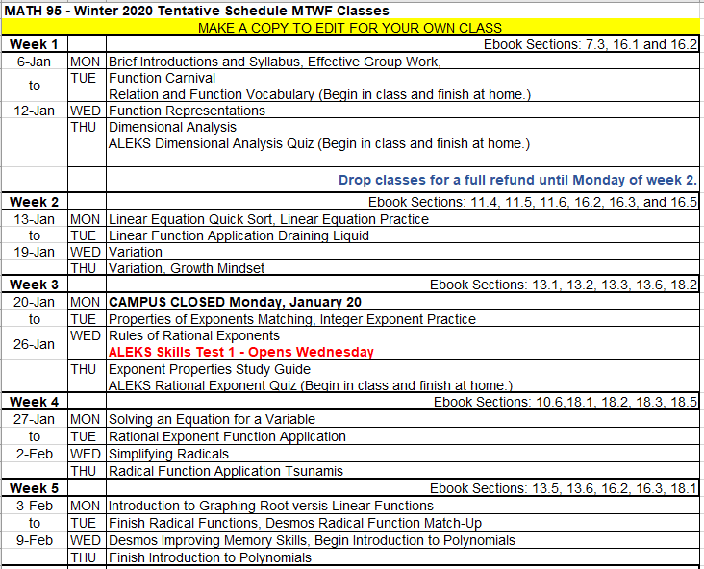
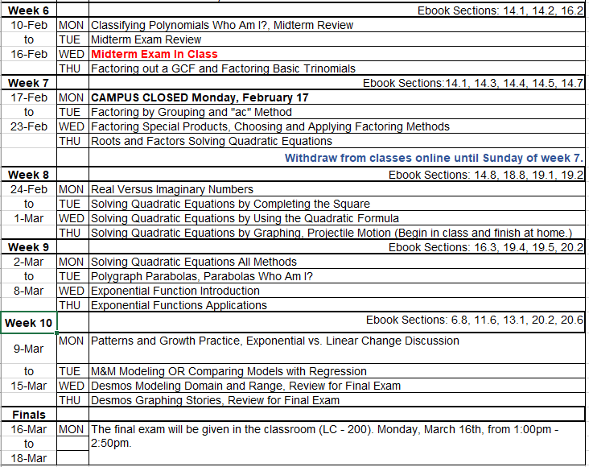

Enrolling in the Class Software: MyOpenMath
1 Go to www.myopenmath.com
2 Click on “Register as a New Student”
3 Enter a user name, I recommend using your student ID number
4 Choose and confirm a password, one you will not forget
5 Enter your first and last names, and your email address
6 Enter the Course ID: 58500
7 Enter the Enrollment Key: MTH98

