Art 254

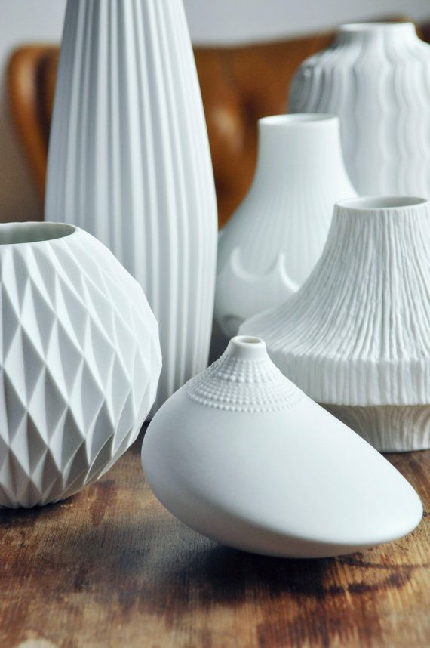
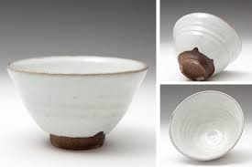
Ceramics II

Winter 2023

CRN 33576 M/W 1:00-3:50

Linn-Benton Community College
Professor: Renee Lynn McKitterick
Email:mckittr@linnbenton.edu
Office: BC 140

Art 254

Ceramics II
Winter 2023
Class Times:
CRN 33576 M/W 1:00-3:50

Professor: Renee Lynn McKitterick
E-mail: mckittr@linnbenton.edu
Phone: 541-757-8944 X5106
Office: BC 140
Office Hours: M/W 12-1 & by appt.

Course Objectives
To continue the exploration of clay as a material for aesthetic possibilities and expression. Students will continue to engage in the medium through a project based approach that combines technical competency and conceptual elements. The process of clay will be investigated with the introduction of slips and underglazes as well as soda firing. Students will continue to engage in self and group critique as well as safe studio practices.

Learning Outcomes
Upon successful completion of this course, students will be able to:
- Illustrate an understanding of the relationship between form, concept and function in the ceramic arts.
- Verbally, visually, and in writing demonstrate competency in concept and design
- Demonstrate skills in self and group directed problem analysis, problem solving, and critical/creative thinking.
- Study historical and contemporary ceramic sources, ideas, and materials

Credits: 4 Credits

Prerequisites
Art 154

Course Supplies:
- Clay : Students will be required to purchase clay that is offered through the LBCC bookstore website. Show an e-receipt to an IA and we will give you your clay right here in the studio. Only clay purchased from the bookstore can be used; no outside clay is allowed.
- Tool kit: A ceramics II tool kit can also be purchased through the bookstore website
- Sketchbook: Because you need a place to put all your great ideas

Assignments | Points
Project 1 (Super-real) | 50
Project 2 (Coil Pot) | 50
Project 3 (Throwing) | 50
Tea Bowls | 50
Attendance | 50
Total Points** | 250
**Subject to Change

Grading Scale
A 90-100%
B 80-89%
C 70-79%
D 60-69%
F 59% or below

Class Structure
Class sessions will be a mix of lecture, discussion, demonstration, and work time.

What do I need to do to be successful in this class?

❖ Attend class.
❖ Check your LBCC email. Check it frequently (preferably daily), or have your
LBCC email forwarded to your preferred account.
❖ Communicate regularly. Communicate with the instructor as needed, in class or by email. I check email most weekdays and occasionally on weekends.
Please head your emails with the course number & your section days/time (e.g. ART
102 MW 1:30-3:00), and sign your email with your first and last names. This will get you
the fastest and most accurate response.
❖ When in class, focus on class. Class time is valuable. You should be focused on class while you are in the room; if you can’t focus, leave the room.. Keep in mind that your actions impact the class. One student’s lack of focus can distract others. If you find you have personal business to attend to (e.g. phone calls/texting, conversations, or other class work), take care of it outside of the studio. I expect you to apply yourself to your education during class hours. You are the person who has the greatest impact on your learning and your grade.
❖ Actively participate. You will NOT be successful in this class if you show up but
then ‘tune out.’ Students who do not participate on a regular basis are unlikely to earn a
passing grade.
❖ Be positive and have fun! This course is about stretching our thinking and
learning together. This can be exhausting and challenging, but also fun!
❖ Be open to the process of making art. You will have “failures” in this class. That is okay! As we move through this class try to expand your ideas, your skills, and your work. It’s difficult to do something we have never done before and “failure” is inevitable (at least if you are doing it right). Let’s all be part of this together and in a positive way.
❖ Be accountable. You are the person who has the greatest impact on your
learning and your grade.

Course Policies

Institutional Drop for Non-Attendance
Faculty at LBCC may administratively withdraw a student for nonattendance during the first week of the term.
Moodle
This course uses Moodle for attendance and posting grades. I will give grades back in class and also post them on moodle. No other class information will be on this platform.

Resources
Moodle Support: If you have questions about Moodle or need technical support, contact:
- Student Help Desk (in the Library): Visit, call (541)917-4630, or email student.helpdesk@linnbenton.edu
- LBCC Moodle User Support Forum: Look up answers or post questions: http://elearning.linnbenton.edu/mod/forum/view.php?id=2697

Important Academic Calendar Dates:
● Last day to add/drop: Monday, January 17th
● Last day to withdraw: February 26th

Attendance Policy
Students enrolled in this class are expected to attend all class sessions.
The course spans only 10 weeks plus finals. It is vital to attend every class session and arrive on time.
Please do not come late to class. It is disruptive, and you risk missing important announcements, demonstrations, and assignments.​

Attendance is taken each class session. Students are marked “Present,” “Absent,” “Late,” or “Excused” for each session.
-Present​: Student arrives on time and stays the entire class session.
-Absent​: Student does not attend a class session, or leaves early without prior approval from the instructor. Unexcused absences negatively impact your course grade.
-Late​: Student is 5 minutes late or more.
-Excused​: Student has arranged an excused absence ​ahead of time with the
Instructor. Excused absences are given at discretion of the Instructor, and will require documentation. Personal vacations and errands are not excused absences.

You will receive an automatic F in the course if you have 4 or more unexcused absences. At this point, work cannot be made-up and you will not be able to pass the course.

Please note: This term looks different for all of us. We are continuously trying to navigate our ever changing environment and I will be flexible and generous when need be. If you are sick or have been exposed to the COVID-19 virus, do NOT come to class. Covid related absences will be excused. We all need to work together to keep ourselves and everyone using our studio safe. Please be a positive part of that. We are also experiencing high levels of influenza and RSV transmission in our community. Please take extra precautions and be sure to NOT come to class if you are sick.

Accessibility Statement:
LBCC is committed to inclusiveness and equal access to higher education. If you have approved accommodations through the Center for Accessibility Resources (CFAR) and would like to use your accommodations in the class, please talk to your instructor as soon as possible to discuss your needs. If you believe you may need accommodations but are not yet registered with CFAR, please visit the CFAR Website for steps on how to apply for services or call (541) 917-4789.

Incomplete Grade Policy
Incompletes are given only in extraordinary and documented circumstances (i.e., a family emergency or serious medical excuse), and at the discretion of the Instructor. You must have regular attendance and completed most assignments for the class. If an Incomplete is granted, the Instructor will provide instructions as well as a nonnegotiable completion deadline for turning in all missing work. If the incomplete work is not turned in on time or is deemed unsatisfactory, the Incomplete will revert to an F-grade.

Academic Honesty
Academic honesty is an indispensable value as students acquire knowledge and develop skills in college. Students are expected to practice academic honesty by not cheating, plagiarizing, or misrepresenting their coursework in any way. Plagiarism, collusion, and other forms of misrepresentation hurt the student and run counter to the goals of education. Students are ultimately responsible for understanding and avoiding academic dishonesty, whether such incidences are intentional or unintentional. Violations will result in failure of an assignment, and possibly the course. All incidents of academic dishonesty will be reported to both the Associate Dean of Student Development and the Dean of Arts, Social Science & Humanities.

Art Research Resources
Google Arts & Culture: https://www.google.com/culturalinstitute/beta/

LBCC Library Art History page: http://library.linnbenton.edu/art.
We will use the Artstor digital image database for research (available through library page above). Please register an account to access all of Artstor’s features.

