Homework 1
Please type or (legibly) write your answers on separate page

Lockout/Tagout (LOTO)
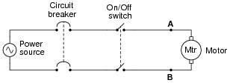
- In this motor control circuit, how would you ensure that there is no danger of electric shock prior to touching either of the motor terminals (shown as points A and B in the schematic diagram)? Describe both the action required to secure the power, and the means by which you would check for the presence of hazardous voltage at the motor:
Answer: Follow these steps:
  - Open the circuit breaker.
  - Lock the circuit breaker in its “open” position so no one can close it.
  - Try to start the motor by turning the On/Off switch “on”.
  - Leave the On/Off switch in the “off” position.
  - Test for hazardous voltage (both AC and DC) between A and B, between A and ground, and between B and ground.

Notes:
Why is it important we do each one of those steps, in the order shown? How many voltage checks must we do with the voltmeter, total?

Also, be sure to ask your students how they would know whether or not their voltmeter was functioning properly prior to using it to check for the presence of hazardous voltage. What types of faults in the meter could cause it to not indicate voltage when there really was voltage?

- When using a padlock to secure a disconnect device in the “open” (off) state, who should be able to open that lock? In other words, how many other people should share a key to the lock you use to secure a breaker or switch in the safe position, if you are the one working on the system?
Answer: You and you alone should be able to open that lock. It needs to be a personal lock, not a lock whose key is shared by other people.

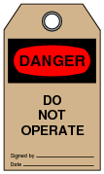
- When securing equipment for safe maintenance, special tags are attached with the lock(s) used to keep circuit breakers and other disconnect devices in the open (off) state. What is the purpose of attaching such a tag to an electrical disconnect device in addition to locking it in the open position? Why is a lock, by itself, not sufficient from a safety perspective?
Answer: A tag informs anyone wishing to turn the disconnect device “on” as to when it was turned off, and who placed the lock(s) on it. Many lockout tags have space on for a written description so that the reason for the lockout may be explained.

- Suppose you are finishing a maintenance project where an electric motor was locked out and tagged, and now the work is complete. Your lock is the last one to be removed from the circuit breaker, everyone else already having taken their locks and tags off. What should you do before removing your lock and turning the circuit breaker back on?
Answer: You should check the equipment site to be sure no one is still working on it, unaware of the impending startup.
Notes:
Real-life story here: I was once asked to place an electric motor back in service after it had been locked out for a few days, for routine maintenance. I removed my lock and tag and was just about to turn the breaker back on, when better judgment prevailed and I decided to first check the job site. Lo and behold, there, still working on the motor coupling, were two contract employees completely oblivious to the situation. They had not been told there was a circuit breaker to secure power to that electric motor, nor were they aware that they needed to lock it out in addition to everyone else on the project! Had I turned that circuit breaker back on, the motor could have started up and severely injured at least one of them!

Lesson to be learned: if you are performing work on a piece of equipment, you need to have your lock and your tag securing energy to that equipment. Never, ever trust someone else to lock-out and tag-out a circuit breaker for you!

Ohm’s Law
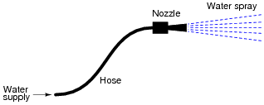
- For a given amount of water pressure, which will flow a greater rate of water: a small (restrictive) nozzle or a large (unrestrictive) nozzle? Explain how this relates to the study of voltage, current, and resistance in a simple electric circuit.
Obviously, an unrestrictive nozzle will pass a greater flow rate of water through it, all other factors being equal. In an electric circuit, less resistance will pass a greater flow rate of electrons (current) for a given amount of “pressure” (voltage).
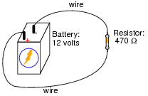
- Explain, step by step, how to calculate the amount of current (I) that will go through the resistor in this circuit. Give you answer in both amps and milliamps.
Answer: Resistor current = 0.02553 amps, or 25.53 milliamps (mA).

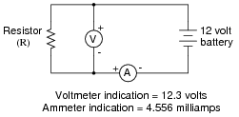
- What is the value of this resistor, in ohms (Ω) and kiloohms?
Answer: Resistor value = 2700 Ω, or 2.7 kΩ.

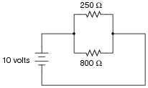
- A common saying about electricity is that ït always takes the path of least resistance.” Explain how this proverb relates to the following circuit, where electric current from the battery encounters two alternate paths, one being less resistive than the other:
Answer: The 250 Ω resistor will experience a current of 40 mA, while the 800 Ω resistor will experience a current of 12.5 mA.

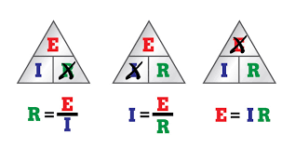
- One of the fundamental equations used in electricity and electronics is Ohm’s Law: the relationship between voltage (E or V, measured in units of volts), current (I, measured in units of amperes), and resistance (R, measured in units of ohms):
Solve for the unknown quantity (E, I, or R) given the other two. Don’t forget to label your answers!

  - I = 20 mA R = 5 kΩ E =
  - I = 150 μA R = 47 kΩ E =
  - E = 24 V R = 3.3 MΩ I =
  - E = 7.2 kV R = 900 Ω I =
  - E = 1.02 mV I = 40 μA R =
  - E = 3.5 GV I = 0.76 kA R =
  - I = 0.00035 A R = 5350 Ω E =
  - I = 1,710,000 A R = 0.002 Ω E =
  - E = 477 V R = 0.00500 Ω I =
  - E = 0.02 V R = 992,000 Ω I =
  - E = 150,000 V I = 233 A R =
  - E = 0.0000084V I = 0.011 A R =
  - I = 45 mA R = 3.0 kΩ E =
  - I = 10 kA R = 0.5 mΩ E =
  - E = 45 V R = 4.7 kΩ I =
  - E = 13.8 kV R = 8.1 kΩ I =
Write your answers for the following in scientific notation
  - E = 500 μV I = 36 nA R =
  - E = 14 V I = 110 A R =
  - I = 0.001 A R = 922 Ω E =
  - I = 825 A R = 15.0 mΩ E =
  - E = 1.2 kV R = 30 MΩ I =
  - E = 750 mV R = 86 Ω I =
  - E = 30.0 V I = 0.0025 A R =
  - E = 0.00071 V I = 3389 A R =
Answer:
- E = 100 V
- E = 7.1 V
- I = 7.3 μA
- I = 8.0 A
- R = 26 Ω
- R = 4.6 MΩ
- E = 1.9 V
- E = 3.42 kV
- I = 95.4 kA
- I = 20 nA
- R = 640 Ω
- R = 760 μΩ
- E = 140 V
- E = 5 V
- I = 9.6 mA
- I = 1.7 A
- R = 14 kΩ = 1.4 ×10⁴ Ω
- R = 130 mΩ = 1.3 ×10⁻¹ Ω
- E = 900 mV = 9 ×10⁻¹ V
- E = 12.4 V = 1.24 ×10¹ V
- I = 40 μA = 4 ×10⁻⁵ A
- I = 8.7 mA = 8.7 ×10⁻³ A
- R = 12 kΩ = 1.2 ×10⁴ Ω
- R = 210 nΩ = 2.1 ×10⁻⁷ Ω

- Suppose an electric current of 1.5 microamps (1.5 μA) were to go through a resistance of 2.3 mega-ohms (2.3 MΩ). How much voltage would be “dropped” across this resistance? Show your work in calculating the answer.
Answer: 1.5 ×10−6 amps of current through a resistance of 2.3 ×106 Ω will produce a voltage “drop” equal to 3.45 volts. It is important for students to understand that metric prefixes are nothing more than “shorthand” forms of scientific notation, with each prefix corresponding to a specific power-of-ten.

Electric Shock
- Why is this sign a joke?
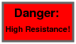

Answer: Electrical resistance is not hazardous in the least. In fact, the more resistance there is, the less chance there is for electrons to flow, thus minimizing shock hazard.

- In the late 1700’s, an Italian professor of anatomy, Luigi Galvani, discovered that the leg muscles of a recently deceased frog could be made to twitch when subjected to an electric current. What phenomenon is suggested by Galvani’s discovery? In other words, what does this tell us about the operation of muscle fibers in living creatures? More importantly, what practical importance does this have for people working near electric circuits?
Answer: Essentially, muscle fibers are “activated” by electrical signals. I’ll let you figure out what practical importance this effect has for you!

- An American researcher named Charles Dalziel performed experiments with both human and animal subjects to determine the effects of electric currents on the body. A table showing his research data is presented here:

Bodily Effect | Gender | Direct Current | 60 Hz AC | 10 kHz AC
Slight sensation at point(s) of contact | Men | 1.0 mA | 0.4 mA | 7 mA
Slight sensation at point(s) of contact | Women | 0.6 mA | 0.3 mA | 5 mA
Threshold of bodily perception | Men | 5.2 mA | 1.1 mA | 12 mA
Threshold of bodily perception | Women | 3.5 mA | 0.7 mA | 8 mA
Pain, with voluntary muscle control maintained | Men | 62 mA | 9 mA | 55 mA
Pain, with voluntary muscle control maintained | Women | 41 mA | 6 mA | 37 mA
Pain, with loss of voluntary muscle control | Men | 76 mA | 16 mA | 75 mA
Pain, with loss of voluntary muscle control | Women | 51 mA | 10.5 mA | 50 mA
Severe pain, difficulty breathing | Men | 90 mA | 23 mA | 94 mA
Severe pain, difficulty breathing | Women | 60 mA | 15 mA | 63 mA
Possible heart fibrillation after three seconds | Men | 500 mA | 100 mA | ---
Possible heart fibrillation after three seconds | Women | 500 mA | 100 mA | ---

Important Note: Dalziel’s human test subjects were men and women in good health, with no known heart conditions or any other abnormalities that would have compromised their safety. In other words, these data points represent best-case scenarios, and do not necessarily reflect the risk to persons in poorer states of health.

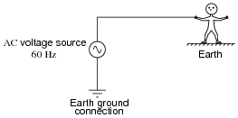
Assuming a skin contact resistance of 600 Ω for a sweaty hand, 1000 Ω of resistance for foot-to-ground contact, 50 Ω internal body resistance, 70 Ω of resistance through the soil from the person’s location to the earth ground point, and a male victim, calculate the amount of voltage necessary to achieve each of the listed shock conditions (threshold of perception, pain, etc.) for this circuit.

Now, assume the man has put on leather gloves with a resistance of 1 MΩ. Recalculate your values using the new resistance through the hands, with everything else staying constant.

Answer:
• Slight sensation at point(s) of contact: 0.69 volts
• Threshold of bodily perception: 1.9 volts
• Pain, with voluntary muscle control maintained: 15.5 volts
• Pain, with loss of voluntary muscle control: 27.5 volts
• Severe pain and difficulty breathing: 39.6 volts
• Possible heart fibrillation after three seconds: 172 volts

- What can electric current do to motor muscles (fingers, arms, legs)?
Answer: It may cause them to involuntarily contract.
- What can electric current do to heart and lungs?
Answer: Paralyze them.
- Why should you use one hand while working on live power circuits?
Answer: To minimize the danger of an across-the-chest path for electric current.
- Why is water dangerous when working around electric power?
Answer: It lowers the resistance of porous substances, including human skin.
- Why is metal jewelry dangerous to wear when working on electric circuits?
Answer: Because the metal pieces optimize contact between your skin and an exposed power conductor, or between two power conductors.

Simple Circuits
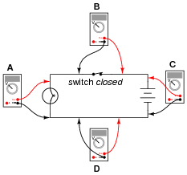
- Determine what these four voltmeters (A, B, C, D) will register when connected to this circuit in the following positions (assume a battery voltage of 6 volts).
A: _________________
B: _________________
C: _________________
D: _________________
Answer:
• Voltmeter A = 6 volts
• Voltmeter B = 0 volts
• Voltmeter C = 6 volts
• Voltmeter D = 0 volts
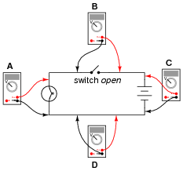
- Determine what these four voltmeters (A, B, C, D) will register when connected to this circuit in the following positions (assume a battery voltage of 6 volts).
A: _________________

B: _________________

C: _________________

D: _________________

Answer:
• Voltmeter A = 0 volts
• Voltmeter B = 6 volts
• Voltmeter C = 6 volts
• Voltmeter D = 0 volts
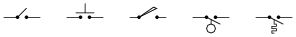
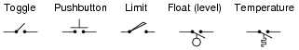
- Identify the following types of switches, according to their style of actuation (how each switch is physically operated).
____________ ____________ ____________ ____________ ___________
Answer:
- What positions do the switches have to be in for the light bulb to receive power?
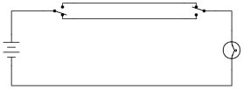
Answer: For the light bulb to be energized, both switches must either be in the “up” position, or in the “down” position.
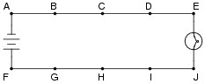
- In this circuit, where would you expect to measure full battery voltage (between what pairs of test points)?

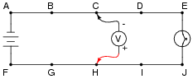
- Suppose this battery and light bulb circuit failed to work. Using a voltmeter, you measure full battery voltage between the points C and H. What does this single measurement indicate about the condition of the circuit? Be as specific as you can.
Based on this one measurement, we are able to determine that the battery is outputting full voltage, and that the circuit wiring is continuous from the negative battery terminal to point C, and from the positive battery terminal to point H. The fault is an “open” somewhere to the right of points C and H - possibly more than one.

Notes:
Some measurements given definite answers, while others only indefinite answers. In this particular question, the single voltage measurement tells us definite things about the left-hand side of the circuit, but little about the right-hand side. It is very important for students to develop the logical skill of distinguishing necessary conclusions from possible conclusions in troubleshooting scenarios. A skill like this takes time and practice to develop, so be sure to spend adequate time throughout the course with your students honing it!

- Suppose this battery and light bulb circuit failed to work. Using nothing but a voltmeter, you measure voltage between the following sets of points:
• Between A and C: 0 volts
• Between D and G: 12 volts
• Between E and J: 0 volts
• Between B and E: 12 volts
From these voltage measurements, what can you tell about the condition of the battery, wiring, and light bulb? Be as specific as you can.
Answer: Based on these measurements, we are able to determine that the battery’s voltage is 12 volts, that the light bulb has good continuity, and that there is a single break in the circuit between points D and E.

Voltage, Current, and Resistance
- Explain what the electrical terms voltage, current, and resistance mean, using your own words.
Answer:
Voltage: electrical “pressure” between two different points or locations.
Current: the flow of electrons.
Resistance: opposition, or “friction,” to the flow of electrons.

- Voltage is also known by another name: electromotive force, or EMF. Explain what this other name for voltage means.
Answer: Electromotive force literally means, “a force that motivates electrons.”

- What is the difference between DC and AC electricity?
Answer: DC is an acronym meaning Direct Current: that is, electrical current that moves in one direction only. AC is an acronym meaning Alternating Current: that is, electrical current that periodically reverses direction (“alternates”). It is important to realize that “DC” and “AC” may also be used to represent voltage as well as current. That is, it is possible to have a voltage that alternates back and forth in polarity (“AC” voltage) just as it is possible to have a current that alternates back and forth in direction of motion.

This worksheet and all related files are licensed under the Creative Commons Attribution License, version 1.0. The terms and conditions of this license allow for free copying, distribution, and/or modification of all licensed works by the general public. Source: allaboutcircuilts.com

