**BA 249: RETAIL MANAGEMENT (CRN 32872)**

**Three Credits / Meets M/W 1:00 p.m. to 2:20 p.m. / MKH 118**

**Linn-Benton Community College – Albany Campus - Winter 2020**

|  |  |
| --- | --- |
| **Albany Office:** MKH - 113  **Albany Phone:** 541-917-4291 | **Albany Office Hours:**  2:20pm-3:00pm/3:30pm-4:00pm |
| **Corvallis Office:** MKH - 112  **Corvallis Phone:** None | **Corvallis Office Hours:**  T/R: 11:00 a.m. – 12:00 p.m. |
| **Instructor: Mindy Bean** | **Email:** beanm@linnbenton.edu |
|  | |

**REQUIRED STUDENT RESOURCES (Course Resources Cost Total: $52.00)**

**ONLINE BOOK- OPEN EDUCATION RESOURCES**

$25 ($34.72) Purchase for Lumen Learning Retail Management Online Book. This is accessed through Moodle, and you will not be able to take the quizzes after Week 1 if you do not purchase the code. Students who would prefer loose leaf copies of Case Study & Simulation Manuals can get it printed at Campus Printing Center for around ~$31.00. Other course content is available on our Moodle page and Simulation Website. We will access many class materials from internet sources including extensive Google searches. Students will also collect their own online resource materials to share with the class.

**INTERPRETIVE SIMULATIONS**

$26.95 ($37.43 in LBCC Bookstore) Purchase for the Interpretive Simulations-ENTREPRENEUR, you will have until Week 1 to purchase this. Can be purchased through the log in website: <https://www.interpretive.com/>

**EXCEL ASSIGNMENTS-USING EXCEL**

FREE- Using Excel is a core element in management and is commonly used in most industries today. The Excel tutorial integrated into this course was selected from numerous tutorials for its clarity, quality, ease of use, and accessibility. The Goodwill Community Foundation (GCF) developed their Excel tutorial (as well as several others) and has made them publicly available for no charge. Anyone can access and view GCF tutorials at any time with no prior account established or registration necessary. <http://www.gcflearnfree.org/>

For free Office 2019 downloads, visit:<http://library.linnbenton.edu/office365> and click link/follow instructions

-An orientation of this element will be provided during the first day of class. You must have a version of Excel to use. Also check on the LBCC campus for available free versions of Microsoft Office 365.

**NOTE: Excel is not taught in this course. It is your responsibility to access tutorials and other available resources to develop your project accordingly.**

**ADOBE ACROBAT READER DC**

To do assignments, you will need to have Adobe Acrobat Reader DC installed to fill out PDFs, save, and upload to Moodle. You can download for free here: <https://acrobat.adobe.com/us/en/acrobat/pdf-reader.html>

**COURSE DESCRIPTION**

Introduces students to retailing and provides an understanding of the types of businesses, strategies, operations, formats and environments through which retailing is carried out. The course takes a multi-disciplinary approach to consider the process and structure of retailing. Retailing topics to be covered will include: planning, research, consumers' behavior, store design, merchandising strategy, management strategy, promotional strategy and pricing strategy. The global dimensions of retailing as well as the relationship between retailing and our society will be stressed throughout the course.

**COURSE OBJECTIVES**

Upon successful completion of this course, students will be able to:

* Describe effective retailing practices in small, medium, and large size retail businesses.
* Identify and evaluate retail merchandising and pricing strategies.
* Discuss marketing communication strategy for retail customers.
* Discuss how technology has transformed the retail business model to an online environment from a solely bricks-and-mortar environment.

**PARTICIPATION**

**Commencing Monday 1/13/2020, a sixth absence shall result in an automatic course grade of “F” for material non-participation.**

**GRADING**

This class is graded “A” through “F”. Letter grades will be assigned according to the following table:

|  |  |
| --- | --- |
| A 100 – 90% | B 89 – 80% |
| C 79 – 70% | D 69 – 60% |
| F Below 60% | |

**Student Evaluation**

|  |  |  |
| --- | --- | --- |
| Item | % of  Final Grade | Notes |
| Lumen Quizzes | **15** | 1% x 15 each Chapter Quiz |
| Retail Simulation | **36** | 6% Simulation Practice  20% Retail Performance  10% Peer Evaluation |
| Simulation Quizzes | **16** | 6% for Case Quiz  10% Concepts Quiz |
| Presentation | **10** | 9% Presentation on Simulation |
| Excel Projects | **9** | 3% Budget  3% Employee Tracking  3% Scheduling |
| Assignments | **14** | 1% x 14 Assignments |
| Total | **100** |  |

**Note:** Punctual, regular attendance is an essential element of your success in BA 249. Attendance will be taken on a regular basis. Attendance is important because of the valuable management soft skills taught in class through classmate simulation. Every absence diminishes the quality of the lesson, and will also diminish the quality of your group’s simulation. Each student is expected to assume responsibility for his or her fair share of the simulation. Each student will complete an anonymous evaluation of his or her group peers’ contributions after the presentations and grade classmates on their presentations. Since your peer evaluations count for 4% of your final grade, regular attendance and contributions are an imperative element of your success. **Students who will not be able to successfully complete this course should withdraw prior to the end of the seventh (7th) week of the term to avoid receiving a failing grade.**

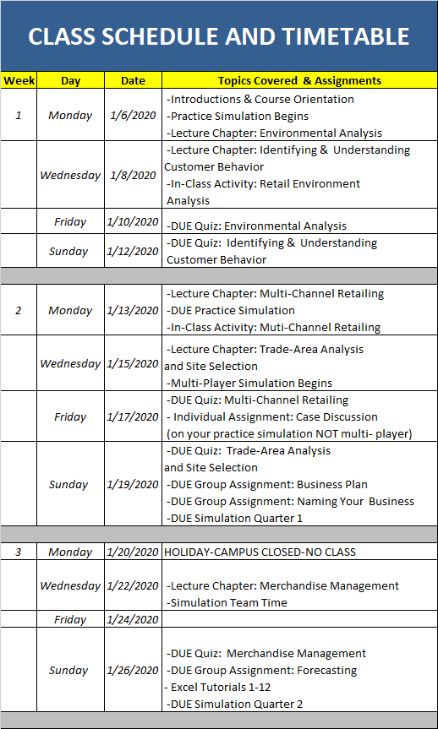

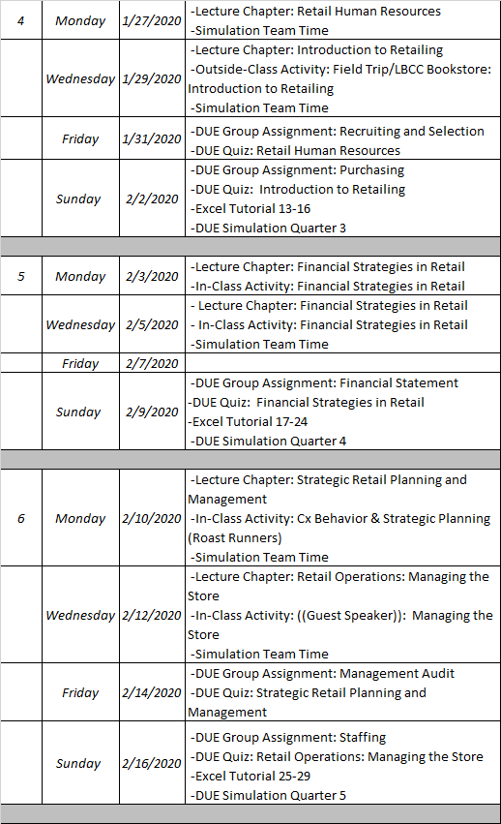

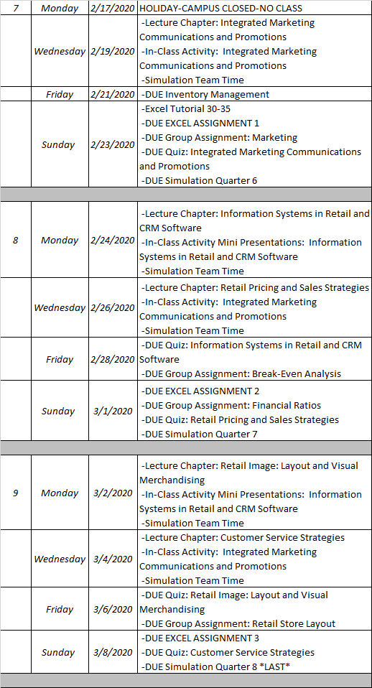

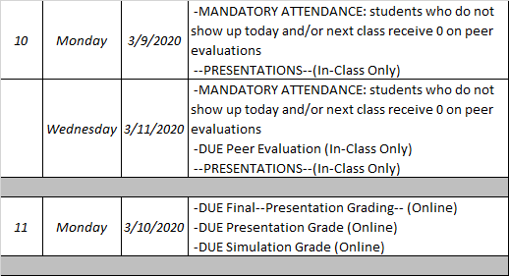

**PRESENTATION (5% Peer Assessment + 5% Class Grading = 10%)**

PRESENTATION 10%

In the first weeks of class, students will be put into partners based on the Simulation Practice and at the end of the simulation will work together to do a 5-10 minute PowerPoint presentations the highlights of their simulation plan objectives and how they chose to achieve those objectives, their business name and rationale of their selection, number of employees and their wage rates, their financial performance, including a discussion of important items on their company’s income statement and balance sheet, key successful factors in Entrepreneur Simulation, and important “takeaways” from the simulation experience. These days are MANDATORY ATTENDANCE, those who do not show will get an automatic 0% on their Peer Evaluation and on Instructor Grading Portion.

CLASS GRADING 5%

During the presentation, fellow classmates will score presenters on presentation with score sheets supplied to them. The average of scores will reflect upon the 5%.

INSTRUCTOR GRADING 5%

Presenters will be given a score card after the presentation ranking their partners on how well they worked together. The score will reflect on 5%. Not only will you be graded on covering the assignment points, you will be graded on your physical appearance and presentation skills.

**QUIZZES (15 x 1% ea. = 15%)**

There will be a quiz for each of the 15 Chapters. They are all open on the first day of classes. Each quiz will have multiple-choice and/or true-false questions. No Time limits, you are allowed two attempts on each quiz. You get two attempts on each quiz. *Quizzes are due on Fridays (if Chapter covered on Monday) and Sundays (if Chapter covered on Wednesday) at 11:55pm*

**RETAIL SIMULATION (36% = 6% Simulation Practice, 20% Competitive Score, 10% Peer Evaluation)**

*SIMULATION PRACTICE 6% x 1*

You will have Week 1 to practice the simulation, you have until **Monday, January 13th at 11:59pm** to do your best, from there you will be placed into teams from best to worst for the rest of the term.

*COMPETITIVE SIMULATION SCORE 20%*

After Week 1, you will be placed into teams on your Practice Simulation outcomes. You will be running your own retail store and competing against your classmates. Those who do the best to get the highest score, those who do not do well get the lowest score. Those who read and understand the manual usually always pass the simulation. Simulation Quarters are due every Sunday at 11:55pm

*PEER EVALUATION 10%*

At the end of the simulation, you and your partner(s) will give a presentation. Then you will rank each other on a scale of 0 - Worst to 10- Best. Instructors do not touch scores once they have been given by teammates. Those who fail to rank their teammates automatically receive a 0. This will be done on the last day of class.

**EXCEL ASSIGNMENTS (3 x 3% ea. = 9%)**

You will need to complete the excel tutorials to be able to complete each assignment. Excel tutorials should be complete in the first couple weeks of the course. All assignments are due at 11:55pm of the due date on the class schedule and timetable.

*BUDGET 3%*

As a manager you will need to keep things under budget, there will be an assignment that will give you step by step instructions on how to keep a budget.

*EMPLOYEE TRACKING 3%*

Managers sometimes are better holding employees accountable by having a tracking system so they know when discipline, promotion, or rewards are to be given. There will be an assignment to assist first time managers step by step on how to create a custom system.

*SCHEDULING BY GANTT CHART 3%*

All managers create efficiency and employee engagement through handling the schedule properly. A step-by-step guide will be handed out to help assist.

**SIMULATION QUIZZES (CASE QUIZ 6% AND CONCEPTS QUIZ 10%)**

*CASE QUIZ 6%*

The Case Quiz is based on the Case Study and will be due in the first two weeks of class.

*CONCEPTS QUIZ 10%*

The Concepts Quiz will be due later in the term, it will be a summary of apply the knowledge from your book, applying the incident experience, and knowledge of the case study in the simulation.

**SPECIAL ACCOMMODATIONS:**

You should meet with your instructor during the first week of class if:

1. You have a documented disability and need accommodations.
2. Your instructor needs to know medical information about you.
3. You need special arrangements in the event of an emergency.

If you have documented your disability, remember that you must make your request for accommodations through the Center for Accessibility Resources (CFAR) [Online Services webpage](https://cascade.accessiblelearning.com/LBCC/) every term in order to receive accommodations. If you believe you may need accommodations but are not yet registered with CFAR, please visit the [CFAR Website](http://www.linnbenton.edu/cfar) for steps on how to apply for services or call 541-917-4789.

**LBCC COMPREHENSIVE STATEMENT OF NONDISCRIMINATION**

LBCC prohibits unlawful discrimination based on race, color, religion, ethnicity, use of native language, national origin, sex, sexual orientation, gender, gender identity, marital status, disability, veteran status, age, or any other status protected under applicable federal, state, or local laws. For further information see Board Policy P1015 in our [Board Policies and Administrative Rules](http://linnbenton.edu/42145BA0-3DCC-11E3-AA36782BCB47BBE7). Title II, IX, & Section 504: Scott Rolen, CC-108, 541-917-4425; Lynne Cox, T-107B, 541-917-4806, LBCC, Albany, Oregon. To report: [linnbenton-advocate.symplicity.com/public report](http://linnbenton-advocate.symplicity.com/public_report).