Ph 299 – Topics in Modern Physics Spring 2019

The purpose of this class is to examine modern topics in physics. You can take this class for one, two, or three credits. If you take this class for more than one credit you will need to develop a project plan during the first week of classes.

Each week in this seminar class we will explore a current topic in physics. For each topic there will be discussion in class along with an in-class activity. Notes from class and from the in-class activities should be kept in the “Drop Box”. On the first day of class you register with your instructor the e-mail address with which you’d like to register with DropBox.

There will be an optional weekend field trip to LIGO and B Reactor in Eastern Washington. We will discuss this trip on the first day of class. Currently it looks like this is going to be a two-night field-trip. If you plan on going on this trip the cost be $60 (people not registered for Ph 299 must pay $120)–this will cover most food, housing and transportation – you will need to pay by cash or a check written out to “The LBCC Science Club” by Mon. of Week 2.

It is also strongly urged that you sign up to become a member of the Society of Physics Students. The cost for undergraduate membership is $20 per year and include the hardcopy subscription to “Physics Today”. You can sign up for this at: http://www.spsnational.org
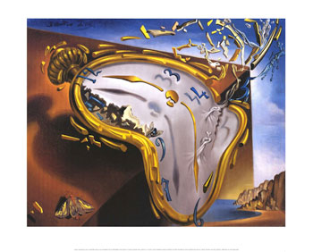
Tentative Schedule:
Week 1: Nuclear Decay and Particle Physics
Week 2: Time Dilation and Relativity
Week 3: The Photoelectric Effect and Quantum Mechanics
Week 4: Dark Matter
Week 5: Cosmology
Weekend of 12.-14.April.2019: Field Trip to LIGO/PNNL*/Hanford B. Security clearances are required for PNNL.

Grading:
You may take PH 299 for 1 credit, 2 credits or 3 credits.
If you are taking the 1 credit version to must complete the following each week:
- Attend each Monday and Wednesday class.
- Be ready at the beginning of each class to ask one question about the reading.
- Save your course notes on DropBox.
At the end of the term you will turn in your “purple sheet” that keeps track of your participation.

Final Grade:
27-30 points A 24-26 points B 21-23 points C 18-20 points D

If you are taking PH 299 for more than one-credit you must submit a project-plan during the first week of the term.

Ph 299 Spring 2019

Score Sheet
Please keep track of your participation in this seminar class by filling out this sheet. Return this sheet to the instructor at the end of Week 10. Each assignment, activity, and posting ‘square’ in the sheet below is worth 1 point for a total of 30pts in the class.

 | Topic | Reading Assignment Completed | Took part in class. | Posting on Drop Box  Completed
Week 1a | No School | √ | √ | √
Week 1b
Week 2a
Week 2b
Week 3a
Week 3b
Week 4a
Week 4b
Week 5a
Week 5b

For students taking PH 299 for more than one credit, you must submit a weekly progress report to your instructor as well. Check off here after you’ve submitted your progress report.
Week | 1 | 2 | 3 | 4 | 5 | 6 | 7 | 8 | 9 | 10

