Training Aids
The following training aids were developed to help with troubleshooting (schematic attached).
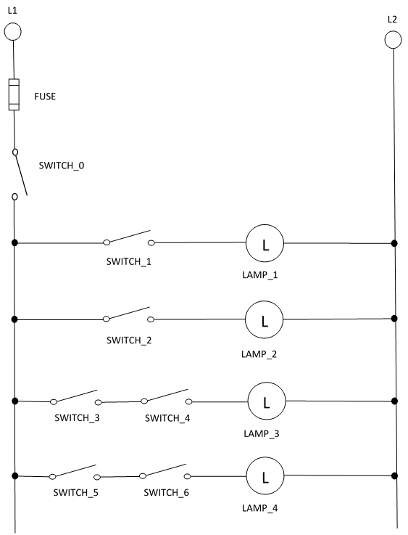
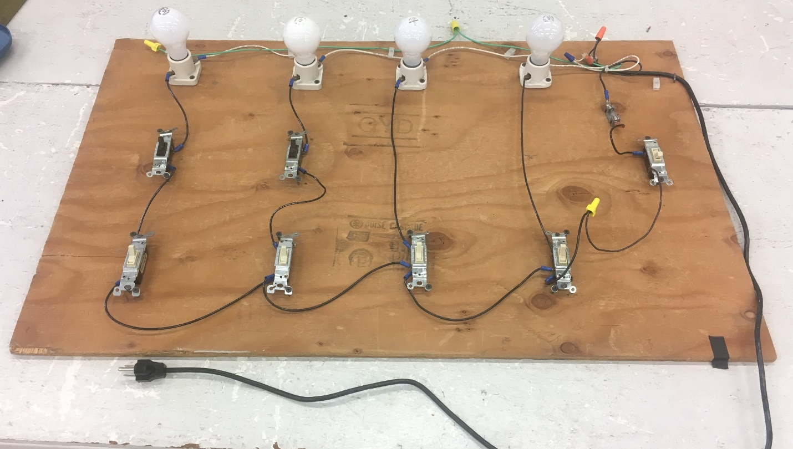

Some things to notice: There’s a “master power” switch and fuse for the system.
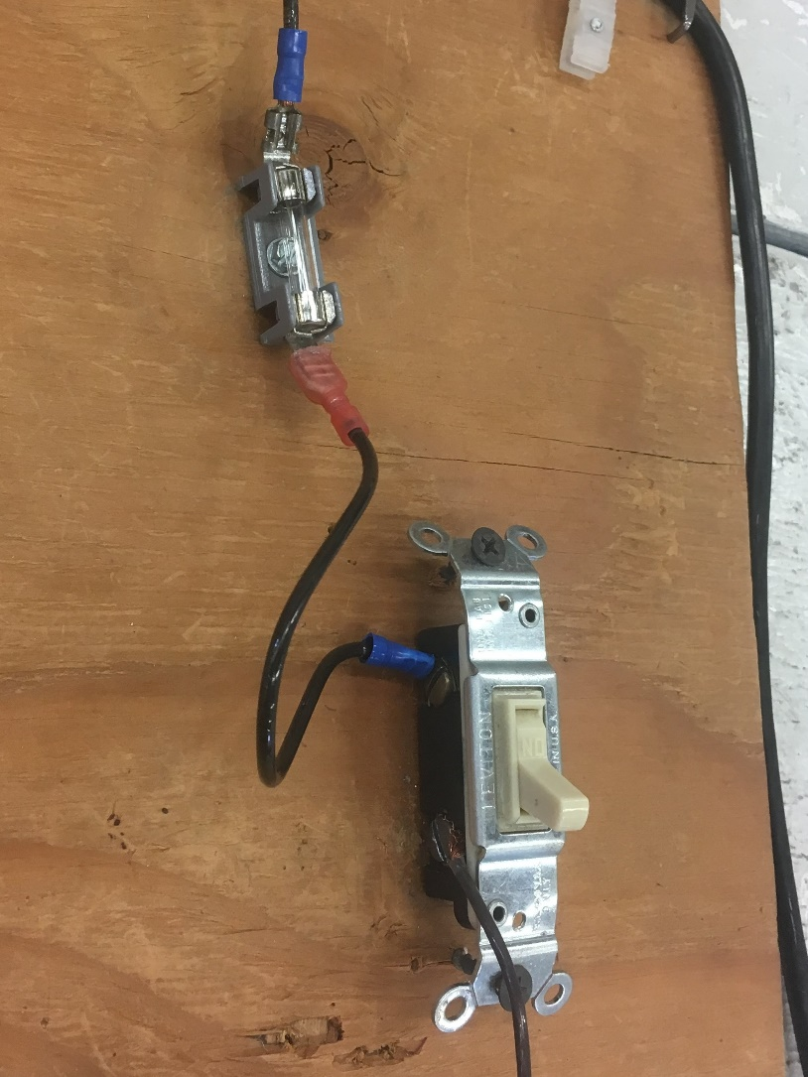
I’ve also used industrial-style EMO-style buttons for this function:
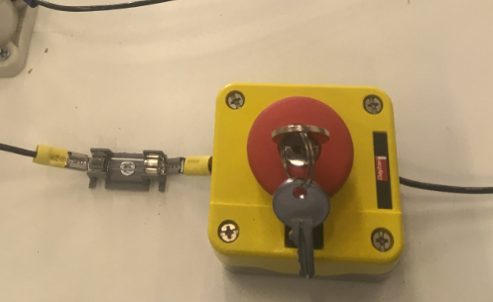
If students are ready, you can also incorporate 3-way switches on one rung, like this:
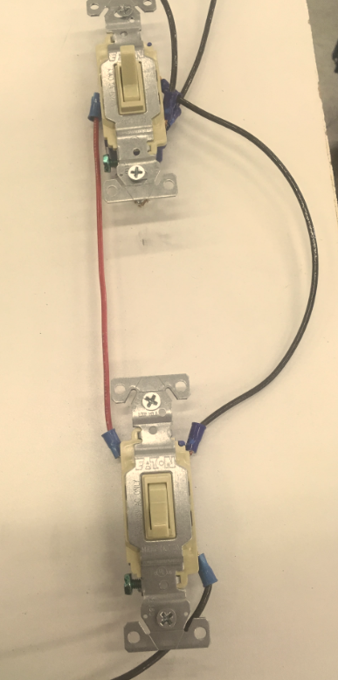

Finally, here’s an image of what was developed for teaching the high-resistance short-to-ground (the orange bulb with alligator clips), along with the 24V transformers and relays used for teaching.
