Writing 115
Intro to College Writing
Leana Dickerson
Spring Term 2015 leana.dickerson@linnbenton.edu
541.917.4551
Room: IA-223 Office Hours: Tuesday and Thursday 10-11
CRN: 44901 Tuesday/Thursday 11:30-12:50 Office: SSH 215

Course Description:
Introduces college-level critical inquiry in academic reading and writing. Students critically read, summarize and respond in paragraph format. Students develop expository essay writing skills, review conventions, and use individual and collaborative writing processes.

Note: This course is transferable as an elective, but does not satisfy institutional writing requirements for the degree seeking or transfer student.
PREREQUISITE: Placement by CPT or successful completion of WR95.

Required Texts:
Models for Writers 7th Ed., by Rosa and Eschholz
Rules for Writers 7th Ed., by Hacker and Sommers

Course Outcomes:
- Write thoughtful, clear, and focused paragraphs and essays for a variety of purposes.
- Illustrate critical reading by clearly summarizing, paraphrasing, and directly quoting.
- Distinguish your ideas from others’ ideas.
- Focus a main point and develop this main point clearly and logically using examples and illustrations in a well-organized essay.
- Revise writing using standard college editing and proofreading conventions (grammar, syntax, spelling, punctuation).
Turning In Assignments:
Unless otherwise discussed in class, all assignments will be turned in via e-mail attachment (either in .doc .x or .rtf format). Please use ONLY your LBCC e-mail address and send directly ONLY to my LBCC e-mail account: leana.dickerson@linnbenton.edu. I will send you a confirmation that I received your attachments. If you do not hear from me within 4 hours of the assigned deadline, assume I have not received your paper.

Assignments:
Participation: Participation not only includes attendance, which is a large part of you being able to participate at all, but also includes how you participate. If you show up every day but never say a word, you can expect only partial credit. If you are involved and turn in assignments regularly, you will be in much better shape come the end of term. Keep in mind too, that participating does not only include activity in-class, but doing the readings and participating outside of class time as well.

In-Class and Take Home Assignments: you will be assigned various take-home or in-class assignments which will ask you to complete a writing task pertaining to the current course discussion and trajectory. These may be response papers, summarization, question and answer, etc.

Essay 1: Your first essay will be a 2-3 page narrative.
Essay 2: This essay will be an informative essay of 2-3 pages.

Final: Your final for this class will be the exact final provided to all students who take WR 115. The following are the expectations; more on the process will be provided to you as we approach the end of term:
- Students will pass an exit final exam (holistically graded) worth 30% of the final grade. In a two-hour testing situation, students critically read a short essay then handwrite a summary and response paragraph. Instructor’s grades of classroom activities, projects, and assignments will be 70% of the final grade.

Grading:
Participation 15%
In-Class and Take Home Assignments 25%
Essay 1 15%
Essay 2 15%
Final 30%
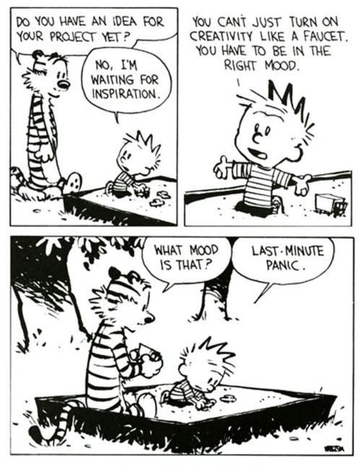

Resources: (use them!)
THE LIBRARY
Linn Benton Learning Center
Linn Benton Writing Center
Linn Benton Online Writing Lab (OWL)
Purdue OWL (Online Writing Lab): https://owl.english.purdue.edu/owl/

Late Work Policy:
Things happen, emergencies come up; as long as it does not become a clear pattern, if you ask me within 24 hours notice, I will most likely provide you with an extension plan for your work. If you do not request an extension within the 24 hour period before the assignment is due, you will automatically lose one letter grade for each class period thereafter. Just don’t do it.

Attendance Policy:
Attendance is considered part of your participation for this course. I will allow you three missed classes, no questions asked. Each absence after will result in the lowering of your participation grade for this course which factors into your final grade. If you have an emergency which may affect your ability to complete this course, please contact me as soon as possible to make arrangements.

Class Cancellation Information:
In the event that we cannot meet on campus (weather, for instance), please be sure to check your LBCC e-mail. You should receive an e-mail from me, as we will still have out-of-class work either via an assignment through e-mail or through moodle.

Electronics in the Classroom:
Please refrain from using electronics in class. I ask that you do not use a laptop or tablet to take notes as it does become a distraction not only for you, but also for your peers, as well as me. If you must make or take a phone call (or a text message), please remove yourself respectfully from class to do so.

Plagiarism:
The MOST important thing to remember when writing and studying for your own academic success, is to only claim your own thoughts and ideas. If you incorporate the work of others, you must utilize citations to provide them with the credit. Not using proper citations when using someone else’s work may result in you failing the assignment and even this course. For more information about plagiarism and what plagiarism includes, please visit: http://plagiarism.arts.cornell.edu/tutorial/index.cfm.

Nondiscrimination Policy:
LBCC maintains a policy of nondiscrimination and equal opportunity in employment and admissions, without regard to race, color, sex, marital and/or parental status, religion, national origin, age, mental or physical disability, Vietnam era, or veteran status. (See Administrative Rule No. E029 and Board Policy Series No. 6090, found at http://po.linnbenton.edu/BPsandARs/).

Accessibility
You should meet with your instructor during the first week of class if:
- You have a documented disability and need accommodations,
- Your instructor needs to know medical information about you, or
- You need special arrangements in the event of an emergency.
If you believe you may need accommodation services please contact Center for Accessibility Resources, 917-4789. If you have documented your disability, remember that you must make your request for accommodations through the Center for Accessibility Resources Online Services web page every term in order to receive accommodations.

Contact:
If you need to contact me, e-mail is the best resource. I frankly do not typically utilize phone communication, but check e-mail regularly except for on weekends, evenings, and holidays. And of course, come to my office hours; they’re designed for you to utilize!

Course Calendar:

