Electrical Systems Troubleshooting Name __________________________
Lab 5: Relay and Transformer
Partner __________________________

Relays

A relay is a device that controls one electrical circuit by opening and closing contacts in another (different) electrical circuit. A small voltage applied to the “input” of a relay can result in a large voltage being switched at its “output.” Basically, a relay is an electrically controlled switch.
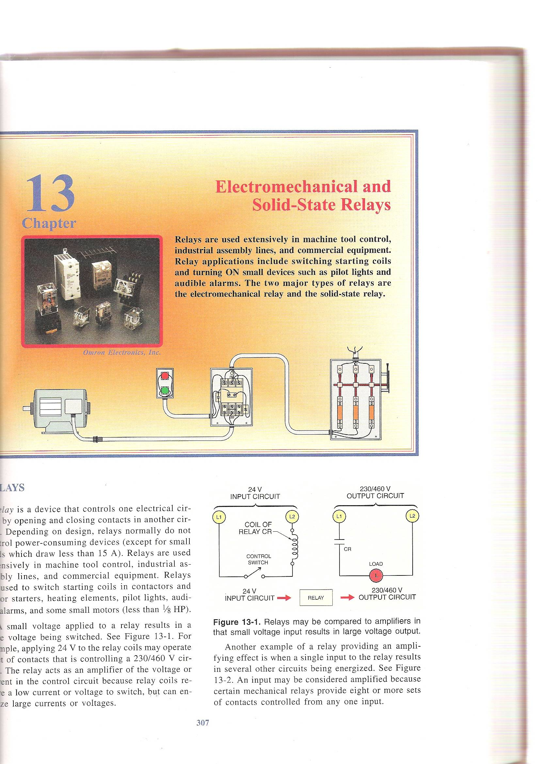
Control
Circuit
Power
Circuit

There are two sections to a relay, the coil and the contacts. Energizing the coil in the control circuit generates an electromagnetic force field which can be used, as in the case of a solenoid, to move a plunger. In the case of a relay, the electromagnetic force causes contacts in the power circuit that are normally open (NO) contacts to close and/or normally closed (NC) contacts to open. The opening and closing of the contacts can be used to energize or de-energize load.

There are two basics types of relays: Electromechanical relays (EMR) and Solid State relays (SSR). Each type has advantages and disadvantages. EMRs often have several sets of contacts for opening and closing numerous circuits simultaneously. SSRs generally have only one set of contacts but they generally outlast EMRs because they contain no moving parts.
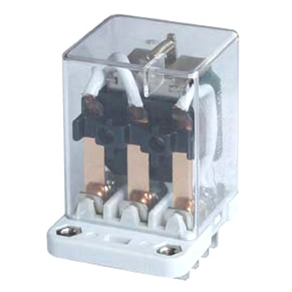
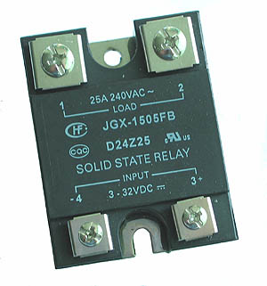

Electromechanical Relay Solid State Relay

TROUBLESHOOTING RELAYS

The operator for a relay is the electromagnetic coil or solenoid plus the mechanical linkage to the contact poles. All of the problems and troubleshooting procedures discussed for switches and contacts apply to relays contacts as well. Relay coils behave electrically like any other coil of wire. Relay problems can be grouped into the categories described for switches and coils plus a third category, relay coil hum.

Devices using AC will have one or more single turn coils, called shading rings, embedded in the face of their magnetic armature assembly. Without this coil the armature would tend to drop out whenever the AC voltage drops toward zero, and then be pulled in as the voltage and magnetic field reverses. This produces a humming noise in AC relays. The shading ring, which minimizes this noise, produces an induced magnetic field that is out of phase with that of the applied power reversals. Over time, shading rings tend to crack from the pounding of the armature faces. When this happens, the solenoid will become very noisy, coil current will increase, and premature failure will result.

The schematic diagram below is of the relay you will be using in this lab.

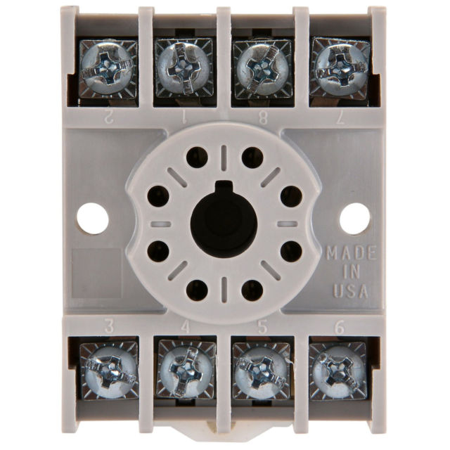
1
5
6
7
4
3
2
8
1
2
7
8
3
4
5
6

(Bottom View)

For each pair of contacts, determine if they are Normally Open (NO) or Normally Closed (NC).

1 and 3: _______ 8 and 5: _______

1 and 4: _______ 8 and 6: _______

Useful equations:
$\frac{N_{s}}{N_{p}}$ $\frac{N_{s}}{N_{p}}=\frac{E_{s}}{E_{p}}$ $\frac{N_{s}}{N_{p}}=\frac{I_{p}}{I_{s}}$ $E=\text{IR}$

Equipment/Parts

Power cord (120 VAC)
Light Switch
120V/24V Transformer
24 VAC Relay
Relay Socket
Connecting Wires
2 Lamps with bases
Wire nuts
DMM

Have your lab instructor supply you with a relay and relay socket. Determine the proper numbering scheme for the socket’s screw terminals based on the schematic diagram on the previous page. Write the correct number for each screw terminal where it belongs in the schematic.

L
LAMP_2
CR_2
L1
L
L2
LAMP_1
CR
120 VAC
24 VAC
SWITCH_1
CR_1

Once terminal connections are numbered, have your work verified:
Initials _______

Measure the resistance of the relay coil. ________

Measure the resistance of the PRIMARY transformer coil ________

Measure the resistance of the SECONDARY transformer coil ________

Measure the resistance of LAMP_1 (in the base) ________

Measure the resistance of LAMP_2 (in the base) ________

If wired correctly, when SWITCH_1 is ON, LAMP_1 will be: (ON / OFF)

If wired correctly, when SWITCH_1 is ON, LAMP_2 will be: (ON / OFF)

If wired correctly, when SWITCH_1 is OFF, LAMP_1 will be: (ON / OFF)

If wired correctly, when SWITCH_1 is OFF, LAMP_2 will be: (ON / OFF)

Wire your circuit then have your work checked before energizing.
Initials _______

- Before plugging in your circuits, fill out your voltage estimates in the top row below:
 | Primary Transformer Coil | Secondary Transformer Coil | Relay Coil  (switch closed) | LAMP_1  (coil on) | LAMP_2  (coil off)
Estimate (V)
Actual (V)
Current (A)

- Now plug in your system and observe its behavior when the switch is turned off and on. With SWITCH_1 ON (circuit energized), measure the actual voltages in the second row of the table above.

- Use your measured voltages/resistances to calculate current through each circuit component.

- Use your DMM to measure the voltage across the relay contacts when:
LAMP_1 NO contacts, when the control circuit is: De-energized _____ Energized: _____

LAMP_2 NC contacts, when the control circuit is: De-energized _____ Energized: _____

Final verification from instructor that everything is working correctly
Initials _______

- If the primary coil of your transformer has 1400 windings, based on your voltage measurements, how many windings would you say are on the secondary side?

