Monday | Tuesday | Wednesday | W/Th Lab | Friday
6.Apr  Chapter 22  Electric Chrg and Force | 7.Apr  Chapter 22 | 8.Apr  Chapter 22  HW#1a Due | Lab #1  Electric Charge  w/Formal Report | 10.Apr  Chapter 22  HW#1b Due  Sunday
13.Apr  Chapter 23  The Electric Field  HIP1 Due | 14.Apr  Chapter 23 | 15.Apr  Chapter 23  HW#2a Due | Lab #2  The Electric Field  Formal Report Rough Draft Due | 17.Apr  Chapter 23  HW#2b Due  Sunday
20.Apr  Chapter 23  HIP2 Due | 21.Apr  Chapter 24  Gauss’ Law | 22.Apr  Chapter 24  HW#3a Due | Lab #3  Gauss’ Law  Formal Report Final Draft Due | 24.Apr  Chapter 24  HW#3b, HIP3 Due Sunday
27.Apr  Chapter 22-24 Review  HIP3 Due | 28.Apr  Exam 1 | 29.Apr  Chapter 25  Electric Potential | Lab #4  Electric Potential | 1.May  Chapter 25  HW#4a Due Fri  HW#4b Due  Sunday
4.May  Chapter 25  HIP 4 Due | 5.May  Chapter 25 | 6.May  Chapter 25/26  HW#5a Due | Lab #5  Circuits | 8.May  Chapter 26  Potential and Field HW#5b
11.May  Chapter 26  HIP 5 Due | 12.May  Chp. 26/27 | 13.May  Chapter 27  HW#6a Due | Lab #6  RC Circuits | 15.May  Chapter 27  HW#6b Due  Sunday
18.May  Chapter 25-27 Review  HIP6 Due | 19.May  Exam 2 | 20.May  Chapter 28  Circuits  HW#7a Due | Lab #7  Earth’s Magnetic Field | 22.May  Chapter 29  Magnetic Fields  HW#7b Due Su
25.May  Memorial Day  No Class | 26.May  Chapter 29  HIP 7 Due | 27.May  Chapter 29  HW#8a Due | Lab #8  Mass of an Electron  w/Formal Report | 29.May  Chapter 30  Induction  HW#8b Due Su
1.June  Chapter 30  HIP 8 Due | 2.June  Chapter 30 | 3.June  Chapter 30/31  EM Fields and Waves  HW#9a Due | Lab #9  Make a Speaker & an Electric Motor | 5.June  Chapter 31  HW#9a Due
8.June  Term in Review | 9.June  Term in Review | 10.June  Term in Review | Exam 3 | 12.June  End of Term Party
PH 213
General Physics
with Calculus

Live Zoom Classes – check for current Zoom link at minirov.info/ph213
Sect. 1: 8-8:50am
Sect. 2: 11-11:50am

Zoom Classes Archived at: http://minirov.info/ph213

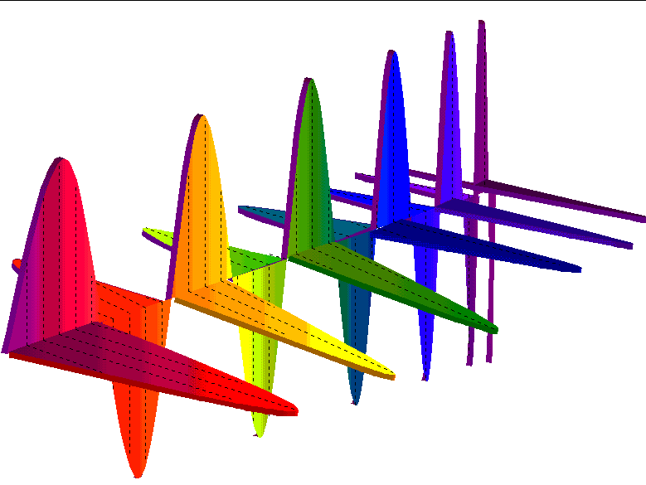

Instructor:
Gregory Mulder

Class Webpage: www.minirov.info/ph213

Class Homework:
www.masteringphysics.com
Mastering Physics Course ID:
PH213SPRING2020

Linn-Benton Community College

Spring 2020

Please check http://minirov.info/ph213 regularly for updates and current Zoom links as well as info on TASS, Help Desk and Tutors.
Office: https://linnbenton.zoom.us/j/5419174744
Check www.minirov.info/ph213 often for possible changes to office zoom site
E-mail: mulderg@linnbenton.edu
Office Hours: MW9-9:50am; T10-10:50am And of course, by appointment
And of course, by appointment.

Linn-Benton Community College—Spring 2020

Ph 213: General Physics with Calculus

P
hysics is the study of nature. It is the study of how rainbows are formed. It is the study of why the sky is blue, why the stars twinkle, and how the planets move through the heavens. Applications of physics have given us eye glasses, levers, pulleys, the combustion engine, transatlantic steamers and communication, television, lasers, computers, satellites, space flight, and new insights into the universe that startle the imagination and can only make hungry to learn more.

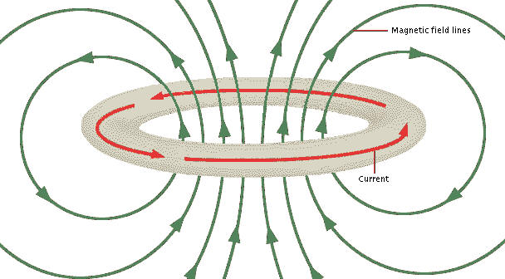
Why should one spend time learning about physics? First of all, physics affects us all. Almost every aspect of life today has been influenced by discoveries that originated in Physics. As a citizen, it is important for each and every one of us to have a good grasp of the scientific issues that face us as a society. When the newspapers talk about the supposed dangers of low frequency EM waves; or scientists warn us of the dangers of CFC’s in the atmosphere; or any number of other current topics in the newspaper, it important for us to be scientifically literate.
Physics is the study of the underlying forces of nature and the search for the understanding of the fundamental building blocks of the universe.

However, in my opinion, the most important reason to study physics is because it is simply fun. Physicists have the neatest toys—many of which I hope to share with you—and we get to go on gedanken journeys that previous generations can’t even imagine.

In Physics 213 we focus on the electricity and magnetism. One hundred years ago physicists were successful in unifying these two seemingly different phenomena. The result was a new way of looking at the universe that allowed us to create new technologies and devices such as motors, generators, radio and radar. The field of electromagnetism also allowed us to better explore the cosmos and paved the way to develop still new models that have allowed us to understand the general nature of the universe in which we live.

Upon successful completion of this course, students will be able to:
- Describe and explain charged physical objects moving in electric fields and magnetic fields.
- Use calculus to determine the electric field of a charge distribution
- Describe and explain the relationship between electric field and electric potential
- Use Gauss' Law to solve a problem
- Solve problems in series and parallel circuits.
- Relate the induced current in a circuit to the motion of magnets.

Math requirements for this class and for physics in general
Math is the language of a large part of what we do in physics. To be able to do well in Physics 213, we’ve created the following prerequisites for this class:
- Completion of Ph 211 and Ph 212 with a ‘C’ or better
- Completion of MTH 254 with a grade of a ‘C’ or better
Physics 213 heavily relies upon mathematics. If you feel yourself getting lost in the math, make sure that you ask for help as quickly as possible.
Attending the Class:
Please check on web runner to find the CRN for which you are registered and find your class times here. The Zoom link and password for the class will be available at minirov.info/ph213.
CRN | Lecture | Lab
43304 | MTWF 11am-11:50am | R 8-10:50am
43305 | MTWF 8am-8:50am | W 5-7:50pm
43306 | MTWF 11am-11:50am | R 11-1:50pm
43307 | MTWF 8am-8:50am | R 8-10:50am
44308 | MTWF 11am-11:50am | W 5-7:50pm
44309 | MTWF 8am-8:50am | R 11-1:50pm

If you can’t make your class time, video recordings of the Zoom lesson will appear at minirov.info/ph213.

Required Materials for the Class:
Textbook – Knight 4th Edition “Physics for Scientists and Engineers” along with a valid access code.
(3rd Edition and MasteringPhysics access also ok)
Computer and webcam with internet access.
The lab packet assignment will be available each week at minirov.info/ph213.

Grading Scale for this course:
Final grades are determined from the below components of the course.
Basis for grading:
Exams: 60%
Labs Reports: 10%
Homework: 10%
HIPs: 20%
Other possible grades at LBCC:
I -- Incomplete. An 'I' grade is assigned if for some reason a student cannot complete all components of the course by the end of the academic term. To receive an 'I' grade, the instructor and student must agree upon a contract that will spell out when uncompleted work will be turned in.

Grading Scale:
90%-100% A
80%-89% B
70%-79% C
60%-69% D
< 60% F
Exams: There will be three exams equally weighted for the term. All exam are comprehensive to everything you have learned before.

Labs: This term two-formal reports will be due. A formal report is a typed up synopsis of your lab for that day. Lab books will not be collected each week—however, as always, you should keep a lab book. Lab Reports should be uploaded to GradeScope. There will also be an exit assignment for each lab.

Homework assignments come from the end of the chapters in our text book and are to be completed online at www.masteringphysics.com. Access to this website comes with your textbook. Sign up for course ID: PH213SPRING2020.

Hand-In Problems: There will be Hand-In Problems assigned throughout the term at www.minirov.info/ph213. When grading your hand-in problems I will be assessing how clearly and thoroughly you show your work. Your HIPs should be uploaded to GradeScope.

Students in need of accommodations: Students who may need accommodations due to documented disabilities, who have medical information which the instructor should know, or who need special arrangements in an emergency, should speak with the instructor during the first week of class. If you have not accessed services and think you may need them, please contact Disability Services, 541-917-4789.

