Monday | Tuesday | Wednesday | W/Th Lab | Friday
1.Apr  No Class Today | 2.Apr  Chapter 22  Electric Chrg and Force | 3.Apr  Chapter 22 | Lab #1  Electric Charge  w/Formal Report | 5.Apr  Chapter 22  HW#1a Due
8.Apr  Chapter 23  The Electric Field  HW#1b Due | 9.Apr  Chapter 23  HIP1 Due | 10.Apr  Chapter 23 | Lab #2  The Electric Field  Formal Report Rough Draft Due | 12.Apr  Chapter 23  HW#2a Due
15.Apr  Chapter 23  HW#2b Due | 16.Apr  Chapter 24  Gauss’ Law  HIP2 Due | 17.Apr  Chapter 24 | Lab #3  Gauss’ Law  Formal Report Final Draft Due | 19.Apr  Chapter 24  HW#3a Due
22.Apr  Chp. 22-24  HW#3b, HIP3 Due for Peer Gd. | 23.Apr  Exam 1 | 24.Apr  Chapter 25  Electric Potential | Lab #4  Electric Potential | 26.Apr  Chapter 25  HW#4a Due
29.Apr  Chapter 25  HW#4b Due | 30.Apr  Chapter 25  HIP4 Due | 1.May  Chapter 26 | Lab #5  Circuits | 3.May  Chapter 26  Potential and Field HW#5a
6.May  Chapter 26  HW#5b Due | 7.May  Chp. 26/27  HIP5 Due | 8.May  Chapter 27 | Lab #6  RC Circuits  w/Formal Report | 10.May  Chapter 27/28  HW#6a Due
13.May  Chapter 28  Circuits  HW#6b Due | 14.May  Chapter 29  Magnetic Fields HIP6 | 15.May  Chapter 29 | Lab #7  Earth’s Magnetic Field  Formal Report Final Draft Due | 17.May  Chapter 29  HW#7a Due  Black Friday Registration
20.May  Review Chp. 25-29 HW#7b  HIP7 Due | 21.May  Exam 2 | 22.May  Chapter 30  Induction | Lab #8  RL Circuits | 24.May  Chapter 30  Induction  HW#8a Due
27.May  Memorial Day  No Class | 28.May  Chapter 30  HW#8b Due | 29.May  Chapter 30  HIP 8 Due | Lab Exam | 31.May  Chapter 31  EM Fields and Waves
3.June  Chapter 31 | 4.June  Chapter 31  HIP9 Due  HW9a Due | 5.June  Chapter 32  HW#9b Due  Turn in Score-Keeper | Lab #9  Make a Electric Motor | 7.June  Review Chp. 22-32  HW#10 & HIP#10 Due E.C. HW Due
10.June  Sect. #1 Final  8am-10:50am |  | 12.Mar  Sect. #2 Final  10am-11:50am
PH 213
General Physics
with Calculus
Sect. 1: 8-8:50am MH 113
Sect. 2: 11-11:50am MH 113

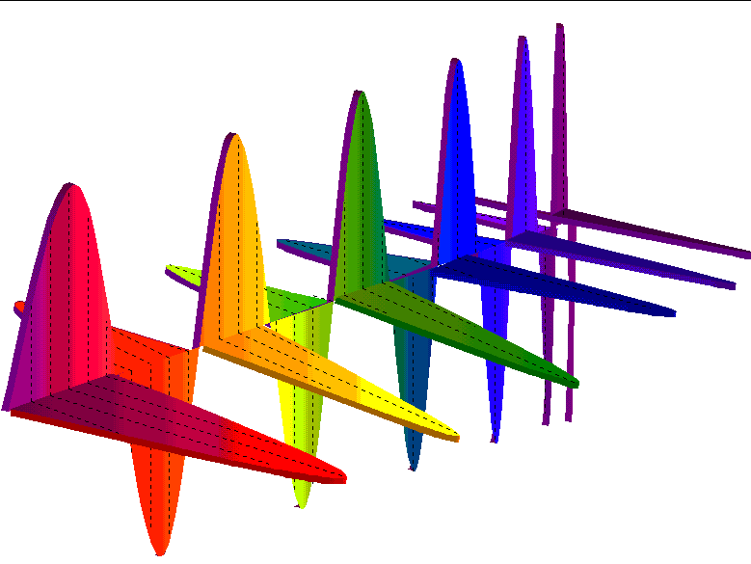

Instructor:
Gregory Mulder

Office: MH109
Phone: 541-917-4744
E-mail: mulderg@linnbenton.edu
Office Hours in MH109, 106 and/or 113:
MW9-9:50am; T10-10:50am
And of course, by appointment.

Class Webpage: www.minirov.info/ph213
Class Homework:
www.masteringphysics.com
Course ID:
PH213SPRING2019

Linn-Benton Community College

Spring 2019

Linn-Benton Community College—Spring 2019

Ph 213: General Physics with Calculus

P
hysics is the study of nature. It is the study of how rainbows are formed. It is the study of why the sky is blue, why the stars twinkle, and how the planets move through the heavens. Applications of physics have given us eye glasses, levers, pulleys, the combustion engine, transatlantic steamers and communication, television, lasers, computers, satellites, space flight, and new insights into the universe that startle the imagination and can only make hungry to learn more.

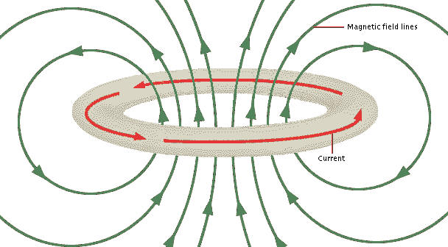
Why should one spend time learning about physics? First of all, physics affects us all. Almost every aspect of life today has been influenced by discoveries that originated in Physics. As a citizen, it is important for each and every one of us to have a good grasp of the scientific issues that face us as a society. When the newspapers talk about the supposed dangers of low frequency EM waves; or scientists warn us of the dangers of CFC’s in the atmosphere; or any number of other current topics in the newspaper, it important for us to be scientifically literate.
Physics is the study of the underlying forces of nature and the search for the understanding of the fundamental building blocks of the universe.

However, in my opinion, the most important reason to study physics is because it is simply fun. Physicists have the neatest toys—many of which I hope to share with you—and we get to go on gedanken journeys that previous generations can’t even imagine.

In Physics 213 we focus on the electricity and magnetism. One hundred years ago physicists were successful in unifying these two seemingly different phenomena. The result was a new way of looking at the universe that allowed us to create new technologies and devices such as motors, generators, radio and radar. The field of electromagnetism also allowed us to better explore the cosmos and paved the way to develop still new models that have allowed us to understand the general nature of the universe in which we live.

Upon successful completion of this course, students will be able to:
- Describe and explain charged physical objects moving in electric fields and magnetic fields.
- Use calculus to determine the electric field of a charge distribution
- Describe and explain the relationship between electric field and electric potential
- Use Gauss' Law to solve a problem
- Solve problems in series and parallel circuits.
- Relate the induced current in a circuit to the motion of magnets.

Math requirements for this class and for physics in general
Math is the language of a large part of what we do in physics. To be able to do well in Physics 213, we’ve created the following prerequisites for this class:
- Completion of Ph 211 and Ph 212 with a ‘C’ or better
- Completion of MTH 254 with a grade of a ‘C’ or better
Physics 213 heavily relies upon mathematics. If you feel yourself getting lost in the math, make sure that you ask for help as quickly as possible.
Required Materials for the Class:
Textbook – Knight 4th Edition “Physics for Scientists and Engineers” along with a valid access code.
Lab Packet – Available at the LBCC book store.
Brown Lab Book – Available at the LBCC book store.

Grading Scale for this course:
Final grades are determined from the below components of the course.
Other possible grades at LBCC:
I -- Incomplete. An 'I' grade is assigned if for some reason a student cannot complete all components of the course by the end of the academic term. To receive an 'I' grade, the instructor and student must agree upon a contract that will spell out when uncompleted work will be turned in.

Basis for grading:
Exams: 40%
Labs: 10%
Lab Final: 8%
Final: 20%
Homework: 10%
HIPs: 12%

Grading Scale:
90%-100% A
80%-89% B
70%-79% C
60%-69% D
< 60% F

Exams: There will be two mid-term exams and one comprehensive exam for the term.

The Final: A central aspect of physics is that every week builds upon what was learned in the previous weeks—this is especially true in Ph213. As a consequence, by nature, the final exam is comprehensive.

Labs: This term two-formal reports will be due. A formal report is a typed up synopsis of your lab for that day. Lab books will not be collected each week—however you must make sure that you complete the lab exam before you leave class and make sure that you “sign out” before you leave the room. You can make up one lab by creating a you-tube video that clearly demonstrates some principle of electricity and magnetism and e-mailing me the link.

There will be a Lab Exam. You may bring your lab book into the Lab Exam. Any permanently affixed items in your lab book can then be used to assist you with the Lab Exam.

Homework assignments come from the end of the chapters in our text book and are to be completed online at www.masteringphysics.com. Access to this website comes with your textbook. Sign up for course ID: PH213SPRING2019.

Hand-In Problems: There will be Hand-In Problems assigned throughout the term at www.minirov.info/ph213. When grading your hand-in problems I will be assessing how clearly and thoroughly you show your work.

Students in need of accommodations: Students who may need accommodations due to documented disabilities, who have medical information which the instructor should know, or who need special arrangements in an emergency, should speak with the instructor during the first week of class. If you have not accessed services and think you may need them, please contact Disability Services, 541-917-4789.

Ph 213 – Score Keeper Spring 2019

Use this sheet to keep track of your overall score in the class. You can use the formula to the right or the grade calculator on the course website to keep track of your overall grade.

Homework 8%:
 | Your Score | Out Of
HW1
HW2
HW3
HW4
HW5
HW6
HW7
HW8
HW9
HW10
EC HW

Hand-In Problems: 12%
 | Your Score | Out Of
HIP1
HIP2
HIP3
HIP4
HIP5
HIP6
HIP7
HIP8
HIP9
HIP10

Basis for grading:
Exams: 40%
Labs: 10%
Lab Final: 8%
Final: 20%
Homework: 10%
HIPs: 12%

Labs: 10%
 | Your Score | Out Of
Lab1
Lab1 Formal Report
Lab2
Lab3
Lab4
Lab5
Lab5 Formal Report
Lab6
Lab7
Lab8

Lab Final: 8%
 | Your Score | Out Of
Part 1
Part 2

Midterms and Final: 60%
 | Your Score | Out Of
Exam1
Exam2
Final

