Art 204
History of Western Art:
Prehistory to the Middle Ages

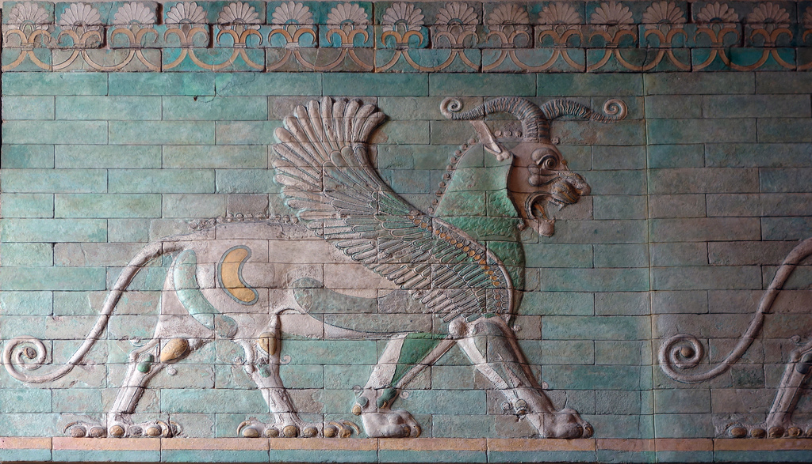

Winter 2017

MWF 11-11:50 am
CRN 33210
Location: NSH 106
Linn-Benton Community College

Professor: Isabelle Havet

Email: haveti@linnbenton.edu
Office: SSH 116C
Office Hours: MW 12-1; TR 1-2
& by appointment

Art 204  History of Western Art:  Prehistory to the Middle Ages |  | Winter 2017  MWF 11-11:50 am  CRN 33210  Location: NSH 106
Professor: Isabelle Havet
E-mail: haveti@linnbenton.edu
Phone: 541-917-4559
Office: SSH 116C
Office Hours: MW 12-1; TR 1-2
& by appt.

Course Description
This course provides an overview of the History of Art from Prehistory to the Middle Ages. Significant artworks, including painting, sculpture, architecture, and the decorative arts are examined within their historical, social, and cultural contexts. Students will develop an understanding and appreciation of the major periods, styles, and artworks produced by different artists and civilizations. This class is the first cond part of the three-part History of Western Art sequence (ART 204, 205 & 206). It is recommended, but not required, that the courses be taken in sequence.

Learning Outcomes
- Articulate verbally and in writing an understanding of the significance of art relative to the prehistoric and ancient cultures that produced them.
- Identify and describe verbally and in writing, specific two and three-dimensional works of art from these early societies, using appropriate art vocabulary.
- Articulate verbally and in writing the form and content of specific and significant works of art from the ancient cultures that produced them.

Credits: 3 credits; 3 hours of class per week.

General Education Requirements: AS Literature & the Arts, AS Western Culture, AAS Human Relations, AS Liberal Arts Core 2, Cultural Literacy AAOT/AAS, AAOT Arts & Letters, AGS Humanities/Arts.

Prerequisites: None.

Recommended (but not required): College-level reading and writing skills.

Required Textbook: Fred S. Kleiner, Gardner's Art through the Ages: A Global History, Volume I. ISBN-13: 978-1285837840. ISBN-10: 1285837843. Cengage Learning, 15th edition.[The 14th edition is also acceptable, but it is the student’s responsibility to figure out the difference in page numbers and do the correct reading each week.]

Course Assignments:
- Weekly Readings & Videos
- Class Activities/Participation
- Weekly Quizzes
- Formal Analysis Paper
- Group Project & Presentation
- Final Exam

Description of Course Assignments:
- Readings & Videos
You are required to read the assigned textbook chapters and watch the assigned videos posted in Moodle for each week. Please come to class having completed all assigned readings and videos. The textbook reading will sometimes be substantial, so it is best to stick to the reading schedule so that you do not fall behind. If you would like tips on successfully completing the assigned readings and/or taking notes, please contact the instructor.
- Attendance
Regular attendance is critical for success in this course. Attendance is taken each class session. If you know that you will not be able to attend class regularly, please drop this course, and feel welcome to re-enroll when you can commit to the class for the entire term.
- Class Activities/Participation
In-class activities and discussions are designed to promote student interaction in the course. These are a fun way to get to know your fellow students and collaborate with them. You will also be able to explore different topics in the course that might interest you. Your thoughts and observations, and the materials that you will bring to the table, will greatly enrich the class for all.

- Weekly Quizzes
Students will take a short quiz in Moodle at the end each week of instruction (Weeks 1-10). These assessments are designed to help students keep pace with course content. They cover information from lectures, readings, and videos for that week, and will include a mix of multiple choice and short answer questions. Quizzes are due in Moodle on Sundays at 11:59 pm. Quizzes automatically close on the deadline, so do not wait until the last minute to take the quiz!

- Formal Analysis Paper
Students will write a short (2-page) paper focused on the formal analysis of artworks. The Paper is meant to sharpen students’ abilities to critically analyze artworks within their social and historical contexts, and to practice different methods of analysis. A first draft as well as final version will be required.

- Group Project & Presentation
During the term, students will work in teams to plan and give a presentation to the class on a topic falling within the scope of the course. Each team will present on a different period/subject, and presentation dates will be determined depending on the topic and how it fits chronologically within the course. Exact presentation topics must be chosen in consultation with the instructor.

- Final Exam
The final exam will consist of identifications of artworks, short answer questions, and formal analysis/comparative analysis short essays.

Failure to submit work or participate in class activities in a timely manner will result in a 0 for that assignment.

Grading:

Assignment | Points
Syllabus quiz | 10
Attendance | 50
Class Activities/Participation | 40
Weekly Quizzes | 100
Formal Analysis Paper | 100
Group Project & Presentation | 100
Final Exam | 100
Total Points | 500

Grading Scale
A 90-100% (450-500 points)
B 80-89% (400-449 points)
C 70-79% (350-399 points)
D 60-69& (300-349 points)
F 59% or below (299 or fewer points)
Course Policies

Institutional Drop for Non-Attendance (Weeks 1)
Faculty at LBCC may administratively withdraw a student for nonattendance during the first week of the term. The instructor makes use of this policy.
You will have at least two assignments to complete in Moodle prior to the second Monday of the term (January 16, 2016). This will give you and the instructor a sense of whether the class is a good fit for you.
To ensure your continued enrollment and success in the course, attend every class and complete ALL required assignments in Moodle during Week 1. Any issues using Moodle (e.g., can’t access course page; can’t take quizzes) MUST be resolved early during Week 1. Do NOT wait until the last minute! Work closely with the Help Desk if you are having any problems. Students will be automatically dropped by the second Monday of the term if they are not fully participating.
Moodle
This course uses the Moodle learning platform. Think of Moodle as the online class hub: use it to to access announcements, the syllabus, class schedule, instructions for assignments, lecture PowerPoints, videos, readings, forums, and more.

You will use Moodle to turn in all assignments not completed in class. Assignments must be uploaded by Sunday at 11:59 pm on the week they are due (See Course Schedule for details). It is the student’s responsibility to upload assignments to Moodle in an acceptable file format (doc, docx, or pdf) by the deadline. If you are having trouble uploading an assignment, contact the Help Desk or email me right away (and before the deadline!) It’s never a good idea to wait until the last minute to turn in work.

Please Note: ASSIGNMENTS MUST BE UPLOADED IN MOODLE. EMAILED ASSIGNMENTS WILL NEVER BE ACCEPTED. Please do not email me attached assignments. Contact me to troubleshoot, especially if it’s before the deadline. But be aware that if it’s not in Moodle, it won’t be graded.

Communication
The best way to reach me is via email, during office hours, or after class. I try to respond to email messages daily during weekdays. I will send out announcements, due date reminders, and important messages to your LBCC email via Moodle, and you are responsible for reading that information on time. Make sure check your LBCC email frequently, or forward your LBCC email to your personal email.

Attendance
The course spans only 10 weeks of instruction. It is vital to attend class regularly and to arrive on time to each session. Please do not arrive late to class. It is disruptive, and you risk of missing important announcements and activities. If you miss an in-class activity, barring an emergency, you will not be allowed to make it up.

Attendance is taken each class session and recorded in Moodle. Please keep track of your attendance record in Moodle, and notify the instructor right away if there is a discrepency. Students are marked “Present,” “Absent,” “Late,” or “Excused” for each session:
-Present: Student arrives on time and stays the entire session.
-Absent: Student does not attend a session, or leaves early without prior approval from the instructor. Unexcused absences negatively impact your course grade.
-Late: Student is 5 minutes late or more. 2 Lates will result in a mark of absent.
-Excused: Student arranges an excused absence ahead of time with the instructor. Excused absences are given at discretion of instructor, and require documentation.
Students start the term with 50 attendance points (10% of course grade). These points are the student’s to lose.
Please note: I understand that things happen. If you are late, are going to be late, or must miss a class for a valid reason (emergency, military duty, death in the family), speak to me as soon as possible. I will excuse tardiness or an absence if there is a truly valid reason and it is not a frequent occurrence. Documentation required for an excused absence.

- How important is regular attendance?
Very. Attendance and participation are mandatory and essential for student success. Lectures and class activities include a lot of information and ideas that are not in the readings or lecture slides. By missing class, you will also miss activities that likely cannot be made up later (barring a documented emergency). Because we have only 10 weeks together, missing classes will put you behind, and generally means you are not getting what you need out of the class. Attendance is taken each class period. Keep track of your attendance record in Moodle, and notify the instructor right away if there is a discrepency.
- How many unexcused absenses are allowed?
There are no “freebie” unexcused absences in this class. Speak to the instructor right away if you need to miss a class, will be late, or need to leave early.
- What if I miss a class?
If you cannot attend a class, get notes from a fellow student and look over the lecture PowerPoint (it will not make much sense without notes), and stop by the instructor’s office hours to figure out what you need to do to catch up. If something is impacting your ability to attend class regularly, contact the instructor as soon as possible. Do NOT wait until the last minute. The sooner you communicate, the more the instructor can help!
- Are extensions or makeup work offered?
Extensions and makeup work are granted in exceptional circumstances. I will, of course, work with students who have true emergencies (i.e., military duty, medical emergency, death in the family). Please let me know as soon as possible (and well before a deadline!) if you need to negotiate an alternate due date for one of these reasons. Documentation required.
- What if I have an issue related to the class, but I’m not sure if it’s worth bringing up to the instructor?
When in doubt, contact the instructor. Email, visit office hours, or see the instructor before or after class.
What do I need to do to be successful in this class?
- Attend class.
- Check your LBCC email. Check it frequently (preferably daily), or have your LBCC email forwarded to your prefered account.
- Communicate regularly. Communicate with the instructor as needed, in class or by email. I check email most weekdays and occasionally on weekends.
Please head your emails with the course number & your section days/time (e.g. ART 204 MWF 11-11:50), and sign your email with your first and last names. This will get you the fastest and most accurate response.
When working in a group, be available to your peers.
- When in class, focus on class. Class time is valuable. You should be focused on class while you are in the room; if you can’t focus, leave the room. Please feel comfortable eating, drinking, and leaving the room for the bathroom or communication needs. If you distract me with one of the above behaviors, I will call you on it. Your actions impact the class. One student’s lack of focus can distract others. If you find you have personal business to attend to (e.g. phones calls/texting, conversations, or other class work), take care of it outside of the classroom. We will be using electronic technology in this class. I believe that access to internet searches and applications will greatly enhance the course experience for all. I think it goes without saying, use it respectfully. I expect you to apply yourself to your education during class hours.You are the person who has the greatest impact on your learning and on your grade.
- Take notes during class, and of assigned readings/videos. This is an important college skill developed through practice. There will be times that you will be very glad to have your notes in class.
- Actively participate. You will NOT be successful in this class if you show up but then ‘tune out.’ Students who do not participate on a regular basis (by actively listening and engaging in discussions and activities) are unlikely to earn a passing grade. The goal in participation is not always to have the “right” ideas or answers. Rather, it is important to try your best, stretch yourself, build on your skills and knowledge, and to learn together as a class.
- Be positive and have fun! This course is about stretching our thinking and learning together. We will be questioning things, and growing a knowledge base together. We will also be looking at cool art and stuff. Bottom line: you’ll get what you put into this class.
- Be a good class citizen. This means be open to: 1) working with others, 2) being respectful, and 3) trying new things. It’s always OK to be unsure about how to do something; it’s never OK to give up without trying.
- Be a good team member. You will spend much of class working with your “team.” Teams will have work assignments during many class sessions (some graded, some not). Approach collaborative activities with the attitude that you will contribute something to the group, rather than with the attitude that you don’t know or can’t do something and so shouldn’t try. Think about what skills, knowledge, and ideas you bring to the table, rather than what you can’t do. It’s OK if you don’t know something; the point is to learn together. People never stop learning–If you knew everything from the start, you wouldn’t need to take this class, or any class ever again. You should devote energy to getting to know your team members. The best teams are willing to work hard both with content and through style differences.
- Get ready to move. Be prepared to stand, move around, and talk each day in class. Do not become too attached to your seat. We will move around in class.
- Be accountable. You are the person who has the greatest impact on your learning and your grade.

Resources

Moodle Support
If you have questions about using Moodle or need technical support, there are several campus resources available:
- Student Help Desk (located in the Library): Either visit, call at 541.917.4630, or email at student.helpdesk@linnbenton.edu
- LBCC Moodle User Support Forum: Look up questions on the forum or post your own here: http://elearning.linnbenton.edu/mod/forum/view.php?id=2697
Campus Resources
Many resources such as the Library, Learning Center, the Writing Desk, and Family Connections are available to you as a student. Please visit the LBCC website.

Accessibility
You should meet with your instructor during the first week of class if:
- you have a documented disability and need accommodations,
- your instructor needs to know medical information about you, or
- you need special arrangements in the event of an emergency.
If you have documented your disability, remember that you must make your request for accommodations through the Center for Accessibility Resources Online Services web page every term in order to receive accommodations. If you believe you may need accommodations, but are not yet registered with CFAR, please go to http://linnbenton.edu/cfar for steps on how to apply for services or call 541-917-4789.
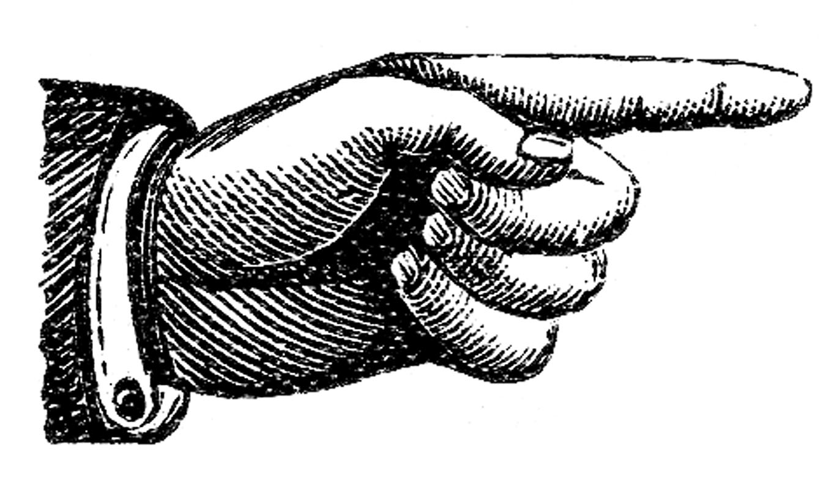
Facebook Page
I invite anyone to follow my Facebook Page “Isabelle Havet Students.” It’s an account I maintain specifically for students at LBCC. It’s mostly a place where I share articles about Art, Art History, Visual Culture, and related interests of mine. I will also post things that I find are directly relevant to what we’re exploring in class. I consider it a community space for all. I welcome student contributions on the page, should you find an interesting article or news item related to the arts. Feel free to check it out here: https://www.facebook.com/ArtHistoryLBCC/

Extra Credit!

- Option 1: Writing Center: You can receive five (5) extra credit points for using the Writing Center for your paper. These services are highly recommended! To receive credit: Attach proof of using the Writing Center (a picture of the Writing Center dated stamp or other confirmation is fine) to the end of your paper.
Writing Center website: https://www.linnbenton.edu/writing-center
There are 3 ways to use the Writing Center:
  - Schedule a 30-minute appointment (recommended)
  - Use Drop-In Services
  - Use OWL (the Online Writing Lab).

- Option 2: Attend a campus/local lecture or exhibition:During the term, I will announce campus/local lectures and exhibitions that are of interest to the class. You can receive up to two (5) extra credit points for each event you attend by turning in a 1-page reflection paper on the event. In your reflection, you may discuss any aspect of the lecture or exhibition that struck you or that you feel ties into issues we’ve explored in the class, as long as you include some specific details showing you attended the event in-person. Students may also suggest local events/exhibition to the instructor for permission to do an Extra Credit write-up.

Important Academic Calendar Dates & Policies

- Last day to add/drop: January 17, 2016.
- Last day to withdraw: February 24, 2017.

Incomplete Grade Policy
Incompletes are rarely granted. They are granted solely at the discretion of the instructor, and only in extraordinary and documented circumstances (i.e., a family emergency or serious medical excuse). You must have regular attendance and have completed most of the assignments. If an Incomplete is granted, the instructor will provide instructions for turning in incomplete work and give a completion deadline for turning in all missing work. This deadline will be nonnegotiable. If the incomplete work is not turned in on time or is deemed unsatisfactory by the instructor, the Incomplete will revert to an F-grade.

Academic Honesty
Academic honesty is an indispensable value as students acquire knowledge and develop skills in college. Students are expected to practice academic honesty by not cheating, plagiarizing, or misrepresenting their coursework in any way. Plagiarism, collusion, and other forms of misrepresentation hurt the student and run counter to the goals of education. Students are ultimately responsible for understanding and avoiding academic dishonesty, whether such incidences are intentional or unintentional. Violations will result in failure of an assignment, and possibly the course. All incidents of academic dishonesty will be reported to both the Associate Dean of Student Development and the Dean of Arts, Social Science & Humanities.

Course Schedule (Subject to change)

Week | Dates | Topic | Readings & Resources | Activities & Assignments
**All assignments due in Moodle on Sunday at 11:59pm of listed week**
1 | Jan 9-15 | Course Introduction | Review Syllabus & Class Schedule  Read Gardner, Introduction pp.2-13 (begin with “Art History in the 21st Century”) | Syllabus Quiz (Moodle)  Quiz 1 (Moodle)  **Failure to complete all Week 1 assignments in Moodle by Sunday at 5:00pm will result in automatic institutional withdrawal from course**
 |  | Art Before History: Paleolithic & Neolithic Art | Chapter 1: Art in the Stone Age pp. 14-29
2 | Jan 16-22 | Ancient Mesopotamia & Persia | Chapter 2:  Ancient Mesopotamia & Persia pp. 30-53 | Quiz 2 (Moodle)
 | Mon, Jan 16 | Martin Luther King Day: College Closed
 | Tu, Jan 17 | Last day to add/drop
3 | Jan 23-29 | Ancient Egypt | Chapter 3:  Egypt 54-81 | Quiz 3 (Moodle)
4 | Jan 30-  Feb 5 | Aegean Art:  Cycladic, Minoan & Mycenaean Art | Chapter 4: Prehistoric Aegean pp. 82-101 | Library Workshop (Fri 2/3)  Quiz 4 (Moodle)
5 | Feb 5-12 | Ancient Greece: Archaic & Early Classical Art | Chapter 5:  Ancient Greece pp. 102-42 | Formal Analysis Paper Outline/Draft due (Moodle)  Quiz 5 (Moodle)
6 | Feb 13-19 | Early & High Classical Art | Chapter 5:  Ancient Greece pp. 102-42 | Quiz 6 (Moodle)
7 | Feb 20-26 | Late Classical & Hellenistic Art | Chapter 5:  Ancient Greece pp. 142-61 | Final Draft of Response Paper (Moodle)  Quiz 7 (Moodle)
 | Mon, Feb 20 | Holiday: College Closed
 | Fri, Feb 24 | Last Day to Withdraw
8 | Feb 27-  Mar 5 | Ancient Rome | Chapter 7: The  Roman Empire pp. 176-229 | Quiz 8 (Moodle)
9 | Mar 6-12 | Late Antiquity  Byzantium | Chapter 8: Late Antiquity, Skim pp. 240-55 (start from “The First Churches;”  Review “The Life of Jesus in Art” pp. 240-41); Chapter 9: Byzantium pp. 256-76 (up to “Empress Zoe”) | Quiz 9 (Moodle)
10 | Mar 13-19 | The Middle Ages: Early Medieval Europe | Chapter 11: Early Medieval Europe pp. 310-37 | Quiz 10 (Moodle)
 |  | Romanesque Europe | Chapter 12:  Romanesque Europe pp. 338-54
 |  | Gothic Europe & Late Medieval Italy | Chapter 13: Gothic Europe pp. 372-390
 | Mar 20-24 | Finals Week
11 | Wed, March 22, 10-11:50 am | Final Exam |  | Final Exam

