Midterm Name: ___________________

- A(n) _______________ is a subatomic particle that has a negative electrical charge.

- Current that travels only in one direction is called ___________ current. Current that changes direction frequently is call ______________ current.

- Current is measured in _____________, while resistance is measure in ____________.

- ______________________ is the amount of electrical pressure (electro-motive force) that causes electrons to move in a circuit.

- A _________________ is a protection device with a fusible link that melts and opens the circuit when an overload condition or a short occurs.

- Circle any correct answers: Contacts in a switch are faulty when they:
a: do not close
b. do not open
c. do not resist current flow when closed
d. none of the above

- A(n) _______________ circuit is a circuit having an incomplete path, which prevents current flow.

- __________________ is the opposition to current flow.

- A material that easily allows electrons to move through it is called a ________________.

- ___________________ is the flow of electrons through a conductor.

- A material that has high resistance is called a ___________________.

- Every circuit must have 3 things in order to function. These are:
a: ___________________
b: ___________________
c: ___________________

- A(n) ___________________ circuit is a circuit that has two or more components connected such that there is only one path for current to flow.

- Ohm’s law: find the missing values:
a: Voltage = 48V b: Voltage = _________ c: Voltage = 24V
Resistance = 16 Ω Resistance = 16 Ω Resistance = _____
Current = _________ Current = 7.5 A Current = 80 mA
- Current of 2 A is equivalent to ____________ mA.

- Voltage of 208 V is equal to _______________ kV.

- A resistance of 4.3 k Ω is the same as __________ Ω.

- ( True / False ) When total resistance increases in a circuit, then total current must increase by a similar amount.

- ( True / False ) Total resistance in a circuit does not change based on voltage.

- ( True / False ) In a parallel circuit, the total resistance is always going to be lower than the resistance of the smallest resistor/load.

- What happens when a load is placed in series with another load in a parallel circuit?

- What problem does this (from question 21) cause?

- How would you troubleshoot this (from question 21) problem?

Use this diagram (120 VAC) for the following questions.
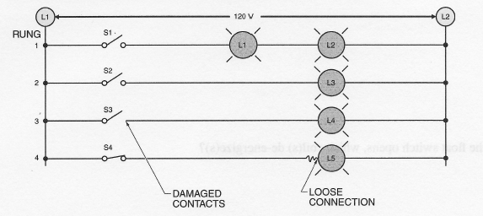

- What is the approximate voltage across L3 when S2 is closed (zero, source, or ghost)?
- If the switch contacts are clean, what is the voltage reading across S2 when it is closed (zero, source, ghost)?
- If L1 and L2 have the same resistance, approximately how much voltage is available for each one when S1 is closed?
- What voltage reading would you expect to indicate damaged contacts on S3 (switch closed)?
- What happens to total circuit resistance (increase, decrease, stay the same) when rungs are added to a parallel circuit?
- What happens to total circuit current (increase, decrease, stay the same) when rungs are added to a parallel circuit?
- If the loose connection on Rung 4 adds 10 Ohms of resistance to that rung, does the current in that rung increase or decrease?

