Name: ______________________
Partner:______________________

Lab 4 - Coils

Part 1: Test a Coil (Solenoid)
Using Voltage:
Testing a coil is similar to testing a heat element. Place the probes of your volt meter across the connections to the coil. Before the coil is energized it should read near zero volts. If it reads source voltage or ghost voltage the coil is likely bad. When the coil is energized it should read slightly less than source voltage. Holding the probes on the coil connections while the coil is being energized should result a change in the meter reading from near zero to nearly source voltage if the coil is good.

Using Resistance:
To test the coil on resistance, completely disconnect the wires leading to the coil and ensure that power to the electrical equipment is de energized. Place the probes of the ohmmeter on the two connection points for the coil. A good coil will read some resistance (compare to manufacturer specification or a known good coil). A bad coil will read OL (infinite resistance) since there is an open in the coil.

Test the following solenoids/heating elements using resistance to determine if they are good or bad:

Coil A
  - Resistance __________________ (Good/Bad)

  - Resistance __________________ (Good/Bad)

Coil B
- Resistance __________________ (Good/Bad)

Coil C
- Resistance __________________ (Good/Bad)

- Resistance __________________ (Good/Bad)

- Resistance __________________ (Good/Bad)

Coil D
- Resistance __________________ (Good/Bad)

Part 2: Test a Relay (Coil and Contacts)

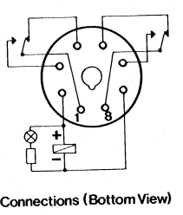
Using Voltage:
When a good coil is energized it will give a voltage drop reading, close to voltage source. When a good coil is not energized it will read nearly .000 volts. If it reads voltage or ghost voltage the coil is bad.

Using Resistance:
Remove the coil from the circuit and test it using the resistance function. A good coil will offer resistance (you probably will not know the exact resistance unless you check manufacturer's specifications or the resistance of a known good coil). A bad coil will read OL if open.

Relay contacts are tested like other contacts.

R1 Good/Bad (Circle One)
For our relays:
OFF = Coil de-energized
ON = Coil energized
Coil Resistance: _________________

Rs 1 to 4 (off): _________________

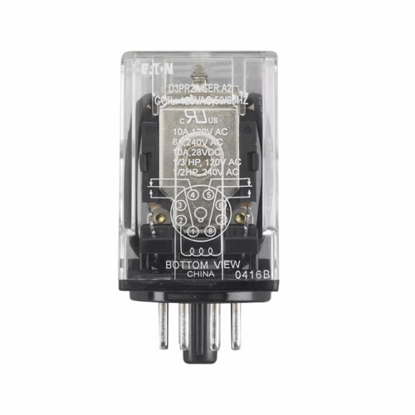
Rs 1 to 4 (on): _________________

Rs 1 to 3 (off): _________________

Rs 1 to 3 (on): _________________

Rs 8 to 6 (off): _________________

Rs 8 to 6 (on): _________________

Rs 8 to 5 (off): _________________

Rs 8 to 5 (on): _________________

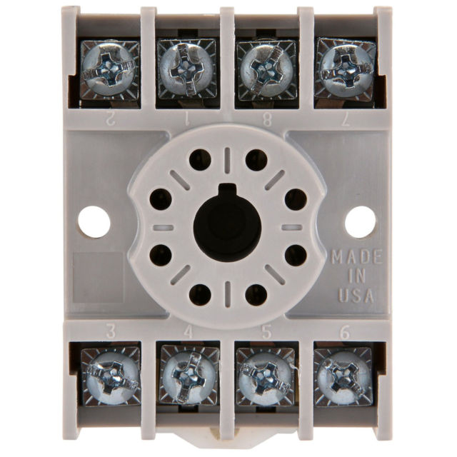
R2 Good/Bad (Circle One)
6
3
4
5
1
2
7
8

Coil Resistance: _________________

Rs 1 to 4 (off): _________________

Rs 1 to 4 (on): _________________

Rs 1 to 3 (off): _________________

Rs 1 to 3 (on): _________________

Rs 8 to 6 (off): _________________

Rs 8 to 6 (on): _________________

Rs 8 to 5 (off): _________________

Rs 8 to 5 (on): _________________

Part 3: Test a Transformer

Using Voltage (not part of today’s lab, but often the crucial first step):
Test secondary voltage. If there is no voltage, test the primary voltage. If there is no primary voltage, test the supply voltage, for example at a circuit breaker box. If there is the correct primary voltage but no secondary voltage test the transformer using an ohmmeter.

Using Resistance:
Inspect the transformer for signs of overheating. Remove the transformer from the circuit by removing the primary and secondary leads.

Check the resistance of the primary and secondary coils at the transformer terminals. There should be some resistance reading if the coils are good. If the coils read OL the coils are bad and the transformer should be replaced.

Check the resistance of the primary and secondary coils to the metal of the transformers. There should be an OL reading if the coils and the insulation around the metal are good. If there is a resistance reading the coils are bad and the transformer should be replaced.

Check the resistance between the primary and secondary coils. There should be an OL reading if the coils are good. If there is a resistance reading the coils are bad and the transformer should be replaced.

Always try to determine why the transformer failed when the new transformer is installed.

Transformer 1 Good/Bad (Circle One)

Rs Primary Coil: ___________

Rs Secondary Coil: ___________

Rs Primary to housing: ___________

Rs Secondary to housing: ___________

Rs Primary to Secondary: ___________

Transformer 2 Good/Bad (Circle One)

Rs Primary Coil: ___________

Rs Secondary Coil: ___________

Rs Primary to housing: ___________

Rs Secondary to housing: ___________

Rs Primary to Secondary: ___________

Transformer 3 Good/Bad (Circle One)

Rs Primary Coil: ___________

Rs Secondary Coil: ___________

Rs Primary to housing: ___________

Rs Secondary to housing: ___________

Rs Primary to Secondary: ___________

Transformer 4 Good/Bad (Circle One)

Transformer 5 Good/Bad (Circle One)

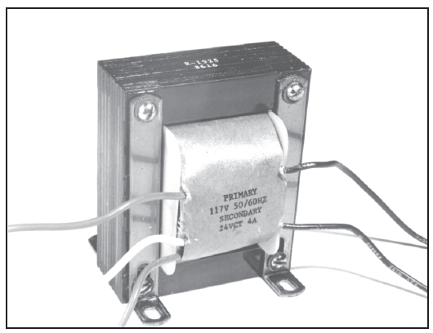

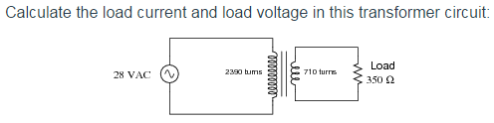
208 VAC
710 turns
20 Ω
29,536 turns

Voltage:

Current:

How many windings would there need to be if the voltage on the secondary side was to remain the same?

I use a switch-controlled 15V lamp on my nightstand because I’m afraid of the dark. I’ve forgotten how to wire my transformer and keep the Boogeyman away. Draw a schematic, then use the check-off method to help me by showing where the wires should go.
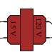
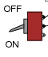


120 V
15 V

