ART 102

Understanding Art

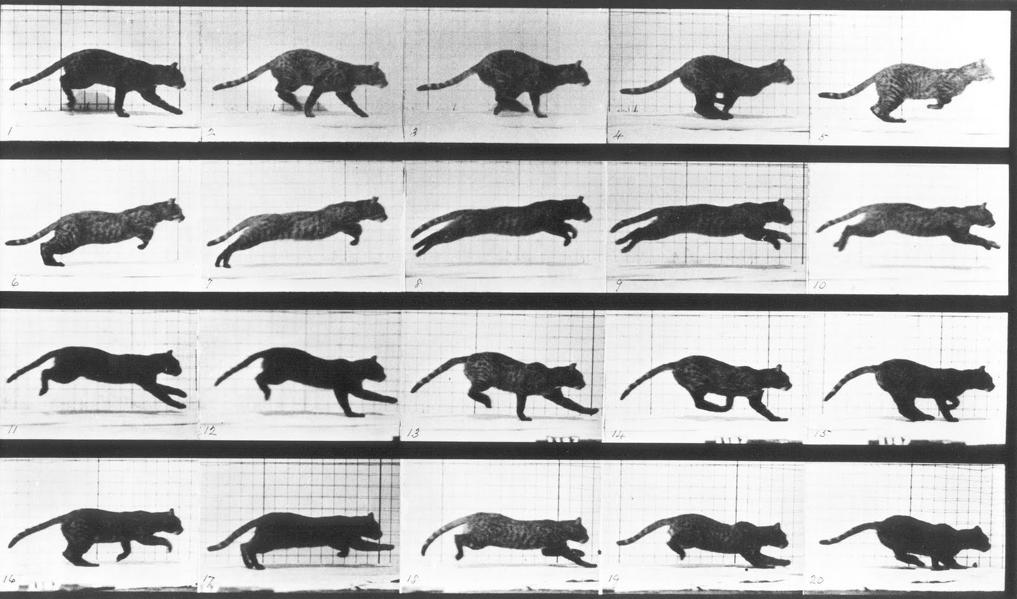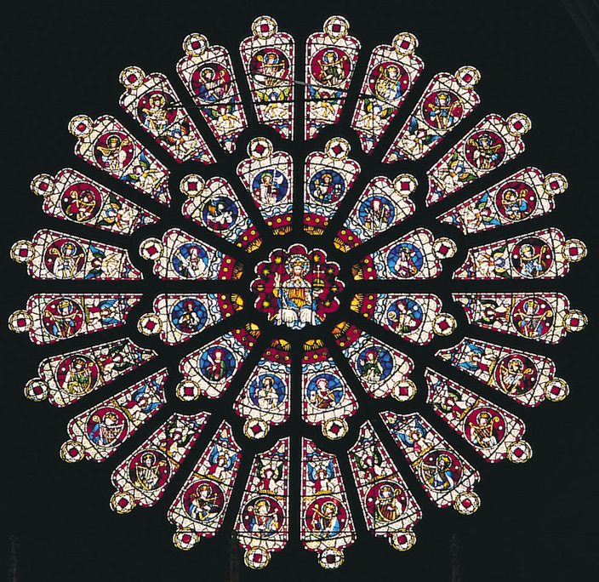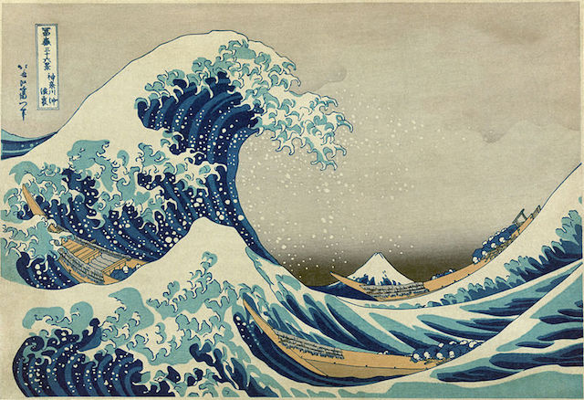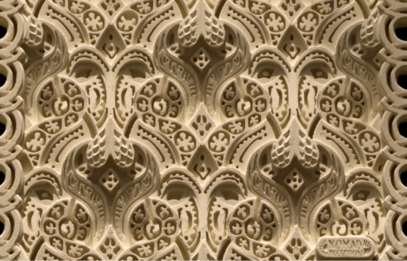
Winter 2017

Class Times:
CRN 30004 MWF 10-10:50
CRN 32270 TR 11:30-12:50
Location: MKH 203
Linn-Benton Community College

Professor: Isabelle Havet

Email:haveti@linnbenton.edu
Office: SSH 116C
Office Hours: MW 12-1; TR 1-2
& by appointment
Art 102  Understanding Art |  | Winter 2017  Class Times:  CRN 30004 MWF 10-10:50  CRN 32270 TR 11:30-12:50  Location: MKH 203
Professor: Isabelle Havet
E-mail: haveti@linnbenton.edu
Phone: 541-917-4559
Office: SSH 116C
Office Hours: MW 12-1; TR 1-2
& by appt.

Course Description

Understanding Art explores the ways we make, perceive, and interpret art, a well as the ways art impacts our daily lives. After gaining a practical understanding of formal elements and principles of design, students survey the major characteristics and developments of artistic movements and artworks within their cultural and historical contexts. Topics include, but are not limited to: drawing, painting, printmaking, sculpture, design, photography, architecture, digital arts and new media. This course focuses on building foundational knowledge of art and art history. Therefore, no prior experience is required.

Learning Outcomes
Upon successful completion of this course, students will be able to:
- Articulate verbally and in writing a general understanding of the significance of visual art in a wide variety of cultures and media.
- Create a personal work of art. Articulate verbally and in writing the form and content of the piece, along with information about significant artists and art works relative to the created artwork, and to visual art.
- Articulate verbally and in writing appropriate art vocabulary, and art evaluation concepts, when viewing visual art.
Credits: 3 credits; 3 hours of class per week.

General Education Requirements: Cultural Literacy AAOT/AAS, Human Relations AAS, AS Liberal Arts Core 1, AAS Human Relations, AAOT Arts & Letters, AS Literature & the Arts, AGS Humanities/Arts.

Prerequisites: None. This is an introductory-level art history course, therefore no prior knowledge of art or art history is required. Recommended (but not required): College-level reading and writing skills.

Textbook: No textbook is required. Readings and other instructional resources will be provided on the Moodle course site.

Course Assignments
- Weekly Readings & Videos
- Weekly Quizzes
- In-Class Activities & Practical Explorations
- Campus Art Scavenger Hunt
- Community Collaboration
- Art Analysis Paper
- Group Project & Presentation

Description of Course Assignments
- Readings & Videos
Read all assigned readings and watch all videos posted in Moodle (unless labeled ‘optional’). Please come to class having completed all assigned readings and be ready to talk about them.
- Attendance
Regular attendance is critical for success in this course. Attendance is taken each class session. If you know that you will not be able to attend class regularly, please drop this course, and feel welcome to re-enroll when you can commit to the class for the entire term.
- Weekly Quizzes
Students will take a short quiz in Moodle at the end of each week of instruction (Weeks 1-10). These assessments are designed to help students keep pace with the course material. Quizzes cover lectures, readings, and videos for that week, and will include a mix of multiple choice and short answer questions.
- In-Class Activities & Practical Explorations
Each week the class will complete activities revolving around a formal element, principle of design, or artistic technique. Some of these activities will be hands-on practical explorations involving the creation/recreation of an artistic technique. These are a chance for students to deepen their knowledge through creating. Some in-class activities will be graded and some will not. If a class activity is missed, it can likely not be made up.
- Campus Art Scavenger Hunt
You have probably noticed that there is a lot of art displayed at the college, both on the campus grounds and in virtually every building. Art is an important part of college life. You may or may not have had the chance to really stop and look at the different art offerings, or delve into the artworks more deeply. Now’s your chance! For the Art Scavenger Hunt, you will work in teams to locate and “collect” as many art objects, spaces, and campus resources as you can. The Instructor will provide a Scavenger Hunt list and instructions on the day of the activity. One smartphone with picture-taking capabilities required per team. What is the benefit of winning the Scavenger Hunt, aside from the glory? The winning team will receive a *special prize.*
- Community Collaboration
Make the world a better place–through art! Students will create a community service, open-license “resource” and share it outside of the class. Topics may include, but are not limited to: create a course study tool (e.g., flash cards, a learning game, visual aid, or multimedia presentation on a concept); contribute to Wikipedia; contribute commentary to a website/blog; post an answer on an online forum; write a blog entry on an art exhibition or other art topic. The object is to make something useful and compelling that people interested in the visual arts can use as a way to learn about or experience art. You are limited only by your imagination.

- Art Analysis Paper
Students will write a short (2-page) paper comparing and contrasting the formal elements of two selected artworks. Students will be graded on both a draft and a final version incorporating instructor/peer feedback.

- Group Project & Presentation
Teams will complete a Group Project revolving around a course topic and present their work to the class. Projects may include, but are not limited to: Teach a lesson; create an online art exhibition; create an art book or catalog; create a website. In-class workshops and resources will be provided during the term depending on the selected project activity.

Failure to submit an assignment or participate in an activity will result in a 0 grade.

Assignment | Points
Syllabus quiz | 10
Attendance | 50
Weekly Quizzes | 100
In-Class Activities & Practical Explorations | 50
Art Scavenger Hunt | 20
Community Collaboration | 70
Art Analysis Paper | 100
Group Project & Presentation | 100
Total Points | 500

Grading Scale
A 90-100% (450-500 points)
B 80-89% (400-449 points)
C 70-79% (350-399 points)
D 60-69& (300-349 points)
F 59% or below (299 or fewer points)
Class Structure
Class sessions will be a mix of lecture, discussions, workshops, and collaborative work. This term, our class is fortunate to be one of a few selected to demo the new Active Learning Classroom (ALC). This means we benefit from having a better space for interacting and collaborating one-on-one, trying out different activities, and using more electronic technology. Students get complimentary access to electronic tablets for use during class and will be able to personalize their assigned tablets. You must use your LBCC email account to sign on to the tablet, so be sure to know your email/password.
What do I need to do to be successful in this class?
- Attend class.
- Check your LBCC email. Check it frequently (preferably daily), or have your LBCC email forwarded to your prefered account.
- Communicate regularly. Communicate with the instructor as needed, in class or by email. I check email most weekdays and occasionally on weekends.
Please head your emails with the course number & your section days/time (e.g. ART 102 MWF 10-11), and sign your email with your first and last names. This will get you the fastest and most accurate response.
When working in a group, be available to your peers.
- When in class, focus on class. Class time is valuable. You should be focused on class while you are in the room; if you can’t focus, leave the room. Please feel comfortable eating, drinking, and leaving the room for the bathroom or communication needs. If you distract me with one of the above behaviors, I will call you on it. Your actions impact the class. One student’s lack of focus can distract others. If you find you have personal business to attend to (e.g. phones calls/texting, conversations, or other class work), take care of it outside of the classroom. We will be using electronic technology in this class. I believe that access to internet searches and applications will greatly enhance the course experience for all. I think it goes without saying, use it respectfully. I expect you to apply yourself to your education during class hours. You are the person who has the greatest impact on your learning and on your grade.
- Take notes during class, and of assigned readings/videos. This is an important college skill developed through practice. There will be times that you will be very glad to have your notes in class.
- Actively participate. You will NOT be successful in this class if you show up but then ‘tune out.’ Students who do not participate on a regular basis (by actively listening and engaging in discussions and activities) are unlikely to earn a passing grade. The goal in participation is not always to have the “right” ideas or answers. Rather, it is important to try your best, stretch yourself, build on your skills and knowledge, and to learn together as a class.
- Be positive and have fun! This course is about stretching our thinking and learning together. We will be questioning things, and growing a knowledge base together. We will also be looking at cool art and stuff. Bottom line: you’ll get what you put into this class.
- Be a good class citizen. This means be open to: 1) working with others, 2) being respectful, and 3) trying new things. It’s always OK to be unsure about how to do something; it’s never OK to give up without trying.
- Be a good team member. You will spend class time working with your “team.” Teams will have work assignments during many sessions (some graded, some not). Approach collaborative activities with the attitude that you can and will contribute something to the group, rather than with the attitude that you don’t know or can’t do something and so shouldn’t try. It’s OK if you don’t know something; the point is to learn together. People never stop learning–If you knew everything from the start, you wouldn’t need to take this class, or any class ever again. You should devote energy to getting to know your team members. The best teams are willing to work hard both with content and through style differences.
- Get ready to move. Be prepared to stand, move around, use your tablet and the internet, and talk each day in class. Do not become too attached to your seat.
- Be accountable. You are the person who has the greatest impact on your learning and your grade.

Course Policies
Institutional Drop for Non-Attendance
Faculty at LBCC may administratively withdraw a student for nonattendance during the first week of the term. The Instructor makes use of this policy.
You will have at least two assignments to complete in Moodle prior to the second Monday of the term (January 16, 2016). This will give you and the Instructor a sense of whether the class is a good fit for you.
To ensure your continued enrollment and success in the course, attend every class and complete ALL required assignments in Moodle during Week 1. Any issues using Moodle (e.g., can’t access course site; can’t take quizzes) MUST be resolved early during Week 1. Do NOT wait until the last minute! Work closely with the Help Desk if you are having any problems. Students will be automatically dropped by the second Monday of the term if they are not fully participating.
Moodle
This course uses the Moodle learning platform. Think of Moodle as the online class hub: use it to access announcements, the syllabus, class schedule, assignments guidelines, lecture slides, videos, readings, forums, and more.
You will use Moodle to turn in all assignments not completed in class. Assignments must be uploaded by Sunday at 5:00 pm on the week they are due (See Course Schedule for details). It is the student’s responsibility to upload assignments to Moodle in an acceptable file format (doc, docx, or pdf) by the deadline. If you are having trouble uploading an assignment, contact the Help Desk or email me right away (before the deadline!) It’s never a good idea to wait until the last minute to turn in work.
Please Note: ASSIGNMENTS MUST BE UPLOADED IN MOODLE. EMAILED ASSIGNMENTS WILL NEVER BE ACCEPTED. Please do not email me attached assignments. Contact me to troubleshoot, especially if it’s before the deadline. But be aware that if it’s not in Moodle, it won’t be graded.
Communication
The best way to reach me is via email, during office hours, or after class. I try to respond to email messages daily during weekdays. I will send out announcements, due date reminders, and important messages to your LBCC email via Moodle, and you are responsible for reading that information on time. Make sure check your LBCC email frequently, or forward your LBCC email to your personal email.
Attendance
The course spans only 10 weeks. It is vital to attend class regularly and arrive on time to each session. Please do not come late to class. It is disruptive, and you risk of missing important announcements and activities. If you miss an in-class activity or class quiz, you will likely not be allowed to make it up.
Attendance is taken each class session. Students are marked “Present,” “Absent,” “Late,” or “Excused” for each session.
-Present: Student arrives on time and stays the entire class session.
-Absent: Student does not attend a class session, or leaves early without prior approval from instructor. Unexcused absences negatively impact your course grade.
-Late: Student is 5 minutes late or more. 2 Late marks will result in an unexcused absence.
-Excused: Student has arranged an excused absence ahead of time with the Instructor. Excused absences are given at discretion of Instructor, and will require documentation.
Students start the term with 50 attendance points (10% of course grade). These points are the student’s to lose.
Please note: I understand that things happen. If you are late, are going to be late, or must miss a class for a valid reason (emergency, military duty, death in the family), see me right away. I will excuse tardiness or an absence for a valid reason if it is not a frequent occurrence. Documentation required for excused absences.

Resources

Moodle Support
If you have questions about using Moodle or need technical support, there are several campus resources available:
- Student Help Desk (located in the Library): Either visit, call at 541.917.4630, or email at student.helpdesk@linnbenton.edu
- LBCC Moodle User Support Forum: Look up questions on the forum or post your own here: http://elearning.linnbenton.edu/mod/forum/view.php?id=2697
Campus Resources
Many resources such as the Library, Learning Center, the Writing Desk, and Family Connections, are available to you as a student. They are described on the LBCC website.

Accessibility
You should meet with your instructor during the first week of class if:
- you have a documented disability and need accommodations,
- your instructor needs to know medical information about you, or
- you need special arrangements in the event of an emergency.
If you have documented your disability, remember that you must make your request for accommodations through the Center for Accessibility Resources Online Services web page every term in order to receive accommodations. If you believe you may need accommodations, but are not yet registered with CFAR, please go to http://linnbenton.edu/cfar for steps on how to apply for services or call 541-917-4789.
Facebook Page
I invite anyone to like my Facebook Page “Isabelle Havet Students.” It’s an account I maintain specifically for students at LBCC. It’s mostly a place where I share articles about Art, Art History, Visual Culture, and related interests of mine. I will also post things that I find are directly relevant to what we’re exploring in class. I consider it a community space for all. I welcome student contributions on the page, should you find an interesting article or news item related to the arts. Feel free to check it out here: https://www.facebook.com/ArtHistoryLBCC/
Extra Credit!

- Option 1: Use the Writing Center
You can receive up to five (5) extra credit points for using the Writing Center for a written assignment. These services are highly recommended!
To receive credit: Attach proof (a picture of the Writing Center dated stamp or other confirmation is fine) to the end of your paper.
Writing Center website: https://www.linnbenton.edu/writing-center
There are 3 ways to use the Writing Center:
  - Schedule a 30-minute appointment (recommended)
  - Use Drop-In Services
  - Use OWL (the Online Writing Lab).

- Option 2: Attend a campus/local lecture or exhibition: During the term, I will announce campus/local lectures and exhibitions that are of interest to the class. You can receive up to five (5) extra credit points for each event you attend by turning in a 1-page reflection paper on the event. In your reflection, you may discuss any aspect of the lecture or exhibition that struck you or that you feel ties into issues we’ve explored in the class, as long as you include some specific details showing you attended the event in-person. It can help to imagine that you’re a reporter or blogger writing a review of the event. Including pictures in your write-up is encouraged. Students are also encouraged to request permission to do an Extra Credit write-up of an alternative local event/exhibition that they would like to attend; instructor approval will be required.

Important Academic Calendar Dates:
- Last day to add/drop: January 17, 2016.
- Last day to withdraw: February 24, 2017.

Incomplete Grade Policy
Incompletes are given only in extraordinary and documented circumstances (i.e., a family emergency or serious medical excuse), and at the discretion of the Instructor. You must have regular attendance and completed most assignments for the class. If an Incomplete is granted, the Instructor will provide instructions as well as a nonnegotiable completion deadline for turning in all missing work. If the incomplete work is not turned in on time or is deemed unsatisfactory, the Incomplete will revert to an F-grade.

Academic Honesty
Academic honesty is an indispensable value as students acquire knowledge and develop skills in college. Students are expected to practice academic honesty by not cheating, plagiarizing, or misrepresenting their coursework in any way. Plagiarism, collusion, and other forms of misrepresentation hurt the student and run counter to the goals of education. Students are ultimately responsible for understanding and avoiding academic dishonesty, whether such incidences are intentional or unintentional. Violations will result in failure of an assignment, and possibly the course. All incidents of academic dishonesty will be reported to both the Associate Dean of Student Development and the Dean of Arts, Social Science & Humanities.

Course Schedule (Subject to change)
Week | Dates | Topic | Activities & Assignments
**All assignments due in Moodle on Sunday at 11:59pm of listed week**
1 | Jan 9-15 | Course Introduction Developing Visual Literacy  The Values of Art | Syllabus Quiz (Moodle)  Quiz 1 (Moodle)  **Failure to complete all Week 1 assignments in Moodle by Sunday at 5:00pm will result in automatic institutional withdrawal from course**
Part I: Formal Elements & Principles of Design
2 | Jan 16-22 | Line  Space | Art Scavenger Hunt (in class)  Quiz 2 (Moodle)
 | Mon, Jan 16 | Martin Luther King Day: College Closed
 | Tu, Jan 17 | Last day to add/drop
3 | Jan 23-29 | Light & Color  Principles of Design | Quiz 3 (Moodle)
4 | Jan 30-Feb 5 | Drawing  Printmaking | Library Workshop (CRN#32270: Thurs 2/2; CRN#30004: Fri 2/3)  Quiz 4 (Moodle)
Part II: Visual Media
5 | Feb 5-12 | Painting  Photography | Quiz 5 (Moodle)  Art Analysis Outline/Draft Due (Moodle)
6 | Feb 13-19 | Sculpture  Architecture | Quiz 6 (Moodle)
7 | Feb 20-26 | The Ancient World | Quiz 7 (Moodle)  Art Analysis Final Draft Due (Moodle)
 | Mon, Feb 20 | Holiday: College Closed
 | Fri, Feb 24 | Last Day to Withdraw (in person)
Part III: Introduction to the History of Art
8 | Feb 27-Mar 5 | The Middle Ages  Renaissance & Baroque | Quiz 8 (Moodle)  Group Project Concept Outline Due (Moodle)
9 | Mar 6-12 | 17th & 18th centuries  The 19th Century | Quiz 9 (Moodle)  Community Collaboration Due
10 | Mar 13-19 | 1900 to the Present | Quiz 10 (Moodle)  Group Project Final Report Due (Moodle)
11 | Mar 20-24 | Finals Week
 | MWF Section: Wed, Mar 22, 8-9:50am  TR Section:  Tues, Mar 21, 12:30-2:20pm | Group Presentations | Group Presentations (in class during Final Exam period)

