LINN-BENTON COMMUNITY COLLEGE

COLLEGE CHEMISTRY II (CH 122)

Open Education Resources Textbook

(CHEMISTRY OER TEXTBOOK)

This Version Is For Public Use.

Developed by Dr. Ommidala Pattawong
June 26, 2021

Attributions
This resource is a remix of several existing chemistry OER. See the attributions sections at the beginning of each chapter for more information. The author has chosen the most open license when possible, but to comply with license compatibility, some chapters have more restrictive licenses:
- Chapter 8: CC BY-NC-SA 4.0.
- Chapter 9: CC BY 4.0.
- Chapter 10: CC BY 4.0.
- Chapter 11: CC BY-NC-SA 4.0.
- Chapter 12: CC BY-NC-SA 4.0.
- Chapter 13: CC BY 4.0.

Table of Contents
Chapter Sections | Page
Chapter 8 – Attributions | 5 – 6
Chapter 8 – Thermochemistry  8.1 Nature of Energy and the First Law of Thermodynamics  8.2 Thermal Energy, Temperature, and Heat  8.3 Measuring Heat  8.4 Enthalpy - Heat of Reaction (∆H_{rxn})  8.5 Measuring Enthalpy from Calorimetry  8.6 Measuring Enthalpy from Hess’s Law  8.7 Measuring Enthalpy from Standard Enthalpies of Formation | 7 – 8  9 – 11  12 – 16  17 – 24  25 – 36  37 – 45  46 – 49  50 – 53
Appendix I: Standard Enthalpies of Formation | 54 – 78
Chapter 9 – Attributions | 79 – 80
Chapter 9 – Gases  9.1 Pressure  9.2 Simple Gas Laws  9.3 The Kinetic Molecular Theory  9.4 The Ideal Gas Law and Its Applications  9.5 Mixtures of Gases and Partial Pressure  9.6 Gas Stoichiometry | 81 – 82  83 – 92  93 – 104  105 – 110  111 – 122  123 – 128  129 – 136
Chapter 10 – Attributions | 137 – 138
Chapter 10 – Solids, Liquids & Their Intermolecular Forces  10.1 Intermolecular Forces  10.2 Properties of Liquids  10.3 Phase Transitions  10.4 Phase Diagrams | 139 – 140  141 – 158  159 – 166  167 – 179  180 – 192

Table of Contents (Continue)
Chapter Sections | Page
Chapter 11 – Attributions | 193 – 194
Chapter 11 – Solutions  11.1 Types of Solutions  11.2 Formation of Solutions and Dissolution Process  11.3 Electrolytes  11.4 Factors that Affect Solubility  11.5 Concentration Units  11.6 Dilution of Solution  11.7 Colligative Properties | 195 – 196  197 – 200  201 – 207  208 – 212  213 – 225  226 – 234  235 – 239  240 – 266
Chapter 12 – Attributions | 267 – 268
Chapter 12 – Chemical Kinetics  12.1 Chemical Reaction Rate  12.2 Factors Affecting Reaction Rate  12.3 Collision Theory  12.4 Differential Rate Laws  12.5 Integrated Rate Laws  12.6 Reaction Mechanisms | 269 – 271  271 – 280  281 – 284  285 – 290  291 – 300  301 – 317  318 – 328
Chapter 13 – Attributions | 329 – 330
Chapter 13 – Chemical Equilibrium  13.1 Concept of Dynamic Equilibrium  13.2 Reaction Quotient (Q) and Equilibrium Constant (K)  13.3 Chemical Equations and Equilibrium Constant Relation  13.4 Equilibrium Calculations  13.5 Le Chaterlier’s Principle | 331 – 332  333– 336  337 – 347  348 – 350  351 – 360  361 – 370

Chapter 8 – Attributions

The contents in this chapter, licensed under CC BY-NC-SA 4.0. has been adopted, modified, reorganized, and/or remixed from the following:

8.0 Introduction
"5 Introduction" by Paul Flowers, Klaus Theopold, Richard Langley, William R. Robinson,, OpenStax is licensed under CC BY 4.0

8.1 Nature of Energy and the First Law of Thermodynamics
"5.1 Energy Basics" by Paul Flowers, Klaus Theopold, Richard Langley, William R. Robinson,, OpenStax is licensed under CC BY 4.0

8.2 Thermal Energy, Temperature, and Heat
"19.3 Molecular Degrees of Freedom" by Mike Blaber, LibreTexts is licensed under CC BY-NC-SA 3.0
"5.1 Energy Basics" by Paul Flowers, Klaus Theopold, Richard Langley, William R. Robinson,, OpenStax is licensed under CC BY 4.0

8.3 Measuring Heat
"5.1 Energy Basics" by Paul Flowers, Klaus Theopold, Richard Langley, William R. Robinson,, OpenStax is licensed under CC BY 4.0

8.4 Enthalpy - Heat of Reaction (∆H_{rxn})
"5.3 Enthalpy" by Paul Flowers, Klaus Theopold, Richard Langley, William R. Robinson,, OpenStax is licensed under CC BY 4.0

8.5 Measuring Enthalpy from Calorimetry
"5.2 Calorimetry" by Paul Flowers, Klaus Theopold, Richard Langley, William R. Robinson,, OpenStax is licensed under CC BY 4.0

8.6 Measuring Enthalpy from Hess’s Law
"5.3 Enthalpy" by Paul Flowers, Klaus Theopold, Richard Langley, William R. Robinson,, OpenStax is licensed under CC BY 4.0

8.7 Measuring Enthalpy from Standard Enthalpies of Formation
"5.3 Enthalpy" by Paul Flowers, Klaus Theopold, Richard Langley, William R. Robinson,, OpenStax is licensed under CC BY 4.0

Chapter 8 Thermochemistry

Chapter Introduction

8.1 Nature of Energy and the First Law of Thermodynamics

8.2 Thermal Energy, Temperature, and Heat

8.3 Measuring Heat

8.4 Enthalpy - Heat of Reaction (∆H_{rxn})

8.5 Measuring Enthalpy from Calorimetry

8.6 Measuring Enthalpy from Hess’s Law

8.7 Measuring Enthalpy from Standard Enthalpies of Formation

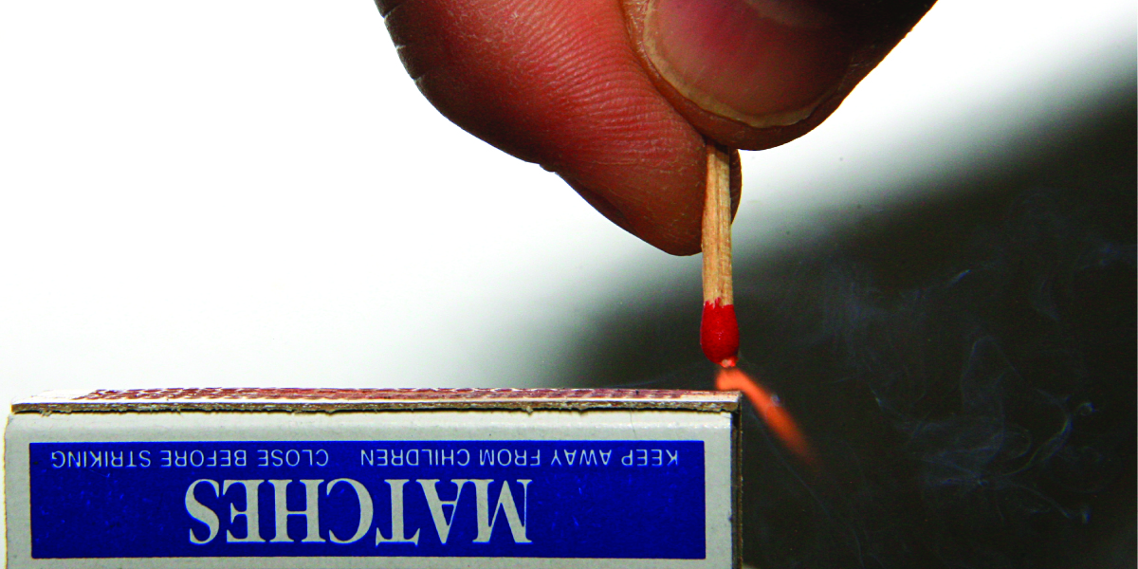
Figure 8.1 Sliding a match head along a rough surface initiates a combustion reaction that produces energy in the form of heat and light. (credit: modification of work by Laszlo Ilyes)
Chemical reactions, such as those that occur when you light a match, involve changes in energy as well as matter. Societies at all levels of development could not function without the energy released by chemical reactions. In 2012, about 85% of US energy consumption came from the combustion of petroleum products, coal, wood, and garbage. We use this energy to produce electricity (38%); to transport food, raw materials, manufactured goods, and people (27%); for industrial production (21%); and to heat and power our homes and businesses (10%).1 While these combustion reactions help us meet our essential energy needs, they are also recognized by the majority of the scientific community as a major contributor to global climate change.

Useful forms of energy are also available from a variety of chemical reactions other than combustion. For example, the energy produced by the batteries in a cell phone, car, or flashlight results from chemical reactions. This chapter introduces many of the basic ideas necessary to explore the relationships between chemical changes and energy, with a focus on thermal energy.

Footnotes
- 1 US Energy Information Administration, Primary Energy Consumption by Source and Sector, 2012, http://www.eia.gov/totalenergy/data/monthly/pdf/flow/css_2012_energy.pdf. Data derived from US Energy Information Administration, Monthly Energy Review (January 2014).

8.1 Nature of Energy and the First Law of Thermodynamics

Learning Objectives
- Define energy, distinguish types of energy, and describe the nature of energy changes that accompany chemical and physical changes
- Understand units of energy
- Define and apply the first law of thermodynamics
- Assign the signs associated with the transfer of energy

Introduction
Chemical changes and their accompanying changes in energy are important parts of our everyday world (Figure 8.2). The macronutrients in food (proteins, fats, and carbohydrates) undergo metabolic reactions that provide the energy to keep our bodies functioning. We burn a variety of fuels (gasoline, natural gas, coal) to produce energy for transportation, heating, and the generation of electricity. Industrial chemical reactions use enormous amounts of energy to produce raw materials (such as iron and aluminum). Energy is then used to manufacture those raw materials into useful products, such as cars, skyscrapers, and bridges.
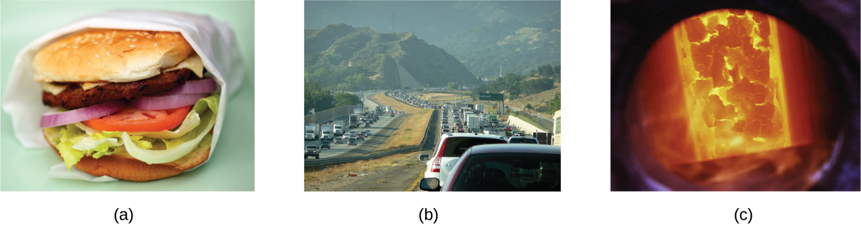
Figure 5.2 The energy involved in chemical changes is important to our daily lives: (a) A cheeseburger for lunch provides the energy you need to get through the rest of the day; (b) the combustion of gasoline provides the energy that moves your car (and you) between home, work, and school; and (c) coke, a processed form of coal, provides the energy needed to convert iron ore into iron, which is essential for making many of the products we use daily. (credit a: modification of work by “Pink Sherbet Photography”/Flickr; credit b: modification of work by Jeffery Turner)
This chapter will introduce the basic ideas of thermochemistry. The thermochemistry is an area of science concerned with the amount of heat absorbed or released during chemical and physical changes. The concepts introduced in this chapter are widely used in almost all scientific and technical fields. Food scientists use them to determine the energy content of foods. Biologists study the energetics of living organisms, such as the metabolic combustion of sugar into carbon dioxide and water. The oil, gas, and transportation industries, renewable energy providers, and many others endeavor to find better methods to produce energy for our commercial and personal needs. Engineers strive to improve energy efficiency, find better ways to heat and cool our homes, refrigerate our food and drinks, and meet the energy and cooling needs of computers and electronics, among other applications. Understanding thermochemical principles is essential for chemists, physicists, biologists, geologists, every type of engineer, and just about anyone who studies or does any kind of science.

Energy
Energy (E) can be defined as the capacity to supply heat or do work. Work (w) is the process of causing matter to move against an opposing force. For example, we do work when we inflate a bicycle tire—we move matter (the air in the pump) against the opposing force of the air already in the tire. Heat (q) is the flow of energy caused by a temperature difference.

Like matter, energy comes in different types. One scheme classifies energy into two types: potential energy is the energy an object has because of its relative position, composition, or condition, and kinetic energy is the energy that an object possesses because of its motion. Water at the top of a waterfall or dam has potential energy because of its position; when it flows downward through generators, it has kinetic energy that can be used to do work and produce electricity in a hydroelectric plant (Figure 8.3). A battery has potential energy because the chemicals within it can produce electricity that can do work.
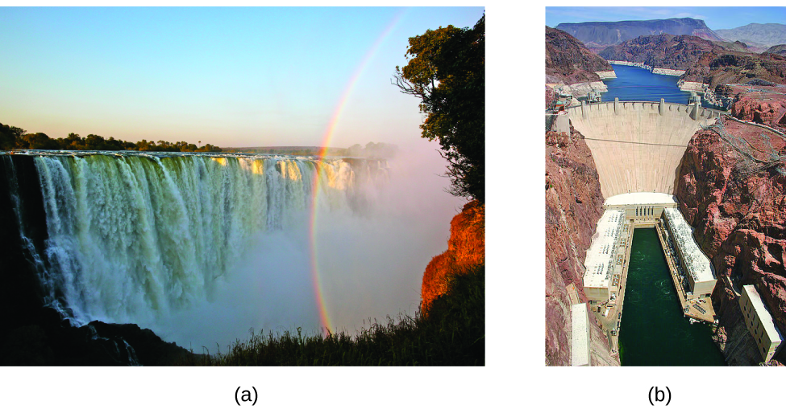
Figure 8.3 (a) Water at a higher elevation, for example, at the top of Victoria Falls, has a higher potential energy than water at a lower elevation. As the water falls, some of its potential energy is converted into kinetic energy. (b) If the water flows through generators at the bottom of a dam, such as the Hoover Dam shown here, its kinetic energy is converted into electrical energy. (credit a: modification of work by Steve Jurvetson; credit b: modification of work by “curimedia”/Wikimedia commons)

Energy can be converted from one form into another, but all of the energy present before a change occurs always exists in some form after the change is completed. This observation is expressed in the law of conservation of energy: during a chemical or physical change, energy can be neither created nor destroyed, although it can be changed in form. This is known as the first law of thermodynamics.

When one substance is converted into another, there is always an associated conversion of one form of energy into another. Heat is usually released or absorbed, but sometimes the conversion involves light, electrical energy, or some other form of energy. For example, chemical energy (a type of potential energy) is stored in the molecules that compose gasoline. When gasoline is combusted within the cylinders of a car’s engine, the rapidly expanding gaseous products of this chemical reaction generate mechanical energy (a type of kinetic energy) when they move the cylinders’ pistons.

8.2 Thermal Energy, Temperature, and Heat

Learning Objectives
- Distinguish the related properties of heat, thermal energy, and temperature
- Predict the flow of heat and assign the sign of heat flow
- Define the term “endothermic” and “exothermic”

Introduction
In the previous section we briefly discussed energy, both kinetic and potential. This chapter section will focus on energy in the form of heat. The chapter will start with some definitions regarding heat and heat transfer.

Thermal Energy
Thermal energy is kinetic energy (KE) associated with the random motion of atoms and molecules, such as translational, rotational, and vibrational motions (Figure 8.4).
- Translational motion. The entire molecule can move in some direction in three dimensions
- Rotational motion. The entire molecule can rotate around any axis, (even though it may not actually change its position translationally)
- Vibrational motion. The atoms within a molecule have certain freedom of movement relative to each other; this displacement can be periodic motion like the vibration of a tuning fork
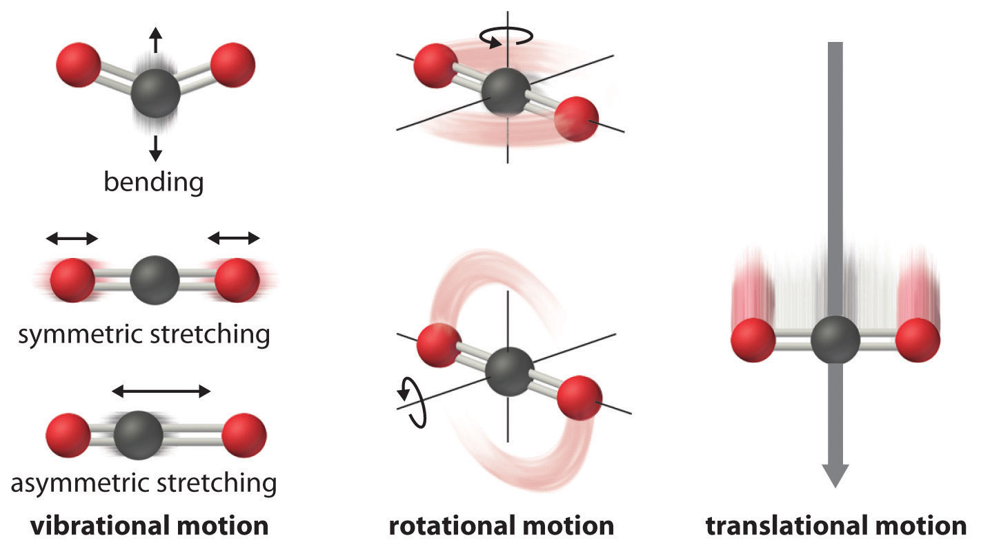

Figure 8.4 Molecular Motions. Vibrational, rotational, and translational motions of a carbon dioxide molecule are illustrated here. Only a perfectly ordered, crystalline substance at absolute zero would exhibit no molecular motion and have zero entropy. In practice, this is an unattainable ideal. (credit: "Molecular Degrees of Freedom" by LibreTexts is licensed under CC BY-NC-SA 3.0

Temperature
Temperature is a quantitative measure of “hot” or “cold.” When the atoms and molecules in an object are moving or vibrating quickly, they have a higher average kinetic energy (KE), and we say that the object is “hot.” When the atoms and molecules are moving slowly, they have lower average KE, and we say that the object is “cold” (Figure 8.5). Assuming that no chemical reaction or phase change (such as melting or vaporizing) occurs, increasing the amount of thermal energy in a sample of matter will cause its temperature to increase. And, assuming that no chemical reaction or phase change (such as condensation or freezing) occurs, decreasing the amount of thermal energy in a sample of matter will cause its temperature to decrease.
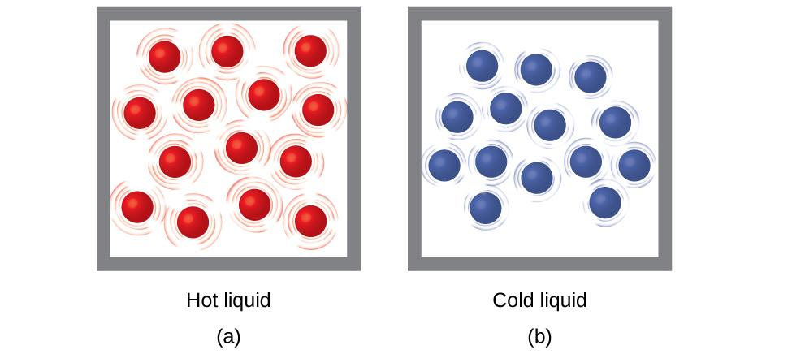
Figure 8.5 (a) The molecules in a sample of hot water move more rapidly than (b) those in a sample of cold water.
Most substances expand as their temperature increases and contract as their temperature decreases. This property can be used to measure temperature changes, as shown in Figure 8.6. The operation of many thermometers depends on the expansion and contraction of substances in response to temperature changes.

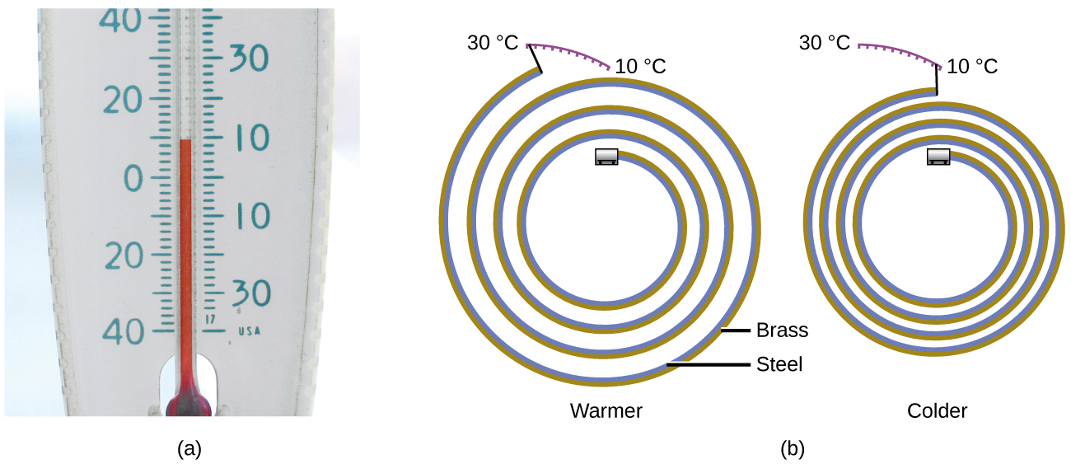
Figure 8.6 (a) In an alcohol or mercury thermometer, the liquid (dyed red for visibility) expands when heated and contracts when cooled, much more so than the glass tube that contains the liquid. (b) In a bimetallic thermometer, two different metals (such as brass and steel) form a two-layered strip. When heated or cooled, one of the metals (brass) expands or contracts more than the other metal (steel), causing the strip to coil or uncoil. Both types of thermometers have a calibrated scale that indicates the temperature. (credit a: modification of work by “dwstucke”/Flickr)

Heat
Heat (q) is the transfer of thermal energy between two bodies at different temperatures. Heat flow (a redundant term, but one commonly used) increases the thermal energy of one body and decreases the thermal energy of the other. Suppose we initially have a high temperature (and high thermal energy) substance (H) and a low temperature (and low thermal energy) substance (L). The atoms and molecules in H have a higher average KE than those in L. If we place substance H in contact with substance L, the thermal energy will flow spontaneously from substance H to substance L. The temperature of substance H will decrease, as will the average KE of its molecules; the temperature of substance L will increase, along with the average KE of its molecules. Heat flow will continue until the two substances are at the same temperature (Figure 8.7).

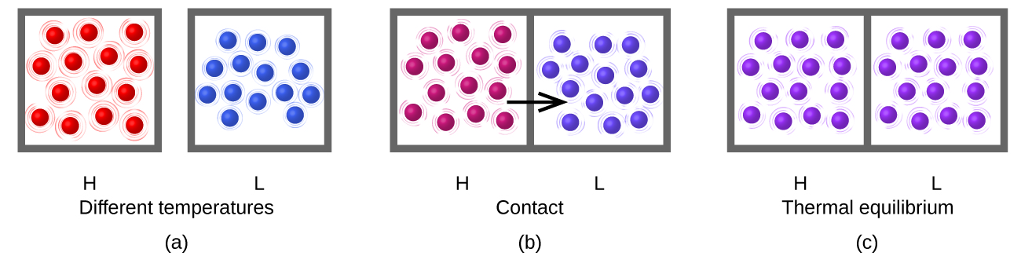
Figure 8.7 (a) Substances H and L are initially at different temperatures, and their atoms have different average kinetic energies. (b) When they contact each other, collisions between the molecules result in the transfer of kinetic (thermal) energy from the hotter to the cooler matter. (c) The two objects reach “thermal equilibrium” when both substances are at the same temperature and their molecules have the same average kinetic energy.

Matter undergoing chemical reactions and physical changes can release or absorb heat. A change that releases heat is called an exothermic process. A negative sign of heat (-q) indicates that the chemical reaction releasing heat. For example, the combustion reaction that occurs when using an oxyacetylene torch is an exothermic process—this process also releases energy in the form of light as evidenced by the torch’s flame (Figure 8.8). A reaction or change that absorbs heat is an endothermic process. A positive sign of heat (+q) indicates that the chemical reaction absorbing heat. A cold pack used to treat muscle strains provides an example of an endothermic process. When the substances in the cold pack (water and a salt like ammonium nitrate) are brought together, the resulting process absorbs heat, leading to the sensation of cold.

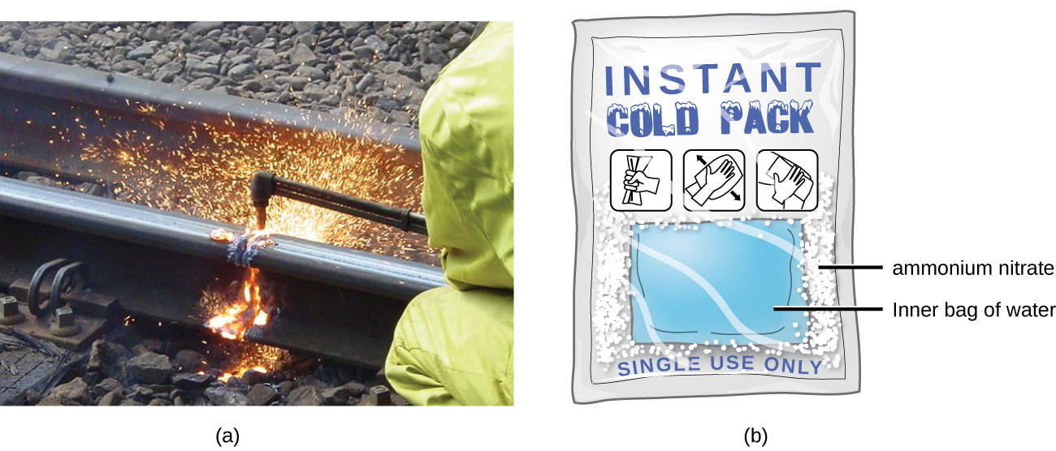
Figure 8.8 (a) An oxyacetylene torch produces heat by the combustion of acetylene in oxygen. The energy released by this exothermic reaction heats and then melts the metal being cut. The sparks are tiny bits of the molten metal flying away. (b) A cold pack uses an endothermic process to create the sensation of cold. (credit a: modification of work by “Skatebiker”/Wikimedia commons)

8.3 Measuring Heat

Learning Objectives
- Define and distinguish specific heat and heat capacity, and describe the physical implications of both
- Perform calculations involving heat, specific heat, and temperature change

Units of Energy and Heat
Historically, energy and heat were measured in units of calories (cal). A calorie is the amount of energy required to raise one gram of water by 1 degree C (1 kelvin). However, this quantity depends on the atmospheric pressure and the starting temperature of the water. The ease of measurement of energy changes in calories has meant that the calorie is still frequently used. The Calorie (Cal, with a capital C), or large calorie, commonly used in quantifying food energy content, is a kilocalorie. The SI unit of heat, work, and energy is the joule. A joule (J) is defined as the amount of energy used when a force of 1 newton moves an object 1 meter. It is named in honor of the English physicist James Prescott Joule. One joule is equivalent to 1 kg·m²/s², which is also called 1 newton–meter. A kilojoule (kJ) is 1000 joules. To standardize its definition, 1 calorie has been set to equal 4.184 joules.

Energy and Heat Conversion Factors
1 calorie (cal) = 4.184 joules (J)
1 Calorie (Cal) = 1 kilocalorie (kcal) = 1000 cal = 4184 J
1 joule (J) = 1 kg·m²/s²

Heat Capacity
We now introduce two concepts useful in describing heat flow and temperature change. The heat capacity (C) of a body of matter is the quantity of heat (q) it absorbs or releases when it experiences a temperature change (ΔT) of 1 degree Celsius (or equivalently, 1 kelvin):
C = q / ΔT
Heat capacity is determined by both the type and amount of substance that absorbs or releases heat. It is therefore an extensive property—its value is proportional to the amount of the substance.
For example, consider the heat capacities of two cast iron frying pans. The heat capacity of the large pan is five times greater than that of the small pan because, although both are made of the same material, the mass of the large pan is five times greater than the mass of the small pan. More mass means more atoms are present in the larger pan, so it takes more energy to make all of those atoms vibrate faster. The heat capacity of the small cast iron frying pan is found by observing that it takes 18,150 J of energy to raise the temperature of the pan by 50.0 °C:

C_{small pan} = (18,150 J) / (50.0°C) = 363J/°C

The larger cast iron frying pan, while made of the same substance, requires 90,700 J of energy to raise its temperature by 50.0 °C. The larger pan has a (proportionally) larger heat capacity because the larger amount of material requires a (proportionally) larger amount of energy to yield the same temperature change:

C_{large pan} = (90,700 J) / (50.0°C) = 1814J/°C

Specific Heat Capacity
The specific heat capacity (c) of a substance, commonly called its “specific heat,” is the quantity of heat required to raise the temperature of 1 gram of a substance by 1 degree Celsius (or 1 kelvin):
c = q / m·ΔT
Specific heat capacity depends only on the kind of substance absorbing or releasing heat. It is an intensive property—the type, but not the amount, of the substance is all that matters. For example, the small cast iron frying pan has a mass of 808 g. The specific heat of iron (the material used to make the pan) is therefore:

c_{iron} = (18,140 J) / (808 g) (50.0°C) = 0.449 J/g °C

The large frying pan has a mass of 4040 g. Using the data for this pan, we can also calculate the specific heat of iron:

c_{iron} = (90,700 J) / (4040 g) (50.0°C) = 0.449 J/g °C

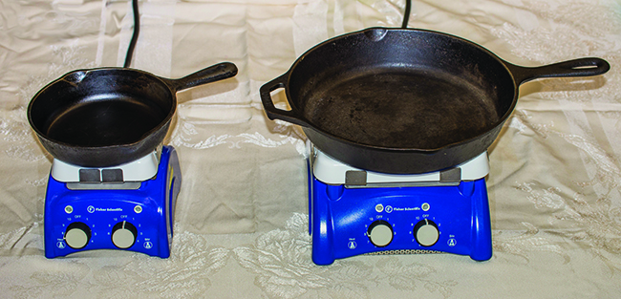
Although the large pan is more massive than the small pan, since both are made of the same material, they both yield the same value for specific heat (for the material of construction, iron). Note that specific heat is measured in units of energy per temperature per mass and is an intensive property, being derived from a ratio of two extensive properties (heat and mass).
The molar heat capacity, also an intensive property, is the heat capacity per mole of a particular substance and has units of J/mol °C (Figure 8.9).

Figure 8.9 Because of its larger mass, a large frying pan has a larger heat capacity than a small frying pan. Because they are made of the same material, both frying pans have the same specific heat. (credit: Mark Blaser)
Water has a relatively high specific heat (about 4.2 J/g °C for the liquid and 2.09 J/g °C for the solid). Most metals have much lower specific heats (usually less than 1 J/g °C). The specific heat of a substance varies somewhat with temperature. However, this variation is usually small enough that we will treat specific heat as constant over the range of temperatures that will be considered in this chapter. Specific heats of some common substances are listed in Table 8.1.

Table 8.1 Specific Heats of Common Substances at 25 ºC and 1 bar.
Substance | Symbol (state) | Specific Heat (J/g °C)
helium | He(g) | 5.193
water | H₂O(l) | 4.184
ethanol | C₂H₆O(l) | 2.376
ice | H₂O(s) | 2.093 (at −10 °C)
water vapor | H₂O(g) | 1.864
nitrogen | N₂(g) | 1.040
air |  | 1.007
oxygen | O₂(g) | 0.918
aluminum | Al(s) | 0.897
carbon dioxide | CO₂(g) | 0.853
argon | Ar(g) | 0.522
iron | Fe(s) | 0.449
copper | Cu(s) | 0.385
lead | Pb(s) | 0.130
gold | Au(s) | 0.129
silicon | Si(s) | 0.712

Measuring Heat
If we know the mass of a substance and its specific heat, we can determine the amount of heat, q, entering or leaving the substance by measuring the temperature change before and after the heat is gained or lost:
q = c · m · ΔT
q = c · m · (T_{final} − T_{initial})
In this equation, c is the specific heat of the substance, m is its mass, and ΔT (which is read “delta T”) is the temperature change, Tfinal − Tinitial. If a substance gains thermal energy, its temperature increases, its final temperature is higher than its initial temperature, Tfinal − Tinitial has a positive value, and the value of qis positive. If a substance loses thermal energy, its temperature decreases, the final temperature is lower than the initial temperature, Tfinal − Tinitial has a negative value, and the value of q is negative.

Example 8.1
Measuring Heat: A flask containing 8.0 × 10² g of water is heated, and the temperature of the water increases from 21 °C to 85 °C. How much heat did the water absorb in kJ?

Solution: To answer this question, consider these factors:
- the specific heat of the substance being heated (in this case, water)
- the amount of substance being heated (in this case, 8.0 × 102 g)
- the magnitude of the temperature change (in this case, from 21 °C to 85 °C).
The specific heat of water is 4.184 J/g °C, so to heat 1 g of water by 1 °C requires 4.184 J. We note that since 4.184 J is required to heat 1 g of water by 1 °C, we will need 800 times as much to heat 8.0 × 10² g of water by 1 °C. Finally, we observe that since 4.184 J are required to heat 1 g of water by 1 °C, we will need 64 times as much to heat it by 64 °C (that is, from 21 °C to 85 °C).

This can be summarized using the equation:
q = c · m · (T_{final} − T_{initial})
= (4.184J/g°C)·(8.0x10²g)·(85−21)°C
= (4.184J/g°C)·(8.0x10²g)·(64)°C
= 210,000 J
= 2.1×10² kJ
Because the temperature increased, the water absorbed heat and q is positive.

Check Your Learning
How much heat, in joules, must be added to a 5.07 × 104 J iron skillet to increase its temperature from 25 °C to 250 °C? The specific heat of iron is 0.449 J/g °C.
Answer: 5.07 × 10⁴ J
Note that the relationship between heat, specific heat, mass, and temperature change can be used to determine any of these quantities (not just heat) if the other three are known or can be deduced.

Example 8.2
Determining Other Quantities: A piece of unknown metal weighs 348 g. When the metal piece absorbs 6.64 kJ of heat, its temperature increases from 22.4 °C to 43.6 °C. Determine the specific heat of this metal (which might provide a clue to its identity).

Solution: Since mass, heat, and temperature change are known for this metal, we can determine its specific heat using the relationship:
q = c · m · (T_{final} − T_{initial})
Substituting the known values:
6640 J = c ·(348 g)·(43.6−22.4)°C
Solving:
c = 6640 J·(348 g)·(21.2°C) = 0.900 J/g °C
Comparing this value with the values in Table 8.1, this value matches the specific heat of aluminum, which suggests that the unknown metal may be aluminum.

Check Your Learning
A piece of unknown metal weighs 217 g. When the metal piece absorbs 1.43 kJ of heat, its temperature increases from 24.5 °C to 39.1 °C. Determine the specific heat of this metal, and predict its identity.
Answer: c = 0.451 J/g °C; the metal is likely to be iron

Chemistry in Everyday Life
Solar Thermal Energy Power Plants
The sunlight that reaches the earth contains thousands of times more energy than we presently capture. Solar thermal systems provide one possible solution to the problem of converting energy from the sun into energy we can use. Large-scale solar thermal plants have different design specifics, but all concentrate sunlight to heat some substance; the heat “stored” in that substance is then converted into electricity.

The Solana Generating Station in Arizona’s Sonora Desert produces 280 megawatts of electrical power. It uses parabolic mirrors that focus sunlight on pipes filled with a heat transfer fluid (HTF) (Figure 8.10). The HTF then does two things: It turns water into steam, which spins turbines, which in turn produces electricity, and it melts and heats a mixture of salts, which functions as a thermal energy storage system. After the sun goes down, the molten salt mixture can then release enough of its stored heat to produce steam to run the turbines for 6 hours. Molten salts are used because they possess a number of beneficial properties, including high heat capacities and thermal conductivities.
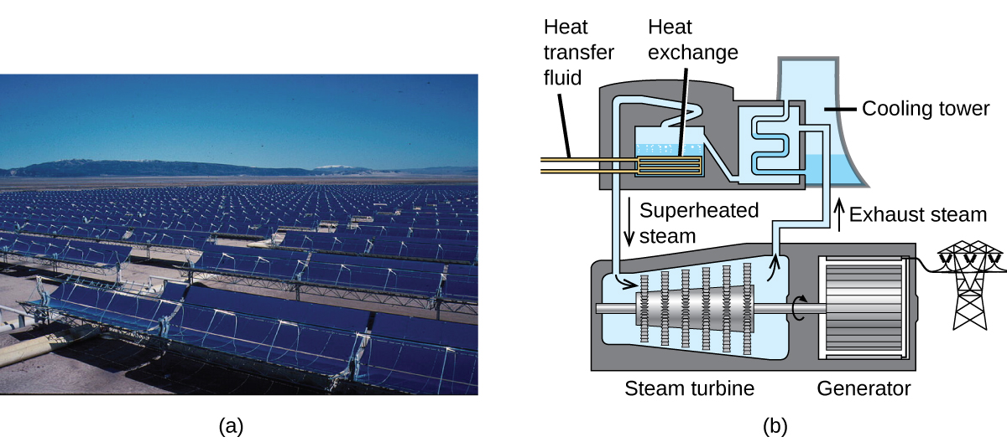
Figure 8.10 This solar thermal plant uses parabolic trough mirrors to concentrate sunlight. (credit a: modification of work by Bureau of Land Management)

The 377-megawatt Ivanpah Solar Generating System, located in the Mojave Desert in California, is the largest solar thermal power plant in the world (Figure 8.11). Its 170,000 mirrors focus huge amounts of sunlight on three water-filled towers, producing steam at over 538 °C that drives electricity-producing turbines. It produces enough energy to power 140,000 homes. Water is used as the working fluid because of its large heat capacity and heat of vaporization.
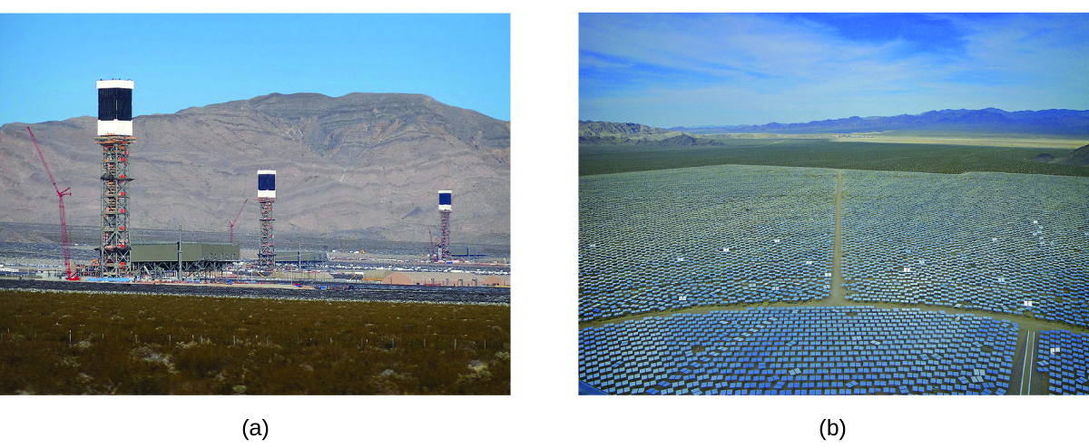
Figure 8.11 (a) The Ivanpah solar thermal plant uses 170,000 mirrors to concentrate sunlight on water-filled towers. (b) It covers 4000 acres of public land near the Mojave Desert and the California-Nevada border. (credit a: modification of work by Craig Dietrich; credit b: modification of work by “USFWS Pacific Southwest Region”/Flickr)

8.4 Enthalpy - Heat of Reaction

Learning Objectives
- Know what ∆H_{rxn} represents
- Assign the sign for ∆H_{rxn} and relating to the term “endothermic” and “exothermic”
- Use stoichiometry to calculate heat absorption or release during a chemical
- State the first law of thermodynamics
- Define enthalpy and explain its classification as a state function
- Write and balance thermochemical equations
- Calculate enthalpy changes for various chemical reactions

Introduction
Substances act as reservoirs of energy, meaning that energy can be added to them or removed from them. Energy is stored in a substance when the kinetic energy of its atoms or molecules is raised. The greater kinetic energy may be in the form of increased translations (travel or straight-line motions), vibrations, or rotations of the atoms or molecules. When thermal energy is lost, the intensities of these motions decrease and the kinetic energy falls. The total of all possible kinds of energy present in a substance is called the internal energy (U), sometimes symbolized as E.
As a system undergoes a change, its internal energy can change, and energy can be transferred from the system to the surroundings, or from the surroundings to the system. Energy is transferred into a system when it absorbs heat (q) from the surroundings or when the surroundings do work (w) on the system. For example, energy is transferred into room-temperature metal wire if it is immersed in hot water (the wire absorbs heat from the water), or if you rapidly bend the wire back and forth (the wire becomes warmer because of the work done on it). Both processes increase the internal energy of the wire, which is reflected in an increase in the wire’s temperature. Conversely, energy is transferred out of a system when heat is lost from the system, or when the system does work on the surroundings. The relationship between internal energy, heat, and work can be represented by the equation:
ΔU = q + w
as shown in Figure 8.12. This is one version of the first law of thermodynamics, and it shows that the internal energy of a system changes through heat flow into or out of the system (positive q is heat flow in; negative q is heat flow out) or work done on or by the system. The work, w, is positive if it is done on the system and negative if it is done by the system.
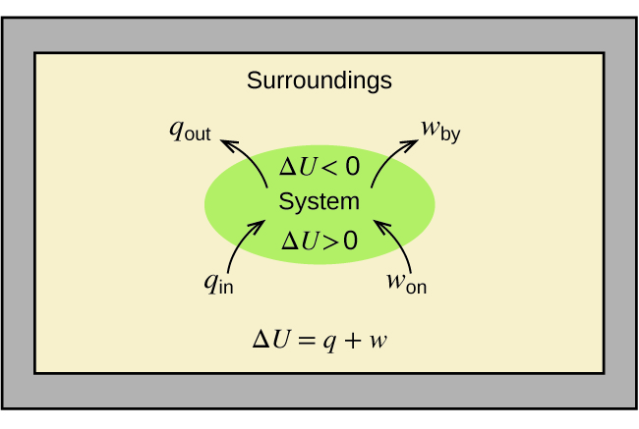
Figure 8.12 The internal energy, U, of a system can be changed by heat flow and work. If heat flows into the system, qin, or work is done on the system, won, its internal energy increases, ΔU > 0. If heat flows out of the system, qout, or work is done by the system, wby, its internal energy decreases, ΔU < 0.
A type of work called expansion work (or pressure-volume work) occurs when a system pushes back the surroundings against a restraining pressure, or when the surroundings compress the system. An example of this occurs during the operation of an internal combustion engine. The reaction of gasoline and oxygen is exothermic. Some of this energy is given off as heat, and some does work pushing the piston in the cylinder. The substances involved in the reaction are the system, and the engine and the rest of the universe are the surroundings. The system loses energy by both heating and doing work on the surroundings, and its internal energy decreases. (The engine is able to keep the car moving because this process is repeated many times per second while the engine is running.) We will consider how to determine the amount of work involved in a chemical or physical change in the chapter on thermodynamics.
As discussed, the relationship between internal energy, heat, and work can be represented as ΔU = q + w. Internal energy is an example of a state function(or state variable), whereas heat and work are not state functions. The value of a state function depends only on the state that a system is in, and not on how that state is reached. If a quantity is not a state function, then its value does depend on how the state is reached. An example of a state function is altitude or elevation. If you stand on the summit of Mt. Kilimanjaro, you are at an altitude of 5895 m, and it does not matter whether you hiked there or parachuted there. The distance you traveled to the top of Kilimanjaro, however, is not a state function. You could climb to the summit by a direct route or by a more roundabout, circuitous path (Figure 8.13). The distances traveled would differ (distance is not a state function) but the elevation reached would be the same (altitude is a state function).

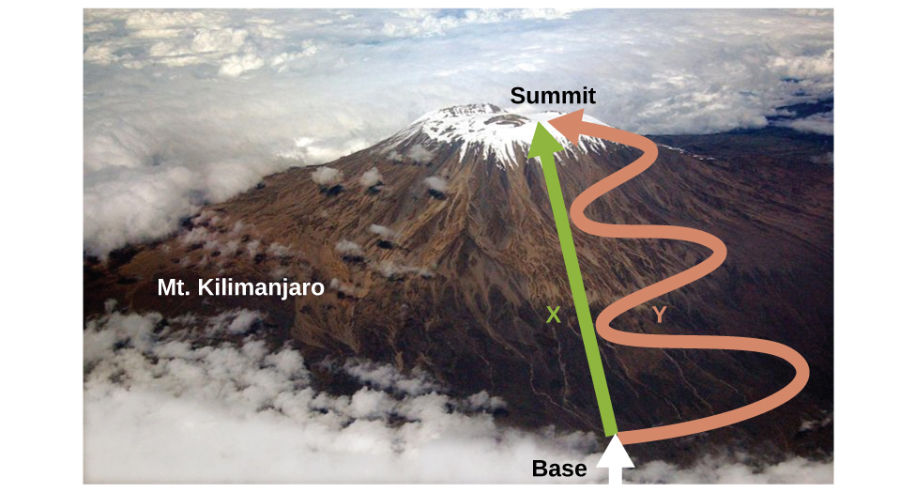

Figure 8.13 Paths X and Y represent two different routes to the summit of Mt. Kilimanjaro. Both have the same change in elevation (altitude or elevation on a mountain is a state function; it does not depend on path), but they have very different distances traveled (distance walked is not a state function; it depends on the path). (credit: modification of work by Paul Shaffner)

Enthalpy (H) and Enthalpy Change (∆H)
Chemists ordinarily use a property known as enthalpy (H) to describe the thermodynamics of chemical and physical processes. Enthalpy is defined as the sum of a system’s internal energy (U) and the mathematical product of its pressure (P) and volume (V):
H = U + PV
Enthalpy is also a state function. Enthalpy values for specific substances cannot be measured directly; only enthalpy changes for chemical or physical processes can be determined. For processes that take place at constant pressure (a common condition for many chemical and physical changes), the enthalpy change (ΔH) is:
ΔH = ΔU + PΔV
The mathematical product PΔV represents work (w), namely, expansion or pressure-volume work as noted. By their definitions, the arithmetic signs of ΔV andw will always be opposite:
PΔV = −w
Substituting this equation and the definition of internal energy into the enthalpy-change equation yields:
ΔH = ΔU + PΔV
ΔH = (q_{p} +w) + (−w)
ΔH = q_{p}
where q_{p} is the heat of reaction under conditions of constant pressure. And so, if a chemical or physical process is carried out at constant pressure with the only work done caused by expansion or contraction, then the heat flow (q_{p}) and enthalpy change (ΔH) for the process are equal.
The heat given off when you operate a Bunsen burner is equal to the enthalpy change of the methane combustion reaction that takes place, since it occurs at the essentially constant pressure of the atmosphere. Chemists usually perform experiments under normal atmospheric conditions, at constant external pressure with q = ΔH, which makes enthalpy the most convenient choice for determining heat changes for chemical reactions.

The following conventions apply when using ΔH:
- A negative value of an enthalpy change, ΔH < 0, indicates an exothermic reaction; a positive value, ΔH > 0, indicates an endothermic reaction. If the direction of a chemical equation is reversed, the arithmetic sign of its ΔH is changed (a process that is endothermic in one direction is exothermic in the opposite direction).
- Chemists use a thermochemical equation to represent the changes in both matter and energy. In a thermochemical equation, the enthalpy change of a reaction is shown as a ΔH value following the equation for the reaction. This ΔH value indicates the amount of heat associated with the reaction involving the number of moles of reactants and products as shown in the chemical equation. For example, consider this equation:
H₂ (g) + ½ O₂ (g) ⟶ H₂O (l) ΔH = −286 kJ
This equation indicates that when 1 mole of hydrogen gas and ½ mole of oxygen gas at some temperature and pressure change to 1 mole of liquid water at the same temperature and pressure, 286 kJ of heat are released to the surroundings. If the coefficients of the chemical equation are multiplied by some factor, the enthalpy change must be multiplied by that same factor (ΔH is an extensive property):
(two-fold increase in amounts)
2 H₂ (g) + O₂ (g) ⟶ 2 H₂O (l) ΔH = 2×(−286 kJ) = -572 kJ
- The enthalpy change of a reaction depends on the physical states of the reactants and products, so these must be shown. For example, when 1 mole of hydrogen gas and ½ mole of oxygen gas change to 1 mole of liquid water at the same temperature and pressure, 286 kJ of heat are released. If gaseous water forms, only 242 kJ of heat are released.
H₂ (g) + ½ O₂ (g) ⟶ H₂O (g) ΔH = −242 kJ

Example 8.3
Writing Thermochemical Equations
When 0.0500 mol of HCl(aq) reacts with 0.0500 mol of NaOH(aq) to form 0.0500 mol of NaCl(aq), 2.9 kJ of heat are produced. Write a balanced thermochemical equation for the reaction of one mole of HCl?
HCl (aq) + NaOH (aq) ⟶ NaCl (aq) + H₂O (l)
Solution: For the reaction of 0.0500 mol acid (HCl), q = −2.9 kJ. The reactants are provided in stoichiometric amounts (same molar ratio as in the balanced equation), and so the amount of acid may be used to calculate a molar enthalpy change. Since ΔH is an extensive property, it is proportional to the amount of acid neutralized:

ΔH = 1mol HCl × $\frac{-2.9 kJ}{0.0500 mol HCl}$ =−58kJ

The thermochemical equation is then
HCl (aq) + NaOH (aq) ⟶ NaCl (aq) + H₂O (l) Δ H=−58kJ

Check Your Learning
When 1.34 g Zn(s) reacts with 60.0 mL of 0.750 M HCl(aq), 3.14 kJ of heat are produced. Determine the enthalpy change per mole of zinc reacting for the reaction:
Zn (s) + 2 HCl (aq) ⟶ ZnCl₂ (aq) + H₂ (g)
Answer: ΔH = −153 kJ
Be sure to take both stoichiometry and limiting reactants into account when determining the ΔH for a chemical reaction.

Example 8.4
Writing Thermochemical Equations
A gummy bear contains 2.67 g sucrose, C₁₂H₂₂O₁₁. How much heat (in kJ) is produced when a gummy bear reacts with 7.19 g potassium chlorate, KClO₃?
C₁₂H₂₂O₁₁ (aq) + 8 KClO₃ (aq) ⟶ 12 CO₂ (g) + 11 H₂O (l) + 8 KCl (aq) ∆H = -5960. kJ
Solution: Unlike the previous example exercise, this one does not involve the reaction of stoichiometric amounts of reactants, and so the limiting reactant must be identified (it limits the yield of the reaction and the amount of thermal energy produced or consumed).

The provided amounts of the two reactants are
( 2.67g )( 1mol/342.3g ) = 0.00780 mol C₁₂H₂₂O₁₁
( 7.19g )( 1mol/122.5g ) = 0.0587 mol KCIO₃

The reactant that produces the least amount of enthalpy change is the limiting reactant. This can be calculated from the stoichiometric ratio:

ΔH = 0.00780 mol C₁₂H₂₂O₁₁ × $\frac{-5960 kJ}{1 mol {C_{12}H_{22}C_{11}}_{ }}$ = −46.5kJ
ΔH = 0.0587 mol KClO₃ × $\frac{-5960 kJ}{8 mol {{KClO}_{3}}_{ }}$ = −43.7kJ
The amount of KClO₃ limits the amount of heat produced; thus, KClO₃ is the limiting reactant. The heat produced is -43.7 kJ.

Check Your Learning
How much heat (in kJ) will be produced when 1.42 g of iron reacts with 1.80 g of chlorine?
Fe (s) + 8 Cl₂ (g) ⟶ FeCl₂ (s) ∆H = -338 kJ
Answer: ΔH = 8.60 kJ −338 kJ

Standard Enthalpy Change (∆Hº)
Enthalpy changes are typically tabulated for reactions in which both the reactants and products are at the same conditions. A standard state is a commonly accepted set of conditions used as a reference point for the determination of properties under different conditions.
For chemists, the IUPAC standard state refers to materials under a pressure of 1 bar and solutions at 1 M, and does not specify a temperature. Many thermochemical tables list values with a standard state of 1 atm. Because the ΔH of a reaction changes very little with such small changes in pressure (1 bar = 0.987 atm), ΔH values (except for the most precisely measured values) are essentially the same under both sets of standard conditions. We will include a superscripted “o” in the enthalpy change symbol to designate standard state. Since the usual (but not technically standard) temperature is 298.15 K, this temperature will be assumed unless some other temperature is specified. Thus, the symbol (ΔH°) is used to indicate an enthalpy change for a process occurring under these conditions. (The symbol ΔHis used to indicate an enthalpy change for a reaction occurring under nonstandard conditions.)
The enthalpy changes for many types of chemical and physical processes are available in the reference literature, including those for combustion reactions, phase transitions, and formation reactions. As we discuss these quantities, it is important to pay attention to the extensive nature of enthalpy and enthalpy changes. Since the enthalpy change for a given reaction is proportional to the amounts of substances involved, it may be reported on that basis (i.e., as the ΔH for specific amounts of reactants). However, we often find it more useful to divide one extensive property (ΔH) by another (amount of substance), and report a per-amount intensive value of ΔH, often “normalized” to a per-mole basis. (Note that this is similar to determining the intensive property specific heat from the extensive property heat capacity, as seen previously.)

Standard Enthalpy of Combustion
Standard enthalpy of combustion (ΔH_{C}°) is the enthalpy change when 1 mole of a substance burns (combines vigorously with oxygen) under standard state conditions; it is sometimes called “heat of combustion.” For example, the enthalpy of combustion of ethanol, −1366.8 kJ/mol, is the amount of heat produced when one mole of ethanol undergoes complete combustion at 25 °C and 1 atmosphere pressure, yielding products also at 25 °C and 1 atm.
C₂H₅OH (l) + 3 O₂ (g) ⟶ 2 CO₂ + 3 H₂O (l) ΔH°=−1366.8 kJ
Enthalpies of combustion for many substances have been measured; a few of these are listed in Table 8.2. Many readily available substances with large enthalpies of combustion are used as fuels, including hydrogen, carbon (as coal or charcoal), and hydrocarbons (compounds containing only hydrogen and carbon), such as methane, propane, and the major components of gasoline.
Table 8.2: Standard Molar Enthalpies of Combustion (∆H_{C}º) at 25 ºC
Substance | Combustion Reaction | ΔHc° (in kJ/mol)
carbon | C(s) + O₂(g) ⟶ CO₂(g) | −393.5
hydrogen | H₂(g) + 12O₂(g) ⟶ H₂O(l) | −285.8
magnesium | Mg(s) + 12O₂(g) ⟶ MgO(s) | −601.6
sulfur | S(s) + O₂(g) ⟶ SO₂(g) | −296.8
methane | CH₄(g) + 2O₂(g) ⟶ CO₂(g) + 2H₂O(l) | −890.8
ethanol | C₂H₅OH(l) + 3O₂(g) ⟶ 2CO₂(g) + 3H₂O(l) | −1366.8
methanol | CH₃OH(l) + 1.5O2(g) ⟶ CO₂(g) + 2H₂O(l) | −726.1
isooctane | C₈H₁₈(l) + 12.5O₂(g) ⟶ 8CO₂(g) + 9H₂O(l) | −5461

Example 8.5
Using Enthalpy of Combustion
As Figure 8.14 suggests, the combustion of gasoline is a highly exothermic process. Let us determine the approximate amount of heat produced by burning 1.00 L of gasoline, assuming the enthalpy of combustion of gasoline is the same as that of isooctane, a common component of gasoline. The density of isooctane is 0.692 g/mL.

Figure 8.14 The combustion of gasoline is very exothermic. (credit: modification of work by “AlexEagle”/Flickr)

Solution: Starting with a known amount (1.00 L of isooctane), we can perform conversions between units until we arrive at the desired amount of heat or energy. The enthalpy of combustion of isooctane provides one of the necessary conversions. Table 8.2 gives this value as −5460 kJ per 1 mole of isooctane (C₈H₁₈). Using these data,
1.00 L C₈H₁₈ ×$\frac{1000 mL}{1 L}$×$\frac{0.692 g}{1 mL}$× $\frac{1 mol {C_{8}H_{18}}_{ }}{114.23 g {C_{8}H_{18}}_{ }}$× $\frac{-5461 kJ}{1 mol {C_{8}H_{18}}_{ }}$ = −3.31x10 ⁴kJ
The combustion of 1.00 L of isooctane produces 33,100 kJ of heat. (This amount of energy is enough to melt 99.2 kg, or about 218 lbs, of ice.)

Check Your Learning
How much heat is produced by the combustion of 125 g of ethanol?
Answer: 3.71 × 10³ kJ

Chemistry in Everyday Life

Emerging Algae-Based Energy Technologies (Biofuels)
As reserves of fossil fuels diminish and become more costly to extract, the search is ongoing for replacement fuel sources for the future. Among the most promising biofuels are those derived from algae (Figure 8.15). The species of algae used are nontoxic, biodegradable, and among the world’s fastest growing organisms. About 50% of algal weight is oil, which can be readily converted into fuel such as biodiesel. Algae can yield 26,000 gallons of biofuel per hectare—much more energy per acre than other crops. Some strains of algae can flourish in brackish water that is not usable for growing other crops. Algae can produce biodiesel, biogasoline, ethanol, butanol, methane, and even jet fuel.

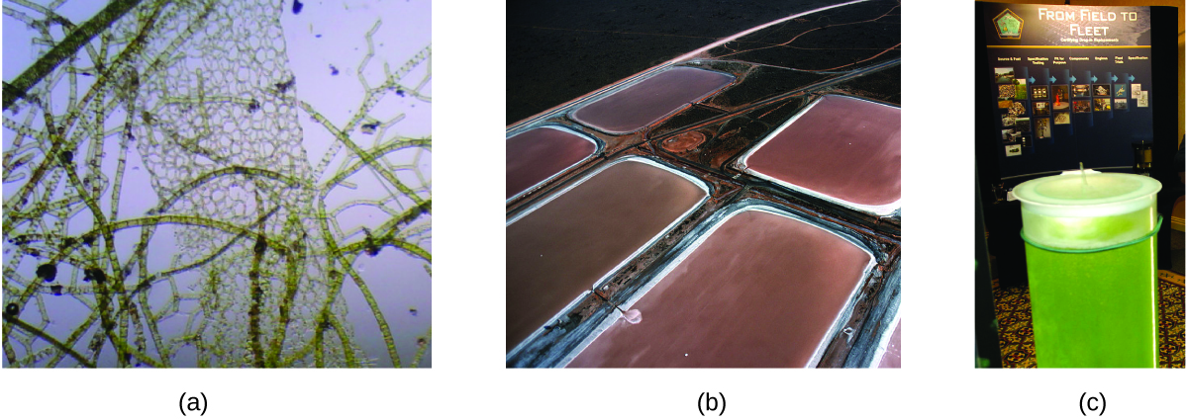
Figure 8.15 (a) Tiny algal organisms can be (b) grown in large quantities and eventually (c) turned into a useful fuel such as biodiesel. (credit a: modification of work by Micah Sittig; credit b: modification of work by Robert Kerton; credit c: modification of work by John F. Williams)

According to the US Department of Energy, only 39,000 square kilometers (about 0.4% of the land mass of the US or less than 17 of the area used to grow corn) can produce enough algal fuel to replace all the petroleum-based fuel used in the US. The cost of algal fuels is becoming more competitive—for instance, the US Air Force is producing jet fuel from algae at a total cost of under $5 per gallon.¹ The process used to produce algal fuel is as follows: grow the algae (which use sunlight as their energy source and CO₂ as a raw material); harvest the algae; extract the fuel compounds (or precursor compounds); process as necessary (e.g., perform a transesterification reaction to make biodiesel); purify; and distribute (Figure 8.16).
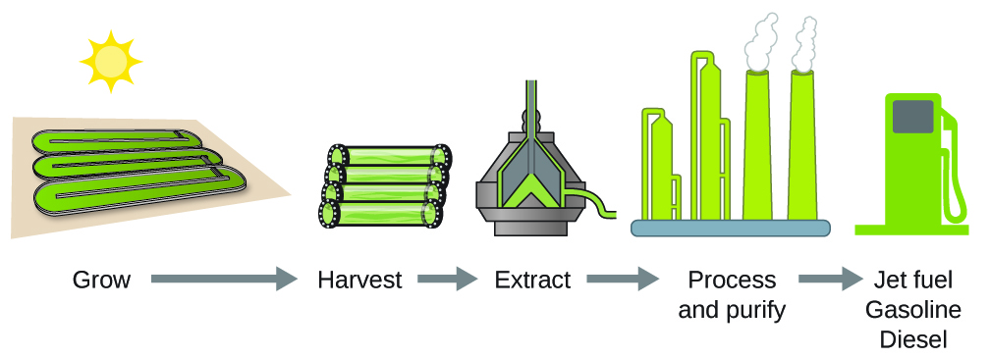
Figure 8.16 Algae convert sunlight and carbon dioxide into oil that is harvested, extracted, purified, and transformed into a variety of renewable fuels.

Footnotes
- 1 For more on algal fuel, see http://www.theguardian.com/environment/2010/feb/13/algae-solve-pentagon-fuel-problem.

8.5 Measuring Enthalpy from Calorimetry

Learning Objectives
- Use coffee-cup calorimetry method to calculate the heat absorbed or released during a chemical reaction

Introduction
One technique we can use to measure the amount of heat involved in a chemical or physical process is known as calorimetry. Calorimetry is used to measure amounts of heat transferred to or from a substance. To do so, the heat is exchanged with a calibrated object (calorimeter). The temperature change measured by the calorimeter is used to derive the amount of heat transferred by the process under study. The measurement of heat transfer using this approach requires the definition of a system (the substance or substances undergoing the chemical or physical change) and its surroundings (all other matter, including components of the measurement apparatus, that serve to either provide heat to the system or absorb heat from the system).

Calorimetry
A calorimeter is a device used to measure the amount of heat involved in a chemical or physical process. For example, when an exothermic reaction occurs in solution in a calorimeter, the heat produced by the reaction is absorbed by the solution, which increases its temperature. When an endothermic reaction occurs, the heat required is absorbed from the thermal energy of the solution, which decreases its temperature (Figure 8.17). The temperature change, along with the specific heat and mass of the solution, can then be used to calculate the amount of heat involved in either case.
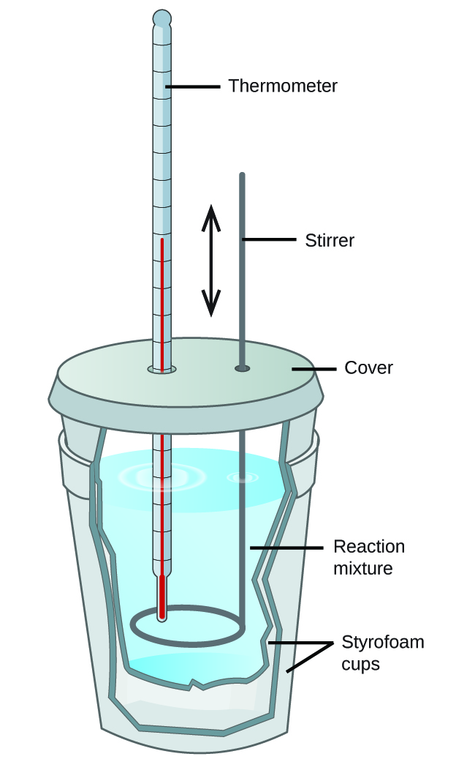
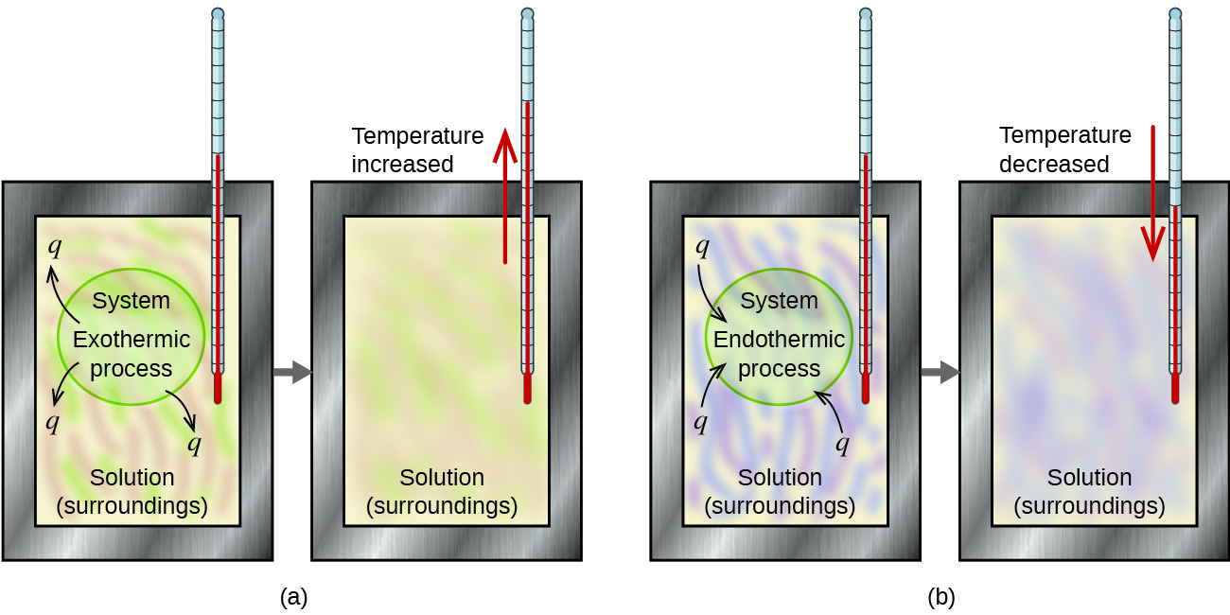
Figure 8.17 In a calorimetric determination, either (a) an exothermic process occurs and heat, q, is negative, indicating that thermal energy is transferred from the system to its surroundings, or (b) an endothermic process occurs and heat, q, is positive, indicating that thermal energy is transferred from the surroundings to the system.
Scientists use well-insulated calorimeters that all but prevent the transfer of heat between the calorimeter and its environment, which effectively limits the “surroundings” to the non-system components with the calorimeter (and the calorimeter itself). This enables the accurate determination of the heat involved in chemical processes, the energy content of foods, and so on. General chemistry students often use simple calorimeters constructed from polystyrene cups (Figure 8.18). These easy-to-use “coffee cup” calorimeters allow more heat exchange with the outside environment, and therefore produce less accurate energy values.
Figure 8.18 A simple calorimeter can be constructed from two polystyrene cups. A thermometer and stirrer extend through the cover into the reaction mixture.
Commercial solution calorimeters are also available. Relatively inexpensive calorimeters often consist of two thin-walled cups that are nested in a way that minimizes thermal contact during use, along with an insulated cover, handheld stirrer, and simple thermometer. More expensive calorimeters used for industry and research typically have a well-insulated, fully enclosed reaction vessel, motorized stirring mechanism, and a more accurate temperature sensor (Figure 8.19).
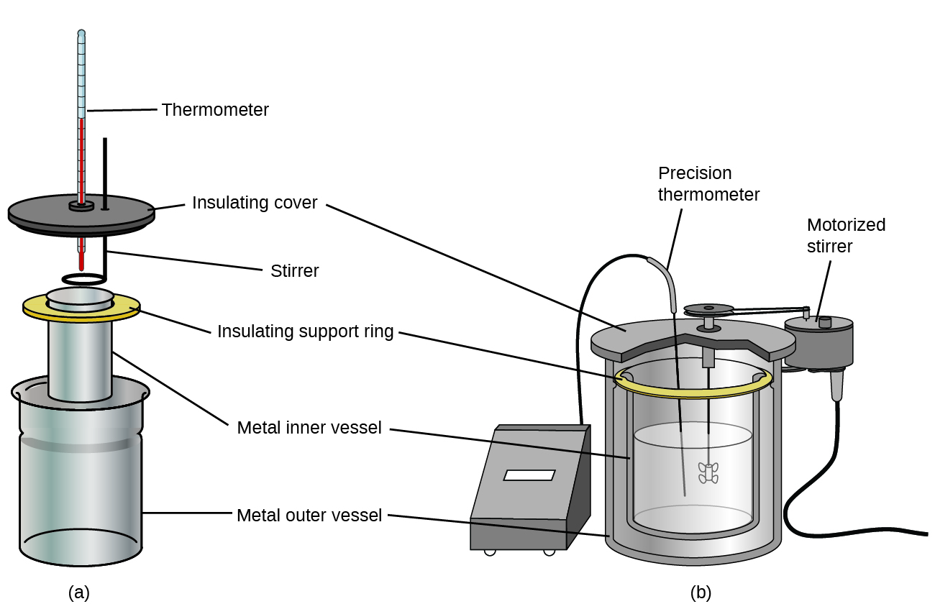
Figure 8.19 Commercial solution calorimeters range from (a) simple, inexpensive models for student use to (b) expensive, more accurate models for industry and research.

Before discussing the calorimetry of chemical reactions, consider a simpler example that illustrates the core idea behind calorimetry. Suppose we initially have a high-temperature substance, such as a hot piece of metal, and a low-temperature substance, such as cool water. If we place the metal in the water, heat will flow from metal to water. The temperature of the metal will decrease, and the temperature of water will increase, until the two substances have the same temperature—that is, when they reach thermal equilibrium (Figure 8.20). If this occurs in a calorimeter, ideally all of this heat transfer occurs between the two substances, with no heat gained or lost by either its external environment. Under these ideal circumstances, the net heat change is zero:
q_{metal} + q_{water} = 0
This relationship can be rearranged to show that the heat gained by metal is equal to the heat lost by water:
q_{metal} = -q_{water}
The magnitude of the heat (change) is therefore the same for both substances, and the negative sign merely shows that q_{metal} and q_{water} are opposite in direction of heat flow (gain or loss) but does not indicate the arithmetic sign of either q value (that is determined by whether the matter in question gains or loses heat, per definition). In the specific situation described, q_{metal} is a negative value and q_{water} is positive, since heat is transferred from metal to water.
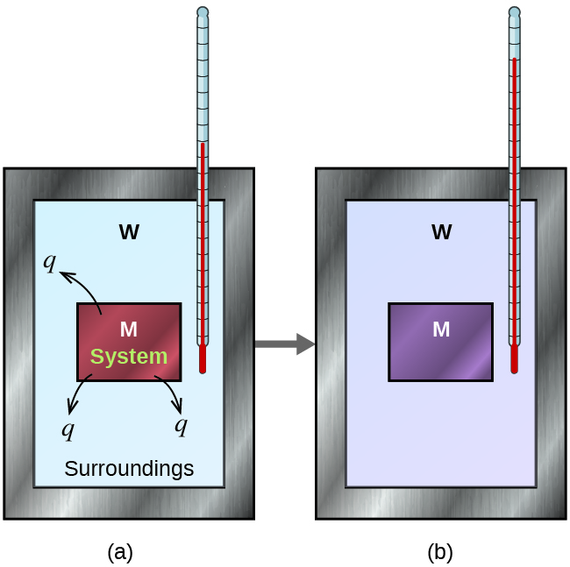
Figure 8.20 In a simple calorimetry process, (a) heat, q, is transferred from the hot metal, M, to the cool water, W, until (b) both are at the same temperature.

Example 8.6
Heat Transfer between Substances at Different Temperatures
A 360.0-g piece of rebar (a steel rod used for reinforcing concrete) is dropped into 425 mL of water at 24.0 °C. The final temperature of the water was measured as 42.7 °C. Calculate the initial temperature of the piece of rebar. Assume the specific heat of steel is approximately the same as that for iron (Table 8.1), and that all heat transfer occurs between the rebar and the water (there is no heat exchange with the surroundings).
Solution: The temperature of the water increases from 24.0 °C to 42.7 °C, so the water absorbs heat. That heat came from the piece of rebar, which initially was at a higher temperature. Assuming that all heat transfer was between the rebar and the water, with no heat “lost” to the outside environment, then heat given off by rebar = −heat taken in by water, or: q_{rebar} = −q_{water}
Since we know how heat is related to other measurable quantities, we have:
(c·m·ΔT)_{rebar} = −(c·m·ΔT)_{water}
Letting f = final and i = initial, in expanded form, this becomes:
[c·m·(T_{final} - T_{initial})]_{rebar} = −[c·m·(T_{final} - T_{initial})]_{water}
The density of water is 1.0 g/mL, so 425 mL of water = 425 g. Noting that the final temperature of both the rebar and water is 42.7 °C, substituting known values yields:
(0.449J/gºC)·(360.0g)·(42.7ºC - T_{initial,rebar}) = −(4.184 J/gºC)·(425g)·(42.7 - 24.0 ºC)
Solving this gives T_{initial,rebar} = 248 °C, so the initial temperature of the rebar was 248 °C.

Check Your Learning
A 248-g piece of copper at 314 °C is dropped into 390 mL of water initially at 22.6 °C. Assuming that all heat transfer occurs between the copper and the water, calculate the final temperature.
Answer: The final temperature (reached by both copper and water) is 38.7 °C.
This method can also be used to determine other quantities, such as the specific heat of an unknown metal.

Example 8.7
Identifying a Metal by Measuring Specific Heat
A 59.7 g piece of metal that had been submerged in boiling water was quickly transferred into 60.0 mL of water initially at 22.0 °C. The final temperature is 28.5 °C. Use these data to determine the specific heat of the metal. Use this result to identify the metal.
Solution: Assuming perfect heat transfer, heat given off by metal = −heat taken in by water, or: q_{metal} = −q_{water}
[c·m·(T_{final} - T_{initial})] _{metal} = −[c·m·(T_{final} - T_{initial})]_{water}
Noting that since the metal was submerged in boiling water, its initial temperature was 100.0 °C; and that for water, 60.0 mL = 60.0 g; we have:
(c_{metal})·(59.7g)·(28.5°C−100.0°C) = −(4.18J/g °C)·(60.0g)·(28.5°C−22.0°C)
c_{metal} = 0.38J/g °C
Comparing this with values in Table 8.1, our experimental specific heat is closest to the value for copper (0.39 J/g °C), so we identify the metal as copper.

Check Your Learning
A 92.9-g piece of a silver/gray metal is heated to 178.0 °C, and then quickly transferred into 75.0 mL of water initially at 24.0 °C. After 5 minutes, both the metal and the water have reached the same temperature: 29.7 °C. Determine the specific heat and the identity of the metal.
Answer: c_{metal} = 0.13 J/g °C This specific heat is close to that of either gold or lead. It would be difficult to determine which metal this was based solely on the numerical values. However, the observation that the metal is silver/gray in addition to the value for the specific heat indicates that the metal is lead.
When we use calorimetry to determine the heat involved in a chemical reaction, the same principles we have been discussing apply. The amount of heat absorbed by the calorimeter is often small enough that we can neglect it (though not for highly accurate measurements, as discussed later), and the calorimeter minimizes energy exchange with the outside environment. Because energy is neither created nor destroyed during a chemical reaction, the heat produced or consumed in the reaction (the “system”), qreaction, plus the heat absorbed or lost by the solution (the “surroundings”), qsolution, must add up to zero:
q_{reaction} + q_{solution} = 0
This means that the amount of heat produced or consumed in the reaction equals the amount of heat absorbed or lost by the solution:
q_{reaction} = −q_{solution}
This concept lies at the heart of all calorimetry problems and calculations.

Example 8.8
Heat Produced by an Exothermic Reaction
When 50.0 mL of 1.00 M HCl(aq) and 50.0 mL of 1.00 M NaOH(aq), both at 22.0 °C, are added to a coffee cup calorimeter, the temperature of the mixture reaches a maximum of 28.9 °C. What is the approximate amount of heat produced by this reaction?
HCl (aq) + NaOH (aq) ⟶ NaCl (aq) + H₂O (l)
Solution: To visualize what is going on, imagine that you could combine the two solutions so quickly that no reaction took place while they mixed; then after mixing, the reaction took place. At the instant of mixing, you have 100.0 mL of a mixture of HCl & NaOH at 22.0 °C. The HCl and NaOH then react until the solution temperature reaches 28.9 °C.
The heat given off by the reaction is equal to that taken in by the solution. Therefore:
q_{reaction} = −q_{solution}
(It is important to remember that this relationship only holds if the calorimeter does not absorb any heat from the reaction, and there is no heat exchange between the calorimeter and the outside environment.)

Next, we know that the heat absorbed by the solution depends on its specific heat, mass, and temperature change:
q_{solution}= (c·m·ΔT)_{solution}
To proceed with this calculation, we need to make a few more reasonable assumptions or approximations. Since the solution is aqueous, we can proceed as if it were water in terms of its specific heat and mass values. The density of water is approximately 1.0 g/mL, so 100.0 mL has a mass of about 1.0 × 10² g (two significant figures). The specific heat of water is approximately 4.184 J/g °C, so we use that for the specific heat of the solution. Substituting these values gives:
q_{solution} = (4.184J/g °C)(1.0×10²g)(28.9°C−22.0°C) = 2.9×10³ J
Finally, since we are trying to find the heat of the reaction, we have:
q_{reaction} = −q_{solution} = -2.9×10³ J or 2.9 kJ
The negative sign indicates that the reaction is exothermic. It produces 2.9 kJ of heat.

Check Your Learning
When 100 mL of 0.200 M NaCl(aq) and 100 mL of 0.200 M AgNO3(aq), both at 21.9 °C, are mixed in a coffee cup calorimeter, the temperature increases to 23.5 °C as solid AgCl forms. How much heat is produced by this precipitation reaction? What assumptions did you make to determine your value?
Answer: 1.34 × 10³ J; assume no heat is absorbed by the calorimeter, no heat is exchanged between the calorimeter and its surroundings, and that the specific heat and mass of the solution are the same as those for water

Chemistry in Everyday Life

Thermochemistry of Hand Warmers
When working or playing outdoors on a cold day, you might use a hand warmer to warm your hands (Figure 8.21). A common reusable hand warmer contains a supersaturated solution of NaC₂H₃O₂ (sodium acetate) and a metal disc. Bending the disk creates nucleation sites around which the metastable NaC₂H₃O₂ quickly crystallizes.
The process NaC₂H₃O₂(aq) ⟶ NaC₂H₃O₂ (s) is exothermic, and the heat produced by this process is absorbed by your hands, thereby warming them (at least for a while). If the hand warmer is reheated, the NaC₂H₃O₂ redissolves and can be reused.
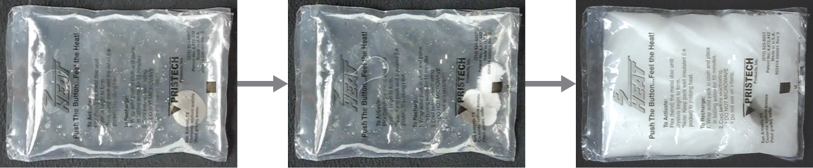
Figure 8.21 Chemical hand warmers produce heat that warms your hand on a cold day. In this one, you can see the metal disc that initiates the exothermic precipitation reaction. (credit: modification of work by Science Buddies TV/YouTube)
Another common hand warmer produces heat when it is ripped open, exposing iron and water in the hand warmer to oxygen in the air. One simplified version of this exothermic reaction is 4Fe(s) + 3 O₂(g) ⟶ 2Fe₂O₃(s). Salt in the hand warmer catalyzes the reaction, so it produces heat more rapidly; cellulose, vermiculite, and activated carbon help distribute the heat evenly. Other types of hand warmers use lighter fluid (a platinum catalyst helps lighter fluid oxidize exothermically), charcoal (charcoal oxidizes in a special case), or electrical units that produce heat by passing an electrical current from a battery through resistive wires.

8.6 Measuring ∆H from Hess’s Law

Learning Objectives
- Use Hess’s law to calculate ∆H_{rxn}

Introduction
There are two ways to determine the amount of heat involved in a chemical change: measure it experimentally, or calculate it from other experimentally determined enthalpy changes. Some reactions are difficult, if not impossible, to investigate and make accurate measurements for experimentally. And even when a reaction is not hard to perform or measure, it is convenient to be able to determine the heat involved in a reaction without having to perform an experiment.

Hess’s Law
This type of calculation usually involves the use of Hess’s law, which states: If a process can be written as the sum of several stepwise processes, the enthalpy change of the total process equals the sum of the enthalpy changes of the various steps. Hess’s law is valid because enthalpy is a state function: Enthalpy changes depend only on where a chemical process starts and ends, but not on the path it takes from start to finish.

For example, we can think of the reaction of carbon with oxygen to form carbon dioxide as occurring either directly or by a two-step process. The direct process is written:
C (s) + O₂ (g) ⟶ CO₂ (g) ΔH° = −394kJ
In the two-step process, first carbon monoxide is formed:
C (s) + 1/2 O₂ (g) ⟶ CO (g) ΔH° = −111kJ
Then, carbon monoxide reacts further to form carbon dioxide:
CO (g) + 1/2 O₂(g) ⟶ CO₂ (g) ΔH°=−283kJ
The equation describing the overall reaction is the sum of these two chemical changes:
Step 1: C (s) + 1/2 O₂ (g) ⟶ CO(g)
Step 2: CO (g) + 1/2 O₂ (g) ⟶ CO₂(g)
Sum: C (s) + 1/2 O₂ (g) + CO (g) + 1/2 O₂(g) ⟶ CO (g) + CO₂ (g)
Because the CO produced in Step 1 is consumed in Step 2, the net change is:
C (s) + O₂ (g) ⟶ CO₂ (g)
According to Hess’s law, the enthalpy change of the reaction will equal the sum of the enthalpy changes of the steps.
C (s) + 1/2 O₂ (g) ⟶ CO (g) ΔH°=−111kJ
CO (g) + 1/2 O₂(g) ⟶ CO₂ (g) ΔH°=−283kJ
Thus, C (s) + O₂ (g) ⟶ CO₂ (g) ΔH° = (-111) + (−283) = −394kJ
The result is shown in Figure 8.22. We see that ΔH of the overall reaction is the same whether it occurs in one step or two. This finding (overall ΔH for the reaction = sum of ΔH values for reaction “steps” in the overall reaction) is true in general for chemical and physical processes.
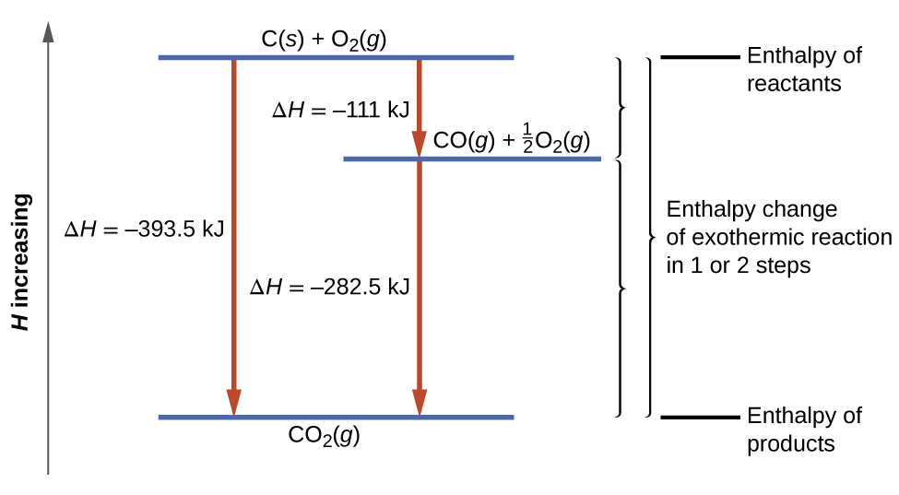
Figure 8.22 The formation of CO₂(g) from its elements can be thought of as occurring in two steps, which sum to the overall reaction, as described by Hess’s law. The horizontal blue lines represent enthalpies. For an exothermic process, the products are at lower enthalpy than are the reactants.
Before we further practice using Hess’s law, let us recall two important features of ΔH.
- ΔH is directly proportional to the quantities of reactants or products. For example, the enthalpy change for the reaction forming 1 mole of NO₂(g) is +33.2 kJ:
½ N₂(g) + O₂ (g) ⟶ NO₂ (g) ΔH = +33.2 kJ
When 2 moles of NO₂ (twice as much) are formed, the ΔH will be twice as large:
N₂ (g) + 2 O₂ (g) ⟶ 2 NO₂ (g) ΔH = +66.4 kJ
In general, if we multiply or divide an equation by a number, then the enthalpy change should also be multiplied or divided by the same number.
- ΔH for a reaction in one direction is equal in magnitude and opposite in sign to ΔH for the reaction in the reverse direction. For example, given that:
H₂ (g) + Cl₂ (g) ⟶ 2HCl (g) ΔH = −184.6kJ
Then, for the “reverse” reaction, the enthalpy change is also “reversed”:
2 HCl (g) ⟶ H₂ (g) + Cl₂ (g) ΔH = +184.6 kJ

Example 8.9
Stepwise Calculation of ΔH_{f}° Using Hess’s Law
Determine the enthalpy of formation, ΔH_{f}°, of FeCl₃(s):
Fe (s) + 1.5 Cl₂(g) ⟶ FeCl₃ (s) ΔH_{f}° = ?
Given the enthalpy changes of the following two-step process that occurs under standard state conditions:
Fe (s) + Cl₂ (g) ⟶ FeCl₂ (s) ΔH°=−341.8kJ
FeCl₂ (s) + 0.5 Cl₂(g) ⟶ FeCl₃ (s) ΔH°=−57.7kJ
Solution: Looking at the reactions, we see that the reaction for which we want to find ΔH° is the sum of the two reactions with known ΔH values, so we must sum their ΔHs:
Given: Fe (s) + Cl₂ (g) ⟶ FeCl₂ (s) ΔH°=−341.8kJ
Given: FeCl₂ (s) + 0.5 Cl₂(g) ⟶ FeCl₃ (s) ΔH°=−57.7kJ
Sum: Fe (s) + 1.5 Cl₂(g) ⟶ FeCl₃ (s) ΔH_{f}° = (-341.8) + (-57.7) = -399.5 kJ
The enthalpy of formation, ΔHf°, of FeCl₃(s) is −399.5 kJ/mol.

Check Your Learning
Calculate ΔH for the process:
N₂ (g) + 2 O₂(g) ⟶ 2 NO₂ (g)
from the following information:
3 N₂ (g) + 3 O₂ (g) ⟶ 6 NO (g) ΔH = 541.5 kJ
2NO (g) + O₂(g) ⟶ 2 NO₂ (g) ΔH = −114.12 kJ
Answer: 66.4 kJ

8.7 Measuring ∆H from Standard Enthalpies of Formation (∆H_{f}º)

Learning Objectives
- Use standard enthalpies of formation to calculate ∆H_{rxn}

Standard Enthalpy of Formation
A standard enthalpy of formation, ΔH_{f}° is an enthalpy change for a reaction in which exactly 1 mole of a pure substance is formed from free elements in their most stable states under standard state conditions. These values are especially useful for computing or predicting enthalpy changes for chemical reactions that are impractical or dangerous to carry out, or for processes for which it is difficult to make measurements. If we have values for the appropriate standard enthalpies of formation, we can determine the enthalpy change for any reaction, which we will practice in the next section on Hess’s law.
The standard enthalpy of formation, ∆H_{f}º of CO₂(g) is −393.5 kJ/mol.
This is the enthalpy change for the exothermic reaction:
C (s) + O₂ (g) ⟶ CO₂ (g) ΔH_{f}° = ΔH° = −393.5 kJ
starting with the reactants at a pressure of 1 atm and 25 °C (with the carbon present as graphite, the most stable form of carbon under these conditions) and ending with one mole of CO₂, also at 1 atm and 25 °C.
For nitrogen dioxide, NO₂(g), ΔH_{f}° is 33.2 kJ/mol.
This is the enthalpy change for the reaction:
12 N₂ (g) + O₂ (g) ⟶ NO₂ (g) ΔH_{f}° = ΔH° = +33.2 kJ
A reaction equation with 12 mole of N₂ and 1 mole of O₂ is correct in this case because the standard enthalpy of formation always refers to 1 mole of product, NO₂(g).
You will find a table of standard enthalpies of formation of many common substances in Appendix I. These values indicate that formation reactions range from highly exothermic (such as −2984 kJ/mol for the formation of P₄O₁₀) to strongly endothermic (such as +226.7 kJ/mol for the formation of acetylene, C₂H₂). By definition, the standard enthalpy of formation of an element in its most stable form is equal to zero under standard conditions, which is 1 atm for gases and 1 M for solutions.

Example 8.10
Writing Reaction Equations for ΔH_{f}°
Write the heat of formation reaction equations for:
(a) C₂H₅OH (l)
(b) Ca₃(PO₄)₂ (s)

Solution: Remembering that ΔH_{f}° reaction equations are for forming 1 mole of the compound from its constituent elements under standard conditions, we have:
(a) 2 C (s,graphite) + 3 H₂ (g) + ½ O₂ (g) ⟶ C₂H₅OH (l)
(b) 3 Ca (s) + ½ P₄ (s) + 4 O₂ (g) ⟶ Ca₃(PO₄)₂ (s)
Note: The standard state of carbon is graphite, and phosphorus exists as P₄.

Check Your Learning
Write the heat of formation reaction equations for:
(a) C₂H₅OC₂H₅ (l)
(b) Na₂CO₃ (s)
Answer: (a) 4 C(s,graphite) + 5 H₂ (g) + ½ O₂ (g) ⟶ C₂H₅OC₂H₅ (l)
(b) 2 Na(s) + C (s,graphite) + 3/2 O₂ (g) ⟶ Na₂CO₃ (s)
We also can use the enthalpies of formation of reactants and products to determine the enthalpy change of any reaction.
The standard enthalpy change of the overall reaction is equal to the sum of the standard enthalpies of formation of all the products minus the sum of the standard enthalpies of formation of the reactants. This is written as follows, with ∑ representing “the sum of” and n standing for the stoichiometric coefficients:
ΔH°_{reaction} = ∑n·ΔH_{f}°_{(products)} − ∑n·ΔH_{f}°_{(reactants)}
The following example shows in detail why this equation is valid, and how to use it to calculate the enthalpy change for a reaction of interest.

Example 8.11
Using Standard Enthalpies of Formation
Calculate the standard enthalpy change for the reaction (∆Hº_{rxn}) using values from Appendix I:
3 NO₂ (g) + H₂O (l) ⟶ 2 HNO₃ (aq) + NO (g) ΔH°=?
Solution: Using the Equation ΔH°_{reaction} = ∑n·ΔH_{f}°_{(products)} − ∑n·ΔH_{f}°_{(reactants)}
ΔH°_{reaction} = [ 2(−207.4 kJ/mol HNO₃) + 1(+90.2 kJ/mol NO) ]
−[ 3(+33.2 kJ/molNO₂) + 1(−285.8 kJ/mol H₂O) ]
= −136.80kJ
Note that this result was obtained by (1) multiplying the ΔH_{f}° of each product by its stoichiometric coefficient and summing those values, (2) multiplying the ΔH_{f}° of each reactant by its stoichiometric coefficient and summing those values, and then (3) subtracting the result found in (2) from the result found in (1). This is also the procedure in using the general equation, as shown.

Check Your Learning
Calculate the heat of combustion of 1 mole of ethanol, C₂H₅OH (l), when H₂O (l) & CO₂ (g) are formed. Use the following enthalpies of formation ∆H_{f}º:
∆H_{f}º C₂H₅OH (l) = −278 kJ/mol
∆H_{f}º H₂O (l) = −286 kJ/mol
∆H_{f}º CO₂(g) = −394 kJ/mol

Answer: −1368 kJ/mol

Appendix I

Standard Enthalpies of Formation (∆H_{f}º)

Standard Thermodynamic Properties for Selected Substances
Substance | ΔH_{f}° (kJ mol^{–1}) | ΔG_{f}° (kJ mol^{–1}) | S° (J K^{–1} mol^{–1})
aluminum
Al(s) | 0 | 0 | 28.3
Al(g) | 324.4 | 285.7 | 164.54
Al³⁺(aq) | –531 | –485 | –321.7
Al₂O₃(s) | –1676 | –1582 | 50.92
AlF₃(s) | –1510.4 | –1425 | 66.5
AlCl₃(s) | –704.2 | –628.8 | 110.67
AlCl₃·6H₂O(s) | –2691.57 | –2269.40 | 376.56
Al₂S₃(s) | –724.0 | –492.4 | 116.9
Al₂(SO₄)₃(s) | –3445.06 | –3506.61 | 239.32

Substance | ΔH_{f}° (kJ mol^{–1}) | ΔG_{f}° (kJ mol^{–1}) | S° (J K^{–1} mol^{–1})

antimony
Sb(s) | 0 | 0 | 45.69
Sb(g) | 262.34 | 222.17 | 180.16
Sb₄O₆(s) | –1440.55 | –1268.17 | 220.92
SbCl₃(g) | –313.8 | –301.2 | 337.80
SbCl₅(g) | –394.34 | –334.29 | 401.94
Sb₂S₃(s) | –174.89 | –173.64 | 182.00
SbCl₃(s) | –382.17 | –323.72 | 184.10
SbOCl(s) | –374.0 | — | —
arsenic
As(s) | 0 | 0 | 35.1
As(g) | 302.5 | 261.0 | 174.21
As₄(g) | 143.9 | 92.4 | 314
As₄O₆(s) | –1313.94 | –1152.52 | 214.22
As₂O₅(s) | –924.87 | –782.41 | 105.44
AsCl₃(g) | –261.50 | –248.95 | 327.06
As₂S₃(s) | –169.03 | –168.62 | 163.59

Substance | ΔH_{f}° (kJ mol^{–1}) | ΔG_{f}° (kJ mol^{–1}) | S° (J K^{–1} mol^{–1})
AsH₃(g) | 66.44 | 68.93 | 222.78
H₃AsO₄(s) | –906.3 | — | —
barium
Ba(s) | 0 | 0 | 62.5
Ba(g) | 180 | 146 | 170.24
Ba²⁺(aq) | –537.6 | –560.8 | 9.6
BaO(s) | –548.0 | –520.3 | 72.1
BaCl₂(s) | –855.0 | –806.7 | 123.7
BaSO₄(s) | –1473.2 | –1362.3 | 132.2
beryllium
Be(s) | 0 | 0 | 9.50
Be(g) | 324.3 | 286.6 | 136.27
BeO(s) | –609.4 | –580.1 | 13.8
bismuth
Bi(s) | 0 | 0 | 56.74
Bi(g) | 207.1 | 168.2 | 187.00
Bi₂O₃(s) | –573.88 | –493.7 | 151.5

Substance | ΔH_{f}° (kJ mol^{–1}) | ΔG_{f}° (kJ mol^{–1}) | S° (J K^{–1} mol^{–1})
BiCl₃(s) | –379.07 | –315.06 | 176.98
Bi₂S₃(s) | –143.1 | –140.6 | 200.4
boron
B(s) | 0 | 0 | 5.86
B(g) | 565.0 | 521.0 | 153.4
B₂O₃(s) | –1273.5 | –1194.3 | 53.97
B₂H₆(g) | 36.4 | 87.6 | 232.1
H₃BO₃(s) | –1094.33 | –968.92 | 88.83
BF₃(g) | –1136.0 | –1119.4 | 254.4
BCl₃(g) | –403.8 | –388.7 | 290.1
B₃N₃H₆(l) | –540.99 | –392.79 | 199.58
HBO₂(s) | –794.25 | –723.41 | 37.66
bromine
Br₂(l) | 0 | 0 | 152.23
Br₂(g) | 30.91 | 3.142 | 245.5
Br(g) | 111.88 | 82.429 | 175.0
Br–(aq) | –120.9 | –102.82 | 80.71

Substance | ΔH_{f}° (kJ mol^{–1}) | ΔG_{f}° (kJ mol^{–1}) | S° (J K^{–1} mol^{–1})
BrF₃(g) | –255.60 | –229.45 | 292.42
HBr(g) | –36.3 | –53.43 | 198.7
cadmium
Cd(s) | 0 | 0 | 51.76
Cd(g) | 112.01 | 77.41 | 167.75
Cd²⁺(aq) | –75.90 | –77.61 | –73.2
CdO(s) | –258.2 | –228.4 | 54.8
CdCl₂(s) | –391.5 | –343.9 | 115.3
CdSO₄(s) | –933.3 | –822.7 | 123.0
CdS(s) | –161.9 | –156.5 | 64.9
calcium
Ca(s) | 0 | 0 | 41.6
Ca(g) | 178.2 | 144.3 | 154.88
Ca²⁺ (aq) | –542.96 | –553.04 | –55.2
CaO(s) | –634.9 | –603.3 | 38.1
Ca(OH)₂(s) | –985.2 | –897.5 | 83.4
CaSO₄(s) | –1434.5 | –1322.0 | 106.5

Substance | ΔH_{f}° (kJ mol^{–1}) | ΔG_{f}° (kJ mol^{–1}) | S° (J K^{–1} mol^{–1})
CaSO₄·2H₂O(s) | –2022.63 | –1797.45 | 194.14
CaCO₃(s) (calcite) | –1220.0 | –1081.4 | 110.0
CaSO₃·H₂O(s) | –1752.68 | –1555.19 | 184.10
carbon
C(s) (graphite) | 0 | 0 | 5.740
C(s) (diamond) | 1.89 | 2.90 | 2.38
C(g) | 716.681 | 671.2 | 158.1
CO(g) | –110.52 | –137.15 | 197.7
CO₂(g) | –393.51 | –394.36 | 213.8
CO₃^{2–} (aq) | –677.1 | –527.8 | –56.9
CH₄(g) | –74.6 | –50.5 | 186.3
CH₃OH(l) | –239.2 | –166.6 | 126.8
CH₃OH(g) | –201.0 | –162.3 | 239.9
CCl₄(l) | –128.2 | –62.5 | 214.4
CCl₄(g) | –95.7 | –58.2 | 309.7
CHCl₃(l) | –134.1 | –73.7 | 201.7
CHCl₃(g) | –103.14 | –70.34 | 295.71

Substance | ΔH_{f}° (kJ mol^{–1}) | ΔG_{f}° (kJ mol^{–1}) | S° (J K^{–1} mol^{–1})
CS₂(l) | 89.70 | 65.27 | 151.34
CS₂(g) | 116.9 | 66.8 | 238.0
C₂H₂(g) | 227.4 | 209.2 | 200.9
C₂H₄(g) | 52.4 | 68.4 | 219.3
C₂H₆(g) | –84.0 | –32.0 | 229.2
CH₃CO₂H(l) | –484.3 | –389.9 | 159.8
CH₃CO₂H(g) | –434.84 | –376.69 | 282.50
C₂H₅OH(l) | –277.6 | –174.8 | 160.7
C₂H₅OH(g) | –234.8 | –167.9 | 281.6
HCO₃–(aq) | –691.11 | –587.06 | 95
C₃H₈(g) | –103.8 | –23.4 | 270.3
C₆H₆(g) | 82.927 | 129.66 | 269.2
C₆H₆(l) | 49.1 | 124.50 | 173.4
CH₂Cl₂(l) | –124.2 | –63.2 | 177.8
CH₂Cl₂(g) | –95.4 | –65.90 | 270.2
CH₃Cl(g) | –81.9 | –60.2 | 234.6
C₂H₅Cl(l) | –136.52 | –59.31 | 190.79

Substance | ΔH_{f}° (kJ mol^{–1}) | ΔG_{f}° (kJ mol^{–1}) | S° (J K^{–1} mol^{–1})
C₂H₅Cl(g) | –112.17 | –60.39 | 276.00
C₂N₂(g) | 308.98 | 297.36 | 241.90
HCN(l) | 108.9 | 125.0 | 112.8
HCN(g) | 135.5 | 124.7 | 201.8
cesium
Cs⁺(aq) | –248 | –282.0 | 133
chlorine
Cl₂(g) | 0 | 0 | 223.1
Cl(g) | 121.3 | 105.70 | 165.2
Cl–(aq) | –167.2 | –131.2 | 56.5
ClF(g) | –54.48 | –55.94 | 217.78
ClF₃(g) | –158.99 | –118.83 | 281.50
Cl₂O(g) | 80.3 | 97.9 | 266.2
Cl₂O₇(l) | 238.1 | — | —
Cl₂O₇(g) | 272.0 | — | —
HCl(g) | –92.307 | –95.299 | 186.9
HClO₄(l) | –40.58 | — | —

Substance | ΔH_{f}° (kJ mol^{–1}) | ΔG_{f}° (kJ mol^{–1}) | S° (J K^{–1} mol^{–1})

chromium
Cr(s) | 0 | 0 | 23.77
Cr(g) | 396.6 | 351.8 | 174.50
CrO₄^{2–} (aq) | –881.2 | –727.8 | 50.21
Cr₂O₇^{2–} (aq) | –1490.3 | –1301.1 | 261.9
Cr₂O₃(s) | –1139.7 | –1058.1 | 81.2
CrO₃(s) | –589.5 | — | —
(NH₄)₂Cr₂O₇(s) | –1806.7 | — | —
cobalt
Co(s) | 0 | 0 | 30.0
Co²⁺ (aq) | –67.4 | –51.5 | –155
Co³⁺ (aq) | 92 | 134 | –305.0
CoO(s) | –237.9 | –214.2 | 52.97
Co₃O₄(s) | –910.02 | –794.98 | 114.22
Co(NO₃)₂(s) | –420.5 | — | —
copper
Cu(s) | 0 | 0 | 33.15

Substance | ΔH_{f}° (kJ mol^{–1}) | ΔG_{f}° (kJ mol^{–1}) | S° (J K^{–1} mol^{–1})
Cu(g) | 338.32 | 298.58 | 166.38
Cu⁺ (aq) | 51.9 | 50.2 | –26
Cu²⁺ (aq) | 64.77 | 65.49 | –99.6
CuO(s) | –157.3 | –129.7 | 42.63
Cu₂O(s) | –168.6 | –146.0 | 93.14
CuS(s) | –53.1 | –53.6 | 66.5
Cu₂S(s) | –79.5 | –86.2 | 120.9
CuSO₄(s) | –771.36 | –662.2 | 109.2
Cu(NO₃)₂(s) | –302.9 | — | —
fluorine
F₂(g) | 0 | 0 | 202.8
F(g) | 79.4 | 62.3 | 158.8
F–(aq) | –332.6 | –278.8 | –13.8
F₂O(g) | 24.7 | 41.9 | 247.43
HF(g) | –273.3 | –275.4 | 173.8
hydrogen
H₂(g) | 0 | 0 | 130.7

Substance | ΔH_{f}° (kJ mol^{–1}) | ΔG_{f}° (kJ mol^{–1}) | S° (J K^{–1} mol^{–1})
H(g) | 217.97 | 203.26 | 114.7
H⁺(aq) | 0 | 0 | 0
OH–(aq) | –230.0 | –157.2 | –10.75
H₃O⁺ (aq) | –285.8 |  | 69.91
H₂O(l) | –285.83 | –237.1 | 70.0
H₂O(g) | –241.82 | –228.59 | 188.8
H₂O₂(l) | –187.78 | –120.35 | 109.6
H₂O₂(g) | –136.3 | –105.6 | 232.7
HF(g) | –273.3 | –275.4 | 173.8
HCl(g) | –92.307 | –95.299 | 186.9
HBr(g) | –36.3 | –53.43 | 198.7
HI(g) | 26.48 | 1.70 | 206.59
H₂S(g) | –20.6 | –33.4 | 205.8
H₂Se(g) | 29.7 | 15.9 | 219.0
HNO₃ | –206.64 | — | —
iodine
I₂(s) | 0 | 0 | 116.14

Substance | ΔH_{f}° (kJ mol^{–1}) | ΔG_{f}° (kJ mol^{–1}) | S° (J K^{–1} mol^{–1})
I₂(g) | 62.438 | 19.3 | 260.7
I(g) | 106.84 | 70.2 | 180.8
I⁻(aq) | –55.19 | –51.57 | 11.13
IF(g) | 95.65 | –118.49 | 236.06
ICl(g) | 17.78 | –5.44 | 247.44
IBr(g) | 40.84 | 3.72 | 258.66
IF₇(g) | –943.91 | –818.39 | 346.44
HI(g) | 26.48 | 1.70 | 206.59
Iron
Fe(s) | 0 | 0 | 27.3
Fe(g) | 416.3 | 370.7 | 180.5
Fe²⁺(aq) | –89.1 | –78.90 | –137.7
Fe³⁺ (aq) | –48.5 | –4.7 | –315.9
Fe₂O₃(s) | –824.2 | –742.2 | 87.40
Fe₃O₄(s) | –1118.4 | –1015.4 | 146.4
Fe(CO)₅(l) | –774.04 | –705.42 | 338.07
Fe(CO)₅(g) | –733.87 | –697.26 | 445.18

Substance | ΔH_{f}° (kJ mol^{–1}) | ΔG_{f}° (kJ mol^{–1}) | S° (J K^{–1} mol^{–1})
FeCl₂(s) | –341.79 | –302.30 | 117.95
FeCl₃(s) | –399.49 | –334.00 | 142.3
FeO(s) | –272.0 | –255.2 | 60.75
Fe(OH)₂(s) | –569.0 | –486.5 | 88.
Fe(OH)₃(s) | –823.0 | –696.5 | 106.7
FeS(s) | –100.0 | –100.4 | 60.29
Fe₃C(s) | 25.10 | 20.08 | 104.60
Lead
Pb(s) | 0 | 0 | 64.81
Pb(g) | 195.2 | 162. | 175.4
Pb²⁺(aq) | –1.7 | –24.43 | 10.5
PbO(s) (yellow) | –217.32 | –187.89 | 68.70
PbO(s) (red) | –218.99 | –188.93 | 66.5
Pb(OH)₂(s) | –515.9 | — | —
PbS(s) | –100.4 | –98.7 | 91.2
Pb(NO₃)₂(s) | –451.9 | — | —
PbO₂(s) | –277.4 | –217.3 | 68.6

Substance | ΔH_{f}° (kJ mol^{–1}) | ΔG_{f}° (kJ mol^{–1}) | S° (J K^{–1} mol^{–1})
PbCl₂(s) | –359.4 | –314.1 | 136.0
lithium
Li(s) | 0 | 0 | 29.1
Li(g) | 159.3 | 126.6 | 138.8
Li⁺ (aq) | –278.5 | –293.3 | 13.4
LiH(s) | –90.5 | –68.3 | 20.0
Li(OH)(s) | –487.5 | –441.5 | 42.8
LiF(s) | –616.0 | –587.5 | 35.7
Li₂CO₃(s) | –1216.04 | –1132.19 | 90.17
magnesium
Mg²⁺(aq) | –466.9 | –454.8 | –138.1
manganese
Mn(s) | 0 | 0 | 32.0
Mn(g) | 280.7 | 238.5 | 173.7
Mn²⁺(aq) | –220.8 | –228.1 | –73.6
MnO(s) | –385.2 | –362.9 | 59.71
MnO₂(s) | –520.03 | –465.1 | 53.05

Substance | ΔH_{f}° (kJ mol^{–1}) | ΔG_{f}° (kJ mol^{–1}) | S° (J K^{–1} mol^{–1})
Mn₂O₃(s) | –958.97 | –881.15 | 110.46
Mn₃O₄(s) | –1378.83 | –1283.23 | 155.64
MnO₄– (aq) | –541.4 | –447.2 | 191.2
MnO₄^{2–} (aq) | –653.0 | –500.7 | 59
mercury
Hg(l) | 0 | 0 | 75.9
Hg(g) | 61.4 | 31.8 | 175.0
Hg²⁺(aq) |  | 164.8
Hg²⁺(aq) | 172.4 | 153.9 | 84.5
HgO(s) (red) | –90.83 | –58.5 | 70.29
HgO(s) (yellow) | –90.46 | –58.43 | 71.13
HgCl₂(s) | –224.3 | –178.6 | 146.0
Hg₂Cl₂(s) | –265.4 | –210.7 | 191.6
HgS(s) (red) | –58.16 | –50.6 | 82.4
HgS(s) (black) | –53.56 | –47.70 | 88.28
HgSO₄(s) | –707.51 | –594.13 | 0.00
nickel

Substance | ΔH_{f}° (kJ mol^{–1}) | ΔG_{f}° (kJ mol^{–1}) | S° (J K^{–1} mol^{–1})
Ni²⁺(aq) | –64.0 | –46.4 | –159
nitrogen
N₂(g) | 0 | 0 | 191.6
N(g) | 472.704 | 455.5 | 153.3
NO(g) | 90.25 | 87.6 | 210.8
NO₂(g) | 33.2 | 51.30 | 240.1
N₂O(g) | 81.6 | 103.7 | 220.0
N₂O₃(g) | 83.72 | 139.41 | 312.17
NO₃– (aq) | –205.0 | –108.7 | 146.4
N₂O₄(g) | 11.1 | 99.8 | 304.4
N₂O₅(g) | 11.3 | 115.1 | 355.7
NH₃(g) | –45.9 | –16.5 | 192.8
NH₄⁺ (aq) | –132.5 | –79.31 | 113.4
N₂H₄(l) | 50.63 | 149.43 | 121.21
N₂H₄(g) | 95.4 | 159.4 | 238.5
NH₄NO₃(s) | –365.56 | –183.87 | 151.08
NH₄Cl(s) | –314.43 | –202.87 | 94.6

Substance | ΔH_{f}° (kJ mol^{–1}) | ΔG_{f}° (kJ mol^{–1}) | S° (J K^{–1} mol^{–1})
NH₄Br(s) | –270.8 | –175.2 | 113.0
NH₄I(s) | –201.4 | –112.5 | 117.0
NH₄NO₂(s) | –256.5 | — | —
HNO₃(l) | –174.1 | –80.7 | 155.6
HNO₃(g) | –133.9 | –73.5 | 266.9
oxygen
O₂(g) | 0 | 0 | 205.2
O(g) | 249.17 | 231.7 | 161.1
O₃(g) | 142.7 | 163.2 | 238.9
phosphorus
P₄(s) | 0 | 0 | 164.4
P₄(g) | 58.91 | 24.4 | 280.0
P(g) | 314.64 | 278.25 | 163.19
PH₃(g) | 5.4 | 13.5 | 210.2
PCl₃(g) | –287.0 | –267.8 | 311.78
PCl₅(g) | –374.9 | –305.0 | 364.4
P₄O₆(s) | –1640.1 | — | —

Substance | ΔH_{f}° (kJ mol^{–1}) | ΔG_{f}° (kJ mol^{–1}) | S° (J K^{–1} mol^{–1})
P₄O₁₀(s) | –2984.0 | –2697.0 | 228.86
PO₄^{3–} (aq) | –1277 | –1019 | –222
HPO₃(s) | –948.5 | — | —
HPO₄^{2–} (aq) | –1292.1 | –1089.3 | –33
H₂PO₄^{2–} (aq) | –1296.3 | –1130.4 | 90.4
H₃PO₂(s) | –604.6 | — | —
H₃PO₃(s) | –964.4 | — | —
H₃PO₄(s) | –1279.0 | –1119.1 | 110.50
H₃PO₄(l) | –1266.9 | –1124.3 | 110.5
H₄P₂O₇(s) | –2241.0 | — | —
POCl₃(l) | –597.1 | –520.8 | 222.5
POCl₃(g) | –558.5 | –512.9 | 325.5
potassium
K(s) | 0 | 0 | 64.7
K(g) | 89.0 | 60.5 | 160.3
K⁺(aq) | –252.4 | –283.3 | 102.5
KF(s) | –576.27 | –537.75 | 66.57

Substance | ΔH_{f}° (kJ mol^{–1}) | ΔG_{f}° (kJ mol^{–1}) | S° (J K^{–1} mol^{–1})
KCl(s) | –436.5 | –408.5 | 82.6
rubidium
Rb⁺(aq) | –246 | –282.2 | 124
silicon
Si(s) | 0 | 0 | 18.8
Si(g) | 450.0 | 405.5 | 168.0
SiO₂(s) | –910.7 | –856.3 | 41.5
SiH₄(g) | 34.3 | 56.9 | 204.6
H₂SiO₃(s) | –1188.67 | –1092.44 | 133.89
H₄SiO₄(s) | –1481.14 | –1333.02 | 192.46
SiF₄(g) | –1615.0 | –1572.8 | 282.8
SiCl₄(l) | –687.0 | –619.8 | 239.7
SiCl₄(g) | –662.75 | –622.58 | 330.62
SiC(s, beta cubic) | –73.22 | –70.71 | 16.61
SiC(s, alpha hexagonal) | –71.55 | –69.04 | 16.48
silver
Ag(s) | 0 | 0 | 42.55

Substance | ΔH_{f}° (kJ mol^{–1}) | ΔG_{f}° (kJ mol^{–1}) | S° (J K^{–1} mol^{–1})
Ag(g) | 284.9 | 246.0 | 172.89
Ag⁺(aq) | 105.6 | 77.11 | 72.68
Ag₂O(s) | –31.05 | –11.20 | 121.3
AgCl(s) | –127.0 | –109.8 | 96.3
Ag₂S(s) | –32.6 | –40.7 | 144.0
sodium
Na(s) | 0 | 0 | 51.3
Na(g) | 107.5 | 77.0 | 153.7
Na⁺(aq) | –240.1 | –261.9 | 59
Na₂O(s) | –414.2 | –375.5 | 75.1
NaCl(s) | –411.2 | –384.1 | 72.1
strontium
Sr²⁺(aq) | –545.8 | –557.3 | –32.6
sulfur
S₈(s) (rhombic) | 0 | 0 | 256.8
S(g) | 278.81 | 238.25 | 167.82
S^{2–}(aq) | 41.8 | 83.7 | 22

Substance | ΔH_{f}° (kJ mol^{–1}) | ΔG_{f}° (kJ mol^{–1}) | S° (J K^{–1} mol^{–1})
SO₂(g) | –296.83 | –300.1 | 248.2
SO₃(g) | –395.72 | –371.06 | 256.76
SO₄^{2–} (aq) | –909.3 | –744.5 | 20.1
S₂O₃^{2–}(aq) | –648.5 | –522.5 | 67
H₂S(g) | –20.6 | –33.4 | 205.8
HS–(aq) | –17.7 | 12.6 | 61.1
H₂SO₄(l) | –813.989 | 690.00 | 156.90
HSO₄–(aq) | –885.75 | –752.87 | 126.9
H₂S₂O₇(s) | –1273.6 | — | —
SF₄(g) | –728.43 | –684.84 | 291.12
SF₆(g) | –1220.5 | –1116.5 | 291.5
SCl₂(l) | –50 | — | —
SCl₂(g) | –19.7 | — | —
S₂Cl₂(l) | –59.4 | — | —
S₂Cl₂(g) | –19.50 | –29.25 | 319.45
SOCl₂(g) | –212.55 | –198.32 | 309.66
SOCl₂(l) | –245.6 | — | —

Substance | ΔH_{f}° (kJ mol^{–1}) | ΔG_{f}° (kJ mol^{–1}) | S° (J K^{–1} mol^{–1})
SO₂Cl₂(l) | –394.1 | — | —
SO₂Cl₂(g) | –354.80 | –310.45 | 311.83
tin
Sn(s) | 0 | 0 | 51.2
Sn(g) | 301.2 | 266.2 | 168.5
SnO(s) | –285.8 | –256.9 | 56.5
SnO₂(s) | –577.6 | –515.8 | 49.0
SnCl₄(l) | –511.3 | –440.1 | 258.6
SnCl₄(g) | –471.5 | –432.2 | 365.8
titanium
Ti(s) | 0 | 0 | 30.7
Ti(g) | 473.0 | 428.4 | 180.3
TiO₂(s) | –944.0 | –888.8 | 50.6
TiCl₄(l) | –804.2 | –737.2 | 252.4
TiCl₄(g) | –763.2 | –726.3 | 353.2
tungsten
W(s) | 0 | 0 | 32.6

Substance | ΔH_{f}° (kJ mol^{–1}) | ΔG_{f}° (kJ mol^{–1}) | S° (J K^{–1} mol^{–1})
W(g) | 849.4 | 807.1 | 174.0
WO₃(s) | –842.9 | –764.0 | 75.9
zinc
Zn(s) | 0 | 0 | 41.6
Zn(g) | 130.73 | 95.14 | 160.98
Zn²⁺(aq) | –153.9 | –147.1 | –112.1
ZnO(s) | –350.5 | –320.5 | 43.7
ZnCl₂(s) | –415.1 | –369.43 | 111.5
ZnS(s) | –206.0 | –201.3 | 57.7
ZnSO₄(s) | –982.8 | –871.5 | 110.5
ZnCO₃(s) | –812.78 | –731.57 | 82.42
complexes
[Co(NH₃)₄(NO₂)₂]NO₃, cis | –898.7 | — | —
[Co(NH₃)₄(NO₂)₂]NO₃, trans | –896.2 | — | —
NH₄[Co(NH₃)₂(NO₂)₄] | –837.6 | — | —
[Co(NH₃)₆][Co(NH₃)₂(NO₂)₄]₃ | –2733.0 | — | —
[Co(NH₃)4Cl₂]Cl, cis | –874.9 | — | —

Substance | ΔH_{f}° (kJ mol^{–1}) | ΔG_{f}° (kJ mol^{–1}) | S° (J K^{–1} mol^{–1})
[Co(NH₃)₄Cl₂]Cl, trans | –877.4 | — | —
[Co(en)₂(NO₂)₂]NO₃, cis | –689.5 | — | —
[Co(en)₂Cl₂]Cl, cis | –681.2 | — | —
[Co(en)₂Cl₂]Cl, trans | –677.4 | — | —
[Co(en)₃](ClO₄)₃ | –762.7 | — | —
[Co(en)₃]Br₂ | –595.8 | — | —
[Co(en)₃]I₂ | –475.3 | — | —
[Co(en)₃]I₃ | –519.2 | — | —
[Co(NH₃)₆](ClO₄)₃ | –1034.7 | –221.1 | 615
[Co(NH₃)₅NO₂](NO₃)₂ | –1088.7 | –412.9 | 331
[Co(NH₃)₆](NO₃)₃ | –1282.0 | –524.5 | 448
[Co(NH₃)₅Cl]Cl₂ | –1017.1 | –582.5 | 366.1
[Pt(NH₃)₄]Cl₂ | –725.5 | — | —
[Ni(NH₃)₆]Cl₂ | –994.1 | — | —
[Ni(NH₃)₆]Br₂ | –923.8 | — | —
[Ni(NH₃)₆]I₂ | –808.3 | — | —

BLANK PAGE

Chapter 9 – Attributions

The contents in this chapter, licensed under CC BY 4.0. has been adopted, modified, reorganized, and/or remixed from the following:

9.0 Introduction
"9 Introduction" by Paul Flowers, Klaus Theopold, Richard Langley, William R. Robinson,, OpenStax is licensed under CC BY 4.0

9.1 Pressure
"9.1 Gas Pressure" by Paul Flowers, Klaus Theopold, Richard Langley, William R. Robinson,, OpenStax is licensed under CC BY 4.0

9.2 Simple Gas Laws
"9.2 Relating Pressure, Volume, Amount, and Temperature: The Ideal Gas Law" by Paul Flowers, Klaus Theopold, Richard Langley, William R. Robinson,, OpenStax is licensed under CC BY 4.0

9.3 The Kinetic Molecular Theory
"9.5 The Kinetic-Molecular Theory" by Paul Flowers, Klaus Theopold, Richard Langley, William R. Robinson,, OpenStax is licensed under CC BY 4.0

9.4 The Ideal Gas Law and Its Applications
"9.2 Relating Pressure, Volume, Amount, and Temperature: The Ideal Gas Law" by Paul Flowers, Klaus Theopold, Richard Langley, William R. Robinson,, OpenStax is licensed under CC BY 4.0
"9.3 Stoichiometry of Gaseous Substances, Mixtures, and Reactions" by Paul Flowers, Klaus Theopold, Richard Langley, William R. Robinson,, OpenStax is licensed under CC BY 4.0

9.5 Mixtures of Gases and Partial Pressure
"9.3 Stoichiometry of Gaseous Substances, Mixtures, and Reactions" by Paul Flowers, Klaus Theopold, Richard Langley, William R. Robinson,, OpenStax is licensed under CC BY 4.0

9.6 Gas Stoichiometry
"9.3 Stoichiometry of Gaseous Substances, Mixtures, and Reactions" by Paul Flowers, Klaus Theopold, Richard Langley, William R. Robinson,, OpenStax is licensed under CC BY 4.0

Chapter 9 Gases

Chapter Introduction

9.1 Pressure

9.2 Simple Gas Laws

9.3 The Kinetic Molecular Theory

9.4 The Ideal Gas Law and Its Applications

9.5 Mixtures of Gases and Partial Pressure

9.6 Gas Stoichiometry

Figure 9.1 The hot air inside these balloons is less dense than the surrounding cool air. This results in a buoyant force that causes the balloons to rise when their guy lines are untied. (credit: modification of work by Anthony Quintano)
We are surrounded by an ocean of gas—the atmosphere—and many of the properties of gases are familiar to us from our daily activities. Heated gases expand, which can make a hot air balloon rise (Figure 9.1) or cause a blowout in a bicycle tire left in the sun on a hot day.
Gases have played an important part in the development of chemistry. In the seventeenth and eighteenth centuries, many scientists investigated gas behavior, providing the first mathematical descriptions of the behavior of matter.
In this chapter, we will examine the relationships between gas temperature, pressure, amount, and volume. We will study a simple theoretical model and use it to analyze the experimental behavior of gases. The results of these analyses will show us the limitations of the theory and how to improve on it.
BLANK PAGE

9.1 Pressure

Learning Objectives
- Define the property of pressure
- Define and convert among the units of pressure measurements
- Describe the operation of common tools for measuring gas pressure

Introduction
The earth’s atmosphere exerts a pressure, as does any other gas. Although we do not normally notice atmospheric pressure, we are sensitive to pressure changes—for example, when your ears “pop” during take-off and landing while flying, or when you dive underwater. Gas pressure is caused by the force exerted by gas molecules colliding with the surfaces of objects (Figure 9.2). Although the force of each collision is very small, any surface of appreciable area experiences a large number of collisions in a short time, which can result in a high pressure. In fact, normal air pressure is strong enough to crush a metal container when not balanced by equal pressure from inside the container.
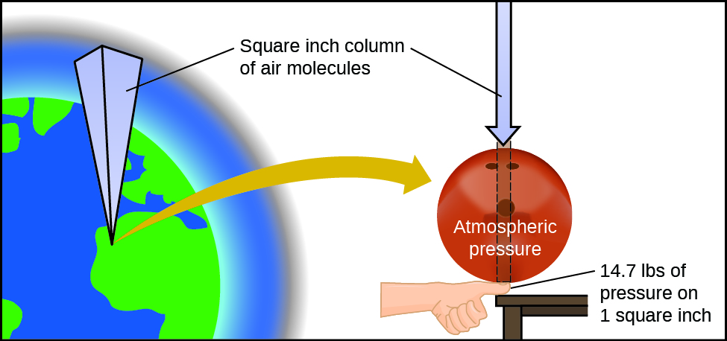
Figure 9.2 The atmosphere above us exerts a large pressure on objects at the surface of the earth, roughly equal to the weight of a bowling ball pressing on an area the size of a human thumbnail.

Atmospheric Pressure
Atmospheric pressure is caused by the weight of the column of air molecules in the atmosphere above an object, such as the tanker car. At sea level, this pressure is roughly the same as that exerted by a full-grown African elephant standing on a doormat, or a typical bowling ball resting on your thumbnail. These may seem like huge amounts, and they are, but life on earth has evolved under such atmospheric pressure. If you actually perch a bowling ball on your thumbnail, the pressure experienced is twice the usual pressure, and the sensation is unpleasant.
In general, pressure is defined as the force exerted on a given area: P = $\frac{F}{A}$. Note that pressure is directly proportional to force and inversely proportional to area. Thus, pressure can be increased either by increasing the amount of force or by decreasing the area over which it is applied; pressure can be decreased by decreasing the force or increasing the area.
Let’s apply this concept to determine which would be more likely to fall through thin ice in Figure 9.3—the elephant or the figure skater? A large African elephant can weigh 7 tons, supported on four feet, each with a diameter of about 1.5 ft (footprint area of 250 in²), so the pressure exerted by each foot is about 14 lb/in²:

pressure per elephant foot = $\frac{14,000 lb}{1 elephant}$ × $\frac{1 elephant}{4 feet}$ × $\frac{1 foot}{250 {in}^{2}}$ = 14 lb/in²
The figure skater weighs about 120 lbs, supported on two skate blades, each with an area of about 2 in², so the pressure exerted by each blade is about 30 lb/in²:

pressure per skate blade = $\frac{120 lb}{1 skater}$ × $\frac{1 skater}{2 blades}$ × $\frac{1 blade}{2 {in}^{2}}$ = 30 lb/in²
Even though the elephant is more than one hundred-times heavier than the skater, it exerts less than one-half of the pressure and would therefore be less likely to fall though thin ice. On the other hand, if the skater removes her skates and stands with bare feet (or regular footwear) on the ice, the larger area over which her weight is applied greatly reduces the pressure exerted:

pressure per human foot = $\frac{120 lb}{1 skater}$ × $\frac{1 skater}{2 feet}$ × $\frac{1 foot}{30 {in}^{2}}$ = 2 lb/in²

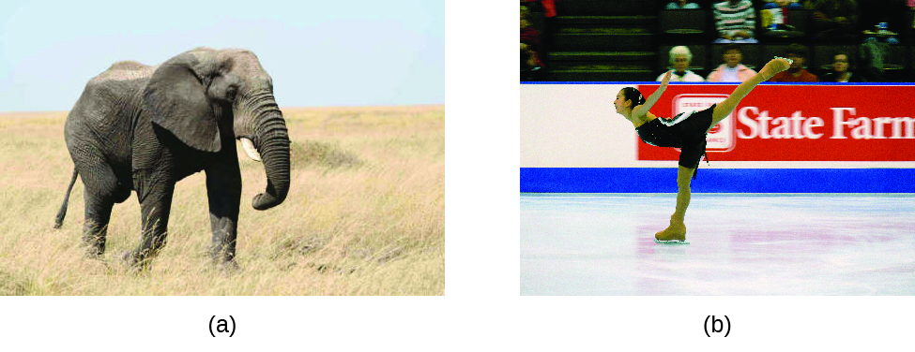
Figure 9.3 Although (a) an elephant’s weight is large, creating a very large force on the ground, (b) the figure skater exerts a much higher pressure on the ice due to the small surface area of her skates. (credit a: modification of work by Guido da Rozze; credit b: modification of work by Ryosuke Yagi)

Pressure Units
The SI unit of pressure is the pascal (Pa), with 1 Pa = 1 N/m², where N is the newton, a unit of force defined as 1 kg m/s². One pascal is a small pressure; in many cases, it is more convenient to use units of kilopascal (1 kPa = 1000 Pa) or bar (1 bar = 100,000 Pa).
In the United States, pressure is often measured in pounds of force on an area of one square inch—pounds per square inch (psi)—for example, in car tires. Pressure can also be measured using the unit atmosphere (atm), which originally represented the average sea level air pressure at the approximate latitude of Paris (45°). Table 9.1 provides some information on these and a few other common units for pressure measurements
Table 9.1 Pressure Units

Unit Name and Abbreviation | Definition or Relation to Other Unit
pascal (Pa) | 1 Pa = 1 N/m²  recommended IUPAC unit
kilopascal (kPa) | 1 kPa = 1000 Pa
pounds per square inch (psi) | air pressure at sea level is ~14.7 psi
atmosphere (atm) | 1 atm = 101,325 Pa  1 atm = 760 torr  air pressure at sea level is ~1 atm
bar (bar, or b) | 1 bar = 100,000 Pa (exactly)  commonly used in meteorology
millibar (mbar, or mb) | 1000 mbar = 1 bar
inches of mercury (in. Hg) | 1 in. Hg = 3386 Pa  used by aviation industry, also some weather reports
torr | 760 torr = 1 atm  named after Evangelista Torricelli, inventor of the barometer
millimeters of mercury (mm Hg) | 1 mm Hg ~1 torr

Example 9.1
Conversion of Pressure Units
The United States National Weather Service reports pressure in both inches of Hg and millibars. Convert a pressure of 29.2 in. Hg into:

(a) torr (b) atm (c) kPa (d) mbar

Solution: This is a unit conversion problem. The relationships between the various pressure units are given in Table 9.1.

(a) 29.2 in Hg ×$\frac{2.54 cm}{1 in}$ × $\frac{1 m}{100 cm}$ × $\frac{1000 mm}{1 m}$ × $\frac{1 torr}{1 mm Hg}$ = 742 torr

(b) 742 torr ×$\frac{1 atm}{760 torr}$ = 0.976 atm

(c) 742 torr ×$\frac{101.325 kPa}{760 torr}$ = 98.9 kPa

(d) 98.9 kPa ×$\frac{1000 Pa}{1 kPa}$ × $\frac{1 bar}{100,000 Pa}$ × $\frac{1000 mbar}{1 bar}$ = 989 mbar

Check Your Learning
A typical barometric pressure in Kansas City is 740 torr. What is this pressure in atmospheres, in millimeters of mercury, in kilopascals, and in bar?

Answer: 0.974 atm; 740 mm Hg; 98.7 kPa; 0.987 bar

Measuring Pressure by Barometer
We can measure atmospheric pressure, the force exerted by the atmosphere on the earth’s surface, with a barometer (Figure 9.4). A barometer is a glass tube that is closed at one end, filled with a nonvolatile liquid such as mercury, and then inverted and immersed in a container of that liquid. The atmosphere exerts pressure on the liquid outside the tube, the column of liquid exerts pressure inside the tube, and the pressure at the liquid surface is the same inside and outside the tube. The height of the liquid in the tube is therefore proportional to the pressure exerted by the atmosphere.
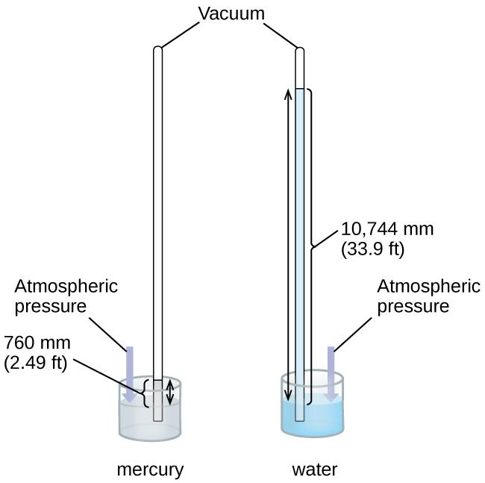
Figure 9.4 In a barometer, the height, h, of the column of liquid is used as a measurement of the air pressure. Using very dense liquid mercury (left) permits the construction of reasonably sized barometers, whereas using water (right) would require a barometer more than 30 feet tall.
If the liquid is water, normal atmospheric pressure will support a column of water over 10 meters high, which is rather inconvenient for making (and reading) a barometer. Because mercury (Hg) is about 13.6-times denser than water, a mercury barometer only needs to be 113.6 as tall as a water barometer—a more suitable size. Standard atmospheric pressure of 1 atm at sea level (101,325 Pa) corresponds to a column of mercury that is about 760 mm (29.92 in.) high. The torr was originally intended to be a unit equal to one millimeter of mercury, but it no longer corresponds exactly. The pressure exerted by a fluid due to gravity is known as hydrostatic pressure, p:
p = hρg
where h is the height of the fluid, ρ is the density of the fluid, and g is acceleration due to gravity.

Chemistry in Everyday Life

Measuring Blood Pressure
Blood pressure is measured using a device called a sphygmomanometer (Greek sphygmos = “pulse”). It consists of an inflatable cuff to restrict blood flow, a manometer to measure the pressure, and a method of determining when blood flow begins and when it becomes impeded (Figure 9.5). Since its invention in 1881, it has been an essential medical device. There are many types of sphygmomanometers: manual ones that require a stethoscope and are used by medical professionals; mercury ones, used when the most accuracy is required; less accurate mechanical ones; and digital ones that can be used with little training but that have limitations. When using a sphygmomanometer, the cuff is placed around the upper arm and inflated until blood flow is completely blocked, then slowly released. As the heart beats, blood forced through the arteries causes a rise in pressure. This rise in pressure at which blood flow begins is the systolic pressure—the peak pressure in the cardiac cycle. When the cuff’s pressure equals the arterial systolic pressure, blood flows past the cuff, creating audible sounds that can be heard using a stethoscope. This is followed by a decrease in pressure as the heart’s ventricles prepare for another beat. As cuff pressure continues to decrease, eventually sound is no longer heard; this is the diastolic pressure—the lowest pressure (resting phase) in the cardiac cycle. Blood pressure units from a sphygmomanometer are in terms of millimeters of mercury (mm Hg).

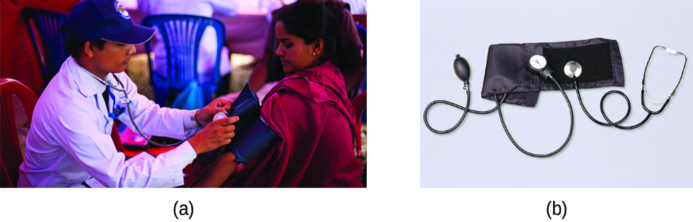
Figure 9.5 (a) A medical technician prepares to measure a patient’s blood pressure with a sphygmomanometer. (b) A typical sphygmomanometer uses a valved rubber bulb to inflate the cuff and a diaphragm gauge to measure pressure. (credit a: modification of work by Master Sgt. Jeffrey Allen)

How Sciences Interconnect

Meteorology, Climatology, and Atmospheric Science
Throughout the ages, people have observed clouds, winds, and precipitation, trying to discern patterns and make predictions: when it is best to plant and harvest; whether it is safe to set out on a sea voyage; and much more. We now face complex weather and atmosphere-related challenges that will have a major impact on our civilization and the ecosystem. Several different scientific disciplines use chemical principles to help us better understand weather, the atmosphere, and climate. These are meteorology, climatology, and atmospheric science. Meteorology is the study of the atmosphere, atmospheric phenomena, and atmospheric effects on earth’s weather. Meteorologists seek to understand and predict the weather in the short term, which can save lives and benefit the economy. Weather forecasts (Figure 9.6) are the result of thousands of measurements of air pressure, temperature, and the like, which are compiled, modeled, and analyzed in weather centers worldwide.
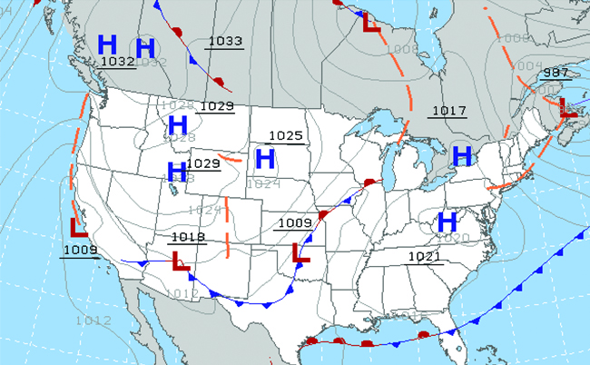
Figure 9.6 Meteorologists use weather maps to describe and predict weather. Regions of high (H) and low (L) pressure have large effects on weather conditions. The gray lines represent locations of constant pressure known as isobars. (credit: modification of work by National Oceanic and Atmospheric Administration)

In terms of weather, low-pressure systems occur when the earth’s surface atmospheric pressure is lower than the surrounding environment: Moist air rises and condenses, producing clouds. Movement of moisture and air within various weather fronts instigates most weather events.

The atmosphere is the gaseous layer that surrounds a planet. Earth’s atmosphere, which is roughly 100–125 km thick, consists of roughly 78.1% nitrogen and 21.0% oxygen, and can be subdivided further into the regions shown in Figure 9.7: the exosphere (furthest from earth, > 700 km above sea level), the thermosphere (80–700 km), the mesosphere (50–80 km), the stratosphere (second lowest level of our atmosphere, 12–50 km above sea level), and the troposphere (up to 12 km above sea level, roughly 80% of the earth’s atmosphere by mass and the layer where most weather events originate). As you go higher in the troposphere, air density and temperature both decrease.
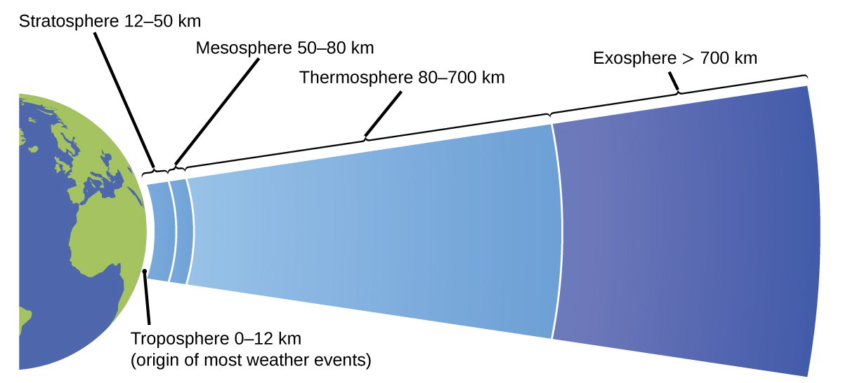
Figure 9.7 Earth’s atmosphere has five layers: the troposphere, the stratosphere, the mesosphere, the thermosphere, and the exosphere.

Climatology is the study of the climate, average weather conditions over long time periods, using atmospheric data. However, climatologists study patterns and effects that occur over decades, centuries, and millennia, rather than shorter time frames of hours, days, and weeks like meteorologists. Atmospheric science is an even broader field, combining meteorology, climatology, and other scientific disciplines that study the atmosphere.

9.2 Simple Gas Laws

Learning Objectives
- Be able to state, use, and give an example of applications of Gay-Lussac’s Law
- Be able to state, use, and give an example of applications of Charles's Law
- Be able to state, use, and give an example of applications of Boyle's Law
- Be able to state, use, and give an example of applications of Avogadro's Law

Introduction
During the seventeenth and especially eighteenth centuries, driven both by a desire to understand nature and a quest to make balloons in which they could fly (Figure 9.8), a number of scientists established the relationships between the macroscopic physical properties of gases, that is, pressure, volume, temperature, and amount of gas. Although their measurements were not precise by today’s standards, they were able to determine the mathematical relationships between pairs of these variables (e.g., pressure and temperature, pressure and volume) that hold for an ideal gas—a hypothetical construct that real gases approximate under certain conditions. Eventually, these individual laws were combined into a single equation—the ideal gas law—that relates gas quantities for gases and is quite accurate for low pressures and moderate temperatures. We will consider the key developments in individual relationships (for pedagogical reasons not quite in historical order), then put them together in the ideal gas law.
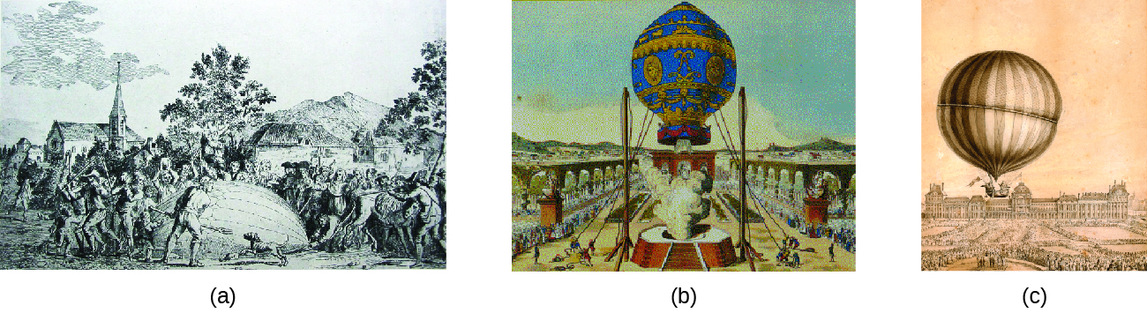
Figure 9.8 In 1783, the first (a) hydrogen-filled balloon flight, (b) manned hot air balloon flight, and (c) manned hydrogen-filled balloon flight occurred. When the hydrogen-filled balloon depicted in (a) landed, the frightened villagers of Gonesse reportedly destroyed it with pitchforks and knives. The launch of the latter was reportedly viewed by 400,000 people in Paris.

Pressure & Temperature: Amonton’s/ Gay-Lussac’s law
Imagine filling a rigid container attached to a pressure gauge with gas and then sealing the container so that no gas may escape. If the container is cooled, the gas inside likewise gets colder and its pressure is observed to decrease. Since the container is rigid and tightly sealed, both the volume and number of moles of gas remain constant. If we heat the sphere, the gas inside gets hotter (Figure 9.9) and the pressure increases.
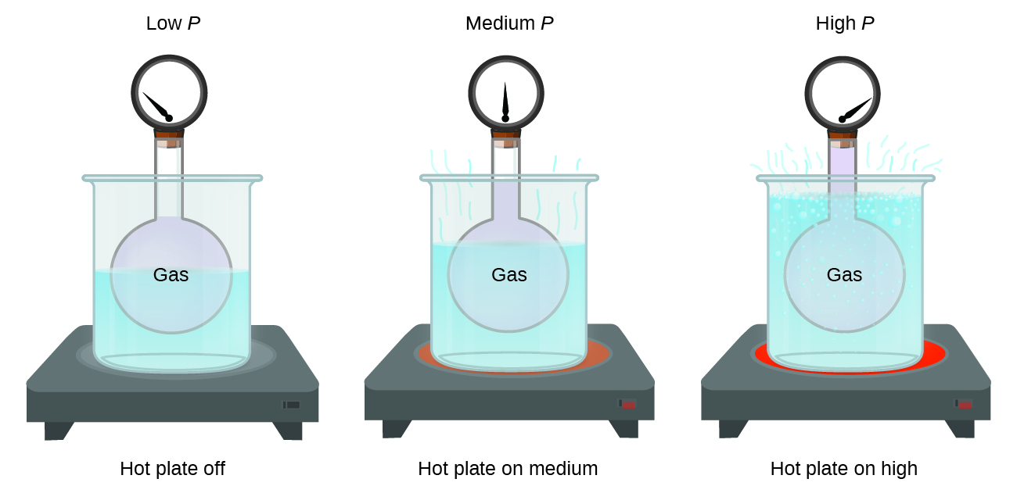

Figure 9.9 The effect of temperature on gas pressure: When the hot plate is off, the pressure of the gas in the sphere is relatively low. As the gas is heated, the pressure of the gas in the sphere increases.

This relationship between temperature and pressure is observed for any sample of gas confined to a constant volume. An example of experimental pressure-temperature data is shown for a sample of air under these conditions in Figure 9.10. We find that temperature and pressure are linearly related, and if the temperature is on the kelvin scale, then P and T are directly proportional (again, when volume and moles of gas are held constant); if the temperature on the kelvin scale increases by a certain factor, the gas pressure increases by the same factor.
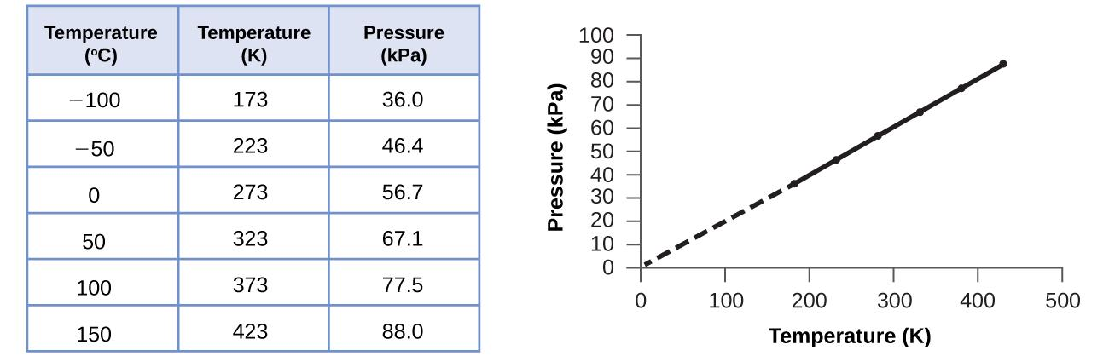
Figure 9.10 For a constant volume and amount of air, the pressure and temperature are directly proportional, provided the temperature is in kelvin. (Measurements cannot be made at lower temperatures because of the condensation of the gas.) When this line is extrapolated to lower pressures, it reaches a pressure of 0 at –273 °C, which is 0 on the kelvin scale and the lowest possible temperature, called absolute zero.
Guillaume Amontons was the first to empirically establish the relationship between the pressure and the temperature of a gas (~1700), and Joseph Louis Gay-Lussac determined the relationship more precisely (~1800). Because of this, the P-T relationship for gases is known as either Amontons’s law or Gay-Lussac’s law. Under either name, it states that the pressure of a given amount of gas is directly proportional to its temperature on the kelvin scale when the volume is held constant. Mathematically, this can be written:
P ∝ T or P = constant·T or P = k·T
where ∝ means “is proportional to,” and k is a proportionality constant that depends on the identity, amount, and volume of the gas.
For a confined, constant volume of gas, the ratio $\frac{P}{T}$ is therefore constant (i.e., $\frac{P}{T}$= k).
If the gas is initially in “Condition 1” (with P = P₁ and T = T₁),
and then changes to “Condition 2” (with P = P₂ and T = T₂),
we have that $\frac{P_{1}}{T_{1}}$ = k and $\frac{P_{2}}{T_{2}}$= k, which reduces to $\frac{P_{1}}{T_{1}}$ = $\frac{P_{2}}{T_{2}}$.
This equation is useful for pressure-temperature calculations for a confined gas at constant volume. Note that temperatures must be on the kelvin scale for any gas law calculations (0 on the kelvin scale and the lowest possible temperature is called absolute zero).

Example 9.2
Predicting Change in Pressure with Temperature
A can of hair spray is used until it is empty except for the propellant, isobutane gas.

(a) On the can is the warning “Store only at temperatures below 120 °F (48.8 °C). Do not incinerate.” Why?

(b) The gas in the can is initially at 24 °C and 360. kPa, and the can has a volume of 350. mL. If the can is left in a car that reaches 50 °C on a hot day, what is the new pressure in the can?

Solution:
(a) The can contains an amount of isobutane gas at a constant volume, so if the temperature is increased by heating, the pressure will increase proportionately. High temperature could lead to high pressure, causing the can to burst. (Also, isobutane is combustible, so incineration could cause the can to explode.)

(b) We are looking for a pressure change due to a temperature change at constant volume, so we will use Amontons’s/Gay-Lussac’s law. Taking P₁ and T₁ as the initial values, T₂ as the temperature where the pressure is unknown and P₂ as the unknown pressure, and converting °C to K, we have:
$\frac{P_{1}}{T_{1}}$ = $\frac{P_{2}}{T_{2}}$ which means that $\frac{360. kPa}{297 K}$ = $\frac{P_{2}}{323 K}$
Solve: P₂ = $\frac{360. kPa}{297 K}$· 323 K = 390. kPa

Check Your Learning
A sample of nitrogen, N₂, occupies 45.0 mL at 27 °C and 600. torr. What pressure will it have if cooled to –73 °C while the volume remains constant?

Answer: 400. torr

Volume and Temperature: Charles’s Law
If we filled a balloon with air and seal it, the balloon contains a specific amount of air at atmospheric pressure, let’s say 1 atm. If we put the balloon in a refrigerator, the gas inside gets cold and the balloon shrinks (although both the amount of gas and its pressure remain constant). If we make the balloon very cold, it will shrink a great deal, and it expands again when it warms up.

Link to Learning
This video (https://www.youtube.com/watch?v=ZgTTUuJZAFs) shows how cooling and heating a gas causes its volume to decrease or increase, respectively.

These examples of the effect of temperature on the volume of a given amount of a confined gas at constant pressure are true in general: The volume increases as the temperature increases, and decreases as the temperature decreases. Volume-temperature data for a 1-mole sample of methane gas at 1 atm are listed and graphed in Figure 9.11.
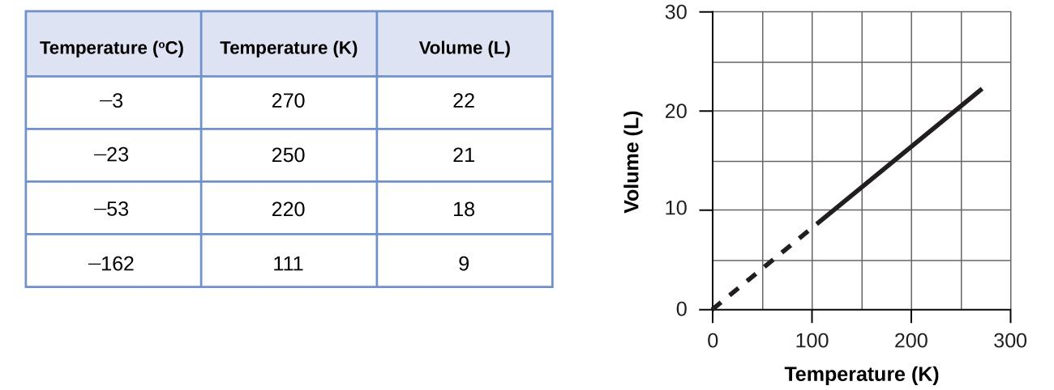
Figure 9.11 The volume and temperature are linearly related for 1 mole of methane gas at a constant pressure of 1 atm. If the temperature is in kelvin, volume and temperature are directly proportional. The line stops at 111 K because methane liquefies at this temperature; when extrapolated, it intersects the graph’s origin, representing a temperature of absolute zero.
The relationship between the volume and temperature of a given amount of gas at constant pressure is known as Charles’s law in recognition of the French scientist and balloon flight pioneer Jacques Alexandre César Charles. Charles’s law states that the volume of a given amount of gas is directly proportional to its temperature on the kelvin scale when the pressure is held constant.
Mathematically, this can be written as:
V ∝ T or V = constant·T or V = k·T

with k being a proportionality constant that depends on the amount and pressure of the gas.
For a confined, constant pressure gas sample, the ratio $\frac{V}{T}$ is constant (i.e., $\frac{V}{T}$= k), and as seen with the P-T relationship, this leads to another form of Charles’s Law: $\frac{V_{1}}{T_{1}}$ = $\frac{V_{2}}{T_{2}}$

Example 9.3
Predicting Change in Volume with Temperature
A sample of carbon dioxide, CO₂, occupies 0.300 L at 10. °C and 750. torr. What volume will the gas have at 30. °C and 750. torr?

Solution: Because we are looking for the volume change caused by a temperature change at constant pressure, this is a job for Charles’s law. Taking V₁ and T₁ as the initial values, T₂ as the temperature at which the volume is unknown and V₂ as the unknown volume, and converting °C into K we have:

$\frac{V_{1}}{T_{1}}$ = $\frac{V_{2}}{T_{2}}$ which means that $\frac{0.300 L}{283 K}$ = $\frac{V_{2}}{303 K}$
Solve: V₂ = $\frac{0.300 L}{283 K}$· 303 K = 0.321 L
This answer supports our expectation from Charles’s law, namely, that raising the gas temperature (from 283 K to 303 K) at a constant pressure will yield an increase in its volume (from 0.300 L to 0.321 L).

Check Your Learning
A sample of oxygen, O₂, occupies 32.2 mL at 30 °C and 452 torr. What volume will it occupy at –70 °C and the same pressure?
Answer: 21.6 mL

Example 9.4
Measuring Temperature with a Volume Change
Temperature is sometimes measured with a gas thermometer by observing the change in the volume of the gas as the temperature changes at constant pressure. The hydrogen in a particular hydrogen gas thermometer has a volume of 150.0 cm³ when immersed in a mixture of ice and water (0.00 °C). When immersed in boiling liquid ammonia, the volume of the hydrogen, at the same pressure, is 131.7 cm³. Find the temperature of boiling ammonia on the kelvin and Celsius scales.

Solution: A volume change caused by a temperature change at constant pressure means we should use Charles’s law. Taking V1 and T1 as the initial values, T2as the temperature at which the volume is unknown and V2 as the unknown volume, and converting °C into K we have:
$\frac{V_{1}}{T_{1}}$ = $\frac{V_{2}}{T_{2}}$ which means that $\frac{150.0 cm^{3}}{273.15 K}$ = $\frac{131.7 cm^{3}}{{T_{2}}_{}}$
Rearrange and Solve: T₂ = 131.7 ${cm}^{3}$ · $\frac{273.15 K}{150.0 cm^{3}}$ = 239.8 K
Subtracting 273.15 from 239.8 K, we find that the temperature of the boiling ammonia on the Celsius scale is –33.4 °C.

Check Your Learning
What is the volume of a sample of ethane at 467 K and 1.1 atm if it occupies 405 mL at 298 K and 1.1 atm?
Answer: 635 mL

Moles of Gas and Volume: Avogadro’s Law
The Italian scientist Amedeo Avogadro advanced a hypothesis in 1811 to account for the behavior of gases, stating that equal volumes of all gases, measured under the same conditions of temperature and pressure, contain the same number of molecules. Over time, this relationship was supported by many experimental observations as expressed by Avogadro’s law: For a confined gas, the volume (V) and number of moles (n) are directly proportional if the pressure and temperature both remain constant.
In equation form, this is written as:
V ∝ n or V = constant·n or V = k·n

For a confined, constant pressure and temperature, the ratio $\frac{V}{n}$ is constant (i.e., $\frac{V}{n}$= k), this leads to another form of Avogadro’s Law: $\frac{V_{1}}{n_{1}}$ = $\frac{V_{2}}{n_{2}}$
Mathematical relationships can also be determined for the other variable pairs, such as P versus n, and n versus T.

Volume and Pressure: Boyle’s Law
If we partially fill an airtight syringe with air, the syringe contains a specific amount of air at constant temperature, say 25 °C. If we slowly push in the plunger while keeping temperature constant, the gas in the syringe is compressed into a smaller volume and its pressure increases; if we pull out the plunger, the volume increases and the pressure decreases. This example of the effect of volume on the pressure of a given amount of a confined gas is true in general. Decreasing the volume of a contained gas will increase its pressure, and increasing its volume will decrease its pressure. In fact, if the volume increases by a certain factor, the pressure decreases by the same factor, and vice versa. Volume-pressure data for an air sample at room temperature are graphed in Figure 9.12.
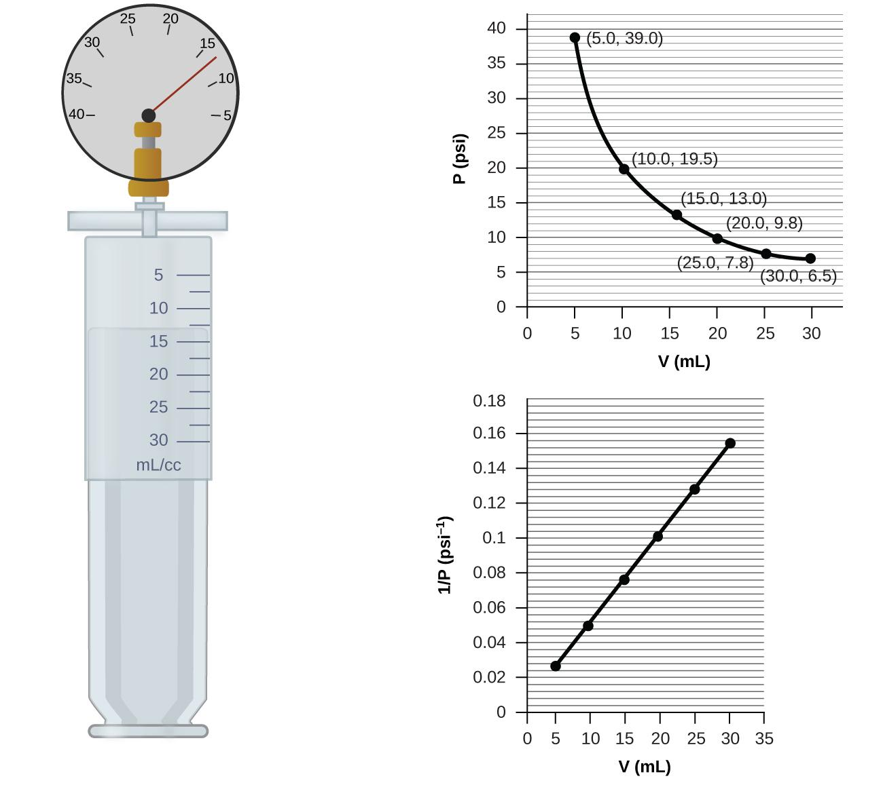
Figure 9.12 When a gas occupies a smaller volume, it exerts a higher pressure; when it occupies a larger volume, it exerts a lower pressure (assuming the amount of gas and the temperature do not change). Since P and V are inversely proportional, a graph of $\frac{1}{P}$ vs. V is linear.
Unlike the P-T and V-T relationships, pressure and volume are not directly proportional to each other. Instead, P and V exhibit inverse proportionality: Increasing the pressure results in a decrease of the volume of the gas. Mathematically, this can be written as:
P ∝ $\frac{1}{V}$ or P = constant·$\frac{1}{V}$ or P·V = k
with k being a constant. Graphically, this relationship is shown by the straight line that results when plotting the inverse of the pressure ($\frac{1}{P}$) versus the volume (V), or the inverse of volume ($\frac{1}{V}$) versus the pressure (P). For a confined constant temperature, this leads to another form of Boyle’s Law: P₁V₁ = P₂V₂
If we plot P versus V, we obtain a hyperbola (see Figure 9.13). Graphs with curved lines are difficult to read accurately at low or high values of the variables, and they are more difficult to use in fitting theoretical equations and parameters to experimental data. For those reasons, scientists often try to find a way to “linearize” their data.

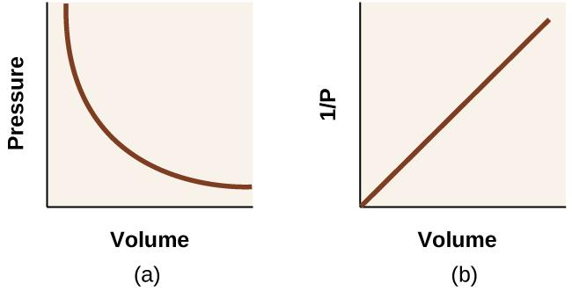
Figure 9.13 The relationship between pressure and volume is inversely proportional. (a) The graph of P vs. V is a hyperbola, whereas (b) the graph of ($\frac{1}{P}$) vs. V is linear.

The relationship between the volume and pressure of a given amount of gas at constant temperature was first published by the English natural philosopher Robert Boyle over 300 years ago. It is summarized in the statement now known as Boyle’s law: The volume of a given amount of gas held at constant temperature is inversely proportional to the pressure under which it is measured.

Example 9.5
Volume of a Gas Sample
The sample of gas in Figure 9.12 has a volume of 15.0 mL at a pressure of 13.0 psi. Determine the pressure of the gas at a volume of 7.5 mL, using:
(a) the P-V graph in Figure 9.12
(b) the $\frac{1}{P}$ vs. V graph in Figure 9.12
(c) the Boyle’s law equation Comment on the likely accuracy of each method.
Solution:
(a) Estimating from the P-V graph gives a value for P somewhere around 27 psi.
(b) Estimating from the $\frac{1}{P}$ versus V graph give a value of about 26 psi.
(c) From Boyle’s law, we know that P₁V₁ = P₂V₂
13.0 psi · 15.0 mL = P₂ · 7.5 mL
Solving: P₂ = $\frac{13.0 psi · 15.0 mL}{7.5 mL}$ = 26 psi
It was more difficult to estimate well from the P-V graph, so (a) is likely more inaccurate than (b) or (c). The calculation will be as accurate as the equation and measurements allow.

Check Your Learning
The sample of gas in Figure 9.12 has a volume of 30.0 mL at a pressure of 6.5 psi. Determine the volume of the gas at a pressure of 11.0 psi, using:
(a) the P-V graph in Figure 9.12
(b) the $\frac{1}{P}$ vs. V graph in Figure 9.12
(c) the Boyle’s law equation Comment on the likely accuracy of each method.

Answer: (a) about 17–18 mL; (b) ~18 mL; (c) 17.7 mL; it was more difficult to estimate well from the P-V graph, so (a) is likely more inaccurate than (b); the calculation will be as accurate as the equation and measurements allow

Chemistry in Everyday Life

Breathing and Boyle’s Law
Respiration, or breathing takes about 20 times per minute for your whole life, without break, and often without even being aware of it. Your lungs take in gas that your body needs (oxygen) and get rid of waste gas (carbon dioxide). Lungs are made of spongy, stretchy tissue that expands and contracts while you breathe. When you inhale, your diaphragm and intercostal muscles (the muscles between your ribs) contract, expanding your chest cavity and making your lung volume larger. The increase in volume leads to a decrease in pressure (Boyle’s law). This causes air to flow into the lungs (from high pressure to low pressure). When you exhale, the process reverses: Your diaphragm and rib muscles relax, your chest cavity contracts, and your lung volume decreases, causing the pressure to increase (Boyle’s law again), and air flows out of the lungs (from high pressure to low pressure). You then breathe in and out again, and again, repeating this Boyle’s law cycle for the rest of your life (Figure 9.14).
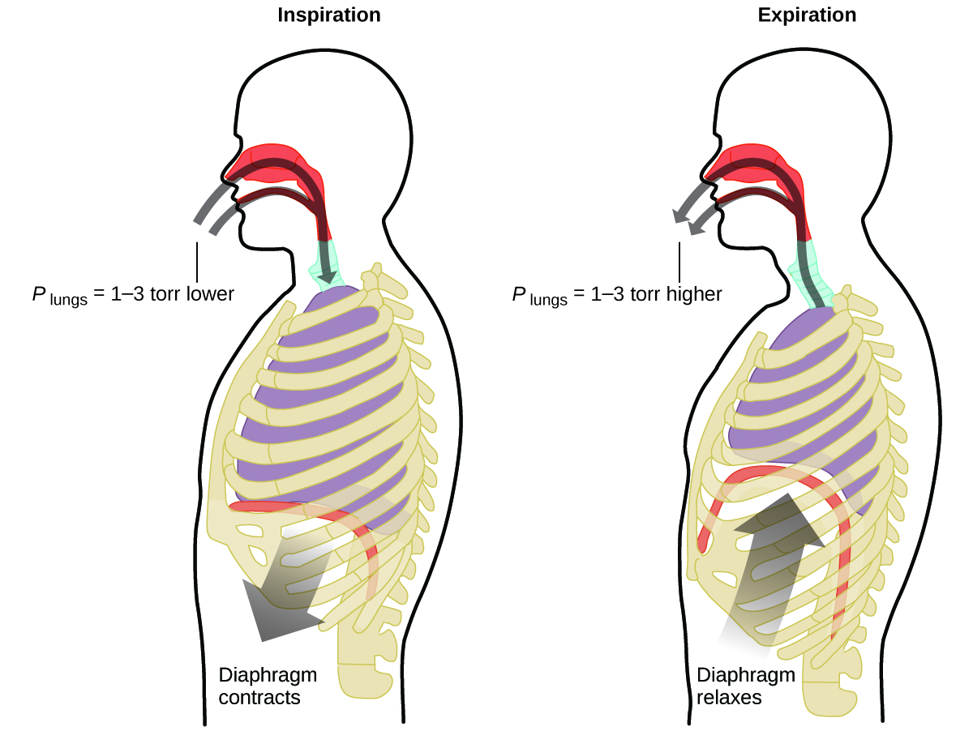
Figure 9.14 Breathing occurs because expanding and contracting lung volume creates small pressure differences between your lungs and your surroundings, causing air to be drawn into and forced out of your lungs.

9.3 The Kinetic Molecular Theory

Learning Objectives
- State the postulates of the kinetic-molecular theory
- Use this theory’s postulates to explain the gas laws

Introduction
The gas laws that we have seen to this point have been derived from experimental observations. Although the gas laws describe relationships that have been verified by many experiments, they do not tell us why gases follow these relationships.

Kinetic Molecular Theory
The kinetic molecular theory (KMT) is a simple microscopic model that effectively explains the gas laws described in previous modules of this chapter. This theory is based on the following five postulates described here. (Note: The term “molecule” will be used to refer to the individual chemical species that compose the gas, although some gases are composed of atomic species, for example, the noble gases.)
- Gases are composed of molecules that are in continuous motion, travelling in straight lines and changing direction only when they collide with other molecules or with the walls of a container.
- The molecules composing the gas are negligibly small compared to the distances between them.
- The pressure exerted by a gas in a container results from collisions between the gas molecules and the container walls.
- Gas molecules exert no attractive or repulsive forces on each other or the container walls; therefore, their collisions are elastic (do not involve a loss of energy).
- The average kinetic energy of the gas molecules is proportional to the kelvin temperature of the gas.
The test of the KMT and its postulates is its ability to explain and describe the behavior of a gas. The various gas laws can be derived from the assumptions of the KMT, which have led chemists to believe that the assumptions of the theory accurately represent the properties of gas molecules. We will first look at the individual gas laws (Amontons’s, Charles’s, Boyle’s, and Avogadro’s, laws) conceptually to see how the KMT explains them.

KMT Explains the Behavior of Gases
Recalling that gas pressure is exerted by rapidly moving gas molecules and depends directly on the number of molecules hitting a unit area of the wall per unit of time, we see that the KMT conceptually explains the behavior of a gas as follows:
- Amontons’s law. If the temperature is increased, the average speed and kinetic energy of the gas molecules increase. If the volume is held constant, the increased speed of the gas molecules results in more frequent and more forceful collisions with the walls of the container, therefore increasing the pressure (Figure 9.15).
- Charles’s law. If the temperature of a gas is increased, a constant pressure may be maintained only if the volume occupied by the gas increases. This will result in greater average distances traveled by the molecules to reach the container walls, as well as increased wall surface area. These conditions will decrease both the frequency of molecule-wall collisions and the number of collisions per unit area, the combined effects of which balance the effect of increased collision forces due to the greater kinetic energy at the higher temperature.
- Boyle’s law. If the gas volume is decreased, the container wall area decreases and the molecule-wall collision frequency increases, both of which increase the pressure exerted by the gas (Figure 9.15).
- Avogadro’s law. At constant pressure and temperature, the frequency and force of molecule-wall collisions are constant. Under such conditions, increasing the number of gaseous molecules will require a proportional increase in the container volume in order to yield a decrease in the number of collisions per unit area to compensate for the increased frequency of collisions (Figure 9.15).
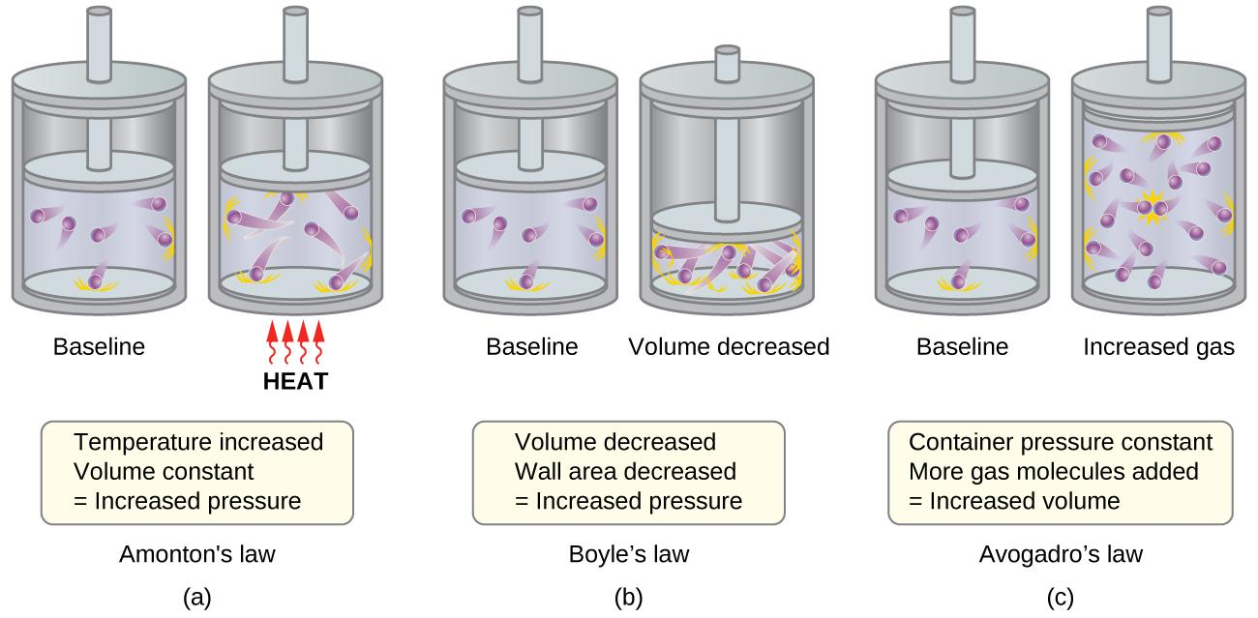
Figure 9.15 (a) When gas temperature increases, gas pressure increases due to increased force and frequency of molecular collisions. (b) When volume decreases, gas pressure increases due to increased frequency of molecular collisions. (c) When the amount of gas increases at a constant pressure, volume increases to yield a constant number of collisions per unit wall area per unit time.

Molecular Velocities and Kinetic Energy
The previous discussion showed that the KMT qualitatively explains the behaviors described by the various gas laws. The postulates of this theory may be applied in a more quantitative fashion to derive these individual laws. To do this, we must first look at velocities and kinetic energies of gas molecules, and the temperature of a gas sample.
In a gas sample, individual molecules have widely varying speeds; however, because of the vast number of molecules and collisions involved, the molecular speed distribution and average speed are constant. This molecular speed distribution is known as a Maxwell-Boltzmann distribution, and it depicts the relative numbers of molecules in a bulk sample of gas that possesses a given speed (Figure 9.16).
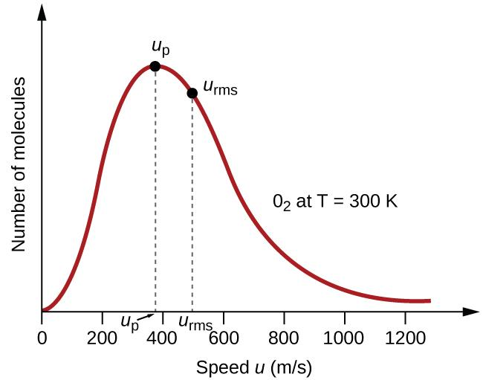
Figure 9.16 The molecular speed distribution for oxygen gas at 300 K is shown here. Very few molecules move at either very low or very high speeds. The number of molecules with intermediate speeds increases rapidly up to a maximum, which is the most probable speed (u_{p}), then drops off rapidly. Note that the most probable speed, u_{p}, is a little less than 400 m/s, while the root mean square speed, u_{rms}, is closer to 500 m/s.
The kinetic energy (KE) of a particle of mass (m) and speed (u) is given by:
KE = $\frac{1}{2}$m·u²
Expressing mass in kilograms and speed in meters per second will yield energy values in units of joules (J = kg·m²·s^{–2}). To deal with a large number of gas molecules, we use averages for both speed and kinetic energy.
In the KMT, the root mean square velocity of a particle, u_{rms}, is defined as the square root of the average of the squares of the velocities with n = the number of particles:
u_{rms} = $\sqrt{\frac{u_{1}^{2} + u_{2}^{2} + u_{3}^{2} + u_{4}^{2} + ...}{n}}$
The average kinetic energy for a mole of particles, KE_{avg}, is then equal to:

KE_{avg} = $\frac{1}{2}$M·$u_{rms}^{2}$
where M is the molar mass expressed in units of kg/mol. The KE_{avg} of a mole of gas molecules is also directly proportional to the temperature of the gas and may be described by the equation:
KE_{avg} = $\frac{3}{2}$RT
where R is the gas constant and T is the kelvin temperature. When used in this equation, the appropriate form of the gas constant is 8.314 J/mol⋅K (8.314 kg·m²·s^{–2}·mol^{–1}·K^{–1}).
These two separate equations for KE_{avg} may be combined and rearranged to yield a relation between molecular speed and temperature:

$\frac{1}{2}$M·$u_{rms}^{2}$ = $\frac{3}{2}$RT rearrange $u_{rms}^{}$ =$\sqrt{\frac{3RT}{M}}$
If the temperature of a gas increases, its KE_{avg} increases, more molecules have higher speeds and fewer molecules have lower speeds, and the distribution shifts toward higher speeds overall, that is, to the right.
If temperature decreases, KE_{avg} decreases, more molecules have lower speeds and fewer molecules have higher speeds, and the distribution shifts toward lower speeds overall, that is, to the left. This behavior is illustrated for nitrogen gas in Figure 9.17.

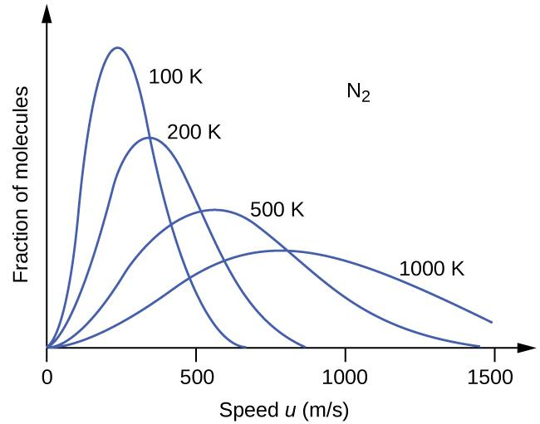

Figure 9.17 The molecular speed distribution for nitrogen gas (N₂) shifts to the right and flattens as the temperature increases; it shifts to the left and heightens as the temperature decreases.

At a given temperature, all gases have the same KE_{avg} for their molecules. Gases composed of lighter molecules have more high-speed particles and a higher u_{rms}, with a speed distribution that peaks at relatively higher velocities. Gases consisting of heavier molecules have more low-speed particles, a lower u_{rms}, and a speed distribution that peaks at relatively lower velocities. This trend is demonstrated by the data for a series of noble gases shown in Figure 9.18.

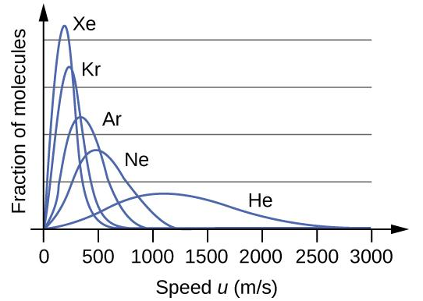

Figure 9.18 Molecular velocity is directly related to molecular mass. At a given temperature, lighter molecules move faster on average than heavier molecules.

9.4 The Ideal Gas Law and Its Applications

Learning Objectives
- Know and be able to use the Ideal Gas Law
- Know the standard temperature and pressure (STP)
- Use the Ideal Gas Law to calculate molar volume
- Use the Ideal Gas Law to calculate molar mass
- Use the Ideal Gas Law to calculate density

The Ideal Gas Law
To this point, four separate laws have been discussed that relate pressure, volume, temperature, and the number of moles of the gas:
- Amontons’s law: $\frac{P}{T}$ = constant at constant V and n
- Charles’s law: $\frac{V}{T}$ = constant at constant P and n
- Avogadro’s law: $\frac{V}{n}$ = constant at constant P and T
- Boyle’s law: PV = constant at constant T and n
Combining these four laws yields the ideal gas law, a relation between the pressure, volume, temperature, and number of moles of a gas:
PV = nRT
where P is the pressure of a gas, V is its volume, n is the number of moles of the gas, T is its temperature on the kelvin scale, and R is a constant called the ideal gas constant or the universal gas constant. The units used to express pressure, volume, and temperature will determine the proper form of the gas constant as required by dimensional analysis, the most commonly encountered values being 0.08206 atm·L·mol^{–1}·K^{–1} and 8.314 kPa·L mol^{–1}·K^{–1}.
Gases whose properties of P, V, and T are accurately described by the ideal gas law (or the other gas laws) are said to exhibit ideal behavior or to approximate the traits of an ideal gas. An ideal gas is a hypothetical construct that may be used along with kinetic molecular theory to effectively explain the gas laws as will be described in a later module of this chapter. Although all the calculations presented in this module assume ideal behavior, this assumption is only reasonable for gases under conditions of relatively low pressure and high temperature. In the final module of this chapter, a modified gas law will be introduced that accounts for the non-ideal behavior observed for many gases at relatively high pressures and low temperatures.
The ideal gas equation contains five terms, the gas constant R and the variable properties P, V, n, and T. Specifying any four of these terms will permit use of the ideal gas law to calculate the fifth term as demonstrated in the following example exercises.

Example 9.6
Using the Ideal Gas Law
Methane, CH₄, is being considered for use as an alternative automotive fuel to replace gasoline. One gallon of gasoline could be replaced by 655 g of CH₄. What is the volume of this much methane at 25 °C and 745 torr?
Solution: We must rearrange PV = nRT to solve for V: V = $\frac{nRT}{P}$
If we choose to use R = 0.08206 L atm mol^{–1} K^{–1}, then the amount must be in moles, temperature must be in kelvin, and pressure must be in atm.
Converting into the “right” units:
n = 655 g CH₄ × $\frac{1 mol}{16.043 g CH_{4}}$= 40.8 mol
T = 25 °C + 273 = 298 K
P = 745 torr × $\frac{1 atm}{760 torr}$ = 0.980 atm
V = $\frac{nRT}{P}$ = $\frac{(40.8 mol)(0.08206 atm·L·{mol}^{-1}·K^{-1})(298 K)}{0.980 atm}$ = 1.02 x 10³ L
It would require 1020 L (269 gal) of gaseous methane at about 1 atm of pressure to replace 1 gal of gasoline. It requires a large container to hold enough methane at 1 atm to replace several gallons of gasoline.

Check Your Learning
Calculate the pressure in bar of 2520 moles of hydrogen gas stored at 27 °C in the 180-L storage tank of a modern hydrogen-powered car.
Answer: 350 bar

If the number of moles of an ideal gas are kept constant under two different sets of conditions, a useful mathematical relationship called the combined gas law is obtained: $\frac{P_{1}V_{1}}{T_{1}}$=$\frac{P_{2}V_{2}}{T_{2}}$ using units of atm, L, and K. Both sets of conditions are equal to the product of n × R (where n = the number of moles of the gas and R is the ideal gas law constant).

Example 9.7
Using the Combined Gas Law
When filled with air, a typical scuba tank with a volume of 13.2 L has a pressure of 153 atm (Figure 9.19). If the water temperature is 27 °C, how many liters of air will such a tank provide to a diver’s lungs at a depth of approximately 70 feet in the ocean where the pressure is 3.13 atm?
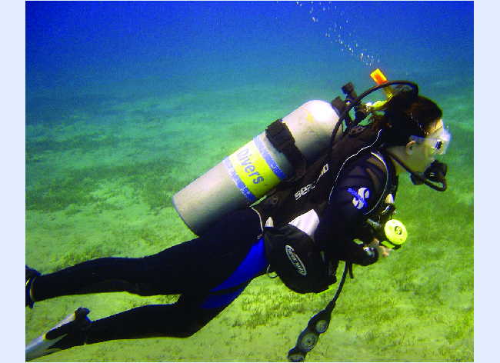
Figure 9.19 Scuba divers use compressed air to breathe while underwater. (credit: modification of work by Mark Goodchild)

Solution:

Letting 1 represent the air in the scuba tank and 2 represent the air in the lungs, and noting that body temperature (the temperature the air will be in the lungs) is 37 °C, we have:
$\frac{P_{1}V_{1}}{T_{1}}$=$\frac{P_{2}V_{2}}{T_{2}}$ $→$ $\frac{(153 atm)(13.2 L)}{(300 K)}$=$\frac{{(3.13 atm)}_{}V_{2}}{(310 K)}$
V₂ =$\frac{(153 atm)(13.2 L)(310 K)}{(300 K) (3.13 atm)}$
V₂ = 667 L

(Note: Be advised that this particular example is one in which the assumption of ideal gas behavior is not very reasonable, since it involves gases at relatively high pressures and low temperatures. Despite this limitation, the calculated volume can be viewed as a good “ballpark” estimate.)

Check Your Learning
A sample of ammonia is found to occupy 0.250 L under laboratory conditions of 27 °C and 0.850 atm. Find the volume of this sample at 0 °C and 1.00 atm.
Answer: 0.193 L

Chemistry in Everyday Life

The Interdependence between Ocean Depth and Pressure in Scuba Diving

Whether scuba diving at the Great Barrier Reef in Australia (shown in Figure 9.20) or in the Caribbean, divers must understand how pressure affects a number of issues related to their comfort and safety.
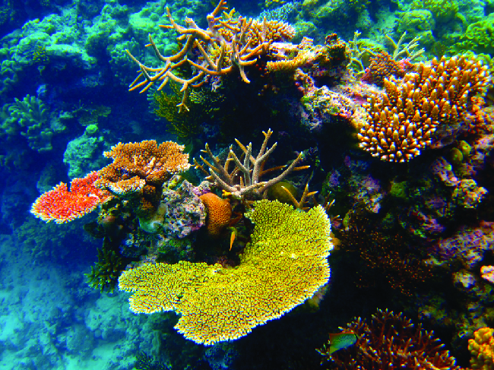
Figure 9.20 Scuba divers, whether at the Great Barrier Reef or in the Caribbean, must be aware of buoyancy, pressure equalization, and the amount of time they spend underwater, to avoid the risks associated with pressurized gases in the body. (credit: Kyle Taylor)

Pressure increases with ocean depth, and the pressure changes most rapidly as divers reach the surface. The pressure a diver experiences is the sum of all pressures above the diver (from the water and the air). Most pressure measurements are given in units of atmospheres, expressed as “atmospheres absolute” or ATA in the diving community: Every 33 feet of salt water represents 1 ATA of pressure in addition to 1 ATA of pressure from the atmosphere at sea level. As a diver descends, the increase in pressure causes the body’s air pockets in the ears and lungs to compress; on the ascent, the decrease in pressure causes these air pockets to expand, potentially rupturing eardrums or bursting the lungs. Divers must therefore undergo equalization by adding air to body airspaces on the descent by breathing normally and adding air to the mask by breathing out of the nose or adding air to the ears and sinuses by equalization techniques; the corollary is also true on ascent, divers must release air from the body to maintain equalization. Buoyancy, or the ability to control whether a diver sinks or floats, is controlled by the buoyancy compensator (BCD). If a diver is ascending, the air in his BCD expands because of lower pressure according to Boyle’s law (decreasing the pressure of gases increases the volume). The expanding air increases the buoyancy of the diver, and she or he begins to ascend. The diver must vent air from the BCD or risk an uncontrolled ascent that could rupture the lungs. In descending, the increased pressure causes the air in the BCD to compress and the diver sinks much more quickly; the diver must add air to the BCD or risk an uncontrolled descent, facing much higher pressures near the ocean floor. The pressure also impacts how long a diver can stay underwater before ascending. The deeper a diver dives, the more compressed the air that is breathed because of increased pressure: If a diver dives 33 feet, the pressure is 2 ATA and the air would be compressed to one-half of its original volume. The diver uses up available air twice as fast as at the surface.

Standard Conditions of Temperature and Pressure
We have seen that the volume of a given quantity of gas and the number of molecules (moles) in a given volume of gas vary with changes in pressure and temperature. Chemists sometimes make comparisons against a standard temperature and pressure (STP) for reporting properties of gases: 273.15 K and 1 atm (101.325 kPa).¹ At STP, one mole of an ideal gas has a volume of about 22.4 L—this is referred to as the standard molar volume (Figure 9.21).
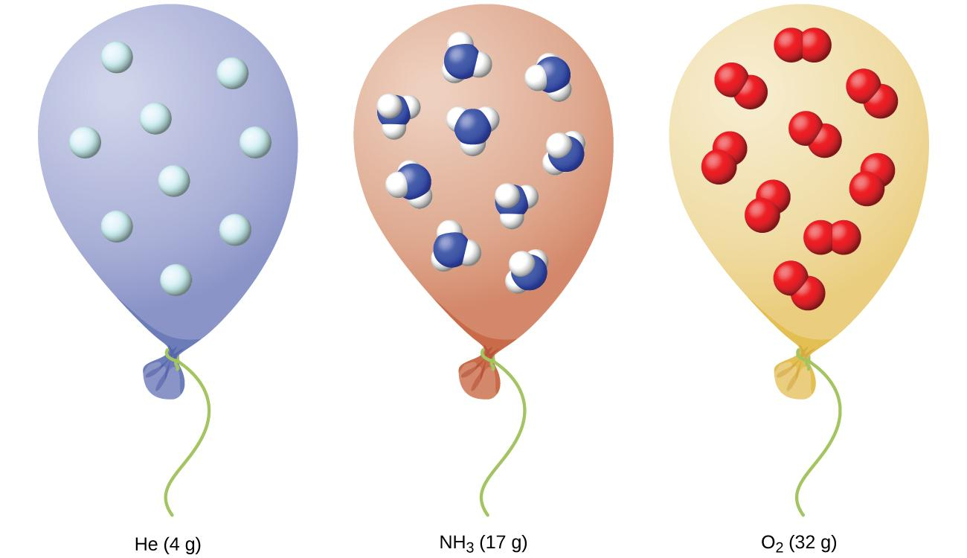
Figure 9.21 Regardless of its chemical identity, one mole of gas behaving ideally occupies a volume of ~22.4 L at STP.

Footnotes
- 1 The IUPAC definition of standard pressure was changed from 1 atm to 1 bar (100 kPa) in 1982, but the prior definition remains in use by many literature resources and will be used in this text.

Gas Density and Molar Mass
The ideal gas law described previously in this chapter relates the properties of pressure P, volume V, temperature T, and molar amount n. This law is universal, relating these properties in identical fashion regardless of the chemical identity of the gas:
PV = nRT
The density d of a gas, on the other hand, is determined by its identity. As described in another chapter of this text, the density of a substance is a characteristic property that may be used to identify the substance.
d = $\frac{m}{V}$
Rearranging the ideal gas equation to isolate V and substituting into the density equation yields
d = $\frac{m}{\frac{nRT}{P}}$= $(\frac{m}{n})(\frac{P}{RT})$
The ratio m/n is the definition of molar mass, M:
M = $\frac{m}{n}$
The density equation can then be written
d = M $(\frac{P}{RT})$ or d = $\frac{M P}{R T}$
This relation may be used for calculating the densities of gases of known identities at specified values of pressure and temperature as demonstrated in Example 9.8.

Example 9.8
Measuring Gas Density
What is the density of molecular nitrogen gas at STP?

Solution: The molar mass of molecular nitrogen, N₂, is 28.01 g/mol. Substituting this value along with standard temperature and pressure into the gas density equation yields
d = $\frac{M P}{R T}$ = $\frac{(28.01 g·mol^{-1})(1.00 atm)}{(0.082.6 atm·L·{mol}^{-1}·L^{-1})(273 K)}$ = 1.25 g/L

Check Your Learning
What is the density of molecular hydrogen gas at 17.0 °C and a pressure of 760 torr?
Answer: d = 0.0847 g/L

When the identity of a gas is unknown, measurements of the mass, pressure, volume, and temperature of a sample can be used to calculate the molar mass of the gas (a useful property for identification purposes). Combining the ideal gas equation
PV = nRT
and the definition of molar mass
M = $\frac{grams}{mole}$= $\frac{m}{n}$
yields the following equation:
M = $\frac{m}{\frac{PV}{RT}}$
M = $\frac{mRT}{PV}$
Determining the molar mass of a gas via this approach is demonstrated in Example 9.9.

Example 9.9
Determining the Molecular Formula of a Gas from its Molar Mass and Empirical Formula
Cyclopropane, a gas once used with oxygen as a general anesthetic, is composed of 85.7% carbon and 14.3% hydrogen by mass. Find the empirical formula. If 1.56 g of cyclopropane occupies a volume of 1.00 L at 0.984 atm and 50 °C, what is the molecular formula for cyclopropane?

Solution:
First determine the empirical formula of the gas. Assume 100 g and convert the percentage of each element into grams. Determine the number of moles of carbon and hydrogen in the 100-g sample of cyclopropane. Divide by the smallest number of moles to relate the number of moles of carbon to the number of moles of hydrogen. In the last step, realize that the smallest whole number ratio is the empirical formula:
$85.7 g C ×\frac{1 mol}{12.011 g C}$ = 7.136 mol C $\frac{7.136 mol}{7.136 mol}$ = 1.00
$14.3 g H ×\frac{1 mol}{1.008 g H}$ = 14.158 mol H $\frac{14.158 mol}{7.136 mol}$= 1.98
Empirical formula is CH₂
Empirical mass is 14.03 g/mol.

Next, use the provided values for mass, pressure, temperature and volume to compute the molar mass of the gas:
M = $\frac{mRT}{PV}$= $\frac{(1.56 g)(0.08206 atm·L·{mol}^{-1}·K^{-1})(323 K)}{(0.984 atm) (1.00 L)}$= 42.0 g/mol

Comparing the molar mass to the empirical formula mass shows how many empirical formula units make up a molecule:
whole number multiplier = $\frac{molecular mass}{empirical mass}$ = $\frac{42.0 g/mol}{14.03 g/mol}$ = 3

The molecular formula is thus derived from the empirical formula by multiplying each of its subscripts by three: (CH₂) x 3 = C₃H₆

Check Your Learning
Acetylene, a fuel used welding torches, is composed of 92.3% C and 7.7% H by mass. Find the empirical formula. If 1.10 g of acetylene occupies of volume of 1.00 L at 1.15 atm and 59.5 °C, what is the molecular formula for acetylene?

Answer: Empirical formula, CH; Molecular formula, C₂H₂

Example 9.10
Determining the Molar Mass of a Volatile Liquid
The approximate molar mass of a volatile liquid can be determined by:
- Heating a sample of the liquid in a flask with a tiny hole at the top, which converts the liquid into gas that may escape through the hole
- Removing the flask from heat at the instant when the last bit of liquid becomes gas, at which time the flask will be filled with only gaseous sample at ambient pressure
- Sealing the flask and permitting the gaseous sample to condense to liquid, and then weighing the flask to determine the sample’s mass (seeFigure 9.22)
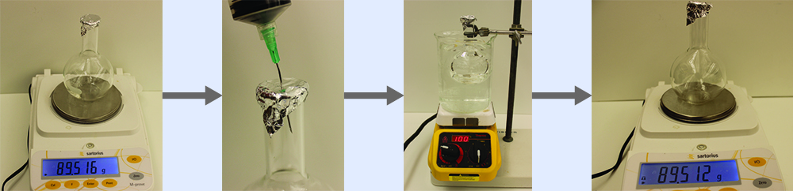
Figure 9.22 When the volatile liquid in the flask is heated past its boiling point, it becomes gas and drives air out of the flask. At t_{l⟶g}, the flask is filled with volatile liquid gas at the same pressure as the atmosphere. If the flask is then cooled to room temperature, the gas condenses and the mass of the gas that filled the flask, and is now liquid, can be measured. (credit: modification of work by Mark Ott)

Using this procedure, a sample of chloroform gas weighing 0.494 g is collected in a flask with a volume of 129 cm³ at 99.6 °C when the atmospheric pressure is 742.1 mm Hg. What is the approximate molar mass of chloroform?

Solution:

M = $\frac{mRT}{PV}$= $\frac{(0.494 g)(0.08206 atm·L·{mol}^{-1}·K^{-1})(372.8 K)}{(0.976 atm) (0.129 L)}$ = 120. g/mol

Check Your Learning
A sample of phosphorus that weighs 3.243 × 10⁻² g exerts a pressure of 31.89 kPa in a 56.0-mL bulb at 550 °C. What are the molar mass and molecular formula of phosphorus vapor?
Answer: 124 g/mol P₄

9.5 Mixtures of Gases and Partial Pressures

Learning Objectives
- State Dalton’s law of partial pressures
- Use Dalton’s law in calculations involving gaseous mixtures

The Pressure of a Mixture of Gases: Dalton’s Law
Unless they chemically react with each other, the individual gases in a mixture of gases do not affect each other’s pressure. Each individual gas in a mixture exerts the same pressure that it would exert if it were present alone in the container (Figure 9.23). The pressure exerted by each individual gas in a mixture is called its partial pressure. This observation is summarized by Dalton’s law of partial pressures: The total pressure of a mixture of ideal gases is equal to the sum of the partial pressures of the component gases:
P_{Total} = P_{A} + P_{B} + P_{C} + … = Σ_{i}P_{i}
In the equation P_{Total} is the total pressure of a mixture of gases, P_{A} is the partial pressure of gas A; P_{B} is the partial pressure of gas B; P_{C} is the partial pressure of gas C; and so on.
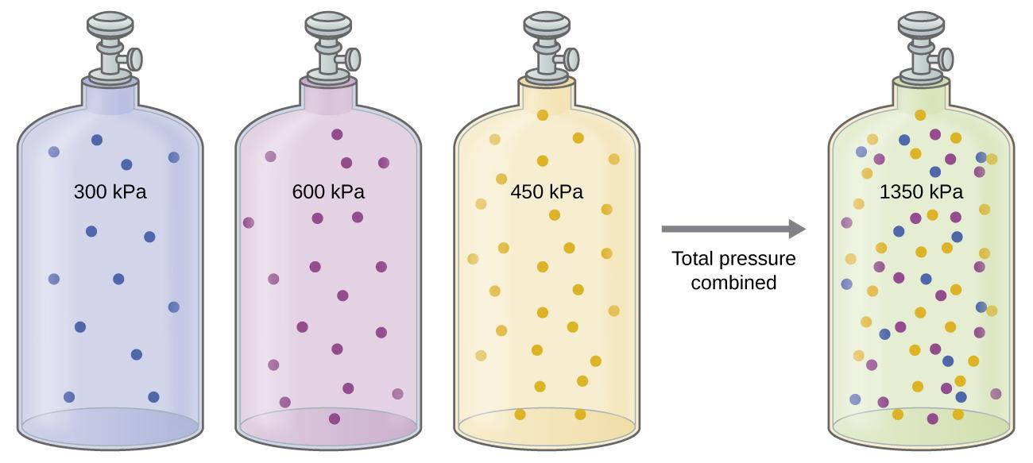
Figure 9.23 If equal-volume cylinders containing gas A at a pressure of 300 kPa, gas B at a pressure of 600 kPa, and gas C at a pressure of 450 kPa are all combined in the same-size cylinder, the total pressure of the mixture is 1350 kPa.
If the container has 20% moles of gas A, gas A would contribute to 20% of the pressure. Thus, the partial pressure of gas A is related to the total pressure of the gas mixture via its mole fraction (X). Mole fraction defines as a ratio between the number of moles of a component to the total number of moles of all components in a mixture:
P_{A} = X_{A} ·P_{Total} where X_{A} = $\frac{n_{A}}{n_{Total}}$
where P_{A}, X_{A}, and n_{A} are the partial pressure, mole fraction, and number of moles of gas A, respectively, and n_{Total} is the number of moles of all components in the mixture.

Example 9.11
The Pressure of a Mixture of Gases
A 10.0-L vessel contains 2.50 × 10⁻³ mol of H₂, 1.00 × 10⁻³ mol of He, and 3.00 × 10⁻⁴ mol of Ne at 35 °C.
(a) What are the partial pressures of each of the gases?
(b) What is the total pressure in atmospheres?
Solution: The gases behave independently, so the partial pressure of each gas can be determined from the ideal gas equation, rearranging PV = nRT to solve for P:
P = $\frac{nRT}{V}$
$P_{H_{2}}$ = $\frac{(2.50 × {10}^{-3} mol)(0.08206 atm·L·{mol}^{-1}·K^{-1})(308 K)}{10.0 L}$ = 6.32 x 10⁻³ atm
$P_{He}$ = $\frac{(1.00 × {10}^{-3} mol)(0.08206 atm·L·{mol}^{-1}·K^{-1})(308 K)}{10.0 L}$ = 2.53 x 10⁻³ atm
$P_{Ne}$ = $\frac{(3.00 × {10}^{-4} mol)(0.08206 atm·L·{mol}^{-1}·K^{-1})(308 K)}{10.0 L}$ = 7.58 x 10⁻⁴ atm
The total pressure is given by the sum of the partial pressures:
P_{T} = $P_{H_{2}}$+$P_{He}$+$P_{Ne}$= 0.00632 + 0.00253 + 0.00076 atm = 9.61×10⁻³ atm

Check Your Learning
A 5.73-L flask at 25 °C contains 0.0388 mol of N₂, 0.147 mol of CO, and 0.0803 mol of H₂. What is the total pressure in the flask in atmospheres?
Answer: 1.137 atm

Example 9.12
Here is another example of this concept, but dealing with mole fraction calculations.
The Pressure of a Mixture of Gases
A gas mixture used for anesthesia contains 2.83 mol oxygen, O₂, and 8.41 mol nitrous oxide, N₂O. The total pressure of the mixture is 192 kPa.
(a) What are the mole fractions of O₂ and N₂O?
(b) What are the partial pressures of O₂ and N₂O?
Solution: The mole fraction is given by X_{A} =$\frac{n_{A}}{n_{Total}}$and the partial pressure is P_{A} = X_{A} ·P_{Tot}
For O₂, X$O_{2}$ = $\frac{n_{O_{2}}}{n_{Total}}$ = $\frac{2.83 mol}{(2.83 + 8.41 mol)}$ = 0.252
P$O_{2}$ = X$O_{2}$ ·P_{Tot} = 0.252 x 192 kPa = 48.4 kPa
For N₂O, X$N_{2}O$ = $\frac{n_{N_{2}O}}{n_{Total}}$ = $\frac{8.41 mol}{(2.83 + 8.41 mol)}$ = 0.748
P$N_{2}O$ = X$N_{2}O$ ·P_{Tot} = 0.748 x 192 kPa = 143.6 kPa

Check Your Learning
What is the pressure of a mixture of 0.200 g of H₂, 1.00 g of N₂, and 0.820 g of Ar in a container with a volume of 2.00 L at 20 °C?
Answer: 1.87 atm

Collection of Gases over Water
A simple way to collect gases that do not react with water is to capture them in a bottle that has been filled with water and inverted into a dish filled with water. The pressure of the gas inside the bottle can be made equal to the air pressure outside by raising or lowering the bottle. When the water level is the same both inside and outside the bottle (Figure 9.24), the pressure of the gas is equal to the atmospheric pressure, which can be measured with a barometer.
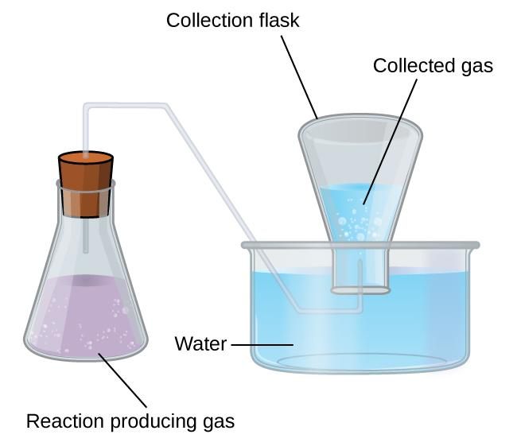
Figure 9.24 When a reaction produces a gas that is collected above water, the trapped gas is a mixture of the gas produced by the reaction and water vapor. If the collection flask is appropriately positioned to equalize the water levels both within and outside the flask, the pressure of the trapped gas mixture will equal the atmospheric pressure outside the flask (see the earlier discussion of manometers).
However, there is another factor we must consider when we measure the pressure of the gas by this method. Water evaporates and there is always gaseous water (water vapor) above a sample of liquid water. As a gas is collected over water, it becomes saturated with water vapor and the total pressure of the mixture equals the partial pressure of the gas plus the partial pressure of the water vapor. The pressure of the pure gas is therefore equal to the total pressure minus the pressure of the water vapor—this is referred to as the “dry” gas pressure, that is, the pressure of the gas only, without water vapor. The vapor pressure of water, which is the pressure exerted by water vapor in equilibrium with liquid water in a closed container, depends on the temperature (Figure 9.25); more detailed information on the temperature dependence of water vapor can be found in Table 9.2, and vapor pressure will be discussed in more detail in the next chapter on liquids.
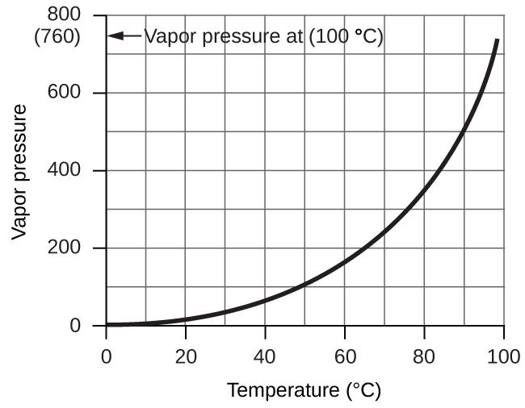
Figure 9.25 This graph shows the vapor pressure of water at sea level as a function of temperature.

Table 9.2 Vapor Pressure (P) of Ice and Water in Various Temperatures (T) at Sea Level
T (°C) | P (torr) |  | T (°C) | P (torr) |  | T (°C) | P (torr)
–10 | 1.95 |  | 18 | 15.5 |  | 30 | 31.8
–5 | 3.0 |  | 19 | 16.5 |  | 35 | 42.2
–2 | 3.9 |  | 20 | 17.5 |  | 40 | 55.3
0 | 4.6 |  | 21 | 18.7 |  | 50 | 92.5
2 | 5.3 |  | 22 | 19.8 |  | 60 | 149.4
4 | 6.1 |  | 23 | 21.1 |  | 70 | 233.7
6 | 7.0 |  | 24 | 22.4 |  | 80 | 355.1
8 | 8.0 |  | 25 | 23.8 |  | 90 | 525.8
10 | 9.2 |  | 26 | 25.2 |  | 95 | 633.9
12 | 10.5 |  | 27 | 26.7 |  | 99 | 733.2
14 | 12.0 |  | 28 | 28.3 |  | 100.0 | 760.0
16 | 13.6 |  | 29 | 30.0 |  | 101.0 | 787.6

Example 9.13
Pressure of a Gas Collected Over Water
If 0.200 L of argon is collected over water at a temperature of 26 °C and a pressure of 750 torr in a system like that shown in Figure 9.24, what is the partial pressure of argon?

Solution: According to Dalton’s law, the total pressure in the bottle (750 torr) is the sum of the partial pressure of argon and the partial pressure of gaseous water:
P$total$ = P_{Ar} + P$H_{2}O$
Rearranging this equation to solve for the pressure of argon gives:
P_{Ar} = P$total$ - P$H_{2}O$
The P$H_{2}O$ above a sample of liquid water at 26 °C is 25.2 torr (Table 9.2), so:
P_{Ar} = 750 torr - 25.2 torr = 725 torr

Check Your Learning
A sample of oxygen collected over water at a temperature of 29.0 °C and a pressure of 764 torr has a volume of 0.560 L. What volume would the dry oxygen from this sample have under the same conditions of temperature and pressure?

Answer: 0.537 L

The Kinetic-Molecular Theory Explains Dalton’s Law
Recalling that gas pressure is exerted by rapidly moving gas molecules and depends directly on the number of molecules hitting a unit area of the wall per unit of time, we see that the KMT conceptually explains the behavior of a gas as follows:
- Dalton’s Law. Because of the large distances between them, the molecules of one gas in a mixture bombard the container walls with the same frequency whether other gases are present or not, and the total pressure of a gas mixture equals the sum of the (partial) pressures of the individual gases.

9.6 Gas Stoichiometry

Learning Objectives
- Perform stoichiometric calculations involving gaseous substances

Introduction
The study of the chemical behavior of gases was part of the basis of perhaps the most fundamental chemical revolution in history. French nobleman Antoine Lavoisier, widely regarded as the “father of modern chemistry,” changed chemistry from a qualitative to a quantitative science through his work with gases. He discovered the law of conservation of matter, discovered the role of oxygen in combustion reactions, determined the composition of air, explained respiration in terms of chemical reactions, and more. He was a casualty of the French Revolution, guillotined in 1794. Of his death, mathematician and astronomer Joseph-Louis Lagrange said, “It took the mob only a moment to remove his head; a century will not suffice to reproduce it.”²
As described in an earlier chapter of this text, we can turn to chemical stoichiometry for answers to many of the questions that ask “How much?” The essential property involved in such use of stoichiometry is the amount of substance, typically measured in moles (n). For gases, molar amount can be derived from convenient experimental measurements of pressure, temperature, and volume. Therefore, these measurements are useful in assessing the stoichiometry of pure gases, gas mixtures, and chemical reactions involving gases. This section will not introduce any new material or ideas, but will provide examples of applications and ways to integrate concepts already discussed.

Chemical Stoichiometry and Gases
Chemical stoichiometry describes the quantitative relationships between reactants and products in chemical reactions. We have previously measured quantities of reactants and products using masses for solids and volumes in conjunction with the molarity for solutions; now we can also use gas volumes to indicate quantities. If we know the volume, pressure, and temperature of a gas, we can use the ideal gas equation to calculate how many moles of the gas are present. If we know how many moles of a gas are involved, we can calculate the volume of a gas at any temperature and pressure.

Avogadro’s Law Revisited
Sometimes we can take advantage of a simplifying feature of the stoichiometry of gases that solids and solutions do not exhibit: All gases that show ideal behavior contain the same number of molecules in the same volume (at the same temperature and pressure). Thus, the ratios of volumes of gases involved in a chemical reaction are given by the coefficients in the equation for the reaction, provided that the gas volumes are measured at the same temperature and pressure.
We can extend Avogadro’s law (that the volume of a gas is directly proportional to the number of moles of the gas) to chemical reactions with gases: Gases combine, or react, in definite and simple proportions by volume, provided that all gas volumes are measured at the same temperature and pressure.
For example, since nitrogen and hydrogen gases react to produce ammonia gas according to:
N₂ (g) + 3 H₂ (g) ⟶ 2 NH₃ (g)
a given volume of nitrogen gas reacts with three times that volume of hydrogen gas to produce two times that volume of ammonia gas, if pressure and temperature remain constant.
The explanation for this is illustrated in Figure 9.26. According to Avogadro’s law, equal volumes of gaseous N₂, H₂, and NH₃, at the same temperature and pressure, contain the same number of molecules. Because one molecule of N₂ reacts with three molecules of H₂ to produce two molecules of NH₃, the volume of H₂ required is three times the volume of N₂, and the volume of NH₃ produced is two times the volume of N₂.
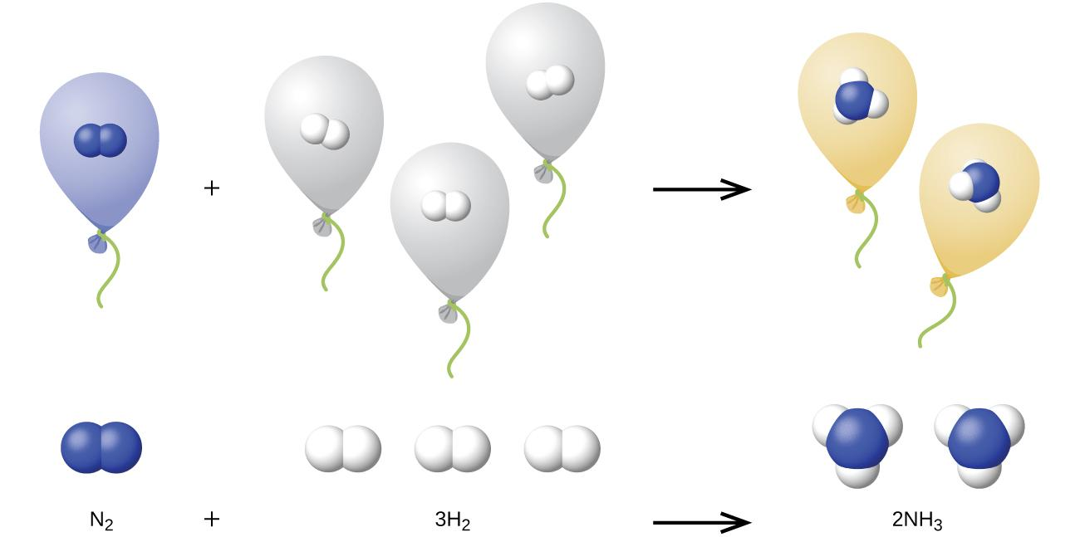
Figure 9.26 One volume of N₂ combines with three volumes of H₂ to form two volumes of NH₃.

Example 9.14
Reaction of Gases
Propane, C₃H₈ (g), is used in gas grills to provide the heat for cooking. What volume of O₂ (g) measured at 25 °C and 760 torr is required to react with 2.7 L of propane measured under the same conditions of temperature and pressure? Assume that the propane undergoes complete combustion.

Solution: The ratio of the volumes of C₃H₈ and O₂ will be equal to the ratio of their coefficients in the balanced equation for the reaction:
C₃H₈ (g) + 5 O₂ (g) ⟶ 3 CO₂ (g) + 4 H₂O (l)
1 volume + 5 volumes 3 volumes + 4 volumes
From the equation, we see that one volume of C₃H₈ will react with five volumes of O₂:
2.7 L C₃H₈ × $\frac{5 L O_{2}}{1 L C_{3}H_{8}}$ = 13.5 L O₂
A volume of 13.5 L of O₂ will be required to react with 2.7 L of C₃H₈.

Check Your Learning
An acetylene tank for an oxyacetylene welding torch provides 9340 L of acetylene gas, C₂H₂, at 0 °C and 1 atm. How many tanks of oxygen, each providing 7.00 × 10³ L of O₂
at 0 °C and 1 atm, will be required to burn the acetylene?
2 C₂H₂ + 5 O₂ ⟶ 4 CO₂ + 2 H₂O
Answer: 3.34 tanks (2.34 × 10⁴ L)

Example 9.15
Volumes of Reacting Gases
Ammonia is an important fertilizer and industrial chemical. Suppose that a volume of 683 billion cubic feet of gaseous ammonia, measured at 25 °C and 1 atm, was manufactured. What volume of H₂(g), measured under the same conditions, was required to prepare this amount of ammonia by reaction with N₂?
N₂ (g) + 3 H₂ (g) ⟶ 2 NH₃ (g)
Solution: Because equal volumes of H₂ and NH₃ contain equal numbers of molecules and each three molecules of H₂ that react to produce two molecules of NH₃, the ratio of the volumes of H₂ and NH₃ will be equal to 3:2. Two volumes of NH₃, in this case in units of billion ft³, will be formed from three volumes of H₂:
683 billion ft³ NH₃ × $\frac{3 billion {ft}^{3} H_{2}}{2 billion {ft}^{3}{NH}_{3}}$ = 1.02 × 10³ billion ft³ H₂
The manufacture of 683 billion ft³ of NH₃ required 1020 billion ft³ of H₂.
(At 25 °C and 1 atm, this is the volume of a cube with an edge length of approximately
1.9 miles.)

Check Your Learning
What volume of O₂(g) measured at 25 °C and 760 torr is required to react with 17.0 L of ethylene, C₂H₄(g), measured under the same conditions of temperature and pressure? The products are CO₂ and water vapor.

Answer: 51.0 L

Example 9.16
Volume of Gaseous Product
What volume of hydrogen at 27 °C and 723 torr may be prepared by the reaction of 8.88 g of gallium with an excess of hydrochloric acid?
2 Ga (s) + 6 HCl (aq) ⟶ 2 GaCl₃ (aq) + 3 H₂ (g)
Solution:
Convert the provided mass of the limiting reactant, Ga, to moles of hydrogen produced:
8.88g Ga × $\frac{1 mol Ga}{69.723 g Ga}$ × $\frac{3 mol H_{2}}{2 mol Ga}$ = 0.191 mol H₂
Convert the provided temperature and pressure values to appropriate units (K and atm, respectively), and then use the molar amount of hydrogen gas and the ideal gas equation to calculate the volume of gas:
V$H_{2}$ = $\frac{nRT}{P}$ = $\frac{(0.191 mol)(0.08206 atm·L·{mol}^{-1}·K^{-1})(300 K)}{0.951 atm}$ = 4.94 L

Check Your Learning
What volume of SO₂ at 343 °C and 1.21 atm is produced by burning l.00 kg of sulfur in excess oxygen?
Answer: 1.30 × 10³ L

How Sciences Interconnect

Greenhouse Gases and Climate Change
The thin skin of our atmosphere keeps the earth from being an ice planet and makes it habitable. In fact, this is due to less than 0.5% of the air molecules. Of the energy from the sun that reaches the earth, almost 13 is reflected back into space, with the rest absorbed by the atmosphere and the surface of the earth. Some of the energy that the earth absorbs is re-emitted as infrared (IR) radiation, a portion of which passes back out through the atmosphere into space. Most if this IR radiation, however, is absorbed by certain atmospheric gases, effectively trapping heat within the atmosphere in a phenomenon known as the greenhouse effect. This effect maintains global temperatures within the range needed to sustain life on earth. Without our atmosphere, the earth's average temperature would be lower by more than 30 °C (nearly 60 °F). The major greenhouse gases (GHGs) are water vapor, carbon dioxide, methane, and ozone. Since the Industrial Revolution, human activity has been increasing the concentrations of GHGs, which have changed the energy balance and are significantly altering the earth’s climate (Figure 9.27).
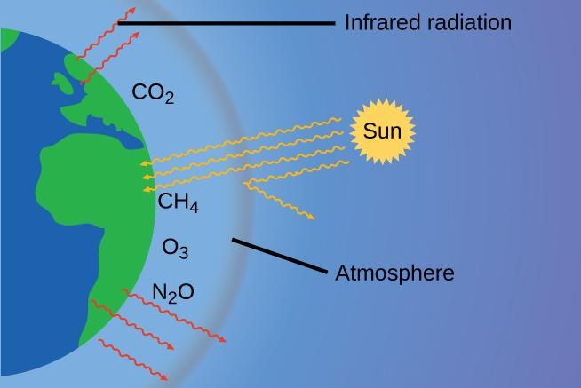
Figure 9.27 Greenhouse gases trap enough of the sun’s energy to make the planet habitable—this is known as the greenhouse effect. Human activities are increasing greenhouse gas levels, warming the planet and causing more extreme weather events.

There is strong evidence from multiple sources that higher atmospheric levels of CO₂ are caused by human activity, with fossil fuel burning accounting for about 34 of the recent increase in CO₂. Reliable data from ice cores reveals that CO₂ concentration in the atmosphere is at the highest level in the past 800,000 years; other evidence indicates that it may be at its highest level in 20 million years. In recent years, the CO₂ concentration has increased preindustrial levels of ~280 ppm to more than 400 ppm today (Figure 9.28).

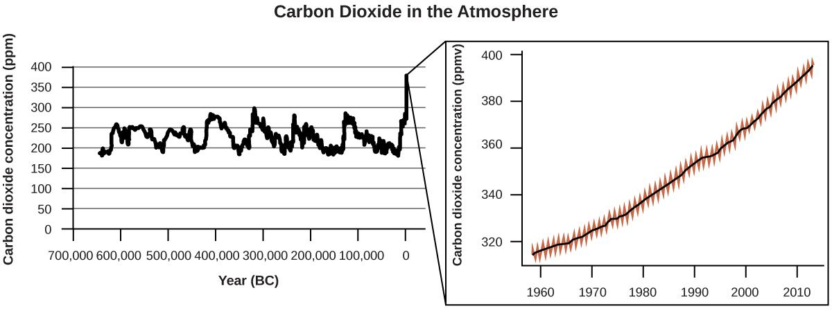

Figure 9.28 CO₂ levels over the past 700,000 years were typically from 200–300 ppm, with a steep, unprecedented increase over the past 50 years.

Portrait of a Chemist

Susan Solomon
Atmospheric and climate scientist Susan Solomon (Figure 9.29) is the author of one of The New York Times books of the year (The Coldest March, 2001), one of Time magazine’s 100 most influential people in the world (2008), and a working group leader of the Intergovernmental Panel on Climate Change (IPCC), which was the recipient of the 2007 Nobel Peace Prize. She helped determine and explain the cause of the formation of the ozone hole over Antarctica, and has authored many important papers on climate change. She has been awarded the top scientific honors in the US and France (the National Medal of Science and the Grande Medaille, respectively), and is a member of the National Academy of Sciences, the Royal Society, the French Academy of Sciences, and the European Academy of Sciences. Formerly a professor at the University of Colorado, she is now at MIT, and continues to work at NOAA. For more information, watch this video (https://www.youtube.com/watch?v=tx3BCP7fmtM) about Susan Solomon.
Figure 9.29 Susan Solomon’s research focuses on climate change and has been instrumental in determining the cause of the ozone hole over Antarctica. (credit: National Oceanic and Atmospheric Administration)

Footnotes
- 2 “Quotations by Joseph-Louis Lagrange,” last modified February 2006, accessed February 10, 2015, http://www-history.mcs.st-andrews.ac.uk/Quotations/Lagrange.html

Chapter 10 – Attributions

- The contents in this chapter, licensed under CC BY 4.0. has been adopted, modified, reorganized, and/or remixed from the following:

- 10.0 Introduction
- "10 Introduction" by Paul Flowers, Klaus Theopold, Richard Langley, William R. Robinson,, OpenStax is licensed under CC BY 4.0

- 10.1 Intermolecular Forces
- "10.1 Intermolecular Forces" by Paul Flowers, Klaus Theopold, Richard Langley, William R. Robinson,, OpenStax is licensed under CC BY 4.0

- 10.2 Properties of Liquids
- "10.2 Properties of Liquids" by Paul Flowers, Klaus Theopold, Richard Langley, William R. Robinson,, OpenStax is licensed under CC BY 4.0

- 10.3 Phase Transitions
- "10.3 Phase Transitions" by Paul Flowers, Klaus Theopold, Richard Langley, William R. Robinson,, OpenStax is licensed under CC BY 4.0

- 10.4 Phase Diagrams
- "10.4 Phase Diagrams" by Paul Flowers, Klaus Theopold, Richard Langley, William R. Robinson,, OpenStax is licensed under CC BY 4.0

- BLANK PAGE

Chapter 10 Liquids, Solids, and Their Intermolecular Forces

Chapter Introduction

10.1 Intermolecular Forces

10.2 Properties of Liquids

10.3 Phase Transitions

10.4 Phase Diagrams

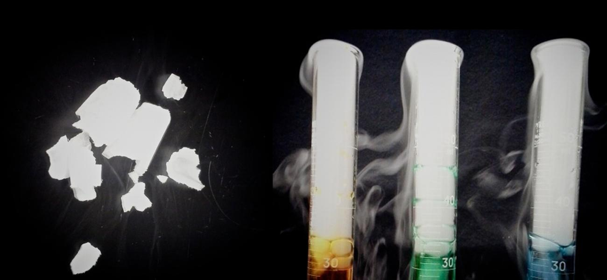
Figure 10.1 Solid carbon dioxide (“dry ice”, left) sublimes vigorously when placed in a liquid (right), cooling the liquid and generating a dense mist of water above the cylinder. (credit: modification of work by Paul Flowers)

The great distances between atoms and molecules in a gaseous phase, and the corresponding absence of any significant interactions between them, allows for simple descriptions of many physical properties that are the same for all gases, regardless of their chemical identities. As described in the final module of the chapter on gases, this situation changes at high pressures and low temperatures—conditions that permit the atoms and molecules to interact to a much greater extent. In the liquid and solid states, these interactions are of considerable strength and play an important role in determining a number of physical properties that do depend on the chemical identity of the substance. In this chapter, the nature of these interactions and their effects on various physical properties of liquid and solid phases will be examined.
BLANK PAGE

10.1 Intermolecular Forces

Learning Objectives
- Know the significant differences between gas and liquid & solid.
- Describe the types of intermolecular forces possible between atoms or molecules in condensed phases (dispersion forces, dipole-dipole attractions, hydrogen bonding)
- Identify the types of intermolecular forces experienced by specific molecules based on their structures
- Explain the relation between the intermolecular forces present within a substance and the temperatures associated with changes in its physical state

Introduction
As was the case for gaseous substances, the kinetic molecular theory may be used to explain the behavior of solids and liquids. In the following description, the term particle will be used to refer to an atom, molecule, or ion. Note that we will use the popular phrase “intermolecular attraction” to refer to attractive forces between the particles of a substance, regardless of whether these particles are molecules, atoms, or ions.
Consider these two aspects of the molecular-level environments in solid, liquid, and gaseous matter:
- Particles in a solid are tightly packed together and often arranged in a regular pattern; in a liquid, they are close together with no regular arrangement; in a gas, they are far apart with no regular arrangement.
- Particles in a solid vibrate about fixed positions and do not generally move in relation to one another; in a liquid, they move past each other but remain in essentially constant contact; in a gas, they move independently of one another except when they collide.
The differences in the properties of a solid, liquid, or gas reflect the strengths of the attractive forces between atoms, molecules, or ions that make up each phase. The phase in which a substance exists depends on the relative extents of its intermolecular forces (IMFs) and the kinetic energies (KE) of its molecules. IMFs are the various forces of attraction that may exist between the atoms and molecules of a substance due to electrostatic phenomena, as will be detailed in this module. These forces serve to hold particles close together, whereas the particles’ KE provides the energy required to overcome the attractive forces and thus increase the distance between particles. Figure 10.2 illustrates how changes in physical state may be induced by changing the temperature, hence, the average KE, of a given substance.
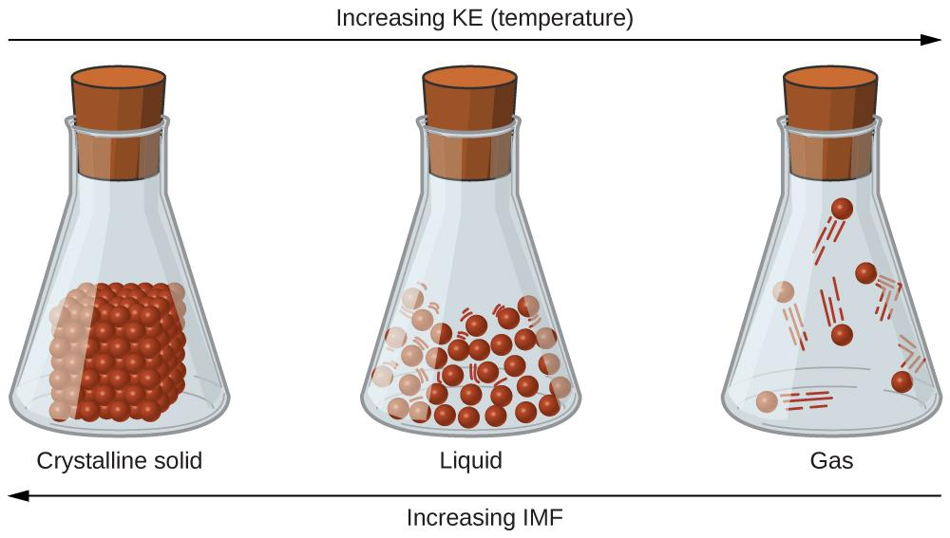
Figure 10.2 Transitions between solid, liquid, and gaseous states of a substance occur when conditions of temperature or pressure favor the associated changes in intermolecular forces. (Note: The space between particles in the gas phase is much greater than shown.)
As an example of the processes depicted in this figure, consider a sample of water. When gaseous water is cooled sufficiently, the attractions between H2O molecules will be capable of holding them together when they come into contact with each other; the gas condenses, forming liquid H2O. For example, liquid water forms on the outside of a cold glass as the water vapor in the air is cooled by the cold glass, as seen in Figure 10.3.

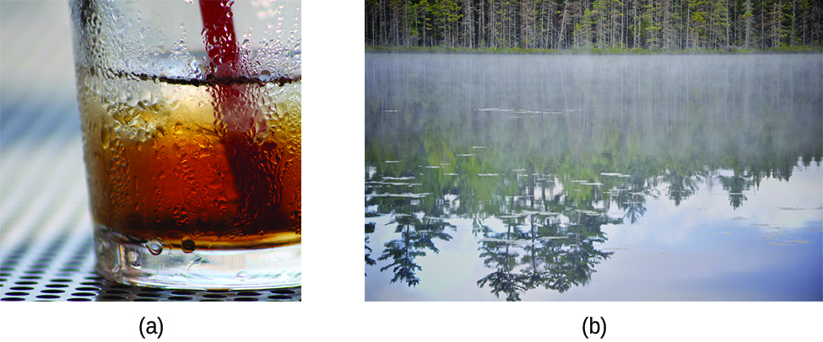
Figure 10.3 Condensation forms when water vapor in the air is cooled enough to form liquid water, such as (a) on the outside of a cold beverage glass or (b) in the form of fog. (credit a: modification of work by Jenny Downing; credit b: modification of work by Cory Zanker)
We can also liquefy many gases by compressing them, if the temperature is not too high. The increased pressure brings the molecules of a gas closer together, such that the attractions between the molecules become strong relative to their KE. Consequently, they form liquids. Butane, C4H10, is the fuel used in disposable lighters and is a gas at standard temperature and pressure. Inside the lighter’s fuel compartment, the butane is compressed to a pressure that results in its condensation to the liquid state, as shown in Figure 10.4.
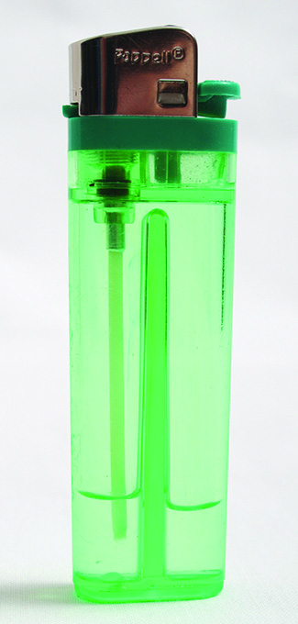
Figure 10.4 Gaseous butane is compressed within the storage compartment of a disposable lighter, resulting in its condensation to the liquid state. (credit: modification of work by “Sam-Cat”/Flickr)
Finally, if the temperature of a liquid becomes sufficiently low, or the pressure on the liquid becomes sufficiently high, the molecules of the liquid no longer have enough KE to overcome the IMF between them, and a solid forms. A more thorough discussion of these and other changes of state, or phase transitions, is provided in a later module of this chapter.

Intermolecular Forces - Forces between Molecules
Under appropriate conditions, the attractions between all gas molecules will cause them to form liquids or solids. This is due to intermolecular forces (IMFs), not intramolecular forces.
Intramolecular forces are those within the molecule that keep the molecule together, for example, the bonds between the atoms.
Intermolecular forces are the attractions between molecules, which determine many of the physical properties of a substance.
Figure 10.5 illustrates these different molecular forces. The strengths of these attractive forces vary widely, though usually the IMFs between small molecules are weak compared to the intramolecular forces that bond atoms together within a molecule.
For example, to overcome the IMFs in one mole of liquid HCl and convert it into gaseous HCl requires only about 17 kilojoules. However, to break the covalent bonds between the hydrogen and chlorine atoms in one mole of HCl requires about 25 times more energy—430 kilojoules.
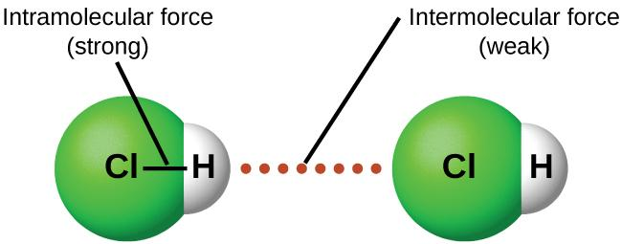
Figure 10.5 Intramolecular forces keep a molecule intact. Intermolecular forces hold multiple molecules together and determine many of a substance’s properties.
All of the attractive forces between neutral atoms and molecules are known as van der Waals forces, although they are usually referred to more informally as intermolecular attraction. We will consider the various types of IMFs in the next three sections of this section.

Dispersion Forces
The London dispersion force is the van der Waals attractive force that is present in all condensed phases, regardless of the nature of the atoms or molecules composing the substance. The London dispersion force is named in honor of German-born American physicist Fritz London who, in 1928, first explained it. This force is often referred to as simply the dispersion force.
The electrons of an atom or molecule are in constant motion. At any moment in time, an atom or molecule can develop a temporary, instantaneous dipole if its electrons are distributed asymmetrically. The presence of this dipole can, in turn, distort the electrons of a neighboring atom or molecule, producing an induced dipole. These two rapidly fluctuating, temporary dipoles, resulting in a relatively weak electrostatic attraction between the species—a so-called dispersion force like that illustrated in Figure 10.6.
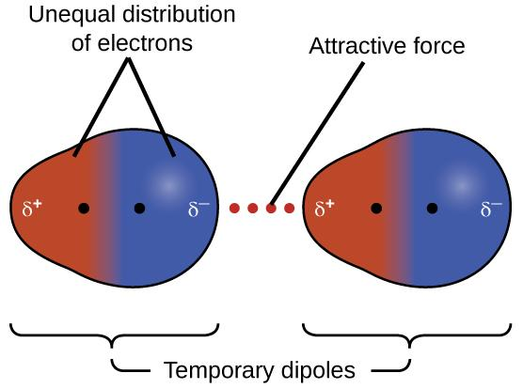
Figure 10.6 Dispersion forces result from the formation of temporary dipoles, as illustrated here for two nonpolar diatomic molecules.
Dispersion forces that develop between atoms in different molecules can attract the two molecules to each other. The forces are relatively weak, however, and become significant only when the molecules are very close. Larger and heavier atoms and molecules exhibit stronger dispersion forces than do smaller and lighter atoms and molecules. F₂ and Cl₂ are gases at room temperature (reflecting weaker attractive forces). Br₂ is a liquid, and I₂ is a solid (reflecting stronger attractive forces). Trends in observed melting and boiling points for the halogens clearly demonstrate this effect, as seen in Table 10.1.
Table 10.1 Melting and Boiling Points of the Halogens
Halogen | Molar Mass | Atomic Radius | Melting Point | Boiling Point
fluorine, F₂ | 38 g/mol | 72 pm | 53 K | 85 K
chlorine, Cl₂ | 71 g/mol | 99 pm | 172 K | 238 K
bromine, Br₂ | 160 g/mol | 114 pm | 266 K | 332 K
iodine, I₂ | 254 g/mol | 133 pm | 387 K | 457 K
astatine, At₂ | 420 g/mol | 150 pm | 575 K | 610 K

The increase in melting and boiling points with increasing atomic/molecular size may be rationalized by considering how the strength of dispersion forces is affected by the electronic structure of the atoms or molecules in the substance. In a larger atom, the valence electrons are, on average, farther from the nuclei than in a smaller atom. Thus, they are less tightly held and can more easily form the temporary dipoles that produce the attraction. The measure of how easy or difficult it is for another electrostatic charge (for example, a nearby ion or polar molecule) to distort a molecule’s charge distribution (its electron cloud) is known as polarizability. A molecule that has a charge cloud that is easily distorted is said to be very polarizable and will have large dispersion forces; one with a charge cloud that is difficult to distort is not very polarizable and will have small dispersion forces.

Example 10.1
London Forces and Their Effects
Order the following compounds of a group 14 element and hydrogen from lowest to highest boiling point: CH₄, SiH₄, GeH₄, and SnH₄. Explain your reasoning.
Solution: Applying the skills acquired in the chapter on chemical bonding and molecular geometry, all of these compounds are predicted to be nonpolar, so they may experience only dispersion forces: the smaller the molecule, the less polarizable and the weaker the dispersion forces; the larger the molecule, the larger the dispersion forces.
The molar masses of CH₄, SiH₄, GeH₄, and SnH₄ are approximately 16 g/mol, 32 g/mol, 77 g/mol, and 123 g/mol, respectively. Therefore, CH₄ is expected to have the lowest boiling point and SnH₄ the highest boiling point.
The ordering from lowest to highest boiling point is expected to be:
CH₄ < SiH₄ < GeH₄ < SnH₄.
A graph of the actual boiling points of these compounds versus the period of the group 14 element shows this prediction to be correct:
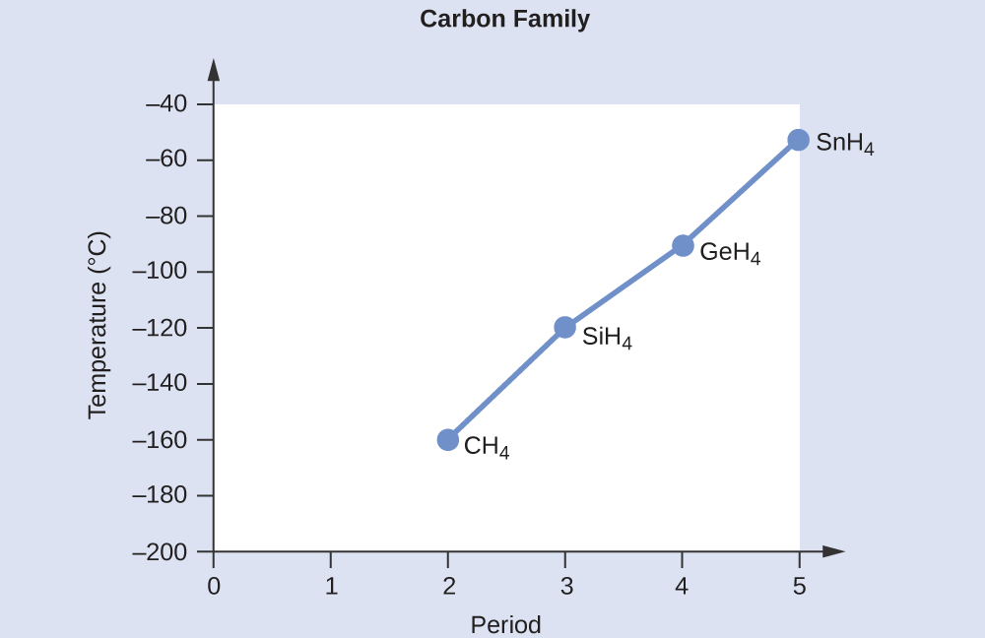

Check Your Learning
Rank the following from lowest to highest boiling point: C₂H₆, C₃H₈, and C₄H₁₀.
Answer: C₂H₆ < C₃H₈ < C₄H₁₀. All of these compounds are nonpolar and only have London dispersion forces: the larger the molecule, the larger the dispersion forces and the higher the boiling point. The ordering from lowest to highest boiling point is therefore
C₂H₆ < C₃H₈ < C₄H₁₀.
The shapes of molecules also affect the magnitudes of the dispersion forces between them. For example, boiling points for the isomers n-pentane, isopentane, and neopentane (shown in Figure 10.7) are 36 °C, 27 °C, and 9.5 °C, respectively. Even though these compounds are composed of molecules with the same chemical formula, C₅H₁₂, the difference in boiling points suggests that dispersion forces in the liquid phase are different, being greatest for n-pentane and least for neopentane. The elongated shape of n-pentane provides a greater surface area available for contact between molecules, resulting in correspondingly stronger dispersion forces. The more compact shape of isopentane offers a smaller surface area available for intermolecular contact and, therefore, weaker dispersion forces. Neopentane molecules are the most compact of the three, offering the least available surface area for intermolecular contact and, hence, the weakest dispersion forces. This behavior is analogous to the connections that may be formed between strips of VELCRO brand fasteners: the greater the area of the strip’s contact, the stronger the connection.
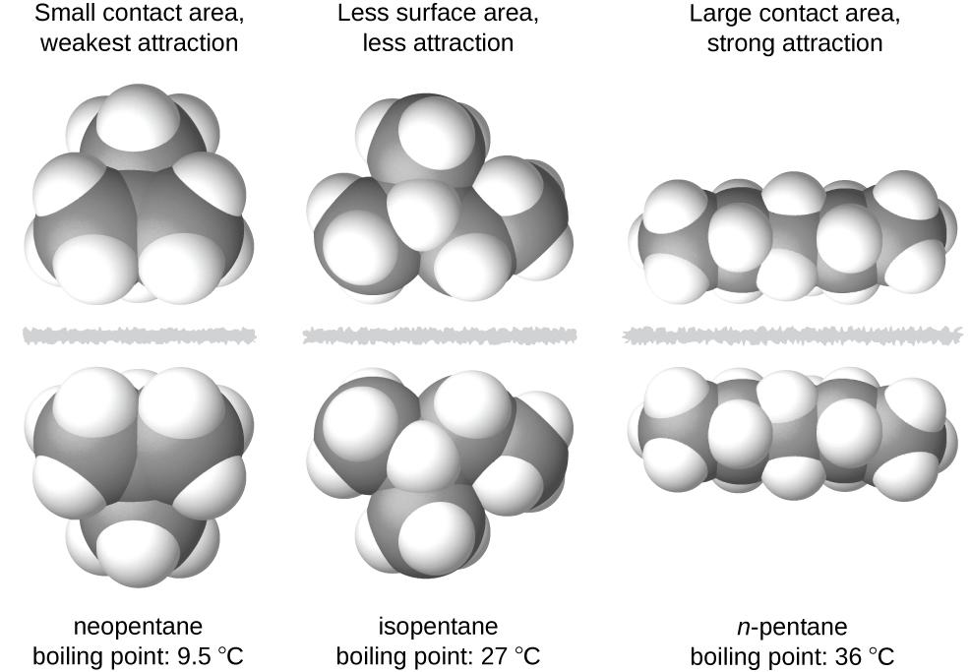
Figure 10.7 The strength of the dispersion forces increases with the contact area between molecules, as demonstrated by the boiling points of these pentane isomers.

Chemistry in Everyday Life

Geckos and Intermolecular Forces
Geckos have an amazing ability to adhere to most surfaces. They can quickly run up smooth walls and across ceilings that have no toe-holds, and they do this without having suction cups or a sticky substance on their toes. And while a gecko can lift its feet easily as it walks along a surface, if you attempt to pick it up, it sticks to the surface. How are geckos (as well as spiders and some other insects) able to do this? Although this phenomenon has been investigated for hundreds of years, scientists only recently uncovered the details of the process that allows geckos’ feet to behave this way.
Geckos’ toes are covered with hundreds of thousands of tiny hairs known as setae, with each seta, in turn, branching into hundreds of tiny, flat, triangular tips called spatulae. The huge numbers of spatulae on its setae provide a gecko, shown in Figure 10.8, with a large total surface area for sticking to a surface. In 2000, Kellar Autumn, who leads a multi-institutional gecko research team, found that geckos adhered equally well to both polar silicon dioxide and nonpolar gallium arsenide. This proved that geckos stick to surfaces because of dispersion forces—weak intermolecular attractions arising from temporary, synchronized charge distributions between adjacent molecules. Although dispersion forces are very weak, the total attraction over millions of spatulae is large enough to support many times the gecko’s weight.

In 2014, two scientists developed a model to explain how geckos can rapidly transition from “sticky” to “non-sticky.” AlexGreaney and Congcong Hu at Oregon State University described how geckos can achieve this by changing the angle between their spatulae and the surface. Geckos’ feet, which are normally nonsticky, become sticky when a small shear force is applied. By curling and uncurling their toes, geckos can alternate between sticking and unsticking from a surface, and thus easily move across it. Further investigations may eventually lead to the development of better adhesives and other applications.
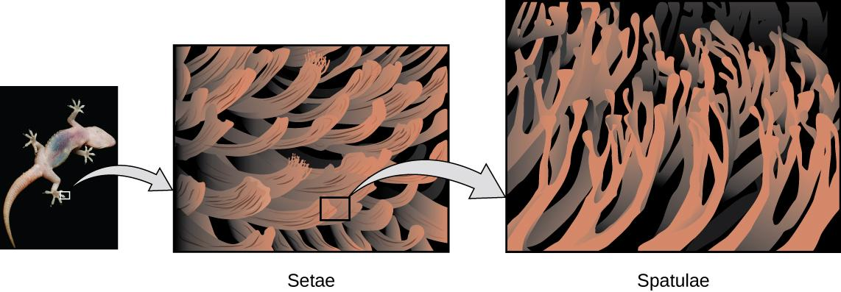
Figure 10.8 Geckos’ toes contain large numbers of tiny hairs (setae), which branch into many triangular tips (spatulae). Geckos adhere to surfaces because of van der Waals attractions between the surface and a gecko’s millions of spatulae. By changing how the spatulae contact the surface, geckos can turn their stickiness “on” and “off.” (credit photo: modification of work by “JC*+A!”/Flickr)

Link to Learning
Watch this video (https://www.youtube.com/watch?v=gzm7yD-JuyM) to learn more about Kellar Autumn’s research that determined that van der Waals forces are responsible for a gecko’s ability to cling and climb.

Dipole-Dipole Attractions
Recall from the chapter on chemical bonding and molecular geometry that polar molecules have a partial positive charge on one side and a partial negative charge on the other side of the molecule—a separation of charge called a dipole. Consider a polar molecule such as hydrogen chloride, HCl. In the HCl molecule, the more electronegative Cl atom bears the partial negative charge, whereas the less electronegative H atom bears the partial positive charge. An attractive force between HCl molecules results from the attraction between the positive end of one HCl molecule and the negative end of another. This attractive force is called a dipole-dipole attraction—the electrostatic force between the partially positive end of one polar molecule and the partially negative end of another, as illustrated in Figure 10.9.
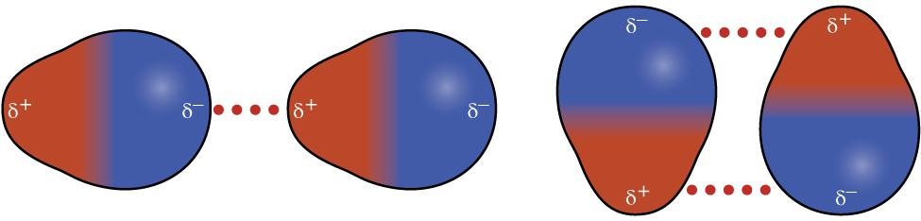
Figure 10.9 This image shows two arrangements of polar molecules, such as HCl, that allow an attraction between the partial negative end of one molecule and the partial positive end of another.
The effect of a dipole-dipole attraction is apparent when we compare the properties of HCl molecules to nonpolar F₂ molecules. Both HCl and F₂ consist of the same number of atoms and have approximately the same molecular mass. At a temperature of 150 K, molecules of both substances would have the same average KE. However, the dipole-dipole attractions between HCl molecules are sufficient to cause them to “stick together” to form a liquid, whereas the relatively weaker dispersion forces between nonpolar F₂ molecules are not, and so this substance is gaseous at this temperature. The higher normal boiling point of HCl (188 K) compared to F₂ (85 K) is a reflection of the greater strength of dipole-dipole attractions between HCl molecules, compared to the attractions between nonpolar F₂ molecules. We will often use values such as boiling or freezing points, or enthalpies of vaporization or fusion, as indicators of the relative strengths of IMFs of attraction present within different substances.

Example 10.2
Dipole-Dipole Forces and Their Effects

Predict which will have the higher boiling point: N₂ or CO. Explain your reasoning.

Solution:
CO and N2 are both diatomic molecules with masses of about 28 amu, so they experience similar London dispersion forces. Because CO is a polar molecule, it experiences dipole-dipole attractions. Because N₂ is nonpolar, its molecules cannot exhibit dipole-dipole attractions. The dipole-dipole attractions between CO molecules are comparably stronger than the dispersion forces between nonpolar N₂ molecules, so CO is expected to have the higher boiling point.

Check Your Learning
Predict which will have the higher boiling point: ICl or Br₂. Explain your reasoning.

Answer: ICl
ICl and Br₂ have similar masses (~160 amu) and therefore experience similar London dispersion forces. ICl is polar and thus also exhibits dipole-dipole attractions; Br₂ is nonpolar and does not. The relatively stronger dipole-dipole attractions require more energy to overcome, so ICl will have the higher boiling point.

Hydrogen Bonding
Nitrosyl fluoride (ONF, molecular mass 49 amu) is a gas at room temperature. Water (H₂O, molecular mass 18 amu) is a liquid, even though it has a lower molecular mass.
We clearly cannot attribute this difference between the two compounds to dispersion forces. Both molecules have about the same shape and ONF is the heavier and larger molecule. It is, therefore, expected to experience more significant dispersion forces.
Additionally, we cannot attribute this difference in boiling points to differences in the dipole moments of the molecules. Both molecules are polar and exhibit comparable dipole moments.
The large difference between the boiling points is due to a particularly strong dipole-dipole attraction that may occur when a molecule contains a hydrogen atom bonded to a fluorine, oxygen, or nitrogen atom (the three most electronegative elements). The very large difference in electronegativity between the H atom (2.1) and the atom to which it is bonded (4.0 for an F atom, 3.5 for an O atom, or 3.0 for a N atom), combined with the very small size of a H atom and the relatively small sizes of F, O, or N atoms, leads to highly concentrated partial charges with these atoms.
Molecules with F-H, O-H, or N-H moieties are very strongly attracted to similar moieties in nearby molecules, a particularly strong type of dipole-dipole attraction called hydrogen bonding. Examples of hydrogen bonds include HF⋯HF, H₂O⋯HOH, and H₃N⋯HNH₂, in which the hydrogen bonds are denoted by dots. Figure 10.10 illustrates hydrogen bonding between water molecules.
Despite the use of the word “bond,” keep in mind that hydrogen bonds are intermolecular attractive forces, not intramolecular attractive forces (covalent bonds). Hydrogen bonds are much weaker than covalent bonds, only about 5 to 10% as strong, but are generally much stronger than other dipole-dipole attractions and dispersion forces.

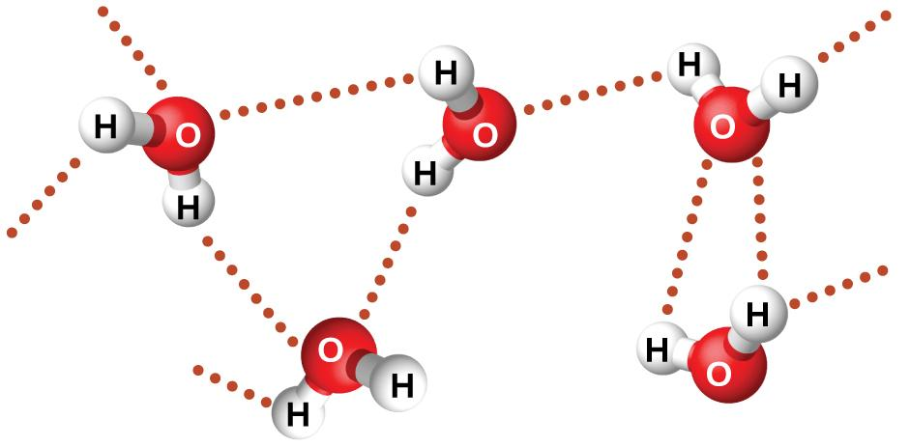
Figure 10.10 Water molecules participate in multiple hydrogen-bonding interactions with nearby water molecules.

Hydrogen bonds have a pronounced effect on the properties of condensed phases (liquids and solids). For example, consider the trends in boiling points for the binary hydrides of group 15 (NH₃, PH₃, AsH₃, and SbH₃), group 16 hydrides (H₂O, H₂S, H₂Se, and H₂Te), and group 17 hydrides (HF, HCl, HBr, and HI). The boiling points of the heaviest three hydrides for each group are plotted in Figure 10.11. As we progress down any of these groups, the polarities of the molecules decrease slightly, whereas the sizes of the molecules increase substantially. The effect of increasingly stronger dispersion forces dominates that of increasingly weaker dipole-dipole attractions, and the boiling points are observed to increase steadily.
If we use this trend to predict the boiling points for the lightest hydride for each group, we would expect NH₃ to boil at about −120 °C, H₂O to boil at about −80 °C, and HF to boil at about −110 °C. However, when we measure the boiling points for these compounds, we find that they are dramatically higher than the trends would predict, as shown in Figure 10.12. The stark contrast between our naïve predictions and reality provides compelling evidence for the strength of hydrogen bonding.

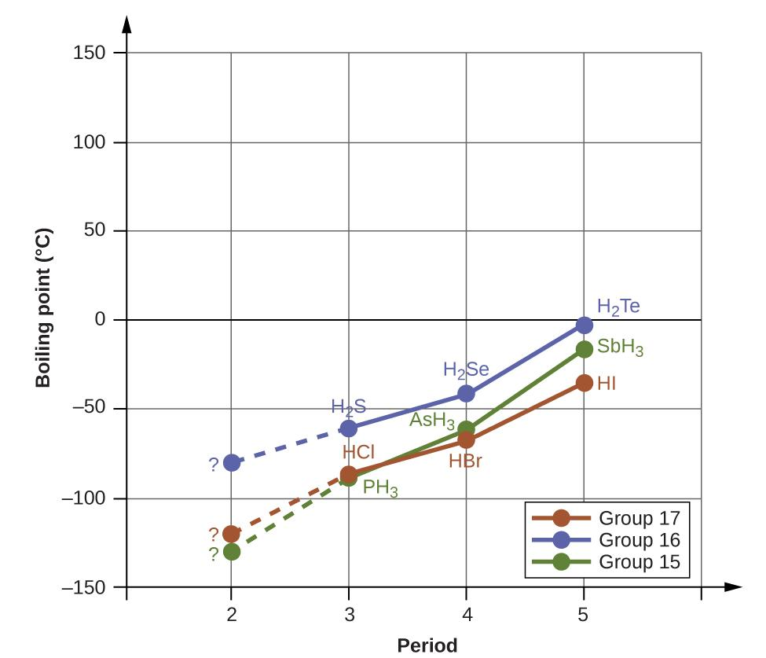
Figure 10.11 For the group 15, 16, and 17 hydrides, the boiling points for each class of compounds increase with increasing molecular mass for elements in periods 3, 4, and 5.
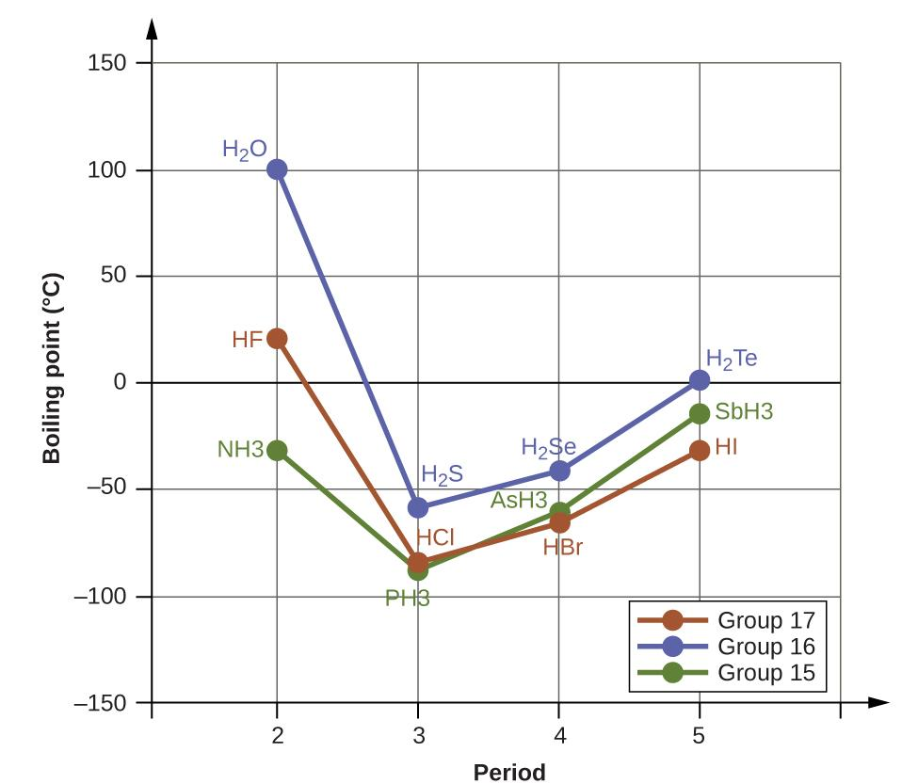
Figure 10.12 In comparison to periods 3−5, the binary hydrides of period 2 elements in groups 17, 16 and 15 (F, O and N, respectively) exhibit anomalously high boiling points due to hydrogen bonding.

Example 10.3
Effect of Hydrogen Bonding on Boiling Points
Consider the compounds dimethylether (CH₃OCH₃), ethanol (CH₃CH₂OH), and propane (CH₃CH₂CH₃). Their boiling points, not necessarily in order, are −42.1 °C, −24.8 °C, and 78.4 °C. Match each compound with its boiling point. Explain your reasoning.

Solution:
The VSEPR-predicted shapes of CH₃OCH₃, CH₃CH₂OH, and CH₃CH₂CH₃ are similar, as are their molar masses (46 g/mol, 46 g/mol, and 44 g/mol, respectively), so they will exhibit similar dispersion forces. Since CH₃CH₂CH₃ is nonpolar, it may exhibit only dispersion forces. Because CH₃OCH₃ is polar, it will also experience dipole-dipole attractions. Finally, CH₃CH₂OH has an −OH group, and so it will experience the uniquely strong dipole-dipole attraction known as hydrogen bonding. So the ordering in terms of strength of IMFs, and thus boiling points, is CH₃CH₂CH₃ < CH₃OCH₃ < CH₃CH₂OH. The boiling point of propane is −42.1 °C, the boiling point of dimethylether is −24.8 °C, and the boiling point of ethanol is 78.5 °C.

Check Your Learning
Ethane (CH₃CH₃) has a melting point of −183 °C and a boiling point of −89 °C. Predict the relative melting and boiling points for methylamine (CH₃NH₂). Explain your reasoning.

Answer:
The melting point and boiling point for methylamine are predicted to be significantly greater than those of ethane. CH₃CH₃ and CH₃NH₂ are similar in size and mass, but methylamine possesses an −NH group and therefore may exhibit hydrogen bonding. This greatly increases its IMFs, and therefore its melting and boiling points. It is difficult to predict values, but the known values are a melting point of −93 °C and a boiling point of −6 °C.

How Sciences Interconnect

Hydrogen Bonding and DNA
Deoxyribonucleic acid (DNA) is found in every living organism and contains the genetic information that determines the organism’s characteristics, provides the blueprint for making the proteins necessary for life, and serves as a template to pass this information on to the organism’s offspring. A DNA molecule consists of two (anti-)parallel chains of repeating nucleotides, which form its well-known double helical structure, as shown in Figure 10.13.
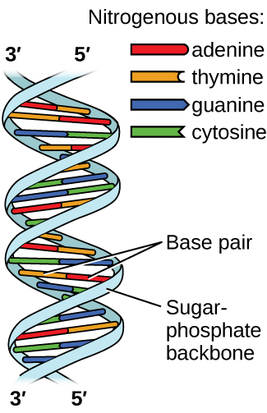
Figure 10.13 Two separate DNA molecules form a double-stranded helix in which the molecules are held together via hydrogen bonding. (credit: modification of work by Jerome Walker, Dennis Myts)
Each nucleotide contains a (deoxyribose) sugar bound to a phosphate group on one side, and one of four nitrogenous bases on the other. Two of the bases, cytosine (C) and thymine (T), are single-ringed structures known as pyrimidines. The other two, adenine (A) and guanine (G), are double-ringed structures called purines. These bases form complementary base pairs consisting of one purine and one pyrimidine, with adenine pairing with thymine, and cytosine with guanine. Each base pair is held together by hydrogen bonding. A and T share two hydrogen bonds, C and G share three, and both pairings have a similar shape and structure Figure 10.14.
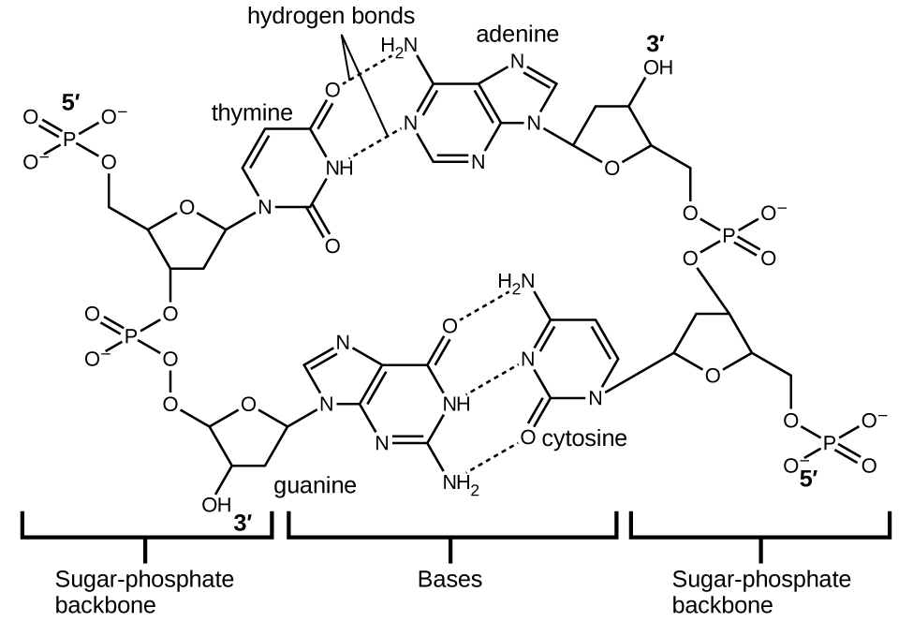
Figure 10.14 The geometries of the base molecules result in maximum hydrogen bonding between adenine and thymine (AT) and between guanine and cytosine (GC), so-called “complementary base pairs.”

The cumulative effect of millions of hydrogen bonds effectively holds the two strands of DNA together. Importantly, the two strands of DNA can relatively easily “unzip” down the middle since hydrogen bonds are relatively weak compared to the covalent bonds that hold the atoms of the individual DNA molecules together. This allows both strands to function as a template for replication.

10.2 Properties of Liquids

Learning Objectives
- Distinguish between adhesive and cohesive forces
- Define viscosity, surface tension, and capillary rise
- Describe the roles of intermolecular attractive forces in each of these properties/phenomena

Viscosity
When you pour a glass of water, or fill a car with gasoline, you observe that water and gasoline flow freely. But when you pour syrup on pancakes or add oil to a car engine, you note that syrup and motor oil do not flow as readily. The viscosity of a liquid is a measure of its resistance to flow. Water, gasoline, and other liquids that flow freely have a low viscosity. Honey, syrup, motor oil, and other liquids that do not flow freely, like those shown in Figure 10.15, have higher viscosities. We can measure viscosity by measuring the rate at which a metal ball falls through a liquid (the ball falls more slowly through a more viscous liquid) or by measuring the rate at which a liquid flows through a narrow tube (more viscous liquids flow more slowly).
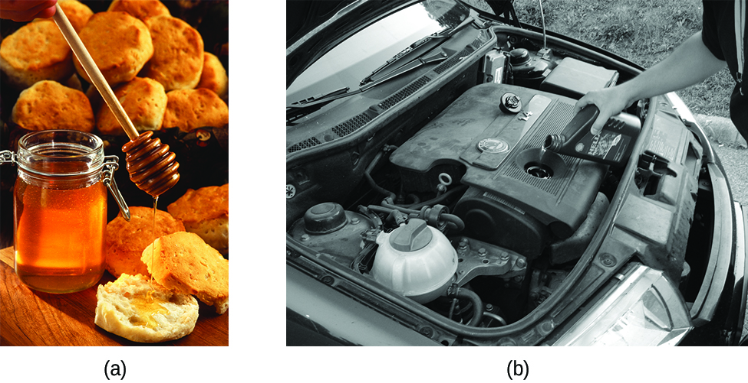
Figure 10.15 (a) Honey and (b) motor oil are examples of liquids with high viscosities; they flow slowly.
(credit a: modification of work by Scott Bauer; credit b: modification of work by David Nagy)

The IMFs between the molecules of a liquid, the size and shape of the molecules, and the temperature determine how easily a liquid flows. As Table 10.2 shows, the more structurally complex are the molecules in a liquid and the stronger the IMFs between them, the more difficult it is for them to move past each other and the greater is the viscosity of the liquid. As the temperature increases, the molecules move more rapidly and their kinetic energies are better able to overcome the forces that hold them together; thus, the viscosity of the liquid decreases.

Table 10.2 Viscosities of Common Substances at 25 °C
Substance | Formula | Viscosity (mPa·s)
water | H₂O | 0.890
mercury | Hg | 1.526
ethanol | C₂H₅OH | 1.074
octane | C₈H₁₈ | 0.508
ethylene glycol | CH₂(OH)CH₂(OH) | 16.1
honey | variable | ~2,000–10,000
motor oil | variable | ~50–500

Cohesive Forces
The various IMFs between identical molecules of a substance are examples of cohesive forces. The molecules within a liquid are surrounded by other molecules and are attracted equally in all directions by the cohesive forces within the liquid. However, the molecules on the surface of a liquid are attracted only by about one-half as many molecules. Because of the unbalanced molecular attractions on the surface molecules, liquids contract to form a shape that minimizes the number of molecules on the surface—that is, the shape with the minimum surface area. A small drop of liquid tends to assume a spherical shape, as shown in Figure 10.16, because in a sphere, the ratio of surface area to volume is at a minimum. Larger drops are more greatly affected by gravity, air resistance, surface interactions, and so on, and as a result, are less spherical.
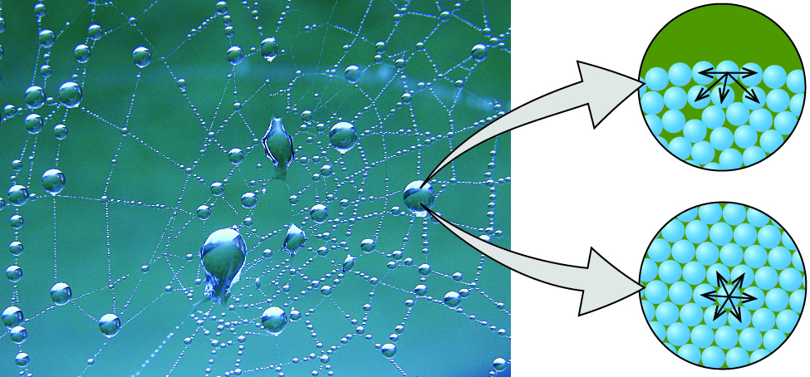
Figure 10.16 Attractive forces result in a spherical water drop that minimizes surface area; cohesive forces hold the sphere together; adhesive forces keep the drop attached to the web. (credit photo: modification of work by “OliBac”/Flickr)

Adhesive Forces
The IMFs of attraction between two different molecules are called adhesive forces. Consider what happens when water comes into contact with some surface. If the adhesive forces between water molecules and the molecules of the surface are weak compared to the cohesive forces between the water molecules, the water does not “wet” the surface. For example, water does not wet waxed surfaces or many plastics such as polyethylene. Water forms drops on these surfaces because the cohesive forces within the drops are greater than the adhesive forces between the water and the plastic. Water spreads out on glass because the adhesive force between water and glass is greater than the cohesive forces within the water. When water is confined in a glass tube, its meniscus (surface) has a concave shape because the water wets the glass and creeps up the side of the tube. On the other hand, the cohesive forces between mercury atoms are much greater than the adhesive forces between mercury and glass. Mercury therefore does not wet glass, and it forms a convex meniscus when confined in a tube because the cohesive forces within the mercury tend to draw it into a drop (Figure 10.17).
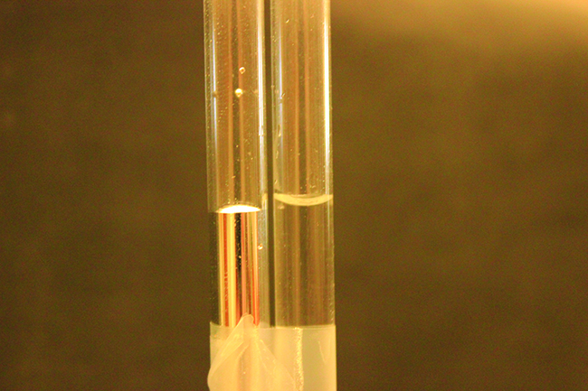
Figure 10.17 Differences in the relative strengths of cohesive and adhesive forces result in different meniscus shapes for mercury (left) and water (right) in glass tubes.
(credit: Mark Ott)

Surface Tension
Surface tension is defined as the energy required to increase the surface area of a liquid, or the force required to increase the length of a liquid surface by a given amount. This property results from the cohesive forces between molecules at the surface of a liquid, and it causes the surface of a liquid to behave like a stretched rubber membrane. Surface tensions of several liquids are presented in Table 10.3. Among common liquids, water exhibits a distinctly high surface tension due to strong hydrogen bonding between its molecules. As a result of this high surface tension, the surface of water represents a relatively “tough skin” that can withstand considerable force without breaking. A steel needle carefully placed on water will float. Some insects, like the one shown in Figure 10.18, even though they are denser than water, move on its surface because they are supported by the surface tension.
Table 10.3 Surface Tensions of Common Substances at 25 °C
Substance | Formula | Surface Tension (mN/m)
water | H₂O | 71.99
mercury | Hg | 458.48
ethanol | C₂H₅OH | 21.97
octane | C₈H₁₈ | 21.14
ethylene glycol | CH₂(OH)CH₂(OH) | 47.99
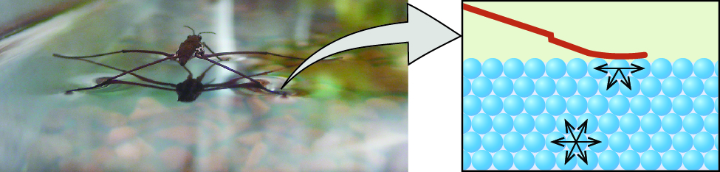
Figure 10.18 Surface tension (right) prevents this insect, a “water strider,” from sinking into the water.

Capillary Action
If you place one end of a paper towel in spilled wine, as shown in Figure 10.19, the liquid wicks up the paper towel. A similar process occurs in a cloth towel when you use it to dry off after a shower. These are examples of capillary action—when a liquid flows within a porous material due to the attraction of the liquid molecules to the surface of the material and to other liquid molecules. The adhesive forces between the liquid and the porous material, combined with the cohesive forces within the liquid, may be strong enough to move the liquid upward against gravity.
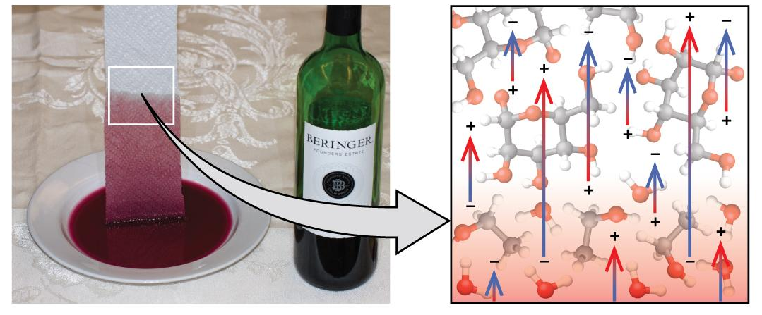
Figure 10.19 Wine wicks up a paper towel (left) because of the strong attractions of water (and ethanol) molecules to the −OH groups on the towel’s cellulose fibers and the strong attractions of water molecules to other water (and ethanol) molecules (right). (credit photo: modification of work by Mark Blaser)
Towels soak up liquids like water because the fibers of a towel are made of molecules that are attracted to water molecules. Most cloth towels are made of cotton, and paper towels are generally made from paper pulp. Both consist of long molecules of cellulose that contain many −OH groups. Water molecules are attracted to these −OH groups and form hydrogen bonds with them, which draws the H2O molecules up the cellulose molecules. The water molecules are also attracted to each other, so large amounts of water are drawn up the cellulose fibers.
Capillary action can also occur when one end of a small diameter tube is immersed in a liquid, as illustrated in Figure 10.20. If the liquid molecules are strongly attracted to the tube molecules, the liquid creeps up the inside of the tube until the weight of the liquid and the adhesive forces are in balance. The smaller the diameter of the tube is, the higher the liquid climbs. It is partly by capillary action occurring in plant cells called xylem that water and dissolved nutrients are brought from the soil up through the roots and into a plant. Capillary action is the basis for thin layer chromatography, a laboratory technique commonly used to separate small quantities of mixtures. You depend on a constant supply of tears to keep your eyes lubricated and on capillary action to pump tear fluid away.
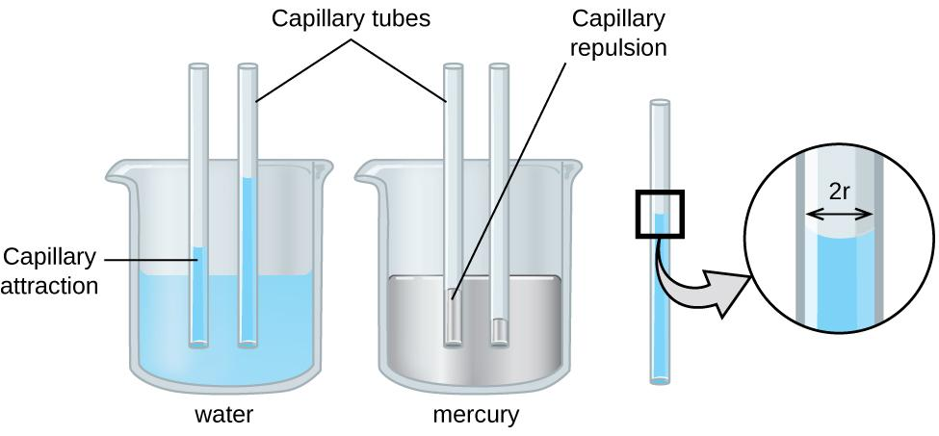
Figure 10.20 Depending upon the relative strengths of adhesive and cohesive forces, a liquid may rise (such as water) or fall (such as mercury) in a glass capillary tube. The extent of the rise (or fall) is directly proportional to the surface tension of the liquid and inversely proportional to the density of the liquid and the radius of the tube.

Chemistry in Everyday Life

Biomedical Applications of Capillary Action
Many medical tests require drawing a small amount of blood, for example to determine the amount of glucose in someone with diabetes or the hematocrit level in an athlete. This procedure can be easily done because of capillary action, the ability of a liquid to flow up a small tube against gravity, as shown in Figure 10.21. When your finger is pricked, a drop of blood forms and holds together due to surface tension—the unbalanced intermolecular attractions at the surface of the drop. Then, when the open end of a narrow-diameter glass tube touches the drop of blood, the adhesive forces between the molecules in the blood and those at the glass surface draw the blood up the tube. How far the blood goes up the tube depends on the diameter of the tube (and the type of fluid). A small tube has a relatively large surface area for a given volume of blood, which results in larger (relative) attractive forces, allowing the blood to be drawn farther up the tube. The liquid itself is held together by its own cohesive forces. When the weight of the liquid in the tube generates a downward force equal to the upward force associated with capillary action, the liquid stops rising.
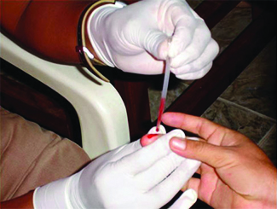
Figure 10.21 Blood is collected for medical analysis by capillary action, which draws blood into a small diameter glass tube. (credit: modification of work by Centers for Disease Control and Prevention)

10.3 Phase Transitions

Learning Objectives
- Define phase transitions and phase transition temperatures
- Explain the relation between phase transition temperatures and intermolecular attractive forces
- Describe the processes represented by typical heating and cooling curves, and compute heat flows and enthalpy changes accompanying these processes

Introduction
We witness and utilize changes of physical state, or phase transitions, in a great number of ways. As one example of global significance, consider the evaporation, condensation, freezing, and melting of water. These changes of state are essential aspects of our earth’s water cycle as well as many other natural phenomena and technological processes of central importance to our lives. In this module, the essential aspects of phase transitions are explored.

Vaporization and Condensation
When a liquid vaporizes in a closed container, gas molecules cannot escape. As these gas phase molecules move randomly about, they will occasionally collide with the surface of the condensed phase, and in some cases, these collisions will result in the molecules re-entering the condensed phase. The change from the gas phase to the liquid is called condensation. When the rate of condensation becomes equal to the rate of vaporization, neither the amount of the liquid nor the amount of vapor in the container changes. The vapor in the container is then said to be in equilibrium with the liquid. Keep in mind that this is not a static situation, as molecules are continually exchanged between the condensed and gaseous phases. Such is an example of a dynamic equilibrium, the status of a system in which reciprocal processes (for example, vaporization and condensation) occur at equal rates. The pressure exerted by vapor in equilibrium with a liquid in a closed container at a given temperature is called the liquid’s vapor pressure (or equilibrium vapor pressure). The area of the surface of the liquid in contact with a vapor and the size of the vessel have no effect on the vapor pressure, although they do affect the time required for the equilibrium to be reached. We can measure the vapor pressure of a liquid by placing a sample in a closed container, like that illustrated in Figure 10.22, and using a manometer to measure the increase in pressure that is due to the vapor in equilibrium with the condensed phase.

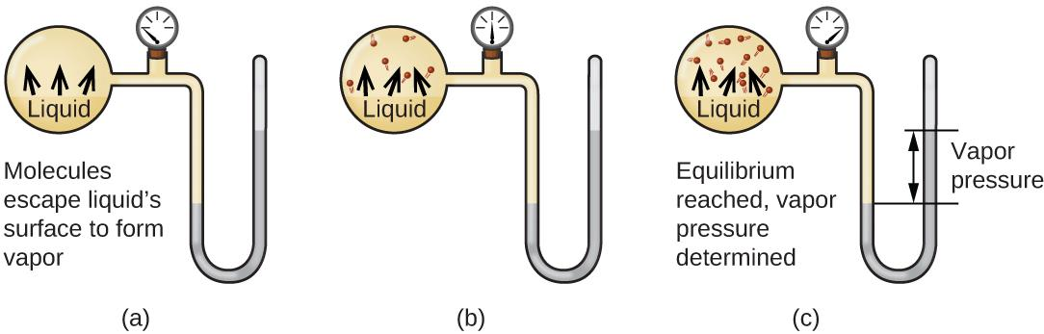

Figure 10.22 In a closed container, dynamic equilibrium is reached when (a) the rate of molecules escaping from the liquid to become gas (b) increases and eventually (c) equals the rate of gas molecules entering the liquid. When this equilibrium is reached, the vapor pressure of the gas is constant, although the vaporization and condensation processes continue.
The chemical identities of the molecules in a liquid determine the types (and strengths) of intermolecular attractions possible; consequently, different substances will exhibit different equilibrium vapor pressures. Relatively strong intermolecular attractive forces will serve to impede vaporization as well as favoring “recapture” of gas-phase molecules when they collide with the liquid surface, resulting in a relatively low vapor pressure. Weak intermolecular attractions present less of a barrier to vaporization, and a reduced likelihood of gas recapture, yielding relatively high vapor pressures. The following example illustrates this dependence of vapor pressure on intermolecular attractive forces.

Example 10.5
Explaining Vapor Pressure in Terms of IMFs
Given the shown structural formulas for these four compounds, explain their relative vapor pressures in terms of types and extents of IMFs:
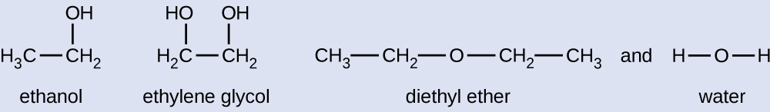
Solution:
Diethyl ether has a very small dipole and most of its intermolecular attractions are London forces. Although this molecule is the largest of the four under consideration, its IMFs are the weakest and, as a result, its molecules most readily escape from the liquid. It also has the highest vapor pressure. Ethanol is capable of hydrogen bonding and, therefore, exhibits stronger overall IMFs, which means that fewer molecules escape from the liquid at any given temperature, and so ethanol has a lower vapor pressure than diethyl ether. Water exhibits extensive hydrogen bonding provides stronger intermolecular attractions, fewer molecules escaping the liquid, and a lower vapor pressure than for either diethyl ether or ethanol. Ethylene glycol has two −OH groups, so, like water, it exhibits extensive hydrogen bonding. It is much larger than water and thus experiences larger London forces. Its overall IMFs are the largest of these four substances, which means its vaporization rate will be the slowest and, consequently, its vapor pressure the lowest.

Check Your Learning
At 20 °C, the vapor pressures of several alcohols are given in this table. Explain these vapor pressures in terms of types and extents of IMFs for these alcohols:
Compound | methanol CH₃OH | ethanol C₂H₅OH | propanol C₃H₇OH | butanol C₄H₉OH
Vapor Pressure at 20 °C | 11.9 kPa | 5.95 kPa | 2.67 kPa | 0.56 kPa

Answer: All these compounds exhibit hydrogen bonding; these strong IMFs are difficult for the molecules to overcome, so the vapor pressures are relatively low. As the size of molecule increases from methanol to butanol, dispersion forces increase, which means that the vapor pressures decrease as observed: P_{methanol} > P_{ethanol} > P_{propanol} > P_{butanol}.
As temperature increases, the vapor pressure of a liquid also increases due to the increased average KE of its molecules. Recall that at any given temperature, the molecules of a substance experience a range of kinetic energies, with a certain fraction of molecules having a sufficient energy to overcome IMF and escape the liquid (vaporize). At a higher temperature, a greater fraction of molecules have enough energy to escape from the liquid, as shown in Figure 10.23. The escape of more molecules per unit of time and the greater average speed of the molecules that escape both contribute to the higher vapor pressure.

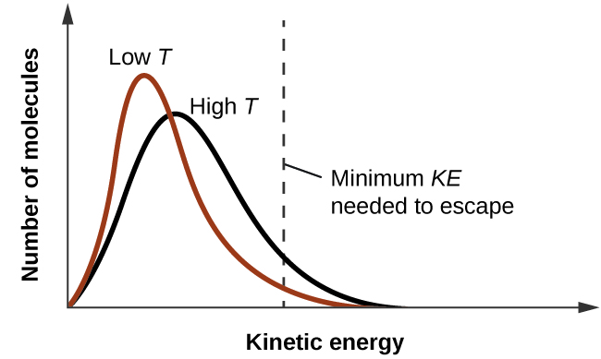

Figure 10.23 Temperature affects the distribution of kinetic energies for the molecules in a liquid. At the higher temperature, more molecules have the necessary kinetic energy, KE, to escape from the liquid into the gas phase.

Boiling Points
When the vapor pressure increases enough to equal the external atmospheric pressure, the liquid reaches its boiling point. The boiling point of a liquid is the temperature at which its equilibrium vapor pressure is equal to the pressure exerted on the liquid by its gaseous surroundings. For liquids in open containers, this pressure is that due to the earth’s atmosphere. The normal boiling point of a liquid is defined as its boiling point when surrounding pressure is equal to 1 atm (101.3 kPa). Figure 10.24 shows the variation in vapor pressure with temperature for several different substances. Considering the definition of boiling point, these curves may be seen as depicting the dependence of a liquid’s boiling point on surrounding pressure.
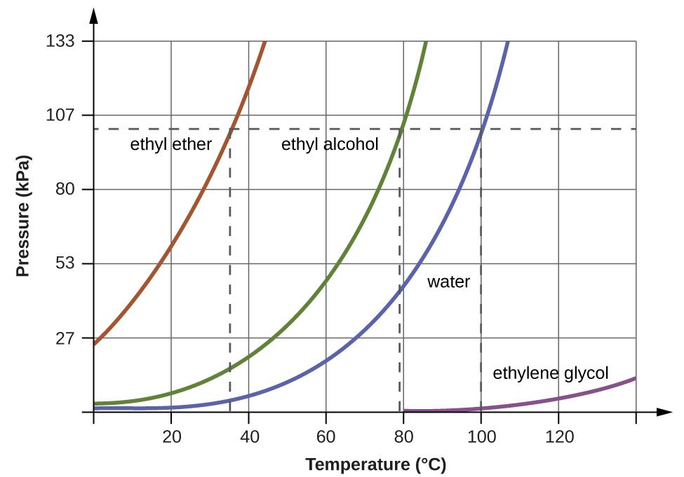
Figure 10.24 The boiling points of liquids are the temperatures at which their equilibrium vapor pressures equal the pressure of the surrounding atmosphere. Normal boiling points are those corresponding to a pressure of 1 atm (101.3 kPa.)

Enthalpy of Vaporization
Vaporization is an endothermic process. The cooling effect can be evident when you leave a swimming pool or a shower. When the water on your skin evaporates, it removes heat from your skin and causes you to feel cold. The energy change associated with the vaporization process is the enthalpy of vaporization, ΔHvap. For example, the vaporization of water at standard temperature is represented by:
H₂O (l) ⟶ H₂O (g) ΔH_{vap} = 44.01 kJ/mol
As described in the chapter on thermochemistry, the reverse of an endothermic process is exothermic. And so, the condensation of a gas releases heat:
H₂O (g) ⟶ H₂O (l) ΔH_{con}= −ΔH_{vap} = −44.01kJ/mol

Example 10.9
Using Enthalpy of Vaporization
One way our body is cooled by evaporation of the water in sweat. In very hot climates, we can lose as much as 1.5 L of sweat per day. Although sweat is not pure water, we can get an approximate value of the amount of heat removed by evaporation by assuming that it is. How much heat is required to evaporate 1.5 L of water (1.5 kg) at 37 °C (normal body temperature); ΔH_{vap} = 43.46 kJ/mol at 37 °C.

Solution:
We start with the known volume of sweat (approximated as just water) and use the given information to convert to the amount of heat needed:
1.5 L H₂O × $\frac{1000 g}{1 L}$ × $\frac{1 mol H_{2}O}{18.015 g}$ × $\frac{43.46 kJ}{1 mol}$ = 3.6 × 10³ kJ
Thus, 3600 kJ of heat are removed by the evaporation of 1.5 L of water.

Check Your Learning
How much heat is required to evaporate 100.0 g of liquid ammonia, NH₃, at its boiling point if its enthalpy of vaporization is 4.8 kJ/mol? Answer: 28 kJ

Melting and Freezing
When we heat a crystalline solid, we increase the average energy of its atoms, molecules, or ions and the solid gets hotter. At some point, the added energy becomes large enough to partially overcome the forces holding the molecules or ions of the solid in their fixed positions, and the solid begins the process of transitioning to the liquid state, or melting. At this point, the temperature of the solid stops rising, despite the continual input of heat, and it remains constant until all of the solid is melted. Only after all of the solid has melted will continued heating increase the temperature of the liquid (Figure 10.25).
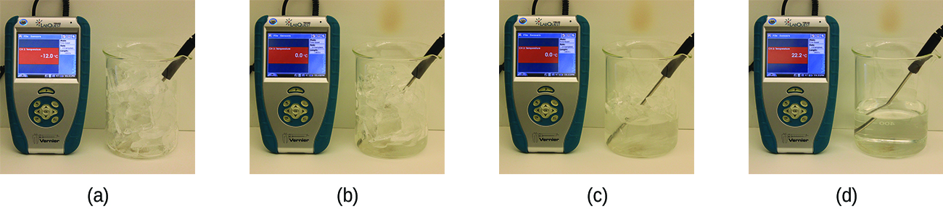
Figure 10.25 (a) This beaker of ice has a temperature of −12.0 °C. (b) After 10 minutes the ice has absorbed enough heat from the air to warm to 0 °C. A small amount has melted. (c) Thirty minutes later, the ice has absorbed more heat, but its temperature is still 0 °C. The ice melts without changing its temperature. (d) Only after all the ice has melted does the heat absorbed cause the temperature to increase to 22.2 °C. (credit: modification of work by Mark Ott)
If we stop heating during melting and place the mixture of solid and liquid in a perfectly insulated container so no heat can enter or escape, the solid and liquid phases remain in equilibrium. This is almost the situation with a mixture of ice and water in a very good thermos bottle; almost no heat gets in or out, and the mixture of solid ice and liquid water remains for hours. In a mixture of solid and liquid at equilibrium, the reciprocal processes of melting and freezing occur at equal rates, and the quantities of solid and liquid therefore remain constant. The temperature at which the solid and liquid phases of a given substance are in equilibrium is called the melting point of the solid or the freezing point of the liquid. Use of one term or the other is normally dictated by the direction of the phase transition being considered, for example, solid to liquid (melting) or liquid to solid (freezing).
The enthalpy of fusion and the melting point of a crystalline solid depend on the strength of the attractive forces between the units present in the crystal. Molecules with weak attractive forces form crystals with low melting points. Crystals consisting of particles with stronger attractive forces melt at higher temperatures.
The amount of heat required to change one mole of a substance from the solid state to the liquid state is the enthalpy of fusion, ΔHfus of the substance. The enthalpy of fusion of ice is 6.0 kJ/mol at 0 °C. Fusion (melting) is an endothermic process:
H₂O (s) ⟶ H₂O (l) ΔH_{fus} = 6.01 kJ/mol
The reciprocal process, freezing, is an exothermic process whose enthalpy change is −6.0 kJ/mol at 0 °C:
H₂O (l) ⟶ H₂O (s) ΔH_{frz} = −ΔH_{fus} = −6.01 kJ/mol

Example 10.10
Using Enthalpy of Fusion
How much heat is required to melt 1.5 L of ice (1.5 kg) at 0 °C (normal melting point for water); ΔH_{fus} = 6.01 kJ/mol at 0 °C.

Solution:
We start with the known volume of sweat (approximated as just water) and use the given information to convert to the amount of heat needed:
1.5 L H₂O × $\frac{1000 g}{1 L}$ × $\frac{1 mol H_{2}O}{18.015 g}$ × $\frac{6.01 kJ}{1 mol}$ = 5.0 × 10² kJ

Sublimation and Deposition
Some solids can transition directly into the gaseous state, bypassing the liquid state, via a process known as sublimation. At room temperature and standard pressure, a piece of dry ice (solid CO2) sublimes, appearing to gradually disappear without ever forming any liquid. Snow and ice sublime at temperatures below the melting point of water, a slow process that may be accelerated by winds and the reduced atmospheric pressures at high altitudes. When solid iodine is warmed, the solid sublimes and a vivid purple vapor forms (Figure 10.26). The reverse of sublimation is called deposition, a process in which gaseous substances condense directly into the solid state, bypassing the liquid state. The formation of frost is an example of deposition.
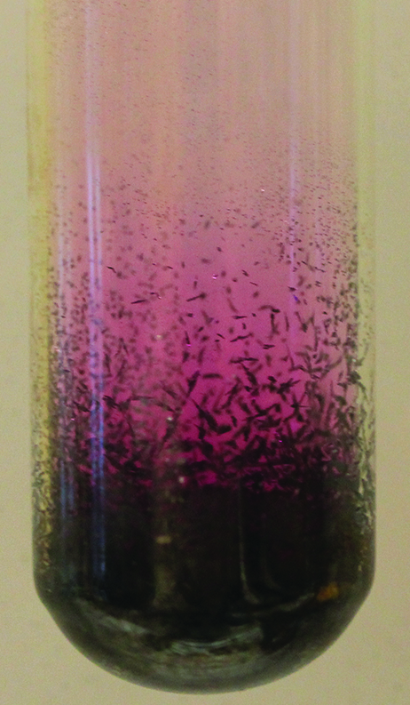
Figure 10.26 Sublimation of solid iodine in the bottom of the tube produces a purple gas that subsequently deposits as solid iodine on the colder part of the tube above. (credit: modification of work by Mark Ott)
Like vaporization, the process of sublimation requires an input of energy to overcome intermolecular attractions. The enthalpy of sublimation, ΔHsub, is the energy required to convert one mole of a substance from the solid to the gaseous state. For example, the sublimation of carbon dioxide is represented by:
CO₂ (s) ⟶ CO₂ (g) ΔH_{sub} = 26.1 kJ/mol
Likewise, the enthalpy change for the reverse process of deposition is equal in magnitude but opposite in sign to that for sublimation:
CO₂ (g) ⟶ CO₂ (s) ΔH_{dep} = −ΔH_{sub} = −26.1 kJ/mol

Summary of Phase Transitions
Consider the extent to which intermolecular attractions must be overcome to achieve a given phase transition. Converting a solid into a liquid requires that these attractions be only partially overcome; transition to the gaseous state requires that they be completely overcome. As a result, the enthalpy of fusion for a substance is less than its enthalpy of vaporization. This same logic can be used to derive an approximate relation between the enthalpies of all phase changes for a given substance. Though not an entirely accurate description, sublimation may be conveniently modeled as a sequential two-step process of melting followed by vaporization in order to apply Hess’s Law. Viewed in this manner, the enthalpy of sublimation for a substance may be estimated as the sum of its enthalpies of fusion and vaporization, as illustrated in Figure 10.27.
For example: solid ⟶ liquid ΔH_{fus}
liquid ⟶ gas ΔH_{vap}
solid ⟶ gas ΔH_{sub} = ΔH_{fus} + ΔH_{vap}
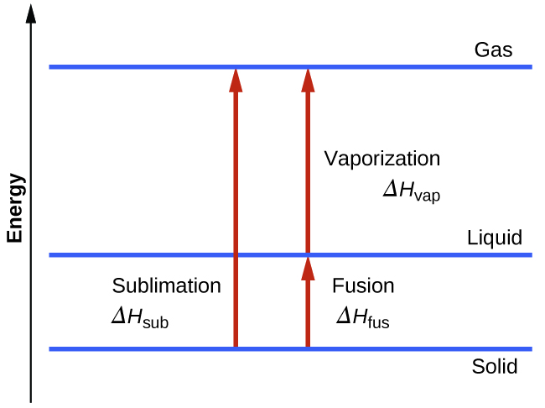
Figure 10.27 For a given substance, the sum of its enthalpy of fusion and enthalpy of vaporization is approximately equal to its enthalpy of sublimation.

Heating and Cooling Curves
In the chapter on thermochemistry, the relation between the amount of heat absorbed or released by a substance, q, and its accompanying temperature change, ΔT, was introduced:
q = m·c·ΔT

where m is the mass of the substance and c is its specific heat. The relation applies to matter being heated or cooled, but not undergoing a change in state. When a substance being heated or cooled reaches a temperature corresponding to one of its phase transitions, further gain or loss of heat is a result of diminishing or enhancing intermolecular attractions, instead of increasing or decreasing molecular kinetic energies. While a substance is undergoing a change in state, its temperature remains constant. Figure 10.28 shows a typical heating curve.

Consider the example of heating a pot of water to boiling. A stove burner will supply heat at a roughly constant rate; initially, this heat serves to increase the water’s temperature. When the water reaches its boiling point, the temperature remains constant despite the continued input of heat from the stove burner. This same temperature is maintained by the water as long as it is boiling. If the burner setting is increased to provide heat at a greater rate, the water temperature does not rise, but instead the boiling becomes more vigorous (rapid). This behavior is observed for other phase transitions as well: For example, temperature remains constant while the change of state is in progress.
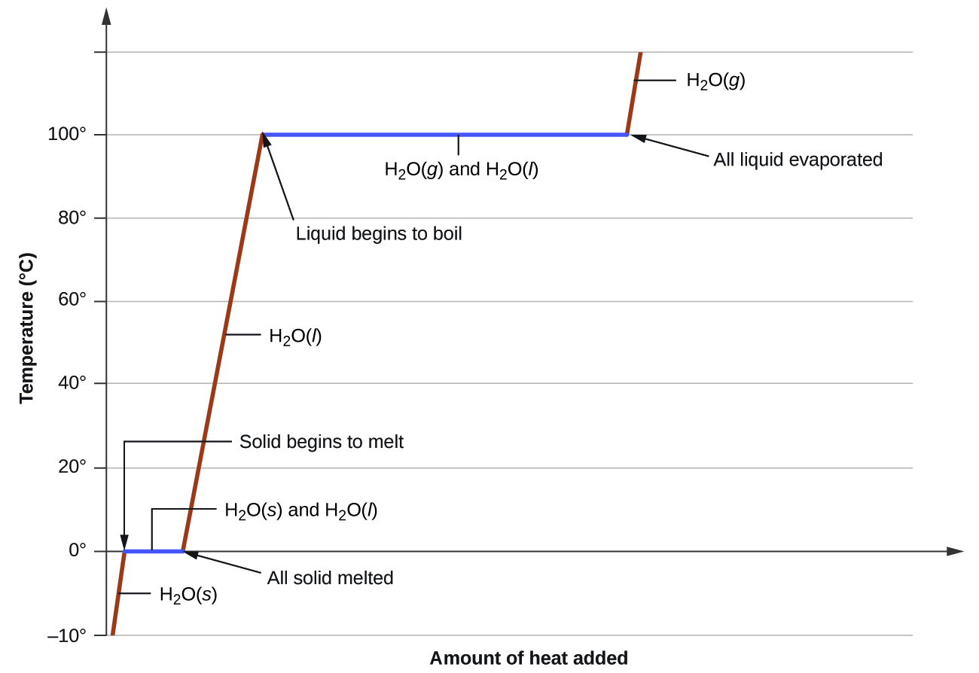
Figure 10.28 A typical heating curve for a substance depicts changes in temperature that result as the substance absorbs increasing amounts of heat. Plateaus in the curve (regions of constant temperature) are exhibited when the substance undergoes phase transitions.

Example 10.11
Total Heat Needed to Change Temperature and Phase for a Substance
How much heat is required to convert 135 g of ice at −15 °C into water vapor at 120 °C?

Solution: The transition described involves the following steps:
- Heat ice from −15 °C to 0 °C
- Melt ice
- Heat water from 0 °C to 100 °C
- Boil water
- Heat steam from 100 °C to 120 °C
The heat needed to change the temperature of a given substance (with no change in phase) is: q = m·c·ΔT (see previous chapter on thermochemistry).

The heat needed to induce a given change in phase is given by q = n × ΔH.

Using these equations with the appropriate values for specific heat of ice, water, and steam, and enthalpies of fusion and vaporization, we have:
- Heat ice from −15 °C to 0 °C q₁ = (m⋅c⋅ΔT)_{ice}
- Melt ice q₂ = n⋅ΔH_{fus}
- Heat water from 0 °C to 100 °C q₃ = (m⋅c⋅ΔT)_{water}
- Boil water q₄ = n⋅ΔH_{vap}
- Heat steam from 100 °C to 120 °C q₅ = (m⋅c⋅ΔT)_{steam}
Total heat (q_{total}) = q₁ + q₂ + q₃ + q₄ + q₅
q₁ = (135 g⋅2.09 J/g⋅°C⋅15°C) = 4230 J = 4.23 kJ
q₂ = (135 g⋅$\frac{1 mol}{18.015 g}$⋅6.01 kJ/mol) = 45.0 kJ = 45.0 kJ
q₃ = (135 g⋅4.18 J/g⋅°C⋅100°C) = 56,500 J = 56.5 kJ
q₄ = (135 g⋅$\frac{1 mol}{18.015 g}$⋅40.67 kJ/mol) = 305 kJ = 305 kJ
q₅ = (135 g⋅1.84 J/g⋅°C⋅20°C) = 4970 J = 4.97 kJ
Total heat (q_{total}) = 4.23 +45.0 +56.5 +305 +4.97 kJ = 416 kJ

Check Your Learning
What is the total amount of heat released when 94.0 g water at 80.0 °C cools to form ice at −30.0 °C?

Answer:
68.7 kJ

10.4 Phase Diagrams

Learning Objectives
- Explain the construction and use of a typical phase diagram
- Use phase diagrams to identify stable phases at given temperatures and pressures, and to describe phase transitions resulting from changes in these properties
- Describe the supercritical fluid phase of matter

Introduction
In the previous section, the variation of a liquid’s equilibrium vapor pressure with temperature was described. Considering the definition of boiling point, plots of vapor pressure versus temperature represents how the boiling point of the liquid varies with pressure. Also described was the use of heating and cooling curves to determine a substance’s melting (or freezing) point. Making such measurements over a wide range of pressures yields data that may be presented graphically as a phase diagram.

Phase Diagram
A phase diagram combines plots of pressure versus temperature for the liquid-gas, solid-liquid, and solid-gas phase-transition equilibria of a substance. These diagrams indicate the physical states that exist under specific conditions of pressure and temperature, and also provide the pressure dependence of the phase-transition temperatures (melting points, sublimation points, boiling points). A typical phase diagram for a pure substance is shown in Figure 10.29.
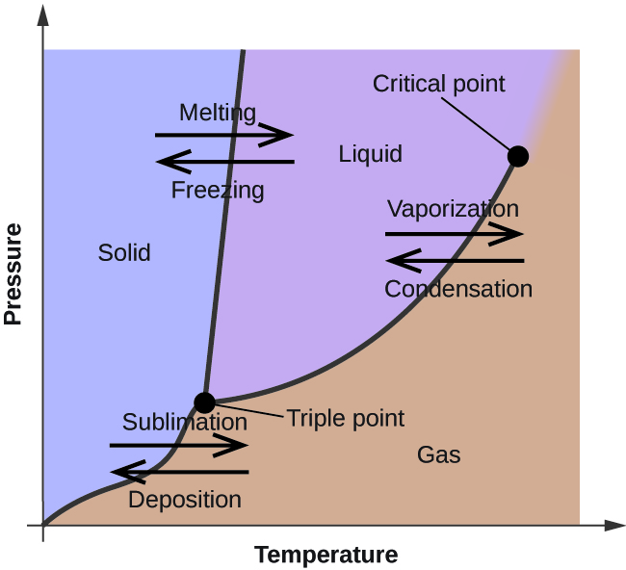
Figure 10.29 The physical state of a substance and its phase-transition temperatures are represented graphically in a phase diagram.

To illustrate the utility of these plots, consider the phase diagram for water shown in Figure 10.30.
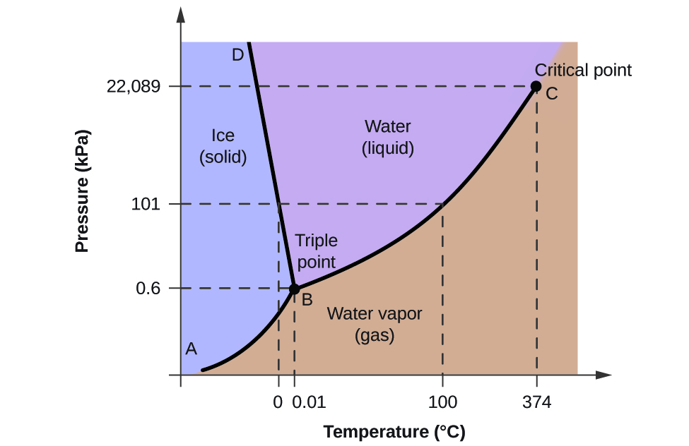
Figure 10.30 The pressure and temperature axes on this phase diagram of water are not drawn to constant scale in order to illustrate several important properties.

We can use the phase diagram to identify the physical state of a sample of water under specified conditions of pressure and temperature. For example, a pressure of 50 kPa and a temperature of −10 °C correspond to the region of the diagram labeled “ice.” Under these conditions, water exists only as a solid (ice). A pressure of 50 kPa and a temperature of 50 °C correspond to the “water” region—here, water exists only as a liquid. At 25 kPa and 200 °C, water exists only in the gaseous state. Note that on the H₂O phase diagram, the pressure and temperature axes are not drawn to a constant scale in order to permit the illustration of several important features as described here.
The curve BC in Figure 10.30 is the plot of vapor pressure versus temperature as described in the previous module of this chapter. This “liquid-vapor” curve separates the liquid and gaseous regions of the phase diagram and provides the boiling point for water at any pressure. For example, at 1 atm, the boiling point is 100 °C. Notice that the liquid-vapor curve terminates at a temperature of 374 °C and a pressure of 218 atm, indicating that water cannot exist as a liquid above this temperature, regardless of the pressure. The physical properties of water under these conditions are intermediate between those of its liquid and gaseous phases. This unique state of matter is called a supercritical fluid, a topic that will be described in the next section of this module.
The solid-vapor curve, labeled AB in Figure 10.30, indicates the temperatures and pressures at which ice and water vapor are in equilibrium. These temperature-pressure data pairs correspond to the sublimation, or deposition, points for water. If we could zoom in on the solid-gas line in Figure 10.30, we would see that ice has a vapor pressure of about 0.20 kPa at −10 °C. Thus, if we place a frozen sample in a vacuum with a pressure less than 0.20 kPa, ice will sublime. This is the basis for the “freeze-drying” process often used to preserve foods, such as the ice cream shown in Figure 10.31.
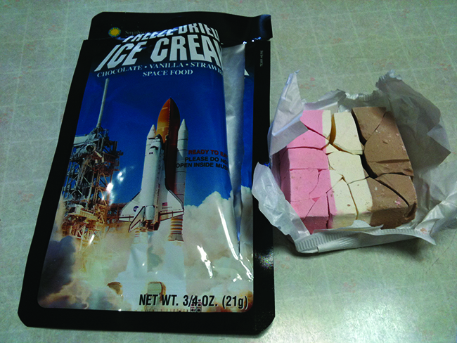
Figure 10.31 Freeze-dried foods, like this ice cream, are dehydrated by sublimation at pressures below the triple point for water. (credit: ʺlwaoʺ/Flickr)
The solid-liquid curve labeled BD shows the temperatures and pressures at which ice and liquid water are in equilibrium, representing the melting/freezing points for water. Note that this curve exhibits a slight negative slope (greatly exaggerated for clarity), indicating that the melting point for water decreases slightly as pressure increases. Water is an unusual substance in this regard, as most substances exhibit an increase in melting point with increasing pressure. This behavior is partly responsible for the movement of glaciers, like the one shown in Figure 10.32. The bottom of a glacier experiences an immense pressure due to its weight that can melt some of the ice, forming a layer of liquid water on which the glacier may more easily slide.
Figure 10.32 The immense pressures beneath glaciers result in partial melting to produce a layer of water that provides lubrication to assist glacial movement. This satellite photograph shows the advancing edge of the Perito Moreno glacier in Argentina. (credit: NASA)
The point of intersection of all three curves is labeled B in Figure 10.30. At the pressure and temperature represented by this point, all three phases of water coexist in equilibrium. This temperature-pressure data pair is called the triple point. At pressures lower than the triple point, water cannot exist as a liquid, regardless of the temperature.

Example 10.11
Determining the State of Water
Using the phase diagram for water given in Figure 10.30, determine the state of water at the following temperatures and pressures:
(a) −10 °C and 50 kPa
(b) 25 °C and 90 kPa
(c) 50 °C and 40 kPa
(d) 80 °C and 5 kPa
(e) −10 °C and 0.3 kPa
(f) 50 °C and 0.3 kPa
Solution: Using the phase diagram for water, we can determine that the state of water at each temperature and pressure given are as follows:
(a) solid; (b) liquid; (c) liquid; (d) gas; (e) solid; (f) gas.

Check Your Learning
What phase changes can water undergo as the temperature changes if the pressure is held at 0.3 kPa? If the pressure is held at 50 kPa?

Answer: At 0.3 kPa: s⟶g at −58 °C. At 50 kPa: s⟶l at 0 °C, l ⟶ g at 78 °C

Consider the phase diagram for carbon dioxide shown in Figure 10.33 as another example. The solid-liquid curve exhibits a positive slope, indicating that the melting point for CO₂ increases with pressure as it does for most substances (water being a notable exception as described previously). Notice that the triple point is well above 1 atm, indicating that carbon dioxide cannot exist as a liquid under ambient pressure conditions. Instead, cooling gaseous carbon dioxide at 1 atm results in its deposition into the solid state. Likewise, solid carbon dioxide does not melt at 1 atm pressure but instead sublimes to yield gaseous CO₂. Finally, notice that the critical point for carbon dioxide is observed at a relatively modest temperature and pressure in comparison to water.

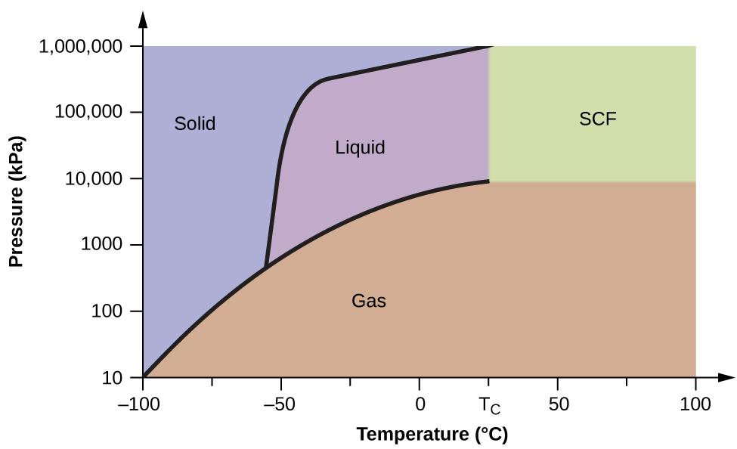
Figure 10.33 A phase diagram for carbon dioxide is shown. The pressure axis is plotted on a logarithmic scale to accommodate the large range of values.

Example 10.12
Determining the State of Carbon Dioxide
Using the phase diagram for carbon dioxide shown in Figure 10.33, determine the state of CO₂ at the following temperatures and pressures:
(a) −30 °C and 2000 kPa
(b) −90 °C and 1000 kPa
(c) −60 °C and 100 kPa
(d) −40 °C and 1500 kPa
(e) 0 °C and 100 kPa
(f) 20 °C and 100 kPa
Solution: Using the phase diagram for carbon dioxide provided, we can determine that the state of CO2 at each temperature and pressure given are as follows:
(a) liquid; (b) solid; (c) gas; (d) liquid; (e) gas; (f) gas.

Check Your Learning
Identify the phase changes that carbon dioxide will undergo as its temperature is increased from −100 °C while holding its pressure constant at 1500 kPa. At 50 kPa. At what approximate temperatures do these phase changes occur?

Answer:
at 1500 kPa: s⟶l at −55 °C, l⟶g at −10 °C;
at 500 kPa: s⟶g at −60 °C

Supercritical Fluids
If we place a sample of water in a sealed container at 25 °C, remove the air, and let the vaporization-condensation equilibrium establish itself, we are left with a mixture of liquid water and water vapor at a pressure of 0.03 atm. A distinct boundary between the more dense liquid and the less dense gas is clearly observed. As we increase the temperature, the pressure of the water vapor increases, as described by the liquid-gas curve in the phase diagram for water (Figure 10.30), and a two-phase equilibrium of liquid and gaseous phases remains. At a temperature of 374 °C, the vapor pressure has risen to 218 atm, and any further increase in temperature results in the disappearance of the boundary between liquid and vapor phases. All of the water in the container is now present in a single phase whose physical properties are intermediate between those of the gaseous and liquid states. This phase of matter is called a supercritical fluid, and the temperature and pressure above which this phase exists is the critical point (Figure 10.34). Above its critical temperature, a gas cannot be liquefied no matter how much pressure is applied. The pressure required to liquefy a gas at its critical temperature is called the critical pressure. The critical temperatures and critical pressures of some common substances are given in the following table.

Substance | Critical Temperature (°C) | Critical Pressure (kPa)
hydrogen | −240.0 | 1300
nitrogen | −147.2 | 3400
oxygen | −118.9 | 5000
carbon dioxide | 31.1 | 7400
ammonia | 132.4 | 11,300
sulfur dioxide | 157.2 | 7800
water | 374.0 | 22,000
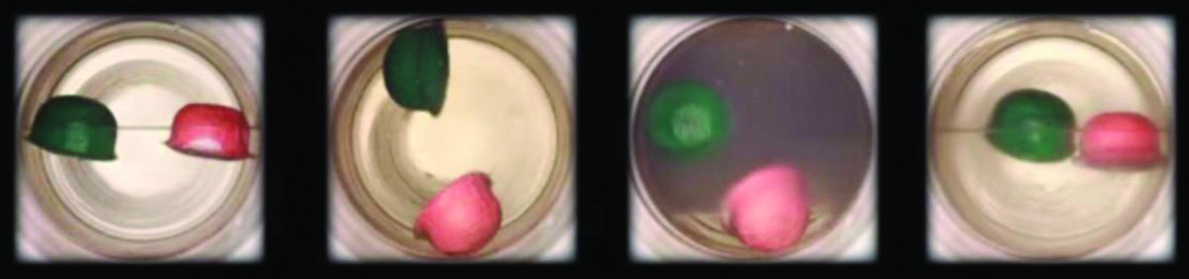
Figure 10.34 (a) A sealed container of liquid carbon dioxide slightly below its critical point is heated, resulting in (b) the formation of the supercritical fluid phase. Cooling the supercritical fluid lowers its temperature and pressure below the critical point, resulting in the reestablishment of separate liquid and gaseous phases (c and d). Colored floats illustrate differences in density between the liquid, gaseous, and supercritical fluid states. (credit: modification of work by “mrmrobin”/YouTube)

Link to Learning
Observe the liquid-to-supercritical fluid transition for carbon dioxide.
(https://www.youtube.com/watch?v=P9EftqFYaHg)

Like a gas, a supercritical fluid will expand and fill a container, but its density is much greater than typical gas densities, typically being close to those for liquids. Similar to liquids, these fluids are capable of dissolving nonvolatile solutes. They exhibit essentially no surface tension and very low viscosities, however, so they can more effectively penetrate very small openings in a solid mixture and remove soluble components. These properties make supercritical fluids extremely useful solvents for a wide range of applications. For example, supercritical carbon dioxide has become a very popular solvent in the food industry, being used to decaffeinate coffee, remove fats from potato chips, and extract flavor and fragrance compounds from citrus oils. It is nontoxic, relatively inexpensive, and not considered to be a pollutant. After use, the CO₂ can be easily recovered by reducing the pressure and collecting the resulting gas.

Example 10.13
The Critical Temperature of Carbon Dioxide
If we shake a carbon dioxide fire extinguisher on a cool day (18 °C), we can hear liquid CO₂ sloshing around inside the cylinder. However, the same cylinder appears to contain no liquid on a hot summer day (35 °C). Explain these observations.
Solution:
On the cool day, the temperature of the CO₂ is below the critical temperature of CO₂, 304 K or 31 °C (Example 10.12), so liquid CO₂ is present in the cylinder.
On the hot day, the temperature of the CO₂ is greater than its critical temperature of 31 °C. Above this temperature no amount of pressure can liquefy CO₂ so no liquid CO₂ exists in the fire extinguisher.

Check Your Learning
Ammonia can be liquefied by compression at room temperature; oxygen cannot be liquefied under these conditions. Why do the two gases exhibit different behavior?
Answer: The critical temperature of ammonia is 405.5 K, which is higher than room temperature. The critical temperature of oxygen is below room temperature; thus oxygen cannot be liquefied at room temperature.

Chemistry in Everyday Life

Decaffeinating Coffee Using Supercritical CO₂
Coffee is the world’s second most widely traded commodity, following only petroleum. Across the globe, people love coffee’s aroma and taste. Many of us also depend on one component of coffee—caffeine—to help us get going in the morning or stay alert in the afternoon. But late in the day, coffee’s stimulant effect can keep you from sleeping, so you may choose to drink decaffeinated coffee in the evening.
Since the early 1900s, many methods have been used to decaffeinate coffee. All have advantages and disadvantages, and all depend on the physical and chemical properties of caffeine. Because caffeine is a somewhat polar molecule, it dissolves well in water, a polar liquid. However, since many of the other 400-plus compounds that contribute to coffee’s taste and aroma also dissolve in H₂O, hot water decaffeination processes can also remove some of these compounds, adversely affecting the smell and taste of the decaffeinated coffee. Dichloromethane (CH₂Cl₂) and ethyl acetate (CH₃CO₂C₂H₅) have similar polarity to caffeine, and are therefore very effective solvents for caffeine extraction, but both also remove some flavor and aroma components, and their use requires long extraction and cleanup times. Because both of these solvents are toxic, health concerns have been raised regarding the effect of residual solvent remaining in the decaffeinated coffee.
Supercritical fluid extraction using carbon dioxide is now being widely used as a more effective and environmentally friendly decaffeination method (Figure 10.35). At temperatures above 304.2 K and pressures above 7376 kPa, CO₂ is a supercritical fluid, with properties of both gas and liquid. Like a gas, it penetrates deep into the coffee beans; like a liquid, it effectively dissolves certain substances. Supercritical carbon dioxide extraction of steamed coffee beans removes 97−99% of the caffeine, leaving coffee’s flavor and aroma compounds intact. Because CO₂ is a gas under standard conditions, its removal from the extracted coffee beans is easily accomplished, as is the recovery of the caffeine from the extract. The caffeine recovered from coffee beans via this process is a valuable product that can be used subsequently as an additive to other foods or drugs.
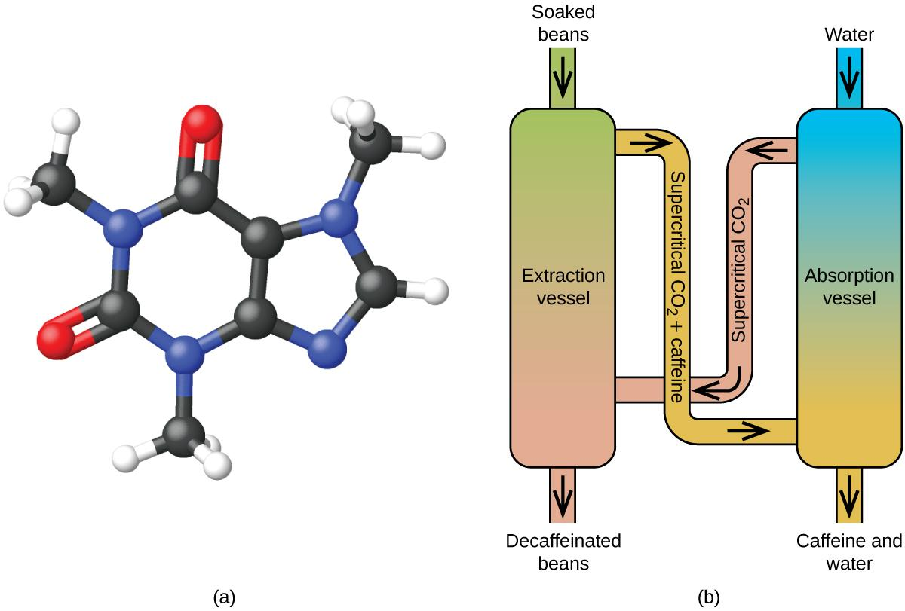
Figure 10.35 (a) Caffeine molecules have both polar and nonpolar regions, making it soluble in solvents of varying polarities. (b) The schematic shows a typical decaffeination process involving supercritical carbon dioxide.

Chapter 11 – Attributions

The contents in this chapter, licensed under CC BY-NC-SA 4.0. has been adopted, modified, reorganized, and/or remixed from the following:

11.0 Introduction
"11 Introduction" by Paul Flowers, Klaus Theopold, Richard Langley, William R. Robinson,, OpenStax is licensed under CC BY 4.0

11.1 Types of Solutions
"3.3 Molarity" by Paul Flowers, Klaus Theopold, Richard Langley, William R. Robinson,, OpenStax is licensed under CC BY 4.0
"11.1 The Dissolution Process" by Paul Flowers, Klaus Theopold, Richard Langley, William R. Robinson,, OpenStax is licensed under CC BY 4.0
"13.1: The Solution Process"LibreTexts is licensed under CC BY-NC-SA 3.0

11.2 Formation of Solutions and Dissolution Process
"13.1: The Solution Process"LibreTexts is licensed under CC BY-NC-SA 3.0
"11.1 The Dissolution Process" by Paul Flowers, Klaus Theopold, Richard Langley, William R. Robinson,, OpenStax is licensed under CC BY 4.0

11.3 Electrolytes
"11.2 Electrolytes" by Paul Flowers, Klaus Theopold, Richard Langley, William R. Robinson,, OpenStax is licensed under CC BY 4.0
"11.1 The Dissolution Process" by Paul Flowers, Klaus Theopold, Richard Langley, William R. Robinson,, OpenStax is licensed under CC BY 4.0

11.4 Factors that Affect Solubility
"11.3 Solubility" by Paul Flowers, Klaus Theopold, Richard Langley, William R. Robinson,, OpenStax is licensed under CC BY 4.0

11.5 Concentration Units
"3.4 Other Units for Solution Concentrations" by Paul Flowers, Klaus Theopold, Richard Langley, William R. Robinson,,OpenStax is licensed under CC BY 4.0
"3.3 Molarity" by Paul Flowers, Klaus Theopold, Richard Langley, William R. Robinson,, OpenStax is licensed under CC BY 4.0

11.6 Dilution of Solution
"3.3 Molarity" by Paul Flowers, Klaus Theopold, Richard Langley, William R. Robinson,, OpenStax is licensed under CC BY 4.0

11.7 Colligative Properties
"11.4 Colligative Properties" by Paul Flowers, Klaus Theopold, Richard Langley, William R. Robinson,, OpenStax is licensed under CC BY 4.0

Chapter 11 Solutions

Chapter Introduction

11.1 Types of Solutions

11.2 Formation of Solutions and Dissolution Process

11.3 Electrolytes

11.4 Factors that Affect Solubility

11.5 Concentration Units

11.6 Dilution of Solution

11.7 Colligative Properties

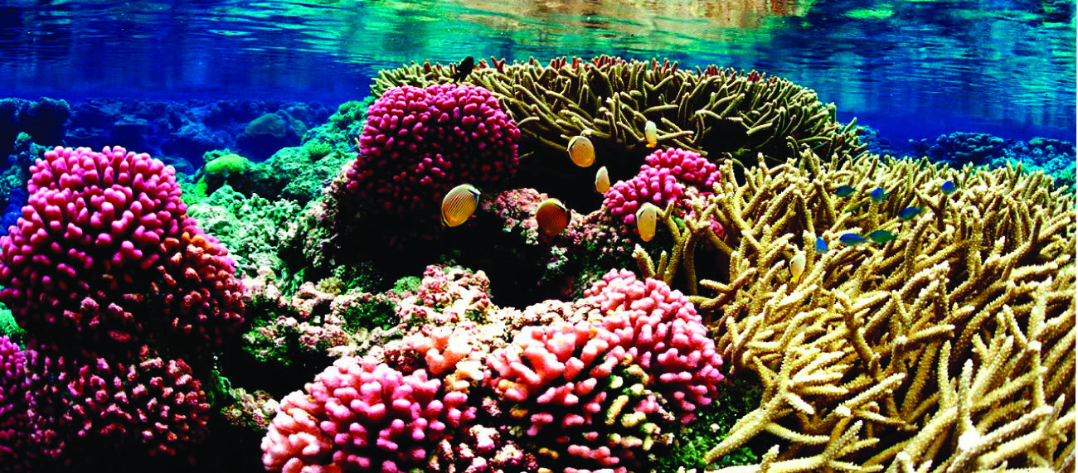
Figure 11.1 Coral reefs, such as this one at the Palmyra Atoll National Wildlife Refuge, are vital to the ecosystem of earth’s oceans. The health of coral reefs and all marine life depends on the specific chemical composition of the complex mixture known as seawater. (credit: modification of work by “USFWS – Pacific Region”/Wikimedia Commons)

Coral reefs are home to about 25% of all marine species. They are being threatened by climate change, ocean acidification, and water pollution, all of which change the composition of the solution known as seawater. Dissolved oxygen in seawater is critical for sea creatures, but as the oceans warm, oxygen becomes less soluble. As the concentration of carbon dioxide in the atmosphere increases, the concentration of carbon dioxide in the oceans increases, contributing to ocean acidification. Coral reefs are particularly sensitive to acidification of the ocean, since the exoskeletons of the coral polyps are soluble in acidic solutions. Humans contribute to the changing of seawater composition by allowing agricultural runoff and other forms of pollution to affect our oceans.
Solutions are crucial to the processes that sustain life and to many other processes involving chemical reactions. This chapter considers the nature of solutions and examines factors that determine whether a solution will form and what properties it may have. The properties of colloids—mixtures containing dispersed particles larger than the molecules and ions of typical solutions—are also discussed.

11.1 Types of Solutions

Learning Objectives
- Describe the fundamental properties of solutions
- Describe the basic properties of solutions and how they form

Introduction
Preceding sections of this chapter focused on the composition of substances: samples of matter that contain only one type of element or compound. However, mixtures—samples of matter containing two or more substances physically combined—are more commonly encountered in nature than are pure substances. Similar to a pure substance, the relative composition of a mixture plays an important role in determining its properties. The relative amount of oxygen in a planet’s atmosphere determines its ability to sustain aerobic life. The relative amounts of iron, carbon, nickel, and other elements in steel (a mixture known as an “alloy”) determine its physical strength and resistance to corrosion. The relative amount of the active ingredient in a medicine determines its effectiveness in achieving the desired pharmacological effect. The relative amount of sugar in a beverage determines its sweetness (see Figure 11.2). This section will describe one of the most common ways in which the relative compositions of mixtures may be quantified.
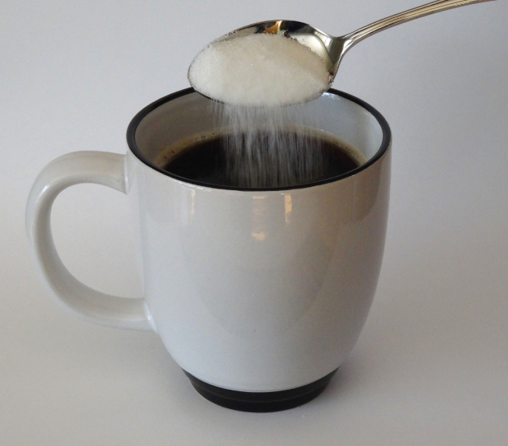
Figure 11.2 Sugar is one of many components in the complex mixture known as coffee. The amount of sugar in a given amount of coffee is an important determinant of the beverage’s sweetness. (credit: Jane Whitney)

Solutions
Solutions have previously been defined as homogeneous mixtures, meaning that the composition of the mixture (and therefore its properties) is uniform throughout its entire volume. Solutions occur frequently in nature and have also been implemented in many forms of manmade technology. A more thorough treatment of solution properties is provided in the chapter on solutions and colloids, but provided here is an introduction to some of the basic properties of solutions.
The relative amount of a given solution component is known as its concentration. Often, though not always, a solution contains one component with a concentration that is significantly greater than that of all other components. This component is called the solvent and may be viewed as the medium in which the other components are dispersed, or dissolved. A solute is a component of a solution that is typically present at a much lower concentration than the solvent. Solute concentrations are often described with qualitative terms such as dilute (of relatively low concentration) and concentrated (of relatively high concentration).
Solutions exhibit these defining traits:
- They are homogeneous; after a solution is mixed, it has the same composition at all points throughout (its composition is uniform).
- The physical state of a solution—solid, liquid, or gas—is typically the same as that of the solvent, as demonstrated by the examples in Table 11.1 and Table 11.2.
- The components of a solution are dispersed on a molecular scale; they consist of a mixture of separated solute particles (molecules, atoms, and/or ions) each closely surrounded by solvent species.
- The dissolved solute in a solution will not settle out or separate from the solvent.
- The composition of a solution, or the concentrations of its components, can be varied continuously (within limits determined by the solubility of the components, discussed in detail later in this chapter).

Different Types of Solutions

Aqueous Solution
Solutions in which water is the solvent are, of course, very common on our planet. A solution in which water is the solvent is called an aqueous solution. Water is used so often as a solvent that the word solution has come to imply an aqueous solution to many people. However, almost any gas, liquid, or solid can act as a solvent.

Alloys
Many alloys are solid solutions of one metal dissolved in another; for example, US five-cent coins contain nickel dissolved in copper.

Gaseous Solution
Air is a gaseous solution, a homogeneous mixture of nitrogen, oxygen, and several other gases. Oxygen (a gas), alcohol (a liquid), and sugar (a solid) all dissolve in water (a liquid) to form liquid solutions.
Table 11.1 gives examples of several different solutions and the phases of solutes and solvents.
Table 11.1 Different Types of Solutions
Solution | Solute | Solvent
air | O₂(g) | N₂(g)
soft drinks** | CO₂(g) | H₂O(l)
hydrogen in palladium | H₂(g) | Pd(s)
rubbing alcohol | H₂O(l) | C₃H₈O(l) (2-propanol)
saltwater | NaCl(s) | H₂O(l)
brass | Zn(s) | Cu(s)

**If bubbles of gas are observed within the liquid, the mixture is not homogeneous and, thus, not a solution.

Table 11.2 More Examples of Different Types of Solutions
Credit: "13.1: The Solution Process"LibreTexts is licensed under CC BY-NC-SA 3.0

Solution | Solute | Solvent | Examples
gas | gas | gas | air, natural gas
liquid | gas | liquid | seltzer water  (CO₂ gas in water)
liquid | liquid | liquid | alcoholic beverage  (ethanol in water), gasoline
liquid | solid | liquid | tea, salt water
solid | gas | solid | H₂ in Pd  (used for H₂ storage)
solid | solid | liquid | mercury in silver or gold (amalgam often used in dentistry)
solid | solid | solid | alloys and other "solid solutions"

11.2 Formation of Solutions and Dissolution Process

Learning Objectives
- To understand how enthalpy and entropy changes affect solution formation.
- To use the magnitude of the changes in both enthalpy and entropy to predict whether a given solute–solvent combination will spontaneously form a solution.
- Explain why some solutions either produce or absorb heat when they form

Introduction
The formation of a solution from a solute and a solvent is a physical process, not a chemical one. That is, both solute and solvent can be recovered in chemically unchanged forms using appropriate separation methods. For example, solid zinc nitrate dissolves in water to form an aqueous solution of zinc nitrate:
Zn(NO₃)₂ (s) + H₂O (l) → Zn²⁺ (aq) + 2 NO³⁻ (aq)
Because Zn(NO₃)₂ can be recovered easily by evaporating the water, this is a physical process. Dissolution of a solute in a solvent to form a solution does not involve a chemical transformation.

Miscibility
Substances that form a single homogeneous phase in all proportions are said to be completely miscible in one another. Ethanol and water are miscible, just as mixtures of gases are miscible. If two substances are essentially insoluble in each other, such as oil and water, they are immiscible. Examples of gaseous solutions that we have already discussed include Earth’s atmosphere.

The Formation of Solutions
The formation of a solution is an example of a spontaneous process, a process that occurs under specified conditions without the requirement of energy from some external source. Sometimes a mixture is stirred to speed up the dissolution process, but this is not necessary; a homogeneous solution will form eventually. The topic of spontaneity is critically important to the study of chemical thermodynamics and is treated more thoroughly in a later chapter of this text. For purposes of this chapter’s discussion, it will suffice to consider two criteria for predicting the spontaneity of solution formation:
- change of enthalpy (∆H_{sys}) (discussed in the thermochemistry chapter)
- change of entropy (∆S_{sys}) (a measure of dispersal of matter in the system, as you will learn more in the later chapter on thermodynamics)

The Role of Enthalpy Change (∆H) in Solution Formation
Energy is required to overcome the intermolecular interactions in a solute, which can be supplied only by the new interactions that occur in the solution, when each solute particle is surrounded by particles of the solvent in a process called solvation (or hydration when the solvent is water). Thus all of the solute–solute interactions and many of the solvent–solvent interactions must be disrupted for a solution to form. In this section, we describe the role of enthalpy in this process.

Because enthalpy is a state function, we can use a thermochemical cycle to analyze the energetics of solution formation. The process occurs in three discrete steps, indicated by ΔH₁, ΔH₂ , and ΔH₃ in Figure 11.3. The overall enthalpy change in the formation of the solution ( ΔH_{soln}) is the sum of the enthalpy changes in the three steps:
ΔH_{soln} = ΔH₁ + ΔH₂ + ΔH₃
When a solvent is added to a solution, steps 1 and 2 are both endothermic because energy is required to overcome the intermolecular interactions in the solvent (ΔH₁) and the solute (ΔH₂). When the solute is an ionic solid, ΔH₂ corresponds to the lattice energy that must be overcome to form a solution. The higher the charge of the ions in an ionic solid, the higher the lattice energy. Consequently, solids that have very high lattice energies, such as MgO (−3791 kJ/mol), are generally insoluble in all solvents.

The solute–solvent interactions (ΔH₃) is exothermic. When the solute-solvent interactions are stronger than the solute–solute and solvent–solvent interactions, the dissolution process to be exothermic (ΔH_{soln} < 0). However, if the solute-solvent interactions are weaker than the solute–solute and solvent–solvent interactions, the dissolution process to be endothermic (ΔH_{soln} > 0).

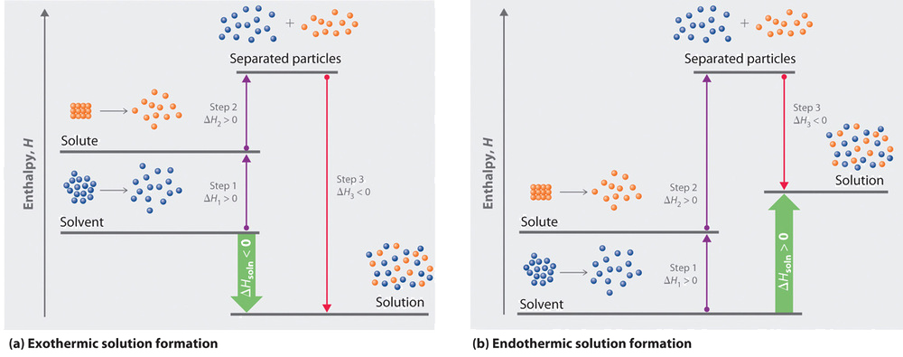
Figure 11.3 Enthalpy Changes That Accompany the Formation of a Solution. Solvation can be an exothermic or endothermic process depending on the nature of the solute and solvent. In both cases, step 1, separation of the solvent particles, is energetically uphill (ΔH₁ > 0), as is step 2, separation of the solute particles (ΔH₂ > 0). In contrast, energy is released in step 3 (ΔH₃< 0) because of interactions between the solute and solvent.
(a) When ΔH₃ is larger in magnitude than the sum of ΔH₁ and ΔH₂, the overall process is exothermic ( ΔH_{soln} < 0), as shown in the thermochemical cycle.
(b) When ΔH₃ is smaller in magnitude than the sum of ΔH₁ and ΔH₂, the overall process is endothermic ( ΔH_{soln}> 0).

A positive value for ΔH_{soln} does not mean that a solution will not form. Enthalpy is only one of the contributing factors to determine whether the formation of a solution occurs spontaneously. A high positive ΔH_{soln} is usually an indication that the substance is not very soluble.
Ammonium nitrate (NH₄NO₃) is one such example and is used to make instant cold packs for treating injuries like the one pictured in Figure 11.4. A thin-walled plastic bag of water is sealed inside a larger bag with solid NH₄NO₃. When the smaller bag is broken, a solution of NH₄NO₃ forms, absorbing heat from the surroundings (the injured area to which the pack is applied) and providing a cold compress that decreases swelling. Endothermic dissolutions such as this one require a greater energy input to separate the solute species than is recovered when the solutes are solvated, but they are spontaneous nonetheless due to the increase in disorder that accompanies formation of the solution.
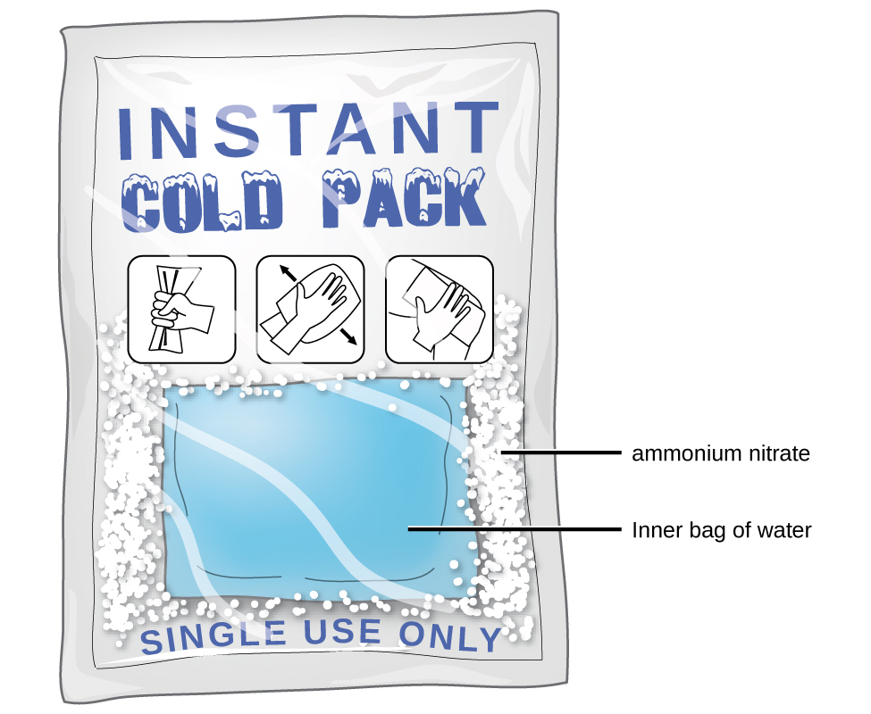
Figure 11.4 An instant cold pack gets cold when certain salts, such as ammonium nitrate, dissolve in water—an endothermic process.

The Role of Entropy Change (∆S) in Solution Formation
The enthalpy change (∆H) that accompanies a process is important because processes that release substantial amounts of energy tend to occur spontaneously. The entropy change (∆S) is a second property of any system that is important in helping us determine whether a given process occurs spontaneously. We will discuss entropy in more detail in a later chapter, but for now we can state that entropy (S) is a measure of the degree of disorder for a substance. A perfect crystal at 0 K, whose atoms are regularly arranged in a perfect lattice and are motionless, has an entropy of zero. In contrast, gases have large positive entropies because their molecules are highly disordered and in constant motion at high speeds.

The formation of a solution disperses molecules, atoms, or ions of one kind throughout a second substance, which generally increases the disorder and results in an increase in the entropy of the system (∆S_{sys} > 0). Thus entropic factors almost always favor formation of a solution. In contrast, a change in enthalpy may or may not favor solution formation.

All spontaneous processes with ΔH ≥ 0 (endothermic) are characterized by an increase in entropy (∆S_{sys} > 0). In other cases, such as mixing oil with water, salt with gasoline, or sugar with hexane, the enthalpy of solution is large and positive, and the increase in entropy resulting from solution formation is not enough to overcome it. Thus in these cases a solution does not form.

Table 11.3 summarizes how enthalpic factors affect solution formation for four general cases. The column on the far right uses the relative magnitudes of the enthalpic contributions to predict whether a solution will form from each of the four. Keep in mind that in each case entropy favors solution formation. In two of the cases the enthalpy of solution is expected to be relatively small and can be either positive or negative. Thus the entropic contribution dominates, and we expect a solution to form readily. In the other two cases the enthalpy of solution is expected to be large and positive. The entropic contribution, though favorable, is usually too small to overcome the unfavorable enthalpy term. Hence we expect that a solution will not form readily.
Table 11.3 Relative Changes in Enthalpies for Different Solute–Solvent Combinations*

ΔH₁ (separation of solvent molecules) | ΔH₂ (separation of solute particles) | ΔH₃  (solute–solvent interactions) | ΔH_{soln}  (ΔH₁+ΔH₂+ΔH₃) | Result of Mixing Solute and Solvent**
large; positive | large; positive | large; negative | small;  positive or negative | solution will usually form
small; positive | large; positive | small; negative | large;  positive | solution will not form
large; positive | small; positive | small; negative | large;  positive | solution will not form
small; positive | small; positive | small; negative | Small;  positive or negative | solution will usually form
* ΔH₁, ΔH₂, and ΔH₃ refer to the processes indicated in Figure 11.3
**In all four cases, entropy increases.

The Role of ∆H_{soln} and ∆S_{sys} in Gaseous Solution Formation
In contrast to liquid solutions, the intermolecular interactions in gases are weak (they are considered to be nonexistent in ideal gases). Hence mixing gases is usually a thermally neutral process (ΔH_{soln} ≈ 0), and the entropic factor due to the increase in disorder is dominant (Figure 11.5). Consequently, all gases dissolve readily in one another in all proportions to form solutions.

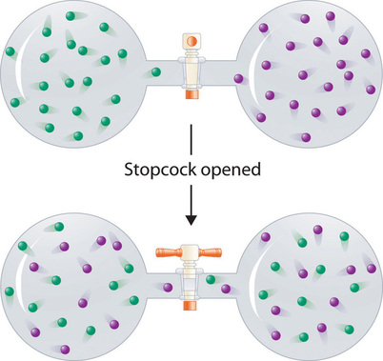

Figure 11.5 Formation of a Solution of Two Gases. (top) Pure samples of two different gases are in separate bulbs. (bottom) When the connecting stopcock is opened, diffusion causes the two gases to mix together and form a solution. Even though ΔH_{soln} is zero for the process, the increased entropy of the solution (the increased disorder) versus that of the separate gases favors solution formation.

11.3 Electrolytes

Learning Objectives
- Define and give examples of electrolytes
- Distinguish between the physical and chemical changes that accompany dissolution of ionic and covalent electrolytes
- Relate electrolyte strength to solute-solvent attractive forces

Introduction
When some substances are dissolved in water, they undergo a physical change that either yield or not yield ions in solution. The substances that yield ions when dissolved are called electrolytes. Substances that do not yield ions when dissolved are called nonelectrolytes. If the dissolution process generates ions that is essentially 100% efficient (all of the dissolved compound yields ions), then the substance is known as a strong electrolyte. If only a relatively small fraction of the dissolved substance undergoes the ion-producing process, it is called a weak electrolyte.
Substances may be identified as strong, weak, or nonelectrolytes by measuring the electrical conductance of an aqueous solution containing the substance. To conduct electricity, a substance must contain freely mobile, charged species. Most familiar is the conduction of electricity through metallic wires, in which case the mobile, charged entities are electrons. Solutions may also conduct electricity if they contain dissolved ions, with conductivity increasing as ion concentration increases. Applying a voltage to electrodes immersed in a solution permits assessment of the relative concentration of dissolved ions, either quantitatively, by measuring the electrical current flow, or qualitatively, by observing the brightness of a light bulb included in the circuit (Figure 11.6).
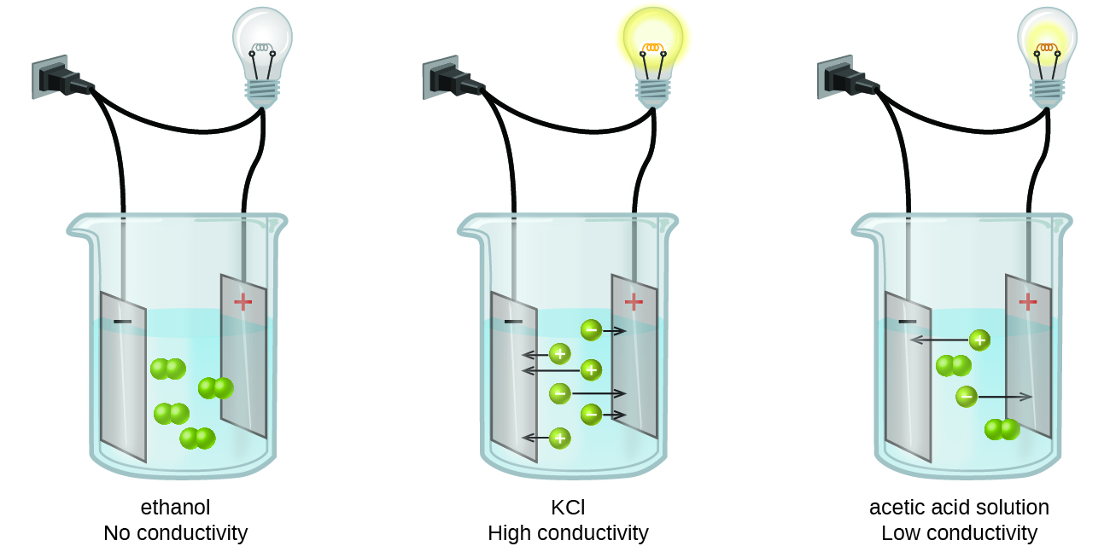
Figure 11.6 Solutions of nonelectrolytes such as ethanol do not contain dissolved ions and cannot conduct electricity. Solutions of electrolytes contain ions that permit the passage of electricity. The conductivity of an electrolyte solution is related to the strength of the electrolyte.

Nonelectrolyte - Molecular Compounds
Pure water is an extremely poor conductor of electricity because it is only very slightly ionized—only about two out of every 1 billion molecules ionize at 25 °C. Water ionizes when one molecule of water gives up a proton (H⁺ ion) to another molecule of water, yielding hydronium (H₃O⁺) and hydroxide (OH⁻) ions.
H₂O (l) + H₂O (l) ⇌ H₃O⁺ (aq) + OH⁻ (aq)
Sugar is an example of nonelectrolyte as it is a molecular compound composed of sucrose molecules, C₁₂H₂₂O₁₁. When this compound dissolves in water, the molecules stay intact. They don’t produce ions; thus, they cannot conduct electricity. The sucrose molecules just become uniformly distributed among the molecules of water:
C₁₂H₂₂O₁₁ (s) ⟶ C₁₂H₂₂O₁₁ (aq)
The subscript “aq” in the equation signifies that the sucrose molecules are solutes and are therefore individually dispersed throughout the aqueous solution (water is the solvent). Although sucrose molecules are heavier than water molecules, they remain dispersed throughout the solution; gravity does not cause them to “settle out” over time.

Electrolyte - Molecular Compounds
However, in few cases, solutions prepared from molecular compounds that are acids and bases conduct electricity because the solute molecules interact with the solvent to produce ions.
For example, pure hydrogen chloride is a gas consisting of covalent HCl molecules. This gas contains no ions. However, an aqueous solution of HCl is a very good conductor, indicating that an appreciable concentration of ions exists within the solution.
Because HCl is an acid, its molecules react with water, transferring H⁺ ions to form hydronium ions (H₃O⁺) and chloride ions (Cl⁻):
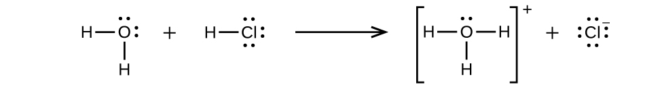
This reaction is essentially 100% complete for HCl (i.e., it is a strong acid and, consequently, a strong electrolyte).
Likewise, weak acids and bases that only react partially generate relatively low concentrations of ions when dissolved in water and are classified as weak electrolytes. You will learn more about strong and weak acids and bases in a later chapter.

Electrolyte - Ionic Compounds
Water and other polar molecules are attracted to ions in the ionic compounds, as shown in Figure 11.7. The electrostatic attraction between an ion and a polar molecule is called an ion-dipole attraction. These attractions play an important role in the dissolution of ionic compounds in water.
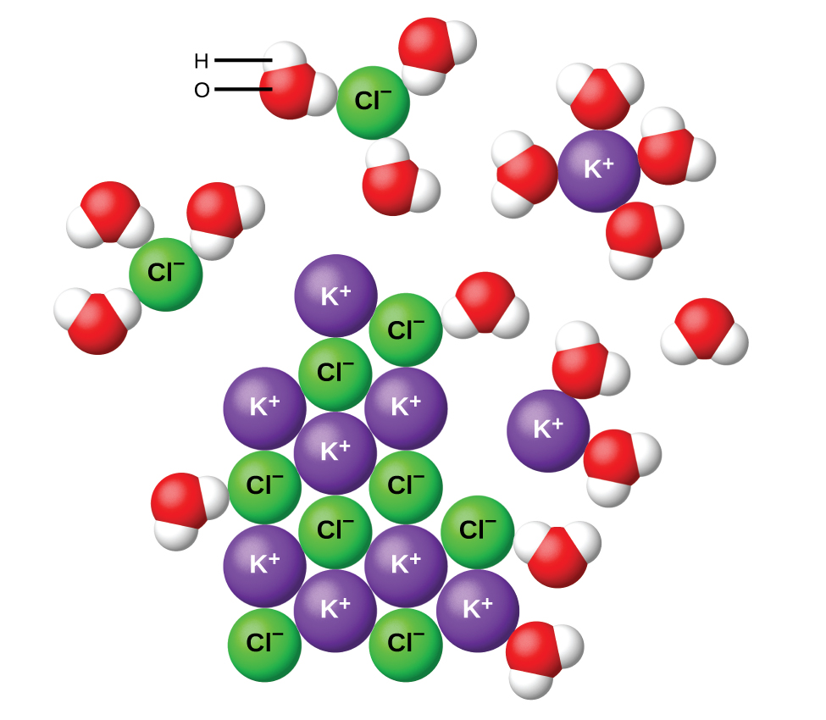
Figure 11.7 As potassium chloride (KCl) dissolves in water, the ions are hydrated. The polar water molecules are attracted by the charges on the K⁺ and Cl⁻ ions. Water molecules in front of and behind the ions are not shown.

When ionic compounds dissolve in water, the ions in the solid separate and disperse uniformly throughout the solution because water molecules surround and solvate the ions, reducing the strong electrostatic forces between them. This process represents a physical change known as dissociation. Under most conditions, ionic compounds will dissociate nearly completely when dissolved, and so they are classified as strong electrolytes. Even sparingly, soluble ionic compounds are strong electrolytes, since the small amount that does dissolve will dissociate completely.
Consider what happens at the microscopic level when solid KCl is added to water. Ion-dipole forces attract positive (hydrogen) end of the polar water molecules to the negative chloride ions at the surface of the solid, and they attract the negative (oxygen) ends to the positive potassium ions. The water molecules surround individual K⁺ and Cl⁻ ions, reducing the strong interionic forces that bind the ions together and letting them move off into solution as solvated ions, as Figure 11.7 shows. Overcoming the electrostatic attraction permits the independent motion of each hydrated ion in a dilute solution as the ions transition from fixed positions in the undissolved compound to widely dispersed, solvated ions in solution.

Another example of electrolytes is potassium dichromate, K₂Cr₂O₇, as it is an ionic compound composed of colorless potassium ions, K⁺, and orange dichromate ions, Cr₂O₇²⁻. When a small amount of solid potassium dichromate is added to water, the compound dissolves and dissociates completely to yield potassium ions and dichromate ions uniformly distributed throughout the mixture (Figure 11.8), as indicated in this equation:
K₂Cr₂O₇ (s) ⟶ 2 K⁺ (aq) + Cr₂O₇²⁻ (aq)
This means that when 100 molecules of K₂Cr₂O₇ dissolve in water, there will be 100 K⁺ ions and 100 Cr₂O₇²⁻ ions are produced, according to the stoichiometric ratio in the equation. Thus, K₂Cr₂O₇ is a strong electrolyte that can conduct electricity.
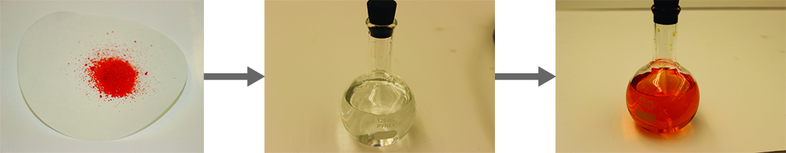
Figure 11.8 When potassium dichromate (K₂Cr₂O₇) is mixed with water, it forms a homogeneous orange solution. (credit: modification of work by Mark Ott)

11.4 Factors that Affect Solubility

Learning Objectives
- Describe the effects of temperature and pressure on solubility
- State Henry’s law and perform solubility of a gas in a liquid calculations
- Explain the degrees of solubility possible for liquid-liquid solutions

Introduction
Imagine adding a small amount of sugar to a glass of water, stirring until all the sugar has dissolved, and then adding a bit more. You can repeat this process until the sugar concentration of the solution reaches its natural limit, a limit determined primarily by the relative strengths of the solute-solute, solute-solvent, and solvent-solvent attractive forces discussed in the previous section. You can be certain that you have reached this limit because, no matter how long you stir the solution, undissolved sugar remains. The concentration of sugar in the solution at this point is known as its solubility.
The solubility of a solute in a particular solvent is the maximum concentration that may be achieved under given conditions when the dissolution process is at equilibrium.
When a solute’s concentration is equal to its solubility, the solution is said to be saturated with solute.
If the solute’s concentration is less than its solubility, the solution is said to be unsaturated. A solution that contains a relatively low concentration of solute is called dilute, and one with a relatively high concentration is called concentrated.
Solutions may be prepared in which a solute concentration exceeds its solubility. Such solutions are said to be supersaturated, and they are interesting examples of nonequilibrium states (a detailed treatment of this important concept is provided in the text chapters on equilibrium). For example, the carbonated beverage in an open container that has not yet “gone flat” is supersaturated with carbon dioxide gas; given time, the CO₂ concentration will decrease until it reaches its solubility.

Solutions of Solids in Liquids
The dependence of solubility on temperature for a number of solids in water is shown by the solubility curves in Figure 11.9. Reviewing these data indicates a general trend of increasing solubility with temperature, although there are exceptions, as illustrated by the ionic compound cerium sulfate.
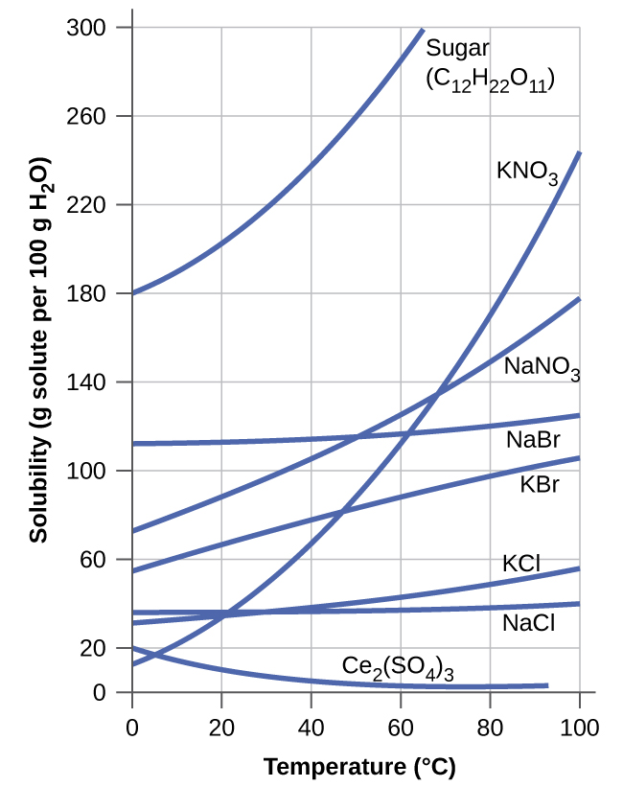
Figure 11.9 This graph shows how the solubility of several solids changes with temperature.
The temperature dependence of solubility can be exploited to prepare supersaturated solutions of certain compounds. A solution may be saturated with the compound at an elevated temperature (where the solute is more soluble) and subsequently cooled to a lower temperature without precipitating the solute. The resultant solution contains solute at a concentration greater than its equilibrium solubility at the lower temperature (i.e., it is supersaturated) and is relatively stable. Precipitation of the excess solute can be initiated by adding a seed crystal or by mechanically agitating the solution. Some hand warmers, such as the one pictured in Figure 11.10, take advantage of this behavior.

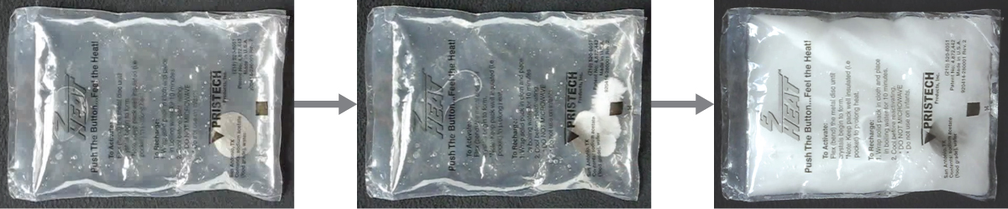

Figure 11.10 This hand warmer produces heat when the sodium acetate in a supersaturated solution precipitates. Precipitation of the solute is initiated by a mechanical shockwave generated when the flexible metal disk within the solution is “clicked.” (credit: modification of work by “Velela”/Wikimedia Commons)

Solutions of Liquids in Liquids
Some liquids may be mixed in any proportions to yield solutions; in other words, they have infinite mutual solubility and are said to be miscible. Ethanol, sulfuric acid, and ethylene glycol (popular for use as antifreeze, pictured in Figure 11.11) are examples of liquids that are completely miscible with water. Two-cycle motor oil is miscible with gasoline, mixtures of which are used as lubricating fuels for various types of outdoor power equipment (chainsaws, leaf blowers, and so on).
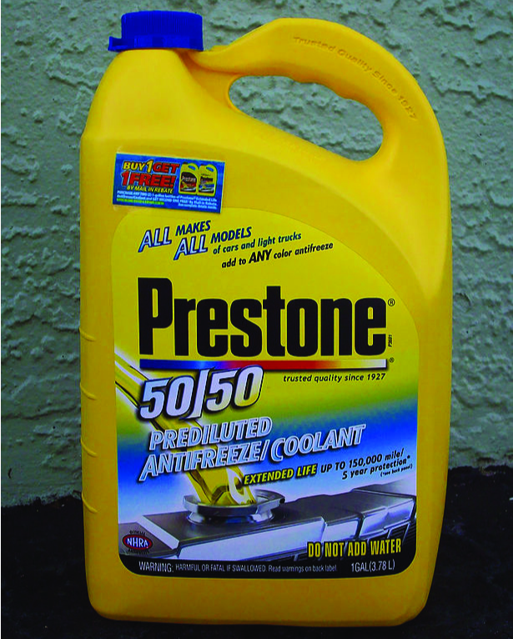

Figure 11.11 Water and antifreeze are miscible; mixtures of the two are homogeneous in all proportions. (credit: “dno1967”/Wikimedia commons)
Miscible liquids are typically those with very similar polarities. Consider, for example, liquids that are polar or capable of hydrogen bonding. For such liquids, the dipole-dipole attractions (or hydrogen bonding) of the solute molecules with the solvent molecules are at least as strong as those between molecules in the pure solute or in the pure solvent. Hence, the two kinds of molecules mix easily. Likewise, nonpolar liquids are miscible with each other because there is no appreciable difference in the strengths of solute-solute, solvent-solvent, and solute-solvent intermolecular attractions. The solubility of polar molecules in polar solvents and of nonpolar molecules in nonpolar solvents is, again, an illustration of the chemical axiom “like dissolves like.”
Two liquids that do not mix to an appreciable extent are called immiscible. Separate layers are formed when immiscible liquids are poured into the same container. Gasoline, oil (Figure 11.12), benzene, carbon tetrachloride, some paints, and many other nonpolar liquids are immiscible with water. Relatively weak attractive forces between the polar water molecules and the nonpolar liquid molecules are not adequate to overcome much stronger hydrogen bonding between water molecules. The distinction between immiscibility and miscibility is really one of extent, so that miscible liquids are of infinite mutual solubility, while liquids said to be immiscible are of very low (though not zero) mutual solubility.

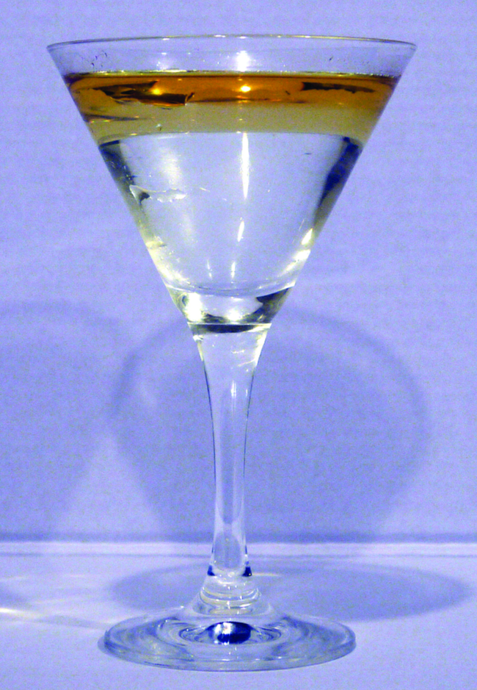

Figure 11.12 Water and oil are immiscible. Mixtures of these two substances will form two separate layers with the less dense oil floating on top of the water. (credit: “Yortw”/Flickr)
Two liquids, such as bromine and water, that are of moderate mutual solubility are said to be partially miscible. Two partially miscible liquids usually form two layers when mixed. In the case of the bromine and water mixture, the upper layer is water, saturated with bromine, and the lower layer is bromine saturated with water. Since bromine is nonpolar, and, thus, not very soluble in water, the water layer is only slightly discolored by the bright orange bromine dissolved in it. Since the solubility of water in bromine is very low, there is no noticeable effect on the dark color of the bromine layer (Figure 11.13).

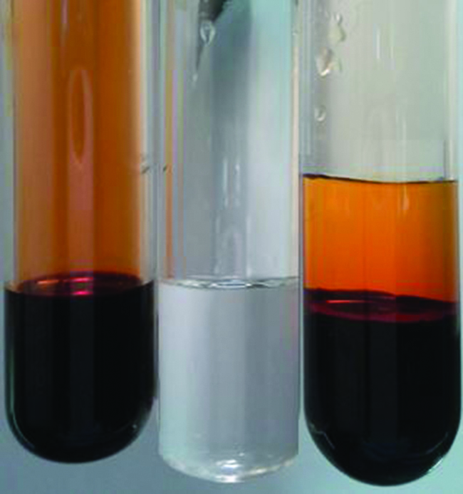

Figure 11.13 Bromine (the deep orange liquid on the left) and water (the clear liquid in the middle) are partially miscible. The top layer in the mixture on the right is a saturated solution of bromine in water; the bottom layer is a saturated solution of water in bromine. (credit: Paul Flowers)

Solutions of Gases in Liquids
As for any solution, the solubility of a gas in a liquid is affected by the intermolecular attractive forces between solute and solvent species. Unlike solid and liquid solutes, however, there is no solute-solute intermolecular attraction to overcome when a gaseous solute dissolves in a liquid solvent since the atoms or molecules comprising a gas are far separated and experience negligible interactions. Consequently, solute-solvent interactions are the sole energetic factor affecting solubility.
For example, the water solubility of oxygen is approximately three times greater than that of helium (there are greater dispersion forces between water and the larger oxygen molecules) but 100 times less than the solubility of chloromethane, CHCl₃ (polar chloromethane molecules experience dipole–dipole attraction to polar water molecules). Likewise note the solubility of oxygen in hexane, C₆H₁₄, is approximately 20 times greater than it is in water because greater dispersion forces exist between oxygen and the larger hexane molecules.
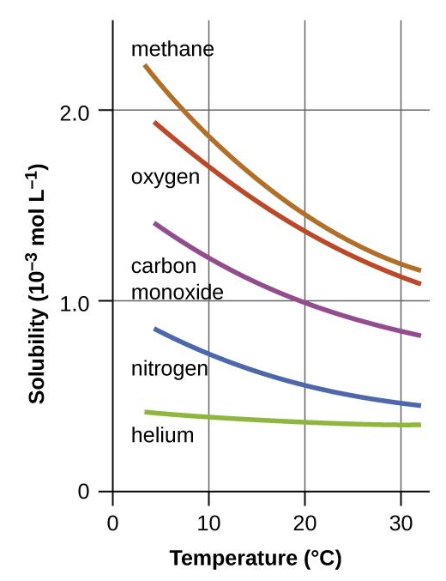
Temperature is another factor affecting solubility, with gas solubility typically decreasing as temperature increases (Figure 11.14). This inverse relation between temperature and dissolved gas concentration is responsible for one of the major impacts of thermal pollution in natural waters.

Figure 11.14 The solubilities of these gases in water decrease as the temperature increases. All solubilities were measured with a constant pressure of 101.3 kPa (1 atm) of gas above the solutions.

When the temperature of a river, lake, or stream is raised, the solubility of oxygen in the water is decreased. Decreased levels of dissolved oxygen may have serious consequences for the health of the water’s ecosystems and, in severe cases, can result in large-scale fish kills (Figure 11.15).

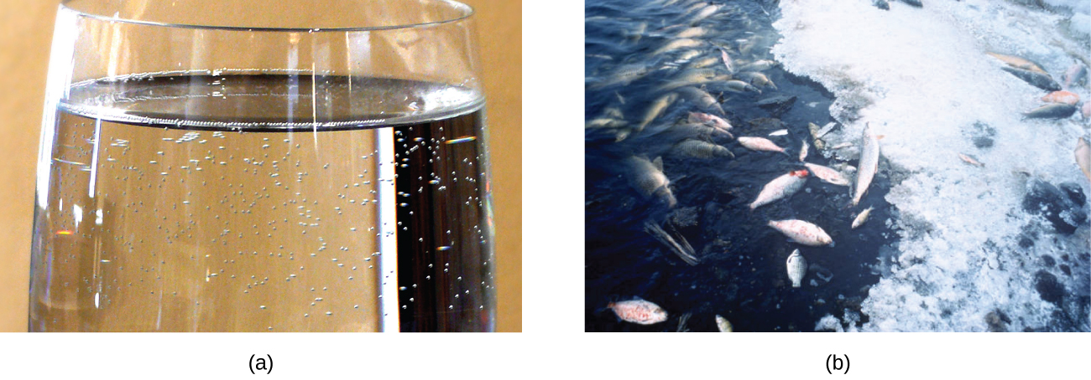
Figure 11.15 (a) The small bubbles of air in this glass of chilled water formed when the water warmed to room temperature and the solubility of its dissolved air decreased. (b) The decreased solubility of oxygen in natural waters subjected to thermal pollution can result in large-scale fish kills. (credit a: modification of work by Liz West; credit b: modification of work by U.S. Fish and Wildlife Service)

The solubility of a gaseous solute is also affected by the partial pressure of solute in the gas to which the solution is exposed. Gas solubility increases as the pressure of the gas increases. Carbonated beverages provide a nice illustration of this relationship. The carbonation process involves exposing the beverage to a relatively high pressure of carbon dioxide gas and then sealing the beverage container, thus saturating the beverage with CO₂ at this pressure. When the beverage container is opened, a familiar hiss is heard as the carbon dioxide gas pressure is released, and some of the dissolved carbon dioxide is typically seen leaving solution in the form of small bubbles (Figure 11.16). At this point, the beverage is supersaturated with carbon dioxide and, with time, the dissolved carbon dioxide concentration will decrease to its equilibrium value and the beverage will become “flat.”
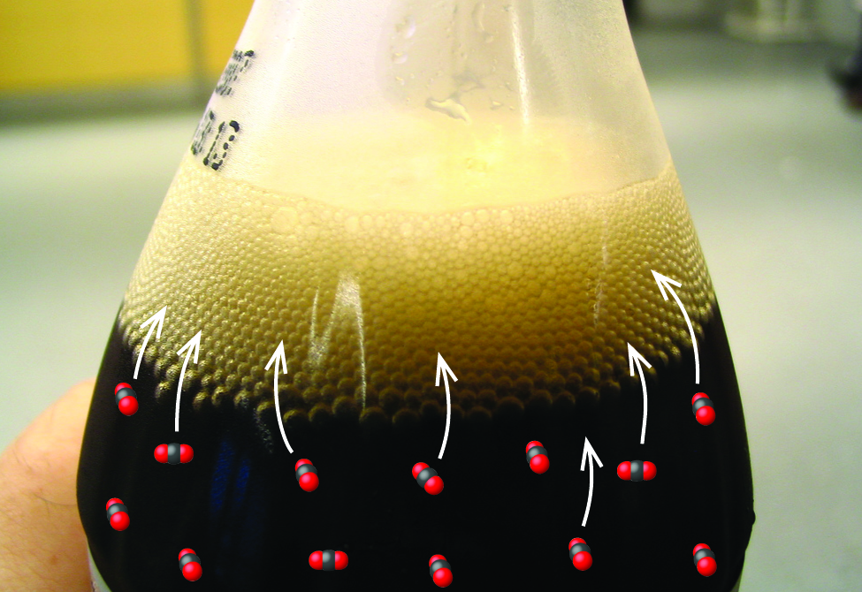

Figure 11.16 Opening the bottle of carbonated beverage reduces the pressure of the gaseous carbon dioxide above the beverage. The solubility of CO₂ is thus lowered, and some dissolved carbon dioxide may be seen leaving the solution as small gas bubbles. (credit: modification of work by Derrick Coetzee)

For many gaseous solutes, the relation between solubility, S_{g}, and partial pressure, P_{g}, is a proportional one:
S_{g} = k·P_{g}
where k is a proportionality Henry’s constant that depends on the identities of the gaseous solute and solvent, and on the solution temperature. This is a mathematical statement of Henry’s law: The quantity of an ideal gas that dissolves in a definite volume of liquid is directly proportional to the pressure of the gas.

***Note that various units may be used to express the solubility (see more in a later section). The most common units are 1) mol/L, which describes the amount of moles of solute in a liter of solution and 2) g/L, which describes grams of solute in one liter of solution.

Example 11.1
Application of Henry’s Law
At 20 °C, the concentration of dissolved oxygen in water exposed to gaseous oxygen at a partial pressure of 101.3 kPa is 1.38 × 10⁻³ mol·L⁻¹. Use Henry’s law to determine the solubility of oxygen when its partial pressure is 20.7 kPa, the approximate pressure of oxygen in earth’s atmosphere.

Solution: According to Henry’s law, for an ideal solution the solubility, S_{g} = k·P_{g}.
Because both S_{g} and P_{g} are known at a higher pressure, we need to solve for k.

S_{g} = k·P_{g} rearrange → $k = \frac{S_{g}}{P_{g}}$
$$k = \frac{1.38 × {10}^{-3}mol·L^{-1}}{101.3 kPa}$$
$$k =1.36 ×{10}^{-5 }mol·L^{-1}·{kPa}^{-1}$$

Now, use k to find the solubility at the lower pressure.

S_{g} = k·P_{g} → S_{g} = ($1.36 ×{10}^{-5 }mol·L^{-1}·{kPa}^{-1}$)(20.7 kPa)
S_{g} = $2.82 ×{10}^{-4 }mol·L^{-1}$

Check Your Learning
Exposing a 100.0 mL sample of water at 0 °C to an atmosphere containing a gaseous solute at 152 torr resulted in the dissolution of 1.45 × 10⁻³ g of the solute. Use Henry’s law to determine the solubility of this gaseous solute when its pressure is 760 torr.
Answer:
7.25 × 10⁻³ g in 100.0 mL or 0.0725 g/L

Example 11.2

Thermal Pollution and Oxygen Solubility
A certain species of freshwater trout requires a dissolved oxygen concentration of 7.5 mg/L. Could these fish thrive in a thermally polluted mountain stream (water temperature is 30.0 °C, partial pressure of atmospheric oxygen is 0.17 atm)? Given that the Henry’s law constant for oxygen in water at 30.0 °C is 1.15 × 10⁻³ mol·L⁻¹·atm⁻¹.

Solution:
S_{g} = k·P_{g} → S_{g} = ($1.15 ×{10}^{-3 }mol·L^{-1}·{atm}^{-1}$)(0.17 atm)
S_{g} = $1.95 ×{10}^{-4 }mol·L^{-1}$

Finally, convert this dissolved oxygen concentration from mol/L to mg/L.
$\frac{1.95 × {10}^{-4} mol O_{2}}{1 L}$ $×$ $\frac{31.998 g O_{2}}{1 mol O_{2}} ×$ $\frac{1000 mg}{1 g}$ = 6.2 mg/L
This concentration is less than the required minimum value of 7.5 mg/L, and so these trout would likely not thrive in the polluted stream.

Deviations from Henry’s law are observed when a chemical reaction takes place between the gaseous solute and the solvent. For example, the solubility of ammonia in water increases more rapidly with increasing pressure than predicted by the law because ammonia, being a base, reacts to some extent with water to form ammonium ions and hydroxide ions.
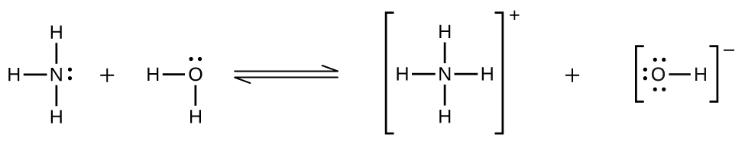
Gases can form supersaturated solutions. If a solution of a gas in a liquid is prepared either at low temperatures or under pressure (or both), then as the solution warms or as the gas pressure is reduced, the solution may become supersaturated. In 1986, more than 1700 people in Cameroon were killed when a cloud of gas, almost certainly carbon dioxide, bubbled from Lake Nyos (Figure 11.17), a deep lake in a volcanic crater. The water at the bottom of Lake Nyos is saturated with carbon dioxide by volcanic activity beneath the lake. It is believed that the lake underwent a turnover due to gradual heating from below the lake, and the warmer, less-dense water saturated with carbon dioxide reached the surface. Consequently, tremendous quantities of dissolved CO₂ were released, and the colorless gas, which is denser than air, flowed down the valley below the lake and suffocated humans and animals living in the valley.

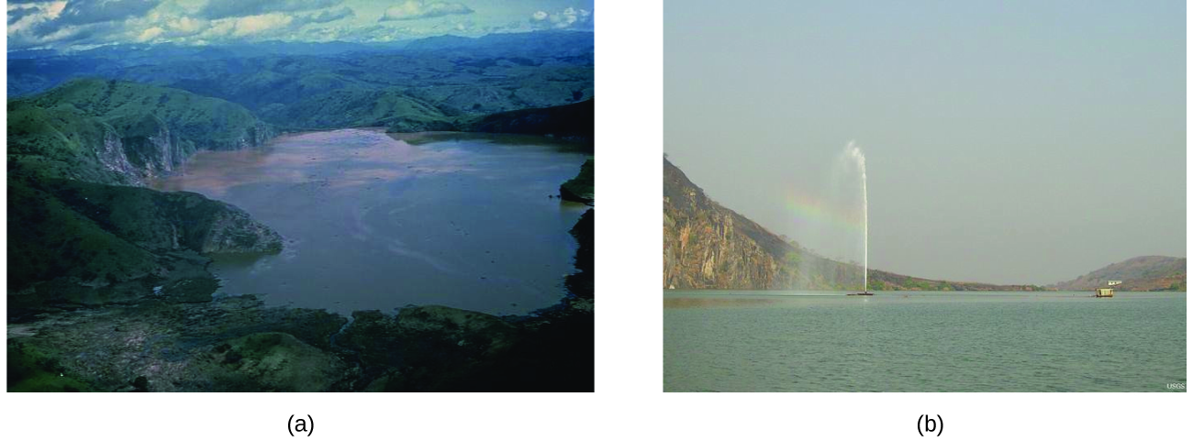
Figure 11.17 (a) It is believed that the 1986 disaster that killed more than 1700 people near Lake Nyos in Cameroon resulted when a large volume of carbon dioxide gas was released from the lake. (b) A CO₂ vent has since been installed to help outgas the lake in a slow, controlled fashion and prevent a similar catastrophe from happening in the future. (credit a: modification of work by Jack Lockwood; credit b: modification of work by Bill Evans)

Chemistry in Everyday Life

Decompression Sickness or “The Bends”
Decompression sickness (DCS), or “the bends,” is an effect of the increased pressure of the air inhaled by scuba divers when swimming underwater at considerable depths. In addition to the pressure exerted by the atmosphere, divers are subjected to additional pressure due to the water above them, experiencing an increase of approximately 1 atm for each 10 m of depth. Therefore, the air inhaled by a diver while submerged contains gases at the corresponding higher ambient pressure, and the concentrations of the gases dissolved in the diver’s blood are proportionally higher per Henry’s law.
As the diver ascends to the surface of the water, the ambient pressure decreases and the dissolved gases become less soluble. If the ascent is too rapid, the gases escaping from the diver’s blood may form bubbles that can cause a variety of symptoms ranging from rashes and joint pain to paralysis and death. To avoid DCS, divers must ascend from depths at relatively slow speeds (10 or 20 m/min) or otherwise make several decompression stops, pausing for several minutes at given depths during the ascent. When these preventive measures are unsuccessful, divers with DCS are often provided hyperbaric oxygen therapy in pressurized vessels called decompression (or recompression) chambers (Figure 11.18).
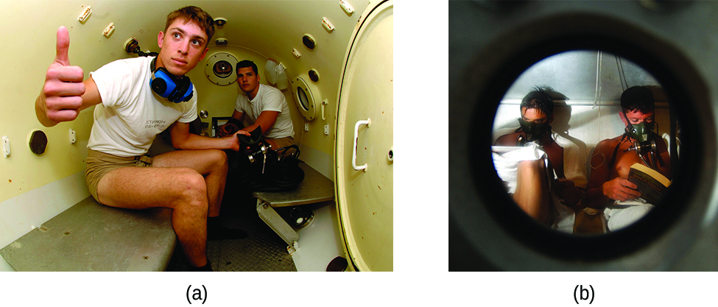
Figure 11.18 (a) US Navy divers undergo training in a recompression chamber. (b) Divers receive hyperbaric oxygen therapy.

11.5 Concentration Units

Learning Objectives
- Define the concentration units of mass percentage, volume percentage, mass-volume percentage, parts-per-million (ppm), and parts-per-billion (ppb)
- Calculate solution concentrations using molarity

Introduction
Concentrations may be quantitatively assessed using a wide variety of measurement units, each convenient for particular applications. This section will describe some units of concentration that are commonly used in various applications, either for convenience or by convention. However, molarity is the unit that we will be using the most often for evaluating the concentration of solutions throughout our chemistry course.

Mass Per Volume
Earlier in this chapter when we discussed about solubility of gas in liquid (see Henry’s law), mass per volume was introduced as a measure of the amount in grams of solute in a liter of solution (g/L). This unit is commonly used to express the solubility of substances, such as solubility of gas in liquid and solubility of solid in liquid. Other units of mass can also be used, such as kg, mg, $μ$g, or ng. In general, the mass per volume of a solution is defined as the ratio of the solute’s mass to the solution’s volume:

mass per volume = $\frac{mass of solute}{volume of solution}$

Mass Percentage
Mass percentages are also commonly used to express the composition of mixtures, including solutions. The mass percentage of a solution component is defined as the ratio of the solute’s mass to the solution’s mass, expressed as a percentage:

mass percentage = $\frac{mass of solute}{mass of solution}$x 100%
Mass percentage is also referred to by similar names such as percent mass, percent weight, weight/weight percent, and other variations on this theme.
The most common symbol for mass percentage is simply the percent sign, %, although more detailed symbols are often used including %mass, %weight, and (w/w)%. Use of these more detailed symbols can prevent confusion of mass percentages with other types of percentages, such as volume percentages (to be discussed later in this section).
Mass percentages are popular concentration units for consumer products. The label of a typical liquid bleach bottle (Figure 11.19) cites the concentration of its active ingredient, sodium hypochlorite (NaOCl), as being 7.4%. A 100.0-g sample of bleach would therefore contain 7.4 g of NaOCl.
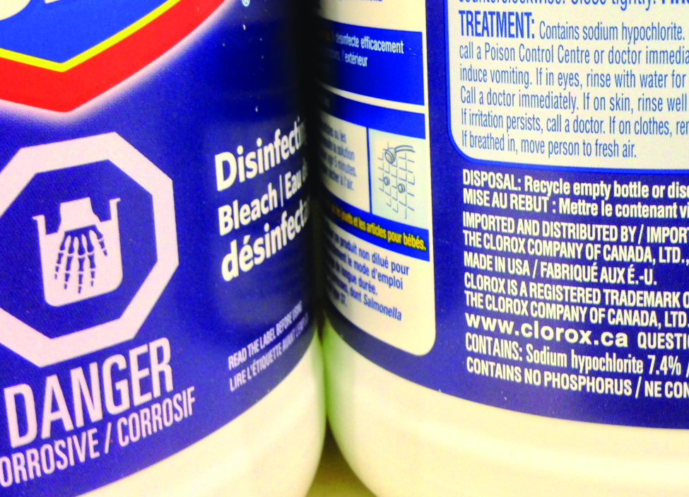

Figure 11.19 Liquid bleach is an aqueous solution of sodium hypochlorite (NaOCl). This brand has a concentration of 7.4% NaOCl by mass.

Volume Percentage
Liquid volumes over a wide range of magnitudes are conveniently measured using common and relatively inexpensive laboratory equipment. The concentration of a solution formed by dissolving a liquid solute in a liquid solvent is therefore often expressed as a volume percentage, %vol or (v/v)%:

volume percentage = $\frac{volume of solute}{volume of solution}$x 100%

Mass-Volume Percentage
“Mixed” percentage units, derived from the mass of solute and volume of solution, are popular for certain biochemical and medical applications. A mass-volume percent is a ratio of a solute’s mass to the solution’s volume expressed as a percentage. The specific units used for solute mass and solution volume may vary, depending on the solution. For example, physiological saline solution, used to prepare intravenous fluids, has a concentration of 0.9% mass/volume (m/v), indicating that the composition is 0.9 g of solute per 100 mL of solution. The concentration of glucose in blood (commonly referred to as “blood sugar”) is also typically expressed in terms of a mass-volume ratio. Though not expressed explicitly as a percentage, its concentration is usually given in milligrams of glucose per deciliter (100 mL) of blood (Figure 11.20).
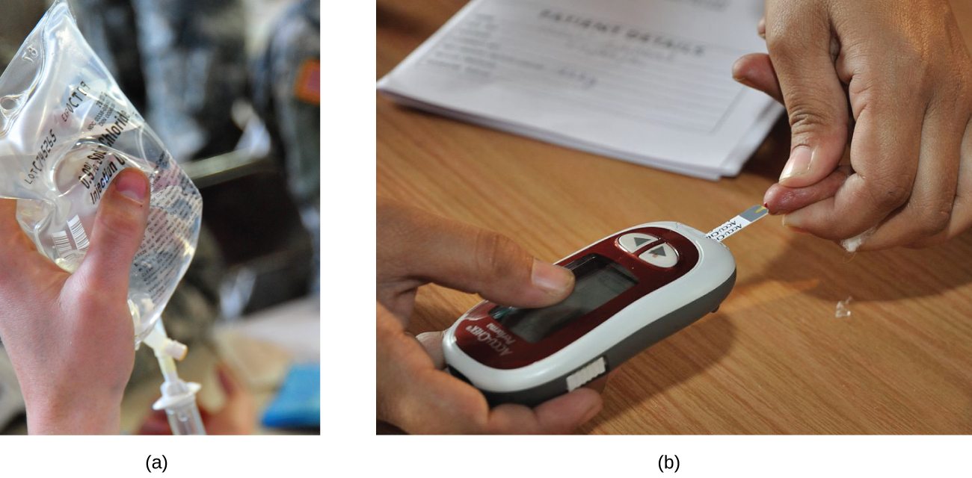
Figure 11.20 “Mixed” mass-volume units are commonly encountered in medical settings. (a) The NaCl concentration of physiological saline is 0.9% (m/v). (b) This device measures glucose levels in a sample of blood. The normal range for glucose concentration in blood (fasting) is around 70–100 mg/dL. (credit a: modification of work by “The National Guard”/Flickr; credit b: modification of work by Biswarup Ganguly)

Parts per Million and Parts per Billion
Very low solute concentrations are often expressed using appropriately small units such as parts per million (ppm) or parts per billion (ppb). Like percentage (“part per hundred”) units, ppm and ppb may be defined in terms of masses, volumes, or mixed mass-volume units. There are also ppm and ppb units defined with respect to numbers of atoms and molecules. The mass-based definitions of ppm and ppb are given here:
parts per million = $\frac{mass of solute}{mass of solution}$x 10⁶ ppm
parts per billion = $\frac{mass of solute}{mass of solution}$x 10⁹ ppb
Both ppm and ppb are convenient units for reporting the concentrations of pollutants and other trace contaminants in water. Concentrations of these contaminants are typically very low in treated and natural waters, and their levels cannot exceed relatively low concentration thresholds without causing adverse effects on health and wildlife.
For example, the EPA has identified the maximum safe level of fluoride ion in tap water to be 4 ppm. Inline water filters are designed to reduce the concentration of fluoride and several other trace-level contaminants in tap water (Figure 11.21).
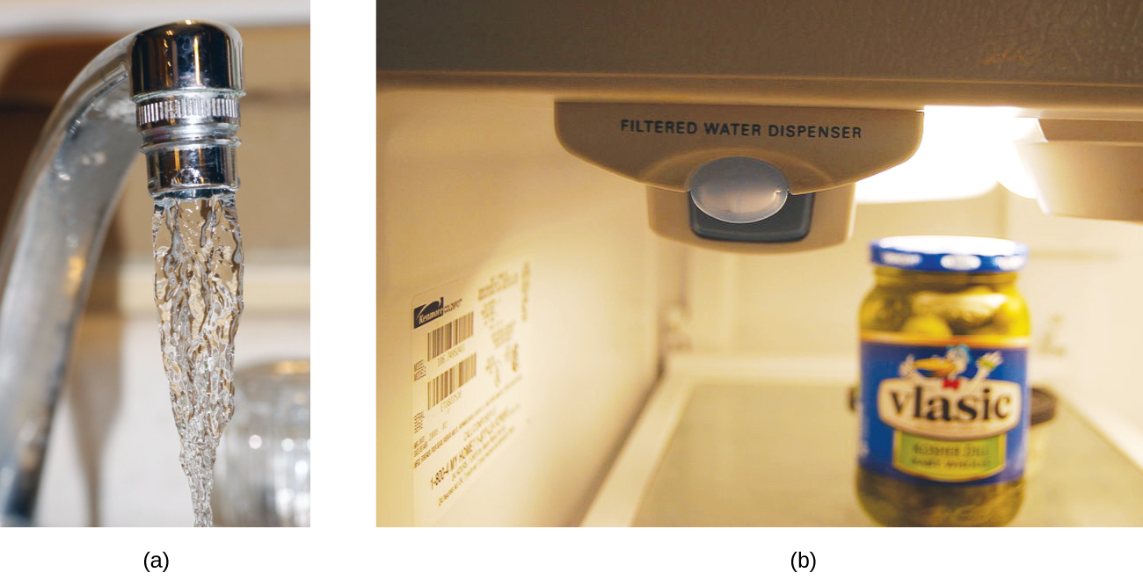
Figure 11.21 (a) In some areas, trace-level concentrations of contaminants can render unfiltered tap water unsafe for drinking and cooking. (b) Inline water filters reduce the concentration of solutes in tap water. (credit a: modification of work by Jenn Durfey; credit b: modification of work by “vastateparkstaff”/Wikimedia commons)

Molarity
Molarity (M) is a useful concentration unit for many applications in chemistry. Molarity is defined as the number of moles of solute in exactly 1 liter (1 L) of the solution:
M = $\frac{mol of solute}{liter of solution}$

Example 11.3
Calculating Molar Concentrations
A 355-mL soft drink sample contains 0.133 mol of sucrose (table sugar). What is the molar concentration of sucrose in the beverage?

Solution
Since the molar amount of solute and volume of solution are both given, the molarity can be calculated using the definition of molarity. Per this definition, the solution volume must be converted from mL to L:
M = $\frac{mol of solute}{liter of solution}$

M = $\frac{0.133 mol}{355 mL}×\frac{1000 mL}{1 L}$= 0.375 mol/L or M

Check Your Learning
A teaspoon of table sugar contains about 0.01 mol sucrose. What is the molarity of sucrose if a teaspoon of sugar has been dissolved in a cup of tea with volume of 200 mL?
Answer: 0.05 M

Example 11.4

Deriving Moles and Volumes from Molar Concentrations
How much sugar (in mol) is contained in a modest sip (~10 mL) of the soft drink from Example 11.3?

Solution:
Rearrange the definition of molarity to isolate the quantity sought, moles of sugar, then substitute the value for molarity derived in Example 11.3, 0.375 M:

10 mL $×\frac{1 L}{1000 mL} ×$ $\frac{0.375 mol}{1 L}$= 0.0038 mol

Check Your Learning
What is the volume (in mL) of 1.50 M NaCl solution that contains 22.0 g of NaCl?

Answer: 250. mL

Example 11.5
Calculating Molar Concentrations from the Mass of Solute
Distilled white vinegar is a solution of acetic acid, CH₃CO₂H, in water.
A 0.500-L vinegar solution contains 25.2 g of acetic acid. What is the concentration of the acetic acid solution in units of molarity?

Solution
As in previous examples, the definition of molarity is the primary equation used to calculate the quantity sought. Since the mass of solute is provided instead of its molar amount, use the solute’s molar mass to obtain the amount of solute in moles:
M = $\frac{mol of solute}{liter of solution}$

Find mol of solute: 25.2 g CH₃CO₂H $×\frac{1 mol}{60.052 gCH_{3}{CO}_{2}H}$ = 0.4196 mol solute

M = $\frac{0.4196 mol}{0.5 L}$= 0.839 mol/L or M

Check Your Learning
Calculate the molarity of 6.52 g of CoCl₂ (128.9 g/mol) dissolved in an aqueous solution with a total volume of 75.0 mL.
Answer: 0.674 M

Example 11.6
Determining the Mass of Solute in a Given Volume of Solution

How many grams of NaCl are contained in 0.250 L of a 5.30-M solution?

Solution
The volume and molarity of the solution are specified, so the amount (mol) of solute is easily computed as demonstrated in Example 11.4:

0.250 L $×\frac{5.30 mol NaCl}{1 L} ×$ $\frac{58.44 g NaCl}{1 mol NaCl}$= 77.4 g NaCl

Check Your Learning
How many grams of CaCl₂ (110.98 g/mol) are contained in 250.0 mL of a 0.200-M solution of calcium chloride?

Answer: 5.55 g CaCl₂

When performing calculations stepwise, as in Example 11.6, it is important to refrain from rounding any intermediate calculation results, which can lead to rounding errors in the final result. In Example 11.6, the molar amount of NaCl computed in the first step, 1.325 mol, would be properly rounded to 1.32 mol if it were to be reported; however, although the last digit (5) is not significant, it must be retained as a guard digit in the intermediate calculation. If the guard digit had not been retained, the final calculation for the mass of NaCl would have been 77.1 g, a difference of 0.3 g.
In addition to retaining a guard digit for intermediate calculations, rounding errors may also be avoided by performing computations in a single step (see Example 11.7). This eliminates intermediate steps so that only the final result is rounded.

Example 11.7
Determining the Volume of Solution Containing a Given Mass of Solute

In Example 11.5, the concentration of acetic acid in white vinegar was determined to be 0.839 M. What volume of vinegar contains 75.6 g of acetic acid?

Solution
First, use the molar mass to calculate moles of acetic acid from the given mass.
Then, use the molarity of the solution to calculate the volume of solution containing this molar amount of solute.

Combining these two steps into one yields:

75.6 g CH₃CO₂H $×\frac{1 mol CH_{3}CO_{2}H}{60.05 g CH_{3}CO_{2}H} ×$ $\frac{1 L}{0.839 mol CH_{3}CO_{2}H}$= 1.50 L solution

Check Your Learning
What volume of a 1.50-M KBr solution contains 66.0 g KBr?

Answer: 0.370 L

11.6 Dilution of Solution

Learning Objectives
- Perform dilution calculations using the dilution equation

Dilution of Solutions
Dilution is the process whereby the concentration of a solution is lessened by the addition of solvent. For example, a glass of iced tea becomes increasingly diluted as the ice melts. The water from the melting ice increases the volume of the solvent (water) and the overall volume of the solution (iced tea), thereby reducing the relative concentrations of the solutes that give the beverage its taste (Figure 11.22).
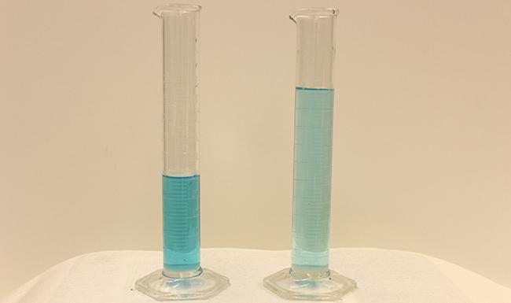
Figure 11.22 Both solutions contain the same mass of copper nitrate. The solution on the right is more dilute because the copper nitrate is dissolved in more solvent. (credit: Mark Ott)
Dilution is also a common means of preparing solutions of a desired concentration. By adding solvent to a measured portion of a more concentrated stock solution, a solution of lesser concentration may be prepared. For example, commercial pesticides are typically sold as solutions in which the active ingredients are far more concentrated than is appropriate for their application. Before they can be used on crops, pesticides must be diluted. This is also a very common practice for the preparation of a number of common laboratory reagents.
A simple mathematical relationship can be used to relate the volumes and concentrations of a solution before and after the dilution process. According to the definition of molarity, the number of moles of solute in a solution (n) is equal to the product of the solution’s molarity (M) and its volume in liters (L):
M = $\frac{mol of solute}{liter of solution}$ or M = $\frac{n}{L}$
Rearrange ---> n = M·L
Expressions like these may be written for a solution before and after it is diluted:
Solution before dilution n₁ = M₁·L₁
Solution after dilution n₂ = M₂·L₂
where the subscripts “1” and “2” refer to the solution before and after dilution, respectively. Since the dilution process does not change the amount of solute in the solution,
n₁ = n₂
Thus, these two equations may be set equal to one another:
M₁·L₁ = M₂·L₂
This relation is commonly referred to as the dilution equation. Although this equation uses molarity as the unit of concentration and liters as the unit of volume, other units of concentration and volume may be used as long as the units properly cancel per the factor-label method. Reflecting this versatility, the dilution equation is often written in the more general form:
C₁·V₁ = C₂·V₂

where C and V are concentration and volume, respectively.

Example 11.8
Determining the Concentration of a Diluted Solution
If 0.850 L of a 5.00-M solution of copper nitrate, Cu(NO₃)₂, is diluted to a volume of 1.80 L by the addition of water, what is the molarity of the diluted solution?

Solution:
The stock concentration, C₁, and volume, V₁, are provided as well as the volume of the diluted solution, V₂. Rearrange the dilution equation to isolate the unknown property, the concentration of the diluted solution, C₂:
C₁·V₁ = C₂·V₂
C₂ = $\frac{C_{1}V_{1}}{V_{2}}$
Since the stock solution is being diluted by more than two-fold (volume is increased from 0.85 L to 1.80 L), the diluted solution’s concentration is expected to be less than one-half 5 M. This ballpark estimate will be compared to the calculated result to check for any gross errors in computation (for example, such as an improper substitution of the given quantities). Substituting the given values for the terms on the right side of this equation yields:
C₂ = $\frac{5.00 M · 0.850 L}{1.80 L}$ = 2.36 M
This result compares well to our ballpark estimate (it’s a bit less than one-half the stock concentration, 5 M).

Check Your Learning
What is the concentration of the solution that results from diluting 25.0 mL of a 2.04-M solution of CH₃OH to 500.0 mL?

Answer: 0.102 M CH₃OH

Example 11.9
Volume of a Diluted Solution
What volume of 0.12 M HBr can be prepared from 11 mL (0.011 L) of 0.45 M HBr?

Solution
Provided are the volume and concentration of a stock solution, V₁ and C₁, and the concentration of the resultant diluted solution, C₂. Find the volume of the diluted solution, V₂ by rearranging the dilution equation to isolate V₂:
C₁·V₁ = C₂·V₂
V₂ = $\frac{C_{1}V_{1}}{C_{2}}$
Since the diluted concentration (0.12 M) is slightly more than one-fourth the original concentration (0.45 M), the volume of the diluted solution is expected to be roughly four times the original volume, or around 44 mL. Substituting the given values and solving for the unknown volume yields:
V₂ = $\frac{0.45 M · 0.011 L}{0.12 M}$ = 0.041 L
The volume of the 0.12-M solution is 0.041 L (41 mL). The result is reasonable and compares well with the rough estimate.

Check Your Learning
A laboratory experiment calls for 0.125 M HNO₃. What volume of 0.125 M HNO₃ can be prepared from 0.250 L of 1.88 M HNO₃?

Answer: 3.76 L

Example 11.10
Volume of a Concentrated Solution Needed for Dilution
What volume of 1.59 M KOH is required to prepare 5.00 L of 0.100 M KOH?

Solution
Given are the concentration of a stock solution, C₁, and the volume and concentration of the resultant diluted solution, V₂ and C₂. Find the volume of the stock solution, V₁ by rearranging the dilution equation to isolate V₁:
C₁·V₁ = C₂·V₂
V₁ = $\frac{C_{2}V_{2}}{C_{1}}$
Since the concentration of the diluted solution 0.100 M is roughly one-sixteenth that of the stock solution (1.59 M), the volume of the stock solution is expected to be about one-sixteenth that of the diluted solution, or around 0.3 liters. Substituting the given values and solving for the unknown volume yields:

V₁ = $\frac{0.100 M · 5.00 L}{1.59 M}$ = 0.314 L
Thus, 0.314 L of the 1.59-M solution is needed to prepare the desired solution. This result is consistent with the rough estimate.

Check Your Learning
What volume of a 0.575-M solution of glucose, C₆H₁₂O₆, can be prepared from 50.00 mL of a 3.00-M glucose solution?

Answer: 0.261 L

11.7 Colligative Properties

Learning Objectives
- Express concentrations of solution components using mole fraction and molality
- Describe the effect of solute concentration on various solution properties (vapor pressure, boiling point, freezing point, and osmotic pressure)
- Perform calculations using the mathematical equations that describe these various colligative effects
- Describe the process of distillation and its practical applications
- Explain the process of osmosis and describe how it is applied industrially and in nature

Introduction
The properties of a solution are different from those of either the pure solute(s) or solvent. Many solution properties are dependent upon the chemical identity of the solute. Compared to pure water, a solution of hydrogen chloride is more acidic, a solution of ammonia is more basic, a solution of sodium chloride is more dense, and a solution of sucrose is more viscous. There are a few solution properties, however, that depend only upon the total concentration of solute species, regardless of their identities. These colligative properties include vapor pressure lowering, boiling point elevation, freezing point depression, and osmotic pressure. This small set of properties is of central importance to many natural phenomena and technological applications, as will be described in this module.

Mole Fraction and Molality
Several units commonly used to express the concentrations of solution components were introduced in an earlier chapter of this text, each providing certain benefits for use in different applications. For example, molarity (M) is a convenient unit for use in stoichiometric calculations, since it is defined in terms of the molar amounts of solute species:
M = $\frac{mol of solute}{liter of solution}$
Because solution volumes vary with temperature, molar concentrations will likewise vary. When expressed as molarity, the concentration of a solution with identical numbers of solute and solvent species will be different at different temperatures, due to the contraction/expansion of the solution. More appropriate for calculations involving many colligative properties are mole-based concentration units whose values are not dependent on temperature. Two such units are mole fraction and molality.
Mole fraction was introduced in the previous chapter on gases. The mole fraction, X, of a component is the ratio of its molar amount to the total number of moles of all solution components:
X_{A} = $\frac{mol of A}{total mol of all components}$
By this definition, the sum of mole fractions for all solution components (the solvent and all solutes) is equal to one.
Molality is a concentration unit defined as the ratio of the numbers of moles of solute to the mass of the solvent in kilograms:
m = $\frac{mol of solute}{kg of solvent}$
Since these units are computed using only masses and molar amounts, they do not vary with temperature and, thus, are better suited for applications requiring temperature-independent concentrations, including several colligative properties, as will be described in this chapter module.

Example 11.11
Calculating Mole Fraction and Molality
The antifreeze in most automobile radiators is a mixture of equal volumes of ethylene glycol and water, with minor amounts of other additives that prevent corrosion. What are the (a) mole fraction and (b) molality of ethylene glycol, C₂H₄(OH)₂, in a solution prepared from 2.22 × 10³ g of ethylene glycol and 2.00 × 10³ g of water (approximately 2 L of glycol and 2 L of water)?

Solution
(a) The mole fraction of ethylene glycol may be computed by first deriving molar amounts of both solution components and then substituting these amounts into the definition of mole fraction.
mol C₂H₄(OH)₂ = 2.22 × 10³g $×\frac{1 mol C_{2}H_{4}(OH)_{2}}{62.07 g C_{2}H_{4}(OH)_{2}}$ = 35.8 mol C₂H₄(OH)₂
mol H₂O = 2.00 × 10³g $×\frac{1 mol H_{2}O}{18.02 g H_{2}O}$ = 111 mol H₂O
X_{ethylene glycol} = $\frac{35.8 mol C_{2}H_{4}(OH)_{2} }{(35.8 + 111) mol total}$ = 0.244
Notice that mole fraction is a dimensionless property, being the ratio of properties with identical units (moles).
(b) Derive moles of solute and mass of solvent (in kg).
First, find moles of solute as in (a) step 1.
Then, convert the mass of the water from grams to kilograms:
kg H₂O = 2.00 × 10³g $×\frac{1 kg}{1000 g}$ = 2.00 kg H₂O
Finally, calculate molarity per its definition:
m = $\frac{mol of solute}{kg of solvent}$ = $\frac{35.8 mol C_{2}H_{4}(OH)_{2}}{2.00 kg H_{2}O}$ = 17.9 m

Check Your Learning
What are the mole fraction and molality of a solution that contains 0.850 g of ammonia, NH₃, dissolved in 125 g of water?
Answer: 7.14 × 10⁻³; 0.399 m

Example 11.12
Converting Mole Fraction and Molal Concentrations
Calculate the mole fraction of solute and solvent in a 3.0 m solution of sodium chloride.

Solution
Converting from one concentration unit to another is accomplished by first comparing the two unit definitions. In this case, both units have the same numerator (moles of solute) but different denominators. The provided molal concentration may be written as:
3.0 m = $\frac{3.0 mol NaCl}{1 kg H_{2}O}$
Moles of solutes is 3.0 mol NaCl. The moles of solvent can be computed by deriving the molar amount of water corresponding to 1.0 kg
mol H₂O = 1 kg $×\frac{1000 g}{1 kg}×\frac{1 mol H_{2}O}{18.02 g H_{2}O}$ = 55 mol H₂O
and then substituting these molar amounts into the definition for mole fraction.
X_{water} = $\frac{55 mol H_{2}O }{(55 + 3.0) mol total}$ = 0.95
X_{NaCl} = $\frac{3.0 mol NaCl }{(55 + 3.0) mol total}$ = 0.052

Check Your Learning
The mole fraction of iodine, I₂, dissolved in dichloromethane, CH₂Cl₂, is 0.115. What is the molal concentration, m, of iodine in this solution?

Answer: 1.50 m

Example 11.13
Molality and Molarity Conversions
Intravenous infusion of a 0.556 M aqueous solution of glucose (density of 1.04 g/mL) is part of some post-operative recovery therapies. What is the molal concentration of glucose in this solution?
Solution
The provided molal concentration may be explicitly written as:
0.556 M = $\frac{0.556 mol glucose}{1 L solution}$
Consider the definition of molality: m = $\frac{mol of solute}{kg of solvent}$
The amount of glucose in 1-L of this solution is 0.556 mol, so the mass of water in this volume of solution is needed. First, compute the mass of 1.00 L of the solution:
Solution mass = 1.00 L $×\frac{1000 mL}{1 L}×\frac{1.04 g}{1 mL }×\frac{1 kg}{1000 g}$ = 1.04 kg solution
This is the mass of both the water and glucose (solute), so the mass of glucose must be subtracted. Compute the mass of glucose from its molar amount:
Glucose mass = 0.556 mol glucose $×\frac{180.2 g glucose}{1 mol}×\frac{1 kg}{1000 g}$ = 0.1002 kg solute
Subtracting the mass of glucose yields the mass of water in the solution:
Mass of water = 1.04 kg solution - 0.1002 kg solute = 0.94 kg water
Finally, the molality of glucose in this solution is computed as:
m = $\frac{mol of solute}{kg of solvent}$ = $\frac{0.556 mol glucose}{0.94 kg H_{2}O}$ = 0.59 m

Check Your Learning
Nitric acid, HNO₃(aq), is commercially available as a 33.7 m aqueous solution
(density = 1.35 g/mL). What is the molarity of this solution?

Answer: 14.6 M

Vapor Pressure Lowering
As described in the chapter on liquids and solids, the equilibrium vapor pressure of a liquid is the pressure exerted by its gaseous phase when vaporization and condensation are occurring at equal rates:

Liquid ⇌ gas

Dissolving a nonvolatile substance in a volatile liquid results in a lowering of the liquid’s vapor pressure. This phenomenon can be rationalized by considering the effect of added solute molecules on the liquid's vaporization and condensation processes. To vaporize, solvent molecules must be present at the surface of the solution. The presence of solute decreases the surface area available to solvent molecules and thereby reduces the rate of solvent vaporization. Since the rate of condensation is unaffected by the presence of solute, the net result is that the vaporization-condensation equilibrium is achieved with fewer solvent molecules in the vapor phase (i.e., at a lower vapor pressure) (Figure 11.23). While this interpretation is useful, it does not account for several important aspects of the colligative nature of vapor pressure lowering. A more rigorous explanation involves the property of entropy, a topic of discussion in a later text chapter on thermodynamics. For purposes of understanding the lowering of a liquid's vapor pressure, it is adequate to note that the more dispersed nature of matter in a solution, compared to separate solvent and solute phases, serves to effectively stabilize the solvent molecules and hinder their vaporization. A lower vapor pressure results, and a correspondingly higher boiling point as described in the next section of this module.
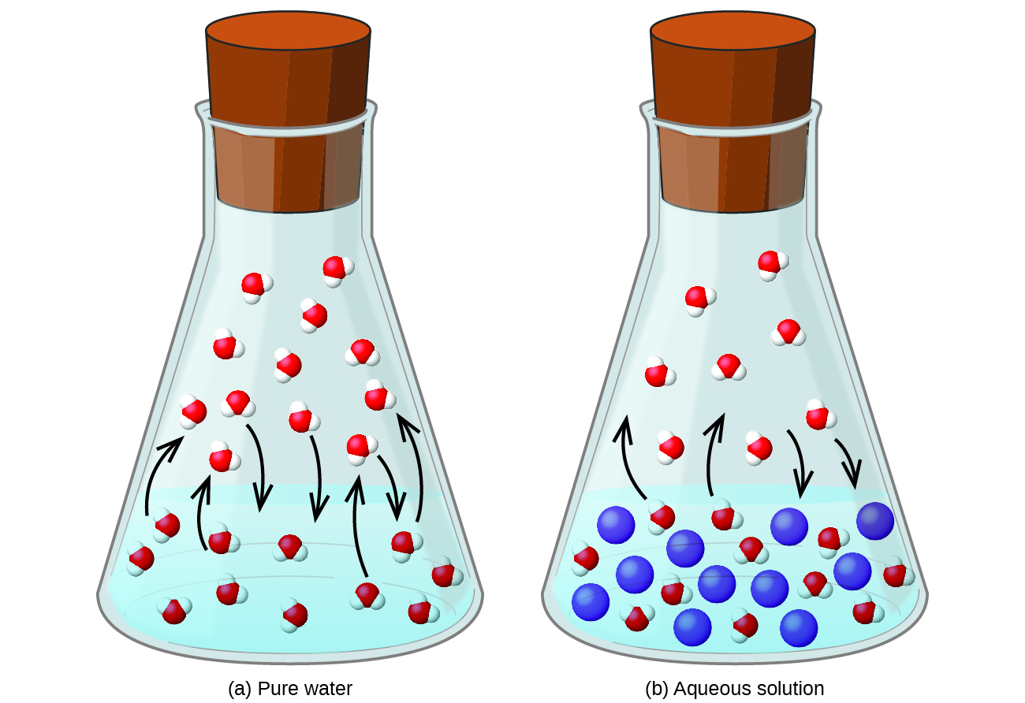
Figure 11.23 The presence of nonvolatile solutes lowers the vapor pressure of a solution by impeding the evaporation of solvent molecules.

The relationship between the vapor pressures of solution components and the concentrations of those components is described by Raoult’s law: The partial pressure exerted by any component of an ideal solution is equal to the vapor pressure of the pure component multiplied by its mole fraction in the solution.
P_{A} = X_{A}· P_{A}*
where P_{A} is the partial pressure exerted by component A in the solution, P_{A}* is the vapor pressure of pure A, and X_{A} is the mole fraction of A in the solution.
Recalling that the total pressure of a gaseous mixture is equal to the sum of partial pressures for all its components (Dalton’s law of partial pressures), the total vapor pressure exerted by a solution containing i components is
P_{solution} = ∑_{i} P_{i} = ∑_{i} X_{i} P*_{i}
A nonvolatile substance is one whose vapor pressure is negligible (P* ≈ 0), and so the vapor pressure above a solution containing only nonvolatile solutes is due only to the solvent:
P_{solution} = X_{solvent} · P* _{solvent}

Example 11.14
Calculation of a Vapor Pressure
Compute the vapor pressure of an ideal solution containing 92.1 g of glycerin, C₃H₅(OH)₃, and 184.4 g of ethanol, C₂H₅OH, at 40 °C. The vapor pressure of pure ethanol is 0.178 atm at 40 °C. Glycerin is essentially nonvolatile at this temperature.

Solution
Since the solvent is the only volatile component of this solution, its vapor pressure may be computed per Raoult’s law as:
P_{solution} = X_{solvent} · P* _{solvent}
First, calculate the molar amounts of each solution component using the provided mass data.
mol glycerin = 92.1 g C₃H₅(OH)₃ $×\frac{1 mol{ C}_{3}H_{5}{(OH)}_{3}}{92.094 g C_{3}H_{5}{(OH)}_{3}}$ = 1.00 mol mol
mol ethanol = 184.4 g C₂H₅OH $×\frac{1 mol{ C}_{2}H_{5}{OH}_{}}{46.069 g C_{2}H_{5}{OH}_{}}$ = 4.00 mol mol
Next, calculate the mole fraction of the solvent (ethanol) and use Raoult’s law to compute the solution’s vapor pressure.

X_{ethanol} = $\frac{4.00 mol { C}_{2}H_{5}{OH}_{} }{(4.00 + 1.00) mol total}$ = 0.800

P_{solution} = X_{solvent} · P* _{solvent} = (0.800) (0.178 atm) = 0.142 atm

Check Your Learning
A solution contains 5.00 g of urea, CO(NH₂)₂ (a nonvolatile solute) and 0.100 kg of water. If the vapor pressure of pure water at 25 °C is 23.7 torr, what is the vapor pressure of the solution assuming ideal behavior?

Answer: 23.4 torr

Distillation of Solutions
Solutions whose components have significantly different vapor pressures may be separated by a selective vaporization process known as distillation. Consider the simple case of a mixture of two volatile liquids, A and B, with A being the more volatile liquid. Raoult’s law can be used to show that the vapor above the solution is enriched in component A, that is, the mole fraction of A in the vapor is greater than the mole fraction of A in the liquid (see end-of-chapter Exercise 65). By appropriately heating the mixture, component A may be vaporized, condensed, and collected—effectively separating it from component B.
Distillation is widely applied in both laboratory and industrial settings, being used to refine petroleum, to isolate fermentation products, and to purify water. A typical apparatus for laboratory-scale distillations is shown in Figure 11.24.
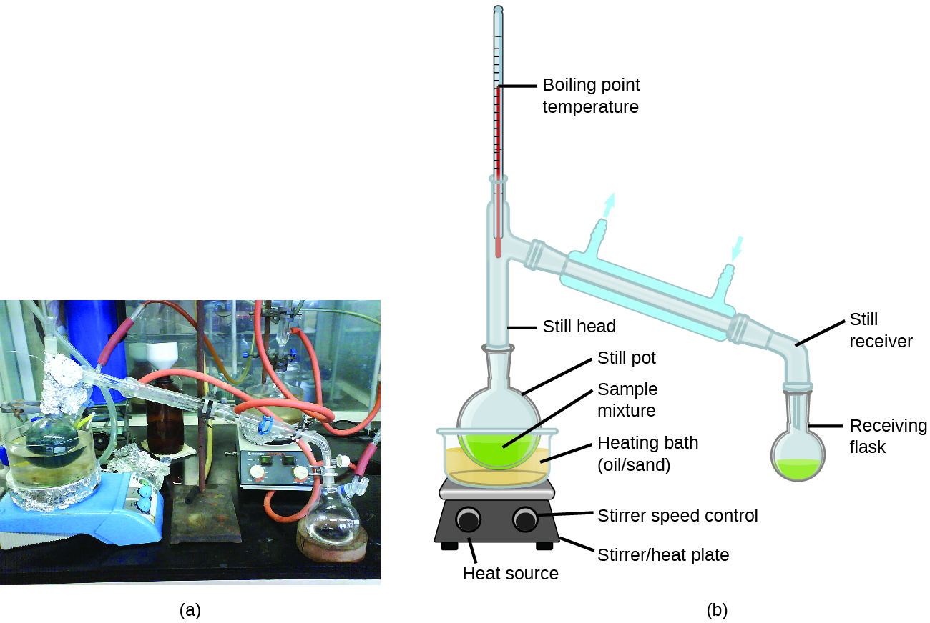
Figure 11.24 A typical laboratory distillation unit is shown in (a) a photograph and (b) a schematic diagram of the components. (credit a: modification of work by “Rifleman82”/Wikimedia commons; credit b: modification of work by “Slashme”/Wikimedia Commons)
Oil refineries use large-scale fractional distillation to separate the components of crude oil. The crude oil is heated to high temperatures at the base of a tall fractionating column, vaporizing many of the components that rise within the column. As vaporized components reach adequately cool zones during their ascent, they condense and are collected. The collected liquids are simpler mixtures of hydrocarbons and other petroleum compounds that are of appropriate composition for various applications (e.g., diesel fuel, kerosene, gasoline), as depicted in Figure 11.25.

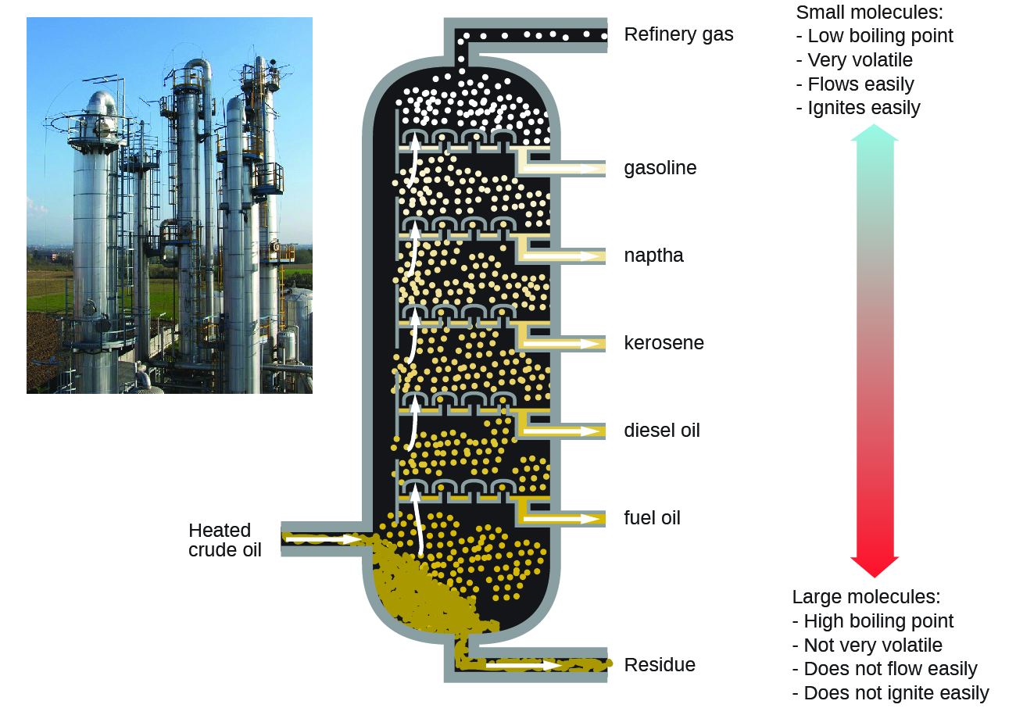

Figure 11.25 Crude oil is a complex mixture that is separated by large-scale fractional distillation to isolate various simpler mixtures.

Boiling Point Elevation
As described in the chapter on liquids and solids, the boiling point of a liquid is the temperature at which its vapor pressure is equal to ambient atmospheric pressure. Since the vapor pressure of a solution is lowered due to the presence of nonvolatile solutes, it stands to reason that the solution’s boiling point will subsequently be increased. Vapor pressure increases with temperature, and so a solution will require a higher temperature than will pure solvent to achieve any given vapor pressure, including one equivalent to that of the surrounding atmosphere. The increase in boiling point observed when nonvolatile solute is dissolved in a solvent, ΔT_{b}, is called boiling point elevation and is directly proportional to the molal concentration of solute species:
ΔT_{b} = K_{b}·m
where K_{b} is the boiling point elevation constant, or the ebullioscopic constant and m is the molal concentration (molality) of all solute species.
Boiling point elevation constants are characteristic properties that depend on the identity of the solvent. Values of K_{b} for several solvents are listed in Table 11.4.
Table 11.4 Boiling Point Elevation Constants for Several Solvents
Solvent | Boiling Point  (°C at 1 atm) | K_{b}  (ºC·m⁻¹)
water | 100.0 | 0.512
hydrogen acetate | 118.1 | 3.07
benzene | 80.1 | 2.53
chloroform | 61.26 | 3.63
nitrobenzene | 210.9 | 5.24

The extent to which the vapor pressure of a solvent is lowered and the boiling point is elevated depends on the total number of solute particles present in a given amount of solvent, not on the mass or size or chemical identities of the particles. A 1 m aqueous solution of sucrose (342 g/mol) and a 1 m aqueous solution of ethylene glycol (62 g/mol) will exhibit the same boiling point because each solution has one mole of solute particles (molecules) per kilogram of solvent.

Example 11.15

Calculating the Boiling Point of a Solution
Assuming ideal solution behavior, what is the boiling point of a 0.33 m solution of a nonvolatile solute in benzene?

Solution
Use the equation relating boiling point elevation to solute molality to solve this problem in two steps.
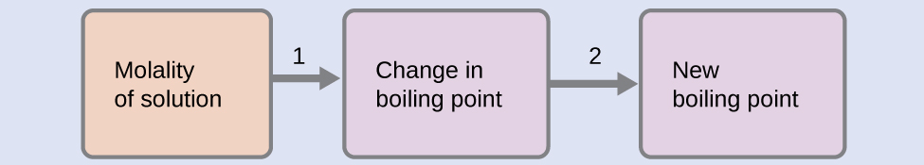
- Step 1. Calculate the change in boiling point.
ΔT_{b} = K_{b}·m = 2.53 ºC·m⁻¹ × 0.33 m = 0.83 ºC
- Step 2. Add the boiling point elevation to the pure solvent’s boiling point.
Boiling temperature = 80.1°C + 0.83°C = 80.9 °C

Check Your Learning
Assuming ideal solution behavior, what is the boiling point of the antifreeze described in Example 11.11?

Answer: 109.2 °C

Freezing Point Depression
Solutions freeze at lower temperatures than pure liquids. This phenomenon is exploited in “de-icing” schemes that use salt (Figure 11.26), calcium chloride, or urea to melt ice on roads and sidewalks, and in the use of ethylene glycol as an “antifreeze” in automobile radiators. Seawater freezes at a lower temperature than freshwater, and so the Arctic and Antarctic oceans remain unfrozen even at temperatures below 0 °C (as do the body fluids of fish and other cold-blooded sea animals that live in these oceans).
Figure 11.26 Rock salt (NaCl), calcium chloride (CaCl₂), or a mixture of the two are used to melt ice. (credit: modification of work by Eddie Welker)
The decrease in freezing point of a dilute solution compared to that of the pure solvent, ΔTf, is called the freezing point depression and is directly proportional to the molal concentration of the solute
ΔT_{f} = K_{f}·m
where m is the molal concentration of the solute and Kf is called the freezing point depression constant (or cryoscopic constant). Just as for boiling point elevation constants, these are characteristic properties whose values depend on the chemical identity of the solvent. Values of Kf for several solvents are listed in Table 11.5.
Table 11.5 Freezing Point Depression Constants for Several Solvents
Solvent | Freezing Point  (°C at 1 atm) | K_{f} (ºC·m⁻¹)
water | 0.0 | 1.86
hydrogen acetate | 16.6 | 3.9
benzene | 5.5 | 5.12
chloroform | −63.5 | 4.68
nitrobenzene | 5.67 | 8.1

Example 11.16
Calculation of the Freezing Point of a Solution
Assuming ideal solution behavior, what is the freezing point of the 0.33 m solution of a nonvolatile nonelectrolyte solute in benzene?

Solution
Use the equation relating freezing point depression to solute molality to solve this problem in two steps.
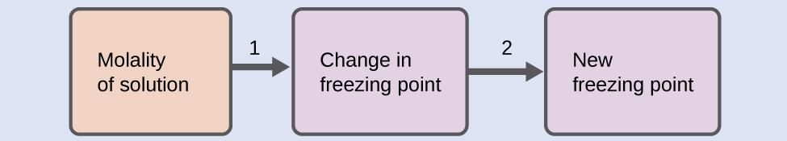
- Step 1. Calculate the change in freezing point.
ΔT_{f} = K_{f}·m = 5.12 ºC·m⁻¹ × 0.33 m = 1.7 ºC
- Step 2. Subtract the freezing point change observed from the pure solvent’s freezing point.
Freezing temperature = 5.5°C - 1.7°C = 3.8 °C

Check Your Learning
Assuming ideal solution behavior, what is the freezing point of a 1.85 m solution of a nonvolatile nonelectrolyte solute in nitrobenzene?

Answer:
−9.3 °C

Example 11.17
Determination of a Molar Mass from a Freezing Point Depression
A solution of 4.00 g of a nonelectrolyte dissolved in 55.0 g of benzene is found to freeze at 2.32 °C. Assuming ideal solution behavior, what is the molar mass of this compound?
Solution: Solve this problem using the following steps.
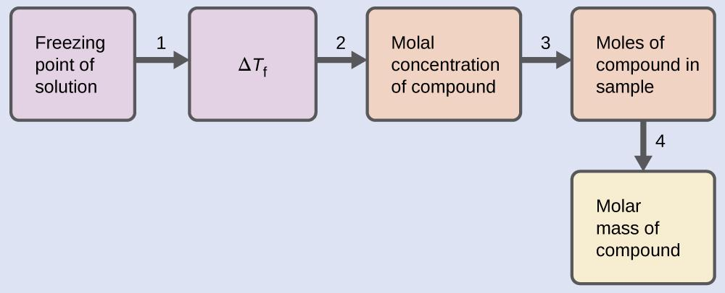
- Step 1. Determine the change in freezing point from the observed freezing point and the freezing point of pure benzene (Table 11.5).
ΔT_{f} = 5.5 °C − 2.32 °C = 3.2 °C
- Step 2. Determine the molal concentration from Kf, the freezing point depression constant for benzene (Table 11.5), and ΔT_{f}.
ΔT_{f} = K_{f}·m → m = $\frac{∆T_{f}}{K_{f}}$ = $\frac{3.2 ºC}{5.12 ºCm^{-1}}$ = 0.63 m
- Step 3. Determine the number of moles of compound in the solution from the molal concentration and the mass of solvent used to make the solution.
- mol solute = 0.0550 kg solvent $×\frac{0.63 mol solute}{1 kg solvent}$ = 0.035 mol solute
- Step 4. Determine the molar mass from the mass of the solute and the number of moles in that mass.
- Molar mass = $\frac{grams solute}{mol solute}$ = $\frac{4.00 g solute}{0.035 mol}$ = 1.1 × 10² g/mol

Check Your Learning
A solution of 35.7 g of a nonelectrolyte in 220.0 g of chloroform has a boiling point of
64.5 °C. Assuming ideal solution behavior, what is the molar mass of this compound? Answer: 1.8 × 10² g/mol

Chemistry in Everyday Life

Colligative Properties and De-Icing
Sodium chloride and its group 2 analogs calcium and magnesium chloride are often used to de-ice roadways and sidewalks, due to the fact that a solution of any one of these salts will have a freezing point lower than 0 °C, the freezing point of pure water. The group 2 metal salts are frequently mixed with the cheaper and more readily available sodium chloride (“rock salt”) for use on roads, since they tend to be somewhat less corrosive than NaCl, and they provide a larger depression of the freezing point, since they dissociate to yield three particles per formula unit, rather than two particles like the sodium chloride.
Because these ionic compounds tend to hasten the corrosion of metal, they would not be a wise choice to use in antifreeze for the radiator in your car or to de-ice a plane prior to takeoff. For these applications, covalent compounds, such as ethylene or propylene glycol, are often used. The glycols used in radiator fluid not only lower the freezing point of the liquid, but they elevate the boiling point, making the fluid useful in both winter and summer. Heated glycols are often sprayed onto the surface of airplanes prior to takeoff in inclement weather in the winter to remove ice that has already formed and prevent the formation of more ice, which would be particularly dangerous if formed on the control surfaces of the aircraft (Figure 11.27).

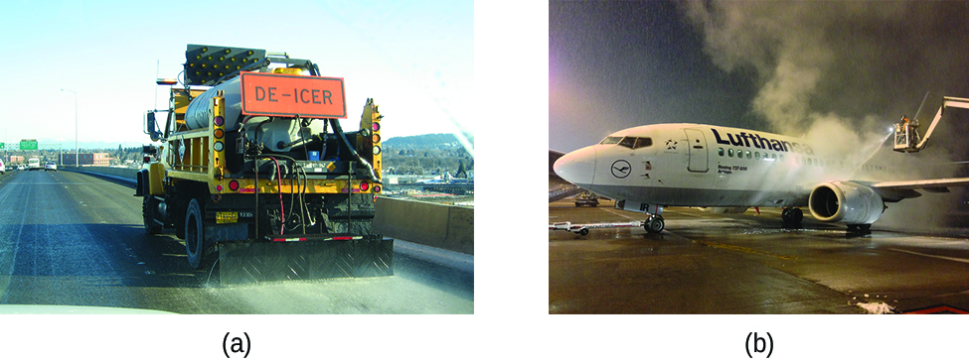
Figure 11.27 Freezing point depression is exploited to remove ice from (a) roadways and (b) the control surfaces of aircraft.

Osmosis and Osmotic Pressure of Solutions
A number of natural and synthetic materials exhibit selective permeation, meaning that only molecules or ions of a certain size, shape, polarity, charge, and so forth, are capable of passing through (permeating) the material. Biological cell membranes provide elegant examples of selective permeation in nature, while dialysis tubing used to remove metabolic wastes from blood is a more simplistic technological example. Regardless of how they may be fabricated, these materials are generally referred to as semipermeable membranes.
Consider the apparatus illustrated in Figure 11.28, in which samples of pure solvent and a solution are separated by a membrane that only solvent molecules may permeate. Solvent molecules will diffuse across the membrane in both directions. Since the concentration of solvent is greater in the pure solvent than the solution, these molecules will diffuse from the solvent side of the membrane to the solution side at a faster rate than they will in the reverse direction. The result is a net transfer of solvent molecules from the pure solvent to the solution. Diffusion-driven transfer of solvent molecules through a semipermeable membrane is a process known as osmosis.
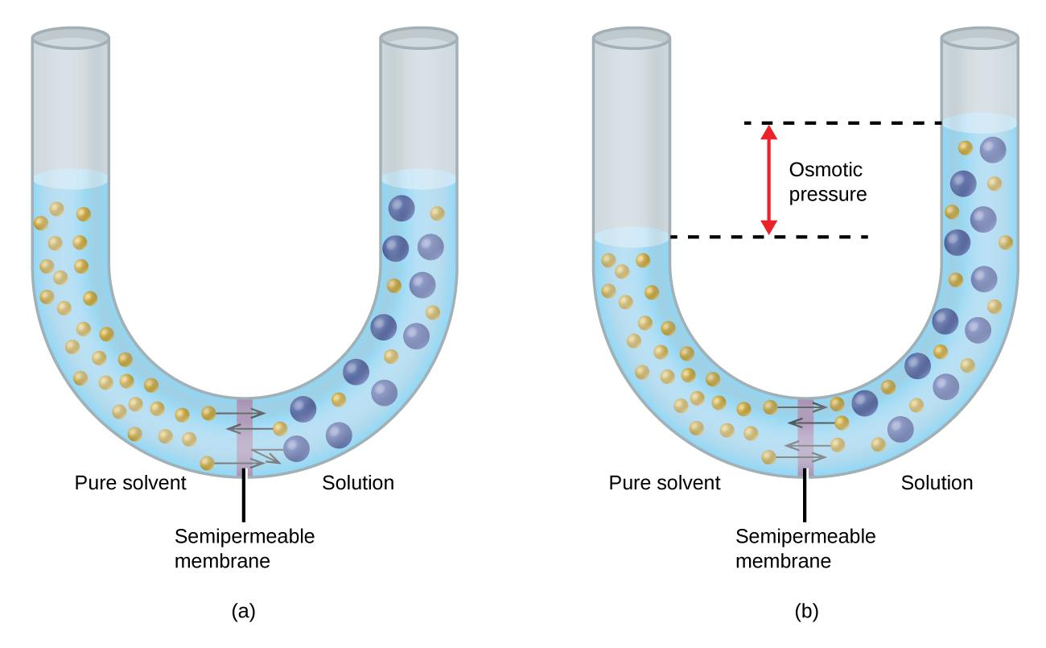
Figure 11.28 (a) A solution and pure solvent are initially separated by an osmotic membrane. (b) Net transfer of solvent molecules to the solution occurs until its osmotic pressure yields equal rates of transfer in both directions.
When osmosis is carried out in an apparatus like that shown in Figure 11.28, the volume of the solution increases as it becomes diluted by accumulation of solvent. This causes the level of the solution to rise, increasing its hydrostatic pressure (due to the weight of the column of solution in the tube) and resulting in a faster transfer of solvent molecules back to the pure solvent side. When the pressure reaches a value that yields a reverse solvent transfer rate equal to the osmosis rate, bulk transfer of solvent ceases. This pressure is called the osmotic pressure (Π) of the solution. The osmotic pressure of a dilute solution is related to its solute molarity, M, and absolute temperature, T, according to the equation
Π = MRT
where R is the universal gas constant (0.08206 atm·L/mol K).

Example 11.18
Calculation of Osmotic Pressure
Assuming ideal solution behavior, what is the osmotic pressure (atm) of a 0.30 M solution of glucose in water that is used for intravenous infusion at body temperature, 37 °C?

Solution: Find the osmotic pressure, Π, using the formula Π = MRT, where T is on the Kelvin scale (310 K) and the value of R is expressed in appropriate units (0.08206 L atm/mol K).

Π = MRT = 0.03 mol/L × 0.08206 L atm/mol K × 310 K = 7.6 atm

Check Your Learning
Assuming ideal solution behavior, what is the osmotic pressure (atm) a solution with a volume of 0.750 L that contains 5.0 g of methanol, CH₃OH, in water at 37 °C?

Answer: 5.3 atm

Example 11.19
Determination of a Molar Mass from Osmotic Pressure
A 0.500 L sample of an aqueous solution containing 10.0 g of hemoglobin has an osmotic pressure of 5.9 torr at 22 °C. Assuming ideal solution behavior, what is the molar mass of hemoglobin?

Solution: Here is one set of steps that can be used to solve the problem:
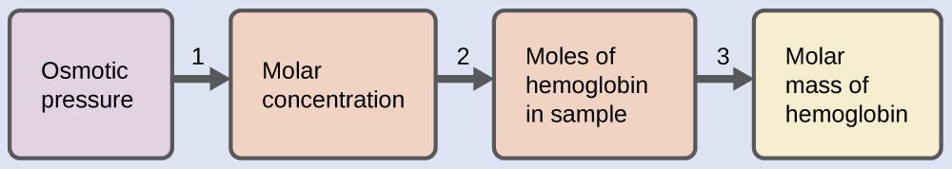
- Step 1. Convert the osmotic pressure to atmospheres, then determine the molar concentration from the osmotic pressure.
- Π = 5.9 torr × $\frac{1 atm}{760 torr}$ = 7.8 × 10⁻³ atm
- Π = MRT → M = $\frac{Π}{RT}$ = $\frac{7.8 × 10^{-3}atm}{(0.08206 L·atm·mol^{-1}K^{-1})(295 K)}$ = 3.2 x 10⁻⁴ M
- Step 2. Determine the number of moles of hemoglobin in the solution from the concentration and the volume of the solution.
- mol hemoglobin = 0.500 L solution$×\frac{3.2 ×{10}^{-4} mol hemoglobin}{1 L solution}$= 1.6 x 10⁻⁴ mol
- Step 3. Determine the molar mass from the mass of hemoglobin and the number of moles in that mass.
- Molar mass = $\frac{grams solute}{mol solute}$ = $\frac{10.0 g}{1.6 × {10}^{-4} mol}$ = 6.2 × 10⁴ g/mol

Check Your Learning
Assuming ideal solution behavior, what is the molar mass of a protein if a solution of 0.02 g of the protein in 25.0 mL of solution has an osmotic pressure of 0.56 torr at 25 °C?

Answer: 3 × 10⁴ g/mol

Examples of osmosis are evident in many biological systems because cells are surrounded by semipermeable membranes. Carrots and celery that have become limp because they have lost water can be made crisp again by placing them in water. Water moves into the carrot or celery cells by osmosis. A cucumber placed in a concentrated salt solution loses water by osmosis and absorbs some salt to become a pickle. Osmosis can also affect animal cells. Solute concentrations are particularly important when solutions are injected into the body. Solutes in body cell fluids and blood serum give these solutions an osmotic pressure of approximately 7.7 atm. Solutions injected into the body must have the same osmotic pressure as blood serum; that is, they should be isotonic with blood serum. If a less concentrated solution, a hypotonic solution, is injected in sufficient quantity to dilute the blood serum, water from the diluted serum passes into the blood cells by osmosis, causing the cells to expand and rupture. This process is called hemolysis. When a more concentrated solution, a hypertonic solution, is injected, the cells lose water to the more concentrated solution, shrivel, and possibly die in a process called crenation. These effects are illustrated in Figure 11.29.
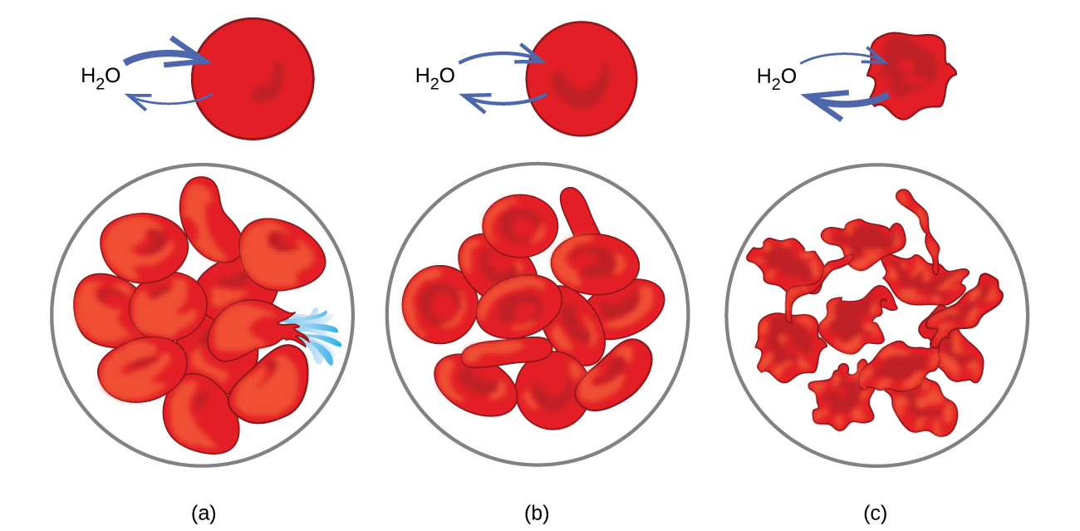
Figure 11.29 Red blood cell membranes are water permeable and will (a) swell and possibly rupture in a hypotonic solution; (b) maintain normal volume and shape in an isotonic solution; and (c) shrivel and possibly die in a hypertonic solution. (credit a/b/c: modifications of work by “LadyofHats”/Wikimedia commons)
If a solution is placed in an apparatus like the one shown in Figure 11.30, applying pressure greater than the osmotic pressure of the solution reverses the osmosis and pushes solvent molecules from the solution into the pure solvent. This technique of reverse osmosis is used for large-scale desalination of seawater and on smaller scales to produce high-purity tap water for drinking.

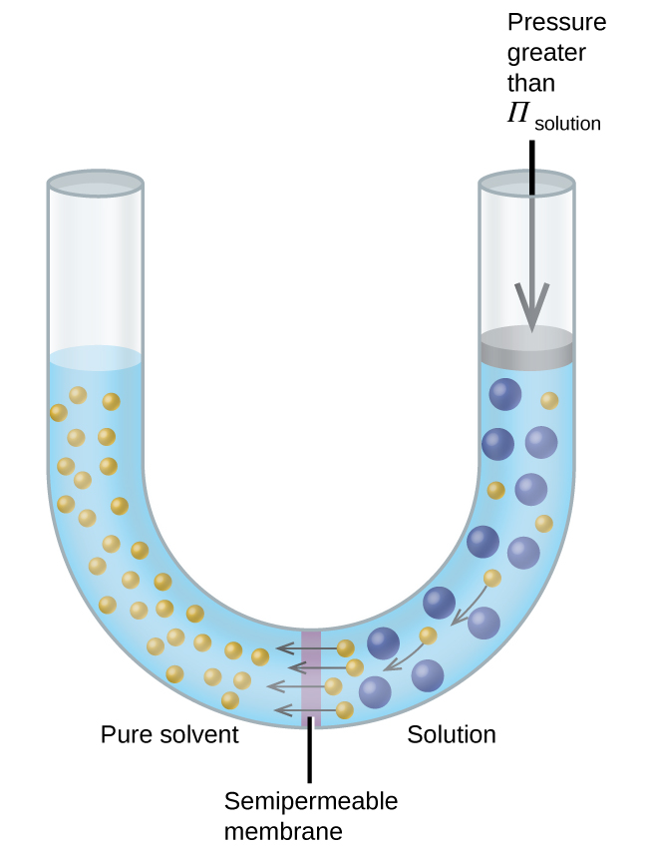

Figure 11.30 Applying a pressure greater than the osmotic pressure of a solution will reverse osmosis. Solvent molecules from the solution are pushed into the pure solvent.

Chemistry in Everyday Life

Reverse Osmosis Water Purification
In the process of osmosis, diffusion serves to move water through a semipermeable membrane from a less concentrated solution to a more concentrated solution. Osmotic pressure is the amount of pressure that must be applied to the more concentrated solution to cause osmosis to stop. If greater pressure is applied, the water will go from the more concentrated solution to a less concentrated (more pure) solution. This is called reverse osmosis. Reverse osmosis (RO) is used to purify water in many applications, from desalination plants in coastal cities, to water-purifying machines in grocery stores (Figure 11.31), and smaller reverse-osmosis household units. With a hand-operated pump, small RO units can be used in third-world countries, disaster areas, and in lifeboats. Our military forces have a variety of generator-operated RO units that can be transported in vehicles to remote locations.
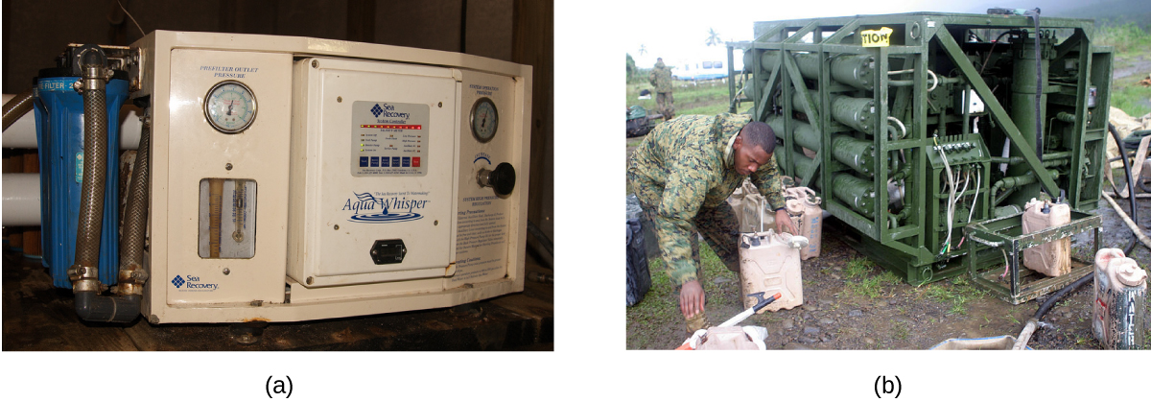
Figure 11.31 Reverse osmosis systems for purifying drinking water are shown here on (a) small and (b) large scales. (credit a: modification of work by Jerry Kirkhart; credit b: modification of work by Willard J. Lathrop)

Colligative Properties of Electrolytes
As noted previously in this module, colligative properties of a solution depend only on the number, not on the identity, of solute species dissolved. The concentration terms in the equations for various colligative properties (freezing point depression, boiling point elevation, osmotic pressure) pertain to all solute species present in the solution. For the solutions considered thus far in this chapter, the solutes have been nonelectrolytes that dissolve physically without dissociation or any other accompanying process. Each molecule that dissolves yields one dissolved solute molecule.
On the other hand, the dissolution of an electrolyte is not this simple, as illustrated by the two common examples below:
Dissociation: NaCl (s) → Na⁺ (aq) + Cl⁻ (aq)
Ionization: HCl (aq) + H₂O (l) → Cl⁻ (aq) + H₃O⁺ (aq)
Considering the first of these examples, and assuming complete dissociation, a 1.0 m aqueous solution of NaCl contains 2.0 mole of ions (1.0 mol Na⁺ and 1.0 mol Cl⁻) per each kilogram of water, and its freezing point depression is expected to be
ΔT_{f} = (2.0 mol ions/kg water) × (1.86°C kg water/mol ion) = 3.7°C.
When this solution is actually prepared and its freezing point depression measured, however, a value of 3.4 °C is obtained. Similar discrepancies are observed for other ionic compounds, and the differences between the measured and expected colligative property values typically become more significant as solute concentrations increase. These observations suggest that the ions of sodium chloride (and other strong electrolytes) are not completely dissociated in solution.
To account for this and avoid the errors accompanying the assumption of total dissociation, an experimentally measured parameter named in honor of Nobel Prize-winning German chemist Jacobus Henricus van’t Hoff is used. The van’t Hoff factor (i) is defined as the ratio of solute particles in solution to the number of formula units dissolved:
i = moles of particles in solution $÷$moles of formula units dissolved
Values for measured van’t Hoff factors for several solutes, along with predicted values assuming complete dissociation, are shown in Table 11.6.
Table 11.6 Predicted and Measured van’t Hoff Factors for Several 0.050 m Aqueous Solutions
Formula unit | Classification | Dissolution products | i (predicted) | i (measured)
C₁₂H₂₂O₁₁ (glucose) | Nonelectrolyte | C₁₂H₂₂O₁₁ | 1 | 1.0
NaCl | Strong electrolyte | Na⁺, Cl⁻ | 2 | 1.9
HCl | Strong electrolyte (acid) | H₃O⁺, Cl⁻ | 2 | 1.9
MgSO₄ | Strong electrolyte | Mg²⁺, SO₄²⁻, | 2 | 1.3
MgCl₂ | Strong electrolyte | Mg²⁺, 2 Cl⁻ | 3 | 2.7
FeCl₃ | Strong electrolyte | Fe³⁺, 3 Cl⁻ | 4 | 3.4
In 1923, the chemists Peter Debye and Erich Hückel proposed a theory to explain the apparent incomplete ionization of strong electrolytes. They suggested that although interionic attraction in an aqueous solution is very greatly reduced by solvation of the ions and the insulating action of the polar solvent, it is not completely nullified. The residual attractions prevent the ions from behaving as totally independent particles (Figure 11.32). In some cases, a positive and negative ion may actually touch, giving a solvated unit called an ion pair. Thus, the activity, or the effective concentration, of any particular kind of ion is less than that indicated by the actual concentration. Ions become more and more widely separated the more dilute the solution, and the residual interionic attractions become less and less. Thus, in extremely dilute solutions, the effective concentrations of the ions (their activities) are essentially equal to the actual concentrations. Note that the van’t Hoff factors for the electrolytes in Table 11.6 are for 0.05 m solutions, at which concentration the value of i for NaCl is 1.9, as opposed to an ideal value of 2.

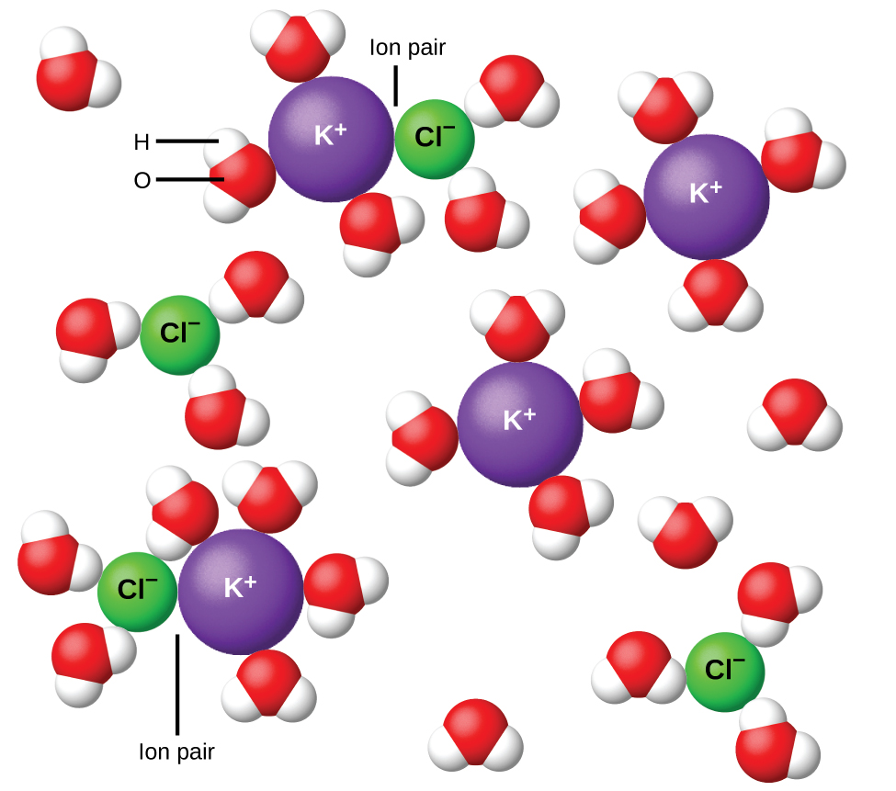

Figure 11.32 Dissociation of ionic compounds in water is not always complete due to the formation of ion pairs.

Example 11.20
The Freezing Point of a Solution of an Electrolyte
The concentration of ions in seawater is approximately the same as that in a solution containing 4.2 g of NaCl dissolved in 125 g of water. Use this information and a predicted value for the van’t Hoff factor (Table 11.6) to determine the freezing temperature the solution (assume ideal solution behavior).

Solution: Solve this problem using the following series of steps.

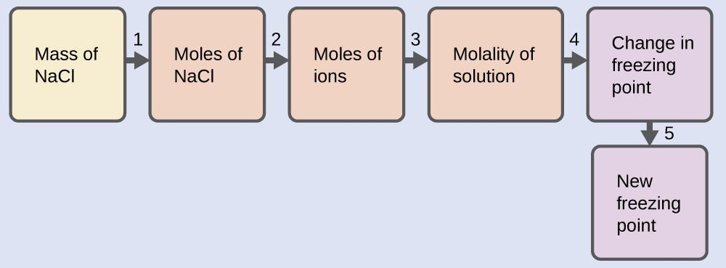

- Step 1. Convert from grams to moles of NaCl using the molar mass of NaCl in the unit conversion factor.
Result: 0.072 mol NaCl
- Step 2. Determine the number of moles of ions present in the solution using the number of moles of ions in 1 mole of NaCl as the conversion factor (2 mol ions/1 mol NaCl).
Result: 0.14 mol ions
- Step 3. Determine the molality of the ions in the solution from the number of moles of ions and the mass of solvent, in kilograms.
Result: 1.2 m
- Step 4. Use the direct proportionality between the change in freezing point and molal concentration to determine how much the freezing point changes.
Result: 2.1 °C
- Step 5. Determine the new freezing point from the freezing point of the pure solvent and the change.
Result: −2.1 °C
- Check each result as a self-assessment, taking care to avoid rounding errors by retaining guard digits in each step’s result for computing the next step’s result.

Check Your Learning
Assuming complete dissociation and ideal solution behavior, calculate the freezing point of a solution of 0.724 g of CaCl₂ in 175 g of water.
Answer: −0.208 °C

Chapter 12 – Attributions
The contents in this chapter, licensed under CC BY-NC-SA 4.0. has been adopted, modified, reorganized, and/or remixed from the following:

12.0 Introduction
"12 Introduction" by Paul Flowers, Klaus Theopold, Richard Langley, William R. Robinson,, OpenStax is licensed under CC BY 4.0

12.1 Chemical Reaction Rate
"12.1 Chemical Reaction Rates" by Paul Flowers, Klaus Theopold, Richard Langley, William R. Robinson,, OpenStax is licensed under CC BY 4.0

12.2 Factors Affecting Reaction Rate
"12.2 Factors Affecting Reaction Rates" by Paul Flowers, Klaus Theopold, Richard Langley, William R. Robinson,, OpenStaxis licensed under CC BY 4.0

12.3 Collision Theory
"12.5 Collision Theory" by Paul Flowers, Klaus Theopold, Richard Langley, William R. Robinson,, OpenStax is licensed under CC BY 4.0

12.4 Differential Rate Laws
"12.3 Rate Laws" by Paul Flowers, Klaus Theopold, Richard Langley, William R. Robinson,, OpenStax is licensed under CC BY 4.0

12.5 Integrated Rate Laws
"12.4 Integrated Rate Laws" by Paul Flowers, Klaus Theopold, Richard Langley, William R. Robinson,, OpenStax is licensed under CC BY 4.0

12.6 Reaction Mechanisms
"15.6: Reaction Mechanisms"LibreTexts is licensed under CC BY-NC-SA 3.0
"12.7 Catalysis" by Paul Flowers, Klaus Theopold, Richard Langley, William R. Robinson,, OpenStax is licensed under CC BY 4.0
BLANK PAGE

Chapter 12 Chemical Kinetics

Chapter Introduction

12.1 Chemical Reaction Rate

12.2 Factors Affecting Reaction Rate

12.3 Collision Theory

12.4 Differential Rate Laws

12.5 Integrated Rate Laws

12.6 Reaction Mechanisms

Figure 12.1 An agama lizard basks in the sun. As its body warms, the chemical reactions of its metabolism speed up.
The lizard in the photograph is not simply enjoying the sunshine or working on its tan. The heat from the sun’s rays is critical to the lizard’s survival. A warm lizard can move faster than a cold one because the chemical reactions that allow its muscles to move occur more rapidly at higher temperatures. A cold lizard is a slower lizard and an easier meal for predators.
From baking a cake to determining the useful lifespan of a bridge, rates of chemical reactions play important roles in our understanding of processes that involve chemical changes. Two questions are typically posed when planning to carry out a chemical reaction. The first is: “Will the reaction produce the desired products in useful quantities?” The second question is: “How rapidly will the reaction occur?” A third question is often asked when investigating reactions in greater detail: “What specific molecular-level processes take place as the reaction occurs?” Knowing the answer to this question is of practical importance when the yield or rate of a reaction needs to be controlled.
The study of chemical kinetics concerns the second and third questions—that is, the rate at which a reaction yields products and the molecular-scale means by which a reaction occurs. This chapter examines the factors that influence the rates of chemical reactions, the mechanisms by which reactions proceed, and the quantitative techniques used to describe the rates at which reactions occur.

12.1 Chemical Reaction Rate

Learning Objectives
- Define chemical reaction rate
- Derive rate expressions from the balanced equation for a given chemical reaction
- Calculate reaction rates from experimental data

Introduction
A rate is a measure of how some property varies with time. Speed is a familiar rate that expresses the distance traveled by an object in a given amount of time. Wage is a rate that represents the amount of money earned by a person working for a given amount of time. Likewise, the rate of a chemical reaction is a measure of how much reactant is consumed, or how much product is produced by the reaction in a given amount of time.

Reaction Rate and The Rate Expression
The rate of reaction is the change in the amount of a reactant or product per unit time. Reaction rates are therefore determined by measuring the time dependence of some property that can be related to reactant or product amounts. Rates of reactions that consume or produce gaseous substances, for example, are conveniently determined by measuring changes in volume or pressure. For reactions involving one or more colored substances, rates may be monitored via measurements of light absorption. For reactions involving aqueous electrolytes, rates may be measured via changes in a solution’s conductivity.
For reactants and products in solution, their relative amounts (concentrations) are conveniently used for purposes of expressing reaction rates. For example, the concentration of hydrogen peroxide, H₂O₂, in an aqueous solution changes slowly over time as it decomposes according to the equation:
2 H₂O₂ (aq) ⟶ 2 H₂O (l) + O₂ (g)
The rate at which the hydrogen peroxide decomposes can be expressed in terms of the rate of change of its concentration, as shown here:
Rate of decomposition of H₂O₂ = −$\frac{change in concentration of reactant}{time interval}$
= − $\frac{{[H_{2}O_{2}]}_{t_{2}}-{ [H_{2}O_{2}]}_{t_{1}}}{t_{2} - t_{1}}$
= − $\frac{{∆ [H_{2}O_{2}]}_{ }}{∆ t}$
This mathematical representation of the change in species concentration over time is the rate expression for the reaction. The brackets indicate molar concentrations, and the symbol delta (Δ) indicates “change in.” Thus, [H₂O₂]$t_{1}$ represents the molar concentration of hydrogen peroxide at some time t₁. Likewise, [H₂O₂]$t_{2}$ represents the molar concentration of hydrogen peroxide at a later time t_{2.} Δ[H₂O₂] represents the change in molar concentration of hydrogen peroxide during the time interval Δt (that is, t₂− t₁). Since the reactant concentration decreases as the reaction proceeds, Δ[H₂O₂] is a negative quantity. Reaction rates are, by convention, positive quantities, and so this negative change in concentration is multiplied by −1. Figure 12.2 provides an example of data collected during the decomposition of H₂O₂.
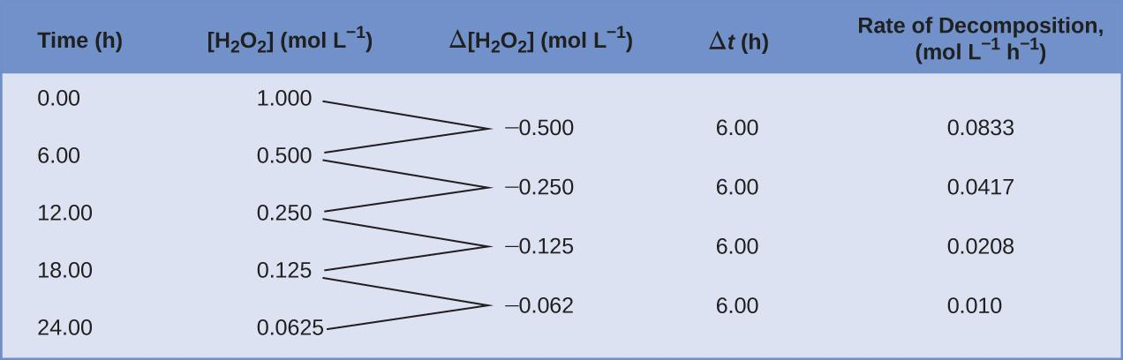
Figure 12.2 The rate of decomposition of H₂O₂ in an aqueous solution decreases as the concentration of H₂O₂ decreases.
To obtain the tabulated results for this decomposition, the concentration of hydrogen peroxide was measured every 6 hours over the course of a day at a constant temperature of 40 °C. Reaction rates were computed for each time interval by dividing the change in concentration by the corresponding time increment, as shown here for the first 6-hour period:
− $\frac{{∆ [H_{2}O_{2}]}_{ }}{∆ t}$ = − $\frac{(0.500 - 1.00 mol/L)}{(6.00 - 0.00 h)}$ = 0.0833 mol L⁻¹ h⁻¹
Notice that the reaction rates vary with time, decreasing as the reaction proceeds. Results for the last 6-hour period yield a reaction rate of:
− $\frac{{∆ [H_{2}O_{2}]}_{ }}{∆ t}$ = − $\frac{(0.0625 - 0.125 mol/L)}{(24.00 - 18.00 h)}$ = 0.0104 mol L⁻¹ h⁻¹
This behavior indicates the reaction continually slows with time.

Average Rate, Instantaneous Rate, and Initial Rate
Using the concentrations at the beginning and end of a time period over which the reaction rate is changing results in the calculation of an average rate for the reaction over this time interval.
At any specific time, the rate at which a reaction is proceeding is known as its instantaneous rate.
The instantaneous rate of a reaction at “time zero,” when the reaction commences, is its initial rate.
Consider the analogy of a car slowing down as it approaches a stop sign. The vehicle’s initial rate—analogous to the beginning of a chemical reaction—would be the speedometer reading at the moment the driver begins pressing the brakes (t₀).
A few moments later, the instantaneous rate at a specific moment—call it t₁—would be somewhat slower, as indicated by the speedometer reading at that point in time. As time passes, the instantaneous rate will continue to fall until it reaches zero, when the car (or reaction) stops.
Unlike instantaneous speed, the car’s average speed is not indicated by the speedometer; but it can be calculated as the ratio of the distance traveled to the time required to bring the vehicle to a complete stop (Δt). Like the decelerating car, the average rate of a chemical reaction will fall somewhere between its initial and final rates.
The instantaneous rate of a reaction may be determined one of two ways. If experimental conditions permit the measurement of concentration changes over very short time intervals, then average rates computed as described earlier provide reasonably good approximations of instantaneous rates. Alternatively, a graphical procedure may be used that, in effect, yields the results that would be obtained if short time interval measurements were possible.
In a plot of the concentration of hydrogen peroxide against time, the instantaneous rate of decomposition of H₂O₂ at any time t is given by the slope of a straight line that is tangent to the curve at that time (Figure 12.3). These tangent line slopes may be evaluated using calculus, but the procedure for doing so is beyond the scope of this chapter.
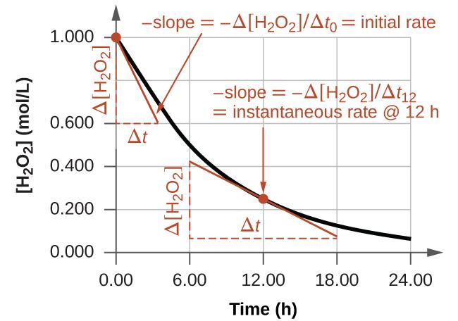
Figure 12.3 This graph shows a plot of concentration versus time for a 1.000 M solution of H₂O₂. The rate at any time is equal to the negative of the slope of a line tangent to the curve at that time. Tangents are shown at t = 0 h (“initial rate”) and at t = 12 h (“instantaneous rate” at 12 h).

Chemistry in Everyday Life

Reaction Rates in Analysis: Test Strips for Urinalysis
Physicians often use disposable test strips to measure the amounts of various substances in a patient’s urine (Figure 12.4). These test strips contain various chemical reagents, embedded in small pads at various locations along the strip, which undergo changes in color upon exposure to sufficient concentrations of specific substances. The usage instructions for test strips often stress that proper read time is critical for optimal results. This emphasis on read time suggests that kinetic aspects of the chemical reactions occurring on the test strip are important considerations.
The test for urinary glucose relies on a two-step process represented by the chemical equations shown here:
C₆H₁₂O₆ + O₂ → C₆H₁₀O₆ + H₂O₂
2 H₂O₂ + 2 I⁻ → I₂ + 2 H₂O + O₂
The first equation depicts the oxidation of glucose in the urine to yield gluconolactone and hydrogen peroxide. The hydrogen peroxide produced subsequently oxidizes colorless iodide ion to yield brown iodine, which may be visually detected. Some strips include an additional substance that reacts with iodine to produce a more distinct color change.
The two test reactions shown above are inherently very slow, but their rates are increased by special enzymes embedded in the test strip pad. This is an example of catalysis, a topic discussed later in this chapter. A typical glucose test strip for use with urine requires approximately 30 seconds for completion of the color-forming reactions. Reading the result too soon might lead one to conclude that the glucose concentration of the urine sample is lower than it actually is (a false-negative result). Waiting too long to assess the color change can lead to a false positive due to the slower (not catalyzed) oxidation of iodide ion by other substances found in urine.
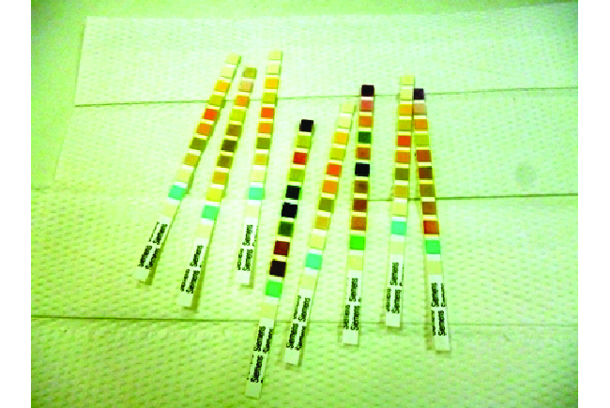

Figure 12.4 Test strips are commonly used to detect the presence of specific substances in a person’s urine. Many test strips have several pads containing various reagents to permit the detection of multiple substances on a single strip. (credit: Iqbal Osman)

Relative Rates of Reaction
The rate of a reaction may be expressed as the change in concentration of any reactant or product. For any given reaction, these rate expressions are all related simply to one another according to the reaction stoichiometry. The rate of the general reaction
a A ⟶ b B
can be expressed in terms of the decrease in the concentration of A or the increase in the concentration of B. These two rate expressions are related by the stoichiometry of the reaction:
Rate = − $\frac{{∆ [A]}_{ }}{a ∆ t}$ = + $\frac{{∆ [B]}_{ }}{b ∆ t}$
the reaction represented by the following equation:
2 NH₃ (g) ⟶ N₂ (g) + 3 H₂ (g)
The relation between the reaction rates expressed in terms of nitrogen production and ammonia consumption, for example, is:
− $\frac{{∆ mol NH_{3}}_{ }}{ ∆ t}×\frac{1 mol N_{2}}{2 mol NH_{3}}$ = + $\frac{∆ mol N_{2}}{ ∆ t}$
This may be represented in an abbreviated format by omitting the units of the stoichiometric factor:
− $\frac{{∆ mol NH_{3}}_{ }}{2 ∆ t}$ = + $\frac{∆ mol N_{2}}{ ∆ t}$
Note that a negative sign has been included as a factor to account for the opposite signs of the two amount changes (the reactant amount is decreasing while the product amount is increasing). For homogeneous reactions, both the reactants and products are present in the same solution and thus occupy the same volume, so the molar amounts may be replaced with molar concentrations:
− $\frac{{∆ [NH_{3}}_{ }]}{2 ∆ t}$ = + $\frac{∆ [N_{2}]}{ ∆ t}$
Similarly, the rate of formation of H₂ is three times the rate of formation of N₂ because three moles of H₂ are produced for each mole of N₂ produced.
+ $\frac{{∆ [H_{2}}_{ }]}{3 ∆ t}$ = + $\frac{∆ [N_{2}]}{ ∆ t}$
Figure 12.5 illustrates the change in concentrations over time for the decomposition of ammonia into nitrogen and hydrogen at 1100 °C. Slopes of the tangent lines at t = 500 s show that the instantaneous rates derived from all three species involved in the reaction are related by their stoichiometric factors. The rate of hydrogen production, for example, is observed to be three times greater than that for nitrogen production:
$\frac{2.91 × 10^{-6} M/s}{9.70 × {10}^{-7} M/s}$ = 3.00
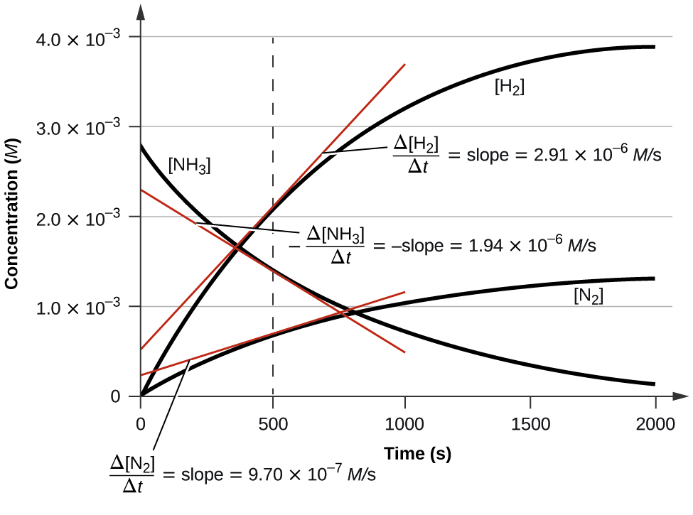
Figure 12.5 Changes in concentrations of the reactant and products for the reaction
2 NH₃ ⟶ N₂ + 3 H₂. The rates of change of the three concentrations are related by the reaction stoichiometry, as shown by the different slopes of the tangents at t = 500 s.

Example 12.1
Expressions for Relative Reaction Rates
The first step in the production of nitric acid is the combustion of ammonia:
4 NH₃ (g) + 5 O₂ (g) ⟶ 4 NO (g) + 6 H₂O (g)
Write the equations that relate the rates of consumption of the reactants and the rates of formation of the products.

Solution
Considering the stoichiometry of this homogeneous reaction, the rates for the consumption of reactants and formation of products are:

−$\frac{{∆ [NH_{3}}_{ }]}{4 ∆ t}$ = −$\frac{∆ [O_{2}]}{ 5 ∆ t}$ = +$\frac{∆ [NO]}{ 4 ∆ t}$ = +$\frac{∆ [H_{2}O]}{6 ∆ t}$

Check Your Learning
The rate of formation of Br₂ is 6.0 × 10⁻⁶ mol/L/s in a reaction described by the following net ionic equation:
5 Br⁻ + BrO₃⁻ + 6 H⁺ ⟶ 3 Br₂ + 3 H₂O
Write the equations that relate the rates of consumption of the reactants and the rates of formation of the products.
Answer:

−$\frac{{∆ [Br^{-}}_{ }]}{5 ∆ t}$ = −$\frac{∆ [BrO_{3}^{-}]}{∆ t}$ = −$\frac{∆ [H^{+}]}{ 6 ∆ t}$ = +$\frac{∆ [{Br}_{2}]}{3 ∆ t}$= +$\frac{∆ [H_{2}O]}{3 ∆ t}$

Example 12.2
Reaction Rate Expressions for Decomposition of H₂O₂
The graph in Figure 12.3 shows the rate of the decomposition of H₂O₂ over time:
2 H₂O₂ ⟶ 2 H₂O + O₂
Based on these data, the instantaneous rate of decomposition of H₂O₂ at t = 11.1 h is determined to be 3.20 × 10⁻² mol/L/h, that is:
−$\frac{{∆ [H_{2}O_{2}}_{ }]}{∆ t}$ = 3.20 x 10⁻² mol L⁻¹ h⁻¹
What is the instantaneous rate of production of H₂O and O₂?

Solution
The reaction stoichiometry shows that −$\frac{{∆ [{H_{2}O}_{2}}_{ }]}{2 ∆ t}$ = +$\frac{∆ [H_{2}O]}{2 ∆ t}$ = +$\frac{∆ [O_{2}]}{∆ t}$
Therefore:
$\frac{∆ [H_{2}O]}{∆ t}$ = −$\frac{{∆ [{H_{2}O}_{2}}_{ }]}{ ∆ t}$ = 3.20 x 10⁻² mol L⁻¹ h⁻¹
$\frac{∆ [O_{2}]}{∆ t}$ = $\frac{1}{2}$ $×$ 3.20 x 10⁻² mol L⁻¹ h⁻¹ = 1.60 x 10⁻² mol L⁻¹ h⁻¹

Check Your Learning
If the rate of decomposition of ammonia, NH₃, at 1150 K is 2.10 × 10⁻⁶ mol/L/s, what is the rate of production of nitrogen and hydrogen?
2 NH₃ (g) ⟶ N₂ (g) + 3 H₂ (g)

Answer: 1.05 × 10⁻⁶ mol/L/s for N₂ and 3.15 × 10⁻⁶ mol/L/s for H₂.

12.2 Factors Affecting Reaction Rate

Learning Objectives
- Describe the effects of chemical nature, physical state, temperature, concentration, and catalysis on reaction rates

Introduction
The rates at which reactants are consumed and products are formed during chemical reactions vary greatly. Five factors typically affecting the rates of chemical reactions will be explored in this section: the chemical nature of the reacting substances, the state of subdivision (one large lump versus many small particles) of the reactants, the temperature of the reactants, the concentration of the reactants, and the presence of a catalyst.

The Chemical Nature of the Reacting Substances
The rate of a reaction depends on the nature of the participating substances. Reactions that appear similar may have different rates under the same conditions, depending on the identity of the reactants. For example, when small pieces of the metals iron and sodium are exposed to air, the sodium reacts completely with air overnight, whereas the iron is barely affected. The active metals calcium and sodium both react with water to form hydrogen gas and a base. Yet calcium reacts at a moderate rate, whereas sodium reacts so rapidly that the reaction is almost explosive.

The Physical States of the Reactants
A chemical reaction between two or more substances requires intimate contact between the reactants. When reactants are in different physical states, or phases (solid, liquid, gaseous, dissolved), the reaction takes place only at the interface between the phases. Consider the heterogeneous reaction between a solid phase and either a liquid or gaseous phase. Compared with the reaction rate for large solid particles, the rate for smaller particles will be greater because the surface area in contact with the other reactant phase is greater. For example, large pieces of iron react more slowly with acids than they do with finely divided iron powder (Figure 12.6). Large pieces of wood smolder, smaller pieces burn rapidly, and saw dust burns explosively.
Figure 12.6 (a) Iron powder reacts rapidly with dilute hydrochloric acid and produces bubbles of hydrogen gas: 2 Fe (s) + 6 HCl (aq) ⟶ 2 FeCl₃ (aq) + 3 H₂ (g). (b) An iron nail reacts more slowly because the surface area exposed to the acid is much less.

Temperature of the Reactants
Chemical reactions typically occur faster at higher temperatures. Food can spoil quickly when left on the kitchen counter. However, the lower temperature inside of a refrigerator slows that process so that the same food remains fresh for days. Gas burners, hot plates, and ovens are often used in the laboratory to increase the speed of reactions that proceed slowly at ordinary temperatures. For many chemical processes, reaction rates are approximately doubled when the temperature is raised by 10 °C.

Concentrations of the Reactants
The rates of many reactions depend on the concentrations of the reactants. Rates usually increase when the concentration of one or more of the reactants increases. For example, calcium carbonate (CaCO₃) deteriorates as a result of its reaction with the pollutant sulfur dioxide. The rate of this reaction depends on the amount of sulfur dioxide in the air (Figure 12.7). An acidic oxide, sulfur dioxide combines with water vapor in the air to produce sulfurous acid in the following reaction:
SO₂ (g) + H₂O (g) ⟶ H₂SO₃ (aq)
Calcium carbonate reacts with sulfurous acid as follows:
CaCO₃ (s) + H₂SO₃ (aq) ⟶ CaSO₃ (aq) + CO₂ (g) + H₂O (l)
In a polluted atmosphere where the concentration of sulfur dioxide is high, calcium carbonate deteriorates more rapidly than in less polluted air. Similarly, phosphorus burns much more rapidly in an atmosphere of pure oxygen than in air, which is only about 20% oxygen.

Figure 12.7 Statues made from carbonate compounds such as limestone and marble typically weather slowly over time due to the actions of water, and thermal expansion and contraction. However, pollutants like sulfur dioxide can accelerate weathering. As the concentration of air pollutants increases, deterioration of limestone occurs more rapidly. (credit: James P Fisher III)

The Presence of a Catalyst
Relatively dilute aqueous solutions of hydrogen peroxide, H₂O₂, are commonly used as topical antiseptics. Hydrogen peroxide decomposes to yield water and oxygen gas according to the equation:
2 H₂O₂ (l) ⟶ 2 H₂O (l) + O₂ (g)
Under typical conditions, this decomposition occurs very slowly. When dilute H₂O₂ (aq) is poured onto an open wound, however, the reaction occurs rapidly and the solution foams because of the vigorous production of oxygen gas. This dramatic difference is caused by the presence of substances within the wound’s exposed tissues that accelerate the decomposition process. Substances that function to increase the rate of a reaction are called catalysts, a topic treated in greater detail later in this chapter.

12.3 Collision Theory

Learning Objectives
- Use the postulates of collision theory to explain the effects of physical state, temperature, and concentration on reaction rates
- Define the concepts of activation energy and transition state

Collision Theory
We should not be surprised that atoms, molecules, or ions must collide before they can react with each other. Atoms must be close together to form chemical bonds. This simple premise is the basis for a very powerful theory that explains many observations regarding chemical kinetics, including factors affecting reaction rates.
Collision theory is based on the following postulates:
- The rate of a reaction is proportional to the rate of reactant collisions:
reaction rate $∝$ $\frac{\# collisions }{time}$
- The reacting species must collide in an orientation that allows contact between the atoms that will become bonded together in the product.
- The collision must occur with adequate energy to permit mutual penetration of the reacting species’ valence shells so that the electrons can rearrange and form new bonds (and new chemical species).

We can see the importance of the two physical factors noted in postulates 2 and 3, the orientation and energy of collisions, when we consider the reaction of carbon monoxide with oxygen:
2 CO (g) + O₂ (g) ⟶ 2 CO₂ (g)
Carbon monoxide is a pollutant produced by the combustion of hydrocarbon fuels. To reduce this pollutant, automobiles have catalytic converters that use a catalyst to carry out this reaction. It is also a side reaction of the combustion of gunpowder that results in muzzle flash for many firearms. If carbon monoxide and oxygen are present in sufficient amounts, the reaction will occur at high temperature and pressure.
The first step in the gas-phase reaction between carbon monoxide and oxygen is a collision between the two molecules:
CO (g) + O₂ (g) ⟶ CO₂ (g) + O (g)
Although there are many different possible orientations the two molecules can have relative to each other, consider the two presented in Figure 12.8. In the first case, the oxygen side of the carbon monoxide molecule collides with the oxygen molecule. In the second case, the carbon side of the carbon monoxide molecule collides with the oxygen molecule. The second case is clearly more likely to result in the formation of carbon dioxide, which has a central carbon atom bonded to two oxygen atoms (O=C=O).This is a rather simple example of how important the orientation of the collision is in terms of creating the desired product of the reaction.

Figure 12.8 Illustrated are two collisions that might take place between carbon monoxide and oxygen molecules. The orientation of the colliding molecules partially determines whether a reaction between the two molecules will occur.
If the collision does take place with the correct orientation, there is still no guarantee that the reaction will proceed to form carbon dioxide. In addition to a proper orientation, the collision must also occur with sufficient energy to result in product formation. When reactant species collide with both proper orientation and adequate energy, they combine to form an unstable species called an activated complex or transition state. These species are very short lived and usually undetectable by most analytical instruments. In some cases, sophisticated spectral measurements have been used to observe transition states.

Reaction Diagram and Activation Energy
The minimum energy necessary to form a product during a collision between reactants is called the activation energy (Ea). How this energy compares to the kinetic energy provided by colliding reactant molecules is a primary factor affecting the rate of a chemical reaction. If the activation energy is much larger than the average kinetic energy of the molecules, the reaction will occur slowly since only a few fast-moving molecules will have enough energy to react. If the activation energy is much smaller than the average kinetic energy of the molecules, a large fraction of molecules will be adequately energetic and the reaction will proceed rapidly. Figure 12.9 shows how the energy of a chemical system changes as it undergoes a reaction converting reactants to products according to the equation
A + B ⟶ C + D
These reaction diagrams are widely used in chemical kinetics to illustrate various properties of the reaction of interest. Viewing the diagram from left to right, the system initially comprises reactants only, A + B. Reactant molecules with sufficient energy can collide to form a high-energy activated complex or transition state. The unstable transition state can then subsequently decay to yield stable products, C + D. The diagram depicts the reaction's activation energy, Ea, as the energy difference between the reactants and the transition state. Using a specific energy, the enthalpy (see chapter on thermochemistry), the enthalpy change of the reaction, ΔH, is estimated as the energy difference between the reactants and products. In this case, the reaction is exothermic (ΔH < 0) since it yields a decrease in system enthalpy.
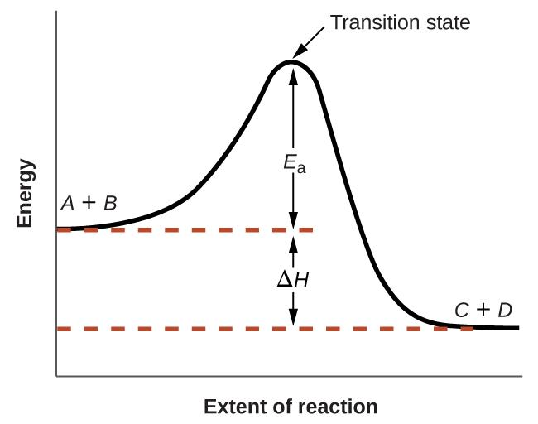
Figure 12.9 Reaction diagram for the exothermic reaction A + B ⟶ C + D.

Collision theory explains why most reaction rates increase as concentrations increase. With an increase in the concentration of any reacting substance, the chances for collisions between molecules are increased because there are more molecules per unit of volume. More collisions mean a faster reaction rate, assuming the energy of the collisions is adequate.
Collision theory also explains why reaction rates increase as temperatures increase.
At higher temperatures, molecules possess greater kinetic energy is sufficient to overcome the activation barrier (Ea). This yields a faster reaction rate.

A catalyst is a substance that increases the rate of a chemical reaction by lowering the activation energy without itself being consumed by the reaction. A catalyst increases the reaction rate by providing an alternative pathway or mechanism for the reaction to follow (Figure 12.10). Catalysis will be discussed in greater detail later in this chapter as it relates to mechanisms of reactions.
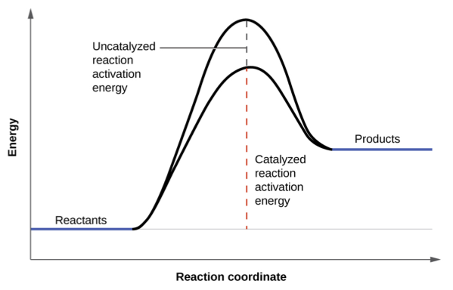
Figure 12.10 The presence of a catalyst increases the rate of a reaction by lowering its activation energy.

The Arrhenius Equation
Postulates of collision theory are nicely accommodated by the Arrhenius equation. The Arrhenius equation relates the activation energy and the rate constant, k, for many chemical reactions:
k = A$e^{-\frac{E_{a}}{RT}}$
In this equation, R is the ideal gas constant, which has a value 8.314 J/mol/K, T is temperature on the Kelvin scale, Ea is the activation energy in joules per mole, e is the constant 2.7183, and A is a constant called the frequency factor, which is related to the frequency of collisions and the orientation of the reacting molecules.
The frequency factor, A, reflects how well the reaction conditions favor properly oriented collisions between reactant molecules. An increased probability of effectively oriented collisions results in larger values for A and faster reaction rates.
The exponential term, $e^{-\frac{E_{a}}{RT}}$, describes the effect of activation energy on reaction rate. According to the kinetic molecular theory (see chapter on gases), the temperature of matter is a measure of the average kinetic energy of its constituent atoms or molecules. A lower activation energy results in a greater fraction of adequately energized molecules and a faster reaction.
The exponential term also describes the effect of temperature on reaction rate. A higher temperature represents a correspondingly greater fraction of molecules possessing sufficient energy (RT) to overcome the activation barrier (Ea). This yields a greater value for the rate constant and a correspondingly faster reaction rate.

12.4 Differential Rate Law

Learning Objectives
- Explain the form and function of a rate law
- Use rate laws to calculate reaction rates
- Use rate and concentration data to identify reaction orders and derive rate laws

Rate Laws, Rate Constant, and Reaction Orders
As described in the previous module, the rate of a reaction is often affected by the concentrations of reactants. Rate laws (sometimes called differential rate laws) or rate equations are mathematical expressions that describe the relationship between the rate of a chemical reaction and the concentration of its reactants. As an example, consider the reaction described by the chemical equation
a A + b B ⟶ products
where a and b are stoichiometric coefficients. The rate law for this reaction is written as:
Rate = k [A]^{m} [B]^{n}
in which [A] and [B] represent the molar concentrations of reactants, and k is the rate constant, which is specific for a particular reaction at a particular temperature. The exponents m and n are the reaction orders and are typically positive integers, though they can be fractions, negative, or zero.
The rate constant k and the reaction orders m and n must be determined experimentally by observing how the rate of a reaction changes as the concentrations of the reactants are changed. The rate constant k is independent of the reactant concentrations, but it does vary with temperature.
The reaction orders in a rate law describe the mathematical dependence of the rate on reactant concentrations. Referring to the generic rate law above, the reaction is m order with respect to A and n order with respect to B. For example, if m = 1 and n = 2, the reaction is first order in A and second order in B. The overall reaction order is simply the sum of orders for each reactant. For the example rate law here, the reaction is third order overall (1 + 2 = 3). A few specific examples are shown below to further illustrate this concept.
The rate law: Rate = k [H₂O₂]
describes a reaction that is first order in hydrogen peroxide and first order overall.
The rate law: Rate = k [C₄H₆]²
describes a reaction that is second order in C₄H₆ and second order overall.
The rate law: Rate = k [H⁺] [OH⁻]
describes a reaction that is first order in H⁺, first order in OH⁻, and second order overall.

Example 12.3
Writing Rate Laws from Reaction Orders
An experiment shows that the reaction of nitrogen dioxide with carbon monoxide:
NO₂ (g) + CO (g) ⟶ NO (g) + CO₂(g)
is second order in NO₂ and zero order in CO at 100 °C. What is the rate law for the reaction?
Solution The reaction will have the form: Rate = k [NO₂]^{m} [CO]^{n}
The reaction is second order in NO₂; thus m = 2.
The reaction is zero order in CO; thus n = 0.
The rate law is: Rate = k [NO₂]² [CO]⁰ = k [NO₂]²
Remember that a number raised to the zero power is equal to 1, thus [CO]⁰ = 1, which is why the CO concentration term may be omitted from the rate law: the rate of reaction is solely dependent on the concentration of NO₂. A later chapter section on reaction mechanisms will explain how a reactant’s concentration can have no effect on a reaction rate despite being involved in the reaction.

Check Your Learning
The rate law for the reaction: H₂ (g) + 2 NO (g) ⟶ N₂O (g) + H₂O (g)
has been determined to be rate = k [NO]²[H₂]. What are the orders with respect to each reactant, and what is the overall order of the reaction?
Answer:
Second order with respect to [NO]
First order with respect to [H₂]
The overall order is third order

Check Your Learning
In a transesterification reaction, a triglyceride reacts with an alcohol to form an ester and glycerol. Many students learn about the reaction between methanol (CH₃OH) and ethyl acetate (CH₃CH₂OCOCH₃) as a sample reaction before studying the chemical reactions that produce biodiesel:
CH₃OH + CH₃CH₂OCOCH₃ ⟶ CH₃OCOCH₃ + CH₃CH₂OH
The rate law for the reaction between methanol and ethyl acetate is, under certain conditions, determined to be: Rate = k [CH₃OH]
What is the order of reaction with respect to methanol and ethyl acetate, and what is the overall order of reaction?
Answer:
First order in CH₃OH
Zeroth order in CH₃CH₂OCOCH₃
The overall order is first order.
A common experimental approach to the determination of rate laws is the method of initial rates. This method involves measuring reaction rates for multiple experimental trials carried out using different initial reactant concentrations. Comparing the measured rates for these trials permits determination of the reaction orders and, subsequently, the rate constant, which together are used to formulate a rate law. This approach is illustrated in the next two example exercises.

Example 12.4
Determining a Rate Law from Initial Rates
Ozone in the upper atmosphere is depleted when it reacts with nitrogen oxides. The rates of the reactions of nitrogen oxides with ozone are important factors in deciding how significant these reactions are in the formation of the ozone hole over Antarctica (Figure 12.11). One such reaction is the combination of nitric oxide, NO, with ozone, O₃:
NO (g) + O₃ (g) ⟶ NO₂ (g) + O₂ (g)
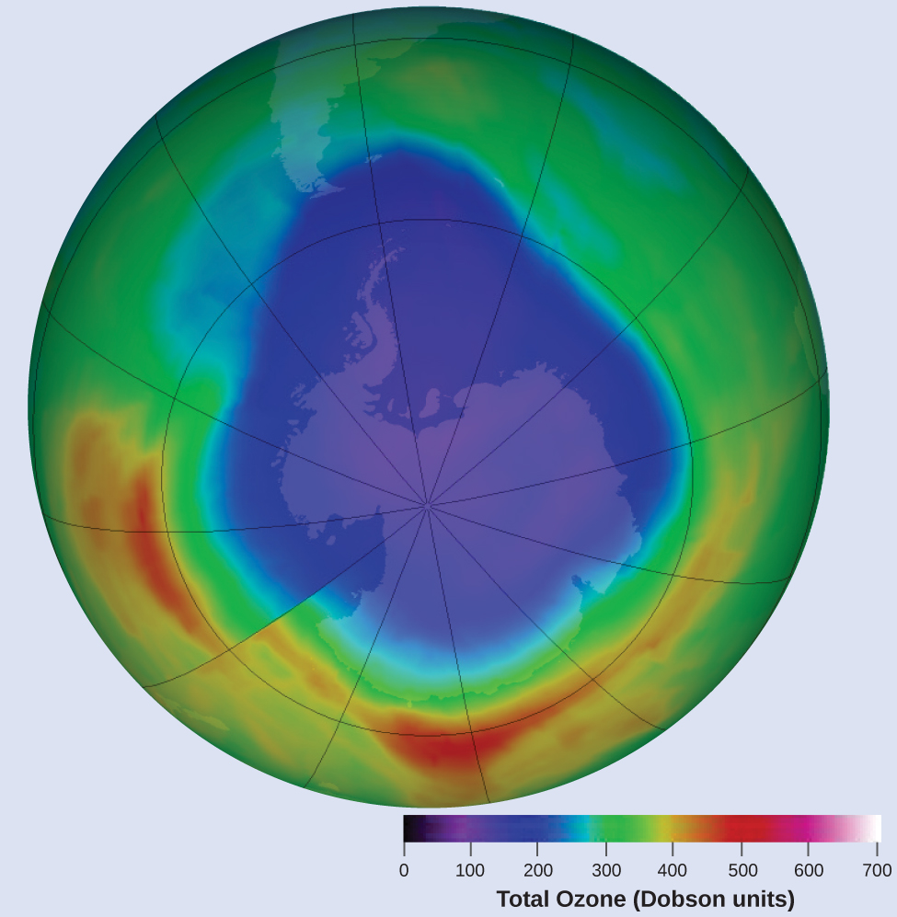
Figure 12.11 A contour map showing stratospheric ozone concentration and the “ozone hole” that occurs over Antarctica during its spring months. (credit: modification of work by NASA)

NO (g) + O₃ (g) ⟶ NO₂ (g) + O₂ (g)
This reaction has been studied in the laboratory, and the following rate data were determined at 25 °C.
Trial | [NO] (mol/L) | [O₃] (mol/L) | $\frac{Δ[NO_{2}]}{∆ t}$(mol L⁻¹s⁻¹)
1 | 1.00 × 10⁻⁶ | 3.00 × 10⁻⁶ | 6.60 × 10⁻⁵
2 | 1.00 × 10⁻⁶ | 6.00 × 10⁻⁶ | 1.32 × 10⁻⁴
3 | 1.00 × 10⁻⁶ | 9.00 × 10⁻⁶ | 1.98 × 10⁻⁴
4 | 2.00 × 10⁻⁶ | 9.00 × 10⁻⁶ | 3.96 × 10⁻⁴
5 | 3.00 × 10⁻⁶ | 9.00 × 10⁻⁶ | 5.94 × 10⁻⁴
Determine the rate law and the rate constant for the reaction at 25 °C.
Solution
The rate law will have the form: Rate = k [NO]^{m} [O₃]^{n}
Determine the values of m, n, and k from the experimental data using the following three-part process:
- Step 1. Determine m from the data in which [NO] varies and [O₃] is constant.
- In the last three experiments, [NO] varies while [O₃] remains constant. When [NO] doubles from trial 3 to 4, the rate doubles, and when [NO] triples from trial 3 to 5, the rate also triples. Thus, the rate is also directly proportional to [NO], and m in the rate law = 1.
- Step 2. Determine n from data in which [O₃] varies and [NO] is constant.
- In the first three experiments, [NO] is constant and [O₃] varies. The reaction rate changes in direct proportion to the change in [O₃]. When [O₃] doubles from trial 1 to 2, the rate doubles; when [O₃] triples from trial 1 to 3, the rate increases also triples. Thus, the rate is directly proportional to [O₃], and n is equal to 1.
- The rate law is thus: Rate = k [NO]¹ [O₃]¹ = k [NO] [O₃]
- Step 3. Determine the value of k from any set of concentrations and the corresponding rate. The data from trial 1 are used below:
k = $\frac{rate}{[NO][O_{3}]}$ = $\frac{6.60 × {10}^{-5}mol L^{-1}s^{-1}}{(1.00 × {10}^{-6}mol L^{-1})(3.00 × {10}^{-6}mol L^{-1})}$
= 2.20 × 10⁷ L mol⁻¹s⁻¹ or M⁻¹s⁻¹

Check Your Learning
Acetaldehyde decomposes when heated to yield methane and carbon monoxide according to the equation:
CH₃CHO (g) ⟶ CH₄ (g) + CO (g)
Determine the rate law and the rate constant for the reaction from the following experimental data:

Trial | [CH₃CHO] (mol/L) | $\frac{-Δ[CH_{3}CHO]}{∆ t}$(mol L⁻¹s⁻¹)
1 | 1.75 × 10⁻³ | 2.06 × 10⁻¹¹
2 | 3.50 × 10⁻³ | 8.24 × 10⁻¹¹
3 | 7.00 × 10⁻³ | 3.30 × 10⁻¹⁰

Answer: Rate = k [CH₃CHO]² with k = 6.73 × 10⁻⁶ M⁻¹ s⁻¹

Example 12.5
Determining Rate Laws from Initial Rates
Using the initial rates method and the experimental data, determine the rate law and the value of the rate constant for this reaction:
2 NO (g) + Cl₂ (g) ⟶ 2 NOCl (g)
Trial | [NO] (mol/L) | [Cl₂] (mol/L) | $\frac{-Δ[NO]}{∆ t}$(mol L⁻¹s⁻¹)
1 | 0.10 | 0.10 | 0.00300
2 | 0.10 | 0.15 | 0.00450
3 | 0.15 | 0.10 | 0.00675

Solution
The rate law for this reaction will have the form: Rate = k [NO]^{m} [Cl₂]^{n}
As in Example 12.4, approach this problem in a stepwise fashion, determining the values of m and n from the experimental data and then using these values to determine the value of k. In this example, however, an explicit algebraic approach (vs. the implicit approach of the previous example) will be used to determine the values of m and n:
- Step 1. Determine m value from the data in which [NO] varies and [Cl₂] is constant.
- Write the ratios with the subscripts x and y to indicate data from two different trials:
- $\frac{{Rate}_{x}}{{Rate}_{y}}$ = $\frac{k {[NO]}_{x}^{m} {[{Cl}_{2}]}_{x}^{n}}{k {[NO]}_{y}^{m} {[{Cl}_{2}]}_{y}^{n}}$
- Using the third trial and the first trial, in which [Cl₂] does not vary, gives:
- $\frac{{Rate}_{3}}{{Rate}_{1}}$ = $\frac{0.00675}{0.00300}$ = $\frac{k {[0.15]}_{ }^{m} {[0.10]}_{ }^{n}}{k {[0.10]}_{ }^{m} {[0.10]}_{ }^{n}}$
- Canceling equivalent terms in the numerator and denominator leaves:
- $\frac{0.00675}{0.00300}$ = $\frac{{[0.15]}_{ }^{m}}{{[0.10]}_{ }^{m}}$
- which simplifies to: 2.25 = [1.5]^{m}
- Use logarithms to determine the value of the exponent m:
log(2.25) = m log(1.5)
$\frac{log(2.25)}{log(1.5)}$ = m
2 = m
- Confirm the result [1.5]² = 2.25

- Step 2. Determine the value of n from data in which [Cl₂] varies and [NO] is constant.
- $\frac{{Rate}_{2}}{{Rate}_{1}}$ = $\frac{0.00450}{0.00300}$ = $\frac{k {[0.10]}_{ }^{m} {[0.15]}_{ }^{n}}{k {[0.10]}_{ }^{m} {[0.10]}_{ }^{n}}$
- Cancelation gives: $\frac{0.00450}{0.00300}$ = $\frac{{[0.15]}_{ }^{n}}{{[0.10]}_{ }^{n}}$
- which simplifies to: 1.5 = [1.5]^{n}
- Thus n must be 1, and the form of the rate law is: Rate = k [NO]^{m} [Cl₂]^{n} = k [NO]² [Cl₂]

- Step 3. Determine the numerical value of the rate constant k with appropriate units.
- The units for the rate of a reaction are mol/L/s or M/s. The units for k are whatever is needed so that substituting into the rate law expression affords the appropriate units for the rate. In this example, the concentration units are mol³/L³ or M³. The units for k should be mol⁻² L²/s or M⁻²S⁻¹ so that the rate is in terms of M/S.
- To determine the value of k once the rate law expression has been solved, simply plug in values from the first experimental trial and solve for k:
- 0.00300 M s⁻¹ = k (0.10 M)² (0.10 M)¹
k = 3.0 M⁻² s⁻¹ or mol⁻²L²s⁻¹

Check Your Learning
Use the provided initial rate data to derive the rate law for the reaction whose equation is:
OCl⁻ (aq) + I⁻ (aq) ⟶ OI⁻ (aq) + Cl⁻ (aq)
Trial | [OCl⁻] (mol/L) | [I⁻] (mol/L) | Initial Rate (M/s)
1 | 0.0040 | 0.0020 | 0.00184
2 | 0.0020 | 0.0040 | 0.00092
3 | 0.0020 | 0.0020 | 0.00046
Determine the rate law expression and the value of the rate constant k with appropriate units for this reaction.
Answer: Rate = k [OCl⁻]² [I⁻] k = 5.75 × 10⁴ M⁻² s⁻¹

Reaction Order and Rate Constant Units
In some of our examples, the reaction orders in the rate law happen to be the same as the coefficients in the chemical equation for the reaction. This is merely a coincidence and very often not the case.
Rate laws may exhibit fractional orders for some reactants, and negative reaction orders are sometimes observed when an increase in the concentration of one reactant causes a decrease in reaction rate. A few examples illustrating these points are provided:
NO₂ + CO ⟶ NO + CO₂ Rate = k [NO₂]²
CH₃CHO ⟶ CH₄ + CO Rate = k [CH₃CHO]²
2 N₂O₅ ⟶ NO₂ + O₂ Rate = k [N₂O₅]
2 NO₂ + F₂ ⟶ 2 NO₂F Rate = k [NO₂] [F₂]
2 NO₂Cl ⟶ 2 NO₂ + Cl₂ Rate = k [NO₂Cl]
It is important to note that rate laws are determined by experiment only and are not reliably predicted by reaction stoichiometry.
The units for a rate constant will vary as appropriate to accommodate the overall order of the reaction. The unit of the rate constant for the second-order reaction described in Example 12.4 was determined to be M⁻¹s⁻¹ or $\frac{1}{Ms}$or $\frac{1}{molL^{-1}s}$or $\frac{L}{mol s}$ or L mol⁻¹ s⁻¹.
For the third-order reaction described in Example 12.5, the unit for k was derived to be M⁻²s⁻¹ or $\frac{1}{M^{2}s}$or $\frac{1}{{mol}^{2}L^{-2}s}$or $\frac{L^{2}}{{mol}^{2} s}$ or L² mol⁻² s⁻¹.
Dimensional analysis requires the rate constant unit for a reaction whose overall order is x to be: M^{1-x} s⁻¹.
Table 12.1 summarizes the rate constant units for common reaction orders.

Table 12.1: Rate Constant Units for Common Reaction Orders
Overall Reaction Order (x) | Rate Constant Unit (M^{1-x} s⁻¹)
0 (zero) | M¹ s⁻¹ = M s⁻¹
1 (first) | M⁰ s⁻¹ = s⁻¹
2 (second) | M⁻¹ s⁻¹
3 (third) | M⁻² s⁻¹

Note that the units in this table were derived using specific units for concentration (mol/L) and time (s), though any valid units for these two properties may be used.

12.5 Integrated Rate Law

Learning Objectives
- Explain the form and function of an integrated rate law
- Perform integrated rate law calculations for zero-, first-, and second-order reactions
- Define half-life and carry out related calculations
- Identify the order of a reaction from concentration/time data

Integrated Rate Laws
The rate laws discussed thus far relate the rate and the concentrations of reactants. We can also determine a second form of each rate law that relates the concentrations of reactants and time. These are called integrated rate laws.
We can use an integrated rate law to determine the amount of reactant or product present after a period of time or to estimate the time required for a reaction to proceed to a certain extent. For example, an integrated rate law is used to determine the length of time a radioactive material must be stored for its radioactivity to decay to a safe level.
Using calculus, the differential rate law for a chemical reaction can be integrated with respect to time to give an equation that relates the amount of reactant or product present in a reaction mixture to the elapsed time of the reaction. This process can either be very straightforward or very complex, depending on the complexity of the differential rate law. For purposes of discussion, we will focus on the resulting integrated rate laws for zero-, first-, and second-order reactions.

Zero-Order Reactions
For zero-order reactions, the differential rate law is Rate = k [reactant]⁰ = k
A zero-order reaction thus exhibits a constant reaction rate, regardless of the concentration of its reactant(s). This may seem counterintuitive, since the reaction rate certainly can’t be finite when the reactant concentration is zero. For purposes of this introductory text, it will suffice to note that zero-order kinetics are observed for some reactions only under certain specific conditions. These same reactions exhibit different kinetic behaviors when the specific conditions aren’t met, and for this reason the more prudent term pseudo-zero-order is sometimes used.
The integrated rate law for a zero-order reaction is a linear function:
[A]_{t} = −kt + [A]₀
y = mx + b
A plot of [A] versus t for a zero-order reaction is a straight line with a slope of −k and a y-intercept of [A]₀.
Figure 12.12 shows a plot of [NH₃] versus t for the thermal decomposition of ammonia at the surface of heated solid tungsten (W). The decomposition reaction exhibits zero-order behavior at a tungsten (W) surface, as suggested by the linear decaying plot of concentration versus time.
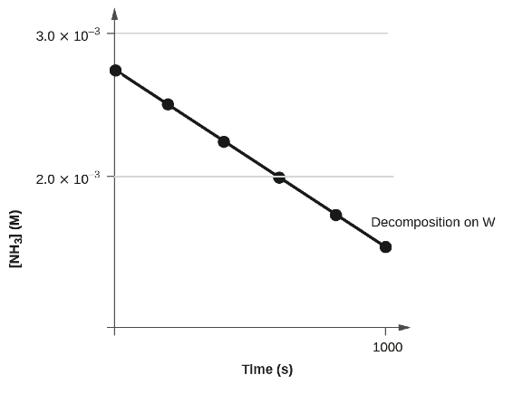
Figure 12.12 The decomposition of NH₃ on a tungsten (W) surface is a zero-order reaction. Not scaled.

Example 12.6
Graphical Determination of Zero-Order Rate Constant
Use the data plot in Figure 12.12 to graphically estimate the zero-order rate constant for ammonia decomposition at a tungsten surface.

Solution: The integrated rate law for zero-order kinetics describes a linear plot of reactant concentration, [A]_{t}, versus time, t, with a slope equal to −k.
Following the mathematical approach of previous examples, the slope of the linear data plot (for decomposition on W) is estimated from the graph.
Using the ammonia concentrations at t = 0 and t = 1000 s:
[NH₃]_{0 s} = 0.0028 M approximately
[NH₃]_{1000 s} = 0.0015 M approximately
k = −slope = − $\frac{(0.0015 - 0.0028 M)}{(1000 - 0 s)}$ = 1.3 × 10⁻⁶ M s⁻¹

Check Your Learning
The zero-order plot in Figure 12.12 shows an initial ammonia concentration of 0.0028 M decreasing linearly with time for 1000 s. Assuming no change in this zero-order behavior, at what time (min) will the concentration reach 0.0001 M?

Answer: 35 min

First-Order Reactions
Integration of the rate law for a simple first-order reaction (rate = k[A]) results in an equation describing how the reactant concentration varies with time. For mathematical convenience, the following format is used to show a linear dependence of concentration in time:
ln[A]_{t} = − kt + ln[A]₀
where [A]_{t} is the concentration of A at any time t, [A]₀ is the initial concentration of A, and k is the first-order rate constant.

Example 12.7
The Integrated Rate Law for a First-Order Reaction
The rate constant (k) for the first-order decomposition of cyclobutane, C₄H₈ at 500 °C is 9.2 × 10⁻³ s⁻¹: C₄H₈ ⟶ 2 C₂H₄
How long will it take for 80.0% of a sample of C₄H₈ to decompose?

Solution: Since the relative change in reactant concentration is provided, a convenient format for the integrated rate law is:
ln[A]_{t} = − kt + ln[A]₀
The initial concentration of C₄H₈, [A]₀, is not provided, but the provision that 80.0% of the sample has decomposed is enough information to solve this problem.
Assume that the initial concentration, [A]₀ is 100.0%. In this case, the concentration at time, t, [A]_{t} = 100.0 - 80.0% = 20.0%. Substituting the provided quantities yields:
ln(20) = −(9.2 × 10⁻³ s⁻¹) t + ln(100)
ln(20) - ln(100) = −(9.2 × 10⁻³ s⁻¹) t
-1.609 = −(9.2 × 10⁻³ s⁻¹) t
$\frac{-1.609 }{ -(9.2 × 10^{-3} s^{-1}) }$ = t → t = 1.7 × 10² s

Check Your Learning
Iodine-131 is a radioactive isotope that is used to diagnose and treat some forms of thyroid cancer. Iodine-131 decays to xenon-131. The decay is first-order with a rate constant of 0.138 day⁻¹. How many days will it take for 90% of the iodine−131 in a 0.500 M solution of this substance to decay to Xe-131?
Answer: 16.7 days

In the next example exercise, a linear format for the integrated rate law will be convenient:
ln[A]_{t} = − kt + ln[A]₀
y = mx + b
A plot of ln[A]_{t} versus t for a first-order reaction is a straight line with a slope of −k and a y-intercept of ln[A]₀. If a set of rate data are plotted in this fashion but do not result in a straight line, the reaction is not first order in A.

Example 12.8
Graphical Determination of Reaction Order and Rate Constant
The data in Figure 12.2 can be represented by a first-order rate law by graphing ln[H₂O₂] versus time. Determine the rate constant for the decomposition of H₂O₂ from these data.

Solution: The data from Figure 12.2 are tabulated below, and a plot of ln[H₂O₂] is shown.
Trial | Time (h) | [H₂O₂] (M) | ln[H₂O₂]
1 | 0.00 | 1.000 | 0.000
2 | 6.00 | 0.500 | −0.693
3 | 12.00 | 0.250 | −1.386
4 | 18.00 | 0.125 | −2.079
5 | 24.00 | 0.0625 | −2.772
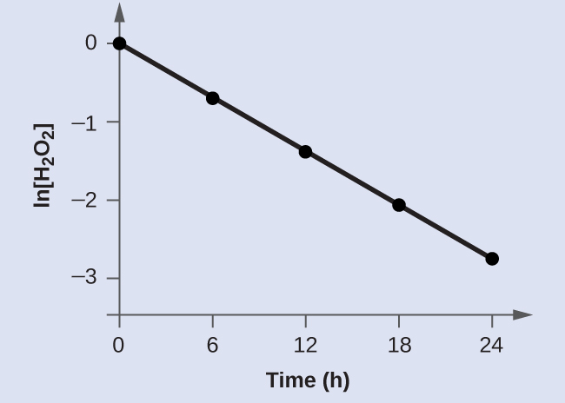
Figure 12.13 A linear relationship between ln[H₂O₂] and time suggests the decomposition of hydrogen peroxide is a first-order reaction.

The plot of ln[H₂O₂] versus time is linear, indicating that the reaction may be described by a first-order rate law.
According to the linear format of the first-order integrated rate law, the rate constant is given by the negative of this plot’s slope.
The slope of this line may be derived from two values of ln[H₂O₂] at different values of t (one near each end of the line is preferable). For example, the value of ln[H₂O₂] when t is 0.00 h is 0.000; the value when t = 24.00 h is −2.772
ln[H₂O₂]_{0 h} = 0.000
ln[H₂O₂]_{24 h} = -2.772
k = −slope = − $\frac{(-2.772 - 0.000)}{(24.00 - 0.00 h)}$ = 0.116 h⁻¹

Check Your Learning
Graph the following data to determine whether the reaction A ⟶ B + C is first order.
Trial | Time (s) | [A]
1 | 4.0 | 0.220
2 | 8.0 | 0.144
3 | 12.0 | 0.110
4 | 16.0 | 0.088
5 | 20.0 | 0.074
Answer:
The plot of ln[A]_{t} vs. t is not linear, indicating the reaction is not first order:
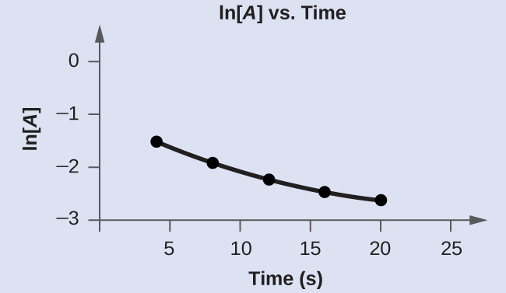

Second-Order Reactions
The equations that relate the concentrations of reactants and the rate constant of second-order reactions can be fairly complicated. To illustrate the point with minimal complexity, only the simplest second-order reactions will be described here, namely, those whose rates depend on the concentration of just one reactant. For these types of reactions, the differential rate law is written as: Rate = k [A]²
For these second-order reactions, the integrated rate law is:
$\frac{1}{{[A]}_{t}}$ = kt + $\frac{1}{{[A]}_{0}}$
where the terms in the equation have their usual meanings as defined earlier.

Example 12.9
The Integrated Rate Law for a Second-Order Reaction
The reaction of butadiene gas (C₄H₆) to yield C₈H₁₂ gas is described by the equation:
2 C₄H₆ (g) ⟶ C₈H₁₂ (g)
This “dimerization” reaction is second order with a rate constant (k) equal to 5.76 × 10⁻² M⁻¹ min⁻¹ under certain conditions. If the initial concentration of butadiene is 0.200 M, what is the concentration after 10.0 min?

Solution: For a second-order reaction, the integrated rate law is written
$\frac{1}{{[A]}_{t}}$ = kt + $\frac{1}{{[A]}_{0}}$
We know three variables in this equation: [A]₀ = 0.200 M, k = 5.76 × 10⁻² M⁻¹ min⁻¹, and t = 10.0 min. Therefore, we can solve for [A]_{t}, the fourth variable:
$\frac{1}{{[A]}_{t}}$ = (5.76 × 10⁻² M⁻¹ min⁻¹)(10 min) + $\frac{1}{0.200 M}$
$\frac{1}{{[A]}_{t}}$ = (5.76 × 10⁻¹ M⁻¹) + 5.00 M⁻¹
$\frac{1}{{[A]}_{t}}$ = 5.576 M⁻¹
$\frac{1}{5.576 M^{-1}}$ = [A]_{t} → [A]_{t} = 0.179 M
Therefore 0.179 mol/L of butadiene remain at the end of 10.0 min, compared to the 0.200 mol/L that was originally present.

Check Your Learning
If the initial concentration of butadiene is 0.0200 M, what is the concentration remaining after 20.0 min?
Answer: 0.0195 mol/L

The integrated rate law for second-order reactions has the form of the equation of a straight line:
$\frac{1}{{[A]}_{t}}$ = kt + $\frac{1}{{[A]}_{0}}$
y = mx + b
A plot of 1[A]t versus t for a second-order reaction is a straight line with a slope of k and a y-intercept of 1[A]0. If the plot is not a straight line, then the reaction is not second order.

Example 12.10
Graphical Determination of Reaction Order and Rate Constant
The data below are for the same reaction described in Example 12.9. Prepare and compare two appropriate data plots to identify the reaction as being either first or second order. After identifying the reaction order, estimate a value for the rate constant.

Solution
Trial | Time (s) | [C₄H₆] (M)
1 | 0 | 1.00 × 10⁻²
2 | 1600 | 5.04 × 10⁻³
3 | 3200 | 3.37 × 10⁻³
4 | 4800 | 2.53 × 10⁻³
5 | 6200 | 2.08 × 10⁻³

In order to distinguish a first-order reaction from a second-order reaction, prepare a plot of ln[C4H6]_{t} versus t and compare it to a plot of $\frac{1}{{[C_{4}H_{6}]}_{t}}$versus t.
Time (s) | $\frac{1}{{[C_{4}H_{6}]}_{t}}$(M⁻¹) | ln[C₄H₆]
0 | 100 | −4.605
1600 | 198 | −5.289
3200 | 296 | −5.692
4800 | 395 | −5.978
6200 | 481 | −6.175

The plots are shown in Figure 12.14, which clearly shows the plot of ln[C₄H₆]_{t} versus t is not linear, therefore the reaction is not first order. The plot of $\frac{1}{{[C_{4}H_{6}]}_{t}}$ versus t is linear, indicating that the reaction is second order.
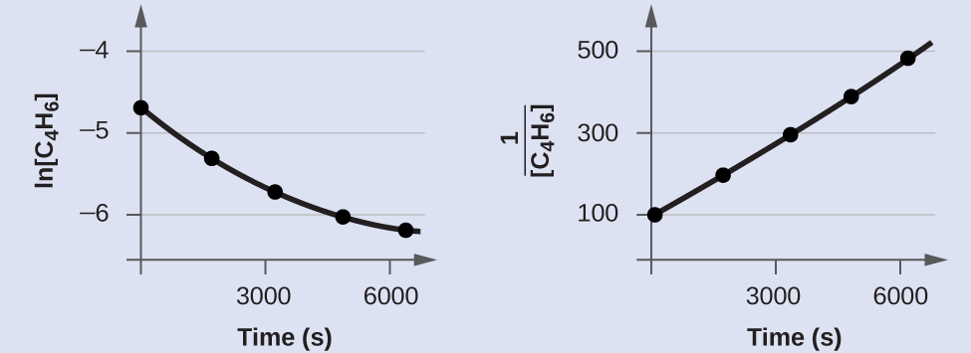
Figure 12.14 These two graphs show first- and second-order plots for the dimerization of C₄H₆. The linear trend in the second-order plot (right) indicates that the reaction follows second-order kinetics.

According to the second-order integrated rate law, the rate constant is equal to the slope of the $\frac{1}{{[A]}_{t}}$ versus t plot. Using the data for t = 0 s and t = 6200 s, the rate constant is estimated as follows:

$\frac{1}{{[C_{4}H_{6}]}_{0 s}}$ = 100 M⁻¹
$\frac{1}{{[C_{4}H_{6}]}_{6200 s}}$ = 481 M⁻¹
k = −slope = $\frac{(481 - 100 M^{-1})}{(6200 - 0.00 s)}$ = 0.0615 M⁻¹s⁻¹

Check Your Learning
Do the following data fit a second-order rate law?
Trial | Time (s) | [A] (M)
1 | 5 | 0.952
2 | 10 | 0.625
3 | 15 | 0.465
4 | 20 | 0.370
5 | 25 | 0.308
6 | 35 | 0.230

Answer: Yes. The plot of 1[A]t vs. t is linear:

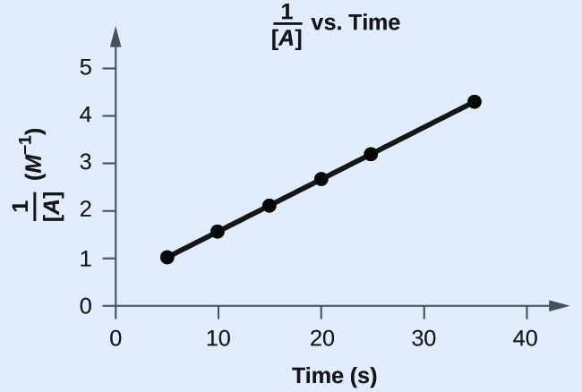

The Half-Life of a Reaction
The half-life of a reaction (t_{1/2}) is the time required for one-half of a given amount of reactant to be consumed. In each succeeding half-life, half of the remaining concentration of the reactant is consumed. Using the decomposition of hydrogen peroxide (Figure 12.2) as an example, we find that during the first half-life (from 0.00 hours to 6.00 hours), the concentration of H₂O₂ decreases from 1.000 M to 0.500 M. During the second half-life (from 6.00 hours to 12.00 hours), it decreases from 0.500 M to 0.250 M]. The concentration of H₂O₂ decreases by half during each successive period of 6.00 hours. Thus, half-life for the decomposition of hydrogen peroxide is 6.00 hours. Let’s us consider half-life for different types of reaction orders.

Zero-Order Reactions
As for other reaction orders, an equation for zero-order half-life may be derived from the integrated rate law:
[A]_{t} = −kt + [A]₀
Restricting the time and concentrations to those defined by half-life: t = t_{1/2} and [A]_{t} = $\frac{{[A]}_{0}}{2}$. Substituting these terms into the zero-order integrated rate law yields:
$\frac{{[A]}_{0}}{2}$ = −kt_{1/2} + [A]₀
kt_{1/2} = [A]₀ −$\frac{{[A]}_{0}}{2}$
kt_{1/2} = $\frac{{[A]}_{0}}{2}$
t_{1/2} = $\frac{{[A]}_{0}}{2k}$
As for all reaction orders, the half-life for a zero-order reaction is inversely proportional to its rate constant. However, the half-life of a zero-order reaction increases as the initial concentration increases.

Example 12.11
Half-Life for Zero-Order Reactions
What is the half-life (in minutes) for the decomposition of ammonia (Example 12.6)?

Solution: The reaction in question is zero order. The initial concentration [A]₀ is 0.0028 M, and exhibits a rate constant of 1.3 × 10⁻⁶ M s⁻¹. Substituting these quantities into the second-order half-life equation: t_{1/2} = $\frac{{[A]}_{0}}{2k}$
t_{1/2} = $\frac{0.0028 M}{2 (1.3 × {10}^{-6}{ M}^{ }s^{-1})}$
t_{1/2} = 1076.9 s $×$ $\frac{1 min}{60 s}$ = 18 mins

First-Order Reactions
An equation relating the half-life of a first-order reaction to its rate constant may be derived from the integrated rate law as follows:
ln[A]_{t} = − kt + ln[A]₀
Invoking the definition of half-life, symbolized t_{1/2}, requires that the concentration of A at this point is one-half its initial concentration: t = t_{1/2} and [A]_{t} = $\frac{{[A]}_{0}}{2}$.
Substituting these terms into the rearranged integrated rate law and simplifying yields the equation for half-life:
ln[A]_{t} = − kt + ln[A]₀
ln$\frac{{[A]}_{0}}{2}$ = − kt_{1/2} + ln[A]₀
kt_{1/2} = ln[A]₀ − ln$\frac{{[A]}_{0}}{2}$ = ln$\frac{{[A]}_{0}}{\frac{{[A]}_{0}}{2}}$ = ln 2 = 0.693
t_{1/2} = $\frac{0.693}{k}$
This equation describes an expected inverse relation between the half-life of the reaction and its rate constant, k. Faster reactions exhibit larger rate constants and correspondingly shorter half-lives. Slower reactions exhibit smaller rate constants and longer half-lives.

Example 12.12
Calculation of a First-order Rate Constant using Half-Life
Calculate the rate constant for the first-order decomposition of hydrogen peroxide in water at 40 °C, using the data given in Figure 12.15.

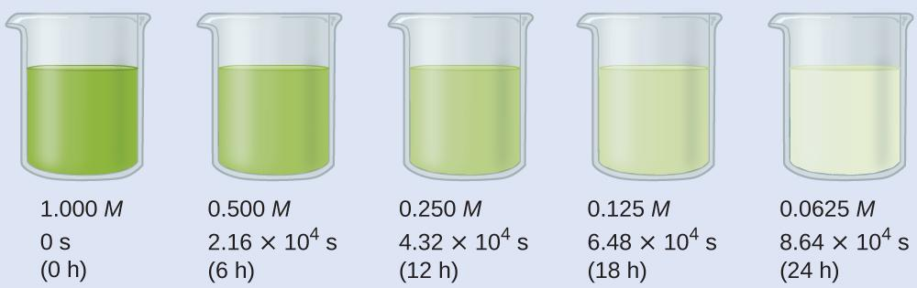
Figure 12.15 The decomposition of H₂O₂ (2 H₂O₂ ⟶ 2 H₂O + O₂) at 40 °C is illustrated.

The intensity of the color symbolizes the concentration of H₂O₂ at the indicated times; H₂O₂ is actually colorless.

Solution: Inspecting the concentration/time data in figure above shows the half-life for the decomposition of H₂O₂ is 2.16 × 10⁴ s:

t_{1/2} = $\frac{0.693}{k}$
k = $\frac{0.693}{t_{1/2}}$= $\frac{0.693}{2.16 × {10}^{4}s}$ = 3.21 × 10⁻⁵ s⁻¹

Check Your Learning
The first-order radioactive decay of iodine-131 exhibits a rate constant of 0.138 d⁻¹. What is the half-life for this decay?
Answer: 5.02 d.

Second-Order Reactions
Following the same approach as used for first-order reactions, an equation relating the half-life of a second-order reaction to its rate constant and initial concentration may be derived from its integrated rate law:
$\frac{1}{{[A]}_{t}}$ = kt + $\frac{1}{{[A]}_{0}}$
Invoking the definition of half-life, symbolized t_{1/2}, requires that the concentration of A at this point is one-half its initial concentration: t = t_{1/2} and [A]_{t} = $\frac{{[A]}_{0}}{2}$.
Substituting these terms into the rearranged integrated rate law and simplifying yields the equation for half-life:
$\frac{1}{{[A]}_{t}}$ = kt + $\frac{1}{{[A]}_{0}}$
$\frac{1}{\frac{{[A]}_{0}}{2}}$ = kt_{1/2} + $\frac{1}{{[A]}_{0}}$
$\frac{2}{{[A]}_{0}}$ = kt_{1/2} + $\frac{1}{{[A]}_{0}}$
$\frac{2}{{[A]}_{0}}$ − $\frac{1}{{[A]}_{0}}$ = kt_{1/2}
$\frac{1}{{[A]}_{0}}$ = kt_{1/2}
t_{1/2} =$\frac{1}{{k[A]}_{0}}$
For a second-order reaction, t_{1/2} is inversely proportional to the concentration of the reactant, and the half-life increases as the reaction proceeds because the concentration of reactant decreases. Unlike with first-order reactions, the rate constant of a second-order reaction cannot be calculated directly from the half-life unless the initial concentration is known.

Example 12.13
Half-Life for Second-Order Reactions
What is the half-life for the decomposition of a butadiene dimerization reaction (Example 12.9)?

Solution: The reaction in question is second order, is initiated with a 0.200 M reactant solution, and exhibits a rate constant of 0.0576 M min⁻¹. Substituting these quantities into the second-order half-life equation:
t_{1/2} = $\frac{1}{{k[A]}_{0}}$
t_{1/2} = $\frac{1}{{(0.0576 M \min^{-1}) (0.200 M)}_{}}$
t_{1/2} = 86.8 min

Summary
Equations for both differential and integrated rate laws and the corresponding half-lives for zero-, first-, and second-order reactions are summarized in Table 12.2.
Table 12.2 Summary of Rate Laws for Zero-, First-, and Second-Order Reactions
 | Zero-Order | First-Order | Second-Order
Differential rate law | rate = k | rate = k [A] | rate = k [A]²
Units of rate constant | M s⁻¹ | s⁻¹ | M⁻¹ s⁻¹
Integrated rate law | [A] = −kt + [A]₀ | ln[A]_{t} = −kt + ln[A]₀ | $\frac{1}{{[A]}_{t}}$= kt +$\frac{1}{{[A]}_{0}}$
Linear plot of integrated rate law | [A] vs. t | ln[A] vs. t | $\frac{1}{{[A]}_{ }}$ vs. t
Slope of linear plot of integrated rate law | k = −slope | k = −slope | k = slope
Half-life | t_{1/2} = $\frac{{[A]}_{0}}{2k}$ | t_{1/2} = $\frac{0.693}{k_{ }}$ | t_{1/2} = $\frac{1}{{k[A]}_{0}}$

12.6 Reaction Mechanisms

Learning Objectives
- Distinguish net reactions from elementary reactions (steps)
- Identify the molecularity of elementary reactions, intermediates, and catalysts
- Write a balanced chemical equation for a process given its reaction mechanism
- Derive the rate law consistent with a given reaction mechanism

Introduction
One of the major reasons for studying chemical kinetics is to use measurements of the macroscopic properties of a system, such as the rate of change in the concentration of reactants or products with time, to discover the sequence of events that occur at the molecular level during a reaction. This molecular description is the mechanism of the reaction; it describes how individual atoms, ions, or molecules interact to form particular products. The stepwise changes are collectively called the reaction mechanism.
In an internal combustion engine, for example, isooctane reacts with oxygen to give carbon dioxide and water:
2 C₈H₁₈ (l) + 25 O₂ (g) → 16 CO₂ (g) + 18 H₂O (g)
For this reaction to occur in a single step, 25 dioxygen molecules and 2 isooctane molecules would have to collide simultaneously and be converted to 34 molecules of product, which is very unlikely. It is more likely that a complex series of reactions takes place in a stepwise fashion. Each individual reaction, which is called an elementary reaction, involves one, two, or (rarely) three atoms, molecules, or ions. The overall sequence of elementary reactions is the mechanism of the reaction. The sum of the individual steps, or elementary reactions, in the mechanism must give the balanced chemical equation for the overall reaction.

Molecularity and the Rate-Determining Step
To demonstrate how the analysis of elementary reactions helps us determine the overall reaction mechanism, we will examine the much simpler reaction of carbon monoxide with nitrogen dioxide.
NO₂ (g) + CO (g) → NO (g) + CO₂ (g)
From the balanced chemical equation, one might expect the reaction to occur via a collision of one molecule of NO₂ with a molecule of CO that results in the transfer of an oxygen atom from nitrogen to carbon. The experimentally determined rate law for the reaction, however, is as follows: Rate = k [NO₂]²
The fact that the reaction is second order in [NO₂] and independent of [CO] tells us that it does not occur by the simple collision model outlined previously. If it did, its predicted rate law would be: Rate = k [NO₂] [CO].
The following two-step mechanism is consistent with the rate law if step 1 is much slower than step 2:
Elementary Reaction Step 1: NO₂ + NO₂ → NO₃ + NO (slow)
Elementary Reaction Step 2: NO₃ + CO → NO₂ + CO₂ (fast)
The Overall Reaction (Sum 1 & 2): NO₂ + CO → NO + CO₂

According to this mechanism, the overall reaction occurs in two steps, or elementary reactions. Summing steps 1 and 2 and canceling on both sides of the equation gives the overall balanced chemical equation for the reaction. The NO₃ molecule is an intermediate in the reaction. An intermediate is a species that does not appear in the balanced chemical equation for the overall reaction. It is formed as a product of the first step but is consumed in the second step.

Using Molecularity to Describe a Rate Law
The molecularity of an elementary reaction is the number of molecules that collide during that step in the mechanism. If there is only a single reactant molecule in an elementary reaction, that step is designated as unimolecular. If there are two reactant molecules, it is bimolecular. If there are three reactant molecules (a relatively rare situation), it is termolecular. Elementary reactions that involve the simultaneous collision of more than three molecules are highly improbable and have never been observed experimentally.
Writing the rate law for an elementary reaction is straightforward because we know how many molecules must collide simultaneously for the elementary reaction to occur; hence the order of the elementary reaction is the same as its molecularity (Table 12.3). In contrast, the rate law for the reaction cannot be determined from the balanced chemical equation for the overall reaction.
Table 12.3 Common Types of Elementary Reactions and Their Rate Laws
Elementary Reaction | Molecularity | Rate Law | Reaction Order
A → products | unimolecular | rate = k [A] | first
2A → products | bimolecular | rate = k [A]² | second
A + B → products | bimolecular | rate = k [A] [B] | second
2A + B → products | termolecular | rate = k [A]² [B] | third
A + B + C → products | termolecular | rate = k [A] [B] [C] | third

** For elementary reactions, the order of the elementary reaction is the same as its molecularity. In contrast, the rate law cannot be determined from the balanced chemical equation for the overall reaction (unless it is a single step mechanism and is therefore also an elementary step).

Identifying the Rate-Determining Step

Note the important difference between writing rate laws for elementary reactions and the balanced chemical equation of the overall reaction. Because the balanced chemical equation does not necessarily reveal the individual elementary reactions by which the reaction occurs, we cannot obtain the rate law for a reaction from the overall balanced chemical equation alone.
In fact, it is the rate law for the slowest overall reaction, which is the same as the rate law for the slowest step in the reaction mechanism that must give the experimentally determined rate law for the overall reaction. The slowest step in the reaction mechanism is called the rate-determining step (RDS). This statement is true if one step is substantially slower than all the others, typically by a factor of 10 or more. If two or more slow steps have comparable rates, the experimentally determined rate laws can become complex. Our discussion is limited to reactions in which one step can be identified as being substantially slower than any other. The reason for this is that any process that occurs through a sequence of steps can take place no faster than the slowest step in the sequence.
In an automotive assembly line, for example, a component cannot be used faster than it is produced. Similarly, blood pressure is regulated by the flow of blood through the smallest passages, the capillaries. Because movement through capillaries constitutes the rate-determining step in blood flow, blood pressure can be regulated by medications that cause the capillaries to contract or dilate. A chemical reaction that occurs via a series of elementary reactions can take place no faster than the slowest step in the series of reactions.
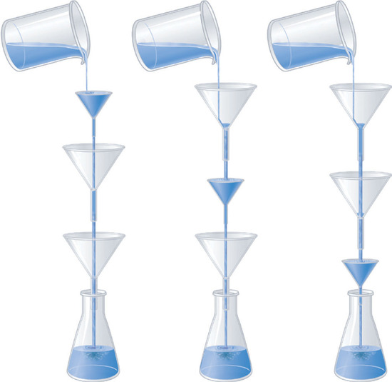
Figure 12.16 Rate-determining step. The phenomenon of a rate-determining step can be compared to a succession of funnels. The smallest-diameter funnel controls the rate at which the bottle is filled, whether it is the first or the last in the series. Pouring liquid into the first funnel faster than it can drain through the smallest results in an overflow.
Look at the rate laws for each elementary reaction in our previous example as well as for the overall reaction.
Step 1 (slow): NO₂ + NO₂ → NO₃ + NO Rate = k₁ [NO₂]² (predicted)
Step 2 (fast): NO₃ + CO → NO₂ + CO₂ Rate = k₂ [NO₃][CO] (predicted)
The Overall: NO₂ + CO → NO + CO₂ Rate = k [NO₂]² (observed)
The experimentally determined rate law for the reaction of NO₂ with CO is the same as the predicted rate law for step 1. This tells us that the first elementary reaction is the rate-determining step, so k for the overall reaction must equal k₁. That is, NO₃ is formed slowly in step 1, but once it is formed, it reacts very rapidly with CO in step 2.
Sometimes chemists are able to propose two or more mechanisms that are consistent with the available data. If a proposed mechanism predicts the wrong experimental rate law, however, the mechanism must be incorrect.

Example 12.13
A Reaction with an Intermediate
In an alternative mechanism for the reaction of NO₂ with CO, N₂O₄ appears as an intermediate.
Step 1 : NO₂ + NO₂ → N₂O₄ (slow)
Step 2 : N₂O₄ + CO → NO + NO₂ + CO₂ (fast)
The Overall: NO₂ + CO → NO + CO₂

Write the rate law for each elementary reaction.
Is this mechanism consistent with the experimentally determined rate law (rate = k [NO₂]²)?
Given: elementary reactions
Asked for: rate law for each elementary reaction and overall rate law
Strategy:
- Determine the rate law for each elementary reaction in the reaction.
- Determine which rate law corresponds to the experimentally determined rate law for the reaction. This rate law is the one for the rate-determining step.
Solution:

1. The rate law for step 1 is: rate = k₁ [NO₂]²
The rate law for step 2 is: rate = k₂ [N₂O₄] [CO]
2. If step 1 is slow (and therefore the rate-determining step), then the overall rate law for the reaction will be the same: rate = k₁ [NO₂]². This is the same as the experimentally determined rate law. Hence this mechanism, with N₂O₄ as an intermediate, and the one described previously, with NO₃ as an intermediate, are kinetically indistinguishable. In this case, further experiments are needed to distinguish between them. For example, the researcher could try to detect the proposed intermediates, NO₃ and N₂O₄, directly.

Check Your Learning
Iodine monochloride (ICl) reacts with H2 as follows:
2 ICl (l) + H₂ (g) → 2 HCl (g) + I₂ (s)
The experimentally determined rate law is rate = k [ICl] [H₂]. Write a two-step mechanism for this reaction using only bimolecular elementary reactions and show that it is consistent with the experimental rate law. (Hint: HI is an intermediate.)

Answer:
Step 1 (slow): ICl + H₂ → HCl + HI Rate = k₁ [ICl] [H₂] (slow)
Step 2 (fast): HI + ICl → HCl + I₂ Rate = k₂ [HI] [ICl] (fast)
The Overall: 2 ICl + H₂ → 2 HCl + I₂ Rate = k [ICl] [H₂] (observed)

This mechanism is consistent with the experimental rate law if the first step is the rate-determining step.

Summary
A balanced chemical reaction does not necessarily reveal either the individual elementary reactions by which a reaction occurs or its rate law. A reaction mechanism is the microscopic path by which reactants are transformed into products. Each step is an elementary reaction. Species that are formed in one step and consumed in another are intermediates. Each elementary reaction can be described in terms of its molecularity, the number of molecules that collide in that step. The slowest step in a reaction mechanism is the rate-determining step.

Catalyst and the Reaction Mechanisms
A catalyst is a substance that can increase the reaction rate without being consumed in the reaction. The concepts introduced in the previous section on reaction mechanisms provide the basis for understanding how catalysts are able to accomplish this very important function. Figure 12.17 shows reaction diagrams for a chemical process in the absence and presence of a catalyst. Inspection of the diagrams reveals several traits of these reactions. Consistent with the fact that the two diagrams represent the same overall reaction, both curves begin and end at the same energies (in this case, because products are more energetic than reactants, the reaction is endothermic). The reaction mechanisms, however, are clearly different. The uncatalyzed reaction proceeds via a one-step mechanism (one transition state observed), whereas the catalyzed reaction follows a two-step mechanism (two transition states observed) with a notably lesser activation energy. This difference illustrates the means by which a catalyst functions to accelerate reactions, namely, by providing an alternative reaction mechanism with a lower activation energy. Although the catalyzed reaction mechanism for a reaction needn’t necessarily involve a different number of steps than the uncatalyzed mechanism, it must provide a reaction path whose rate determining step is faster (lower Ea).
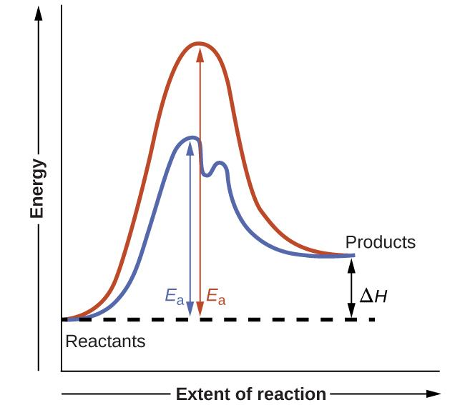
Figure 12.17 Reaction diagrams for an endothermic process in the absence (red curve) and presence (blue curve) of a catalyst. The catalyzed pathway involves a two-step mechanism (note the presence of two transition states) and an intermediate species (represented by the valley between the two transitions states).

Portrait of a Chemist

Mario J. Molina
The 1995 Nobel Prize in Chemistry was shared by Paul J. Crutzen, Mario J. Molina (Figure 12.18), and F. Sherwood Rowland “for their work in atmospheric chemistry, particularly concerning the formation and decomposition of ozone.”¹ Molina, a Mexican citizen, carried out the majority of his work at the Massachusetts Institute of Technology (MIT).
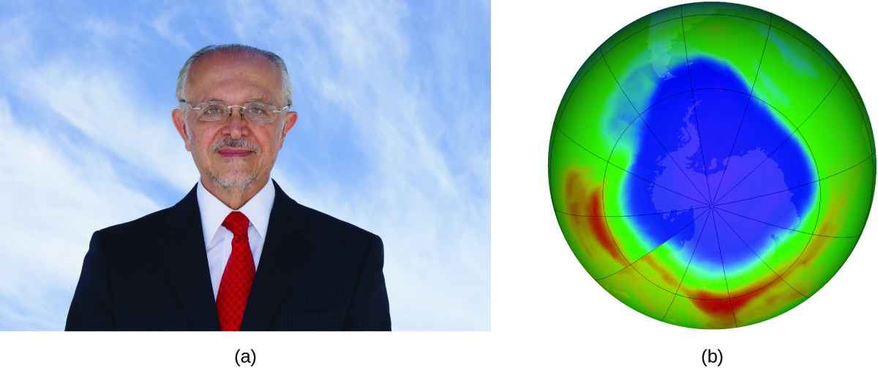
Figure 12.18 (a) Mexican chemist Mario Molina (1943 –) shared the Nobel Prize in Chemistry in 1995 for his research on (b) the Antarctic ozone hole. (credit a: courtesy of Mario Molina; credit b: modification of work by NASA)

In 1974, Molina and Rowland published a paper in the journal Nature detailing the threat of chlorofluorocarbon gases to the stability of the ozone layer in earth’s upper atmosphere. The ozone layer protects earth from solar radiation by absorbing ultraviolet light. As chemical reactions deplete the amount of ozone in the upper atmosphere, a measurable “hole” forms above Antarctica, and an increase in the amount of solar ultraviolet radiation— strongly linked to the prevalence of skin cancers—reaches earth’s surface. The work of Molina and Rowland was instrumental in the adoption of the Montreal Protocol, an international treaty signed in 1987 that successfully began phasing out production of chemicals linked to ozone destruction.
Molina and Rowland demonstrated that chlorine atoms from human-made chemicals can catalyze ozone destruction. Chlorine atoms are generated when chlorocarbons or chlorofluorocarbons — once widely used as refrigerants and propellants — are photochemically decomposed by ultraviolet light or react with hydroxyl radicals. A sample mechanism is shown here using methyl chloride:
CH₃Cl + OH ⟶ Cl + other products
Chlorine radicals break down ozone and are regenerated by the following catalytic cycle:
Step 1: Cl + O₃ ⟶ ClO + O₂
Step 2: ClO + O ⟶ Cl + O₂
Overall Reaction: O₃ + O ⟶ 2 O₂
A single monatomic chlorine can break down thousands of ozone molecules. Luckily, the majority of atmospheric chlorine exists as the catalytically inactive forms Cl₂ and ClONO₂.
Since receiving his portion of the Nobel Prize, Molina has continued his work in atmospheric chemistry at MIT.

Footnotes
- 1 “The Nobel Prize in Chemistry 1995,” Nobel Prize.org, accessed February 18, 2015, http://www.nobelprize.org/nobel_prizes/chemistry/laureates/1995/.

Chemistry in Everyday Life

Automobile Catalytic Converters
Scientists developed catalytic converters to reduce the amount of toxic emissions produced by burning gasoline in internal combustion engines. By utilizing a carefully selected blend of catalytically active metals, it is possible to effect complete combustion of all carbon-containing compounds to carbon dioxide while also reducing the output of nitrogen oxides. This is particularly impressive when we consider that one step involves adding more oxygen to the molecule and the other involves removing the oxygen.
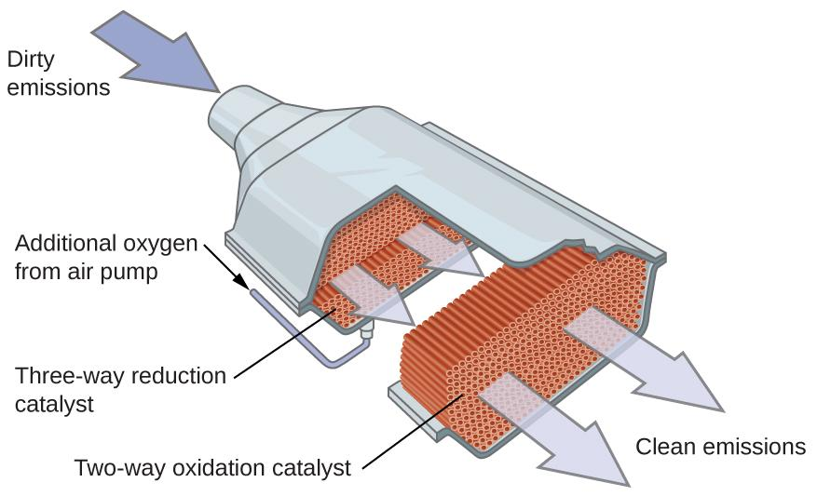
Figure 12.19 A catalytic converter allows for the combustion of all carbon-containing compounds to carbon dioxide, while at the same time reducing the output of nitrogen oxide and other pollutants in emissions from gasoline-burning engines.
Most modern, three-way catalytic converters possess a surface impregnated with a platinum-rhodium catalyst, which catalyzes the conversion of nitric oxide into dinitrogen and oxygen as well as the conversion of carbon monoxide and hydrocarbons such as octane into carbon dioxide and water vapor:
2 NO₂ (g) ⟶ N₂ (g) + 2 O₂ (g)
2 CO (g) + O₂ (g) ⟶ 2 CO₂ (g)
2 C₈H₁₈ (g) + 25 O₂ (g) ⟶ 16 CO₂ (g) + 18 H₂O (g)
In order to be as efficient as possible, most catalytic converters are preheated by an electric heater. This ensures that the metals in the catalyst are fully active even before the automobile exhaust is hot enough to maintain appropriate reaction temperatures.

Chapter 13 – Attributions

The contents in this chapter, licensed under CC BY 4.0. has been adopted, modified, reorganized, and/or remixed from the following:

13.0 Introduction
"13 Introduction" by Paul Flowers, Klaus Theopold, Richard Langley, William R. Robinson,, OpenStax is licensed under CC BY 4.0

13.1 Concept of Dynamic Equilibrium
"13.1 Chemical Equilibria" by Paul Flowers, Klaus Theopold, Richard Langley, William R. Robinson,, OpenStax is licensed under CC BY 4.0

13.2 Equilibrium Constant (K)
"13.2 Equilibrium Constants" by Paul Flowers, Klaus Theopold, Richard Langley, William R. Robinson,, OpenStax is licensed under CC BY 4.0

13.3 Chemical Equations and Equilibrium Constant Relation
"13.2 Equilibrium Constants" by Paul Flowers, Klaus Theopold, Richard Langley, William R. Robinson,, OpenStax is licensed under CC BY 4.0

13.4 Equilibrium Calculations
"13.4 Equilibrium Calculations" by Paul Flowers, Klaus Theopold, Richard Langley, William R. Robinson,, OpenStax is licensed under CC BY 4.0

13.5 Le Chaterlier’s Principle
"13.3 Shifting Equilibria: Le Châtelier’s Principle" by OpenStax CNX is licensed under CC BY 4.0

BLANK PAGE

Chapter 13 Chemical Equilibrium

Chapter Introduction

13.1 Concept of Dynamic Equilibrium

13.2 Reaction Quotient (Q) and Equilibrium Constant (K)

13.3 Chemical Equations and Equilibrium Constant Relation

13.4 Equilibrium Calculations

13.5 Le Chaterlier’s Principle

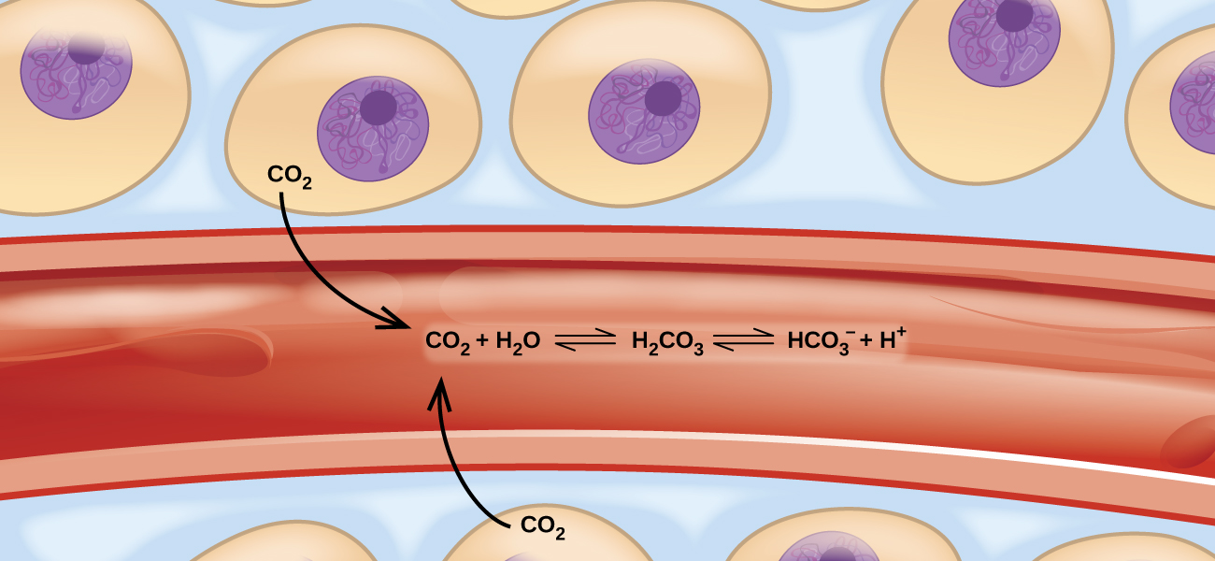

Figure 13.1 Transport of carbon dioxide in the body involves several reversible chemical reactions, including hydrolysis and acid ionization (among others).
Imagine a beach populated with sunbathers and swimmers. As those basking in the sun get too hot, they enter the surf to swim and cool off. As the swimmers tire, they return to the beach to rest. If the rate at which sunbathers enter the surf were to equal the rate at which swimmers return to the sand, then the numbers (though not the identities) of sunbathers and swimmers would remain constant. This scenario illustrates a dynamic phenomenon known as equilibrium, in which opposing processes occur at equal rates. Chemical and physical processes are subject to this phenomenon; these processes are at equilibrium when the forward and reverse reaction rates are equal. Equilibrium systems are pervasive in nature; the various reactions involving carbon dioxide dissolved in blood are examples (see Figure 13.1). This chapter provides a thorough introduction to the essential aspects of chemical equilibria.
BLANK PAGE

13.1 Concept of Dynamic Equilibrium

Learning Objectives
- Describe the nature of equilibrium systems
- Explain the dynamic nature of a chemical equilibrium

Dynamic Equilibrium
The convention for writing chemical equations involves placing reactant formulas on the left side of a reaction arrow and product formulas on the right side. By this convention, and the definitions of “reactant” and “product,” a chemical equation represents the reaction in question as proceeding from left to right.
Reversible reactions, however, may proceed in both forward (left to right) and reverse (right to left) directions. When the rates of the forward and reverse reactions are equal, the concentrations of the reactant and product species remain constant over time and the system is at dynamic equilibrium. The relative concentrations of reactants and products in equilibrium systems vary greatly; some systems contain mostly products at equilibrium, some contain mostly reactants, and some contain appreciable amounts of both.
Figure 13.2 illustrates fundamental equilibrium concepts using the reversible decomposition of colorless dinitrogen tetroxide to yield brown nitrogen dioxide, an elementary reaction described by the equation:
N₂O₄ (g) ⇌ 2 NO₂ (g)
Note that a special double arrow is used to emphasize the reversible nature of the reaction.
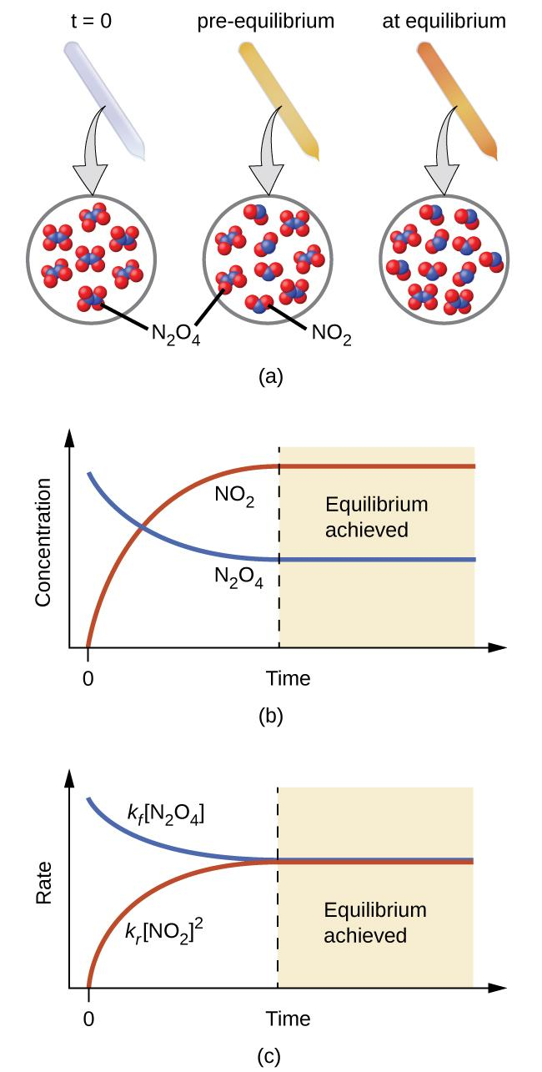
Figure 13.2 (a) A sealed tube containing colorless N₂O₄ darkens as it decomposes to yield brown NO₂. (b) Changes in concentration over time as the decomposition reaction achieves equilibrium. (c) At equilibrium, the forward and reverse reaction rates are equal.
For this elementary process, rate laws for the forward and reverse reactions may be derived directly from the reaction stoichiometry:
Rate_{forward} = k_{f} [N₂O₄]
Rate_{reverse} = k_{r} [NO₂]²
As the reaction begins (t = 0), the concentration of the N₂O₄ reactant is finite and that of the NO₂ product is zero, so the forward reaction proceeds at a finite rate while the reverse reaction rate is zero.
As time passes, N₂O₄ is consumed and its concentration falls, while NO₂ is produced and its concentration increases (Figure 13.2b).
The decreasing concentration of the reactant slows the forward reaction rate, and the increasing product concentration speeds the reverse reaction rate (Figure 13.2c). This process continues until the forward and reverse reaction rates become equal, at which time the reaction has reached equilibrium, as characterized by constant concentrations of its reactants and products (shaded areas of Figure 13.2b and Figure 13.2c).
It’s important to emphasize that chemical equilibria are dynamic; a reaction at equilibrium has not “stopped,” but is proceeding in the forward and reverse directions at the same rate. This dynamic nature is essential to understanding equilibrium behavior as discussed in this and subsequent chapters of the text.
Figure 13.3 A two-person juggling act illustrates the dynamic aspect of chemical equilibria. Each person is throwing and catching clubs at the same rate, and each holds a (approximately) constant number of clubs.
Physical changes, such as phase transitions, are also reversible and may establish equilibria. This concept was introduced in another chapter of this text through discussion of the vapor pressure of a condensed phase (liquid or solid). As one example, consider the vaporization of bromine:
Br₂ (l) ⇌ Br₂ (g)
When liquid bromine is added to an otherwise empty container and the container is sealed, the forward process depicted above (vaporization) will commence and continue at a roughly constant rate as long as the exposed surface area of the liquid and its temperature remains constant. As increasing amounts of gaseous bromine are produced, the rate of the reverse process (condensation) will increase until it equals the rate of vaporization and equilibrium is established. A photograph showing this phase transition equilibrium is provided in Figure 13.4.

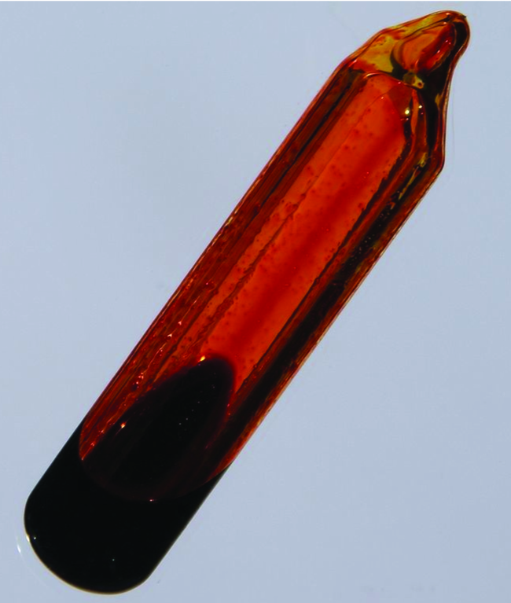

Figure 13.4 A sealed tube containing an equilibrium mixture of liquid and gaseous bromine. (credit: http://images-of-elements.com/bromine.php)

13.2 Reaction Quotient (Q) and Equilibrium Constant (K)

Learning Objectives
- Write the reaction quotient expressions from chemical equations representing homogeneous and heterogeneous reactions
- Write the equilibrium constant expressions from chemical equations representing homogeneous and heterogeneous reactions
- Calculate values of reaction quotients and equilibrium constants, using concentrations and pressures
- Relate the magnitude of an equilibrium constant to properties of the chemical system

Reaction Quotient (Q)
The status of a reversible reaction is conveniently assessed by evaluating its reaction quotient (Q). For a reversible reaction described by
m A + n B ⇌ x C + y D
the reaction quotient is derived directly from the stoichiometry of the balanced equation as
Q_{C} = $\frac{{[C]}^{x}{[D]}^{y}}{{[A]}^{m}{[B]}^{n}}$
where the subscript c denotes the use of molar concentrations in the expression.
If the reactants and products are gaseous, a reaction quotient may be similarly derived using partial pressures:
Q_{C} = $\frac{P_{C}^{x} P_{D}^{y}}{P_{A}^{m} P_{B}^{n}}$

Note that the reaction quotient equations above are a simplification of more rigorous expressions that use relative values for concentrations and pressures rather than absolute values. These relative concentration and pressure values are unitless. Consequently, the reaction quotients are unitless.

Example 13.1
Writing Reaction Quotient Expressions
Write the concentration-based reaction quotient expression for each of the following reactions:
(a) 3 O₂ (g) ⇌ 2 O₃ (g)
(b) N₂ (g) + 3 H₂ (g) ⇌ 2 NH₃ (g)
(c) 4 NH₃ (g) + 7 O₂ (g) ⇌ 4 NO₂ (g) + 6 H₂O (g)
Solution
(a) Q_{C} = $\frac{{[O_{3}]}^{2}}{{[O_{2}]}^{3}}$ (b) Q_{C} = $\frac{{[{NH}_{3}]}^{2}}{{[N_{2}]}^{ }{[H_{2}]}^{3}}$ (c) Q_{C} = $\frac{{[{NO}_{2}]}^{4}{[H_{2}O]}^{6}}{{[{NH}_{3}]}^{4 }{[O_{2}]}^{7}}$

Check Your Learning
Write the concentration-based reaction quotient expression for each of the following reactions:
(a) 2 SO₂ (g) + O₂ (g) ⇌ 2 SO₃ (g)
(b) C₄H₈ (g) ⇌ 2 C₂H₄ (g)
(c) 2 C₄H₁₀ (g) + 13 O₂ (g) ⇌ 8 CO₂ (g) + 10 H₂O (g)

Answer:
(a) Q_{C} = $\frac{{[{SO}_{3}]}^{2}}{{{[{SO}_{2}]}^{2}[O_{2}]}^{ }}$ (b) Q_{C} = $\frac{{[C_{2}H_{4}]}^{2}}{{[C_{4}H_{8}]}^{ }}$ (c) Q_{C} = $\frac{{[{CO}_{2}]}^{8}{[H_{2}O]}^{10}}{{[{C_{4}H}_{10}]}^{2 }{[O_{2}]}^{13}}$

The numerical value of Q varies as a reaction proceeds towards equilibrium; therefore, it can serve as a useful indicator of the reaction’s status. To illustrate this point, consider the oxidation of sulfur dioxide:
2 SO₂ (g) + O₂ (g) ⇌ 2 SO₃ (g)
Two different experimental scenarios are depicted in Figure 13.5, one in which this reaction is initiated with a mixture of reactants only, SO₂ and O₂, and another that begins with only product, SO₃. For the reaction that begins with a mixture of reactants only, Q is initially equal to zero:
Q_{C} = $\frac{{[{SO}_{3}]}^{2}}{{{[{SO}_{2}]}^{2}[O_{2}]}^{ }}$= $\frac{0^{2}}{{{[{SO}_{2}]}^{2}[O_{2}]}^{ }}$ = 0
As the reaction proceeds toward equilibrium in the forward direction, reactant concentrations decrease (as does the denominator of Q_{C}), product concentration increases (as does the numerator of Q_{C}), and the reaction quotient consequently increases. When equilibrium is achieved, the concentrations of reactants and products remain constant, as does the value of Q_{C}.
If the reaction begins with only product present, the value of Q_{C} is initially undefined (immeasurably large, or infinite):
Q_{C} = $\frac{{[{SO}_{3}]}^{2}}{{{[{SO}_{2}]}^{2}[O_{2}]}^{ }}$= $\frac{{[{SO}_{3}]}^{2}}{{0^{2}· 0}^{ }}$ → ∞
In this case, the reaction proceeds toward equilibrium in the reverse direction. The product concentration and the numerator of Q_{C} decrease with time, the reactant concentrations and the denominator of Q_{C} increase, and the reaction quotient consequently decreases until it becomes constant at equilibrium.

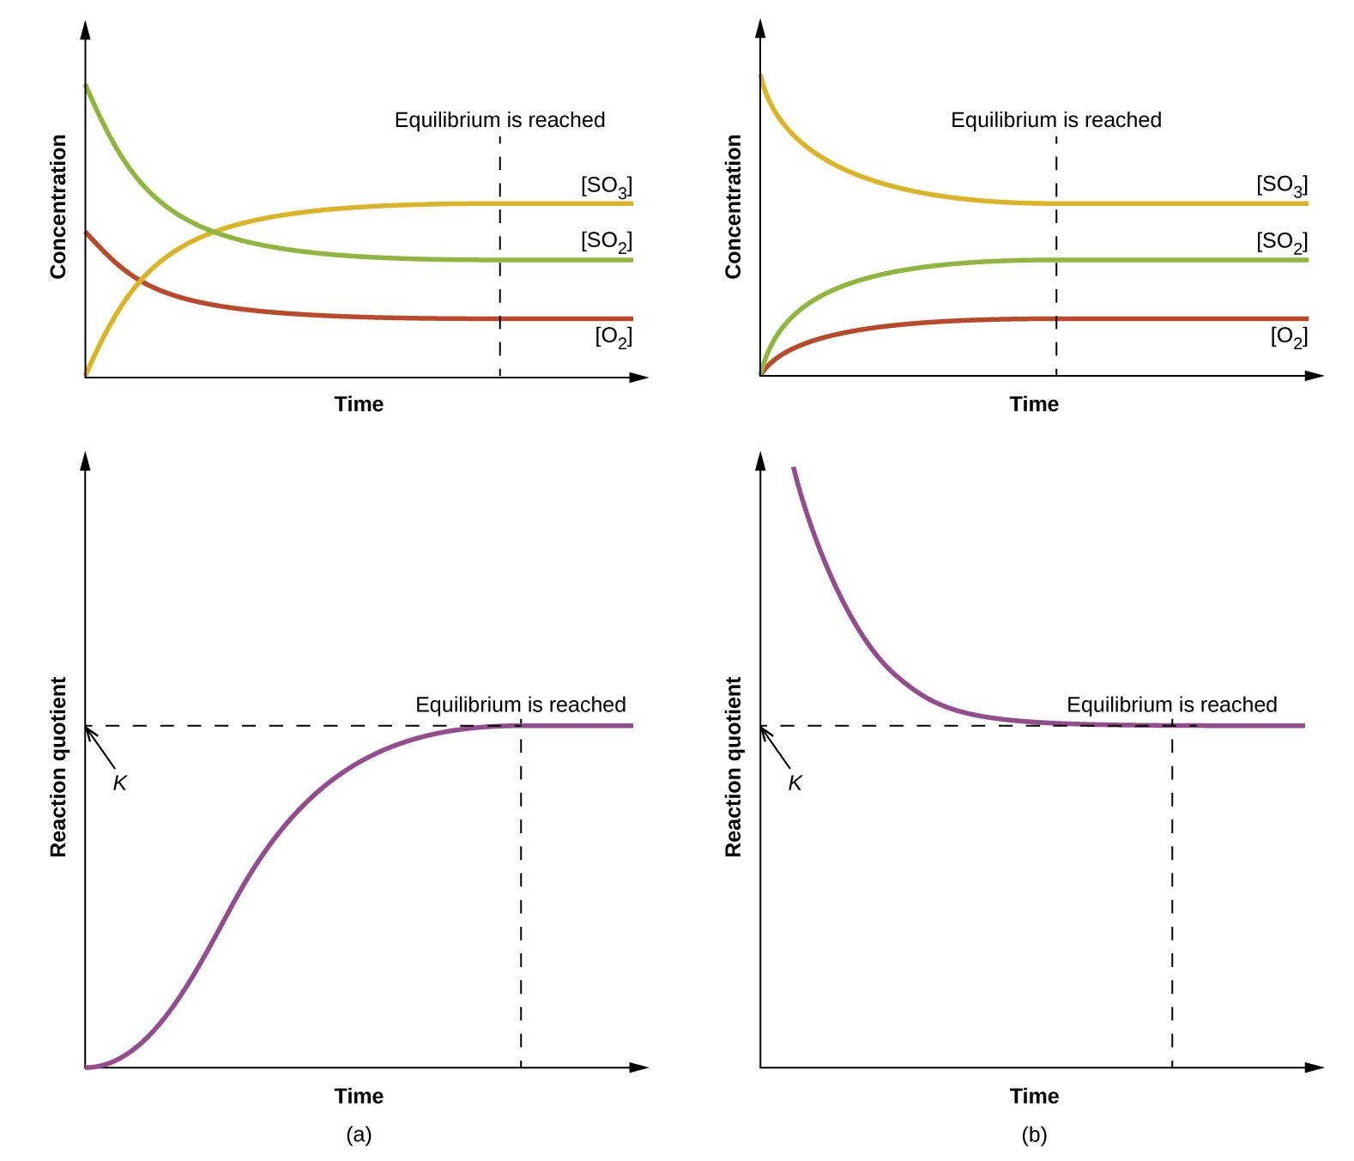

Figure 13.5 Changes in concentrations and Q_{C} for a chemical equilibrium achieved beginning with (a) a mixture of reactants only and (b) products only.

Equilibrium Constant (K)
The equilibrium constant, K is the Q exhibits by a system at equilibrium:
K ≡ Q at equilibrium
Comparison of the data plots in Figure 13.5 shows that both experimental scenarios resulted in the same value for the equilibrium constant. This is a general observation for all equilibrium systems, known as the law of mass action. At a given temperature, the reaction quotient for a system at equilibrium is constant.

Example 13.2
Evaluating a Reaction Quotient and Equilibrium Constant
Gaseous nitrogen dioxide forms dinitrogen tetroxide according to this equation:
2 NO₂ (g) ⇌ N₂O₄ (g)
When 0.10 mol NO₂ is added to a 1.0-L flask at 25 °C, the concentration changes so that at equilibrium, [NO₂] = 0.016 M and [N₂O₄] = 0.042 M.
(a) What is the value of the reaction quotient before any reaction occurs?
(b) What is the value of the equilibrium constant for the reaction?
Solution: As for all equilibrium calculations the Q and K are unitless.
(a) Before any product is formed, [NO₂] = $\frac{0.10 mol}{1.0 L}$=0.10M, and [N₂O₄] = 0 M.
Thus, Q_{C} = $\frac{{[N_{2}O_{4}]}^{ }}{{{[{NO}_{2}]}^{2}}^{ }}$= $\frac{0}{{{0.10}^{2}}^{ }}$ = 0
(b) At equilibrium, K_{C} = Q_{C} = $\frac{{0.0420}^{ }}{{{0.016}^{2}}^{ }}$= 1.6 × 10². The equilibrium constant is 1.6 × 10².

Check Your Learning
For the reaction 2 SO₂ (g) + O₂ (g) ⇌ 2 SO₃ (g), the concentrations at equilibrium are [SO₂] = 0.90 M, [O₂] = 0.35 M, and [SO₃] = 1.1M. What is the value of the equilibrium constant, K_{C}? Answer: K_{C} = 4.3

The Significance of Equilibrium Constant
By its definition, the magnitude of an equilibrium constant (K) explicitly reflects the composition of the reaction mixture at equilibrium, and it may be interpreted with regard to the extent of the forward reaction.
A reaction exhibiting a large K will reach equilibrium when most of the reactant has been converted to product. Whereas, a small K indicates the reaction achieves equilibrium after very little reactant has been converted. It’s important to keep in mind that the magnitude of K does not indicate how rapidly or slowly equilibrium will be reached. Some equilibria are established so quickly as to be nearly instantaneous, and others so slowly that no perceptible change is observed over the course of days, years, or longer.
The equilibrium constant for a reaction can be used to predict the behavior of mixtures containing its reactants and/or products. As demonstrated by the sulfur dioxide oxidation process described above, a chemical reaction will proceed in whatever direction is necessary to achieve equilibrium. Comparing Q to K for an equilibrium system of interest allows prediction of what reaction (forward or reverse), if any, will occur.
To further illustrate this important point, consider the reversible reaction shown below:
CO (g) + H₂O (g) ⇌ CO₂ (g) + H₂ (g) K_{C} = 0.640 T = 800°C
The bar charts in Figure 13.6 represent changes in reactant and product concentrations for three different reaction mixtures. The reaction quotients for mixtures 1 and 3 are initially less than the reaction’s equilibrium constant, so each of these mixtures will experience a net forward reaction to achieve equilibrium. The reaction quotient for mixture 2 is initially greater than the equilibrium constant, so this mixture will proceed in the reverse direction until equilibrium is established.
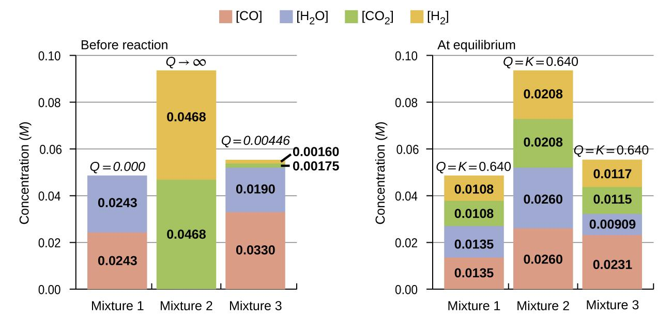
Figure 13.6 Compositions of three mixtures before (Qc ≠ Kc) and after (Qc = Kc) equilibrium is established for the reaction CO (g) + H₂O (g) ⇌ CO₂ (g) + H₂ (g)

Example 13.3
Predicting the Direction of Reaction
Given here are the starting concentrations of reactants and products for three experiments involving this reaction:
CO (g) + H₂O (g) ⇌ CO₂ (g) + H₂ (g) K_{C} = 0.64
Determine in which direction the reaction proceeds as it goes to equilibrium in each of the three experiments shown.
Reactants/Products | Experiment 1 | Experiment 2 | Experiment 3
[CO]_{i} | 0.020 M | 0.011 M | 0.0094 M
[H₂O]_{i} | 0.020 M | 0.0011 M | 0.0025 M
[CO₂]_{i} | 0.0040 M | 0.037 M | 0.0015 M
[H₂]_{i} | 0.0040 M | 0.046 M | 0.0076 M

Solution
Experiment 1:
Q_{c} = $\frac{{[CO_{2}][H_{2}]}^{ }}{[CO][H_{2}O]}$= $\frac{(0.0040)(0.0040)}{{(0.020)(0.020)}^{ }}$ = 0.040 Q_{C} < K_{C} (0.040 < 0.64)
The reaction is not at equilibrium. The reaction will proceed in the forward direction.

Experiment 2:
Q_{C} = $\frac{{[CO_{2}][H_{2}]}^{ }}{[CO][H_{2}O]}$= $\frac{(0.037)(0.046)}{{(0.011)(0.0011)}^{ }}$ = 1.4 × 10² Q_{C} > K_{C} ( 1.4 × 10² > 0.64)
The reaction is not at equilibrium. The reaction will proceed in the reverse direction.

Experiment 3:
Q_{C} = $\frac{{[CO_{2}][H_{2}]}^{ }}{[CO][H_{2}O]}$= $\frac{(0.0015)(0.0076)}{{(0.0094)(0.0025)}^{ }}$ = 0.48 Q_{C} < K_{C} (0.48 < 0.64)
The reaction is not at equilibrium. The reaction will proceed in the forward direction.

Check Your Learning
Calculate the reaction quotient and determine the direction in which each of the following reactions will proceed to reach equilibrium.
(a) A 1.0-L flask contains 0.050 mol of NO (g), 0.0155 mol of Cl₂ (g), and 0.50 mol of NOCl:
2 NO (g) + Cl₂ (g) ⇌ 2 NOCl (g) K_{C} = 4.6 × 10⁴
(b) A 5.0-L flask contains 17 g of NH₃, 14 g of N₂, and 12 g of H₂:
N₂ (g) + 3 H₂ (g) ⇌ 2 NH₃ (g) K_{C} = 0.060
(c) A 2.00-L flask contains 230 g of SO₃(g):
2 SO₃ (g) ⇌ 2 SO₂ (g) + O₂ (g) K_{C} = 0.230

Answer: (a) Q_{C} = 6.45 × 103, forward. (b) Q_{C} = 0.23, reverse. (c) Q_{C} = 0, forward.

Heterogeneous Equilibria
A heterogeneous equilibrium involves reactants and products in two or more different phases, as illustrated by the following examples:
PbCl₂ (s) ⇌ Pb²⁺ (aq) + 2 Cl⁻ (aq) K_{C} = [Pb²⁺] [Cl⁻]²
CaO (s) + CO₂ (g) ⇌ CaCO₃ (s) K_{C} = $\frac{1}{[CO_{2}]}$
C (s) + 2 S (g) ⇌ CS₂ (g) K_{C} = $\frac{{[CS}_{2}]}{{[S]}^{2}}$
Br₂ (l) ⇌ Br₂ (g) K_{C} = [Br₂ (g)]
Note that concentration terms are only included for gaseous and solute species.

Homogeneous Equilibria
A homogeneous equilibrium is one in which all reactants and products (and any catalysts, if applicable) are present in the same phase. By this definition, homogeneous equilibria take place in solutions. These solutions are most commonly either liquid or gaseous phases, as shown by the examples below:
C₂H₂ (aq) + 2 Br₂ (aq) ⇌ C₂H₂Br₄ (aq) K_{C} = $\frac{{[C}_{2}H_{2}{Br}_{4}]}{[C_{2}H_{2}][{Br}_{2}]^{2}}$
I₂ (aq) + I⁻ (aq) ⇌ I₃⁻ (aq) K_{C} = $\frac{[I_{3}^{-}]}{[I_{2}][I^{-}]^{ }}$
HF (aq) + H₂O (l) ⇌ H₃O⁺ (aq) + F⁻ (aq) K_{C} = $\frac{[H_{3}O^{+}][F_{ }^{-}]}{[HF]}$
NH₃ (aq) + H₂O (l) ⇌ NH₄⁺ (aq) + OH⁻ (aq) K_{C} = $\frac{[{NH}_{4} ^{+}][{OH}_{ }^{-}]}{[{NH}_{3}]}$
These examples all involve aqueous solutions, those in which water functions as the solvent. In the last two examples, water also functions as a reactant, but its concentration is not included in the reaction quotient. The reason for this omission is related to the more rigorous form of the Q (or K) expression mentioned previously in this chapter, in which relative concentrations for liquids and solids are equal to 1 and needn’t be included. Consequently, reaction quotients include concentration or pressure terms only for gaseous and solute species.
The equilibria below all involve gas-phase solutions:
C₂H₆ (g) ⇌ C₂H₄ (g) + H₂ (g) K_{C} = $\frac{{[C}_{2}H_{4}][H_{2}]}{[C_{2}H_{6}]}$
3 O₂ (g) ⇌ 2 O₃ (g) K_{C} = $\frac{[O_{3}]^{2}}{[O_{2}]^{3}}$
N₂ (g) + 3 H₂ (g) ⇌ 2 NH₃ (g) K_{C} = $\frac{[NH_{3}]^{2}}{[N_{2}][H_{2}]^{3}}$
C₃H₈ (g) + 5 O₂ (g) ⇌ 3 CO₂ (g) + 4 H₂O (g) K_{C} = $\frac{[CO_{2}]^{3}[H_{2}O]^{4}}{[C_{3}H_{8}][O_{2}]^{5}}$
For gas-phase solutions, the equilibrium constant may be expressed in terms of either the molar concentrations (K_{C}) or partial pressures (K_{P}) of the reactants and products.
The relationship between K_{C} and K_{P} for the gas-phase reaction mA + nB ⇌ xC + yD is:
K_{P} = K_{C} (RT)^{Δn}
where R is the gas constant (0.0821 atm·L·mol⁻¹·K⁻¹), T is temperature (K), and Δn is the difference in the molar amounts of product and reactant gases, in this case:
Δn = (x+y) − (m+n)

Example 13.4
Calculation of K_{P}
Write the equations relating K_{C} to K_{P} for each of the following reactions:
(a) C₂H₆ (g) ⇌ C₂H₄ (g) + H₂ (g)
(b) CO (g) + H₂O (g) ⇌ CO₂ (g) + H₂ (g)
(c) N₂ (g) + 3 H₂ (g) ⇌ 2 NH₃ (g)
(d) CS₂ (g) + 4 H₂ (g) ⇌ CH₄ (g) + 2 H₂S (g) has K_{C} = 0.28 at 900 °C. What is K_{P}?

Solution
(a) Δn = (2) − (1) = 1 K_{P} = K_{C} (RT)^{Δn} = K_{C} (RT)¹ = K_{C} (RT)
(b) Δn = (2) − (2) = 0 K_{P} = K_{C} (RT)^{Δn} = K_{C} (RT)⁰ = K_{C}
(c) Δn = (2) − (1 + 3) = −2 K_{P} = K_{C} (RT)^{Δn} = K_{C} (RT)⁻² = $\frac{K_{C}}{{RT}^{2}}$
(d) Δn = (1 + 2) − (1 + 4) = −2 K_{P} = K_{C} (RT)^{Δn} = K_{C} (RT)⁻²
K_{P} = (0.28)[(0.0821)(1173)]⁻² = 3.0 × 10⁻⁵

Check Your Learning
Write the equations relating K_{C} to K_{P} for each of the following reactions:
(a) 2 SO₂ (g) + O₂ (g) ⇌ 2 SO₃ (g)
(b) N₂O₄ (g) ⇌ 2 NO₂ (g)
(c) C₃H₈ (g) + 5 O₂ (g) ⇌ 3 CO₂ (g) + 4 H₂O (g)
(d) CH₃OH(g) ⇌ CO (g) + 2 H₂ (g) has K_{C} = 0.0952 at 227 °C. Would be the value of K_{P}?

Answer: (a) K_{P} = K_{C} (RT)⁻¹; (b) K_{P} = K_{C} (RT);
(c) K_{P} = K_{C} (RT); (d) 160 or 1.6 × 10²

13.3 Chemical Equations and Equilibrium Constant Relations

Learning Objectives
- Manipulate given chemical equations and equilibrium constants to obtain the interest equilibrium constant

Coupled Equilibria
The equilibrium systems discussed so far have all been relatively simple, involving just single reversible reactions. Many systems, however, involve two or more coupled equilibrium reactions, those which have in common one or more reactant or product species.
Since the law of mass action allows for a straightforward derivation of equilibrium constant expressions from balanced chemical equations, the K value for a system involving coupled equilibria can be related to the K values of the individual reactions. Three basic manipulations are involved in this approach, as described below.
1. Changing the direction of a chemical equation essentially swaps the identities of “reactants” and “products,” and so the equilibrium constant for the reversed equation is simply the reciprocal of that for the forward equation.

A ⇌ B K_{C} = $\frac{[B]}{[A]}$
B ⇌ A K’_{C} = $\frac{[A]}{[B]}$

K’_{C} = $\frac{1}{K_{C}}$
2. Changing the stoichiometric coefficients in an equation by some factor x results in an exponential change in the equilibrium constant by that same factor:
A ⇌ B K_{C} = $\frac{[B]}{[A]}$
xA ⇌ xB K’_{C} = $\frac{[B]^{x}}{[A]^{x}}$

K’_{C} = $K_{C}^{x}$

3. Adding two or more equilibrium equations together yields an overall equation whose equilibrium constant is the mathematical product of the individual reaction’s K values:
A ⇌ B K_{C1} = $\frac{[B]}{[A]}$
B ⇌ C K_{C2} = $\frac{[C]^{ }}{[B]}$
The net reaction for these coupled equilibria is obtained by summing the two equilibrium equations and canceling any redundancies:
A + B ⇌ B + C K_{C1}· K_{C2} = $\frac{[B][C]}{[A][B]}$
A ⇌ C K’_{C} = $\frac{[C]^{ }}{[A]}$
K’_{C} = K_{C1}· K_{C2}

Example 13.5 demonstrates the use of this strategy in describing coupled equilibrium processes.

Example 13.5
Equilibrium Constants for Coupled Reactions
A mixture containing nitrogen, hydrogen, and iodine established the following equilibrium at 400 °C:
2 NH₃ (g) + 3 I₂ (g) ⇌ N₂(g) + 6 HI (g)
Use the information below to calculate K_{C} for this reaction.

N₂ (g) + 3 H₂ (g) ⇌ 2 NH₃ (g) K_{C1} = 0.50 at 400°C
H₂ (g) + I₂ (g) ⇌ 2 HI (g) K_{C2} = 50 at 400°C

Solution
The equilibrium equation of interest and its K value may be derived from the equations for the two coupled reactions as follows.
Reverse the first coupled reaction equation:
2 NH₃ (g) ⇌ N₂ (g) + 3 H₂ (g) K’_{C1} = $\frac{1}{K_{C1}}$= $\frac{1}{0.50}$= 2.0
Multiply the second coupled reaction by 3:
3 H₂ (g) + 3 I₂ (g) ⇌ 6 HI (g) K’_{C2} = $K_{C2}^{x}$ = 50³ = 1.2 × 10⁵
Finally, add the two revised equations:
2 NH₃ (g) + 3 H₂ (g) + 3 I₂ (g) ⇌ N₂ (g) + 3 H₂ (g) + 6 HI (g)
2 NH₃ (g) + 3 I₂ (g) ⇌ N₂ (g) + 6 HI (g) K_{C} = K’_{C1}· K’_{C2} = (2.0)(1.2 × 10⁵) = 2.5 × 10⁵

Check Your Learning
Use the provided information to calculate K_{C} for the following reaction at 550 °C:
H₂ (g) + CO₂ (g) ⇌ CO (g) + H₂O (g) K_{C} = ?
CoO (s) + CO (g) ⇌ Co (s) + CO₂ (g) K_{C1} = 490
CoO (s) + H₂ (g) ⇌ Co (s) + H₂O (g) K_{C2} = 67
Answer: K_{C} = 0.14

13.4 Equilibrium Calculations

Learning Objectives
- Identify the changes in concentration or pressure that occur for chemical species in equilibrium systems
- Calculate equilibrium concentrations or pressures and equilibrium constants, using various algebraic approaches

Introduction
Having covered the essential concepts of chemical equilibria in the preceding sections of this chapter, this section will demonstrate the more practical aspect of using these concepts and appropriate mathematical strategies to perform various equilibrium calculations. These types of calculations are essential to many areas of science and technology—for example, in the formulation and dosing of pharmaceutical products. After a drug is ingested or injected, it is typically involved in several chemical equilibria that affect its ultimate concentration in the body system of interest. Knowledge of the quantitative aspects of these equilibria is required to compute a dosage amount that will solicit the desired therapeutic effect.

Changes in Reactant and Product Concentrations
Many of the useful equilibrium calculations that will be demonstrated here require terms representing changes in reactant and product concentrations. These terms are derived from the stoichiometry of the reaction, as illustrated by decomposition of ammonia:
2 NH₃ (g) ⇌ N₂ (g) + 3 H₂ (g)
As shown earlier in this chapter, this equilibrium may be established within a sealed container that initially contains either NH₃ only, or a mixture of any two of the three chemical species involved in the equilibrium. Regardless of its initial composition, a reaction mixture will show the same relationships between changes in the concentrations of the three species involved, as dictated by the reaction stoichiometry (see also the related content on expressing reaction rates in the chapter on kinetics). For example, if the nitrogen concentration increases by an amount x:
Δ[N₂] = +x
The corresponding changes in the other species concentrations are
Δ[H₂] = +3x Δ[NH₃] = -2x
The positive sign indicates an increase in concentration; whereas, the negative sign indicates a decrease in concentration.
The coefficients in the ∆ terms are identical to those in the balanced equation.
2 NH₃ (g) ⇌ N₂ (g) + 3 H₂ (g)
-2x +x +3x

Example 13.6
Determining Relative Changes in Concentration
Derive the missing terms representing concentration changes for each of the following reactions.
(a) C₂H₂ (g) + 2 Br₂ (g) ⇌ C₂H₂Br₄ (g)
x _____ _____
(b) I₂ (aq) + I⁻ (aq) ⇌ I₃⁻ (aq)
_____ _____ x
(c) C₃H₈ (g) + 5 O₂ (g) ⇌ 3 CO₂ (g) + 4 H₂O (g)
x _____ _____ _____
Solution
(a) C₂H₂ (g) + 2 Br₂ (g) ⇌ C₂H₂Br₄ (g)
x 2x -x
(b) I₂ (aq) + I⁻ (aq) ⇌ I₃⁻ (aq)
-x -x x
(c) C₃H₈ (g) + 5 O₂ (g) ⇌ 3 CO₂ (g) + 4 H₂O (g)
x 5x -3x -4x

Check Your Learning
Complete the changes in concentrations for each of the following reactions:
(a) 2 SO₂ (g) + O₂ (g) ⇌ 2 SO₃ (g)
_____ x _____
(b) C₄H₈ (g) ⇌ 2 C₂H₄ (g)
_____ −2x
(c) 4 NH₃ (g) + 7 H₂O (g) ⇌ 4 NO₂ (g) + 6 H₂O (g)
_____ _____ _____ _____
Answer:
(a) 2 SO₂ (g) + O₂ (g) ⇌ 2 SO₃ (g)
2x x -2x
(b) C₄H₈ (g) ⇌ 2 C₂H₄ (g)
x −2x
(c) 4 NH₃ (g) + 7 H₂O (g) ⇌ 4 NO₂ (g) + 6 H₂O (g)
-4x -7x +4x +6x

Calculation of an Equilibrium Constant
The equilibrium constant for a reaction is calculated from the equilibrium concentrations (or pressures) of its reactants and products. If these concentrations are known, the calculation simply involves their substitution into the K expression, as was illustrated by Example 13.2.
A slightly more challenging example is provided next, in which the reaction stoichiometry is used to derive equilibrium concentrations from the information provided. The basic strategy of this computation is helpful for many types of equilibrium calculations and relies on the use of terms for the reactant and product concentrations initially present, for how they change as the reaction proceeds, and for what they are when the system reaches equilibrium. The acronym ICE is commonly used to refer to this mathematical approach, and the concentrations terms are usually gathered in a tabular format called an ICE table.

Example 13.7
Calculation of an Equilibrium Constant
Iodine molecules react reversibly with iodide ions to produce triiodide ions.
I₂ (aq) + I⁻ (aq) ⇌ I₃⁻ (aq)
If a solution with the concentrations of I₂ and I⁻ both equal to 1.000 × 10⁻³ M before reaction gives an equilibrium concentration of I₂ of 6.61 × 10⁻⁴ M, what is the equilibrium constant for the reaction?
Solution
To calculate the equilibrium constants, equilibrium concentrations are needed for all the reactants and products:
K_{C} = $\frac{[I_{3}^{-}]}{[I_{2}][I^{-}]^{ }}$
Provided are the initial concentrations of the reactants and the equilibrium concentration of the product. Use this information to derive terms for the equilibrium concentrations of the reactants, presenting all the information in an ICE table.
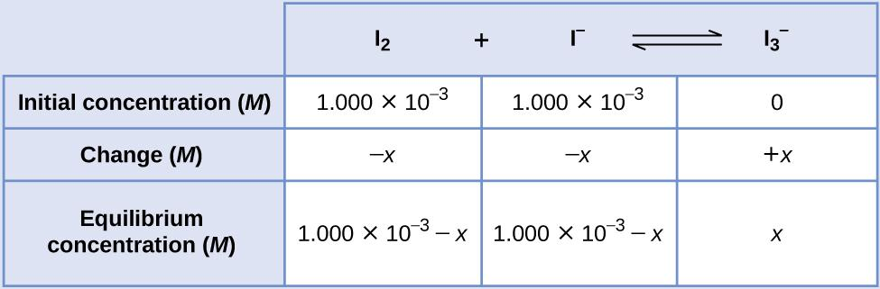
At equilibrium the concentration of I₂ is 6.61 × 10⁻⁴ M so that
1.000 × 10⁻³ − x = 6.61 × 10⁻⁴
x = 1.000 × 10⁻³ − 6.61 × 10⁻⁴
x = 3.39 × 10⁻⁴ M
The ICE table may now be updated with numerical values for all its concentrations:
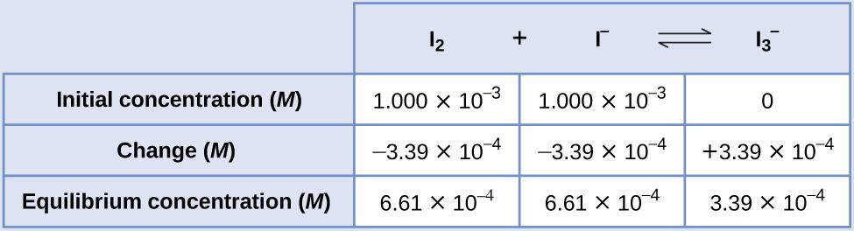
Finally, substitute the equilibrium concentrations into the K expression and solve:
K_{C} = $\frac{[I_{3}^{-}]}{[I_{2}][I^{-}]^{ }}$ = $\frac{3.39 ×10^{-4}}{(6.61 ×{10}^{-4})(6.61 ×{10}^{-4})}$= 776

Check Your Learning
Ethanol and acetic acid react and form water and ethyl acetate, the solvent responsible for the odor of some nail polish removers.
C₂H₅OH + CH₃CO₂H ⇌ CH₃CO₂C₂H₅ + H₂O
When 1 mol each of C₂H₅OH and CH₃CO₂H are allowed to react in 1 L of the solvent dioxane, equilibrium is established when 13 mol of each of the reactants remains. Calculate the equilibrium constant for the reaction. (Note: Water is a solute in this reaction.)
Answer: K_{C} = 4

Calculation of a Missing Equilibrium Concentration
When the equilibrium constant and all but one equilibrium concentration are provided, the other equilibrium concentration(s) may be calculated. A computation of this sort is illustrated in the next example exercise.

Example 13.8
Calculation of a Missing Equilibrium Concentration
Nitrogen oxides are air pollutants produced by the reaction of nitrogen and oxygen at high temperatures. At 2000 °C, the value of the K_{C} is 4.1 × 10⁻⁴ for the reaction:
N₂ (g) + O₂ (g) ⇌ 2 NO (g)
Calculate the equilibrium concentration of NO(g) in air at 1 atm pressure and 2000 °C. The equilibrium concentrations of N₂ and O₂ at this pressure and temperature are 0.036 M and 0.0089 M, respectively.
Solution: Substitute the provided quantities into the equilibrium constant expression and solve for [NO].
K_{C} = $\frac{[{NO]}^{2}}{{[N}_{2}]{[O}_{2}]}$
$[{NO]}^{2}$ = K_{C} ${[N}_{2}]{[O}_{2}]$
$[{NO]}^{ }$ = $\sqrt{{K_{C}[N}_{2}]{[O}_{2}]}$
$[{NO]}^{ }$ = $\sqrt{(4.1 × {10}^{-4})(0.036)(0.0089)}$
= $\sqrt{1.31 × {10}^{-7}}$
= 3.6 × 10⁻⁴
Thus [NO] is 3.6 × 10⁻⁴ mol/L at equilibrium under these conditions.
To confirm this result, it may be used along with the provided equilibrium concentrations to calculate a value for K:
K_{C} = $\frac{[{NO]}^{2}}{{[N}_{2}]{[O}_{2}]}$ = $\frac{(3.6×{10}^{-4})^{2}}{(0.036)(0.0089)}$ = 4.0 × 10⁻⁴
This result is consistent with the provided value for K within nominal uncertainty, differing by just 1 in the least significant digit’s place.

Check Your Learning
The equilibrium constant Kc for the reaction of nitrogen and hydrogen to produce ammonia at a certain temperature is 6.00 ×10⁻². Calculate the equilibrium concentration of ammonia if the equilibrium concentrations of nitrogen and hydrogen are 4.26 M and 2.09 M, respectively.
Answer: 1.53 mol/L

Calculation of Equilibrium Concentrations from Initial Concentrations
Perhaps the most challenging type of equilibrium calculation can be one in which equilibrium concentrations are derived from initial concentrations and an equilibrium constant. For these calculations, a four-step approach is typically useful:
- Identify the direction in which the reaction will proceed to reach equilibrium.
- Develop an ICE table.
- Calculate the concentration changes and, subsequently, the equilibrium concentrations.
- Confirm the calculated equilibrium concentrations.
The following example demonstrates the application of this strategy.

Example 13.9
Calculation of Equilibrium Concentrations Using an Algebra-Simplifying Assumption
What are the concentrations at equilibrium of a 0.15 M solution of HCN?
HCN (aq) ⇌ H+ (aq) + CN− (aq) K_{C} = 4.9 × 10⁻¹⁰
Solution: We have no products initially, Q_{C} = 0 and the reaction will proceed to the right. This means the change of concentration for the reactant will decrease, but the change of concentration of the products will increase.
Using “x” to represent the concentration of each product at equilibrium gives this ICE table.
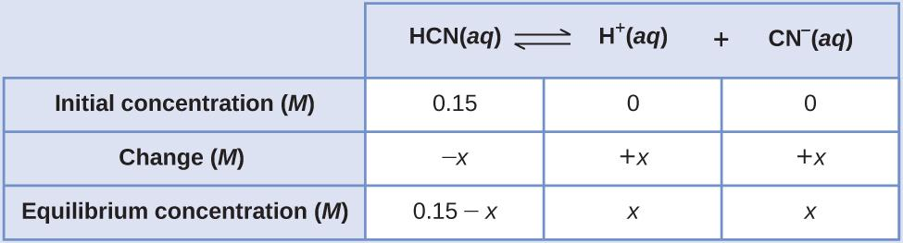
Substitute the equilibrium concentration terms into the K_{C} expression
K_{C} = $\frac{[H^{+}][{CN}^{-}]}{[HCN]}$ = 4.9 × 10⁻¹⁰
K_{C} = $\frac{(x)(x)}{(0.15 - x)}$ = 4.9 × 10⁻¹⁰
Note in this case that the change in concentration x is significantly less than the initial concentration (a consequence of the small K), and so the initial concentration experiences a negligible change:
If x ≪ 0.15 M, then (0.15 – x ) ≈ 0.15
This approximation allows for a more expedient mathematical approach to the calculation that avoids the need to solve for the roots of a quadratic equation:
K_{C} = $\frac{(x)(x)}{(0.15 - x)}$ = $\frac{x^{2}}{0.15}$ = 4.9 × 10⁻¹⁰
x² = (4.9 × 10⁻¹⁰)(0.15) = 7.4 × 10⁻¹¹
X = 8.6 × 10⁻⁶ M
The value of x calculated is, indeed, much less than the initial concentration
8.6 × 10⁻⁶ ≪ 0.15 M, and so the approximation was justified. If this simplified approach were to yield a value for x that did not justify the approximation, the calculation would need to be repeated without making the approximation.

Check Your Learning
What are the equilibrium concentrations in a 0.25 M NH₃ solution?
NH₃ (aq) + H₂O (l) ⇌ NH₄⁺ (aq) + OH⁻ (aq) K_{C} = 1.8 × 10⁻⁵

Answer: [OH⁻] = [NH₄⁺] = 0.0021M; [NH₃] = 0.25 M

13.5 Le Chatelier’s Principle

Learning Objectives
- Describe the ways in which an equilibrium system can be stressed
- Predict the response of a stressed equilibrium using Le Châtelier’s principle

Introduction
As we saw in the previous section, reactions proceed in both directions (reactants go to products and products to reactants). We can tell a reaction is at equilibrium if the reaction quotient (Q) is equal to the equilibrium constant (K). A system at equilibrium is in a state of dynamic balance, with forward and reverse reactions taking place at equal rates. If an equilibrium system is subjected to a change, then the rates are no longer equal. Thus, the system is not at equilibrium. The system will subsequently experience a net reaction in the direction of greater rate (a shift) that will re-establish the equilibrium. This phenomenon is summarized by Le Châtelier’s principle.
Le Châtelier’s principle states that if an equilibrium system is stressed, the system will experience a shift in response to the stress that re-establishes equilibrium.
We next address what happens when a system at equilibrium is disturbed so that Q is no longer equal to K. If a system at equilibrium is subjected to stress (such as a change in concentration) the position of equilibrium changes. As discussed in the Kinetic chapter, reaction rates are affected by changes in concentration and temperature; thus, we will explore the effect of these changes.

Predicting the Direction of a Reversible Reaction
Le Châtelier's principle can be used to predict changes in equilibrium concentrations when a system at equilibrium is subjected to a stress. However, if we have a mixture of reactants and products that have not yet reached equilibrium, the changes necessary to reach equilibrium may not be so obvious. In such a case, we can compare the values of Q and K for the system to predict the changes.

Effect of Change in Concentration on Equilibrium
A chemical system at equilibrium can be temporarily shifted out of equilibrium by adding or removing one or more of the reactants or products. The concentrations of both reactants and products then undergo additional changes to return the system to equilibrium.
The stress on the system in Figure 13.7 is the reduction of the equilibrium concentration of SCN⁻ (lowering the concentration of one of the reactants would cause Q to be larger than K). As a consequence, Le Châtelier's principle leads us to predict that the concentration of Fe(SCN)²⁺ should decrease, increasing the concentration of SCN⁻ part way back to its original concentration, and increasing the concentration of Fe³⁺ above its initial equilibrium concentration.
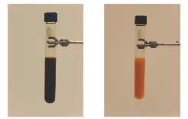
(A) (B)
Figure 13.7 (a) The test tube contains orange Fe³⁺, SCN⁻ , and red Fe(SCN)²⁺ ion at equilibrium, according to the reaction: Fe³⁺(aq) + SCN⁻(aq) ⇌ Fe(SCN)²⁺(aq).
(b) Silver nitrate has been added to the solution in (a), precipitating some of the SCN⁻ as the white solid AgSCN: Ag⁺(aq) + SCN⁻(aq) ⇌ AgSCN(s). This results in the decrease in the SCN⁻ concentration causing the reaction shifts to the left, increasing the concentration of Fe³⁺ and SCN⁻ (becoming more orange) and decreasing the concentration of the Fe(SCN)²⁺ (becoming less red) . (credit: modification of work by Mark Ott)
The effect of a change in concentration on a system at equilibrium is illustrated further by the equilibrium of this chemical reaction:
H₂ (g) + I₂ (g) ⇌ 2 HI (g) K_{C} = 50.0 at 400 °C
The numeric values for this example have been determined experimentally. A mixture of gases at 400 °C with [H₂] = [I₂] = 0.221 M and [HI] = 1.563 M is at equilibrium. For this mixture, Q_{C} = K_{C} = 50.0. If H₂ is introduced into the system so quickly that its concentration doubles before it begins to react (new [H₂] = 0.442 M), the reaction will shift so that a new equilibrium is reached, at which [H₂] = 0.374 M, [I₂] = 0.153 M, and [HI] = 1.692 M. This gives:
Q_{C} = $\frac{{[HI]}^{2}}{[H_{2}][I_{2}]}$ = $\frac{{(1.692)}^{2}}{(0.374)(0.153)}$ = 50.0 = K_{C}
We have stressed this system by introducing additional H₂. The stress is relieved when the reaction shifts to the right, using up some (but not all) of the excess H₂, reducing the amount of uncombined I₂, and forming additional HI.

Effect of Change in Pressure on Equilibrium
Sometimes we can change the position of equilibrium by changing the pressure of a system. However, changes in pressure have a measurable effect only in systems in which gases are involved, and then only when the chemical reaction produces a change in the total number of gas molecules in the system. An easy way to recognize such a system is to look for different numbers of moles of gas on the reactant and product sides of the equilibrium. While evaluating pressure (as well as related factors like volume), it is important to remember that equilibrium constants are defined with regard to concentration (for K_{C}) or partial pressure (for K_{P}). Some changes to total pressure, like adding an inert gas that is not part of the equilibrium, will change the total pressure but not the partial pressures of the gases in the equilibrium constant expression. Thus, the addition of a gas not involved in the equilibrium will not perturb the equilibrium.
As we increase the pressure of a gaseous system at equilibrium, either by decreasing the volume of the system or by adding more of one of the components of the equilibrium mixture, we introduce a stress by increasing the partial pressures of one or more of the components. In accordance with Le Châtelier's principle, a shift in the equilibrium that reduces the total number of molecules per unit of volume will be favored because this relieves the stress. The reverse reaction would be favored by a decrease in pressure.
Consider what happens when we increase the pressure on a system in which NO, O₂, and NO₂ are at equilibrium:
2 NO (g) + O₂ (g) ⇌ 2 NO₂ (g)
The formation of additional amounts of NO₂ decreases the total number of molecules in the system because each time two molecules of NO₂ form, a total of three molecules of NO and O₂ are consumed. This reduces the total pressure exerted by the system and reduces, but does not completely relieve the stress of the increased pressure. On the other hand, a decrease in the pressure on the system favors decomposition of NO₂ into NO and O₂, which tends to restore the pressure.
Now consider this reaction: N₂ (g) + O₂ (g) ⇌ 2 NO (g)
Because there is no change in the total number of molecules in the system during reaction, a change in pressure does not favor either formation or decomposition of gaseous nitrogen monoxide.

Effect of Change in Temperature on Equilibrium
Changing concentration or pressure perturbs an equilibrium because the reaction quotient is shifted away from the equilibrium value. Changing the temperature of a system at equilibrium has a different effect: A change in temperature actually changes the value of the equilibrium constant. However, we can qualitatively predict the effect of the temperature change by treating it as a stress on the system and applying Le Châtelier's principle.
When hydrogen reacts with gaseous iodine, heat is evolved.
H₂ (g) + I₂ (g) ⇌ 2 HI (g) ΔH = −9.4 kJ (exothermic)
Because this reaction is exothermic, we can write it with heat as a product.
H₂ (g) + I₂ (g) ⇌ 2 HI (g) + heat
Increasing the temperature of the reaction increases the internal energy of the system. Thus, increasing the temperature has the effect of increasing the amount of one of the products of this reaction. The reaction shifts to the left to relieve the stress, and there is an increase in the concentration of H₂ and I₂ and a reduction in the concentration of HI. Lowering the temperature of this system reduces the amount of energy present, favors the production of heat, and favors the formation of hydrogen iodide.
When we change the temperature of a system at equilibrium, the equilibrium constant for the reaction changes. Lowering the temperature in the HI system increases the equilibrium constant: At the new equilibrium the concentration of HI has increased and the concentrations of H₂ and I₂ decreased. Raising the temperature decreases the value of the equilibrium constant, from 67.5 at 357 °C to 50.0 at 400 °C.
Temperature affects the equilibrium between NO₂ and N₂O₄ in this reaction
N₂O₄ (g) ⇌ 2 NO₂ (g) ΔH = 57.20 kJ (endothermic)
The positive ΔH value tells us that the reaction is endothermic and could be written
heat + N₂O₄ (g) ⇌ 2 NO₂ (g)
At higher temperatures, the gas mixture has a deep brown color, indicative of a significant amount of brown NO₂ molecules. If, however, we put a stress on the system by cooling the mixture (withdrawing energy), the equilibrium shifts to the left to supply some of the energy lost by cooling. The concentration of colorless N₂O₄ increases, and the concentration of brown NO₂ decreases, causing the brown color to fade.

Catalysts Do Not Affect Equilibrium
As we learned during our study of kinetics, a catalyst can speed up the rate of a reaction. Though this increase in reaction rate may cause a system to reach equilibrium more quickly (by speeding up the forward and reverse reactions), a catalyst has no effect on the value of an equilibrium constant nor on equilibrium concentrations.
The interplay of changes in concentration or pressure, temperature, and the lack of an influence of a catalyst on a chemical equilibrium is illustrated in the industrial synthesis of ammonia from nitrogen and hydrogen according to the equation
N₂ (g) + 3 H₂ (g) ⇌ 2 NH₃ (g)
A large quantity of ammonia is manufactured by this reaction. Each year, ammonia is among the top 10 chemicals,
by mass, manufactured in the world. About 2 billion pounds are manufactured in the United States each year.
Ammonia plays a vital role in our global economy. It is used in the production of fertilizers and is, itself, an important fertilizer for the growth of corn, cotton, and other crops. Large quantities of ammonia are converted to nitric acid, which plays an important role in the production of fertilizers, explosives, plastics, dyes, and fibers, and is also used in the steel industry.
It has long been known that nitrogen and hydrogen react to form ammonia. However, it became possible to manufacture ammonia in useful quantities by the reaction of nitrogen and hydrogen only in the early 20th century after the factors that influence its equilibrium were understood.
To be practical, an industrial process must give a large yield of product relatively quickly. One way to increase the yield of ammonia is to increase the pressure on the system in which N₂, H₂, and NH₃ are at equilibrium or are coming to equilibrium.
The formation of additional amounts of ammonia reduces the total pressure exerted by the system and somewhat reduces the stress of the increased pressure.
Although increasing the pressure of a mixture of N₂, H₂, and NH₃ will increase the yield of ammonia, at low temperatures, the rate of formation of ammonia is slow. At room temperature, for example, the reaction is so slow that if we prepared a mixture of N₂ and H₂, no detectable amount of ammonia would form during our lifetime. The formation of ammonia from hydrogen and nitrogen is an exothermic process:
N₂ (g) + 3 H₂ (g) ⇌ 2 NH₃ (g) ΔH = −92.2 kJ
Thus, increasing the temperature to increase the rate lowers the yield. If we lower the temperature to shift the equilibrium to favor the formation of more ammonia, equilibrium is reached more slowly because of the large decrease of reaction rate with decreasing temperature.
Part of the rate of formation lost by operating at lower temperatures can be recovered by using a catalyst. The net effect of the catalyst on the reaction is to cause equilibrium to be reached more rapidly.
In the commercial production of ammonia, conditions of about 500 °C, 150–900 atm, and the presence of a catalyst are used to give the best compromise among rate, yield, and the cost of the equipment necessary to produce and contain high-pressure gases at high temperatures (Figure 13.8).
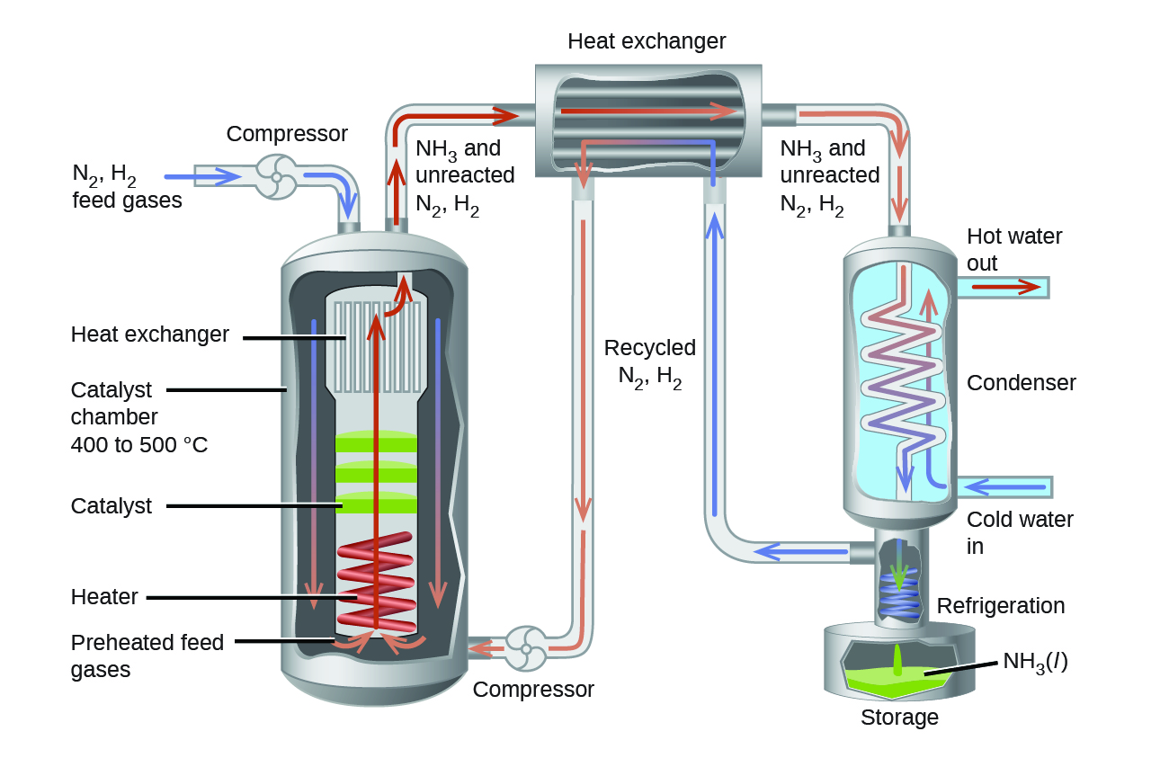
Figure 13.8 Commercial production of ammonia requires heavy equipment to handle the high temperatures and pressures required. This schematic outlines the design of an ammonia plant.

Portrait of a Chemist

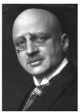
Fritz Haber
Although N₂ account for 78% of air, plants cannot use N₂ directly for growth due the tremendous stability of the nitrogen-nitrogen triple bond. For plants to use atmospheric nitrogen, the nitrogen must be converted to a more bioavailable form.
In the early 20th century, German chemist Fritz Haber developed a practical process for converting diatomic nitrogen into ammonia to be used as fertilizer.
N₂ (g) + 3 H₂ (g) ⇌ 2 NH₃ (g)
Haber was born in Wroclaw, Poland in December 1868. While he was studying at the University of Karlsruhe, he developed the catalytic formation of ammonia from hydrogen and atmospheric nitrogen under high temperatures and pressures. This process is known as the Haber process. Haber was awarded the 1918 Nobel Prize in Chemistry for this work. The Haber process allowed the production of fertilizers to no longer be dependent on mined feed stocks such as sodium nitrate. Currently, the annual production of synthetic nitrogen fertilizers exceeds 100 million tons and synthetic fertilizer production has increased the number of humans that arable land can support from 1.9 persons per hectare in 1908 to 4.3 in 2008.
In addition, Haber is also remembered by history as one of the fathers of chemical warfare. During World War I, he played a major role in the development of poisonous gases used for trench warfare. Regarding his role in these developments, Haber said, “During peace time a scientist belongs to the World, but during war time he belongs to his country.”^{[1]} Haber defended the use of gas warfare against accusations that it was inhumane by whatever means it was inflicted. He stands as an example of the ethical dilemmas that face scientists in times of war and the double-edged nature of the sword of science.
Like Haber, the products made from ammonia can be multifaceted. In addition to their value for agriculture, nitrogen compounds, such as ammonium nitrate can also be used in explosives, including improvised explosive devices.

Chemistry in Everyday Life

Equilibrium and Soft Drinks
The connection between chemistry and carbonated soft drinks goes back to 1767, when Joseph Priestley (1733–1804) developed a method of infusing water with carbon dioxide to make carbonated water. Priestly’s approach involved production of carbon dioxide reacting oil of vitriol (sulfuric acid) with chalk (calcium carbonate).
The carbon dioxide was then dissolved in water, reacting to produce hydrogen carbonate, a weak acid that subsequently ionized to yield bicarbonate and hydrogen ions:
Dissolution CO₂ (g) ⇌ CO₂ (aq)
Hydrolysis CO₂ (aq) + H₂O (l) ⇌ H₂CO₃ (aq)
Ionization H₂CO₃ (aq) ⇌ HCO₃⁻ (aq) + H⁺ (aq)
These same equilibrium reactions are the basis of today’s soft-drink carbonation process. Beverages are exposed to a high pressure of gaseous carbon dioxide during the process to shift the first equilibrium above to the right, resulting in desirably high concentrations of dissolved carbon dioxide and, per similar shifts in the other two equilibria, its hydrolysis and ionization products. A bottle or can is then nearly filled with carbonated beverage, leaving a relatively small volume of air in the container above the beverage surface (the headspace) before it is sealed. The pressure of carbon dioxide in the container headspace is very low immediately after sealing, but it rises as the dissolution equilibrium is re-established by shifting to the left. Since the volume of the beverage is significantly greater than the volume of the headspace, only a relatively small amount of dissolved carbon dioxide is lost to the headspace.
When a carbonated beverage container is opened, a hissing sound is heard as pressurized CO₂ escapes from the headspace. This causes the dissolution equilibrium to shift left, resulting in a decrease in the concentration of dissolved CO₂ and subsequent left-shifts of the hydrolysis and ionization equilibria. Fortunately for the consumer, the dissolution equilibrium is usually re-established slowly, and so the beverage may be enjoyed while its dissolved carbon dioxide concentration remains palatably high. Once the equilibria are re-established, the CO₂ (aq) concentration will be significantly lowered, and the beverage acquires a characteristic taste referred to as “flat.”
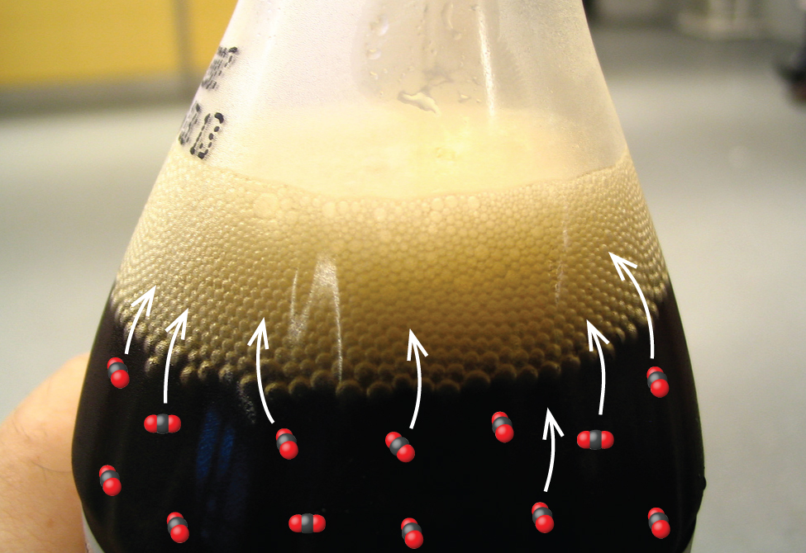
Figure 13.9 Opening a soft-drink bottle lowers the CO₂ pressure above the beverage, shifting the dissolution equilibrium and releasing dissolved CO₂ from the beverage.
(credit: modification of work by “D Coetzee”/Flickr)

Footnotes:

1. Herrlich, P. “The Responsibility of the Scientist: What Can History Teach Us About How Scientists Should Handle Research That Has the Potential to Create Harm?” EMBO Reports 14 (2013): 759–764.

