HUM 103 INTRODUCTION TO HUMANITIES Spring 2017
CRN 45543 Online Section

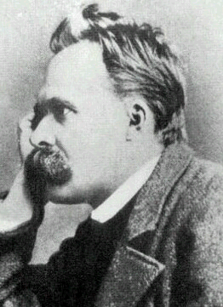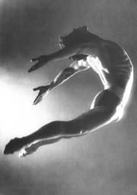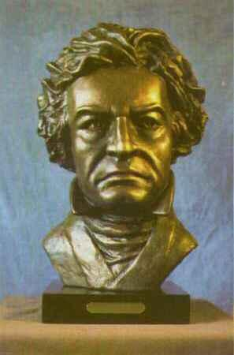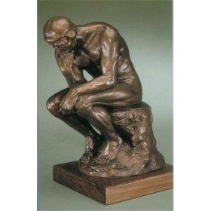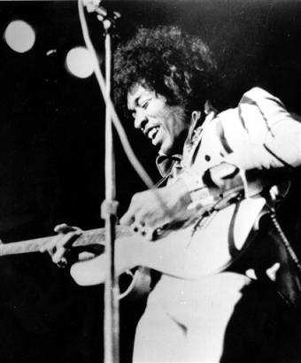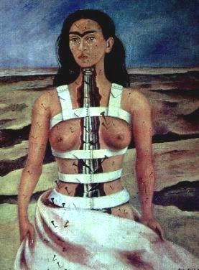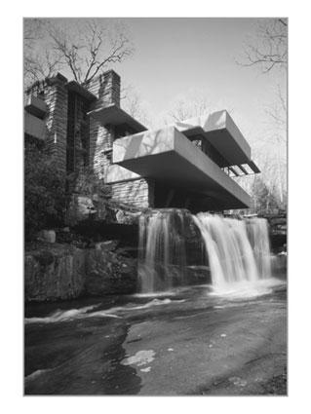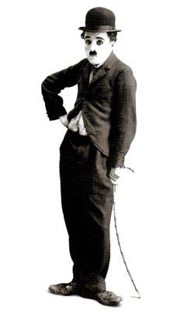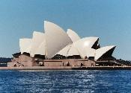

Instructor David Bockoven E-mail: bockovd@linnbenton.edu
Office: IA-218 Cell Phone: 541-543-3429
Office hours: Tu/Th 9-9:50 and by appointment
Class website on Moodle course management system: http://elearning.linnbenton.edu Look for course labeled HUM103_DB

COURSE CONTENT PREVIEW Have you ever wondered if music by Beethoven is more important than music by Louis Armstrong? What might Frank Lloyd Wright and Malcolm X have in common? What is minimalism? Pop art? Op art? What do romantics have in common with realists? What do people “see” in abstract art? What impact does war have on our culture? What inspires people to write music, create art, design buildings that challenge our sense of what “modern” means? In short, what changes have most influenced our 21st Century culture?
Our class will explore the connections between the arts, ideas and human experiences through the study and experiencing of selected works in art, philosophy, literature, history, architecture, drama, dance, and music from about 1800 to the present. Develop your skills in responding to any work of art by understanding the work itself, by appreciating its particular time and place, and by coming to know its unique cultural meaning.
Prerequisite: None. Co- or pre-requisite of WR121 strongly recommended.
Required Texts: Two books are required: Fiero, Gloria K. The Humanistic Tradition, Volume 5: Romanticism, Realism and the 19th Century World, 7th edition. and Fiero, Gloria K. The Humanistic Tradition, Volume 6: Modernism, Postmodernism, and the Global Perspective, 7th edition. New York: McGraw-Hill (2015). NOTE: An older edition is on reserve at LBCC's Main Campus library. Older editions are acceptable, but page numbers may not match. I have created a conversion chart accessible on Moodle which compares the reading assignments in the new edition with the 6th edition.

METHODS OVERVIEW: The Fiero Humanities textbook will be supplemented by online materials. Class assignments, study guides, and online resources will be posted weekly on our class website. You can anticipate using the Internet every week for online discussion to post your reactions to weekly readings and to respond to what others have written. You may also view PowerPoint slideshows online. You will attend and report on cultural events at a time and place convenient to you (for example, an art exhibit, play or concert) as a required part of our class. A Gallery Walk project may substitute for the event report. Finally, you will explore a particular work of art that you have discovered during the quarter or work with other students on a Web Quest project. There will be three exams which challenge you to explore what you have read and seen.

CLASS GOALS: Our class goals are immense – to expand our appreciation, awareness and understanding of our own and other cultures’ values, artifacts, and ideas. Much of what we discuss will be controversial and subject to interpretation, but all the cultural artifacts we study (even those we don’t understand) affirm the creativity and courage of individuals who pursue the very human urge to create something beautiful. Our class will help you to:
- Recognize how studying the humanities helps us to understand human thought, creativity, and aesthetics in a global and historical context.
- Critically interpret and evaluate artifacts and ideas from different cultures and different times, drawn from art, architecture, literature, philosophy, drama, music, dance and theater.
- Demonstrate how understanding the humanities can enhance our own creativity and our appreciation of our own and other cultures.
- Write and speak confidently about your own and other’s ideas about the humanities.
WAITLIST. Students not “attending” class during the first week will be withdrawn from the class, and waitlisted students will be admitted to the class on a “space available” basis. In an on-line context, “not attending” means not completing the first week’s online discussion assignment (due Sunday), or not contacting me by Sunday 4/09 to let me know you want to stay in the class. Many students want to add this class. If you know you want to drop, please do so as soon as possible or let me know so that as many students who do want to take the class can.

ASSIGNMENTS: Earn an “A” with 90% and above of total points, a “B” with 80%, a “C” with 70%, etc. Please talk with me any time to clarify your progress in our class. NOTE: If you need accommodations for learning, please speak with me as soon as possible.

Introductory E-mail during Week One 10 points
Online Discussion (10 points a week) 100 points
Three Reading Exams (33/33/34) 100 points
Project One: Event Reports/Gallery Walk 25 points
Project Two 40 points
Total Class Points 275 points

Detailed Assignment descriptions are posted on our Moodle class site that add to this Preview. See below for a brief description, too.
PROJECTS:
PROJECT 1 : (Due Sunday Week 6) Choose to do either an event report or a gallery walk, following the instructions below and more completely under the Assignments section of our Web site.
A. OPTION 1 Event Report (25 points). Attend an out-of-class event that relates to the humanities we’re studying (museum visit; theater, music or dance performance; history or philosophy lecture; architecture; photography or art exhibits). Write a 3 page paper that tells me what you did (be specific about who, what, where, when and why) and what your evaluation and reaction was for the event. Include outside source information on an aspect of what you see. Try an event you have never attended before!
.
- OPTION 2: Gallery Walk (25 points). Select 5 artifacts from the periods we’re studying, describe and discuss each artifact, then write a conclusion that summarizes why these particular artifacts are important. Include a bibliography and use in-text citations for images and information summarized or paraphrased from outside sources. See online assignment for more details.

PROJECT 2: (Due Wednesday Week 9)
A. OPTION 1: Art Work Exploration (40 points). For this option you will explore the text, context, subtext and modern significance of a work of art from the time period we are studying (c. 1800-2017). The result will be a 4-6 page thesis research paper which will be a combination of your analysis supported by outside research.

B. OPTION 2: Web Quest Project (40 points). This option is a team written presentation. With one or two other classmates, go on a Web Quest to answer your questions about a topic selected from the POSSIBLE TOPICS listed in the online assignment. Your team’s goal will be to create a group presentation (your choice of a PowerPoint presentation with essay, or an online paper with images, or a Web site, or a face-to-face presentation with essay). Each person will prepare the equivalent of a 3-4 page paper. See online assignment for more details.

WEEKLY ONLINE DISCUSSION (100 points). Earn 10 points each week by participating in class discussion. You’ll post your reactions to each week’s readings and respond to what others in your discussion group say. Emphasize your own thinking, interpretation, analysis, and personal reactions. Begin your response with a summary of the key ideas you will respond to, then liberally sprinkle your writing with “I thought,” or “This made me remember” or “I don’t understand why.” Use your own words to avoid plagiarism! Special Note: Weekly online discussion cannot be made up after the due date. PowerPoint presentations, study guides, and online resources and activities supplement each chapter. The LBCC Library has a good collection of videos covering our period that you may also find useful. You can earn 1 extra credit point each week if you post your initial post by midnight Wednesday.

When you post a message to the weekly discussion board, plan to post about 250-300 words in response to the ideas you’ve read. Then, when you respond to at least 2 other people, try for a minimum of 50-75 words, using your post to expand your understanding. Ask questions, talk online, and use this feature of our class to expand your understanding.
One of the goals of this course is to construct a "discourse community," a space in which students feel comfortable expressing their ideas openly. This means that on the discussion forums basic rules of etiquette should be followed. No personal attacks will be tolerated. Also, avoid talking while someone else is speaking or frequent use of cell phones/pagers. The LBCC community is enriched by diversity. Everyone has the right to think, learn, and work together in an environment of respect, tolerance, and goodwill. We will work toward creating a community without prejudice, intimidation, or discrimination. (related to Board Policy #1015). LBCC prohibits unlawful discrimination based on race, color, religion, ethnicity, use of native language, national origin, sex, sexual orientation, marital status, disability, veteran status, age, or any other status protected under applicable federal, state, or local laws.
EXAMS (33 or 34 points each) There will be three exams (multiple choice and short-answer essay questions) that encourage you to expand your understanding of the course content from the previous three week period. In addition to your own analysis and information from our text, you are encouraged to use at least one source from outside the textbook in answering at least one of the questions.
INCOMPLETE GRADES. You may be eligible for an "Incomplete" grade IF you have finished 75% of class work. If you have an "Incomplete," all coursework must be finished by the end of the next term. Please contact me before the end of the term if you need to use this option.

GUIDELINES FOR GRADING PAPERS AND PROJECTS: I encourage you to develop your own opinions about what you read and how this relates to what we are studying. "A" and "B" papers and discussion forums have a well-defined purpose, are logically organized, use evidence (from our reading or from research) to support general ideas, and are clearly written. They offer a reader thoughtful explanations, analysis of the meaning and/or context of the ideas, and your personal reactions. “A” and “B” papers and forum posts also have few spelling, grammar or punctuation problems and follow MLA (Modern Language Association) guidelines for quoting, summarizing and paraphrasing, bibliographies and in-text citations.

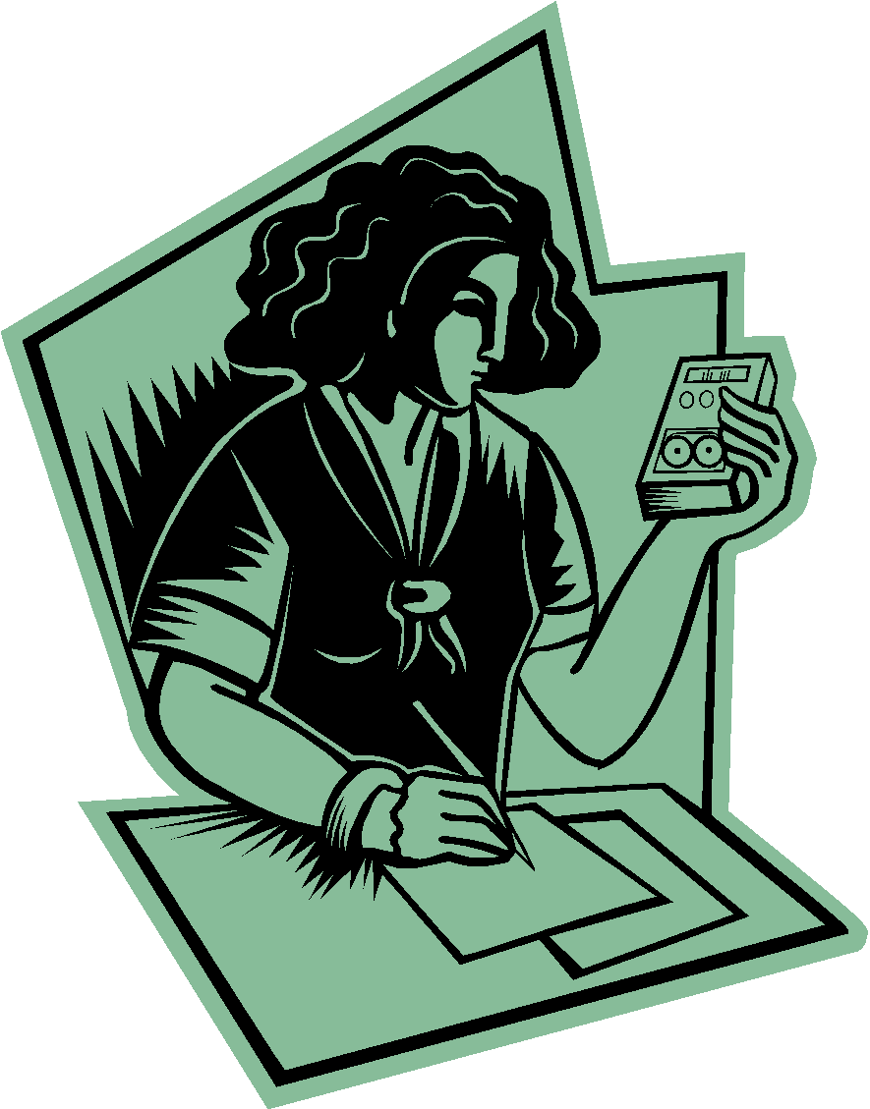
About Revisions/Late Work: Procrastination can lead to disaster and higher levels of stress! Plan to meet the weekly due dates for assignments. You may revise any assignment once (except as we move into the final two weeks of the term). If work is turned in below a "C," I may request revisions. All assignments are due by midnight of the dates shown. Please note that late assignments will not be graded if more than one week late without prior permission.
About Plagiarism: Our class is part of a larger academic community. We will follow standard MLA (Modern Language Association) guidelines for giving credit to outside sources in all assignments. Bibliographies (called “Works Cited” in MLA or “References” in APA) and in-text citations are required whenever you use outside sources, including sources from the Internet.

Do your own work. Using someone else’s work as your own or using information, images or ideas without proper in-text citations or a bibliography can lead to your failing the assignment or the class. NOTE: Bibliographies (called "Works Cited" in MLA) AND in-text citations (for example, Fiero 27) are required whenever you quote, paraphrase or summarize information that is an original idea or the information is not commonly known. These guidelines apply to all assignments (including EXAMS and ONLINE DISCUSSION) as well as to your use of any information, ideas or images from the Internet. If you have any questions about this policy, please contact me.
GUIDELINES FOR ASSIGNMENTS: To gain the most from our class, please:
- Plan to spend about 6 to 9 hours each week on reading and homework.
- Plan to stretch your understanding with each assignment. I will look for: thoughtful content, logical organization, a clear style, and appropriate format. Call or e-mail me to talk about any assignment or visit the Writing Desk in the Learning Center.
- When uploading your homework on to the class Moodle site, please use MS Word (.doc format or .docx), .pdf, or Rich Text format. I cannot accept WORKS format.
- Format your paper using 1 inch margins and 12 point font size (no fancy fonts or small print, please!). Doublespace your lines. Put YOUR NAME, the date, and the ASSIGNMENT NAME on all assignments at the top of the first page (a title page is not necessary).
- Use descriptive SUBJECT LINES in your E-mail. Please always include HUM103 and your last name in the SUBJECT LINE of any e-mail you send to me. If you need to reach me in an emergency, USE ALL CAPITALS in your subject line so I can respond quickly. Once the term gets going, I receive several e-mails a day. Here are examples of two subject lines:
To: bockovd@linnbenton.edu
Subject: Hum103 Question re Paper 1 (Jones)
Subject: Hum103 HELP RE QUIZ 1 (JONES)
- Plan to participate actively each week in online discussion. We may not agree with everyone’s posts we read or all that we talk about online, but we can learn much about other viewpoints and cultures when we are willing to share our ideas and when we listen to others with a sense of fairness and courteousness.

ABOUT MEETING WITH YOUR INSTRUCTOR: Since we will be working online, much of our work together is a conversation on the discussion forum, by e-mail or by phone. I will be holding office hours Tuesdays and Thursdays on the Albany campus in my office IA-218 9-9:50. I might be able to meet with you at a different time and place, if you arrange a time to meet in advance, but note that I live in Eugene and am only in this neck of the woods on Tuesdays and Thursdays.

Please plan to talk with me by e-mail or on the telephone during the first week of class if you have a documented reason for needing accommodations, if you feel I should know medical information about you, or if you need special arrangements in the event of an emergency. If you think you may need special accommodations, please contact the Center for Accessibility Resources, 541-917-4789.

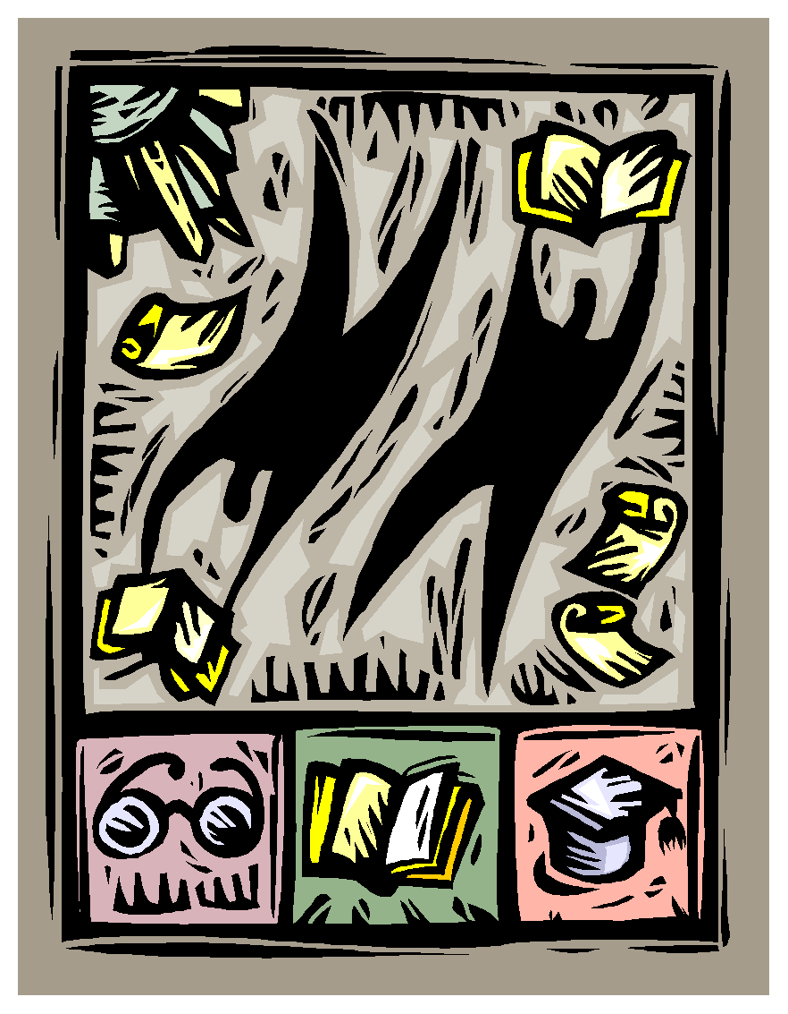
Added Note: If obligations outside school commitments (family, military, or work-related) begin to affect your successful participation in our class, please talk to me as soon as possible.

ABOUT MOODLE SKILLS. If you are new to Moodle or an on-line course environment, I encourage you to meet with me early on in the quarter. If technical difficulties develop, I beg your indulgence in trying to sort them out. Beginning Moodle users may find the Moodle orientation video on LBCC’s eLearning main page helpful.

Spring 2017 Schedule | Weekly Readings | Due this week
Week 1: Apr 3-9 | Book 5: THE ROMANTIC ERA: Romantic View of Nature. Read Chapter 27 (pages ix-xii, and 209-36). | Post Introductory Posting by midnight Thurs. 4/06; Post Online Discussion #1 by Apr 9
Week 2: Apr 10-16 | The Romantic Hero and the Romantic Style in Art and Music. Read most of Chapter 28 (pages 237-48 and 254-56) and Chapter 29 (pages 257-77). | Post Discussion #2 by Apr 16
Week 3: Apr 17-23  NOTE: LBCC closed Fri. 4/21 for In-Service | Book 5: REALISM AND EARLY MODERNISM: Industry, Empire and Realist Style. Read Chap. 30 (278-318). | Post Discussion #3 by Apr 23
Week 4: Apr 24-30 | The Move to Modernism. Read Chap 31 (pages 319-51). | Submit Exam #1 by Apr 30  Post Discussion #4 by Apr 30
Week 5: May 1-7 | Book 6: THE TRIUMPH OF MODERNISM: The Modernist Assault. Read Chap. 32 (pages 353-77). | Post Discussion #5 by May 7
Week 6: May 8-14 | The Freudian Revolution. Read Chapter 33 (pages 378-98) | Post Project #1 by Sunday May 14. Form WebQuest group for Project #2. Post Discussion #6 by May 14.
Week 7: May 15-21 | Total War, Totalitarianism, and the Arts. Read Chapter 34 (pages 399-422). | Submit Exam #2 by May 21. E-Mail Proposal for Project #2 by May 21. Post Discussion #7 by May 21
Week 8: May 22-28 | The Quest for Meaning. Read Chap 35 (pages 423-43). Begin Chap 36 Liberation and Equality (pages 444-63). | Post Discussion #8 by May 28
Week 9: May 29-June 04  - Friday Week 9 Last Day for late work. NOTE: LBCC closed 5/29 for Memorial Day. | Book 6: THE POSTMODERN TURN: Liberation and Equality. Finish Chapter 36 (pages 463-74). The Information Age. Read Chapter 37 (475-501) | Post Project #2 by Wednesday May 31.  Post Discussion #9 by June 4
Week 10: June 5-11 | Globalism: The Contemporary World Read Chapter 38 (pages 502-25). | Submit Exam #3 by June 14  Post Discussion #10 by June 11
Finals: Jun 12-14 |  | FINALS: Submit Exam #3 no later than Wednesday, June 14

