Syllabus for English 121

Writing 121 Fall 2018
CRN: 22645
Lebanon Center
Room 222
Tues/Thurs 3-4:20PM
Prof. Nannette Schultz
Office Hour: 2-2:50pm Tues/Thurs/By appointment
nannette.schultz@linnbenton.edu

Textbooks: Required
They Say, I Say 4th edition by Gerald Graff & Cathy Birkenstein
W.W. Norton & Company
New York/ London, 2018
IBSN: 978-0-393-63167-8

Recommended:
The Little Seagull Handbook
Paperback Dictionary

Final Exam Schedule: (Room 222)
Monday, Noon-12:50 pm Dec. 10, 2018
Tuesday, 11:30-12:20 pm Dec 11, 2018

Course Description:

121 (3 credits) Covers processes and fundamentals of writing expository essays, including structure, organization and development, diction and style, revision and editing, mechanics and standard usage required for college-level writing. Placement determined by pre-enrollment testing (CPT). Prerequisite: Placement in WR 121 is determined by pre-enrollment testing (CPT) or by passing WR 115 or ENL 115W (Introduction to College Writing for ELLs) with a grade of "C" or better. Students may challenge their mandatory placement, with an advisor's approval, by signing a self-placement form through their counselor.

Course Overview:

This is a required course for all Linn Benton students. It is considered a “gateway course”. The purpose of this course is to prepare students for the rigors of college writing expectations. It includes learning to paraphrase and quote sources for effective integration and cite sources using both MLA and APA formatting. This course requires a minimum of three essays that go through a revision process in different genres. (outside of class essays). Support assignments both in and out of class will be provided. Short in-class quizzes will be given to review terms. There is also a two-day final exam which is an in-class timed writing essay. Day One: The Rough Draft is written. Day Two: The final draft is written.

Course Outcomes:

Upon successful completion of this course, students will be able to:
Analyze the rhetorical needs (the interaction of audiences, purpose/outcome, and subject) of a variety of academic and practical writing assignments. Apply appropriate levels of critical thinking strategies (knowledge, comprehension, application, analysis, synthesis, evaluation) in response to the rhetorical needs of an assignment. Implement appropriate rhetorical elements and organization (introduction, thesis, development and support, rebuttal, visuals, narration, conclusion, etc.) in response to the rhetorical needs of an assignment. Locate, evaluate, and integrate high-quality information and opinion in response to the rhetorical needs of an assignment. Craft sentences and paragraphs that communicate their ideas clearly and effectively using words, sentence patterns, and writing conventions to make their writing clear, credible, and persuasive.

Grading:

At Linn Benton, all final course grades a full letter grades: A, B, C, D, F. There are no minus grades! The in-class timed writing exam is worth 30% of the final course score. The in-class participation, quizzes, and out of class essays will make up the other 70% of the final course score. Any final course grade below C will means the course will need to be re-taken. D and F grades can also have a negative impact on financial aid. Out-of class essays will go through a revision process. Credit will be given for on-time first time drafts. Final drafts will be more heavily weighted. I encourage additional revision for improvement of essay scores and for improvement of writing in general.

90-100=A
89-80=B
79-70=C
69-60=D
59-0=F

Course Breakdown:

3 Out of class Essays (total) 50% (16.66% each)
Class Participation 10%
Final exam 30%
Smaller homework assignments and quizzes 10%

Materials Needed:
- Textbook/Little Seagull or other writing guide
- Pens, paper, access to computers, printer paper
- A paperback dictionary is also very useful
- Two Blue/Greenbooks for final exam

Class Attendance and Participation is critical in writing courses. Writers should not work in complete isolation. Valuable insights can be gleaned from others who are struggling with same writing issues. As your instructor, I will serve as a writing coach and mentor not just someone who “imposes” grades. It is important to attend all classes if at all possible. Much our work will be in small groups which cannot be duplicated at home and alone. Small group work will be collected at end of class sessions to verify participation. Class Participation will be worth 10% of the overall course score. However, class participation should enable writers to become more effective writers and higher score on the three out of class essays. So, class participation is worth a lot than just the stated 10% here!

Professor Schultz’s Policies & Expectations

All essays of the out-of-class essays whether first draft or final draft MUST be typed:
- Doubled-spaced
- 14-point font
- Preferably: Georgia or Veranda type style
- Stapled if applicable
- Assignments should be proofread and edited Before submission

--Smaller homework assignments are recommended to be typed as well, I will accept handwritten but if I cannot read it, I cannot give you points!

Late Assignment Policy:

Assignments are due at the beginning of class hard copy.

--I reserve the right to take off 5% of the assignment grade for every class period that an assignment is late.

Exceptions: I will make an exception in the case of unforeseen and unavoidable emergencies of a documentable nature. I understand that life happens!!! If you know of something, ahead of time, coming up that will prevent you from attending a class session or turning in an assignment, then please discuss this we me and we can make the necessary arrangements. I am very happy to work with you but I cannot do that without communication. Communication with instructors is key to college success!

Revision Policy:

I will allow revision of any assignment that was turned in on-time for a higher grade! Theref0re, it is your best interest to turn all assignments on time.

Smaller Homework Assignments:

These are support assignments are will not be accepted for credit two weeks after initial due date as the relevance will be minimized…unless I make a specific arrangement individually or with the class.

Attendance will be noted every course session:

- In a writing course, everyone is a participant not an observer.
- Your presence is not only requested but it is required.
- Participation points cannot be earned without attendance.
- Participation points cannot be made up.
- You will have a harder time without the support of the team and the team will have a harder time without you!!!

Classroom Etiquette:

Electronics should be turned off and put away unless they are being used as part of the learning environment.

If you are expecting an important call or text, please put your phone on vibrate, and take the call in the hallway. Our time is very short in the classroom, so the attention needs to be on what is going in the classroom not what is what is going in in the outside world. They can wait!

I know that sometimes, we all forget to “silence out cell phones, now”. If cell phone use becomes a major distraction in our learning environment, then I reserve the right to impose the “baked goods policy”.

Simply: If an offending cell phone becomes a major source of distraction over time, the said offending phone’s owner will be required to sweeten rather than contaminate the learning environment. Entry into next class session will require a sweet treat (baked good) to shared will the class. This will only be at my discretion. This is not to turn into a “gotcha situation”. There will be ample warning in this situation.

Group Work and Peer Review are expected in this course:

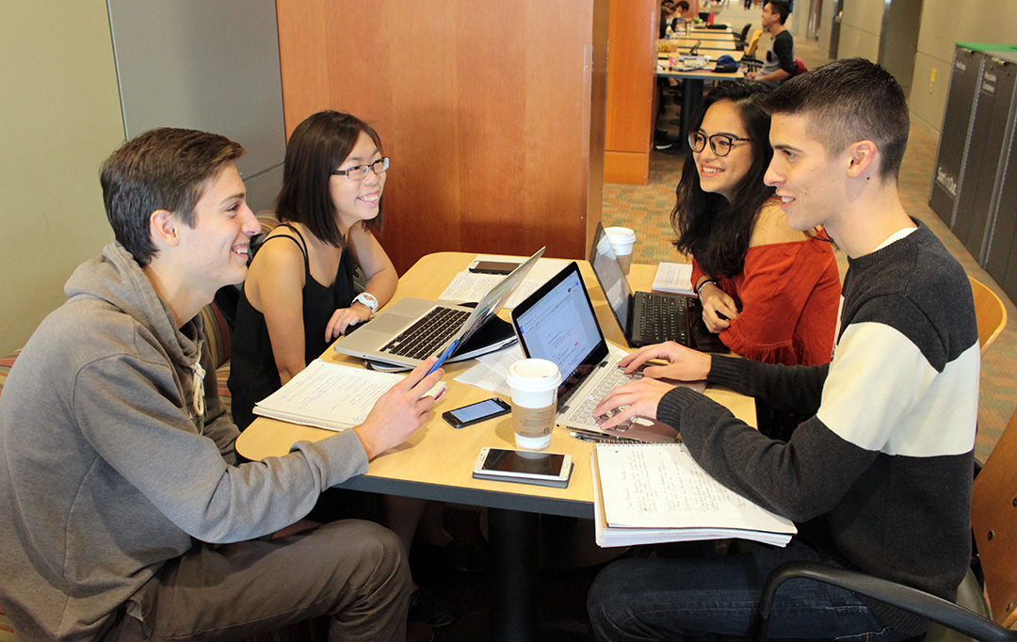

Small Group Work and Peer Review are required

- Come to class prepared and on time.
- Be willing to participate.
- Expect to share your writing.
- Be respectful of the ideas of others at all times!
- It is fine to disagree with ideas but not to disrespect the person.
- No “Ad Homonym” arguments—no name calling!
- Linn-Benton provides a safe and inclusive learning environment for all students. (See Student Rights and Responsibilities on the LBCC)
- Use the Golden Rule: Treat others the way you want to be treated!
- This will be an interactive classroom environment.
- Active Learning not passive learning will occur here.
- Overly disruptive behavior will not be tolerated.

Campus Resources

CFAR (located on main campus) www.linnbenton.edu/cfar
This is an office devoted to assisting students who have a learning or other type of disability. They can offer a wide range of services from alternate study materials formatting to extra time on exams and extending due dates with instructors. In order to receive these services, one needs to make an appointment to discuss what is needed. (541) 917-4328 Red Cedar Hall Room 105 (Coming soon to the Lebanon Center!!!)

Writing Center (On Main Campus)

They have peer tutors available and writing resources as well as a safe space to work. Linn Benton also has an online writing lab/ OWL that is available to all students remotely. They can provide feedback on writing assignments prior to submission.

Lebanon Center:

A Learning Center has provided for a safe and comfortable workspace in which students can type and print out papers. No tutoring is available there at this time.

Academic Honesty AKA Plagiarism

Academic Integrity is expected of all Linn-Benton students. All work that is turned in by students should be the work of that student. In a writing class, sources are often incorporated into a student’s writing. All borrowed words AND ideas must give credit where credit is due. One of the major things that we learn in this course is how to paraphrase effectively and to the use of in-text citations to distinguish between what is the student’s writing and what is another author’s writing. Anything that is deliberately turned in that is someone else’s work that is not credited to that other person is called PLAGIARISM. In the academic world and the workplace, the act of willful plagiarism is a major offense as it is stealing the work of others. Plagiarism or any form cheating in college is punishable by failing the assignment and/or the course. Multiple offenses can lead to permanent expulsion from the college.

My Definition of Plagiarism:
The willful and repeated (not accidental and not incidental) use of another person’s work. This class is the training ground for how NOT to commit accidental plagiarism. I expect that there will be mistakes in learning how to format in MLA and APA correctly. That is not a problem. Anyone who tries to take a shortcut a submit a paper not their own will be subject to the consequences mentioned above. In the end, one is only cheating themselves by not learning to write effectively.

Most Important:
I am here for you to help you be successful in college and in the later in the workplace by improving your writing skills and being ready for the new expectations of college level writing! Please so not hesitate to come see me in my office or make an appointment if the office hour time is not convenient. I can also be reached at email. I am happy to answer questions about anything in the course and provide feedback on drafts in progress!

This class is all about: Revise, Revise, Revise!!!

Stephen King says: “Write with the door closed but re-write with the door open!” (On Writing)

