Improvisation Recipe Book
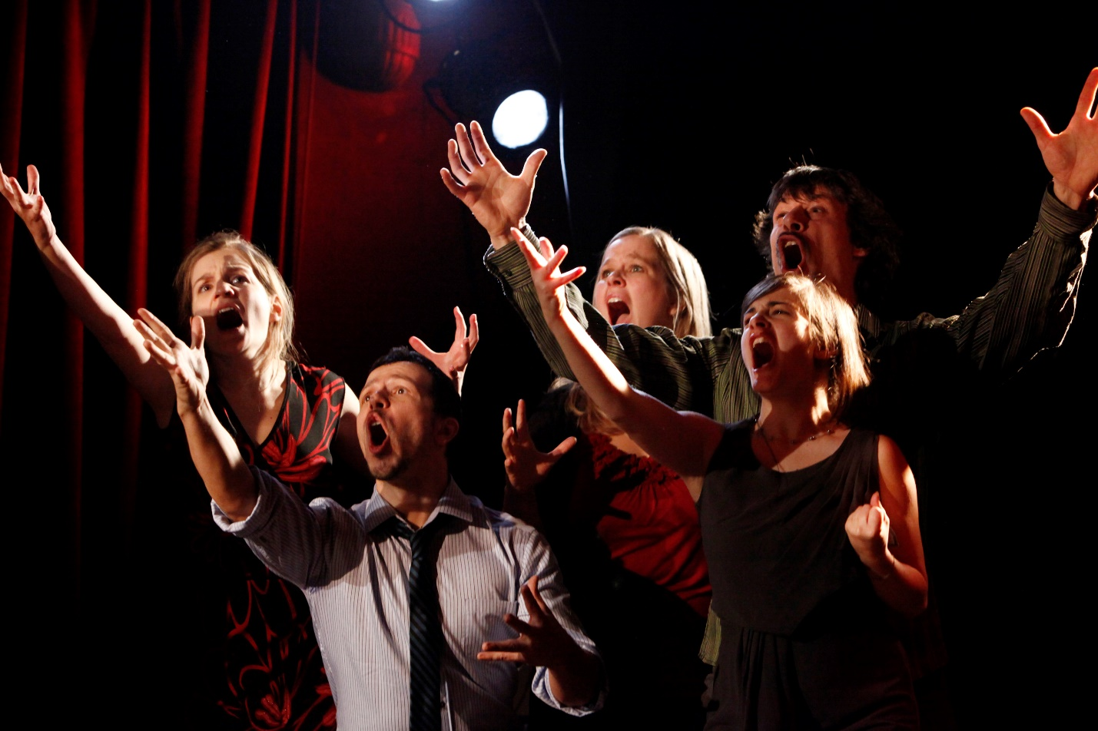
"Ligue d'improvisation montréalaise" by Aude Vanlathem is licensed under CC BY 2.5
The following recipes, or games, are intended to be used as reference and study for the college course: Improvisation. This format has been set up to help with ease of quick learning and immediate application. Bon Appétit ! - Dan Stone

Contents
Improvisation Recipe Book 1
First Course: Ready, Set, Go! 4
History: A Brief History of Improv 5
Improv Rules 7
Vocabulary: Theatre Terms 8
Improv Style: Long Form vs. Short Form Improv 9
Appetizers (AKA Warm-ups) 10
Tap-Out 11
My Day 12
Fruit Salad 13
Point and Cross 14
Twizzle 15
Fairytale Relay 16
Three Framed Fairytale 17
Entrees (AKA Games or Handles) 18
ABC’s 19
Changing Realities 20
Count Down 21
Dub-Movie 22
Lines from a Play 23
Action Movie 24
Sentence Smash 25
When the Bell Tolls 26
Expert Panel 27
So, I’m Dumping You 28
So, we’re firing you…. 29
Survivor 30
Interpreter 31
Improv in Business: Career Uses for Improv 32
Devised Theatre Through Improvisation 34
Getting Started - The Known 35
Fill in the Gaps 39
The Scenario 42
Development through Improvisation 46
My Day 48
Twizzle 48
Tap Out 49
Changing Realities 49

First Course: Ready, Set, Go!

History: A Brief History of Improv

The earliest well documented use of improvisational theatre in Eastern history is found in the Atellan Farce of Africa 391 BC. From the 16th to the 18th centuries, commedia dell'arte performers improvised based on a broad outline in the streets of Italy. In the 1890s, theatrical theorists and directors such as the Russian Konstantin Stanislavski and the French Jacques Copeau, founders of two major streams of acting theory, both heavily utilized improvisation in acting training and rehearsal.

Modern
Modern theatrical improvisation games began as drama exercises for children, which were a staple of drama education in the early 20th century thanks in part to the progressive education movement initiated by John Dewey in 1916. Some people credit American Dudley Riggs as the first vaudevillian to use audience suggestions to create improvised sketches on stage. Improvisation exercises were developed further by Viola Spolin in the 1940s, 50s, and 60s, and codified in her book Improvisation For The Theater, the first book that gave specific techniques for learning to do and teach improvisational theater. In the 1970s in Canada, British playwright and director Keith Johnstone wrote Impro: Improvisation and the Theatre, a book outlining his ideas on improvisation, and invented Theatresports, which has become a staple of modern improvisational comedy and is the inspiration for the popular television show Whose Line Is It Anyway?
Spolin influenced the first generation of modern American improvisers at The Compass Players in Chicago, which led to The Second City. Her son, Paul Sills, along with David Shepherd, started The Compass Players. Following the demise of the Compass Players, Paul Sills began The Second City. They were the first organized troupes in Chicago, and the modern Chicago improvisational comedy movement grew from their success.
Many of the current "rules" of comedic improv were first formalized in Chicago in the late 1950s and early 1960s, initially among The Compass Players troupe, which was directed by Paul Sills. From most accounts, David Shepherd provided the philosophical vision of the Compass Players, while Elaine May was central to the development of the premises for its improvisations. Mike Nichols, Ted Flicker, and Del Close were her most frequent collaborators in this regard. When The Second City opened its doors on December 16, 1959, directed by Paul Sills, his mother Viola Spolin began training new improvisers through a series of classes and exercises which became the cornerstone of modern improv training. By the mid1960s, Viola Spolin's classes were handed over to her protégé, Jo Forsberg, who further developed Spolin's methods into a one-year course, which eventually became The Players Workshop, the first official school of improvisation in the USA. During this time, Forsberg trained many of the performers who went on to star on The Second City stage.

Improv Rules

There are no absolute rules in improv but here are some commonly suggested principles:
- Listen: easier said than done, and that's exactly the point
- Agreement: say yes and add something, don't reject ideas
- Team Work: have a group mind, think of others
- Don't Block: stealing jokes / not listening / changing topic
- Relationship: focus on connection between characters, not just subject of scene
- Initiation: who, what, when to set the scene
- Point of View, Opinion and Intention: have them, these help express and build your character
- Be in Character: maintain character throughout the scene
- Don't Ask Questions: too many questions can make your partner do all the work
- Make Active Choices: Do something. Don't be talking heads

Vocabulary: Theatre Terms

A brief list of terms that relate to Improvisation Course work:
Ad-lib: When a performer improvises line on-stage.
Derived from ad libitum (Latin).
Amphitheater: an open-air theater, with seats rising in curved rows.
Apron: The front area of the stage, nearest the audience; the portion of the stage in front of proscenium arch.
Ask For: Question asked of the audience seeking information that is incorporated into any particular ‘handle’. Example: ‘Give me something that you do in your backyard’. Aside: A line spoken by an actor/actress directly to the audience, unheard by the other performers on-stage.
Auditorium: The portion of a theater which contains the audience seating.
Avante Garde: Experimental or innovative works or people, derived from the French.
Balcony: An elevated portion of seating in the back of the auditorium.
Curtain Call: At the end of a live performance the cast will come out and do a bow while the audience applauds.
Doubling: When an actor plays more than one character in a production. Most times this is done for economical reasons but it can be that because an actor would like to take on more than one role in the performance. Handle: Another word for ‘improv game’, term used for an improv game played in front of an audience.

Improv Style: Long Form vs. Short Form Improv

Article
The Difference Between Long– Form and Short-Form Improv by Dan Holloway via Backstage Magazine.

Videos
TEDX Victoria – Dave Morris: The Way of Improvisation

Appetizers (AKA Warm-ups)
This chapter is formatted to wet your appetite or in other words, warm you up!

Tap-Out
Serves: 10—15 Players
Cook Time: 10 min

Ingredients
- 10—15 Players
- An Audience ‘Ask For’
- Example object ‘Ask For’
- Trash can
- Fire Truck
- Cell Phone
- Toilet

Instructions
- One player makes an ‘ask’ for an object, item, or scenario
- At any time plyers may call ‘freeze’ and enter the scene
- Every time a player enters the scene, the scene must change completely, but be connected to whatever action or position was taking place in the previous scene.
- Only two players may be active at any time.

Notes
In ‘Tap Out’ all players arrange themselves in a ring or line, with one player to begin the game. This player makes an ‘ask for’: object, item, situation, etc. and begins the scene. At any time one player may call ‘freeze’ and enter the scene. Once a player has entered the scene they must change it completely, but have some connection to the position or actions taking place in the previous scene. The game works the best when done quickly, typically no more than 15-30 seconds should lapse before someone changes the scene. Linking the scenes to current events or humorous stories in the news also greatly increases the effectiveness of the game.

My Day
Serves: 2 Players
Cook Time: 20 min

Ingredients
- 10 Players
- Memory

Instructions
- Players are paired up
- Each player takes a turn telling the other player they’re activities for the entire day up until the moment they came to class
- While telling the partner of the activities they use physical movements to simulate that activity
- Players must continue talking without stopping or saying ‘um, um’
- After each player does this then partner A repeats the same story but at one point the Instructor will yell ‘Freeze’. The Instructor will then offer a prompt, example: ‘Suddenly, Big Foot shows up with a bundle of flowers.”
- Once the prompt is heard the player must incorporate that prompt into their original story.

Notes
Players must maintain eye contact, cannot break eye contact.

Fruit Salad
Serves: 2 Players
Cook Time: 20 min

Ingredients
- 8 - 20 Players
- Chairs

Instructions
- Players sit in a chair which are arranged in a circle facing inwards. One Player is in the middle and does not have a chair.
- The person in the middle needs to say something that applies to at least 2 people in the circle, example: ‘anyone wearing blue’
- All those ‘wearing blue’ get out of chair and try to find an empty chair to sit in, including the person in the middle.
- The person in the middle tries to sit down. There'll be one person left without a chair- this person will be the next person in the middle of the circle. The standing person starts a new round by saying a different statement.
- Players cannot move to the seat immediately to their left or right.
- Players avoid being left in the middle of the circle.

Notes
The person in the middle needs to say something that applies to at least 2 people in the circle. For example, “Anyone who has a dog”, “Anyone who likes sushi”. If the person’s statement applies to someone sitting in the circle, that person has to move from his or her seat and sit in a different chair. If the person says "Fruit Salad", then everyone needs to move to a different chair.

Point and Cross
Serves: 15 Players
Cook Time: 20 min

Ingredients
15 - 20 Players

Instructions
- Players stand in a circle facing inward.
- One play begins by pointing to some across the circle.
- The player being point to then nods in recognition of the ’pointer’.
- Once the ’pointer’ gets a nod they begin crossing the circle to the spot where the player who nodded is standing.
- The player who nodded must then point to someone else in the circle, receive a nod and then cross to their position before the first pointer reaches their spot.
- This continues until the focus is broken.

Notes
This game is intended to help players focus and constantly be in a position of readiness. At no time are players supposed to be on their toes or walking as they point. Players should stand in Neutral with a sense of ease.

Twizzle
Serves: 15 Players
Cook Time: 20 min

Ingredients
15 - 20 Players

Instructions
- Players stand in a circle facing clockwise
- Cues are words that the players must execute throughout game.
- Cues: Go: Walk
- Cue: Turn: pivot and face opposite direction
- Cue: Jump: Jump and land facing in opposite direction
- Cue: Twizzle: Jump while spinning 360 degrees in air and land in the same direction as started.
- At anytime the Instructor will call out these ‘Cues’ and the players must comply or be asked to sit in the middle of the circle or Mush Pot.
- This is an elimination game.

Notes
Players must freeze in the position they landed after executing the ‘cue’. No scratching, adjusting clothing or talking. If any of this occurs then that player goes to the middle of circle and sits in the mush pot.

Fairytale Relay
Serves: 15 Players
Cook Time: 20 min

Ingredients
10 - 20 Players

Instructions
- Players are broken into groups of 3 to 5
- Instructor stands/sits in middle of room evenly distant from each group that is stationed in the corners of the room/space.
- Instructor is holding cards with well known or reviewed fairytales.
- One players from each group runs up and looks at the card and begins ‘acting out’ the fairytale until their group guesses.
- Once a group guesses the fairytale the player runs back to the Instructor and grabs the card, returns to their group and a new player begins the whole process again.

Notes
Players cannot communicate in any other way other than physical, no mouthing words. Players must return to their group before acting out the fairytale, no stopping half way to group in order to eliminate distance to retrieve card from Instructor.

Three Framed Fairytale
Serves: 15 Players
Cook Time: 20 min

Ingredients
10 - 20 Players

Instructions
- Players are broken into groups of 3 to 5
- Instructor gives a card to each group with a fairytale on it.
- Groups work to create tableaus or frozen ‘pictures’ of three moments in the story.
- The three tableaus are of all members in the group and must display the beginning, middle and end of the fairytale.
- Once a group shows the three tableaus the audience guesses which story they were telling.

Notes
Players cannot communicate or move in the tableaus, they must do their best to illustrate the moment in the story in only a picture.

Entrees (AKA Games or Handles)

ABC’s
Serves: 8
Cook Time: 5 min

Ingredients
- 8—10 Players
- Audience ‘Ask For’ suggestions:
- ‘Give us a suggestion for a heart-to-heart discussion between family members’

Instructions
- Players partner assigning ‘a’ or ‘b’
- Player ‘A’ must begin the scene with a sentence starting with the letter ‘A”
- Player ‘B” then must respond with the next sentence starting with the letter ‘B’.
- Players alternate letters of the alphabet until they reach ‘Z’.

Notes
To play this game plyers must create a rapid fire scene based on changing dialogue. Players must be in sentences with lets of the alphabet and alternate between each other with the next letter. Scene or relationships between the players are to be determined at random by the audience, or an ‘Ask For’.

Changing Realities
Serves: 4
Cook Time: 5—10 min

Ingredients
- 8—10 Players
- Example of ‘Ask For’: ‘Give me an object’

Instructions
- 4 Players line up
- 1 Plyers begins with an ‘Ask For’
- Each player subsequently stops the scene and chest it with their own introduction
- The 4th player to enter the scene must find a reason to leave the scene
- After each player leaves the scene it reverts back to the previous moment
- Players may not use dancing as a means of excusing themselves from the scene or beginning one.

Notes
This game begins with a group of 3 to 5 players; though 4 players is ideal. The first player begins the game by making an ‘Ask For’ be it an item, a situation or a profession. At any point the remaining players can call out ‘freeze’, the scene then stops and that player changes the scene to whatever the player(s) appears to look like they are doing. When the final player enters the scene is t is their job to change the location, position, or action of all other players and then find a justifiable reason to leave the scene. After a player leaves the scene all remaining players revert to previous scene but must now justify their new positions or movements. This is repeated until the original player is the only one left on stage.

Count Down
Serves: 4
Cook Time: 5—10 min

Ingredients
- 4 Players Props or items in room
- Ask For’s:
  - “Give me a family run business”
  - “Why are the customers come to this business?”

Instructions
- 2 Players are given a family business and a profession and a sinister or bizarre secret timed to the job.
- 2 Players are given a relationship between each other or alternative profession, and a strange quirk about them.
- The first 2 players are given 1 minute to construct a scene based on their context.
- After 1 minute the remaining 2 players enter the scene and must interact with the previous 2 players’ scene for one additional minute.
- At the end of the two minutes the entire scene is done again, but each group of player’ time is cut to 30 seconds each, (1 min. total)
- This is then repeated again to 15 seconds each (30 min. total)
- Continue to only 5 sections per group (j10 sec. total)
- Finally the entire scene is performed one more time in the span of 1 second.

Notes
This game begins with 4 players, paired up into two groups. The information for scene is acquired through an ‘ask for’. The game starts with 1 minute of the first pair creating a scene based on their environment. After 1 minute the second pair enters and must interact with their ‘strange event’, while exhibiting their strange quirk, this too is given 1 minute. After 2m minutes the players must perform the entire scene again, recreating as much of the same dialogue and physical interactions that too place in the previous scene, in half the time. This is done again in the half then time, then in a total of 10 seconds, and finally all in 1 second.

Dub-Movie
Serves: 4
Cook Time: 5—10 min

Ingredients
- 4 Players
- 2 chairs
- Suggested ‘Ask For’: “Give us something that would happen in an action movie”.

Instructions
- Two players take a seat with their backs to the stage
- The two seated players act as the voice of the other players in the center of the stage (they cannot see the standing actors)
- The two players who are not seated must act out everything that is said by the other players and cannot speak

Notes
This game begins with each of the two players being assigned as the voice over of the other two players (they cannot see on stage). These two must remain seated in with their backs to the ‘movie’ or other players on stage and cannot see whe either player is doing. The objective of these two players are to provide all the dialogue and actions of the other two players they cannot see. On the flip side the players acting out the ‘movie’ are not allowed to speak and must act out all of the ‘dubbers’ actions/story.

Lines from a Play
Serves: 2 –3
Cook Time: 5—10 min

Ingredients
- Players
- 2 –3 Scripts
- Suggested ‘Ask For’: “Give us something you do on vacation.”

Instructions
- Scripts are selected at random from a stack of plays
- Plays are opened to a random page determined by the audience.
- The starting line of each page is determined by the audience
- This is repeated for however many players will be reading lines from the scripts
- Players reading from scripts may only read lines from that play
- Players can read any lines in the script
- At least one player must not have a script.

Notes
This game starts with two of three players and all but one of them receiving a random script from a wide selection of plays. Each script has its starting page and starting line decided by the audience who will shout out ‘stop!’, as the player randomly flips through the script. Players reading from the script may only read lines from the play but can read any lines in any order and are not restricted to lines from any other character. The remaining player (s) must react to the dialogue t the other players and create a scene based on the context given by the audience.

Action Movie
Serves: 3
Cook Time: 5—10 min

Ingredients
- Players
- Audience ‘ask for’
- Suggested ‘Ask For’: “Give us a situation found in an action film”
- Example:
  - Disarming a bomb
  - High speed car chase
  - Hijacking a plane

Instructions
- 2 Players are given 2 separate words or phrases. They can only speak using those phrases.
- 3rd Player is the leader of the team, he/she is free to speak. They guide the two other players through the scene.

Notes
During this game the audience is asked to provide 4 words or phrases which are divided among two of the players. These players can only speak using the phrases prescribed to them. The audience is then asked for the scene from an action movie or a situation in which something exciting is happening. The player without any restrictions is then left to drive the scene and react to whatever is being said. This game typically works best when players vary their tone and inflection with their phrases, and find ways for their phrases to interact with each other as well as the player with no restrictions.

Sentence Smash
Serves: 2
Cook Time: 5—10 min

Ingredients
- Large selection of random sentences on slips of paper
- Suggested ‘Ask For’’:
  - Give us something you do in the backyard
  - Family run business
  - Something that would happen in a science fiction film

Instructions
- Each player takes a handful of slips of paper with random sentences on written on them.
- Throughout the scene the players must pull out the slips of paper and incorporate the sentence within the scene.

Notes
In this game players are given a large assortment of random sentences provided by the audience. The audience then gives them context for a scene such as an everyday situation, a profession or an unusual scenario. Players must improvise from the information provided and periodically pull out the slips of paper and incorporate the sentence into the scene. This is done to the greatest effect when the players either pull out their slips white the other player is speaking, or playing off the fact that they are reading something. Things such as ‘look at this sweet love note my honey left this morning’ or ‘look at what my eviction notice says’ works well.

When the Bell Tolls
Serves: 3
Cook Time: 5 min

Ingredients
- Bell, Buzzer, or noise maker
- Suggested ‘Ask For’: Give us a skilled trade

Instructions
- 2 Players are given a situation, profession, or relationship
- At any point the remaining player may ring the bell or buzzer
- When the bell or buzzer is sounded, whoever spoke or acted last must immediately change their action to something else
- The bell or buzzer must be rung at least twice in a fairly quick succession

Notes
Players must think quickly and be prepared to say or do almost anything. Two players will be given a profession or relationship between each other and begin a scene. At any time another player may ring the bell. When this occurs the last player to say or do something must immediately say or do the opposite, or change what they said or did completely. The bell ringer must buzz or ring at least twice but may do so a long as it is appropriate and entertaining for the audience.

Expert Panel
Serves: 4 –6
Cook Time: 5—7 min

Ingredients
- Chairs for Players to sit
- Suggested ‘Ask For’: Give us 3 unusual careers or jobs

Instructions
- Each of the players are given a bizarre area of expertise from the audience.
- Players are given a topic affecting the world and must discuss it.
- Players must find a way to incorporate or connect the subject to their area of expertise.

Notes
4 to 6 players begin with an ‘ask for’: a bizarre area of expertise to each of the players to be ‘experts’. The audience is then asked for a problem facing the world for the ‘experts’ to address. The players must then discuss how to solve the problem or how the problem is directly connected to their area of expertise.

So, I’m Dumping You
Serves: 4 –5
Cook Time: 5—7 min

Ingredients
- 2 chairs

Instructions
- 1 Player is the ‘dumpee’
- 1 Player is the ‘dumper’
- Remaining players are various employees or a restaurant where the ‘dumping’ or break-up occurs.
- Dumpee leaves the room while the remaining players ask audience for:
  - 3 reasons why the dumpee is being dumped
  - Where the dumper is moving
  - and a new profession for the dumper.
- Dumpee comes back into the room and must begin scene without knowing the above ‘ask fors’.
- Dumpee must guess why they are being dumped, where the dumper is going and what their new job will be.
- Remaining players may help give cues; preferably through action.

Notes
‘Dumpee’ player leaves room. Meanwhile one of the other players is designated as the ‘dumper’ who asks the audience for the necessary info for scene (see above). When the ‘dumpee’ returns they are greeted by on eof the remaining players who will play the role of the restaurants server/waiter. The dumpee and the dumper begin with small talk until the dumper says ‘so, I’m dumping you…..” At this point the dumper and the remaining players must give only clues to the dumpee who then must guess why they are being dumped, where dumper is moving and what their new job will be.

So, we’re firing you….
Serves: 4 –5
Cook Time: 5—7 min

Ingredients
- 2 chairs

Instructions
- 2 players are the ‘bosses’
- 1 player is being fired
- Remaining players are various employees where the firing occurs.
- Employee to be fired leaves the room while the remaining players ask audience for: 3 reasons why they are being fired and what the business they actually are being fired from.
- Remaining players may help give cues; preferably through action.

Notes
1 Player who is being fired from the company leaves the room while the ‘ask fors’ are established (see above). The player returns to the room greeted by one of the remaining players who is their fellow ‘co-worker’. The player and the two bosses begin a dialogue until they say ‘so, we’re firing you….’. At this point the bosses and the remaining players must give clues to the player being fired who then guesses all the ‘ask for’ information.

Survivor
Serves: 4 –5
Cook Time: 5—7 min

Ingredients
- Suggested ‘Ask For’: “Give us something you would do on a deserted island”

Instructions
- Players ask the audience for a situation that might occur on a deserted island.
- Players then act out the scene for approximately 2 minutes.
- At the end of 2 minutes one player is ‘voted off the island’ by the audience.
- The remaining players then act out the scene again.
- This continues until only one play remains.

Notes
Players ask the audience for a scenario that could happen on a deserted island. Next the players must act out the scene, approx. 2 minutes. At the end of 2 minutes the audience then ‘votes off’ one of the players. The remaining players must then act out the scene in its entirety, including moments when the voted off player was involved. This continues until only one player remains who will then act out the entire scene by themselves.

Interpreter
Serves: 2
Cook Time: 5—7 min

Ingredients
- Podium or Music Stand

Instructions
- 1 Player is a fictional foreign dignitary
- 1 Player is the other player’s ‘interpreter’
- The dignitary asks the audience for the name of a fictional country
- The interpreter asks for a crisis affecting the world
- The dignitary speaks in gibberish about the topic
- The interpreter ‘translates’ whatever the dignitary is saying

Notes
One player is designated the leader of a fictional country with its own language (gibberish). The audience is asked to provide the name of the fictional country and a problem facing that country. The dignitary then begins to speak about the problem facing their country. The interpreter then translates what they dignitary is saying for the audience.

Improv in Business: Career Uses for Improv

Purpose of the study
This study aims to contribute to the need for sound theory development and empirical research in the field of improvisation training by providing empirical evidence to support the use of improvisational theatre techniques for enhancing climate for work group innovation. It also aims to contribute to the development of the existing theory in making explicit the link between the principles of improvisational theatre and the factors of climate for work group innovation.

Current theoretical perspectives
Improvisational theatre is a form of theatre that does not use a script or predetermined ideas for dialogue, direction or movement (Nevraumont, Hanson & Smeaton, 2002). The performance is executed spontaneously and without any preconceptions in response to the immediate stimuli of the environment (Frost & Yarrow, 1990). These stimuli include suggestions from the audience about the characters, location, situation and style of the scene and include offers made by fellow actors on stage (Nevraumont et al., 2002). In order to create successful performances, improvisational actors must therefore work together as a cooperative team (Frost & Yarrow, 1990). Although improvisational theatre performances are unpredictable, this does not imply that they are without substantial structure or principles. These principles are trust and support, acceptance, listening and awareness and narrative skills. It is suggested here that these principles relate to the factors supportive of an innovative work group climate.

Improvisational training in organizations
Background: Recent research results have shown that creativity and originality are neglected in the formal educational system (Beard & Wilson, 2002). It has, however, been suggested that individuals can relearn to be creative and spontaneous (De Bono, 1982; 1990; Vera & Crossan 2005). Improvisational theatre has shown that the potential to be creative and spontaneous can be rediscovered and developed through exercises. According to Izzo (1997) and Lowe (2000), creativity and spontaneity are improvisational skills and can be learned by anyone, as long as learners understand and apply themselves to the principles. Learning can take place during experiential training that incorporates theatre games and exercises (Frost & Yarrow, 1990; Izzo, 1997; Spolin, 1963).
Process of improvisational training: Improvisational training involves the playing of theatre games designed to develop process skills (e.g. listening and communication), context-specific knowledge (a perspective and a context that enable team members to leave their comfort zone) as well as techniques that promote acceptance and shared responsibility (Crossan, 1998). Therefore improvisational theatre exercises provide a context wherein individuals can learn experientially the principles necessary for innovation. Teams develop through playing, seeing that bonds of communication are created between the playing members as well as through experiencing shared attitudes and behavioural patterns (Pirola-Marlo et al., 2002). Can it therefore be argued that a work group which is exposed to an improvisational theatre training programme would not only learn skills that would help the individual to be more innovative, but would also create shared attitudes and behaviours that could benefit the group as a whole? This question deserves note, as this study is concerned with whether or not climate for work group innovation, (as a shared attitude toward the work environment) would be influenced by improvisational interventions. Improvisation is a skill that can be learnt by applying oneself to the principles of improvisational theatre when playing theatre games (Frost & Yarrow, 1990; Izzo, 1997; Spolin, 1963). Furthermore, the skill of improvisation promotes a group’s capacity to innovate (Vera & Crossan, 2005).

Devised Theatre Through Improvisation
Dan Stone
This article deals with devising a new piece of theatre through the use ensemble based collaboration, research and improvisation.
Often times when we as Theatre practitioners think about producing a play we sometimes start rummaging through old anthologies of plays and online play databases looking for something that might inspire us to pursue. I can’t tell you how many times I have gone through the many volumes of play anthologies in my library in search of that one play that gets my creative juices flowing. After a while my eyes glaze over and everything starts looking the same. Then this feeling of a cannonball resting at the base of neck starts as I become bogged down from perusing pages upon pages of plays that I’ve seen or read a millions times. I then stop and say to myself “Why are you doing this?”. “We don’t need no stinking play!”. “Let’s make our own!”. Of course, there’s far more to it than just making a proclamation. There’s a ton of planning, research and creating.
Finding a method or approach to the creation of a new work is one of the first things we must tackle. How are we going to this? The process that I will be laying out here will focus on methods that can be used while working with an ensemble of actors and designers. The purpose is to create a new work of Theatre created through guided collaborative improvisation. I believe the word guided is an important term here. This term indicates that information is funnelled or distilled through an outside pair of eyes. This usually means that a director is guiding the ensemble through this process. For this process I will be referring to a course I taught at Linn-Benton Community College in devising theatre. In this particular course we were tasked with devising a new theatre for children play based on the origin story of the character, Scarecrow, from the Wonderful Wizard of Oz.
You can “devise” a piece of theatre through inspiration from numerous sources and/approaches. One can merely take an idea, life experience, social issue, myth, folk story, news headline as material to begin the process in the creation of a new work of theatre. The possibilities are endless. Within our work with Sanctuary Stage, in a style of theatre called, Community Engaged Theatre or Theatre of Place, we use material gained from personal interviews and story circles from members a micro-communities found within our larger communities to create new work about the people who live around us. In this current project we are using a piece of literature that exists within the public domain. This is important when working with a piece of literature or any other copy written material. Unless you get written permission from from the original creator or his/her estate you should stick with material found within the “public domain”. It just so happens that, The Wonderful Wizard of Oz has just recently entered the public domain.

Getting Started - The Known
The first thing I ask students when devising a piece of theatre from scratch is: “What are our knowns?” “What solid information do we have right now?”
- We know that this play will be our children’s theatre play for next year.
- We know we are telling the origin story of the character, Scarecrow, from the book The Wonderful Wizard of Oz.
- We know that the only information about the origins of the Scarecrow come from a few paragraphs found in the chapter, Road Through the Forest, found in the book, The Wonderful Wizard of Oz.
- We know that the play will be performed in front an audience of children ranging in grades from Kindergarten to 8th.
- We know that the play can only run from 45 minutes to an hour in length.
- We know that we will have two performances a day every Tuesday and Thursday one at 10:00am and the second at 12:30pm.
- We know that we will have three Saturday matinee performances.
Below is an expert from the chapter, Road Through the Forest, from The Wonderful Wizard of Oz by Frank Baum
The Scarecrow looked at her reproachfully, and answered:
"My life has been so short that I really know nothing whatever. I was only made day before yesterday. What happened in the world before that time is all unknown to me. Luckily, when the farmer made my head, one of the first things he did was to paint my ears, so that I heard what was going on. There was another Munchkin with him, and the first thing I heard was the farmer saying, 'How do you like those ears?'
"'They aren't straight,'" answered the other.
"'Never mind,'" said the farmer. "'They are ears just the same,'" which was true enough.
"'Now I'll make the eyes,'" said the farmer. So he painted my right eye, and as soon as it was finished I found myself looking at him and at everything around me with a great deal of curiosity, for this was my first glimpse of the world.

"'That's a rather pretty eye,'" remarked the Munchkin who was watching the farmer. "'Blue paint is just the color for eyes.'
"'I think I'll make the other a little bigger,'" said the farmer. And when the second eye was done I could see much better than before. Then he made my nose and my mouth. But I did not speak, because at that time I didn't know what a mouth was for. I had the fun of watching them make my body and my arms and legs; and when they fastened on my head, at last, I felt very proud, for I thought I was just as good a man as anyone.
"'This fellow will scare the crows fast enough,' said the farmer. 'He looks just like a man.'
"'Why, he is a man,' said the other, and I quite agreed with him. The farmer carried me under his arm to the cornfield, and set me up on a tall stick, where you found me. He and his friend soon after walked away and left me alone.
"I did not like to be deserted this way. So I tried to walk after them. But my feet would not touch the ground, and I was forced to stay on that pole. It was a lonely life to lead, for I had nothing to think of, having been made such a little while before. Many crows and other birds flew into the cornfield, but as soon as they saw me they flew away again, thinking I was a Munchkin; and this pleased me and made me feel that I was quite an important person. By and by an old crow flew near me, and after looking at me carefully he perched upon my shoulder and said:
"'I wonder if that farmer thought to fool me in this clumsy manner. Any crow of sense could see that you are only stuffed with straw.' Then he hopped down at my feet and ate all the corn he wanted. The other birds, seeing he was not harmed by me, came to eat the corn too, so in a short time there was a great flock of them about me.
"I felt sad at this, for it showed I was not such a good Scarecrow after all; but the old crow comforted me, saying, 'If you only had brains in your head you would be as good a man as any of them, and a better man than some of them. Brains are the only things worth having in this world, no matter whether one is a crow or a man.'
"After the crows had gone I thought this over, and decided I would try hard to get some brains. By good luck you came along and pulled me off the stake, and from what you say I am sure the Great Oz will give me brains as soon as we get to the Emerald City."
"I hope so," said Dorothy earnestly, "since you seem anxious to have them."

"Oh, yes; I am anxious," returned the Scarecrow. "It is such an uncomfortable feeling to know one is a fool."
"Well," said the girl, "let us go." And she handed the basket to the Scarecrow.
It is through the use of this text and other excerpts from other “Oz” books that we will create the foundation of our play.
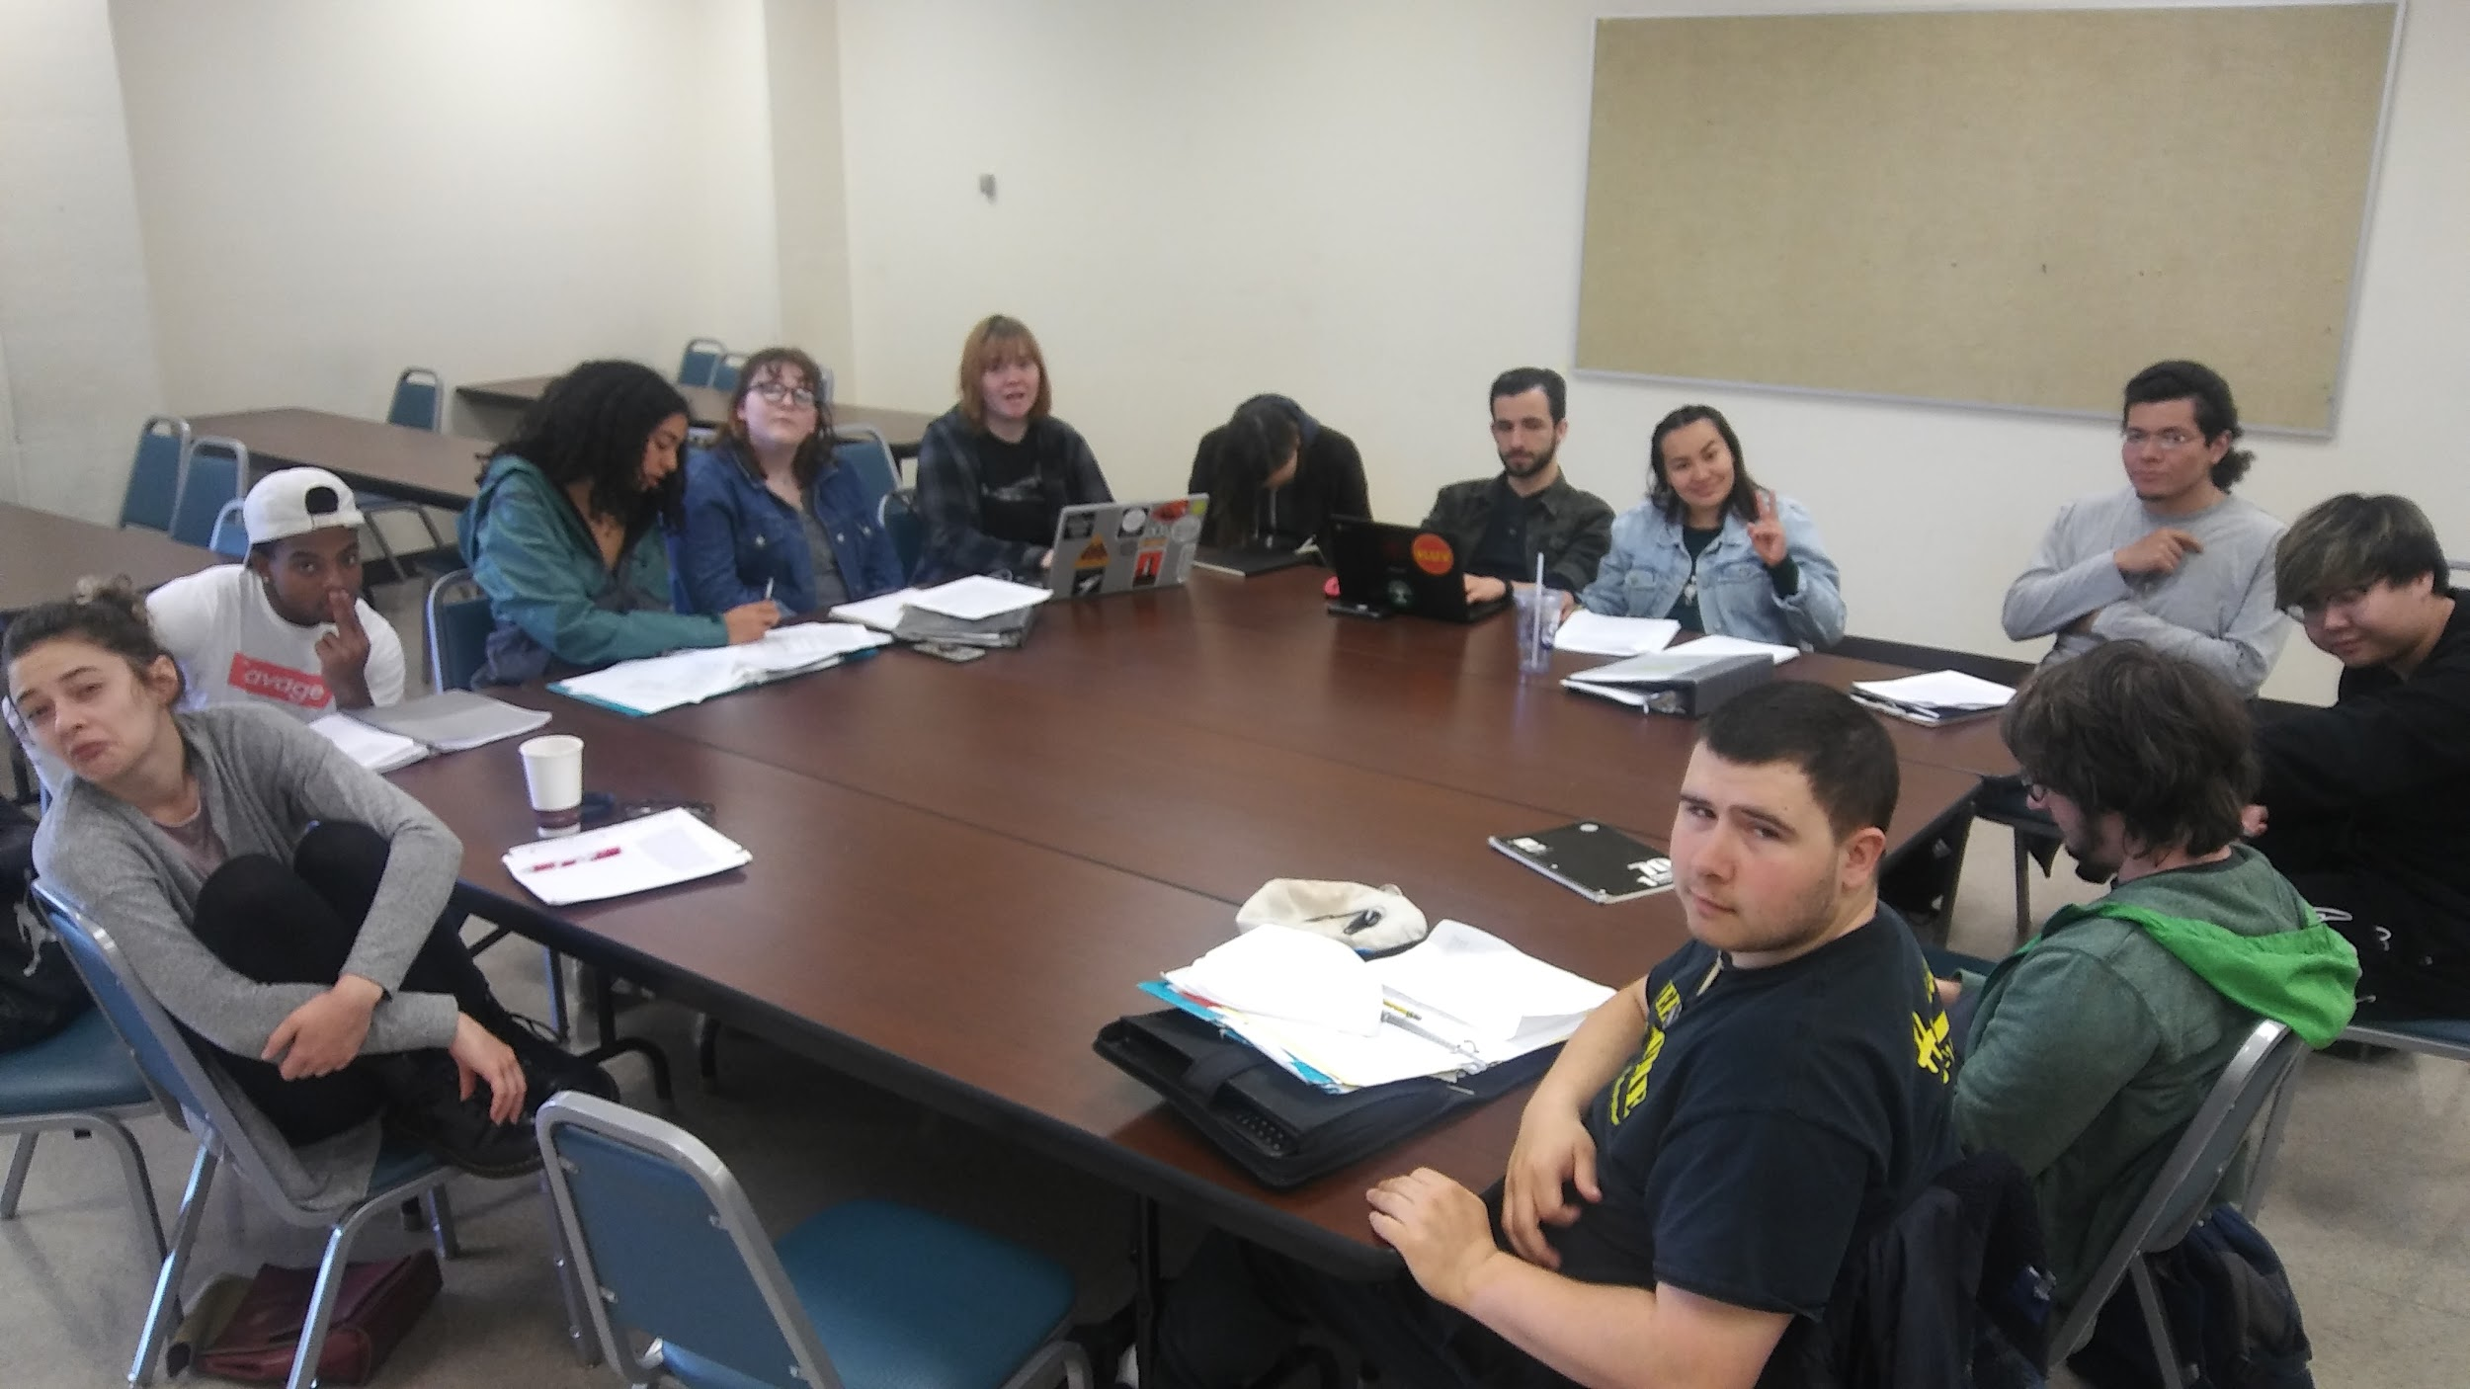
Once our students received a copy of the book, we go through it with a fine-toothed comb looking for clues within the text that will ultimately inform the structure of our story. This happens again by asking the question what are the knowns in regards to the origin of the Scarecrow found in the text? As we go through the text this “known” information is written down.

The use of a white board is very helpful as place to take notes as the ensemble discussions and debates information.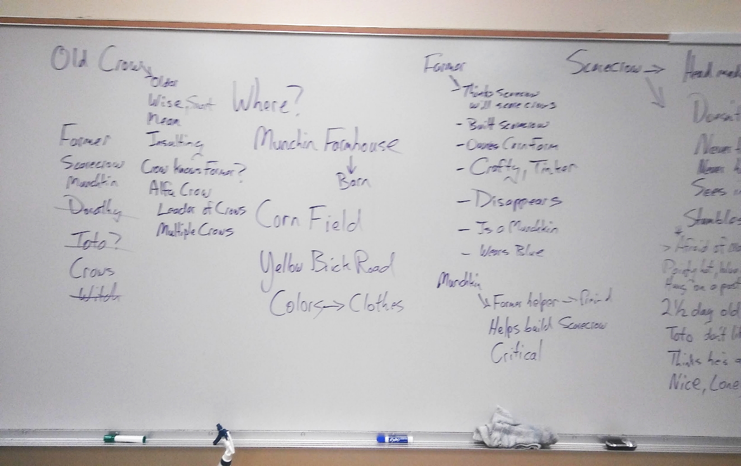
We know:
- The play takes place in the land of Oz, more specifically Munchkin Country.
- The action takes place on a corn farm.
- A farmer builds the Scarecrow.
- The Farmer is a Munchkin.
- The Farmer grows corn.
- The Farmer does not like crows. He sees them as pests.
- The Farmer thinks this new Scarecrow will scare away crows.
- An unknown Munchkin comments on the building of the Scarecrow.
- The Scarecrow knows that he is being built as he is being built.
- The Scarecrow is only a day and a half old.
- Crows are not scared of the Scarecrow.
- The Scarecrow is afraid of fire.
- The Scarecrow’s clothes are colored blue, the favorite color of the Munchkins.
- The Scarecrow is never hungry.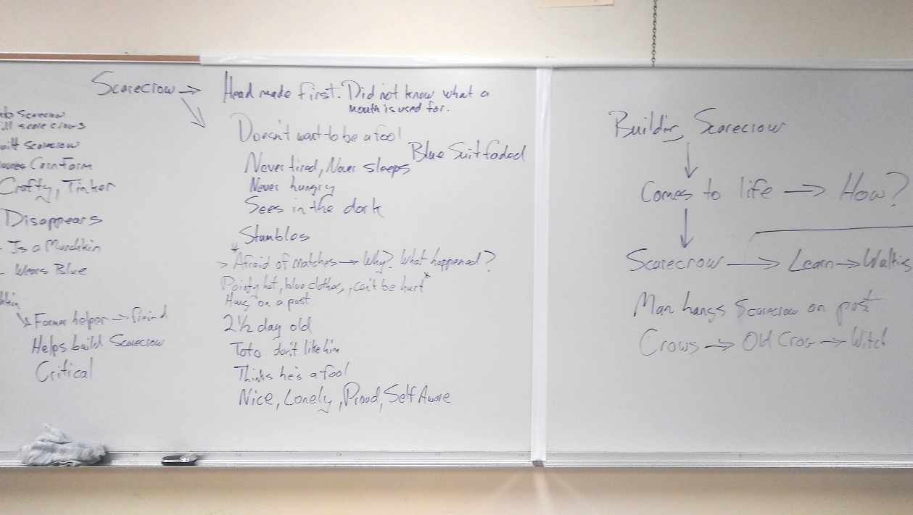
- The Scarecrow never sleeps.
- The Scarecrow can see in the dark.
- At first, the Scarecrow did not know what a mouth is used for.
- The Scarecrow is nice, lonely and naive.
- The Scarecrow thinks that he is a fool.
- The Scarecrow is hung a post.
- The Farmer disappears
- The unknown Munchkin disappears.
- The Farmer wears blue clothes.
- The Scarecrow has a pointed hat.
- The Scarecrow does not walk very well. He stumbles a lot.
- There is an Old Crow that is antagonistic towards the Scarecrow.
- The Old Crow is wise but insulting.
All of this information was found within the few paragraphs from the chapter, Road Through the Forest. This list may seem long but it is incomplete for the sake of this article. You would be amazed at how much information you can pull out of a piece of text when you dig deep enough.

Fill in the Gaps
Now that we have found all of our “known” information from our text we must fill in the gaps. There are some blaring questions that we must ask ourselves concerning the information found within our text. Below are some of the questions raised during our table work.

- Who is the Farmer?
- Why is the farmer building a scarecrow?
- Who is the unknown Munchkin?
- How does the scarecrow come to life?
- Where is the farm?
- Why are the crows not scared of the scarecrow?
- Why does the Farmer disappear?
- Why does the unknown Munchkin disappear?

Now we could very easily just take the paragraphs straight out of the book, stage it, slap on a narrator and let that be that. Here are a few problems with this approach. First of all the length. If we were to stage the few paragraphs from the book as is, the play would only be twenty minutes long at best. Remember we need to fill forty five minutes to an hour. Secondly, there are too many gaps in this story as is. This is evident by reviewing the questions listed above. Our challenge is to now fill in gaps with information that makes sense when used in combination with the information discovered in the paragraphs from where we are working. However, there is still another problem we face when adding additional information. It is important to maintain some kind of continuity from within the greater world of the literature. That means we have to do our best to use material found within the canon of literature about the Wizard of Oz written by Frank Baum. Luckily Mr. Baum wrote numerous books revolving around the world of Oz. It is just a matter of sifting through these books to find appropriate information to use to help fill in our gaps.
The two questions that stuck out in most of our student ensemble minds seemed to be
- Why does the farmer build the scarecrow?
- How does the scarecrow come to life?
The obvious answer to the first question would be that the farmer merely wants to build a scarecrow to safeguard his corn fields from those pesky crows.This may seem to be the logical answer to this question. However, the stakes don’t seem high enough for this action. The building of a scarecrow to just scare crows seem mundane and not strong enough to carry an hour long play. Although not specifically found within the Oz books, the ensemble decided that the Farmer was lonely and wanted a companion. This seemed like a good idea until a member of the student ensemble brought up the fact that the idea sounds too much like the premise of the story of Pinocchio.Good thing this issue was brought up because the answer then solved another one of our questions, Who is the unknown Munchkin? One ensemble member asked, “What if there were two farmers, a husband and a wife?”. Another ensemble member then asked, “What if this husband and wife cannot have children?” This made sense. Now we didn’t find anything within the books that resembled this situation. However, the story of a wife and husband not having the ability to have children is a sort of universal story and would within our world. So then and there the ensemble made the choice of a wife and husband who are Munchkin corn farmers who cannot have children of their own answer the questions
- Why does the Farmer build the scarecrow?
- Who is the unknown Munchkin?
Now on to what I think was the most challenging question to answer. How does the scarecrow come to life? Nowhere within our text does it state exactly how the scarecrow came to life. We know that the Farmer built the Scarecrow and we know the Scarecrow was aware of himself being built. But, from where did the Scarecrow’s awareness derive? The answer had to lay in magic somehow. We know that magic exists within the land of Oz but from where? We’re aware that there are several witches that live in Oz in the surrounding areas of Munchkinland. Could a witch have enchanted our Scarecrow? How could that have happened? All we get from the chapter is that the Farmer started to build the Scarecrow and that’s it. There is no mention of any witch at all. We do know that the Farmer uses paint to paint on the facial feature of the Scarecrow? What if this paint has something to do with the bringing to life this inanimate object? Could the paint been enchanted by a witch? That means that the paint needed to be procured by the two farmers somewhere as they do not possess any magical abilities.. From where do they get the paint and how is it enchanted. It would be easy to say that this “magical” paint came from one of the witches who dwell nearby. It would be far more interesting if the justification for using magical paint to animate the Scarecrow ere found within the world of Oz. It just so happens that a witch named, Mombi, ruled over a part of Oz called Gilkinland. She was a terrible person, worse than the Wicked Witch of the West. Mobi had a child slave named Tip. Tip discovered a magic powder that could bring inanimate objects to life. Mombi of course takes this magic powder from Tip and animates a creature named Jack Pumpkin head. Why couldn’t this same powder animate our Scarecrow? Well as a matter of fact that just may be the case. In doing further research we found that there is a theory that this very same powder used by the witch Mombi is the life source of the character Scarecrow. What a coincidence!

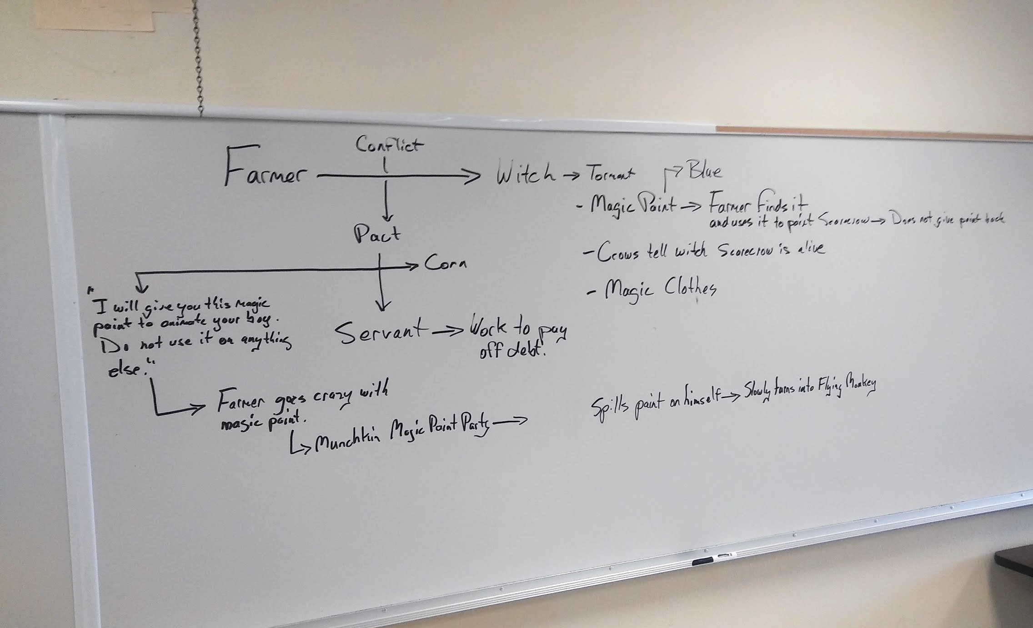
Armed with this new information the ensemble decided to go ahead to use these details to help fill in a couple of the larger gaps in our story. They decided that there would be two farmers Mazey and Cornelius. They are unable to have children. They go to Mombi the witch to get help from her, even though she is not the most trustworthy person in Oz. Mazey and Cornelius are desperate. Mombi gives them paint that has been mixed with the magic powder. The couple would need to build a boy out of whatever material they have handy and use the “magic” paint in the creation of their child. Mombi warns them however, that the paint can only be used once. If the paint is used for other reasons Mombi will not be happy and the two farmers would pay a price. Of course Mombi knows that the paint will be used more than once. It is part of her plan to ultimately enslave the two farmers. This will become the core of our story although this direction raises some new questions.
- How does the paint get misused and by whom?
- What actually happens to the two farmers if and when the paint gets misused?
- What kind of pact is made between to farmers and the witch?
- Are we staying true to the world of Oz with this direction?
- Can this information be inserted into the material at hand seamlessly without going too rogue with Frank Baum’s story?

The Scenario
Once we have answered our questions to the best of our ability it is now time to structure our story. Before we begin the process of creating situations and dialogue through improvisation we need to know where we are going. It does no good to have a group of actors standing in a rehearsal room and say “Go ahead. Improvise something.” From my experiences in doing this type of work for the past 20 years actors need a pathway to improvise this type of material. Even while performing short form improv actors always ask for material from an audience in order to get started. When devising a play through improvisation when need a road map. Through my work in Commedia dell’ Arte I have grown comfortable in developing scenarios as a way to keep information and story structure straight during improvised creation sessions.
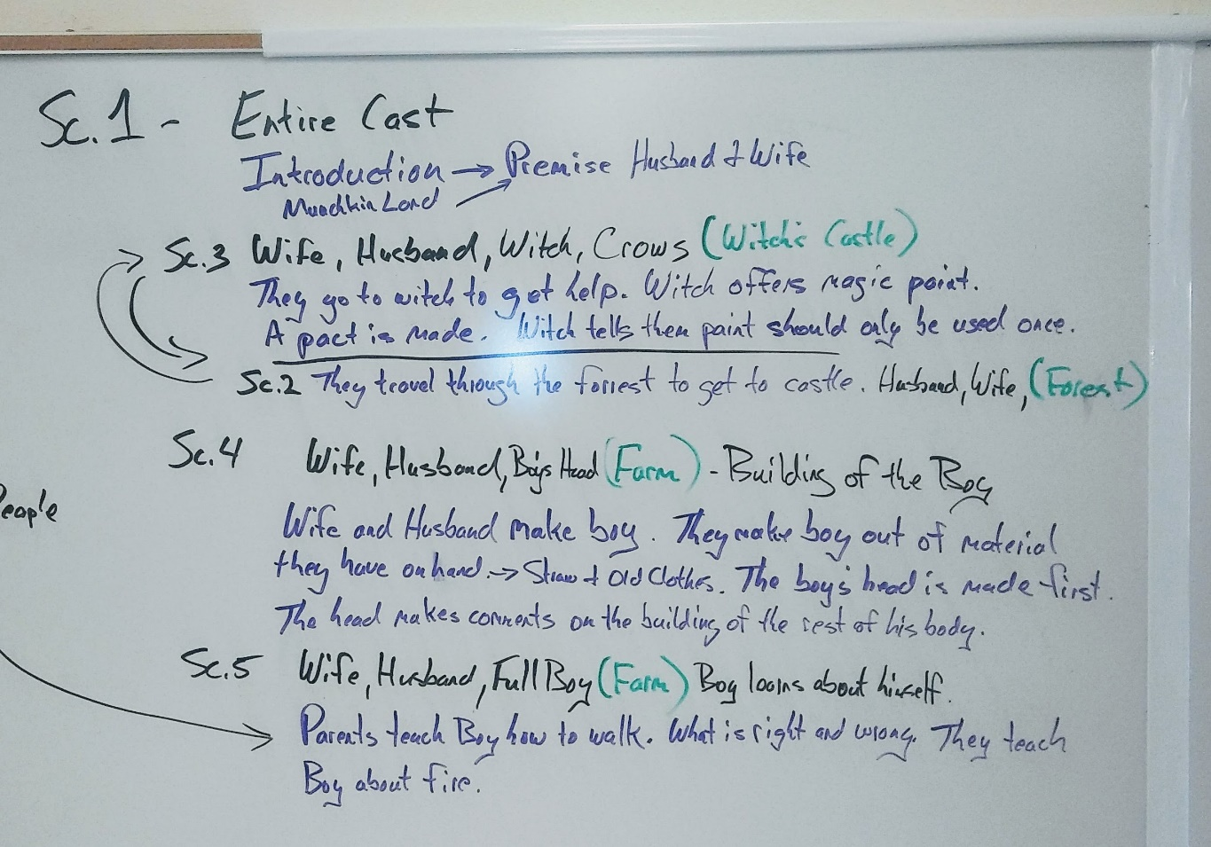
A scenario is essentially a road map for our ensemble of performers and writers to use while navigating our story. I guess in our case our scenario is a yellow brick road. A scenario is a simple outline of a play. This “outline” is divided into scenes in order from beginning to end. Within each scene when know who is in the scene and what is supposed to happen in the scene. A scenario can as simple or as complex as you want. You can add stage direction and even samples of possible dialogue. This is up to you and your creators. The only required information is that each scene states exactly who is in the scene and what is supposed to happen. Below are the first seven scenes of the scenario develop by our student ensemble. I do not list the rest of the play. You’ll have to come see it. :-)
Scarecrow
Scenario
1. Entire Cast
Introduction. Premise material about Munchkins, Munchkinland and the Farmers. This introduction must include the problem the farmers have with not having children.

2. Mazey, Cornelius, crows and other creatures (Forest)
The two farmers make their way through the scary forest to Mombi’s castle.

3. Mazey, Cornelius, Mombi, Tip, Crows (Witch Castle)
The two farmers arrive at Mombi’s castle. Tip greets them and takes them to Mombi. The farmers explain that they need help from the Witch in regards to them not being able to have a child. The witch explains that she possesses a magic powder that can bring inanimate object to life. Mombi demonstrates how her magic powder works by bringing to life a human shaped figure with a pumpkin head. The witch tells the farmers that she will mix the powder into a jar of paint. They would use this paint in the creation of their child. A pact is made between them. Mombi offers them “magic” paint. The witch tells the farmers that the paint can only be used one time and one time only. If she discovers that the paint has been used for other purposes than what they agreed, the farmers would pay a price.
Possible song
4. Mazey, Cornelius, Boy’s Head (Farm)
Mazey and Cornelius begin to build a boy our of whatever material they have on hand—Straw and old clothes. They first make the head. They make the head out of an old burlap bag that is filled with straw. They use the magic paint to first paint the eyes. The eyes open and look around. The farmers are excited to see the eyes moving. They then paint the mouth. The farmers introduce themselves. The Boy’s head is pleased to meet them. The boy’s head comments as the farmers construct the rest of the body. Once the boy is built Mazey and Cornelius teach him how to walk and move about.
Possible Song.
5. Mazey, Cornelius, Boy (Farm)
The Boy is finally built. The farmers teach the boy how to walk and use his body. The boy has many questions. “Who am I?” “Where am I?” “What is a mother and a father?” “What are clothes?” “What is straw?” “What is a witch?” The boys sees a candle burning on a table. He rushes to it. “What is this!” The farmers stop him and warn him of the dangers of fire. They farmers tell the Boy that it is time for bed. “What is a bed?, asks the boy. The farmers try to explain what it means to be tired and that he must sleep. “What is sleep?” asks the boy. They lay the boy down in his bed. The Mother tells the Boy that “Sleeping is a time for dreams.” What are dreams?” asks the Boy. Cornelius explains, “Dreams are like going to another world filled with all of your good memories. “What are memories?” asks the Boy. The Mother explains “Memories are like pictures in your head of things you’ve seen or done in the past.” The Boy closes his eyes really tight and says, “Mother. I do not have any memories.” The Mother replies, “You will. You will have lots of wonderful memories.” Mazey kisses the Boy on the head. The farmers go to bed themselves leaving the Boy alone in his bed.
6. Boy, Crow (Farm)
The Boy is restless in his bed. He sits up. “I cannot sleep.” “I close my eyes but I cannot sleep.” Why Can I not sleep?” “Why can I not see my dreams?” At that moment a crow appears in the window. “Hello.” Says the Boy. The crow caws. What are you? Are you a Boy too?” The Crow caws. “I see. Well it is very nice to meet you.” The crow hops from the window sill over to the Boys bed post. “You do not look like my mother or father.” The crow caws. “You have funny arms and legs.” “See. I have arms and legs now too.” The Boy shows the Crow his arms and legs. “I don’t know how to use them very well but my father says that I will soon become big and strong like him and will soon help him grow the corn. Whatever that is.” “Do you have a mother and a father?” The Crow caws. “Can you tell about your dreams?” asks the Boy. The Crow caws and flaps its wings. “I wish I could understand you. You speak a funny language.” “My mother and father told me that I have to sleep but I can’t. I try and I try but I cannot sleep.” “Do you sleep?” The Crow caws. “I see. Maybe we can both sit here and not sleep together.” The Boy and Crow sit quietly. Lights out.
7. Boy, Wife, Husband (Farm) The next day
The farmers enter and see the Boy sitting up in his bed. The Crow is sitting on the windowsill. The Father shoos the Crow away. “Get out of here!” “Father!” exclaims the Boy. “That was my friend.” “Those birds are no friends of ours! It’s all I can do to keep them out of the corn fields.” says the Father. The Mother enters. “Time for breakfast!” “What is breakfast?” asks the Boy. The Mother says “Why it is the first meal of the day.” “What is a meal?” asks the Boy. “The Mother responds “You see when your belly gets hungry you must put food in it.” She makes a circular motion in front of her stomach with her hands. “My belly?” asks the Boy. The boy then puts his hand inside his shirt where his belly would be and pulls out a handful of straw. “Is this a belly?” asks the Boy. “No. I guess not.” says the Mother. The Fathers says “It’s time to go to work. We’ll talk about food later.” “Work! That sounds like fun!” The Boy jumps out of bed but immediately falls. The Father helps him up. They exit the house hand in hand.

Development through Improvisation
Now that we have a somewhat structured story we are ready for some improv. I say “somewhat structured” because you never know what will happen during the improvisational phase of the devising process. This why I find using improvisation during the development stages of a new play to be invaluable. You never know what an actor will bring to the table. An actor may say or do something that you as a playwright may have never considered or even thought of. A good actor has the ability to bring a richness to the development of characters that we sometimes can’t find while sitting in a chair in front of a computer screen writing dialogue.
Now that most of table work is completed, into the rehearsal room we go with scenarios in hand. The process is simple. We start with scene one and progress through the entire play to the end. This is a fun way to work but it may take a bit of time to complete. Depending on the play you may want to consider a good solid week or two dedicated to this part of the process. I must make a distinction here. There are a number of ways to devise a piece of theatre and there a number of ways a final product can be achieved. You can devise a play with an ensemble of actors and never produce a single piece of written material. That works great. I have developed numerous plays that have been completely and totally improvised. However, those plays were new creations from beginning to end. This particular play, Scarecrow, deals with a piece of existing literature and it is important that we take care that we try to stay as true as we can to the nature of the world found in the literature. This why we spend a lot of time engaged in table work with this type of play. If we were creating an original Commedia dell'Arte play we would spend more time working lazzi and less time worrying about the story. For this particular play we are using this process to create a final script to be used by a different cast for the following year.
When enter the rehearsal room it is important that we set up some guidelines for our student ensemble. Our rehearsal room is a sanctuary. Because we are improvising new material we want everyone to feel at ease and open. People seem to be the most vulnerable during this phase of experimentation and journeying through the unknown.
- Be respectful to everyone in the rehearsal room.
- Be respectful to everyone’s ideas.
- No harsh criticisms. Allow the director to engage in constructive criticism.
- No excessive talking during scene development.
We also give some creative guidelines to our student ensembles upon entering the rehearsal room for the first time.
- Bring your copy of the scenario everyday!
- Come prepared. Bring pencils and notebooks to take notes.
- Make notes in regards to things you said and did that seemed to work during improv sessions.
- There are no “bad” ideas. Ideas are ideas are ideas. A perceived “bad” idea will more than likely will lead to a more useful idea.
- Throw out your first idea. I say this because more times than not, your first idea has already been done by someone in the world somewhere. We strive to challenge ourselves to be creative and original.
- Don’t hold on too tightly to your ideas. If for some reason your idea may not work at that time let it go.
- Try not to be offended if your idea is rejected by the ensemble. Keep trying.
- Your ideas belong to the ensemble and to the play.
Once we get settled into the rehearsal space characters are assigned to ensemble members for the day as well as note takers. If you have a stage manager or a dramaturg they would be very helpful in taking dialogue and blocking notes for the final script or performance if that is the direction you are going with your play. Depending on the ensemble I will assign characters to different ensemble members everyday. I do this because every actor will bring something different to that character and we will ultimately, in my opinion, create a more well rounded and interesting character. If you just stick with using the same actor again and again during this period you run the risk of creating a character that is flat without dimension. It is not uncommon for us during these processes to create a character based on the workings of three or more actors.
Once the characters are assigned we get on our feet and start working.
Every director works differently. Each director has her/his own methods for conducting rehearsals. Some directors spend time warming up and playing games. Other directors like to get to work right away. I find value in both approaches. Warm ups and game playing are great ways to bond your ensemble members together. However, those take up valuable creation time. If you would like to engage in game playing at the top of every rehearsal there are numerous ensemble building games out there to play with your student creators to get their improvisational juices flowing. The work of Viola Spolin is a fantastic place to start. Below are a few games you can play to get things rolling if you wish.

My Day

Instructions
- Players are paired up
- Each player takes a turn telling the other player they’re activities for the entire day up until the moment they came to class
- While telling the partner of the activities they use physical movements to simulate that activity
- Players must continue talking without stopping or saying ‘um, um’
- After each player does this then partner A repeats the same story but at one point the Instructor will yell ‘Freeze’.
- The Instructor will then offer a prompt, example: ‘Suddenly, Big Foot shows up with a bundle of flowers.” Once the prompt is heard the player must incorporate that prompt into their original story.

Notes
Players must maintain eye contact, cannot break eye contact.

Twizzle

Instructions
- Players stand in a circle facing clockwise
- Cues are words that the players must execute throughout game.
- Cues: Go: Walk Cue: Turn: pivot and face opposite direction
- Cue: Jump: Jump and land facing in opposite direction
- Cue: Twizzle: Jump while spinning 360 degrees in air and land in the same direction as started.
- At anytime the Instructor will call out these ‘Cues’ and the players must comply or be asked to sit in the middle of the circle or Mush Pot. This is an elimination game.

Notes
Players must freeze in the position they landed after executing the ‘cue’. No scratching, adjusting clothing or talking. If any of this occurs then that player goes to the middle of circle and sits in the mush pot.

Tap Out

Instructions
- One player makes an ‘ask’ for an object, item, or scenario
- At any time players may call ‘freeze’ and enter the scene
- Every time a player enters the scene, the scene must change completely, but be connected to whatever action or position was taking place in the previous scene.
- Only two players may be active at any time.

Notes
In ‘Tap Out’ all players arrange themselves in a ring or line, with one player to begin the game. This player makes an ‘ask for’ : object, item, situation, etc. and begins the scene. At any time one player may call ‘freeze’ and enter the scene. Once a player has entered the scene they must change it completely, but have some connection to the position or actions taking place in the previous scene. The game works the best when done quickly, typically no more than 15-30 seconds should lapse before someone changes the scene. Linking the scenes to current events or humorous stories in the news also greatly increases the effectiveness of the game.

Changing Realities

Instructions
- 4 Players line up
- 1 Player begins with an ‘Ask For’
- Each player subsequently stops the scene and chest it with their own introduction
- The 4th player to enter the scene must find a reason to leave the scene
- After each player leaves the scene it reverts back to the previous moment
- Players may not use dancing as a means of excusing themselves from the scene or beginning one.

Notes
This game begins with t a group of 3 to 5 players; though 4 players is ideal. The first player begins the game by making an ‘Ask For’ be it an item, a situation or a profession. At any point the remaining players can call out ‘freeze’, the scene then stops and that player changes the scene to whatever the player(s) appears to look like they are doing. When the final player enters the scene is t is their job to change the location, position, or action of all other players and then find a justifiable reason to leave the scene. After a player leaves the scene all remaining players revert to previous scene but must now justify their new positions or movements. This is repeated until the original player is the only one left on stage
------------------------------------------------------------------------------------------------------------------
As stated earlier, we usually go through the scenario once scene at a time in order. We do this because it helps to maintain continuity and a sense of rhythm to the play. Handle each scene in the play as it’s own little play that has a beginning, middle and an end. I find it very helpful to read or have a stage manager read aloud the scene before we begin. You can give some initial direction as you begin if you would like. I will usually just let the actors start and see what happens. If something is working don’t stop them too often. However, don’t be afraid to stop the actors to give direction. Look for the stuff that seems to be working and then expand it. It is always better to have too much material to work with than not to have enough. Don’t worry too much about blocking the actors unless movement is a part of the story telling. What we’re looking for here is mainly interesting and motivated dialogue. These types of rehearsals can be as free or as structured as you would like. It is totally up to you.
Usually what happens after a scene has been improvised a small group of ensemble members will take their observation notes and begin putting that scene on paper. They will distill all the useful and interesting material to create dialogue that flows well and feels natural. Typically after a few days regardless of how many scenes we get through we will return to the table with copies of all the written material. We all sit around with coffee and pencils in hand reading what has been written thus far from the improv sessions. This is an important step in the process in that we get to see whether or not we are on the right track and to see if we need to go back and make adjustments in certain areas. We will usually only have a day back at the table after about three days of improv. We will maintain this pattern until we have gone through the entire scenario thoroughly.
Once we feel good about the work we’ve accomplished in the rehearsal room back to the computer screen we go. There are two directions you can go to from here. You can either take ALL the information gathered from the entire process and fine tune the script by yourself or hand it off to another independent writer or secondly you can fine tune the script by assigning scene to groups of writer within your ensemble. I have found it better to tackle the final stage of this process as a lone writer. I say this because as a lone writer the script will have a single unifying voice. Again, there are numerous ways in which we can create a new piece of theatre. This is only one approach and very useful one at that in my opinion. Regardless of what creation style you as an artist deploy we must remain open to new ideas and methodologies.

This list draws from the "Glossary of theater terms" by Wikipedia which is licensed under CC BY-SA 3.0
* KIRSTEN, B., DU PREEZ, R. Improvisational theatre as team development intervention for climate for work group innovation. SA Journal of Industrial Psychology, 36, Nov. 2010. Available at: https://sajip.co.za/index.php/sajip/article/view/862/952. Date accessed: 16 Sep. 2016. Used under CC BY 4.0.

