Art 131 Drawing I
Instructor: Anne Magratten  Email: magrata@linnbenton.edu  Phone: 541.917.4545  Office Hours: T/TH 10:00-11:00am  or by appointment | CRN: 21879  Credits: 4  Times: T/Th 2:00-4:50pm

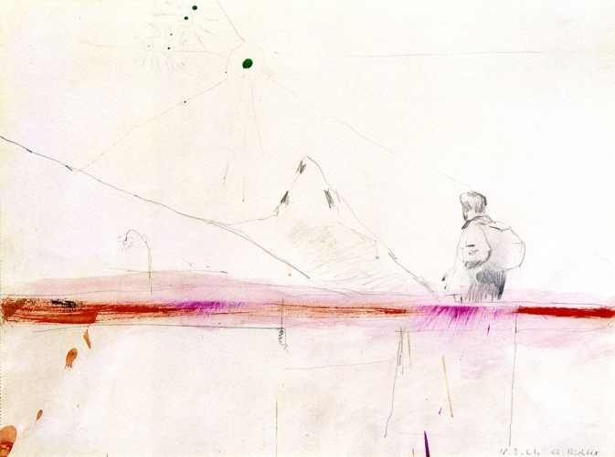
Mountaineer, Gerhard Richter, 11” x 15”, graphite & watercolor on paper, 1964
“Inspiration exists, but it has to find you working.” ~Pablo Picasso
Course Description: Emphasizes the development of perceptual and technical skills needed to describe 3-D objects on 2-D surfaces. Exposes students to conceptual and technical art references and encourages students to think critically about art and expression as an integral part of learning to draw.
Course objectives:
The class will provide individualized instruction in practical drawing skills designed for the beginner. We will cover fundamental gesture, contour, and value approaches to drawing from observation. Analytical techniques for spatial organization will be stressed. Progress will be made through exercises, slide lectures, demonstrations, and homework assignments. We will use different media including charcoal, pencil, white drawing tools, and ink. Drawings will be shared for group and individual assessment (critique) as part of the learning-evaluating process.

Student Learning Outcomes:
Upon successful completion of this course, students will be able to:
- Apply appropriate vocabulary in written and oral critiques of artistic works.
- Demonstrate competency in applying a range of value with black and white drawing media.
- Construct a drawing showing spatial depth using the principles of linear perspective.
- Illustrate basic forms with black and white drawing media.
Attendance & Classroom Etiquette:
Due to the interactive nature of this course attendance is extremely important. After three absences a student’s grade will drop a full letter. For example a student holding a B will then have a C. Arriving late or leaving early will also hamper your understanding of course materials. Three late arrivals or early departures will be counted as an absence. Emergencies and extenuating circumstances can be excused if communicated in a timely manner.
In each class we will draw, critique, and produce verbal/written reflections on art. Your participation enhances our diversity of perspective and being present will allow you to reflect on the contributions of others. To engage fully in the course please limit cell phone use to academic research (extenuating circumstances please simply let me know in advance).
Please meet with me during the first week of class if
- you have a documented disability and need accommodations,
- your instructor needs to know medical information about you, or
- you need special arrangements in the event of an emergency.
If you believe you may need accommodation services please contact Center for Accessibility Resources, 541-917-4789. If you have documented your disability, remember that you must make your request for accommodations through the Center for Accessibility Resources Online Services web page every term in order to receive accommodations.
Please meet at any point throughout the term if
- you realize you need something to improve your learning experience
- you have questions regarding your grade or the course material

Assignments & Grading:

Example of Grading Template:  Assignments: | 4 points: superior, drawing exceeds goals in this area  3 points: above average, meets the goal in this area  2 points: average, meets some goals in this area  1 point: below average, doesn’t meet expectations  0 points: failing, does not consider the goal at all | Pts.
Project # 1 Epic Contour (16) | Blind, Semi blind (4), Continuous, Non-dominant (4)  Line quality (4) Communicating form & Edges (4)
Project # 2 Value Matching (12) | Values match (4), Texture (4), Label/Presentation (4)
Project # 3 Grid Master Study (12) | Grid management of proportion (4), Value/line quality (4), Personal adaptation of original (4)
Project # 4 Negative Space (12) | Composition (4), Separation of -/+ shapes (4), Presentation(4)
Project # 5 Still Life (16) | Composition (4), Proportion (4), Value: Form shadow, cast shadow, highlights, relational value (4), Spatial grounding of objects (4)
Project # 6 Perspective (16) | Vanishing points (4) perspective lines establish depth (4) consistent eye level (4) Focal Point & Composition (4)
Project # 7 Visual Space (12) | Overlap, Scale, Density, Focus, Contrast (4)  Composition (4) Value & Line Quality (4)
Project # 8 Gesture (12) | Basic Structures-spine, hips, shoulders (4), Dynamic Movement (4), Line quality (4)
Project # 9 Tonal Figure (12) | Uses mid-tone of paper (4), Highlights & Shadows (4), Composition (4)
Homework 4 x 8 (32) | Unity, Conceptual Development, Composition, Application & Development of technique (4)  1 2 3 4 5 6 7 8
Final Project (20) | Conceptual Development (4), Composition (4), Unity (4), Experimentation with techniques (4) & concepts developed throughout the term (4)
Critiques (12) | Use of visual art vocabulary (4), formulating and receiving constructive criticism (4), holistic engagement of technical, conceptual, and social significance (4)
Artistic Research (16) | Reading responses (8) & Artist Summaries (8)
Absences: Late: | After three absences, each absence reduces the final grade by half a letter. Arriving late or leaving early three times will be counted as an absence
Extra Credit
Final Grade: 200 | A 200- 180, B 179- 160, C 159-140, D 139-120, F 119-0

Late work will be marked down one letter grade. For example a late visual journal earning a B will become a C. As college students, life does happen. You will be given two exemptions (it is prudent to save them for emergencies). If you never use your exemptions they will convert to 2 points at the end of the term.
Extra Credit is available until week 9. Extra credit can be earned by visiting an art museum and providing a written reflection of the experience. Regional examples include the Portland Museum of Art, Hallie Ford Museum of Art in Salem, Jordan Schnitzer Museum of Art in Eugene, or others with instructor approval. Alternatively, attending an artist lecture, going on a studio visit, or watching an approved documentary can also be fodder for creating a drawing or written reflection.
Academic Integrity:
The presentation of another individual’s work as one’s own or the act of seeking unfair academic advantage through cheating, plagiarism or other dishonest means is a violation of the college’s “Student Rights and Responsibilities.” Turning in someone else’s work as your own, or buying a paper from a professional writer or a research center, or downloading one from a Web site, is plagiarism. Turning in another artist’s drawing as your own is also plagiarism. All sources must be clearly presented. A plagiarized project will receive a zero. Two zeros for plagiarism will be grounds for an F in the course, regardless of other grades.*Recycling, referencing, appropriation, and outsourcing play important roles in contemporary art. If you use these tools be sure you can clearly state the conceptual significance of your choices and be transparent about them during critique/reflection.

LBCC Statement of Nondiscrimination:
LBCC prohibits unlawful discrimination based on race, color, religion, ethnicity, use of native language, national origin, sex, sexual orientation, marital status, disability, veteran status, age, or any other status protected under applicable federal, state, or local laws.

LBCC Statement of Inclusion:
The LBCC community is enriched by diversity. Each individual has worth and makes contributions to create that diversity at the college. Everyone has the right to think, learn, and work together in an environment of respect, tolerance, and goodwill.

Materials:
Please Purchase  - Sketchbook for homework 9”x 12” or larger, 30 pages or more, heavy weight if possible.  - Graphite pencils 2H, HB, 4B, 6B,8B  - Kneaded eraser  - Ruler 24”  From Home:  - Studio Clothes  - Small jars with lid x2 | Provided by Instructor  - Paper for class projects  - Newsprint for class projects  - Graphite sticks  - Charcoal  - White Charcoal or Conté  - Ink  - Brushes  - Powdered Graphite  - Artist Tape

Course Calendar*
Week 1: | 9/27 Introduction to class  Studio Safety & Layout  Contour Drawing session 1  Homework: Purchase materials | 9/29 Contour Drawing session 2  Critique Contour Studies  Homework Assigned
Week 2: | 10/4 Value Matching Project  Reading Response Due  Homework 1 Due | 10/6 Value Matching Project…  Homework Assigned
Week 3: | 10/11 Critique Value Matching  Master Grid Project  Artist Research Due  Homework 2 Due | 10/13 Master Grid…  Homework Assigned
Week 4: | 10/18  Master Grid Project  Reading Response Due  Homework 3 Due | 10/20 Begin still life drawing  Critique Master Drawing  Homework Assigned
Week 5: | 10/25 Still life…  Artist Research Due  Homework 4 Due | 10/27 Critique Still life  Homework Assigned
Week 6: | 11/1 Perspective Lecture  Perspective drawing …  Homework 5 Due | 11/3 Perspective drawing …  Homework Assigned
Week 7: | 11/8 Critique Perspective Project  Homework 6 Due | 11/10 Visual Space Project  Homework Assigned
Week 8: | 11/15 Critique Visual Space Project  Homework 7 Due | 11/17 Figure Drawing Studio  Gesture Drawings  Critique intermingled  Homework Assigned
Week 9: | 11/22 Figure Drawing Studio  Critique intermingled  Homework Assigned  Homework 8 Due  Extra Credit Due | Thanksgiving!
Week 10: | 11/29 Final Project Open Studio  Homework: Refine final project | 12/1 Final Project Open Studio
Finals Week | 12/6 Time: 4:30-6:20pm  Critique or Exhibition
*Instructor reserves the ability to change dates and deadlines to best fulfill academic objectives.

