Art 234 Figure Drawing
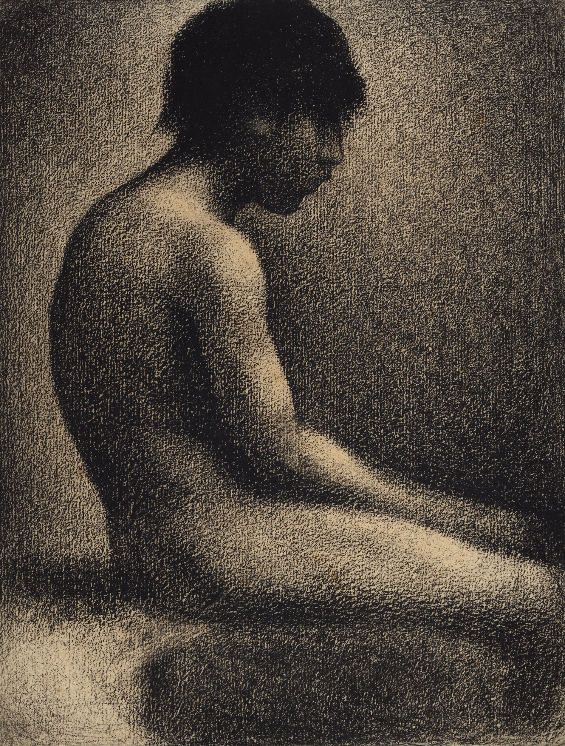 | Instructor:  Anne Magratten  Email: magrata@linnbenton.edu  Phone: 541.917.4545  Office Hours: M/W 5:00-6:00 p.m.  or appointment | CRN: 32323  Credits: 4  Times: M/W 2:00-4:50 p.m.  Image: Georges Seurat, Seated Nude (Study for Une Baignade), 1883.

Course Description: An introductory course in drawing the nude figure. Emphasis is on basic anatomical structures, surface topography, foreshortening, composition, and form. Students are exposed to art historical references as they relate to the human form, as well as being encouraged to write and think critically about art and expression. Models will be provided when available and probable field trips include visits to a dance or exercise session as well. This is a structured and rigorous 200 level course.

Student Learning Outcomes:
Upon successful completion of this course, students will be able to:
- Apply the creative process in planning, designing and solving visual problems.
- Practice advanced drawing techniques and skills.
- Draw a proportionate human figure which demonstrates a basic understanding of anatomy.
- Effectively critique art using art and anatomy vocabulary.
- Understand the significance of figurative art across cultures and time Recognize and reflect on (orally and in writing) the potential within each individual for creative expression.

COURSE STRUCTURE: Classes are designed with a weekly schedule of two hours of lecture and 4 hours of lab. Most classes will begin with individual studio setup, short lecture, and then progress to lab work. Classes will be devoted to drawing from life, discussing technique and anatomical structures, critiquing work, and completing assignments that target specific drawing concepts. The last ten minutes of each day will be devoted to a brief clean up. This is done to build sound studio habits as well as a courtesy to the incoming class with which we share studio space. Students are expected to make full use of class time and participate in individual and group processes. It is also expected that each student will complete all homework and the occasional written assignment, attend field trips, and be an intellectual/artistic contributor to the class.

DRAWING FROM THE NUDE MODEL: Traditional methods used in a scholarly approach to art include the use of the nude model; this class is solidly based upon that studio tradition and practice. This is a privileged learning experience valued by the art department as an important step in a student’s introduction to college level art.

Classroom Climate: We are all responsible for creating a safe and inclusive studio environment. Any unscholarly or disrespectful remarks (as interpreted by the instructor) may warrant the students being dismissed from the class session. (Examples: Remarks that humiliate; are intended to embarrass, sexualize or objectify the model; remarks about specific body part size, weight, beauty/ugliness ... are not appropriate.) Repeated inappropriate remarks or behavior will result in the students dismissal from the class for the remainder of the term. While the model is disrobed no use of cellphones will be permitted. Anyone taking photos without consent from both the model and instructor will be asked to leave the session and may be required to attend a disciplinary session with the dean.

Attendance: Due to the cost and availability of models no makeup sessions can be offered. Repeated absences will significantly hamper your understanding of course content and weaken the progress of your portfolio. Missing three or more classes will result in your overall grade being reduced by a full letter grade. For example, a student holding a B will then receive a C. Makeup work can be arranged with advanced notice. Absences related to serious illness or emergency should be communicated in a timely manner. Punctuality is essential! The door will be locked after the studio session begins. Arriving late, leaving early or without cleaning up will be treated as a half absence.

Please meet with me during the first week of class if:

1. you have a documented disability and need accommodations,

2. your instructor needs to know medical information about you, or

3. you need special arrangements in the event of an emergency.

If you have documented your disability, remember that you must make your request for accommodations through the Center for Accessibility Resources Online Services web page every term in order to receive accommodations. If you believe you may need accommodations, but are not yet registered with CFAR, please go to http://linnbenton.edu/cfar for steps on how to apply for services or call 541-917- 4789.

Assignments & Grading:

Example of Grading Template:  Portfolio: | 4 points: superior, drawing exceeds goals in this area  3 points: above average, meets the goal in this area  2 points: average, meets some goals in this area  1 point: below average, doesn’t meet expectations  0 points: failing, does not consider the goal at all | Pts.
1 Gesture Drawing | Lines communicate direction (4), movement & weight (4) Attention is given to critical structures spine, shoulders, hips (4) | /12
2 Contour Drawing:  Blind or Semi blind | Evidence of focus (4), Line quality (4) Communicating form & edges (4) | /12
3 Long Study in Charcoal | Composition (4), Value (4), Proportion (4) | /12
4 Contour Drawing:  Continuous or Non-dominant | Unbroken line or experimentation with control (4), Line quality (4) Effective communication of form & edges (4) | /12
Midterm Portfolio Review:  Best drawings 1 - 4 | Organization: Ordered/Clearly labeled (4),  Presentation: Clean edges, cover sheet (4)  Demonstrates commitment & improvement (4) | /12
5 Multi Gesture Page | Lines communicate direction (4), movement & weight (4) Attention is given to critical structures spine, shoulders, hips (4) | /12
6 Viewfinder Studies | Frame (4), Composition (4), Value (4) | /12
7 Long Pose | Establishes anatomic structures (4) Proportion (4)  Figure is grounded (4) Focal Point & Composition (4) Value & Line Quality (4) | /20
8 Gesture | Basic Structures-spine, hips, shoulders (4), Dynamic Movement (4), Line quality (4) | /12
9 Toned Ground | Uses mid-tone of paper (4), Highlights & Shadows (4), Composition (4) | /12
Final Portfolio Review:  Drawings 5 - 9 | Organization: Ordered/Clearly labeled (4),  Presentation: Clean edges, cover sheet (4)  Demonstrates commitment & improvement (4) | /12
Final Project | Conceptual Development (4), Composition (4), Unity (4), Experimentation with techniques (4) & concepts developed throughout the term (4) | /20
Critiques | Use of visual art vocabulary (4), formulating and receiving constructive criticism (4), holistic engagement of technical, conceptual, and social significance (4) | /12
Homework 4 x 7 | Unity, Conceptual Development, Composition, Application & Development of technique (4)  1. 2. 3. 4. 5. 6. 7. | /28
Absences: Late: | After three absences, the course final grade will be reduced by one letter. Arriving late or leaving early three times will be counted as an absence. Four or more absences may result in failing the course.
Extra Credit
Final Grade: 200 | A 200- 180, B 179- 160, C 159-140, D 139-120, F 119-0

PORTFOLIOS: Keep ALL drawings, label each with your name and date on the back. These will be your portfolio entries. Clearly label the portfolio carrier on an outside flap, with your name and contact info. Make sure it has sturdy handles. Selected work from the term will be fastened together and neatly placed in chronological order for the final evaluation/grading. More on this later.

Late work will be marked down one letter grade. For example a late homework earning a B will become a C. As college students, life does happen. You will be given two exemptions (it is prudent to save them for emergencies). If you never use your exemptions they will convert to 2 points at the end of the term.

Portfolio Review: Missing the Midterm or Final Portfolio Review will result in the entire portfolio being marked down one letter grade. If you know you must miss a review submit your portfolio in advance and schedule a makeup review. If you fall ill let me know asap to schedule a new time.

Extra Credit is available until week 9. Extra credit can be earned by visiting an art museum and providing a written reflection of the experience. Regional examples include the Portland Museum of Art, Hallie Ford Museum of Art in Salem, Jordan Schnitzer Museum of Art in Eugene, or the campus art galleries of LBCC. Alternatively, attending an artist lecture, going on a studio visit, submitting work to a show or watching an approved documentary can also be fodder for creating a drawing or written reflection.

Academic Integrity:
The presentation of another individual’s work as one’s own or the act of seeking unfair academic advantage through cheating, plagiarism or other dishonest means is a violation of the college’s “Student Rights and Responsibilities.” Turning in someone else’s work as your own, or buying a paper from a professional writer or a research center, or downloading one from a Web site, is plagiarism. Turning in another artist’s drawing as your own is also plagiarism. All sources must be clearly presented. A plagiarized project will receive a zero. Two zeros for plagiarism will be grounds for an F in the course, regardless of other grades.*Recycling, referencing, appropriation, and outsourcing play important roles in contemporary art. If you use these tools be sure you can clearly state the conceptual significance of your choices and be transparent about them during critique/reflection.

LBCC Statement of Nondiscrimination:
LBCC prohibits unlawful discrimination based on race, color, religion, ethnicity, use of native language, national origin, sex, sexual orientation, marital status, disability, veteran status, age, or any other status protected under applicable federal, state, or local laws.

LBCC Statement of Inclusion:
The LBCC community is enriched by diversity. Each individual has worth and makes contributions to create that diversity at the college. Everyone has the right to think, learn, and work together in an environment of respect, tolerance, and goodwill.

LOCKERS: Lockers are available for artists to use on a term by term basis. Find an empty locker and record its number, take the number to the department secretary and he/she will give you a key. Empty your locker and return the key by the end of the term to avoid penalty fees.

ABANDONED ARTWORK: Work that has been left behind after critiques is the responsibility of the individual artist. The custodian may dispose of any work that falls on the floor. Be certain to clean out your lockers during finals week. We do not want you to lose your work.

ATTIRE: Wear clothing to class that is comfortable and can be soiled with charcoal, graphite, etc. This will happen since Art 234 is essentially a studio/shop class. Students may bring in protective items (gloves, aprons) if desired.

SPRAY FIXATIVE AND HAIR SPRAY: DO NOT use spray fixative ANYWHERE inside the building. Take your drawings outside, away from all buildings and smoking areas, to spray fix them. Consider placing newsprint or trace between drawings for a non toxic approach to preventing smudging.

Course Calendar*
Week 1: | 1/9 Introduction to class  Studio Safety & Layout  Introduction to gesture  Homework: Purchase materials | 1/11 Skeleton Study  Critique Contour Studies  Homework Assigned
Week 2: | 1/16 Martin Luther King Day  No Class | 1/18 Model Session: Spine  Gesture & Contour  Homework 1 Due  Homework Assigned
Week 3: | 1/23 Gesture & Contour  Pelvis & Ribs  Homework 2 Due | 1/25 Value & Mass  Homework Assigned
Week 4: | 1/30 Value & Mass  Legs  Homework 3 Due | 2/1 Tools for Proportion  Homework Assigned
Week 5: | 2/6 Midterm Portfolio Review  Hands & Feet  Homework 4 Due | 2/8 Midterm Portfolio Review  Hands & Feet  Homework Assigned
Week 6: | 2/13 Tools for Foreshortening  Arm  Homework 5 Due | 2/15 Head  Homework Assigned
Week 7: | 2/20 Presidents Day  NO CLASS | 2/22 Head & Face  Homework 6 Due  Homework Assigned
Week 8: | 2/27 Toned Ground  Homework 7 Due | 3/1 Toned Ground  Experimental Media Session  Homework Assigned
Week 9: | 3/6 Last model session  Homework 8 Due  Extra Credit Due | 3/8 Final Project  Clean up/ Finish Portfolio  Organize Final Portfolio
Week 10: | 3/13 Final Project Open Studio  Individual Portfolio Review | 3/15 Final Project Open Studio  Individual Portfolio Reviews
Finals Week | 3/20  10-11:50 Critique Final Project
*Instructor reserves the ability to change dates and deadlines to best fulfill academic objectives.

Materials:
Please Purchase  - Vine Charcoal  - Compressed charcoal  - Red or Brown Conte  - 18 x 24 Newsprint Sketchbook  - 18 x 24 White Sketchbook  - Gum eraser  - Kneaded eraser  - Graphite pencils 2B & 2H  From Home:  1. Studio Clothes  2. Small jars with lid x2 | Provided by Instructor  1. Toned paper  2. White Charcoal or Conté  3. Ink  4. Brushes  5. Powdered Graphite  6. Artist Tape  7. Paper  8. Pastels (if time allows)

