COMM111 – Fall 2018
PUBLIC SPEAKING

Professor: M. Zakir Khan, J.D., M.A. - “Dr. Khan”
E-mail Address: khanz@linnbenton.edu
Office: South Santiam Hall (SSH) 202
Phone: 541-817-4834
Meeting time: MWF 9-950A | 10-1050A
Section: 20514 | 20528
Classroom: IA-231 | MKH-203
Office Hours: T - 11:30-12:30PM | W - 11-12PM and by appointment.
Course Websites: 1) Moodle – https://elearning.linnbenton.edu/login/index.php
2) Piazza – http://piazza.com/linnbenton/fall2018/comm111
Access Code: comm111
*Or activate via the email that gets sent out at the beginning of the term.
3) Course Schedule: https://docs.google.com/document/d/17bA3-wWPMJSukpDcPXV_PWaXfUanpnz8Gl-_fx-Fgfc/edit?usp=sharing

- I will be using Piazza to post assignments, announce class cancellations, and discuss important issues related to class. Signing up is mandatory.
- If you have a smartphone, you can download/use the Piazza app.
- Piazza is to be used by students only for discussing course materials/asking questions.
- Items posted by students on Piazza are anonymous to other students, but the professor can view which student is posting them.
- The top 5 student contributors per class– get 20 extra credit points. **contributions are posts, responses, edits, follow-ups, and comments to follow-ups (i.e., everything)

Disclaimer: All items discussed in this syllabus are subject to change based upon the professor’s discretion and students will be provided notice of any changes.

Test Date
- Final Exam – Check finals schedule at: https://www.linnbenton.edu/finals-schedule
Reporting Sexual Misconduct
Students who believe they are the victims of sexual harassment or assault should
contact Campus Safety at 541-926-6855, and/or local law enforcement.

Required Materials
Valenzano III, J. M., Braden, S. W., Broeckelman-Post, M. A. (2018). The Speaker's
Primer. Southlake, TX: Fountainhead Press.
- ISBN-10: 1680363212
- ISBN-13: 978-1680363210

Course Description
This course exposes students to theory and practice in the creation, adaptation and delivery of original speeches before an audience. It will also provide the opportunity to understand the nature of public speaking and discourse in both ancient and modern society

Course Outcomes
LBCC
As a result of taking Comm 111, a student should be able to: • Synthesize and organize information for varied audiences • Interact with confidence while adapting messages to audience needs • Listen critically
Student Learning Outcomes
Students who pass this class will demonstrate the ability to: • • • • •

Grading Breakdown
Assignment | Possible Points | Your Points
Elevator Pitch (P/F) | 25
Participation | 200
Quizzes | 100
1 Minute Info Speech | 50
Informative Speech Introduction and First Point Completed | 50
Informative Speech Rough Outline (Completed) | 50
Informative Speech Outline | 50
Informative Speech (in-class) | 100
Informative Reflection Piece | 25
Shark Tank Check-in | 25
Shark Tank Rough Draft | 25
Shark Tank Outline | 50
Shark Tank Speech (in-class) | 200
Life Lesson Speech (in-class) | 50
Extra Credit | ?
Total | 1000

Grading Scale
Grades | Percentage
Grade = A | 90-100+%
Grade = B | 80-89.9%
Grade = C | 70-79.9%
Grade = D | 60-69.9%
Grade = F | 59.9%-0.0%

Cell Phone Policy
- Students are barred from using cell phones at any point during the entire class session, unless the professor tells them to use it for certain activities.
- Phones should be out of sight and should be on silent before class starts.
- Students that have some sort of emergency going on (emergency call) should notify the professor of this occurrence before class starts and should sit at the back of the classroom so as not to be distraction to other students.

Electronic Device Policy
- Tablets and other e-reading devices are only allowed in class to be used for their textbook purposes. These devices cannot be used to take notes or for any other purpose. The exception to this rule is if students need accommodations pursuant to the Americans with Disabilities Act.
- All other electronic devices are not allowed to be used in class, unless the professor gives express permission.

Consequences for improper cellphone/electronic device usage/ cell phone going off during class
  - 1st offense: 50 points deducted from the participation grade.
  - 2nd offense: 150 points deducted from the participation grade and Student Affairs is notified.
  - 3rd offense: The student will get a F in the class and Student Affairs will be notified.
  - At the discretion of the professor, these offenses may be forgiven if the student exercises proper behavior for the rest of the quarter.
If this is a deal breaker, there are no hard feelings.
But PLEASE drop this class today to allow someone else to take your seat.
Attendance Policy

- Students are allowed three absences and two tardies without penalty.
- Every absence that exceeds this will result in a 5% (50 points) overall grade penalty. Every tardy that exceeds this will result in a 2.5% (25 points) grade penalty. For example, if you are receiving a 90% in the class and have one more absence than you are allowed, you will then receive an 85% for the course.
- Leaving class early will count as a tardy, unless previously cleared with the professor.
- Attendance is called right at the start of class.
- Special Circumstances: If something is going on with you that is impacting your ability to perform well in the class and attend class on time, please come see me! I’m glad to help!

Attendance Notes
- Students are responsible for keeping track of their own attendance, but can check in with the professor to see their current attendance situation.
- Students are responsible for coming up to the professor at the conclusion of the class to notify him of their tardy. If the student does not do this, the student will be marked down as having an unexcused absence. This cannot be corrected at a later time!
- If a student is going on a trip, or some other occasion (school sponsored or not) it is the student’s responsibility within the first two weeks of the quarter to notify the professor that they will be absent, and that they will miss a speech/assignment. If a student does not notify the instructor of a trip in advance, the student will receive a zero on the assignment.
- It is the student’s responsibility to figure out what they missed during class from another student in the class.
  - Please make sure to get the contact information for three of your classmates and write it down. Now ☺.
Plagiarism
LBCC is dedicated to maintaining an optimal learning environment and insists upon academic honesty. To uphold the academic integrity of the institution, all members of the academic community, faculty, staff and students alike, must assume responsibility for providing an educational environment of the highest standards characterized by a spirit of academic honesty. Accordingly, if you exchange information with another student during an exam, use unauthorized sources during a exam, and/or submit someone else’s work or ideas as your own in any of your assignments, you will receive an F for the assignment and may be subject to further discipline.
The better way to think about plagiarism:
Don'ts
Don't cheat. Don't lie. Don't steal. Don't misrepresent others work as yours. Don't go to places like schoolsucks.com, evilhouseofcheat.com, termpapersrus.com, or any of the other hundreds of online and off line sources where term papers can be commissioned or bought or borrowed for <wink>research purposes only</wink>. Don't make up fake sources. Don't make up fake quotes. Don't make up fake interviews. Don't think that by copying something over and changing every couple of words that you've put it in your own words. Don't think that because something is on the Net it doesn't need to be cited. Don't think that because a lot of textbooks and other printed matter you read don't site sources that you don't have to cite them either. Don't think that because politicians have speech writers and actors have script writers who often go unacknowledged that you can get a writer to "secretary" your paper for you; rules that apply in other settings are different here, where the purpose is for you to do the writing. Don't go to the library, find a book that hasn't been checked out often, then find a source in its bibliography, and then copy that source into a paper as yours. Don't procrastinate on assignments and homework so that you end up under too much deadline pressure and become tempted to take shortcuts. Don't be afraid to come see me if you feel overwhelmed, unsure, fear missing a deadline, or start falling behind. Don't try to get around any of these Don'ts by working so hard to disguise them that you might as well have just done the Do's.
Do's
Do share ideas with one another. Do swap writing. Do help one another write. Do edit and rewrite sections of one another's papers from time to time; writers do that kind of thing all the time, and editors do it with them. Do learn to like your writing; even when it's bad, hand it in any way, and know I'll always find something to like about it. Do expect to make mistakes managing and citing sources. Do expect to correct them. Do take care in downloading sources and taking notes. Do find a way to use sources wisely and fairly. Do learn the myriad rhetorical purposes that including and citing sources can serve. Do use the word processor to help you manage sources (for example, put sources you're quoting or paraphrasing in a different font and font color until the final draft so you don't accidentally forget they came from some other writer). Do have fun with sources, think of using them as weaving, building, playing with blocks, or any other metaphor that you associate with "taking what's at hand and making something of it." Do write before, while, and after you research, but especially before. Do discover an argument so you have a distinctive voice in your own essay, and aren't overwhelmed and intimidated by sources. Do come see me whenever you have a question about the course, are feeling overwhelmed, or unhappy with an assignment or your work; we can talk and find a way to make things work.

Consequences
- For the first plagiarism offense, students will receive a zero on the assignment (this includes speeches). In addition, students will be given a substantial assignment from the professor to complete through the Writing Lab. Upon completion of which, the student will be able to get back 50% of the points lost on the assignment. This offense will also be reported to Student Affairs.
- For the second plagiarism offense, a student will receive an automatic F in the course. Again, the student will be reported to Student Affairs.
Citations
- All citations must be done according to the Chicago Manual of Style (CMS).
- This resource may help student cite sources: https://owl.english.purdue.edu/owl/resource/717/01/
- Students should use footnotes (NOT endnotes) for their citations whether they are quotations or paraphrases.
- Every single time a source other than a student’s self that is used, a citation MUST be given.

Email Etiquette

Before emailing me, consider These:
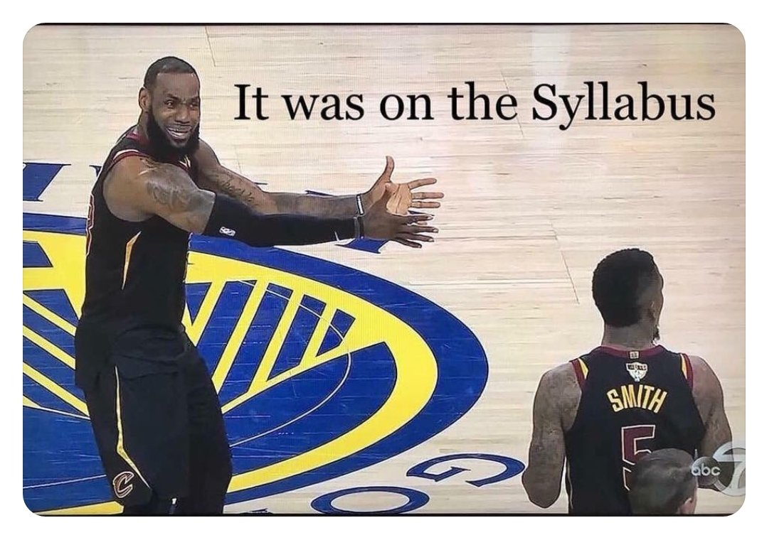
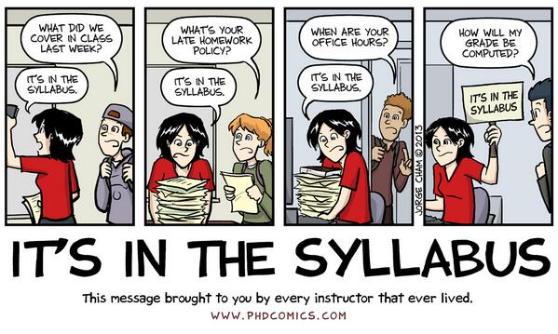
- Before you email me, read these links. Seriously. You’ll be a pro-emailer just by reading these links.
  - https://www.mindtools.com/pages/article/write-effective-emails-infographic.htm
  - https://www.wikihow.com/Email-a-Professor
  - https://medium.com/@lportwoodstacer/how-to-email-your-professor-without-being-annoying-af-cf64ae0e4087
  - https://www.insidehighered.com/views/2015/04/16/advice-students-so-they-dont-sound-silly-emails-essay
  - Subject lines should begin with something similar to the following: [COMM111 MW 9-9:50a]. The reason for this is to provide notice to the professor as to which class the student is in. The professor teaches several sections so he’d appreciate being able to keep track of where emails are coming from. ☺
- A good example of how to do a proper subject line is the following:
  - Subject: Group Project [COMM111 MW 9-9:50a]
- Please do not email me on LinkedIn or Twitter. Those are personal accounts, and I will not respond to you.
Email Response Times
- If the professor does not get to your email the same day, he will get back to you as soon as he can. If a student urgently needs to understand a concept or has a question, the student should seek help from other students on Piazza.
Reviewing Student Work
The professor will only review a student’s work during office hours.
Participation
- Students are expected to have completed all of the readings prior to coming to class.
- Students are encouraged to take handwritten notes on the readings before coming to class. These notes may be used on both in-class exams and quizzes. Typed notes are not permitted to be used on exams.
- Lectures/Activities: A student’s participation grade is determined by participating in activities, and lectures. Students found to be unprepared for class will face a loss of points to their participation grade.
- Be respectful of yourself, others and me.
- Participation grades are typically not calculated till the end of the quarter.
- Some assignments might become a part of the participation grade.

Assignment Guidelines
- Policy on late assignments: All assignments are due by the dates and times stated on the course schedule or on Piazza. Unless I make an announcement to the contrary. Assignments must be submitted through Moodle.
- I do NOT accept late assignments (especially because all deadlines are given to students at the start of the semester). If an emergency arises, you must contact me in via email before the due date to request an extension.
- Plagiarism: Don’t do it. Make sure to understand it: https://bconline.broward.edu/shared/orientation/academicintegrity.html
- Assignment format: All assignments should include your first and last name. The text of the assignment should be in 12-point Times New Roman type (with normal spacing in between letters), double-spaced and, with each page having one-inch margins on all sides.*No abnormal/weird formatting please. Please also include footer in the lower right-hand corner of each page (except the first) with the following information: last name, page X of Y (with Y indicating the total number of pages you are submitting) in 10-point Times New Roman type. Assignments exceeding the specified page limit or violating any of these requirements may be penalized. Specific penalties for breaking this rule will be articulated in the assignment guidelines when they are given during class.
  - There is a formatting checklist on Piazza. Use it before submitting assignment to me.

Assignments

- Speeches
- Informative Speech / 1 minute speech
- Students will create an informative speech on a topic of their choosing. The purpose of this speech is to teach the audience something new. Any speech which seeks to persuade the audience should be refrained from. Students should think of themselves as a journalist, and just give the audience the facts.
- The one-minute speech is the introduction of the Informative Speech. Students will complete the assignment in order to get feedback as to what to improve on prior to the Informative speech being due.
- An outline is required for this speech.
- A minimum of 7 sources must be cited.
- Oral citations must be used. Only credible websites/journals should be used.
- Length: 5-6 minutes.
- After the speech is completed students will draft an Informative Reflection Piece to reflect upon their performance on the speech.
- ONE 3x5 notecard is permitted. More than one notecard will result in a score of 0 for the speech.
- Students are not permitted to read speeches to the class, doing so will result in a zero on the speech.
- Shark Tank Speech (Persuasive Speech) Students will work in teams of 2-3 students to create a project to pitch to an investor.
- Each student is individually responsible for their own grade. No “group” grade will be given. Each student will have a different role in the group.
- An outline is required for this speech.
- Oral citations must be used. Only credible websites/journals should be used.
- 2-3 citations must be used.
- Length 3-5 minutes per person.
- No notecard is allowed to be utilized for this presentation. Students are not permitted to read speeches to the class, doing so will result in a zero on the speech.

- Life Lesson Speech
- Length: 1-3 minutes.
- Students should create a speech in which they share a life lesson with the class. The life lesson should be clear. The student should also use a story to describe how they came to knowing about this life lesson.
- Students are encouraged to speak from the heart.
- No notecard should be utilized for this presentation. Students are not permitted to read speeches to the class, doing so will result in a zero on the speech.

- Other Assignments
- Informative Reflection Piece
- Students will write a two-page (full two pages – yes, go to the bottom of the 2nd page) essay reflecting upon your preparation and performance on the Informative Speech.
- 1) The first page should talk about:
  - What steps you took to prepare? (1 paragraph)
  - Were those steps effective? (1 paragraph)
- 2) The second page should talk about:
  - What you're doing to improve on your next speech. (1 paragraph)
  - What you've learned from your first speech. (1 paragraph)
- Quizzes – Will be given based upon past and present material. Students are welcome to use hand-written notes during in-class quizzes. In the event that all the quizzes aren’t given out, the points will be transferred into one or more categories. Quizzes may be scheduled or unscheduled.

Disability Accommodation
- LBCC is committed to inclusiveness and equal access to higher education. If you have approved accommodations through the Center for Accessibility Resources (CFAR) and would like to use your accommodations in the class, please talk to your instructor as soon as possible to discuss your needs. If you believe you may need accommodations but are not yet registered with CFAR, please visit the CFAR Website for steps on how to apply for services or call 541-917-4789.

LBCC Comprehensive Statement of Nondiscrimination
LBCC prohibits unlawful discrimination based on race, color, religion, ethnicity, use of native language, national origin, sex, sexual orientation, gender, gender identity, marital status, disability, veteran status, age, or any other status protected under applicable federal, state, or local laws. For further information see Board Policy P1015 in our Board Policies and Administrative Rules. Title II, IX, & Section 504: Scott Rolen, CC-108, 541-917-4425; Lynne Cox, T-107B, 541-917-4806, LBCC, Albany, Oregon. To report: linnbenton-advocate.symplicity.com/public report.
Audio Recordings
- Lectures can be recorded, but please do not record class discussions as private information may be discussed
Final Note
The professor seeks to promote a supportive, inclusive, and positive educational environment where all students have an opportunity to be successful! Please help contribute to it through the way you conduct yourself in the classroom.

From: Talking about Plagiarism: https://www.macmillanlearning.com/catalog/static/bsm/technotes/workshops/talkingplagy.htm

