ART 206

History of Western Art: 18th-Century to the Present

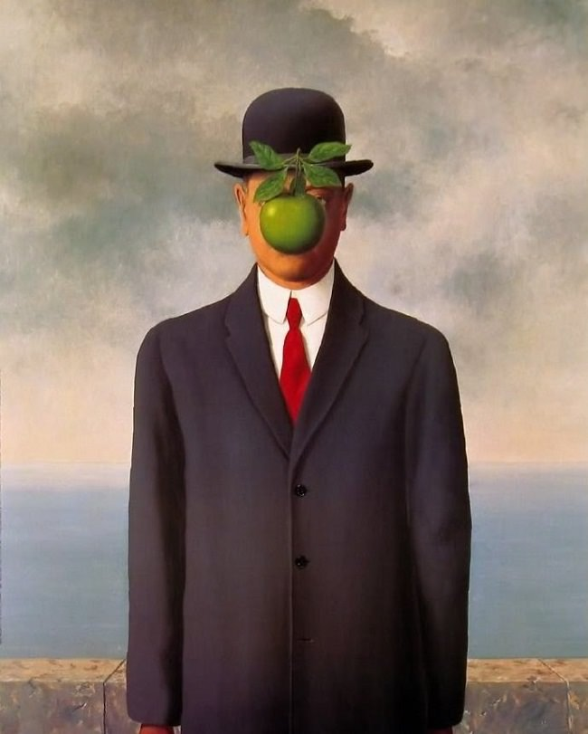
Spring 2017
Linn-Benton Community College
CRN 40008 TR 10-11:20am, NSH106
CRN 40005 TR 2-3:20pm, NSH106

Professor: Isabelle Havet

Email:haveti@linnbenton.edu
Office: SSH 116C
Office Hours: MW 11:30-1:00; TR 1:30-2
& by appointment
Art 206  History of Western Art: 18th-Century to the Present |  | Spring 2017  Class Times:  CRN: 40008 TR 10-11:20am, NSH106  CRN: 40005 TR 2-3:20pm, NSH106
Professor: Isabelle Havet
E-mail: haveti@linnbenton.edu
Phone: 541-917-4559
Office: SSH 116C
Office Hours: MW 11:30-1:00; TR 1:30-2 & by appt.

Course Description

This course provides an overview of the History of Western Art from the 18th-Century to the present. Significant artworks, including painting, sculpture, architecture, and the decorative arts are examined within their historical, social, and cultural contexts. This class is the third part of the three-part History of Western Art sequence (ART 204, 205 & 206).

Learning Outcomes
Upon successful completion of this course, students will be able to:
- Articulate verbally and in writing an understanding of the significance of art relative to the Western societies that produced them from the 18th-Century to the present day
- Identify and describe verbally and in writing, specific two and three-dimensional works of art from Western art of the 18th through the 21st-Century, using appropriate art vocabulary
- Articulate verbally and in writing the form and content of specific and significant works of art from the 18th-20th-Century European and American cultures that produced them

Credits: 3 credits; 3 hours of class per week.

General Education Requirements: Cultural Literacy AAOT/AAS, Human Relations AAS, AS Liberal Arts Core 1, AAS Human Relations, AAOT Arts & Letters, AS Literature & the Arts, AGS Humanities/Arts.

Prerequisites: None. This is an introductory-level course.
Recommended (but not required): College-level reading and writing skills.

Required Textbook: Fred S. Kleiner, Gardner's Art through the Ages: A Global History, Volume II, Cengage Learning, 15th edition. ISBN-10: 1285839390; ISBN-13: 978-1285839394. (The 14th edition is acceptable, but it is the student’s responsibility to complete the correct reading assignments, as the pagination is different.)

Required Supplies: Notebook (will be collected).
Course Assignments
- Notebook
- Quizzes
- Class Activities
- Group Presentation
- Art Analysis Paper
- Midterm Exam
- Final Exam

Description of Course Assignments

Readings and videos are assigned for each class session. Read all assigned readings and watch all assigned videos before each class session. See the Course Schedule for what to read for each class. You will frequently be asked to write reflections or discuss readings and videos in class, and thus are expected to keep on top of them. The quizzes, midterm, and final will revolve heavily around readings, videos, and lectures. I will check your Moodle progress frequently. If I see that you are falling behind, I will ask you why.
- Notebook
You are required to take notes during class. Studies show that note-taking students perform better than non-note-taking students. In addition to regular note-taking of lectures and assigned readings/videos, you will sometimes be asked to write reflections on certain topics. Your Notebook will be collected and graded.
- Quizzes
Students will take short quizzes in Moodle each week of instruction (Weeks 1-10). Quizzes are designed to help students keep pace with the material (readings, videos, lectures). Quizzes are a mix of multiple choice, True/False, word matching, and short answers.
- Class Activities
Students will frequently participate in class activities, both individually and in groups. Activities may include: writing assignments, pop quizzes, and class presentations on selected course topics. Some activities will be graded and some will not.
- Group Presentations
Small groups co-teach a 10-15 minute lesson on select topics (See Course Schedule).
- Comparative Analysis Paper
One short (2-3 page) comparative formal analysis paper on two chosen artworks.

- Midterm & Final Exam
The midterm and final exams will include a combination of multiple choice questions, short answers, and essays. These exams are not cumulative.

Failure to submit an assignment or participate in an activity in a timely manner will result in a 0 grade. Class activities cannot be made up later.

Assignment | Points
Attendance & Participation | 10
Weekly Quizzes (10) & Syllabus Quiz | 20
Notebook | 10
Group Presentation | 20
Comparative Analysis Paper | 20
Midterm & Final Exam | 20
Total Points | 100

Grading Scale
A 90-100%
B 80-89%
C 70-79%
D 60-69&
F 59% or below
What do I need to do to be successful in this class?
- Attend class.
- Check your LBCC email. Check it frequently (preferably daily), or have your LBCC email forwarded to your prefered account.
- Communicate regularly. Come to office hours or see me before or after class if you need to talk to me. I check email most weekdays and occasionally on weekends.
- Keep up with the material. Do not let it snowball on you. You should be spending at least 30-60 minutes reviewing assigned materials and taking notes before each class period. The instructor reserves the right to administer pop quizzes to ascertain if students are keeping up.
- Take notes during class, and of assigned readings/videos. This is an important college skill developed through practice. There will be times that you will be very glad to have your notes in class. Your Notebook will be collected periodically and graded.
- When in class, focus on class. Class time is valuable. You should be focused on class while you are in the room; if you can’t focus, leave the room. If you have personal business to attend to (e.g. phones calls/texting, conversations, or other class work), take care of it outside of the classroom. I expect you to apply yourself to your education during class hours. You are the person who has the greatest impact on your learning and your grade.
- Actively participate. You will NOT be successful in this class if you show up and “tune out.” Students who do not participate on a regular basis (by actively listening and engaging in discussions and activities) are unlikely to earn a passing grade. The goal is not always to have the “right” answers, but to try your best, stretch yourself, and be open to learning.
- Be positive and have fun! This course is about stretching our thinking and learning together. We will also be looking at cool art and stuff.
- Be a good class citizen. This means be open to: 1) working with others, 2) being respectful your peers and the instructor, and 3) trying new things. It’s always OK to be unsure about how to do something; it’s never OK to give up without trying.
- Be a good team member. You will spend time working with your “team.” Teams will have work assignments (some graded, some not). The best teams work through style differences. Approach collaborative activities with the attitude that you will contribute something to the group, rather than that you don’t know or can’t do something, and so shouldn’t try.
- Get ready to move. Be prepared to stand, move around, use your electronic device/the internet, and talk each day in class.
- Be accountable. Bottom line: you’ll get what you put into this class. You are the person who has the greatest impact on your learning, and ultimately, on your grade in this class.
Course Policies
Institutional Drop for Non-Attendance
Faculty at LBCC may administratively withdraw a student for nonattendance during the first week of the term. Students will be automatically dropped by the second Monday of the term if they are not attending regularly and fully participating in the course. Students who do not attend each session during the first week of class, or who do not complete the Syllabus Quiz and Quiz 1 by the end of Week 1, may be institutionally dropped from the course.
Moodle
This course uses the Moodle learning platform. Think of Moodle as the online class hub: you will use Moodle to access announcements, the Syllabus and Class Schedule, assignments guidelines, lecture slides, videos, readings, forums, and more.
I will upload my lecture slide presentation each day after class. Please note that the slide presentation will include the visuals only. There will be no audio recording of the lecture. Use the slide presentations to learn the images and key terms contained within. Do not republish any images found in the presentations online, as you may be breaking copyright laws. The images are for you to use to learn for exams only!

You will turn in assignments in Moodle. Assignments must be uploaded by Sunday at 11:59 pm on the week they are due (See Course Schedule for specific due dates). It is the student’s responsibility to upload assignments to Moodle by deadline in an acceptable file format (doc, docx, or pdf). If you are having trouble uploading an assignment, contact the Help Desk or email the instructor right away (before the deadline!) Do not wait until the last minute to turn in assignments! “Last-minute problems,” such as a faulty internet connection, computer problem, conflicting travel plans or personal scheduling conflicts, or other classwork, are not considered valid excuses for missing assignment deadlines.
Emailed assignments will NEVER be accepted. If it’s not submitted in Moodle, it’s not graded.
Attendance & Participation
The course spans only 10 weeks. It is vital to attend class regularly and arrive on time. Please do not come late to class. It is disruptive, and you risk missing important information and activities. If you miss an in-class activity or assignment, you cannot make it up.
Grading System:
A (Excellent)= Always prepared, frequently participates, rarely absent
B (Good)= Usually prepared, participates only when called on, rarely absent
C (Average)= Usually prepared, rarely speaks, sometimes absent
D (Below average)= Often unprepared, several absences
F = Usually unprepared, frequent absences

Moodle Attendance
Students track their own attendance is tracked in Moodle using their personal electronic devices. I find that this method is much more efficient and less of a hassle for all. Students mark themselves as Present, Absent, or Late at the beginning of each class session. If you do not have a personal device to mark your attendance, just come see me after class and I will mark your attendance for you. Attendance works on the honor system. Falsifying your attendance record in any way constitutes plagiarism, a serious college offense (See Academic Honesty below).
Present: Student arrives on time and stays the entire session.
Absent: Student does not attend class, or leaves early without prior approval.
Late: Student is 5 min late or more. 2 Late marks result in an unexcused absence.
Excused (marked only by instructor): Excused absences require documentation and are granted solely at the discretion of the instructor. If at all possible, arrange excused absences ahead of time.

Unexcused absences result in a lowering of the student’s final course grade by 5 points per absence. Please plan accordingly.

I understand that sometimes things happen. If you are late, will be late, or must miss class for a valid reason (emergency, military duty, death in the family), speak with me right away. I will excuse tardiness/absences if it is for a valid reason if it is not a frequent occurrence. Talk to me right away–do not wait!

Communication
- The best way to reach me is via email and during office hours. I try to respond to emails daily during weekdays. Feel free to email me if you have a question.
- When you email:
  - Write your first & last name, course number & section days/time, and a short reason in the subject line (e.g.: Jane Smith, ART101 MW 10-11–Request for Appointment).
  - Double-check that your email is appropriate and written in a professional manner. I love teaching, and I enjoy interacting with students outside of class. However, it is disheartening to receive emails that are disrespectful, demanding, overly-personal, angy, or venting. This happens rarely, and is more often than not unintentional. However this method of communication is helpful to neither instructor nor student and runs counter to LBCC core values, and thus is unacceptable.
- Check your LBCC email frequently (preferably daily), or forward it to your personal email. I frequently send out important information via Moodle, and you are responsible for reading that information on time.

Resources

Moodle Support
If you have questions about Moodle or need technical support, contact:
- Student Help Desk (located in the Library): Either visit, call at 541.917.4630, or email at student.helpdesk@linnbenton.edu
- LBCC Moodle User Support Forum: Look up or post questions: http://elearning.linnbenton.edu/mod/forum/view.php?id=2697
Accessibility
You should meet with your instructor during the first week of class if:
- you have a documented disability and need accommodations,
- your instructor needs to know medical information about you, or
- you need special arrangements in the event of an emergency.
If you have documented your disability, remember that you must make your request for accommodations through the Center for Accessibility Resources Online Services web page every term in order to receive accommodations. If you believe you may need accommodations, but are not yet registered with CFAR, please go to http://linnbenton.edu/cfar for steps on how to apply for services or call 541-917-4789.
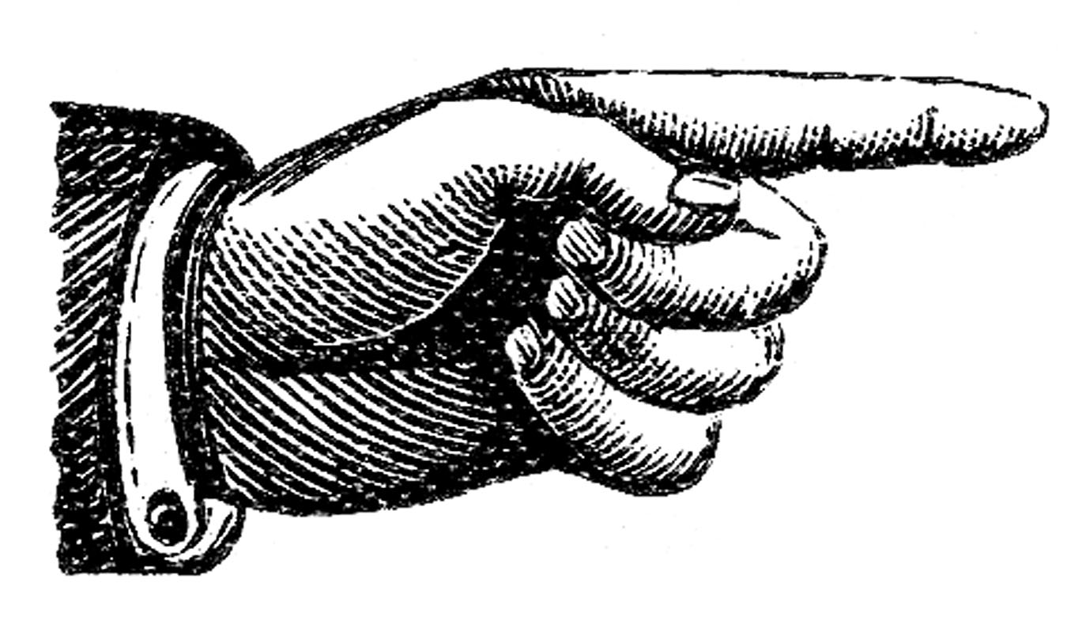
Extra Credit!

- Option 1: Use the Writing Center
You can receive up to ⅓ letter grade, or three (3) points, extra credit for using the Writing Center for the paper. These services are highly recommended!
To receive credit: Attach proof (a picture of the Writing Center dated stamp or other confirmation is fine) to the end of your paper.
Writing Center website: https://www.linnbenton.edu/writing-center
There are 3 ways to use the Writing Center: Schedule a 30-minute appointment (recommended); Use Drop-In Services; Use OWL (the Online Writing Lab).

- Option 2: Attend a campus/local lecture or exhibition: During the term, I will announce campus/local lectures and exhibitions that are of interest to the class. You can receive up to two (2) extra credit points added to your course grade for each event you attend by turning in a 1-page reflection paper on the event. In your reflection, you may discuss any aspect of the lecture or exhibition that struck you or that you feel ties into issues we’ve explored in the class, as long as you include some specific details showing you attended the event. Imagine that you’re a reporter or blogger writing a review of the event. Including pictures in your write-up is great. You are encouraged to request permission to do an extra credit write-up of an alternative local event/exhibition they wish to attend; instructor approval required.

- Option 3: Write a 1-page reflection in your Notebook. Topics announced in class.

Important Academic Calendar Dates:
Last day to add/drop: April 10, 2017
Last day to withdraw: May 19, 2017

Incomplete Grade Policy
An incomplete grade may be assigned when a student has completed and passed a majority of the required work, but for reasons beyond the student’s control, cannot complete the entire course. Incompletes are given only in extraordinary and documented circumstances (i.e., a family emergency or serious medical excuse), and at the discretion of the instructor. If an Incomplete is granted, the instructor will determine the work that must be completed as well as a nonnegotiable completion deadline for submitting all missing work. If the incomplete work is not submitted on time or is deemed unsatisfactory, the incomplete will revert to an F-grade.

Academic Honesty
Academic honesty is an indispensable value as students acquire knowledge and develop college skills. Students are expected to practice academic honesty by not cheating, plagiarizing, or misrepresenting their coursework in any way. Plagiarism, collusion, and other forms of misrepresentation hurt the student and run counter to the goals of education. Students are ultimately responsible for understanding and avoiding academic dishonesty, whether such incidences are intentional or unintentional. Violations will result in failure of the assignment and possibly the course. Per LBCC policy, all incidents of academic dishonesty will be reported to the Associate Dean of Student Development and the Dean of Arts, Social Science & Humanities.

Stay Connected with LBCC Visual Arts!
You can follow LBCC’s Visual Arts department on Instagram and Facebook, to stay up to date on art-related stuff, LBCC advising, scheduling, gallery opening events, and much more!
Instagram: @lbccart
Facebook: Linn-Benton Community College Visual Arts

