Homework 1
Please type or (legibly) write your answers on separate page

Lockout/Tagout (LOTO)
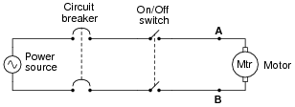
- In this motor control circuit, how would you ensure that there is no danger of electric shock prior to touching either of the motor terminals (shown as points A and B in the schematic diagram)? Describe both the action required to secure the power, and the means by which you would check for the presence of hazardous voltage at the motor:
- When using a padlock to secure a disconnect device in the “open” (off) state, who should be able to open that lock? In other words, how many other people should share a key to the lock you use to secure a breaker or switch in the safe position, if you are the one working on the system?
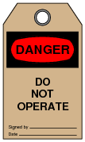
- When securing equipment for safe maintenance, special tags are attached with the lock(s) used to keep circuit breakers and other disconnect devices in the open (off) state. What is the purpose of attaching such a tag to an electrical disconnect device in addition to locking it in the open position? Why is a lock, by itself, not sufficient from a safety perspective?

- Suppose you are finishing a maintenance project where an electric motor was locked out and tagged, and now the work is complete. Your lock is the last one to be removed from the circuit breaker, everyone else already having taken their locks and tags off. What should you do before removing your lock and turning the circuit breaker back on?

Ohm’s Law
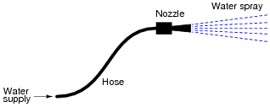
- For a given amount of water pressure, which will flow a greater rate of water: a small (restrictive) nozzle or a large (unrestrictive) nozzle? Explain how this relates to the study of voltage, current, and resistance in a simple electric circuit.

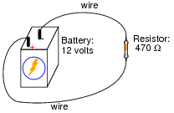
- Explain, step by step, how to calculate the amount of current (I) that will go through the resistor in this circuit. Give you answer in both amps and milliamps.

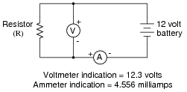
- What is the value of this resistor, in ohms (Ω) and kiloohms?

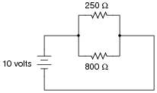
- A common saying about electricity is that ït always takes the path of least resistance.” Explain how this proverb relates to the following circuit, where electric current from the battery encounters two alternate paths, one being less resistive than the other:

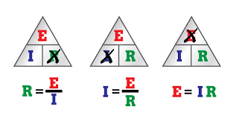
- One of the fundamental equations used in electricity and electronics is Ohm’s Law: the relationship between voltage (E or V, measured in units of volts), current (I, measured in units of amperes), and resistance (R, measured in units of ohms):
Solve for the unknown quantity (E, I, or R) given the other two. Don’t forget to label your answers!

  - I = 20 mA R = 5 kΩ E =
  - I = 150 μA R = 47 kΩ E =
  - E = 24 V R = 3.3 MΩ I =
  - E = 7.2 kV R = 900 Ω I =
  - E = 1.02 mV I = 40 μA R =
  - E = 3.5 GV I = 0.76 kA R =
  - I = 0.00035 A R = 5350 Ω E =
  - I = 1,710,000 A R = 0.002 Ω E =
  - E = 477 V R = 0.00500 Ω I =
  - E = 0.02 V R = 992,000 Ω I =
  - E = 150,000 V I = 233 A R =
  - E = 0.0000084V I = 0.011 A R =
  - I = 45 mA R = 3.0 kΩ E =
  - I = 10 kA R = 0.5 mΩ E =
  - E = 45 V R = 4.7 kΩ I =
  - E = 13.8 kV R = 8.1 kΩ I =
Write your answers for the following in scientific notation
  - E = 500 μV I = 36 nA R =
  - E = 14 V I = 110 A R =
  - I = 0.001 A R = 922 Ω E =
  - I = 825 A R = 15.0 mΩ E =
  - E = 1.2 kV R = 30 MΩ I =
  - E = 750 mV R = 86 Ω I =
  - E = 30.0 V I = 0.0025 A R =
  - E = 0.00071 V I = 3389 A R =

- Suppose an electric current of 1.5 microamps (1.5 μA) were to go through a resistance of 2.3 mega-ohms (2.3 MΩ). How much voltage would be “dropped” across this resistance? Show your work in calculating the answer.

Electric Shock
- Why is this sign a joke?
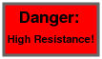

- In the late 1700’s, an Italian professor of anatomy, Luigi Galvani, discovered that the leg muscles of a recently deceased frog could be made to twitch when subjected to an electric current. What phenomenon is suggested by Galvani’s discovery? In other words, what does this tell us about the operation of muscle fibers in living creatures? More importantly, what practical importance does this have for people working near electric circuits?
- An American researcher named Charles Dalziel performed experiments with both human and animal subjects to determine the effects of electric currents on the body. A table showing his research data is presented here:
Bodily Effect | Gender | Direct Current | 60 Hz AC | 10 kHz AC
Slight sensation at point(s) of contact | Men | 1.0 mA | 0.4 mA | 7 mA
 | Women | 0.6 mA | 0.3 mA | 5 mA
Threshold of bodily perception | Men | 5.2 mA | 1.1 mA | 12 mA
 | Women | 3.5 mA | 0.7 mA | 8 mA
Pain, with voluntary muscle control maintained | Men | 62 mA | 9 mA | 55 mA
 | Women | 41 mA | 6 mA | 37 mA
Pain, with loss of voluntary muscle control | Men | 76 mA | 16 mA | 75 mA
 | Women | 51 mA | 10.5 mA | 50 mA
Severe pain, difficulty breathing | Men | 90 mA | 23 mA | 94 mA
 | Women | 60 mA | 15 mA | 63 mA
Possible heart fibrillation after three seconds | Men | 500 mA | 100 mA | ---
 | Women | 500 mA | 100 mA | ---

Important Note: Dalziel’s human test subjects were men and women in good health, with no known heart conditions or any other abnormalities that would have compromised their safety. In other words, these data points represent best-case scenarios, and do not necessarily reflect the risk to persons in poorer states of health.
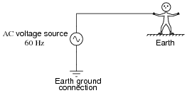
Assuming a skin contact resistance of 600 Ω for a sweaty hand, 1000 Ω of resistance for foot-to-ground contact, 50 Ω internal body resistance, 70 Ω of resistance through the soil from the person’s location to the earth ground point, and a male victim, calculate the amount of voltage necessary to achieve each of the listed shock conditions (threshold of perception, pain, etc.) for this circuit.

Now, assume the man has put on leather gloves with a resistance of 1 MΩ. Recalculate your values using the new resistance through the hands, with everything else staying constant.

Answer:
• Slight sensation at point(s) of contact: 0.69 volts
• Threshold of bodily perception: 1.9 volts
• Pain, with voluntary muscle control maintained: 15.5 volts
• Pain, with loss of voluntary muscle control: 27.5 volts
• Severe pain and difficulty breathing: 39.6 volts
• Possible heart fibrillation after three seconds: 172 volts

- What can electric current do to motor muscles (fingers, arms, legs)?
- What can electric current do to heart and lungs?
- Why should you use one hand while working on live power circuits?
- Why is water dangerous when working around electric power?
- Why is metal jewelry dangerous to wear when working on electric circuits?

Simple Circuits
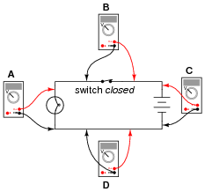
- Determine what these four voltmeters (A, B, C, D) will register when connected to this circuit in the following positions (assume a battery voltage of 6 volts).
A: _________________
B: _________________
C: _________________
D: _________________

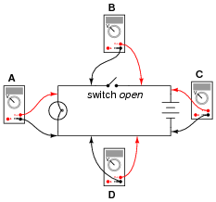
- Determine what these four voltmeters (A, B, C, D) will register when connected to this circuit in the following positions (assume a battery voltage of 6 volts).
A: _________________

B: _________________

C: _________________

D: _________________

- Identify the following types of switches, according to their style of actuation (how each switch is physically operated).
____________ ____________ ____________ ____________ ___________
- What positions do the switches have to be in for the light bulb to receive power?
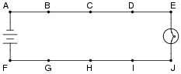
- In this circuit, where would you expect to measure full battery voltage (between what pairs of test points)?

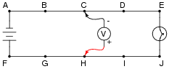
- Suppose this battery and light bulb circuit failed to work. Using a voltmeter, you measure full battery voltage between the points C and H. What does this single measurement indicate about the condition of the circuit? Be as specific as you can.

- Suppose this battery and light bulb circuit failed to work. Using nothing but a voltmeter, you measure voltage between the following sets of points:
• Between A and C: 0 volts
• Between D and G: 12 volts
• Between E and J: 0 volts
• Between B and E: 12 volts
From these voltage measurements, what can you tell about the condition of the battery, wiring, and light bulb? Be as specific as you can.

Voltage, Current, and Resistance
- Explain what the electrical terms voltage, current, and resistance mean, using your own words.
- Voltage is also known by another name: electromotive force, or EMF. Explain what this other name for voltage means.
- What is the difference between DC and AC electricity?

