LINN-BENTON COMMUNITY COLLEGE

COLLEGE CHEMISTRY I (CH 121)

Open Education Resources Textbook

(CHEMISTRY OER TEXTBOOK)

This Version Is For Public Use.

Developed by Dr. Ommidala Pattawong
June 26, 2021

Disclaimer
This resource is a remix of several existing chemistry OER. To respect the remixing terms of some Creative Common sharealike licenses, some content with an incompatible license have been removed to make this version for public sharing. The following chapter sections were removed from the version use only at LBCC:
- 4.4 The Periodic Trends
- 5.1 Types of Chemical Bonds

Attributions
This resource is a remix of several existing chemistry OER. See the attributions sections at the beginning of each chapter for more information. The author has chosen the most open license when possible, but to comply with license compatibility, some chapters have more restrictive licenses:
- Chapter 1: CC BY 4.0.
- Chapter 2: CC BY 4.0.
- Chapter 3: CC BY-NC-SA 4.0.
- Chapter 4: CC BY-NC-SA 4.0.
- Chapter 5: CC BY-NC-SA 4.0.
- Chapter 6: CC BY 4.0.
- Chapter 7: CC BY 4.0.

Table of Contents
Chapter Sections | Page
Chapter 1 – Attributions | 5 – 6
Chapter 1 – Essential Ideas in Chemistry  1.1 Chemistry in Context  1.2 Phases and Classification of Matter  1.3 Properties and Changes  1.4 Measurements: Numbers, Units, and Uncertainty  1.5 Dimensional Analysis | 7 – 45  9 – 15  16 – 23  24 – 27  28 – 39  40 – 46
Chapter 2 – Attributions | 47 – 48
Chapter 2 – Atomic Structure  2.1 Modern Atomic Theories and The Discovery of Subatomic Particles  2.2 Atomic Structure and Atomic Mass | 49 – 50  51 – 62  63 – 76
Chapter 3 – Attributions | 77 – 78
Chapter 3 – Development of Electronic Structure of Atoms  3.1 Light as Wave – Electromagnetic Spectrum  3.2 Light as Particle – Quantized Energy and Photon  3.3 The Bohr Model  3.4 Development of Quantum Theory  3.5 Quantum Numbers and Shapes of Orbitals | 79 – 80  81 – 88  89 – 98  99 – 104  105 – 113  114– 122
Chapter 4 – Attributions | 123 - 124
Chapter 4 – Electron Configurations and Periodic Properties of Elements  4.1 How Electrons Occupy Orbitals  4.2 Electron Configurations of Atoms  4.3 The Periodic Table  4.4 The Periodic Trends | 125 – 126  127 – 133  134 – 142  143 – 149  150 – 156

Table of Contents (Continue)
Chapter Sections | Page
Chapter 5 – Attributions | 157 – 158
Chapter 5 – Bond Formations and Nomenclature  5.1 Types of Chemical Bonds  5.2 Determination of Chemical Composition  5.3 Determination of Chemical Formulas  5.4 Formula Mass, Molecular Mass, and Molar Mass  5.5 Ionic Compounds – Formulas and Names  5.6 Molecular Compounds – Formulas and Names | 159 – 160  161 – 173  174 – 175  176 – 180  181 – 183  184 – 189  190 – 194
Chapter 6 – Attributions | 195 – 196
Chapter 6 – Chemical Bonding  6.1 Lewis Model  6.2 Valence Shell Electron Pair Repulsion Theory (VSEPR)  6.3 Valence Bond Theory (VBT)  6.4 Molecular Orbital Theory (MOT) | 197 – 198  199 – 215  216 – 233  234 – 256  257 – 262
Chapter 7 – Attributions | 263 – 264
Chapter 7 – Chemical Equations and Chemical Quantities  7.1 Writing and Balancing Chemical Equations  7.2 Reaction Stoichiometry  7.3 Limiting Reactant, Theoretical Yield, and Percent Yield | 265 – 266  267– 274  275 – 281  282 – 286

Chapter 1 – Attributions

The contents in this chapter, licensed under CC BY 4.0. has been adopted, modified, reorganized, and/or remixed from the following:

1.0 Introduction
"1 Introduction" by Paul Flowers, Klaus Theopold, Richard Langley, William R. Robinson, PhD, OpenStax is licensed under CC BY 4.0

1.1 Chemistry in Context
"1.1 Chemistry in Context" by Paul Flowers, Klaus Theopold, Richard Langley, William R. Robinson, PhD, OpenStax is licensed under CC BY 4.0

1.2 Phases and Classification of Matter
"1.2 Phases and Classification of Matter" by Paul Flowers, Klaus Theopold, Richard Langley, William R. Robinson, PhD, OpenStax is licensed under CC BY 4.0

1.3 Properties and Changes
"1.3 Physical and Chemical Properties" by Paul Flowers, Klaus Theopold, Richard Langley, William R. Robinson, PhD, OpenStax is licensed under CC BY 4.0

1.4 Measurements: Numbers, Units, and Uncertainty
"1.4 Measurements" by Paul Flowers, Klaus Theopold, Richard Langley, William R. Robinson, PhD, OpenStax is licensed under CC BY 4.0
"1.5 Measurement Uncertainty, Accuracy, and Precision" by Paul Flowers, Klaus Theopold, Richard Langley, William R. Robinson, PhD, OpenStax is licensed under CC BY 4.0

1.5 Dimensional Analysis
"1.6 Mathematical Treatment of Measurement Results" by Paul Flowers, Klaus Theopold, Richard Langley, William R. Robinson, PhD, OpenStax is licensed under CC BY 4.0

BLANK PAGE

Chapter 1 Essential Ideas in Chemistry

Chapter Introduction

1.1 Chemistry in Context

1.2 Phases and Classification of Matter

1.3 Properties and Changes

1.4 Measurements: Numbers, Units, and Uncertainty

1.5 Dimensional Analysis

Figure 1.1 Chemical substances and processes are essential for our existence, providing sustenance, keeping us clean and healthy, fabricating electronic devices, enabling transportation, and much more. (credit “left”: modification of work by “vxla”/Flickr; credit “left middle”: modification of work by “the Italian voice”/Flickr; credit “right middle”: modification of work by Jason Trim; credit “right”: modification of work by “gosheshe”/Flickr)

Why should we study chemistry?” Do you have an answer? You may be studying chemistry because it fulfills an academic requirement, but if you consider your daily activities, you might find chemistry interesting for other reasons. Most everything you do and encounter during your day involves chemistry. Making coffee, cooking eggs, and toasting bread involve chemistry. The products you use—like soap and shampoo, the fabrics you wear, the electronics that keep you connected to your world, the gasoline that propels your car—all of these and more involve chemical substances and processes. Whether you are aware or not, chemistry is part of your everyday world. In this course, you will learn many of the essential principles underlying the chemistry of modern-day life.

BLANK PAGE

1.1 Chemistry in Context

Learning Objectives
- Be able to provide examples of the importance of chemistry in everyday life
- Be able to describe the scientific method
- Be able to differentiate among hypotheses, theories, and laws

Chemistry: The History

Throughout human history, people have tried to convert matter into more useful forms. Our Stone Age ancestors chipped pieces of flint into useful tools and carved wood into statues and toys. These endeavors involved changing the shape of a substance without changing the substance itself. But as our knowledge increased, humans began to change the composition of the substances as well—clay was converted into pottery, hides were cured to make garments, copper ores were transformed into copper tools and weapons, and grain was made into bread.

Humans began to practice chemistry when they learned to control fire and use it to cook, make pottery, and smelt metals. Subsequently, they began to separate and use specific components of matter. A variety of drugs such as aloe, myrrh, and opium were isolated from plants. Dyes, such as indigo and Tyrian purple, were extracted from plant and animal matter. Metals were combined to form alloys—for example, copper and tin were mixed together to make bronze—and more elaborate smelting techniques produced iron. Alkalis were extracted from ashes, and soaps were prepared by combining these alkalis with fats. Alcohol was produced by fermentation and purified by distillation.

Attempts to understand the behavior of matter extend back for more than 2500 years. As early as the sixth century BC, Greek philosophers discussed a system in which water was the basis of all things. You may have heard of the Greek postulate that matter consists of four elements: Earth, air, fire, and water. Subsequently, an amalgamation of chemical technologies and philosophical speculations was spread from Egypt, China, and the eastern Mediterranean by alchemists, who endeavored to transform “base metals” such as lead into “noble metals” like gold, and to create elixirs to cure disease and extend life (Figure 1.2).

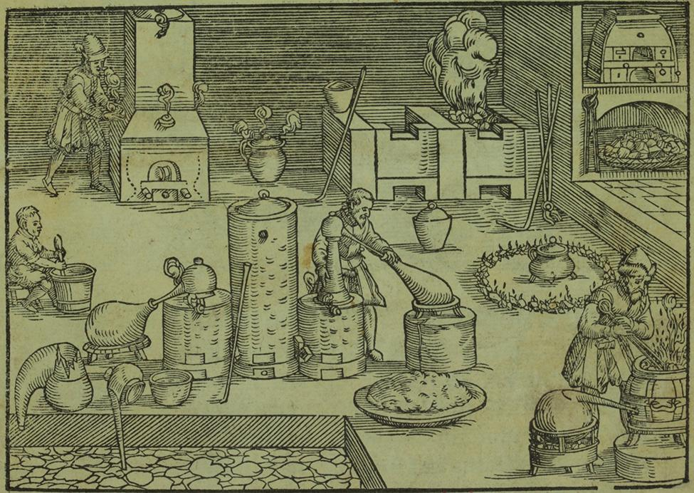

Figure 1.2 This portrayal shows an alchemist’s workshop circa 1580. Although alchemy made some useful contributions to how to manipulate matter, it was not scientific by modern standards. (credit: Chemical Heritage Foundation) From alchemy came the historical progressions that led to modern chemistry: the isolation of drugs from natural sources, metallurgy, and the dye industry. Today, chemistry continues to deepen our understanding and improve our ability to harness and control the behavior of matter.

Chemistry: The Central Science

Chemistry is sometimes referred to as “the central science” due to its interconnectedness with a vast array of other STEM disciplines (STEM stands for areas of study in the science, technology, engineering, and math fields). Chemistry and the language of chemists play vital roles in biology, medicine, materials science, forensics, environmental science, and many other fields (Figure 1.3). The basic principles of physics are essential for understanding many aspects of chemistry, and there is extensive overlap between many subdisciplines within the two fields, such as chemical physics and nuclear chemistry. Mathematics, computer science, and information theory provide important tools that help us calculate, interpret, describe, and generally make sense of the chemical world. Biology and chemistry converge in biochemistry, which is crucial to understanding the many complex factors and processes that keep living organisms (such as us) alive. Chemical engineering, materials science, and nanotechnology combine chemical principles and empirical findings to produce useful substances, ranging from gasoline to fabrics to electronics. Agriculture, food science, veterinary science, and brewing and wine making help provide sustenance in the form of food and drink to the world’s population. Medicine, pharmacology, biotechnology, and botany identify and produce substances that help keep us healthy. Environmental science, geology, oceanography, and atmospheric science incorporate many chemical ideas to help us better understand and protect our physical world. Chemical ideas are used to help understand the universe in astronomy and cosmology.

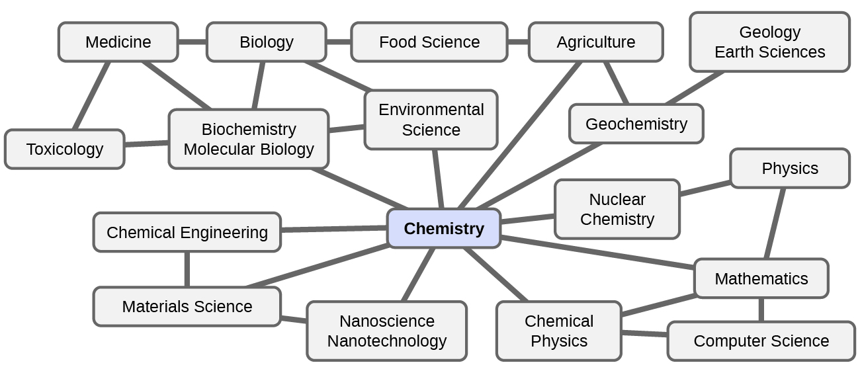

Figure 1.3 Knowledge of chemistry is central to understanding a wide range of scientific disciplines. This diagram shows just some of the interrelationships between chemistry and other fields. Digesting and assimilating food, synthesizing polymers that are used to make clothing, containers, cookware, and credit cards, and refining crude oil into gasoline and other products are just a few examples. As you proceed through this course, you will be learning chemistry, the study of the composition, properties, and interactions of matter. The practice of chemistry is not limited to chemistry books or laboratories: It happens whenever someone is involved in changes in matter or in conditions that may lead to such changes.

The Scientific Method
Chemistry is a science based on observation and experimentation. Doing chemistry involves attempting to answer questions and explain observations in terms of the laws and theories of chemistry, using procedures that are accepted by the scientific community. There is no single route to answering a question or explaining an observation, but there is an aspect common to every approach: Each uses knowledge based on experiments that can be reproduced to verify the results. Some routes involve a hypothesis, a tentative explanation of observations that acts as a guide for gathering and checking information. A hypothesis is tested by experimentation, calculation, and/or comparison with the experiments of others and then refined as needed.

Some hypotheses are attempts to explain the behavior that is summarized in laws. The laws of science summarize a vast number of experimental observations, and describe or predict some facet of the natural world. If such a hypothesis turns out to be capable of explaining a large body of experimental data, it can reach the status of a theory. Scientific theories are well-substantiated, comprehensive, testable explanations of particular aspects of nature. Theories are accepted because they provide satisfactory explanations, but they can be modified if new data become available. The path of discovery that leads from question and observation to law or hypothesis to theory, combined with experimental verification of the hypothesis and any necessary modification of the theory, is called the scientific method (Figure 1.4).

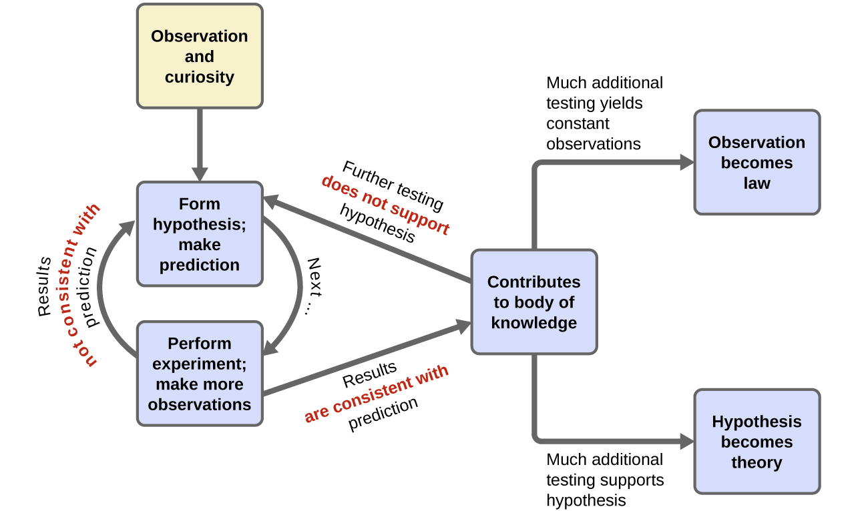

Figure 1.4 The scientific method follows a process similar to the one shown in this diagram. All the key components are shown, in roughly the right order. Scientific progress is seldom neat and clean: It requires open inquiry and the reworking of questions and ideas in response to findings.

The Domains of Chemistry
Chemists study and describe the behavior of matter and energy in three different domains: macroscopic, microscopic, and symbolic. These domains provide different ways of considering and describing chemical behavior.

Macro is a Greek word that means “large.” The macroscopic domain is familiar to us: It is the realm of everyday things that are large enough to be sensed directly by human sight or touch. In daily life, this includes the food you eat and the breeze you feel on your face. The macroscopic domain includes everyday and laboratory chemistry, where we observe and measure physical and chemical properties such as density, solubility, and flammability.

Micro comes from Greek and means “small.” The microscopic domain of chemistry is often visited in the imagination. Some aspects of the microscopic domain are visible through standard optical microscopes, for example, many biological cells. More sophisticated instruments are capable of imaging even smaller entities such as molecules and atoms (see Figure 1.5 (b)). However, most of the subjects in the microscopic domain of chemistry are too small to be seen even with the most advanced microscopes and may only be pictured in the mind. Other components of the microscopic domain include ions and electrons, protons and neutrons, and chemical bonds, each of which is far too small to see.

The symbolic domain contains the specialized language used to represent components of the macroscopic and microscopic domains. Chemical symbols (such as those used in the periodic table), chemical formulas, and chemical equations are part of the symbolic domain, as are graphs, drawings, and calculations. These symbols play an important role in chemistry because they help interpret the behavior of the macroscopic domain in terms of the components of the microscopic domain. One of the challenges for students learning chemistry is recognizing that the same symbols can represent different things in the macroscopic and microscopic domains, and one of the features that makes chemistry fascinating is the use of a domain that must be imagined to explain behavior in a domain that can be observed.
A helpful way to understand the three domains is via the essential and ubiquitous substance of water. That water is a liquid at moderate temperatures, will freeze to form a solid at lower temperatures, and boil to form a gas at higher temperatures (Figure 1.5) are macroscopic observations. But some properties of water fall into the microscopic domain—what cannot be observed with the naked eye. The description of water as comprising two hydrogen atoms and one oxygen atom, and the explanation of freezing and boiling in terms of attractions between these molecules, is within the microscopic area. The formula H₂O, which can describe water at either the macroscopic or microscopic levels, is an example of the symbolic domain. The abbreviations (g) for gas, (s) for solid, and (l) for liquid are also symbolic.

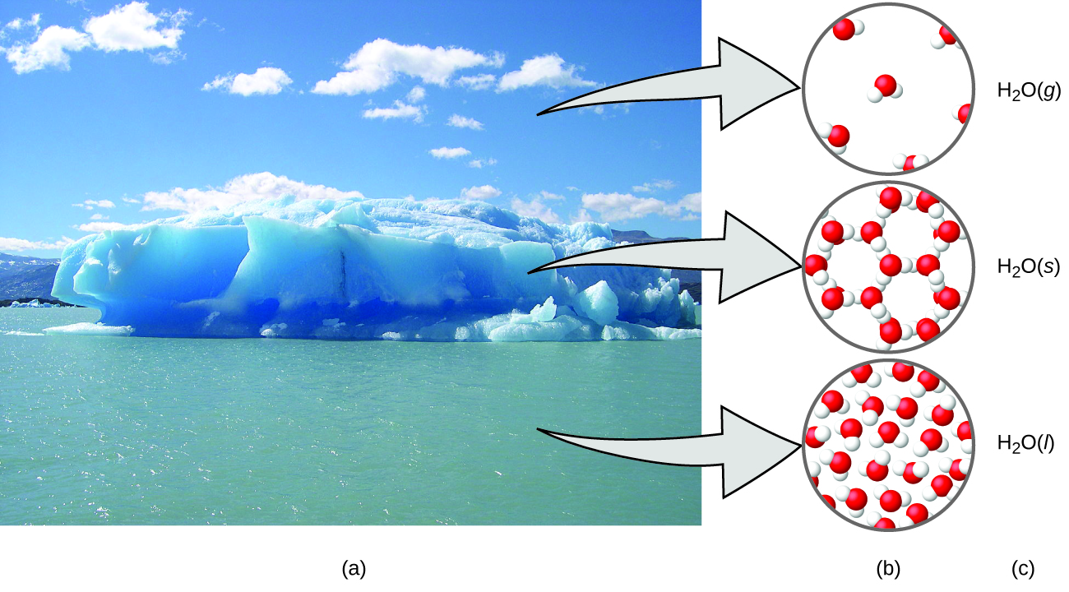
Figure 1.5 (a) Moisture in the air, icebergs, and the ocean represent water in the macroscopic domain. (b) At the molecular level (microscopic domain), gas molecules are far apart and disorganized, solid water molecules are close together and organized, and liquid molecules are close together and disorganized. (c) The formula H₂O symbolizes water, and (g), (s), and (l) symbolize its phases. Note that clouds actually comprise either very small liquid water droplets or solid water crystals; gaseous water in our atmosphere is not visible to the naked eye, although it may be sensed as humidity. (credit a: modification of work by “Gorkaazk”/Wikimedia Commons)

1.2 Phases and Classification of Matter

Learning Objectives
- Describe the basic properties of each physical state of matter: solid, liquid, and gas
- Distinguish between mass and weight
- Apply the law of conservation of matter
- Classify matter as an element, compound, homogeneous mixture, or heterogeneous mixture with regard to its physical state and composition
- Define and give examples of atoms and molecules

Matter
Matter is defined as anything that occupies space and has mass, and it is all around us. Solids and liquids are more obviously matter: We can see that they take up space, and their weight tells us that they have mass. Gases are also matter; if gases did not take up space, a balloon would not inflate (increase its volume) when filled with gas.

Mass
The mass of an object is a measure of the amount of matter in it. One way to measure an object’s mass is to measure the force it takes to accelerate the object. It takes much more force to accelerate a car than a bicycle because the car has much more mass. A more common way to determine the mass of an object is to use a balance to compare its mass with a standard mass.

Weight
Although weight is related to mass, it is not the same thing. Weight refers to the force that gravity exerts on an object. This force is directly proportional to the mass of the object. The weight of an object changes as the force of gravity changes, but its mass does not. An astronaut’s mass does not change just because she goes to the moon. But her weight on the moon is only one-sixth her earth-bound weight because the moon’s gravity is only one-sixth that of the earth’s. She may feel “weightless” during her trip when she experiences negligible external forces (gravitational or any other), although she is, of course, never “massless.”

The Law of Conservation of Matter
The law of conservation of matter states that there is no detectable change in the total quantity of matter present when matter converts from one type to another (a chemical change) or changes among solid, liquid, or gaseous states (a physical change). Brewing beer and the operation of batteries provide examples of the conservation of matter (Figure 1.6). During the brewing of beer, the ingredients (water, yeast, grains, malt, hops, and sugar) are converted into beer (water, alcohol, carbonation, and flavoring substances) with no actual loss of substance. This is most clearly seen during the bottling process, when glucose turns into ethanol and carbon dioxide, and the total mass of the substances does not change. This can also be seen in a lead-acid car battery: The original substances (lead, lead oxide, and sulfuric acid), which are capable of producing electricity, are changed into other substances (lead sulfate and water) that do not produce electricity, with no change in the actual amount of matter.
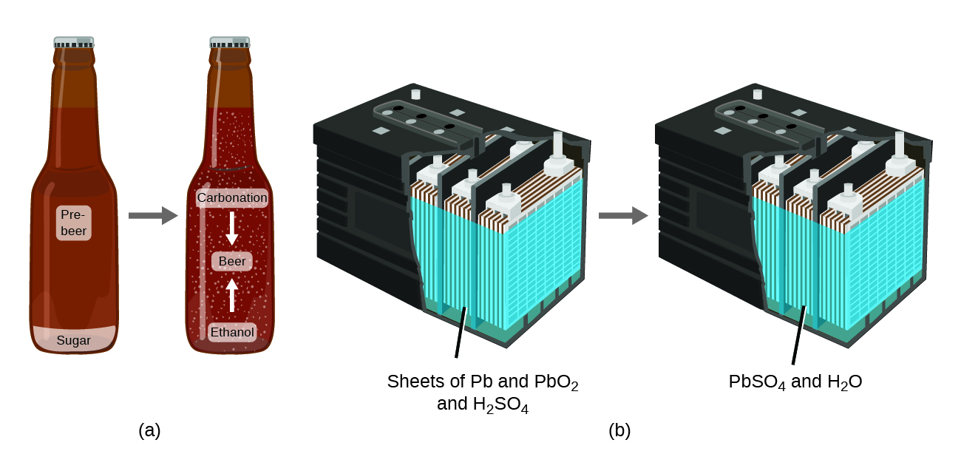
Figure 1.6 (a) The mass of beer precursor materials is the same as the mass of beer produced: Sugar has become alcohol and carbon dioxide. (b) The mass of the lead, lead oxide, and sulfuric acid consumed by the production of electricity is exactly equal to the mass of lead sulfate and water that is formed.

Phase or States of Matter
Solids, liquids, and gases are the three states of matter commonly found on earth (Figure 1.7). A solid is rigid and possesses a definite shape. A liquid flows and takes the shape of its container, except that it forms a flat or slightly curved upper surface when acted upon by gravity. (In zero gravity, liquids assume a spherical shape.) Both liquid and solid samples have volumes that are very nearly independent of pressure. A gas takes both the shape and volume of its container.
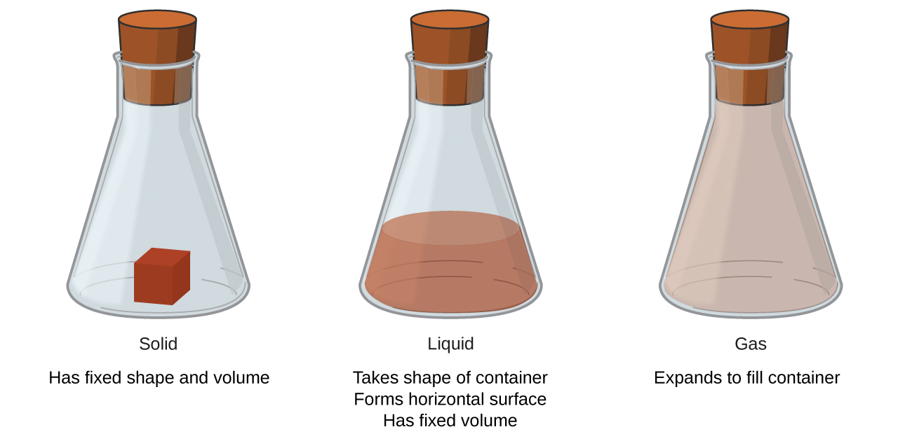
Figure 1.7 The three most common states or phases of matter are solid, liquid, and gas.
This site shows pictures of matter on the microscopic views and characteristics of gas, liquid, and solid.

Classifying Matter
Matter can be classified into several categories.

Pure Substances and Mixtures
A pure substance has a constant composition. All specimens of a pure substance have exactly the same makeup and properties. Any sample of sucrose (table sugar) consists of 42.1% carbon, 6.5% hydrogen, and 51.4% oxygen by mass. Any sample of sucrose also has the same physical properties, such as melting point, color, and sweetness, regardless of the source from which it is isolated. Pure substances may be divided into two classes: elements and compounds.

Elements are pure substances that cannot be broken down into simpler substances by chemical changes. Iron, silver, gold, aluminum, sulfur, oxygen, and copper are familiar examples of the more than 100 known elements, of which about 90 occur naturally on the earth, and two dozen or so have been created in laboratories.

Compounds are pure substances that can be broken down by chemical changes. This breakdown may produce either elements or other compounds, or both. Mercury(II) oxide, an orange, crystalline solid, can be broken down by heat into the elements mercury and oxygen (Figure 1.8). When heated in the absence of air, the compound sucrose is broken down into the element carbon and the compound water. (The initial stage of this process, when the sugar is turning brown, is known as caramelization—this is what imparts the characteristic sweet and nutty flavor to caramel apples, caramelized onions, and caramel). Silver(I) chloride is a white solid that can be broken down into its elements, silver and chlorine, by absorption of light. This property is the basis for the use of this compound in photographic films and photochromic eyeglasses (those with lenses that darken when exposed to light).

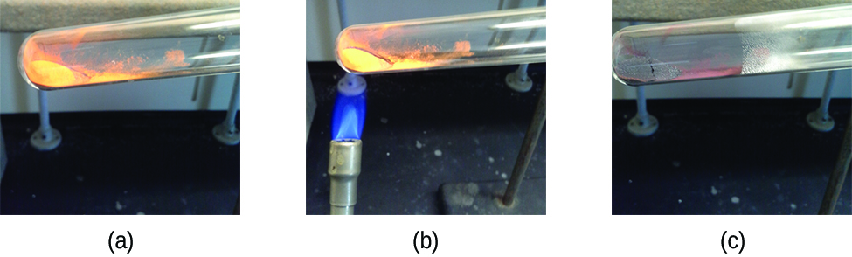
Figure 1.8 (a) The compound mercury(II) oxide, (b) when heated, (c) decomposes into silvery droplets of liquid mercury and invisible oxygen gas. (credit: modification of work by Paul Flowers)

Link to Learning: Many compounds break down when heated. This site shows the breakdown of mercury oxide, HgO. You can also view an example of the photochemical decomposition of silver chloride (AgCl), the basis of early photography.

A mixture is composed of two or more types of matter that can be present in varying amounts and can be separated by physical changes, such as evaporation (you will learn more about this later).

A heterogeneous mixture has a composition that varies from point to point. Italian dressing is an example of a heterogeneous mixture (Figure 1.9). Its composition can vary because it may be prepared from varying amounts of oil, vinegar, and herbs. It is not the same from point to point throughout the mixture—one drop may be mostly vinegar, whereas a different drop may be mostly oil or herbs because the oil and vinegar separate and the herbs settle. Other examples of heterogeneous mixtures are chocolate chip cookies (we can see the separate bits of chocolate, nuts, and cookie dough) and granite (we can see the quartz, mica, feldspar, and more).

A homogeneous mixture or also called solution exhibits a uniform composition and appears visually the same throughout. An example of a solution is a sports drink, consisting of water, sugar, coloring, flavoring, and electrolytes mixed together uniformly (Figure 1.9). Each drop of a sports drink tastes the same because each drop contains the same amounts of water, sugar, and other components.

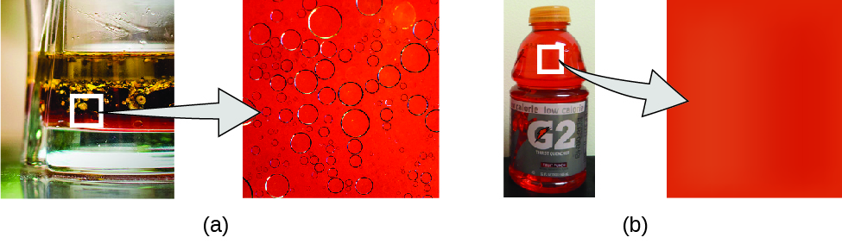
Figure 1.9 (a) Oil and vinegar salad dressing is a heterogeneous mixture because its composition is not uniform throughout. (b) A commercial sports drink is a homogeneous mixture because its composition is uniform throughout. (credit a “left”: modification of work by John Mayer; credit a “right”: modification of work by Umberto Salvagnin; credit b “left: modification of work by Jeff Bedford)

Link to Learning: A solution can appear in any phase. An example of a gaseous solution is air, consisting of 78% nitrogen, 21% oxygen, and 1% of other gases. Another example of a solid-solid solution is brass, consisting of copper and zinc. This site shows additional solution types and examples. Also visit this site to see microscopic views of different kind of solutions.

Although there are just over 100 elements, tens of millions of chemical compounds result from different combinations of these elements. Each compound has a specific composition and possesses definite chemical and physical properties that distinguish it from all other compounds. And, of course, there are innumerable ways to combine elements and compounds to form different mixtures. A summary of how to distinguish between the various major classifications of matter is shown in (Figure 1.10).

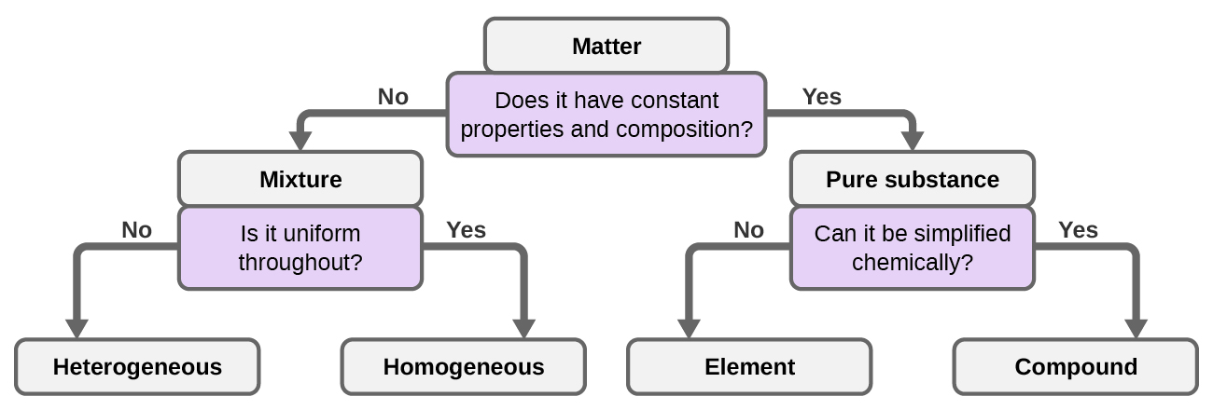

Figure 1.10 Depending on its properties, a given substance can be classified as a homogeneous mixture, a heterogeneous mixture, a compound, or an element.

A majority of elements on earth are found in chemical combinations with other elements; about one-quarter of the elements are also found in the free state. Oxygen constitutes nearly one-half and silicon about one-quarter of the total quantity of these elements.

Table 1.1 Elements make up the earth’s crust and atmosphere

Elemental Composition of Earth
Element | Symbol | Percent Mass |  | Element | Symbol | Percent Mass
oxygen | O | 49.20 |  | chlorine | Cl | 0.19
silicon | Si | 25.67 |  | phosphorus | P | 0.11
aluminum | Al | 7.50 |  | manganese | Mn | 0.09
iron | Fe | 4.71 |  | carbon | C | 0.08
calcium | Ca | 3.39 |  | sulfur | S | 0.06
sodium | Na | 2.63 |  | barium | Ba | 0.04
potassium | K | 2.40 |  | nitrogen | N | 0.03
magnesium | Mg | 1.93 |  | fluorine | F | 0.03
hydrogen | H | 0.87 |  | strontium | Sr | 0.02
titanium | Ti | 0.58 |  | all others | - | 0.47

Atoms and Molecules
An atom is the smallest particle of an element that has the properties of that element and can enter into a chemical combination. An atom is so small that its size is difficult to imagine. One of the smallest things we can see with our unaided eye is a single thread of a spider web: These strands are about 1/10,000 of a centimeter (0.0001 cm) in diameter. A single carbon atom in the web has a diameter of about 0.000000015 centimeter, and it would take about 7000 carbon atoms to span the diameter of the strand. To put this in perspective, if a carbon atom were the size of a dime, the cross-section of one strand would be larger than a football field, which would require about 150 million carbon atom “dimes” to cover it.

An atom is so light that its mass is also difficult to imagine. A billion lead atoms (1,000,000,000 atoms) weigh about 3 × 10⁻¹³ grams, a mass that is far too light to be weighed on even the world’s most sensitive balances. It would require over 300,000,000,000,000 lead atoms (300 trillion, or 3 × 10¹⁴) to be weighed, and they would weigh only 0.0000001 gram.

It is rare to find collections of individual atoms. Only a few elements, such as the gases helium, neon, and argon, consist of a collection of individual atoms that move about independently of one another. Other elements consist of two or more atoms.

A molecule consists of two or more atoms joined by strong forces called chemical bonds. The atoms in a molecule move around as a unit, much like the cans of soda in a six-pack or a bunch of keys joined together on a single key ring. A molecule may consist of two or more identical atoms, as in the molecules found in the elements hydrogen, oxygen, and sulfur, or it may consist of two or more different atoms, as in the molecules found in water. Each water molecule is a unit that contains two hydrogen atoms and one oxygen atom. Each glucose molecule is a unit that contains 6 carbon atoms, 12 hydrogen atoms, and 6 oxygen atoms. Like atoms, molecules are incredibly small and light. If an ordinary glass of water were enlarged to the size of the earth, the water molecules inside it would be about the size of golf balls.

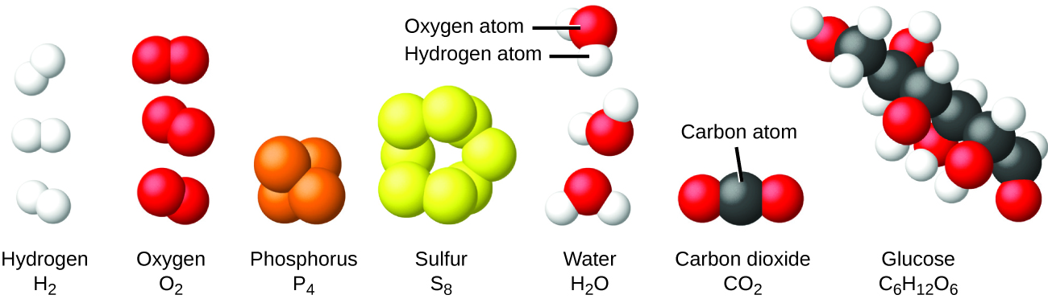

Figure 1.12 The elements hydrogen, oxygen, phosphorus, and sulfur form molecules consisting of two or more atoms of the same element. The compounds water, carbon dioxide, and glucose consist of combinations of atoms of different elements.

1.3 Properties and Changes

Learning Objectives
- Differentiate between physical and chemical properties of matter
- Differentiate between physical and chemical changes of matter

Physical vs. Chemical Properties
The characteristics that distinguish one substance from another are called properties. A physical property is a characteristic of matter that is not associated with a change in its chemical composition. Familiar examples of physical properties include density, color, hardness, melting and boiling points, and electrical conductivity. Some physical properties, such as density and color, may be observed without changing the physical state of the matter. Other physical properties, such as the melting temperature of iron or the freezing temperature of water, can only be observed as matter undergoes a physical change.

A chemical property is the change of one type of matter into another type (or the inability to change). Examples of chemical properties include flammability, toxicity, acidity, and many other types of reactivity. Iron, for example, combines with oxygen in the presence of water to form rust; chromium does not oxidize (Figure 1.13). Nitroglycerin is very dangerous because it explodes easily; neon poses almost no hazard because it is very unreactive.
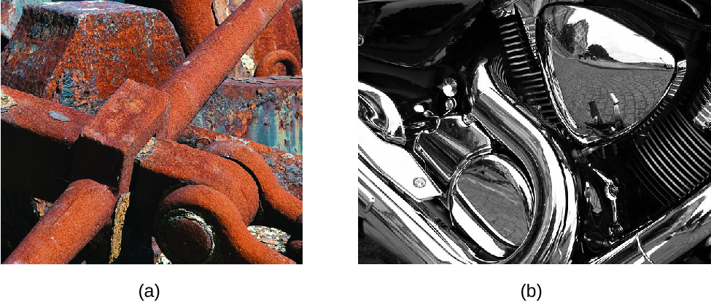
Figure 1.13 (a) One of the chemical properties of iron is that it rusts; (b) one of the chemical properties of chromium is that it does not. (credit a: modification of work by Tony Hisgett; credit b: modification of work by “Atoma”/Wikimedia Commons)

Physical vs. Chemical Changes
A physical change is a change in the state or properties of matter without any accompanying change in the chemical identities or composition of the substances contained in the matter. Figure 1.14 illustrates state change of matter. Melting, or fusion is the phase transition of a substance from a solid to a liquid. Vaporization is the phase transition from a liquid to gas. Sublimation is the phase transition directly from a solid to a gas without going through a liquid. These transitions occur when the internal energy of matter increases; for example, by increasing temperature. On the other hand, the opposite transitions: condensation, freezing, and deposition occur when the internal energy decreases. Condensation is the phase transition from a gas to liquid. Freezing is the phase transition from a liquid to a solid. Deposition is the phase transition directly from a gas to a solid without going through a liquid. Examples of physical changes that involve phase transition are wax melting, steam condenses into liquid water, dry ice subliming, etc.
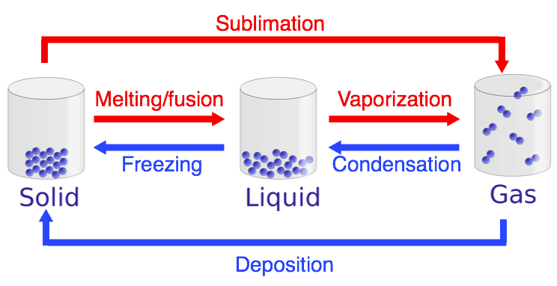
Figure 1.14 Phase transitions of matter: melting/fusion (solid to liquid), vaporization (liquid to gas), sublimation (solid to gas), condensation (gas to liquid), freezing (liquid to solid), and deposition (gas to solid). (credit: modified from "File:States of matter En.svg" by Yelod - Wikimedia Commons is licensed under CC BY-SA 3.0)

Other examples of physical changes include sugar dissolving in coffee, magnetizing and demagnetizing metals (as is done with common antitheft security tags) and grinding solids into powders (which can sometimes yield noticeable changes in color). In each of these examples, there is a change in the physical state, form, or properties of the substance, but no change in its chemical composition.

A chemical change always produces one or more types of matter that differ from the matter present before the change. A chemical change results in a change in chemical composition. The formation of rust is a chemical change because rust is a different kind of matter than the iron, oxygen, and water present before the rust formed. The explosion of nitroglycerin is a chemical change because the gases produced are very different kinds of matter from the original substance. Other examples of chemical changes include reactions that are performed in a lab (such as copper reacting with nitric acid), all forms of combustion (burning), and food being cooked, digested, or rotting (Figure 1.15).

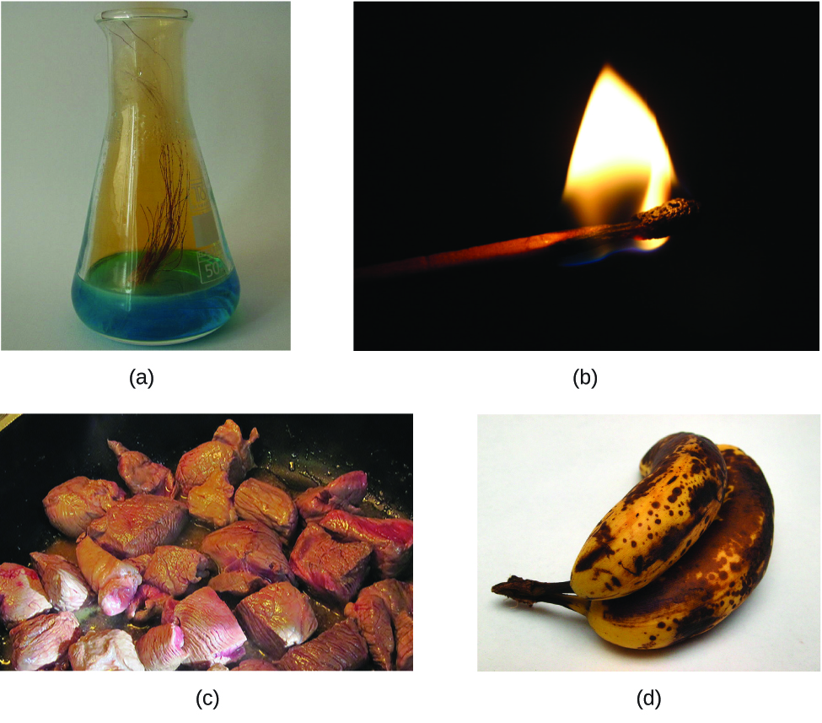

Figure 1.15 (a) Copper and nitric acid undergo a chemical change to form copper nitrate and brown, gaseous nitrogen dioxide. (b) During the combustion of a match, cellulose in the match and oxygen from the air undergo a chemical change to form carbon dioxide and water vapor. (c) Cooking red meat causes a number of chemical changes, including the oxidation of iron in myoglobin that results in the familiar red-to-brown color change. (d) A banana turning brown is a chemical change as new, darker (and less tasty) substances form. (credit b: modification of work by Jeff Turner; credit c: modification of work by Gloria Cabada-Leman; credit d: modification of work by Roberto Verzo)

While many elements differ dramatically in their chemical and physical properties, some elements have similar properties. For example, many elements conduct heat and electricity well, whereas others are poor conductors. These properties can be used to sort the elements into three classes: metals (elements that conduct well), nonmetals (elements that conduct poorly), and metalloids (elements that have intermediate conductivities).

The periodic table is a table of elements that places elements with similar properties close together (Figure 1.16). You will learn more about the periodic table as you continue your study of chemistry.

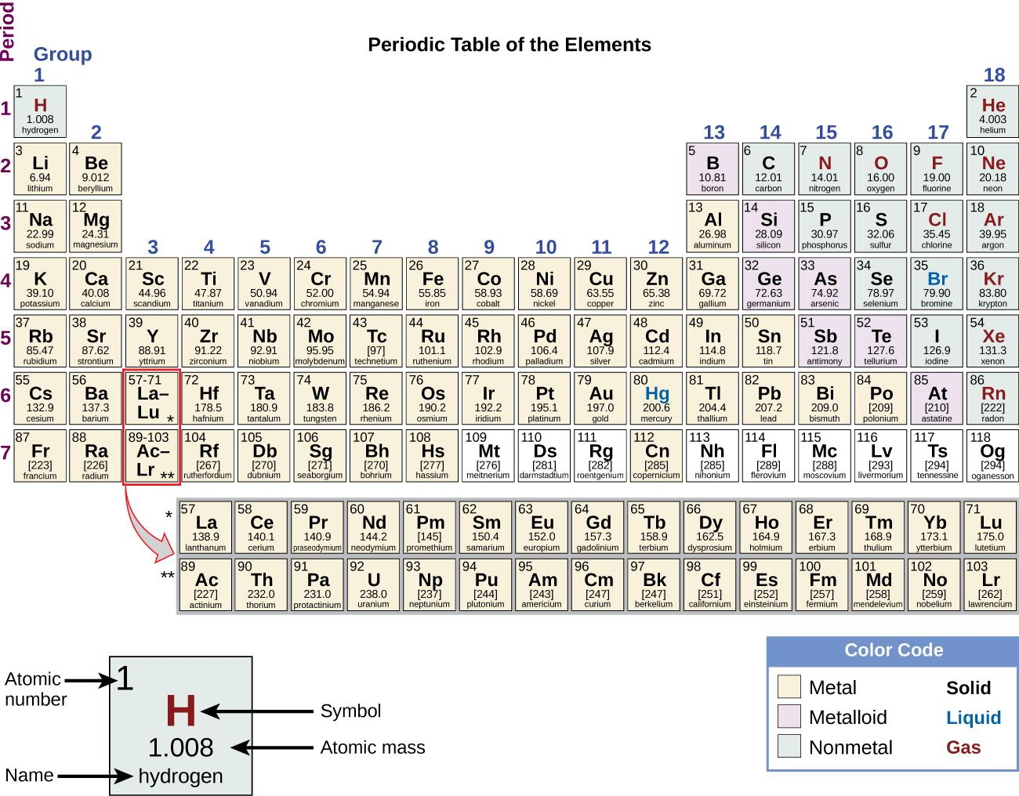

Figure 1.16 The periodic table shows how elements may be grouped according to certain similar properties. Note the background color denotes whether an element is a metal, metalloid, or nonmetal, whereas the element symbol color indicates whether it is a solid, liquid, or gas.

1.4 Measurements: Numbers, Units, and Uncertainty

Learning Objectives
- Identify the three basic information that come from every measurement
- Represent numbers in form of decimal and scientific notation
- Describe the properties and units of length, mass, volume, density, temperature, and time
- Perform basic unit calculations and conversions in the metric and other unit systems
- Perform density calculations
- Use appropriate prefix multiplier
- Distinguish exact and uncertain numbers
- Correctly represent uncertainty in quantities using significant figures
- Apply proper significant figure rules in calculations
- Define and distinguish accuracy and precision

Measurements provide much of the information that informs the hypotheses, theories, and laws describing the behavior of matter and energy in both the macroscopic and microscopic domains of chemistry. Every measurement provides three kinds of information: the size or magnitude of the measurement (a number); a standard of comparison for the measurement (a unit); and an indication of the uncertainty of the measurement. While the number and unit are explicitly represented when a quantity is written, the uncertainty is an aspect of the measurement result that is more implicitly represented and will be discussed later.

Magnitude of the Measurement (A Number)
The number in the measurement can be represented in different ways, including decimal form and scientific notation. (Scientific notation is also known as exponential notation; a review of this topic can be found in the Lecture Manual, the end of this learning unit) For example, the maximum takeoff weight of a Boeing 777-200ER airliner is 298,000 kilograms, which can also be written as 2.98 × 10⁵ kg. The mass of the average mosquito is about 0.0000025 kilograms, which can be written as 2.5 × 10⁻⁶ kg.

Units
Without units, a number can be meaningless, confusing, or possibly life threatening. Suppose a doctor prescribes phenobarbital to control a patient’s seizures and states a dosage of “100” without specifying units. Not only will this be confusing to the medical professional giving the dose, but the consequences can be dire: 100 mg given three times per day can be effective as an anticonvulsant, but a single dose of 100 g is more than 10 times the lethal amount.

The units such as miles, gallons, pounds, and feet are commonly used in the United States. These units are part of the English unit system. However, in most parts of the world including all scientific communities, the International System of Units or SI Units (from the French, Le Système International d’Unités) are commonly used. The SI units evolved from the metric system.

Units are written after number. The measurement units (“base units”) for fundamental properties commonly used in chemistry are listed in Table 1.2. Units for other properties may be derived from these seven base units.

Table 1.2 Base Units of the SI, Metric, and Imperial Systems
Property Measured | SI System | Metric System | English System
length | Meter (m) | Meter (m) | Inch (in)
mass | Kilogram (kg) | gram (g) | Pound (lb)
time | Second (s) | Second (s) | Second (s)
temperature | Kelvin (K) | Degree Celsius (ºC) | Degree Fahrenheit (ºF)
amount of substance | Mole (mol) | Mole (mol) | Dozen
Volume | Cubic meters (m³) | Liter (L) | Gallon (gal)

Derived Units
We can derive many units from the above base units. For example, we can use the base unit of length to define a unit of volume, and the base units of mass and length to define a unit of density.

Volume is a measure of the amount of space occupied by an object. The standard SI unit of volume is defined by the base unit of length (Figure 1.17). The standard volume is a cubic meter (m³), a cube with an edge length of exactly one meter. To dispense a cubic meter of water, we could build a cubic box with edge lengths of exactly one meter. This box would hold a cubic meter of water or any other substance.

A more commonly used unit of volume is derived from the decimeter (0.1 m, or 10 cm). A cube with edge lengths of exactly one decimeter contains a volume of one cubic decimeter (dm³). A liter (L) is the more common name for the cubic decimeter. One liter is about 1.06 quarts.

A cubic centimeter (cm³) is the volume of a cube with an edge length of exactly one centimeter. The abbreviation cc (for cubiccentimeter) is often used by health professionals. A cubic centimeter is equivalent to a milliliter (mL) and is 1/1000 of a liter.
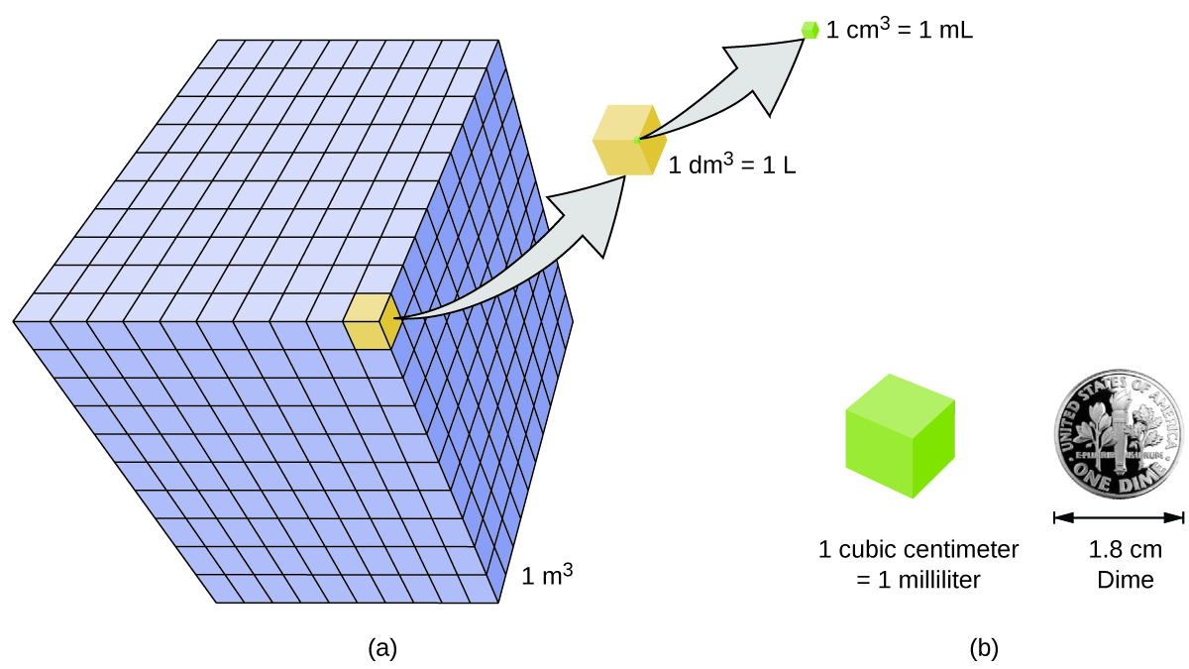
Figure 1.17 (a) The relative volumes are shown for cubes of 1 m³, 1 dm³ (1 L), and 1 cm³ (1 mL) (not to scale). (b) The diameter of a dime is compared relative to the edge length of a 1-cm³ (1-mL) cube.
Density of a substance is the ratio of the mass of a sample of the substance to its volume. Thus, the units of density are defined by the base units of mass and length. The mass is found directly by weighing. The volume is found indirectly through length measurements (width x length x height) and/or through displacement of water.

$$Density = \frac{Mass}{Volume}$$

The SI unit for density is the kilogram per cubic meter (kg/m³). For many situations, however, this as an inconvenient unit, and we often use grams per cubic centimeter (g/cm³) for the densities of solids and liquids, and grams per liter (g/L) for gases. Density does not depend on the amount of a substance, but it does depend on temperature. This is because the volume of substances is temperature dependant.

Table 1.3 The densities of some common substances.
Solids | Liquids | Gases  (at 25 °C and 1 atm)
ice (at 0 °C) 0.92 g/cm³ | water 1.0 g/cm³ | dry air 1.20 g/L
oak (wood) 0.60–0.90 g/cm³ | ethanol 0.79 g/cm³ | oxygen 1.31 g/L
iron 7.9 g/cm³ | acetone 0.79 g/cm³ | nitrogen 1.14 g/L
copper 9.0 g/cm³ | glycerin 1.26 g/cm³ | carbon dioxide 1.80 g/L
lead 11.3 g/cm³ | olive oil 0.92 g/cm³ | helium 0.16 g/L
silver 10.5 g/cm³ | gasoline 0.70–0.77 g/cm³ | neon 0.83 g/L
gold 19.3 g/cm³ | mercury 13.6 g/cm³ | radon 9.1 g/L

To learn more about the relationship between mass, volume, and density, use this interactive simulator to explore the density of different materials, like wood, ice, brick, and aluminum.

Prefix Multipliers
Base units often come with prefix multipliers in order to describe more convenient measurements. For example, longer distances are often reported in kilometers (1 km = 1000 m = 10³ m), whereas shorter distances can be reported in centimeters (1 cm = 0.01 m = 10⁻² m) or millimeters (1 mm = 0.001 m = 10⁻³ m). Prefix multipliers are fractions or multiples that are always powers of 10. For example, a length of 1000 meters is also called a kilometer because the prefix kilo means “one thousand,” which in scientific notation is 10³ (1 kilometer = 1000 m = 10³ m).

Table 1.4 The prefixes used and the powers to which 10 are raised. You will need to know this list.

Common Unit Prefixes
Prefix | Symbol | Factor | Example
nano | n | 10⁻⁹ | 4 nanograms (ng) = 4 × 10⁻⁹ g (0.000000004 g)
micro | µ | 10⁻⁶ | 1 microliter (μL) = 1 ×10⁻⁶ L (0.000001 L)
milli | m | 10⁻³ | 2 millimoles (mmol) = 2 ×10⁻³ mol (0.002 mol)
centi | c | 10−2 | 7 centimeters (cm) = 7 × 10⁻² m (0.07 m)
deci | d | 10−1 | 1 deciliter (dL) = 1 ×10⁻¹ L (0.1 L )
kilo | k | 10³ | 1 kilometer (km) = 1 ×10³ m (1000 m)

Uncertainty
Counting is the only type of measurement that is free from uncertainty, provided the number of objects being counted does not change while the counting process is underway. The result of such a counting measurement is an example of an exact number. By counting the eggs in a carton, one can determine exactly how many eggs the carton contains. The numbers of defined quantities are also exact. By definition, 1 foot is exactly 12 inches, 1 inch is exactly 2.54 centimeters, and 1 gram is exactly 0.001 kilogram. However, quantities derived from measurements other than counting are uncertain to varying extents due to practical limitations of the measurement process used.

Significant Figures in Measurement
The numbers of measured quantities, unlike defined or directly counted quantities, are not exact. To measure the volume of liquid in a graduated cylinder, you should make a reading at the bottom of the meniscus, the lowest point on the curved surface of the liquid.
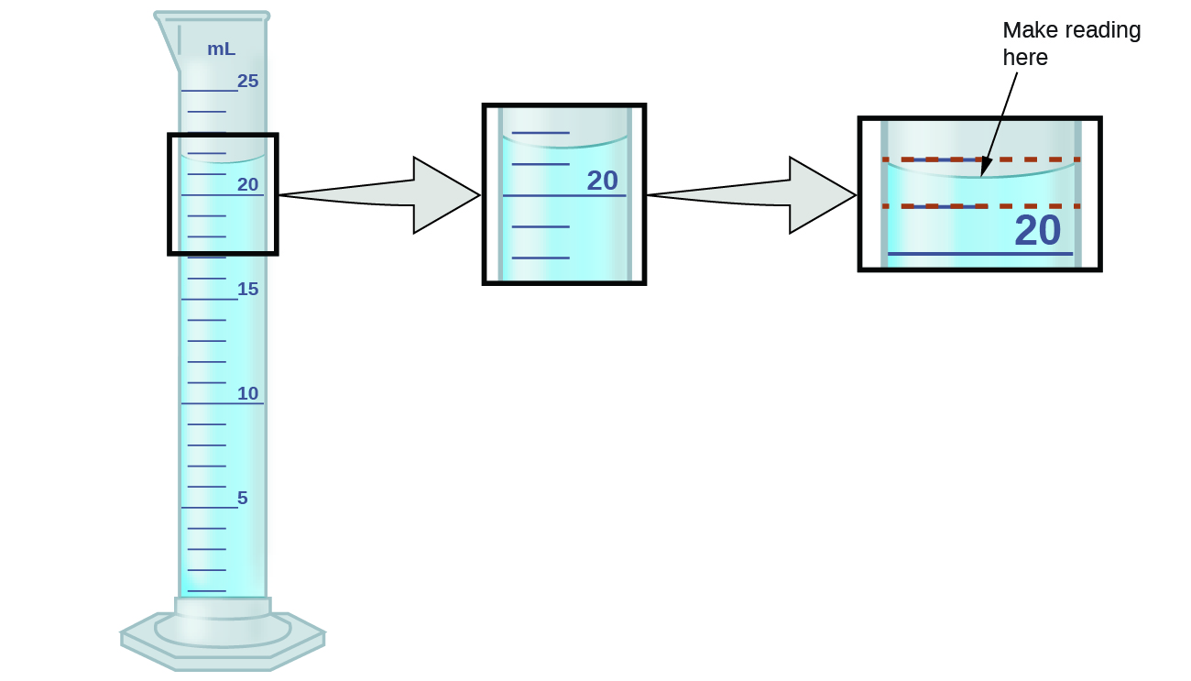
Figure 1.18 To measure the volume of liquid in this graduated cylinder, you must mentally subdivide the distance between the 21 and 22 mL marks into tenths of a milliliter, and then make a reading (estimate) at the bottom of the meniscus.
Refer to the illustration in Figure 1.18. The bottom of the meniscus in this case clearly lies between the 21 and 22 markings, meaning the liquid volume is certainly greater than 21 mL but less than 22 mL. The meniscus appears to be a bit closer to the 22-mL mark than to the 21-mL mark, and so a reasonable estimate of the liquid’s volume would be 21.6 mL. In the number 21.6, then, the digits 2 and 1 are certain, but the 6 is an estimate. Some people might estimate the meniscus position to be equally distant from each of the markings and estimate the tenth-place digit as 5, while others may think it to be even closer to the 22-mL mark and estimate this digit to be 7. Note that it would be pointless to attempt to estimate a digit for the hundredths place, given that the tenths-place digit is uncertain. In general, numerical scales such as the one on this graduated cylinder will permit measurements to one-tenth of the smallest scale division. The scale in this case has 1-mL divisions, and so volumes may be measured to the nearest 0.1 mL.

This concept holds true for all measurements, even if you do not actively make an estimate. If you place a quarter on a standard electronic balance, you may obtain a reading of 6.72 g. The digits 6 and 7 are certain, and the 2 indicates that the mass of the quarter is likely between 6.71 and 6.73 grams. The quarter weighs about 6.72 grams, with a nominal uncertainty in the measurement of
± 0.01 gram. If the coin is weighed on a more sensitive balance, the mass might be 6.723 g. This means its mass lies between 6.722 and 6.724 grams, an uncertainty of 0.001 gram. Every measurement has some uncertainty, which depends on the device used (and the user’s ability). All of the digits in a measurement, including the uncertain last digit, are called significant figures or significant digits.

A measurement result is properly reported when its significant digits accurately represent the certainty of the measurement process. But what if you were analyzing a reported value and trying to determine what is significant and what is not? Well, for starters, all nonzero digits are significant, and it is only zeros that require some thought. We will use the terms “leading,” “trailing,” and “captive” for the zeros and will consider how to deal with them.
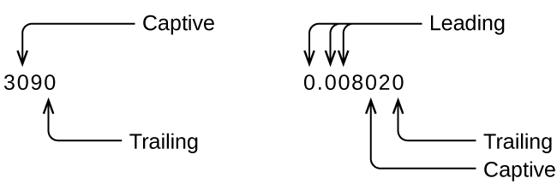

Starting with the first nonzero digit on the left, count this digit and all remaining digits to the right. This is the number of significant figures in the measurement unless the last digit is a trailing zero lying to the left of the decimal point.

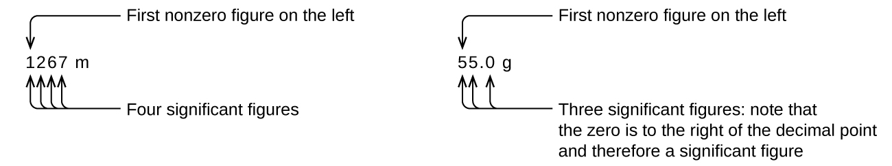

Captive zeros result from measurement and are therefore always significant. Leading zeros, however, are never significant—they merely tell us where the decimal point is located.

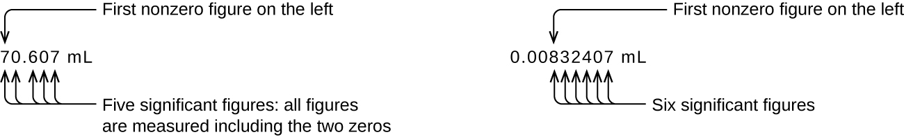

The leading zeros in this example are not significant. We could use exponential notation (as described in Appendix B) and express the number as 8.32407 × 10⁻³; then the number 8.32407 contains all of the significant figures, and 10⁻³ locates the decimal point.

The number of significant figures is uncertain in a number that ends with a zero to the left of the decimal point location. The zeros in the measurement 1,300 grams could be significant or they could simply indicate where the decimal point is located. The ambiguity can be resolved with the use of exponential notation: 1.3 × 10³ (two significant figures), 1.30 × 10³ (three significant figures, if the tens place was measured), or 1.300 × 10³ (four significant figures, if the ones place was also measured). In cases where only the decimal-formatted number is available, it is prudent to assume that all trailing zeros are not significant.

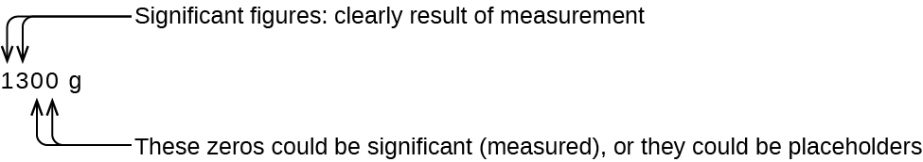

When determining significant figures, be sure to pay attention to reported values and think about the measurement and significant figures in terms of what is reasonable or likely when evaluating whether the value makes sense. For example, the official January 2014 census reported the resident population of the US as 317,297,725. Do you think the US population was correctly determined to the reported nine significant figures, that is, to the exact number of people? People are constantly being born, dying, or moving into or out of the country, and assumptions are made to account for the large number of people who are not actually counted. Because of these uncertainties, it might be more reasonable to expect that we know the population to within perhaps a million or so, in which case the population should be reported as 3.17 × 10⁸ people.

Significant Figures in Calculations
A second important principle of uncertainty is that results calculated from a measurement are at least as uncertain as the measurement itself. Take the uncertainty in measurements into account to avoid misrepresenting the uncertainty in calculated results. One way to do this is to report the result of a calculation with the correct number of significant figures, which is determined by the following three rules for rounding numbers:

When adding or subtracting numbers, round the result to the same number of decimal places as the number with the least number of decimal places (the least certain value in terms of addition and subtraction).

When multiplying or dividing numbers, round the result to the same number of digits as the number with the least number of significant figures (the least certain value in terms of multiplication and division).

If the digit to be dropped (the one immediately to the right of the digit to be retained) is less than 5, “round down” and leave the retained digit unchanged; if it is more than 5, “round up” and increase the retained digit by 1; if the dropped digit is 5, round up or down, whichever yields an even value for the retained digit. (The last part of this rule may strike you as a bit odd, but it’s based on reliable statistics and is aimed at avoiding any bias when dropping the digit “5,” since it is equally close to both possible values of the retained digit.)

The following examples illustrate the application of this rule in rounding a few different numbers to three significant figures:

0.028675 rounds “up” to 0.0287 (the dropped digit, 7, is greater than 5)
18.3384 rounds “down” to 18.3 (the dropped digit, 3, is less than 5)
6.8752 rounds “up” to 6.88 (the dropped digit is 5, and the retained digit is even)
92.85 rounds “down” to 92.8 (the dropped digit is 5, and the retained digit is even)

Accuracy and Precision
Scientists typically make repeated measurements of a quantity to ensure the quality of their findings and to evaluate both precision and accuracy of their results. Measurements are said to be precise if they yield very similar results when repeated in the same manner. A measurement is considered accurate if it yields a result that is very close to the true or accepted value. Precise values agree with each other; accurate values agree with a true value. These characterizations can be extended to other contexts, such as the results of an archery competition (Figure 1.19).

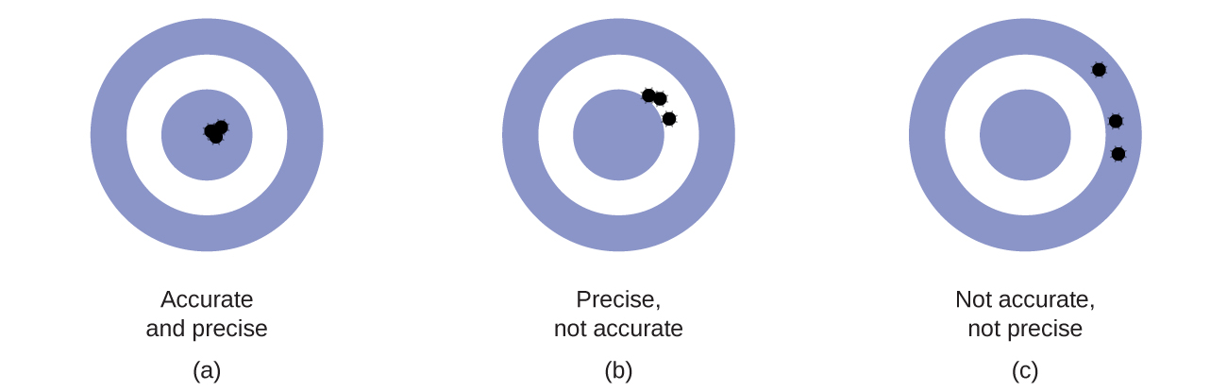

Figure 1.19 (a) These arrows are close to both the bull’s eye and one another, so they are both accurate and precise. (b) These arrows are close to one another but not on target, so they are precise but not accurate. (c) These arrows are neither on target nor close to one another, so they are neither accurate nor precise.

Suppose a quality control chemist at a pharmaceutical company is tasked with checking the accuracy and precision of three different machines that are meant to dispense 10 ounces (296 mL) of cough syrup into storage bottles. She proceeds to use each machine to fill five bottles and then carefully determines the actual volume dispensed, obtaining the results tabulated in Table 1.5.

Table 1.5 Volume (mL) of Cough Medicine Delivered by 10-oz (296 mL) Dispensers

Dispenser #1 | Dispenser #2 | Dispenser #3
283.3 | 298.3 | 296.1
284.1 | 294.2 | 295.9
283.9 | 296.0 | 296.1
284.0 | 297.8 | 296.0
284.1 | 293.9 | 296.1

Considering these results, she will report that dispenser #1 is precise (values all close to one another, within a few tenths of a milliliter) but not accurate (none of the values are close to the target value of 296 mL, each being more than 10 mL too low). Results for dispenser #2 represent improved accuracy (each volume is less than 3 mL away from 296 mL) but worse precision (volumes vary by more than 4 mL). Finally, she can report that dispenser #3 is working well, dispensing cough syrup both accurately (all volumes within 0.1 mL of the target volume) and precisely (volumes differing from each other by no more than 0.2 mL).

1.5 Dimensional Analysis

Learning Objectives
- Explain the dimensional analysis (factor label) approach to mathematical calculations involving quantities
- Use dimensional analysis to carry out unit conversions for a given property and computations involving two or more properties

Dimensional Analysis
It is often the case that a quantity of interest may not be easy (or even possible) to measure directly but instead must be calculated from other directly measured properties and appropriate mathematical relationships. For example, consider measuring the average speed of an athlete running sprints. This is typically accomplished by measuring the time required for the athlete to run from the starting line to the finish line, and the distance between these two lines, and then computing speed from the equation that relates these three properties:

speed = $\frac{distance}{time}$

An Olympic-quality sprinter can run 100 m in approximately 10 s, corresponding to an average speed of

$\frac{100 m}{10 s}$ = 10$\frac{ m}{ s}$ or 10 m/s

Note that this simple arithmetic involves dividing the numbers of each measured quantity to yield the number of the computed quantity (100/10 = 10) and likewise dividing the units of each measured quantity to yield the unit of the computed quantity (m/s = m/s).

Now, consider using this same relation to predict the time required for a person running at this speed to travel a distance of 25 m. The same relation among the three properties is used, but in this case, the two quantities provided are a speed (10 m/s) and a distance (25 m). To yield the sought property, time, the equation must be rearranged appropriately:

time = $\frac{distance}{speed}$

The time can then be computed as:

$\frac{25 m}{10 m/s}$ = 2.5 s

Again, arithmetic on the numbers (25/10 = 2.5) was accompanied by the same arithmetic on the units (m/m/s = s) to yield the number and unit of the result, 2.5 s. Note that, just as for numbers, when a unit is divided by an identical unit (in this case, m/m), the result is “1”—or, as commonly phrased, the units “cancel.”

These calculations are examples of a versatile mathematical approach known as dimensional analysis (or the factor-label method). Dimensional analysis is based on this premise: the units of quantities must be subjected to the same mathematical operations as their associated numbers. This method can be applied to computations ranging from simple unit conversions to more complex, multi-step calculations involving several different quantities.

Conversion Factors
A ratio of two equivalent quantities expressed with different measurement units can be used as a unit conversion factor. For example, the lengths of 2.54 cm and 1 in. are equivalent (by definition), and so a unit conversion factor may be derived from the ratio,

2.54 cm = 1 in or $\frac{2.54 cm}{1 in}$ or 2.54 $\frac{ cm}{ in}$ or 2.54 cm/in

The above conversion factor can also be written as:

$\frac{1 in}{2.54 cm}$

Several other commonly used conversion factors are given in Table 1.6.

Table 1.6 Common Conversion Factors

Length | Volume | Mass
1 in. = 2.54 cm (exact) ** | 1 cm³ = 1 mL ** | 1 lb = 453.59 g **
1 ft = 12 in (exact) ** | 1 m³ = 1000 L | 1 kg = 2.2046 lb
1 mi = 1.61 km ** | 1 L = 1.0567 qt | 1 (avoirdupois) oz = 28.349 g
1 m = 3.28 ft | 1 ft3 = 28.317 L | 1 (troy) oz = 31.103 g
1 yd = 3 ft (exact) | 1 tbsp = 14.787 mL

For this course, you are expected to know the above conversion factors with **.

When a quantity (such as distance in inches) is multiplied by an appropriate unit conversion factor, the quantity is converted to an equivalent value with different units (such as distance in centimeters). For example, a basketball player’s vertical jump of 34 inches can be converted to centimeters by:
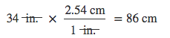

Since this simple arithmetic involves quantities, the premise of dimensional analysis requires that we multiply both numbers and units. The numbers of these two quantities are multiplied to yield the number of the product quantity, 86, whereas the units are multiplied to yield $\frac{in × cm}{in}$, and the unit product thus simplifies to cm. (When identical units divide to yield a factor of 1, they are said to “cancel.”) Dimensional analysis may be used to confirm the proper application of unit conversion factors.

Approach to Problem Solving
Here are the general steps when you approach mathematical problems in chemistry:

Underline the question, what the problem asks you to find
Identify given information
Set up dimensional analysis in fractional form as below to cancel given unit and obtain desired unit

Given unit $× \frac{desire unit}{given unit}$

Again, the basic approach is the same—all the factors involved in the calculation must be appropriately oriented to ensure that their labels (units) will appropriately cancel and/or combine to yield the desired unit in the result. As your study of chemistry continues, you will encounter many opportunities to apply this approach.

Conversion of Temperature Units
We use the word temperature to refer to the hotness or coldness of a substance. One way we measure a change in temperature is to use the fact that most substances expand when their temperature increases and contract when their temperature decreases. The mercury or alcohol in a common glass thermometer changes its volume as the temperature changes, and the position of the trapped liquid along a printed scale may be used as a measure of temperature.

Temperature scales are defined relative to selected reference temperatures: Two of the most commonly used are the freezing and boiling temperatures of water at a specified atmospheric pressure. On the Celsius scale, 0 °C is defined as the freezing temperature of water and 100 °C as the boiling temperature of water. The space between the two temperatures is divided into 100 equal intervals, which we call degrees. On the Fahrenheit scale, the freezing point of water is defined as 32 °F and the boiling temperature as 212 °F. The space between these two points on a Fahrenheit thermometer is divided into 180 equal parts (degrees).

Unlike the Celsius and Fahrenheit scales, the kelvin scale is an absolute temperature scale in which 0 (zero) K corresponds to the lowest temperature that can theoretically be achieved. Since the kelvin temperature scale is absolute, a degree symbol is not included in the unit abbreviation, K. The early 19th-century discovery of the relationship between a gas’s volume and temperature suggested that the volume of a gas would be zero at −273.15 °C. In 1848, British physicist William Thompson, who later adopted the title of Lord Kelvin, proposed an absolute temperature scale based on this concept (further treatment of this topic is provided in this text’s chapter on gases). The freezing temperature of water on this scale is 273.15 K and its boiling temperature is 373.15 K.
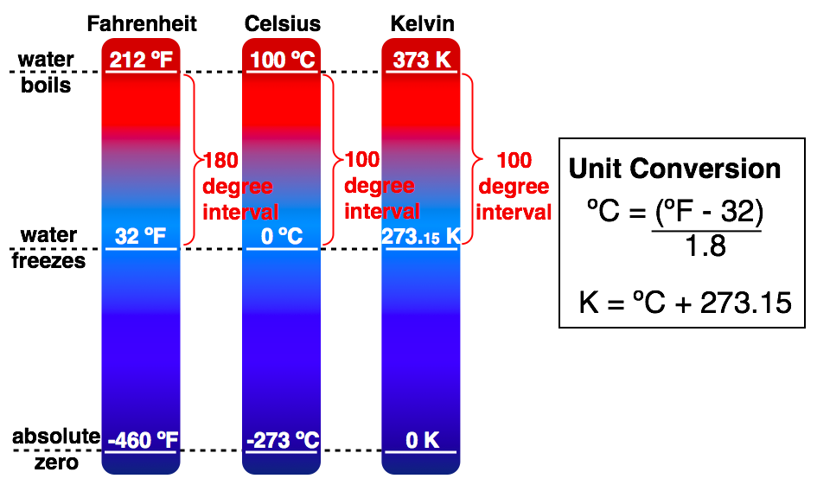

Figure 1.20 The Fahrenheit, Celsius, and kelvin temperature scales and their relations.

BLANK PAGE

Chapter 2 – Attributions

The contents in this chapter, licensed under CC BY 4.0. has been adopted, modified, reorganized, and/or remixed from the following:

2.0 Introduction
"1.2 Phases and Classification of Matter" by Paul Flowers, Klaus Theopold & Richard Langley et al., OpenStax CNX is licensed under CC BY 4.0

2.1 Modern Atomic Theories and The Discovery of Subatomic Particles
"2.1 Early Ideas in Atomic Theory" by Paul Flowers, Klaus Theopold, Richard Langley, William R. Robinson, PhD, OpenStaxis licensed under CC BY 4.0
"2.2 Evolution of Atomic Theory" by Paul Flowers, Klaus Theopold, Richard Langley, William R. Robinson, PhD, OpenStax is licensed under CC BY 4.0

2.2 Atomic Structure and Average Atomic Mass
"2.3 Atomic Structure and Symbolism" by Paul Flowers, Klaus Theopold, Richard Langley, William R. Robinson, PhD,OpenStax is licensed under CC BY 4.0

BLANK PAGE

Chapter 2 Atomic Structure

Chapter Introduction

2.1 Modern Atomic Theories and The Discovery of Subatomic Particles

2.2 Atomic Structure and Average Atomic Mass

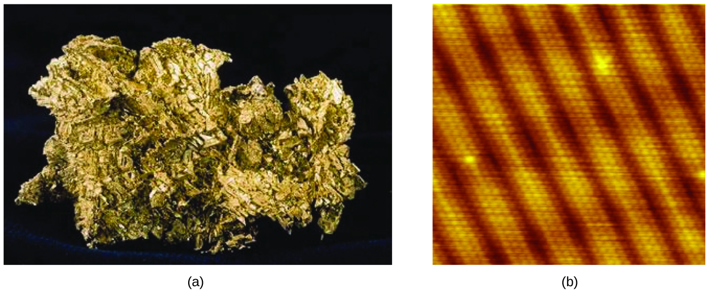
Figure 2.1 (a) This photograph shows a gold nugget. (b) A scanning-tunneling microscope (STM) can generate views of the surfaces of solids, such as this image of a gold crystal. Each sphere represents one gold atom. (credit a: modification of work by United States Geological Survey; credit b: modification of work by “Erwinrossen”/Wikimedia Commons)

An atom is the smallest particle of an element that has the properties of that element and can enter into a chemical combination. Consider the element gold, for example. Imagine cutting a gold nugget in half, then cutting one of the halves in half, and repeating this process until a piece of gold remained that was so small that it could not be cut in half (regardless of how tiny your knife may be). This minimally sized piece of gold is an atom (from the Greek atomos, meaning “indivisible”) (Figure 2.1). This atom would no longer be gold if it were divided any further. In this chapter, you will explore modern atomic theories, the discovery of electrons, and the structure of atom.

BLANK PAGE

2.1 Modern Atomic Theories and The Discovery of Subatomic Particles

Learning Objectives
- State the postulates of Dalton’s atomic theory
- Use postulates of Dalton’s atomic theory to explain the laws of definite and multiple proportions
- Outline milestones in the development of modern atomic theory
- Summarize and interpret the results of the experiments of Thomson, Millikan, and Rutherford

Early Ideas in Atomic Theory
The earliest recorded discussion of the basic structure of matter comes from ancient Greek philosophers, the scientists of their day. In the fifth century BC, Leucippus and Democritus argued that all matter was composed of small, finite particles that they called atomos, a term derived from the Greek word for “indivisible.” They thought of atoms as moving particles that differed in shape and size, and which could join together. Later, Aristotle and others came to the conclusion that matter consisted of various combinations of the four “elements”—fire, earth, air, and water—and could be infinitely divided. Interestingly, these philosophers thought about atoms and “elements” as philosophical concepts, but apparently never considered performing experiments to test their ideas.

John Dalton - The Idea of Atom
The Aristotelian view of the composition of matter held sway for over two thousand years, until English schoolteacher John Dalton helped to revolutionize chemistry with his hypothesis that the behavior of matter could be explained using an atomic theory. First published in 1807, many of Dalton’s hypotheses about the microscopic features of matter are still valid in modern atomic theory. Here are the postulates of Dalton’s atomic theory.

1. Matter is composed of exceedingly small particles called atoms. An atom is the smallest unit of an element. Atoms are indivisible.

2. Atoms of a given element are identical (Figure 2.2). Atoms of one element differ in properties from atoms of all other elements.
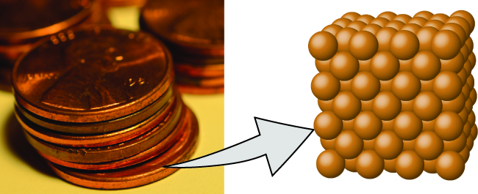
Figure 2.2 A pre-1982 copper penny (left) contains approximately 3 × 10²² copper atoms (several dozen are represented as brown spheres at the right), each of which has the same chemical properties. (credit: modification of work by “slgckgc”/Flickr)

3. A compound consists of atoms of two or more elements combined in a small, whole-number ratio. In a given compound, the numbers of atoms of each of its elements are always present in the same ratio (Figure 2.3).
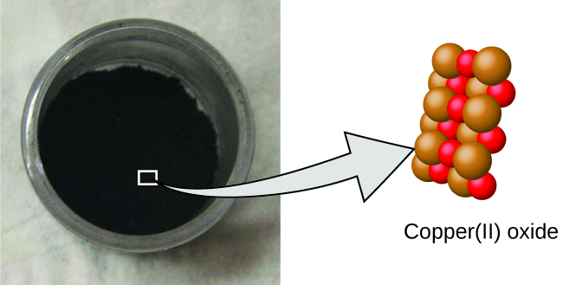
Figure 2.3 Copper(II) oxide, a powdery, black compound, results from the combination of two types of atoms—copper (brown spheres) and oxygen (red spheres)—in a 1:1 ratio. (credit: modification of work by “Chemicalinterest”/Wikimedia Commons)

4. Atoms are neither created nor destroyed during a chemical change, but are instead rearranged to yield substances that are different from those present before the change (Figure 2.4).

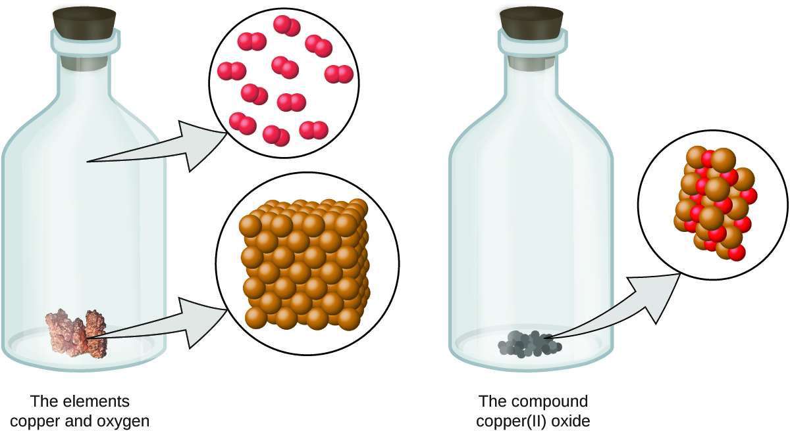

Figure 2.4 When the elements copper (a shiny, red-brown solid, shown here as brown spheres) and oxygen (a clear and colorless gas, shown as red spheres) react, their atoms rearrange to form a compound containing copper and oxygen (a powdery, black solid). (credit copper: modification of work by http://images-of-elements.com/copper.php)

Dalton’s atomic theory provides a microscopic explanation of the many macroscopic properties of matter that you’ve learned about. For example, if an element such as copper consists of only one kind of atom, then it cannot be broken down into simpler substances, that is, into substances composed of fewer types of atoms. And if atoms are neither created nor destroyed during a chemical change, then the total mass of matter present when matter changes from one type to another will remain constant (the law of conservation of matter).

Dalton knew of the experiments of French chemist Joseph Proust, who demonstrated that all samples of a pure compound contain the same elements in the same proportion by mass. This statement is known as the law of definite proportions or the law of constant composition. The suggestion that the numbers of atoms of the elements in a given compound always exist in the same ratio is consistent with these observations. For example, when different samples of isooctane (a component of gasoline and one of the standards used in the octane rating system) are analyzed, they are found to have a carbon-to-hydrogen mass ratio of 5.33:1, as shown in Table 2.1.

Table 2.1 Constant Composition of Isooctane
Sample | Carbon (C) | Hydrogen (H) | Mass Ratio Carbon : Hydrogen
A | 14.82 g | 2.78 g | $\frac{14.82 g C}{2.78 g H}$ = $\frac{5.33 g C}{1.00 g H}$
B | 22.33 g | 4.19 g | $\frac{22.33 g C}{4.19 g H}$ = $\frac{5.33 g C}{1.00 g H}$
C | 19.40 g | 3.64 g | $\frac{19.40 g C}{3.64 g H}$ = $\frac{5.33 g C}{1.00 g H}$

It is worth noting that although all samples of a particular compound have the same mass ratio, the converse is not true in general. That is, samples that have the same mass ratio are not necessarily the same substance. For example, there are many compounds other than isooctane that also have a carbon-to-hydrogen mass ratio of 5.33:1.00.

Dalton also used data from Proust, as well as results from his own experiments, to formulate another interesting law. The law of multiple proportions states that when two elements react to form more than one compound, a fixed mass of one element will react with masses of the other elements in a ratio of small whole numbers.

For example, copper and chlorine can form a green, crystalline solid with a mass ratio of 0.558 g chlorine to 1 g copper, as well as a brown crystalline solid with a mass ratio of 1.116 g chlorine to 1 g copper. These ratios by themselves may not seem particularly interesting or informative; however, if we take a ratio of these ratios, we obtain a useful and possibly surprising result: a small, whole-number ratio.

$\frac{\frac{1.116 g Cl}{1 g Cu}}{\frac{0.558 g Cl}{1 g Cu}}$ = $\frac{2}{1}$

This 2-to-1 ratio means that the brown compound has twice the amount of chlorine per amount of copper as the green compound.

This can be explained by atomic theory if the copper-to-chlorine ratio in the brown compound is 1 copper atom to 2 chlorine atoms, and the ratio in the green compound is 1 copper atom to 1 chlorine atom. The ratio of chlorine atoms (and thus the ratio of their masses) is therefore 2 to 1 (Figure 2.5).

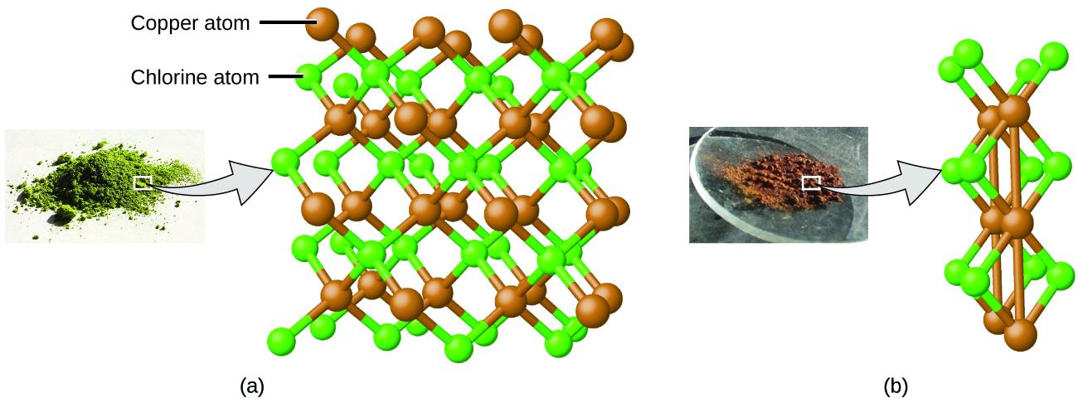
Figure 2.5 Compared to the copper chlorine compound in (a), where copper is represented by brown spheres and chlorine by green spheres, the copper chlorine compound in (b) has twice as many chlorine atoms per copper atom. (credit a: modification of work by “Benjah-bmm27”/Wikimedia Commons; credit b: modification of work by “Walkerma”/Wikimedia Commons)

Evolution of Atomic Theory
If matter is composed of atoms, what are atoms composed of? Are they the smallest particles, or is there something smaller? In the late 1800s, a number of scientists interested in questions like these.

J. J. Thomson - The Discovery of Electrons
English physicist J. J. Thomson used a cathode ray tube to investigate the electrical discharges that could be produced in low-pressure gases. He made the most significant discovery of electrons. The cathode ray apparatus consisted of a sealed glass tube from which almost all the air had been removed; the tube contained two metal electrodes. When high voltage was applied across the electrodes, a visible beam called a cathode ray appeared between them. This beam was deflected toward the positive charge and away from the negative charge, and was produced in the same way with identical properties when different metals were used for the electrodes. In similar experiments, the ray was simultaneously deflected by an applied magnetic field, and measurements of the extent of deflection and the magnetic field strength allowed Thomson to calculate the charge-to-mass ratio of the cathode ray particles to be -1.759 x 10¹¹ coulombs per kilogram. The results of these measurements indicated that these particles were much lighter than atoms.
Figure 2.6 (a) J. J. Thomson produced a visible beam in a cathode ray tube. (b) This is an early cathode ray tube, invented in 1897 by Ferdinand Braun. (c) In the cathode ray, the beam (shown in yellow) comes from the cathode and is accelerated past the anode toward a fluorescent scale at the end of the tube. Simultaneous deflections by applied electric and magnetic fields permitted Thomson to calculate the charge-to-mass ratio of the cathode ray particles. (credit a: modification of work by Nobel Foundation; credit b: modification of work by Eugen Nesper; credit c: modification of work by “Kurzon”/Wikimedia Commons)
Based on his observations, here is what Thomson proposed and why:

1. The particles are attracted by positive (+) charges and repelled by negative (−) charges, so they must be negatively charged (like charges repel and unlike charges attract).

2. They are less massive than atoms and indistinguishable, regardless of the source material, so they must be fundamental, subatomic constituents of all atoms.

Although controversial at the time, Thomson’s idea was gradually accepted, and his cathode ray particle is what we now call an electron, a negatively charged subatomic particle with a mass more than one thousand-times less that of an atom. The term “electron” was coined in 1891 by Irish physicist George Stoney, from “electric ion.”

View this animation of cathode ray experiment and how to determine charge to mass ratio of an electron. Also, view this video for a different shape of cathode ray.

In 1904, Thomson proposed the “plum pudding” model of atoms, which described a positively charged mass with an equal amount of negative charge in the form of electrons embedded in it, since all atoms are electrically neutral. (Figure 2.7).
Figure 2.7 (a) Thomson suggested that atoms resembled plum pudding, an English dessert consisting of moist cake with embedded raisins (“plums”). (credit a: modification of work by “Man vyi”/Wikimedia Commons)

Robert A. Millikan - The Discovery of Charge of an Electron
In 1909, more information about the electron was uncovered by American physicist Robert A. Millikan via his “oil drop” experiments. Millikan created microscopic oil droplets, which could be electrically charged by friction as they formed or by using X-rays. These droplets initially fell due to gravity, but their downward progress could be slowed or even reversed by an electric field lower in the apparatus. By adjusting the electric field strength and making careful measurements and appropriate calculations, Millikan was able to determine the charge on individual drops (Figure 2.8).
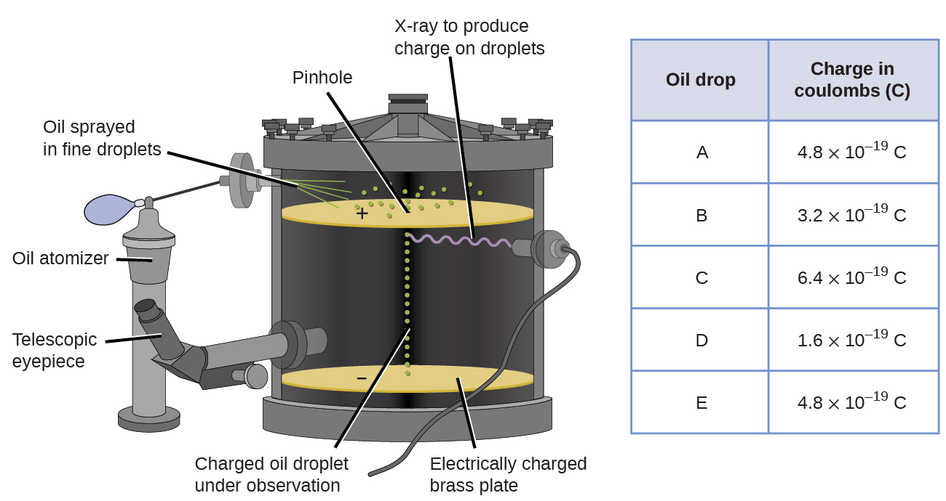
Figure 2.8 Millikan’s experiment measured the charge of individual oil drops. The tabulated data are examples of a few possible values. View this animation of Millikan Oil Drop Experiment.

Looking at the charge data that Millikan gathered, you may have recognized that the charge of an oil droplet is always a multiple of a specific charge, 1.6 × 10⁻¹⁹ coulombs (C). Millikan concluded that this value must therefore be a fundamental charge—the charge of a single electron—with his measured charges due to an excess of one electron (1 times 1.6 ×10⁻¹⁹ C), two electrons (2 times 1.6 ×10⁻¹⁹ C), three electrons (3 times 1.6 ×10⁻¹⁹ C), and so on, on a given oil droplet. Since the charge of an electron was now known due to Millikan’s research, and the charge-to-mass ratio was already known due to Thomson’s research (1.759 ×10¹¹ C/kg), it only requires a simple calculation to determine the mass of the electron as well.
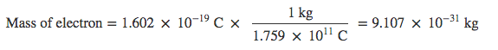
Scientists had now established that the atom was not indivisible as Dalton had believed, and due to the work of Thomson, Millikan, and others, the charge and mass of the negative, subatomic particles—the electrons—were known. However, the positively charged part of an atom was not yet well understood.

Ernest Rutherford - The Discovery of Protons in Nucleus
The next major development in understanding the atom came from Ernest Rutherford, a physicist from New Zealand who largely spent his scientific career in Canada and England. He performed a series of experiments using a beam of high-speed, positively charged alpha particles (α particles) that were produced by the radioactive decay of radium; α particles consist of two protons and two neutrons.

To test Thomson’s Plum Pudding Model, Rutherford and his colleagues Hans Geiger (later famous for the Geiger counter) and Ernest Marsden set up gold foil experiment. They aimed a beam of α particles at a very thin piece of gold foil and examined the resultant scattering of the α particles using a luminescent screen that glowed briefly where hit by an α particle. If Thomson’s model is correct, they expected that the beam of α particles pass through gold foil without any deflection.

Figure 2.9 The expected result of gold foil experiment on account of Thomson’s Plum-Pudding model. (credit: modification of work by "Kurzon/Wikimedia Commons" is licensed under CC BY-SA 3.0.)
However, they discovered that even though most particles passed through the foil without being deflected, some were diverted slightly, and a very small number were deflected almost straight back toward the source (Figure 2.10). Rutherford described finding these results: “It was quite the most incredible event that has ever happened to me in my life. It was almost as incredible as if you fired a 15-inch shell at a piece of tissue paper and it came back and hit you.”¹
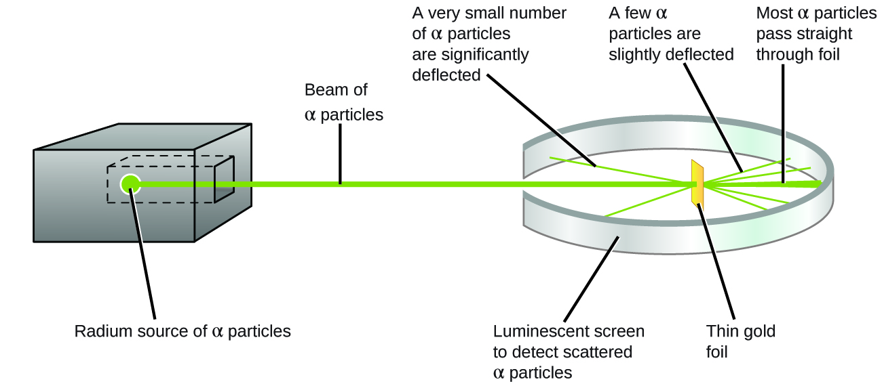

Figure 2.10 Geiger and Rutherford fired α particles at a piece of gold foil and detected where those particles went, as shown in this schematic diagram of their experiment. Most of the particles passed straight through the foil, but a few were deflected slightly and a very small number were significantly deflected.

Here is what Rutherford deduced: Because most of the fast-moving α particles passed through the gold atoms undeflected, they must have traveled through essentially empty space inside the atom. Alpha particles are positively charged, so deflections arose when they encountered another positive charge (like charges repel each other). Since like charges repel one another, the few positively charged α particles that changed paths abruptly must have hit, or closely approached, another body that also had a highly concentrated, positive charge. Since the deflections occurred a small fraction of the time, this charge only occupied a small amount of the space in the gold foil.

View this simulation of the Rutherford gold foil experiment. Adjust the slit width to produce a narrower or broader beam of α particles to see how that affects the scattering pattern.
Analyzing a series of such experiments in detail, Rutherford drew two conclusions:

1. The volume occupied by an atom must consist of a large amount of empty space.

2. A small, relatively heavy, positively charged body, the nucleus, must be at the center of each atom.

This analysis led Rutherford to propose a model in which an atom consists of a very small, positively charged nucleus, in which most of the mass of the atom is concentrated, surrounded by the negatively charged electrons, so that the atom is electrically neutral (Figure 2.11). After many more experiments, Rutherford also discovered that the nuclei of other elements contain the hydrogen nucleus as a “building block,” and he named this more fundamental particle the proton, the positively charged, subatomic particle found in the nucleus. With one addition, which you will learn next, this nuclear model of the atom, proposed over a century ago, is still used today.

Figure 2.11 The α particles are deflected only when they collide with or pass close to the much heavier, positively charged gold nucleus. Because the nucleus is very small compared to the size of an atom, very few α particles are deflected. Most pass through the relatively large region occupied by electrons, which are too light to deflect the rapidly moving particles. (credit: modification of work by "Kurzon/Wikimedia Commons" is licensed under CC BY-SA 3.0.)

James Chadwick - The Discovery of Neutrons in Nucleus
One puzzle remained: The nucleus was known to contain almost all of the mass of an atom, with the number of protons only providing half, or less, of that mass. Different proposals were made to explain what constituted the remaining mass, including the existence of neutral particles in the nucleus. As you might expect, detecting uncharged particles is very challenging, and it was not until 1932 that James Chadwick found evidence of neutrons, uncharged, subatomic particles with a mass approximately the same as that of protons. The existence of the neutron also explained isotopes: They differ in mass because they have different numbers of neutrons, but they are chemically identical because they have the same number of protons. This will be explained in more detail later in this chapter.

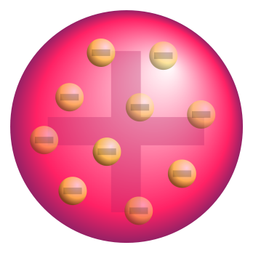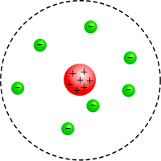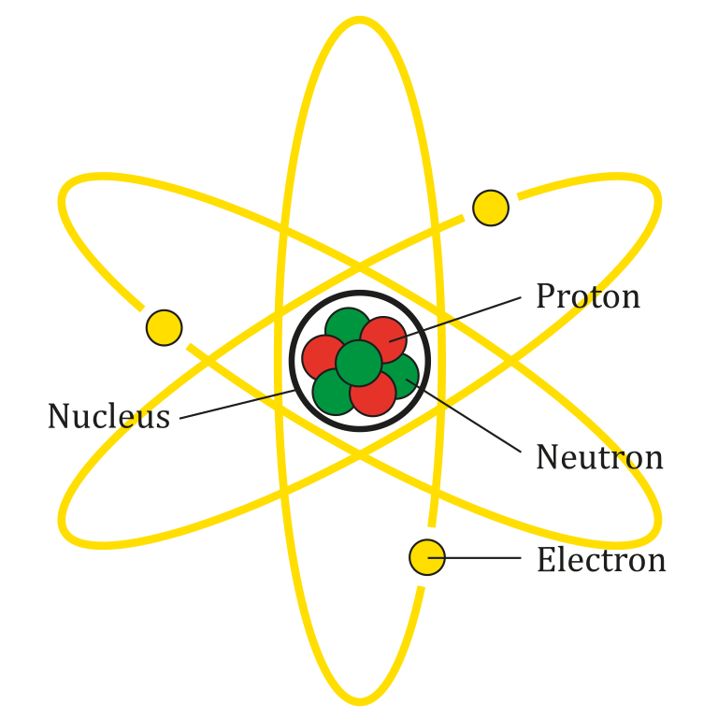

a b c

Figure 2.12 a) Thomson’s Plum-Pudding Model, b) Rutherford’s Model, and c) Nuclear Atomic Model.

Footnotes
- 1 Ernest Rutherford, “The Development of the Theory of Atomic Structure,” ed. J. A. Ratcliffe, in Background to Modern Science, eds. Joseph Needham and Walter Pagel, (Cambridge, UK: Cambridge University Press, 1938), 61–74. Accessed September 22, 2014,https://ia600508.us.archive.org/3/items/backgroundtomode032734mbp/backgroundtomode032734mbp.pdf.

2.2 Atomic Structure, Average Atomic Mass, and Mole Concept

Learning Objectives
- Describe the three subatomic particles that compose atoms
- Write and interpret symbols that depict the atomic number, mass number, and charge of an atom or ion
- Define isotopes and give examples for several elements
- Define the atomic mass unit and average atomic mass
- Calculate average atomic mass and isotopic abundance
- Define the amount unit mole and the related quantity Avogadro’s number
- Relate mass, moles, and numbers of atoms

Properties of Subatomic Particles
The development of modern atomic theory revealed much about the inner structure of atoms. It was learned that an atom contains a very small nucleus composed of positively charged protons and uncharged neutrons, surrounded by a much larger volume of space containing negatively charged electrons. The nucleus contains the majority of an atom’s mass because protons and neutrons are much heavier than electrons, whereas electrons occupy almost all of an atom’s volume. The diameter of an atom is on the order of 10−10 m, whereas the diameter of the nucleus is roughly 10−15 m—about 100,000 times smaller. For a perspective about their relative sizes, consider this: If the nucleus were the size of a blueberry, the atom would be about the size of a football stadium (Figure 2.13).

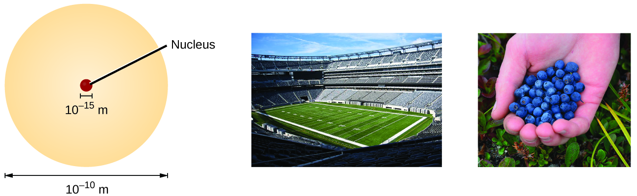
Figure 2.13 If an atom could be expanded to the size of a football stadium, the nucleus would be the size of a single blueberry. (credit middle: modification of work by “babyknight”/Wikimedia Commons; credit right: modification of work by Paxson Woelber)

Atoms are extremely small. For example, a carbon atom weighs less than 2 × 10⁻²³ g, and an electron has a charge of less than 2 ×10⁻¹⁹ C (coulomb). When describing the properties of tiny objects such as atoms, we use appropriately small units of measure, such as the atomic mass unit (amu) and the fundamental unit of charge (e).

The amu was originally defined based on hydrogen, the lightest element. Since 1961, it has been defined with regard to the most abundant isotope of carbon, atoms of which are assigned masses of exactly 12 amu. (This isotope is known as “carbon-12”.) Thus, one amu is exactly 1/12 of the mass of one carbon-12 atom: 1 amu = 1.6605 × 10⁻²⁴ g. (The Dalton (Da) and the unified atomic mass unit (u) are alternative units that are equivalent to the amu.)

The fundamental unit of charge (also called the elementary charge) equals the magnitude of the charge of an electron (e) with e = 1.602 × 10⁻¹⁹ C.

The properties of these subatomic particles are summarized in Table 2.2. (An observant student might notice that the sum of an atom’s subatomic particles does not equal the atom’s actual mass: The total mass of six protons, six neutrons, and six electrons is 12.0993 amu, slightly larger than 12.00 amu. This “missing” mass is known as the mass defect.)

Table 2.2 Properties of Subatomic Particles
Name | Location | Charge (C) | Relative Charge | Mass (g) | Mass (amu)
electron | outside nucleus | −1.602 × 10⁻¹⁹ | 1− | 0.00091 × 10⁻²⁴ | 0.00055
proton | nucleus | 1.602 × 10⁻¹⁹ | 1+ | 1.67262 × 10⁻²⁴ | 1.00727
neutron | nucleus | 0 | 0 | 1.67493 × 10⁻²⁴ | 1.00866

The number of protons in the nucleus of an atom is its atomic number (Z). This is the defining trait of an element: Its value determines the identity of the atom. For example, any atom that contains six protons is the element carbon and has the atomic number 6, regardless of how many neutrons or electrons it may have. A neutral atom must contain the same number of positive and negative charges, so the number of protons equals the number of electrons. Therefore, the atomic number also indicates the number of electrons in an atom. The total number of protons and neutrons in an atom is called its mass number (A). The number of neutrons is therefore the difference between the mass number and the atomic number.

Atomic number (Z) = number of protons

mass number (A) = number of protons + number of neutrons

A − Z = number of neutrons

Chemical Symbols
A chemical symbol is an abbreviation that we use to indicate an element or an atom of an element. For example, the symbol for mercury is Hg (Figure 2.13). We use the same symbol to indicate one atom of mercury or to label a container of many atoms of the element mercury.
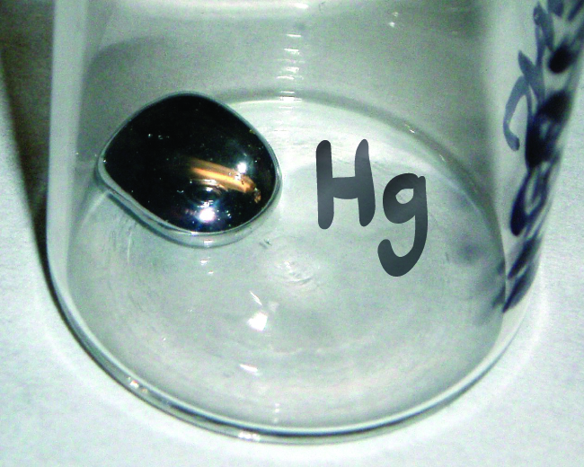

Figure 2.13 The symbol Hg represents the element mercury regardless of the amount; it could represent one atom of mercury or a large amount of mercury.

The symbols for several common elements and their atoms are listed in Table 2.3. Some symbols are derived from the common name of the element; others are abbreviations of the name in another language. Most symbols have one or two letters, but three-letter symbols have been used to describe some elements that have atomic numbers greater than 112. To avoid confusion with other notations, only the first letter of a symbol is capitalized. For example, Co is the symbol for the element cobalt, but CO is the notation for the compound carbon monoxide, which contains atoms of the elements carbon (C) and oxygen (O). All known elements and their symbols are in the periodic table.

Traditionally, the discoverers of a new element name the elements. However, until the name is recognized by the International Union of Pure and Applied Chemistry (IUPAC), the recommended name of the new element is based on the Latin word(s) for its atomic number. For example, element 106 was called unnilhexium (Unh), element 107 was called unnilseptium (Uns), and element 108 was called unniloctium (Uno) for several years. These elements are now named after scientists (or occasionally locations); for example, element 106 is now known as seaborgium (Sg) in honor of Glenn Seaborg, a Nobel Prize winner who was active in the discovery of several heavy elements.
Table 2.3 Some Common Elements and Their Symbols

Element | Symbol | Element | Symbol
aluminum | Al | iron | Fe (from ferrum)
bromine | Br | lead | Pb (from plumbum)
calcium | Ca | magnesium | Mg
carbon | C | mercury | Hg (from hydrargyrum)
chlorine | Cl | nitrogen | N
chromium | Cr | oxygen | O
cobalt | Co | potassium | K (from kalium)
copper | Cu (from cuprum) | silicon | Si
fluorine | F | silver | Ag (from argentum)
gold | Au (from aurum) | sodium | Na (from natrium)
helium | He | sulfur | S
hydrogen | H | tin | Sn (from stannum)
iodine | I | zinc | Zn

Isotopes
Another important finding was the discovery of isotopes. During the early 1900s, scientists identified several substances that appeared to be new elements, isolating them from radioactive ores. For example, a “new element” produced by the radioactive decay of thorium was initially given the name mesothorium. However, a more detailed analysis showed that mesothorium was chemically identical to radium (another decay product), despite having a different atomic mass. This result, along with similar findings for other elements, led the English chemist Frederick Soddy to realize that an element could have types of atoms with different masses that were chemically indistinguishable. These different types are called isotopes—atoms of the same element that differ in mass. Soddy was awarded the Nobel Prize in Chemistry in 1921 for this discovery.

Isotopic Symbols or Nuclear Notations
The symbol for a specific isotope of any element is written by placing the mass number as a superscript to the left of the element symbol (Figure 2.14). The atomic number is sometimes written as a subscript preceding the symbol, but since this number defines the element’s identity, as does its symbol, it is often omitted.

For example, magnesium exists as a mixture of three isotopes, each with an atomic number of 12 and with mass numbers of 24, 25, and 26, respectively. These isotopes can be identified as ²⁴Mg, ²⁵Mg, and ²⁶Mg. These isotope symbols are read as “element, mass number” and can be symbolized consistent with this reading.

For instance, ²⁴Mg is read as “magnesium 24,” and can be written as “magnesium-24” or “Mg-24.”

25Mg is read as “magnesium 25,” and can be written as “magnesium-25” or “Mg-25.”

All magnesium atoms have 12 protons in their nucleus. They differ only because a ²⁴Mg atom has 12 neutrons in its nucleus, a ²⁵Mg atom has 13 neutrons, and a ²⁶Mg has 14 neutrons.
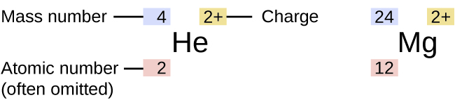

Figure 2.14 The symbol for an atom indicates the element via its usual two-letter symbol, the mass number as a left superscript, the atomic number as a left subscript (sometimes omitted), and the charge as a right superscript.

Information about the naturally occurring isotopes of elements with atomic numbers 1 through 10 is given in Table 2.4. Note that in addition to standard names and symbols, the isotopes of hydrogen are often referred to using common names and accompanying symbols. Hydrogen-2, symbolized ²H, is also called deuterium and sometimes symbolized D. Hydrogen-3, symbolized ³H, is also called tritium and sometimes symbolized T.

Table 2.4 Nuclear Compositions of Atoms of the Very Light Elements
Element | Symbol | Atomic Number | Number of  Protons | Number of Neutrons | Mass (amu) | % Natural Abundance
hydrogen | H-1 | 1 | 1 | 0 | 1.0078 | 99.989
 | H-2 | 1 | 1 | 1 | 2.0141 | 0.0115
 | H-3 | 1 | 1 | 2 | 3.01605 | — (trace)
helium | He-3 | 2 | 2 | 1 | 3.01603 | 0.00013
 | He-4 | 2 | 2 | 2 | 4.0026 | 100
lithium | Li-6 | 3 | 3 | 3 | 6.0151 | 7.59
 | Li-7 | 3 | 3 | 4 | 7.0160 | 92.41
Element | Symbol | Atomic Number | Number of  Protons | Number of Neutrons | Mass (amu) | % Natural Abundance
beryllium | Be-9 | 4 | 4 | 5 | 9.0122 | 100
boron | B-10 | 5 | 5 | 5 | 10.0129 | 19.9
 | B-11 | 5 | 5 | 6 | 11.0093 | 80.1
carbon | C-12 | 6 | 6 | 6 | 12.0000 | 98.89
 | C-13 | 6 | 6 | 7 | 13.0034 | 1.11
 | C-14 | 6 | 6 | 8 | 14.0032 | — (trace)
nitrogen | N-14 | 7 | 7 | 7 | 14.0031 | 99.63
 | N-14 | 7 | 7 | 8 | 15.0001 | 0.37
oxygen | O-16 | 8 | 8 | 8 | 15.9949 | 99.757
 | O-17 | 8 | 8 | 9 | 16.9991 | 0.038
 | O-18 | 8 | 8 | 10 | 17.9992 | 0.205
fluorine | F-19 | 9 | 9 | 10 | 18.9984 | 100
neon | Ne-20 | 10 | 10 | 10 | 19.9924 | 90.48
 | Ne-21 | 10 | 10 | 11 | 20.9938 | 0.27
 | Ne-22 | 10 | 10 | 12 | 21.9914 | 9.25

Ion

Atoms are electrically neutral if they contain the same number of positively charged protons and negatively charged electrons. When an atom (or groups of atoms) gains or loses an electron(s) it is called an ion.

The charge of an atom is defined as follows:

Atomic charge = number of protons − number of electrons

Atoms (and molecules) typically acquire charge by gaining or losing electrons. An atom that gains one or more electrons will exhibit a negative charge and is called an anion. Positively charged atoms called cations are formed when an atom loses one or more electrons. For example, a neutral sodium atom (Z = 11) has 11 electrons. If this atom loses one electron, it will become a cation with a 1+ charge (11 − 10 = 1+). A neutral oxygen atom (Z = 8) has eight electrons, and if it gains two electrons it will become an anion with a 2− charge (8 − 10 = 2−).

Average Atomic Mass
Because each proton and each neutron contribute approximately one amu to the mass of an atom, and each electron contributes far less, the atomic mass of a single atom is approximately equal to its mass number (a whole number). However, the average masses of atoms of most elements are not whole numbers because most elements exist naturally as mixtures of two or more isotopes.

The mass of an element shown in a periodic table or listed in a table of atomic masses is a weighted, average mass of all the isotopes present in a naturally occurring sample of that element. This is equal to the sum of each individual isotope’s mass multiplied by its fractional abundance.

average mass = ∑ (fractional abundance × isotopic mass)_{i}

For example, the element boron is composed of two isotopes: About 19.9% of all boron atoms are B-10 with a mass of 10.0129 amu, and the remaining 80.1% are B-11 with a mass of 11.0093 amu.

The average atomic mass for boron is calculated to be:

boron average mass = (0.199 × 10.0129 amu) + (0.801 × 11.0093 amu)
= 1.99 amu + 8.82 amu
= 10.81 amu

It is important to understand that no single boron atom weighs exactly 10.8 amu; 10.8 amu is the average mass of all boron atoms, and individual boron atoms weigh either approximately 10 amu or 11 amu.

Mole Concept and Molar Mass
The mole is an amount unit similar to familiar units like pair, dozen, gross, etc. It provides a specific measure of the number of atoms or molecules in a bulk sample of matter. A mole is defined as the amount of substance containing the same number of discrete entities (such as atoms, molecules, and ions) as the number of atoms in a sample of pure C-12 weighing exactly 12 g. One Latin connotation for the word “mole” is “large mass” or “bulk,” which is consistent with its use as the name for this unit. The mole provides a link between an easily measured macroscopic property, bulk mass, and an extremely important fundamental property, number of atoms, molecules, and so forth.

The number of entities composing a mole has been experimentally determined to be 6.022 × 10²³, a fundamental constant named Avogadro’s number (N_{A}) or the Avogadro constant in honor of Italian scientist Amedeo Avogadro. This constant is properly reported with an explicit unit of “per mole”: 6.022 × 10²³ per mol.

Consistent with its definition as an amount unit, 1 mole of any element contains the same number of atoms as 1 mole of any other element. The masses of 1 mole of different elements, however, are different, since the masses of the individual atoms are drastically different. The molar mass of an element (or compound) is the mass in grams of 1 mole of that substance, a property expressed in units of grams per mole (g/mol) (see Figure 3.5).

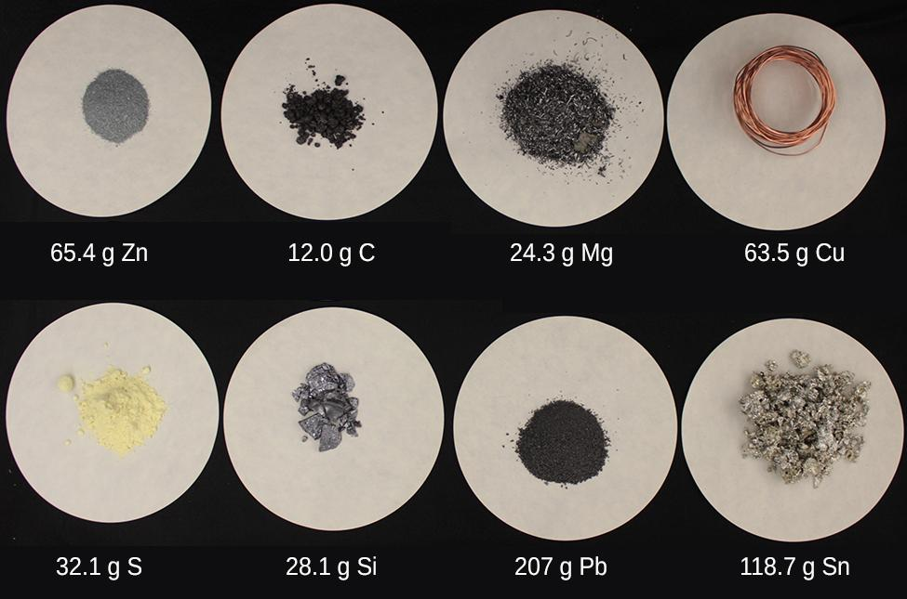

Figure 3.5 Each sample contains 6.022 × 10²³ atoms —1.00 mol of atoms. From left to right (top row): 65.4 g zinc, 12.0 g carbon, 24.3 g magnesium, and 63.5 g copper. From left to right (bottom row): 32.1 g sulfur, 28.1 g silicon, 207 g lead, and 118.7 g tin. (credit: modification of work by Mark Ott)

Because the definitions of both the mole and the atomic mass unit are based on the same reference substance, C-12, the molar mass of any substance is numerically equivalent to its atomic or formula weight in amu. Per the amu definition, a single C-12 atom weighs 12 amu (its atomic mass is 12 amu). According to the definition of the mole, 12 g of C-12 contains 1 mole of C-12 atoms (its molar mass is 12 g/mol). This relationship holds for all elements, since their atomic masses are measured relative to that of the amu-reference substance, C-12. Extending this principle, the molar mass of a compound in grams is likewise numerically equivalent to its formula mass in amu (Figure 3.6)

Figure 3.6 Each sample contains 6.022 × 10²³ molecules or formula units—1.00 mol of the compound or element. Clock-wise from the upper left: 130.2 g of C₈H₁₇OH (1-octanol, formula mass 130.2 amu), 454.4 g of HgI₂ (mercury(II) iodide, formula mass 454.4 amu), 32.0 g of CH₃OH (methanol, formula mass 32.0 amu) and 256.5 g of S₈ (sulfur, formula mass 256.5 amu). (credit: Sahar Atwa)

Element | Average Atomic Mass (amu) | Molar Mass (g/mol) | Atoms/Mole
C | 12.01 | 12.01 | 6.022 × 10²³
H | 1.008 | 1.008 | 6.022 × 10²³
O | 16.00 | 16.00 | 6.022 × 10²³
Na | 22.99 | 22.99 | 6.022 × 10²³

While atomic mass and molar mass are numerically equivalent, keep in mind that they are vastly different in terms of scale, as represented by the vast difference in the magnitudes of their respective units (amu versus g).

BLANK PAGE

Chapter 3 – Attributions

The contents in this chapter, licensed under CC BY-NC-SA 4.0. has been adopted, modified, reorganized, and/or remixed from the following:

3.0 Introduction
"6 Introduction" by Paul Flowers, Klaus Theopold, Richard Langley, William R. Robinson, PhD, OpenStax is licensed under CC BY 4.0

3.1 Light as Wave - Electromagnetic Radiation
"6.1 Electromagnetic Energy" by Paul Flowers, Klaus Theopold, Richard Langley, William R. Robinson, PhD, OpenStax is licensed under CC BY 4.0
"Diffraction" by Wikipedia, the free encyclopedia is licensed under CC BY-SA 3.0

3.2 Light as Particle - Quantized Energy and Photon
"6.1 Electromagnetic Energy" by Paul Flowers, Klaus Theopold, Richard Langley, William R. Robinson, PhD, OpenStax is licensed under CC BY 4.0

3.3 The Bohr Model
"6.2 The Bohr Model" by Paul Flowers, Klaus Theopold, Richard Langley, William R. Robinson, PhD, OpenStax is licensed under CC BY 4.0
"6.2 The Bohr Model" by Paul Flowers, Klaus Theopold, Richard Langley, William R. Robinson, PhD, OpenStax is licensed under CC BY 4.0

3.4 Development of Quantum Theory
"6.3 Development of Quantum Theory" by Paul Flowers, Klaus Theopold, Richard Langley, William R. Robinson, PhD, OpenStax is licensed under CC BY 4.0
"7.1: Schrödinger's Cat" by LibreTexts is licensed under CC BY-NC-SA 3.0
"6.5 Atomic Orbitals and Their Energies" by 2012 Book Archive is licensed under CC BY-NC-SA 3.0

3.5 Quantum Numbers and Shapes of Orbitals
"6.3 Development of Quantum Theory" by Paul Flowers, Klaus Theopold, Richard Langley, William R. Robinson, PhD, OpenStax is licensed under CC BY 4.0
"6.6: 3D Representation of Orbitals" by Joshua Halpern , LibreTexts is licensed under CC BY-NC-SA 3.0

Chapter 3 Development of Electronic Structure of Atoms

Chapter Introduction

3.1 Light as Wave - Electromagnetic Radiation

3.2 Light as Particle - Quantized Energy and Photon

3.3 The Bohr Model

3.4 Development of Quantum Theory

3.5 Quantum Numbers and Shapes of Orbitals

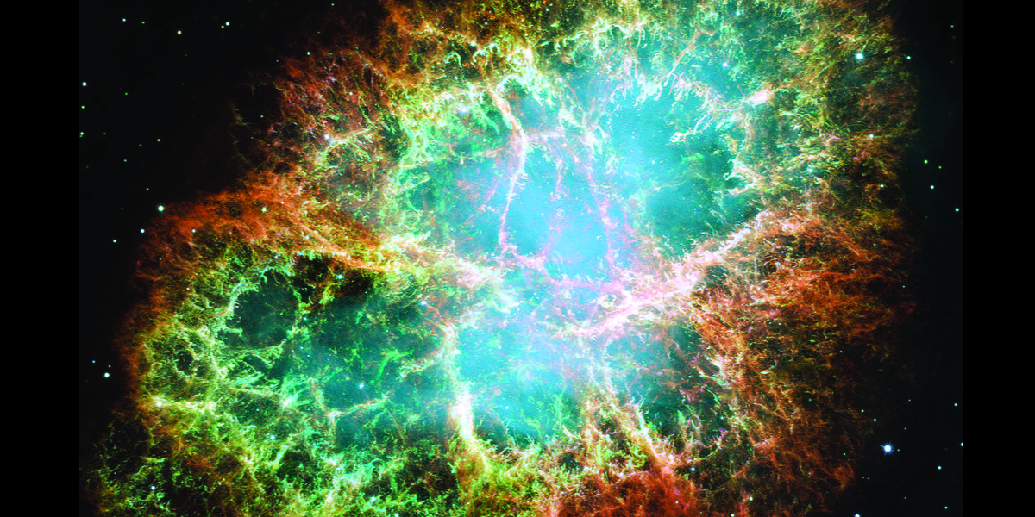
Figure 3.1 The Crab Nebula consists of remnants of a supernova (the explosion of a star). NASA’s Hubble Space Telescope produced this composite image. Measurements of the emitted light wavelengths enabled astronomers to identify the elements in the nebula, determining that it contains specific ions including S⁺ (green filaments) and O²⁺ (red filaments). (credit: modification of work by NASA and ESA)

In 1054, Chinese astronomers recorded the appearance of a “guest star” in the sky, visible even during the day, which then disappeared slowly over the next two years. The sudden appearance was due to a supernova explosion, which was much brighter than the original star. Even though this supernova was observed almost a millennium ago, the remaining Crab Nebula (Figure 3.1) continues to release energy today. It emits not only visible light but also infrared light, X-rays, and other forms of electromagnetic radiation. The nebula emits both continuous spectra (the blue-white glow) and atomic emission spectra (the colored filaments). In this chapter, we will discuss light and other forms of electromagnetic radiation and how they are related to the electronic structure of atoms.

BLANK PAGE

3.1 Light as Wave - Electromagnetic Radiation

Learning Objectives
- Explain the basic behavior of waves, and characteristics used to describe a wave
- Describe the wave nature of light
- Know speed of light
- Know what is meant by the terms electromagnetic radiation, frequency, wavelength
- Understand that visible light is a type of electromagnetic radiation, what electromagnetic radiation is, and be familiar with the other regions of the electromagnetic spectrum.
- Know typical units for the frequency, wavelength, and speed
- Use appropriate equations to calculate related light-wave properties such as frequency, and wavelength

Introduction
The nature of light has been a subject of inquiry since the seventeenth century. By the end of the nineteenth century, scientists viewed the physical universe as roughly comprising two separate domains: matter composed of particles moving according to Newton's laws of motion, and electromagnetic radiation consisting of waves governed by Maxwell's equations. Today, these domains are referred to as classical mechanics and classical electrodynamics (or classical electromagnetism). Although there were a few physical phenomena that could not be explained within this framework, scientists at that time were so confident of the overall soundness of this framework that they viewed these aberrations as puzzling paradoxes that would ultimately be resolved somehow within this framework. As we shall see, these paradoxes led to a contemporary framework that intimately connected particles and waves at a fundamental level called wave-particle duality, which has superseded the classical view.

Electromagnetic Radiation
Visible light and other forms of electromagnetic radiation play important roles in chemistry, since they can be used to infer the energies of electrons within atoms and molecules. Much of modern technology is based on electromagnetic radiation. For example, radio waves from a mobile phone, X-rays used by dentists, the energy used to cook food in your microwave, the radiant heat from red-hot objects, and the light from your television screen are forms of electromagnetic radiation that all exhibit wavelike behavior.

Waves
A wave is an oscillation or periodic movement that can transport energy from one point in space to another. Common examples of waves are all around us. Shaking the end of a rope transfers energy from your hand to the other end of the rope, dropping a pebble into a pond causes waves to ripple outward along the water's surface, and the expansion of air that accompanies a lightning strike generates sound waves (thunder) that can travel outward for several miles. In each of these cases, kinetic energy is transferred through matter (the rope, water, or air) while the matter remains essentially in place. An insightful example of a wave occurs in sports stadiums when fans in a narrow region of seats rise simultaneously and stand with their arms raised up for a few seconds before sitting down again while the fans in neighboring sections likewise stand up and sit down in sequence. While this wave can quickly encircle a large stadium in a few seconds, none of the fans actually travel with the wave-they all stay in or above their seats.

Waves need not be restricted to travel through matter. As Maxwell showed, electromagnetic waves consist of an electric field oscillating in step with a perpendicular magnetic field, both of which are perpendicular to the direction of travel. These waves can travel through a vacuum at a constant speed of 2.998 × 10⁸ m/s, the speed of light (denoted by c).

All waves, including forms of electromagnetic radiation, are characterized by, a wavelength (denoted by λ, the lowercase Greek letter lambda), a frequency (denoted by ν, the lowercase Greek letter nu), and an amplitude.
As can be seen in Figure 3.2, the wavelength is the distance between two consecutive peaks or troughs in a wave (measured in meters in the SI system). Electromagnetic waves have wavelengths that fall within an enormous range-wavelengths of kilometers (10³ m) to picometers (10⁻¹² m) have been observed.

The frequency is the number of wave cycles that pass a specified point in space in a specified amount of time (in the SI system, this is measured in seconds). A cycle corresponds to one complete wavelength. The unit for frequency, expressed as cycles per second [s⁻¹], is the hertz (Hz). Common multiples of this unit are megahertz, (1 MHz = 1 × 10⁶ Hz) and gigahertz (1 GHz = 1 ×10⁹ Hz).

The amplitude corresponds to the magnitude of the wave's displacement and so, in Figure 3.2, this corresponds to one-half the height between the peaks and troughs. The amplitude is related to the intensity of the wave, which for light is the brightness, and for sound is the loudness.
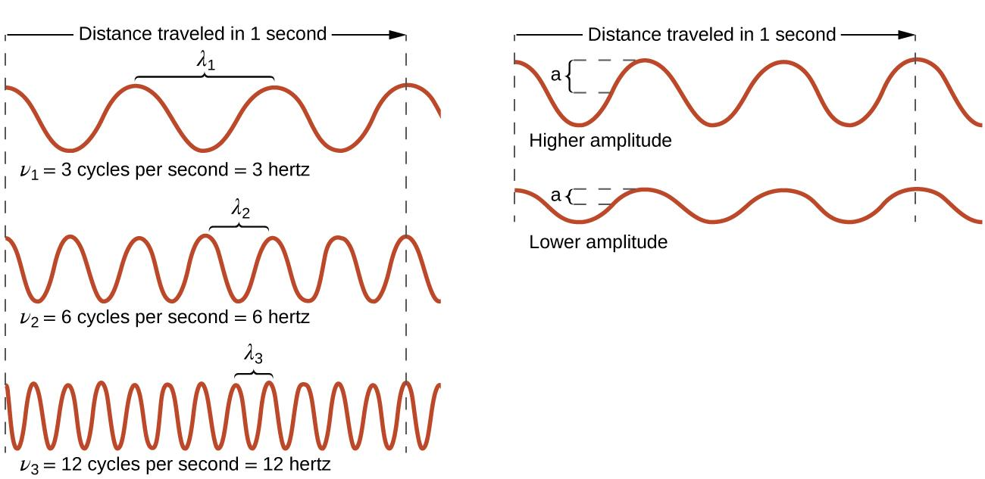

Figure 3.2 One-dimensional sinusoidal waves show the relationship between wavelength, frequency, and speed. The wave with the shortest wavelength has the highest frequency. Amplitude is one-half the height of the wave from peak to trough.
The product of a wave's wavelength (λ) and its frequency (ν), λν, is the speed of the wave. Thus, for electromagnetic radiation in a vacuum, speed is equal to the fundamental constant, c:
λν = c = 2.998 × 10⁸ ms⁻¹
Wavelength and frequency are inversely proportional: As the wavelength increases, the frequency decreases. The inverse proportionality is illustrated in Figure 3.3. This figure also shows the electromagnetic spectrum, the range of all types of electromagnetic radiation. Each of the various colors of visible light has specific frequencies and wavelengths associated with them, and you can see that visible light makes up only a small portion of the electromagnetic spectrum. Because the technologies developed to work in various parts of the electromagnetic spectrum are different, for reasons of convenience and historical legacies, different units are typically used for different parts of the spectrum. For example, radio waves are usually specified as frequencies (typically in units of MHz), while the visible region is usually specified in wavelengths (typically in units of nm or angstroms).

Visible Light Region on the Electromagnetic Spectrum

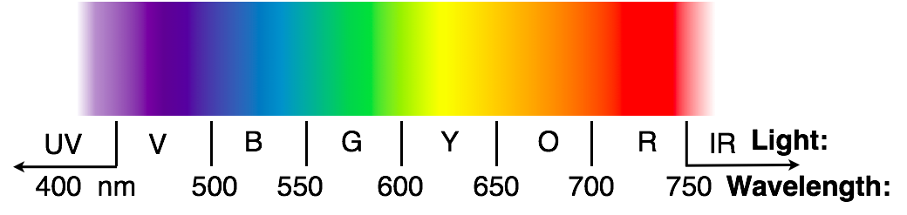

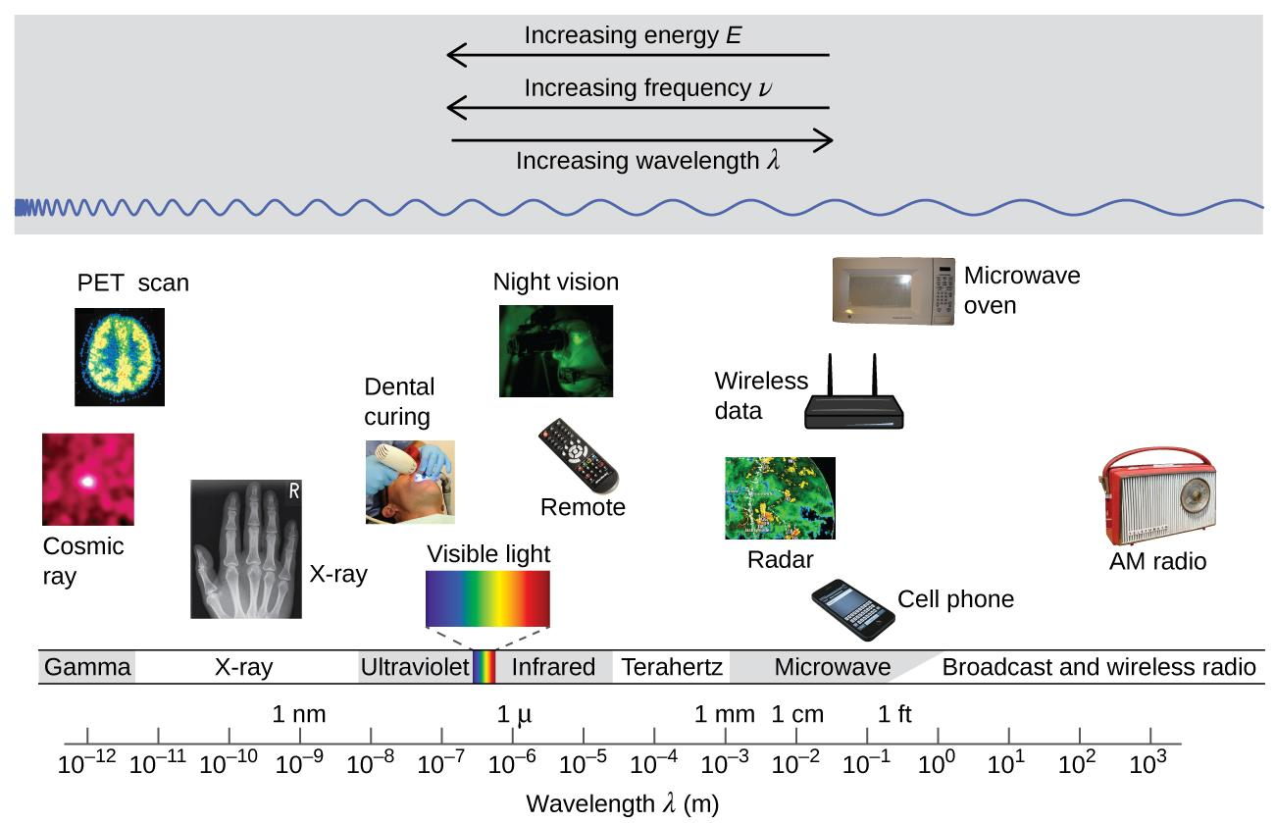
Figure 3.3 Portions of the electromagnetic spectrum are shown in order of decreasing frequency and increasing wavelength. (credit “Cosmic ray": modification of work by NASA; credit “PET scan": modification of work by the National Institute of Health; credit “X-ray": modification of work by Dr. Jochen Lengerke; credit “Dental curing": modification of work by the Department of the Navy; credit “Night vision": modification of work by the Department of the Army; credit “Remote": modification of work by Emilian Robert Vicol; credit “Cell phone": modification of work by Brett Jordan; credit “Microwave oven": modification of work by Billy Mabray; credit “Ultrasound": modification of work by Jane Whitney; credit “AM radio": modification of work by Dave Clausen)

Wireless Communication
Figure 3.4 Radio and cell towers are typically used to transmit long-wavelength electromagnetic radiation. Increasingly, cell towers are designed to blend in with the landscape, as with the Tucson, Arizona, cell tower (right) disguised as a palm tree. (credit left: modification of work by Sir Mildred Pierce; credit middle: modification of work by M.O. Stevens)

Many valuable technologies operate in the radio (3 kHz-300 GHz) frequency region of the electromagnetic spectrum. At the low frequency (low energy, long wavelength) end of this region are AM (amplitude modulation) radio signals (540-2830 kHz) that can travel long distances. FM (frequency modulation) radio signals are used at higher frequencies (87.5-108.0 MHz). In AM radio, the information is transmitted by varying the amplitude of the wave (Figure 3.5). In FM radio, by contrast, the amplitude is constant and the instantaneous frequency varies.
Figure 3.5 This schematic depicts how amplitude modulation (AM) and frequency modulation (FM) can be used to transmit a radio wave.

Other technologies also operate in the radio-wave portion of the electromagnetic spectrum. For example, 4G cellular telephone signals are approximately 880 MHz, while Global Positioning System (GPS) signals operate at 1.228 and 1.575 GHz, local area wireless technology (Wi-Fi) networks operate at 2.4 to 5 GHz, and highway toll sensors operate at 5.8 GHz. The frequencies associated with these applications are convenient because such waves tend not to be absorbed much by common building materials.

Behaviors of Waves
Waves diffract when they pass through a barrier with slit. They also interfere with each other when they come into contact.

Diffraction refers to various phenomena that occur when a wave encounters an obstacle or a slit. It is defined as the bending of waves around the corners of an obstacle or through an aperture into the region of the geometrical shadow of the obstacle/aperture. The diffracting object or aperture effectively becomes a secondary source of the propagating wave. (Wikipedia). Figure 3.6 shows how light diffract through the barrier and the diffraction pattern.
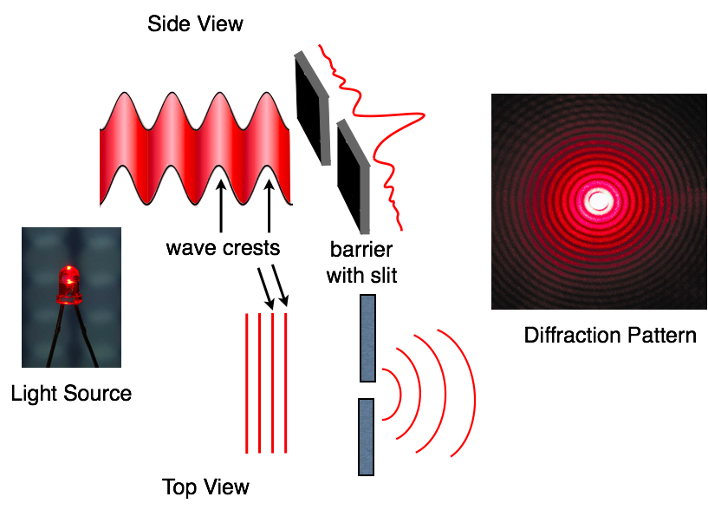
Figure 3.6 Diffraction pattern of red laser beam made on a plate after passing through a small circular aperture in another plate. Figure licensed under CC BY-SA 4.0 (Attribution for content previously shared: “Diffraction Pattern” by Wiskey is CC BY-SA 3.0. “Light Source” by https://torange.biz/ is CC BY 4.0. Modifications: Added wave crests, barrier with slit, side view and top view).

Interference refers to when the light passes through the two slits, each slit effectively acts as a new source, resulting in two closely spaced waves coming into contact. As they come into contact with each other, they can cancel or amplify each other.
As shown in Figure 3.7, the dark regions correspond to regions where the peaks for the wave from one slit happen to coincide with the troughs for the wave from the other slit. They cancel each other. This is called destructive interference. While the brightest regions correspond to the regions where the peaks for the two waves (or their two troughs) happen to coincide. They amplify each other. This is called constructive interference.

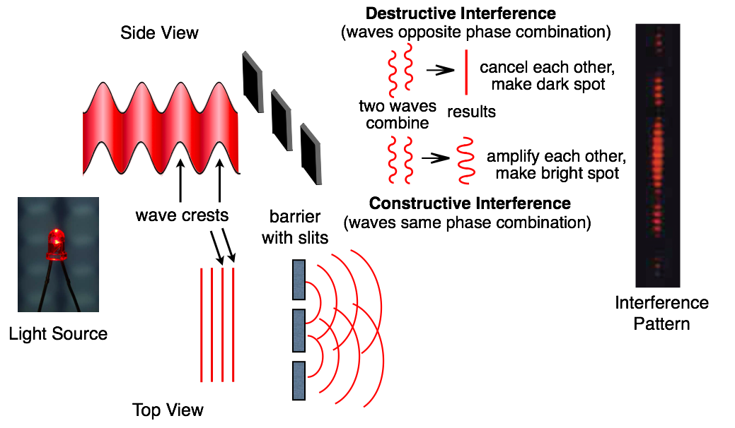
Figure 3.7 Interference patterns are shown for light passing through two closely spaced, narrow slits. The spacing of the slits depends on the wavelength. (Attribution for content previously shared: “Interference Pattern” by PASCO, “Light Source” by https://torange.biz/ is CC BY 4.0. Modifications: Added wave crests, barrier with slit, side view and top view, destructive interference, and constructive interference )

Footnote
- Francesco Maria Grimaldi, Physico mathesis de lumine, coloribus, et iride, aliisque annexis libri duo (Bologna ("Bonomia"), Italy: Vittorio Bonati, 1665), page 2 Archived 2016-12-01 at the Wayback Machine:
- Cajori, Florian "A History of Physics in its Elementary Branches, including the evolution of physical laboratories." Archived 2016-12-01 at the Wayback Machine MacMillan Company, New York 1899

3.2 Light as Particle - Quantized Energy and Photon

Learning Objectives
- Know typical units for the frequency, wavelength, and energy of electromagnetic radiation
- Know the relationship between energy, frequency and wavelength
- Understand and describe what it means to say that energy levels are quantized in molecules and atoms.
- Be able to describe the photoelectric effect, why it was puzzling, and why it was important in the development of quantum mechanics
- Understand the characteristics of light described as a particle.

Introduction
From the previous topic, we see the nature of light as wave. However, the classical wave theory of light had been failed to describe many important phenomena such as blackbody radiation, photoelectric effect, and atomic emission spectra. This led scientists articulated a new set of theories that view light as a particle known as a photon.

Blackbody Radiation and UV Catastrophe
A blackbody is an object that absorbs all of the radiations and emits its own radiations. A black body at room temperature appears black, as most of the energy it radiates is in the infrared spectrum and cannot be perceived by the human eye. When a blackbody object is heated, it radiates light covering a wide range of wavelength/frequency. This emission of light from a hot object is called blackbody radiation. An example of a blackbody radiation is when a metal in incandescent light bulb (a blackbody object) is heated to very high temperatures and emits light (Figure 3.8).
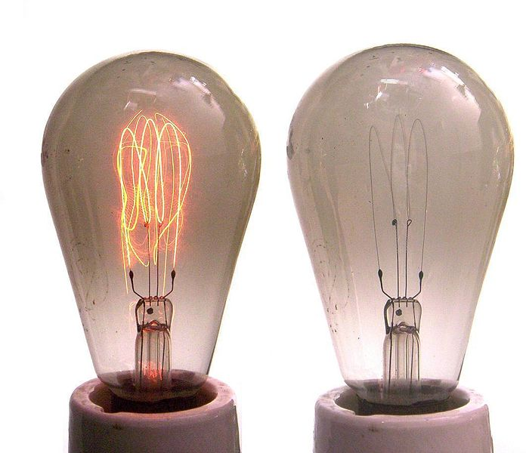

Figure 3.8 Example of a blackbody radiation.
(Credit: "File:Carbonfilament.jpg" by Ulfbastel, Wikimedia Commons, the free media repository is licensed under CC BY-SA 3.0)

The classical theory explained this phenomenon that the atoms composing the blackbody object vibrated at increasing frequencies (or decreasing wavelengths) as the temperature increased, with these vibrations being the source of the emitted electromagnetic radiation.

Blackbody spectral distribution curves are shown for some representative temperatures in Figure 3.9. The maxima in the blackbody curves, λ_{max}, shift to shorter wavelengths as the temperature increases, reflecting the observation that metals being heated to high temperatures begin to glow a darker red that becomes brighter as the temperature increases, eventually becoming white hot at very high temperatures as the intensities of all of the visible wavelengths become appreciable. This common observation was at the heart of the first paradox that showed the fundamental limitations of classical physics that we will examine.

Physicists derived mathematical expressions for the blackbody curves using well-accepted concepts from the theories of classical mechanics and classical electromagnetism (see classical theory curve on Figure 3.9). The theoretical expressions as functions of temperature fit the observed experimental blackbody curves well at longer wavelengths, but showed significant discrepancies at shorter wavelengths. Not only did the theoretical curves not show a peak, they absurdly showed the intensity becoming infinitely large as the wavelength became smaller, which would imply that everyday objects at room temperature should be emitting large amounts of UV light. This became known as the “ultraviolet catastrophe” because no one could find any problems with the theoretical treatment that could lead to such unrealistic short-wavelength behavior.

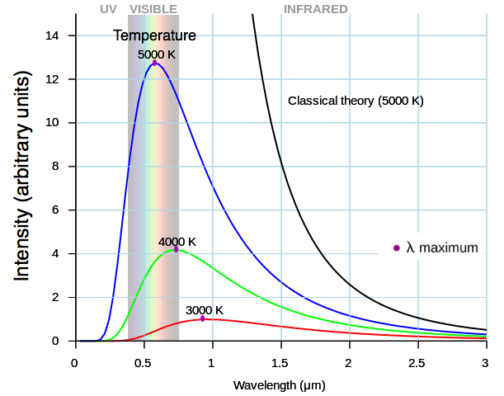

Figure 3.9 Blackbody spectral distribution curves are shown for some representative temperatures. (Credit: "File:Black body.svg" by Darth Kule, Wikimedia Commons, the free media repository is in the Public Domain)

Planck’s Theory of Light
Finally, around 1900, Max Planck derived a theoretical expression for blackbody radiation that fit the experimental observations exactly (within experimental error). Planck developed his theoretical treatment by extending the earlier work. But where the earlier treatments had allowed the vibrating atoms to have any energy values obtained from a continuous set of energies (perfectly reasonable, according to classical physics), Planck found that by restricting the vibrational energies to discrete values for each frequency, he could derive an expression for blackbody radiation that correctly had the intensity dropping rapidly for the short wavelengths in the UV region.
E = nhν ,n = 1,2,3,. . .
The quantity h is a constant now known as Planck's constant, in his honor. The value of Planck's constant is very small, 6.626 × 10⁻³⁴ joule seconds (J s).

Planck’s theory looks at light as standing waves. Standing waves (also known as stationary waves) remain constrained within some region of space. As we shall see, standing waves play an important role in our understanding of the electronic structure of atoms and molecules. The simplest example of a standing wave is a one-dimensional wave associated with a vibrating string that is held fixed at its two end points (Figure 3.10).
Although the string's motion lies mostly within a plane, the wave itself is considered to be one dimensional, since it lies along the length of the string. The motion of string segments in a direction perpendicular to the string length generates the waves and so the amplitude of the waves is visible as the maximum displacement of the curves seen in Figure 3.10.

The key observation from the figure is that only those waves having an integer number, n, of half-wavelengths between the end points can form. A system with fixed end points such as this restricts the number and type of the possible waveforms. This is an example of quantization, in which only discrete values from a more general set of continuous values of some property are observed.

Another important observation is that the harmonic waves (those waves displaying more than one-half wavelength) all have one or more points between the two end points that are not in motion. These special points are nodes. The energies of the standing waves with a given amplitude in a vibrating string increase with the number of half-wavelengths n. Since the number of nodes is n – 1, the energy can also be said to depend on the number of nodes, generally increasing as the number of nodes increases.
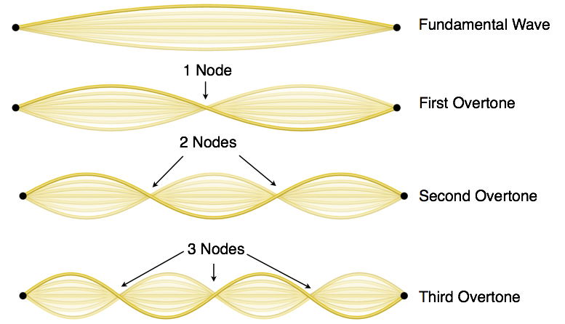

Figure 3.10 A vibrating string shows some one-dimensional standing waves. The four lowest-energy standing waves (the fundamental wave and the lowest three harmonics) for a vibrating string at a particular amplitude. Since the two end points of the string are held fixed, only waves having an integer number of half-wavelengths can form. The points on the string between the end points that are not moving are called the nodes.

The Photoelectric Effect
The next paradox in the classical theory to be resolved concerned the photoelectric effect (Figure 3.11). The photoelectric effect is the ejection of electrons from metal surface when light having a frequency greater than some threshold frequency was shone on it.
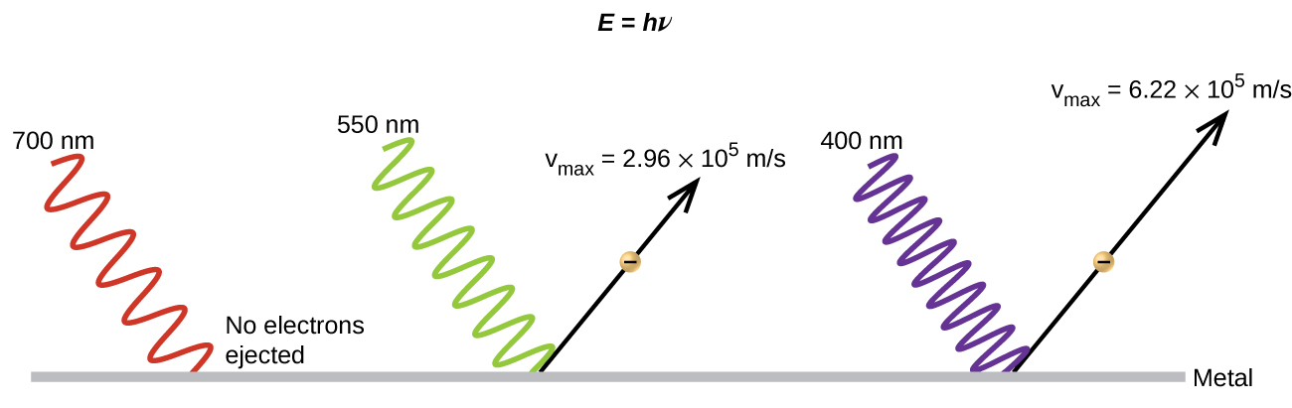
Figure 3.11 Photons with low frequencies do not have enough energy to cause electrons to be ejected via the photoelectric effect. For any frequency of light above the threshold frequency, the kinetic energy of an ejected electron will increase linearly with the energy of the incoming photon.

According to classical wave theory, a wave's energy depends on its intensity (which depends on its amplitude), not its frequency. However, the ejected electrons did not depend on the brightness (intensity) of the light, but increased with increasing frequency of the light.

In 1905, Albert Einstein was able to resolve the paradox by incorporating Planck's quantization findings into the discredited particle view of light (Einstein actually won his Nobel prize for this work, and not for his theories of relativity for which he is most famous).

Einstein argued that the quantized energies that Planck had postulated in his treatment of blackbody radiation could be applied to the light in the photoelectric effect so that the light striking the metal surface should not be viewed as a wave, but instead as a stream of particles (later called photons) whose energy depended on their frequency, according to Planck's formula,

E = hν

or, in terms of wavelength using ν = c/λ

E = h$\frac{c}{λ}$

Electrons were ejected when hit by photons having sufficient energy (a frequency greater than the threshold). The greater the frequency, the greater the kinetic energy imparted to the escaping electrons by the collisions. Einstein also argued that the light intensity did not depend on the amplitude of the incoming wave, but instead corresponds to the number of photons striking the surface within a given time period. This explains why the number of ejected electrons increased with increasing brightness, since the greater the number of incoming photons, the greater the likelihood that they would collide with some of the electrons.

With Einstein's findings, the nature of light took on a new air of mystery. Although many light phenomena could be explained either in terms of waves or particles, certain phenomena, such as the interference patterns obtained when light passed through a double slit, were completely contrary to a particle view of light, while other phenomena, such as the photoelectric effect, were completely contrary to a wave view of light. Somehow, at a deep fundamental level still not fully understood, light is both wavelike and particle-like. This is known as wave-particle duality.

Atomic Emission - Line Spectra
Another paradox within the classical electromagnetic theory that scientists in the late nineteenth century struggled with concerned the light emitted from atoms and molecules. When solids, liquids, or condensed gases are heated sufficiently, they radiate some of the excess energy as light.

Photons produced in this manner have a range of energies, and thereby produce a continuous spectrum in which an unbroken series of wavelengths is present. Most of the light generated from stars (including our Sun) is produced in this fashion. You can see all the visible wavelengths of light present in sunlight by using a prism to separate them or as a rainbow. Sunlight also contains UV light (shorter wavelengths) and IR light (longer wavelengths) that can be detected using instruments but that are invisible to the human eye. Incandescent (glowing) solids such as tungsten filaments in incandescent lights also give off light that contains all wavelengths of visible light. These continuous spectra can often be approximated by blackbody radiation curves at some appropriate temperature, such as those shown in Figure 3.9.

In contrast to continuous spectra, light can also occur as discrete or line spectra having very narrow line widths interspersed throughout the spectral regions such as those shown in Figure 3.12. Exciting a gas at low partial pressure using an electrical current, or heating it, will produce line spectra. Fluorescent light bulbs and neon signs operate in this way (Figure 3.13). Each element displays its own characteristic set of lines, as do molecules, although their spectra are generally much more complicated.
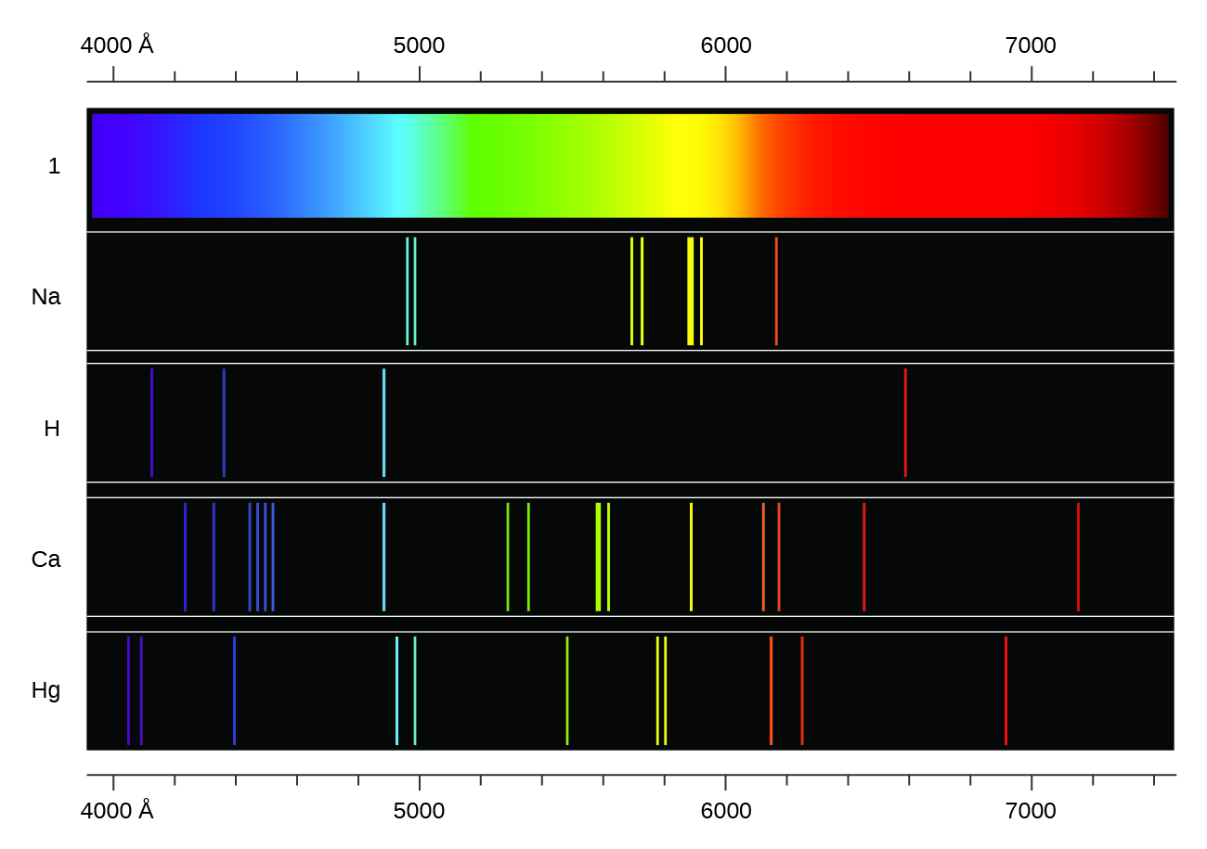
Figure 3.12 Compare the two types of emission spectra: continuous spectrum of white light (top) and the line spectra of the light from excited sodium, hydrogen, calcium, and mercury atoms.

Figure 3.13 Neon signs operate by exciting a gas at low partial pressure using an electrical current. This sign shows the elaborate artistic effects that can be achieved. (credit: Dave Shaver)

Each emission line consists of a single wavelength of light, which implies that the light emitted by a gas consists of a set of discrete energies. For example, when an electric discharge passes through a tube containing hydrogen gas at low pressure, the H₂ molecules are broken apart into separate H atoms and we see a blue-pink color. Passing the light through a prism produces a line spectrum, indicating that this light is composed of photons of four visible wavelengths, as shown in Figure 3.12.

The origin of discrete spectra in atoms and molecules was extremely puzzling to scientists in the late nineteenth century, since according to classical electromagnetic theory, only continuous spectra should be observed. Even more puzzling, in 1885, JohannBalmer was able to derive an empirical equation that related the four visible wavelengths of light emitted by hydrogen atoms to whole integers. That equation is the following one, in which k is a constant:
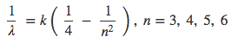
Other discrete lines for the hydrogen atom were found in the UV and IR regions. Johannes Rydberg generalized Balmer's work and developed an empirical formula that predicted all of hydrogen's emission lines, not just those restricted to the visible range, where,n1 and n2 are integers, n1 < n2, and R∞ is the Rydberg constant (1.097 × 10⁷ m⁻¹).
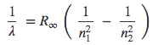
Even in the late nineteenth century, spectroscopy was a very precise science, and so the wavelengths of hydrogen were measured to very high accuracy, which implied that the Rydberg constant could be determined very precisely as well. That such a simple formula as the Rydberg formula could account for such precise measurements seemed astounding at the time, but it was the eventual explanation for emission spectra by Neils Bohr in 1913 that ultimately convinced scientists to abandon classical physics and spurred the development of modern quantum mechanics.

3.3 The Bohr Model

Learning Objectives
- Describe the Bohr model of the hydrogen atom
- Use the Rydberg equation to calculate energies of light emitted or absorbed by hydrogen atoms

Introduction
Following the work of Ernest Rutherford and his colleagues in the early twentieth century, the picture of atoms consisting of tiny dense nuclei surrounded by lighter and even tinier electrons continually moving about the nucleus was well established. This picture was called the planetary model, since it pictured the atom as a miniature “solar system” with the electrons orbiting the nucleus like planets orbiting the sun. The simplest atom is hydrogen, consisting of a single proton as the nucleus about which a single electron moves. The electrostatic force attracting the electron to the proton depends only on the distance between the two particles. This classical mechanics description of the atom is incomplete, however, since an electron moving in an elliptical orbit would be accelerating (by changing direction) and, according to classical electromagnetism, it should continuously emit electromagnetic radiation. This loss in orbital energy should result in the electron’s orbit getting continually smaller until it spirals into the nucleus, implying that atoms are inherently unstable.

The Bohr Model
In 1913, Niels Bohr attempted to resolve the atomic paradox by ignoring classical electromagnetism’s prediction that the orbiting electron in hydrogen would continuously emit light. Instead, he incorporated into the classical mechanics description of the atom Planck’s ideas of quantization and Einstein’s finding that light consists of photons whose energy is proportional to their frequency. Bohr assumed that the electron orbiting the nucleus would not normally emit any radiation (the stationary state hypothesis), but it would emit or absorb a photon if it moved to a different orbit. The energy absorbed or emitted would reflect differences in the orbital energies according to this equation:
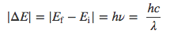
In this equation, h is Planck’s constant and Ei and Ef are the initial and final orbital energies, respectively. The absolute value of the energy difference is used, since frequencies and wavelengths are always positive. Instead of allowing for continuous values of energy, Bohr assumed the energies of these electron orbitals were quantized:
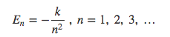
In this expression, k is a constant comprising fundamental constants such as the electron mass and charge and Planck’s constant. Inserting the expression for the orbit energies into the equation for E_{n} and ΔE give:
$$E_{n}= -2.18 × {10}^{-18} J \left(\frac{1}{n^{2}}\right)$$
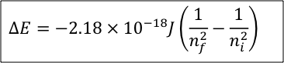
The lowest few energy levels are shown in Figure 3.14. One of the fundamental laws of physics is that matter is most stable with the lowest possible energy. Thus, the electron in a hydrogen atom usually moves in the n = 1 orbit, the orbit in which it has the lowest energy. When the electron is in this lowest energy orbit, the atom is said to be in its ground electronic state (or simply ground state). If the atom receives energy from an outside source, it is possible for the electron to move to an orbit with a higher n value and the atom is now in an excited electronic state (or simply an excited state) with a higher energy. When an electron transitions from an excited state (higher energy orbit) to a less excited state, or ground state, the difference in energy is emitted as a photon. Similarly, if a photon is absorbed by an atom, the energy of the photon moves an electron from a lower energy orbit up to a more excited one. We can relate the energy of electrons in atoms to what we learned previously about energy. The law of conservation of energy says that we can neither create nor destroy energy. Thus, if a certain amount of external energy is required to excite an electron from one energy level to another, that same amount of energy will be liberated when the electron returns to its initial state (Figure 3.15).
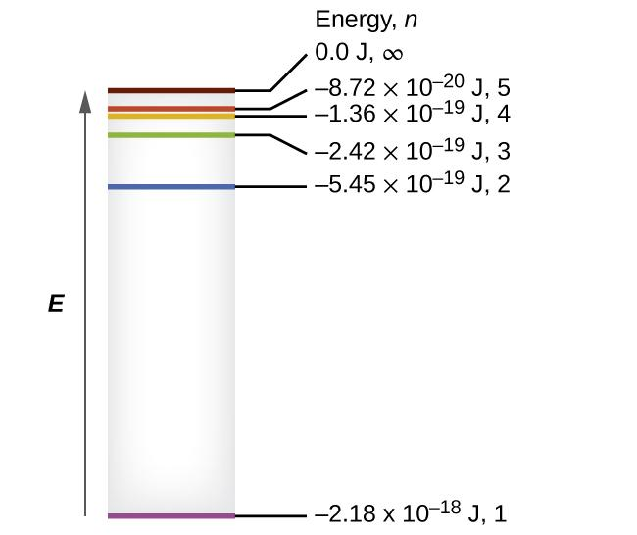
Figure 3.14 Quantum numbers and energy levels in a hydrogen atom. The more negative the calculated value, the lower the energy.
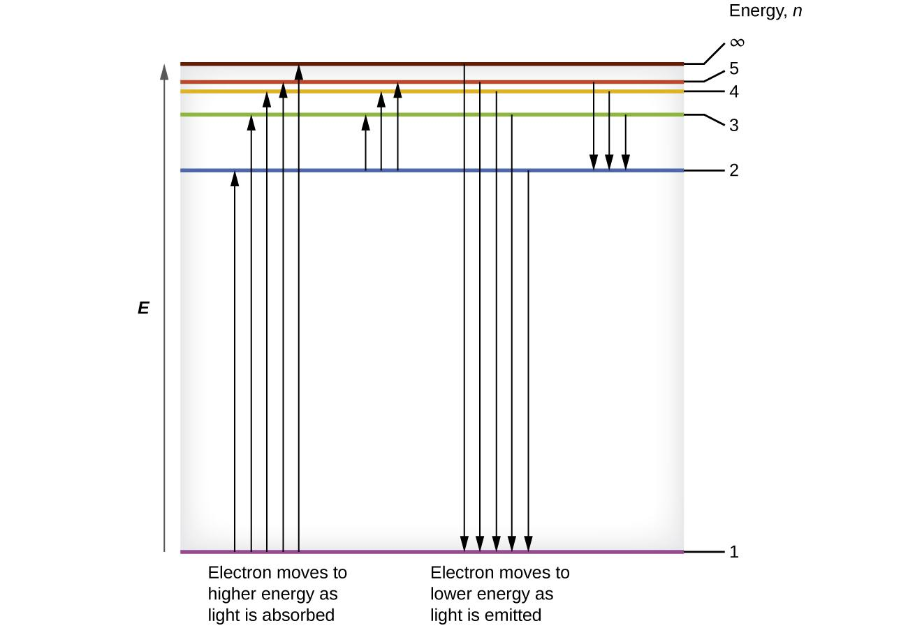
Figure 3.15 The horizontal lines show the relative energy of orbits in the Bohr model of the hydrogen atom, and the vertical arrows depict the energy of photons absorbed (left) or emitted (right) as electrons move between these orbits.
Since Bohr’s model involved only a single electron, it could also be applied to the single electron ions He⁺, Li²⁺, Be³⁺, and so forth, which differ from hydrogen only in their nuclear charges, and so one-electron atoms and ions are collectively referred to as hydrogen-like atoms.

Bohr’s model of the hydrogen atom provides insight into the behavior of matter at the microscopic level, but it is does not account for electron–electron interactions in atoms with more than one electron. It does introduce several important features of all models used to describe the distribution of electrons in an atom. These features include the following:
The energies of electrons (energy levels) in an atom are quantized, described by quantum numbers: integer numbers having only specific allowed value and used to characterize the arrangement of electrons in an atom.
An electron’s energy increases with increasing distance from the nucleus.
The discrete energies (lines) in the spectra of the elements result from quantized electronic energies.

Of these features, the most important is the postulate of quantized energy levels for an electron in an atom. As a consequence, the model laid the foundation for the quantum mechanical model of the atom. Bohr won a Nobel Prize in Physics for his contributions to our understanding of the structure of atoms and how that is related to line spectra emissions.

The Chemistry of Fireworks
The colors of fireworks are also due to atomic emission spectra. As shown in part (a) in Figure 3.16, a typical shell used in a fireworks display contains gunpowder to propel the shell into the air and a fuse to initiate a variety of redox reactions that produce heat and small explosions. Thermal energy excites the atoms to higher energy states; as they decay to lower energy states, the atoms emit light that gives the familiar colors. When oxidant/reductant mixtures listed in Table 3.1 are ignited, a flash of white or yellow light is produced along with a loud bang. Achieving the colors shown in part (b) in Figure 3.16 requires adding a small amount of a substance that has an emission spectrum in the desired portion of the visible spectrum. For example, sodium is used for yellow because of its 589 nm emission lines. The intense yellow color of sodium would mask most other colors, so potassium and ammonium salts, rather than sodium salts, are usually used as oxidants to produce other colors, which explains the preponderance of such salts in Table 3.1. Strontium salts, which are also used in highway flares, emit a red light, whereas barium gives a green color. Blue is one of the most difficult colors to achieve. Copper(II) salts emit a pale blue light, but copper is dangerous to use because it forms highly unstable explosive compounds with anions such as chlorate. As you might guess, preparing fireworks with the desired properties is a complex, challenging, and potentially hazardous process.
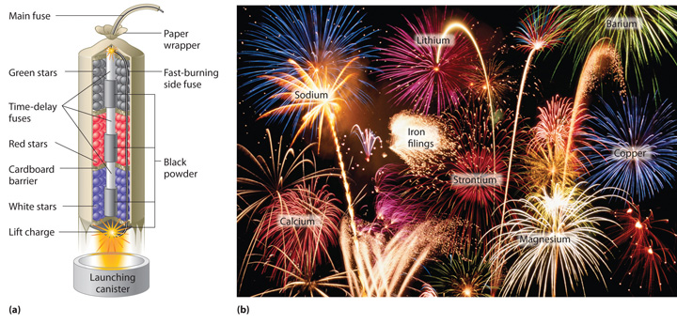
Figure 3.16 (a) In the “multibreak” shell used for fireworks, the chambers contain mixtures of fuels and oxidizers plus compounds for special effects (“stars”) connected by time-delay fuses so that the chambers explode in stages. (b) The finale of a fireworks display usually consists of many shells fired simultaneously to give a dazzling multicolor display. The labels indicate the substances that are responsible for the colors of some of the fireworks shown.
Table 3.1 Common Chemicals Used in the Manufacture of Fireworks*

Oxidizers | Fuels (reductants) | Special effects
ammonium perchlorate | aluminum | blue flame: copper carbonate, copper sulfate, or copper oxide
barium chlorate | antimony sulfide | red flame: strontium nitrate or strontium carbonate
barium nitrate | charcoal | white flame: magnesium or aluminum
potassium chlorate | magnesium | yellow flame: sodium oxalate or cryolite (Na₃AlF₆)
potassium nitrate | sulfur | green flame: barium nitrate or barium chlorate
potassium perchlorate | titanium | white smoke: potassium nitrate plus sulfur
strontium nitrate |  | colored smoke: potassium chlorate and sulfur, plus organic dye
 |  | whistling noise: potassium benzoate or sodium salicylate
 |  | white sparks: aluminum, magnesium, or titanium
 |  | gold sparks: iron fillings or charcoal
*Almost any combination of an oxidizer and a fuel may be used along with the compounds needed to produce a desired special effect.

3.4 Development of Quantum Theory

Learning Objectives
- Extend the concept of wave–particle duality that was observed in electromagnetic radiation to matter as well
- Understand the general idea of the quantum mechanical description of electrons in an atom, and that it uses the notion of three-dimensional wave functions, or orbitals, that define the distribution of probability to find an electron in a particular part of space

Introduction
Bohr’s model explained the experimental data for the hydrogen atom and was widely accepted, but it also raised many questions. Why did electrons orbit at only fixed distances defined by a single quantum number n = 1, 2, 3, and so on, but never in between? Why did the model work so well describing hydrogen and one-electron ions, but could not correctly predict the emission spectrum for helium or any larger atoms? To answer these questions, scientists needed to completely revise the way they thought about matter.

Wave-Particle Duality
We know how matter behaves in the macroscopic world—objects that are large enough to be seen by the naked eye follow the rules of classical physics. A billiard ball moving on a table will behave like a particle: It will continue in a straight line unless it collides with another ball or the table cushion, or is acted on by some other force (such as friction). The ball has a well-defined position and velocity at any given moment. In other words, the ball is moving in a classical trajectory. This is the typical behavior of a classical object.

When waves interact with each other, they show interference patterns that are not displayed by macroscopic particles such as a billiard ball. For example, interacting waves on the surface of water can produce interference patterns similar to those shown on Figure 3.17. This is a case of wave behavior on the macroscopic scale, and it is clear that particles and waves are very different phenomena in the macroscopic realm.
Figure 3.17 An interference pattern on the water surface is formed by interacting waves. The waves are caused by reflection of water from the rocks. (credit: modification of work by Sukanto Debnath)

As technological improvements allowed scientists to probe the microscopic world in greater detail, it became increasingly clear by the 1920s that very small pieces of matter follow a different set of rules from those we observe for large objects. The unquestionable separation of waves and particles was no longer the case for the microscopic world.

One of the first people to pay attention to the special behavior of the microscopic world was Louis de Broglie. He asked the question: If electromagnetic radiation can have particle-like character, can electrons and other submicroscopic particles exhibit wavelike character? In his 1925 doctoral dissertation, de Broglie extended the wave–particle duality of light that Einstein used to resolve the photoelectric-effect paradox to material particles. He predicted that a particle with mass m and velocity v (that is, with linear momentum p) should also exhibit the behavior of a wave with a wavelength value λ, given by this expression in which h is the familiar Planck’s constant:

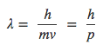
This is called the de Broglie wavelength. Unlike the other values of λ discussed in this chapter, the de Broglie wavelength is a characteristic of particles and other bodies, not electromagnetic radiation (note that this equation involves velocity [v, m/s], not frequency [ν, Hz]. Although these two symbols appear nearly identical, they mean very different things).

Where Bohr had postulated the electron as being a particle orbiting the nucleus in quantized orbits, de Broglie argued that Bohr’s assumption of quantization can be explained if the electron is considered not as a particle, but rather as a circular standing wave such that only an integer number of wavelengths could fit exactly within the orbit (Figure 3.18).
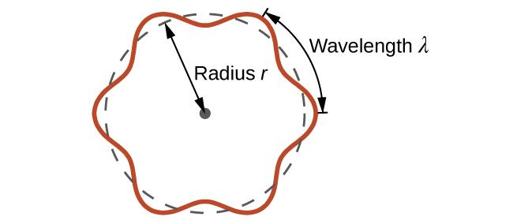
Figure 3.18 If an electron is viewed as a wave circling around the nucleus, an integer number of wavelengths must fit into the orbit for this standing wave behavior to be possible.

Shortly after de Broglie proposed the wave nature of matter, two scientists at Bell Laboratories, C. J. Davisson and L. H. Germer, demonstrated experimentally that electrons can exhibit wavelike behavior by showing an interference pattern for electrons travelling through a regular atomic pattern in a crystal (Figure 3.19). It is strikingly similar to the interference patterns for light shown in Figure 3.7 when light passing through two closely spaced, narrow slits.

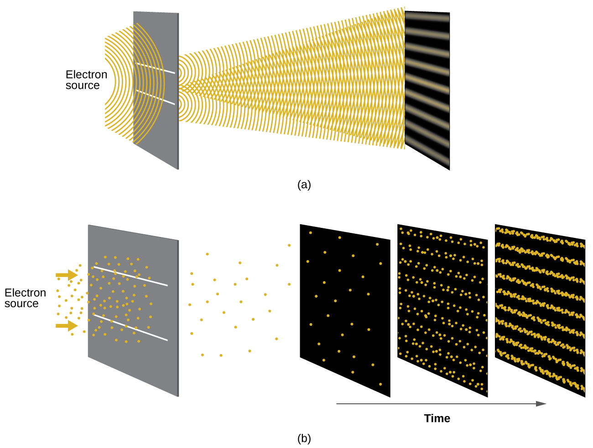
Figure 3.19 (a) The interference pattern for electrons passing through very closely spaced slits demonstrates that quantum particles such as electrons can exhibit wavelike behavior. (b) The experimental results illustrated here demonstrate the wave–particle duality in electrons.

The wave–particle duality of matter can be seen in Figure 3.119 by observing what happens if electron collisions are recorded over a long period of time. Initially, when only a few electrons have been recorded, they show clear particle-like behavior, having arrived in small localized packets that appear to be random. As more and more electrons arrived and were recorded, a clear interference pattern that is the hallmark of wavelike behavior emerged. Thus, it appears that while electrons are small localized particles, their motion does not follow the equations of motion implied by classical mechanics, but instead it is governed by some type of a wave equation. Thus the wave–particle duality first observed with photons is actually a fundamental behavior intrinsic to all quantum particles.

Heisenberg Uncertainty Principle
Werner Heisenberg considered the limits of how accurately we can measure properties of an electron or other microscopic particles. He determined that there is a fundamental limit to how accurately one can measure both a particle’s position and its momentum simultaneously. The more accurately we measure the momentum of a particle, the less accurately we can determine its position at that time, and vice versa. This is summed up in what we now call the Heisenberg uncertainty principle:

“It is fundamentally impossible to determine simultaneously and exactly both the momentum and the position of a particle.”

Heisenberg’s principle imposes ultimate limits on what is knowable in science. The uncertainty principle can be shown to be a consequence of wave–particle duality, which lies at the heart of what distinguishes modern quantum theory from classical mechanics.

Schrödinger’s Cat
You may also have heard of Schrödinger because of his famous thought experiment that explains the concepts of superposition and entanglement as related to a cat in a box with poison.

In the early 1930's Erwin Schrödinger published a way of thinking about the circumstance of radioactive decay and this helps explain the wave-particle duality behavior of light and matter.

In this thought experiment, an apparatus containing just one radioactive atom and a detector that will respond when the atom decays was set up. This apparatus was connected to the detector is a relay connected to a hammer, and when the atom decays the relay releases the hammer which then falls on a glass vial containing poison gas. Then the entire apparatus was put it in a box. Finally, a cat was placed in the box, close the lid, and wait 10 minutes (Figure 3.20). We then ask: Is the cat alive or dead? The answer according to quantum mechanics is that it is 50% dead and 50% alive.
Without observing the cat inside the box, the system will have a form in which the living cat and dead cat are mixed in equal portions. When we open the box, we "collapse the state" and have either a live cat or a dead cat. In other words, whether we observe light or electron as a wave or particle, it depends on how the experiment is designed. An electron is observed as either a particle or a wave, but never both at once!

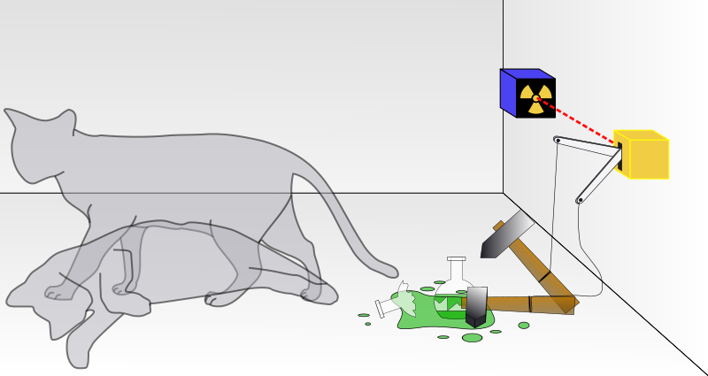

Figure 3.20 Schrödinger's cat: a cat, a flask of poison, and a radioactive source are placed in a sealed box. If an internal monitor detects radioactivity (i.e., a single atom decaying), the flask is shattered, releasing the poison, which kills the cat. The Copenhagen interpretation of quantum mechanics implies that after a while, the cat is simultaneously alive and dead. Yet, when one looks in the box, one sees the cat either alive or dead, not both alive and dead. This poses the question of when exactly quantum superposition ends and reality collapses into one possibility or the other. Image used with permission (CC BY-SA 3.0; Dhatfield).

The Quantum–Mechanical Model of an Atom
Shortly after de Broglie published his ideas that the electron in a hydrogen atom could be better thought of as being a circular standing wave instead of a particle moving in quantized circular orbits, Erwin Schrödinger extended de Broglie’s work by deriving what is today known as the Schrödinger equation. When Schrödinger applied his equation to hydrogen-like atoms, he was able to reproduce Bohr’s expression for the energy and, thus, the Rydberg formula governing hydrogen spectra.

Schrödinger described electrons as three-dimensional stationary waves, or wavefunctions, represented by the Greek letter psi, ψ. A few years later, MaxBorn proposed an interpretation of the wavefunction ψ that is still accepted today: Electrons are still particles, and so the waves represented by ψ are not physical waves but, instead, are complex probability amplitudes. The square of the magnitude of a wavefunction ∣ψ∣² describes the probability of the quantum particle being present near a certain location in space. This means that wavefunctions can be used to determine the distribution of the electron’s density with respect to the nucleus in an atom. In the most general form, the Schrödinger equation can be written as:
$$\hat{H}ψ=Eψ$$
$\hat{H}$ is the Hamiltonian operator, a set of mathematical operations representing the total energy of the quantum particle (such as an electron in an atom),

ψ is the wavefunction of this particle that can be used to find the special distribution of the probability of finding the particle, and

E is the actual value of the total energy of the particle.

Schrödinger’s work, as well as that of Heisenberg and many other scientists following in their footsteps, is generally referred to as quantum mechanics. Although quantum mechanics uses sophisticated mathematics, you do not need to understand the mathematical details to follow our discussion of its general conclusions. We focus on the properties of the wave functions that are the solutions of Schrödinger’s equations.

Wave Functions
A wave function (Ψ) is a mathematical function that relates the location of an electron at a given point in space (identified by x, y, and z coordinates) to the amplitude of its wave, which corresponds to its energy. Thus each wave function is associated with a particular energy E. The properties of wave functions derived from quantum mechanics are summarized here:
- A wave function uses three variables to describe the position of an electron. A fourth variable is usually required to fully describe the location of objects in motion. Three specify the position in space (as with the Cartesian coordinates x, y, and z), and one specifies the time at which the object is at the specified location. For example, if you wanted to intercept an enemy submarine, you would need to know its latitude, longitude, and depth, as well as the time at which it was going to be at this position (Figure 3.21). For electrons, we can ignore the time dependence because we will be using standing waves, which by definition do not change with time, to describe the position of an electron.
- The magnitude of the wave function at a particular point in space is proportional to the amplitude of the wave at that point. Many wave functions are complex functions. The amplitude of the wave has no real physical significance. In contrast, the sign of the wave function (either positive or negative) corresponds to the phase of the wave, which is important.
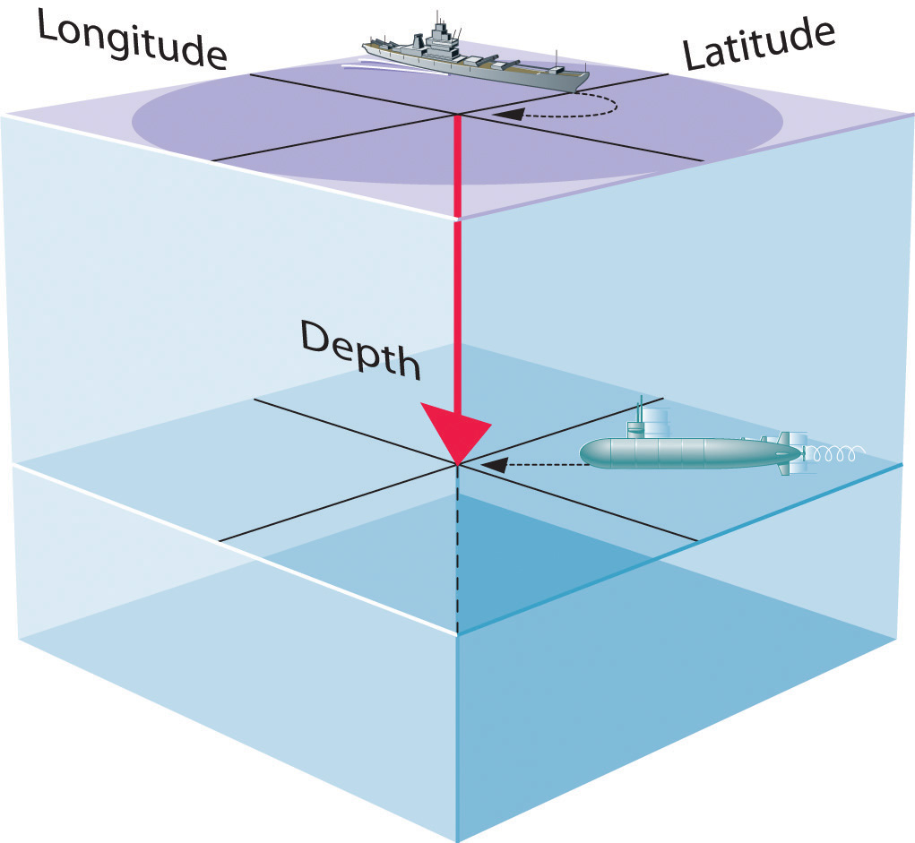
Figure 3.21 The Four Variables (Latitude, Longitude, Depth, and Time) Required to Precisely Locate an Object. If you are the captain of a ship trying to intercept an enemy submarine, you need to deliver your depth charge to the right location at the right time.

- The square of the wave function at a given point is proportional to the probability of finding an electron at that point, which leads to a distribution of probabilities in space. The square of the wave function (Ψ²) is always a real quantity that is proportional to the probability of finding an electron at a given point. We use probabilities because, according to Heisenberg’s uncertainty principle, we cannot precisely specify the position of an electron. As one way of graphically representing the probability distribution, the probability of finding an electron is indicated by the density of colored dots, as shown for the ground state of the hydrogen atom in Figure 3.22
- Describing the electron distribution as a standing wave leads to sets of quantum numbers that are characteristic of each wave function.
- Each wave function is associated with a particular energy. As in Bohr’s model, the energy of an electron in an atom is quantized; it can have only certain allowed values. The major difference between Bohr’s model and Schrödinger’s approach is that Bohr had to impose the idea of quantization arbitrarily, whereas in Schrödinger’s approach, quantization is a natural consequence of describing an electron as a standing wave.
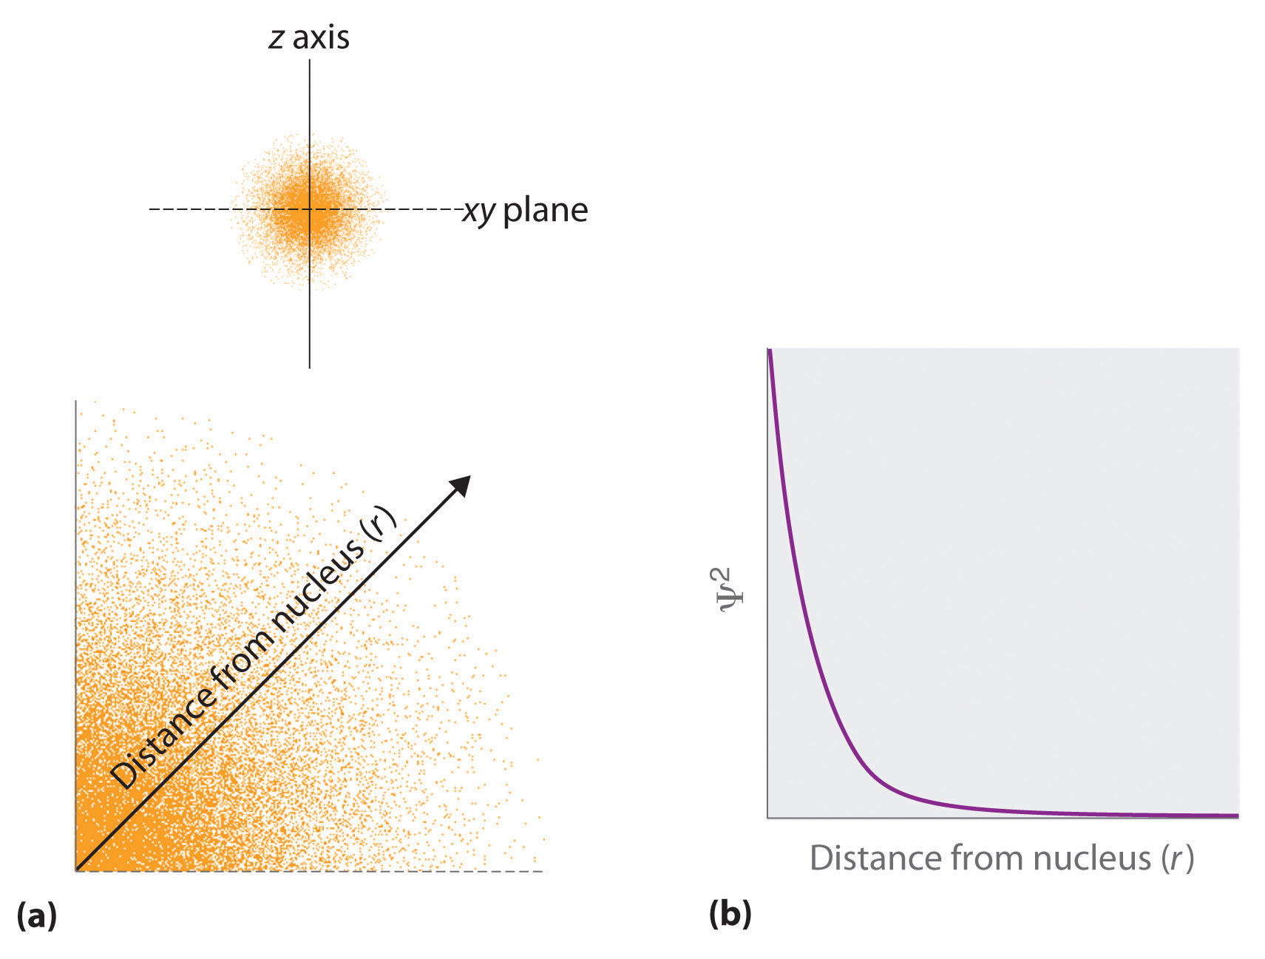
Figure 3.22 Probability of Finding the Electron in the Ground State of the Hydrogen Atom at Different Points in Space. (a) The density of the dots shows electron probability. (b) In this plot of Ψ² versus r for the ground state of the hydrogen atom, the electron probability density is greatest at r = 0 (the nucleus) and falls off with increasing r. Because the line never actually reaches the horizontal axis, the probability of finding the electron at very large values of r is very small but not zero.

3.5 Quantum Numbers and Shapes of Orbitals

Learning Objectives
- List and describe the traits of the four quantum numbers and the shapes of orbitals

Introduction
The goal of this section is to understand the electron orbitals (location of electrons in atoms), their different energies, and other properties. The use of quantum theory provides the best understanding to these topics. This knowledge is a precursor to chemical bonding.

Quantum Numbers
As was described previously, electrons in atoms can exist only on discrete energy levels but not between them. It is said that the energy of an electron in an atom is quantized, that is, it can be equal only to certain specific values and can jump from one energy level to another but not transition smoothly or stay between these levels.

Principal Quantum Number (n)
The energy levels are labeled with an n value, where n = 1, 2, 3, …. Generally speaking, the energy of an electron in an atom is greater for greater values of n. This number, n, is referred to as the principal quantum number. The principal quantum number defines the location of the energy level. It is essentially the same concept as the n in the Bohr atom description. Another name for the principal quantum number is the shell number. The shells of an atom can be thought of concentric circles radiating out from the nucleus. The electrons that belong to a specific shell are most likely to be found within the corresponding circular area. The further we proceed from the nucleus, the higher the shell number, and so the higher the energy level (Figure 3.23). The positively charged protons in the nucleus stabilize the electronic orbitals by electrostatic attraction between the positive charges of the protons and the negative charges of the electrons. So the further away the electron is from the nucleus, the greater the energy it has.
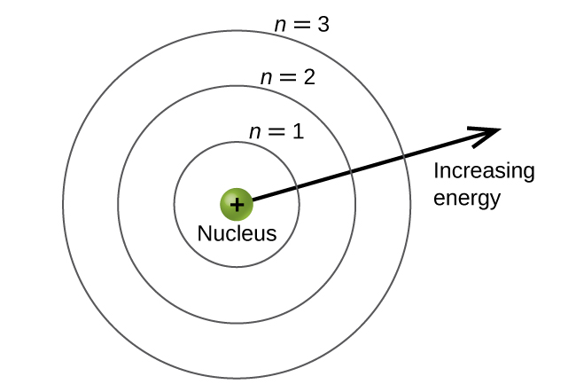
Figure 3.23 Different shells are numbered by principal quantum numbers.

This quantum mechanical model for where electrons reside in an atom can be used to look at electronic transitions, the events when an electron moves from one energy level to another. If the transition is to a higher energy level, energy is absorbed, and the energy change has a positive value. To obtain the amount of energy necessary for the transition to a higher energy level, a photon is absorbed by the atom. A transition to a lower energy level involves a release of energy, and the energy change is negative. This process is accompanied by emission of a photon by the atom.

The principal quantum number is one of three quantum numbers used to characterize an orbital. An atomic orbital is a general region in an atom within which an electron is most probable to reside. The quantum mechanical model specifies the probability of finding an electron in the three-dimensional space around the nucleus and is based on solutions of the Schrödinger equation. In addition, the principal quantum number defines the energy of an electron in a hydrogen or hydrogen-like atom or an ion (an atom or an ion with only one electron) and the general region in which discrete energy levels of electrons in a multi-electron atoms and ions are located.

Angular Momentum Quantum Number (l)
Another quantum number is l, the angular momentum quantum number. It is an integer that may take the values, l = 0, 1, 2, …, n – 1. This means that an orbital with n = 1 can have only one value of l, l = 0, whereas n = 2 permits l = 0 and l = 1, and so on. Whereas the principal quantum number, n, defines the general size and energy of the orbital, the secondary quantum number l specifies the shape of the orbital. Orbitals with the same value of l define a subshell.

Orbitals with l = 0 are called s orbitals and they make up the s subshells.
Orbitals with l = 1 are called p orbitals and they make up the p subshells.
Orbitals with l = 2 are called d orbitals and they make up the d subshells.
Orbitals with l = 3 are called f orbitals and they make up the f subshells.

There are certain distances from the nucleus at which the probability density of finding an electron located at a particular orbital is zero. In other words, the value of the wavefunction ψ is zero at this distance for this orbital. Such a value of radius r is called a radial node. The number of radial nodes in an orbital is n – l – 1. Consider the examples in Figure 3.24. The orbitals depicted are of the s type, thus l = 0 for all of them. It can be seen from the graphs of the probability densities that there are 1 – 0 – 1 = 0 places where the density is zero (nodes) for 1s (n = 1), 2 – 0 – 1 = 1 node for 2s, and 3 – 0 – 1 = 2 nodes for the 3s orbitals.
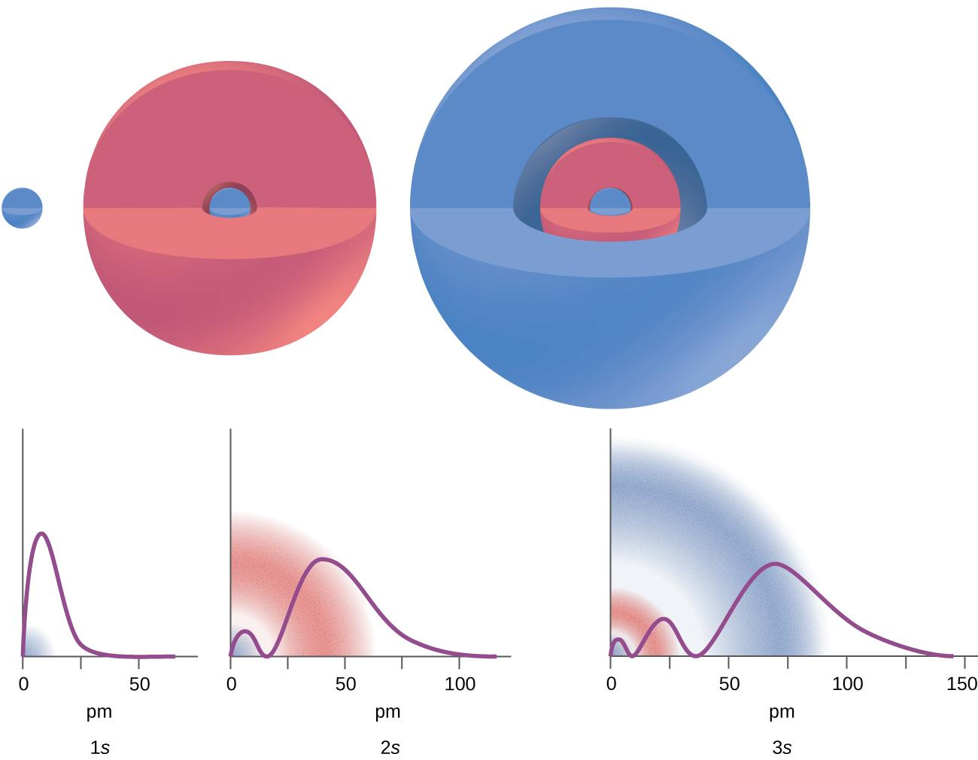
Figure 3.24 The graphs show the probability (y axis) of finding an electron for the 1s, 2s, 3s orbitals as a function of distance from the nucleus.

Magnetic Quantum Number (m_{l})
The magnetic quantum number, m_{l}, specifies the relative spatial orientation of a particular orbital (Figure 3.25). Generally speaking, m_{l} can be equal to –l, –(l – 1), …, 0, …, (l – 1), l. The total number of possible orbitals with the same value of l (that is, in the same subshell) is 2l + 1. Thus, there is one s-orbital in an s subshell (l = 0), there are three p-orbitals in a p subshell (l = 1), five d-orbitals in a d subshell (l = 2), seven f-orbitals in an f subshell (l = 3), and so forth.
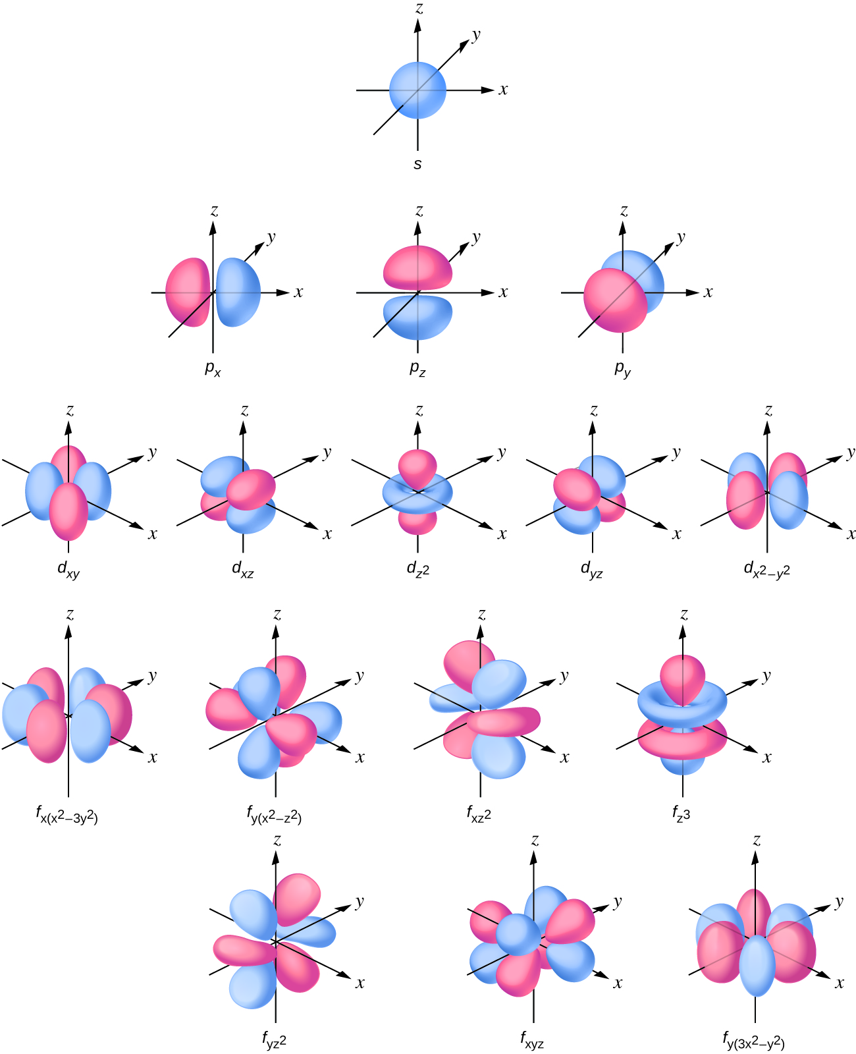
Figure 3.25 Shapes of s, p, d, and f orbitals.
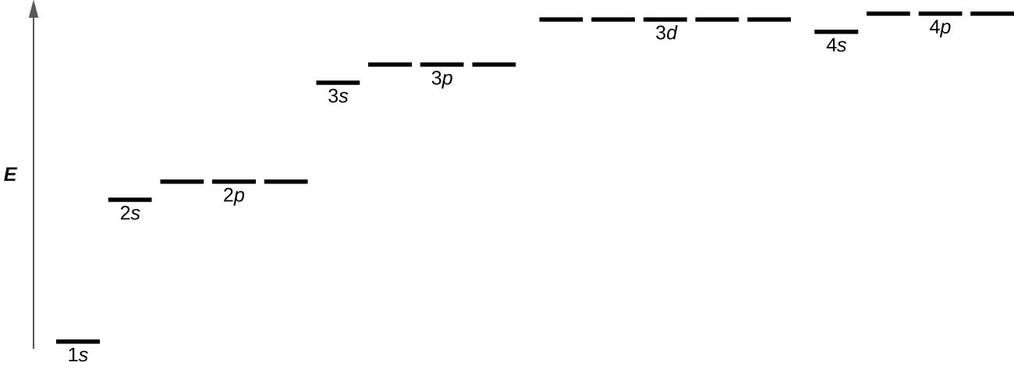
Figure 3.26 The chart shows the energies of electron orbitals in a multi-electron atom.

Figure 3.26 illustrates the energy levels for various orbitals. The number before the orbital name (such as 2s, 3p, and so forth) stands for the principal quantum number, n. The letter in the orbital name defines the subshell with a specific angular momentum quantum number l = 0 for s orbitals, 1 for p orbitals, 2 for d orbitals.

Spin Quantum Number (m_{s})
The other three quantum numbers, n, l, and m_{l}, are properties of specific atomic orbitals that also define in what part of the space an electron is most likely to be located.
The spin quantum number, or m_{s} describes an intrinsic electron "rotation" or "spinning."

Any electron, regardless of the atomic orbital it is located in, can only have one of those two values of the spin quantum number. The energies of electrons having m_{s} =−1/2 and m_{s}=1/2 are different if an external magnetic field is applied (Figure 3.27).
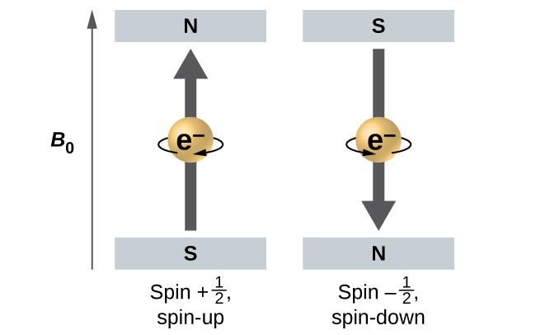
Figure 3.27 Electrons with spin in an external magnetic field.

Shapes of Orbitals

s Orbitals
S orbitals look like sphere. Three things happen to s orbitals as n increases:

- They become larger, extending farther from the nucleus.
- They contain more nodes. This is similar to a standing wave that has regions of significant amplitude separated by nodes, points with zero amplitude.
- For a given atom, the s orbitals also become higher in energy as n increases because of their increased distance from the nucleus.

Orbitals are generally drawn as three-dimensional surfaces that enclose 90% of the electron density, as was shown for the hydrogen 1s, 2s, and 3s orbitals in Figure 3.24 and in part (b) Figure 3.28. Although such drawings show the relative sizes of the orbitals, they do not normally show the spherical nodes in the 2s and 3s orbitals because the spherical nodes lie inside the 90% surface. Fortunately, the positions of the spherical nodes are not important for chemical bonding.
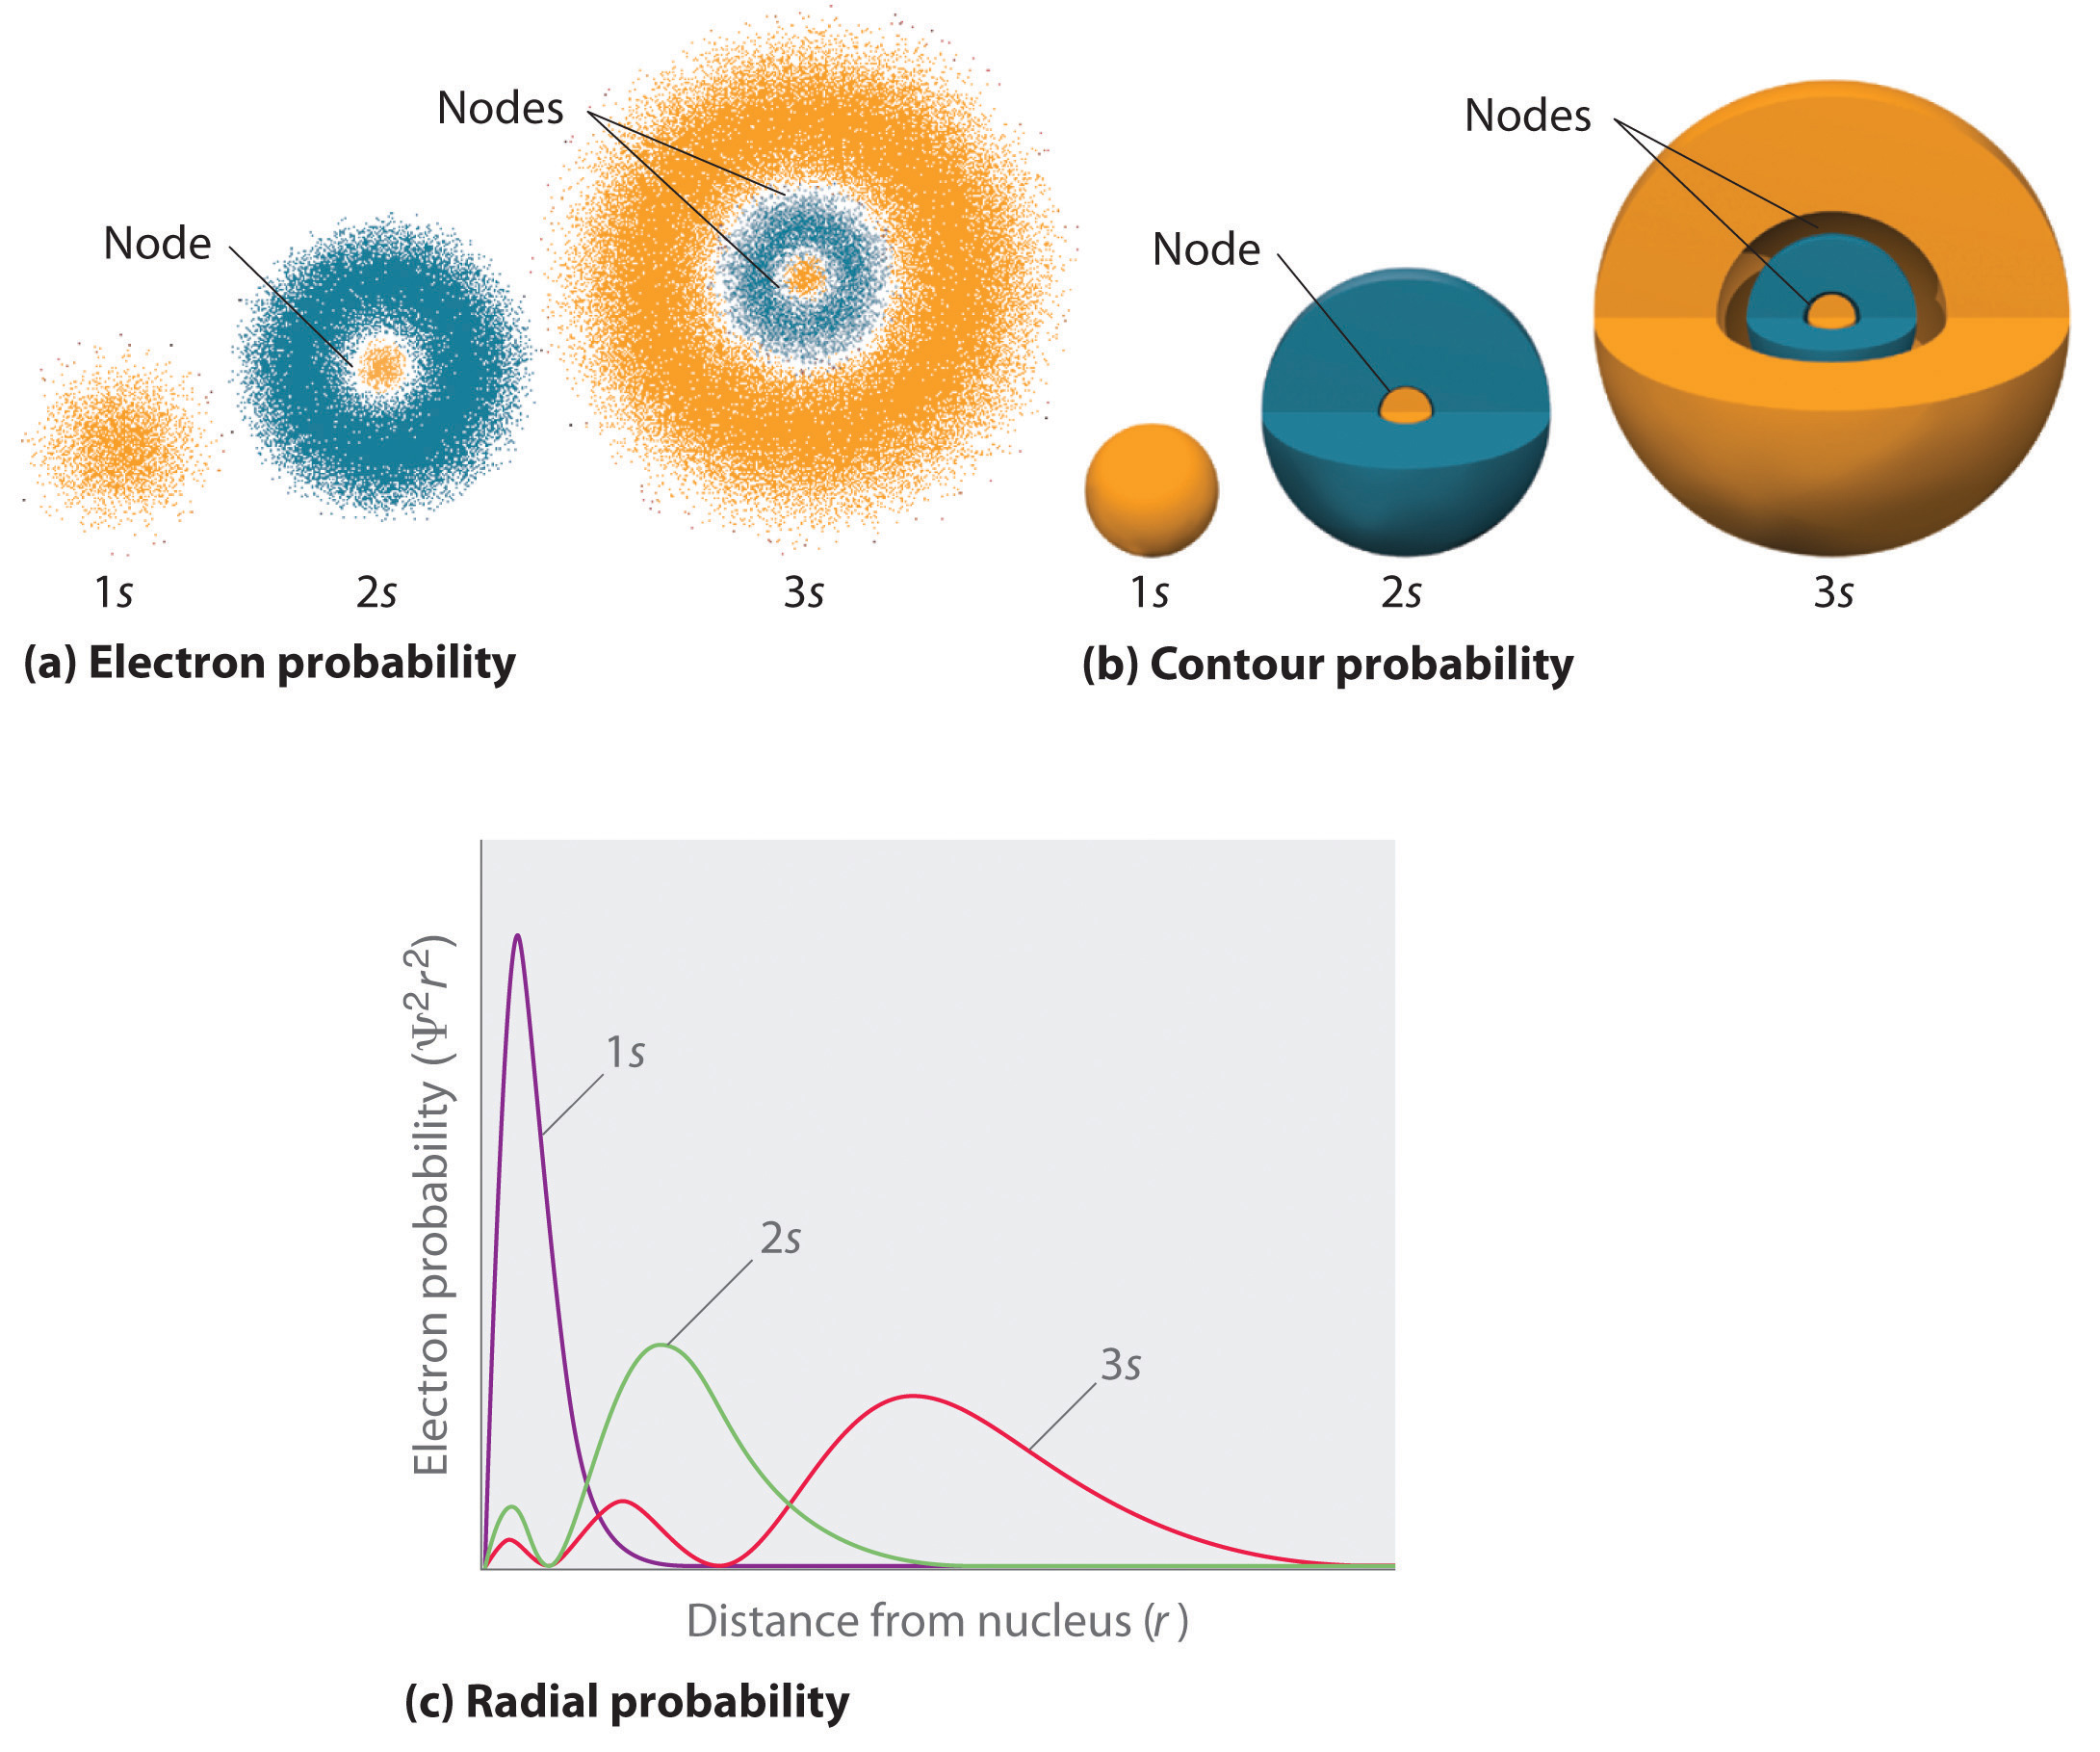
Figure 3.28 Probability Densities for the 1s, 2s, and 3s Orbitals of the Hydrogen Atom

p Orbitals
p orbitals look like dumbbell. Because the 2p subshell has l = 1, with three values of m_{l} (−1, 0, and +1), there are three 2p orbitals.
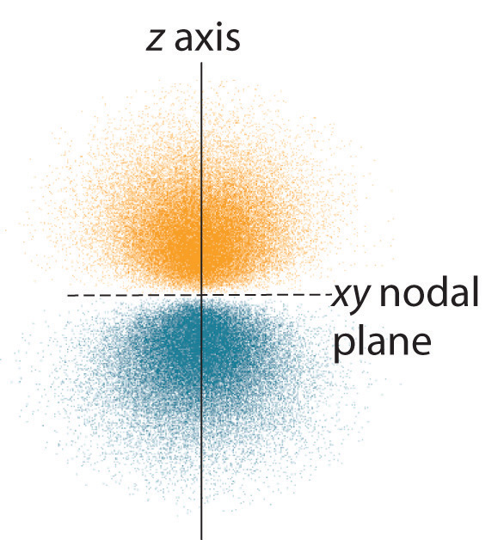
Figure 3.29 Electron Probability Distribution for a Hydrogen 2p Orbital The nodal plane of zero electron density separates the two lobes of the 2p orbital. As in the colors correspond to regions of space where the phase of the wave function is positive (orange) and negative (blue).

The electron probability distribution for one of the hydrogen 2p orbitals is shown in Figure 3.29. Because this orbital has two lobes of electron density, it can arrange in three different way along x, y, and z axes (Figure 3.30). Note that each p orbital has just one nodal plane. In each case, the phase of the wave function for each of the 2p orbitals is positive for the lobe that points along the positive axis and negative for the lobe that points along the negative axis.
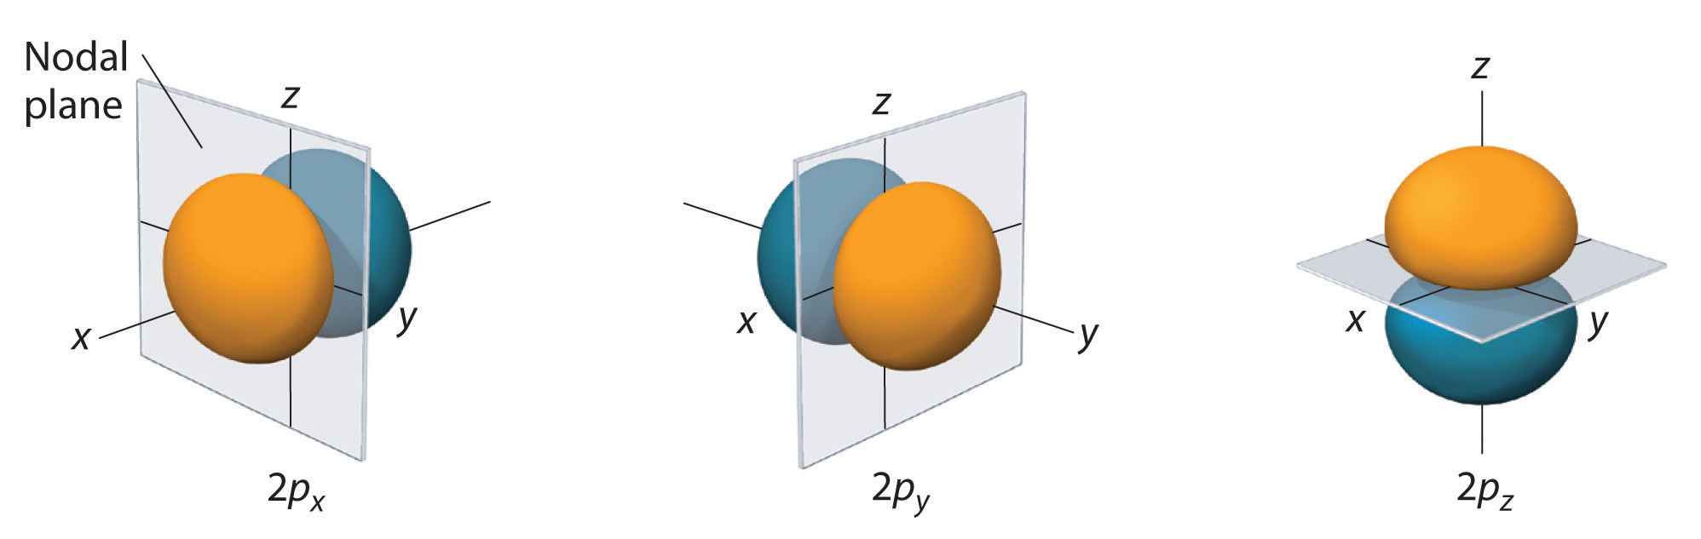
Figure 3.30 The three equivalent 2p orbitals of the hydrogen atom. The surfaces shown enclose 90% of the total electron probability for the 2p_{x}, 2p_{y}, and 2p_{z} orbitals. Each orbital is oriented along the axis indicated by the subscript and a nodal plane that is perpendicular to that axis bisects each 2p orbital. The phase of the wave function is positive (orange) in the region of space where x, y, or z is positive and negative (blue) where x, y, or z is negative.

d Orbitals
Subshells with l = 2 have five d orbitals; the first principal shell to have a d subshell corresponds to n= 3. The five d orbitals have m_{l} values of −2, −1, 0, +1, and +2.
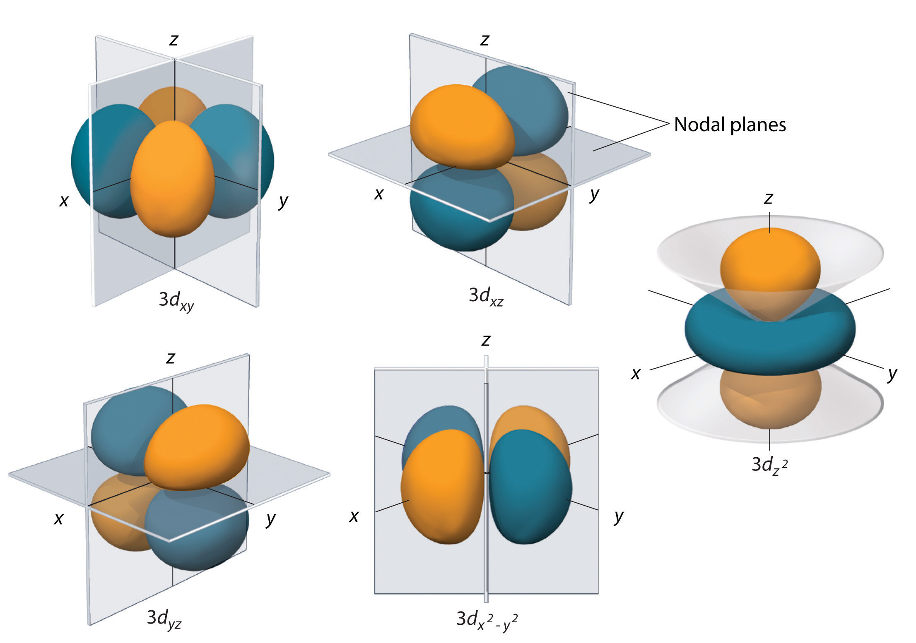
Figure 3.31 The five equivalent 3d orbitals of the hydrogen atom. The surfaces shown enclose 90% of the total electron probability for the five hydrogen 3d orbitals. Four of the five 3d orbitals consist of four lobes arranged in a plane that is intersected by two perpendicular nodal planes. These four orbitals have the same shape but different orientations. The fifth 3d orbital, , has a distinct shape even though it is mathematically equivalent to the others. The phase of the wave function for the different lobes is indicated by color: orange for positive and blue for negative.

The hydrogen 3d orbitals, shown in Figure 3.31, have more complex shapes than the 2p orbitals. All five 3d orbitals contain two nodal surfaces, as compared to one for each p orbital and zero for each s orbital. In three of the d orbitals, the lobes of electron density are oriented between the x and y, x and z, and y and z planes; these orbitals are referred to as the 3d_{xy}, 3d_{xz}, and 3d_{yz} orbitals, respectively. A fourth d orbital has lobes lying along the x and y axes; this is the orbital. The fifth 3d orbital, called the orbital, has a unique shape: it looks like a 2p_{z} orbital combined with an additional doughnut of electron probability lying in the xy plane. Despite its peculiar shape, the orbital is mathematically equivalent to the other four and has the same energy.
BLANK PAGE

Chapter 4 – Attributions

The contents in this chapter, licensed under CC BY-NC-SA 4.0. has been adopted, modified, reorganized, and/or remixed from the following:

4.0 Introduction
"Celebrating the 150th Anniversary of the Periodic Table: Nano-Style!" by Cathy Murphy, Sustainable Nano is licensed under CC BY-NC-SA 3.0

4.1 How Electrons Occupy Orbitals
"6.4 Electronic Structure of Atoms (Electron Configurations)" by Paul Flowers, Klaus Theopold, Richard Langley, William R. Robinson, PhD, OpenStax is licensed under CC BY 4.0
"Penetration & Shielding" by Sidra Ayub (UCD), Alan Chu (UCD), LibreTexts is licensed under CC BY-NC-SA 3.0
"2.2: Atomic Orbitals and Quantum Numbers" LibreTexts is licensed under CC BY-NC-SA 3.0

4.2 Electron Configurations of Atoms
"6.4 Electronic Structure of Atoms (Electron Configurations)" by Paul Flowers, Klaus Theopold, Richard Langley, William R. Robinson, PhD, OpenStax is licensed under CC BY 4.0

4.3 The Periodic Table
"2.5 The Periodic Table" by Paul Flowers, Klaus Theopold, Richard Langley, William R. Robinson, PhD, OpenStax is licensed under CC BY 4.0
"6.4 Electronic Structure of Atoms (Electron Configurations)" by Paul Flowers, Klaus Theopold, Richard Langley, William R. Robinson, PhD, OpenStax is licensed under CC BY 4.0

4.4 The Periodic Trends
"6.5 Periodic Variations in Element Properties" by Paul Flowers, Klaus Theopold, Richard Langley, William R. Robinson, PhD, OpenStax is licensed under CC BY 4.0
"Periodic Trends: Atomic Radius" by lumenlearning is licensed under CC BY-NC 4.0
"The Shielding Effect and Effective Nuclear Charge" by lumenlearning is licensed under CC BY-SA 3.0
"Periodic Trends: Electronegativity" by lumenlearning is licensed under CC BY-NC 4.0
"Ionic Radius" by lumenlearning is licensed under CC BY-SA 4.0
"Metallic and Nonmetallic Character" by Calbreath, Baxter, et al., LumenLearning is licensed under CC BY-NC 4.0

Chapter 4 Electron Configurations and Periodic Properties of Elements

Chapter Introduction

4.1 How Electrons Occupy Orbitals

4.2 Electron Configurations of Atoms

4.3 The Periodic Table

4.4 The Periodic Trends

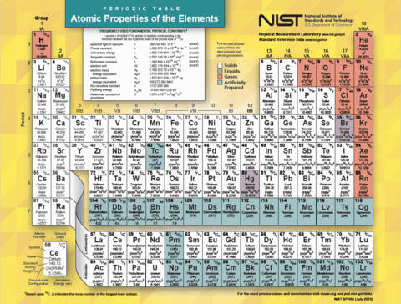
Figure 4.1 Periodic Table - Atomic Properties of the Element
(credit: https://www.nist.gov/pml/periodic-table-elements)

Did you know that 2019 is the International Year of the Periodic Table? We chemists in the Center for Sustainable Nanotechnology are happy to celebrate this all year long!
The periodic table as we know it was first published 150 years ago. Its structure is familiar to anyone who has taken a chemistry class in high school or college: the 100 or so elements that make up the universe are arranged in rows according to their atomic number, and in columns according to their properties. In this chapter, you will explore the arrangement of electrons in an atom, how it affects physical and chemical properties, and the trends in the periodic table.

BLANK PAGE

4.1 How Electrons Occupy Orbitals

Learning Objectives
- Relate quantum numbers to electronic structure
- Be able apply the Pauli Exclusion Principle, Hund’s Rule and the Aufbau Principle

Introduction
Having introduced the basics of atomic structure and quantum mechanics, we can use our understanding of quantum numbers to determine how atomic orbitals relate to one another. This allows us to determine which orbitals are occupied by electrons in each atom. The specific arrangement of electrons in orbitals of an atom determines many of the chemical properties of that atom.

Orbital Energies and Atomic Structure
The energy of atomic orbitals increases as the principal quantum number, n, increases. In any atom with two or more electrons, the repulsion between the electrons makes energies of subshells with different values of l differ so that the energy of the orbitals increases within a shell in the order s < p < d < f. Figure 4.2 depicts how these two trends in increasing energy related.

The 1s orbital at the bottom of the diagram is the orbital with electrons of lowest energy. The energy increases as we move up to the 2s, 2p, 3s, and 3p orbitals, showing that the increasing n value has more influence on energy than the increasing l value for small atoms. However, this pattern does not hold for larger atoms. The 3d orbital is higher in energy than the 4s orbital. Such overlaps continue to occur frequently as we move up the chart.

Electrons in successive atoms on the periodic table tend to fill low-energy orbitals first. Thus, many students find it confusing that, for example, the 5p orbitals fill immediately after the 4d, and immediately before the 6s.

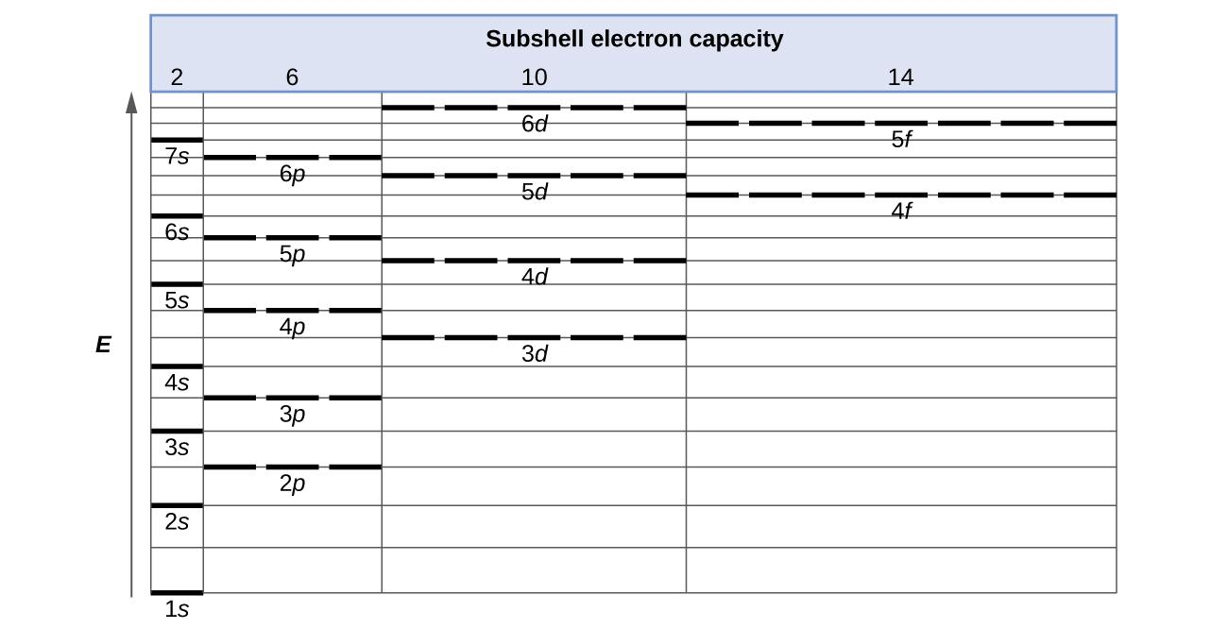
Figure 4.2 Generalized energy-level diagram for atomic orbitals in an atom with two or more electrons (not to scale).

The filling order is based on observed experimental results, and has been confirmed by theoretical calculations. As the principal quantum number, n, increases, the size of the orbital increases and the electrons spend more time farther from the nucleus. Thus, the attraction to the nucleus is weaker and the energy associated with the orbital is higher (less stabilized). But this is not the only effect we have to take into account.

Electrons that are closer to the nucleus slightly repel electrons that are farther out, offsetting the more dominant electron–nucleus attractions slightly (recall that all electrons have −1 charges, but nuclei have +Z charges). This phenomenon is called shielding (Figure 4.3).

Shielding refers to the core electrons repelling the outer rings and thus lowering the 1:1 ratio. Hence, the nucleus has "less grip" on the outer electrons and are shielded from them. Electrons in orbitals that experience more shielding are less stabilized and thus higher in energy. For small orbitals (1s through 3p), the increase in energy due to n is more significant than the increase due to l; however, for larger orbitals the two trends are comparable and cannot be simply predicted. We will discuss methods for remembering the observed order.

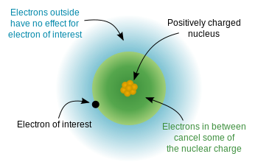

Figure 4.3 This image shows how inner electrons can shield the outer electrons from the nuclear charge. (Credit: "File:Effective Nuclear Charge.svg", Wikimedia Commons, the free media repository is in the Public Domain, CC0)

Within each shell, as the value of l increases, the electrons are less penetrating (meaning there is less electron density found close to the nucleus). Penetration describes the proximity to which an electron can approach to the nucleus. In a multi-electron system, electron penetration is defined by an electron's relative electron density (probability density) near the nucleus of an atom (Figure 4.3). Electrons in different orbitals have different electron densities around the nucleus. In other words, penetration depends on the shell (n) and subshell (l).

For example, a 1s electron (Figure 4.4; purple curve) has greater electron density near the nucleus than a 2p electron (Figure 4.4; red curve) and has a greater penetration. This relates to the shielding constants since the 1s electrons are closer to the nucleus than a 2p electron, hence the 1s screens a 2p electron almost perfectly. However, the 2s electron has a lower shielding constant because it can penetrate close to the nucleus in the small area of electron density within the first spherical node (Figure 3; green curve). In this way the 2s electron can "avoid" some of the shielding effect of the inner 1s electron.

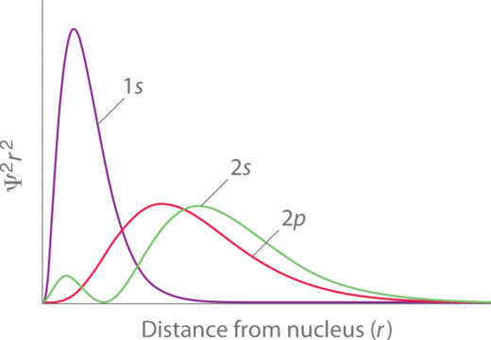

Figure 4.4 Orbital Penetration. A comparison of the radial probability distribution of the 2s and 2p orbitals for various states of the hydrogen atom shows that the 2s orbital penetrates inside the 1s orbital more than the 2p orbital does. Consequently, when an electron is in the small inner lobe of the 2s orbital, it experiences a relatively large value of Z_{eff}, which causes the energy of the 2s orbital to be lower than the energy of the 2p orbital.

For the same shell value (n) the penetrating power of an electron follows this trend in subshells (Figure 4.4): s > p > d ≈ f.

For different values of shell (n) and subshell (l), penetrating power of an electron follows this trend:
1s > 2s > 2p > 3s > 3p > 4s > 3d > 4p > 5s > 4d > 5p > 6s > 4f ⋅⋅⋅

The arrangement of electrons in the orbitals of an atom is called the electron configuration of the atom. We describe an electron configuration with a symbol that contains three pieces of information (Figure 4.5):

- The number of the principal quantum shell, n,
- The letter that designates the orbital type (the subshell, l), and
- A superscript number that designates the number of electrons in that particular subshell.
For example, the notation 2p⁴ (read "two–p–four") indicates four electrons in a p subshell (l = 1) with a principal quantum number (n) of 2. The notation 3d⁸ (read "three–d–eight") indicates eight electrons in the d subshell (i.e., l = 2) of the principal shell for which n = 3.
Figure 4.5 The diagram of an electron configuration specifies the subshell (n and l value, with letter symbol) and superscript number of electrons.

The Aufbau Principle
To determine the electron configuration for any particular atom, we can “build” the structures in the order of atomic numbers. Beginning with hydrogen, and continuing across the periods of the periodic table, we add one proton at a time to the nucleus and one electron to the proper subshell until we have described the electron configurations of all the elements. This procedure is called the Aufbau principle, from the German word Aufbau (“to build up”). Each added electron occupies the subshell of lowest energy available (in the order shown in Figure 4.2), subject to the limitations imposed by the allowed quantum numbers according to the Pauli exclusion principle. Electrons enter higher-energy subshells only after lower-energy subshells have been filled to capacity. Figure 4.6 illustrates the traditional way to remember the filling order for atomic orbitals.
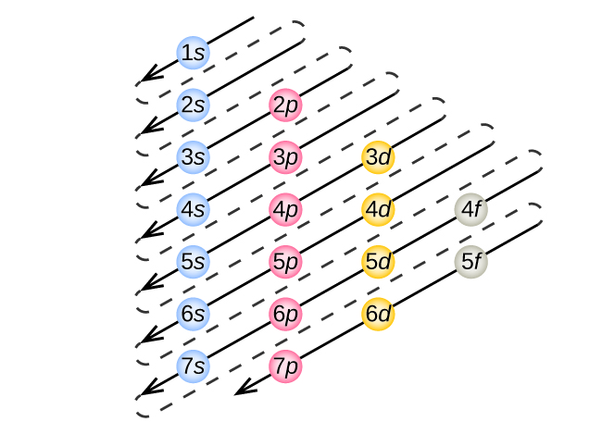
Figure 4.6 This diagram depicts the energy order for atomic orbitals and is useful for deriving ground-state electron configurations.

The Pauli Exclusion Principle
An electron in an atom is completely described by four quantum numbers: n, l, m_{l} , and m_{s}. The first three quantum numbers define the orbital and the fourth quantum number describes the intrinsic electron property called spin. An Austrian physicist Wolfgang Pauli formulated a general principle that gives the last piece of information that we need to understand the general behavior of electrons in atoms. The Pauli exclusion principle can be formulated as follows:

“No two electrons in the same atom can have exactly the same set of all four quantum numbers.”

What this means is that two electrons can share the same orbital (the same set of quantum numbers n, l, and m_{l}) only if their spin quantum number m_{s} have different values. Since the spin quantum number can only have two values (±1/2), no more than two electrons can occupy the same orbital (and if two electrons are located in the same orbital, they must have opposite spins). Therefore, any atomic orbital can be populated by only zero, one, or two electrons. The properties and meaning of the quantum numbers of electrons in atoms are briefly summarized in Table 4.1.

Table 4.1 Quantum numbers, their properties, and significance.

Name | Symbol | Allowed values | Physical meaning
principal quantum number | n | 1, 2, 3, 4, …. | shell, the general region for the value of energy for an electron on the orbital
angular momentum or azimuthal quantum number | l | 0 ≤ l ≤ n – 1 | subshell, the shape of the orbital
magnetic quantum number | m_{l} | – l ≤ m_{l} ≤ l | orientation of the orbital
spin quantum number | m_{s} | 1/2, −1/2 | direction of the intrinsic quantum “spinning” of the electron

The Hund’s Rule
The orbitals are filled as described by Hund’s rule: Electrons first occupy the orbital singly with parallel spin (half-filled). Once all the orbitals of the subshell are half-filled the pairing of electrons can take place.

4.2 Electron Configurations of Atoms

Learning Objectives
- Be able to write orbital diagrams for element up to Z = 56
- Be able to use the periodic table to write the electron configuration of any element up to Z = 56
- Be able to distinguish between core and valence electrons
- Be able to state how many valence electrons an atom has
- Relate quantum mechanic electron configurations to Bohr’s electron shell model
- Understand that some transition metals do not follow the general orbital filling rules
- Be able to determine the ground state electron configuration of ions
- Be able to identify isoelectronic species

Relating Quantum Numbers and the Periodic Table
The arrangement of the periodic table is based on the electron configurations, Figure 4.7 provides an alternative method for determining the electron configuration. The filling order simply begins at hydrogen and includes each subshell as you proceed in increasing Z order. For example, after filling the 3p block up to Ar, we see the orbital will be 4s (K, Ca), followed by the 3d orbitals.
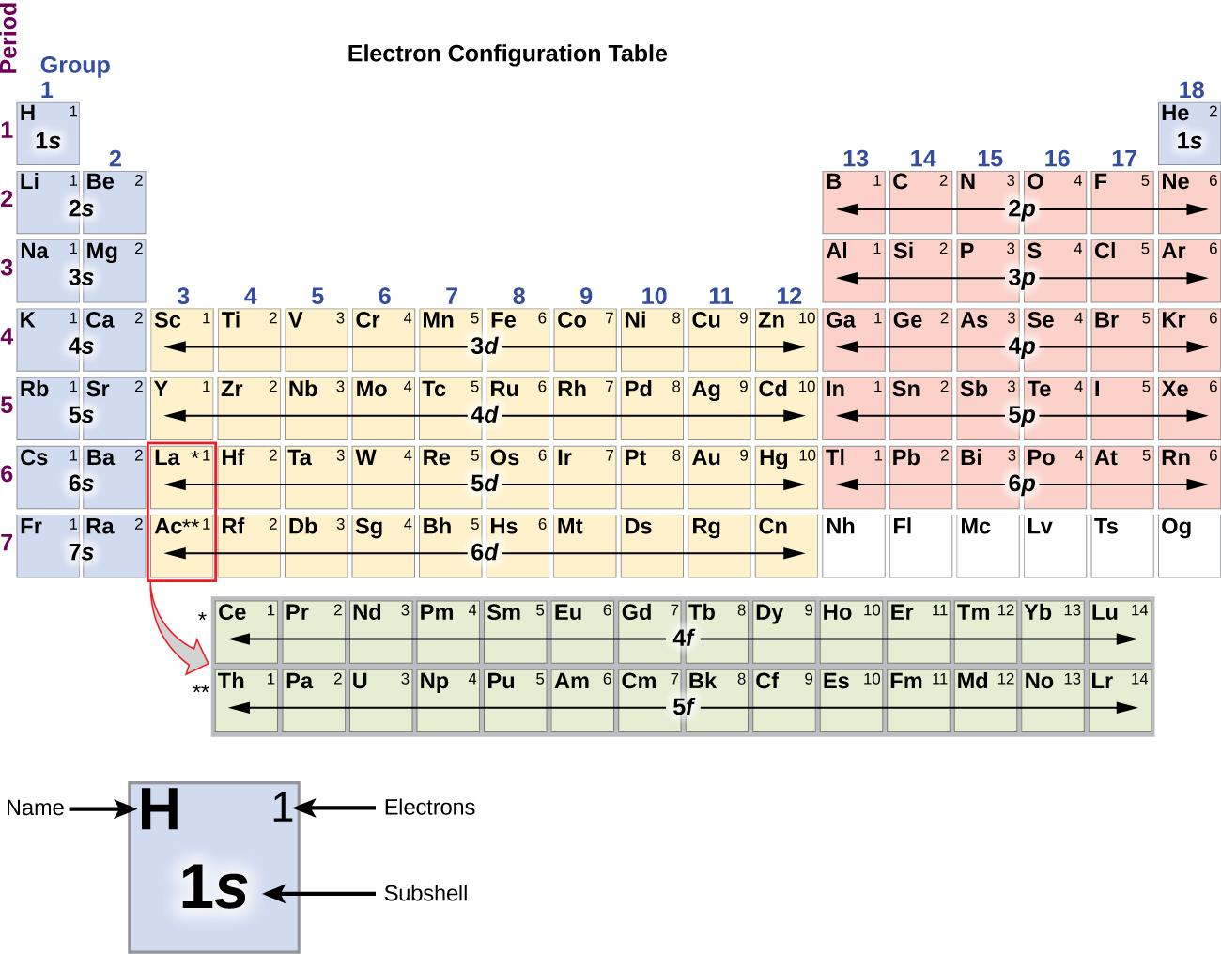
Figure 4.7 This shows the electron configuration for each subshell. By “building up” from hydrogen, this table can be used to determine the electron configuration for any atom.

Types of Ground – State Electron Configurations

1. Orbital Filling Diagrams
An orbital filling diagram is a pictorial representation of the electron configuration, showing the individual orbitals and the pairing arrangement of electrons. The placement of electrons in orbitals follows a certain set of rules.

2. Complete (Full) Ground-State Electron Configurations
A complete ground-state electron configuration shows how the electrons in an atom are organized in a logical manner. As the atomic number increases, electrons are added to the subshells according to their energy. Lower energy subshells fill before higher energy subshells.

3. Condensed (Abbreviated) Electron Configurations
An abbreviated electron configuration is a condensed form of a full electron configuration using noble-gas shorthand. It displays inner and outer electron configurations.

How to Write the ground-state electron configurations
We will follow the Aufbau’s Principle, Pauli’s Exclusion Principle, and Hund’s Rule as mentioned previously in chapter section 4.1 to construct the ground-state electron configurations.

Let’s start with a single hydrogen atom (atomic number 1), which consists of one proton and one electron. Referring to Figure 4.6 or Figure 4.7, we would expect to find the electron in the 1s orbital. By convention, the m_{s} = +1/2 value is usually filled first. The electron configuration and the orbital diagram are:
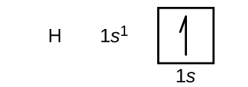

Following hydrogen is the noble gas helium, which has an atomic number of 2. The helium atom contains two protons and two electrons. The first electron has the same four quantum numbers as the hydrogen atom electron (n = 1, l = 0, m_{l} = 0, m_{s} = +1/2). The second electron also goes into the 1s orbital and fills that orbital. The second electron has the same n, l, and m_{l} quantum numbers, but must have the opposite spin quantum number, m_{s} = −1/2. This is in accord with the Pauli exclusion principle: No two electrons in the same atom can have the same set of four quantum numbers. For orbital diagrams, this means two arrows go in each box (representing two electrons in each orbital) and the arrows must point in opposite directions (representing paired spins). The electron configuration and orbital diagram of helium are:

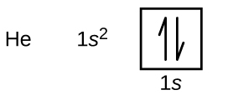
The n = 1 shell is completely filled in a helium atom.

The next atom is the alkali metal lithium with an atomic number of 3. The first two electrons in lithium fill the 1s orbital and have the same sets of four quantum numbers as the two electrons in helium. The remaining electron must occupy the orbital of the next lowest energy, the 2s orbital (Figure 4.6 or Figure 4.7). Thus, the electron configuration and orbital diagram of lithium are:

An atom of the alkaline earth metal beryllium, with an atomic number of 4, contains four protons in the nucleus and four electrons surrounding the nucleus. The fourth electron fills the remaining space in the 2s orbital.

An atom of boron (atomic number 5) contains five electrons. The n = 1 shell is filled with two electrons and three electrons will occupy the n = 2 shell. Because any s subshell can contain only two electrons, the fifth electron must occupy the next energy level, which will be a 2p orbital. There are three degenerate 2p orbitals (m_{l} = −1, 0, +1) and the electron can occupy any one of these p orbitals. When drawing orbital diagrams, we include empty boxes to depict any empty orbitals in the same subshell that we are filling.

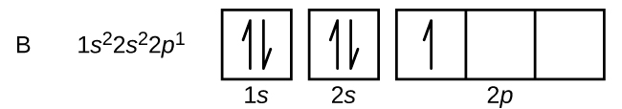

Carbon (atomic number 6) has six electrons. Four of them fill the 1s and 2s orbitals. The remaining two electrons occupy the 2p subshell. We now have a choice of filling one of the 2p orbitals and pairing the electrons or of leaving the electrons unpaired in two different, but degenerate, p orbitals. The orbitals are filled as described by Hund’s rule: the lowest-energy configuration for an atom with electrons within a set of degenerate orbitals is that having the maximum number of unpaired electrons. Thus, the two electrons in the carbon 2p orbitals have identical n, l, and m_{s} quantum numbers and differ in their ml quantum number (in accord with the Pauli exclusion principle). The electron configuration and orbital diagram for carbon are:
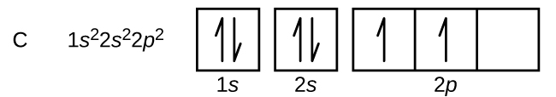

Nitrogen (atomic number 7) fills the 1s and 2s subshells and has one electron in each of the three 2p orbitals, in accordance with Hund’s rule. These three electrons have unpaired spins.

Oxygen (atomic number 8) has a pair of electrons in any one of the 2p orbitals (the electrons have opposite spins) and a single electron in each of the other two.

Fluorine (atomic number 9) has only one 2p orbital containing an unpaired electron.

Neon (atomic number 10) has paired electrons in 2p., and all of the orbitals in the n= 1 and the n = 2 shells are filled.
The alkali metal sodium (atomic number 11) has one more electron than the neon atom. This electron must go into the lowest-energy subshell available, the 3s orbital, giving a 1s² 2s² 2p⁶ 3s¹ configuration.

The electrons occupying the outermost shell orbital(s) (highest value of n) are called valence electrons, and those occupying the inner shell orbitals are called core electrons (Figure 4.8). Since the core electron shells correspond to noble gas electron configurations, we can abbreviate electron configurations by writing the noble gas that matches the core electron configuration, along with the valence electrons in a condensed format. For our sodium example, the symbol [Ne] represents core electrons, (1s² 2s² 2p⁶) and our abbreviated or condensed configuration is [Ne] 3s¹.

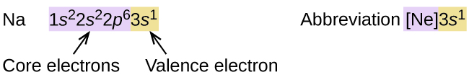

Figure 4.8 A core-abbreviated electron configuration (right) replaces the core electrons with the noble gas symbol whose configuration matches the core electron configuration of the other element.

Similarly, the abbreviated configuration of lithium can be represented as [He] 2s¹, where [He] represents the configuration of the helium atom, which is identical to that of the filled inner shell of lithium. Writing the configurations in this way emphasizes the similarity of the configurations of lithium and sodium. Both atoms, which are in the alkali metal family, have only one electron in a valence s subshell outside a filled set of inner shells.

Li: [ He ] 2s¹
Na: [ Ne ] 3s¹

The alkaline earth metal magnesium (atomic number 12), with its 12 electrons in a [Ne] 3s² configuration, is analogous to its family member beryllium, [He] 2s². Both atoms have a filled s subshell outside their filled inner shells.

Aluminum (atomic number 13), with 13 electrons and the electron configuration [Ne] 3s² 3p¹, is analogous to its family member boron, [He] 2s² 2p¹.

The electron configurations of silicon (14 electrons), phosphorus (15 electrons), sulfur (16 electrons), chlorine (17 electrons), and argon (18 electrons) are analogous in the electron configurations of their outer shells to their corresponding family members carbon, nitrogen, oxygen, fluorine, and neon, respectively, except that the principal quantum number of the outer shell of the heavier elements has increased by one to n = 3.

When we come to the next element in the periodic table, the alkali metal potassium (atomic number 19), we might expect that we would begin to add electrons to the 3d subshell. However, all available chemical and physical evidence indicates that potassium is like lithium and sodium, and that the next electron is not added to the 3d level but is, instead, added to the 4s level. As discussed previously, the 3d orbital with no radial nodes is higher in energy because it is less penetrating and more shielded from the nucleus than the 4s, which has three radial nodes. Thus, potassium has an electron configuration of [Ar] 4s¹. Hence, potassium corresponds to Li and Na in its valence shell configuration.

The next element is calcium. Its electron is added to complete the 4s subshell and calcium has an electron configuration of [Ar] 4s². This gives calcium an outer-shell electron configuration corresponding to that of beryllium and magnesium.

For transition metals, additional electrons are added successively to the 3d subshell. This subshell is filled to its capacity with 10 electrons (remember that for l = 2 [d orbitals], there are 2l + 1 = 5 m_{l} values, meaning that there are five d orbitals that have a combined capacity of 10 electrons). The 4p subshell fills next. Note that for three series of elements, scandium (Sc) through copper (Cu), yttrium (Y) through silver (Ag), and lutetium (Lu) through gold (Au), a total of 10 d electrons are successively added to the (n – 1) shell next to the n shell to bring that shell from 8 to 18 electrons.

For two series lanthanides and actinides, 14 f electrons (l = 3, 2l + 1 = 7 m_{l} values; thus, seven orbitals with a combined capacity of 14 electrons) are successively added to the (n – 2) shell to bring that shell from 18 electrons to a total of 32 electrons.

Half-filled and Full-filled Electron configurations
The periodic table can be a powerful tool in predicting the electron configuration of an element. However, we do find exceptions to the order of filling of orbitals. For instance, the electron configurations of the transition metals in chromium (Cr) group and copper (Cu) group are not those we would expect. In general, such exceptions involve subshells with very similar energy, and small effects can lead to changes in the order of filling.

In the case of Cr and Cu, we find that half-filled and completely filled subshells apparently represent conditions of preferred stability. This stability is such that an electron shifts from the 4s into the 3d orbital to gain the extra stability of a half-filled 3d subshell (in Cr) or a filled 3d subshell (in Cu).

Cr: [ Ar ] 4s¹ 3d⁵ (half-filled)
Cu: [ Ar ] 4s¹ 3d¹⁰ (full-filled)

Electron Configurations of Ions
Ions are formed when atoms gain or lose electrons.

A cation (positively charged ion) forms when one or more electrons are removed from a parent atom. For main group elements, the electrons that were added last are the first electrons removed. For transition metals and inner transition metals, however, electrons in the s orbital are easier to remove than the d or f electrons, and so the highest ns electrons are lost, and then the (n – 1)d or (n – 2)f electrons are removed.

An anion (negatively charged ion) forms when one or more electrons are added to a parent atom. The added electrons fill in the order predicted by the Aufbau principle.

For example:

When Na loses one electron it becomes Na⁺.
Na: 1s² 2s² 2p⁶ 3s¹
Na⁺: 1s² 2s² 2p⁶ 3s⁰ or 1s² 2s² 2p⁶

When Al loses two electrons it becomes Al²⁺.
Al: 1s² 2s² 2p⁶ 3s² 3p¹
Al²⁺: 1s² 2s² 2p⁶ 3s¹ 3p⁰ or 1s² 2s² 2p⁶ 3s¹

When Fe loses two electrons it becomes Fe²⁺.
Fe: 1s² 2s² 2p⁶ 3s² 3p⁶ 4s² 3d⁶
Fe²⁺: 1s² 2s² 2p⁶ 3s² 3p⁶ 4s⁰ 3d⁶ or 1s² 2s² 2p⁶ 3s² 3p⁶ 3d⁶

When P gains three electrons it becomes P³⁻.
P: 1s² 2s² 2p⁶ 3s² 3p³
P³⁻: 1s² 2s² 2p⁶ 3s² 3p⁶

4.3 The Periodic Table

Learning Objectives
- Know how the periodic table can be divided into four blocks based on the filling order of orbitals
- Be able to determine expected charge for the main group elements as they undergo chemical
reaction

Development of Periodic Table
As early chemists worked to purify ores and discovered more elements, they realized that various elements could be grouped together by their similar chemical behaviors. One such grouping includes lithium (Li), sodium (Na), and potassium (K): These elements all are shiny, conduct heat and electricity well, and have similar chemical properties. A second grouping includes calcium (Ca), strontium (Sr), and barium (Ba), which also are shiny, good conductors of heat and electricity, and have chemical properties in common. However, the specific properties of these two groupings are notably different from each other. For example: Li, Na, and K are much more reactive than are Ca, Sr, and Ba.

Dimitri Mendeleev in Russia (1869) and Lothar Meyer in Germany (1870) independently recognized that there was a periodic relationship among the properties of the elements known at that time. Both published tables with the elements arranged according to increasing atomic mass. But Mendeleev went one step further than Meyer: He used his table to predict the existence of elements that would have the properties similar to aluminum and silicon, but were yet unknown. The discoveries of gallium (1875) and germanium (1886) provided great support for Mendeleev’s work. Although Mendeleev and Meyer had a long dispute over priority, Mendeleev’s contributions to the development of the periodic table are now more widely recognized (Figure 4.9).

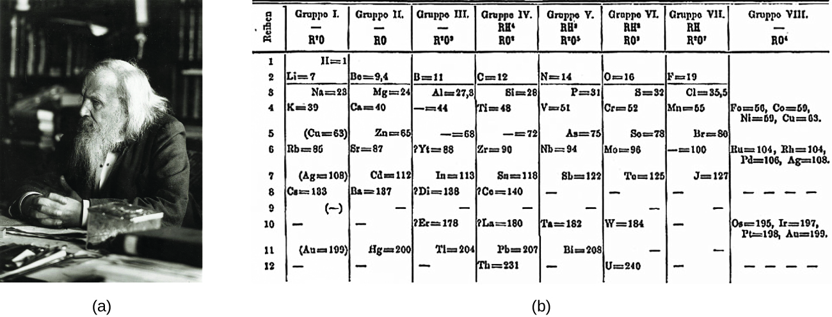
Figure 4.9 (a) Dimitri Mendeleev is widely credited with creating (b) the first periodic table of the elements. (credit a: modification of work by Serge Lachinov; credit b: modification of work by “Den fjättrade ankan”/Wikimedia Commons)

By the twentieth century, it became apparent that the periodic relationship involved atomic numbers rather than atomic masses. The modern statement of this relationship, the periodic law, is as follows: the properties of the elements are periodic functions of their atomic numbers.

A modern periodic table arranges the elements in increasing order of their atomic numbers and groups atoms with similar properties in the same vertical column (Figure 4.10). Each box represents an element and contains its atomic number, symbol, average atomic mass, and (sometimes) name. The elements are arranged in seven horizontal rows called periods or series, and 18 vertical columns, called groups. Groups are labeled at the top of each column. In the United States, the labels traditionally were numerals with capital letters (A and B). However, IUPAC recommends that the numbers 1 through 18 be used, and these labels are more common. For the table to fit on a single page, parts of two of the rows, a total of 14 columns, are usually written below the main body of the table.

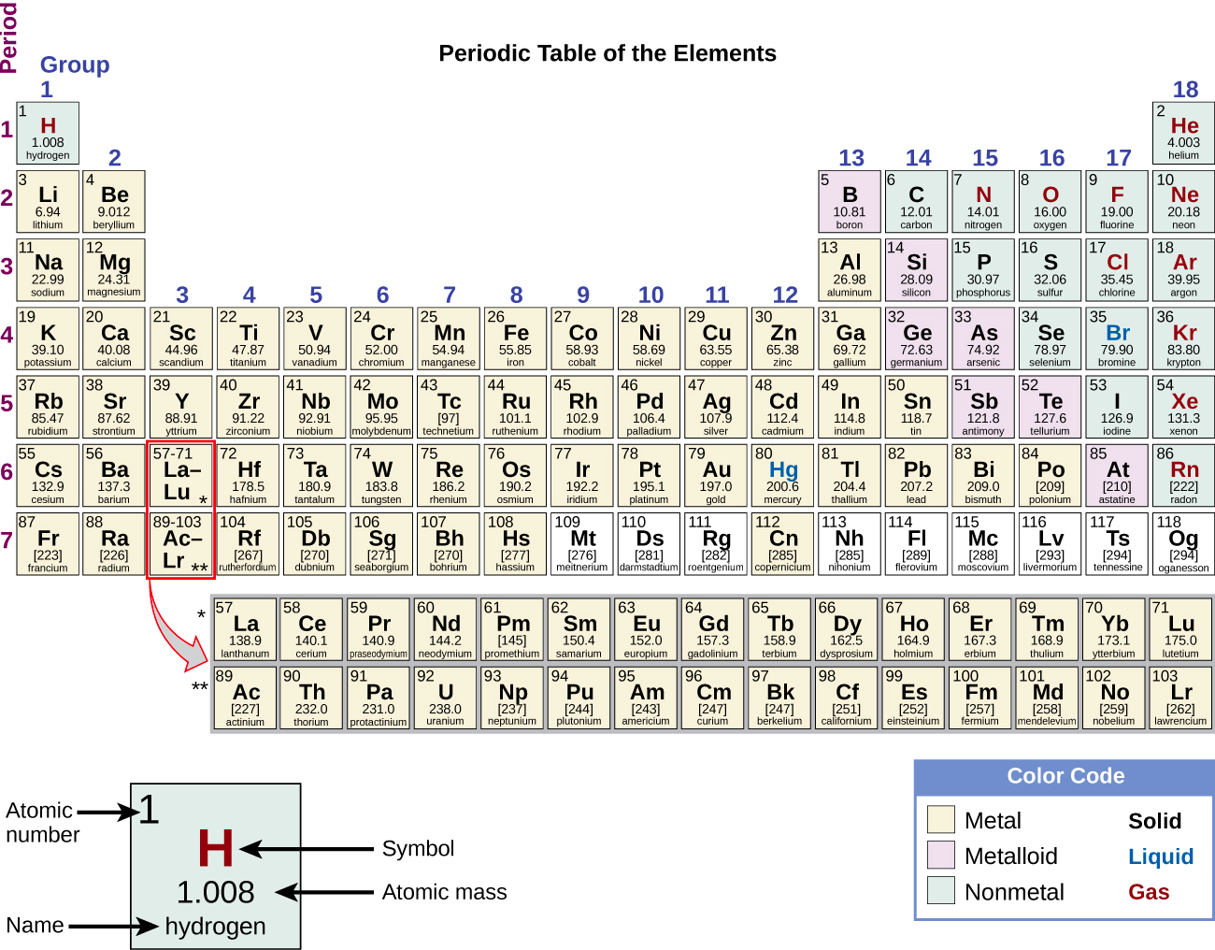
Figure 4.10 Elements in the periodic table are organized according to their properties.
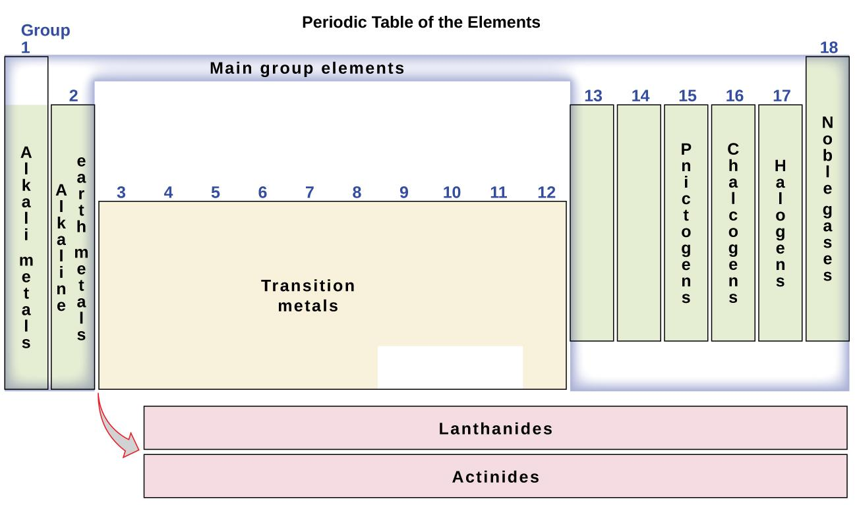
Figure 4.11 The periodic table organizes elements with similar properties into groups.
Many elements differ dramatically in their chemical and physical properties, but some elements are similar in their behaviors. We can sort the elements into large classes with common properties: Metals are elements that are shiny, malleable (able to be deformed without breaking), ductile (can be drawn into wires), good conductors of heat and electricity, and shaded yellow. Nonmetals are elements that appear dull, poor conductors of heat and electricity, and shaded green. Metalloids are elements that conduct heat and electricity moderately well, and possess some properties of metals and some properties of nonmetals, and shaded purple.

The elements can also be classified into the main-group elements (or representative elements) in the columns labeled 1, 2, and 13–18; the transition metals in the columns labeled 3–12¹; and inner transition metals in the two rows at the bottom of the table (the top-row elements are called lanthanides and the bottom-row elements are actinides; Figure 4.11).

The elements can be subdivided further by more specific properties, such as the composition of the compounds they form. For example, the elements in group 1 (the first column) form compounds that consist of one atom of the element and one atom of hydrogen. These elements (except hydrogen) are known as alkali metals, and they all have similar chemical properties.

The elements in group 2 (the second column) form compounds consisting of one atom of the element and two atoms of hydrogen: These are called alkaline earth metals, with similar properties among members of that group.

Other groups with specific names are the pnictogens (group 15), chalcogens (group 16), halogens (group 17), and the noble gases (group 18, also known as inert gases). The groups can also be referred to by the first element of the group. For example, the chalcogens can be called the oxygen group or oxygen family.

Hydrogen is a unique, nonmetallic element with properties similar to both group 1 and group 17 elements. For that reason, hydrogen may be shown at the top of both groups, or by itself.

Electron Configurations and the Periodic Table
As described earlier, the periodic table arranges atoms based on increasing atomic numbers so that elements with the same chemical properties recur periodically. When their electron configurations are added to the table (Figure 4.12), we also see a periodic recurrence of similar electron configurations in the outer shells of these elements. Because they are in the outer shells of an atom, valence electrons play the most important role in chemical reactions. The outer electrons have the highest energy of the electrons in an atom and are more easily lost or shared than the core electrons. Valence electrons are also the determining factor in some physical properties of the elements.

Elements in any one group (or column) have the same number of valence electrons:
The alkali metals lithium and sodium each have only one valence electron;
The alkaline earth metals beryllium and magnesium each have two;
The halogens fluorine and chlorine each have seven valence electrons.

The similarity in chemical properties among elements of the same group occurs because they have the same number of valence electrons. It is the loss, gain, or sharing of valence electrons that defines how elements react.

It is important to remember that the periodic table was developed on the basis of the chemical behavior of the elements, well before any idea of their atomic structure was available. Now we can understand why the periodic table has the arrangement it has—the arrangement puts elements whose atoms have the same number of valence electrons in the same group.
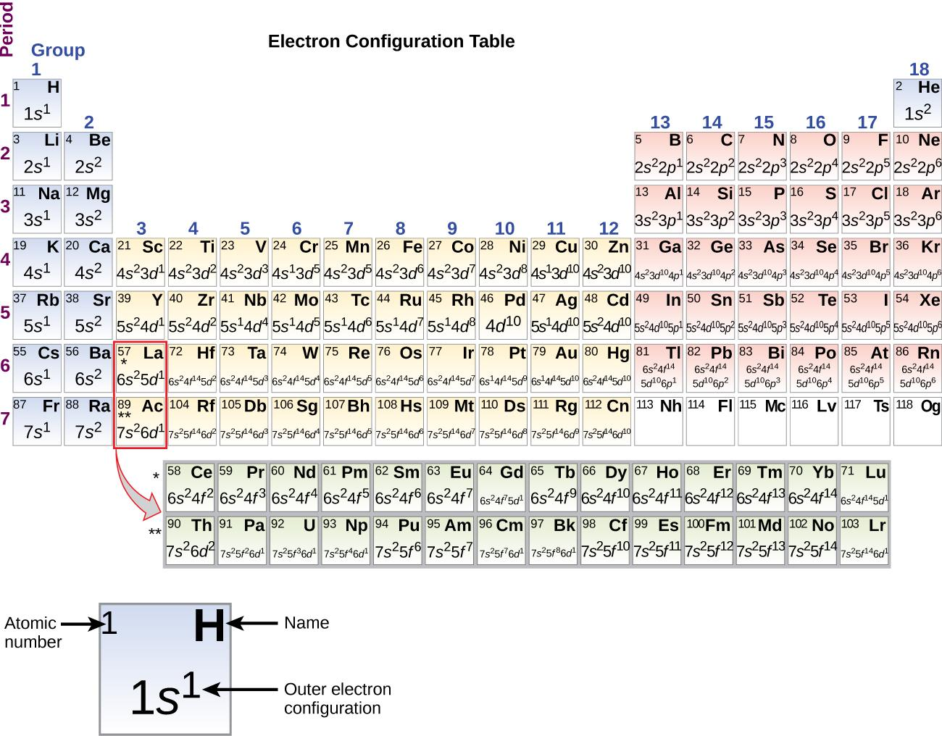

Figure 4.12 This version of the periodic table shows the outer-shell electron configuration of each element. Note that down each group, the configuration is often similar.

Main group elements (sometimes called representative elements) are those in which the last electron added enters an s or a p orbital in the outermost shell, shown in blue and red in Figure 4.12. This category includes all the nonmetallic elements, as well as many metals and metalloids. The valence electrons for main group elements are those with the highest n level. For example, gallium (Ga, atomic number 31) has the electron configuration [Ar] 4s² 3d¹⁰ 4p¹, which contains three valence electrons (bold). The completely filled d orbitals count as core, not valence, electrons.

Transition elements or transition metals are metallic elements in which the last electron added enters a d orbital. The valence electrons (those added after the last noble gas configuration) in these elements include the ns and (n – 1) d electrons. The official IUPAC definition of transition elements specifies those with partially filled d orbitals. Thus, the elements with completely filled orbitals (Zn, Cd, Hg, as well as Cu, Ag, and Au in Figure 4.12) are not technically transition elements. However, the term is frequently used to refer to the entire d block (colored yellow in Figure 4.12), and we will adopt this usage in this textbook.

Inner transition elements are metallic elements in which the last electron added occupies an f orbital. They are shown in green in Figure 4.12. The valence shells of the inner transition elements consist of the (n – 2)f, the (n – 1)d, and the ns subshells. There are two inner transition series:

- The lanthanide series: lanthanide (La) through lutetium (Lu)
- The actinide series: actinide (Ac) through lawrencium (Lr)

Lanthanum and actinium, because of their similarities to the other members of the series, are included and used to name the series, even though they are transition metals with no f electrons.

Footnotes
- 1. Per the IUPAC definition, group 12 elements are not transition metals, though they are often referred to as such. Additional details on this group’s elements are provided in a chapter on transition metals and coordination chemistry.

4.4 The Periodic Trends

Content Statement
The content of this chapter section (from page 150 – 166) has been removed from public sharing version due to an incompatibile license.

BLANK PAGE

Chapter 5 – Attributions

The contents in this chapter, licensed under CC BY-NC-SA 4.0. has been adopted, modified, reorganized, and/or remixed from the following:

5.0 Introduction
"2 Introduction" by Paul Flowers, Klaus Theopold, Richard Langley, William R. Robinson, PhD, OpenStax is licensed under CC BY 4.0

5.1 Types of Chemical Bonds
"Metallic Bonding" by Jim Clark, Daniel James Berger, et. al, LibreTexts is licensed under CC BY-NC-SA 3.0
"9.2: Types of Chemical Bonds" by Mike Blaber, LibreTexts is licensed under CC BY-NC-SA 3.0
"Bonding in Metals: The Electron Sea Model" by lumenlearning is licensed under CC BY-SA 4.0
"7.1 Ionic Bonding" by Paul Flowers, Klaus Theopold, Richard Langley, William R. Robinson, PhD, OpenStax is licensed under CC BY 4.0
"7.5 STRENGTHS OF IONIC AND COVALENT BONDS" by opentextbc is licensed under CC BY 4.0
"7.2 Covalent Bonding" by Paul Flowers, Klaus Theopold, Richard Langley, William R. Robinson, PhD, OpenStax is licensed under CC BY 4.0

5.2 Determination of Chemical Composition
"3.2 Determining Empirical and Molecular Formulas" by Paul Flowers, Klaus Theopold, Richard Langley, William R. Robinson, PhD, OpenStax is licensed under CC BY 4.0

5.3 Determination of Chemical Formulas
"3.2 Determining Empirical and Molecular Formulas" by Paul Flowers, Klaus Theopold, Richard Langley, William R. Robinson, PhD, OpenStax is licensed under CC BY 4.0

5.4 Formula Mass, Molecular Mass, and Molar Mass
"3.1 Formula Mass and the Mole Concept" by Paul Flowers, Klaus Theopold, Richard Langley, William R. Robinson, PhD,OpenStax is licensed under CC BY 4.0

5.5 Ionic Compounds - Formulas and Names
"2.6 Molecular and Ionic Compounds" by Paul Flowers, Klaus Theopold, Richard Langley, William R. Robinson, PhD,OpenStax is licensed under CC BY 4.0
"2.7 Chemical Nomenclature" by Paul Flowers, Klaus Theopold, Richard Langley, William R. Robinson, PhD, OpenStax is licensed under CC BY 4.0

5.6 Molecular Compounds - Formulas and Names
"2.7 Chemical Nomenclature" by Paul Flowers, Klaus Theopold, Richard Langley, William R. Robinson, PhD, OpenStax is licensed under CC BY 4.0

Chapter 5 Bond Formations and Nomenclature

Chapter Introduction

5.1 Types of Chemical Bonds

5.2 Determination of Chemical Composition

5.3 Determination of Chemical Formulas

5.4 Formula Mass, Molecular Mass, and Molar Mass

5.5 Ionic Compounds - Formulas and Names

5.6 Molecular Compounds - Formulas and Names

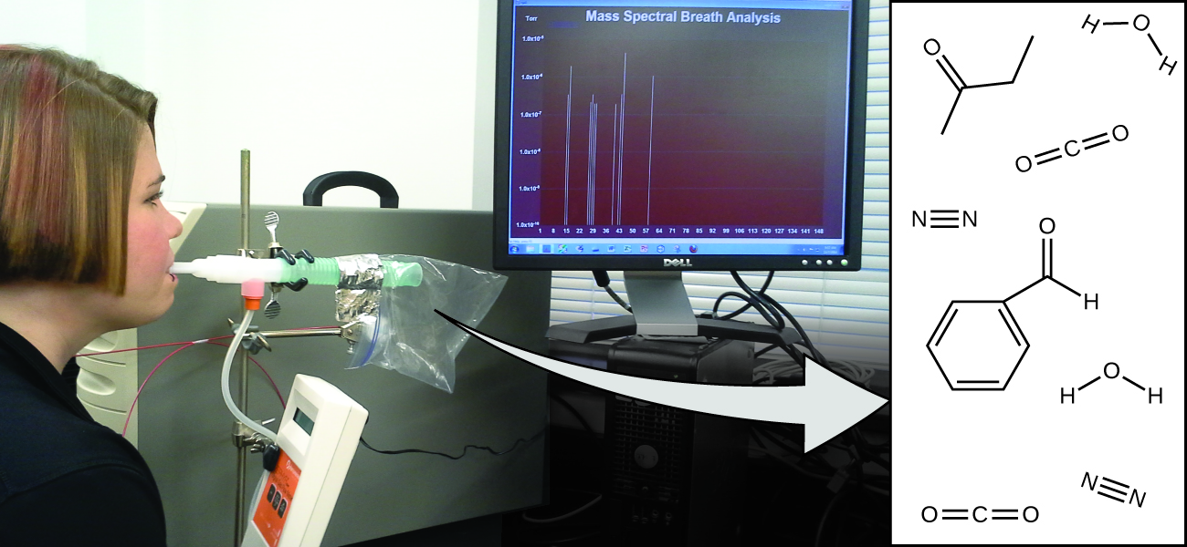
Figure 5.1 Analysis of molecules in an exhaled breath can provide valuable information, leading to early diagnosis of diseases or detection of environmental exposure to harmful substances. (credit: modification of work by Paul Flowers)

Your overall health and susceptibility to disease depends upon the complex interaction between your genetic makeup and environmental exposure, with the outcome difficult to predict. Early detection of biomarkers, substances that indicate an organism’s disease or physiological state, could allow diagnosis and treatment before a condition becomes serious or irreversible. Recent studies have shown that your exhaled breath can contain molecules that may be biomarkers for recent exposure to environmental contaminants or for pathological conditions ranging from asthma to lung cancer. Scientists are working to develop biomarker “fingerprints” that could be used to diagnose a specific disease based on the amounts and identities of certain molecules in a patient’s exhaled breath. An essential concept underlying this goal is that of a molecule’s identity, which is determined by the numbers and types of atoms it contains, and how they are bonded together. This chapter will describe some of the fundamental chemical principles related to the composition of matter and how their chemical bonds are formed.

BLANK PAGE

5.1 Types of Chemical Bonds

Content Statement
The content of this chapter section (from page 161 – 173) has been removed from public sharing version due to an incompatible license.

5.2 Determination of Chemical Composition

Learning Objectives
- Determine mass percent of element in the compound

Percent Composition
The elemental makeup of a compound defines its chemical identity, and chemical formulas are the most succinct way of representing this elemental makeup. When a compound’s formula is unknown, measuring the mass of each of its constituent elements is often the first step in the process of determining the formula experimentally. The results of these measurements permit the calculation of the compound’s percent composition, defined as the percentage by mass of each element in the compound. For example, consider a gaseous compound composed solely of carbon and hydrogen. The percent composition of this compound could be represented as follows:

%H = mass H $÷$ mass compound ×100%

%C = mass C $÷$ mass compound ×100%

If analysis of a 10.0-g sample of this gas showed it to contain 2.5 g H and 7.5 g C, the percent composition would be calculated to be 25% H and 75% C:

%H = 2.5g H $÷$ 10.0g compound ×100% =25%

%C = 7.5g C $÷$ 10.0g compound ×100% =75%

Percent composition is also useful for evaluating the relative abundance of a given element in different compounds of known formulas. As one example, consider the common nitrogen-containing fertilizers ammonia (NH₃), ammonium nitrate (NH₄NO₃), and urea (CH₄N₂O). The element nitrogen is the active ingredient for agricultural purposes, so the mass percentage of nitrogen in the compound is a practical and economic concern for consumers choosing among these fertilizers. For these sorts of applications, the percent composition of a compound is easily derived from its formula mass and the atomic masses of its constituent elements. A molecule of NH₃ contains one N atom weighing 14.01 amu and three H atoms weighing a total of (3 × 1.008 amu) = 3.024 amu. The formula mass of ammonia is therefore (14.01 amu + 3.024 amu) = 17.03 amu, and its percent composition is:

%N = 14.01 amu N $÷$ 17.03 amuNH₃ ×100% = 82.27%

%H = 3.024 amu H $÷$ 17.03 amuNH₃ ×100% = 17.76%

5.3 Determination of Chemical Formulas

Learning Objectives
- Determine empirical formula from mass and percent mass
- Determine molecular formula

Types of Chemical Formula
Empirical formula shows the relative number of atoms of each type in a molecule.

Formula unit is used to represent chemical formula for ionic compounds. The formula unit shows only the smallest ratio between metal and nonmetal in ionic compounds; thus, we can also called it empirical formula.

Molecular formula shows the actual number of atoms in a molecule. It is used in molecular compounds.

Determination of Empirical Formulas

Deriving Empirical Formulas from Mass Composition
As previously mentioned, the most common approach to determining a compound’s chemical formula is to first measure the masses of its constituent elements. However, keep in mind that chemical formulas represent the relative numbers, not masses, of atoms in the substance. Therefore, any experimentally derived data involving mass must be used to derive the corresponding numbers of atoms in the compound. This is accomplished using molar masses to convert the mass of each element to a number of moles. These molar amounts are used to compute whole-number ratios that can be used to derive the empirical formula of the substance.

Consider a sample of compound determined to contain 1.71 g C and 0.287 g H. The corresponding numbers of atoms (in moles) are:

$$1.71 g C × \frac{1 mol C}{12.01 g C} = 0.142 mol C$$

$$0.287 g H × \frac{1 mol H}{1.008 g H} = 0.284 mol H$$

Thus, this compound may be represented by the formula C_{0.142}H_{0.248}.

However, chemical formulas must be expressed with whole-number subscripts. This can be achieved by dividing each subscript by the smaller subscript:

$$1.71 g C × \frac{1 mol C}{12.01 g C} =\frac{0.142 mol C}{0.142 mol } = 1$$

$$0.287 g H × \frac{1 mol H}{1.008 g H} = \frac{0.284 mol H}{0.142 mol } = 2$$

Thus, the empirical formula for this compound is CH₂. (Recall that subscripts of “1” are not written but rather assumed if no other number is present.) This may or not be the compound’s molecular formula; however, additional information is needed to make that determination (as discussed later in this section).

Consider as another example a sample of compound determined to contain 5.31 g Cl and 8.40 g O. Following the same approach yields a tentative empirical formula of:

$$5.31 g Cl × \frac{1 mol Cl}{35.45 g Cl} =\frac{0.1498 mol Cl}{0.1498 mol } = 1$$

$$8.40 g O × \frac{1 mol O}{15.999 g O} = \frac{0.5250 mol O}{0.1498 mol } = 3.5$$
In this case, dividing by the smallest subscript still leaves us with a decimal subscript in the empirical formula. To convert this into a whole number, multiply each of the subscripts by 2, retaining the same atom ratio and yielding Cl₂O₇ as the final empirical formula.

$$5.31 g Cl × \frac{1 mol Cl}{35.45 g Cl} =\frac{0.1498 mol Cl}{0.1498 mol } = 1×2=2$$

$$8.40 g O × \frac{1 mol O}{15.999 g O} = \frac{0.5250 mol O}{0.1498 mol } = 3.5×2=7$$

In summary, empirical formulas are derived from experimentally measured element masses by:

- Deriving the number of moles of each element from its mass

- Dividing each element’s molar amount by the smallest molar amount to yield subscripts for a tentative empirical formula

- Multiplying all coefficients by an integer, if necessary, to ensure that the smallest whole-number ratio of subscripts is obtained

The outline of this procedure shows in Figure 5.9 for a substance containing elements A and X.

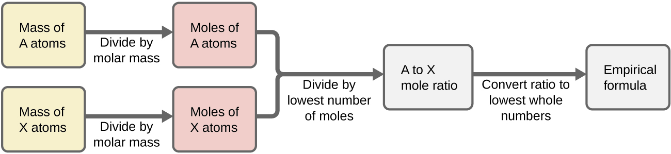
Figure 5.9 The empirical formula of a compound can be derived from the masses of all elements in the sample.

Deriving Empirical Formulas from Percent Composition
Finally, with regard to deriving empirical formulas, consider instances in which a compound’s percent composition is available rather than the absolute masses of the compound’s constituent elements. In such cases, the percent composition can be used to calculate the masses of elements present in any convenient mass of compound; these masses can then be used to derive the empirical formula in the usual fashion.

Determination of Molecular Formula
Recall that empirical formulas are symbols representing the relative numbers of a compound’s elements. Determining the absolute numbers of atoms that compose a single molecule of a covalent compound requires knowledge of both its empirical formula and its molecular mass or molar mass. These quantities may be determined experimentally by various measurement techniques.

Molecular formulas are derived by comparing the compound’s molecular or molar mass to its empirical formula mass. As the name suggests, an empirical formula mass is the sum of the average atomic masses of all the atoms represented in an empirical formula. If the molecular mass of the substance is known, it may be divided by the empirical formula mass to yield the number of empirical formula units per molecule (n):

$$\frac{molecular mass (amu) }{empirical formula mass (amu) } = n (formula units/molecule)$$

The molecular formula is then obtained by multiplying each subscript in the empirical formula by n.

For example, consider a covalent compound whose empirical formula is determined to be CH₂O. The empirical formula mass for this compound is approximately 30 amu. If the compound’s molecular mass is determined to be 180 amu, this indicates that the molecule of this compound contains six times the number of atoms represented in the empirical formula:

$$\frac{180 amu }{30 amu } = 6 formula units/molecule$$

Molecules of this compound are then represented by molecular formulas whose subscripts are six times greater than those in the empirical formula:

(CH₂O)$×$6 = C₆H₁₂O₆

Note that this same approach may be used when the molar mass (g/mol) instead of the molecular mass (amu) is used. In this case, one mole of empirical formula units and molecules is considered, as opposed to single units and molecules.

5.4 Formula Mass, Molecular Mass, and Molar Mass of Compounds

Learning Objectives
- Distinguish between formula mass, molecular mass and molar mass
- Calculate formula mass, molecular mass, and molar mass

Formula Mass for Ionic Compounds
Ionic compounds are composed of discrete cations and anions combined in ratios to yield electrically neutral bulk matter. The formula mass for an ionic compound is calculated by summing the average atomic masses of all the atoms in the compound’s formula. Keep in mind that the formula for an ionic compound does not represent the composition of a discrete molecule, so it may not correctly be referred to as the “molecular mass.”
As an example, consider sodium chloride, NaCl, the chemical name for common table salt. Sodium chloride is an ionic compound composed of sodium cations, Na⁺, and chloride anions, Cl⁻, combined in a 1:1 ratio. The formula mass for this compound is computed as 58.44 amu (see Figure 5.10).
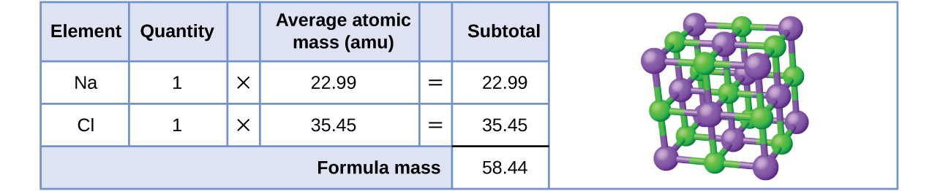
Figure 5.10 Table salt, NaCl, contains an array of sodium and chloride ions combined in a 1:1 ratio. Its formula mass is 58.44 amu.

Note that the average masses of neutral sodium and chlorine atoms were used in this calculation, rather than the masses for sodium cations and chlorine anions. This approach is perfectly acceptable when calculating the formula mass of an ionic compound. The mass of an electron is negligibly small with respect to the mass of a typical atom. The missing or additional electrons can generally be ignored, since their contribution to the overall mass is negligible.

Molecular Mass for Covalent Substances
For covalent substances, the formula represents the numbers and types of atoms composing a single molecule of the substance; therefore, the formula mass may be correctly referred to as a molecular mass. Consider chloroform (CHCl₃), a covalent compound once used as a surgical anesthetic and now primarily used in the production of tetrafluoroethylene, the building block for the "anti-stick" polymer, Teflon. The molecular formula of chloroform indicates that a single molecule contains one carbon atom, one hydrogen atom, and three chlorine atoms. The average molecular mass of a chloroform molecule is therefore equal to the sum of the average atomic masses of these atoms. Figure 5.11 outlines the calculations used to derive the molecular mass of chloroform, which is 119.37 amu.
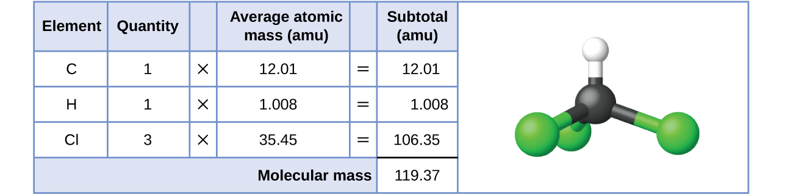
Figure 5.11 The molecular mass of a chloroform molecule, CHCl₃, is 119.37 amu, which is the sum of the average atomic masses of each of its constituent atoms. The model shows the molecular structure of chloroform.

Likewise, the molecular mass of an aspirin molecule, C₉H₈O₄, is the sum of the atomic masses of nine carbon atoms, eight hydrogen atoms, and four oxygen atoms, which amounts to 180.15 amu (Figure 5.12).
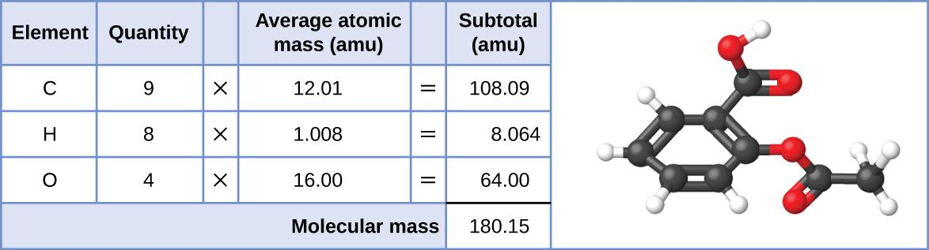
Figure 5.12 The molecular mass of an aspirin molecule is 180.15 amu. The model shows the molecular structure of aspirin, C₉H₈O₄.

Molar Mass for All Substances
The molar mass of a compound is the mass in grams of one mole of compound. It is numerically equal to the formula or molecular mass, but reported in units of g/mol. We can use molar mass to determine the mass, moles, or number of molecules (or formula units) of a compound.

For example, glycine, which has the molecular formula C₂H₅O₂N, is one of the amino acids that our bodies use to synthesize proteins. The molar mass of glycine, C₂H₅O₂N can be calculated in the same fashion as its molecular mass. One mole of glycine, C₂H₅O₂N, contains 2 moles of carbon, 5 moles of hydrogen, 2 moles of oxygen, and 1 mole of nitrogen, which amounts to 75.07 g/mol (Figure 5.13).

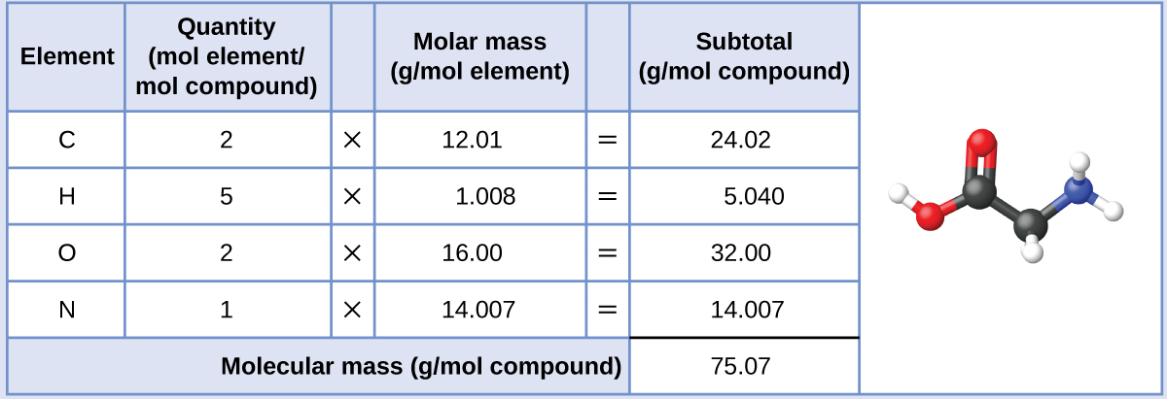

Figure 5.13 The molar mass of a glycine molecule is 75.07 g/mol. The model shows the molecular structure of glycine, C₂H₅O₂N.

5.5 Ionic Compounds – Formulas and Names

Learning Objectives
- Write chemical formula for ionic compounds
- Name ionic compounds

Writing Formulas of Ionic Compounds
During the formation of ionic compounds, atoms gain or lose electrons, and form electrically charged particles called ions. You can use the periodic table to predict whether an atom will form an anion or a cation, and you can often predict the charge of the resulting ion. Atoms of many main-group metals lose enough electrons to leave them with the same number of electrons as an atom of the preceding noble gas.

To illustrate, an atom of an alkali metal (group 1) loses one electron and forms a cation with a 1+ charge. An alkaline earth metal (group 2) loses two electrons and forms a cation with a 2+ charge, and so on. For example, a neutral calcium atom, with 20 protons and 20 electrons, readily loses two electrons. This results in a cation with 20 protons, 18 electrons, and a 2+ charge. It has the same number of electrons as atoms of the preceding noble gas, argon, and is symbolized Ca²⁺. The name of a metal ion is the same as the name of the metal atom from which it forms, so Ca²⁺ is called a calcium ion.

When atoms of nonmetal elements form ions, they generally gain enough electrons to give them the same number of electrons as an atom of the next noble gas in the periodic table. Atoms of group 17 gain one electron and form anions with a 1− charge. Atoms of group 16 gain two electrons and form ions with a 2− charge, and so on. For example, the neutral bromine atom, with 35 protons and 35 electrons, can gain one electron to provide it with 36 electrons. This results in an anion with 35 protons, 36 electrons, and a 1− charge. It has the same number of electrons as atoms of the next noble gas, krypton, and is symbolized Br−.
Note the usefulness of the periodic table in predicting likely ion formation and charge (Figure 5.14). Moving from the far left to the right on the periodic table, main-group elements tend to form cations with a charge equal to the group number. That is, group 1 elements form 1+ ions; group 2 elements form 2+ ions, and so on. Moving from the far right to the left on the periodic table, elements often form anions with a negative charge equal to the number of groups moved left from the noble gases. For example, group 17 elements (one group left of the noble gases) form 1− ions; group 16 elements (two groups left) form 2− ions, and so on. This trend can be used as a guide in many cases, but its predictive value decreases when moving toward the center of the periodic table. In fact, transition metals and some other metals often exhibit variable charges that are not predictable by their location in the table.
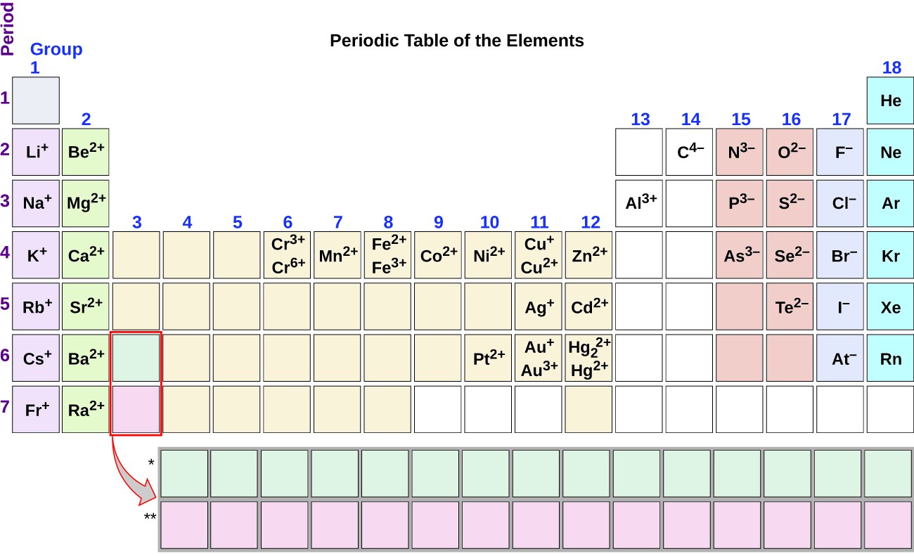
Figure 5.14 Some elements exhibit a regular pattern of ionic charge when they form ions.

As all substances must be electrically neutral, the total number of positive charges on the cations of an ionic compound must equal the total number of negative charges on its anions. The formula of an ionic compound represents the simplest ratio of the numbers of ions necessary to give identical numbers of positive and negative charges. For example, the formula for aluminum oxide, Al₂O₃, indicates that this ionic compound contains two aluminum cations, Al³⁺, for every three oxide anions, O²⁻ [thus, (2 × +3) + (3 × –2) = 0].

Naming Ionic Compounds
To name an ionic compound, we need to consider the answers to several questions. First, does the metal form ions of only one type (fixed charge) or more than one type (variable charge)? Are the ions monatomic or polyatomic? From the answers we derive, we place the compound in an appropriate category and then name it accordingly.

Compounds Containing Only Monatomic Ions
The name of a binary compound containing monatomic ions consists of the name of the cation (the name of the metal) followed by the name of the anion (the name of the nonmetallic element with its ending replaced by the suffix –ide). Some examples are given in Table 5.1.

Table 5.1 Names of Some Ionic Compounds
KBr, potassium bromide | ZnS, Zinc sulfide
CaI₂, calcium iodide | Mg₃N₂, magnesium nitride
CsF, cesium fluoride | Ca₃P₂, calcium phosphide
LiCl, lithium chloride | Al₄C₃, aluminum carbide

Compounds Containing Polyatomic Ions
Compounds containing polyatomic ions are named similarly to those containing only monatomic ions, i.e. by naming first the cation and then the anion. Examples are shown in Table 5.2.

Table 5.2 Names of Some Polyatomic Ionic Compounds
KCH₃CO₂, potassium acetate | NH₄Cl, ammonium chloride
NaHCO₃, sodium bicarbonate | CaSO₄, calcium sulfate
Al₂(CO₃)₃, aluminum carbonate | Mg₃(PO₄)₂, magnesium phosphate

Ionic Compounds in Your Cabinet
Every day you encounter and use a large number of ionic compounds. Some of these compounds, where they are found, and what they are used for are listed in Table 5.3. Look at the label or ingredients list on the various products that you use during the next few days, and see if you run into any of those in this table, or find other ionic compounds that you could now name or write as a formula.

Table 5.3 Everyday Ionic Compounds
Ionic Compound | Use
NaCl, sodium chloride | ordinary table salt
KI, potassium iodide | added to “iodized” salt for thyroid health
NaF, sodium fluoride | ingredient in toothpaste
NaHCO₃, sodium bicarbonate | baking soda; used in cooking (and as antacid)
Na₂CO₃, sodium carbonate | washing soda; used in cleaning agents
NaOCl, sodium hypochlorite | active ingredient in household bleach
CaCO₃ calcium carbonate | ingredient in antacids
Mg(OH)₂, magnesium hydroxide | ingredient in antacids
Al(OH)₃, aluminum hydroxide | ingredient in antacids
NaOH, sodium hydroxide | lye; used as drain cleaner
K₃PO₄, potassium phosphate | food additive (many purposes)
MgSO₄, magnesium sulfate | added to purified water
Na₂HPO₄, sodium hydrogen phosphate | anti-caking agent; used in powdered products
Na₂SO₃, sodium sulfite | preservative

Compounds Containing a Metal Ion with a Variable Charge
Most of the transition metals and some main group metals can form two or more cations with different charges. Compounds of these metals with nonmetals are named with the same method as compounds in the first category, except the charge of the metal ion is specified by a Roman numeral in parentheses after the name of the metal.

The charge of the metal ion is determined from the formula of the compound and the charge of the anion. For example, consider binary ionic compounds of iron and chlorine. Iron typically exhibits a charge of either 2+ or 3+ (see Figure 5.14), and the two corresponding compound formulas are FeCl₂ and FeCl₃. The simplest name, “iron chloride,” will, in this case, be ambiguous, as it does not distinguish between these two compounds. In cases like this, the charge of the metal ion is included as a Roman numeral in parentheses immediately following the metal name. These two compounds are then unambiguously named iron(II) chloride and iron(III) chloride, respectively. Other examples are provided in Table 5.4.

Table 5.4 Some Ionic Compounds with Variably Charged Metal Ions
Compound | Name
FeCl₂ | iron(II) chloride
FeCl₃ | iron(III) chloride
SnF₂ | tin(II) fluoride
SnF₄ | tin(IV) fluoride

Out-of-date nomenclature used the suffixes –ic and –ous to designate metals with higher and lower charges, respectively: Iron(III) chloride, FeCl₃, was previously called ferric chloride, and iron(II) chloride, FeCl₂, was known as ferrous chloride. Though this naming convention has been largely abandoned by the scientific community, it remains in use by some segments of industry. For example, you may see the words stannous fluoride on a tube of toothpaste. This represents the formula SnF₂, which is more properly named tin(II) fluoride. The other fluoride of tin is SnF₄, which was previously called stannic fluoride but is now named tin(IV) fluoride.

Ionic Hydrates
Ionic compounds that contain water molecules as integral components of their crystals are called hydrates. The name for an ionic hydrate is derived by adding a term to the name for the anhydrous (meaning “not hydrated”) compound that indicates the number of water molecules associated with each formula unit of the compound.

The added word begins with a Greek prefix denoting the number of water molecules (see Table 5.5) and ends with “hydrate.” For example, the anhydrous compound copper(II) sulfate also exists as a hydrate containing five water molecules and named copper(II) sulfate pentahydrate. Washing soda is the common name for a hydrate of sodium carbonate containing 10 water molecules; the systematic name is sodium carbonate decahydrate.

Formulas for ionic hydrates are written by appending a vertically centered dot, a coefficient representing the number of water molecules, and the formula for water. The two examples mentioned in the previous paragraph are represented by the formulas

copper(II) sulfate pentahydrate CuSO₄∙5H₂O
sodium carbonate decahydrate Na₂CO₃∙10H₂O

Table 5.5 Nomenclature Prefixes
Number | Prefix |  | Number | Prefix
1 (sometimes omitted) | mono- |  | 6 | hexa-
2 | di- |  | 7 | hepta-
3 | tri- |  | 8 | octa-
4 | tetra- |  | 9 | nona-
5 | penta- |  | 10 | deca-

5.6 Molecular Compounds – Formulas and Names

Learning Objectives
- Write chemical formula for molecular compounds including acids
- Name molecular compounds including acids

Writing Formula and Naming Molecular Compounds
The bonding characteristics of inorganic molecular compounds are different from ionic compounds, and they are named using a different system as well. The charges of cations and anions dictate their ratios in ionic compounds, so specifying the names of the ions provides sufficient information to determine chemical formulas. However, because covalent bonding allows for significant variation in the combination ratios of the atoms in a molecule, the names for molecular compounds must explicitly identify these ratios.

Compounds Composed of Two Elements
When two nonmetallic elements form a molecular compound, several combination ratios are often possible. For example, carbon and oxygen can form the compounds CO and CO₂. Since these are different substances with different properties, they cannot both have the same name (they cannot both be called carbon oxide). To deal with this situation, we use a naming method that is somewhat similar to that used for ionic compounds, but with added prefixes to specify the numbers of atoms of each element. The name of the more metallic element (the one farther to the left and/or bottom of the periodic table) is first, followed by the name of the more nonmetallic element (the one farther to the right and/or top) with its ending changed to the suffix –ide. The numbers of atoms of each element are designated by the Greek prefixes shown in Table 5.5.

When only one atom of the first element is present, the prefix mono- is usually deleted from that part. Thus, CO is named carbon monoxide, and CO₂ is called carbon dioxide. When two vowels are adjacent, the a in the Greek prefix is usually dropped. Some other examples are shown in Table 5.6.
Table 5.6 Names of Some Molecular Compounds Composed of Two Elements

Compound | Name |  |  | Compound |  | Name
SO₂ | sulfur dioxide |  |  | BCl₃ |  | boron trichloride
SO₃ | sulfur trioxide |  | SF₆ |  | sulfur hexafluoride
NO₂ | nitrogen dioxide |  | PF₅ |  | phosphorus pentafluoride
N₂O₄ | dinitrogen tetroxide |  | P₄O₁₀ |  | tetraphosphorus decaoxide
N₂O₅ | dinitrogen pentoxide |  | IF₇ |  | iodine heptafluoride

There are a few common names that you will encounter as you continue your study of chemistry. For example, although NO is often called nitric oxide, its proper name is nitrogen monoxide. Similarly, N₂O is known as nitrous oxide even though our rules would specify the name dinitrogen monoxide. (And H₂O is usually called water, not dihydrogen monoxide.) You should commit to memory the common names of compounds as you encounter them.

Binary Acids
Some compounds containing hydrogen are members of an important class of substances known as acids. The chemistry of these compounds is explored in more detail in later chapters of this text, but for now, it will suffice to note that many acids release hydrogen ions, H+, when dissolved in water. To denote this distinct chemical property, a mixture of water with an acid is given a name derived from the compound’s name. If the compound is a binary acid (comprised of hydrogen and one other nonmetallic element):

- The word “hydrogen” is changed to the prefix hydro-
- The other nonmetallic element name is modified by adding the suffix -ic
- The word “acid” is added as a second word
For example, when the gas HCl (hydrogen chloride) is dissolved in water, the solution is called hydrochloric acid. Several other examples of this nomenclature are shown in Table 5.7.

Table 5.7 Names of Some Simple Acids

Name of Gas | Name of Acid
HF(g), hydrogen fluoride | HF (aq), hydrofluoric acid
HCl (g), hydrogen chloride | HCl (aq), hydrochloric acid
HBr (g), hydrogen bromide | HBr (aq), hydrobromic acid
HI (g), hydrogen iodide | HI (aq), hydroiodic acid
H₂S (g), hydrogen sulfide | H₂S (aq), hydrosulfuric acid

Oxyacids
Many compounds containing three or more elements (such as organic compounds or coordination compounds) are subject to specialized nomenclature rules that you will learn later. However, we will briefly discuss the important compounds known as oxyacids, compounds that contain hydrogen, oxygen, and at least one other element, and are bonded in such a way as to impart acidic properties to the compound (you will learn the details of this in a later chapter). Typical oxyacids consist of hydrogen combined with a polyatomic, oxygen-containing ion. To name oxyacids:

- Omit “hydrogen”
- Start with the root name of the anion
- Replace –ate with –ic, or –ite with –ous
- Add “acid”

For example, consider H₂CO₃ (which you might be tempted to call “hydrogen carbonate”). To name this correctly, “hydrogen” is omitted; the –ate of carbonate is replace with –ic; and acid is added—so its name is carbonic acid. Other examples are given in Table 5.8. There are some exceptions to the general naming method (e.g., H₂SO₄ is called sulfuric acid, not sulfic acid, and H₂SO₃ is sulfurous, not sulfous, acid).

Table 5.8 Names of Common Oxyacids

Formula | Anion Name | Acid Name
HCH₃CO₂ | acetate | acetic acid
HNO₃ | nitrate | nitric acid
HNO₂ | nitrite | nitrous acid
HClO₄ | perchlorate | perchloric acid
H₂CO₃ | carbonate | carbonic acid
H₂SO₄ | sulfate | sulfuric acid
H₂SO₃ | sulfite | sulfurous acid
H₃PO₄ | phosphate | phosphoric acid

BLANK PAGE

Chapter 6 – Attributions

The contents in this chapter, licensed under CC BY 4.0. has been adopted, modified, reorganized, and/or remixed from the following:

6.0 Introduction
"7 Introduction" by Paul Flowers, Klaus Theopold, Richard Langley, William R. Robinson, PhD, OpenStax is licensed under CC BY 4.0

6.1 Lewis Model
"7.3 Lewis Symbols and Structures" by Paul Flowers, Klaus Theopold, Richard Langley, William R. Robinson, PhD, OpenStax is licensed under CC BY 4.0
"7.4 Formal Charges and Resonance" by Paul Flowers, Klaus Theopold, Richard Langley, William R. Robinson, PhD, OpenStax is licensed under CC BY 4.0

6.2 Valence Shell Electron Pair Repulsion Theory (VSEPR)
"7.6 Molecular Structure and Polarity" by Paul Flowers, Klaus Theopold, Richard Langley, William R. Robinson, PhD, OpenStax is licensed under CC BY 4.0
"11.3 Solubility" by Paul Flowers, Klaus Theopold, Richard Langley, William R. Robinson, PhD, OpenStax is licensed under CC BY 4.0

6.3 Valence Bond Theory (VBT)
"8.1 Valence Bond Theory" by Paul Flowers, Klaus Theopold, Richard Langley, William R. Robinson, PhD, OpenStax is licensed under CC BY 4.0
"8.2 Hybrid Atomic Orbitals" by Paul Flowers, Klaus Theopold, Richard Langley, William R. Robinson, PhD, OpenStax is licensed under CC BY 4.0
"8.3 Multiple Bonds" by Paul Flowers, Klaus Theopold, Richard Langley, William R. Robinson, PhD, OpenStax is licensed under CC BY 4.0

6.4 Molecular Orbital Theory (MOT)
"8.4 Molecular Orbital Theory" by Paul Flowers, Klaus Theopold, Richard Langley, William R. Robinson, PhD, OpenStax is licensed under CC BY 4.0
BLANK PAGE

Chapter 6 Chemical Bonding

Chapter Introduction

6.1 Lewis Model

6.2 Valence Shell Electron Pair Repulsion Theory (VSEPR)

6.3 Valence Bond Theory (VBT)

6.4 Molecular Orbital Theory (MOT)

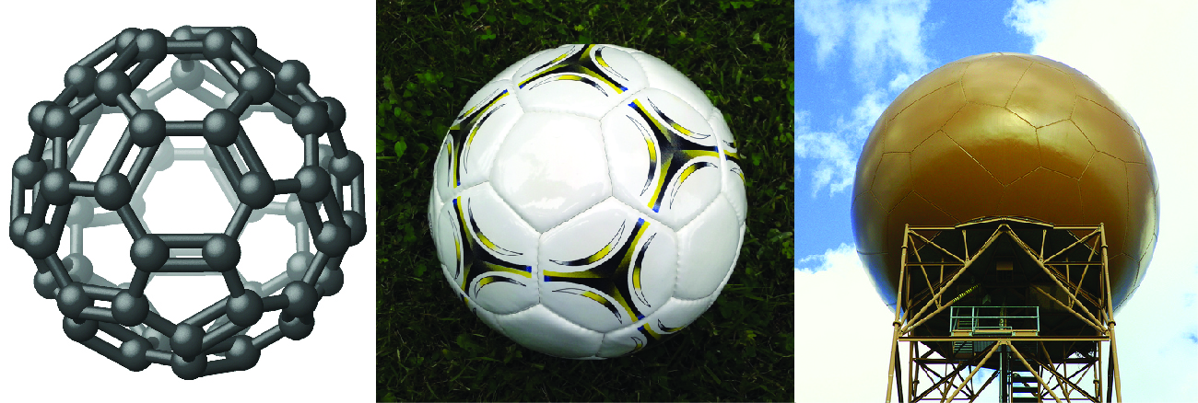
Figure 6.1 Nicknamed “buckyballs,” buckminsterfullerene molecules (C60) contain only carbon atoms (left) arranged to form a geometric framework of hexagons and pentagons, similar to the pattern on a soccer ball (center). This molecular structure is named after architect R. Buckminster Fuller, whose innovative designs combined simple geometric shapes to create large, strong structures such as this weather radar dome near Tucson, Arizona (right). (credit middle: modification of work by “Petey21”/Wikimedia Commons; credit right: modification of work by Bill Morrow)

It has long been known that pure carbon occurs in different forms (allotropes) including graphite and diamonds. But it was not until 1985 that a new form of carbon was recognized: buckminsterfullerene. This molecule was named after the architect and inventor R. Buckminster Fuller (1895–1983), whose signature architectural design was the geodesic dome, characterized by a lattice shell structure supporting a spherical surface. Experimental evidence revealed the formula, C60, and then scientists determined how 60 carbon atoms could form one symmetric, stable molecule. They were guided by bonding theory—the topic of this chapter—which explains how individual atoms connect to form more complex structures.
BLANK PAGE

6.1 Lewis Model

Learning Objectives
- Write Lewis dot structure for atom, ionic compounds, and molecular compounds, including those that exhibit resonance and those that violate the octet rule
- Be able to explain what is meant by the term resonance
- Be able to recognize molecules that exhibit resonance
- Be able to recognize molecules that violate the octet rule
- Be able to calculate formal charge for each atom in a molecule or ion
- Be able to use formal charge to determine which of several Lewis structures is “best”
- Be able to state the relationship between bond order, bond length, and bond strength

Lewis Dot Structure of Atoms
We use Lewis symbols to describe valence electron configurations of atoms and monatomic ions. A Lewis symbol consists of an elemental symbol surrounded by one dot for each of its valence electrons:
Figure 6.2 The Lewis symbol for the element, calcium (Ca).
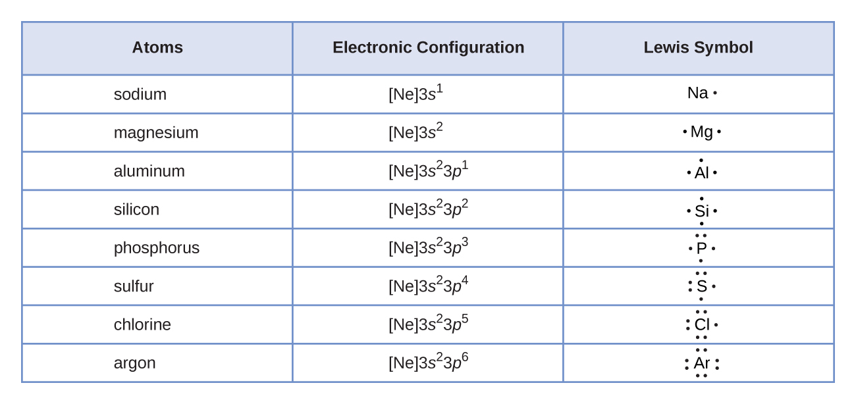
Figure 6.3 Lewis symbols illustrating the number of valence electrons for each element in the third period of the periodic table.

Lewis Dot Structure of Ionic Compounds

Lewis symbols can also be used to illustrate the formation of cations from atoms, as shown here for sodium and calcium:

Likewise, they can be used to show the formation of anions from atoms, as shown here for chlorine and sulfur:

Figure 6.4 demonstrates the use of Lewis symbols to show the transfer of electrons during the formation of ionic compounds.
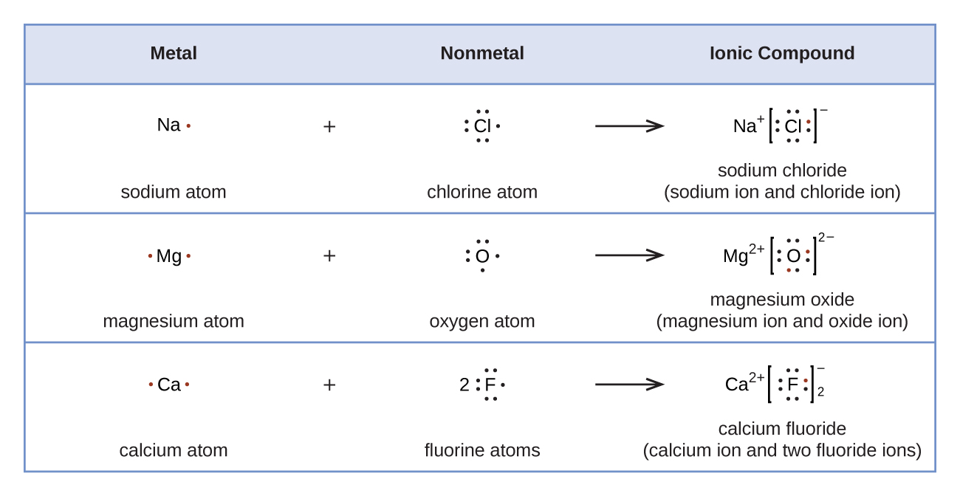
Figure 6.5 Cations are formed when atoms lose electrons, represented by fewer Lewis dots, whereas anions are formed by atoms gaining electrons. The total number of electrons does not change.

Lewis Dot Structures of Molecular Compounds

We also use Lewis symbols to indicate the formation of covalent bonds, which are shown in Lewis structures, drawings that describe the bonding in molecules and polyatomic ions. For example, when two chlorine atoms form a chlorine molecule, they share one pair of electrons:
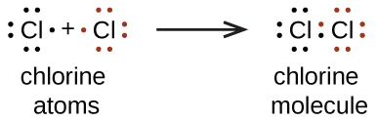

The Lewis structure indicates that each Cl atom has three pairs of electrons that are not used in bonding (called lone pairs) and one shared pair of electrons (written between the atoms). A dash (or line) is sometimes used to indicate a shared pair of electrons:

A single shared pair of electrons is called a single bond. Each Cl atom interacts with eight valence electrons: the six in the lone pairs and the two in the single bond.

The Octet Rule

The other halogen molecules (F₂, Br₂, I₂, and At₂) form bonds like those in the chlorine molecule: one single bond between atoms and three lone pairs of electrons per atom. This allows each halogen atom to have a noble gas electron configuration. The tendency of main group atoms to form enough bonds to obtain eight valence electrons is known as the octet rule.

The number of bonds that an atom can form can often be predicted from the number of electrons needed to reach an octet (eight valence electrons); this is especially true of the nonmetals of the second period of the periodic table (C, N, O, and F). For example, each atom of a group 14 element has four electrons in its outermost shell and therefore requires four more electrons to reach an octet. These four electrons can be gained by forming four covalent bonds, as illustrated here for carbon in CCl₄ (carbon tetrachloride) and silicon in SiH₄ (silane). Because hydrogen only needs two electrons to fill its valence shell, it is an exception to the octet rule. The transition elements and inner transition elements also do not follow the octet rule:
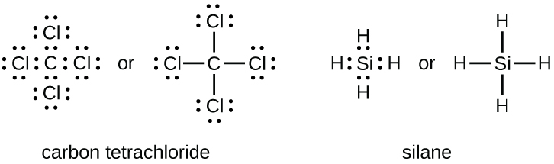

Group 15 elements such as nitrogen have five valence electrons in the atomic Lewis symbol: one lone pair and three unpaired electrons. To obtain an octet, these atoms form three covalent bonds, as in NH₃ (ammonia). Oxygen and other atoms in group 16 obtain an octet by forming two covalent bonds:
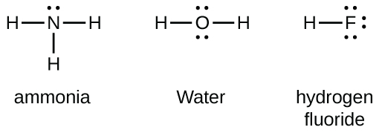

Double and Triple Bonds

As previously mentioned, when a pair of atoms shares one pair of electrons, we call this a single bond. However, a pair of atoms may need to share more than one pair of electrons in order to achieve the requisite octet. A double bond forms when two pairs of electrons are shared between a pair of atoms, as between the carbon and oxygen atoms in CH₂O (formaldehyde) and between the two carbon atoms in C₂H₄ (ethylene):

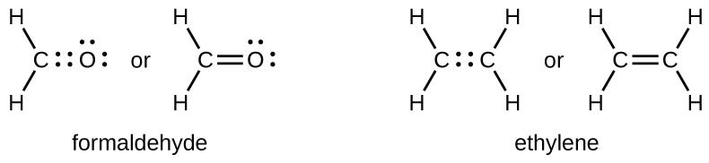

A triple bond forms when three electron pairs are shared by a pair of atoms, as in carbon monoxide (CO) and the cyanide ion (CN–):

Writing Lewis Structures with the Octet Rule

For very simple molecules and molecular ions, we can write the Lewis structures by merely pairing up the unpaired electrons on the constituent atoms. See these examples:

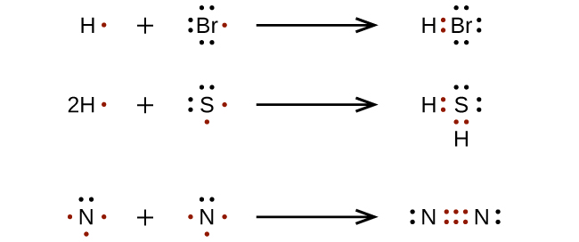

For more complicated molecules and molecular ions, it is helpful to follow the step-by-step procedure outlined here:

- Determine the total number of valence (outer shell) electrons. For cations, subtract one electron for each positive charge. For anions, add one electron for each negative charge.
- Draw a skeleton structure of the molecule or ion, arranging the atoms around a central atom. (Generally, the least electronegative element should be placed in the center.) Connect each atom to the central atom with a single bond (one electron pair).
- Distribute the remaining electrons as lone pairs on the terminal atoms (except hydrogen), completing an octet around each atom.
- Place all remaining electrons on the central atom.
- Rearrange the electrons of the outer atoms to make multiple bonds with the central atom in order to obtain octets wherever possible.

Let us determine the Lewis structures of SiH₄, CHO₂⁻, NO⁺, and OF₂ as examples in following this procedure:
- Determine the total number of valence (outer shell) electrons in the molecule or ion.
  - For a molecule, we add the number of valence electrons on each atom in the molecule:
SiH₄ Si: 4 valence electrons/atom
H: 1 valence electron/atom
Total valence electrons = (4x1) + (1x4) = 8 valence electrons
  - For a negative ion, such as CHO₂⁻, we add the number of valence electrons on the atoms to the number of negative charges on the ion (one electron is gained for each single negative charge):
CHO₂⁻ C: 4 valence electrons/atom
H: 1 valence electron/atom
O: 6 valence electrons/atom
+1 additional electron
Total valence electrons = (4x1) + (1x1) + (6x2) + 1 = 18 valence electrons
  - For a positive ion, such as NO⁺, we add the number of valence electrons on the atoms in the ion and then subtract the number of positive charges on the ion (one electron is lost for each single positive charge) from the total number of valence electrons:
NO⁺ N: 5 valence electrons/atom
O: 6 valence electron/atom
-1 lost electron
Total valence electrons = (5x1) + (6x1) - 1 = 10 valence electrons
  - Since OF₂ is a neutral molecule, we simply add the number of valence electrons:
OF₂ O: 6 valence electrons/atom
F: 7 valence electron/atom
Total valence electrons = (6x1) + (7x2) = 20 valence electrons

- Draw a skeleton structure of the molecule or ion, arranging the atoms around a central atom and connecting each atom to the central atom with a single (one electron pair) bond. (Note that we denote ions with brackets around the structure, indicating the charge outside the brackets:)
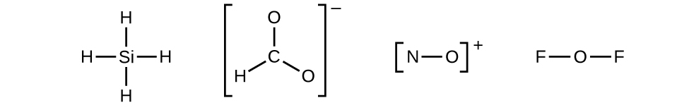
When several arrangements of atoms are possible, as for CHO₂⁻, we must use experimental evidence to choose the correct one. In general, the less electronegative elements are more likely to be central atoms. In CHO₂⁻, the less electronegative carbon atom occupies the central position with the oxygen and hydrogen atoms surrounding it. Other examples include P in POCl₃, S in SO₂, and Cl in ClO₄⁻. An exception is that hydrogen is almost never a central atom. As the most electronegative element, fluorine also cannot be a central atom.

- Distribute the remaining electrons as lone pairs on the terminal atoms (except hydrogen) to complete their valence shells with an octet of electrons.
  - There are no remaining electrons on SiH4, so it is unchanged:
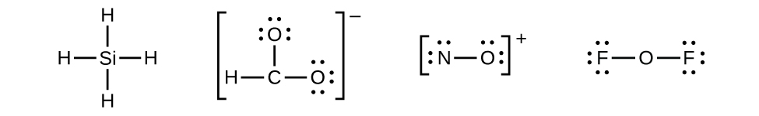

- Place all remaining electrons on the central atom.
  - For SiH₄, CHO₂⁻, and NO⁺, there are no remaining electrons; we already placed all of the electrons determined in Step 1.

  - For OF₂, we had 16 electrons remaining in Step 3, and we placed 12, leaving 4 to be placed on the central atom:

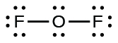
- Rearrange the electrons of the outer atoms to make multiple bonds with the central atom in order to obtain octets wherever possible.
  - SiH₄: Si already has an octet, so nothing needs to be done.
  - CHO₂⁻: We have distributed the valence electrons as lone pairs on the oxygen atoms, but the carbon atom lacks an octet:
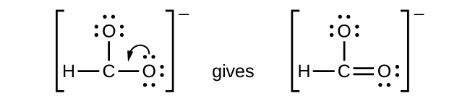
  - NO⁺: For this ion, we added eight valence electrons, but neither atom has an octet. We cannot add any more electrons since we have already used the total that we found in Step 1, so we must move electrons to form a multiple bond:
  - This still does not produce an octet, so we must move another pair, forming a triple bond:
  - In OF₂, each atom has an octet as drawn, so nothing changes.

Formal Charge
The formal charge of an atom in a molecule is the hypothetical charge the atom would have if we could redistribute the electrons in the bonds evenly between the atoms. Another way of saying this is that formal charge results when we take the number of valence electrons of a neutral atom, subtract the nonbonding electrons, and then subtract the number of bonds connected to that atom in the Lewis structure. Thus, we calculate formal charge as follows:

F.C. = # valence electrons. (free atom) − # lone pair electrons − # bonds

We must remember that the formal charge calculated for an atom is not the actual charge of the atom in the molecule. Formal charge is only a useful bookkeeping procedure; it does not indicate the presence of actual charges.

Formal Charge of Neutral Molecules
Formal charges of each atom can be assigned from the complete Lewis dot structure. For a neutral molecule, the sum of the formal charges must equal zero.

Let’s consider the molecule BrCl₃. The complete Lewis dot structure of BrCl₃ is shown below.
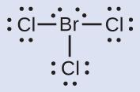

F.C. of Br = 7 - 4 - 3 = 0

F.C. of Cl = 7 - 6 - 1 = 0

All atoms in BrCl₃ have a formal charge of zero, and the sum of the formal charges totals zero, as it must in a neutral molecule.

Formal Charge of Ions
For an ion, the sum of the formal charges must equal charge of the ion.

Let’s consider the ICl₄⁻ ion. The complete Lewis dot structure of ICl₄⁻ is shown below.
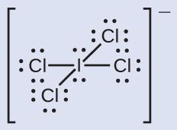

F.C. of I = 7 - 4 - 4 = -1

F.C. of Cl = 7 - 6 - 1 = 0

The sum of the formal charges of all atoms in ICl₄⁻ equals -1, as it must equal to charge of the ion.

Using Formal Charge to Predict Molecular Structure
The arrangement of atoms in a molecule or ion is called its molecular structure. In many cases, following the steps for writing Lewis structures may lead to more than one possible molecular structure—different multiple bond and lone-pair electron placements or different arrangements of atoms, for instance. A few guidelines involving formal charge can be helpful in deciding which of the possible structures is most likely for a particular molecule or ion:
- A molecular structure in which all formal charges are zero is preferable to one in which some formal charges are not zero.
- If the Lewis structure must have nonzero formal charges, the arrangement with the smallest nonzero formal charges is preferable.
- Lewis structures are preferable when adjacent formal charges are zero or of the opposite sign.
- When we must choose among several Lewis structures with similar distributions of formal charges, the structure with the negative formal charges on the more electronegative atoms is preferable.

To see how these guidelines apply, let us consider some possible structures for carbon dioxide, CO₂. We know from our previous discussion that the less electronegative atom typically occupies the central position, but formal charges allow us to understand why this occurs. We can draw three possibilities for the structure: carbon in the center and double bonds, carbon in the center with a single and triple bond, and oxygen in the center with double bonds:

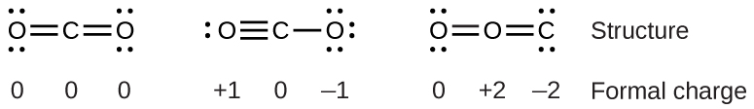

Comparing the three formal charges, we can definitively identify the structure on the left as preferable because it has only formal charges of zero (Guideline 1).

As another example, the thiocyanate ion, an ion formed from a carbon atom, a nitrogen atom, and a sulfur atom, could have three different molecular structures: NCS–, CNS–, or CSN–. The formal charges present in each of these molecular structures can help us pick the most likely arrangement of atoms. Possible Lewis structures and the formal charges for each of the three possible structures for the thiocyanate ion are shown here:

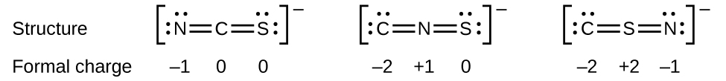

Note that the sum of the formal charges in each case is equal to the charge of the ion (–1). However, the first arrangement of atoms is preferred because it has the lowest number of atoms with nonzero formal charges (Guideline 2). Also, it places the least electronegative atom in the center, and the negative charge on the more electronegative element (Guideline 4).

Resonance

Resonance structures are two or more Lewis structures with the same arrangement of atoms can be written for a molecule or ion. We call the individual Lewis structures resonance forms. A double-headed arrow between Lewis structures indicates that they are resonance forms.

Notice that the more likely structure for the nitrite anion (see below) may actually be drawn in two different ways, distinguished by the locations of the N-O and N=O bonds:

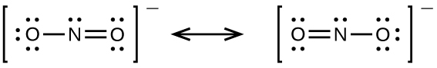

If nitrite ions do indeed contain a single and a double bond, we would expect for the two bond lengths to be different. A double bond between two atoms is shorter (and stronger) than a single bond between the same two atoms. Experiments show, however, that both N–O bonds in NO₂⁻ have the same strength and length, and are identical in all other properties. The actual distribution of electrons in each of the nitrogen-oxygen bonds in NO₂⁻ is the average of a double bond and a single bond. The actual electronic structure of the molecule (the average of the resonance forms) is called a resonance hybrid of the individual resonance forms.

We should remember that a molecule described as a resonance hybrid never possesses an electronic structure described by either resonance form. It does not fluctuate between resonance forms; rather, the actual electronic structure is always the average of that shown by all resonance forms.

The carbonate anion, CO₃²⁻, provides a second example of resonance:

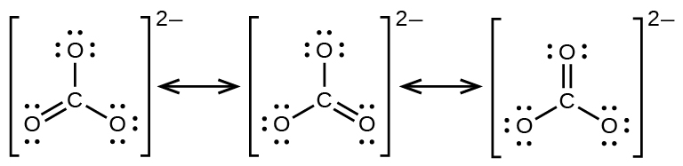

One oxygen atom must have a double bond to carbon to complete the octet on the central atom. All oxygen atoms, however, are equivalent, and the double bond could form from any one of the three atoms. This gives rise to three resonance forms of the carbonate ion. Because we can write three identical resonance structures, we know that the actual arrangement of electrons in the carbonate ion is the average of the three structures. Again, experiments show that all three C–O bonds are exactly the same.

Exceptions to the Octet Rule

Many covalent molecules have central atoms that do not have eight electrons in their Lewis structures. These molecules fall into three categories:

- Odd-electron molecules have an odd number of valence electrons, and therefore have an unpaired electron.
- Electron-deficient molecules have a central atom that has fewer electrons than needed for a noble gas configuration.
- Hypervalent molecules have a central atom that has more electrons than needed for a noble gas configuration.

Odd-electron Molecules
We call molecules that contain an odd number of electrons free radicals. Nitric oxide, NO, is an example of an odd-electron molecule; it is produced in internal combustion engines when oxygen and nitrogen react at high temperatures.

To draw the Lewis structure for an odd-electron molecule like NO, we follow the same five steps we would for other molecules, but with a few minor changes:

- Determine the total number of valence (outer shell) electrons. The sum of the valence electrons is 5 (from N) + 6 (from O) = 11. The odd number immediately tells us that we have a free radical, so we know that not every atom can have eight electrons in its valence shell.
- Draw a skeleton structure of the molecule. We can easily draw a skeleton with an N–O single bond: N–O
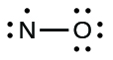
- Distribute the remaining electrons as lone pairs on the terminal atoms. In this case, there is no central atom, so we distribute the electrons around both atoms. We give eight electrons to the more electronegative atom in these situations; thus oxygen has the filled valence shell:
- Place all remaining electrons on the central atom. Since there are no remaining electrons, this step does not apply.
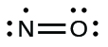
- Rearrange the electrons to make multiple bonds with the central atom in order to obtain octets wherever possible. We know that an odd-electron molecule cannot have an octet for every atom, but we want to get each atom as close to an octet as possible. In this case, nitrogen has only five electrons around it. To move closer to an octet for nitrogen, we take one of the lone pairs from oxygen and use it to form a NO double bond. (We cannot take another lone pair of electrons on oxygen and form a triple bond because nitrogen would then have nine electrons:)

Incomplete Octet: Electron-deficient Molecules
We will also encounter a few molecules that contain central atoms that do not have a filled valence shell. Generally, these are molecules with central atoms from groups 2 and 13, outer atoms that are hydrogen, or other atoms that do not form multiple bonds.

For example, in the Lewis structures of beryllium dihydride, BeH₂, and boron trifluoride, BF₃, the beryllium and boron atoms each have only four and six electrons, respectively. It is possible to draw a structure with a double bond between a boron atom and a fluorine atom in BF₃, satisfying the octet rule, but experimental evidence indicates the bond lengths are closer to that expected for B–F single bonds. This suggests the best Lewis structure has three B–F single bonds and an electron deficient boron. The reactivity of the compound is also consistent with an electron deficient boron. However, the B–F bonds are slightly shorter than what is actually expected for B–F single bonds, indicating that some double bond character is found in the actual molecule.

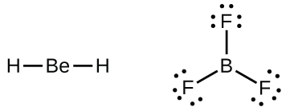

An atom like the boron atom in BF₃, which does not have eight electrons, is very reactive. It readily combines with a molecule containing an atom with a lone pair of electrons. For example, NH₃ reacts with BF₃ because the lone pair on nitrogen can be shared with the boron atom:

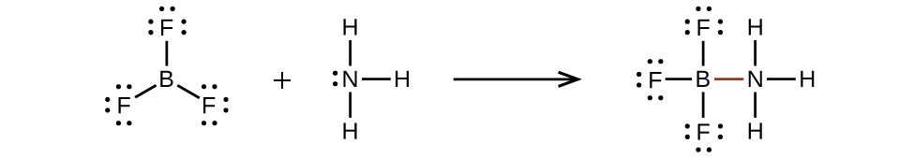

Expanded Octet: Hypervalent Molecules
Elements in the second period of the periodic table (n = 2) can accommodate only eight electrons in their valence shell orbitals because they have only four valence orbitals (one 2s and three 2p orbitals). Elements in the third and higher periods (n ≥ 3) have more than four valence orbitals and can share more than four pairs of electrons with other atoms because they have empty d orbitals in the same shell. Molecules formed from these elements are sometimes called hypervalent molecules. Below shows the Lewis structures for two hypervalent molecules, PCl₅ and SF₆.

In PCl₅, the central atom phosphorus shares five pairs of electrons. In SF₆, sulfur shares six pairs of electrons.

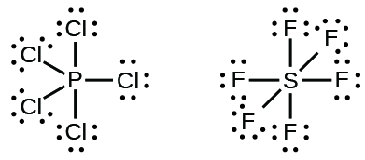

In some hypervalent molecules, such as IF₅ and XeF₄, some of the electrons in the outer shell of the central atom are lone pairs:

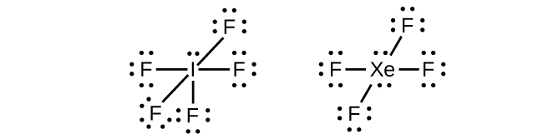

When we write the Lewis structures for these molecules, we find that we have electrons left over after filling the valence shells of the outer atoms with eight electrons. These additional electrons must be assigned to the central atom.

6.2 Valence Shell Electron Pair Repulsion Theory

Learning Objectives
- Be able to explain what VSEPR theory is and what it based on
- Be able to use VSEPR theory to determine electron-domain and molecular geometries of molecules and ions
- Know the bond angles associated with the five electron-domain geometries and be able to explain how the presence of one or more lone pairs in a molecule or ion will change the bond angles
- Be able to determine whether or not a molecule or ion is polar by using molecular geometries and bond dipole moments

Introduction
Thus far, we have used two-dimensional Lewis structures to represent molecules. However, molecular structure is actually three-dimensional, and it is important to be able to describe molecular bonds in terms of their distances, angles, and relative arrangements in space (Figure 6.6). A bond angle is the angle between any two bonds that include a common atom, usually measured in degrees. A bond distance (or bond length) is the distance between the nuclei of two bonded atoms along the straight line joining the nuclei. Bond distances are measured in Ångstroms (1 Å = 10–10 m) or picometers (1 pm = 10–12m, 100 pm = 1 Å).
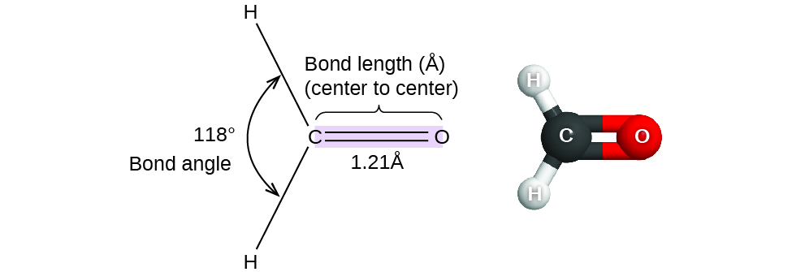

Figure 6.6 Bond distances (lengths) and angles are shown for the formaldehyde molecule, H₂CO.

VSEPR Theory
Valence shell electron-pair repulsion theory (VSEPR theory) enables us to predict the molecular structure, including approximate bond angles around a central atom, of a molecule from an examination of the number of bonds and lone electron pairs in its Lewis structure. The VSEPR model assumes that electron pairs in the valence shell of a central atom will adopt an arrangement that minimizes repulsions between these electron pairs by maximizing the distance between them. The electrons in the valence shell of a central atom form either bonding pairs of electrons, located primarily between bonded atoms, or lone pairs. The electrostatic repulsion of these electrons is reduced when the various regions of high electron density assume positions as far from each other as possible.

VSEPR theory predicts the arrangement of electron pairs around each central atom and, usually, the correct arrangement of atoms in a molecule. We should understand, however, that the theory only considers electron-pair repulsions. Other interactions, such as nuclear-nuclear repulsions and nuclear-electron attractions, are also involved in the final arrangement that atoms adopt in a particular molecular structure.

As a simple example of VSEPR theory, let us predict the structure of a gaseous BeF₂ molecule. The Lewis structure of BeF₂ (Figure 6.7) shows only two electron pairs around the central beryllium atom. With two bonds and no lone pairs of electrons on the central atom, the bonds are as far apart as possible, and the electrostatic repulsion between these regions of high electron density is reduced to a minimum when they are on opposite sides of the central atom. The bond angle is 180° (Figure 6.7).

Figure 6.7 The BeF₂ molecule adopts a linear structure in which the two bonds are as far apart as possible, on opposite sides of the Be atom.

Electron-Domain or Electron-Pair Geometry

Figure 6.8 below illustrates this and other electron-pair geometries that minimize the repulsions among regions of high electron density (bonds and/or lone pairs). The regions of high electron density are also called electron domains. Two regions of electron density around a central atom in a molecule form a linear geometry; three regions form a trigonal planar geometry; four regions form a tetrahedral geometry; five regions form a trigonal bipyramidal geometry; and six regions form an octahedral geometry.

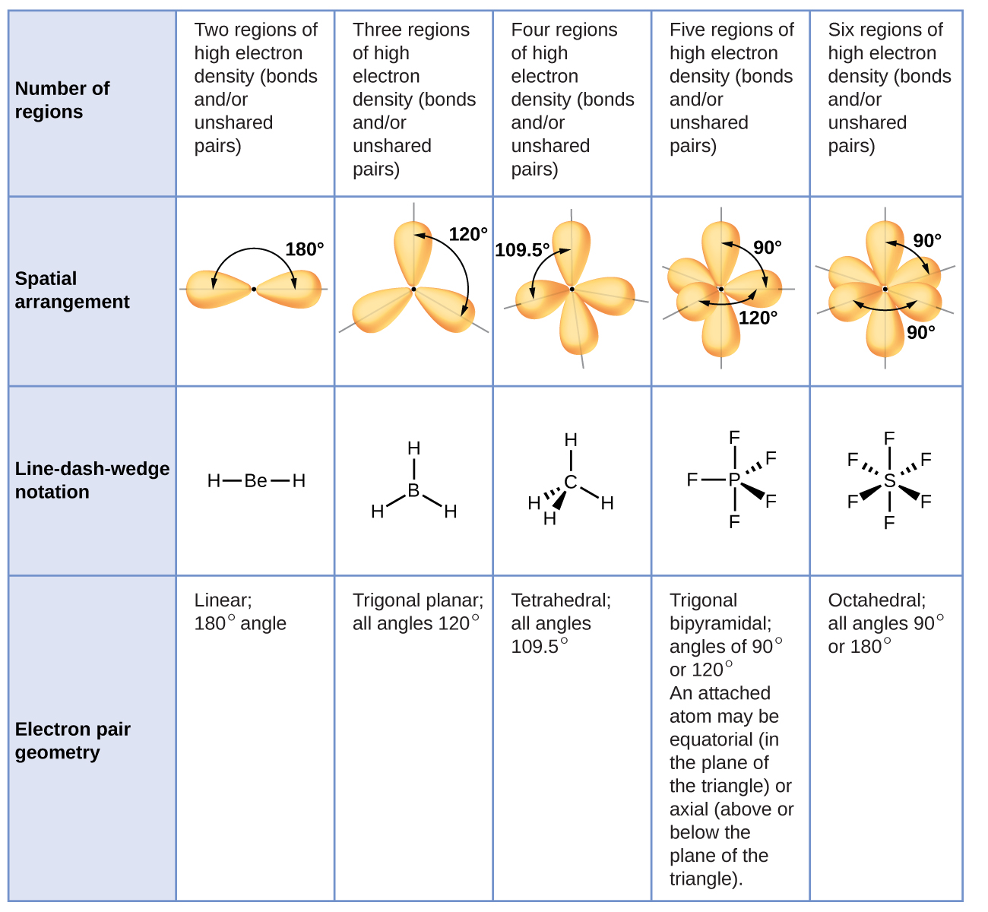

Figure 6.8 The basic electron-pair geometries predicted by VSEPR theory maximize the space around any region of electron density (bonds or lone pairs) or electron domains.

Molecular Geometry

It is important to note that electron-domain geometry around a central atom is not the same thing as its molecular geometry. The electron-domain geometries shown in Figure 6.8 describe all regions where electrons are located, bonds as well as lone pairs. Molecular geometry describes the location of the atoms, not the electrons.

We differentiate between these two situations by naming the geometry that includes all electron pairs the electron-pair or electron-domain geometry. The structure that includes only the placement of the atoms in the molecule is called the molecular geometry. The electron-domain geometries will be the same as the molecular geometry when there are no lone electron pairs around the central atom, but they will be different when there are lone pairs present on the central atom.

For example, the methane molecule, CH₄, which is the major component of natural gas, has four bonding pairs of electrons around the central carbon atom; the electron-pair geometry is tetrahedral, as is the molecular structure (Figure 6.9). On the other hand, the ammonia molecule, NH₃, also has four electron pairs associated with the nitrogen atom, and thus has a tetrahedral electron-pair geometry. One of these regions, however, is a lone pair, which is not included in the molecular structure, and this lone pair influences the shape of the molecule (Figure 6.10).

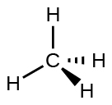

Figure 6.9 The molecular structure of the methane molecule, CH₄, is shown with a tetrahedral arrangement of the hydrogen atoms. VSEPR structures like this one are often drawn using the wedge and dash notation, in which solid lines represent bonds in the plane of the page, solid wedges represent bonds coming up out of the plane, and dashed lines represent bonds going down into the plane.
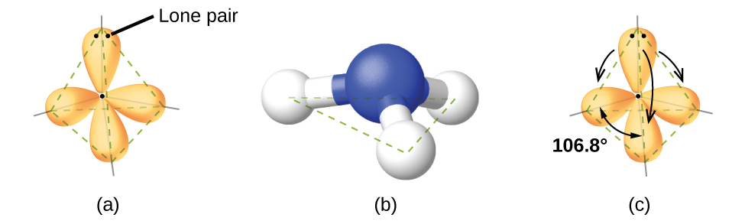
Figure 6.10 (a) The electron-domain geometry for the ammonia molecule is tetrahedral with one lone pair and three single bonds. (b) The trigonal pyramidal molecular geometry is determined from the electron-domain geometry. (c) The actual bond angles deviate slightly from the idealized angles because the lone pair takes up a larger region of space than do the single bonds, causing the HNH angle to be slightly smaller than 109.5°.

As seen in Figure 6.10, small distortions from the ideal angles in Figure 6.8 can result from differences in repulsion between various regions of electron density. VSEPR theory predicts these distortions by establishing an order of repulsions and an order of the amount of space occupied by different kinds of electron pairs. The order of electron-pair repulsions from greatest to least repulsion is:

lone pair-lone pair > lone pair-bonding pair > bonding pair-bonding pair

This order of repulsions determines the amount of space occupied by different regions of electrons. A lone pair of electrons occupies a larger region of space than the electrons in a triple bond; in turn, electrons in a triple bond occupy more space than those in a double bond, and so on. The order of sizes from largest to smallest is:

lone pair > triple bond > double bond > single bond

Consider formaldehyde, H₂CO, which is used as a preservative for biological and anatomical specimens (Figure 6.6). This molecule has regions of high electron density that consist of two single bonds and one double bond. The basic geometry is trigonal planar with 120° bond angles, but we see that the double bond causes slightly larger angles (121°), and the angle between the single bonds is slightly smaller (118°).

In the ammonia molecule, the three hydrogen atoms attached to the central nitrogen are not arranged in a flat, trigonal planar molecular structure, but rather in a three-dimensional trigonal pyramid (Figure 6.10) with the nitrogen atom at the apex and the three hydrogen atoms forming the base. The ideal bond angles in a trigonal pyramid are based on the tetrahedral electron domain geometry. Again, there are slight deviations from the ideal because lone pairs occupy larger regions of space than do bonding electrons. The H–N–H bond angles in NH₃ are slightly smaller than the 109.5° angle in a regular tetrahedron (Figure 6.8) because the lone pair-bonding pair repulsion is greater than the bonding pair-bonding pair repulsion (Figure 6.10).
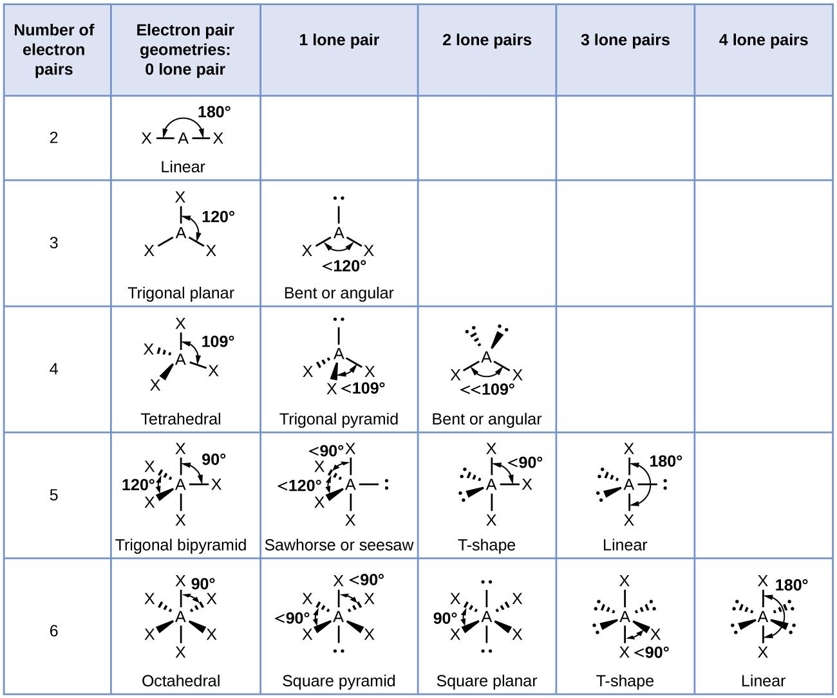
Figure 6.11 The molecular structures are identical to the electron-pair geometries when there are no lone pairs present (first column). For a particular number of electron pairs (row), the molecular structures for one or more lone pairs are determined based on modifications of the corresponding electron-pair geometry.
According to VSEPR theory, the terminal atom locations (Xs in Figure 6.11) are equivalent within the linear, trigonal planar, and tetrahedral electron-domain geometries (the first three rows of the table). It does not matter which X is replaced with a lone pair because the molecules can be rotated to convert positions. For trigonal bipyramidal electron-domain geometries, however, there are two distinct X positions, as shown in Figure 6.12: an axial position (if we hold a model of a trigonal bipyramid by the two axial positions, we have an axis around which we can rotate the model) and an equatorial position (three positions form an equator around the middle of the molecule). As shown in Figure 6.11, the axial position is surrounded by bond angles of 90°, whereas the equatorial position has more space available because of the 120° bond angles. In a trigonal bipyramidal electron-pair geometry, lone pairs always occupy equatorial positions because these more spacious positions can more easily accommodate the larger lone pairs.

Theoretically, we can come up with three possible arrangements for the three bonds and two lone pairs for the ClF₃ molecule (Figure 6.12). The stable structure is the one that puts the lone pairs in equatorial locations, giving a T-shaped molecular structure.

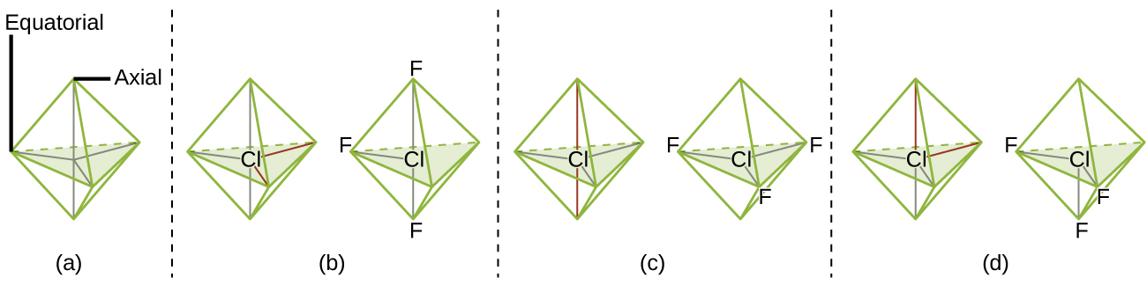
Figure 6.12 (a) In a trigonal bipyramid, the two axial positions are located directly across from one another, whereas the three equatorial positions are located in a triangular arrangement. (b–d) The two lone pairs (red lines) in ClF3 have several possible arrangements, but the T-shaped molecular structure (b) is the one actually observed, consistent with the larger lone pairs both occupying equatorial positions.

When a central atom has two lone electron pairs and four bonding regions, we have an octahedral electron-pair geometry. The two lone pairs are on opposite sides of the octahedron (180° apart), giving a square planar molecular structure that minimizes lone pair-lone pair repulsions (Figure 6.11).

Predicting Electron-Domain Geometry and Molecular Geometry
The following procedure uses VSEPR theory to determine the electron pair geometries and the molecular structures:
- Write the Lewis structure of the molecule or polyatomic ion.
- Count the number of regions of electron density (lone pairs and bonds) around the central atom. A single, double, or triple bond counts as one region of electron density.
- Identify the electron-pair geometry based on the number of regions of electron density: linear, trigonal planar, tetrahedral, trigonal bipyramidal, or octahedral (Figure 6.11, first column).
- Use the number of lone pairs to determine the molecular structure (Figure 6.11). If more than one arrangement of lone pairs and chemical bonds is possible, choose the one that will minimize repulsions, remembering that lone pairs occupy more space than multiple bonds, which occupy more space than single bonds. In trigonal bipyramidal arrangements, repulsion is minimized when every lone pair is in an equatorial position. In an octahedral arrangement with two lone pairs, repulsion is minimized when the lone pairs are on opposite sides of the central atom.
The following examples illustrate the use of VSEPR theory to predict the molecular geometry of molecules or ions. First, let’s consider the Lewis structure of BCl₃ as:

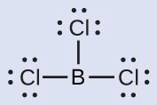

Thus we see that BCl₃ contains three bonds, and there are no lone pairs of electrons on boron. The arrangement of three regions of high electron density gives a trigonal planar electron-pair geometry. The B–Cl bonds lie in a plane with 120° angles between them. BCl3 also has a trigonal planar molecular structure (Figure 6.13).
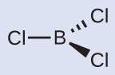
Figure 6.13 The electron-pair geometry and molecular structure of BCl₃ are both trigonal planar. Note that the VSEPR geometry indicates the correct bond angles (120°), unlike the Lewis structure shown above.

Ammonium nitrate and ammonium sulfate, both used as fertilizers, contain the ammonium ion. To predict the electron-domain geometry and molecular geometry of the NH₄⁺ cation, first let’s consider the Lewis structure of NH₄⁺ as:
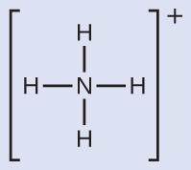

We can see that NH₄⁺ contains four bonds from the nitrogen atom to hydrogen atoms and no lone pairs. We expect the four regions of high electron density to arrange themselves so that they point to the corners of a tetrahedron with the central nitrogen atom in the middle (Figure 6.11). Therefore, the electron pair geometry of NH₄⁺ is tetrahedral, and the molecular structure is also tetrahedral (Figure 6.14).

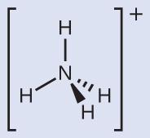

Figure 6.14 The ammonium ion displays a tetrahedral electron-pair geometry as well as a tetrahedral molecular structure.
Sulfur tetrafluoride, SF₄, is extremely valuable for the preparation of fluorine-containing compounds used as herbicides (i.e., SF₄ is used as a fluorinating agent). To predict the electron-domain geometry and molecular geometry of the SF₄, first let’s consider the Lewis structure of SF₄ as:

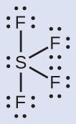

We expect these five regions to adopt a trigonal bipyramidal electron-pair geometry. To minimize lone pair repulsions, the lone pair occupies one of the equatorial positions. The molecular structure (Figure 6.15) is that of a seesaw (Figure 6.11).

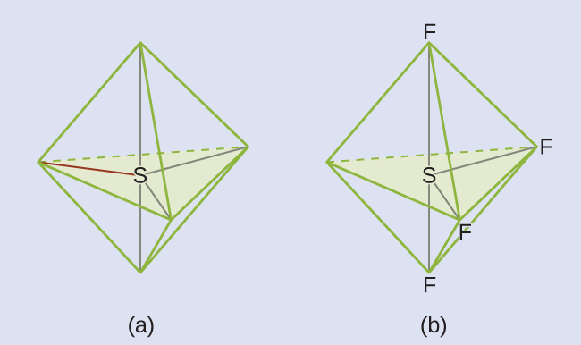

Figure 6.15 (a) SF₄ has a trigonal bipyramidal arrangement of the five regions of electron density. (b) One of the regions is a lone pair, which results in a seesaw-shaped molecular structure.

Molecular Structure for Multicenter Molecules
When a molecule or polyatomic ion has only one central atom, the molecular structure completely describes the shape of the molecule. Larger molecules do not have a single central atom, but are connected by a chain of interior atoms that each possess a “local” geometry. The way these local structures are oriented with respect to each other also influences the molecular shape, but such considerations are largely beyond the scope of this introductory discussion. For our purposes, we will only focus on determining the local structures.

The Lewis structure for the simplest amino acid, glycine, H₂NCH₂CO₂H, is shown here. To predict the local geometry for the nitrogen atom, the two carbon atoms, and the oxygen atom with a hydrogen atom attached, first consider the Lewis structure of glycine below:
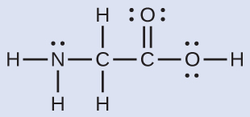
Consider each central atom independently. The electron-domain geometries:
- nitrogen––four regions of electron density; tetrahedral
- carbon (CH₂)––four regions of electron density; tetrahedral
- carbon (CO₂)—three regions of electron density; trigonal planar
- oxygen (OH)—four regions of electron density; tetrahedral
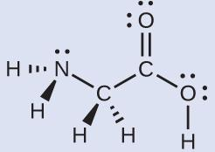
The local molecular geometries:
- nitrogen––three bonds, one lone pair; trigonal pyramidal
- carbon (CH₂)—four bonds, no lone pairs; tetrahedral
- carbon (CO₂)—three bonds (double bond counts as one bond), no lone pairs; trigonal planar
- oxygen (OH)—two bonds, two lone pairs; bent (109°)

Molecular Polarity and Dipole Moment
As discussed previously, polar covalent bonds connect two atoms with differing electronegativities, leaving one atom with a partial positive charge (δ+) and the other atom with a partial negative charge (δ–), as the electrons are pulled toward the more electronegative atom. This separation of charge gives rise to a bond dipole moment. The magnitude of a bond dipole moment is represented by the Greek letter mu (µ) and is given by the formula shown here, where Q is the magnitude of the partial charges (determined by the electronegativity difference) and r is the distance between the charges:

μ = Q·r

This bond moment can be represented as a vector, a quantity having both direction and magnitude (Figure 6.16). Dipole vectors are shown as arrows pointing along the bond from the less electronegative atom toward the more electronegative atom. A small plus sign is drawn on the less electronegative end to indicate the partially positive end of the bond. The length of the arrow is proportional to the magnitude of the electronegativity difference between the two atoms.
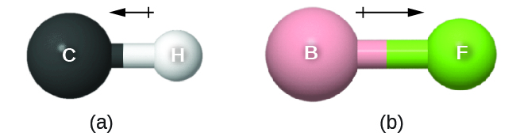
Figure 6.16 (a) There is a small difference in electronegativity between C and H, represented as a short vector. (b) The electronegativity difference between B and F is much larger, so the vector representing the bond moment is much longer.

A whole molecule may also have a separation of charge, depending on its molecular structure and the polarity of each of its bonds. If such a charge separation exists, the molecule is said to be a polar molecule (or dipole); otherwise the molecule is said to be nonpolar. The dipole moment measures the extent of net charge separation in the molecule as a whole. We determine the dipole moment by adding the bond moments in three-dimensional space, taking into account the molecular structure.
For diatomic molecules, there is only one bond, so its bond dipole moment determines the molecular polarity. Homonuclear diatomic molecules such as Br₂ and N₂ have no difference in electronegativity, so their dipole moment is zero. For heteronuclear molecules such as CO, there is a small dipole moment. For HF, there is a larger dipole moment because there is a larger difference in electronegativity.

When a molecule contains more than one bond, the geometry must be taken into account. If the bonds in a molecule are arranged such that their bond moments cancel (vector sum equals zero), then the molecule is nonpolar. This is the situation in CO₂ (Figure 6.17). Each of the bonds is polar, but the molecule as a whole is nonpolar. From the Lewis structure, and using VSEPR theory, we determine that the CO₂ molecule is linear with polar C=O bonds on opposite sides of the carbon atom. The bond moments cancel because they are pointed in opposite directions. In the case of the water molecule (Figure 6.17), the Lewis structure again shows that there are two bonds to a central atom, and the electronegativity difference again shows that each of these bonds has a nonzero bond moment. In this case, however, the molecular structure is bent because of the lone pairs on O, and the two bond moments do not cancel. Therefore, water does have a net dipole moment and is a polar molecule (dipole).
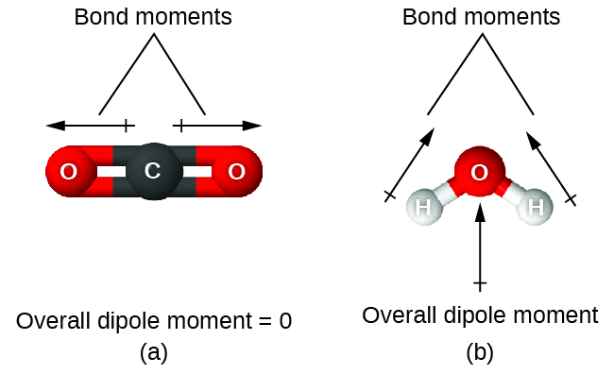
Figure 6.17 The overall dipole moment of a molecule depends on the individual bond dipole moments and how they are arranged. (a) Each CO bond has a bond dipole moment, but they point in opposite directions so that the net CO₂ molecule is nonpolar. (b) In contrast, water is polar because the OH bond moments do not cancel out.
The OCS molecule has a structure similar to CO₂, but a sulfur atom has replaced one of the oxygen atoms. To determine if this molecule is polar, we draw the molecular structure. VSEPR theory predicts a linear molecule:
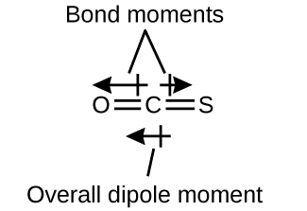

The C-O bond is considerably polar. Although C and S have very similar electronegativity values, S is slightly more electronegative than C, and so the C-S bond is just slightly polar. Because oxygen is more electronegative than sulfur, the oxygen end of the molecule is the negative end.

Chloromethane, CH₃Cl, is a tetrahedral molecule with three slightly polar C-H bonds and a more polar C-Cl bond. The relative electronegativities of the bonded atoms is H < C < Cl, and so the bond moments all point toward the Cl end of the molecule and sum to yield a considerable dipole moment (the molecules are relatively polar).

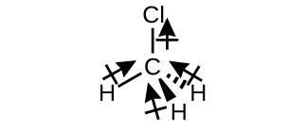
For molecules of high symmetry such as BF₃ (trigonal planar), CH₄ (tetrahedral), PF₅ (trigonal bipymidal), and SF₆ (octahedral), all the bonds are of identical polarity (same bond moment) and they are oriented in geometries that yield nonpolar molecules (dipole moment is zero).

Molecules of less geometric symmetry, however, may be polar even when all bond moments are identical. For these molecules, the directions of the equal bond moments are such that they sum to give a nonzero dipole moment and a polar molecule. Examples of such molecules include hydrogen sulfide, H₂S (nonlinear), and ammonia, NH₃(trigonal pyramidal).

To summarize, to be polar, a molecule must:
- Contain at least one polar covalent bond.
- Have a molecular structure such that the sum of the vectors of each bond dipole moment does not cancel.

Properties of Polar Molecules
Polar molecules tend to align when placed in an electric field with the positive end of the molecule oriented toward the negative plate and the negative end toward the positive plate (Figure 6.18). We can use an electrically charged object to attract polar molecules, but nonpolar molecules are not attracted. Also, polar solvents are better at dissolving polar substances, and nonpolar solvents are better at dissolving nonpolar substances.
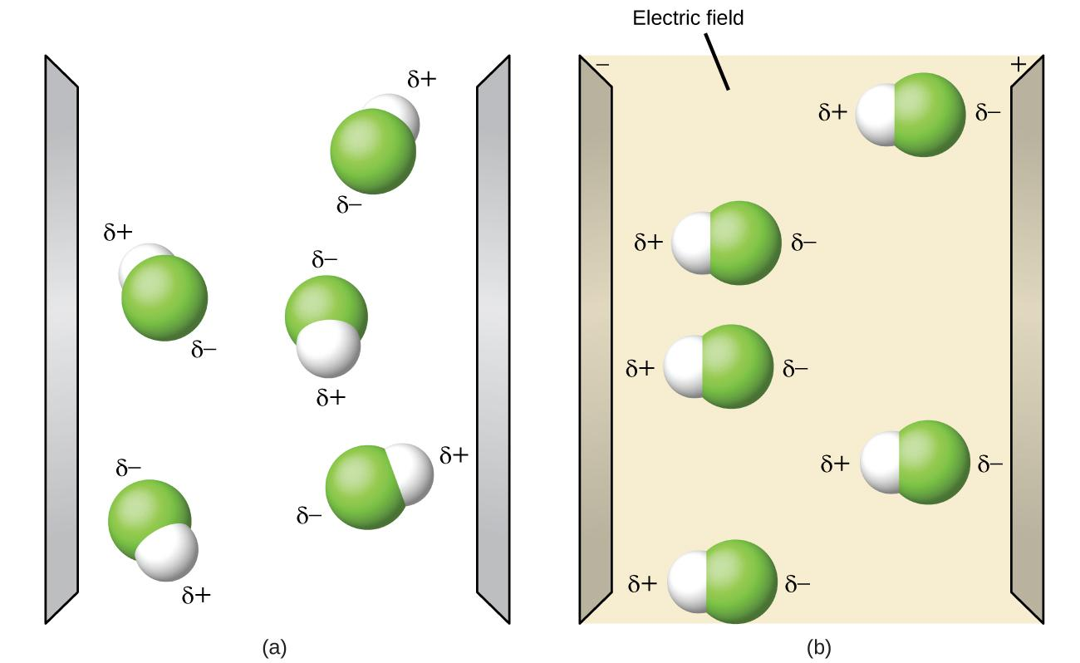
Figure 6.18 (a) Molecules are always randomly distributed in the liquid state in the absence of an electric field. (b) When an electric field is applied, polar molecules like HF will align to the dipoles with the field direction.

Miscibility
Miscibility is the ability of two liquids to mix to form a homogeneous solution. Some liquids that are mixed in any proportions to yield homogeneous solutions are said to be miscible. Ethanol, sulfuric acid, and ethylene glycol (popular for use as antifreeze, pictured in Figure 6.19) are examples of liquids that are completely miscible with water. Two-cycle motor oil is miscible with gasoline, mixtures of which are used as lubricating fuels for various types of outdoor power equipment.

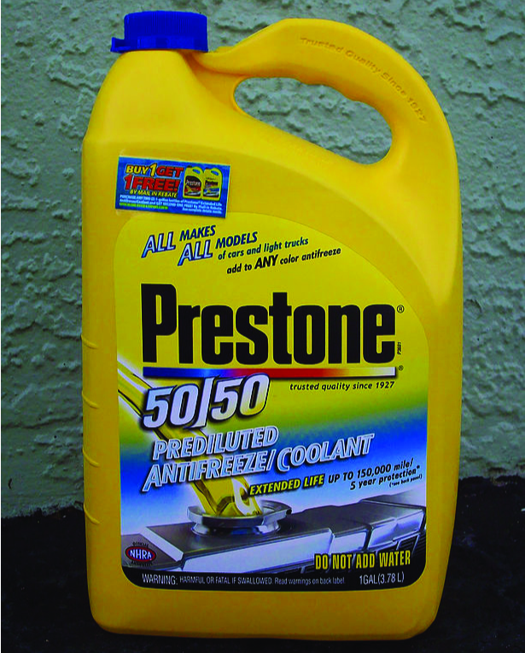
Figure 6.19 Water and antifreeze are miscible; mixtures of the two are homogeneous in all proportions. (credit: “dno1967”/Wikimedia commons)

Miscible liquids are typically those with very similar polarities. Liquids that are polar mix easily because their dipole-dipole attractions of the solute molecules with the solvent molecules are at least as strong as those between molecules in the pure solute or in the pure solvent.

Likewise, nonpolar liquids are miscible with each other because there is no appreciable difference in the strengths of solute-solute, solvent-solvent, and solute-solvent intermolecular attractions.

The solubility of polar molecules in polar solvents and of nonpolar molecules in nonpolar solvents is, again, an illustration of the chemical axiom “like dissolves like.”

Two liquids that do not mix to an appreciable extent are called immiscible. Separate layers are formed when immiscible liquids are poured into the same container. Gasoline, oil (Figure 6.20), benzene, carbon tetrachloride, some paints, and many other nonpolar liquids are immiscible with water. Relatively weak attractive forces between the polar water molecules and the nonpolar liquid molecules are not adequate to overcome much stronger attractive force between water molecules.

The distinction between immiscibility and miscibility is really one of extent, so that miscible liquids are of infinite mutual solubility, while liquids said to be immiscible are of very low (though not zero) mutual solubility.

Figure 6.20 Water and oil are immiscible. Mixtures of these two substances will form two separate layers with the less dense oil floating on top of the water. (credit: “Yortw”/Flickr)

Two liquids, such as bromine and water, that are of moderate mutual solubility are said to be partially miscible. Two partially miscible liquids usually form two layers when mixed. In the case of the bromine and water mixture, the upper layer is water, saturated with bromine, and the lower layer is bromine saturated with water. Since bromine is nonpolar, and, thus, not very soluble in water, the water layer is only slightly discolored by the bright orange bromine dissolved in it. Since the solubility of water in bromine is very low, there is no noticeable effect on the dark color of the bromine layer (Figure 6.21).

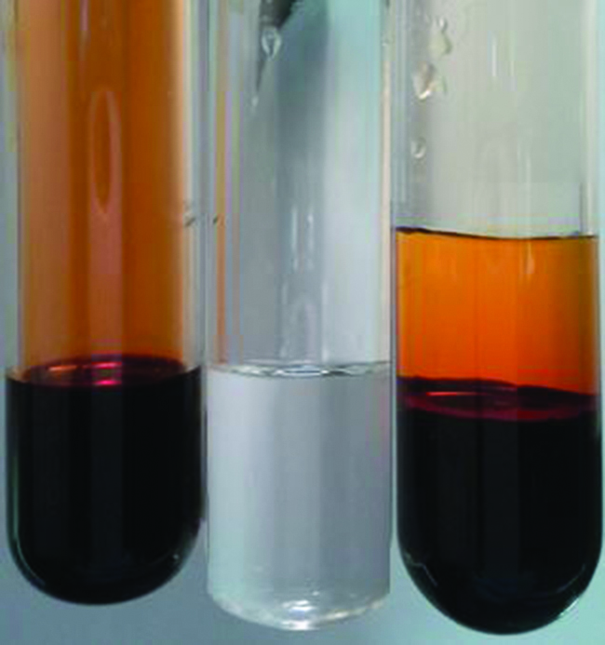

Figure 6.21 Bromine (the deep orange liquid on the left) and water (the clear liquid in the middle) are partially miscible. The top layer in the mixture on the right is a saturated solution of bromine in water; the bottom layer is a saturated solution of water in bromine. (credit: Paul Flowers)

6.3 Valence Bond Theory

Learning Objectives
- Be able to explain, using valence bond theory, how bonds form
- Understand the hybridization of atomic orbitals
- Determine the hybridization of any atom in the molecule or ion
- Be able to explain how sp³, sp², sp hybridizations are formed, and know their geometries
- Be able to use hybridization to determine shapes of molecules and ions
- Be able to explain the difference between sigma (σ) and pi (π) bonds
- Be able to identify the number of sigma and pi bonds in a molecule or ion

Introduction
As we know, a scientific theory is a strongly supported explanation for observed natural laws or large bodies of experimental data. For a theory to be accepted, it must explain experimental data and be able to predict behavior. For example, VSEPR theory has gained widespread acceptance because it predicts three-dimensional molecular shapes that are consistent with experimental data collected for thousands of different molecules. However, VSEPR theory does not provide an explanation of chemical bonding.

There are successful theories that describe the electronic structure of atoms. We can use quantum mechanics to predict the specific regions around an atom where electrons are likely to be located: A spherical shape for an s orbital, a dumbbell shape for a p orbital, and so forth. However, these predictions only describe the orbitals around free atoms. When atoms bond to form molecules, atomic orbitals are not sufficient to describe the regions where electrons will be located in the molecule. A more complete understanding of electron distributions requires a model that can account for the electronic structure of molecules. One popular theory holds that a covalent bond forms when a pair of electrons is shared by two atoms and is simultaneously attracted by the nuclei of both atoms. In the following sections, we will discuss how such bonds are described by valence bond theory and hybridization.

Valence bond theory
Valence bond theory describes a covalent bond as the overlap of half-filled atomic orbitals (each containing a single electron) that yield a pair of electrons shared between the two bonded atoms. According to valence bond theory, a covalent bond results when two conditions are met: (1) an orbital on one atom overlaps an orbital on a second atom and (2) the single electrons in each orbital combine to form an electron pair.

The mutual attraction between the negatively charged electron pair and the two atoms’ positively charged nuclei serves to physically link the two atoms through a force we define as a covalent bond. The strength of a covalent bond depends on the extent of overlap of the orbitals involved. Orbitals that overlap extensively form bonds that are stronger than those that have less overlap.

Figure 6.22 illustrates how the sum of the energies of two hydrogen atoms (the colored curve) changes as they approach each other. When the atoms are far apart there is no overlap, and by convention we set the sum of the energies at zero.

As the atoms move together, their orbitals begin to overlap. Each electron begins to feel the attraction of the nucleus in the other atom. In addition, the electrons begin to repel each other, as do the nuclei. While the atoms are still widely separated, the attractions are slightly stronger than the repulsions, and the energy of the system decreases. (A bond begins to form.)

As the atoms move closer together, the overlap increases, so the attraction of the nuclei for the electrons continues to increase (as do the repulsions among electrons and between the nuclei). At some specific distance between the atoms, which varies depending on the atoms involved, the energy reaches its lowest (most stable) value. This optimum distance between the two bonded nuclei is the bond distance between the two atoms. The bond is stable because at this point, the attractive and repulsive forces combine to create the lowest possible energy configuration.

If the distance between the nuclei were to decrease further, the repulsions between nuclei and the repulsions as electrons are confined in closer proximity to each other would become stronger than the attractive forces. The energy of the system would then rise (making the system destabilized), as shown at the far left of Figure 6.22.
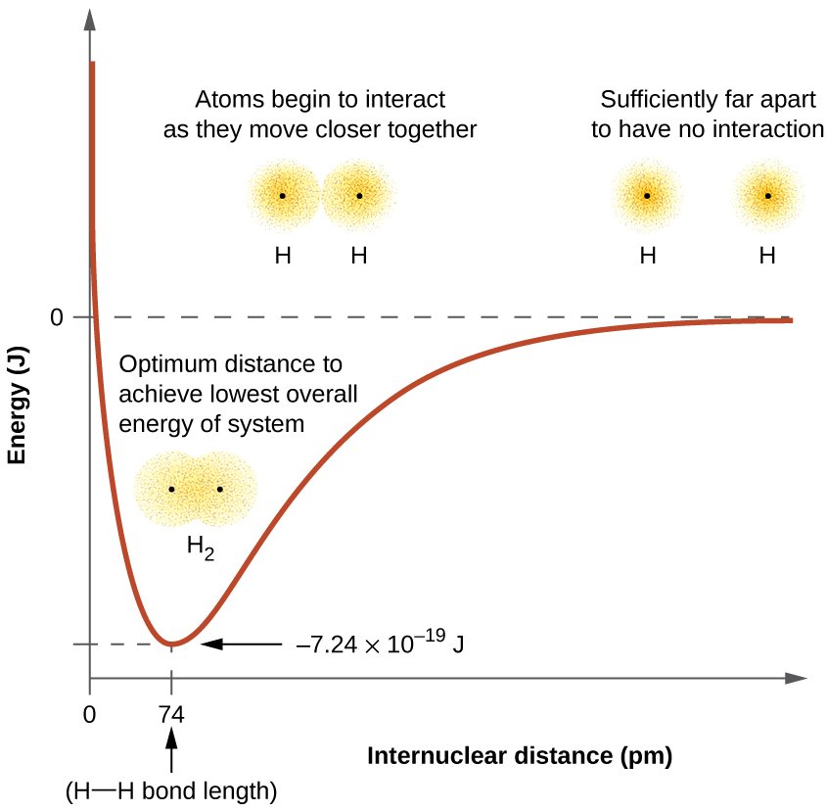

Figure 6.22 (a) The interaction of two hydrogen atoms changes as a function of distance. (b) The energy of the system changes as the atoms interact. The lowest (most stable) energy occurs at a distance of 74 pm, which is the bond length observed for the H₂ molecule.

The bond energy is the difference between the energy minimum and the energy of the two separated atoms. This is the quantity of energy released when the bond is formed. Conversely, the same amount of energy is required to break the bond.

For the H₂ molecule (Figure 6.22), the bond energy (at bond distance of 74 pm) is 7.24 × 10⁻¹⁹ J lower in energy than the two separated hydrogen atoms. This may seem like a small number. However, we know from our earlier description of thermochemistry that bond energies are often discussed on a per-mole basis. For example, it requires 7.24 × 10⁻¹⁹ J to break one H–H bond, but it takes 4.36 × 10⁵ J to break 1 mole of H–H bonds.

A comparison of some bond lengths and energies is shown in Table 6.1. We can find many of these bonds in a variety of molecules, and this table provides average values. For example, breaking the first C–H bond in CH₄ requires 439.3 kJ/mol, while breaking the first C–H bond in H–CH₂C₆H₅ (a common paint thinner) requires 375.5 kJ/mol.

Table 6.1 Representative Bond Energies and Lengths

Bond | Length (pm) | Energy (kJ/mol) |  | Bond | Length (pm) | Energy (kJ/mol)
H–H | 74 | 436 |  | C–O | 140.1 | 358
H–C | 106.8 | 413 |  | C=O | 119.7 | 745
H–N | 101.5 | 391 |  | C≡O | 113.7 | 1072
H–O | 97.5 | 467 |  | H–Cl | 127.5 | 431
C–C | 150.6 | 347 |  | H–Br | 141.4 | 366
C=C | 133.5 | 614 |  | H–I | 160.9 | 298
C≡C | 120.8 | 839 |  | O–O | 148 | 146
C–N | 142.1 | 305 |  | O=O | 120.8 | 498
C=N | 130.0 | 615 |  | F–F | 141.2 | 159
C≡N | 116.1 | 891 |  | Cl–Cl | 198.8 | 243

In addition to the distance between two orbitals, the orientation of orbitals also affects their overlap (other than for two s orbitals, which are spherically symmetric). Greater overlap is possible when orbitals are oriented such that they overlap on a direct line between the two nuclei. Figure 6.23 illustrates this for two p orbitals from different atoms; the overlap is greater when the orbitals overlap end to end rather than at an angle.

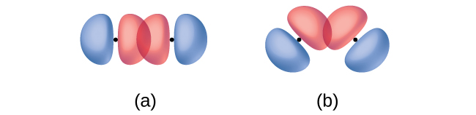

Figure 6.23 (a) The overlap of two p orbitals is greatest when the orbitals are directed end to end. (b) Any other arrangement results in less overlap. The dots indicate the locations of the nuclei.

The overlap of two s orbitals (as in H₂), the overlap of an s orbital and a p orbital (as in HCl), and the end-to-end overlap of two p orbitals (as in Cl₂) all produce sigma bonds (σ bonds), as illustrated in Figure 6.24. A σ bond is a covalent bond in which the electron density is concentrated in the region along the internuclear axis; that is, a line between the nuclei would pass through the center of the overlap region. Single bonds in Lewis structures are described as σ bonds in valence bond theory.

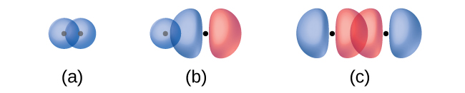

Figure 6.24 Sigma (σ) bonds form from the overlap of the following: (a) two s orbitals, (b) an s orbital and a p orbital, and (c) two p orbitals. The dots indicate the locations of the nuclei.

A pi bond (π bond) is a type of covalent bond that results from the side-by-side overlap of two p orbitals, as illustrated in Figure 6.25. In a π bond, the regions of orbital overlap lie on opposite sides of the internuclear axis. Along the axis itself, there is a node, that is, a plane with no probability of finding an electron.

Figure 6.25 Pi (π) bonds form from the side-by-side overlap of two p orbitals. The dots indicate the location of the nuclei.

While all single bonds are σ bonds, multiple bonds consist of both σ and π bonds. As the Lewis structures below suggest, O₂ contains a double bond, and N₂ contains a triple bond. The double bond consists of one σ bond and one π bond, and the triple bond consists of one σ bond and two π bonds. Between any two atoms, the first bond formed will always be a σ bond, but there can only be one σ bond in any one location. In any multiple bond, there will be one σ bond, and the remaining one or two bonds will be π bonds. These bonds are described in more detail later in this chapter.

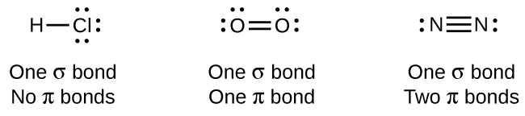

As seen in Table 6.1, an average carbon-carbon single bond is 347 kJ/mol, while in a carbon-carbon double bond, the π bond increases the bond strength by 267 kJ/mol. Adding an additional π bond causes a further increase of 225 kJ/mol. We can see a similar pattern when we compare other σ and π bonds. Thus, each individual π bond is generally weaker than a corresponding σ bond between the same two atoms. In a σ bond, there is a greater degree of orbital overlap than in a π bond.

Hybridization
Thinking in terms of overlapping atomic orbitals is one way for us to explain how chemical bonds form in diatomic molecules. However, to understand how molecules with more than two atoms form stable bonds, we require a more detailed model. As an example, let us consider the water molecule, in which we have one oxygen atom bonding to two hydrogen atoms. Oxygen has the electron configuration 1s² 2s² 2p⁴, with two unpaired electrons (one in each of the two 2p orbitals). Valence bond theory would predict that the two O–H bonds form from the overlap of these two 2p orbitals with the 1s orbitals of the hydrogen atoms. If this were the case, the bond angle would be 90°, as shown in Figure 6.26, because p orbitals are perpendicular to each other. Experimental evidence shows that the bond angle is 104.5°, not 90°. The prediction of the valence bond theory model does not match the real-world observations of a water molecule; a different model is needed.
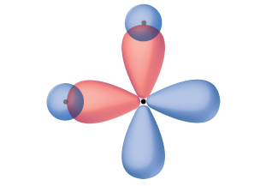
Figure 6.26 The hypothetical overlap of two of the 2p orbitals on an oxygen atom (red) with the 1s orbitals of two hydrogen atoms (blue) would produce a bond angle of 90°. This is not consistent with experimental evidence.1

Quantum-mechanical calculations suggest why the observed bond angles in H₂O differ from those predicted by the overlap of the 1s orbital of the hydrogen atoms with the 2p orbitals of the oxygen atom. The mathematical expression known as the wave function, ψ, contains information about each orbital and the wavelike properties of electrons in an isolated atom. When atoms are bound together in a molecule, the wave functions combine to produce new mathematical descriptions that have different shapes. This process of combining the wave functions for atomic orbitals is called hybridization and is mathematically accomplished by the linear combination of atomic orbitals, LCAO, (a technique that we will encounter again later). The new orbitals that result are called hybrid orbitals. The valence orbitals in an isolated oxygen atom are a 2s orbital and three 2p orbitals. The valence orbitals in an oxygen atom in a water molecule differ; they consist of four equivalent hybrid orbitals that point approximately toward the corners of a tetrahedron (Figure 6.27). Consequently, the overlap of the O and H orbitals should result in a tetrahedral bond angle (109.5°). The observed angle of 104.5° is experimental evidence for which quantum-mechanical calculations give a useful explanation: Valence bond theory must include a hybridization component to give accurate predictions.
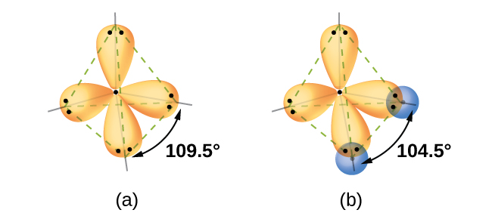
Figure 6.27 (a) A water molecule has four regions of electron density, so VSEPR theory predicts a tetrahedral arrangement of hybrid orbitals. (b) Two of the hybrid orbitals on oxygen contain lone pairs, and the other two overlap with the 1s orbitals of hydrogen atoms to form the O–H bonds in H2O. This description is more consistent with the experimental structure.

The following ideas are important in understanding hybridization:

- Hybrid orbitals do not exist in isolated atoms. They are formed only in covalently bonded atoms.
- Hybrid orbitals have shapes and orientations that are very different from those of the atomic orbitals in isolated atoms.
- A set of hybrid orbitals is generated by combining atomic orbitals. The number of hybrid orbitals in a set is equal to the number of atomic orbitals that were combined to produce the set.
- All orbitals in a set of hybrid orbitals are equivalent in shape and energy.
- The type of hybrid orbitals formed in a bonded atom depends on its electron-pair geometry as predicted by the VSEPR theory.
- Hybrid orbitals overlap to form σ bonds. Unhybridized orbitals overlap to form π bonds.

In the following sections, we shall discuss the common types of hybrid orbitals.

sp Hybridization
The beryllium atom in a gaseous BeCl₂ molecule is an example of a central atom with no lone pairs of electrons in a linear arrangement of three atoms. There are two regions of valence electron density in the BeCl₂ molecule that correspond to the two covalent Be–Cl bonds. To accommodate these two electron domains, two of the Be atom’s four valence orbitals will mix to yield two hybrid orbitals. This hybridization process involves mixing of the valence s orbital with one of the valence p orbitals to yield two equivalent sp hybrid orbitals that are oriented in a linear geometry (Figure 6.28). In this figure, the set of sp orbitals appears similar in shape to the original p orbital, but there is an important difference. The number of atomic orbitals combined always equals the number of hybrid orbitals formed. The p orbital is one orbital that can hold up to two electrons. The sp set is two equivalent orbitals that point 180° from each other. The two electrons that were originally in the s orbital are now distributed to the two sp orbitals, which are half filled. In gaseous BeCl₂, these half-filled hybrid orbitals will overlap with orbitals from the chlorine atoms to form two identical σ bonds.
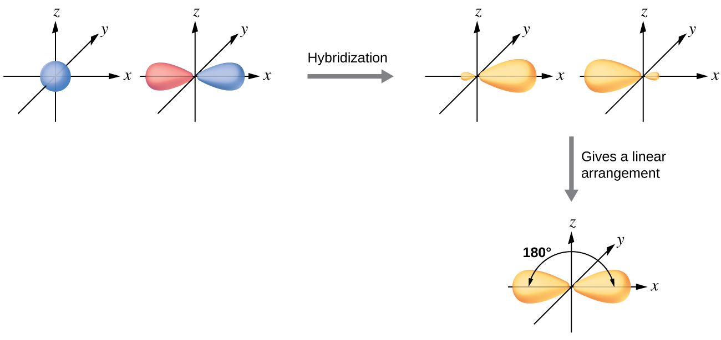
Figure 6.28 Hybridization of an s orbital (blue) and a p orbital (red) of the same atom produces two sp hybrid orbitals (yellow). Each hybrid orbital is oriented primarily in just one direction. Note that each sp orbital contains one lobe that is significantly larger than the other. The set of two sp orbitals are oriented at 180°, which is consistent with the geometry for two domains.
We illustrate the electronic differences in an isolated Be atom and in the bonded Be atom in the orbital energy-level diagram in Figure 6.29. These diagrams represent each orbital by a horizontal line (indicating its energy) and each electron by an arrow. Energy increases toward the top of the diagram. We use one upward arrow to indicate one electron in an orbital and two arrows (up and down) to indicate two electrons of opposite spin.

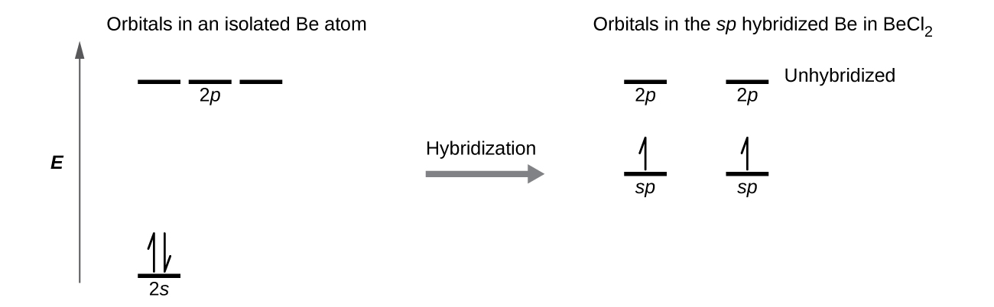
Figure 6.29 This orbital energy-level diagram shows the sp hybridized orbitals on Be in the linear BeCl₂ molecule. Each of the two sp hybrid orbitals holds one electron and is thus half filled and available for bonding via overlap with a Cl 3p orbital.

When atomic orbitals hybridize, the valence electrons occupy the newly created orbitals. The Be atom had two valence electrons, so each of the sp orbitals gets one of these electrons. Each of these electrons pairs up with the unpaired electron on a chlorine atom when a hybrid orbital and a chlorine orbital overlap during the formation of the Be–Cl bonds.

Any central atom surrounded by just two regions of valence electron density in a molecule will exhibit sp hybridization.

sp² Hybridization
The valence orbitals of a central atom surrounded by three regions of electron density consist of a set of three sp² hybrid orbitals and one unhybridized porbital. This arrangement results from sp² hybridization, the mixing of one s orbital and two p orbitals to produce three identical hybrid orbitals oriented in a trigonal planar geometry (Figure 6.30).

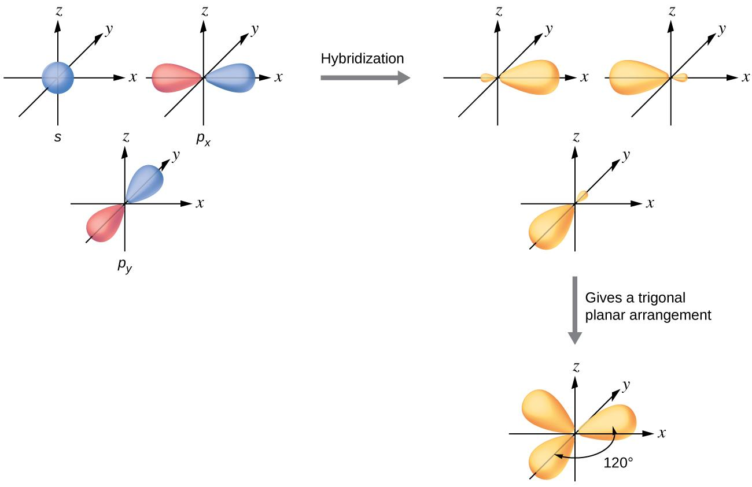
Figure 6.30 The hybridization of an s orbital (blue) and two p orbitals (red) produces three equivalent sp² hybridized orbitals (yellow) oriented at 120° with respect to each other. The remaining unhybridized p orbital is not shown here, but is located along the z axis.

Although quantum mechanics yields the “plump” orbital lobes as depicted in Figure 6.30, sometimes for clarity these orbitals are drawn thinner and without the minor lobes, as in Figure 6.31, to avoid obscuring other features of a given illustration. We will use these “thinner” representations whenever the true view is too crowded to easily visualize.

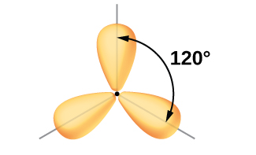
Figure 6.31 This alternate way of drawing the trigonal planar sp² hybrid orbitals is sometimes used in more crowded figures.

The observed structure of the borane molecule, BH₃, suggests sp² hybridization for boron in this compound. The molecule is trigonal planar, and the boron atom is involved in three bonds to hydrogen atoms (Figure 6.32). We can illustrate the comparison of orbitals and electron distribution in an isolated boron atom and in the bonded atom in BH3 as shown in the orbital energy level diagram in Figure 6.33. We redistribute the three valence electrons of the boron atom in the three sp² hybrid orbitals, and each boron electron pairs with a hydrogen electron when B–H bonds form.
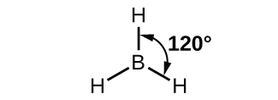
Figure 6.32 BH₃ is an electron-deficient molecule with a trigonal planar structure.
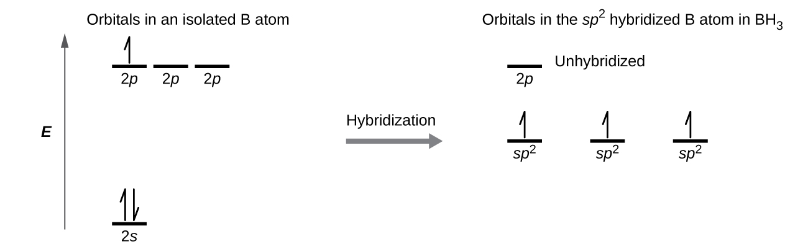
Figure 6.33 In an isolated B atom, there are one 2s and three 2p valence orbitals. When boron is in a molecule with three regions of electron density, three of the orbitals hybridize and create a set of three sp² orbitals and one unhybridized 2p orbital. The three half-filled hybrid orbitals each overlap with an orbital from a hydrogen atom to form three σ bonds in BH₃.
Any central atom surrounded by three regions of electron density will exhibit sp² hybridization. This includes molecules with a lone pair on the central atom, such as ClNO (Figure 6.34), or molecules with two single bonds and a double bond connected to the central atom, as in formaldehyde, CH₂O, and ethene, H₂CCH₂.

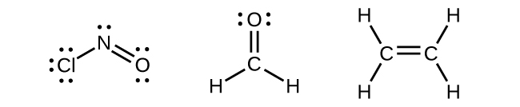

Figure 6.34 The central atom(s) in each of the structures shown contain three regions of electron density and are sp² hybridized. As we know from the discussion of VSEPR theory, a region of electron density contains all of the electrons that point in one direction. A lone pair, an unpaired electron, a single bond, or a multiple bond would each count as one region of electron density.

sp³ Hybridization
The valence orbitals of an atom surrounded by a tetrahedral arrangement of bonding pairs and lone pairs consist of a set of four sp³ hybrid orbitals. The hybrids result from the mixing of one s orbital and all three p orbitals that produces four identical sp3 hybrid orbitals (Figure 6.35). Each of these hybrid orbitals points toward a different corner of a tetrahedron.
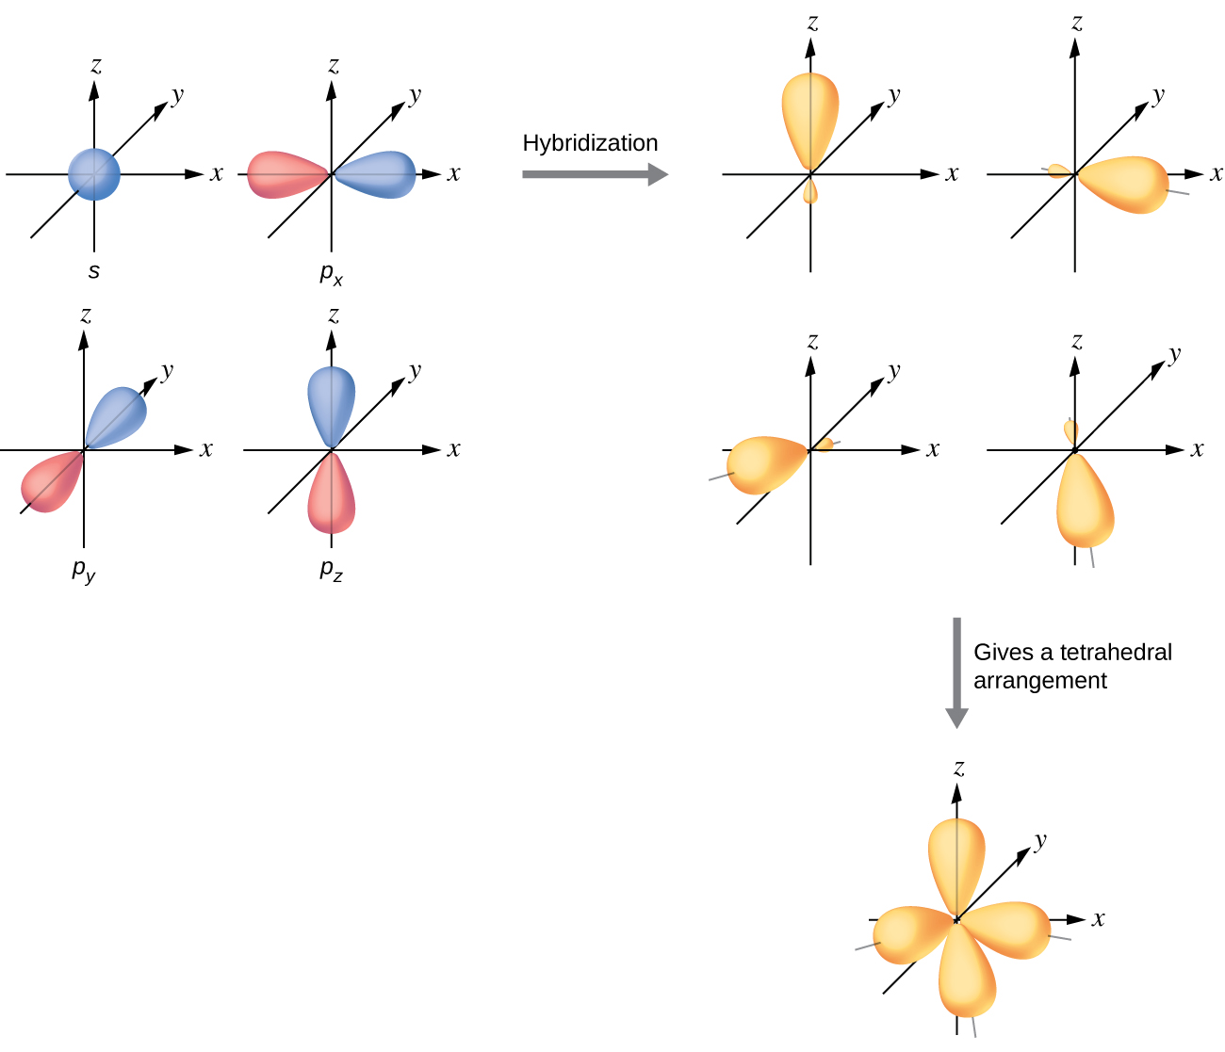
Figure 6.35 The hybridization of an s orbital (blue) and three p orbitals (red) produces four equivalent sp³ hybridized orbitals (yellow) oriented at 109.5° with respect to each other.

A molecule of methane, CH₄, consists of a carbon atom surrounded by four hydrogen atoms at the corners of a tetrahedron. The carbon atom in methane exhibits sp³ hybridization. We illustrate the orbitals and electron distribution in an isolated carbon atom and in the bonded atom in CH₄ in Figure 6.36. The four valence electrons of the carbon atom are distributed equally in the hybrid orbitals, and each carbon electron pairs with a hydrogen electron when the C–H bonds form.

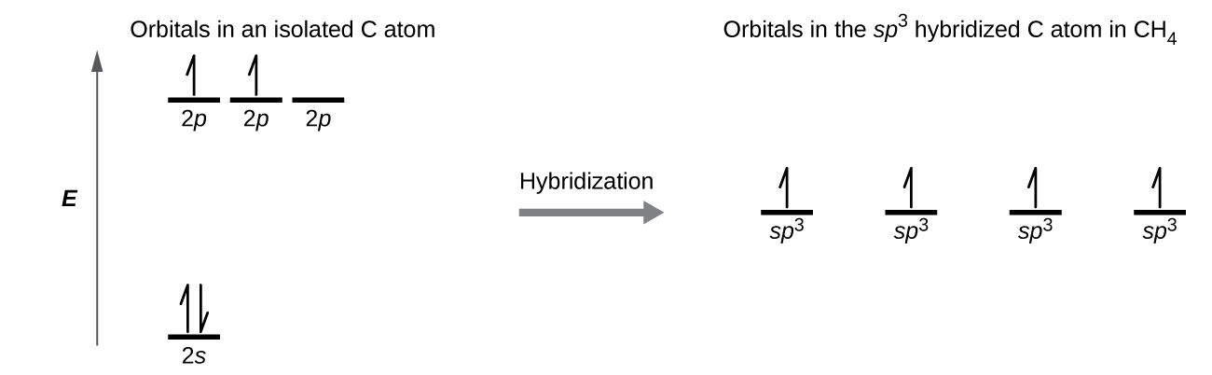

Figure 6.36 The four valence atomic orbitals from an isolated carbon atom all hybridize when the carbon bonds in a molecule like CH₄ with four regions of electron density. This creates four equivalent sp3 hybridized orbitals. Overlap of each of the hybrid orbitals with a hydrogen orbital creates a C–H σ bond.

In a methane molecule, the 1s orbital of each of the four hydrogen atoms overlaps with one of the four sp³ orbitals of the carbon atom to form a sigma (σ) bond. This results in the formation of four strong, equivalent covalent bonds between the carbon atom and each of the hydrogen atoms to produce the methane molecule, CH₄.

The structure of ethane, C₂H₆, is similar to that of methane in that each carbon in ethane has four neighboring atoms arranged at the corners of a tetrahedron—three hydrogen atoms and one carbon atom (Figure 6.37). However, in ethane an sp³ orbital of one carbon atom overlaps end to end with an sp³ orbital of a second carbon atom to form a σ bond between the two carbon atoms. Each of the remaining sp³ hybrid orbitals overlaps with an s orbital of a hydrogen atom to form carbon–hydrogen σ bonds. The structure and overall outline of the bonding orbitals of ethane are shown in Figure 6.37. The orientation of the two CH₃ groups is not fixed relative to each other. Experimental evidence shows that rotation around σ bonds occurs easily.
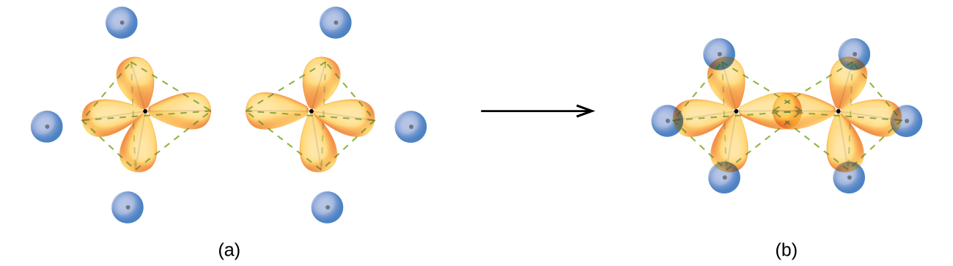
Figure 6.37 (a) In the ethane molecule, C₂H₆, each carbon has four sp³ orbitals. (b) These four orbitals overlap to form seven σ bonds.

An sp³ hybrid orbital can also hold a lone pair of electrons. For example, the nitrogen atom in ammonia is surrounded by three bonding pairs and a lone pair of electrons directed to the four corners of a tetrahedron. The nitrogen atom is sp³ hybridized with one hybrid orbital occupied by the lone pair.

The molecular structure of water is consistent with a tetrahedral arrangement of two lone pairs and two bonding pairs of electrons. Thus we say that the oxygen atom is sp³ hybridized, with two of the hybrid orbitals occupied by lone pairs and two by bonding pairs. Since lone pairs occupy more space than bonding pairs, structures that contain lone pairs have bond angles slightly distorted from the ideal. Perfect tetrahedra have angles of 109.5°, but the observed angles in ammonia (107.3°) and water (104.5°) are slightly smaller. Other examples of sp3 hybridization include CCl₄, PCl₃, and NCl₃.

sp³d and sp³d² Hybridization
To describe the five bonding orbitals in a trigonal bipyramidal arrangement, we must use five of the valence shell atomic orbitals (the s orbital, the three p orbitals, and one of the d orbitals), which gives five sp³d hybrid orbitals (see Figure 6.38). With an octahedral arrangement of six hybrid orbitals, we must use six valence shell atomic orbitals (the s orbital, the three p orbitals, and two of the d orbitals in its valence shell), which gives six sp³d² hybrid orbitals. These hybridizations are only possible for atoms that have d orbitals in their valence subshells (that is, not those in the first or second period).

In a molecule of phosphorus pentachloride, PCl₅, there are five P–Cl bonds (thus five pairs of valence electrons around the phosphorus atom) directed toward the corners of a trigonal bipyramid. We use the 3s orbital, the three 3p orbitals, and one of the 3d orbitals to form the set of five sp³d hybrid orbitals (Figure 6.39) that are involved in the P–Cl bonds. Other atoms that exhibit sp³d hybridization include the sulfur atom in SF4 and the chlorine atoms in ClF₃ and in ClF₄⁺. (The electrons on fluorine atoms are omitted for clarity.)
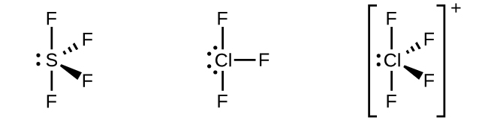
Figure 6.38 The three compounds pictured exhibit sp³d hybridization in the central atom and a trigonal bipyramid form.
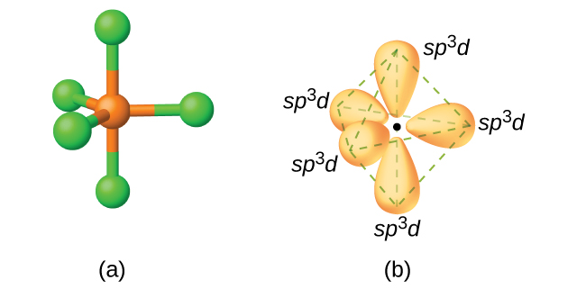
Figure 6.39 (a) The five regions of electron density around phosphorus in PCl₅ require five hybrid sp³d orbitals. (b) These orbitals combine to form a trigonal bipyramidal structure with each large lobe of the hybrid orbital pointing at a vertex. As before, there are also small lobes pointing in the opposite direction for each orbital (not shown for clarity).
The sulfur atom in sulfur hexafluoride, SF₆, exhibits sp³d² hybridization (see Figure 6.40). A molecule of sulfur hexafluoride has six bonding pairs of electrons connecting six fluorine atoms to a single sulfur atom. There are no lone pairs of electrons on the central atom. To bond six fluorine atoms, the 3s orbital, the three 3p orbitals, and two of the 3d orbitals form six equivalent sp³d² hybrid orbitals, each directed toward a different corner of an octahedron. Other atoms that exhibit sp³d² hybridization include the phosphorus atom in PCl₆⁻, the iodine atom in the interhalogens IF₆⁺, IF₅, ICl₄⁻, IF₄⁻ and the xenon atom in XeF₄.
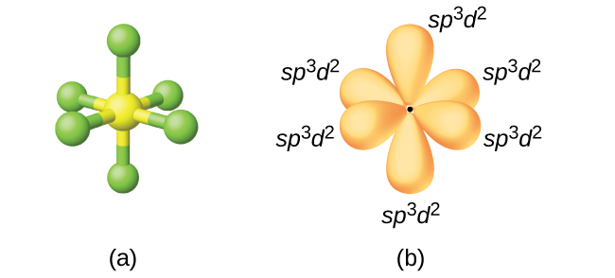
Figure 6.40 (a) Sulfur hexafluoride, SF₆, has an octahedral structure that requires sp³d² hybridization. (b) The six sp³d² orbitals form an octahedral structure around sulfur. Again, the minor lobe of each orbital is not shown for clarity.

Assignment of Hybrid Orbitals to Central Atoms
The hybridization of an atom is determined based on the number of regions of electron density that surround it. The geometrical arrangements characteristic of the various sets of hybrid orbitals are shown in Figure 6.41. These arrangements are identical to those of the electron-pair geometries predicted by VSEPR theory. VSEPR theory predicts the shapes of molecules, and hybrid orbital theory provides an explanation for how those shapes are formed. To find the hybridization of a central atom, we can use the following guidelines:
- Determine the Lewis structure of the molecule.
- Determine the number of regions of electron density around an atom using VSEPR theory, in which single bonds, multiple bonds, radicals, and lone pairs each count as one region.
- Assign the set of hybridized orbitals from Figure 6.41 that corresponds to this geometry.
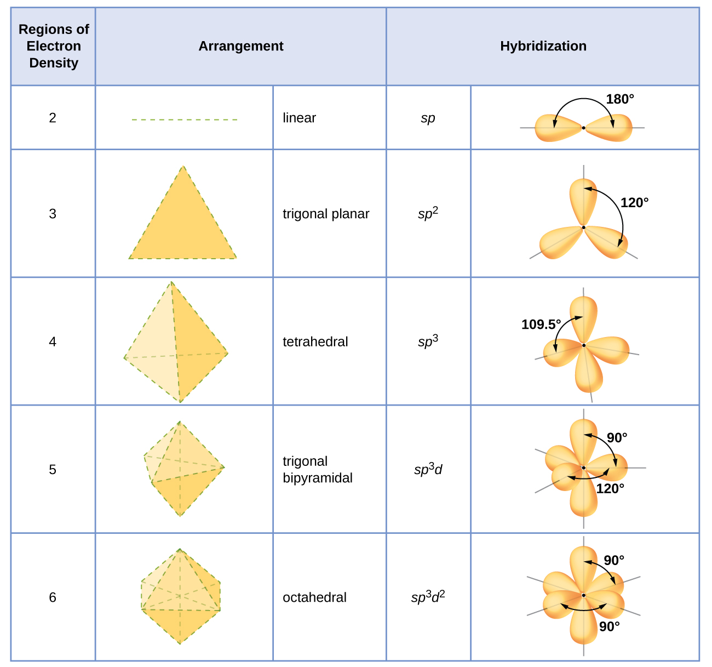
Figure 6.41 The shapes of hybridized orbital sets are consistent with the electron-pair geometries. For example, an atom surrounded by three regions of electron density is sp2 hybridized, and the three sp2 orbitals are arranged in a trigonal planar fashion.

Multiple Bonds
The hybrid orbital model appears to account well for the geometry of molecules involving single covalent bonds. Is it also capable of describing molecules containing double and triple bonds? We have already discussed that multiple bonds consist of σ and π bonds. Next we can consider how we visualize these components and how they relate to hybrid orbitals. The Lewis structure of ethene, C₂H₄, shows us that each carbon atom is surrounded by one other carbon atom and two hydrogen atoms.
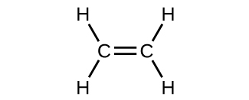
The three bonding regions form a trigonal planar electron-pair geometry. Thus we expect the σ bonds from each carbon atom are formed using a set of sp² hybrid orbitals that result from hybridization of two of the 2p orbitals and the 2s orbital (Figure 6.42). These orbitals form the C–H single bonds and the σ bond in the C=C double bond (Figure 6.43). The π bond in the C=C double bond results from the overlap of the third (remaining) 2p orbital on each carbon atom that is not involved in hybridization. This unhybridized p orbital (lobes shown in red and blue in Figure 6.43) is perpendicular to the plane of the sp² hybrid orbitals. Thus the unhybridized 2p orbitals overlap in a side-by-side fashion, above and below the internuclear axis (Figure 6.43) and form a π bond.

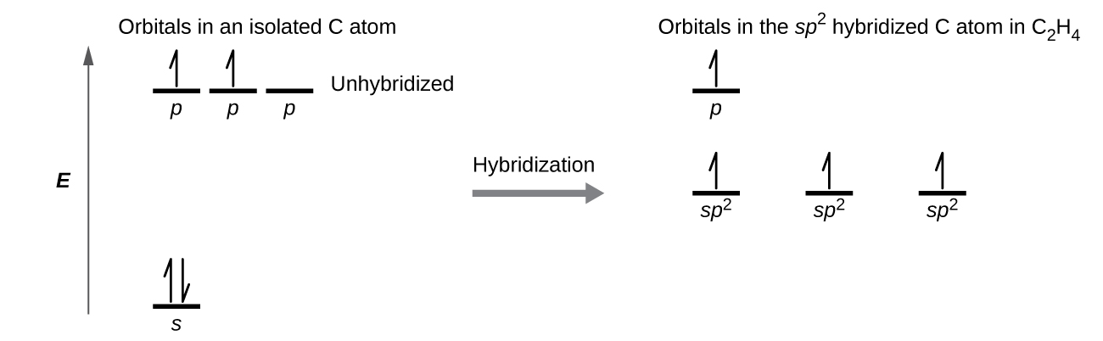
Figure 6.42 In ethene, each carbon atom is sp² hybridized, and the sp² orbitals and the p orbital are singly occupied. The hybrid orbitals overlap to form σ bonds, while the p orbitals on each carbon atom overlap to form a π bond.
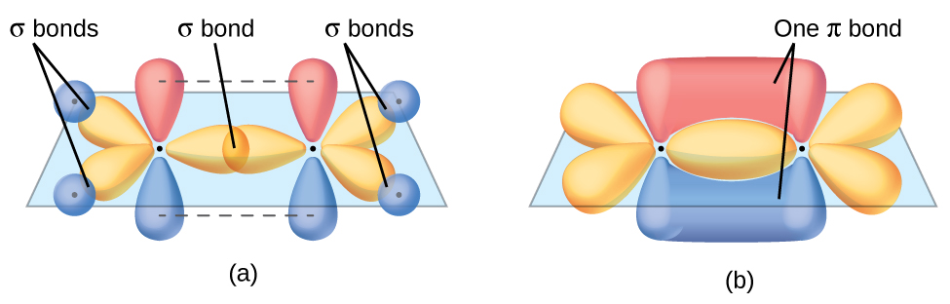
Figure 6.43 In the ethene molecule, C₂H₄, there are (a) five σ bonds. One C–C σ bond results from overlap of sp² hybrid orbitals on the carbon atom with one sp2 hybrid orbital on the other carbon atom. Four C–H bonds result from the overlap between the C atoms' sp² orbitals with s orbitals on the hydrogen atoms. (b) The π bond is formed by the side-by-side overlap of the two unhybridized p orbitals in the two carbon atoms. The two lobes of the π bond are above and below the plane of the σ system.

In an ethene molecule, the four hydrogen atoms and the two carbon atoms are all in the same plane. If the two planes of sp² hybrid orbitals tilted relative to each other, the p orbitals would not be oriented to overlap efficiently to create the π bond. The planar configuration for the ethene molecule occurs because it is the most stable bonding arrangement. This is a significant difference between σ and π bonds; rotation around single (σ) bonds occurs easily because the end-to-end orbital overlap does not depend on the relative orientation of the orbitals on each atom in the bond. In other words, rotation around the internuclear axis does not change the extent to which the σ bonding orbitals overlap because the bonding electron density is symmetric about the axis. Rotation about the internuclear axis is much more difficult for multiple bonds; however, this would drastically alter the off-axis overlap of the π bonding orbitals, essentially breaking the π bond.

In molecules with sp hybrid orbitals, two unhybridized p orbitals remain on the atom (Figure 6.44). We find this situation in acetylene, H−C≡C−H, which is a linear molecule. The sp hybrid orbitals of the two carbon atoms overlap end to end to form a σ bond between the carbon atoms (Figure 6.45). The remaining sp orbitals form σ bonds with hydrogen atoms. The two unhybridized p orbitals per carbon are positioned such that they overlap side by side and, hence, form two π bonds. The two carbon atoms of acetylene are thus bound together by one σ bond and two π bonds, giving a triple bond.
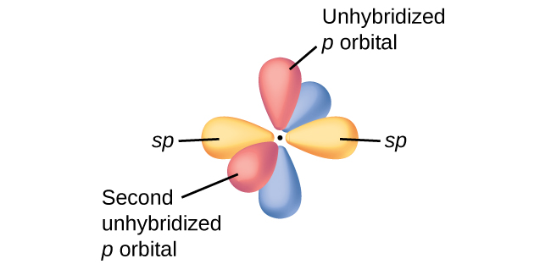

Figure 6.44 Diagram of the two linear sp hybrid orbitals of a carbon atom, which lie in a straight line, and the two unhybridized p orbitals at perpendicular angles.

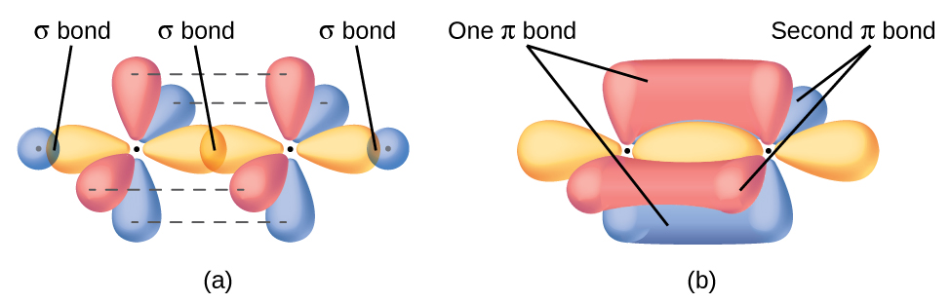

Figure 6.45 (a) In the acetylene molecule, C₂H₂, there are two C–H σ bonds and a C≡C triple bond involving one C–C σ bond and two C–C π bonds. The dashed lines, each connecting two lobes, indicate the side-by-side overlap of the four unhybridized p orbitals. (b) This shows the overall outline of the bonds in C₂H₂. The two lobes of each of the π bonds are positioned across from each other around the line of the C–C σ bond.

Hybridization involves only σ bonds, lone pairs of electrons, and single unpaired electrons (radicals). Structures that account for these features describe the correct hybridization of the atoms. However, many structures also include resonance forms. Remember that resonance forms occur when various arrangements of π bonds are possible. Since the arrangement of π bonds involves only the unhybridized orbitals, resonance does not influence the assignment of hybridization.

For example, molecule benzene has two resonance forms (Figure 6.46). We can use either of these forms to determine that each of the carbon atoms is bonded to three other atoms with no lone pairs, so the correct hybridization is sp². The electrons in the unhybridized p orbitals form π bonds. Neither resonance structure completely describes the electrons in the π bonds. They are not located in one position or the other, but in reality are delocalized throughout the ring. Valence bond theory does not easily address delocalization. Bonding in molecules with resonance forms is better described by molecular orbital theory. (See the next module.)

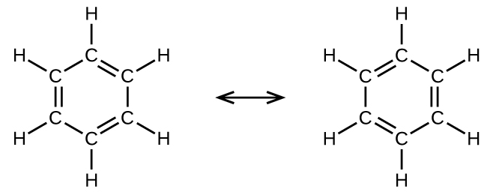

Figure 6.46 Each carbon atom in benzene, C₆H₆, is sp² hybridized, independently of which resonance form is considered. The electrons in the π bonds are not located in one set of p orbitals or the other, but rather delocalized throughout the molecule.

Footnotes
- 1 Note that orbitals may sometimes be drawn in an elongated “balloon” shape rather than in a more realistic “plump” shape in order to make the geometry easier to visualize.

6.4 Molecular Orbital Theory (MOT)

Learning Objectives
- Understand the need for MOT, and how it can address some of the inconsistencies that arise from valence bond theory (VBT).
- Be able to compare and contrast VBT and MOT.
- Understand what is meant by bonding, nonbonding, and antibonding in reference to molecular orbitals.

Molecular Orbital Theory (MOT)

Molecular orbital theory (MO theory) provides an explanation of chemical bonding that accounts for the magnetic properties of molecules. It also explains the bonding in a number of other molecules, such as violations of the octet rule and more molecules with more complicated bonding (beyond the scope of this text) that are difficult to describe with Lewis structures. Additionally, it provides a model for describing the energies of electrons in a molecule and the probable location of these electrons.

Unlike valence bond theory, which uses hybrid orbitals that are assigned to one specific atom, MO theory uses the combination of atomic orbitals to yield molecular orbitals that are delocalized over the entire molecule rather than being localized on its constituent atoms. MO theory also helps us understand why some substances are electrical conductors, others are semiconductors, and still others are insulators. Table 6.2. summarizes the main points of the two complementary bonding theories. Both theories provide different, useful ways of describing molecular structure.

Table 6.2 Comparison of Bonding Theories

Valence Bond Theory | Molecular Orbital Theory
considers bonds as localized between one pair of atoms | considers electrons delocalized throughout the entire molecule
creates bonds from overlap of atomic orbitals (s, p, d…) and hybrid orbitals (sp, sp2, sp3…) | combines atomic orbitals to form molecular orbitals (σ, σ*, π, π*)
forms σ or π bonds | creates bonding and antibonding interactions based on which orbitals are filled
predicts molecular shape based on the number of regions of electron density | predicts the arrangement of electrons in molecules
needs multiple structures to describe resonance

Molecular orbital theory describes the distribution of electrons in molecules in much the same way that the distribution of electrons in atoms is described using atomic orbitals. The mathematical process of combining atomic orbitals to generate molecular orbitals is called the linear combination of atomic orbitals (LCAO). The wave function describes the wavelike properties of an electron. Molecular orbitals are combinations of atomic orbital wave functions. Combining waves can lead to constructive interference, in which peaks line up with peaks, or destructive interference, in which peaks line up with troughs (Figure 6.47). In orbitals, the waves are three dimensional, and they combine with in-phase waves producing regions with a higher probability of electron density and out-of-phase waves producing nodes, or regions of no electron density.
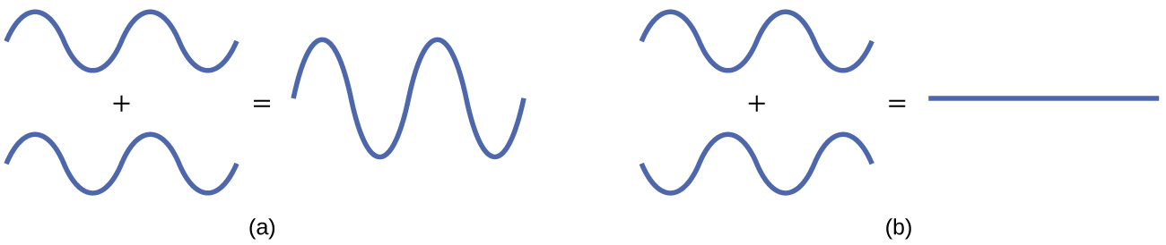

Figure 6.47 (a) When in-phase waves combine, constructive interference produces a wave with greater amplitude. (b) When out-of-phase waves combine, destructive interference produces a wave with less (or no) amplitude.

There are two types of molecular orbitals that can form from the overlap of two atomic s orbitals on adjacent atoms. The two types are illustrated in Figure 6.48. The in-phase combination produces a lower energy σ_{s} molecular orbital (read as "sigma-s") in which most of the electron density is directly between the nuclei. The out-of-phase addition (which can also be thought of as subtracting the wave functions) produces a higher energy σ_{s}* molecular orbital (read as "sigma-s-star") molecular orbital in which there is a node between the nuclei. The asterisk signifies that the orbital is an antibonding orbital. Electrons in a σs orbital are attracted by both nuclei at the same time and are more stable (of lower energy) than they would be in the isolated atoms. Adding electrons to these orbitals creates a force that holds the two nuclei together, so we call these orbitals bonding orbitals. Electrons in the σ_{s}* orbitals are located well away from the region between the two nuclei. The attractive force between the nuclei and these electrons pulls the two nuclei apart. Hence, these orbitals are called antibonding orbitals. Electrons fill the lower-energy bonding orbital before the higher-energy antibonding orbital, just as they fill lower-energy atomic orbitals before they fill higher-energy atomic orbitals.
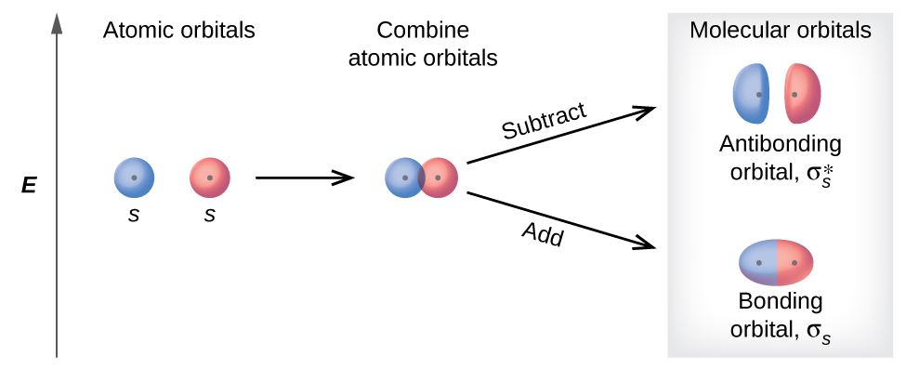
Figure 6.48 Sigma (σ) and sigma-star (σ*) molecular orbitals are formed by the combination of two s atomic orbitals. The plus (+) signs indicate the locations of nuclei.

In p orbitals, the wave function gives rise to two lobes with opposite phases, analogous to how a two-dimensional wave has both parts above and below the average. We indicate the phases by shading the orbital lobes different colors. When orbital lobes of the same phase overlap, constructive wave interference increases the electron density. When regions of opposite phase overlap, the destructive wave interference decreases electron density and creates nodes. When p orbitals overlap end to end, they create σ and σ* orbitals (Figure 6.49). If two atoms are located along the x-axis in a Cartesian coordinate system, the two px orbitals overlap end to end and form σ_{px} (bonding) and σ_{px}* (antibonding) (read as "sigma-p-x" and "sigma-p-x star," respectively). Just as with s-orbital overlap, the asterisk indicates the orbital with a node between the nuclei, which is a higher-energy, antibonding orbital.
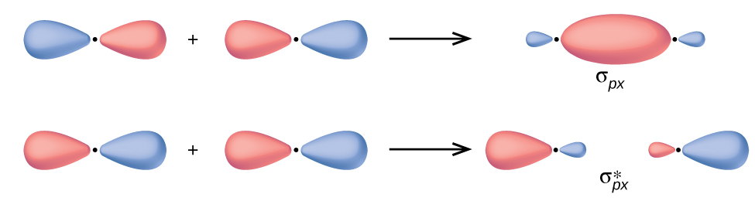
Figure 6.49 Combining wave functions of two p atomic orbitals along the internuclear axis creates two molecular orbitals, σp and σp*.

The side-by-side overlap of two p orbitals gives rise to a pi (π) bonding molecular orbital and a π* antibonding molecular orbital, as shown in Figure 6.50. In valence bond theory, we describe π bonds as containing a nodal plane containing the internuclear axis and perpendicular to the lobes of the p orbitals, with electron density on either side of the node. In molecular orbital theory, we describe the π orbital by this same shape, and a π bond exists when this orbital contains electrons. Electrons in this orbital interact with both nuclei and help hold the two atoms together, making it a bonding orbital. For the out-of-phase combination, there are two nodal planes created, one along the internuclear axis and a perpendicular one between the nuclei.
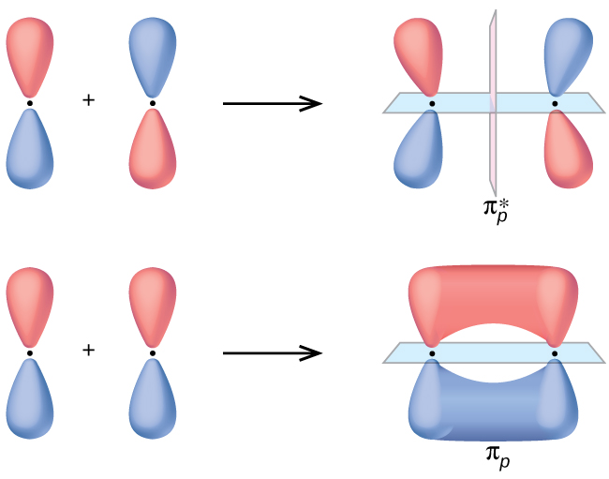
Figure 6.50 Side-by-side overlap of each two p orbitals results in the formation of two π molecular orbitals. Combining the out-of-phase orbitals results in an antibonding molecular orbital with two nodes. One contains the internuclear axis, and one is perpendicular to the axis. Combining the in-phase orbitals results in a bonding orbital. There is a node (blue) containing the internuclear axis with the two lobes of the orbital located above and below this node.

In the molecular orbitals of diatomic molecules, each atom also has two sets of p orbitals oriented side by side (py and pz), so these four atomic orbitals combine pairwise to create two π orbitals and two π* orbitals. The π_{py} and π_{py}* orbitals are oriented at right angles to the π_{pz} and π_{pz}* orbitals. Except for their orientation, the π_{py} and π_{pz} orbitals are identical and have the same energy; they are degenerate orbitals. The π_{py}* and π_{pz}* antibonding orbitals are also degenerate and identical except for their orientation. A total of six molecular orbitals results from the combination of the six atomic p orbitals in two atoms: σ_{px} and σ_{px}*, π_{py} and π_{py}*, π_{pz} and π_{pz}*.
BLANK PAGE

Chapter 7 – Attributions

The contents in this chapter, licensed under CC BY 4.0. has been adopted, modified, reorganized, and/or remixed from the following:

7.0 Introduction
"4 Introduction" by Paul Flowers, Klaus Theopold, Richard Langley, William R. Robinson, PhD, OpenStax is licensed under CC BY 4.0

7.1 Writing and Balancing Chemical Equations
"4.1 Writing and Balancing Chemical Equations" by Paul Flowers, Klaus Theopold, Richard Langley, William R. Robinson, PhD, OpenStax is licensed under CC BY 4.0

7.2 Reaction Stoichiometry
"4.3 Reaction Stoichiometry" by Paul Flowers, Klaus Theopold, Richard Langley, William R. Robinson, PhD, OpenStax is licensed under CC BY 4.0

7.3 Limiting Reactant, Theoretical Yield, and Percent Yield
"4.4 Reaction Yields" by Paul Flowers, Klaus Theopold, Richard Langley, William R. Robinson, PhD, OpenStax is licensed under CC BY 4.0

BLANK PAGE

Chapter 7 Chemical Equations and Chemical Quantities

Chapter Introduction

7.1 Writing and Balancing Chemical Equations

7.2 Reaction Stoichiometry

7.3 Limiting Reactant, Theoretical Yield, and Percent Yield

Figure 7.1 Many modern rocket fuels are solid mixtures of substances combined in carefully measured amounts and ignited to yield a thrust-generating chemical reaction. (credit: modification of work by NASA)

Solid-fuel rockets are a central feature in the world’s space exploration programs, including the new Space Launch System being developed by the National Aeronautics and Space Administration (NASA) to replace the retired Space Shuttle fleet (Figure 7.1). The engines of these rockets rely on carefully prepared solid mixtures of chemicals combined in precisely measured amounts. Igniting the mixture initiates a vigorous chemical reaction that rapidly generates large amounts of gaseous products. These gases are ejected from the rocket engine through its nozzle, providing the thrust needed to propel heavy payloads into space. Both the nature of this chemical reaction and the relationships between the amounts of the substances being consumed and produced by the reaction are critically important considerations that determine the success of the technology. This chapter will describe how to symbolize chemical reactions using chemical equations, how to classify some common chemical reactions by identifying patterns of reactivity, and how to determine the quantitative relations between the amounts of substances involved in chemical reactions—that is, the reaction stoichiometry.
BLANK PAGE

7.1 Writing and Balancing Chemical Equations

Learning Objectives
- Understand a chemical equation, reactants, products, and coefficients.
- Be able to balance a chemical equation
- Know what the symbols (s), (l), (g), and (aq) mean in a chemical equation
- Be able to provide a chemical equation from a given chemical reaction

Introduction

An earlier chapter of this text introduced the use of element symbols to represent individual atoms. When atoms gain or lose electrons to yield ions, or combine with other atoms to form molecules, their symbols are modified or combined to generate chemical formulas that appropriately represent these species. Extending this symbolism to represent both the identities and the relative quantities of substances undergoing a chemical (or physical) change involves writing and balancing a chemical equation. Consider as an example the reaction between one methane molecule (CH₄) and two diatomic oxygen molecules (O₂) to produce one carbon dioxide molecule (CO₂) and two water molecules (H₂O). The chemical equation representing this process is provided in the upper half of Figure 7.2, with space-filling molecular models shown in the lower half of the figure.
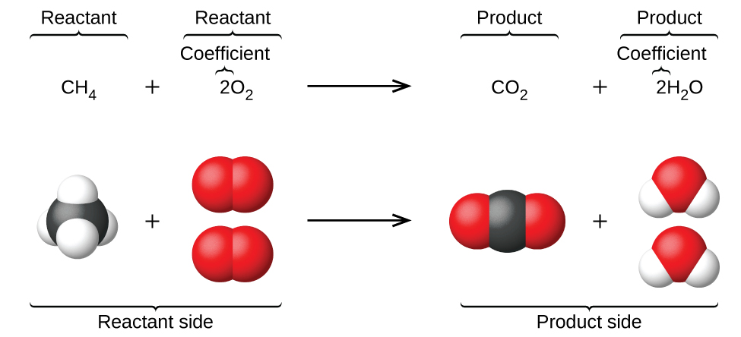

Figure 7.2 The reaction between methane and oxygen to yield carbon dioxide and water (shown at bottom) may be represented by a chemical equation using formulas (top).

This example illustrates the fundamental aspects of any chemical equation:

- The substances undergoing reaction are called reactants, and their formulas are placed on the left side of the equation.
- The substances generated by the reaction are called products, and their formulas are placed on the right side of the equation.
- Plus signs (+) separate individual reactant and product formulas, and an arrow (⟶) separates the reactant and product (left and right) sides of the equation.
- The relative numbers of reactant and product species are represented by coefficients (numbers placed immediately to the left of each formula). A coefficient of 1 is typically omitted.

It is common practice to use the smallest possible whole-number coefficients in a chemical equation, as is done in this example. Realize, however, that these coefficients represent the relative numbers of reactants and products, and, therefore, they may be correctly interpreted as ratios. Methane and oxygen react to yield carbon dioxide and water in a 1:2:1:2 ratio. This ratio is satisfied if the numbers of these molecules are, respectively, 1-2-1-2, or 2-4-2-4, or 3-6-3-6, and so on (Figure 7.3).

Likewise, these coefficients may be interpreted with regard to any amount (number) unit, and so this equation may be correctly read in many ways, including:

- One methane molecule and two oxygen molecules react to yield one carbon dioxide molecule and two water molecules.
- One dozen methane molecules and two dozen oxygen molecules react to yield one dozen carbon dioxide molecules and two dozen water molecules.
- One mole of methane molecules and 2 moles of oxygen molecules react to yield 1 mole of carbon dioxide molecules and 2 moles of water molecules.

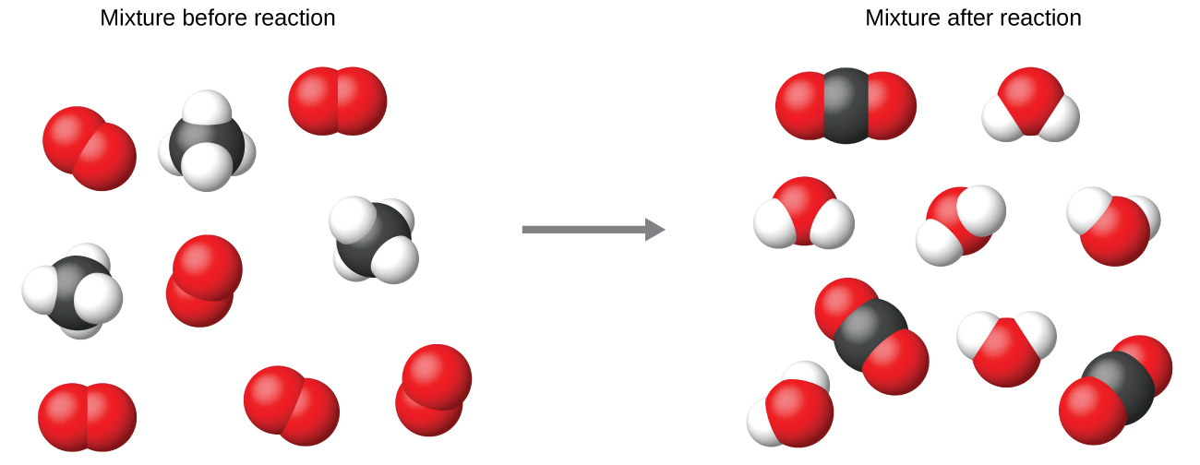

Figure 7.3 Regardless of the absolute numbers of molecules involved, the ratios between numbers of molecules of each species that react (the reactants) and molecules of each species that form (the products) are the same and are given by the chemical reaction equation.

Balancing Equations
The chemical equation described in Figure 7.2 is balanced, meaning that equal numbers of atoms for each element involved in the reaction are represented on the reactant and product sides. This is a requirement the equation must satisfy to be consistent with the law of conservation of matter. It may be confirmed by simply summing the numbers of atoms on either side of the arrow and comparing these sums to ensure they are equal.

Note that the number of atoms for a given element is calculated by multiplying the coefficient of any formula containing that element by the element’s subscripts in the formula. If an element appears in more than one formula on a given side of the equation, the number of atoms represented in each must be computed and then added together. For example, both product species in the example reaction, CO₂ and H₂O, contain the element oxygen, and so the number of oxygen atoms on the product side of the equation is

(2 O atoms in CO₂ molecule) + 2(1 O atom in H₂O molecule) = 4 O atoms

The equation for the reaction between methane and oxygen to yield carbon dioxide and water is confirmed to be balanced per this approach, as shown here:

CH₄ + 2 O₂ ⟶ CO₂ + 2 H₂O

Element | Reactants | Products | Balanced?
C | 1 × 1 = 1 | 1 × 1 = 1 | 1 = 1, yes
H | 4 × 1 = 4 | 2 × 2 = 4 | 4 = 4, yes
O | 2 × 2 = 4 | (1 × 2) + (2 × 1) = 4 | 4 = 4, yes

A balanced chemical equation often may be derived from a qualitative description of some chemical reaction by a fairly simple approach known as balancing by inspection. Consider as an example the decomposition of water to yield molecular hydrogen and oxygen. This process is represented qualitatively by an unbalanced chemical equation:

H₂O ⟶ H₂ + O₂ (unbalanced)
Comparing the number of H and O atoms on either side of this equation confirms its imbalance:
Element | Reactants | Products | Balanced?
H | 1 × 2 = 2 | 1 × 2 = 2 | 2 = 2, yes
O | 1 × 1 = 1 | 1 × 2 = 2 | 1 ≠ 2, no

The numbers of H atoms on the reactant and product sides of the equation are equal, but the numbers of O atoms are not. To achieve balance, the coefficients of the equation may be changed as needed. Keep in mind, of course, that the formula subscripts define, in part, the identity of the substance, and so these cannot be changed without altering the qualitative meaning of the equation. For example, changing the reactant formula from H₂O to H₂O₂ would yield balance in the number of atoms, but doing so also changes the reactant’s identity (it’s now hydrogen peroxide and not water). The O atom balance may be achieved by changing the coefficient for H₂O to 2.

2 H₂O ⟶ H₂ + O₂ (unbalanced)
Element | Reactants | Products | Balanced?
H | 2 × 2 = 4 | 1 × 2 = 2 | 4 ≠ 2, no
O | 2 × 1 = 2 | 1 × 2 = 2 | 2 = 2, yes

The H atom balance was upset by this change, but it is easily reestablished by changing the coefficient for the H₂ product to 2.

2 H₂O ⟶ 2 H₂ + O₂ (balanced)
Element | Reactants | Products | Balanced?
H | 2 × 2 = 4 | 2 × 2 = 4 | 4 = 4, yes
O | 2 × 1 = 2 | 1 × 2 = 2 | 2 = 2, yes

These coefficients yield equal numbers of both H and O atoms on the reactant and product sides, and the balanced equation is, therefore:

2 H₂O ⟶ 2 H₂ + O₂

It is sometimes convenient to use fractions instead of integers as intermediate coefficients in the process of balancing a chemical equation. When balance is achieved, all the equation’s coefficients may then be multiplied by a whole number to convert the fractional coefficients to integers without upsetting the atom balance. For example, consider the reaction of ethane (C₂H₆) with oxygen to yield H₂O and CO₂, represented by the unbalanced equation:

C₂H₆ + O₂ ⟶ H₂O + CO₂ (unbalanced)

Following the usual inspection approach, one might first balance C and H atoms by changing the coefficients for the two product species, as shown:

C₂H₆ + O₂ ⟶ 3 H₂O + 2 CO₂ (unbalanced)
This results in seven O atoms on the product side of the equation, an odd number—no integer coefficient can be used with the O₂ reactant to yield an odd number, so a fractional coefficient, 7/2, is used instead to yield a provisional balanced equation:

C₂H₆ + 7/2 O₂ ⟶ 3 H₂O + 2 CO₂

A conventional balanced equation with integer-only coefficients is derived by multiplying each coefficient by 2:

2 C₂H₆ + 7 O₂ ⟶ 6 H₂O + 4 CO₂

Finally with regard to balanced equations, recall that convention dictates use of the smallest whole-number coefficients. Although the equation for the reaction between molecular nitrogen and molecular hydrogen to produce ammonia is, indeed, balanced,

3 N₂ + 9 H₂ ⟶ 6 NH₃

the coefficients are not the smallest possible integers representing the relative numbers of reactant and product molecules. Dividing each coefficient by the greatest common factor, 3, gives the preferred equation:

N₂ + 3 H₂ ⟶ 2NH₃

Additional Information in Chemical Equations

The physical states of reactants and products in chemical equations very often are indicated with a parenthetical abbreviation following the formulas. Common abbreviations include s for solids, l for liquids, g for gases, and aq for substances dissolved in water (aqueous solutions, as introduced in the preceding chapter). These notations are illustrated in the example equation here:

2 Na (s) + 2 H₂O (l) ⟶ 2 NaOH (aq) + H₂ (g)

This equation represents the reaction that takes place when sodium metal is placed in water. The solid sodium reacts with liquid water to produce molecular hydrogen gas and the ionic compound sodium hydroxide (a solid in pure form, but readily dissolved in water).

Special conditions necessary for a reaction are sometimes designated by writing a word or symbol above or below the equation’s arrow. For example, a reaction carried out by heating may be indicated by the uppercase Greek letter delta (Δ) over the arrow.

CaCO₃ (s) CaO(s)+CO₂(g)

7.2 Reaction Stoichiometry

Learning Objectives
- Be able to explain the significance of the coefficients in a balanced chemical equation
- Understand the term stoichiometrically equivalent quantities or stoichiometric ratio between reactant-reactant and reactant-product
- Be able to calculate amounts, in grams or moles, of reactants and products for a reaction

Introduction
A balanced chemical equation provides a great deal of information in a very succinct format. Chemical formulas provide the identities of the reactants and products involved in the chemical change, allowing classification of the reaction. Coefficients provide the relative numbers of these chemical species, allowing a quantitative assessment of the relationships between the amounts of substances consumed and produced by the reaction. These quantitative relationships are known as the reaction’s stoichiometry, a term derived from the Greek words stoicheion (meaning “element”) and metron (meaning “measure”). In this module, the use of balanced chemical equations for various stoichiometric applications is explored.

The general approach to using stoichiometric relationships is similar in concept to the way people go about many common activities. Food preparation, for example, offers an appropriate comparison. A recipe for making eight pancakes calls for 1 cup pancake mix, 34 cup milk, and one egg. The “equation” representing the preparation of pancakes per this recipe is

1 cup mix + 34 cup milk + 1 egg ⟶ 8 pancakes

If two dozen pancakes are needed for a big family breakfast, the ingredient amounts must be increased proportionally according to the amounts given in the recipe. For example, the number of eggs required to make 24 pancakes is

$$24 pancakes × \frac{1 egg}{8 pancakes} = 3 eggs$$

Balanced chemical equations are used in much the same fashion to determine the amount of one reactant required to react with a given amount of another reactant, or to yield a given amount of product, and so forth. The coefficients in the balanced equation are used to derive stoichiometric factors that permit computation of the desired quantity. To illustrate this idea, consider the production of ammonia by reaction of hydrogen and nitrogen:

N₂ (g) + 3 H₂ (g) ⟶ 2 NH₃ (g)

This equation shows ammonia molecules are produced from hydrogen molecules in a 2:3 ratio, and stoichiometric factors may be derived using any amount (number) unit:

2 NH₃ molecules = 3 H₂ moleculesor
2 dozen NH₃ = 3 dozen H₂
2 mol NH₃ = 3 mol H₂

These stoichiometric factors can be used to compute the number of ammonia molecules produced from a given number of hydrogen molecules, or the number of hydrogen molecules required to produce a given number of ammonia molecules. Similar factors may be derived for any pair of substances in any chemical equation.

Example 1: Moles of Reactant Required in a Reaction
Question
How many moles of I₂ are required to react with 0.429 mol of Al according to the following equation (see Figure 7.4)? 2 Al + 3 I₂ ⟶ 2 AlI₃

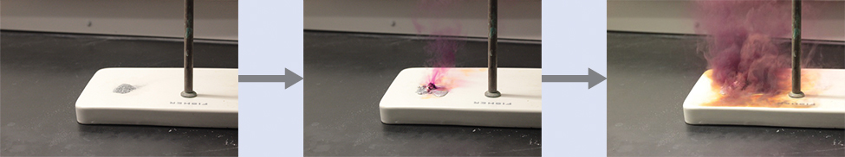

Figure 7.4 Aluminum and iodine react to produce aluminum iodide. The heat of the reaction vaporizes some of the solid iodine as a purple vapor. (credit: modification of work by Mark Ott)

Solution
Referring to the balanced chemical equation, the stoichiometric factor relating the two substances of interest is 3 mol I₂ to 2 mol Al. The molar amount of iodine is derived by multiplying the provided molar amount of aluminum by this factor:

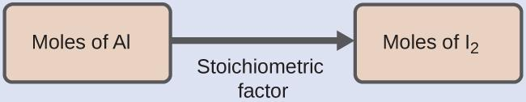

$0.429 mol Al ×\frac{3 mol I_{2}}{2 mol Al}$ = 0.644 mol I₂

Example 2: Number of Product Molecules Generated by a Reaction
Question
How many carbon dioxide molecules are produced when 0.75 mol of propane is combusted according to this equation?

C₃H₈ + 5 O₂ ⟶ 3 CO₂ + 4 H₂O

Solution
The approach here is the same as for Example 1, though the absolute number of molecules is requested, not the number of moles of molecules. This will simply require use of the moles-to-numbers conversion factor, Avogadro’s number.

The balanced equation shows that carbon dioxide is produced from propane in a 3:1 ratio:
3 mol CO₂ to 1 molC₃H₈

Using this stoichiometric factor, the provided molar amount of propane, and Avogadro’s number,

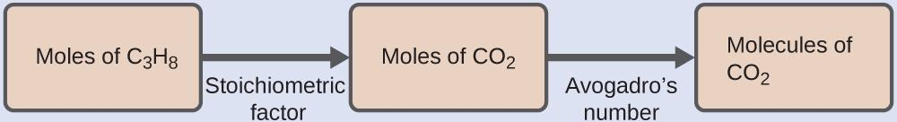

0.75 mol C₃H₈ $× \frac{3 mol CO_{2}}{1 mol C_{3}H_{8}} × \frac{6.022 × {10}^{23} molecules CO_{2}}{1 mol CO_{2}}$

= 1.4 x10²⁴ molecules CO₂

Example 3: Relating Masses of Reactants and Products
Question
What mass of sodium hydroxide, NaOH, would be required to produce 16 g of the antacid milk of magnesia [magnesium hydroxide, Mg(OH)₂] by the following reaction?
MgCl₂ (aq) + 2 NaOH (aq) ⟶ Mg(OH)₂ (s) + 2 NaCl (aq)

Solution
The approach used previously in Example 1 and Example 2 is likewise used here; that is, we must derive an appropriate stoichiometric factor from the balanced chemical equation and use it to relate the amounts of the two substances of interest. In this case, however, masses (not molar amounts) are provided and requested, so additional steps of the sort learned in the previous chapter are required. The calculations required are outlined in this flowchart:
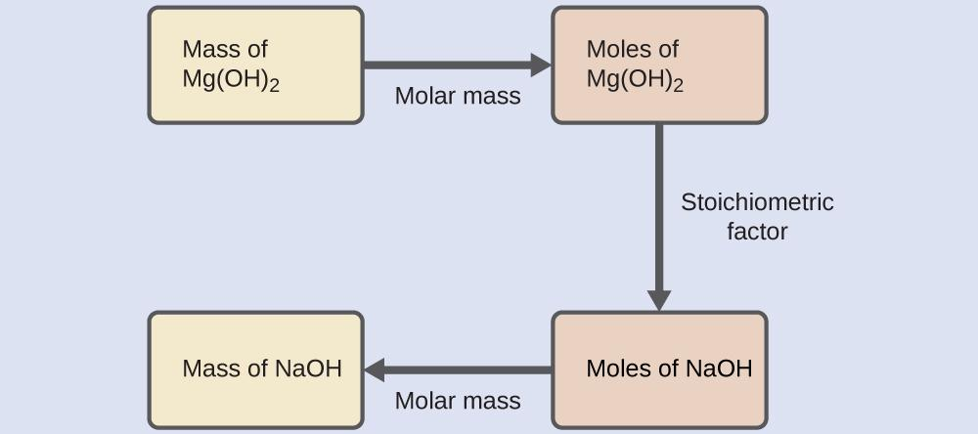

16 g Mg(OH)₂ $×\frac{1 mol Mg(OH)_{2}}{58.3 g Mg(OH)_{2}} ×\frac{2 mol NaOH}{1 mol Mg(OH)_{2}} ×\frac{40.0 g NaOH}{1 mol NaOH}$

= 22 g NaOH

Example 4: Relating Masses of Reactants
Question
What mass of oxygen gas, O₂, from the air is consumed in the combustion of 702 g of octane, C₈H₁₈, one of the principal components of gasoline?

2 C₈H₁₈ + 25 O₂ ⟶ 16 CO₂ + 18 H₂O

Solution
The approach required here is the same as for the Example 3, differing only in that the provided and requested masses are both for reactant species.

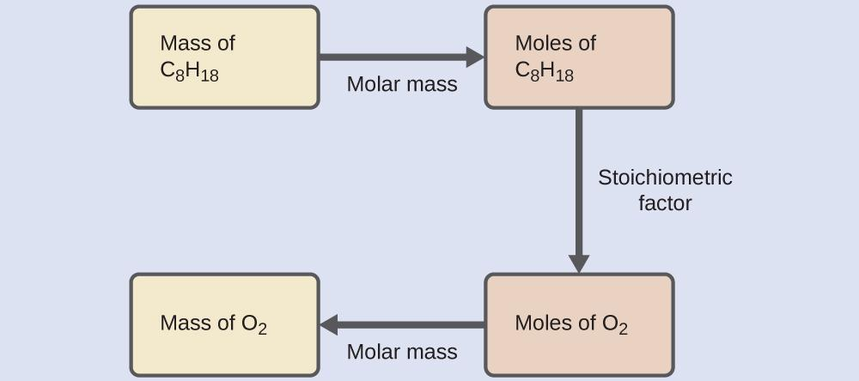

702 g C₈H₁₈ $×\frac{1 mol C_{8}H_{18}}{114.23 g C_{8}H_{18}} ×\frac{25 mol O_{2}}{2 mol C_{8}H_{18}} ×\frac{32.00 g O_{2}}{1 mol O_{2}}$

= 2.46 x 10³ g O₂

Stoichiometry Road Map
These examples illustrate just a few instances of reaction stoichiometry calculations. Numerous variations on the beginning and ending computational steps are possible depending upon what particular quantities are provided and sought (volumes, solution concentrations, and so forth). Regardless of the details, all these calculations share a common essential component: the use of stoichiometric factors derived from balanced chemical equations. Figure 7.5 provides a general outline of the various computational steps associated with many reaction stoichiometry calculations.

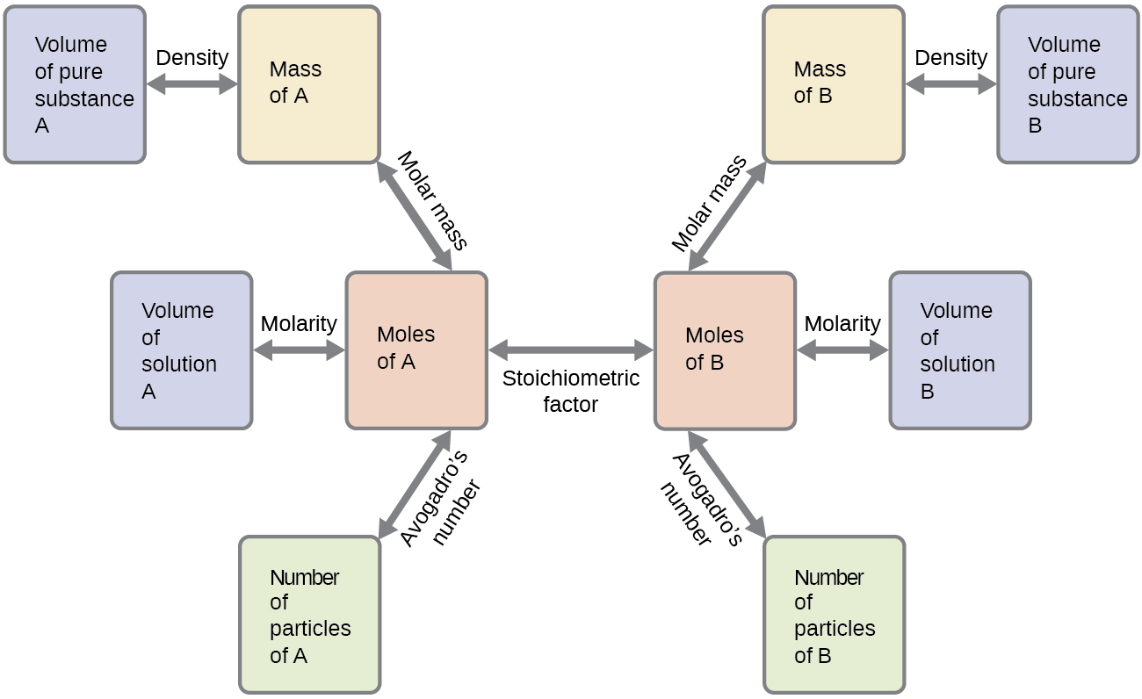

Figure 7.5 The flowchart depicts the various computational steps involved in most reaction stoichiometry calculations. Note that you will learn more about molarity in CH 122 and CH 123.

7.3 Limiting Reactant, Theoretical Yield, and Percent Yield

Learning Objectives
- Be able to define the terms limiting reactant/reagent, in excess reactant, theoretical yield, and percent yield
- Be able to calculate the theoretical yield
- Be able to calculate the percent yield of a reaction

Introduction
The relative amounts of reactants and products represented in a balanced chemical equation are often referred to as stoichiometric amounts. All the exercises of the preceding module involved stoichiometric amounts of reactants. For example, when calculating the amount of product generated from a given amount of reactant, it was assumed that any other reactants required were available in stoichiometric amounts (or greater). In this module, more realistic situations are considered, in which reactants are not present in stoichiometric amounts.

Limiting Reactant
Consider another food analogy, making grilled cheese sandwiches (Figure 7.6):

1 slice of cheese + 2 slices of bread ⟶ 1 sandwich

Stoichiometric amounts of sandwich ingredients for this recipe are bread and cheese slices in a 2:1 ratio. Provided with 28 slices of bread and 11 slices of cheese, one may prepare 11 sandwiches per the provided recipe, using all the provided cheese and having six slices of bread left over. In this scenario, the number of sandwiches prepared has been limited by the number of cheese slices, and the bread slices have been provided in excess.
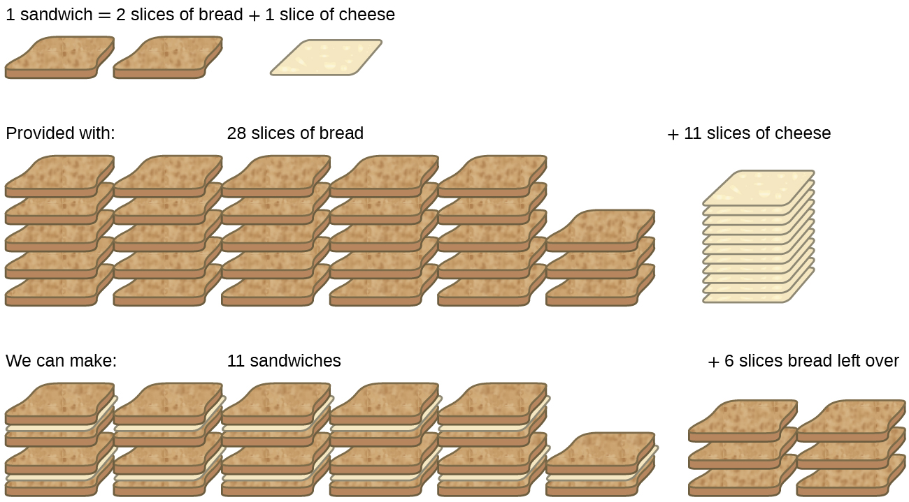

Figure 7.6 Sandwich making can illustrate the concepts of limiting and excess reactants.

Consider this concept now with regard to a chemical process, the reaction of hydrogen with chlorine to yield hydrogen chloride:
H₂ (g) + Cl₂ (g) ⟶ 2 HCl (g)

The balanced equation shows the hydrogen and chlorine react in a 1:1 stoichiometric ratio. If these reactants are provided in any other amounts, one of the reactants will nearly always be entirely consumed, thus limiting the amount of product that may be generated. This substance is the limiting reactant, and the other substance is the excess reactant. Identifying the limiting and excess reactants for a given situation requires computing the molar amounts of each reactant provided and comparing them to the stoichiometric amounts represented in the balanced chemical equation. For example, imagine combining 3 moles of H₂ and 2 moles of Cl₂. This represents a 3:2 (or 1.5:1) ratio of hydrogen to chlorine present for reaction, which is greater than the stoichiometric ratio of 1:1. Hydrogen, therefore, is present in excess, and chlorine is the limiting reactant. Reaction of all the provided chlorine (2 mol) will consume 2 mol of the 3 mol of hydrogen provided, leaving 1 mol of hydrogen unreacted.
An alternative approach to identifying the limiting reactant involves comparing the amount of product expected for the complete reaction of each reactant. Each reactant amount is used to separately calculate the amount of product that would be formed per the reaction’s stoichiometry. The reactant yielding the lesser amount of product is the limiting reactant. For the example in the previous paragraph, complete reaction of the hydrogen would yield

3 mol H₂ $×\frac{2 mol HCl}{1 mol H_{2}}$= 6 mol HCl

Complete reaction of the provided chlorine would produce

2 mol Cl₂ $×\frac{2 mol HCl}{1 mol {Cl}_{2}}$= 4 mol HCl

The chlorine will be completely consumed once 4 moles of HCl have been produced. Since enough hydrogen was provided to yield 6 moles of HCl, there will be unreacted hydrogen remaining once this reaction is complete. Chlorine, therefore, is the limiting reactant and hydrogen is the excess reactant (Figure 7.7).
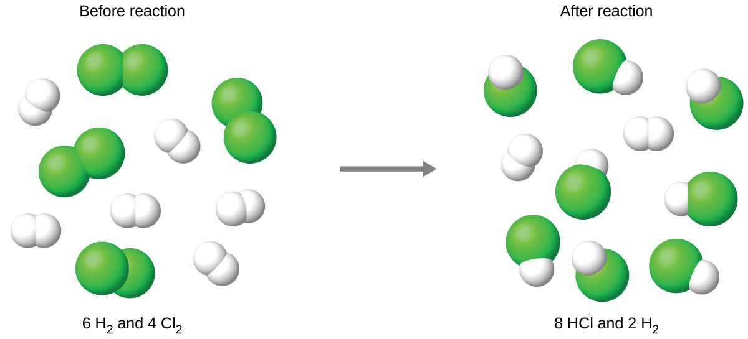
Figure 7.7 When H₂ and Cl₂ are combined in nonstoichiometric amounts, one of these reactants will limit the amount of HCl that can be produced. This illustration shows a reaction in which hydrogen is present in excess and chlorine is the limiting reactant.

Theoretical Yield, Actual Yield, and Percent Yield
The amount of product that may be produced by a reaction under specified conditions, as calculated per the stoichiometry of an appropriate balanced chemical equation, is called the theoretical yield of the reaction. In practice, the amount of product obtained is called the actual yield, and it is often less than the theoretical yield for a number of reasons. Some reactions are inherently inefficient, being accompanied by side reactions that generate other products. Others are, by nature, incomplete (consider the partial reactions of weak acids and bases discussed earlier in this chapter). Some products are difficult to collect without some loss, and so less than perfect recovery will reduce the actual yield. The extent to which a reaction’s theoretical yield is achieved is commonly expressed as its percent yield:

percent yield = $\frac{actual yield}{theoretical yield}×100\%$

Actual and theoretical yields may be expressed as masses or molar amounts (or any other appropriate property; e.g., volume, if the product is a gas). As long as both yields are expressed using the same units, these units will cancel when percent yield is calculated.

BLANK PAGE

