Writing 115
Intro to College Writing
Linn Benton Community College
Leana Dickerson
Winter Term 2017 leana.dickerson@linnbenton.edu
Room: IA 227 Office Hours: Tues. and Thurs. 1:00-2:30
CRN: 30958 Tuesday/Thursday 11:30-12:50 Office: SSH 215

Course Description:
Introduces college-level critical inquiry in academic reading and writing. Students critically read, summarize and respond in paragraph format. Students develop expository essay writing skills, review conventions, and use individual and collaborative writing processes.

Note: This course is transferable as an elective, but does not satisfy institutional writing requirements for the degree seeking or transfer student.

PREREQUISITE: Placement by CPT or successful completion of WR95.

Required Texts and Supplies:
Models for Writers 12th Edition, Rosa and Eschholz
3x5 Note cards (20, one for each class period)
2 Green Books (exam books from the bookstore)

Course Outcomes:
- Write thoughtful, clear, and focused paragraphs and essays for a variety of purposes.
- Illustrate critical reading by clearly summarizing, paraphrasing, and directly quoting.
- Distinguish your ideas from others’ ideas.
- Focus a main point and develop this main point clearly and logically using examples and illustrations in a well-organized essay.
- Revise writing using standard college editing and proofreading conventions (grammar, syntax, spelling, punctuation).

Turning In Assignments:
About half of your assignments will be done in-class and handed in at the end of the class period. Be sure to bring paper to class each day to be able to take notes or to complete in-class assignments.
All assignments due outside of class will be turned in via TurnItIn (On turnitin.com, you will need to create a free account in the first two weeks and register for our class using the class ID: 14258206 and password: Dante)

Assignments:
Participation: Participation not only includes attendance, which is a large part of you being able to participate at all, but also includes how you participate. If you show up every day but never say a word, you can expect only partial credit. If you are involved and turn in assignments regularly, you will be in much better shape come the end of term. Part of your participation grade will also include daily questions regarding the reading assigned.

In-Class and Take Home Assignments: you will be assigned various take-home or in-class assignments which will ask you to complete a writing task pertaining to the current course discussion and trajectory. These may be response papers, summarization, question and answer, etc.

Writing Center Visit: I encourage you to use the writing center as much as possible. You will be required to use the writing center AT LEAST once during the term for one of your at-home assignments (your essay or your summary/response papers). Visit the writing center, meet with a tutor about your work. When you have completed your session, you must turn in proof of your visit WITH a half-page, double spaced, typed reflection of your experience at the writing center and how it improved your writing. This can be turned in any time throughout term, and no later than Friday of the 10th week.

Summary/Response Papers: These will develop throughout the course, but you will finish with four summary or summary/response papers turned in via TurnItIn. These two-paragraph assignments will help develop your skills and prepare for the final exam.

Expository Essay: You will write one 3-4 page expository essay which will include summary and response of one essay from our text.

Narrative Essay: You will write a 3-4 page narrative essay.

Final: Your final for this class will be the exact final provided to all students who take WR 115. The following are the expectations; more on the process will be provided to you as we approach the end of term:
- Students will pass an exit final exam (holistically graded) worth 30% of the final grade. In a two-hour testing situation, students critically read a short essay then handwrite a summary and response paragraph. Instructor’s grades of classroom activities, projects, and assignments will be 70% of the final grade.
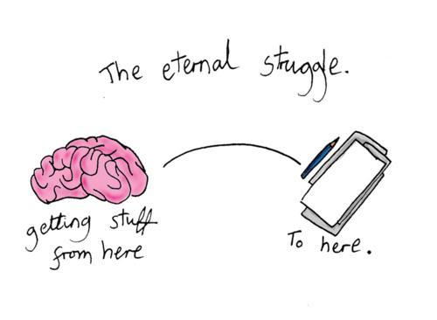
Grading:
Participation 10%
In-Class Assignments 20%
Out of Class Summary/Responses 40%
Final 30%

Resources: (use them!)
THE LIBRARY
Linn Benton Learning Center
Linn Benton Writing Center
Linn Benton Online Writing Lab (OWL)
Purdue OWL (Online Writing Lab): https://owl.english.purdue.edu/owl/

Late Work Policy:
Things happen, emergencies come up; as long as it does not become a clear pattern, if you ask me within 24 hours notice, I will most likely provide you with an extension plan for your work. If you do not request an extension within the 24 hour period before the assignment is due, you will automatically lose 5% of your grade for the assignment each DAY it is late thereafter (including weekends). Just don’t do it.

Attendance Policy:
Attendance is considered part of your participation for this course. I will allow you three missed classes which will not affect your grade, no questions asked. Each absence after will result in the lowering of your participation grade for this course which factors into your final grade. If you have an emergency which may affect your ability to complete this course, please contact me as soon as possible to make arrangements.

Class Cancellation Information:
In the event that we cannot meet on campus (weather, for instance), please be sure to check your LBCC e-mail. You should receive an e-mail from me, as we will still have out-of-class work either via an assignment through e-mail or through TurnItIn.

Electronics in the Classroom:
Please refrain from using electronics in class. I ask that you do not use a laptop or tablet to take notes as it does become a distraction not only for you, but also for your peers, as well as me. If you must make or take a phone call (or a text message), please remove yourself respectfully from class to do so.

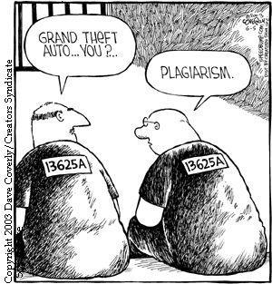
Academic Honesty:
The MOST important thing to remember when writing and studying for your own academic success, is to only claim your own thoughts and ideas. If you incorporate the work of others, you must utilize citations to provide them with the credit. Not using proper citations when using someone else’s work may result in you failing the assignment and even this course. For more information about plagiarism and what plagiarism includes, please visit: http://plagiarism.arts.cornell.edu/tutorial/index.cfm.

Nondiscrimination Policy:
LBCC maintains a policy of nondiscrimination and equal opportunity in employment and admissions, without regard to race, color, sex, marital and/or parental status, religion, national origin, age, mental or physical disability, Vietnam era, or veteran status. (See Administrative Rule No. E029 and Board Policy Series No. 6090, found at http://po.linnbenton.edu/BPsandARs/).

Accessibility
You should meet with your instructor during the first week of class if:
- You have a documented disability and need accommodations,
- Your instructor needs to know medical information about you, or
- You need special arrangements in the event of an emergency.
If you believe you may need accommodation services please contact Center for Accessibility Resources, 917-4789. If you have documented your disability, remember that you must make your request for accommodations through the Center for Accessibility Resources Online Services web page every term in order to receive accommodations.

Contact:
If you need to contact me, e-mail is the best resource. I frankly do not typically utilize phone communication, but check e-mail regularly except for on weekends, evenings, and holidays. And of course, come to my office hours; they’re designed for you to utilize!

Course Calendar: subject to (and will regularly) change. Check the google doc regularly using the link provided the first week of class.

