Linn-Benton Community College
Department of Communication
Interpersonal Communication
Course Syllabus: Fall 2020

Course Information

Course Number and CRN: COMM 218 CRN 20812
Credits: 3.00
Course Dates: September 28- December 7
Course Meeting Times: MWF 9:00-9:50am
Course Location: Online (Zoom)
Instructor: Steven Merge, M.S., M.B.A. (merges@linnbenton.edu), Phone: 541.490.2456

Office Hours: By Appointment for Zoom or Phone meetings; or you can Email me anytime (I usually
Email back within a few hours)

The biggest communication problem is we don’t listen to understand. We listen to reply. –Stephen R Covey
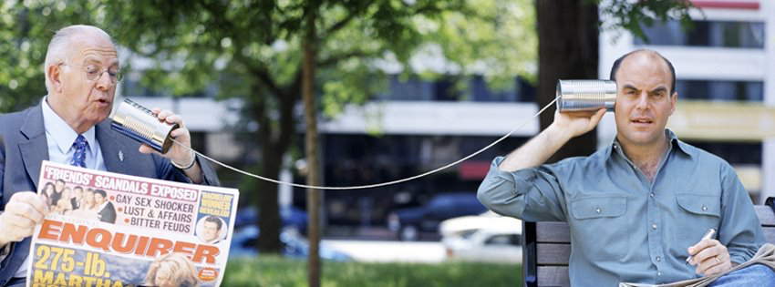

Did you know: A human can make more than 10,000 facial expressions to express a wide variety of subtle emotions.

COURSE OVERVIEW:
This course introduces students to various aspects of the communication process in one-to-one relationships. Emphasis is placed on enhancing personal and professional relationships by expanding knowledge, increasing understanding and developing practical skills necessary for competent communication.

COURSE OUTCOME:
Upon successful completion of this course, students will be able to:
Apply interpersonal communication research and theory. Identify interpersonal communication's key functional areas. Analyze, select, and enact appropriate interpersonal communication behaviors based on the interpretation of the context.

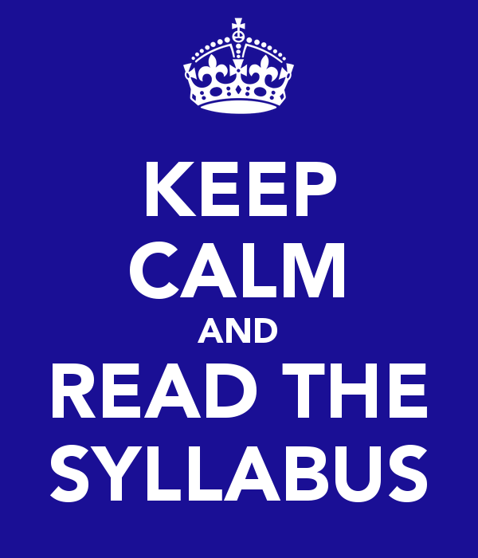

Required Text:
Adler, Ronald B. INTERPLAY. ISBN 9780190646257. 14TH EDITION

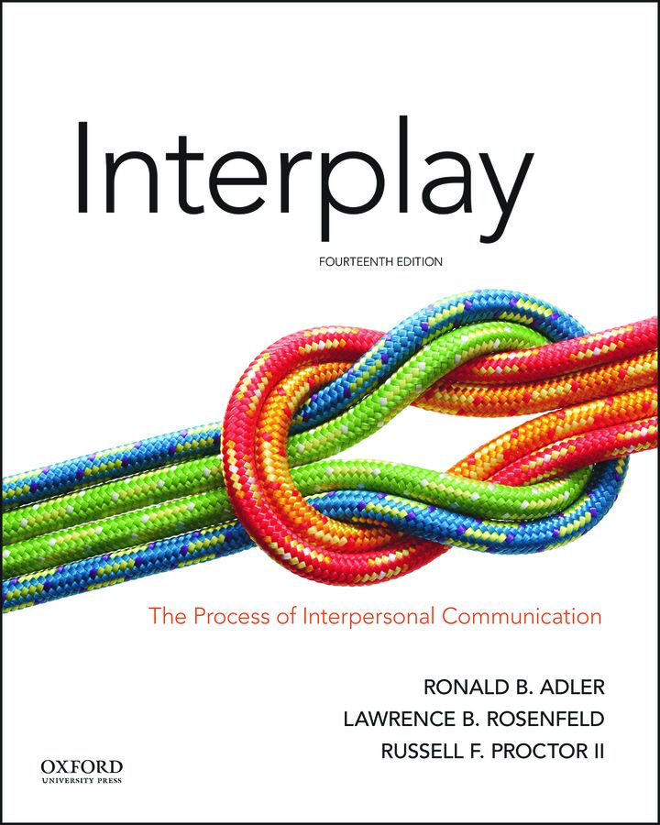
ADDITIONAL COURSE REQUIREMENTS:
You will need access to the Internet, Computer/laptop, and Moodle

GENERAL ASSIGNMENTS: Please be aware assignments may change or vary week to week. Dates of quizzes and midterm are posted in Moodle. Quizzes are open from 8:00-6:00 Fridays, Assignments must be posted by Sunday at 10pm.

Week 1 September 28th | Read Chapter One and complete first week’s listening exercise, take quiz 1

Week 2 October 5th | Read Chapter Two, complete second week of listening assignment, take quiz 2
Week 3 October 12th | Read Chapter Three, complete third week of listening assignment, take quiz 3
Week 4 October 19th | Read Chapter Four, complete fourth week of listening assignment, take quiz 4
Week 5 October 26th | Read Chapter Five, complete fifth week of listening assignment, take quiz 5
Week 6 November 2nd | Read Chapter Six, complete sixth week of listening assignment,  MIDTERM (on first 5 chapters)
Week 7 November 9th | Read Chapter Seven, take quizzes 6 & 7
Week 8 November 16th | Read Chapter Eight, take quiz 8, complete “thought” assignment”
Week 9 November 23rd | Read Chapter Ten take quiz 10
Week 10 November 30th | Read Chapter 11, take quiz 11
Week 11- The Final (Chapters 6, 7, 8, 10, &11) is on Wednesday, December 7, 10:00- 11:50am.
KEEP IN MIND…Interpersonal communication forms the basis for many of the most important relationships in our lives. The purpose of this course is to allow students to develop their interpersonal communication skills, gain insights into their own communication activities, and to explore the role that communication plays in the construction of their world.

Ah Harry, how often this happens, even between the best of friends. Each of us believes that what he has to say is much more important than anything the other might have to contribute. ~ Albus Dumbledore
On Moodle you will find weekly class assignments, readings, and due dates for quizzes, Midterm, and Final. Please contact me with any questions you have. This is not a difficult class, but you need to stay current with your work to succeed.

MAJOR CLASS ASSIGNMENT: (Please find this and other assignments posted on Moodle)
Weekly Listening Skills Assignment
Examples and further explanations are posted on Moodle
You will do this every week for six weeks!
The goal of the weekly assignment is to better understand the concepts from the text and how they apply to your everyday interpersonal interactions with others. The emphasis is almost entirely on developing your listening skills. You will do this assignment for six weeks during the term.
The assignment will provide you with opportunities to apply these concepts, gain important insights into your communication practices, and begin to think critically about how well you and others communicate successfully.
Explanation: Pick a conversation you had with another person. It could be anyone from family to the checker at the grocery store. Listen carefully to everything being said to you. Be responsive to everything being said (verbal and nonverbal) and make sure to answer every question asked.

Each week, please write a 1-2 page paper that includes the following:
1. Describe: In great detail, describe the encounter. Explain the situation, the environment, the mood, exactly what was said, and the outcome.

2. Relate the event to the material in this course, particularly with the current week’s reading. Please either CAPITILIZE, bold, or highlight the textbook terms that you use.

3. Provide Insights: Conclude by providing some type of insightful discussion of the interpersonal exchange that you are discussing.
Suggestion: This assignment is not as easy as it looks. I highly recommend starting the first week with someone who is providing a service to you. Examples would be a server, barista, or the checker at the grocery store.
The second week you can try a more personal conversation. Examples would be a teacher or a salesclerk.
Save more intimate conversations until at least the third week.
For more details go to Moodle or Email me with questions.

MAJOR GRADED WORK:

Please refer to Moodle for weekly assignments. Be aware, they can change, so you must check Moodle every day or two! I try to email the class when changes are made.

Extremely Important! You must log into Moodle on the first day of the term (September 28th) to secure your spot in the class.

There will be weekly quizzes, mid-term and final, plus class assignments.
You will be graded on:
Quizzes (10 points each)
Mid-term 50 points)
Final (50 points)
Assignments (10 points each)
Total Points (270)

***Grading and Assignments: All assignments must be turned in by Sunday, at 10PM. Quizzes are open from 8AM to 6PM on Fridays. All assignments must be turned in the week it was assigned. Example: Any assignments given the second week, must be turned in by the Sunday before the start of the third week.

Assignments or quizzes that are turned in late will receive 10% lower grades. There is no extra credit offered for this class.

GRADING SCALE:

A 90-100%
B 80-89%
C 70-79%
D 60-69%
F 0-59%
I Incomplete (OPTIONAL: include your policy on incompletes. For examples, see [web link])
W Withdrawal (Indicate here under what conditions you would not support a student requesting a withdrawal from the course which by LBCC policy is available from the 8th week into finals week with instructor permission. If you would consider such requests, you do not have to include an explanation.)

PLEASE REVIEW THE FOLLOWING:
Writing Guidelines: While this is not a writing course, proofreading/editing for grammatical and spelling errors is imperative in effective communication. Please proof your work!

Honor Code: LBCC is dedicated to maintaining an optimal learning environment and insists upon academic honesty. To uphold the academic integrity of the institution, all members of the academic community, faculty, staff and students alike, must assume responsibility for providing an educational environment of the highest standards characterized by a spirit of academic honesty. Accordingly, if you exchange information with another student during an exam, use unauthorized sources during an exam, or submit someone else’s work or ideas as your own in any of your assignments, you will receive an F for the exam/assignment and may be subject to further discipline.

Equal Opportunity and Non-Discrimination Policy: LBCC prohibits unlawful discrimination based on race, color, religion, ethnicity, use of native language, national origin, sex, sexual orientation, marital status, disability, veteran status, age, or any other status protected under applicable federal, state, or local laws.

Pronouns & Names: In order to provide an optimal learning environment for all students, creating a safe space is imperative. If you identify with a particular pronoun/name not represented on the class roster, please feel free to send me an email or come and discuss it with me in-person so I can be sure to recognize this. Your learning and identity are important.

Please read the following links:
Student Rights, Responsibilities, and Conduct Policy
Student Conduct
Classroom Etiquette
Student support: CFAR Website

Also:
Statement of Inclusion: To promote academic excellence and learning environments that encourage multiple perspectives and the free exchange of ideas, all courses at LBCC will provide students the opportunity to interact with values, opinions, and/or beliefs different than their own in safe, positive and nurturing learning environments. LBCC is committed to producing culturally literate individuals capable of interacting, collaborating and problem-solving in an ever-changing community and diverse workforce.

Basic Needs Statement: Any student who has difficulty affording food or finding a safe and stable place to live, or who needs assistance with resources for transportation, childcare, etc., is urged to contact the Single Stop office in Takena Hall, LBCC Albany campus, for support and referral to community resources. 541-917- 4877, linnbenton.edu/singlestop or SinglestopatLBCC@linnbenton.edu Also, please talk with your instructor if you are comfortable doing so. This can help them direct you to the appropriate office and resource.

