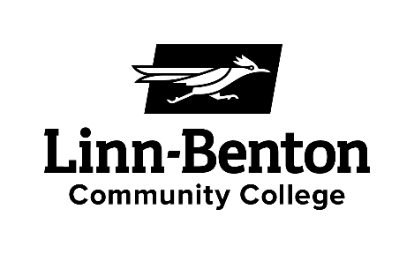

**Course Syllabus – Winter 2020**

**Math 255 – Vector Calculus**

**Instructor Information**

Instructor: Jeff Crabill

Office: WOH-131

Office Hours: MWF 12:00 – 12:50 PM  
 I am always available by appointment to accommodate your schedules.

Phone: (541) 917-4627

Email: jeff.crabill@linnbenton.edu

**Course Information**

Course Name and Title: Math 255 – Vector Calculus

Course Credits: 4 credit hours

Registration Information: CRN 30156 MTWF 11:00 pm

Prerequisite Course: Math 254 – Multivariable Calculus

Course Description: An intermediate treatment of multivariate calculus with a vector approach. Provides the mathematical skills for courses in advanced calculus, fluid mechanics and electromagnetic theory.

**Course Website:** Sign up for an account at [www.schoology.com](http://www.schoology.com) and register using the code given in class for our Math 255 course website.

**Course Materials**

Text: *Any Calculus Reference (Text or Online)*

*Stewart – Chapter 16 plus other materials  
 “Bridge Project” Vector Calculus Text (link at Schoology website)*

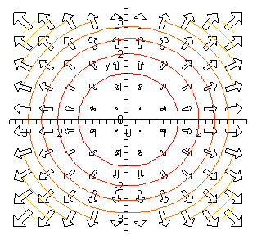

**Class Format**

Learning will always be happening in Math 255 and in a variety of forms – lectures, discussions, or group activities. Every classroom experience will be designed to elucidate a new concept and you will want to be open to those new ideas.

Each week, we will do a group activity. The structure of the activities will be explained in class. These activities are designed to introduce new concepts (some of which you’ll not have seen before!) and to challenge your understanding of the subject. They should spread light on the topics as well as the relationship of the material to physics if you take your role in the group activity seriously.

**Learning Environment**

* There must be a respectful exchange of ideas with instructor and other students in class.
* Cell phones turned off.
* Arrive on time and when late, join us quietly.
* When you need to leave early, sit by the door and leave when you need to.

**Course Policies**

**Attendance:** Important! Students who come to class learn more and do better on average than those who do not. You are responsible for information covered in class!

**Bad Weather:** If school is closed and our class is cancelled, we will continue with our schedule adjusted accordingly.

**Incomplete Grades:** Incompletes are given at the instructor’s discretion. I will only consider an incomplete for verifiable unusual circumstances for students who have completed 80% of the course material. (A student should withdraw from the course in most other circumstances.) Grades of Y or WP will not be issued in this course.

**Academic Dishonesty:** Cases of academic dishonest, as defined the *Student Code of Conduct*, will be reported to the Dean of Student Services. First offenses will be given a zero on the affected assignment and reported to the Dean of Students. Second offenses will be reported for disciplinary action and the student will receive a failing grade in the course.

**Late Work:** No late work is accepted. Plan to hand in what you have completed at the time the assignment is due for the credits on the parts of the assignment you have done. Better some credit than none!

**Syllabus Caveat:** Any item not specifically covered in this syllabus shall be determined solely at the discretion of the course instructor. You agree to abide by the syllabus and the decisions of the instructor. **Course Evaluation**

**Homework:** You will be required to turn in approximately ten homework assignments, one each week. Homework due dates will be posted with each assignment on the course website. Some assignments will be thoroughly graded and others may be spot checked.

You are required to use only the front side of either blank, unlined paper, or engineering paper. Illegible or poorly presented assignments will not receive more than 70% credit.

We will discuss minimum standards for written work and presentation of written work in class.

**Activities**: In an effort to focus on conceptual understanding of the calculus of vectors and to relate the study of vector calculus to the field of physics, students will complete nine group activities this term. **The activities are designed to increase your geometric understanding and reasoning**. You will be working in groups of 3 or 4, and group membership may change from time to time. Each group effort will have a fundamental question for you to ponder after the work and then something to submit individually. **This is the primary way that we will approach and assess course outcome #1.**

The highlighted note above in the homework section also applies to written work submitted after an activity.

**Tests:** We will have one mid-term exam and one cumulative final exam. Testing dates will be announced in class. Tests are to be taken on the testing dates and any needs to test other than the scheduled dates must be given at least two days prior to the test. Make-up tests are given at the discretion of the instructor.

During exams, students are allowed one 3x5 notecard and a non-programmable calculator.

**Grading**

Your course grade will be determined by the number of points that you earn, and then distributed equally among the four major assignment categories shown here.

* Homework: 25% 90% - 100% A
* Activities: 25% 80% - 89% B
* One Midterm Exam 25% 70% - 79% C
* One Final Exam 25% 60% - 69% D  
   < 60% F

Midterm Exam – Friday of Week #5

Final Exam – See the school calendar of finals for our final time and date**Student Learning Outcomes**

Upon completion of the course, the student will be able to

1. Develop a unifying thread throughout the major topics in the course starting with the vector differential.
2. Construct and evaluate line integrals and surface integrals.
3. Develop an analytic and geometric understanding of the gradient and of conservative vector fields, and their relationship to each other.
4. Develop an analytic and geometric understanding of curl and divergence, including their relationship to circulation and flux.
5. Develop an analytic and geometric understanding of the Divergence Theorem and of Stokes’ Theorem.

**LBCC Comprehensive Statement of Nondiscrimination**

LBCC prohibits unlawful discrimination based on race, color, religion, ethnicity, use of native language, national origin, sex, sexual orientation, marital status, disability, veteran status, age, or any other status protected under applicable federal, state, or local laws.

(for further information <http://po.linnbenton.edu/BPsandARs/> )

**Disabilities Services Statement**

Students who may need accommodations due to documented disabilities, who have medical information which the instructor should know, or who need special arrangements in an emergency, should speak with the instructor during the first week of class. If you have not accessed services and think you may need them, please contact Disability Services, 917-4789.

**Statement of Inclusion**

The LBCC community is enriched by diversity. Everyone has the right to think, learn, and work together in an environment of respect, tolerance, and goodwill. I actively support this right regardless of race, creed, color, personal opinion, gender, sexual orientation, or any of the countless other ways in which we are diverse.  (related to Board Policy #1015)