Fall 2018
COMM 218 - Interpersonal Communication

Professor: M. Zakir Khan, J.D., M.A. - “Dr. Khan”
E-mail Address: khanz@linnbenton.edu
Office: South Santiam Hall (SSH) 202
Phone: 541-817-4834
Meeting time: TR 10-11:20A | 1-2:20P
Section: 20661 | 20738
Classroom: IA-232 | IA-223
Office Hours: T - 11:30-12:30PM | W - 11-12PM and by appointment.
Course Websites: 1) Moodle: https://elearning.linnbenton.edu/login/index.php
[Accessible later in the term]
2) Piazza: http://piazza.com/linnbenton/fall2018/comm218

Access Code: comm218
*Class 1: Comm 218, insert access code and join as a student. Click Join classes. Enter your email address on the next page. Use your LBCC email account for your email address and then type in the validation code.
*Or activate via the email that gets sent out at the beginning of the term.

3) Course Schedule – Available on this link:

- This term we will be using Piazza for class discussion. The system is highly catered to getting you help fast and efficiently from classmates and me. Rather than emailing questions to me, I encourage you to post your questions on Piazza. If you have any problems or feedback for the developers, email team@piazza.com.
- I will be using Piazza to post assignments, announce class cancellations, and discuss important issues related to class. Signing up is mandatory.
- If you have a smartphone, you can download/use the Piazza app.
- Piazza is to be used by students only for discussing course materials/asking questions.
- Items posted by students on Piazza are anonymous to other students, but the professor and TAs can view which student is posting them.
- The top 5 student contributors in each class – get 20 extra credit points. **contributions are posts, responses, edits, follow-ups, and comments to follow-ups (i.e., everything)

Important Notes

1) If something is going on with you that will affect your ability to be successful, please let me know what I can do to help.
2) I seek to promote a supportive, inclusive, and positive educational environment where all students have an opportunity to be successful! Please help contribute to it through the way you conduct yourself in the classroom.

Disclaimer: All items discussed in this syllabus are subject to change based upon the professor’s discretion and students will be provided notice of any changes.
Test Date
- Final Exam – Check finals schedule at: https://www.linnbenton.edu/finals-schedule
  - TR 10am - Tuesday, December 4 - 9:30-11:20am
  - TR 1pm - Tuesday, December 4 - 2:30-4:20pm

Required Materials
- Interplay by Ronald B. Adler. 13th edition, 2015. ISBN10: 0199390487. ISBN13: 978-0199390489.
- American Hate by Arjun Singh Sethi, 2018. ISBN10: 1620973715. ISBN13: 978-1620973714.

Reporting Sexual Misconduct
Students who believe they are the victims of sexual harassment or assault should contact Campus Safety at 541-926-6855, and/or local law enforcement.
Course Description
This course introduces students to various aspects of the communication process in
one-to-one relationships. Emphasis is placed on enhancing personal and professional relationships by expanding knowledge, increasing understanding and developing
practical skills necessary for competent communication.

LBCC Course Outcomes
As a result of taking Comm 218, a student should be able to: • Apply interpersonal communication research and theory • Identify interpersonal communication’s key functional areas • Analyze, select, and enact appropriate interpersonal communication behaviors based on the interpretation of the context

Student Learning Objectives
Students who pass this class will demonstrate the ability to: • Use theory to explain behaviors in interpersonal relationships • Monitor, analyze and adjust their communication behaviors • Effectively interact with others in personal and professional settings • Manage conflict more effectively • Empathize with people who have different thoughts, beliefs and lifestyles

Grading Breakdown
Assignment | Possible Points | Your Points
Personal Shield Presentation | 25
Thank You Note | 25
Midterm Exam | 100
Quizzes | 50
Participation | 200
Group Project Check-in | 25
Group Project Rough Draft | 50
Group Project | 250
Application Paper | 100
Privilege Reflection Paper | 25
American Hate Paper | 100
Life Lesson Speech | 50
Extra Credit | 40 points Max
Total | 1000

Grading Scale
Grades | Percentage
Grade = A | 89.5-100+%
Grade = B | 79.5-89.4%
Grade = C | 69.5-79.4%
Grade = D | 59.5-69.4%
Grade = F | 59.4%-0.0%

Attendance Policy

- Students are allowed three absences and two tardies without penalty.
- Every absence that exceeds this will result in a 5% (50 points) overall grade penalty. Every tardy that exceeds this will result in a 2.5% (25 points) grade penalty. For example, if you are receiving a 90% in the class and have one more absence than you are allowed, you will then receive an 85% for the course.
- Attendance is called at the start of class.
- Arriving after attendance is called is a tardy.
- Arriving after 10 minutes is an absence.
- Leaving class within 10 minutes of class ending will count as a tardy, unless previously cleared with the professor.
- Leaving class before the last 10 minutes will be an absence.
- Special Circumstances: If something is going on with you that is impacting your ability to perform well in the class and attend class on time, please come see me! I’m glad to help!

Attendance Notes
- Students are responsible for keeping track of their own attendance, but can check in with the professor to see their current attendance situation.
- Students are responsible for coming up to the professor at the conclusion of the class to notify him of their tardy. If the student does not do this, the student will be marked down as having an unexcused absence. This cannot be corrected at a later time!
- If a student is going on a trip, or some other occasion (school sponsored or not) it is the student’s responsibility within the first week weeks of the term to notify the professor that they will be absent, and that they will miss a speech/assignment. If a student does not notify the instructor of a trip in advance, the student will receive a zero on the assignment.
- All work must be submitted prior to the due date; extensions will not be given to students who don’t show up to class when a particularly assignment is due.
- It is the student’s responsibility to figure out what they missed during class from another student in the class.
  - Please make sure to get the contact information for three of your classmates and write it down. Now ☺.

Cell Phone Policy
- Students are barred from using cell phones at any point during the entire class session, unless the professor tells them to use it for certain activities. Phones should be out of sight and should be on silent before class starts.
- Students that have some sort of emergency going on (emergency call) should notify the professor of this occurrence before class starts and should sit at the back of the classroom so as not to be distraction to other students. Phones should also be on silent.

Electronic Device Policy
- Tablets and other e-reading devices are only allowed in class to be used for their textbook purposes. These devices cannot be used to take notes or for any other purpose. Exceptions can be made, but need to be cleared by the professor in advance.

Consequences for improper cellphone/electronic device usage/ cell phone going off during class
  - 1st offense: The student will be asked to leave the class and thus, receive an unexcused absence.
  - 2nd offense: The student will be asked to leave the class, receive an unexcused absence, forfeit 10% of their overall grade and be referred to Student Affairs. If a student has already exceeded the maximum amount of unexcused absences this consequence will scale to 15%.
  - 3rd offense: The student will get a F in the class.
  - At the discretion of the professor, these offenses may be forgiven if the student exercises proper behavior for the rest of the quarter.
If this is a deal breaker, there are no hard feelings.
But PLEASE drop this class today to allow someone else to take your seat.
Plagiarism
LBCC is dedicated to maintaining an optimal learning environment and insists upon academic honesty. To uphold the academic integrity of the institution, all members of the academic community, faculty, staff and students alike, must assume responsibility for providing an educational environment of the highest standards characterized by a spirit of academic honesty. Accordingly, if you exchange information with another student during an exam, use unauthorized sources during a exam, and/or submit someone else’s work or ideas as your own in any of your assignments, you will receive an F for the assignment and may be subject to further discipline.
The better way to think about plagiarism:
Don'ts
Don't cheat. Don't lie. Don't steal. Don't misrepresent others work as yours. Don't go to places like schoolsucks.com, evilhouseofcheat.com, termpapersrus.com, or any of the other hundreds of online and off line sources where term papers can be commissioned or bought or borrowed for <wink>research purposes only</wink>. Don't make up fake sources. Don't make up fake quotes. Don't make up fake interviews. Don't think that by copying something over and changing every couple of words that you've put it in your own words. Don't think that because something is on the Net it doesn't need to be cited. Don't think that because a lot of textbooks and other printed matter you read don't site sources that you don't have to cite them either. Don't think that because politicians have speech writers and actors have script writers who often go unacknowledged that you can get a writer to "secretary" your paper for you; rules that apply in other settings are different here, where the purpose is for you to do the writing. Don't go to the library, find a book that hasn't been checked out often, then find a source in its bibliography, and then copy that source into a paper as yours. Don't procrastinate on assignments and homework so that you end up under too much deadline pressure and become tempted to take shortcuts. Don't be afraid to come see me if you feel overwhelmed, unsure, fear missing a deadline, or start falling behind. Don't try to get around any of these Don'ts by working so hard to disguise them that you might as well have just done the Do's.
Do's
Do share ideas with one another. Do swap writing. Do help one another write. Do edit and rewrite sections of one another's papers from time to time; writers do that kind of thing all the time, and editors do it with them. Do learn to like your writing; even when it's bad, hand it in any way, and know I'll always find something to like about it. Do expect to make mistakes managing and citing sources. Do expect to correct them. Do take care in downloading sources and taking notes. Do find a way to use sources wisely and fairly. Do learn the myriad rhetorical purposes that including and citing sources can serve. Do use the word processor to help you manage sources (for example, put sources you're quoting or paraphrasing in a different font and font color until the final draft so you don't accidentally forget they came from some other writer). Do have fun with sources, think of using them as weaving, building, playing with blocks, or any other metaphor that you associate with "taking what's at hand and making something of it." Do write before, while, and after you research, but especially before. Do discover an argument so you have a distinctive voice in your own essay, and aren't overwhelmed and intimidated by sources. Do come see me whenever you have a question about the course, are feeling overwhelmed, or unhappy with an assignment or your work; we can talk and find a way to make things work.
Consequences
- For the first plagiarism offense, students will receive a zero on the assignment (this includes speeches). In addition, the student may be given a substantial assignment from the professor to complete through the Writing Lab. Upon completion of which, the student will be able to get back 50% of the points lost on the assignment. This offense will also be reported to Student Affairs.
- For the second plagiarism offense, a student will receive an automatic F in the course. Again, the student will be reported to Student Affairs.
Citations (if needed)
- All citations must be done according to the Chicago Manual of Style (CMS). This resource may help student cite sources: https://owl.english.purdue.edu/owl/resource/717/01/
- Students should use footnotes (NOT endnotes) for their citations whether they are quotations or paraphrases. Every single time a source other than a student’s self that is used, a citation MUST be given.

Email Etiquette

Before emailing me, consider These:
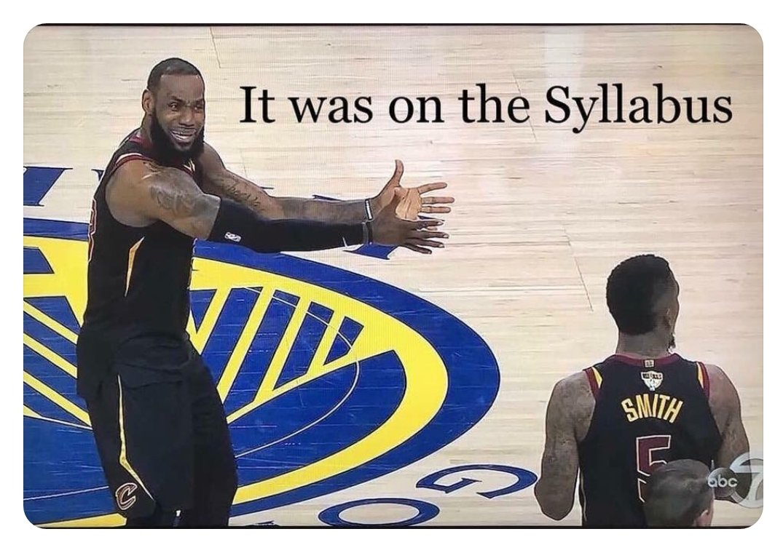
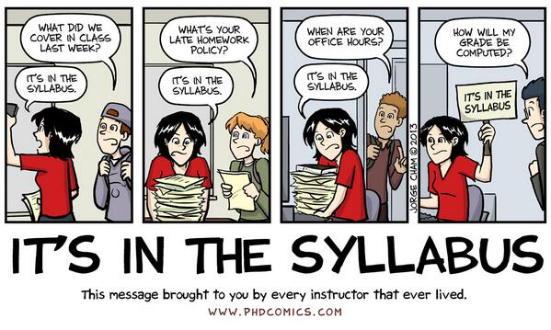
- Before you email me, read these links. Seriously. You’ll be a pro-emailer just by reading these links.
  - https://www.mindtools.com/pages/article/write-effective-emails-infographic.htm
  - https://www.wikihow.com/Email-a-Professor
  - https://medium.com/@lportwoodstacer/how-to-email-your-professor-without-being-annoying-af-cf64ae0e4087
  - https://www.insidehighered.com/views/2015/04/16/advice-students-so-they-dont-sound-silly-emails-essay
  - Subject lines should begin with something similar to the following: [COMM111 MW 9-9:50a]. The reason for this is to provide notice to the professor as to which class the student is in. The professor teaches several sections so he’d appreciate being able to keep track of where emails are coming from. ☺
- A good example of how to do a proper subject line is the following:
  - Subject: Group Project [COMM111 MW 9-9:50a]
- Please do not email me on LinkedIn or Twitter. Those are personal accounts, and I will not respond to you.
Email Response Times
- If the professor does not get to your email the same day, he will get back to you as soon as he can. If a student urgently needs to understand a concept or has a question, the student should seek help from other students on Piazza.
Reviewing Student Work
The professor will only review a student’s work during office hours and class.
Participation
- Students are expected to have completed all of the readings prior to coming to class.
- Students are encouraged to take hand-written notes on the readings before coming to class. These notes may be used on both in-class exams.
- Lectures/Activities: A student’s participation grade is determined by the following items:
  - Adding value to class discussions, through openness and/or knowledge of the material.
  - Participating fully in activities.
  - Asking questions.
  - Being a good audience member and colleague to fellow classmates.
  - Students found to be unprepared for class may face a loss of points to their participation grade, this is typically capped at 20 points.
- Be respectful of yourself, others and me.
- Participation grades are typically not calculated till the end of the quarter.

These policies are in place to make this a successful and enjoyable course for everyone. Failure to comply with the policies will result in disciplinary actions as deemed appropriate by the instructor (as outlined in the rules and regulations established by the college).
Assignment Guidelines
- Policy on late assignments: All assignments are due by the dates and times stated on the course schedule, Piazza or assignment guidelines page. Unless I make an announcement to the contrary. The mode of submission will be stated in class or on Piazza.
- I do NOT accept late assignments (especially because all deadlines are given to students at the start of the semester). If an emergency arises, you must contact me in via email before the due date to request an extension.
- Assignment format: All assignments should include your first and last name. The text of the assignment should be in 12-point Times New Roman type (with normal spacing in between letters), double-spaced and, with each page having one-inch margins on all sides.*No abnormal/weird formatting please. Please also include footer in the lower right-hand corner of each page (except the first) with the following information: last name, page X of Y (with Y indicating the total number of pages you are submitting) in 10-point Times New Roman type. Assignments exceeding the specified page limit or violating any of these requirements may be penalized. Specific penalties for breaking this rule will be articulated in the assignment guidelines when they are given during class.
  - Please see the formatting checklist on Piazza for more help.

Assignments

- Personal Shield Project
  - This project is an opportunity for us to learn about what’s most important to you and for you to reflect upon who you are. In each section, use any combination of drawings, pictures, or words to tell us about you. Sections on your personal shield should answer the following questions:
    - Tell us who your hero is.
    - What inspires you?
    - What is a strength of yours?
    - If could you drop everything and do one thing to improve humanity in some way, what would you do?
  - When you present this in class you should discuss why you picked that certain visual and what it means to you.
  - Please put your shield on a PowerPoint/PDF/Google slides and then you will present it to the class.
- Thank You Paper (Half-a-page)
  - Write a letter/note/thank you card to the classmate who you paired up with and tell them what you appreciated about them sharing in their presentation. Tell them why you appreciated that. Your words will stay with you, me and your partner. Bring a copy with you to class (either a card, or a sheet of paper - your preference).
- Quizzes – May be given if students are not reading.
- Midterm
  - This exam will be multiple-choice. Questions will come from the readings, lectures, discussions and activities.
- Group Presentation
  - Students will be divided into groups and each group will interview the leadership of a campus organization (administration/department/club) or local entity and determine a topic of interest of that organization that can be addressed through interpersonal communication concepts covered in the course.
  - Each student must lead the workshop for a set period of time determined by the guidelines of the assignment. Those minutes must be consecutive – meaning the speaker is the only one in charge at that point.
  - Students will create a 15-25-minute workshop that contains the following elements:
    - “(a) begins with a brief overview of the mini-workshop’s topic, purpose, and significance to the organization or office it is intended for;
    - (b) engages the class in a brief exercise providing practical experience with the topic; and
    - (c) ends with a question & answer period and a critical discussion of the exercise, what the class learned from it, and how it may be improved and actually presented (with caveats) to the organization or group the mini-workshop is intended for.”
  - Prior to the presentation the professor will be checking in with every group and will also review a rough draft of their outline.
- Application Paper
  - Students will be given a hypothetical that they will have to apply a theory or a concept to.
- Privilege Reflection Paper
  - Students will draft a paper where they examine and reflect upon their privileges.
- American Hate Paper
  - The guidelines for this assignment will be given later this term.
- Life Lesson Speech
  - Length: 1-3 minutes.
  - Students should create a speech in which they share a life lesson with the class. The life lesson should be clear. The student should also use a story to describe how they came to knowing about this life lesson.
  - Students are encouraged to speak from the heart.
  - No notecard should be utilized for this presentation. Students are not permitted to read speeches to the class, doing so will result in a zero on the speech.

Request for Special Needs or Accommodations:
Direct questions about or requests for special needs or accommodations to the LBCC Disability
Coordinator, RCH-105, 6500 Pacific Blvd. SW, Albany, Oregon 97321, Phone 541-917-4789 or
via Oregon Telecommunications Relay TTD at 1-800-735-2900 or 1-800-735-1232. Make sign
language interpreting or real-time transcribing requests 2-4 weeks in advance. Make all other
requests at least 72 hours prior to the event. LBCC will make every effort to honor requests.
LBCC Comprehensive Statement of Nondiscrimination:
LBCC prohibits unlawful discrimination based on race, color, religion, ethnicity, use of native
language, national origin, sex, sexual orientation, gender, gender identity, marital status,
disability, veteran status, age, or any other status protected under applicable federal, state, or
local laws. For further information see Board Policy P1015 in our Board Policies and
Administrative Rules. Title II, IX, & Section 504: Scott Rolen, CC-108, 541-917-4425; Lynne
Cox, T-107B, 541-917-4806, LBCC, Albany, Oregon. To report: http://linnbenton-advocate.symplicity.com/public_report

Audio Recordings
- Lectures can be recorded, but please do not record class discussions as private information may be discussed. If you are recording the class you must tell the class verbally that you are recording.
Final Note
- The professor seeks to promote a supportive, inclusive, and positive educational environment where all students have an opportunity to be successful! Please help contribute to it through the way you conduct yourself in the classroom.

From: Talking about Plagiarism: https://www.macmillanlearning.com/catalog/static/bsm/technotes/workshops/talkingplagy.htm
This activity is adapted from Hamilton College’s John Adams’ Interpersonal Communication Course.
https://www.hamilton.edu/applications/advising/pdf/RhetoricandCommunication222.pdf

