Name: ______________________
Lab Partner: _____________________

Lab 2 – Resistance and Opens

Part 1 - Resistance
When feasible, remove the component being tested from the circuit to get an accurate measurement and to avoid damaging your meter (or worse). Contacts will read nearly zero ohms when closed, OL when open. Contacts that do not operate in this fashion are not operating correctly. The trick is to watch the meter readout since it will change as the contacts change position. If the closed contacts offer higher than expected resistance, they are dirty or worn and must be replaced, or they are not closing completely and need adjustment.

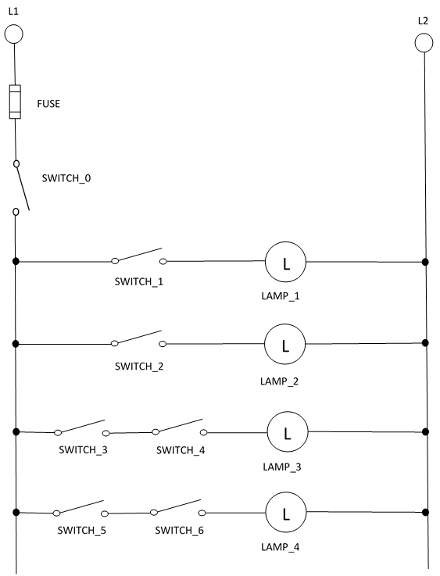

The following will be done with the board disconnected from any source of power and the meter set to measure resistance (Ohms - Ω).

Switches/Fuses
- Estimate how much resistance you would expect to find in a GOOD switch when ON? OFF?

- Disconnect one switch from the system and measure the resistance. What are the actual readings across both terminals when in the ON position? OFF?

- How much resistance (in ohms) would you expect to get from a good fuse?

- Remove your fuse from the system. What is the actual resistance reading for the fuse? Reinstall.

Resistance
- Measure and record the resistance of one 40W light bulb when disconnected from the circuit.

- Estimate the resistance in the entire circuit with one bulb in place.

- Place ONE bulb in the circuit at LAMP_1 and measure resistance in entire circuit (all switches in “ON” position and DMM connected to the prongs of the plug).

- How do you explain the difference between your estimate and the actual reading?

- If another bulb with the same resistance is placed in our parallel circuit at LAMP_2, will the overall resistance go up or down?

- Record the resistance of another bulb and estimate the resistance of the circuit with TWO bulbs.

- Measure the actual resistance with TWO light bulbs (all switches ON) and write it below.

- Measure the resistance of your last two bulbs, then calculate the resistance for all FOUR bulbs in parallel (show work, round to the nearest 1/10th ohm).
- Now put all four bulbs in the circuit. What is the actual resistance with all switches ON? Can you explain the difference between your estimate and the actual?

- Calculate the resistance for all FOUR bulbs, if they were placed in series (show work).

- What voltage would you expect to get across each bulb, if they were in series (show work)?

Part 2 - Opens
The following will be done with the board connected (plugged-in) and the meter set to measure volts.
First, make sure your circuits is working correctly by installing all bulbs and testing each branch.
NEVER CONNECT/DISCONNECT WIRES FROM YOUR CIRCUIT WITHOUT LOCKING-OUT THE SYSTEM

We’re going to start introducing fails into our circuit. The first fail we’re going to look at are opens. Opens happen when there is not a complete path for electron flow.
Use the check-off method when you have a malfunctioning circuit, but the fuse or circuit breaker does not blow. Study the system prints and locate the part of the circuit that is likely to contain the fault then use the check-off method to locate the problem. Look for disconnected wires, incorrectly installed wiring, or incorrectly numbered wires or swapped wires, 6 for 9 for example.
If the switch you are testing with your voltmeter is closed, you should read nearly 0.0 volts (expect a small (millivolt) reading). This means that no voltage is being used (dropped) as the current flows through the closed contacts. You do not want contacts using voltage or they will heat up and eventually fail. Depending on the sensitivity of the meter you might actually see a very small reading, for example 136 mV instead of 0.0 V. When you read the meter display, make sure you read not just the numbers but the units that the numbers represent. The trick is to watch the meter readout since it will change as the contacts change position.
If a switch is open and you use a jumper wire (while the circuit is de-energized) to bridge the switch the equipment should start. Use extreme caution since the circuit will energize using this test. If the circuit energizes properly, then the component that is “jumpered” is defective. Be sure that you do not jumper around a load since this will cause a short circuit. Make sure the jumper is removed after the circuit is repaired. Use jumper wires of an odd colored wire so that you will notice it if it is left on the circuit.
Opens can be troubleshot with the circuit de-energized, but often technicians don’t have the luxury of turning off a circuit to isolate an issue. We’ll be troubleshooting our circuit with the circuit energized.
- With SWITCH_0 “ON” what voltage would you estimate at SWITCH_1 with the switch OFF? ON?
- Record the actual voltage, both off and on. How does this compare to your estimate?

- What voltage would you expect to get by measuring across the fuse (with all other switches on)?

- Record the actual voltage across the fuse (all switches on).

- Turn on every light in the system and measure voltage across any single wire. How does that measurement compare to your fuse measurement?

- Now measure voltage across a load. What is the voltage and how does this differ from #19?

- Unplug the system and remove the fuse. Plug the system back in. What voltage do you expect across the “bad” fuse with all switches in the ON position? What’s the actual voltage?

- Reinstall the fuse. Turn ON all the switches. Create an open by turning OFF SWITCH_3. Measure the voltage across this open set of contacts.

- Now create an additional open by turning off SWITCH_4. Measure and record the voltage across SWITCH_3. How could you use this number for troubleshooting purposes (what does this number tell you)?

- Now partially unscrew one of the lightbulbs and turn all the switches ON. We can see what problems the “Open” has caused (light off), but describe how you might isolate the problem using your meter.

Of course, opens can be caused by missing or disconnected wires. Take turns having one partner [secretly] disconnect a wire for the other person to “find” using their meter. Do this each a couple of times until you’re comfortable finding opens. The idea isn’t to look for missing wires when you’re the one trying to find the problem. The idea is to use your meter and logic to isolate the problem. In an industrial setting, you often won’t usually be able to see an open. You’ll have to use a meter to find components that aren’t working correctly.

- What types of things do you think might cause opens in an industrial workplace setting?

