**ART 102**: Understanding Art

Spring 2019

CRN 41814

Syllabus

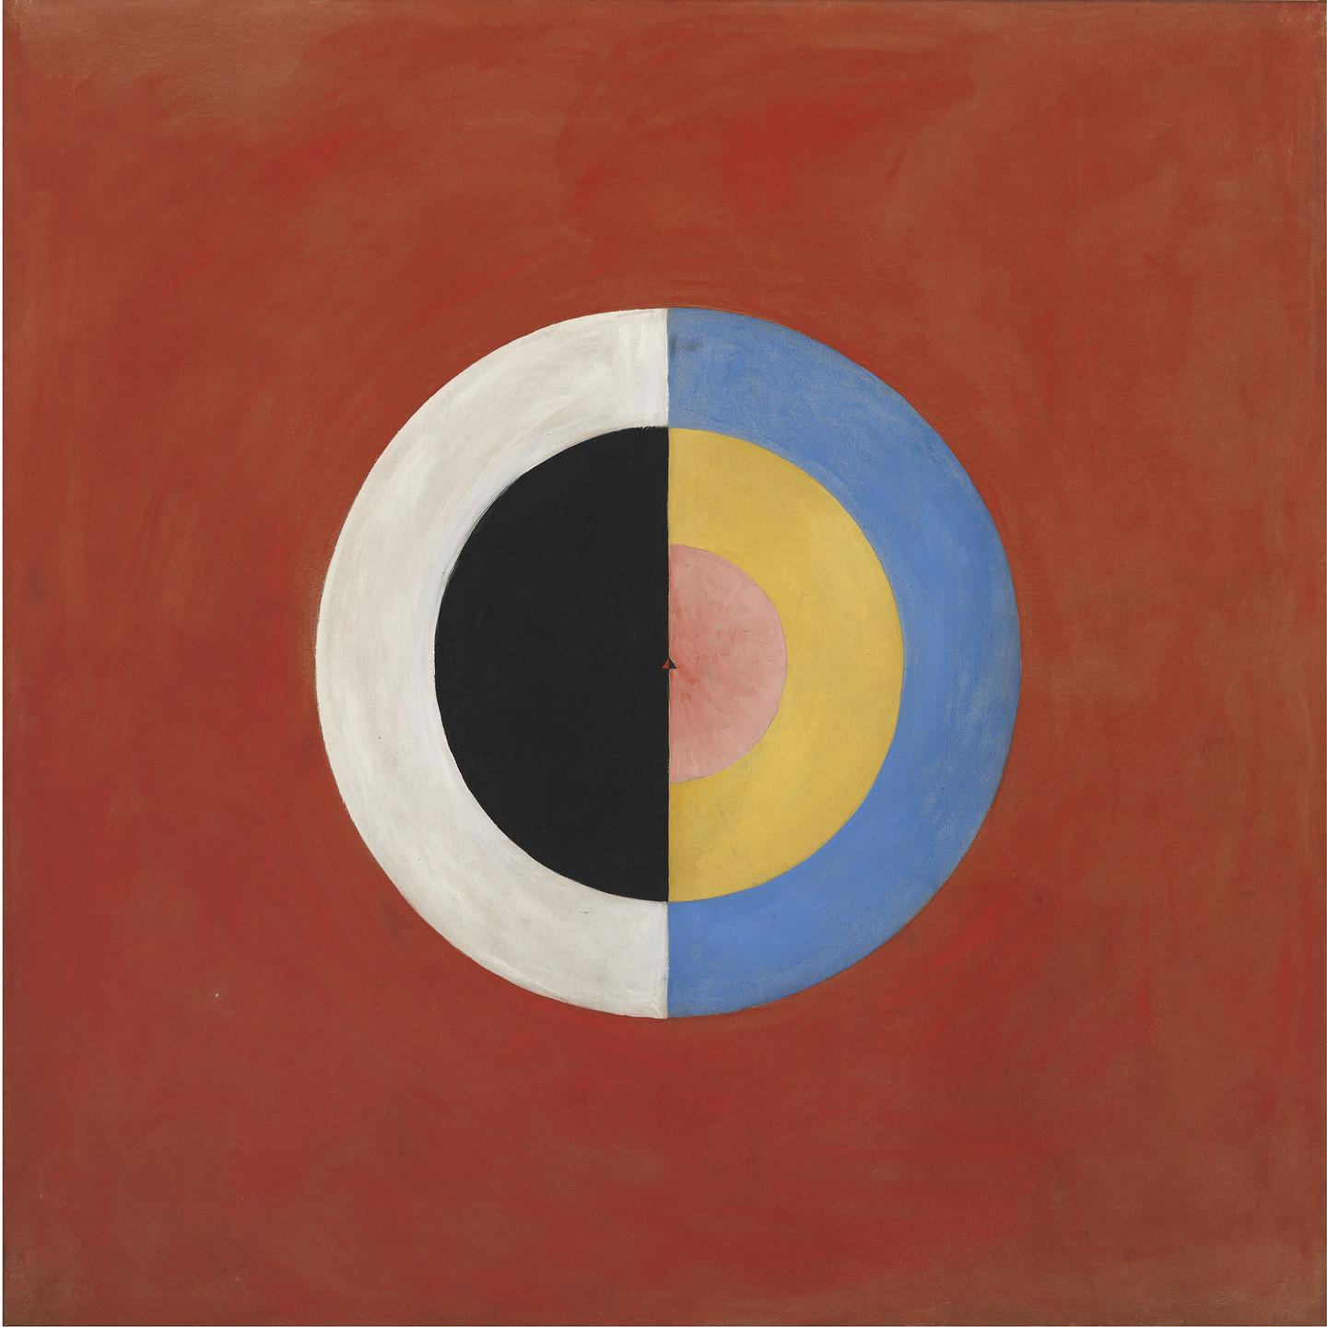

Hilma af Klint, Swans, nr 17, group IX/SUW, 1915

**COURSE INFORMATION**

Credits: 3

Course Location: Benton Center 209

Course Meeting Times: Monday and Wednesdays 2:30-3:50pm

**INSTRUCTOR INFORMATION**

**Instructor:** Laura Butler Hughes

**Email:** HughesL@linnbenton.edu

**Communication Response Time:** 24 hours, I do not check email on weekends.

**Phone Number:** (541) 917-4541 (Call only during ofﬁce hours)

**Ofﬁce Location/Hours:** BC 201 / 4-5 pm on M/W, and by appointment on Monday and Wednesday only

**COURSE DESCRIPTION**

Understanding Art explores the ways we make, perceive, and interpret art. After gaining a practical understanding of major formal elements and principles of design, students survey the characteristics and developments of artistic media and movements within their cultural and historical contexts. Topics include drawing, painting, graphic arts, sculpture, design, architecture, digital arts, and new media. This course focuses on building foundational knowledge of art and art history, therefore no prior experience is required.

**PURPOSE OF THE SYLLABUS**

This syllabus contains all the vital information about this course — what you’ll be learning, what will be expected of you, and what you can expect from me. Since this is a valuable document, you should read it carefully and refer to it regularly throughout the term. The better you know the syllabus, the better the chance you’ll do well in the course.

**STUDENT LEARNING OUTCOMES**

Upon successful completion of this course, students will be able to:

- Demonstrate an understanding of a variety of media and technique;

- Analyze in writing an artwork using the formal elements and principles of design;

- Understand artworks within their social, cultural, and historical contexts.

**COURSE MATERIALS**

**Textbook**

*Introduction to Art: Design, Context, Meaning.* This free e-textbook can be downloaded at:

http://oer.galileo.usg.edu/arts-textbooks/3/.

If you prefer a hard copy, you can buy it on Amazon for a reasonable price.

**Additional Materials**

Additional required readings and videos will be provided in Moodle. Materials and supplies for class activities and projects will be provided in class. If you miss class, you may need to provide your own supplies to complete an activity or project on time.

**COURSE POLICIES**

**“No Show” Policy**

Faculty at LBCC may administratively withdraw a student for non-attendance during the first week of the term. Students may be automatically dropped from the course by the second Monday of the term if they miss both class sessions OR if they do not complete all Week 1 assignments by deadline. This policy is to ensure that the class is the right fit for you. If you cannot commit to these requirements, please consider dropping the course, and feel free to re-register in a future term.

**Communication**

The best ways to reach me are during office hours or via email at [HughesL@linnbenton.edu](mailto:HughesL@linnbenton.edu). Please allow 24 hours for a response, I check email M-Th.

**Attendance Policy**

The course spans only 10 weeks. It is vital to attend class regularly and arrive on time. Please do not arrive late to class or leave early without speaking to me beforehand. It is disruptive, and you risk missing important information and activities. Most class periods include graded activities that cannot be made up. Regular attendance is taken, as students

are expected to be in class and fully prepared to learn and discuss readings and lecture materials.

**Participation**

Your presence and participation will form an important part of your grade, as it is crucial for an effective classroom experience for all students. To receive full credit, you must be present and active! Students who demonstrate that they are adequately prepared each week will be rewarded. As the minimum requirements of the course are that assigned readings and assignments be completed on their due dates, students who do not fulfill these requirements have not fulfilled their responsibilities in this course. Students who do not complete assignments on time or participate in classroom activities will not receive a passing grade. You will get what you put into this class.

**Absences**

Students are allowed 2 absences. Each absence thereafter will deduct 10 points from the final grade (i.e. you will drop a full letter from an A to a B, or a B to a C).

**Late Marks**

You are considered late when you arrive after I have started class. Three late arrivals or early departures will be counted as an absence.

**ASSIGNMENTS & GRADING**

**Class Activities & Workshops**

Class activities reinforce the week’s lesson topic and may include both in-class and take-home activities. Workshops allow students to deepen their knowledge of media and techniques through hands-on creation. Workshops will be completed in class, although students may be required to finish their projects at home. These are assessed according to effort and exploration, rather than artistic skill.

Class activities and workshops are worth 20% of the final grade. Rather than receiving written feedback, assignments are graded on a 10-point scale with the following values:

10 = Excellent

9 = Very good

8 = Good

7 = Adequate

6 = Inadequate

5 and below = Fundamentally flawed

**Weekly Quizzes**

Quizzes are due in Moodle **each** week of instruction (Weeks 1-10). There are designed to help students keep pace with the material. Quizzes are due Sundays at 11:59pm.

**Principles of Design Photobook**

A digital photobook of original compositions demonstrating the student’s understanding of the fundamental elements of art and principles of design.

**Formal Analysis Paper**

A 3-4 page formal analysis paper on an artwork that has been closely observed in person.

**Final Project: Exhibition Design**

A creative project designing an exhibition of artworks in a digital gallery. Students will use research to make connections between a group of works through cultural, historical, biographical, and formal contexts.

**Grading**

Class Activities & Technical Workshops 20%

Weekly Quizzes 20%

Formal Analysis Paper 20%

Principles of Design Photobook 20%

Final Project 20%

**Grade Scale**

A = 90-100% - Passing work that is excellent

B = 80-89% - Good Work

C = 70-79% - Average Work

D = 60-69% - Poor Work

F = 0-59% - Failing Grade

**Moodle**

This course uses the Moodle learning platform. Think of Moodle as the online class hub: you will use the Moodle course site to access announcements, the syllabus and schedule, assignment guidelines, slide presentations, videos, readings, and more.

**Keeping up with Moodle Content**

You are expected to keep up with all readings and videos posted under each week’s module. I will check your Moodle progress throughout the term. As the minimum requirements of the course are that the assigned readings and assignments be completed on their due dates, students who do not fulfill these requirements have not fulfilled their responsibilities in this course. Failure to make adequate weekly progress in Moodle (by not keeping up with assigned readings and videos) will result in a significantly lower course grade.

**Turning in Assignments on Moodle**

Most assignments must be turned in to Moodle by **Sunday at 11:59pm of that week.**

**I’m having trouble uploading an assignment in Moodle. What do I do?**

* Make sure you have a strong internet connection
* Try using a different web browser
* Try using a different electronic device
* If the problem persists try uploading the document a little later. Sometimes the server gets overloaded, especially during peak traffic (e.g. Sunday night when everyone at LBCC is rushing to submit assignments by deadline)
* For continued problems, contact the Help Desk or email me right away (before the

deadline!) Do not wait until the last minute to turn in work!

**WHAT DO I NEED TO DO TO BE SUCCESSFUL IN THIS CLASS?**

1. **Attend class.**
2. **Check your LBCC email regularly (preferably daily).** It is the student’s responsibility to receive and read messages in a timely manner.
3. **When in class, focus on class.** Class time is valuable. You should be focused on class while you are in the room; if you can’t focus, leave the room. If you have personal business (phone calls/texting, other class work), take care of it outside the classroom.
4. **Communicate Regularly**. Visit office hours, or see me before of after class if you have questions or need anything. I also check email M-Th.
5. **Keep up with the material and check into Moodle frequently.** Readings/videos are substantial and build on each other. Do not let your work snowball on you. You should spend about 60 minutes reviewing materials and taking notes before class.
6. **Take notes of readings/video/lectures.** These will be useful when completing

assignments.

1. **Be a good class citizen.** This means to be open to: 1) working with others, 2) being respectful of your peers, and 3) trying new things. It’s always OK to be unsure about how to do something; it’s never OK to give up without trying.
2. **Get ready to move/be flexible.** Be prepared to stand, move, and interact with your peers.
3. **Be accountable.** Bottom line: you’ll get what you put into this class. You are the person who has the greatest impact on your learning and ultimately, on your grade.
4. **Be positive and have fun!** This course is about stretching our thinking and learning together. We will also be looking at cool art and stuff.

**ACADEMIC HONESTY**

Academic honesty is an indispensable value as students acquire knowledge and develop college skills. Students are expected to practice academic honesty by not cheating, plagiarizing, or misrepresenting their coursework in any way. Plagiarism, collusion, and other forms of misrepresentation hurt the student and run counter to the goals of education. Students are responsible for understanding and avoiding academic dishonesty, whether such incidences are intentional or unintentional. You are held accountable to the Student Code of Conduct, which outlines expectations pertaining to academic honesty (including cheating and plagiarism), classroom conduct, and general conduct. Violations will result in failure of the assignment and possibly the course. Per LBCC policy, all incidents of academic dishonesty are reported to the Associate Dean of Student Development and the Dean of Arts, Social Science & Humanities.

**COLLEGE POLICIES**

**LBCC Email and Course Communications**

You are responsible for all communications sent via Moodle and to your LBCC email account. You are required to use your LBCC provided email account for all email communications at the College. You may access your LBCC student email account through Student Email.

**Incomplete Grade Policy**

An incomplete grade may be assigned when a student has **completed** and **passed** a majority of the required work, but cannot complete the course for reasons beyond the student’s control. Incompletes are given only in extraordinary and documented circumstances (i.e. family emergency or serious medical excuse), and at the discretion of the instructor. If an incomplete grade is granted, the instructor will determine the work that must be completed as well as a nonnegotiable completion deadline for submitting all missing work. If the incomplete work is not submitted on time or is unsatisfactory the incomplete will revert to an F-grade.

**Accessibility Statement**

LBCC is committed to inclusiveness and equal access to higher education. If you have approved accommodations through the Center for Accessibility Resources (CFAR) and would like to use your accommodations in the class, please talk to your instructor as soon as possible to discuss your needs. If you believe you may need accommodations but are not yet registered with CFAR, please visit the CFAR Website for steps on how to apply for services or call 541-917-4789.

**Statement of Inclusion**

To promote academic excellence and learning environments that encourage multiple perspectives and the free exchange of ideas, all courses at LBCC will provide students the opportunity to interact with values, opinions, and/or beliefs different than their own in a safe, positive, and nurturing learning environments. LBCC is committed to producing culturally literate individuals capable of interacting, collaborating and problem-solving in an ever- changing community and diverse workforce.

**Veterans**

Veterans and active duty military personnel with special circumstances are welcome and encouraged to communicate these, in advance if possible, to the instructor.

**RESOURCES**

**Important Academic Calendar Dates**

Last day to add/drop: Monday, April 8th

Last day to withdraw: Friday, May 17th

Memorial Day: Monday, May 27th

Exam date: Monday, June 10th: 3-4:50pm

**Moodle Support**

If you have questions about Moodle or need technical support contact:

**Student Help Desk** (in the Library at the Albany campus): Visit, call (541) 917-4630, or

email [student.helpdesk@linnbenton.edu](mailto:student.helpdesk@linnbenton.edu)

**LBCC Moodle User Support Forum**: Look up answers or post questions:

http://elearning.linnbenton.edu/mod/forum/view.php?id=26

**Writing Center**

Website: <https://linnbenton.edu/writing-center>.

There are 3 ways to use the Writing Center:

Schedule a 30-minute appointment (recommended);

Use Drop-In Services;

Use OWL (Online Writing Lab).

**Basic Needs Statement**

Any student who has difficulty affording groceries or food, or who lacks a safe and stable place to live, is urged to contact a Student Resource Navigator in the Single Stop Office (T- 112): Amanda Stanley, stanlea@linnbenton.edu, 541-917-4877. The navigator can connect students to resources. Furthermore, please talk with your instructor if you are comfortable doing so. This will enable them to provide any resources that they may have.

**CHANGES TO THE SYLLABUS AND SCHEDULE**

I reserve the right to change the contents of this Syllabus and Course Schedule. These may need to be adjusted along the term for many good reasons. You will be given notice of relevant changes in class, through a Moodle Announcement, or through LBCC email.

**EXTRA CREDIT OPPORTUNITIES !**

**Extra Credit Option 1: Use the Writing Center for your Formal Analysis/Exhibition**

You can receive up to a third of a letter grade (3 points) extra credit on the Formal Analysis Paper by using the Writing Center and attaching proof at the end of your paper. This service is highly recommended!

**To receive credit for using the Writing Center:** Attach proof of using the Writing Center at the **end** of your paper (a picture you take with your phone of the Writing Center dated stamp us fine. Make sure you ask for one at your appointment). Proof **must** be attached to receive credit.

**Extra Credit Option 2: Attend a campus/local lecture or exhibition**

During the term, I will announce campus/local lectures and exhibitions that are of interest to the class. You can receive up to 3 extra credit points added to your final course grade for each event you attend by turning in a **1-2 page reflection paper on the event**. In your reflection, you may discuss any aspect of the lecture or exhibition that struck you or that you feel ties into issues we’ve explored in the class, as long as you include some specific details showing you attended the event. Imagine you’re a reporter or blogger writing a review of the event. Including pictures in your write-up is great! You are encouraged to request permission to do an extra credit write-up of an alternative local event/exhibition you wish to attend; instructor approval required.

**Extra Credit Option 3: Watch an Approved Art Film**

Approved films will be announced in class. You can receive up to 3 extra credit points added to your final course grade by turning in a **1-2 page reflection paper on the film.**

**\*\*\* All Extra Credit Due by the end of Week 10 on Sunday at 11:59pm \*\*\***