Art 131 Drawing I
Instructor: Anne Magratten  Email: magrata@linnbenton.edu  Phone: 541.917.4545  Office Hours: By appointment | CRN: 26589  Credits: 4  Times: M/W/F 1:04-3:26 PM
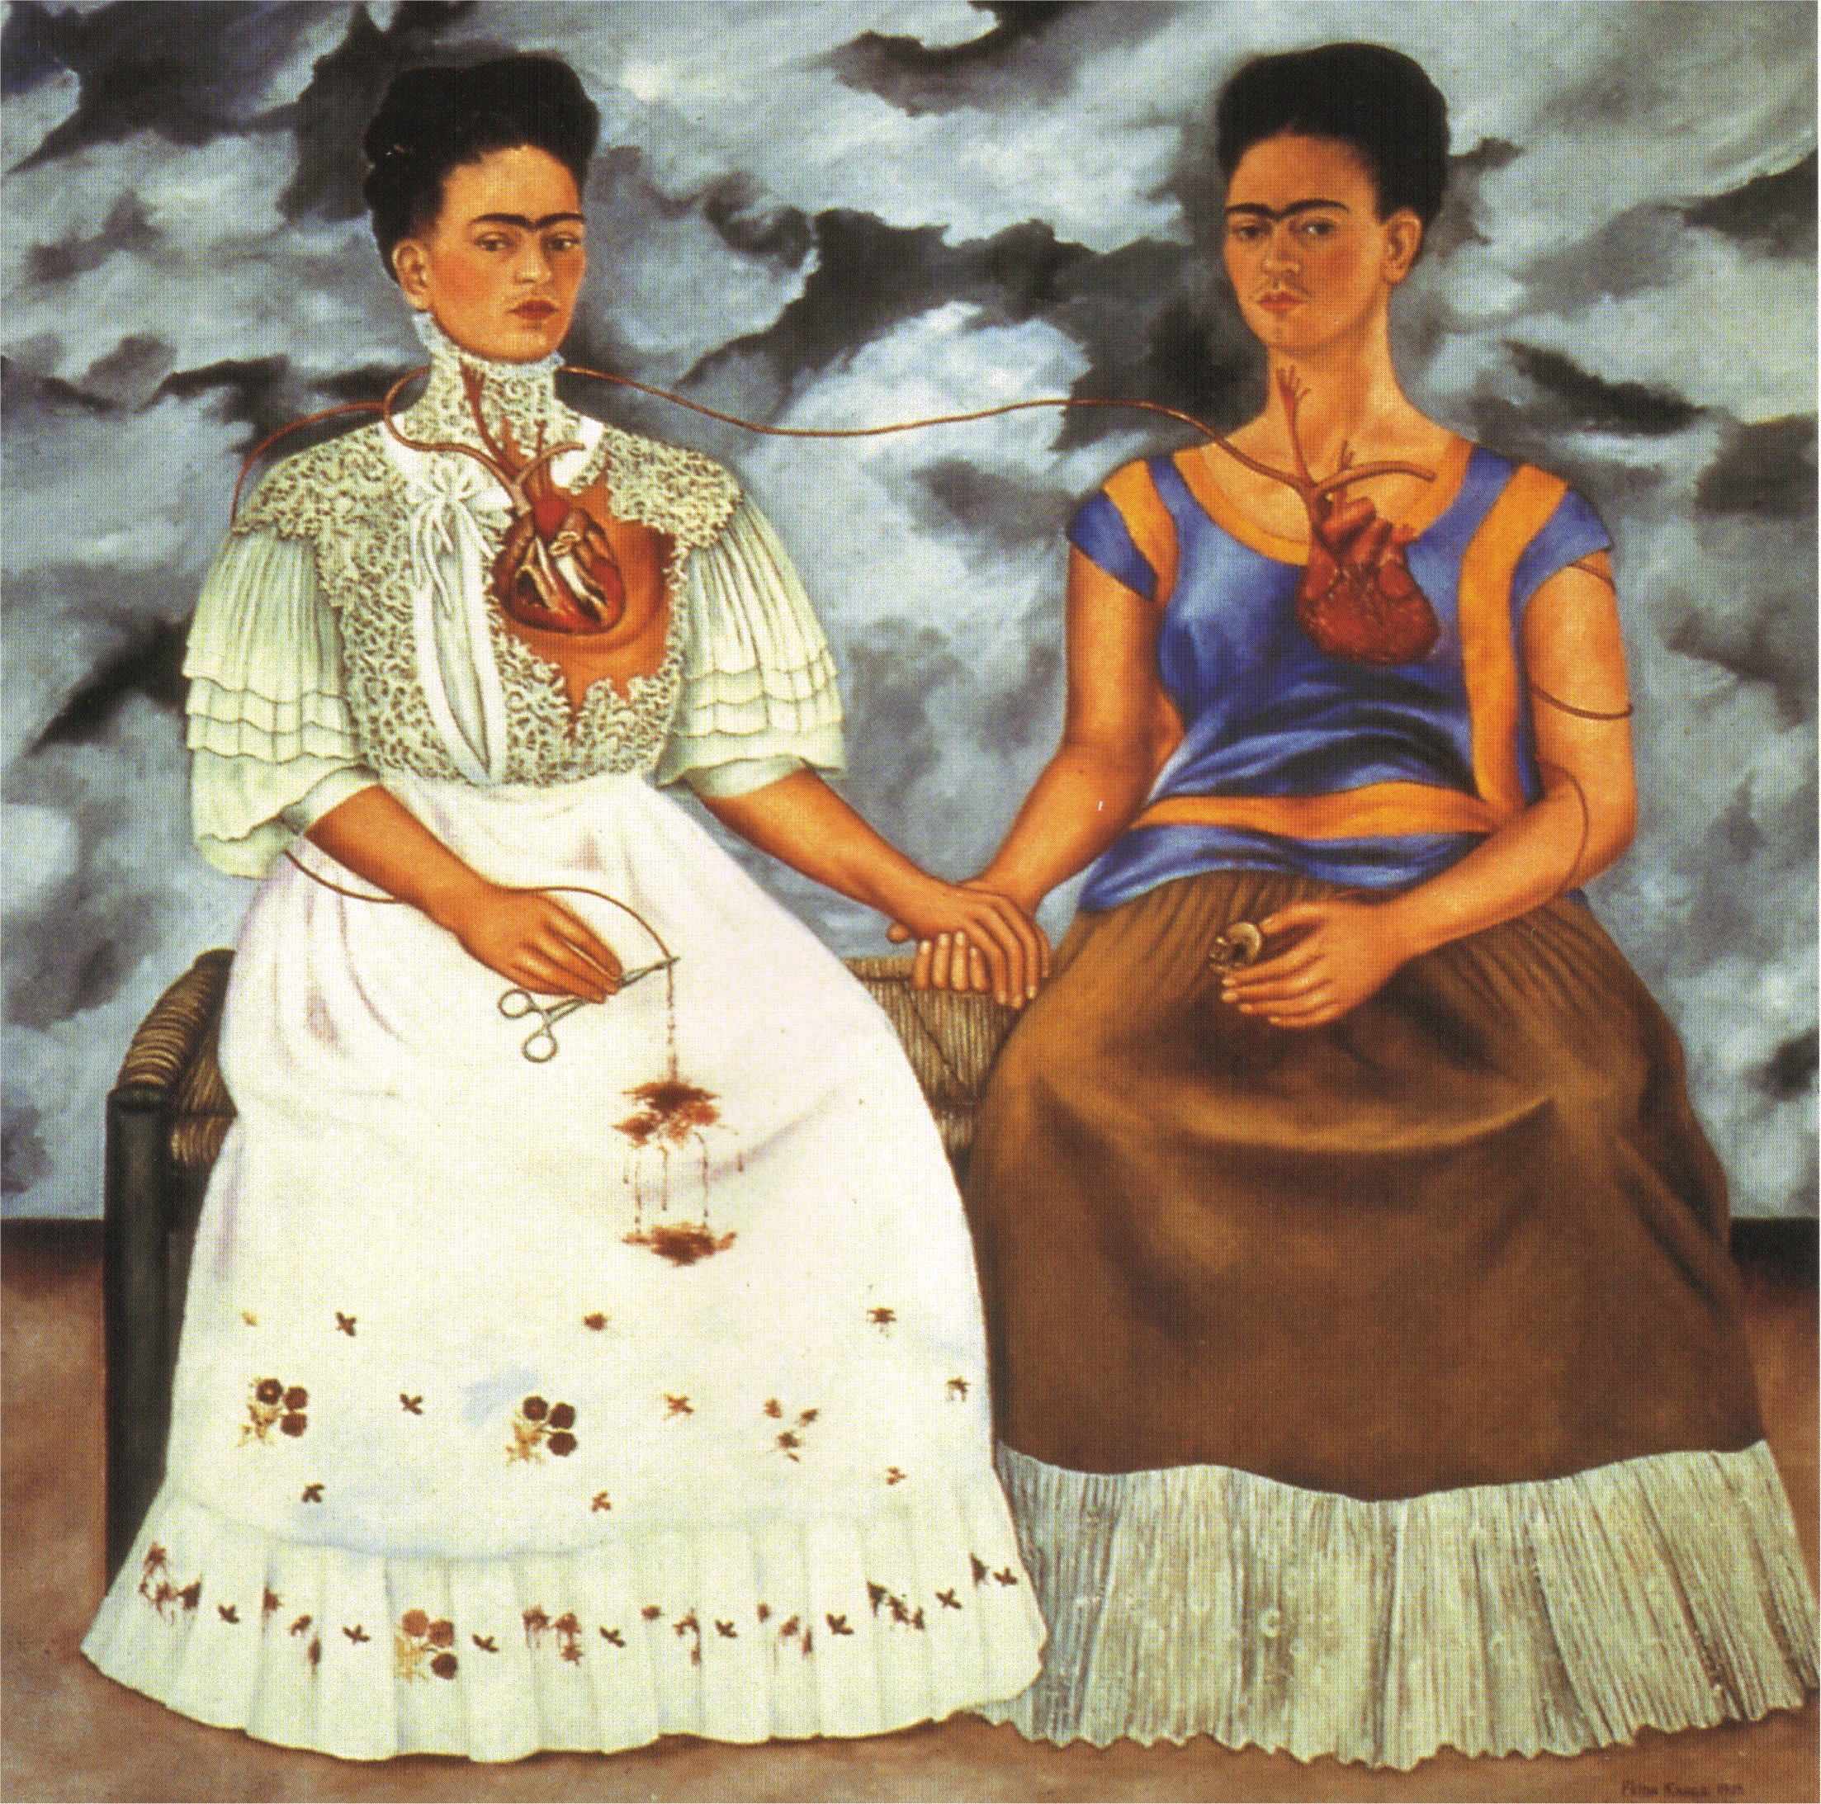
Las Dos Fridas, Frida Kahlo, oil on canvas, 1939
’They thought I was a Surrealist, but I wasn’t. I never painted dreams. I painted my own reality.’ - quote of Frida Kahlo, in: ‘Mexican Autobiography’, Time Magazine, 27 April 1953
Course Description: Emphasizes the development of perceptual and technical skills needed to describe 3-D objects on 2-D surfaces. Exposes students to conceptual and technical art references and encourages students to think critically about art and expression as an integral part of learning to draw.

Course objectives:
The class will provide individualized instruction in practical drawing skills designed for the beginner. We will cover fundamental gesture, contour, and value approaches to drawing from observation. Analytical techniques for spatial organization will be stressed. Progress will be made through exercises, slide lectures, demonstrations, and homework assignments. We will use different media including charcoal, pencil, white drawing tools, and ink. Drawings will be shared for group and individual assessment (critique) as part of the learning-evaluating process.

Student Learning Outcomes:
Upon successful completion of this course, students will be able to:
· Apply appropriate vocabulary in written and oral critiques of artistic works.
· Demonstrate competency in applying a range of value with black and white drawing media.
· Construct a drawing showing spatial depth using the principles of linear perspective.
· Illustrate basic forms with black and white drawing media.

Attendance & Classroom Etiquette:
Due to the interactive nature of this course attendance is extremely important. After three absences a student’s grade will drop a full letter. For example a student holding a B will then have a C. Arriving late or leaving early will also hamper your understanding of course materials. Three late arrivals or early departures will be counted as an absence. Emergencies and extenuating circumstances can be excused if communicated in a timely manner.

In each class we will draw, critique, and produce verbal/written reflections on art. Your participation enhances our diversity of perspective and being present will allow you to reflect on the contributions of others. To engage fully in the course please limit cell phone use to academic research (for extenuating circumstances please simply let me know in advance).

Please meet with me during the first week of class if:

1. you have a documented disability and need accommodations,

2. your instructor needs to know medical information about you, or

3. you need special arrangements in the event of an emergency.

If you have documented your disability, remember that you must make your request for accommodations through the Center for Accessibility Resources Online Services web page every term in order to receive accommodations. If you believe you may need accommodations, but are not yet registered with CFAR, please go to http://linnbenton.edu/cfar for steps on how to apply for services or call 541-917- 4789.

Please meet at any point throughout the term if you realize you need something to improve your learning experience or if you have questions regarding your grade or the course material.

Assignments & Grading:
Keep all drawing you create during the course. They will be needed for the final portfolio review.

Example of Grading Template:  Assignments: | 4 points: superior, drawing exceeds goals in this area  3 points: above average, meets the goal in this area  2 points: average, meets some goals in this area  1 point: below average, doesn’t meet expectations  0 points: failing, does not consider the goal at all | Pts.
Project # 1  Epic Contour | Blind, Semi blind (4), Continuous, Non-dominant (4)  Line quality (4) Communicating form & Edges (4) | /16
Homework 1 | 1 Value Scale & Dream Drawing | /4
Project # 2  Value Matching | Values match (4), Texture (4), Label/Presentation (4) | /12
Homework 2 | 10 x 10 Texture grid | /4
Project # 3  Negative Space | Composition (4), Separation of -/+ shapes (4), Presentation (4) | /12
Homework 3 | 50 Drawings of object | /4
Project # 4  Still Life | Composition (4), Proportion (4), Value: Form shadow, cast shadow, highlights, relational value (4), Spatial grounding of objects (4) | /16
Homework 4 | Perspective Words | /4
Mini Show | Collaboration (4), Drawing (4), Installation (4) | /12
Homework 5 | Free choice drawing | /4
Project # 5  Grid Master Study | Grid management of proportion (4), Value/line quality (4), Personal adaptation of original (4) | /12
Homework 6 | Free choice drawing | /4
Project # 6  Viewfinder Studies | Overlap, Scale, Density, Focus, Contrast (4) Composition (4) | /8
Project # 7  Visual Space /Perspective | Vanishing points/ Perspective lines establish depth (4) Consistent eye level (4) Focal Point (4) Value & Line Quality (4) | /16
Homework 7 | Free choice drawing | /4
Project # 8  Gesture | Basic Structures-spine, hips, shoulders (4), Dynamic Movement (4), Line quality (4) | /12
Project  Sketchbook warm ups | Looseness (4), movement (4), experimentation (4) | /12
Final Portfolio Review | Strongest work 4 examples  Organization: Ordered/Clearly labeled (4),  Presentation: Clean edges, cover sheet (4)  Demonstrates commitment & improvement (4) | /12
Final Project | Conceptual Development (4), Composition (4), Unity (4), Experimentation with techniques (4) & concepts developed throughout the term (4) | /20
Critiques | Use of visual art vocabulary (4), formulating and receiving constructive criticism (4), holistic engagement of technical, conceptual, and social significance (4) | /12
Absences: Late: | After three absences, each absence reduces the final grade by half a letter. Arriving late or leaving early three times will be counted as an absence
Extra Credit
Final Grade: 200 | A 200- 180, B 179- 160, C 159-140, D 139-120, F 119-0

Late work will be marked down one letter grade. Points regained through extra credit and revision. Critiques cannot be made up. You may still earn points by participating with in progress work or giving feedback to your fellow artists.

Portfolio Review: Missing the Final Portfolio Review will result in the entire portfolio being marked down one letter grade. If you know you must miss your review submit your portfolio in advance and schedule a makeup review. If you fall ill let me know asap to schedule a new time. Extra Credit is available until week 9.

Academic Integrity:

Work made before the start of this course or for other art courses will not be accepted for credit. The presentation of another individual’s work as one’s own or the act of seeking unfair academic advantage through cheating, plagiarism or other dishonest means is a violation of the college’s “Student Rights and Responsibilities.” Turning in someone else’s work as your own, or buying a paper from a professional writer or a research center, or downloading one from a website, is plagiarism. Turning in another artist’s drawing as your own is also plagiarism. All sources must be clearly presented. A plagiarized project will receive a zero. Two zeros for plagiarism will be grounds for an F in the course, regardless of other grades.*Recycling, referencing, appropriation, and outsourcing play important roles in contemporary art. If you use these tools be sure you can clearly state the conceptual significance of your choices and be transparent about them during critique/reflection.

LBCC Comprehensive Statement of Nondiscrimination:
LBCC prohibits unlawful discrimination based on race, color, religion, ethnicity, use of native language, national origin, sex, sexual orientation, gender, gender identity, marital status, disability, veteran status, age, or any other status protected under applicable federal, state, or local laws. For further information see Board Policy P1015 in our Board Policies and Administrative Rules. Title II, IX, & Section 504: Scott Rolen, CC-108, 541-917-4425; Lynne Cox, T-107B, 541-917-4806, LBCC, Albany, Oregon. To report: linnbenton-advocate.symplicity.com/public_report

LBCC Statement of Inclusion:
The LBCC community is enriched by diversity. Each individual has worth and makes contributions to create that diversity at the college. Everyone has the right to think, learn, and work together in an environment of respect, tolerance, and goodwill.

Materials:
Personal materials should be stored in your clear folder.
Be sure to label each item with your full name.
For sketchbooks, name must be printed on front, spine, and inside cover. Contact info recommend.
Course Calendar*

Week 1  10/1  10/3  10/5 | Monday:  Introduction  Slide show  Contour Drawing Homework: Value scale | Wednesday:  Contour Drawing Continued  Homework: Dream Drawing | Friday:  Critique Contour Studies  Begin Value Matching Project (meet Laura)
Week 2  10/8  10/10  10/12 | Value Matching Project  Continued  Homework due:  Dream & Value | Slide show  Value Matching Project  Homework:  10 x 10 Texture grid | Value Matching Project  Critique Value Matching  (Laura)
Week 3  10/15  10/17  10/19 | Begin Sketching Workshop  Negative Space Project 10x10 Homework Due | Negative Space Project  Homework:  50 Drawings | Negative Space Critique…
Week 4  10/22  10/24  10/26 | Still Life Project  Composition/ planning  50 Drawings  Drawing Due | Still Life Project  Light/value  Homework  Perspective Words | Critique Still Life  Wayward Women  Research & Abstraction
Week 5  10/29  10/31  11/2 | Grid Project  Homework due  Perspective words | Grid Project  Homework Assigned  Free Choice Drawing | Grid Project…
Week 6  11/5  11/7  11/9 | Grid Project  Homework Due  Free Choice #1 | Critique Master Grid  Collect work & writing for publication  Homework Assigned  Free Choice Drawing | Depth Lecture  Viewfinder Studies
Week 7  11/12  11/14  11/16 | Veterans Day No Class | 1 point perspective  Homework Due  Free Choice #2 | 2 point perspective  Homework Assigned  Free Choice #3
Week 8  11/19  11/21  11/23 | 2 point perspective  Homework Due  Free Choice #3  Homework  Sketches for Final | Thanksgiving Holiday  No Class | Thanksgiving Holiday  No Class
Week 9  11/26  11/28  11/30 | Organize Final Portfolio  Work on Final Drawing | Clean up/ Finish Portfolio  Extra Credit Due | Work on Final Drawing Individual Portfolio Reviews
Finals  12/3  12/5 | Critique final drawings  Review publication | Critique final drawings  Review publication

*Instructor reserves the ability to change dates and deadlines to best fulfill academic objectives.

