SPN 101

Foreign Languages Department SPRING 2017

INSTRUCTORA Margarita Casas
CONTACTO NSH-117; teléfono 541.917.4558, casasm@linnbenton.edu
HORAS DE OFICINA MWTR 11:00 to 11:50, or by appointment.

LIBRO DE TEXTO Exploraciones, Second edition (bundle of textbook & access to Quia books i-Lrn, both REQUIRED). ISBN-13: 978-1-305-25247-9

Your key is good for 18 months. Do not buy used books unless you are prepared to add the cost of i-Lrn access, which is about $90).

After you sign up in i-Lrn, use this course code for our class: PCPJXK648

¡IMPORTANTE! To make sure you buy the right bundle (with i-Lrn), get it from LBCC or at the website suggested in my SPN 101 webpage. Beware of cheap deals in the internet -they end up costing you more.

What to expect
This is a beginner class. If you have had Spanish classes before, take the placement exam. Ask me about it!

The pace of the class is fast. Class time is used to introduce concepts and practice them, but language learning requires a lot of practice and dedication. Allow at least two hours for studying and doing homework for every contact hour that we have. This is a general guideline -some students might need more time.

Basic keys to success in the class:
1) Be disciplined! Never skip class and complete all your homework daily!
2) Ask for help if needed, and participate (speaking is the only way to learn how to speak!).
3) Meet regularly with a tutor or with a classmate and practice together.
4) Practice Spanish every day, even if only for a short period. Studying for 20 minutes 3 times a day daily will be a lot more effective than studying twice a week for 3 hours. Read the advice from former SPN 101 students posted in my website!

The class is in Spanish! We use English to explain or clarify but, as we progress, you will hear less English and more Spanish. This could be challenging and frustrating at times, but it is important. Ask questions if things are not clear. Also, remember that guessing from the context is an important strategy to learn a language. You are expected to start speaking Spanish from the first class.

General Objectives and Outcomes
In SPN 101 you will learn some basic Spanish language structures that will allow you to communicate and understand simple information. At the end of this course you will be able to...

- Communicate and demonstrate an understanding of personal information in oral and written form.
- Demonstrate an understanding of the meaning and history of the terms Latino, Hispanic, and Latin.
Additional learning objectives:
- Learn the basics of Spanish pronunciation and acquire a basic vocabulary to communicate personal info.
- Empathize with speakers of other languages, and explore the history & cultures from Hispanic countries.

Websites for SPN 101

1) INSTRUCTOR WEBSITE at LBCC. Includes links, additional handouts, presentations, study guides, etc.

2) QUIA BOOKS: When you purchase your textbook you will get a key code to sign up in i-Lrn, which is the site where your homework comes from. The site also offers many additional online resources, such as diagnostic exams, videos, tutorials, etc.

3) QUIA GAMES: Practice with fun games and activities. Visit it often as I add new activities all the time

Tutors
Free tutoring is available at the Learning Center. Sign up on the tutoring website and make an appointment at the LC at least 24 hours in advance. Use this very valuable resource frequently!

Grades and Evaluation
Grading for this class is optional (A-F, or Pass/Fail). Last day to modify your choice is the end of the 6th week. A passing grade is 70 points and up. 70 points is also the minimum grade necessary to continue to SPN 102.

This is how your grade is calculated:

ASSIGNMENTS
Exámenes (2) 20%
Pruebas (quizzes) ((3) 20%
Tareas 24% Composiciones (3) 18% Participación en clase 10%
Conversaciones 5%
Learning Journals 4% Total 101%
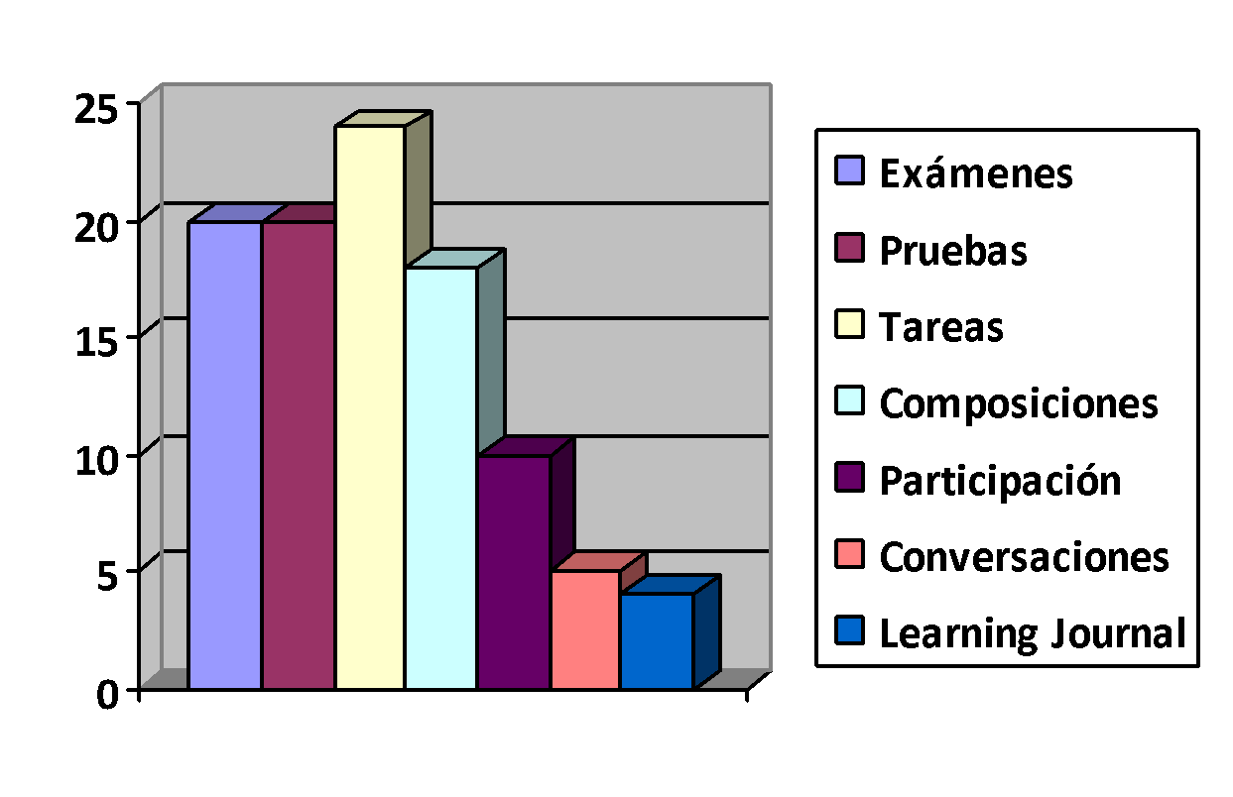

A = 90-100%; B = 89-80%; C = 79-70% (PASSING GRADE); D= 69-60%; F = 59% or less.

Exámenes y Pruebas (Quizzes)
There will be one midterm and one final exam (see calendar), plus 3 chapter quizzes. If you cannot attend class on the day of an exam/quiz because of a MAJOR reason, notify me in advance, so arrangements can be made to take it within 2 days. Otherwise, you will lose the points for the missed exam/quiz.

Tareas (homework)
We learn a language through practice, and homework gives you precisely that. Completing it on time is a key to your success. All homework is assigned online. Once you log in, click on Assignment Calendar (top of menu on the right hand). Assigned activities have a DUE DATE next to them. You get full credit for homework turned on time. There is no credit for late work. You will have up to 7 attempts to submit your work (only the last attempt counts for calculating your grade). It is highly recommended to complete your homework before class on the day it is assigned. For example, your homework is assigned for a Monday, ideally you would complete all your homework by Sunday. However, you can submit homework for full credit as late as midnight of the day when an activity is assigned.

Composiciones
Writing is an important part of the learning experience. The objective of writing is that you use what we have learned. Each one of our compositions consist of a first draft and a correction. You will write the first draft in class (treat it as a test: you have to be in class that day!).

If you write only a first draft, the maximum possible grade is 50 points (assuming it is an excellent draft and on time). If you are not in class the day we write, you will have ONE day to write at the Assessment center (RCH-111), like if it was an exam.

When I return your first draft with comments and corrections, you will revise it based on the following guidelines. YOU SHOULD ALWAYS ATTACH THE FIRST DRAFT TO YOUR CORRECTIONS.

- Use ONLY the vocabulary and grammar we have learned in class. Using grammar we have not learned will
hurt your grade.
- Underline any word you have to look up. The maximum number you can use is 8 new words.
- Do not ask for help from friends -it has to be YOUR work.*
- If you use an online dictionary, look up ONE word at a time, and never look up a full sentence.
If I see evidence that a text was not entirely written by you, you will get a zero for the assignment. Re-occurrence may result in a failing grade for the class. The use of electronic translators is considered cheating.

Participación
Being in class is not equal to participating, but you cannot participate unless you are in class. Participating in class is a combination of the following:

- Come to class prepared, pay attention and ask questions. Turn off your mobile!
- Volunteer answers and work actively in groups/pairs. Help your partners!
- Be respectful, friendly and helpful to everyone. Keep a positive attitude.
- Arrive punctually and remain in the classroom until the class has finished. Do not start packing early!

Conversaciones
This is a group assignment to demonstrate oral proficiency. Basically, you will have a conversation in Spanish for ten minutes. You will receive more information later in the term.

Learning Journal
This assignment helps me to understand how you are learning the language. It is also a way to communicate with me and reflect about your learning process. It is written in English. Do not discard them (or any other class work) before the end of the term

Additional tips for Success in this class
- Be realistic about your expectations: No one learns to speak a language in one school term. Acquiring proficiency in a foreign language requires a lot of time, motivation and hard work.
- Not everyone learns the same way, so it is important that you discover your own learning style.
- Use the resources we offer, such as tutors, office hours, web resources and books at the library.
- Make connections between the Spanish language and your life... meet new friends! Use the language!
- At the very minimum, spend at least two hours of study for every hour of class.

Make this class part of your life and learn faster!!!
The resources to practice and use Spanish are unlimited. You can hear and read Spanish basically everywhere. These are some ideas to make Spanish part of your everyday life:

- Explore some of the thousands of Internet sites in Spanish, including radio stations, audio files, grammar and vocabulary resources.
- Download a few free apps to your phone so you can practice Spanish whenever you have two minutes!
- TV channels Univisión (Channel 31) and Telemundo (channel 30) broadcast in Spanish. You can also find lots of choices to watch through Neftlix, Hulu and cable television.
- Meet friends who speak the language! Try meeting someone with common interests and start a friendship.
- Find a language partner at the Multicultural Center in Corvallis, at the DAC, through our ESL program at LBCC, or volunteer to help international students learn English (for more info, call the International Office at OSU).

Accessibility resources/Disability Statement
Students who may need accommodations due to documented disabilities, or who have medical information which the instructor should know, or who need special arrangements in an emergency, should speak with the instructor during the first week of class. If you believe you may need accommodations, but are not yet registered with CFAR, please go to http://linnbenton.edu/cfar for steps on how to apply for services or call 541-917-4789.

Integrity Statement
Be advised that all the assignments must have been written by you. While it is OK to ask for help to other people, every assignment should have been written and created by you. You may use models, but it is not acceptable to copy full sentences or use any type of electronic translators -- you will not learn anything if you use them, and they result in incomprehensible chains of unrelated words, without any syntax, grammar or meaning. Assignments that are considered cheating will automatically receive an zero.

LBCC Comprehensive Statement of Nondiscrimination
LBCC prohibits unlawful discrimination based on race, color, religion, ethnicity, use of native language, national origin, sex, sexual orientation, marital status, disability, veteran status, age, or any other status protected under applicable federal, state, or local laws. (for further information http://po.linnbenton.edu/BPsandARs/ )

Inclement weather closures
Occasionally we experience snow days or icy roads that result on college closures. If that happens, CHECK YOUR LBCC EMAIL and the ANNOUNCEMENTS tab on your i-lrn (Quia books). If you do not use your LBCC e-mail, make sure to forward your LBCC messages to your preferred account, so you do not miss important information.
CALENDARIO PARA SPN 101 (subject to changes) SPRING 2017

LUNES MARTES MIÉRCOLES JUEVES
Semana 1  3-6 de abril | syllabus  saludos (greetings)  alfabeto/pronunciación  Classes begin | Capítulo 1  Saludos, el salón de clases/gender-number, artícles  Learning journal 1 | números 1-100  definite/indefinite articles; Haber; gender/number | Conexiones culturales  Reading strategies
Semana 2  10-13 de abril | Descripciones; SER | pronombres personales  gender & number of adjectives | reciclar: gender/number  pronouns, ser, ser de | Prueba # 1
Semana 3  17-20 de abril | Capítulo 2  Vocabulario: la familia, adjetivos posesivos | la familia, adjetivos posesivos, verbos -AR | Verbos -AR | Verbos -AR  España  Learning Journal 2
Semana 4  24-27 de abril | Vocabulario: la universidad/clases | Tener y expresiones con tener | Tener/adjective placement | Tener/adjective placement  Composición # 1
Semana 5  1-4 de mayo | Prueba # 2 | Capítulo 3  Vocabulario: la ropa/colores/el clima | Gustar/el clima  Verbos er/ir | Gustar  Verbos er/ir  Corrección # 1
Semana 6  8-11 de mayo | Verbos er/ir  Las fechas/la hora | Verbos -er/-ir  Las fechas/la hora | El verbo IR  México | El verbo IR  El futuro (ir +a + inf)  Composición # 2
Semana 7  15-18 de mayo | El verbo IR  El futuro (ir +a + inf) | MIDTERM | Capítulo 4  Vocab: La ciudad | Stem-change o→ue  Corrección # 2
Semana 8  22-25 de mayo | Stem-change o→ue  estar + prepositions | estar + prepositions | Vocabulario: la casa | Question words  Learning Journal 3
Semana 9  29 de mayo al 1^{ero} de junio | NO HAY CLASES | Question words  Hispanic vs Latin | Stem change e→i/ie | Stem change e→i/ie  Question words  Composición # 3
Semana 10  5-7 de junio | Review | Prueba # 3 | Conversaciones  Corrección # 3 | Conversaciones  Corrección # 3

Examen Final → Lunes 12 de junio a las 10:00 am.

