WR121: English Composition
Course Syllabus/Fall 2016
MWF from 9-9:50am, Lebanon Center 222
CRN: 22645; Credit Hours: 3

MWF from 1-1:50pm, Albany Campus IA232
CRN: 20792/25252 (ALP)

You come late. When you arrive, others have long preceded you, and they are engaged in a heated discussion, a discussion too heated for them to pause and tell you exactly what it is about. . . . You listen for a while, until you decide that you have caught the tenor of the argument; then you put in your oar. Someone answers; you answer him; another comes to your defense; another aligns himself against you. . . . The hour grows late, you must depart. And you do depart, with the discussion still vigorously in progress. - Kenneth Burke

Amelia Kaspari, Instructor
kaspara@linnbenton.edu
Office: Lebanon Campus: LC214; Albany Campus: SSH203
Mailbox: Lebanon Campus: Main Office, 1st floor of Lebanon Center; Albany Campus: NSH Faculty Workroom (next to the Star Wars office)
Office hours:email me to set up an appointment between 10am and 1pm MWF

Required Textbook: They Say, I Say, 3rd edition.

Course Description: Emphasizes clear, detailed writing that employs critical reading and thinking and basic research skills.

Prerequisites: Placement into WR121, WR115 with a grade of C or better, or registration in ALP.
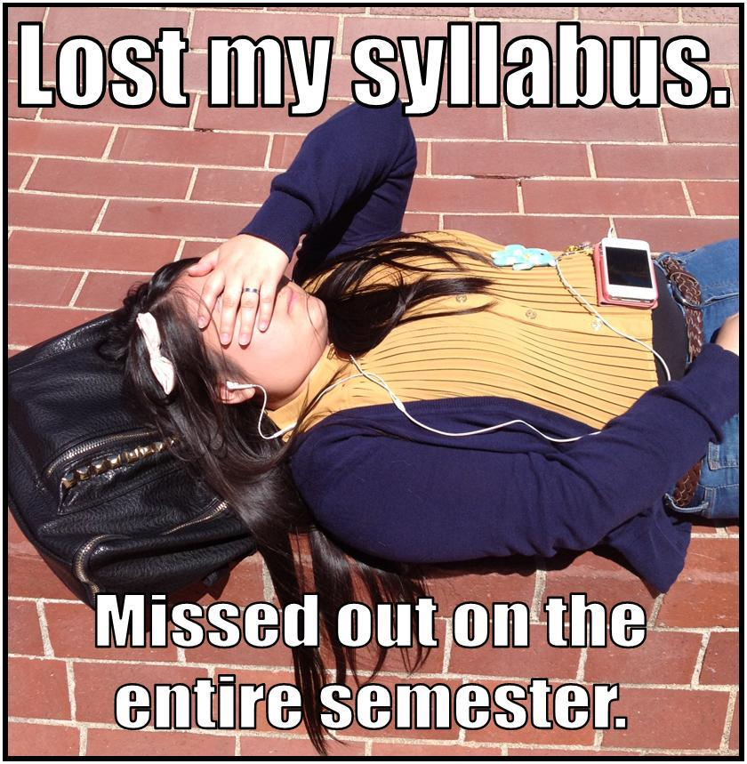
Course Components and Point Values
Email Assignment: 50pts
Career Narrative: 100pts
“What the Critics are Saying” Paper: 100pts
“Entering the Conversation” Paper: 100pts
Cover Letter: 100pts
Reading Quizzes: 25pts x 6 = 150pts
Revision Workshops: 25pts x 4 = 100pts
Library Workshop: 25pts
Computer Lab Workshop: 25pts
Engagement/Participation: 25pts
Final Exam: 30% of Total Grade

Total: 775, not including Final Exam

Grading Scale: A: 100%-90%, B: 89%-80%, C: 79%-70%, D: 69%-60%, F: 59%-0%.

Course Policies

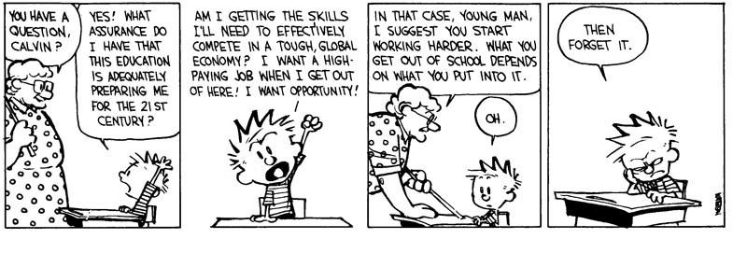Attendance: Attendance is crucial for success in this class. If you are going to be absent for any reason (dire illness, family emergency, etc.), e-mail me before class time to let me know; however, YOU are responsible for figuring out what you missed, by checking the syllabus and getting notes from a classmate.

Late Assignments: Work turned in late will automatically lose 15% of possible points. If work is turned in late because of circumstances beyond your control, please talk to me or send me an e-mail. To be considered on time, assignments must be turned in during class on the day they are due, so if you are going to be absent from class, send work with a classmate. No e-mail submissions, please.

Plagiarism: Plagiarism includes:
- Using another person’s words or ideas (even if you have paraphrased), without properly citing your source.
- Using direct quotes without quotation marks.
- Allowing anyone else to write or type an assignment for you.
- Writing or typing an assignment for someone else.
- Paying another person to complete an assignment for you.

If plagiarism is detected, you will be held accountable: First occurrence: You will receive a warning and be asked to redo the plagiarized assignment. Second occurrence: F grade in this course; report sent to the college.

Formatting of Assignments: ALL final drafts must be typed and printed (no e-mail submissions please), in Times New Roman, size 12 font, double-spaced, with 1” margins. Final drafts should be printed on standard computer paper (no cardstock or colored paper) and stapled. Failure to turn in correctly formatted assignments may result in loss of points.

Extra Credit: The only way to gain extra credit in this class is to visit the Writing Center. For each Writing Center visit, I will add 5 points to the assignment of your choice. Just be sure to turn in proof that you visited the Writing Center, along with a note indicating where you would like the 5 points added. The Writing Center is located on the second floor of Willamette Hall (entrance off of courtyard). You may want to make an appointment ahead of time, as the WC can be extremely busy, especially later in the term. The WC encourages you to bring an assignment at any stage (brainstorming, drafting, final revisions, etc.), but be sure to come with specific questions and specific areas you need help with. (And yes, I just ended a sentence with a preposition.)

Course Outcomes

By the end of this course, students will be able to:
- Analyze the rhetorical needs (the interaction of audiences, purpose/outcome, and subject) of a variety of academic and practical writing assignments.
- Apply appropriate levels of critical thinking strategies (knowledge, comprehension, application, analysis, synthesis, evaluation) in response to the rhetorical needs of an assignment.
- Implement appropriate rhetorical elements and organization (introduction, thesis, development and support, rebuttal, visuals, narration, conclusion, etc.) in response to the rhetorical needs of an assignment.
- Locate, evaluate, and integrate high-quality information and opinion in response to the rhetorical needs of an assignment.
- Craft sentences and paragraphs that communicate their ideas clearly and effectively using words, sentence patterns, and writing conventions to make their writing clear, credible, and persuasive.

WR121 Course Schedule
(Subject to Change)
Italicized readings are to be completed before class on the day they are listed.
Bolded items are due in class on the day they are listed.

Week 1
M: 9/26: Syllabus and Course Schedule; Introductions; In-class writing.

W: 9/28: Emails (bring handout in syllabus)

F: 9/30: Email DUE by class time; Career Narrative and Reflection Assignment Guidelines. Read “Superman and Me” together in class.

Week 2
M: 10/3: Narrative Strategies: the abstraction ladder and lists.

W: 10/5: Narrative Strategies: dialogue and slowing down the action.

F: 10/7: Rough Draft DUE for revision workshop.

Week 3
M: 10/10: Final Draft DUE; What the Critics are Saying Assignment Guidelines. “Spotlight” in class.

W: 10/12: Read TSIS, Introduction and Chapter 1, pp. 1-29. Reading Quiz 1. Finding critical reviews.

F: 10/14: Read TSIS, Chapters 2-3. Reading Quiz 2. Practice integrating quotes.

Week 4
M: 10/17: Read TSIS, Chapters 4-5, pp. 55-77. Reading Quiz 3. In-Text Citations.

W: 10/19: Reference Pages, MLA Style.

F: 10/21: Rough Draft DUE for Revision Workshop.

Week 5
M: 10/24: Final Draft DUE; “Entering the Conversation” Paper Assignment Guidelines; Problematizing Discussion (country music)

W: 10/26: More Problematizing Practice: FRIENDS. Brainstorming in class.

F: 10/28: Library Database Workshop - Finding Reliable, Relevant, Current sources.

Week 6
M: 10/31: Class Practice: Reliability, Relevancy, and Currency.

W: 11/2: Read TSIS, Chapters 6-7. Reading Quiz 4. Bring one of your sources to annotate (summarize and evaluate) in class.

F: 11/4: Annotation DUE. Read “The College Essay is Your Own Idea” in class. Topic, Thesis, and Thesis Statement.

Week 7
M: 11/7: Read TSIS, Chapters 8-9. Reading Quiz 5. From Topic to Thesis Statement - FRIENDS example

W: 11/9: From Thesis Statement to Outline - FRIENDS

F: 11/11: NO CLASS - VETERAN’S DAY

Week 8
M: 11/14: Rough Draft DUE for Review Workshop. A closer look at the introduction.

W: 11/16: The Reference Page. Computer Lab Workshop. NSH 113 (Albany)

F: 11/18: Read TSIS, Chapter 10. Reading Quiz 6. Bring Rough Draft. Practice with Metacommentary.

Week 9
M: 11/21: Troubleshooting. Bring Rough Draft.

W: 11/23: FINAL DRAFT DUE. Last Chance Editing. Cover Letter Assignment Guidelines.

F: 11/25: NO CLASS - THANKSGIVING BREAK

Week 10
M: 11/28: Cover Letter Assignment Guidelines - Group Activity

W: 11/30: Rough Draft DUE for Revision Workshop

F: 12/2: Cover Letter DUE; Discuss Final Exam

Week 11
Final Exam

Albany Campus: Monday, December 5th, from 12-12:50pm and Tuesday, December 6th, from 11:30-12:20pm

Lebanon Campus: Date and Location TBA

Email Assignment
Assignment: Write an email to your professor (me) in which you briefly introduce yourself.
To prepare, write down the answers to the following questions as we discuss them in class:
- What is the purpose/function of an email?

- What do I need to consider about my audience when writing an email?

- When can an email be informal, and when should it be formal/professional? (What makes an email informal, and what makes it formal?)

- When do I need to include a subject header? What about a salutation?

- What formatting should I use?

- In what ways is email similar to texting? In what ways is it dissimilar?

- When do I need to respond to an email?

- How time-sensitive are emails?

- What might be my reason to write an email to my writing professor at the beginning of the term? (Besides the fact that it’s required!)

- What information should I include to fulfill this purpose?

Career Narrative and Reflection: 100pts
Write a 700-800 word paper in which you tell a story from your past that heavily influenced your vocation*, and then reflect on where you want to be along that vocational path in 2026 (ten years from now). What will it take to get there? How is studying at LBCC preparing you for your vocation?
*vocation: a strong feeling of suitability for a particular career or occupation
Requirements:
- Narrative portion: 40-50% of paper length
- Vivid, descriptive details (be specific!)
- Dialogue where appropriate
- Showing rather than telling
- Relevant to the vocation you will be discussing in the rest of the paper
- Skillful transition: 2 sentences to a paragraph
- Show the reader the connection between your narrative and your chosen vocation. You might use this paragraph to describe an “aha!” moment when you realized what your vocation would be. Or you might use a smooth transitional sentence like: “My childhood experience with _________ led me to the decision to pursue ___________.”
- Reflection: 40-50% of paper length
- Discuss how you might get to where you may be in 2026. What types of endeavors should you pursue to get to where you hope to be? What kinds of commitments might you make? What do you see as issues and critical conversations that will concern you? Which conversations will be important for you to enter? What do you see as your responsibilities and activities? Use specific examples as often as you can!
- Conclusion: 1 paragraph
- Provide a satisfying final paragraph in which you refer back to the narrative you told at the beginning of the paper.

“What the Critics are Saying” Assignment Guidelines
Choose a film you have seen recently. This film does not have to be a recently released film; however, one of your goals in this paper is to help your audience decide whether or not to see this film, so a recent film (or even a film still in theaters) is ideal. Your task is to write a 650-750 word informative paper in which you answer the question, “What are the critics saying about this film?” Your hypothetical audience wants to know if this particular film is any good, according to professional film critics, not according to you personally, unfortunately. Thus, for this paper, you must read at least TWO critical reviews of your film (check IMDB for critical reviews), and include quotes and paraphrases from these sources to illustrate and sum up what critics view as the film’s strengths and weaknesses.
Specific Requirements:
- The premise of the film, given in a 1-2 sentence summary that does not give away spoilers
- The film’s genre
- A focusing statement at the end of the introduction that provides direction and clarity for the rest of the paper (“While critics agree that ________ contains a few minor flaws in regards to _________, on the whole they praise it as a ___________ film, well worth seeing.”)
- Paraphrases and direct quotes from at least TWO different film critics which illustrate and sum up what the critics believe the film does well, and what it does poorly
- Careful framing of each of your quotes, including MLA in-text citations
- A reference page in correct MLA format which includes an entry for your film as well as entries for the two reviews you read (3 entries total)
Holistic Grading Questions:
- Does your paper meet the length requirement and include all components listed above?
- Does your paper provide only the opinion of the critics (They Say), and not your own opinion?
- Do you avoid distracting mistakes in spelling, punctuation, and grammar?

“Entering the Conversation” Assignment Guidelines

Explore a topic that interests you and how it relates to either race or gender. For example, last year there was much discussion about the Olympics and gender (should female athletes with unusually high testosterone levels be allowed to compete?) as well as sportscasters’ language and gender (to what extent are questions and comments directed toward female olympians offensive or sexist?). Similarly, you could look at how race plays into an area of interest, such as the Academy Awards or Hollywood. You might be surprised at what happens if you simply enter your topic of interest and either “race” or “gender” into your Google searchbar. “Friends TV Show and Race,” “Game of Thrones and gender,” “job interviews and gender,” “higher education and race,” . . . the list goes on.

Your task is to find a topic that a) interests you, b) somehow relates to or asks questions about race or gender, and c) is relevant to what people are talking, thinking, or worrying about today.

Once you have chosen your topic, your task is to write a 1200-1500 word researched paper (in which you cite 3-5 credible, relevant, current sources) in MLA format. This does not have to be a strictly argumentative paper, in which you take a stance on the issue, but it is not a report in which you merely summarize all of the information you found. Instead, use the method explained in They Say, I Say: find, read, and consider what is being said about your topic, and then enter the conversation and say something back. This paper should demonstrate a good balance between other people’s ideas (they say), and your own ideas (I say).

Specific Requirements:
- Introduction that explains the question or problem you are investigating, offers at least one specific example or anecdote, and provides a focusing thesis statement
- Effective organization of your main ideas, and transitions between main points, paragraphs, and sentences
- Quotes and paraphrases from 3-5 reliable, current, and relevant sources throughout, cited in MLA format (be sure to frame your quotes effectively!)
- Effective use of specific examples and details to illustrate or support your points
- Reference page in MLA format, which includes every source cited in your paper

Holistic Grading Questions:
- Focus - does your paper maintain a consistent focus from beginning to end, without going off on tangents or detours?
- They Say - do you integrate quotes and paraphrases from your sources to establish what is being said about your topic?
- I Say - do you focus your paper around your own idea about the topic, while demonstrating that you have thought critically about what “they say?”
- Conventions of academic writing – do you avoid distracting mistakes in spelling, punctuation, and grammar?
Cover Letter Assignment Guidelines:

Write a cover letter to your professor (me), explaining what grade you think you deserve and why.

