Name: _______________________
Lab Partner: _______________________

Lab 1 – Testing fuses in a 3-phase system

Objective:
The purpose of this lab is to understand and apply skills in testing fuses in a 3-phase (3Φ) electrical system.

Equipment NEEDED:
- 3-phase disconnect box
- Digital Multimeter (DMM)
- Personal Protective Equipment (PPE)
  - Safety glasses with side-shields, goggles or a face shield
  - Leather gloves
  - Long-sleeve shirt (cotton)
- Fuse test board

Background
Three-phase electric power is the most common form of power generation, transmission and distribution worldwide. Three-phase AC power is used around the world because it’s simpler, cheaper and more efficient than single-phase AC power. While most homes and small businesses are wired only for single-phase AC, many businesses and industries, especially those requiring large motors or pumps, will use three-phase power, which is why we need to understand how to test fuses in these systems.
There are two ways to test fuses. The ideal method might be to de-energize the circuit, remove the fuses, and then test the resistance of the fuses using a DMM. However, in a three-phase system, this would involve pulling all three fuses and checking the resistance of each, which could lead to expensive down time when the fuses may not even be the problem!
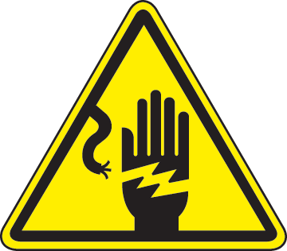 | DANGER! High voltages present. Serious damage to equipment and personnel may result. This lab may only be done under the direct supervision of an experienced instructor.
Luckily, there’s a way we can test the fuses without de-energizing the entire system. If one fuse is bad, our system of testing will quickly point to the faulty component, which can then be replaced. This system of testing is inherently more dangerous, because the system is still energized, but it will allow troubleshooting to begin without having to de-energize the entire circuit that is being investigated.

Scenario
An equipment operator from your area has come to you and says that one of the three-phase motors has been running in reverse ever since the motor overheated on the previous shift. You suspect a blown fuse, but you need to verify before troubleshooting further. Your facility is behind on producing parts for the month, and you want to minimize down time as much as possible while looking for root cause.

Part 1
Find a partner to work with and locate the 208 VAC fused disconnect box where measurements will be taken. One partner will be responsible for holding the DMM and writing down measured results. The other will be responsible for taking the actual measurements. Once the first person has taken measurements of the line voltages and fuses, both partners will swap positions. Every student MUST take measurements.
Step 1 – After donning proper PPE, visually inspect the inside and outside of the fused disconnect box. What are you looking for?
___________________________________________________________________________________

Step 2 – Measure the line-side voltage between phases. Correctly label your results.
L1 to L2: _____________ L1 to L3: _____________ L2 to L3: _____________

Step 3 – Test voltage across each fuse. Correctly label your measurements.
Fuse A: ___________ Fuse B: ___________ Fuse C: ___________

Step 4 – What’s the voltage for each line to ground? Again, label your answers.
L1: _____________ L2: _____________ L3: _____________
What voltage reading would you expect to get that would indicate the fuse was bad? ____________________________________________________________________________
Fuse | Resistance | Good/Bad?
1
2
3
4
5

Part 2
For this part of the assignment, you have several fuses that have already been pulled from their systems. These fuses are located on a fuse test board. Your task is to measure the resistance of each fuse and indicate if you believe the fuse is good or bad. Please do not use the meters in Continuity Test mode (), but measure the actual resistance in Ohms ($Ω$). Correctly label all measurements.

Part 3
Using the internet, work with your partner to find answers to the following questions. Having pulled a bad fuse, you find the markings on it read “Low Peak, LPJ-150SP.”
- How many Amps is this fuse designed to handle? Volts? ___________ ___________
- How long is its time delay (at 500% rating)? ___________
- What UL class is this fuse? ___________
- Use www.fusesunlimited.com/glossary.aspx to describe the features of this class of fuse:
__________________________________________________________________________________________________________________________________________________________________________________________________________________________________________

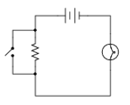
Part 4
Given this schematic diagram (right) and the components shown beneath it, draw how the components may be connected with wires to form the same circuit depicted in the schematic (don’t move any of the components).

Check-off Method and Wiring
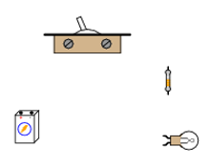
As you troubleshoot circuits, you will work from a wiring diagram or schematic. To ensure the circuit is wired correctly, use the check off method. Working from the schematic, find and trace each wire. When the wire is checked and verified to be correctly placed and securely connected, place a check mark by the wire on the schematic. Work through the circuit in a logical order and make sure to check every wire. This method works for most electrical, hydraulic, and pneumatic circuits.
Make sure the circuit is de-energized when using the check off method, since you are likely to come into contact with potentially live components, or you could pull loose a live wire that might cause a dangerous short circuit.
Use the Check-off Method on ALL lab activities.

