General Information

Instructor Information and Availability
Name: Miranda Dudzik (Pronounced Doo-jick)
Phone: (541) 917-4662 (Email preferred)
Cell phone provided in Moodle (elearning.linnbenton.edu) for emergencies
Email: dudzikm@linnbenton.edu
Office hours: Tuesday 5 pm – 6 pm in WOH 211 (or in the classroom) and by appointment

Course Information
Course name: General Biology 102 - Cell Biology, Genetics, and Evolution
CRN and Section: 30420 section 03
Credits: 4
Location: WOH 205, Tuesday (Lecture) and Thursday (Lab), 6:00 pm - 8:20 pm

Prerequisites
MTH 65 highly recommended. Biology 101, 102 and 103 need not be taken in numerical order, but only one BI 102 theme course can be used to meet graduation requirements. If you have taken a different BI 102, Miraculous Microbes for example, this section will not fulfill any other prerequisites for your degree program.

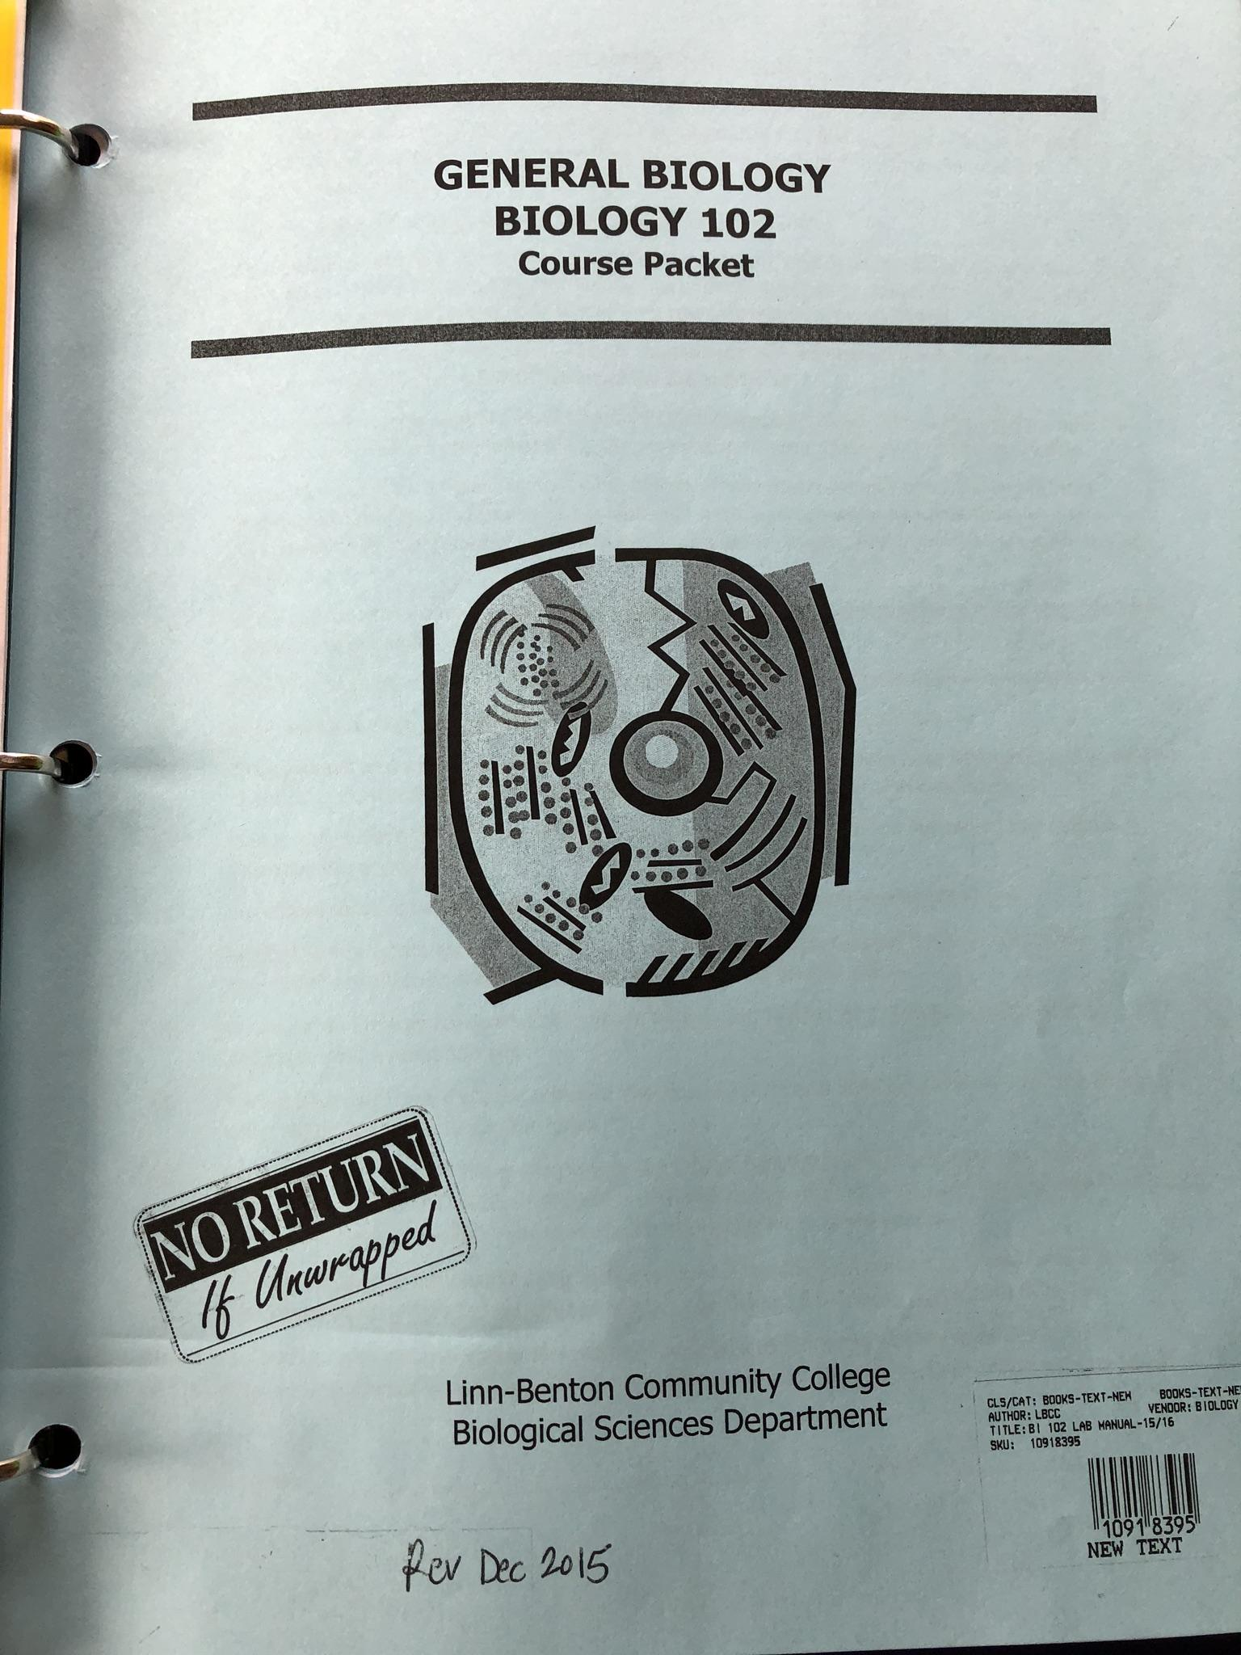
Required Course Materials
- OpenStax Concepts of Biology, free online textbook
  - Links to the assigned chapters each week will be provided in Moodle.
  - Hardbound copies of the book are available at the LBCC Campus Store for approximately $35.
- BI 102 General Biology Lab Packet
- Five Scantron forms for exams

Course Description
Biology 102 is an introductory lab science course. This course introduces knowledge that extends from atoms and molecules to DNA analysis, including genetic analysis of human and plant traits, as well as providing an historical perspective on the evolution of major theories and ideas. This course is intended for NON-Science Majors. Students typically have little or no science background, yet are enrolled in this course to fulfill requirements needed for a non-science degree and who want to expand their knowledge and appreciation of biology.

Student Learning Outcomes
By the end of this course you will be able to:
- Explain how natural selection drives evolution.
- Express how changes in the genome can affect the phenotype or traits within a population.
- Be able to describe the patterns of inheritance.
- Be able describe selected key cell processes.
- Distinguish between the groups of biomolecules.

Grading Categories | Points | Percentage of Total Grade
Pre-Labs (10 @ 2 pts) | 20 | ~ 5%
Labs (10 @ 8 pts) | 80 | ~18%
Online Study Modules (9 @ 5 pts) | 45 | ~10%
In Class Activities (1 pt each) | ~10 | ~ 2%
Exams (4 @ 35 pts) | 140 | ~31%
Comprehensive Final | 150 | ~34%
Total | 445 | 100%
As with the course schedule, point distribution is subject to minor changes.

Class Policies

Lecture and Lab Attendance
You are required and expected to attend all lectures. Attendance will not be taken, but to achieve success in this class, coming to class and participating in activities is essential. No graded assignments or lab work will be accepted if you were not in attendance when the work was performed and/or due. This is a lab science course, so it is expected that you attend at least 6 of the labs to gain a passing grade.

If a student misses more than 4 labs, that individual will automatically fail the course regardless of the overall points for the remainder of the course. Pre-labs are due at the beginning of class on lab day and will not be accepted late for any reason. Labs are due by the following day after the lab activities have been performed.

Additional handouts will be provided in class. Lecture materials and study guides will be posted on Moodle which can be accessed at www.elearning.linnbenton.edu. You are required to log onto the Moodle course associated with this CRN and check your LBCC email regularly. Failure to do so means that you will be unable to take the online quiz and you will miss out on important updates and messages regarding the class.

Online Study Modules
Each week there will be online study modules that align with lecture and lab materials for the week. These assignments are meant to be done outside of class and worth 5 points each. These assignments are structured as online multiple choice questions and can be attempted as many times as you need, with the highest score earned automatically recorded. See schedule at the end of this document for specific due dates. Details on each assignment can be found in Moodle, under the “Online Study Modules” section.

Lab Reports

Your time in lab on Thursdays will be spent running experiments, collecting data, and working on the lab analysis questions. The lab reports will be due promptly at the beginning of class the following Tuesday. Late reports will not be accepted unless your absence on the day it is due has been prearranged.

Exams
All exams are in class and closed notes, closed book. There will be four exams throughout the term, worth 35 points each. The final exam will be cumulative and worth 100 points. See schedule at the end of this document for specific dates. The format of exams will be a mixture of multiple choice, matching, visual identification, short answer, and problem solving questions. All exams will have a scantron component and a written component. You must provide your own Scantrons, the instructor WILL NOT have extras to distribute! Arrangements can be made to take the exam in the Student Assessment Center (RCH 111) if you require a language translator or CFAR accommodations. If you miss an exam, you will be allowed to make it up within 5 days, contingent upon discussing arrangements with the instructor.

In Class Activities
Almost every class period will involve activities relating to the topic being presented that day. These activities are worth 1 point each, are never turned in or graded, and are meant as a tool for you to study and conceptualize the topics. These activities bring the student a deeper understanding of the subject matter and greatly improve performance on the exams. If you do not attend class, you will not be given the opportunity to do these activities.

Moodle Gradebook
As assignments are completed and graded, your scores will be entered into the Moodle gradebook. You are encouraged to check your grade regularly and connect with your instructor if you are struggling.

Extra Credit
On a few occasions on the exams and in class there may be extra credit opportunities made available, which will be high-challenge questions that can aid your score. This credit will generally not influence a grade more than 2-4% for the overall grade, but it could make a big difference in borderline grade situations. Extra credit will NOT be issued or allowed for missed work – there are no exceptions to this rule. Please do not ask for exceptions due to poor performance.

Statement of Respect

Your instructor will make every attempt to create an environment free of distraction and one open to free discourse. The college environment is one of exploring ideas, but also in a context of mutual respect for your peers and instructors. If a pattern of disrespect develops, expect to be pulled aside to discuss appropriate behavioral expectations to gain a better understanding this responsibility. At no time will a hostile or condescending classroom environment be tolerated.

Academic Integrity
Plagiarism and cheating as explained in the Student Rights, Responsibilities, and Conduct policies will not be tolerated. Examples of academic dishonesty include (but not limited to) looking at other student exams while taking the exam, submitting assignments with identical answers, and copying answers directly from the internet. If a student is found cheating on an exam or plagiarizing an assignment, after due process, a grade of zero will be given to all students involved on that exam or assignment without the opportunity to make it up, with the possibility of official intervention by the Dean of Student Affairs.

Personal Computers (Notebook/Laptop/Tablets)
You are permitted and encouraged to use a personal computer or tablet (i.e. an iPad) for the purpose of taking notes during class time. If you are found once to be using the device for personal use, web surfing, Facebook, games etc. during class time you will receive a warning. Your second offense will result in loss of the privilege of using the device for the remainder of the term. Computers in the labs are only to be used for class or lab activities, not for personal reasons and under no circumstances should downloading of software be attempted.

Cell Phones
Cell phones must be silenced during class (Silenced, not just put on vibrate!). You may not talk or text message at any time during class. If you need to have an active phone (e.g., spouse close to labor, sick child) you must clear it with the instructor prior to class. Cell phones may not be used as calculators during exams. If an exam or class activity requires the use of a calculator, they will be provided.

College Policies and Resources

Center for Accessibility Resources
You should meet with your instructor during the first week of class if:
- You have a documented disability and need accommodations.
- Your instructor needs to know medical information about you.
- You need special arrangements in the event of an emergency.
If you have documented your disability, remember that you must make your request for accommodations through the Center for Accessibility Resources (CFAR) Online Services webpage every term in order to receive accommodations. If you believe you may need accommodations but are not yet registered with CFAR, please visit the CFAR Website for steps on how to apply for services or call 541-917-4789.

LBCC Statement of Nondiscrimination
LBCC prohibits unlawful discrimination based on race, color, religion, ethnicity, use of native language, national origin, sex, sexual orientation, gender, gender identity, marital status, disability, veteran status, age, or any other status protected under applicable federal, state, or local laws. For further information see Board Policy BP-1015. Title II, IX, & Section 504: Scott Rolen, CC-108, 541-917-4425; Lynne Cox, T-107B, 541-917-4806, LBCC, Albany, Oregon. To report: linnbenton-advocate.symplicity.com/public_report

Title IX Reporting Policy
If you or another student are the victim of any form of sexual misconduct (including dating/domestic violence, stalking, sexual harassment), or any form of gender discrimination, LBCC can assist you. You can report a violation of our sexual misconduct policy directly to our Title IX Coordinator. You may also report the issue to a faculty member, who is required to notify the Coordinator, or you may make an appointment to speak confidentially to our Advising and Career Center by calling 541-917-4780.

Public Safety/Campus Security/Emergency Resources
In an emergency, call 911. Also, call LBCC Campus Security/Public Safety at 541-926-6855 and 541-917-4440.

From any LBCC phone, you may alternatively dial extension 411 or 4440. LBCC has a public safety app available for free. You are to download it to their cell phones. Public Safety also is the home for LBCC's Lost & Found. They provide escorts for safety when needed.

Inclement Weather Policy
Only if the campus is closed will an exam be postponed, and this will occur on the next scheduled class date following the closure. If a late start is announced, classes will resume on their usual scheduled times, early labs may resume and be held if the college opens during the scheduled lab period e.g. 2 hour delay. Please listen to local media coverage for notice of closures such as T.V. & radio stations. Closure information is also posted on the LB website. Information will also be communicated through Moodle as soon as the instructor.

Struggling to Meet Basic Needs Outside of the Classroom?
Any student who has difficulty affording groceries or accessing sufficient food to eat every day, or who lacks a safe and stable place to live, and believes this may affect their performance in the course, is urged to contact the Single Stop Office for support (SinglestopatLBCC@linnbenton.edu , 541-917- 4877, or visit us on the web: Single Stop at LBCC, under Student Support for Current Students). This office can help students get connected to resources to help. If you are comfortable doing so, talk to your instructor for more resources.

