Name: ______________________
Partner:______________________

Lab 6 – Measuring Current

- Test your meter to ensure both fuses are good (from lab demonstration). If either fuse is bad, get a replacement from the instructor.
- Set up your trainer with four 40-watt lightbulbs.
- Take a total resistance measurement of:
  - System with all switches off: _________
  - System with one rung on: _________
  - System with two rungs on: _________
  - System with three rungs on: _________
  - System with all rungs on: _________
- Before plugging in, determine a good spot to measure total system current (schematic provided) and put the meter into your circuit to measure amperage (10A setting).

- Think about how current should behave when loads are added to your parallel circuit. Plug-in your system and measure/estimate the current below:
  - MEASURE with one rung energized: _________
  - ESTIMATE having two rungs energized: _________
  - MEASURE with three rungs energized: _________
  - ESTIMATE having four rungs energized: _________
  - MEASURE with four rungs energized: _________
- Measure the voltage across Lamp_1 (energized): _________

- Measure the voltage across Switch_0 (energized): _________

- Test your meter to ensure both fuses are good. If either fuse is bad, apologize to your peers for increasing their student fees, and then get a new fuse from the instructor.
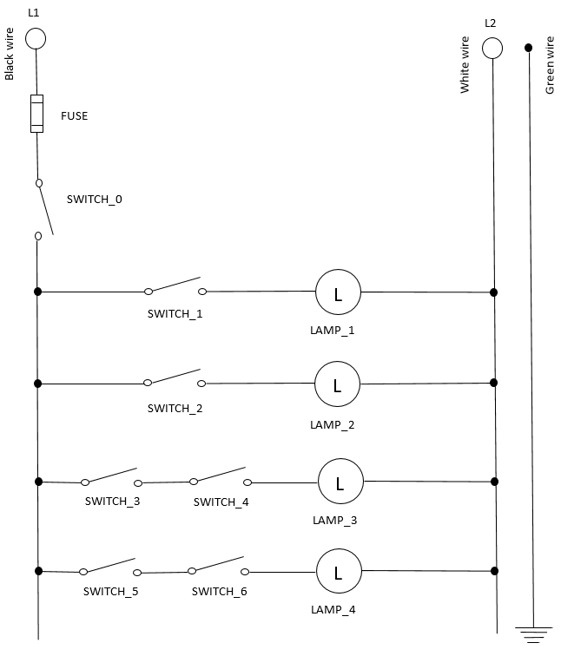
High Resistance Short-to-ground
A high resistance short-to-ground might not blow the fuse, but it will likely create localized heating at the sight of the short. It is a ground fault, meaning that a hot wire is touching grounded metal through a high resistance pathway, for example: oily, damp dirt or wood chips. It is very dangerous because you could touch grounded metal and, being an easier electric path to ground, current could flow through your body. The ground fault will act like an additional parallel load increasing total current draw.

Look for signs of heating, cracked wire, or a build-up of dirt or debris around a wire or in a junction or switch box. If the circuit has a ground fault interrupter (GFI or GFCI) the GFI should open, de-energizing the circuit.

If you see nothing obvious, attach an ammeter to the grounded metal or the ground circuit. Note the amount of current flow in a good ground circuit should be .000 Amps. If there is current flow in the ground circuit, there is a ground fault. If this is the case, start at the far end of the circuit and disconnect one parallel branch at a time. If the current flow does not drop when the branch is disconnected, reconnect that circuit and move on to the next circuit. When the amperage reading takes a sudden drop to near zero after a branch is removed the branch just removed contains the high resistance short-to-ground. Inspect that section for the exact location of the short.

Exercise: Create a high resistance short-to-ground and measure current flow.
- Install a high-resistance short-to-ground in your circuit.

- Draw on the schematic where your high-resistance short-to-ground is located.
- How much current is flowing through your ground wire? ________
Initials _______
- Once it’s working, have the lab instructor check your circuit.

- What dangers might arise from a high resistance short-to-ground?

