ART 102
Understanding Art
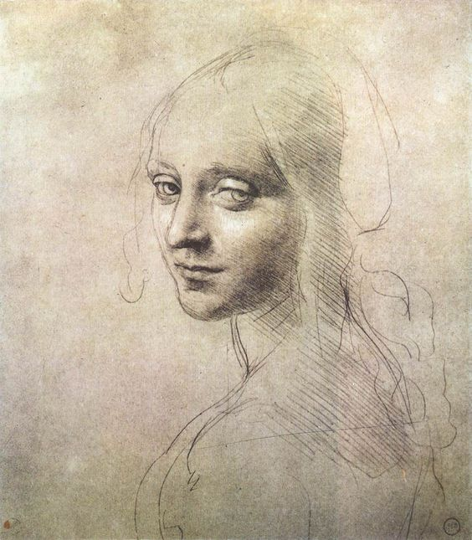  Leonardo Da Vinci, Study for the head of a girl, c. 1483 | CRN: 24983  Tues/Thurs 2:00-3:20pm  Credits: 3  Instructor: Luis De Luna  Email: delunal@linnbenton.edu  Phone: 210-264-7880  Office Hours: T/TH 3:30-4:30 pm or  By email appointment  Office: SSH 116

Course Description: Surveys the basic elements of visual form. Traditional and contemporary visual arts from around the world are examined in ways designed to provide a framework for meaningful responses to form and content.
Student Learning Outcomes
Upon successful completion of this course, students will be able to:
- Articulate verbally and in writing a general understanding of the significance of visual art in a wide variety of cultures and media.
- Create a personal work of art.
- Articulate verbally and in writing the form and content of the piece, along with information about significant artists and art works relative to the created artwork, and to visual art.
- Articulate verbally and in writing appropriate art vocabulary, and art evaluation concepts, when viewing visual art.
Attendance & Classroom Etiquette:
Due to the interactive nature of this course, attendance is extremely important. After three absences a student’s grade will drop a full letter. For example, a student holding a B will then have a C. Arriving late or leaving early will also hamper your understanding of course materials.

Three late arrivals or early departures will be counted as an absence. Emergencies and extenuating circumstances can be excused if communicated in a timely manner.
Each class we will research, draw, discuss, and produce verbal/written reflections on art. Your participation enhances our diversity of perspective and being present will allow you to reflect on the contributions of others. To engage fully in the course, please PUT AWAY cell phones and laptops during lecture. If needed limit it to academic research. (For extenuating circumstances, please simply let me know in advance).
Please meet with me during the first week of class if
- You have a documented disability and need accommodations,
- Your instructor needs to know medical information about you, or
- You need special arrangements in the event of an emergency.
If you believe you may need accommodation services please contact Center for Accessibility Resources, 541-917-4789. If you have documented your disability, remember that you must make your request for accommodations through the Center for Accessibility Resources Online Services web page every term in order to receive accommodations.
Please arrange to meet with me at any point throughout the term if
- You realize you need something to improve your learning experience
- You have questions regarding your grade or the course material
Assignments & Grading:
Quizzes: At the end of each week, you will be taking a quiz over chapters discussed during the week. There will one quiz every week so it will extremely important to keep up with the reading as well as coming to class to be involved with discussions.
Written Reflections: We will watch various Ted Talks throughout the winter quarter. Each written reflection paper should be no less than 600 words. There will be a separate handout for the criteria of each written reflection.
Medium Experiments: During our chapters on various media, students will have 4 hands-on studio experiences. Projects will be evaluated as experiments not final works of art.
Visual Analysis Final Project: Written or Visual option The 4 page minimum paper for the winter term will be on an artist of your choosing. There is also a separate handout for this paper.
Grading:
A: 90-100%
B: 80-89%
C: 70-79%
D: 60-69%
F: 59% and below
Incomplete grades will require a valid reason.
Late work will be marked down one letter grade.

Extra Credit is available until week 9. Extra credit can be earned by visiting an art museum and writing a written reflection based on the experience. Regional examples include the Portland Museum of Art, Hallie Ford Museum of Art in Salem, Jordan Schnitzer Museum of Art in Eugene, or others with instructor approval. Alternatively, attending an artist lecture, going on a studio visit, or watching an approved documentary can also be used for creating an extra credit written reflection.
Tips for Success: 1. Come to class curious, 2. Write things you would want to read, 3. Reach out to those around you in a kind respectful way, 4. Ask for help if needed.
Academic Integrity:
The presentation of another individual’s work as one’s own or the act of seeking unfair academic advantage through cheating, plagiarism or other dishonest means is a violation of the college’s “Student Rights and Responsibilities.” Turning in someone else’s work as your own, or buying a paper from a professional writer or a research center, or downloading one from a Web site, is plagiarism. Turning in another artist’s drawing as your own is also plagiarism. It is plagiarism to copy sentences out of a source without putting them in quotes, or to paraphrase too closely or to fail to cite the source of the information. Any statements of fact or ideas that you borrow from sources must be put into your own words. All sources must be clearly presented. A plagiarized paper or visual journal entry will receive a zero. Two zeros for plagiarism will be grounds for an F in the course, regardless of other grades.
*Recycling, referencing, appropriation, and outsourcing play important roles in contemporary art. If you use these tools be sure you can clearly state the conceptual significance of your choices and be transparent about them during assessment/critique/reflection.
LBCC Statement of Nondiscrimination:
LBCC prohibits unlawful discrimination based on race, color, religion, ethnicity, use of native language, national origin, sex, sexual orientation, marital status, disability, veteran status, age, or any other status protected under applicable federal, state, or local laws.

LBCC Statement of Inclusion:
The LBCC community is enriched by diversity. Each individual has worth and makes contributions to create that diversity at the college. Everyone has the right to think, learn, and work together in an environment of respect, tolerance, and goodwill.
Materials: Available at the LBCC Bookstore
- Preble’s Artforms: An Introduction to the Visual Arts, Patrick Frank, Eleventh Edition, ISBN: 978-0-205-96811-4. *Several copies will be made available at the college library. Please see me if the expense might keep you from obtaining a textbook.
- Binder with lined and unlined paper.

2017 ART 102 Class Calendar: *
Week 1: | TUES 1/10  Introduction to Art Appreciation  Chapter 1  Watch How to be Creative Video  Homework: Acquire notebook &  Textbook  Homework: Read Chapter 1 & 2  Homework: Write Written reflection on how to be creative video | THU 1/12  Lecture on Function of Art  Chapter 2  Homework: Chapter 1 & 2 Quiz on Canvas  Homework: Read Chapters 3 & 4
Week 2: | TUES 1/17  Lecture on Visual Elements  Chapter 3  Due: Written reflection on How to be creative video-uploaded to Canvas | THU 1/19  Lecture on Design Principles  Chapter 4  Homework: Chapter 3 &4 Quiz on Canvas  Homework: Read Chapter 5 & 6
Week 3: | TUES 1/24  Lecture on Evaluating Art  Chapter 5  Watch Taking Imagination seriously Video  Homework: Write Written reflection on Taking Imagination Seriously video | THU 1/26  Drawing - Studio time  Chapter 6  Homework: Chapter 5 & 6 Quiz on Canvas  Homework: Read Chapter 7 & 8
Week 4: | TUES 1/31  Painting - Studio Time  Chapter 7  Watch Diego Rivera Video  Homework: Written reflection on Taking Imagination seriously video | THU 2/2  Printmaking Presentation  Homework: Chapter 7 & 8 Quiz on Canvas  Homework: Read Chapter 9, 10 & 11
Week 5: | TUES 2/7  Photography -Studio Time  Chapter 9  Decide on which Artist to write Visual analysis  Due: Written reflection on Diego Rivera video-  Uploaded to Canvas | THU 2/9  Film & Digital Art - Studio Time  Design Disciplines  Chapter 10 & 11  Homework: Chapter 9,10 &11 Quiz on Canvas  Homework: Read Chapter 12, 14 & 15
Week 6: | TUES 2/14  Architecture - Studio Time  Sculpture  Chapter 12 & 14 | THU 2/16  Lecture from the Earliest Art to the Bronze Age  Chapter 15  Homework: Chapter 12,14 &15 Quiz on Canvas  Homework: Read Chapters 16 & 17
Week 7: | TUES 2/21  Lecture on the Classical Age to Medieval West  Chapter 16 | THU 2/23  Lecture on Renaissance & Baroque Europe  Chapter 17  Homework: Chapter 16 Quiz on Canvas  Homework: Read Chapter 17 & 19
Week 8: | TUES 2/28  Lecture continued on Renaissance & Baroque Europe  Chapter 17  Draft on visual Analysis to be emailed | THU 3/2  The Islamic World  Chapter 19  Homework: Chapter 17 &19 Quiz on Canvas  Homework: Read Chapter 20 & 21
Week 9: | TUES 3/7  Africa, Oceania, and the Americas  Chapter 20 | THU 3/9  Lecture on Late 18thand 19th Century  Chapter 21  Homework: Chapter 20 & 21 Quiz on Canvas  Homework: Read Chapter 22 & 23
Week 10: | TUES 3/14  Lecture on Early 20th Century  Chapter 22 | THU 3/16  Lecture on Between World Wars  Chapter 23  Homework: Chapter 22 & 23 Quiz on Canvas
Finals Week | TUES3/21  Visual Analysis Final Due  From 4:30-6:20 pm | THU 3/23  Done No Class
*Instructor reserves the ability to make changes to best fit the needs of the class

