Writing 123
English Composition: Research
Leana Dickerson
Spring Term 2015 leana.dickerson@linnbenton.edu
541.917.4551
Room: IA-224 Office Hours: Tuesday and Thursday 10-11
CRN: 48974 Tuesday/Thursday 8:30-9:50 Office: SSH 215

Course Description:
Writing 123 introduces informative and analytical writing supported by research. Students design a research plan, use primary and secondary sources critically, develop research methods, use proper documentation, and develop writing strategies for longer papers. 3 credits.
Required Texts:
Palmquist, Mike. The Bedford Researcher. 5th Edition.

Course Outcomes:
- Analyze the rhetorical needs (the needs of their audience in relationship to the assignment) for college-level research-based writing assignments.
- Apply appropriate levels of critical thinking strategies (knowledge, comprehension, application, analysis, synthesis, evaluation) in their written assignments, with an emphasis on in-depth evidence-based analysis and evaluation in academic contexts.
- Implement appropriate rhetorical elements and organization (introduction, thesis, development and research-based support, visual evidence, conclusion, etc.) in their written assignments, with an emphasis on in-depth evidence-based analysis and evaluation.
- Locate, evaluate, and integrate high-quality information and opinion appropriate for in-depth research-based informational, analysis and argument assignments.
- Craft sentences and paragraphs that communicate their ideas clearly and effectively using words, sentence patterns, and writing conventions at a high college level to make their writing clear and credible.

Turning In Assignments:
Unless otherwise discussed in class, all assignments will be turned in via e-mail attachment (either in .doc .x or .rtf format). Please use ONLY your LBCC e-mail address and send directly ONLY to my LBCC e-mail account: leana.dickerson@linnbenton.edu. I will send you a confirmation that I received your attachments. If you do not hear from me within 4 hours of the assigned deadline, assume I have not received your paper.

Assignments:
Participation: Participation not only includes attendance, which is a large part of you being able to participate at all, but also includes how you participate. If you show up every day but never say a word, you can expect only partial credit. If you are involved and turn in assignments regularly, you will be in much better shape come the end of term. Keep in mind too, that participating does not only include activity in-class, but doing the readings and participating outside of class time as well.

In-Class and Take Home Assignments: Many of your take-home and class assignments will contribute to your final portfolio. That being said-- keep a hold of those things as you get them returned so that you can include them in your final packet.

Midterm Essay: You will have an in-class mid-term essay in which you will be able to demonstrate your understanding and usage of proper MLA format, fluent and organized ideas, as well as integration of quotations, summary, and/or paraphrase.
Final Project: Your final project for this course will be a 16-20 page paper which researches a pertinent question on topic of your choice. Must be typed, 12 pt. font, and in correct MLA format.
Project Portfolio: By the end of this course you will have accumulated many documents that have helped you develop your final project. You will turn in these documents in a portfolio along with your final paper:

- Project Proposal (Due week 2)
- Annotated Bibliography (due week 5)
- Side by Side Notes of at least 4 Sources (due week 6)
- Full Outline (due week 7)
- Full Draft for peer review and conference (due week 8)

Grading:
Participation 15%
In-Class and Take Home Assignments 15%
Midterm Essay 15%
Final Project 40%
Project Portfolio 15%

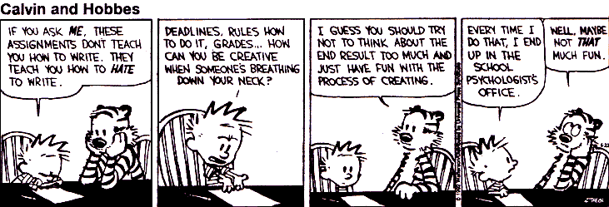

Resources: (use them!)
THE LIBRARY
Linn Benton Learning Center
Linn Benton Writing Center
Linn Benton Online Writing Lab (OWL)
Purdue OWL (Online Writing Lab): https://owl.english.purdue.edu/owl/
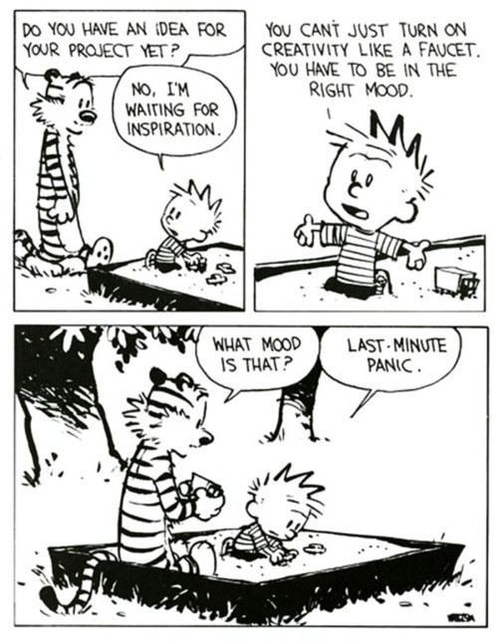
Late Work Policy:
Things happen, emergencies come up; as long as it does not become a clear pattern, if you ask me within 24 hours notice, I will most likely provide you with an extension plan for your work. If you do not request an extension within the 24 hour period before the assignment is due, you will automatically lose one letter grade for each class period thereafter. Just don’t do it.

Attendance Policy:
Attendance is considered part of your participation for this course. I will allow you three missed classes, no questions asked. Each absence after will result in the lowering of your participation grade for this course which factors into your final grade. If you have an emergency which may affect your ability to complete this course, please contact me as soon as possible to make arrangements.

Class Cancellation Information:
In the event that we cannot meet on campus (weather, for instance), please be sure to check your LBCC e-mail. You should receive an e-mail from me, as we will still have out-of-class work either via an assignment through e-mail or through moodle.

Electronics in the Classroom:
Please refrain from using electronics in class. I ask that you do not use a laptop or tablet to take notes as it does become a distraction not only for you, but also for your peers, as well as me. If you must make or take a phone call (or a text message), please remove yourself respectfully from class to do so.

Plagiarism:
The MOST important thing to remember when writing and studying for your own academic success, is to only claim your own thoughts and ideas. If you incorporate the work of others, you must utilize citations to provide them with the credit. Not using proper citations when using someone else’s work may result in you failing the assignment and even this course. For more information about plagiarism and what plagiarism includes, please visit: http://plagiarism.arts.cornell.edu/tutorial/index.cfm.

Nondiscrimination Policy:
LBCC maintains a policy of nondiscrimination and equal opportunity in employment and admissions, without regard to race, color, sex, marital and/or parental status, religion, national origin, age, mental or physical disability, Vietnam era, or veteran status. (See Administrative Rule No. E029 and Board Policy Series No. 6090, found at http://po.linnbenton.edu/BPsandARs/).

Accessibility
You should meet with your instructor during the first week of class if:
- You have a documented disability and need accommodations,
- Your instructor needs to know medical information about you, or
- You need special arrangements in the event of an emergency.
If you believe you may need accommodation services please contact Center for Accessibility Resources, 917-4789. If you have documented your disability, remember that you must make your request for accommodations through the Center for Accessibility Resources Online Services web page every term in order to receive accommodations.

Contact:
If you need to contact me, e-mail is the best resource. I frankly do not typically utilize phone communication, but check e-mail regularly except for on weekends, evenings, and holidays. And of course, come to my office hours; they’re designed for you to utilize!

Course Calendar:

