ART 210

Women in Art

Spring 2017
Linn-Benton Community College

CRN: 48799
TR 11:30-12:50
NSH 106

Professor: Isabelle Havet

Email:haveti@linnbenton.edu
Office: SSH 116C, Albany Campus
Office Hours: MW 11:30-1:00; TR 1:30-2
& by appointment

Art 210  Women in Art |  | Spring 2017  CRN: 48799  Class Time: TR 11:30-12:50
Professor: Isabelle Havet
E-mail: haveti@linnbenton.edu
Phone: 541-917-4559
Office: SSH 116C, Albany Campus
Office Hours: MW 11:30-1:00;
TR 1:30-2 & by appt.

Course Description

This course will explore the roles and status of women in art from prehistory to the present, focusing in particular on the Renaissance to contemporary period in Western culture. We will proceed chronologically as well as thematically, exploring both male artists' depictions of women in various historical periods as well as the achievements of women artists through the centuries. Some important themes we will explore include gendered sight, art history's exclusions, the “ideal” spectator, the nude, the fragmented body, virgin/whore dichotomies, and sexuality in the media. No prior knowledge of art history is required.

Learning Outcomes
Upon successful completion of this course, students will be able to:
- Articulate verbally and in writing an understanding of the significance of art created by women relative to their societies.
- Identify and describe verbally and in writing, specific two and three-dimensional works of art, created by women from the Middle Ages onward, using appropriate art vocabulary.
- Articulate verbally and in writing the form and content of specific and significant works of art from the Middle Ages onward from the cultures and women that produced them.
Credits: 3 credits; 3 hours of class per week.

General Education Requirements: AAOT Arts & Letters

Prerequisites: WR 115 Introduction to College Writing, with a C or better.

Required Textbook: Guerrilla Girls, The Guerrilla Girls’ Bedside Companion to the History of Western Art, Penguin Books, 2008. ISBN-10: 014025997X. ISBN-13: 978-0140259971.

Required Supplies: Notebook (will be collected)

Requirements

Course Assignments
- Notebook
- Quizzes
- Class Activities
- Group Presentation
- Paper
- Midterm & Exam

Description of Course Assignments
Readings and videos are assigned for each class session. Read all assigned readings and watch all assigned videos before each class session. Class time, quizzes, midterm, and final will revolve heavily around readings, videos, and lectures. I will also check your Moodle progress frequently. If I see that you are falling behind, I will ask you why.
- Notebook
You are required to take notes in class on lectures and assignments. Studies show that note-taking students perform better than non-note-taking students. In addition to regular note-taking of lectures and assigned readings/videos, you will periodically be asked to write short reflections on specific topics. Your Notebook will be collected and graded.
- Quizzes
Students will take short quizzes in Moodle each week of instruction (Weeks 1-10). Quizzes are designed to help students keep pace with the material (readings, videos, lectures). Quizzes are a mix of multiple choice, True/False, word matching, and short answers.
- Class Activities & Group Presentation
Students will frequently participate in class activities, both individually and in groups. You may be asked to prepare and submit materials in advance. Activities may include: class presentations, show & tells, and writing assignments. Group Presentation: Small groups co-teach a 10-minute lesson (See Course Schedule for topics).
- Paper
Students complete a short (2-3 page) analysis paper on one or more selected artworks. You must send me the images you will be writing on at least two weeks in advance.

- Midterm & Final Exam
The midterm exam will include a combination of multiple choice questions, short answers, and essays. Exams are not cumulative.

Failure to submit an assignment or participate in an activity on time will result in a 0 grade. Class activities cannot be made up later.

Assignment | Points
Notebook | 20
Quizzes | 20
Class Activities (including Group Presentation) | 20
Paper | 20
Midterm & Final | 20
Total Points | 100

Grading Scale
A 90-100%
B 80-89%
C 70-79%
D 60-69&
F 59% or below
Course Policies
Institutional Drop for Non-Attendance
Faculty at LBCC may administratively withdraw a student for nonattendance during the first week of the term. Students will be automatically dropped by the second Monday of the term if they are not attending regularly and fully participating in the course. Students who do not attend each session during the first week of class, or who do not complete ALL Week 1 assignments by the end of Week 1, may be institutionally dropped from the course.
Moodle
This course uses the Moodle learning platform. Think of Moodle as the online class hub: you will use the Moodle course site to access announcements, the Syllabus and Class Schedule, assignments guidelines, lecture slides, videos, readings, forums, and more.
I will upload my lecture slide presentation each day after class. Please note that the slide presentation will include the visuals only. Use the slide presentations to learn the images and key terms contained within. This is a courtesy. Do not republish any images found in the presentations online, as you may be breaking copyright laws. The images are for you to use to learn for exams only!
You will be asked to turn in assignments in Moodle. Assignments must be uploaded by Sunday at 11:59 pm on the week they are due, unless otherwise noted (See Course Schedule for details). It is the student’s responsibility to upload assignments to Moodle by deadline, and in an acceptable file format (doc, docx, or pdf). If you are having trouble uploading an assignment, contact the Help Desk or email the instructor right away (before the deadline!) It is the student’s responsibility to turn in work on time. Do not wait until the last minute to turn in assignments! “Last-minute problems,” such as losing your internet connection or having a computer problem at 11:55pm, conflicting travel plans, personal schedule conflicts, or work in other classes, are not considered valid excuses for missing assignment deadlines.
Emailed assignments will NEVER be accepted. If it’s not in Moodle, it’s not graded.
Attendance & Participation
The course spans only 10 weeks. It is vital to attend class regularly and arrive on time. Please do not come late to class. It is disruptive, and you risk missing important information and activities. If you miss an in-class activity or assignment, you cannot make it up. I come to class fully prepared; I show up early; I respect thoughtful input. In return, I expect you to show up fully prepared, on time, and respectful of me and your peers.
Controversial Content
Please be aware that this class will touch on themes that some may find explicit or disturbing, including violent and sexualy explicit material. Student are expected to behave with integrity and treat their peers with respect.

Moodle Attendance
Students track their own attendance is tracked in Moodle using their personal electronic devices. I find that this method is much more efficient and less of a hassle for all. Students mark themselves as Present, Absent, or Late at the beginning of each class session. If you do not have a personal device to mark your attendance, just come see me after class and I will mark your attendance for you. Attendance works on the honor system. Falsifying your attendance record in any way constitutes plagiarism, a serious college offense (See Academic Honesty below).
Present: Student arrives on time and stays the entire session.
Absent: Student does not attend class, or leaves early without prior approval.
Late: Student is 5 min late or more. 2 Late marks result in an unexcused absence.
Excused (marked only by instructor): Excused absences require documentation and are granted solely at the discretion of the instructor. If at all possible, arrange excused absences ahead of time.

Unexcused absences result in a lowering of the student’s final course grade by 5 points per absence. Please plan accordingly.

I understand that sometimes things happen. If you are late, will be late, or must miss class for a valid reason (emergency, military duty, death in the family), speak with me right away. I will excuse tardiness/absences if it is for a valid reason if it is not a frequent occurrence. Talk to me right away–do not wait!

Communication
- The best way to reach me is via email and during office hours. I try to respond to emails daily during weekdays. Feel free to email me if you have a question.
- When you email me:
  - Write your first & last name, course number & section days/time, and a short reason in the subject line (e.g.: Jane Smith, ART101 MW 10-11–Request for Appointment).
  - Please double-check that your email is written in a professional manner and is appropriate. I love teaching, and I enjoy interacting with students outside of class. However, it is disheartening to receive emails that are disrespectful, demanding, overly-personal, angy, or venting. This happens rarely, and is more often than not unintentional. However this method of communication is helpful to neither instructor nor student and runs counter to LBCC core values, and thus is unacceptable.
- Check your LBCC email frequently (preferably daily), or forward it to your personal email. I frequently send out important information via Moodle, and you are responsible for reading that information on time.

Resources

Moodle Support
If you have questions about Moodle or need technical support, contact:
- Student Help Desk (located in the Library): Either visit, call at 541.917.4630, or email at student.helpdesk@linnbenton.edu
- LBCC Moodle User Support Forum: Look up or post questions: http://elearning.linnbenton.edu/mod/forum/view.php?id=2697
Accessibility
You should meet with your instructor during the first week of class if:
- you have a documented disability and need accommodations,
- your instructor needs to know medical information about you, or
- you need special arrangements in the event of an emergency.
If you have documented your disability, remember that you must make your request for accommodations through the Center for Accessibility Resources Online Services web page every term in order to receive accommodations. If you believe you may need accommodations, but are not yet registered with CFAR, please go to http://linnbenton.edu/cfar for steps on how to apply for services or call 541-917-4789.
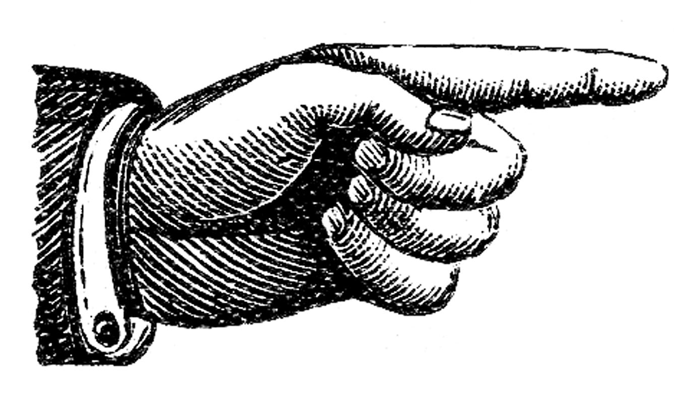
Extra Credit!

- Option 1: Use the Writing Center
You can receive up to three (3) extra credit points on your Paper by using the Writing Center. These services are highly recommended, and almost always result in a far better paper. Students have reported very positive experiences.
To receive credit for using the Writing Center: Attach proof (a picture of the Writing Center dated/initialed stamp or other confirmation is fine) to the end of your paper.
Writing Center website: https://www.linnbenton.edu/writing-center
There are 3 ways to use the Writing Center: Schedule a 30-minute appointment (recommended), Use Drop-In Services, Use OWL (the Online Writing Lab).

- Option 2: Attend a campus/local lecture or exhibition: During the term, I will announce campus/local lectures and exhibitions that are of interest to the class. You can receive up to two (2) extra credit points added to your course grade for each event you attend by turning in a 1-page reflection paper on the event. In your reflection, you may discuss any aspect of the lecture or exhibition that struck you or that you feel ties into issues we’ve explored in the class, as long as you include some specific details showing you attended the event. Imagine that you’re a reporter or blogger writing a review of the event. Including pictures in your write-up is great. You are encouraged to request permission to do an extra credit write-up of an alternative local event/exhibition they wish to attend; instructor approval required.

- Option 3: Write a 1-page reflection in your Notebook. Topics announced in class.

Important Academic Calendar Dates:
- Last day to add/drop: April 10, 2017
- Last day to withdraw: May 19, 2017

Incomplete Grade Policy
An incomplete grade may be assigned when a student has completed and passed a majority of the required work, but for reasons beyond the student’s control, cannot complete the entire course. Incompletes are given only in extraordinary and documented circumstances (i.e., a family emergency or serious medical excuse), and at the discretion of the instructor. If an Incomplete is granted, the instructor will determine the work that must be completed as well as a nonnegotiable completion deadline for submitting all missing work. If the incomplete work is not submitted on time or is deemed unsatisfactory, the incomplete will revert to an F-grade.

Academic Honesty
Academic honesty is an indispensable value as students acquire knowledge and develop college skills. Students are expected to practice academic honesty by not cheating, plagiarizing, or misrepresenting their coursework in any way. Plagiarism, collusion, and other forms of misrepresentation hurt the student and run counter to the goals of education. Students are ultimately responsible for understanding and avoiding academic dishonesty, whether such incidences are intentional or unintentional. Violations will result in failure of the assignment and possibly the course. Per LBCC policy, all incidents of academic dishonesty will be reported to the Associate Dean of Student Development and the Dean of Arts, Social Science & Humanities.

Stay Connected with LBCC Visual Arts!
You can follow LBCC’s Visual Arts department on Instagram and Facebook, to stay up to date on LBCC advising, scheduling, gallery opening events, and much more!
Instagram: @lbccart
Facebook: Linn-Benton Community College Visual Arts

