Homework 2

Basic Voltmeter Use
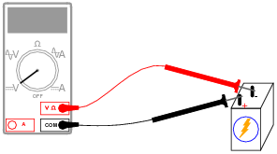
- What will this voltmeter register when connected to a battery as shown (assume a battery voltage of 6 volts)? Explain your answer.
Answer: The voltmeter will register -6 volts.

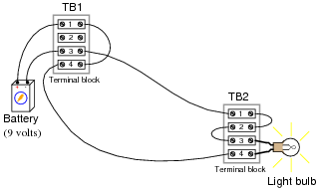
- Determine how much voltage a voltmeter would indicate when connected between the following points in this circuit (you may want to create a schematic of this diagram to help).
TB1-1 to TB1-3: ________
TB1-4 to TB2-4: ________
TB2-3 to TB2-1: ________
TB1-1 to TB2-1: ________

Answer:
• Between TB1-1 and TB1-3 (Voltmeter measures 9 volts)
• Between TB1-4 and TB2-4 (Voltmeter measures 0 volts)
• Between TB2-3 and TB2-1 (Voltmeter measures 0 volts)
• Between TB1-1 and TB2-1 (Voltmeter measures 9 volts)

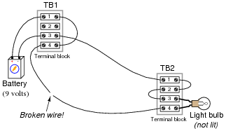
- Determine how much voltage a voltmeter would indicate when connected between the following points in this faulted circuit (you may want to create a schematic of this diagram to help).
TB1-1 and TB1-3: ______
TB1-4 and TB2-4: ______
TB2-3 and TB2-1: ______
TB1-1 and TB2-1: ______

Answer:
Between TB1-1 and TB1-3 (Voltmeter measures 9 volts)
Between TB1-4 and TB2-4 (Voltmeter measures 9 volts)
Between TB2-3 and TB2-1 (Voltmeter measures 0 volts)
Between TB1-1 and TB2-1 (Voltmeter measures 9 volts)

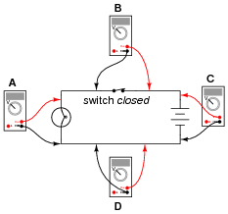
- Determine what these four voltmeters (A, B, C, D) will register when connected to this circuit in the following positions (assume a battery voltage of 6 volts):
Voltmeter A: ______
Voltmeter B: ______
Voltmeter C: ______
Voltmeter D: ______

Answer:
• Voltmeter A = 6 volts
• Voltmeter B = 0 volts
• Voltmeter C = 6 volts
• Voltmeter D = 0 volts

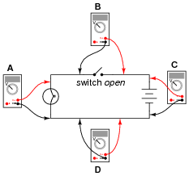
- Determine what these four voltmeters (A, B, C, D) will register when connected to this circuit in the following positions (assume a battery voltage of 6 volts).
Voltmeter A: ______
Voltmeter B: ______
Voltmeter C: ______
Voltmeter D: ______

Answer:
• Voltmeter A = 0 volts
• Voltmeter B = 6 volts
• Voltmeter C = 6 volts
• Voltmeter D = 0 volts

Basic Ohmmeter Use
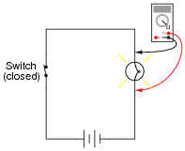
- What would be wrong about measuring the resistance of a light bulb while it is being powered by a battery (or any other electrical source)?
Answer: The voltage impressed across the light bulb by the battery will interfere with the ohmmeter’s measurement.

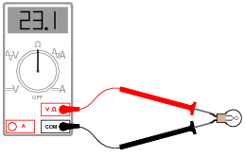
- Explain how an ohmmeter is able to measure the resistance of a component (in this case, a light bulb) when there is no battery or other source of power connected to it. Also, what reading would you get if the bulb were burnt out (failed open)?
Answer: Ohmmeters always contain a battery or some other internal source of electrical power so that the component under test may be supplied with a small amount of current, in order to measure how hard it is for current to go through.

Series Circuits
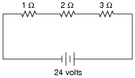
- In this circuit, three resistors receive the same amount of current (4 amps) from a single source. Calculate the amount of voltage “dropped” by each resistor, as well as the amount of power dissipated by each resistor.
Answer:
E1 Ω = 4 volts, E2 Ω = 8 volts, E3 Ω = 12 volts
P1 Ω = 16 watts, P2 Ω = 32 watts, P3 Ω = 48 watts

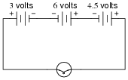
- How much voltage does the light bulb receive in this circuit? Explain your answer.
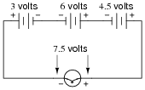
Answer:

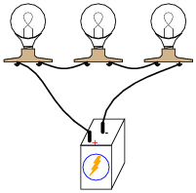
- Re-draw this circuit in the form of a schematic diagram:

- What would happen if three 6-volt light bulbs were connected as shown to a 6-volt battery? How would their brightnesses compare to just having a single 6-volt light bulb connected to a 6-volt battery?
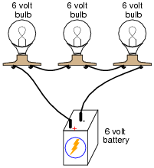
Answer: The three light bulbs would glow dimly.

Parallel Circuits
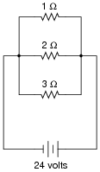
- In this circuit, three resistors receive the same amount of voltage (24 volts) from a single source. Calculate the amount of current “drawn” by each resistor, as well as the amount of power dissipated by each resistor.
Answer:
I1 Ω = 24 amps, I2 Ω = 12 amps, I3 Ω = 8 amps
P1 Ω = 576 watts, P2 Ω = 288 watts, P3 Ω = 192 watts

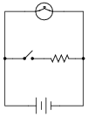
- What will happen to the brightness of the light bulb if the switch in this circuit is suddenly closed?
Answer: Ideally, there will be no change whatsoever in the light bulb’s brightness when the switch is closed, because voltage sources are supposed to maintain constant voltage output regardless of loading. As you might have supposed, though, the additional current “drawn” by the resistor when the switch is closed might actually cause the lamp to dim slightly, due to the battery voltage “sagging” under the additional load. If the battery is well oversized for the application, though, the degree of voltage “sag” will be inconsequential.

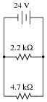
- According to Ohm’s Law, how much current goes through each of the two resistors in this circuit?
Answer: I_{R(2.2k)} = 10.91 mA, I_{R(4.7k)} = 5.11 mA

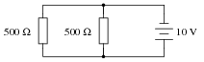
- Calculate the total amount of current that the battery must supply to this parallel circuit. Also, calculate the total resistance in this circuit.
Answer: I_{total} = 40.0 mA, R_{total} = 250 Ω

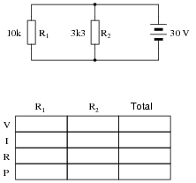
- Complete the table of values for this circuit
Answer: 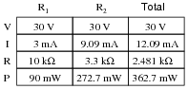

Wire Types and Sizes

- Most electrical wire is covered in a rubber or plastic coating called insulation. What is the purpose of having this “insulation” covering the metal wire?
Answer: The purpose of insulation covering the metal part of an electrical wire is to prevent accidental contact with other conductors of electricity, which might result in an unintentional electric current through those other conductors.

- Electrical wire is often rated according to its cross-sectional diameter by a gauge scale. Which is the larger-diameter wire size, 14 gauge or 8 gauge?
Answer: 8 gauge is the larger diameter

- If an electric drill is plugged into a very long extension cord instead of being plugged directly into a power receptacle, what will happen to the drill’s performance? Explain your answer, with reference to Ohm’s Law.
Answer: The drill will not perform with as much power as it would if directly plugged into a power receptacle. Challenge question: draw an equivalent schematic diagram showing the resistance of the extension cord conductors as resistors with the labels Rwire1 and Rwire2.

This worksheet and all related files are licensed under the Creative Commons Attribution License,
version 1.0. To view a copy of this license, visit http://creativecommons.org/licenses/by/1.0/, or send a
letter to Creative Commons, 559 Nathan Abbott Way, Stanford, California 94305, USA. The terms and
conditions of this license allow for free copying, distribution, and/or modification of all licensed works by
the general public. Source: allaboutcircuilts.com

