Syllabus for English 115

Writing 115 Fall 2018
CRN: 25674 & 25672
Sweet Home Center
Room 102
Tues/Thurs 10:30-12:00 (noon)
Prof. Nannette Schultz
Office Hour: 12:00-1:00 pm Tues/Thurs/By appointment
nannette.schultz@linnbenton.edu

Textbooks: Required
They Say, I Say 4th edition by Gerald Graff & Cathy Birkenstein
W.W. Norton & Company
New York/ London, 2018
IBSN: 978-0-393-63167-8

Recommended:
The Little Seagull Handbook
Paperback Dictionary

Final Exam Schedule: (Room 102)
Monday, Noon-12:50 pm Dec. 10, 2018
Tuesday, 11:30-12:20 pm Dec 11, 2018

Course Description:
(3 credits) Introduces college level critical inquiry in academic and professional reading and writing. WR 115 students critically read, summarize, and respond in paragraph format. Students develop expository essay writing skills, review conventions, and use individual and collaborative processes. Note: This course does not satisfy institutional writing requirements for the degree seeking or transfer student. Prerequisite: Placement in WR 115 is determined by pre-enrollment testing (CPT) or by passing WR 095 or ENL 095W (College Writing Fundamentals for ELLs) with a grade of C or better. Students may challenge their mandatory placement, with an advisor's approval, by signing a self-placement form through their counselor.

Course Overview:

Writing 115 is a course that provides additional support for students with college level essay than that provided in Writing 121. Since, this is an ALP (Accelerated Learning Program) version of Writing 115, you will NOT be doing additional full-length essays other than those required in Writing 121. There will be additional support assignments to help with the writing process for the required essays in Writing 121. These support assignments will be graded and used for the Writing 115 Course grade. We will do an extra practice in class timed writing exam in addition to the practice one in Writing 121 to help get the ALP students more prepared and comfortable with the times writing final exam.

Course Outcomes:

Upon successful completion of this course, students will be able to:
Write thoughtful, clear, and focused paragraphs and essays for a variety of purposes. Illustrate critical reading by clearly summarizing, paraphrasing, and directly quoting. Distinguish your ideas from others' ideas in your writing. Focus a main point and develop this main point clearly and logically using examples and illustrations in a well-organized essay. Revise writing using standard college editing and proofreading conventions (grammar, syntax, spelling, punctuation).

Grading:

At Linn Benton, all final course grades a full letter grades: A, B, C, D, F. There are no minus grades! The Writing 115 portion of the ALP course will receive a separate course grade from the one that is received in Writing 121. Both course grades will be computed into your Linn Benton overall GPA. The final exam for this course will consist of a portfolio of writing which will show improvement in college level writing skills over the course of the term. Many of the in-class and homework assignments will be included in the final portfolio! (Save them!!!) A writing journal will also be kept throughout the duration of the course.

90-100=A
89-80=B
79-70=C
69-60=D
59-0=F

Course Breakdown:

Class Participation/In class assignments 15%
Homework assignments 20%
Writing Journal 15%
Final Portfolio 50%

Materials Needed:
- Textbook/Little Seagull or other writing guide
- Pens, paper, access to computers, printer paper
- A paperback dictionary is also very useful
- Two Blue/Greenbooks for final exam
- A composition book for journal writing
- A folder to turn in the final portfolio.

Class Attendance and Participation:
Welcome to ALP! You have made a wise choice to accelerate your learning through this course and with the help of your peers in this course. A successful ALP course requires a small learning community of students like yourselves in order to be successful. Writers need each other!!! We have much to learn from each other, here! This course will only be as successful as the participants in it. You will come to depend upon the feedback and insights of your peers in this class AND They will equally depend upon you. It is essential that you plan to attend every class session. Do not miss class unless absolutely necessary! ALP courses are small by design so each player is an essential part of a unique team. We need YOU! Less than one’s best effort in this course will let down not only you but your team here as well.
Class participation is worth a lot than just the stated 15% here!

Professor Schultz’s Policies & Expectations

--It is recommended that the homework assignments be typed when applicable. I will accept handwritten but if I cannot read it, I cannot give you points!

Most of the pieces of the final journal will need to be type. It may be easier to type as you go!

The writing journal will NOT be type but hand written both in class and out of class. Try to make legible. Block Print if needed!!!

Late Assignment Policy:

Assignments are due at the beginning of class hard copy.

Exceptions: I will make an exception in the case of unforeseen and unavoidable emergencies of a documentable nature. I understand that life happens!!! If you know of something, ahead of time, coming up that will prevent you from attending a class session or turning in an assignment, then please discuss this we me and we can make the necessary arrangements. I am very happy to work with you but I cannot do that without communication. Communication with instructors is key to college success!

Revision Policy:

If you feel the need to revise any assignment for any reason, please feel free to do so. I will be happy to re-grade the assignment and change the grade if needed. Permission for revision is not needed. Some revision samples will be required in the final portfolio. I will be providing tons of feedback to help with revision.

Attendance will be noted every course session:

- In a writing course, everyone is a participant not an observer.
- Your presence is not only requested but it is required.
- Participation points cannot be earned without attendance.
- Participation points cannot be made up.
- You will have a harder time without the SUPPORT of the TEAM & the team will have a harder time without YOU!!!
- The ALP class is all about team work!

Classroom Etiquette:

Electronics should be turned off and put away unless they are being used as part of the learning environment.

If you are expecting an important call or text, please put your phone on vibrate, and take the call in the hallway. Our time is very short in the classroom, so the attention needs to be on what is going in the classroom not what is what is going in in the outside world. They can wait!

I know that sometimes, we all forget to “silence out cell phones, now”.
Let’s stay focus on our purpose here!!! 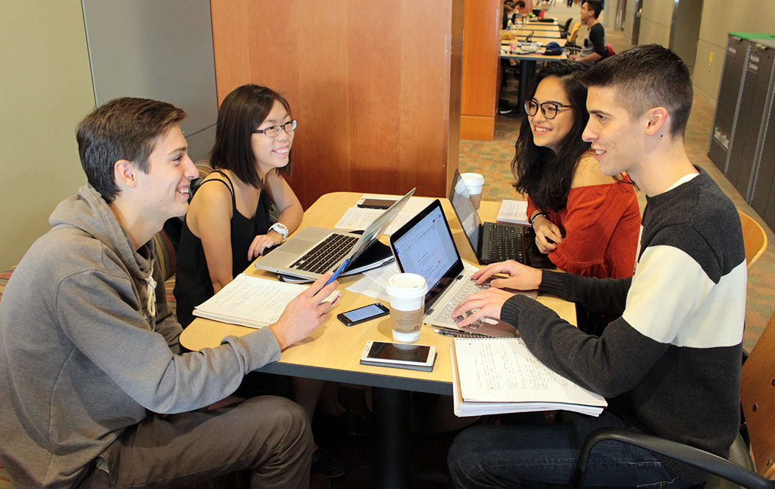

This class will often function as a peer workshop/peer review throughout the course. I will present skills and activities like a traditional class but I will mostly function as team captain. A team captain is no good without the support of the team!!!

- Come to class prepared and on time.
- Be willing to participate.
- Expect to share your writing.
- Be respectful of the ideas of others at all times!
- It is fine to disagree with ideas but not to disrespect the person.
- No “Ad Homonym” arguments—no name calling!
- Linn-Benton provides a safe and inclusive learning environment for all students. (See Student Rights and Responsibilities on the LBCC)
- Use the Golden Rule: Treat others the way you want to be treated!
- This will be an interactive classroom environment.
- Active Learning not passive learning will occur here.
- Overly disruptive behavior will not be tolerated.

Campus Resources

CFAR (located on main campus) www.linnbenton.edu/cfar
This is an office devoted to assisting students who have a learning or other type of disability. They can offer a wide range of services from alternate study materials formatting to extra time on exams and extending due dates with instructors. In order to receive these services, one needs to make an appointment to discuss what is needed. (541) 917-4328 Red Cedar Hall Room 105 (Coming soon to the Lebanon Center!!!)

Writing Center (On Main Campus)

They have peer tutors available and writing resources as well as a safe space to work. Linn Benton also has an online writing lab/ OWL that is available to all students remotely. They can provide feedback on writing assignments prior to submission.

Academic Honesty AKA Plagiarism

Academic Integrity is expected of all Linn-Benton students. All work that is turned in by students should be the work of that student. In a writing class, sources are often incorporated into a student’s writing. All borrowed words AND ideas must give credit where credit is due. One of the major things that we learn in this course is how to paraphrase effectively and to the use of in-text citations to distinguish between what is the student’s writing and what is another author’s writing. Anything that is deliberately turned in that is someone else’s work that is not credited to that other person is called PLAGIARISM. In the academic world and the workplace, the act of willful plagiarism is a major offense as it is stealing the work of others. Plagiarism or any form cheating in college is punishable by failing the assignment and/or the course. Multiple offenses can lead to permanent expulsion from the college.

My Definition of Plagiarism:
The willful and repeated (not accidental and not incidental) use of another person’s work. This class is the training ground for how NOT to commit accidental plagiarism. I expect that there will be mistakes in learning how to format in MLA and APA correctly. That is not a problem. Anyone who tries to take a shortcut a submit a paper not their own will be subject to the consequences mentioned above. In the end, one is only cheating themselves by not learning to write effectively. Your work will be going through revisions with teacher and peer feedback so plagiarism will be will virtually… impossible!

Most Important:
I am here for you to help you be successful in college and in the later in the workplace by improving your writing skills and being ready for the new expectations of college level writing! Please so not hesitate to come see me in my office or make an appointment if the office hour time is not convenient. I can also be reached at email. I am happy to answer questions about anything in the course and provide feedback on drafts in progress!

This class is all about: Revise, Revise, Revise!!!

Stephen King says: “Write with the door closed but re-write with the door open!” (On Writing)

---We will be here for you and you need to be here for us!

