WR121: English Composition
Course Syllabus/Winter 2017
MW from 2:30-3:50pm, NSH 209
CRN: 30028 OR 32425 (ALP); Credit Hours: 3

You come late. When you arrive, others have long preceded you, and they are engaged in a heated discussion, a discussion too heated for them to pause and tell you exactly what it is about. . . . You listen for a while, until you decide that you have caught the tenor of the argument; then you put in your oar. Someone answers; you answer him; another comes to your defense; another aligns himself against you. . . . The hour grows late, you must depart. And you do depart, with the discussion still vigorously in progress. - Kenneth Burke

Amelia Kaspari, Instructor
kaspara@linnbenton.edu
Office: SSH203
Mailbox: NSH Faculty Workroom (next to the Star Wars office)
Office hours: Email me to set up an appointment between 10am and 1pm MW

Required Textbooks:
They Say, I Say, 3rd edition.
The Purdue Online Writing Lab, a free online resource. You will specifically be using the MLA Formatting and Style Guide, found at https://owl.english.purdue.edu/owl/resource/747/01/

Course Description: Emphasizes clear, detailed writing that employs critical reading and thinking and basic research skills.

Prerequisites: Placement into WR121, WR115 with a grade of C or better, or registration in ALP.
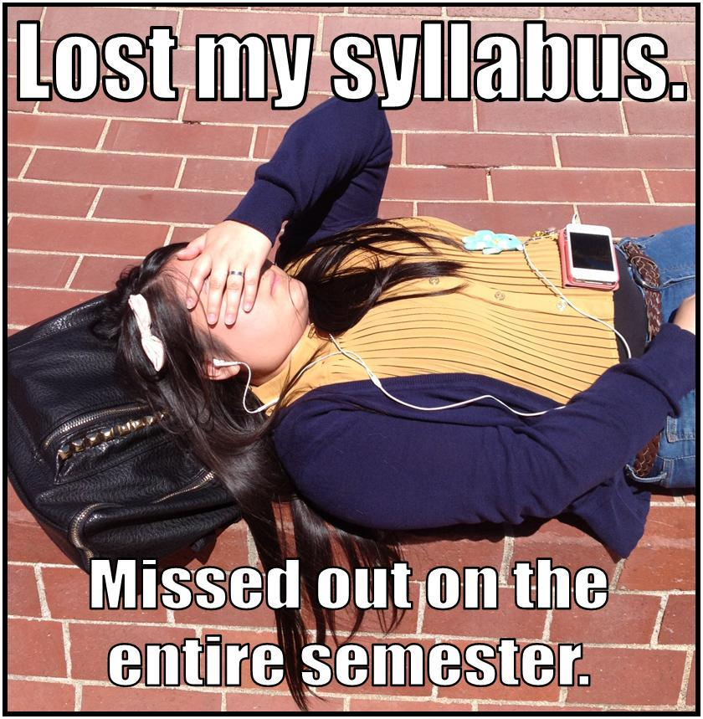
Course Components and Point Values
Email Assignment: 50pts
Career Narrative: 100pts
“What the Critics are Saying” Paper: 100pts
Annotation and Anchor Article: 50pts
“Entering the Conversation” Paper: 150pts
Cover Letter: 50pts
Reading Quizzes: 25pts x 6 = 150pts
Revision Workshops: 25pts x 4 = 100pts
Engagement/Participation: 50pts
Final Exam: 30% of Total Grade

Total: 800, not including Final Exam

Grading Scale: A: 100%-90%, B: 89%-80%, C: 79%-70%, D: 69%-60%, F: 59%-0%.

Course Policies

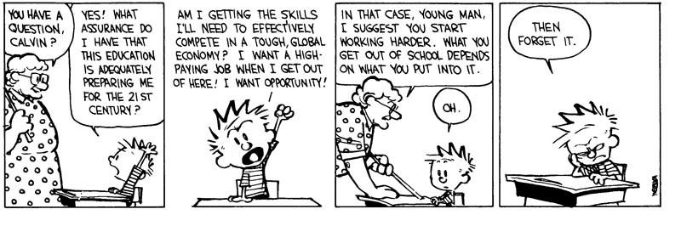Formatting of Assignments: ALL final drafts must be typed and printed (no email submissions please), in Times New Roman, size 12 font, double-spaced, with 1” margins. Final drafts should be printed on standard computer paper (no cardstock or colored paper) and stapled. Failure to turn in correctly formatted assignments may result in loss of points.

Attendance: Attendance is crucial for success in this class. If you are going to be absent for any reason (dire illness, family emergency, etc.), e-mail me before class time to let me know; however, YOU are responsible for figuring out what you missed, by checking the syllabus and getting notes from a classmate.

Late Assignments: Work turned in late will automatically lose 15% of possible points. If work is turned in late because of circumstances beyond your control, please talk to me or send me an e-mail. To be considered on time, assignments must be turned in during class on the day they are due, so if you are going to be absent from class, send work with a classmate. No email submissions, please.

Plagiarism: Plagiarism includes:
- Using another person’s words or ideas (even if you have paraphrased), without properly citing your source.
- Using direct quotes without quotation marks.
- Allowing anyone else to write or type an assignment for you.
- Writing or typing an assignment for someone else.
- Paying another person to complete an assignment for you.

If plagiarism is detected, you will be held accountable: First occurrence: You will receive a warning and be asked to redo the plagiarized assignment. Second occurrence: F grade in this course; report sent to the college.

Extra Credit: The only way to gain extra credit in this class (outside of E.C. on reading quizzes) is to visit the Writing Center. For each Writing Center visit, I will add 5 points to the assignment of your choice. Just be sure to turn in proof that you visited the Writing Center, along with a note indicating where you would like the 5 points added. The Writing Center is located on the second floor of Willamette Hall (entrance off of courtyard side). You may want to make an appointment ahead of time, as the WC can be extremely busy, especially later in the term. The WC encourages you to bring an assignment at any stage (brainstorming, drafting, final revisions, etc.), but be sure to come with specific questions and specific areas you need help with. (And yes, I just ended a sentence with a preposition.)

Course Outcomes

By the end of this course, students will be able to:
- Analyze the rhetorical needs (the interaction of audiences, purpose/outcome, and subject) of a variety of academic and practical writing assignments.
- Apply appropriate levels of critical thinking strategies (knowledge, comprehension, application, analysis, synthesis, evaluation) in response to the rhetorical needs of an assignment.
- Implement appropriate rhetorical elements and organization (introduction, thesis, development and support, rebuttal, visuals, narration, conclusion, etc.) in response to the rhetorical needs of an assignment.
- Locate, evaluate, and integrate high-quality information and opinion in response to the rhetorical needs of an assignment.
- Craft sentences and paragraphs that communicate their ideas clearly and effectively using words, sentence patterns, and writing conventions to make their writing clear, credible, and persuasive.

WR121 Course Schedule
(Subject to Change)
Italicized readings are to be completed before class on the day they are listed.
Bolded items are due in class on the day they are listed.

Week 1
M: 1/9: Syllabus; Introductions; Emails

W: 1/11: Email DUE by class time; Career Narrative Assignment Guidelines. Read Examples together in class. Fragments.

Week 2
M: 1/16: NO CLASS: Martin Luther King Day

W: 1/18: Narrative Strategies: Moving Down the Abstraction Ladder, Dialogue, and Slowing Down the Action.

Week 3
M: 1/23: Rough Draft DUE for Revision Workshop. Volunteers to Read.

W: 1/25: Final Draft DUE; “What the Critics are Saying” Assignment Guidelines. What makes a good movie? Read Example Paper. Finding Critical Reviews.

Week 4
M: 1/30: Read TSIS, Introduction and Chapter 1, pp. 1-29. Reading Quiz 1. Reference Pages, MLA Style.

W: 2/1: Read TSIS, Chapters 2-3. Reading Quiz 2. Bring 1-2 Reviews to Class (printed or on your laptop). Practice integrating quotes.

Week 5
M: 2/6: Rough Draft DUE for Revision Workshop.

W: 2/8: Final Draft DUE; Read TSIS, Chapters 4-5, pp. 55-77. Reading Quiz 3. “Entering the Conversation” Paper Assignment Guidelines. Browse news sources.

Week 6
M: 2/13: Annotation Assignment Guidelines and Example. Practice evaluating source in class.

W: 2/15: Annotation DUE. Using the Library Database to find Relevant, Reliable, and Current Sources.

Week 7
M: 2/20: NO CLASS - President's Day

W: 2/22: Freewriting: Generating your own idea on a topic. Workshop Thesis Statements.

Week 8
M: 2/27: Read TSIS, Chapters 6-7. Reading Quiz 4. Speed Dating.

W: 3/1: Rough Draft DUE for Review Workshop. A closer look at the introduction.

Week 9
M: 3/6: Read TSIS, Chapters 8, 10. Reading Quiz 5. Bring Rough Draft. Practice with Metacommentary.

W: 3/8: FINAL DRAFT DUE. Last Chance Editing. Cover Letter Assignment Guidelines - Group Activity.

Week 10
M: 3/13: Rough Draft of Cover Letter DUE for Revision Workshop; Discuss Final Exam.

W: 3/15: Cover Letter DUE; Discuss Final Exam.

Week 11
Final Exam: Monday, March 20th, from 12-12:50pm and Tuesday, March 21st, from 11:30-12:20pm

Email Assignment: 50pts
Write (and actually send!) an email to your professor (me) in which you briefly introduce yourself.
To prepare, write down the answers to the following questions as we discuss them in class:
- What are some different purposes/functions of emails?

- What do I need to consider about my audience when writing an email?

- When can an email be informal, and when should it be formal/professional? (What makes an email informal, and what makes it formal?)

- When do I need to include a subject header? What about a salutation (greeting)?

- What formatting should I use?

- In what ways is email similar to texting? In what ways is it dissimilar?

- Do I always need to respond to an email?

- How quickly should I respond to emails?

- What might be my reason to write an email to my writing professor at the beginning of the term (besides the fact that it’s required)?

- What information should I include to fulfill this purpose?

Career Narrative and Reflection: 100pts
“Why tell us she’s angry, when you can show her tapping her foot? We see her face, we see her foot, and we know.”
-Mike Skinner, qtd. In John Yorke

Write a 700-800 word paper in which you tell a story from your past that heavily influenced your vocation*.
*vocation: a strong feeling of suitability for a particular career or occupation
Requirements:
- Narrative portion: 80-90% of paper length
- Vivid, descriptive details (be specific!)
- Dialogue where appropriate
- Action Verbs
- Relevant to the vocation you will be discussing later in your paper
- Skillful transition: 2 sentences to a paragraph
- Show the reader the connection between your narrative and your chosen vocation. You might use a transitional sentence like: “My childhood experience with _________ led me to the decision to pursue ___________.”
- Reflection: 10-20% of paper length
- Briefly reflect on where you are now on the path to your chosen vocation. What are you learning, or how are you preparing, to enter this vocation?
- Conclusion: 1 paragraph
- Provide a satisfying final paragraph in which you refer back to the narrative you told at the beginning of the paper.
You will be graded on: adherence to the above criteria, and lack of sentence fragments. For each sentence fragment, you will lose 2 points.

“What the Critics are Saying” Assignment: 100pts
Choose a film you have seen recently. This film does not have to be a recently released film; however, one of your goals in this paper is to help your audience decide whether or not to see this film, so a recent film (or even a film still in theaters) is ideal. Your task is to write a 650-750 word informative paper in which you answer the question, “What are the critics saying about this film?” Your hypothetical audience wants to know if this particular film is any good, according to professional film critics, not according to you personally, unfortunately. Thus, for this paper, you must read at least TWO critical reviews of your film (check IMDB for critical reviews), and include quotes and paraphrases from these sources to illustrate and sum up what critics view as the film’s strengths and weaknesses.
Specific Requirements:
- The premise of the film, given in a 1-2 sentence summary that does not give away spoilers
- The film’s genre
- A focusing statement at the end of the introduction that provides direction and clarity for the rest of the paper (“While critics agree that ________ contains a few minor flaws in regards to _________, on the whole they praise it as a ___________ film, well worth seeing.”)
- Paraphrases and direct quotes from at least TWO different film critics which illustrate and sum up what the critics believe the film does well, and what it does poorly
- Careful framing of each of your quotes in a “quotation sandwich”
- A reference page in correct MLA format which includes an entry for your film as well as entries for the two reviews you read (3 entries total)
You will be graded on: Adherence to the above guidelines and lack of typos, misspellings, mistakes in capitalization, and fragments. For each of the above mistakes, you will lose 2 points.

Annotation Assignment: 50pts

Choose a feature-length article from a credible news source that is not too popular and not too scholarly, read the article carefully, and write an annotated bibliography for the article.

Step 1: Choose an article that:
- Interests you, on a subject about which you are willing to write a 4-5 page research paper later in the term.
- Appears in a credible (but not TOO scholarly) news source, such as the following:
  - The Atlantic
  - TIME
  - The New Yorker
  - The New York Times
  - Huffington Post
  - Newsweek
- Is a full-length article (at least 3 pages), often called a “feature article.”
- Is fairly recent (published no earlier than 2015).

Note: You are NOT “thinking of a topic” and then searching for articles on that topic. You’re BROWSING the above news sources and seeing what feature articles have been published recently until you come across one that interests you.

Step 2: Read the article carefully.
- Make sure you fully comprehend what you’re reading.
- Look up unknown vocab.
- Read twice if necessary.

Step 3: Write a bibliographic entry in MLA format
- Title your assignment “Annotated Bibliography.”
- Use Purdue OWL to find how to cite your source (you’ll probably use the guidelines for “Article in a Magazine,” “Article in a Newspaper,” or “Article in a Web Magazine.”)
- Write out a full citation for your source, in MLA format (hanging indent, double-spaced, etc.).

Step 4: Write an annotation (a good-sized paragraph) which does the following:
- Explains what kind of source this is and where it’s from
- Summarizes the article’s main point and most relevant supporting points
- Describes the quality of information provided
  - Authority and credentials of the author(s) – degree in the field? Experience?
  - Reliability of information - what kind of evidence do they use? Is it objective evidence? Subjective? Based on data? Anecdotes? Personal experience?
  - Potential biases - on the part of the author or organization
- Explains how this article might help you in writing your “Entering the Conversation” Paper.
“Entering the Conversation” Assignment Guidelines

Once you have chosen your topic (based on your anchor article), your task is to write a 1200-1500 word researched paper (in which you cite 3-5 credible, relevant, current sources) in MLA format. This does not have to be a strictly argumentative paper, in which you take a stance on the issue, but neither is it a report in which you merely summarize all of the information you found. Instead, use the method explained in They Say, I Say: find, read, and consider what is being said about your topic, and then enter the conversation and say something back. This paper should demonstrate a good balance between other people’s ideas (they say), and your own ideas (I say).

Specific Requirements:
- Introduction that explains the question or problem you are investigating, offers at least one specific example or anecdote, and provides a focusing thesis statement
- Effective organization of your main ideas, and transitions between main points, paragraphs, and sentences
- Quotes and paraphrases from 3-5 reliable, current, and relevant sources throughout, given proper attribution, either formally or informally (be sure to frame your quotes effectively!)
- Effective use of specific examples and details to illustrate or support your points
- Works Cited page in MLA format, which includes every source cited in your paper

Holistic Grading Questions:
- Focus - does your paper maintain a consistent focus from beginning to end, without going off on tangents or detours?
- They Say - do you integrate quotes and paraphrases from your sources to establish what is being said about your topic?
- I Say - do you focus your paper around your own idea about the topic and demonstrate that you have thought critically about what “they say?”
- Conventions of academic writing – do you avoid distracting mistakes in spelling, punctuation, and grammar?
Cover Letter Assignment Guidelines:

Write a cover letter to your professor (me), explaining what grade you think you deserve in this course and why.

