Homework 2
Please type or (legibly) write your answers on separate page

Basic Voltmeter Use
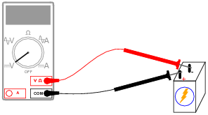
- What will this voltmeter register when connected to a battery as shown (assume a battery voltage of 6 volts)? Explain your answer.

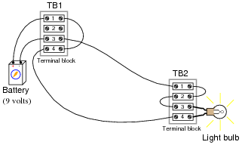
- Determine how much voltage a voltmeter would indicate when connected between the following points in this circuit (you may want to create a schematic of this diagram to help).
TB1-1 to TB1-3: ________
TB1-4 to TB2-4: ________
TB2-3 to TB2-1: ________
TB1-1 to TB2-1: ________

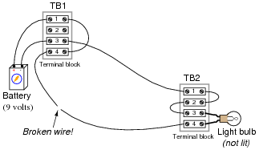
- Determine how much voltage a voltmeter would indicate when connected between the following points in this faulted circuit (you may want to create a schematic of this diagram to help).
TB1-1 and TB1-3: ______
TB1-4 and TB2-4: ______
TB2-3 and TB2-1: ______
TB1-1 and TB2-1: ______

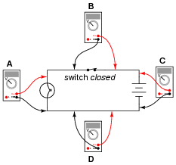
- Determine what these four voltmeters (A, B, C, D) will register when connected to this circuit in the following positions (assume a battery voltage of 6 volts):
Voltmeter A: ______
Voltmeter B: ______
Voltmeter C: ______
Voltmeter D: ______

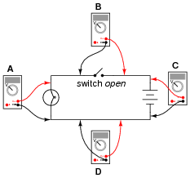
- Determine what these four voltmeters (A, B, C, D) will register when connected to this circuit in the following positions (assume a battery voltage of 6 volts).
Voltmeter A: ______
Voltmeter B: ______
Voltmeter C: ______
Voltmeter D: ______

Basic Ohmmeter Use
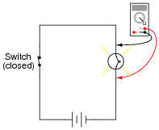
- What would be wrong about measuring the resistance of a light bulb while it is being powered by a battery (or any other electrical source)?

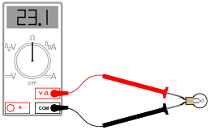
- Explain how an ohmmeter is able to measure the resistance of a component (in this case, a light bulb) when there is no battery or other source of power connected to it. Also, what reading would you get if the bulb were burnt out (failed open)?

Series Circuits
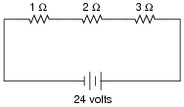
- In this circuit, three resistors receive the same amount of current (4 amps) from a single source. Calculate the amount of voltage “dropped” by each resistor, as well as the amount of power dissipated by each resistor.

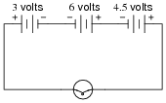
- How much voltage does the light bulb receive in this circuit? Explain your answer.

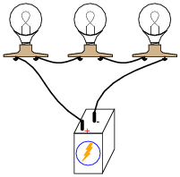
- Re-draw this circuit in the form of a schematic diagram:

- What would happen if three 6-volt light bulbs were connected as shown to a 6-volt battery? How would their brightnesses compare to just having a single 6-volt light bulb connected to a 6-volt battery?
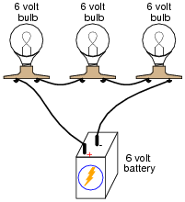

Parallel Circuits
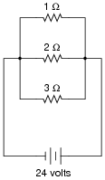
- In this circuit, three resistors receive the same amount of voltage (24 volts) from a single source. Calculate the amount of current “drawn” by each resistor, as well as the amount of power dissipated by each resistor.

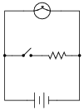
- What will happen to the brightness of the light bulb if the switch in this circuit is suddenly closed?

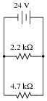
- According to Ohm’s Law, how much current goes through each of the two resistors in this circuit?

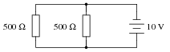
- Calculate the total amount of current that the battery must supply to this parallel circuit. Also, calculate the total resistance in this circuit.

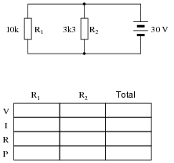
- Complete the table of values for this circuit

Wire Types and Sizes
- Most electrical wire is covered in a rubber or plastic coating called insulation. What is the purpose of having this “insulation” covering the metal wire?

- Electrical wire is often rated according to its cross-sectional diameter by a gauge scale. Which is the larger-diameter wire size, 14 gauge or 8 gauge?

- If an electric drill is plugged into a very long extension cord instead of being plugged directly into a power receptacle, what will happen to the drill’s performance? Explain your answer, with reference to Ohm’s Law.

This worksheet and all related files are licensed under the Creative Commons Attribution License,
version 1.0. To view a copy of this license, visit http://creativecommons.org/licenses/by/1.0/, or send a
letter to Creative Commons, 559 Nathan Abbott Way, Stanford, California 94305, USA. The terms and
conditions of this license allow for free copying, distribution, and/or modification of all licensed works by
the general public. Source: allaboutcircuilts.com

