Homework 3
Please type or (legibly) write your answers on separate page

Resistors
- Shown here is the schematic symbol for a resistor: . What is the purpose of a resistor? What function does it perform? Also, draw an illustration of what a real resistor looks like.
Answer: The purpose of a resistor is to provide a precise amount of electrical resistance in a circuit.

- Many resistors have their electrical resistance shown by a set of color codes, or “bands,” imprinted around their circumference. A standard color code associates each color with a specific decimal digit (0 through 9). Associate each of the following digits with its respective color:
0: _____________
1: _____________
2: _____________
3: _____________
4: _____________
5: _____________
6: _____________
7: _____________
8: _____________
9: _____________
Answer:
0 = Black
1 = Brown
2 = Red
3 = Orange
4 = Yellow
5 = Green
6 = Blue
7 = Violet
8 = Grey
9 = White

- What does the last color band represent on a color-coded resistor?
Answer: On some resistors, the last band represents the tolerance (also known as precision) for that resistor, expressed as a percentage. On other resistors, the last band represents a reliability rating for that resistor.

- Determine the nominal resistance values of these resistors, given their band colors, and also express the allowable tolerance in ohms. For example, a 25 kΩ resistor with a 10% tolerance rating would have an allowable tolerance of +/- 2.5 kΩ. Next, determine if the measured resistance is within tolerance or not.

  - (Org, Org, Red, Blk, Blu) Measured resistance = 332.5 Ω
  - (Brn, Blk, Blk, Gld, Red) Measured resistance = 9.7 Ω
  - (Blu, Vio, Brn, Red, Grn) Measured resistance = 67.43 kΩ
  - (Red, Wht, Grn, Yel, Vio) Measured resistance = 2.949 MΩ
  - (Yel, Vio, Org, Gld) Measured resistance = 44.68 kΩ
  - (Gry, Red, Brn, Sil) Measured resistance = 905 Ω
  - (Grn, Blu, Gld) Measured resistance = 6.73 Ω
  - (Vio, Brn, Red, Gld, Brn) Measured resistance = 70.82 Ω
  - (Wht, Org, Blu, Brn, Grn) Measured resistance = 9.38 kΩ
  - (Red, Blk, Wht, Grn, Vio) Measured resistance = 20.86 MΩ
Answer:
a. (Org, Org, Red, Blk, Blu) Measured resistance = 332.5 Ω Within tolerance
b. (Brn, Blk, Blk, Gld, Red) Measured resistance = 9.7 Ω Out of tolerance!
c. (Blu, Vio, Brn, Red, Grn) Measured resistance = 67.43 kΩ Within tolerance
d. (Red, Wht, Grn, Yel, Vio) Measured resistance = 2.949 MΩ Within tolerance
e. (Yel, Vio, Org, Gld) Measured resistance = 44.68 kΩ Within tolerance
f. (Gry, Red, Brn, Sil) Measured resistance = 905 Ω Out of tolerance!
g. (Grn, Blu, Gld) Measured resistance = 6.73 Ω Out of tolerance!
h. (Vio, Brn, Red, Gld, Brn) Measured resistance = 70.82 Ω Within tolerance
i. (Wht, Org, Blu, Brn, Grn) Measured resistance = 9.38 kΩ Within tolerance
j. (Red, Blk, Wht, Grn, Vio) Measured resistance = 20.86 MΩ Out of tolerance!

Series/Parallel Circuits
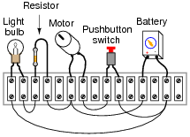
- From observation of this circuit (with components attached to a “terminal strip”), draw an appropriate schematic diagram. Once you’ve drawn the schematic, describe what happens when the button is pressed and what function the resistor has.

Answer:
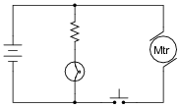

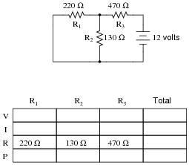
- Complete the table of values for this circuit:
Answer:
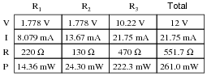

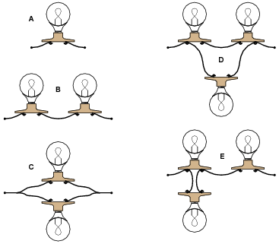
- Rank these five light bulb assemblies according to their total electrical resistance (in order of least to greatest), assuming that each of the bulbs is the same type and rating.
Answer:
• C (least total resistance)
• D
• A
• E
• B (greatest total resistance)

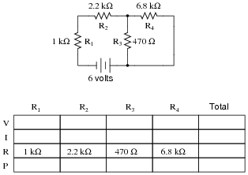
- Complete the table of values for this circuit:
Answer:
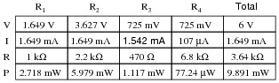

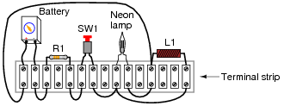
- Identify which of these components are connected directly in series with each other, and which are connected directly in parallel with each other.
Answer:
Connected directly in series: Battery, R1, and SW1. Connected directly in parallel: Neon lamp and L1.

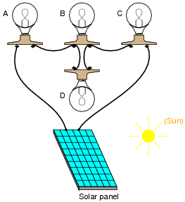
- Determine which light bulb(s) will glow brightly, and which light bulb(s) will glow dimly (assuming all light bulbs are identical).
Answer:
Bulbs “A” and “C” will glow brightly, while bulbs “B” and “D” will glow dimly.

Follow-up question: explain why bulbs “A” and “C” will become dimmer (less bright) if the filament in bulb “D” fails open.

Basic Troubleshooting
- As a technician, you are sent to troubleshoot a complex piece of electronic equipment that has stopped working. Upon opening the cabinet door for this equipment, your nose is greeted by the pungent odor of burnt circuit board (a smell you are unlikely to forget, once having experienced it). What does this simple fact indicate (or possibly indicate) about the nature of the equipment’s fault?
Answer: he fact that you can smell trouble indicates you are most likely dealing with a catastrophic failure caused by (or resulting in) excessive current. When components have been heated to such a degree that they emit strong odors, the damage is often visible as well, which makes it easier to locate problem areas. Follow-up question: upon further investigation, you locate the charred remains of an electronic component, located on one of the system’s circuit boards. Is this the only fault, being that it is the only component visibly damaged? Explain why or why not.

- Two computer technicians are called to troubleshoot malfunctioning computer systems. Although the symptoms in each system are very similar, the histories of the two systems are not. The first computer is a unit that has been in operation for over two years, while the second system is a brand-new prototype, still in the developmental stages. Without knowing any more details on these two computer systems, what recommendations can you give to the two technicians about to troubleshoot them? If you were asked to troubleshoot each system, how would you approach the two systems differently? What ranges of problems might you expect from each system?

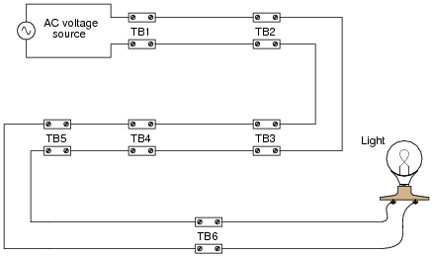
- An electrician is troubleshooting a faulty light circuit, where the power source and light bulb are far removed from one another. There are several terminal blocks (“TB”) through which electrical power is routed to the light bulb. These terminal blocks provide convenient connection points to join wires together, enabling sections of wire to be removed and replaced if necessary, without removing and replacing all the wiring. The terminal blocks are located too far apart to allow for voltage checks between blocks (say, between one connection in TB2 and another connection in TB3). The voltmeter’s test leads are only long enough to check for voltage between pairs of connections at each terminal block. How would you test this system in order to find the fault?
Answer: the electrician’s sequence was the most efficient depends on two factors not given in the problem: The distance between terminal blocks, The time required to gain access for a voltage check, upon reaching the terminal block location.

One of the most common troubleshooting techniques taught to technicians is the so-called “divide and conquer” method, whereby the system or signal path is divided into halves with each measurement, until the location of the fault is pinpointed. However, there are some situations where it might actually save time to perform measurements in a linear progression (from one end to the other, until the power or signal is lost). Efficient troubleshooters never limit themselves to a rigid methodology if other methods are more efficient.

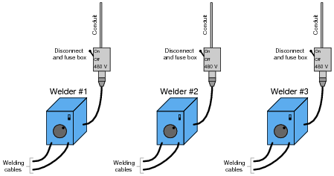
- At a construction site, several electric “arc” welders are plugged into 480 volt receptacles. Each receptacle has its own safety disconnect switch and fuse overcurrent protection. You, as an technician working at the job site, happen to be walking past these welders when one of the welding personnel stops you to ask for help with Welder #1. You didn’t bring your multimeter or any other test equipment, so you can’t check for voltage at the receptacle. As you look around the job site, you notice that no one is using Welder #2. When you flip its power switch on, Welder #2 turns on just like it should. Deciding to apply your “Swap interchangeable components” troubleshooting strategy, you turn off both welders’ power switches, then turn off the disconnect switches at both receptacles and swap the power cables between receptacles. When you turn the disconnect switches on and try to start both welders, you find that neither one turns on now! Switching the power cables back to their original receptacles doesn’t make things better, either. Both Welders #1 and #2 are still “dead,” which is a worse situation than what you first encountered. This is not good, because the person who called you for help is beginning to cast angry looks in your direction, and you are fairly sure the operator of Welder #2 won’t be much happier when he returns to find his welder non-functional as well. Identify the most likely location of the fault in this system, and explain why the “Swap interchangeable components” strategy got you into trouble.
Answer: The likely location of the fault is in Welder #1. I’ll let you determine what the nature of this fault most likely is, and why the strategy employed in this scenario probably wasn’t the wisest.

- One day a bicyclist called a mechanic friend of his over the telephone, and describes a problem with his bicycle. The bicycle is making a rhythmic “clicking” sound as it is pedaled, but the bicyclist is not very mechanically inclined, and cannot determine the cause of the noise. The mechanic considered some of the options. Being a rhythmic noise, it was probably being caused by one of the bicycle’s rotating objects. This includes the wheels, crank, and chain, which all rotate at different speeds. After a bit of thought, the mechanic asked his bicyclist friend a question. “Does the pace of the clicking increase as you ride faster?” The bicyclist answered, “Yes, it does.” “If you shift into a higher gear so that your crank is turning slower for the same road speed, does the pace of the clicking change?” asked the mechanic. The bicyclist admitted he didn’t know the answer to this question, as he hadn’t thought to pay attention to this detail. After riding the bike once again to test the mechanic’s idea, the bicyclist reported back. “No, the pace of the clicking does not change when I shift gears. It only changes with changes in road speed.” Upon hearing this, the mechanic knew the general location of the problem, and continued his troubleshooting over the telephone with further questions for the bicyclist. Where is the clicking sound coming from on this bicycle, based on the information presented here? How do you (and the mechanic) know?
Answer: The clicking noise has something to do with one of the wheels, and not the chain or crank.

- One day a car owner approached a mechanic friend of theirs with a problem. The battery in this car seemed to be dying, requiring frequent jump-starts from other vehicles, or the application of a battery charger overnight, to be able to start reliably. “What could be the problem?” asked the car owner to the mechanic. The mechanic considered some of the options. One possibility was that a parasitic load was draining the battery of its charge when the car was shut off. Another possibility was that the car’s charging system (the engine-driven generator and its associated circuitry) was faulty and not charging the battery when the engine was running. A third possibility was that the battery itself was defective, and unable to hold a charge. “Let’s check the battery voltage with the engine stopped, and with the engine running,” said the mechanic. The two walked over to the car and opened the hood, then the mechanic connected a voltmeter to the battery’s terminals. It read 11.3 volts DC. This was a 12-volt (nominal) battery. “Start the car,” said the mechanic, still watching the voltmeter. As the electric starting motor labored to turn the engine, the voltmeter’s reading sagged to 9 volts. Once the engine started and the electric starter disengaged, the voltmeter rebounded to 11.2 volts. “That’s the problem!” shouted the mechanic. With that, the owner stopped the car’s engine. Explain which of the three hypotheses was confirmed by the voltmeter’s reading, and how the mechanic was able to know this.

- Troubleshooting a system of any kind requires scientific thinking: sound deductive reasoning from effect to cause, and cause to effect. One of the principles frequently applied in science is Ockham’s Razor, named after Sir William of Ockham (1284-1350). In Ockham’s own words, the principle is as follows, ”A plurality is not to be posited without necessity.” Applied to troubleshooting electric circuits, one could re-phrase Ockham’s Razor as such, ”Look for single faults before considering multiple, simultaneous faults.” Justify the use of Ockham’s Razor in troubleshooting circuits. Why should we first consider single faults to account for the problems the circuit is having rather than considering interesting combinations of faults which would account for the same problems?
Answer: Because it is simply more likely that one thing has failed, than that multiple (unrelated) things have failed in just the right way to cause the problem to occur.

Basic Circuit Troubleshooting
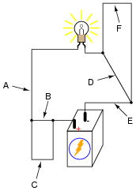
- Determine if the light bulb will de-energize for each of the following breaks in the circuit. Consider just one break at a time, and label if the circuit with deenergize or have no effect.
  - ___________
  - ___________
  - ___________
  - ___________
  - ___________
  - ___________
Answer:
- • A: de-energize
- • B: no effect
- • C: no effect
- • D: no effect
- • E: de-energize
- • F: no effect
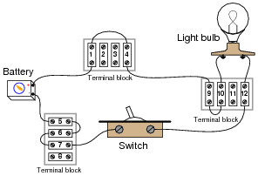
- Examine the following illustration of a simple battery-switch-lamp circuit, connected together using screw-terminal blocks, each connection point on each terminal block identified by a unique number. Determine whether or not voltage should be present between the following pairs of terminal block points with the switch in the ON and OFF position.
Points | Switch ON | Switch OFF
1 and 5
6 and 7
4 and 10
9 and 12
6 and 12
9 and 10
4 and 7

Answer:
Points | Switch ON | Switch OFF
1 and 5 | Yes | Yes
6 and 7 | No | No
4 and 10 | No | No
9 and 12 | Yes | No
6 and 12 | No | Yes
9 and 10 | No | No
4 and 7 | Yes | Yes

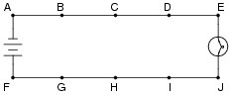
- In this circuit, where would you expect to measure full battery voltage (between what pairs of test points)?
Answer: You should expect to measure full battery voltage with one test lead of your voltmeter touching any of the points along the top wire of the circuit (points A through E), and with the other test lead touching any of the points along the bottom wire of the circuit (points F through J).

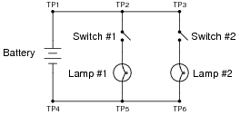
- The following circuit has a problem. Switch #1 is able to control lamp #1, but lamp #2 never comes on no matter what is done with switch #2. Identify which of these hypothetical faults could account for this problem, and which could not account for the problem. In other words, which of these faults are possible, and which are not possible, given the symptoms exhibited by the circuit? Consider each of these hypothetical faults one at a time (no multiple, simultaneous faults).
  - • Battery is dead
  - • Switch #2 failed open
  - • Switch #2 failed shorted
  - • Switch #1 failed open
  - • Switch #1 failed shorted
  - • Open wire between test points 1 and 2 (between TP1 and TP2)
  - • Open wire between test points 5 and 6 (between TP5 and TP6)
Answer:
- • Battery is dead: Not possible
- • Switch #2 failed open: Possible
- • Switch #2 failed shorted: Not possible
- • Switch #1 failed open: Not possible
- • Switch #1 failed shorted: Not possible
- • Open wire between test points 1 and 2 (between TP1 and TP2): Not possible
- • Open wire between test points 5 and 6 (between TP5 and TP6): Possible

This worksheet and all related files are licensed under the Creative Commons Attribution License,
version 1.0. To view a copy of this license, visit http://creativecommons.org/licenses/by/1.0/, or send a
letter to Creative Commons, 559 Nathan Abbott Way, Stanford, California 94305, USA. The terms and
conditions of this license allow for free copying, distribution, and/or modification of all licensed works by
the general public. Source: allaboutcircuilts.com

