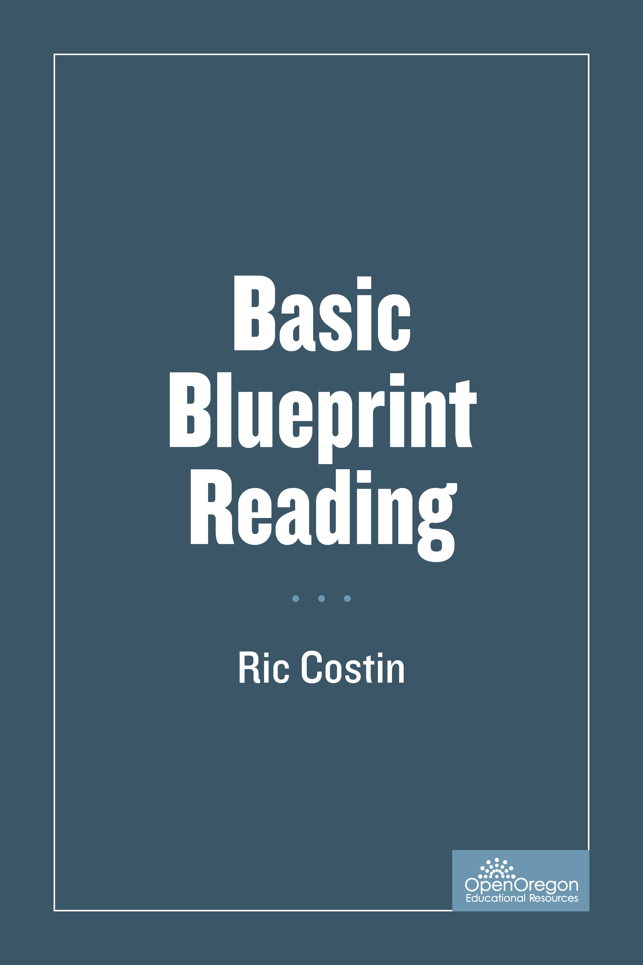

Basic Blueprint Reading

Basic Blueprint Reading

Ric Costin

Open Oregon

Albany Oregon

Basic Blueprint Reading by Linn-Benton Community College is licensed under a Creative Commons Attribution 4.0 International License, except where otherwise noted.

Contents
- Introduction
- Cover
- The Language of Lines
- Visualization
- Technical Sketching
- Scaling
- Dimensioning
- Auxiliary Views
- Sectional Views
- Machined Features
- Print Interpretation
- Appendix

Welcome to the Linn-Benton Welding Department’s First edition to blueprint reading.
Being able to read and understand, as well as sketch, or even draw a blueprint, is important to the making of accurate parts and complete fabrications.
Blueprints are tools that communicate what needs to be built or made, what materials are needed and what specifications are required. They insure that a design is made with complete accuracy what meets the needs of the customer.
This book is an updated version of the originally authored publication by the Department of Engineering and Drafting Technology Department at Linn-Benton Community College, in Albany Oregon.

Chapter 1

Cover
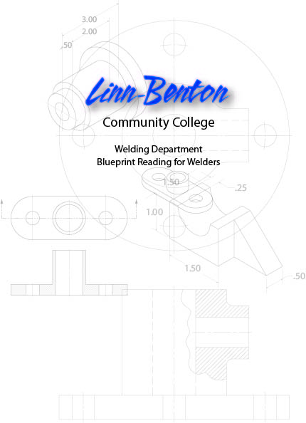

Chapter 2

The Language of Lines

- OBJECTLINE
- HIDDEN LINE
- SECTION LINE
- CENTER LINE
- DIMENSION LINE
- EXTENSION LINE
- LEADER LINE
- CUTTING PLANE LINE
- BREAK LINES
- PHANTOM LINES
- BORDER LINE
You have heard the saying, “A picture is worth a thousand words”. This statement is particularly true in regards to technical drawings.
It would be almost impossible for an engineer, designer, or architect to describe in words the shape, size, and relationship of a complex object. Therefore, drawings have become the universal language used by engineers, designers, technicians, as well as craftsmen, to communicate the Information necessary to build, assemble and service the products of industry.
It is Important to remember, as you study Print Reading, that you are learning to communicate with the graphic language used by Industry: Lines are part of that language.
Since technical drawings are made of lines, it is logical that the first step in learning to “read” a drawing is to learn the meaning of each kind of line. Generally, there are 11 basic types of lines. Each kind of line has a definite form and “weight”. Weight refers to line thickness or width. When combined in a drawing, lines provide part of the Information needed to understand the print.
Being able to interpret a blueprint and accurately build objects is a needed skill to become successful in all trade crafts. It is a skill, like many others you will learn, and it will take time and practice to fully understand and become proficient.

Object Line

A visible line, or object line is a thick continuous line, used to outline the visible edges or contours of an object.
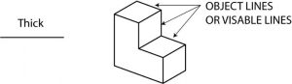

Hidden Line
A hidden line, also known as a hidden object line is a medium weight line, made of short dashes about 1/8” long with 1/16”gaps, to show edges, surfaces and corners which cannot be seen. Sometimes they are used to make a drawing easier to understand. Often they are omitted in an isometric view.
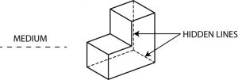

Section Line
Section lines are used to show the cut surfaces of an object in section views. They are fine, dark lines. Various types of section lines may indicate the type of material cut by the cutting plane line.
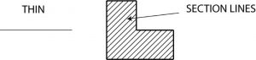

Center Line
Center lines are used to indicate the centers of holes, arcs, and symmetrical objects. They are very thin (size), long-short-long kinds of lines.
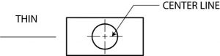

Dimension Line
Dimension lines are thin and are used to show the actual size of an object. There are arrowheads at both end that terminate at the extension lines.

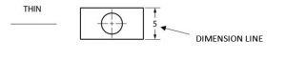

Extension Line
Extension lines are also thin lines, showing the limits of dimensions. Dimension line arrowheads touch extension lines.
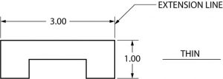
Leader Line
Leaders are more thin lines used to point to an area of a drawing requiring a note for explanation. They are preferably drawn at a 45° angles.
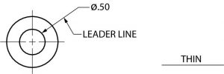

Cutting Plane Line
A cutting plane line (very heavy) helps to show the internal shape at a part or assembly by slicing through the object.
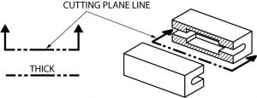
Break Line
There are three kinds of break lines used in drawings. They are used to remove, or ‘break out” part of a drawing for clarity, and also to shorten objects which have the same shape throughout their length and may be too long to place on the drawing.
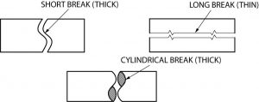
Short and long break lines are used for flat surfaces. Cylindrical are used on rods, dowels, etc.

Phantom Line
Phantom lines are long-short-short-long lines most often used to show the travel or movement of an object or a part in alternate positions. It can also be used to show adjacent objects or features.
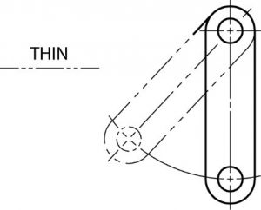
Border Line
Borderlines are very thick, continuous lines used to show the boundary of the drawing or to separate different objects drawn on one sheet. They are also used to separate the title block form the rest of the drawing.
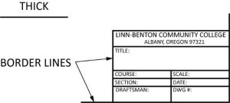
Quiz….
Directions: Name the types of lines shown below. Check your own answers
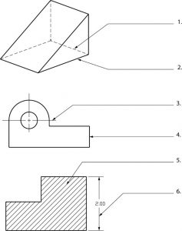

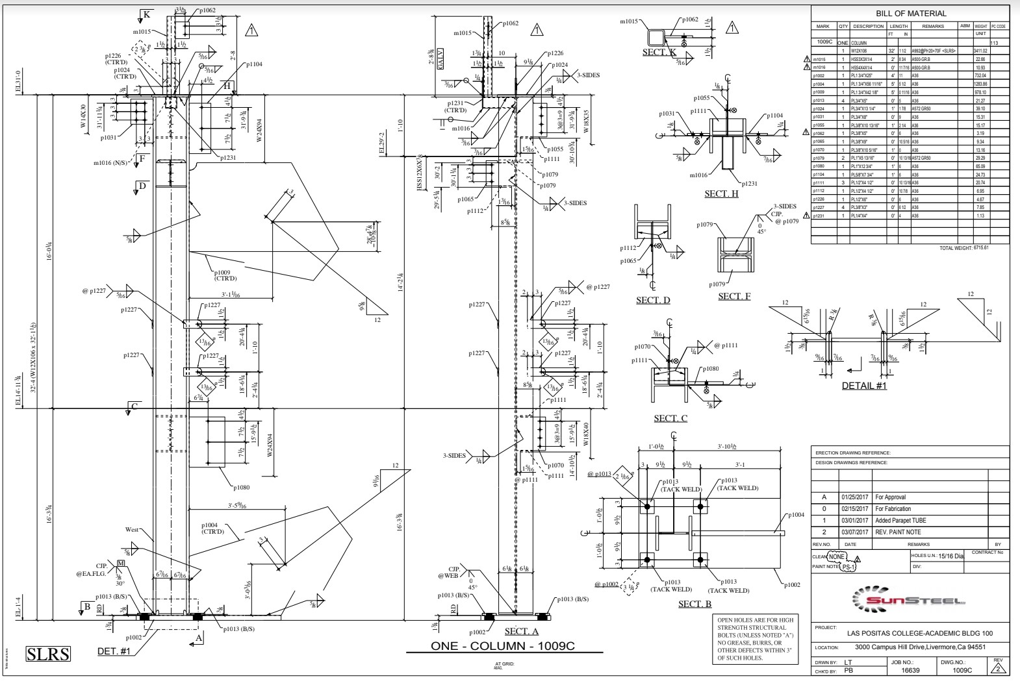
Identify the various line types used in this drawing. (instructor will provide a copy of this drawing)

Name the types of lines shown below. Check your own answers.
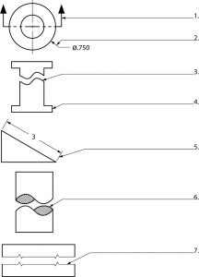

Directions: Draw and identify the lines needed to complete the figures as indicated.
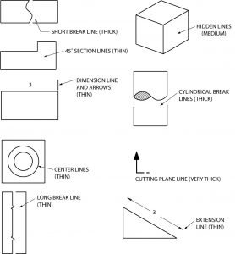

Chapter 3

Visualization

Visualization
- PERSPECTIVE
- OBLIQUE DRAWING
- ISOMETRIC DRAWING
- ONE-VIEW DRAWING
- TWO-VIEW DRAWING
- ORTHOGRAPHIC PROJECTION
- HIDDEN SURFACES
- CURVED SURFACES
- INCLINED SURFACES
Now that you have learned about the kinds of lines found on prints, the next step is to develop your visualization abilities. The ability to ”see” technical drawings; that is to ”think in three dimensions,” is the most important part of this course. Since most engineering and architectural prints utilize some form of orthographic projection (multi-view drawing), that type of drawing will be emphasized.
Before going into a study of orthographic projection, you should be able to recognize several other types of drawings. They are; 1. Perspective drawing, 2. Oblique drawing, and 3. Isometric drawing. As a group, they are called “pictorial drawings”. They are found on prints and are easy to visualize, so let’s look at their differences.

Perspective
Perspective is the most realistic form of drawing. Artists use one-point perspective, two-point (shown here), and three point to create visual depth. Perspectives are used by architects and for industrial pictorials of plan layouts, machinery, and other subjects where realism is required. Objects drawn in perspective grow smaller as they recede into the horizon.
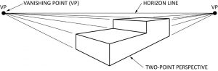

Oblique
Oblique drawings are drawn with one plane (front) of the object parallel to the drawing surface. The side, or other visible part of the object is generally drawn at 30◦ or 45◦. Note that only the side is on an angle. Many times these types of drawing are not drawn to scale. The receding lines are drawn at 45◦ or 30◦ and will be drawn at a different scale as the vertical and horizontal lines. This make the drawing seem “out of shape”. This type of drawing is not used very often in industry.
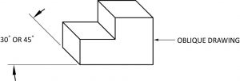

Isometric
Isometric drawings have less distortion than oblique drawings, and are used more frequently by industry for that reason. An isometric drawing has both visible surfaces drawn at 30◦. These are the most used type of drawings in the piping industry and take a good deal of practice to fully understand how to draw. They best represent what is being built and what it will look like from the different sides with one drawing.

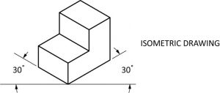

Directions: Name the types of drawings shown below. Check your own answers.
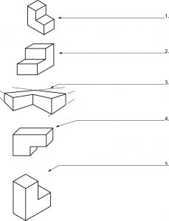

Single View
A single view of an object is sometimes all that is needed for a complete visual explanation. When dimensions, material, and other information is Included, an object requiring only a single view is easy to understand.
Most one-view drawings are of flat objects, made from materials such as sheet metal and gasket stock. Spherical objects, such as a cannonball, would require only one view and a note indicating the material and diameter of the sphere.
The object shown in the one-view drawing below could be made of any appropriate material that might be specified. In appearance, it is much like the gasket used as part of the cooling system on many cars. All that would need to be noted is the material type and thickness required.
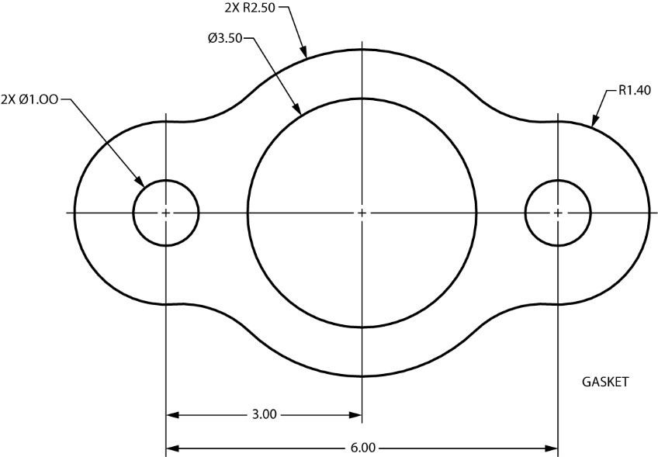

Two View
Sometimes “two-view” drawings are use on prints. Two views may be all that is needed to show the shape of an object. Objects that are cylindrical, such as a length of pipe, are usually shown on a print with two views. In such a case, two views is sufficient to explain the shape. Notice in the two-view drawing shown below that the length of the pipe is shown in one view, while the diameter is called out in the other. Without the view on the right, what might this shape be mistaken for? Square tube, channel…

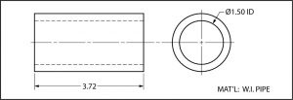

Orthographic Projection
Orthographic projection is a name given to drawings that usually have three views. Often, the three views selected are the top, front, and right side. It is possible, of course, to select other views such as the left side or bottom. Generally, though, it’s the top, front and right side that are traditionally seen by the person reading prints.
Since most prints make use of the orthographic projection system, and because the top, front, right side views are most often used, it is important that you have their order, or arrangement on the print fixed in your mind. To help you understand this system, think of a chalkboard eraser, a short length of 2″ x 4″ lumber, or a common brick. It looks like this:

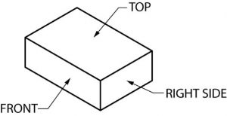

When seen on a print, using orthographic projection, it would appear like this.
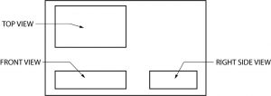
This system of orthographic projection may be difficult to understand or visualize at first, but you will grasp it with some practice. Here’s a basic example of how it works, using a simple object.
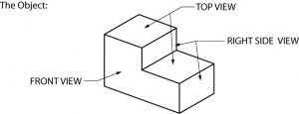

Orthographic projection does not show depth, so the object shown above will appear flat. With practice, however, you will learn to scan the three views and “read” depth into them. Remember that the location of the top, front and right side views does not change. The projection lines between the orthographic views below show the height, width, and depth relationship that exists between each view and the other two views.

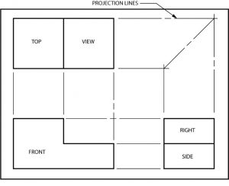

In case you did not understand the three-view on the last page, let’s take another look at the same thing. This time numbers will be used for identification for the surfaces.

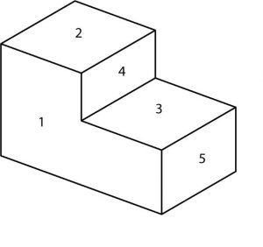
Using orthographic projection, the object with the surfaces numbered appears like this:

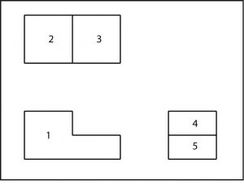

Notice that the front view (1) is the key to the drawing, because it most clearly shows the shape of the object. It tells you the object is “L” shaped from the front. The other two views don’t tell you much by themselves. By looking at surface 1, however, you can see that 2 is taller than 3. Therefore, in “reading” the surfaces, 2 should appear to be closer to you than 3. Now look at 4 and 5. Which surface is projected closest to you?·
Answer: Surface 5 (rotate and place at bottom of layout)

Now draw a simple box and tape all sides together to form a cube. The cube will be 2”x 2”x 2”. Once the instructor has approved your drawing you will proceed to cut out and tape edges together to form a cube.

Visualization Quiz
Directions:
All visible surfaces on the objects shown are numbered. To complete this quiz, you are to place those numbers on the corresponding surfaces of the orthographic drawings.
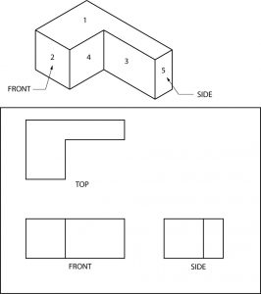

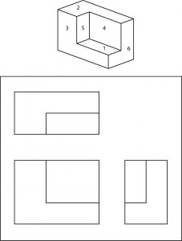

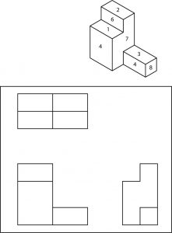

You may be wondering at this point why something like orthographic projection is used on prints when isometric or oblique drawings are so much easier to visualize. The answer is that both of those types of pictorials are used for relatively uncomplicated drawings. When an object is complex, however, neither can equal the orthographic system for clear presentation of dimensions, notes, and configuration details.

Hidden Surfaces
Another advantage of orthographic projection is that it allows the person reading the print to have the ability to see the inside, or surfaces of an object which normally could not be seen.
With complicated objects this can become very useful.
In the drawing below, the hidden line in the right side view represents the entire surface of the flat area between the two higher sides.
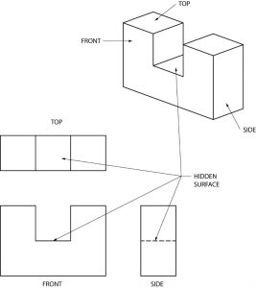

In this example, the hidden lines result from a square hole through the middle of the object.
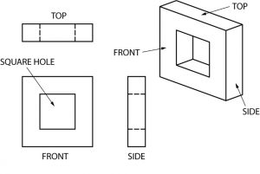

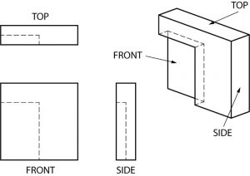

The hidden lines in this example are there because a part of one corner of the front surface was cut away, or “recessed.

Hidden Surfaces
Directions: Draw the hidden lines which are missing in the views below. Each problem has one incomplete view.
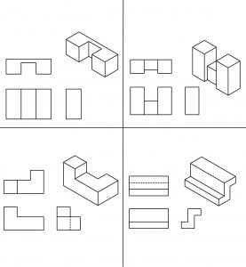

Curved Surfaces
Curved surfaces are perhaps tricky to “see” until you remember that the curve is only shown in one view. You must put the curve in the other views yourself, through visualization. Try to think that when there is a sharp change of direction like at a corner, then that will produce a line visible in another view. When the change of direction is smooth like a curve, no line will be seen.
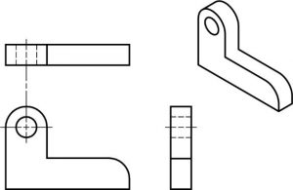

Here’s another example of curved surfaces:
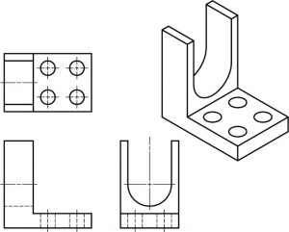

Curved surfaces exercise.

Directions: Draw the lines which are missing in the views below. Each problem has one incomplete view. Do not draw center lines.
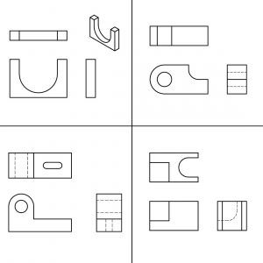

Inclined Surfaces
Inclined surfaces are those which are at an angle, or slanted. In other words, they are surfaces which are neither horizontal nor vertical. In viewing orthographic drawings you need to be alert to angles and inclined surfaces, for they are often found on the prints you will be reading later.
Notice the hidden line in the right view created by the inclined surface on this object:
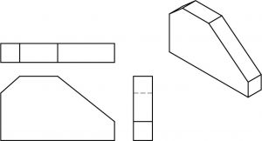

Here is an object with two inclined surfaces.
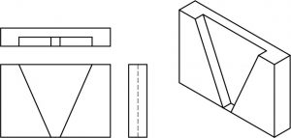

Inclined surfaces exercise
Directions: Draw the lines which are missing in the views below. Each problem has one incomplete view.
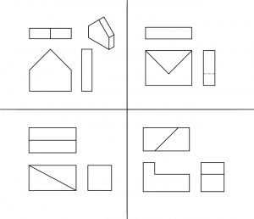

Chapter 4

Technical Sketching

Technical Sketching
- SKETCHING TECHNIQUES
- LETTERING
- OBLIQUE SKETCHING
- ISOMETRIC SKETCHING
- ORTHOGRAPHIC SKETCHING
- ON-THE-SPOT SKETCHING
On many occasions in your work it will most likely be necessary for you to make a sketch. Perhaps your boss can’t visualize a particular problem without one, or you find it’s necessary to make a dimensioned sketch to show an apprentice how to complete a job. In any case knowing how to sketch can make you more effective, and therefore more valuable, as a tradesperson.
Many times out in the field you are working on sketches drawn on anything from napkins, cardboard, wood scrapes or any flat surface. Don’t get me wrong, you will work projects with professionally produced drawings but sometimes you have to work with what you have.
Being able to make technical sketches doesn’t mean you need to be an artist; and sketching isn’t difficult if you follow a few simple rules. You may be a little slow at first, but with some practice you will be able to turn out reasonably good sketches without too much effort.
You are not going to be judged as a professional draftsperson or architect but you need to be able to describe, with lines what you are needing built, repaired or modified. This take practice and is a very important skill to develop.

Sketching Techniques
All you need to start is a pencil and some paper. A soft pencil works best for most people, so try a #2 or an F. Keep the pencil sharp, but not too sharp: hold it with a grip firm enough for control, but not so tight that your arm isn’t relaxed. Don’t draw heavily at first. That way it is easier to erase without smudging. Darken the sketch when it begins to shape up the way you want it.
It’s generally best to begin sketching with plain paper, although some people like to use grid paper. On the job, you may find yourself sketching on the back of a work order or piece of packing crate. In any case, it’s learning to sketch quickly and effectively that’s important.
Here are some limbering up exercises wot get you started. To keep your pencil sharper longer, and for more even lines widths, try turning your pencil slowly while completing the lines in the exercises below.
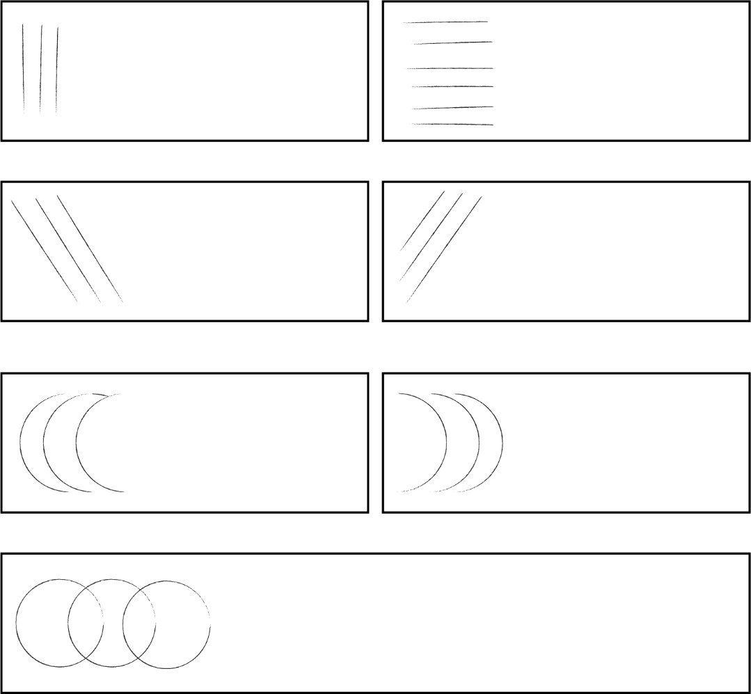
Next, try sketching the objects on this page. Make your sketches as much like the examples as possible.
Remember; sketching means freehand drawing. No Straightedges, compass, coins, etc!
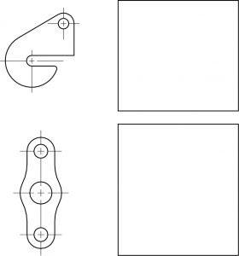

Lettering
Now that you are warmed up, we will take the straight and curved lines from the sketching exercise and use them to form letters. The entire alphabet can be formed from the straight and curved lines you have practiced.
Look at the lettering below. If your printing is similar, and is easily readable, you can skip this exercise and go on to oblique sketching. If not, do some practicing. Some of the work ahead (and tests) require good lettering.
Remember, the most important requirement of good lettering is legibility. There is no use making a drawing if the person looking at drawing cannot read your writing.

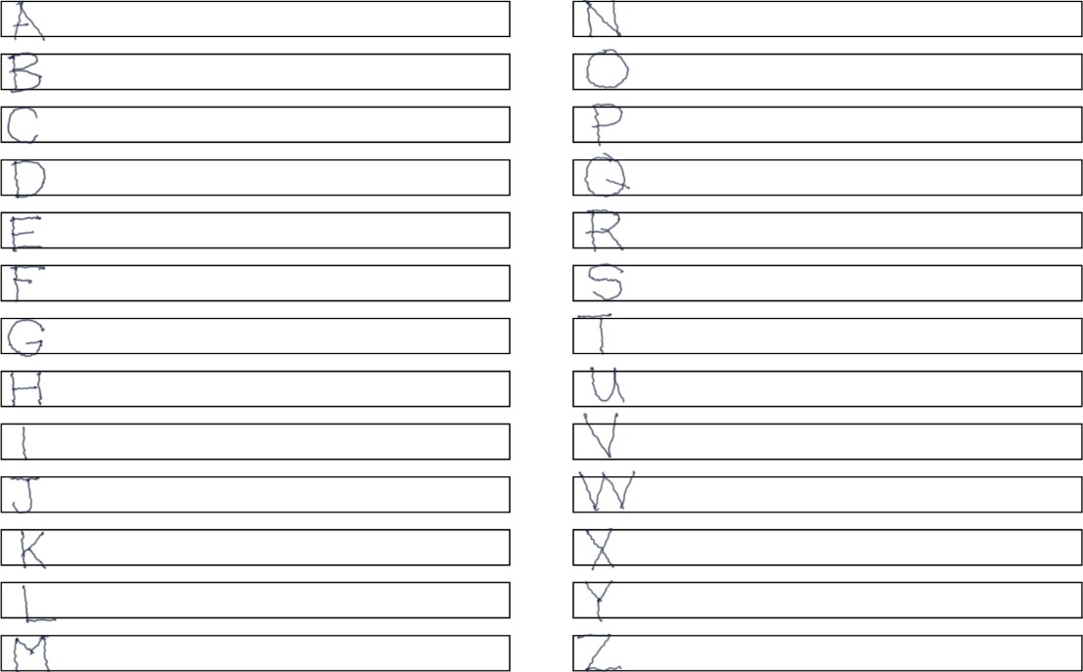

Oblique Sketching
Oblique sketches are a type of pictorial having one plane parallel to the drawing surface, and the visible side sketched at an angle. Usually, that angle works best at 30◦ to 45◦, or somewhat in between. Beginners often have trouble keeping the 30◦ or 45◦ lines as the same angle. If that happens, your sketch will look distorted.
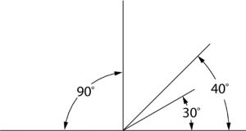

Here’s how to sketch an oblique cube in three steps:
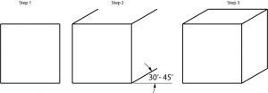
Possibly you might want to show the left side of the cube, or perhaps draw the hidden lines, as at the right;

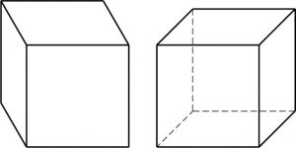

In the spaces below, sketch oblique cubes as indicated.
Sketch these objects in oblique, as shown:
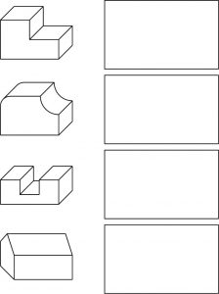
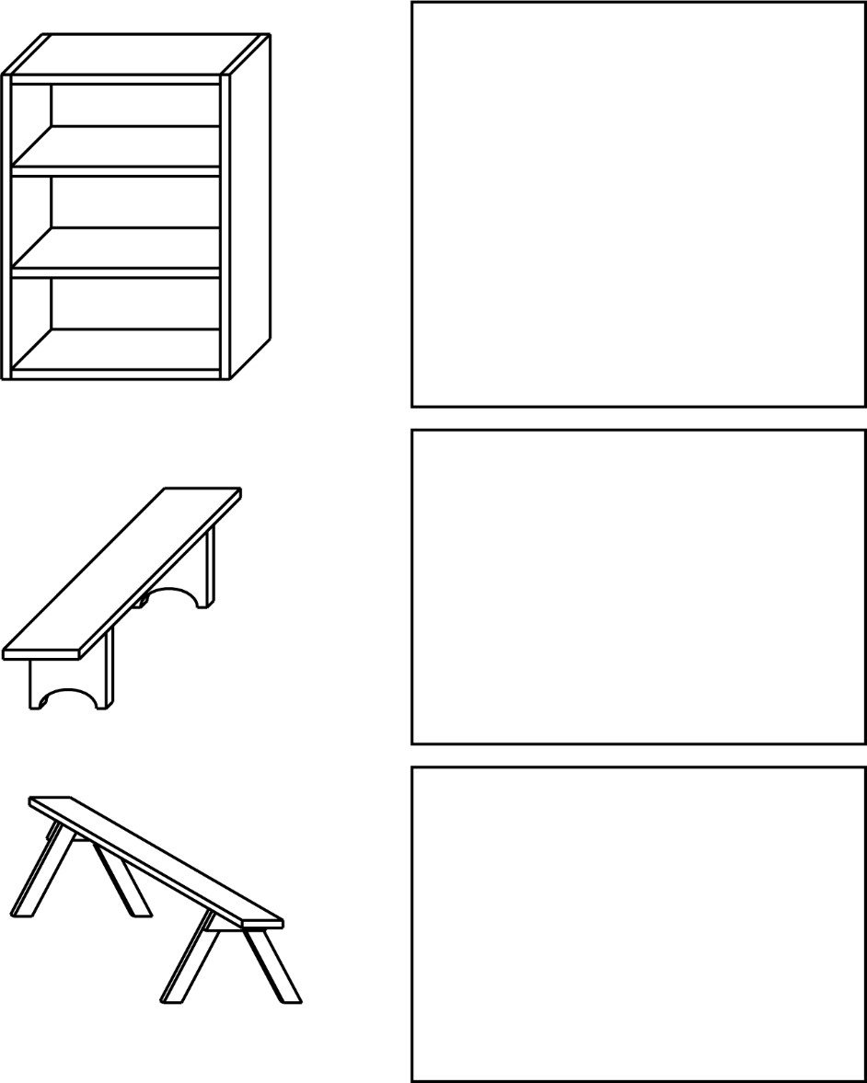

In this more difficult exercise, you are to make oblique sketches of the objects shown. The third problem is drawn in isometric. You are to sketch it in oblique. Convert problem four from orthographic to an oblique sketch.
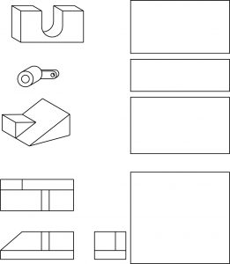

Isometric Sketching
Isometric sketches, unlike oblique, must maintain an angle very close to 30°.
Therefore, to get the “feel” of an isometric, try sketching 30° angles in this exercise:

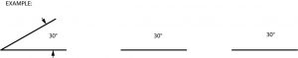

Sketching in isometric can be done in different ways. Generally, it’s recommended that you start and the bottom of the object and “box it in”, thereby enclosing it within a rectangular framework. For example, if we were to take a simple object like this,
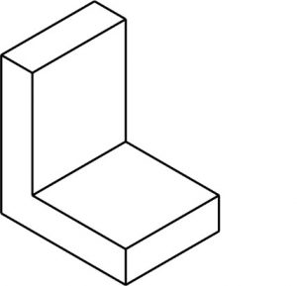
The steps needed to sketch it in isometric would be;

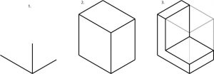
The unnecessary lines are then removed, leaving the object. Once you gain some practice at this, it will be possible for you to make an ISO drawing without the “guide” lines. It is important to use them early on the help train your brain.
To the beginner, building a “frame” before sketching the object often seems unnecessary. That may be true with simple objects. However, when things become more complex, a frame gives you a means of developing the various parts in an organized way. Without such guidelines you can easily “lose” your sketch.
Sketch the examples given, using guidelines as shown in the first exercise. Draw the guidelines lightly. Notice that 3 and 5 require the use of non-isometric lines. Since those lines are not at 30◦, it is best to connect the end points of those lines after the sketch nears completion.

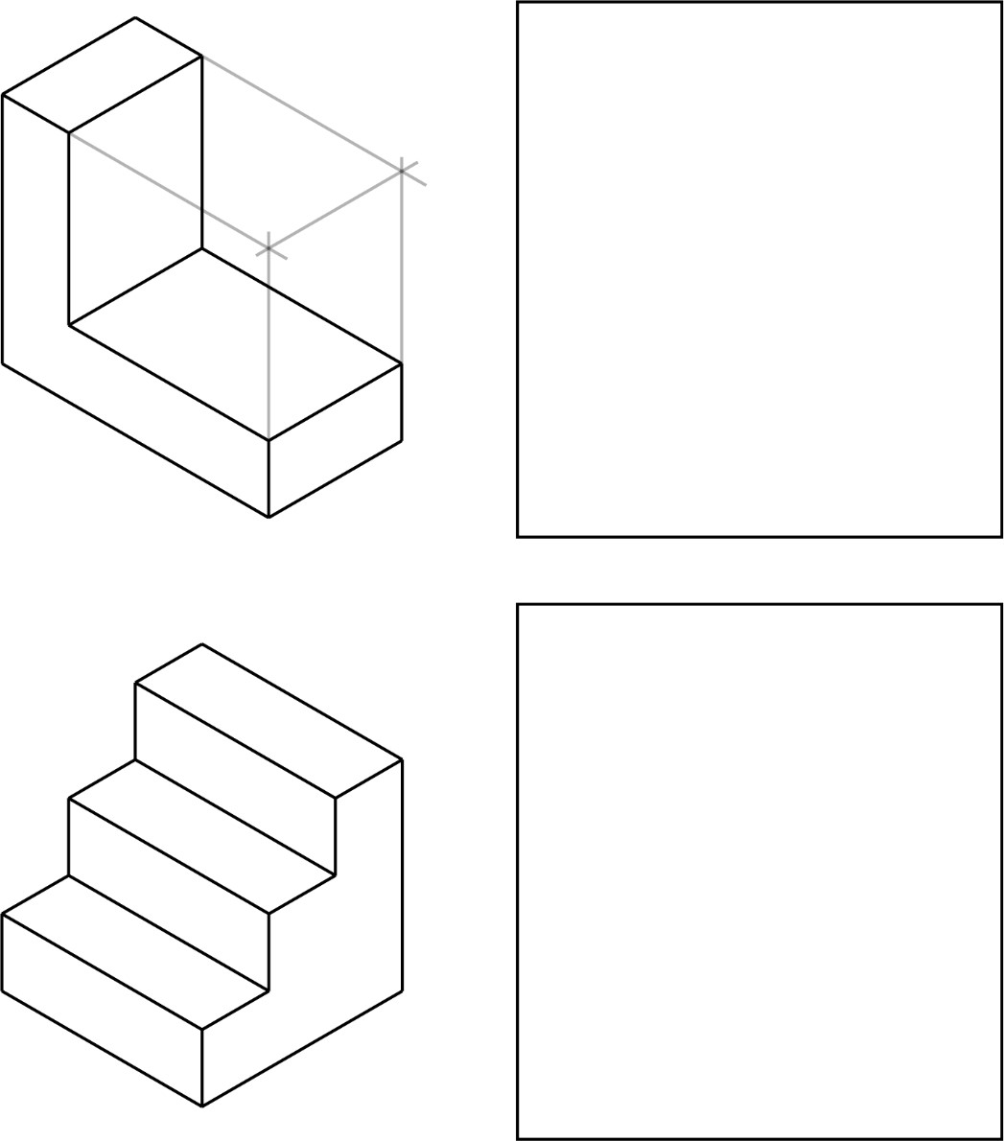
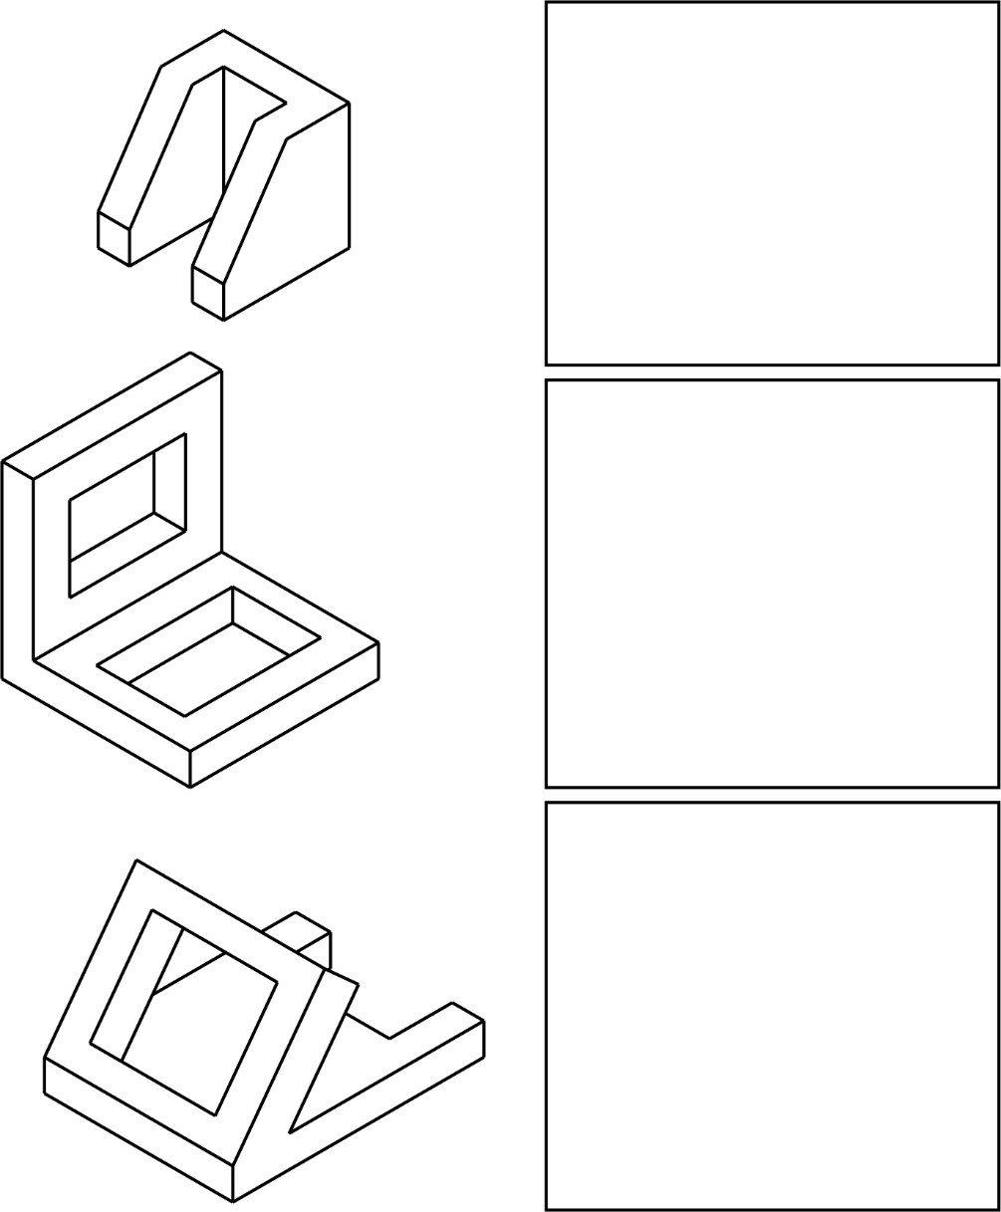

Circles and arcs, when sketched in isometric, become elliptical in shape. If a circle is used, it will appear distorted, as in this example:
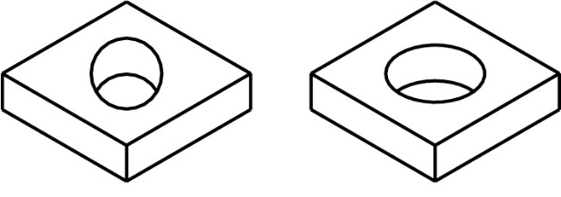
In sketching isometric circles and arcs, there are three positions in which they are normally sketched, depending upon the surface where the circular feature is located. Those surfaces, or picture planes are:
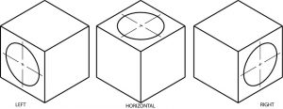

On the cube shapes below sketch ellipses as on the examples above.

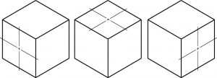
You may also want to practice sketching ellipses on the other surfaces of the cubes.
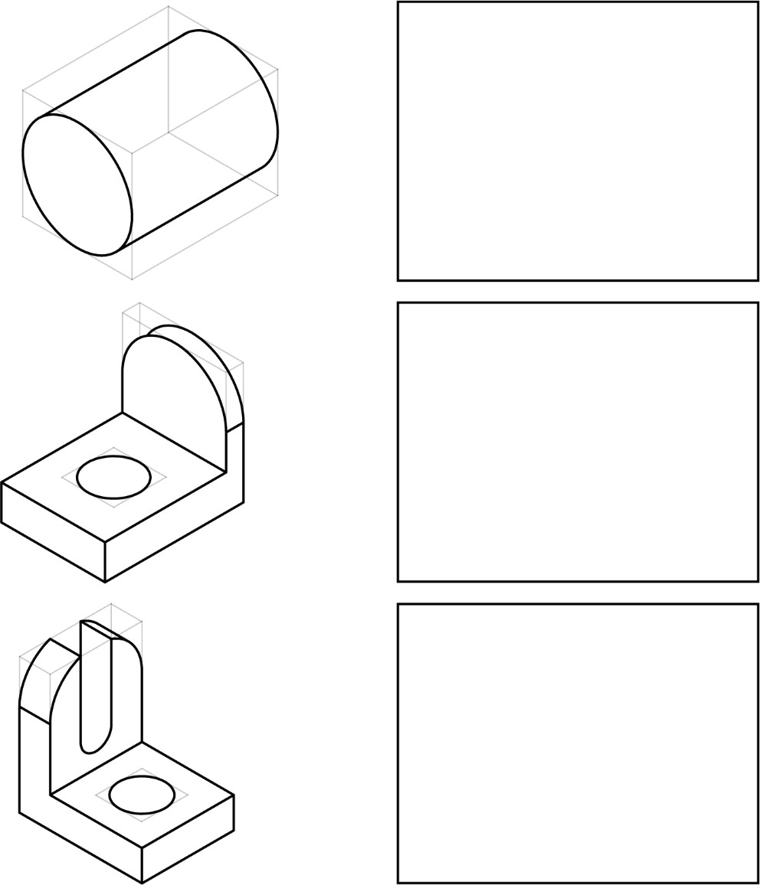
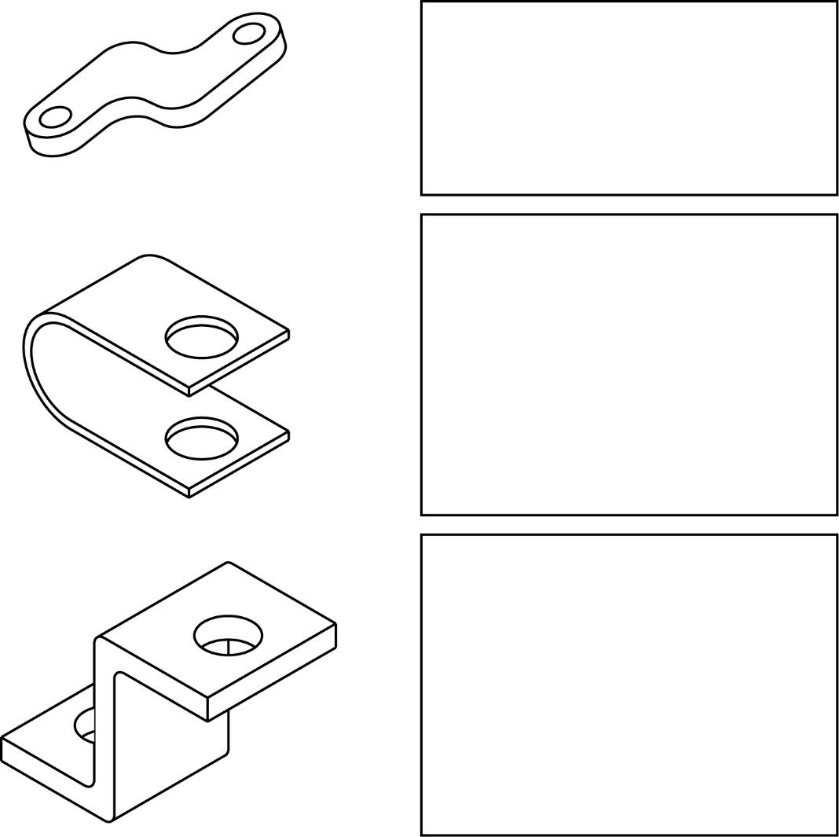

Orthographic Sketching
Of all the methods of making drawings, orthographic projection is the most commonly used by draftsperson. Although the other methods serve their purposes, they cannot always show the parts of an object as well as orthographic representation.
Orthographic projection is a system of projecting from view to view to graphically describe the object. As a way of reviewing, study the views of the small garage in this drawing. Notice the location and relationship of each view to the other views.
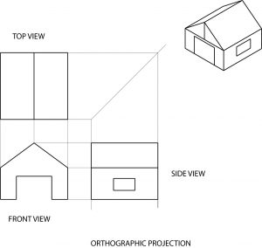
The important thing to remember in orthographic sketching is the alignment of views. The top view is projected directly above the front view. The front and side view also line up with each other. The height, width, and length of the object must remain the same from view to view. There should be enough distance between the views to prevent crowding; and to leave room for dimensions.
Produce a top view in the drawing below.
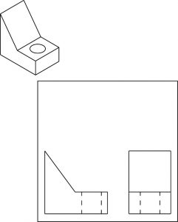

Sketch each object in orthographic in the spaces on the right. Remember, the idea is to project! Front, top and right side view.

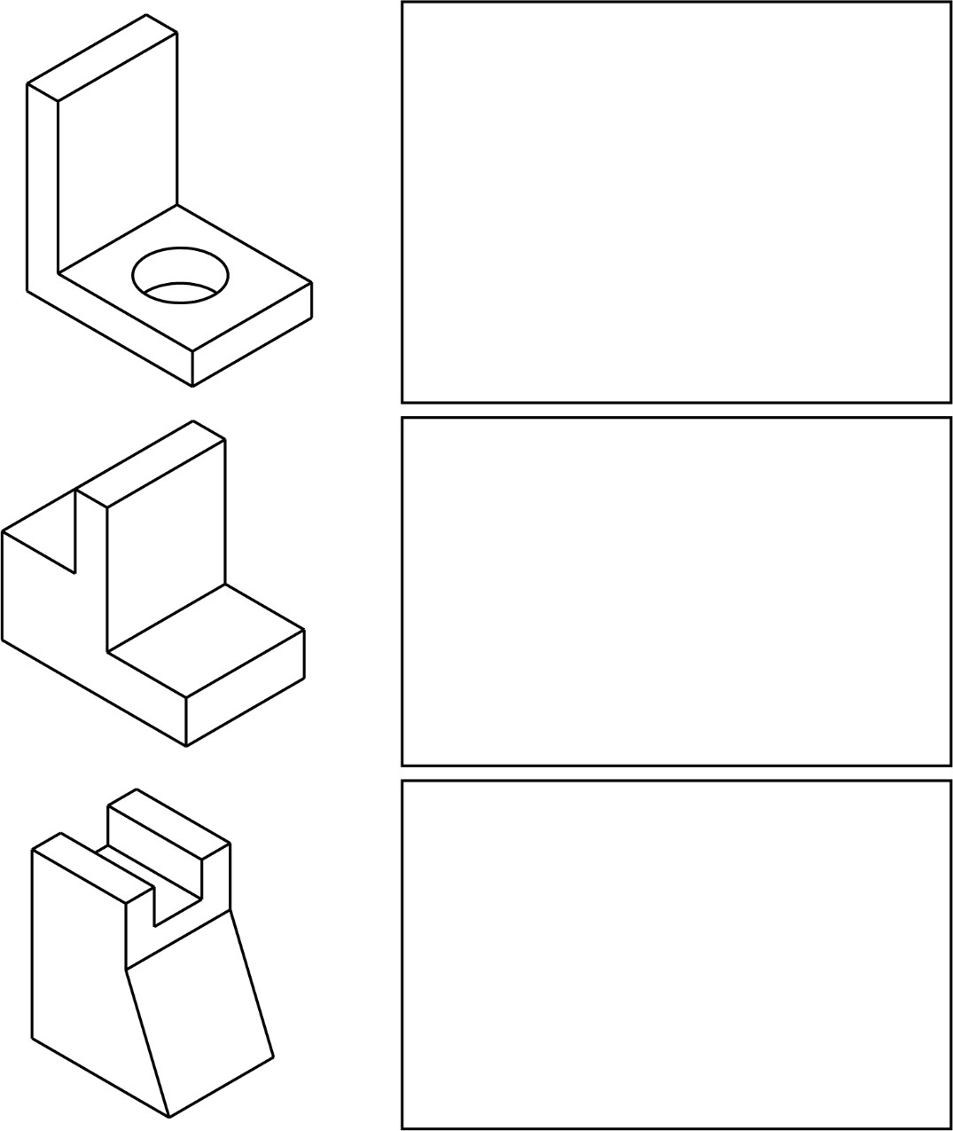
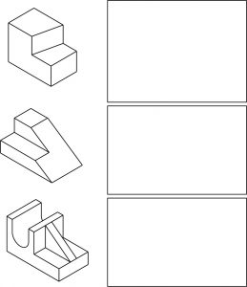

“On-THE-SPOT” Sketching
Now that you have learned the three different methods of sketching, it is time to make sketches you can place in front of you and touch, rather that sketching from drawings on paper.
Sketching “ON-THE-SPOT” is a standard industry practice. A piece of machinery needs to be changed, a support needs to be added, or pictorial information in some way requires a sketch.
Instructor will give you an object to sketch…
You will need to produce an isometric of the object and also an orthographic drawing with as many views as required to show details of object to be built.

Chapter 5

Scaling

Scaling
- SCALE MEASUREMENT
- FULL SIZE
- HALF SIZE
- QUARTER SIZE
The ability to make accurate measurements is a basic skill needed by everyone who reads and uses blueprints. This section is intended as a review of the fundamental principles of measurement. Since some students have had little need to measure accurately, these exercises will provide the practice they need. Others, who have had more experience, may find these exercises a worthwhile review.
Whether or not you need to review these fundamentals, there is one important thing to remember about getting measurements from a print. If you need a dimension that is unclear or is not given, do not measure the print! Since prints shrink, stretch, and may not be drawn to scale, you can easily come up with some very inaccurate dimensions.

Scale Measurement
A drawing of an object may be the same size as the object (full size), or it may be larger or smaller than the object. In mo.st cases, if it is not drawn full size, the drawing is made smaller than the object. This is done primarily for the convenience of the users of the drawings. After all, who wants to carry around a full size drawing of a locomotive? Obviously, with an object as small as a wristwatch, it would be necessary to draw to a larger scale.
A machine part, for example, may be half the size (1/2”=1”); a building may be drawn 1/48 size (1/4”=1’-0”); a map may be drawn 1/200 size (1”=100’-0”); and a gear in that wristwatch may be ten-times size (10”=1”).
There are numerous scales for different needs. Since each occupational group has their own frequently used scales, some practice or basics review will help you to work with the scales used in your technology.

Full Scale
Full scale is simply letting one inch on a ruler, steel rule, or draftsman’s scale equal one inch on the actual object. Rules of this kind are usually divided into 1 /16” or 1 /32” units. The first measurement exercise will be with full size. If you can measure accurately in full scale, you may want to skip ahead.
Here is a “big Inch”. Each space equals 1/32”. If you have not worked with accurate measurement, spend some time studying it.
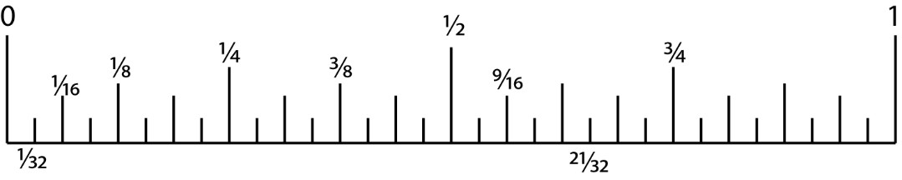
Measurement practice: on the scale above, locate the following fractions:
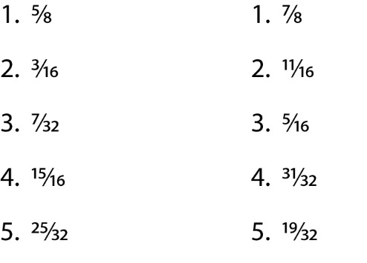
Directions:
Each of the fractions below is numbered. Write that number above the scale and point with an arrow where the fraction is located. Number 1 has been completed.

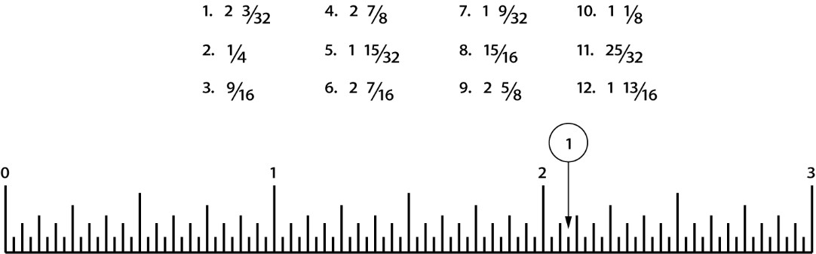

Half Size
The principle of half size measurements on a drawing is simply letting a unit, such as 1/2” on the scale, represent a larger unit such as 1” on the drawing. If the drawing is properly labeled, the words HALF SIZE or 1/2″= 1′ will appear in the title block.
Using the half-size scale is not difficult, but it does take some practice. To measure a distance of 2-3/16” you look first for the 2, then go backwards to the zero and count off another 3/16. You measure this way for each dimension that has a fraction. Whole numbers (numbers without fractions) are measured in the usual way.
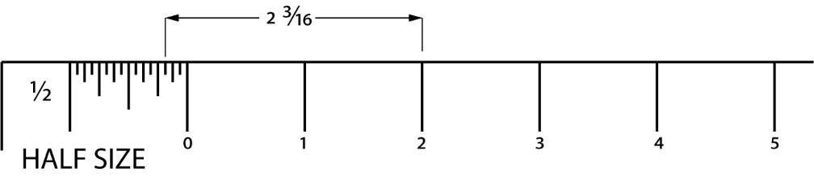
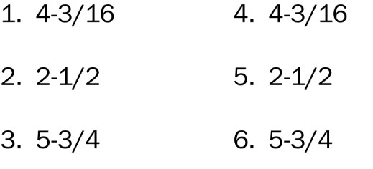
Next, locate a half size scale (available in the lab) and measure the lines· below to the nearest 1 /32 of an inch. Write the length of the line in the space provided.
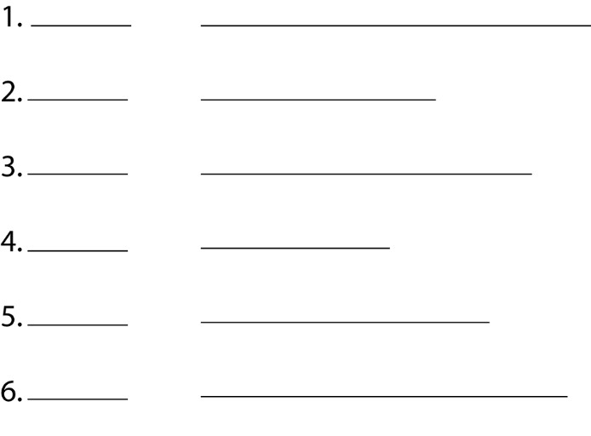
Because paper is dimensionally unstable due to humidity, exact answers to this half size measurement practice cannot be given. That is another reminder that it’s poor practice to measure from a piece of paper.

Quarter Size
Quarter size is used and read in a similar way to half size except that each unit, such as a quarter of an inch, represents a larger unit, such as one inch. If the drawing is properly labeled the words QUARTER SIZE, QUARTER.SCALE, or 1/4″ = 1″ will appear in the title block.
The quarter size scale is used in a similar manner as the half size scale.
For quarter size practice, draw lines in the area provided to the required length. Have another student or the lab instructor check your lines for accuracy. (A ¼”=1” scale is available in the lab.)
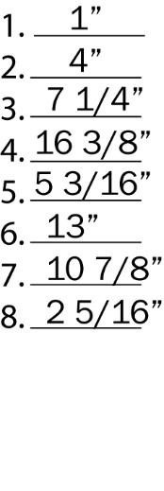
Quiz
For this quiz, you will be given an object to measure with a ruler or tape measure. You will record measurements in full scale and then draw each length in ½ and ¼ scale.

Chapter 6

Dimensioning
- Numerals
- Dimensions
- Extension Lines
- Arrowheads
- Dimension Figures
- Isometric Dimensioning
- Orthographic Dimensioning
If a drawing is to be complete, so that the object represented by the drawing can be made as intended by the designer, it must tell two complete stories. It tells this with views, which describe the shape of the object, and with dimensions and notes, which gives sizes and other information needed to make the object.
Therefore, your next step is to learn the basics of dimensioning. In that way you will understand not only how to interpret a drawing to get the information you need, but also how to dimension your sketches so that they can be used to communicate size information to others.

Numerals
It may seem a bit basic, but a few exercises with the shapes of numbers comes before dimensioning. The reason for such review is simply that incorrectly or carelessly made numbers on a drawing or sketch can easily be misinterpreted by someone on the job. That can be costly.
Therefore, the study of numbers forms is justified.
The number forms presented here have been determined to be the most legible, and are used by industry nationwide. The United States standardized 1/8” vertical numbers are correctly formed as follows:
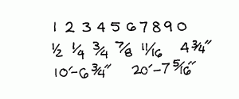

Dimension Lines
The dimension line is a fine, dark, solid line with arrowheads on each end. It indicates direction and extent of a dimension. In machine sketches and drawings, in which fractions and decimals are used for dimensions, the dimension line is usually broken near the middle to provide open space for the dimension numerals. In architectural and structural sketches and drawings, the numerals are usually above an unbroken dimension line.

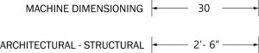
In either case, the dimension line which is closest to the object should be placed approximately
1/2″ away. The other dimensions beyond the first dimension (if any) should be approximately 3/8″ apart. You do not necessarily have to remember this, but you should remember not to crowd your dimension lines and to keep them a uniform distance apart.
The most important thing is that the drawing needs to be “clean” and dimensions need to be located in a space where they cannot be confused with a surface they are not intended to be used for.
Here is how dimension lines should be sketched:

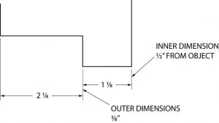
Note: Dimensions less than six feet (72 in.) are given in inches. Dimensions over six feet are usually shown in feet and inches. Be sure that it is clear how dimensions are called out. When calling out dimensions that are over 12”, make sure ALL of dimensions are called out in total inches or feet inches throughout the entire drawing. Either 4’-5” or 53”, they both mean the same thing but if there is a mix of dimensioning it can become easy to look at 4’-8” and see 48”.

Extension Lines
Extension lines on a drawing are fine, dark, solid lines that extend outward from a point on a drawing to which a dimension refers. Usually, the dimension line meets the extension line at right angles. There should be a gap of about 1 / 16″ where the extension line would meet the outline of the object, and the extension line should go beyond the outermost arrowhead approximately 1 /8″. Also, there should be not gaps where extension lines cross. Notice in this example the larger dimensions are correctly placed outside, or beyond the shorter dimensions, and that the dimensions are preferably not drawn on the object itself. Sometimes, however, it is necessary to dimension on the object.

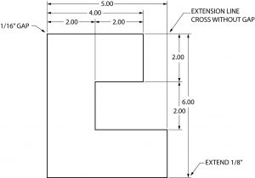

It is important to remember to place dimensions on the views, in a two or three view drawing, where they will be the most easily understood. Avoid dimensioning to a hidden line and avoid the duplication of dimensions. Use common sense; keep dimensions as clear and simple as possible. Remember, the person reading your drawing needs to clearly understand, beyond question, how to proceed. Otherwise, costly time and material will be wasted.
There are two basic methods of placing dimensions on a sketch. They may be placed so they read from the bottom of the sketch (unidirectional dimensions) or from the bottom and right side (aligned dimensions). The unidirectional system is usually best, because it is more easily read by workmen.

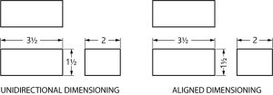

When dimensions will not fit in a space in the usual way, other methods are used to dimension clearly, when those crowded conditions exist.

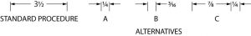
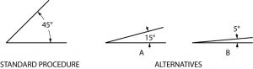

Arrowheads
Arrowheads are placed at each end of dimension lines, on leader lines, etc. Correctly made, arrows are about 1/8” to 3/16” in length, and are about three times as long as they are wide. Usually they have a slight barb, much like a fishhook.
To make your drawing look clean, use the same style throughout your drawing or sketch.

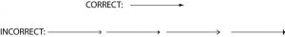

Dimension numerals
Numerals used to dimension an object are normally about 1/8” in height.
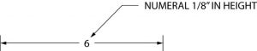
When a dimension includes a fraction, the fraction is approximately 1 / 4″ in height, making the fractional numbers slightly smaller to allow for space above and below the fractional line.
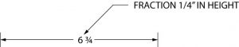
Again, it is particularly important that the numbers and fractions you may put on a sketch or drawing be legible. Sloppy numbers can cause expensive mistakes.

Notes
Notes are used on drawings to provide supplementary information. They should be brief and carefully worded to avoid being misinterpreted, and located on the sketch in an uncrowded area. The leader lines going to the note should be kept short. Notes are usually added after a sketch has been dimensioned to avoid interference with dimensions.

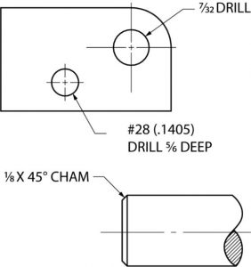

Quiz

Directions: Dimension the examples as indicated.

Dimension this 3 ¼ x 6 15/32 rectangle unidirectionally on the top and right sides.

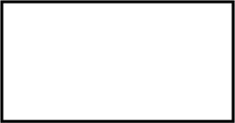

With a note, show a 5/16 drilled hole.

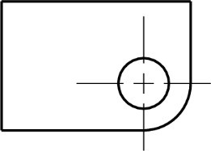

Dimension this object. The shorter lines are 3 inches in length.

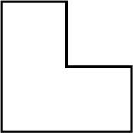

Dimension this object. Use a ruler or scale to determine the line lengths.

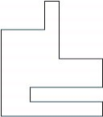

Oblique Dimensioning
Oblique dimensioning is mostly remembering to avoid dimensioning on the object itself (when possible) and the use of common sense dimensioning principles. It is also usually best to have dimensions read from the bottom (unidirectional) as shown here.

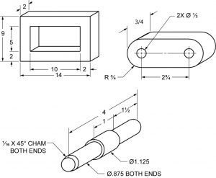

Although it is best not to dimension on the view itself, its usually accepted practice to place diameter and radius dimension on the views if space permits.
Sometime space and time is limited and you might have to bend the typical rules of drawing and dimensioning. The most important thing is to keep the drawing clean, concise, try to not a repeat dimensions but give all required ones.
Directions: Complete as indicated.
Dimension this three inch cube.

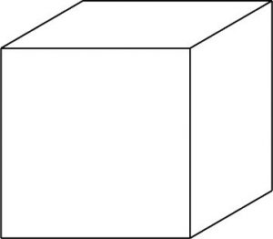

The shorter section of this rod is 5/8 inches in diameter by 2 1/8 inches long. The longer section is 7/8 inches in diameter by 3 ½ inches long. Dimension the drawing.

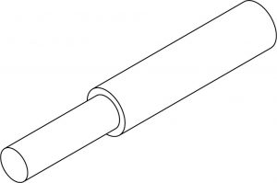

Isometric Dimensioning
When dimensioning an isometric sketch, it is important to keep dimensions away from the object itself, and to place the dimension on the same plane as the surface of the object being dimensioned. You will probably find that to dimension well in isometric will take some practice.
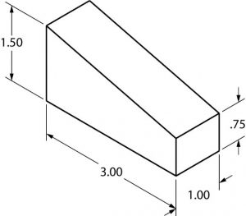
Place notes on an isometric drawing without regard to placing them on the same plane, as with dimensions. It is easier to do, and easier to read.

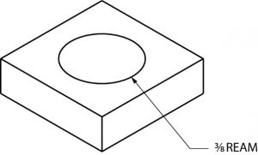

Isometric notes do not have to be on the same plane.
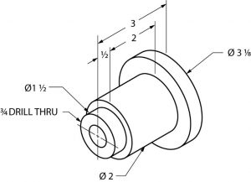

Notice in the example above that part of each leader line to the notes are sketched at an approximate angle of 15, 30, 45, 60 or 75 degrees. This is done to avoid confusion with other lines. Never draw leader lines entirely horizontal or vertical.

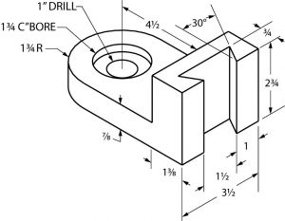
Quiz
Directions: complete as indicated.
Dimension this drawing. The dimensions are 3” long, 2 1/8” wide, 1 5/8” high with a 45◦ angle ½” deep. The angle begins as the midpoint of the 3” long dimension.

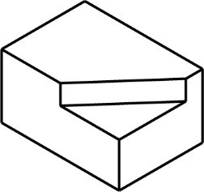

Dimension this drawing. The base is ½” x 1 ½” square. The cylinder is 1” ∅. x 1-1/8”
long. The drilled through hole is ∅5/8”.

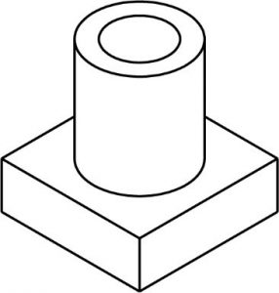

Quiz
Directions: You will be given an object to sketch and dimension.

Orthographic Dimensioning
When you look at the dovetailed object several pages back, it is easy to see that an isometric sketch can quickly become cluttered with dimensions. Because of this, more complicated sketches and drawings are dimensional in orthographic. This method provides the best way to dimension clearly and in detail.
Here are seven general rules to follow when dimensioning.
- Show enough dimensions so that the intended sizes can be determined without having a workman calculate or assume any distances.
- State each dimension clearly, so it is understood in only one way.
- Show dimensions between points, lines or surfaces which have a necessary relationship to each other or which control the location of other components or mating parts.
- Select or arrange dimensions to avoid accumulations of dimensions that may cause unsatisfactory mating of parts. (In other words, provide for a buildup of tolerances, as in the example below.
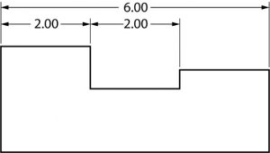
- Show each dimension only once. (Do not duplicate dimensions).
- Where possible, dimension each feature in the view where it appears most clearly, and where its true shape appears.
- Whenever possible, specify dimensions to make use of readily available materials, parts and tools.

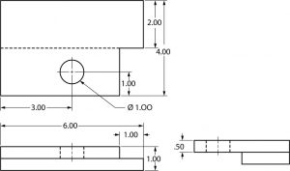

Notice the dimensions are correctly placed between the views, rather than around the outside edges of the drawing.

Quiz
Directions: one a separate piece of paper, make a dimensioned orthographic sketch of this object.
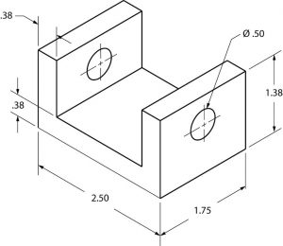
Directions: on a separate piece of paper, make a dimensional orthographic sketch of the object.
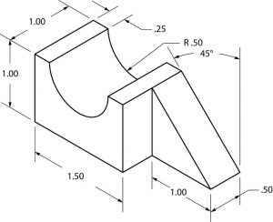
Quiz
Directions: You will be given an object to sketch and dimension.

Chapter 7

Auxiliary Views
- FRONT VIEW AUXILIARIES
- TOP VIEW AUXILIARIES
- SIDE VIEW AUXILIARIES
- SKETCHING AUXILIARY VIEWS
When an object has a slanted or inclined surface, it usually is not possible to show the inclined surface in an orthographic drawing without distortion. To present a more accurate description of any inclined surface, an additional view, known as an auxiliary view, is usually required.
An auxiliary view is simply a “helper” view, which shows the slanted part of the object as it actually is. It turns, or projects, the. object so that the true size and shape of the surf ace (or surfaces) are seen as they actually are.
Auxiliary views are commonly found on many types of industrial drawings.

Front View Auxiliaries
There are three basic type of auxiliary views. In the first type, the auxiliary view is projected from the front view of a three view (orthographic) drawing. In the second and third types of drawings, the auxiliary views are projected from the top and side views.
Here is a front view auxiliary of a simple object with an inclined surface.

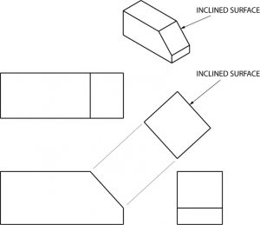

Notice that the projection lines are perpendicular to the slanted surface of the first view, and that only the slanted surface of the object is shown in the auxiliary view. · The rest of the object is omitted, however, for clarification portions of the adjacent· surfaces are sometimes shown. Also, notice that the slanted surfaces of the top and side views are shortened because of distortion, whereas the surface of the auxiliary view is true, or actual size.
To sketch an auxiliary view, you begin with orthographic. views of the object and add projection lines perpendicular (90◦) to the slanted surface, adding a reference line any convenient distance from the view with the slanted surface.

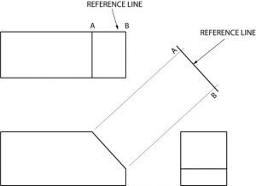

Next, the distance CB on the auxiliary view is made the same length as the related distance in one of the orthographic views; in this example it’s the side view. This completes the auxiliary view.

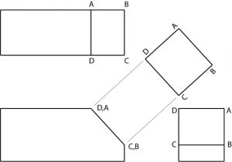

Top View Auxiliaries
A top view auxiliary is developed in the same way as a front view auxiliary, except that the auxiliary is projected from the top view.
Whether the auxiliary view is to be projected from the front, top, or side view depends on the position of the object, or which surface of the object is slanted. In this example, the top view is slanted. Therefore the auxiliary view must be projected from the top view.
Again, notice how the angled surfaces shown in the front and side views are not shown in true length.

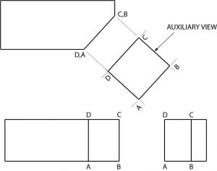

Side View Auxiliary
Side view auxiliaries are drawn in the same way as front and top view auxiliaries. Again, where the auxiliary view is to be projected depends upon the position of the object or which surface of the object is slanted.

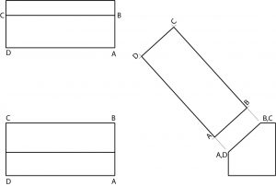
Obviously, these are very basic auxiliary view examples and are presented to introduce you to the concept of auxiliary views.
As objects with inclined surfaces become more complex, auxiliary views provide a means of presenting objects in their true size and shape.

Sketching Auxiliary Views
The following problems require and auxiliary view to be complete. Sketch the auxiliary views required in the spaces provided.

Drawing practice 1
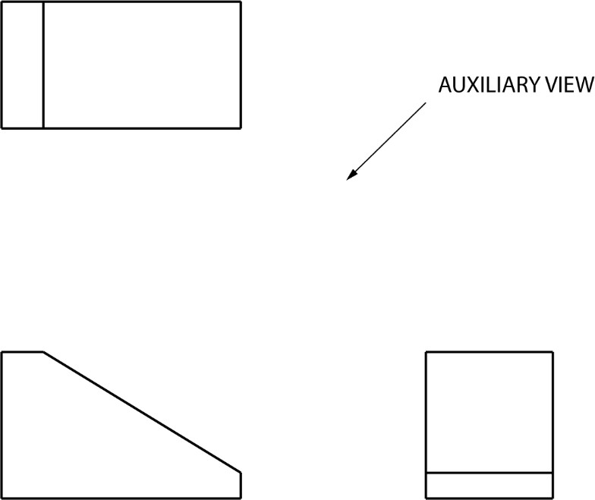
Drawing practice 2
In this problem, a round hole is centered on the slanted surface and drilled through the object. The hole appears elliptical in the. front and side views because of distortion. It will appear in its true shape on the auxiliary view. Remember that the auxiliary is developed from the view with the slanted surface. Complete the auxiliary view.

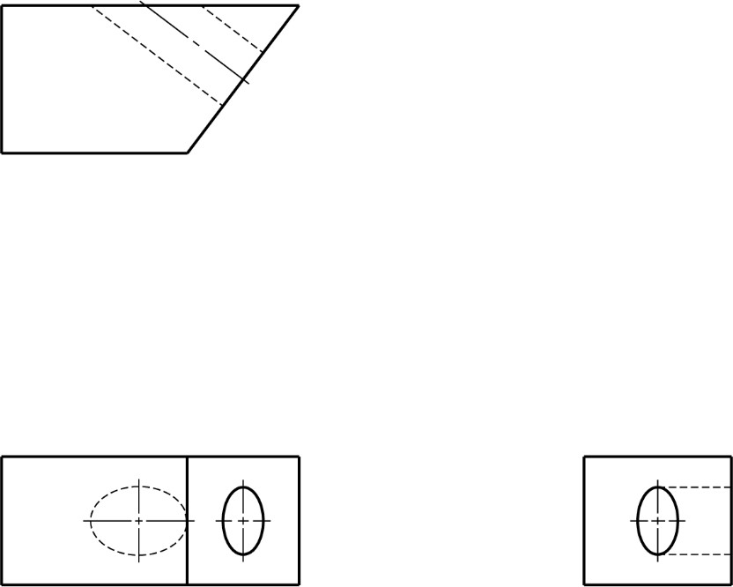
Drawing practice 3
In this problem, a square hole has been cut part way into the object. Complete the auxiliary view.

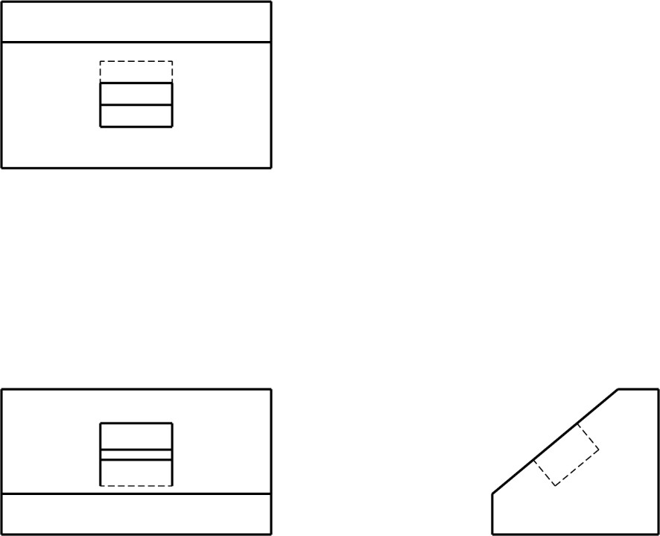
Quiz
Directions: Complete the auxiliary view in the space provided.

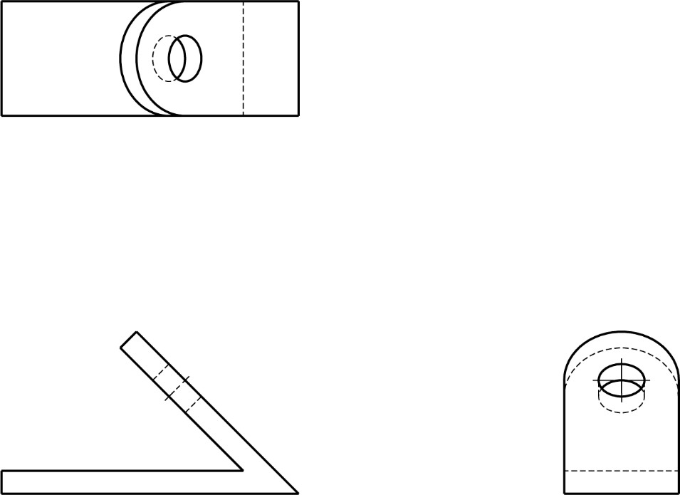

Chapter 8

Sectional Views

Sectional Views
- CUTTING PLANE
- CUTTING PLANE LINE
- SECTION LINING
- FULL SECTIONS
- HALF SECTIONS
- BROKEN OUT SECTIONS
- REVOLVFD SECTIONS
- OFFSET SECTIONS
- REMOVED SECTIONS
You have learned that when making a multiview sketch, hidden edges and surfaces are usually shown with hidden (dash) lines.
When an object becomes more complex, as in the case of an automobile engine block, a clearer presentation of the interior can be made by sketching the object as it would look if it were cut apart. In that way, the many hidden lines on the sketch are eliminated.
The process of sketching the internal configuration of an object by showing it cut apart is known as sectioning. Sectioning is used frequently on a wide variety of Industrial drawings.
In this example, blocks A and B result after the block in figure 1 has been “Sectioned”. When you cut an apple in half you have sectioned it. Just as an apple can be sectioned any way you choose, so can an object in a sectional view of a drawing or sketch.
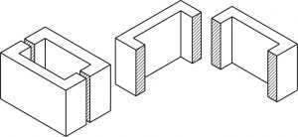

Cutting Plane

A surface cut by the saw in the drawing above is a cutting plane. Actually, it is an imaginary cutting plane taken through the object, since the object is imagined as being cut through at a desired location.

Cutting Plane Line

A cutting plane is represented on a drawing by a cutting plane line. This is a heavy long-short-short-long kind of line terminated with arrows. The arrows in show the direction of view.
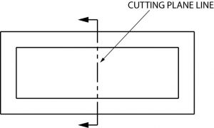

Once again, here is an graphic example of a cutting plane line and the section that develops from it.
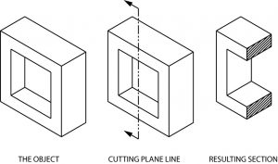

Section Lining
The lines in the figure above, which look like saw marks, are called section lining. They are found on most sectional views, and indicate the surface which has been exposed by the cutting plane. Notice that the square hole in the object has no section lining, since it was not changed by sectioning.

Different kinds of section lining is used to identify different materials. When an object is made of a combination of materials, a variety of section lining symbols makes materials identification easier. Here are a few examples:

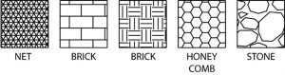

Section lines are very light. When sketching an object or part that requires a sectional view, they are drawn by eye at an angle of approximately 45 degrees, and are spaced about 1/8” apart. Since they are used to set off a section, they must be drawn with care.
It is best to use the symbol for the material being shown as a section on a sketch. If that symbol is not known, you may use the general purpose symbol, which is also the symbol for cast iron.

Full Sections
When a cutting plane line passes entirely through an object, the resulting section is called a full section Fig. 7 illustrates a full section.

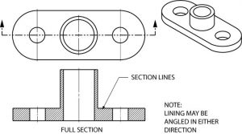

It is possible to section an object whenever a closer look intentionally is desired. Here is an object sectioned from two different directions.

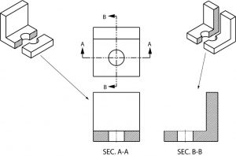

Half Sections
If the cutting plane is passed halfway through an object, and one-quarter of the object is removed, the resulting section is a half section. A half section has the advantage of showing both inside and outside configurations.
It is frequently used for symmetrical objects. Hidden lines are usually not shown on the un-sectioned half unless they are needed for clearness or for dimensioning purposes. As in all sectional drawings, the cutting plane take precedence over the center line.

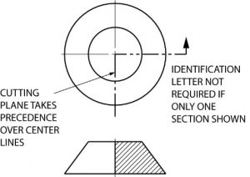

Here is another example of a half section. Remember that only one fourth of the object is removed with a half section, whereas half of the object is generally removed with a full section.
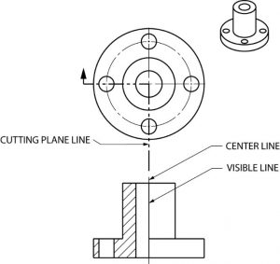

This manufacturer’s drawing, using both full and half section, illustrates the advantages of sectional views. The different line directions indicate different parts and materials used in the assembly of this valve.

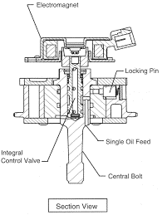

Quiz
Directions: On a separate sheet of paper, complete the section view.
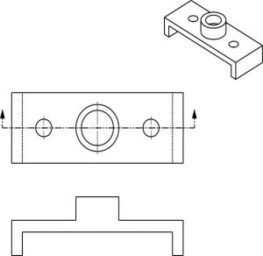

Broken Out Sections
In many cases only a small part of a view needs to be sectioned in order to show some internal detail. In the figure below, the broken out section is removed by a freehand break line. A cutting plane line does not need to be shown, since the location of the cut is obvious.

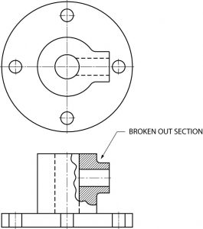

Revolved Sections
A revolved section shows the shape of an object by rotating a section 90 degrees to face the viewer. The three revolved sections illustrated in the spear-like object of figure 12 show the changes that take place in its shape.

Offset Sections
An offset section is a means of including in a single section several features of an object that are not in a straight line. To do this, the cutting plane line is bent, or “OFFSET” to pass through the features of the part.

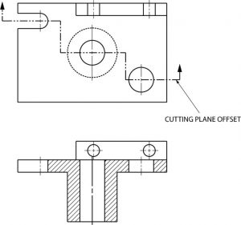

Removed Sections
A section removed from its normal projected position in the standard arrangement of views is called a “removed” section. Such sections are labeled SECTION A-A, SECTION B-B, etc., corresponding to the letter designation at the ends of the cutting plane line. Removed sections may be partial sections and are often drawn to a different scale.

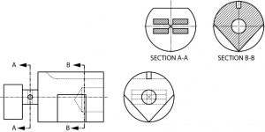
Quiz
Directions: Complete the half section view of a separate sheet of paper.

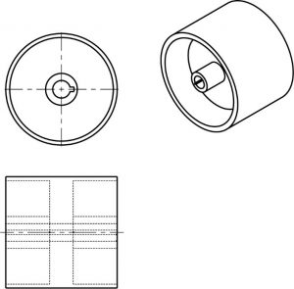

Chapter 9

Machined Features

Machined Features
- BEVEL
- BOSS
- CHAMFER
- COUNTERBORE
- COUNTERSINK
- DOVETAIL
- FILLET
- KERF
- KEYWAY
- KEYSEAT
- KNURL
- LUG
- NECK
- PAD
- ROUND
- SPLINE
- SPOTFACE
- T-SLOT
The machined features in this section are common terms related to basic industry processes. These terms are often found on prints. For a better understanding of these processes, look at the models of machined features in the Print Reading Lab.

Bevel
A surface cut at an angle. In regard to welding, a bevel will normally end up being a surface prep for a weld.

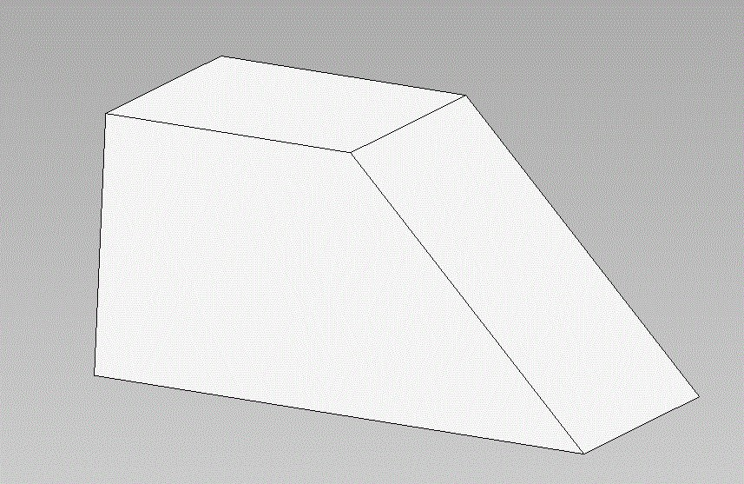

Boss
A circular pad on forgings or castings, which project out from that body of the part. The surface of the boss is machined smooth for a bold head to seat on and it has a hole drilled through to accommodate the bolt shank.
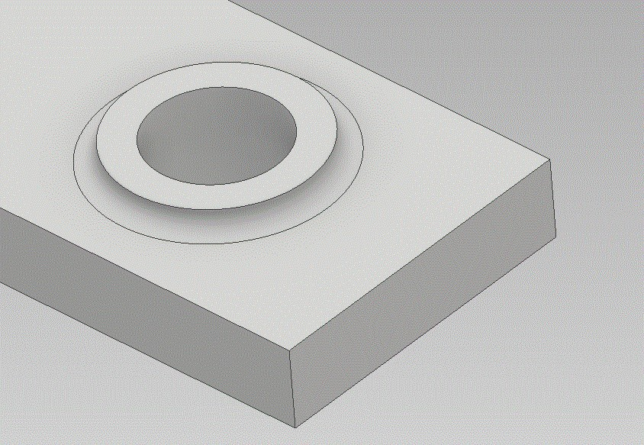

Chamfer
A process of cutting away a sharp external corner or edge. Not for welding.
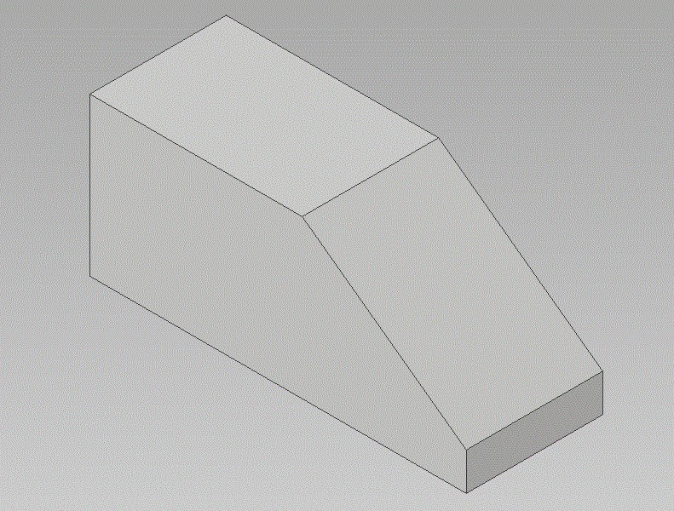

Counterbore
To enlarge drilled hole to a given diameter and depth. Usually done for recessing a bolt head.
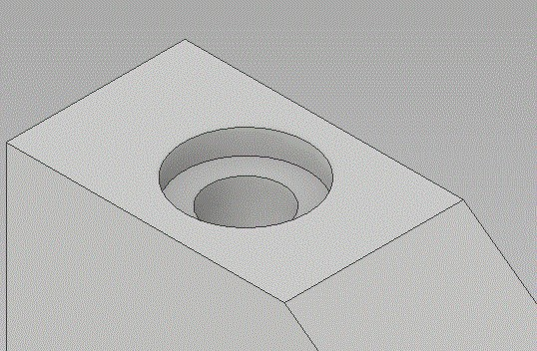

Countersink
To machine a conical depression in a drilled hole for recessing flathead screws or bolts.
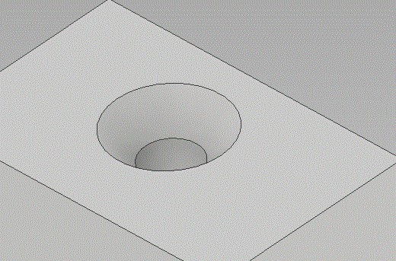

Dovetail
A slot of any depth and width, which has angled sides.
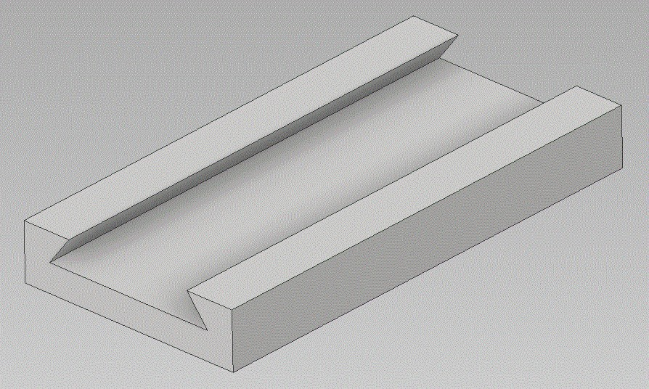

Quiz
Directions: Name the machined features shown below.

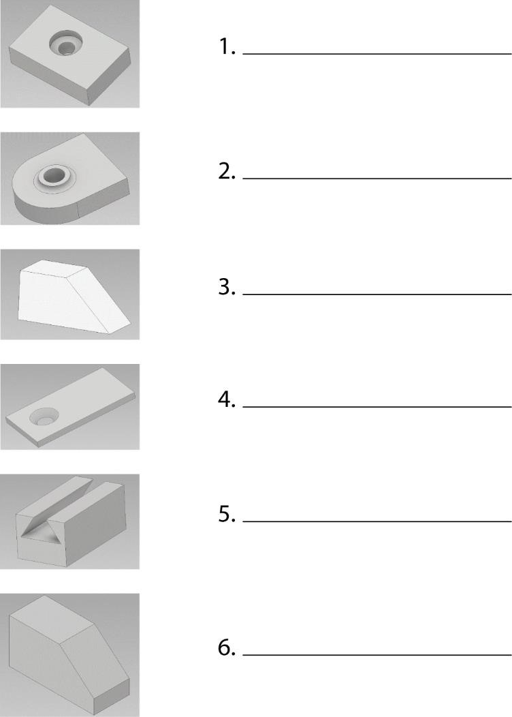

Fillet
A small radius filling formed between the inside angle of two surfaces.
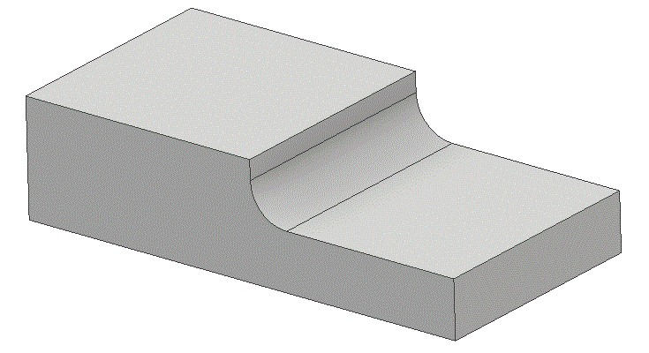

Kerf
The narrow slot formed by removing material while sawing or other machining.
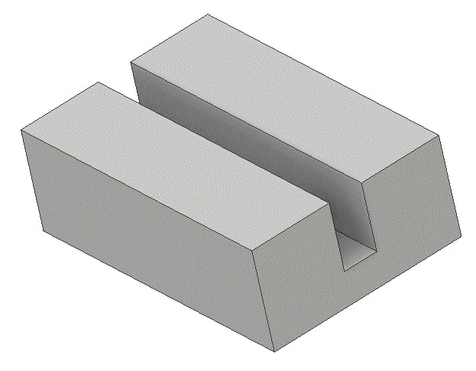

Keyway
A narrow groove or slot cut in the shaft hole of a sleeve or hub for accommodating a key.

Keyseat
A narrow groove or slot cut in a shaft for accommodating a key.
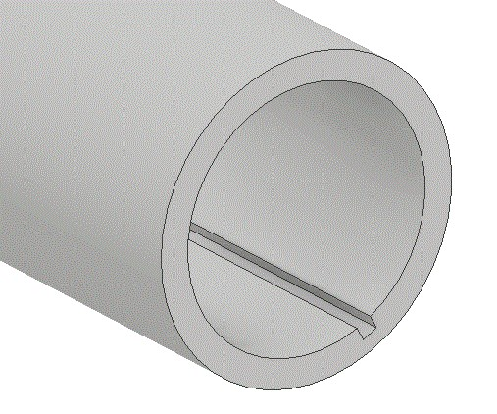

Knurl
To uniformly roughen with a diamond or straight pattern a cylindrical or flat surface.

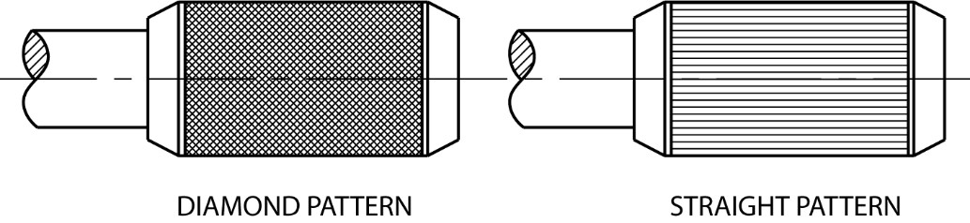

Lug
A piece projecting out from the body of a part. Usually rectangular in cross section with a hole or slot in it.
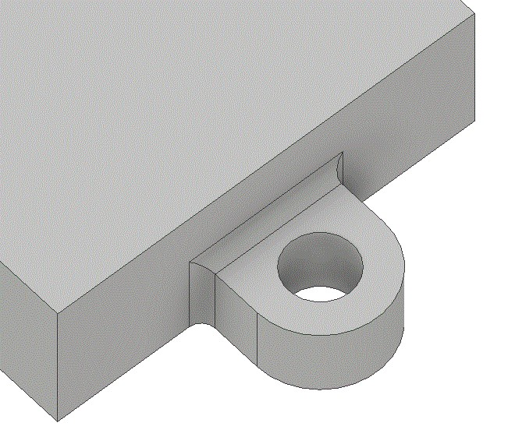

Neck
To machine a narrow groove on a cylindrical part or object.
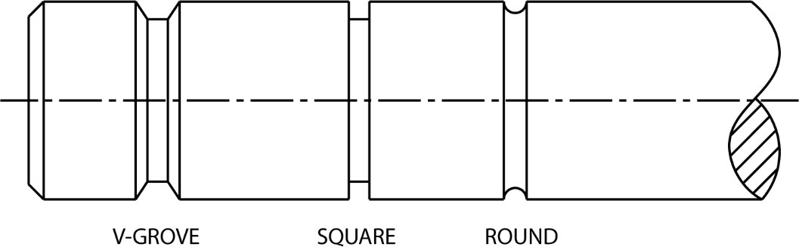
Quiz
Directions: Name the machined features shown below. Check your answer.
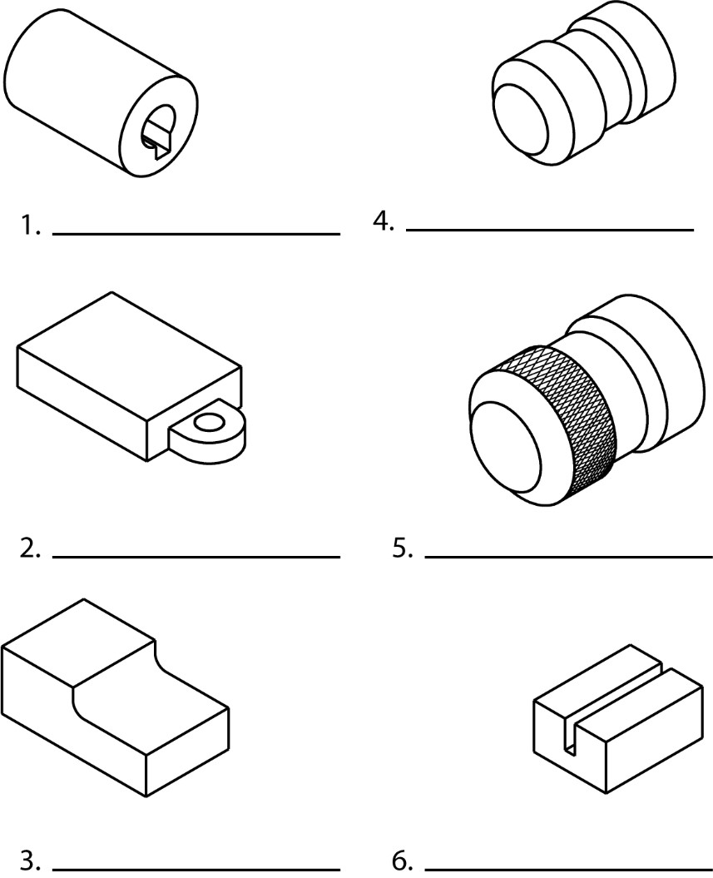

Additional features and shapes.

Pad
A slightly raised surface projecting out from the body of a part. The pad surface can be of any size or shape. (Remember, bosses can only be round)
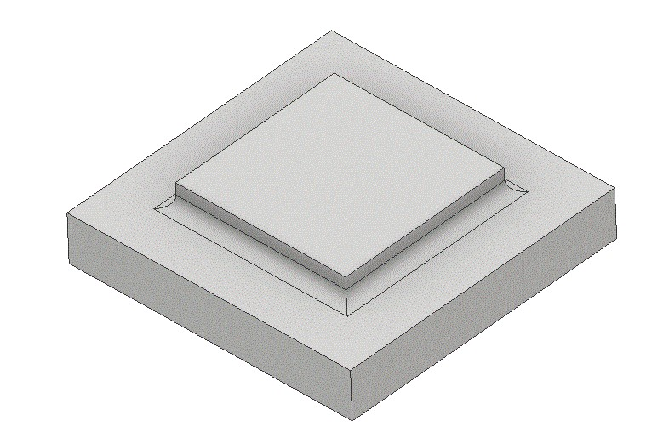

Round
A small radius rounded outside corner formed between two surfaces.
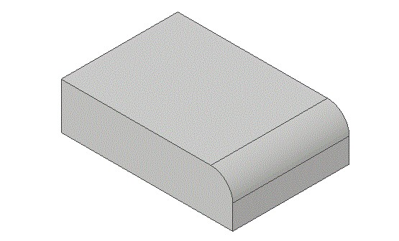

Spline
A gear-like serrated surface on a shaft. Take the place of a key when more torque strength is required.
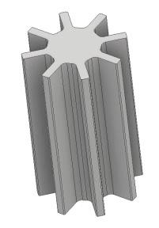

Spotface
A round surface on a casting or forging for a bold head. Usually about 1/16” deep.
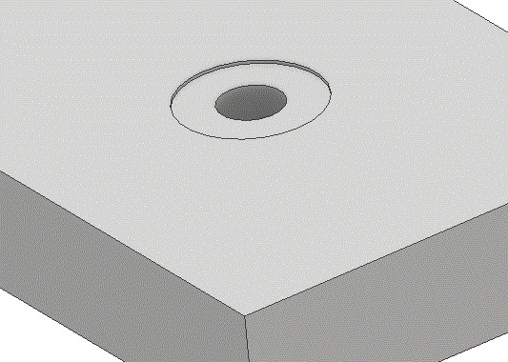

T-Slot
A slot of any dimensions to resemble a “T”.
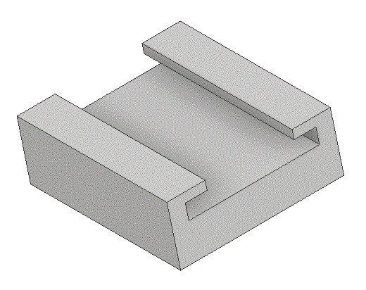
Quiz
Directions: Name that machined features shown below. Check your Answers.

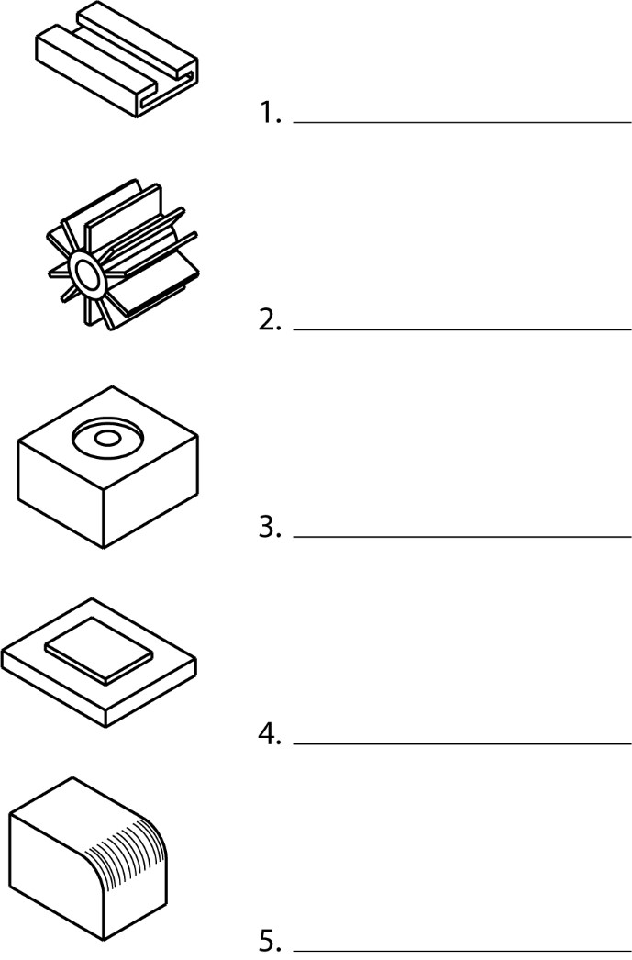

Chapter 10

Print Interpretation

Print Interpretation
This final section introduces basic print reading. Because machine drawings are used to some extent in nearly every trade, the working drawings used in this section are all machine drawings.
The purpose of this package is to provide an opportunity to put your fundamental knowledge of print reading to use before you go on to more specialized and advanced print reading activities.
Exercise 1
Study the print below and fill in the related dimensions.
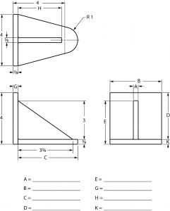
Exercise 2
Study the print below and fill in the related dimensions.
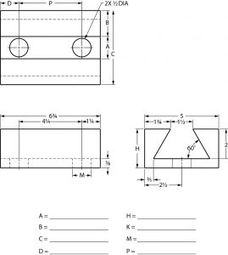
Exercise 3
Study the print below and fill in the related dimensions.
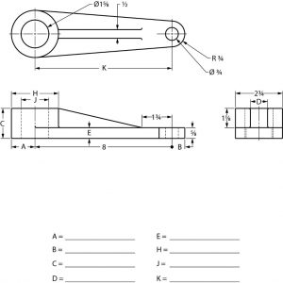
Exercise 4
Study the print below and fill in the related dimensions.
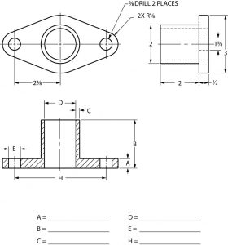

Exercise 5
Study the print below and fill in the related dimensions.
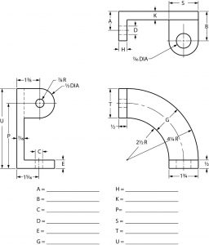

1

Appendix
This is where you can add appendices or other back matter.

